WATER DAMAGE INVESTIGATION

Massachusetts Gaming Commission
101 Federal Street
Boston, Massachusetts

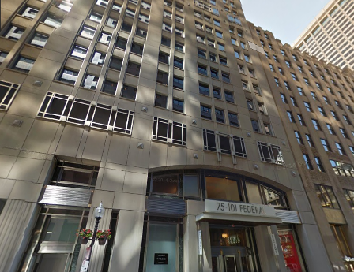

Prepared by:
Massachusetts Department of Public Health
Bureau of Environmental Health
Indoor Air Quality Program
February 2016

BACKGROUND
Building: | Massachusetts Gaming Commission (MGC)
Address: | 101 Federal Street Boston, MA
Assessment Requested by: | Virginia Platt, Project Manager, Division of Capital Asset Management and Maintenance (DCAMM)
Reason for Request: | Water Damage
Date of Assessment: | February 17, 2016
Massachusetts Department of Public Health/Bureau of Environmental Health (MDPH/BEH) Staff Conducting Assessment: | Jason Dustin, Environmental Analyst/Inspector, Indoor Air Quality (IAQ) Program
Date of Building Construction: | 1988
Building/Site Description: | The MGC is located on the twelfth story of a downtown high rise. The space has been completely renovated before the MGC began occupying it in August 2015.
Windows: | Not openable

Executive Summary:
No significant public health concerns were identified during this visit. Moisture testing of porous building materials (e.g., carpeting, wallboard) revealed that the majority of areas were properly dried by remediation efforts. According to MGC staff, remaining moistened wallboard and carpeting identified during the site visit is scheduled to be removed and replaced.

METHODS
BEH/IAQ staff performed a visual inspection of building materials for water damage and/or microbial growth. Moisture content of porous building was measured using a Delmhorst, BD-2000 Model Moisture Detector. Please refer to the IAQ Manual and appendices for methods, sampling procedures, and interpretation of results (MDPH, 2015).

RESULTS AND DISCUSSION
Due to the severe cold weather experienced on the evening of Sunday, February 14, 2016 and early morning hours of Monday, February 15, 2016 two heating pipes had frozen and burst in different areas of the MGC. Water leaked from these broken pipes and damaged gypsum wallboard (GW), insulation, carpet, and ceiling tiles.
The property manager and facilities personnel for the building responded within two hours of the incident. Flood remediation contractor, Belfor Property Restoration was brought in to extract water from the space and begin drying moistened materials with fans and dehumidifiers (Picture 1). The heating, ventilating and air conditioning (HVAC) system was set to increase both temperature and ventilation to aid in the drying/dehumidification process. Temperature was measured between 81°F and 83°F and relative humidity was between 25 and 31% during the assessment.
A slight odor was detected by BEH staff upon entering the MGC space. This odor is most likely due to the moistening of the carpet tile adhesive after the flooding occurred. Continued ventilation should remove the odors while the carpet dries. Relocation of the employees in the affected areas should mitigate possible irritant effects until the odors are gone.
In some areas of the MGC, holes were drilled or the GW was cut away to remove any accumulated water that standing inside the metal framing members and allow the wall cavity to dry (Picture 2).
Use of the moisture meter showed that most of the impacted GW in the MGC was dry by the time of the February 17, 2016 site visit. However, a few areas of GW were found to have elevated moisture levels. The height of moistened GW measured in most areas was well within the lower two feet, a zone of GW that was proposed to be removed by the remediation contractor. One of the pipes had burst directly above the ceiling in room #1273. Peeling paint and moistened GW were found in the affected corner (Picture 3), including moistened GW at heights above the two-foot removal zone. It was reported by MGC staff that the contractor was aware of this condition and had proposed removing the affected GW in the entire corner of this office. Although most carpeting tested with the moisture meter was found to be dry, a few carpet tiles in office #1273 were found still moistened and these were also recommended to be removed.
The US Environmental Protection Agency (US EPA) and the American Conference of Governmental Industrial Hygienists (ACGIH) recommends that porous materials (e.g., wallboard, carpeting) be dried with fans and heating within 24 to 48 hours of becoming wet (US EPA, 2008; ACGIH, 1989). If porous materials are not dried within this time frame, mold growth may occur.

CONCLUSIONS AND RECOMMENDATIONS
The following recommendations were made at the time of the assessment and are reiterated below:

- If possible, continue to keep affected staff relocated until remediation is complete.
- Continue with plans to remove lower two feet of affected GW in impacted areas as well as the GW in the entire corner of office #1273. Consider removal of carpet tiles in this corner as well.
- Water-damaged carpeting, ceiling tiles, GW and insulation should be removed in a manner consistent with recommendations found in “Mold Remediation in Schools and Commercial Buildings” published by the US Environmental Protection Agency (US EPA, 2001).
- During remediation the following steps should be taken to reduce exposure to remediation debris, odors and/or airborne particulate matter:
- Remediation work should be done while area is unoccupied;
- Remove furniture and personal items or cover employee workstations in areas of remediation to protect items and facilitate cleanup;
- Place water-damaged/mold-colonized materials in plastic bags for transport;
- Ensure air handling units are deactivated and/or seal vents temporarily in remediation areas during removal/remediation;
- Once removal/remediation is complete, clean areas/surfaces in remediation area with a high efficiency particulate arrestance (HEPA) filter equipped vacuum cleaner in conjunction with wet wiping of all non-porous surfaces.
- Consult MDPH guideline “Methods Used to Reduce/Prevent Exposure to Construction/Renovation Generated Pollutants in Occupied Buildings” (MDPH, 2006).
- Ensure that thermostats are set to “fan on” during occupied periods for continuous air exchange.

REFERENCES

ACGIH. 1989. Guidelines for the Assessment of Bioaerosols in the Indoor Environment. American Conference of Governmental Industrial Hygienists, Cincinnati, OH.
MDPH. 2006. Methods Used to Reduce/Prevent Exposure to Construction/Renovation Generated Pollutants in Occupied Buildings. Available at: http://www.mass.gov/eohhs/gov/departments/dph/programs/environmental-health/exposure-topics/iaq/pollution/renovate/constructionrenovation-pollutants-prevention.html
MDPH. 2015. Massachusetts Department of Public Health. Indoor Air Quality Manual: Chapters I-III. Available at: http://www.mass.gov/eohhs/gov/departments/dph/programs/environmental-health/exposure-topics/iaq/iaq-manual/.
US EPA. 2008. Mold Remediation in Schools and Commercial Buildings. US Environmental Protection Agency, Office of Air and Radiation, Indoor Environments Division, Washington, D.C. EPA 402-K-01-001. http://www.epa.gov/mold/mold-remediation-schools-and-commercial-buildings-guide.
Picture 1

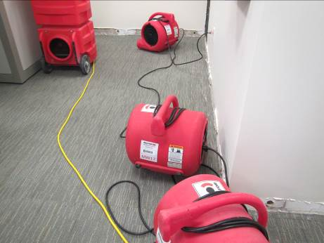

Fans and dehumidifiers used to facilitate drying
Picture 2
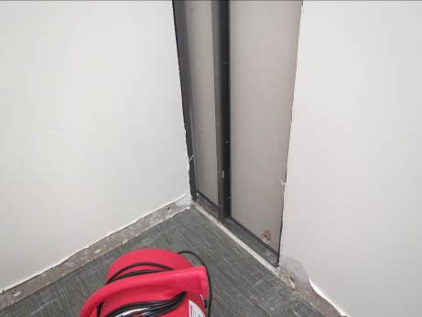

GW removed and holes drilled to dry wall cavity
Picture 3
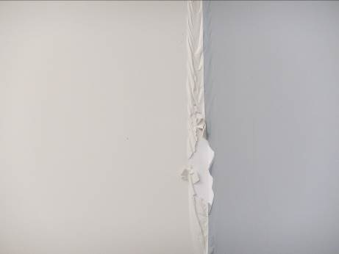

Peeling paint and moistened GW in office # 1273

