INDOOR AIR QUALITY ASSESSMENT

MOLD INVESTIGATION

Massachusetts Gaming Commission

Raynham Park

1958 Broadway

Raynham, Massachusetts

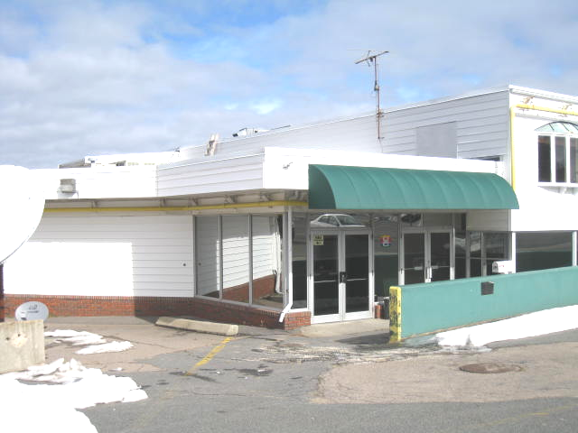

Prepared by:
Massachusetts Department of Public Health
Bureau of Environmental Health
Indoor Air Quality Program
March 2013

Background/Introduction
At the request of Ms. Alexandra Lightbown, Chief Veterinarian/Operations Manager, Massachusetts Gaming Commission (MGC), the Massachusetts Department of Public Health (MDPH), Bureau of Environmental Health (BEH) provided assistance and consultation regarding indoor air quality (IAQ) concerns at the MGC office, located at Raynham Park, 1958 Broadway, Raynham, Massachusetts. Reports of musty odors and concerns about possible mold growth from water-damaged carpeting prompted the assessment.
On February 22, 2013, a visit was made to the MGC office by Cory Holmes, Environmental Analyst/Regional Inspector in BEH’s IAQ Program. Mr. Holmes was accompanied by Mr. Tom Clifford, Maintenance Supervisor and Ms. Lightbown during the assessment.
The MGC office is an interior room located on the ground floor of Raynham Park, a simulcasting racing center and gaming facility. The MGC office consists of painted gypsum wallboard (GW), a suspended ceiling and commercial grade wall-to-wall carpeting with no padding. This office does not have windows.

Methods
MDPH staff performed a visual inspection of building materials for water damage and/or microbial growth. Moisture content of porous building materials (carpeting, GW) was measured with a Delmhorst, BD-2000 Model, Moisture Detector equipped with a Delmhorst Standard Probe.

Microbial/Moisture Concerns
In order for building materials to support mold growth, a source of water exposure is necessary. Repeated water damage to porous building materials (GW, ceiling tiles, carpeting) can result in microbial growth. The US Environmental Protection Agency (US EPA) and the American Conference of Governmental Industrial Hygienists (ACGIH) recommend that porous materials be dried with fans and heating within 24 to 48 hours of becoming wet (US EPA, 2001; ACGIH, 1989). If not dried within this time frame, mold growth may occur. Once mold has colonized porous materials, they are difficult to clean and should be removed.
It was reported that the office occupant noticed a musty odor and wet carpeting on February 11, 2013. The likely source of moisture, as described by Mr. Clifford, was melting snow from the blizzard of 2013 (February 8 and 9) that was plowed against the exterior of the building in this area. At the time of the BEH/IAQ site visit on February 22, moisture measurements showed that the carpeting beneath file cabinets remained wet (Table 1). No elevated moisture measurements were detected in other areas of carpeting or GW (Table 1). However, the carpet throughout the office appeared to be past its useful lifespan, with some areas observed to be damaged, worn or soiled. Since the average lifespan of a carpet is approximately eleven years (Bishop, 2002), at the time of assessment BEH/IAQ staff recommended removal of the carpet.
In subsequent correspondence with Ms. Lightbown, she reported that the carpeting had been removed, the floor had been cleaned and disinfected and that new flooring will consist of tiles for ease of cleaning.

Conclusions/Recommendations
In view of the findings at the time of the assessment, no further recommendations are made.
References
ACGIH. 1989. Guidelines for the Assessment of Bioaerosols in the Indoor Environment. American Conference of Governmental Industrial Hygienists, Cincinnati, OH.
Bishop. 2002. Bishop, J. & Institute of Inspection, Cleaning and Restoration Certification. A Life Cycle Cost Analysis for Floor Coverings in School Facilities.
US EPA. 2001. “Mold Remediation in Schools and Commercial Buildings”. Office of Air and Radiation, Indoor Environments Division, Washington, DC. EPA 402-K-01-001. March 2001. Available at: http://www.epa.gov/iaq/molds/mold_remediation.html
Location | Moisture Testing | Comments
Carpeting in main entrance/outside MGC office | Dry | No odors detected
Carpeting at rear of MGC office | Dry | No odors detected
Carpeting at center of MGC office | Dry | No odors detected
Carpeting at front of MGC office | Dry | No odors detected
Carpeting beneath file cabinets at front of MGC office | Wet | Slight odors detected
Gypsum wallboard along front of MGC office where water infiltrated | Dry | No odors detected

