Depatman Resous Agrikòl Massachusetts
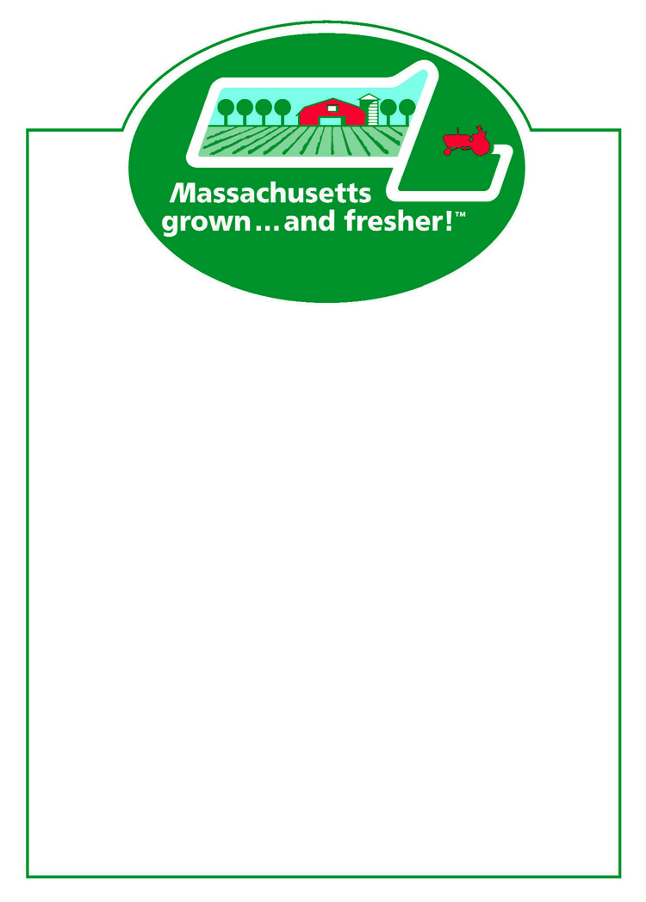
Materyèl Maketing pou Pwen Dacha a

“Kiltive... ak pi fre nan Massachusetts!”

Kat Pri pou Tablo Blan 5"x 7" (50 pou chak blòk) ________
Kat Pri pou Tablo Blan 7" x 11" (50 pou chak blòk) ________



Otokolan avò Logo MassGrown 500 pou chak woulo Woulo(yo)
Otokolan siwo myèl Massachusetts 100 pou chak woulo Woulo(yo)

Afich Gwosè: Tout 14” x 18”
MassGrown ak siy frechè
_____ Pòm _____ Mitil _____ Plant a flè / masif _____
_____ Siwo myèl _____ Siwo erab _____ Joumou
_____ Frèz _____ Legim _____ Top 10 Rezon pou achte lokal

Tablo Disponibilite : _____ 8” x11” _____ 11”x 17”
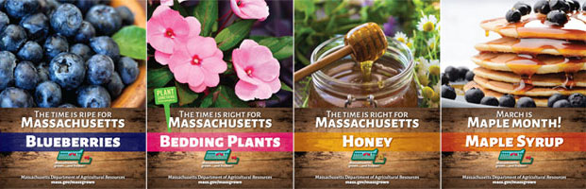
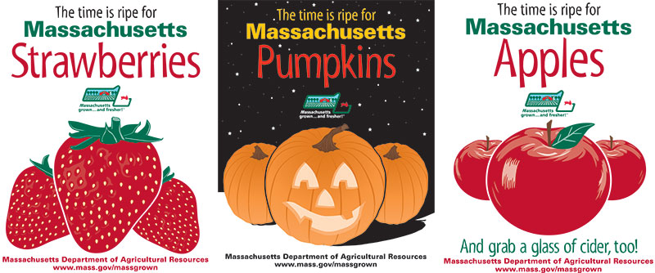
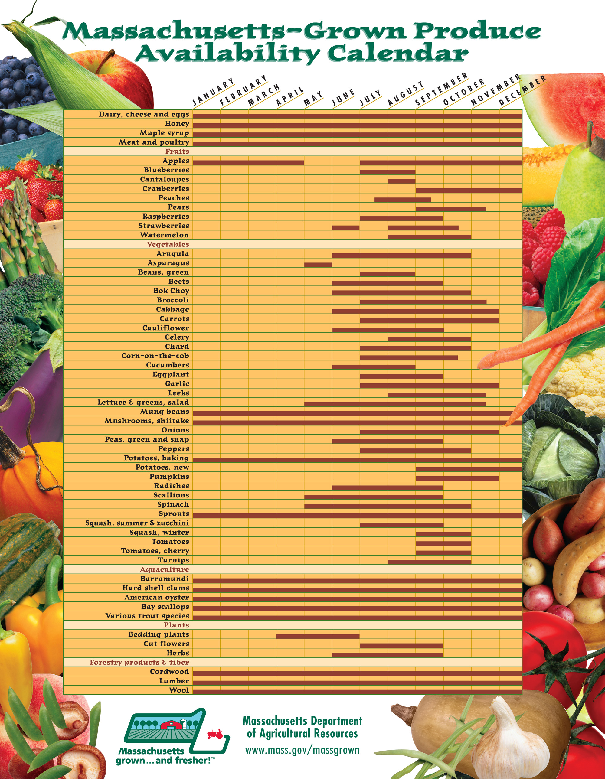

Mwen dakò pou m itilize atik avèk logo Massachusetts yo sèlman ak atik yo kiltive, eleve, oswa enkli engredyan yo kiltive nan Commonwealth Massachusetts.

*Siyati – (obligatwa)
___________________________________________ dat_____________

Non Fèm/Antrepriz : _______________________________________________________
Non kontak : ______________________________Imèl :__________________________
Mailing Address: ___________________________________________________________
Vil : Kòd postal : Telefòn :____________________

Kesyon : Kontak Rick LeBlanc, Richard.LeBlanc@mass.gov, 617-655-3529
Adrès postal : Mass. Dept. of Agricultural Resources
225 Turnpike Road
Southborough, MA 01772

