Massachusetts Department of Agricultural Resources
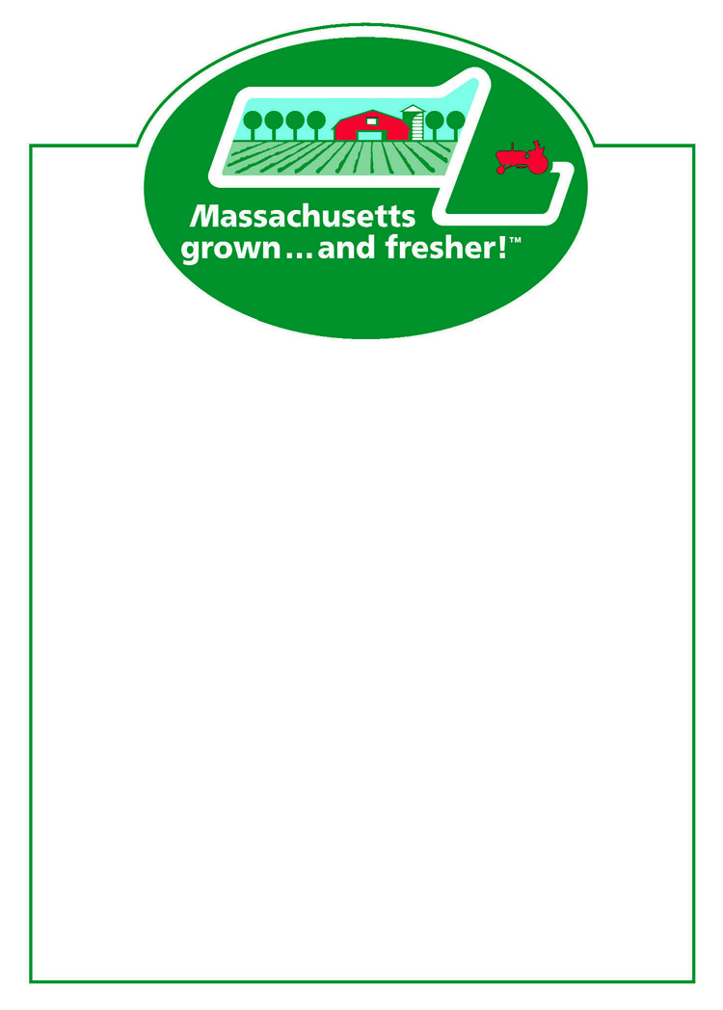
Marketing Point of Purchase Materials

“Massachusetts grown…and fresher!”
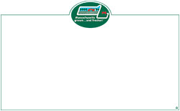
Whiteboard Price Cards 5"x 7" (50 per pad) ________
Whiteboard Price Cards 7" x 11" (50 per pad) ________


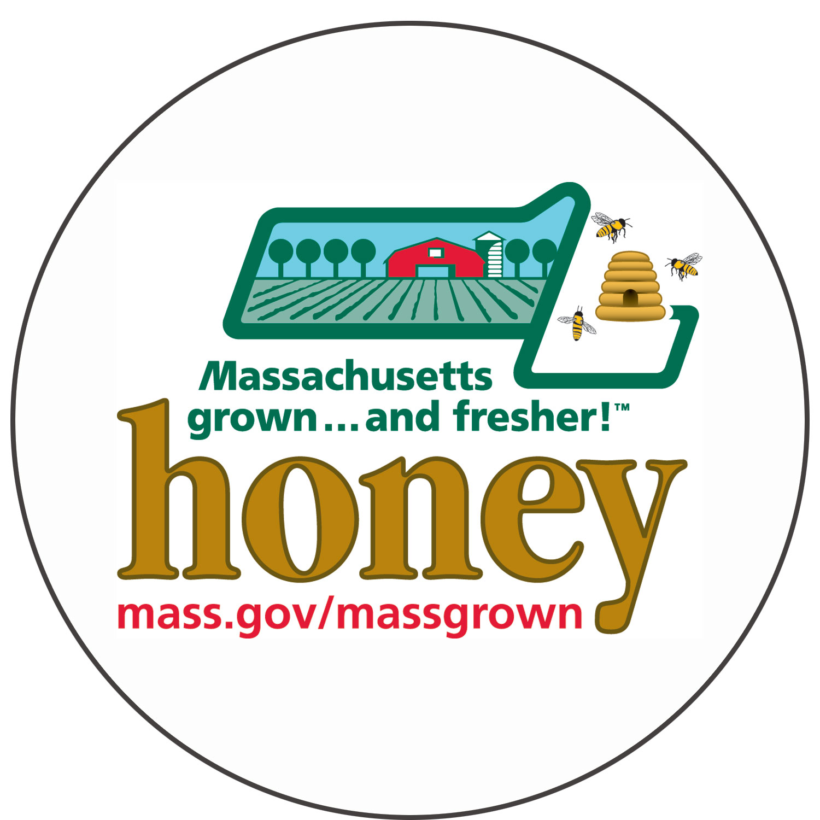
MassGrown Logo Stickers 500 per roll roll(s)
Massachusetts Honey Stickers 100 per roll roll(s)

Posters Sizes: all 14” x 18”
_____ Apples _____ Blueberries _____ Flower/Bedding Plants
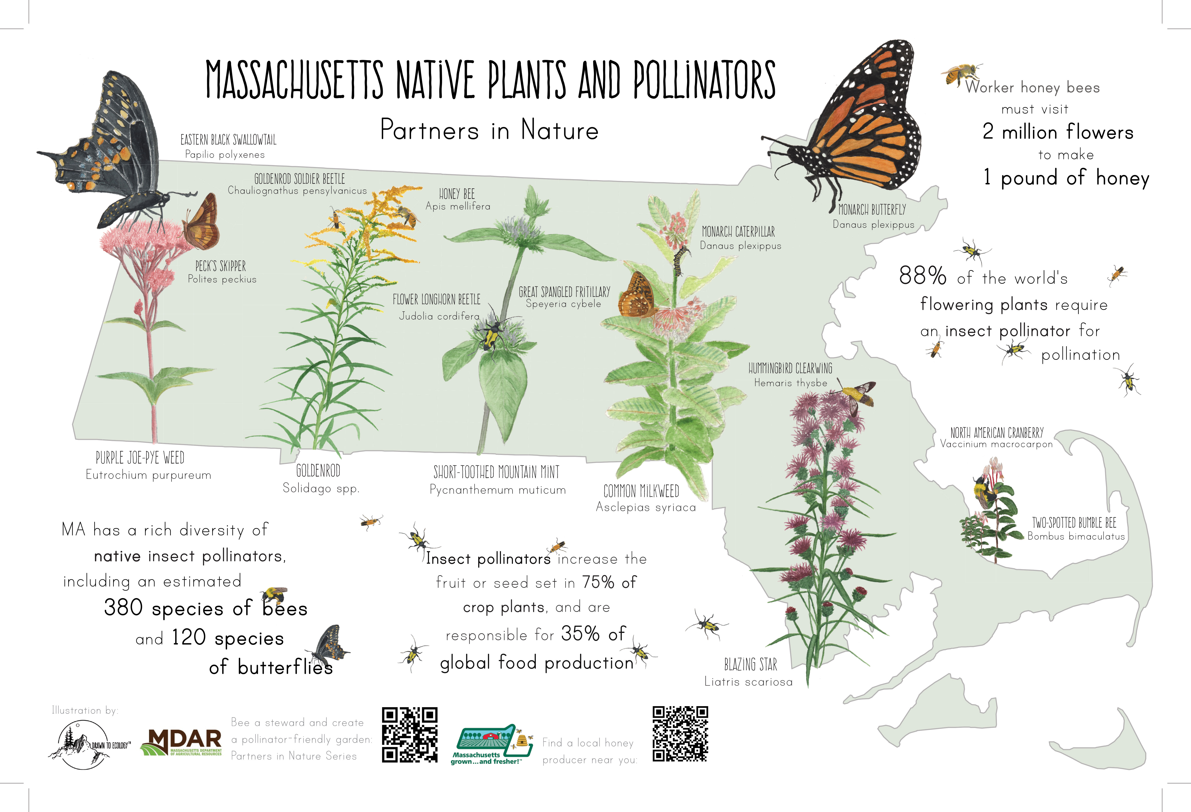
_____ Honey _____ Maple Syrup _____ Pumpkins
_____ Strawberries _____ Vegetables _____ Top 10 Reasons to
Buy Local

Availability Chart:_____8” x11” _____11”x 17” _____ Native Plants
and Pollinators

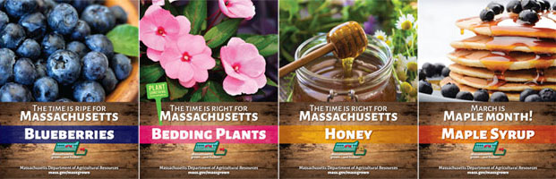
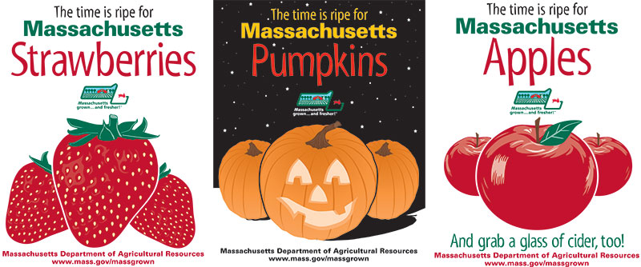
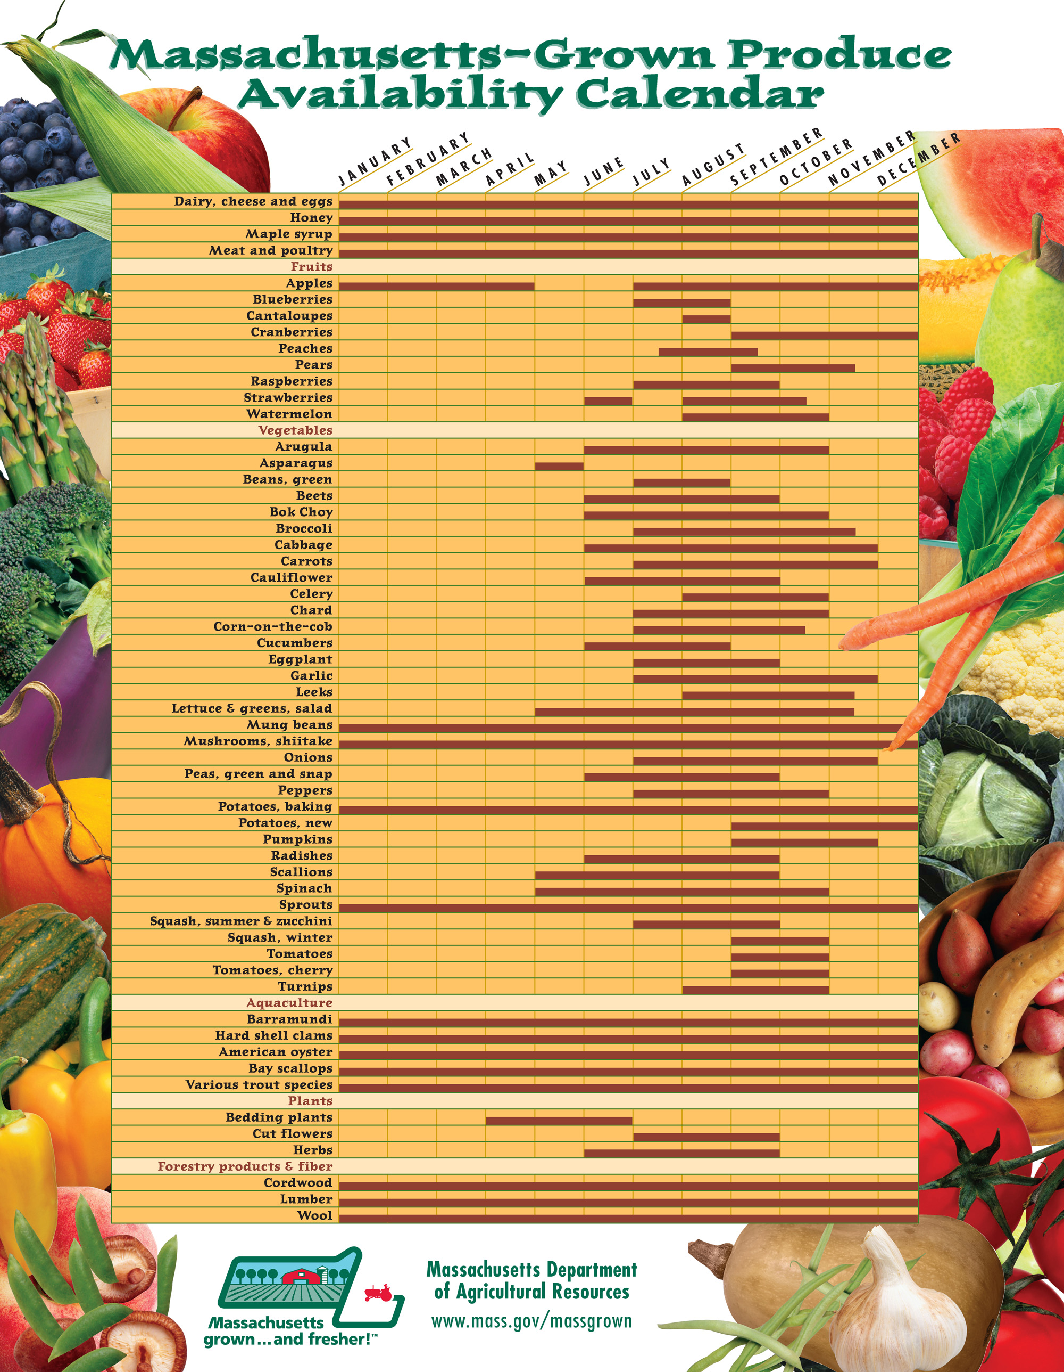

I agree to use the Massachusetts logo items exclusively with items grown, raised, or include ingredients grown in the Commonwealth of Massachusetts.

*Signature – (required)
___________________________________________ date_____________

Farm Name/Business: _______________________________________________________
Contact Name: ______________________________Email:__________________________
Mailing Address: ___________________________________________________________
City: Zip: Phone:_________________________

Questions: Contact Rick LeBlanc, Richard.LeBlanc@mass.gov, 617-655-3529
Mailing Address: Mass. Dept. of Agricultural Resources
225 Turnpike Road
Southborough, MA 01772

