Inmar Rx Solutions, Inc.


Massachusetts State Drug Stewardship Program 2023 Annual Report
(1/1/2023 through 12/31/2023)

March 1, 2024

EXECUTIVE SUMMARY | 01
PARTICIPATING MANUFACTURERS | 01
UNWANTED DRUGS COLLECTED | 02
COLLECTION SITES | 02
MAIL-BACK RETURNS | 06
MAIL-BACK DISTRIBUTION SITES | 06
DROP-OFF DAY EVENTS | 07
TRANSPORTERS AND DISPOSAL FACILITIES | 08
SAFETY OR SECURITY CONCERNS | 09
OUTREACH INITIATIVES | 09
APPENDIX | 10
Appendix A - Outreach and Promotion Material | 10

EXECUTIVE SUMMARY
Inmar Rx Solutions, Inc (Inmar) was approved to operate a Drug Stewardship Program (“Program”) on August 6, 2020 pursuant to the Massachusetts Drug Stewardship Program, codified as M.G.L. c. 94H and under the guidance of Circular Letter DHCQ 17-1-666. This Annual Report is for the period between January 1, 2023 and December 31, 2023.
Throughout the Reporting Period, there was one collection site closure and Inmar secured 30 additional collection sites. As of today, Inmar is operating 124 collection sites and 36 mail-back distribution locations across the state of Massachusetts. Inmar collected a total of 5,135.59 pounds of Unwanted Drugs by means of collection sites (kiosks) and mail-back services including mail-back distribution sites, as well as by request via the Program’s website or toll-free phone number.

PARTICIPATING MANUFACTURERS
Manufacturer | Mailing Address
Camber Pharmaceuticals, Inc. | 1031 Centennial Avenue, Piscataway, NJ 08854
Dr. Reddy’s Laboratories Inc. | 107 College Road East, Princeton NJ 08540
Epic Pharma, LLC | 517 Rt 1 S, Ste 4002, Iselin, NJ 08830
Glenmark Pharmaceuticals Inc., USA | 750 Corporate Drive, Mahwah, New Jersey 07430
Heritage Pharmaceuticals Inc. DBA Avet  Pharmaceuticals Inc | 1 Tower Center Boulevard, Suite 1700, East Brunswick, NJ 08816
Hikma Pharmaceuticals USA, Inc. | 200 Connell Drive, 4th Floor, Berkeley Heights, NJ 07922
Lannett Company Inc. | 1101 C Avenue West, Seymour, IN 47274
Leading Pharma, LLC | 3 Oak Road, Fairfield, NJ 07004
Micro Labs USA, Inc. | 220 Davidson Avenue, suite 402, Somerset, NJ 08873
Neurelis Inc. | 3430 Carmel Mountain Road, Suite 300, San Diego, CA 92121
Novadoz Pharmaceuticals, LLC | 20 DUKE ROAD, SUITE A, PISCATAWAY, NJ 08854-3714
Sebela Pharmaceuticals Inc. | 645 Hembree Parkway, Suite I, Roswell, GA 30076
Somerset Pharma, LLC | 300 Franklin Square Dr, Somerset, NJ 08873
Strides Pharma, Inc | 1 Ram Ridge Rd, Chestnut Ridge, NY 10977
Sun Pharmaceutical Industries, Inc. | 2 Independence Way, Princeton, NJ 08540
Taro Pharmaceuticals U.S.A., Inc. | 2 Independence Way, Princeton, NJ 08540
TruPharma, LLC. | 4100 W Kennedy Blvd, Suite 220, Tampa, FL 33609
Unichem Pharmaceuticals (USA), Inc. | 1 Tower Center Boulevard, Suite 2200 East Brunswick, NJ 08816
Upsher-Smith Laboratories, LLC | 6701 Evenstad Drive, Maple Grove, MN 55369

UNWANTED DRUGS COLLECTED
Type | # of Liners \ Envelopes | Reporting Period  1/1/2023 - 12/31/2023  (pounds collected)
Collection Sites (kiosks) | 222 | 5,108.22
Mail-Back Distribution Sites | 83 | 27.37
Total | 305 | 5,135.59

COLLECTION SITES
Pharmacy Name / DBA Name | Street | City | Zip | County | Status
Beth Israel Deaconess - Needham | 148 Chestnut Street | Needham | 02492 | Norfolk | Active
Beth Israel Deaconess Hospital Milton | 199 Reedsdale Road | Milton | 02186 | Norfolk | Active
BNHC Pharmacy | 83 Main Street | Brockton | 02301 | Plymouth | Active
Boston College Police Department | 21 Campanella Way | Chestnut Hill | 02467 | Norfolk | Active
Boston Medical Center Shapiro | 1 Boston Medical Ctr Pl # 1 | Boston | 02118 | Suffolk | Active
Boston Medical Center Yawkey Outpatient  Pharmacy Menino Campus | 840 Harrison Avenue | Boston | 02118 | Suffolk | Active
Bristol County Sheriff's Office | 400 Faunce Corner Road | Dartmouth | 02747 | Bristol | Active
Charles River Community Health | 43 Foundry Avenue | Waltham | 02453 | Middlesex | Active
Charles River Community Health | 495 Western Ave | Brighton | 02135 | Suffolk | Active
Chicopee Health Center | 505 Front Street | Chicopee | 01013 | Hampden | Active
Crawford Drug | 1735 Dorchester Ave | Dorchester | 02124 | Suffolk | Active
Cure-Aid Pharmacy Inc | 101 Amesbury St Ste 207 | Lawrence | 01840 | Essex | Active
Dedham Pharmacy & Medical Supply | 596 Providence Hwy | Dedham | 02026 | Norfolk | Active
Dothouse Health | 1353 Dorchester Ave | Dorchester | 02122 | Suffolk | Active
East Boston Neighborhood Health Center | 151 Orleans Street 1St  Floor Stock Room | East Boston | 02128 | Suffolk | Active
EssentialRX at Saint Vincent Hospital | 123 Summer St. | Worcester | 01608 | Worcester | Active
Fairhaven Pharmacy | 72 Main Street | Fairhaven | 02719 | Bristol | Active
Faulkner Hospital | 1153 Centre St | Jamaica Plain | 02130 | Suffolk | Active
Hannaford 8003 | 118 Lancaster St. | Leominster | 01453 | Worcester | Active
Hannaford 8004 | 193 Boston Post Rd. West,  Rte 20 | Marlborough | 01752 | Middlesex | Active
Hannaford 8005 | 8 Merchants Way | Middleborough | 02346 | Plymouth | Active
Hannaford 8012 | 927 Merriam Avenue | Leominster | 01453 | Worcester | Active

Hannaford 8014 | 158 N. Main St. Suite 3 | Uxbridge | 01569 | Worcester | Active
Hannaford 8017 | 55 Russell St. | Waltham | 02453 | Middlesex | Active
Hannaford 8191 | 66-2 Drum Hill Shopping  Ctr. | Chelmsford | 01824 | Middlesex | Active
Hannaford 8192 | 301 Pleasant St. | Dracut | 01826 | Middlesex | Active
Hannaford 8383 | 255 Joseph E. Warner Blvd. | Taunton | 02780 | Bristol | Active
Hannaford 8388 | 333 Mass Ave. | Lunenburg | 01462 | Worcester | Active
Holyoke Health Center Pharmacy | 230 Maple St | Holyoke | 01040 | Hampden | Active
HRI Hospital | 227 Babcock St | Brookline | 02446 | Norfolk | Active
Jeffrey And Susan Brudnick Center For Living | 240 Lynnfield Street | Peabody | 01960 | Essex | Active
JGS Lifecare - Jewish Nursing Home | 770 Converse Street | Longmeadow | 01106 | Hampden | Active
Leslie's Drug Store | 65 Main Street | Vineyard  Haven | 02568 | Dukes | Active
Louis & Clark Drug #572 | 155 Brookdale Dr. | Springfield | 01104 | Hampden | Active
Market 32 Pharmacy 140 | 555 Hubbard Ave | Pittsfield | 01201 | Berkshire | Active
Market 32 Pharmacy 194 | 72 Pullman Street | Worcester | 01606 | Worcester | Active
Market 32 Pharmacy 244 | 21 Galaxy Pass | Sutton | 01590 | Worcester | Active
Marlboro Pharmacy And Wellness Center, Inc. | 561 Boston Post Rd E Ste 1 | Marlborough | 01752 | Middlesex | Active
Martha's Vineyard Hospital | 1 Hospital Rd | Oak Bluffs | 02557 | Dukes | Active
Mercy Hospital | 271 Carew Street | Springfield | 01104 | Hampden | Active
Metrowest Pharmacy | 214 Union Ave | Framingham | 01702 | Middlesex | Active
Nantucket Cottage Hospital | 57 Prospect Street | Nantucket | 02554 | Nantucket | Active
Osco Pharmacy #0428 | 95 Washington Street,  Cobbs Corner | Canton | 02021 | Norfolk | Active
Osco Pharmacy #0495 | 180 A Cambridge Street | Burlington | 01803 | Middlesex | Active
Osco Pharmacy #0603 | 137 Teaticket Highway | East Falmouth | 02536 | Barnstable | Active
Osco Pharmacy #0624 | 14 West Boylston Street | Worcester | 01605 | Worcester | Active
Osco Pharmacy #0627 | 760A Boston Road | Groton | 01450 | Middlesex | Active
Osco Pharmacy #1409 | 476 Liberty Street | Hanson | 02341 | Plymouth | Active
Osco Pharmacy #1412 | 125 Toner Blvd. | North  Attleborough | 02760 | Bristol | Active
Osco Pharmacy #1414 | 230 Main Street | Medfield | 02052 | Norfolk | Active
Osco Pharmacy #1429 | 641 Belmont Street | Brockton | 02301 | Plymouth | Active
Osco Pharmacy #2470 | 50 Boston Turnpike Road | Shrewsbury | 01545 | Worcester | Active
Osco Pharmacy #2565 | 699 Mt. Auburn Street | Cambridge | 02138 | Middlesex | Active
Osco Pharmacy #2569 | 1070 Lexington Street | Waltham | 02452 | Middlesex | Active
Osco Pharmacy #2579 | 1377 Hyde Park Avenue | Hyde Park | 02136 | Suffolk | Active

Osco Pharmacy #2583 | 535 Trapelo Road | Belmont | 02478 | Middlesex | Active
Osco Pharmacy #2584 | 155 Great Road | Stow | 01775 | Middlesex | Active
Osco Pharmacy #2585 | 2260 State Road | Plymouth | 02360 | Plymouth | Active
Osco Pharmacy #2594 | 16 Webster Square | Marshfield | 02050 | Plymouth | Active
Osco Pharmacy #3577 | 75 Spring Street | West Roxbury | 02132 | Suffolk | Active
Osco Pharmacy #3581 | 255 East Central Street | Franklin | 02038 | Norfolk | Active
Osco Pharmacy #3588 | 1065 Commonwealth  Avenue | Boston | 02215 | Suffolk | Active
Osco Pharmacy #3696 | 90 Causeway St. | Boston | 02114 | Suffolk | Active
Osco Pharmacy #4572 | 370 Western Avenue | Brighton | 02135 | Suffolk | Active
Osco Pharmacy #4587 | 45 Morrissey Blvd. | Dorchester | 02124 | Suffolk | Active
Osco Pharmacy #4596 | 18 Sisson Road | Harwich Port | 02646 | Barnstable | Active
Pembroke Hospital | 199 Oak Street | Pembroke | 02359 | Plymouth | Active
Pharma Rx Worcester LLC | 708 Park Ave | Worcester | 01603 | Worcester | Active
Price Chopper Pharmacy 155 | 300 Stockbridge Road | Gt. Barrington | 01230 | Berkshire | Active
Price Chopper Pharmacy 179 | 50 Cambridge Street | Worcester | 01610 | Worcester | Active
Price Chopper Pharmacy 229 | 731 Boston Turnpike | Shrewsbury | 01545 | Worcester | Active
Price Chopper Pharmacy 239 | 560 Main Street | Gardner | 01440 | Worcester | Active
Price Chopper Pharmacy 240 | 2 Worcester Road | Webster | 01570 | Worcester | Active
Randolph Pharmacy | 1187 N Main St | Randolph | 02368 | Norfolk | Active
Signature Healthcare Pharmacy | 110 Liberty Street | Brockton | 02301 | Plymouth | Active
South Shore Hospital | 55 Fogg Rd | South  Weymouth | 02190 | Norfolk | Active
Springfield Pharmacy | 2547 Main St. | Springfield | 01107 | Hampden | Active
Standard Pharmacy | 246 E Main St | Fall River | 02724 | Bristol | Closed
Standard Pharmacy @ Healthfirst | 387 Quarry Street | Fall River | 02723 | Bristol | Active
Stop & Shop Pharmacy #12 | 65 Route 6a | Sandwich | 02563 | Barnstable | Active
Stop & Shop Pharmacy #22 | 55 Long Pond Drive | S Yarmouth | 02664 | Barnstable | Active
Stop & Shop Pharmacy #2403 | 56 Shank Painter Road | Provincetown | 02657 | Barnstable | Active
Stop & Shop Pharmacy #425 | 20 Teaticket Highway | Falmouth | 02536 | Barnstable | Active
Stop & Shop Pharmacy #475 | 111 Chatham Road | Harwich | 02645 | Barnstable | Active
Stop & Shop Pharmacy 11 | 40 Furlong Dr | Revere | 02151 | Suffolk | Active
Stop & Shop Pharmacy 17 | 495 Southern Artery | Quincy | 02169 | Norfolk | Active
Stop & Shop Pharmacy 21 | 1 Dan Fox Dr Rte 7 | Pittsfield | 01201 | Berkshire | Active
Stop & Shop Pharmacy 2418 | 126 Medway Road | Milford | 01757 | Worcester | Active
Stop & Shop Pharmacy 30 | 2265 Northampton Street | Holyoke | 01040 | Hampden | Active

Stop & Shop Pharmacy 421 | 815 Grand Army Hwy | Somerset | 02726 | Bristol | Active
Stop & Shop Pharmacy 429 | 1100 Massachusetts  Avenue | Dorchester | 02125 | Suffolk | Active
Stop & Shop Pharmacy 432 | 469 Pleasant St | Attleboro | 02703 | Bristol | Active
Stop & Shop Pharmacy 458 | 660 Merrill Road | Pittsfield | 01201 | Berkshire | Active
Stop & Shop Pharmacy 473 | 333 Mariano Bishop  Boulevard | Fall River | 02721 | Bristol | Active
Stop & Shop Pharmacy 498 | 779 Mcgrath Highway | Somerville | 02145 | Middlesex | Active
Stop & Shop Pharmacy 499 | 100 Macy Street | Amesbury | 01913 | Essex | Active
Stop & Shop Pharmacy 55 | 932 North Montello Street | Brockton | 02301 | Plymouth | Active
Stop & Shop Pharmacy 64 | 2110 Cranberry Cove Plaza | Orleans | 02653 | Barnstable | Active
Stop & Shop Pharmacy 67 | 35 Washington Street | Lynn | 01904 | Essex | Active
Stop & Shop Pharmacy 7 | 377 Chauncy Street | Mansfield | 02048 | Bristol | Active
Stop & Shop Pharmacy 70 | 1001 Kings Hwy | New Bedford | 02745 | Bristol | Active
Stop & Shop Pharmacy 71 | 501 Rodman Street | Fall River | 02721 | Bristol | Active
Stop & Shop Pharmacy 72 | 57 Main Street | Westfield | 01085 | Hampden | Active
Stop & Shop Pharmacy 787 | 228 King Street | Northampton | 01060 | Hampshire | Active
Stop & Shop Pharmacy 80 | 1277 Liberty Street | Springfield | 01104 | Hampden | Active
Stop & Shop Pharmacy 82 | 341 Plymouth Street | Halifax | 02338 | Plymouth | Active
Stop & Shop Pharmacy 87 | 39 Nathan Ellis Highway | Mashpee | 02649 | Barnstable | Active
Stop & Shop Pharmacy 91 | 539571 Boston Turnpike | Shrewsbury | 01545 | Worcester | Active
Stop & Shop Pharmacy 94 | 935 Riverdale Street | W Springfield | 01089 | Hampden | Active
Stop & Shop Pharmacy 98 | 438 Dartmouth Street | New Bedford | 02742 | Bristol | Active
Sullivan Pharmacy | 1 Corinth Street | Roslindale | 02131 | Suffolk | Active
The Arbour Hospital | 49 Robinwood Ave | Jamaica Plain | 02130 | Suffolk | Active
Trang Pharmacy Inc | 456 Park Ave | Worcester | 01610 | Worcester | Active
Umass Health Alliance - Fitchburg Hospital | 275 Nichols Rd. | Fitchburg | 01420 | Worcester | Active
UMass Health Alliance - Leominster Hospital | 60 Hospital Road | Leominster | 01453 | Worcester | Active
UMass Memorial Medical Center Specialty  Pharmacy | 55 Lake Ave N Suite  Ac1.033 | Worcester | 01655 | Worcester | Active
University Health Services Pharmacy | 150 Infirmary Way | Amherst | 01003 | Hampshire | Active
USCG Base Cape Cod - Kaehler Memorial  Clinic | 5201 Lee Road | Buzzards Bay | 02542 | Barnstable | Active
Vineyard Scripts | 117 Beach Rd | Vineyard  Haven | 02568 | Dukes | Active
Walsh Pharmacy | 202 Rock Street | Fall River | 02720 | Bristol | Active
Wells Healthcare Pharmacy | 435 Shrewsbury St. Ste#4 | Worcester | 01604 | Worcester | Active
Westborough Behavioral Health | 300 Friberg Parkway | Westborough | 01581 | Worcester | Active
Whole Health Pharmacy | 596 W Main St | Hyannis | 02601 | Barnstable | Active
WP Acquisition Sub, LLC | 76 Summer Street | Haverhill | 01830 | Essex | Active

MAIL-BACK RETURNS
During the Reporting Period, Inmar secured 3 additional mail-back distribution sites and distributed 400 mail-back envelopes. There were 83 envelopes returned with a total weight of 27.37 pounds. This is a 477.43% increase in the amount of weight returned from mail-back envelopes in 2022.
Type | # Envelopes | Reporting Period  1/1/2023 - 12/31/2023  (pounds collected) | % Increase from  2022
Envelopes Returned | 83 | 27.37 | 477.43%

MAIL-BACK DISTRIBUTION SITES
Pharmacy Name / DBA Name | Street | City | Zip | Status
Apothecare Of Cape Cod | 145 Barnstable Road | Barnstable | 02601 | Active
Boston Children's Health Solutions Rx | 283 Longwood Ave. | Boston | 02115 | Active
Brigham And Women's Health Care Center | 20 Patriot Place | Foxborough | 02035 | Active
Brigham And Women's Health Outpatient  Pharmacy | 20 Patriot Place | Foxborough | 02035 | Active
Brigham And Women's Hospital | 45 Francis Street | Boston | 02115 | Active
Brigham And Women's Hospital Outpatient  Pharmacy | 45 Francis Street | Boston | 02115 | Active
Brigham And Women's Hospital Outpatient  Pharmacy | 75 Francis Street Attn: Outpatient  Pharmacy | Boston | 02115 | Active
Brigham And Women's Hospital Outpatient  Pharmacy | 850 Boylston Street Attn:  Pharmacy Dept. 75F | Chestnut Hill | 02467 | Active
Brigham And Women's Hospital, Health Care  Center Chestnut Hill | 850 Boylston Street Suite 302A | Chestnut Hill | 02467 | Active
Brigham And Women's/Mass General Health | 20 Patriot Place Attn: Pharmacy Dept. | Foxborough | 02035 | Active
Bringham and Women's Hospital | 850 Boylston Street Attn:  Pharmacy Dept. | Chestnut Hill | 02467 | Active
Brockton Health Center | 63 Main Street | Brockton | 02301 | Active
Cape Cod Healthcare Pharmacy At CCH | 27 Park Street | Hyannis | 02601 | Active
Cape Cod Healthcare Pharmacy At Falmouth | 100 Ter Heun Drive | Falmouth | 02540 | Active
Caribou Police Department | 25 High Street | Caribou | 04736 | Active
Charles River Community Health | 43 Foundry Avenue | Waltham | 02453 | Active
Charles River Community Health | 495 Western Avenue | Brighton | 02135 | Active
Costco Pharmacy #301 | 11 Newbury St. | Danvers | 01923 | Active
Costco Pharmacy #302 | 119 Daggett Drive | W.Springfield | 01089 | Active
Costco Pharmacy #303 | 120 Stockwell Drive | Avon | 02322 | Active
Costco Pharmacy #308 | 71 Second Avenue | Waltham | 02451 | Active
Costco Pharmacy #319 | 200 Legacy Boulevard | Dedham | 02026 | Active
Costco Pharmacy #333 | 2 Mystic View Road | Everett | 02149 | Active
Curahealth | 909 Sumner Street | Stoughton | 02072 | Active
Dana Farber Cancer Institute | 300 Boylston Street Suite 310 | Chestnut Hill | 02050 | Active
Dana Farber Merrimack Valley | 5 Branch Street | Methuen | 01840 | Active
East Boston Neighborhood Health Center | 10 Gove Street | East Boston | 02128 | Active
EMO Health | 86 Newfield Street | West Roxbury | 02132 | Active
First Choice Healthcare, Inc. | 1842 Beacon Street Suite 203 | Brookline | 02445 | Active
HRI Hospital Inc. | 227 Babcock Street | Brookline | 02446 | Active
Mount Auburn Hospital | 330 Mount Auburn Street | Cambridge | 02138 | Active
Pembroke Hospital | 199 Oak Street | Pembroke | 02359 | Active
Prime Pharmacy | 201 Humboldt Avenue | Dorchester | 02121 | Closed
Revere Health Center Clinic Pharmacy | 300 Ocean Avenue | Revere | 02151 | Active
Richmond Pharmacy | 499 Eastern Avenue | Lynn | 01902 | Active
Vibra Hospital Of Southeastern Mass | 4499 Acushnet Avenue | New Bedford | 02745 | Active
Walden Behavioral Care | 10 Carematrix Drive | Chestnut Hill | 02467 | Active
Whittier Rehabilitation | 150 Flanders Road | Westborough | 01581 | Active
DROP-OFF DAY EVENTS
Inmar did not host any drop-off day events for 2023.

TRANSPORTERS AND DISPOSAL FACILITIES
Company Name | Contact Information | Registration  Information | Service Provided
123 Compliant Logistics, LLC  2626 N 29th Ave  Phoenix, AZ 85009 | Rory Buske  602-612-4140 | DEA Reverse  Distributor-Collector:  R90571264 | Reverse Distributor – All Unwanted  Covered Drugs & Sharps Waste  Containers
City of Spokane WTW & Recycling Disposal  Site  2900 S. Geiger Blvd  Spokane, WA, 99224 | Jen Lennon  509-625-6514 | EPA ID:  WAR000000463 | Non-Hazardous Waste to Energy  Facility
Covanta Environmental Solutions, LLC  2515 S. Holt Road, Suite 200  Indianapolis, IN 46241 | Robert Willard  317-315-8117 | N/A | Non-Hazardous DEA Reverse  Distributor
Indianapolis Resource Recovery Facility  (Covanta)  2320 South Harding Street  Indianapolis, IN 46221 | Robert Willard  317-315-8117 | IND984882365 | Non-Hazardous Waste Incinerator
FedEx | Account  Representative  847-346-6292 | FedEx Express  USDOT ID  Number: 86876  FedEx Ground  USDOT ID  Number: 265752 | Common Carrier –  Packaged Containers
USPS | Account  Representative  919-501-9394 |  | Common Carrier – All Mailers
TForce Freight, Inc.  1000 Semmes Avenue  Po Box 1216  Richmond, Va 23218-1216 | 800-227-8046 | US DOT ID: 121058  Hazmat Reg #:  052421550207DF | Common Carrier - All Covered  Drugs
Schneider National Carriers Inc.  3101 South Packerland Dr.  Green Bay, Wi 54313 | 800-558-6767 | US DOT ID: 264184  Hazmat Reg #:  060922550094EG | Common Carrier - All Covered  Drugs
Saia Motor Freight Line LLC  11465 Johns Creek PKWY  Suite 400,  Johns Creek, GA 30097 | 800-765-7242 | US DOT ID: 29124  Hazmat Reg #:  052721550039DF | Common Carrier - All Covered  Drugs

SAFETY OR SECURITY CONCERNS
Policies and procedures for collecting, transporting and disposing of Unwanted Covered Drugs, as established in the Plan, were followed in the Reporting Period. There are no safety or security concerns for the Reporting Period.

OUTREACH INITIATIVES
- Digital Media - Programmatic
Programmatic media provides targeted display ads on browser sites on internet capable devices (smart phones, computers, tablets, etc.). Inmar ran ads across a prequalified list of over 200,000 domains including a variety of retail websites, Google, and Facebook. The programmatic targeted ads ran for six weeks leading up to the DEA’s National Prescription Take Back Days from April 1,
2023 to May 18, 2023 and October 10, 2023 to December 31, 2023. Examples of the Programmatic ads are included in Appendix A - Figure 2.
- Digital Media - Influencer Marketing and Social Media
Influencer marketing is a content creation tactic used to drive awareness and education to a targeted audience through blogs and social media outlets. Influencers create authentic content around their everyday lives and interests while weaving the story of prescription drug take-back into their content. Influencer content is converted into paid ad units across social platforms and then targeted to community members across the state of Massachusetts.
Paid advertisements for influencer content were run on a variety of platforms including Google, Instagram and Facebook. Inmar ran social media influencer campaigns concurrently with other digital media campaigns. Inmar posted two social media posts per month per platform (Instagram, Twitter, and Facebook). Images used in the social media posts are included in Appendix A - Figure
1.

Appendix A - Outreach and Promotion Material
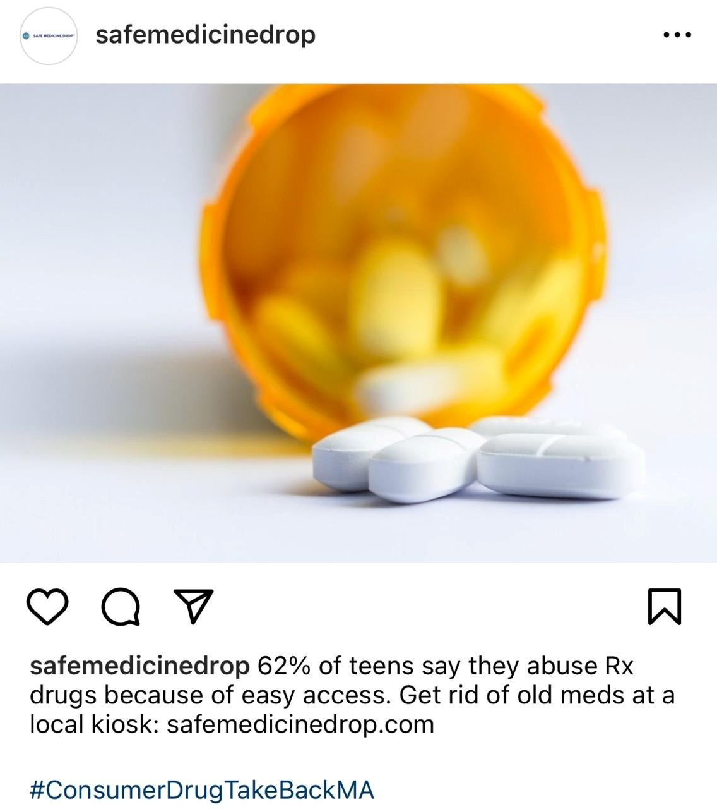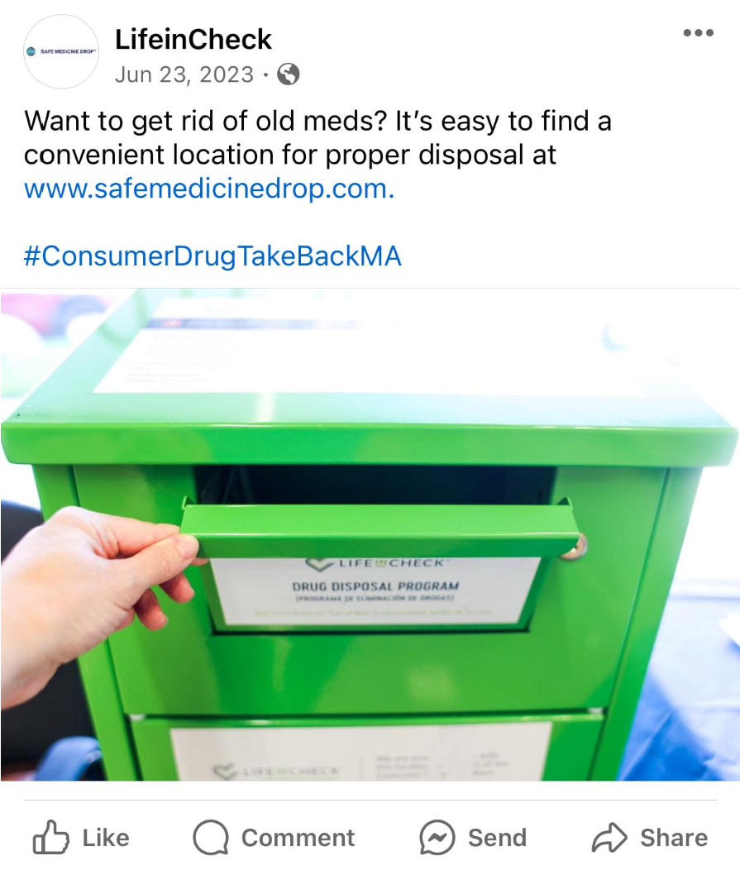
Figure 1 - Images from Social Media Channels
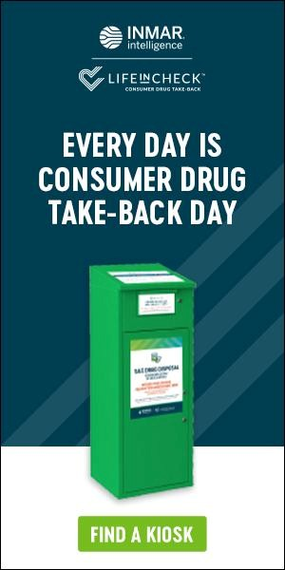
Figure 2 - Examples of Programmatic Media

