

INMAR RX SOLUTIONS, INC.


MASSACHUSETTS STATE DRUG STEWARDSHIP PROGRAM 2024 ANNUAL REPORT
(1/1/2024 through 12/31/2024)

MARCH 1, 2025

EXECUTIVE SUMMARY | 01
PARTICIPATING MANUFACTURERS | 01
UNWANTED DRUGS COLLECTED | 02
COLLECTION SITES | 02
MAIL-BACK RETURNS | 07
MAIL-BACK DISTRIBUTION SITES | 07
DROP-OFF DAY EVENTS | 08
TRANSPORTERS AND DISPOSAL FACILITIES | 08
SAFETY AND SECURITY CONCERNS | 08
PUBLIC EDUCATION AND OUTREACH | 09
APPENDIX | 10
Appendix A - Education and Outreach Materials | 10

EXECUTIVE SUMMARY
Inmar Rx Solutions, Inc. (Inmar) was approved to operate a Drug Stewardship Program (“Program”) on August 6, 2020 pursuant to the Massachusetts Drug Stewardship Program (“Ordinance”), codified as M.G.L. c. 94H and under the guidance of Circular Letter DHCQ 17-1-666. This Annual Report is for the period between January 1, 2024 and December 31, 2024.
Capitalized terms used herein are the same as those used in Inmar’s approved Plan.

The following information contained within this Annual Report mirrors the requirements outlined in Title XV, Chapter 94H of the Ordinance.

PARTICIPATING MANUFACTURERS
The following list of Participating Manufacturers were participating in Inmar’s Stewardship Plan during the reporting period.
Manufacturer
Accord Healthcare, Inc
Alora Pharmaceuticals, LLC
Camber Pharmaceuticals, Inc.
Cipla USA Inc
Dr. Reddy’s Laboratories Inc.
Epic Pharma, LLC
Glenmark Pharmaceuticals Inc., USA
Heritage Pharmaceuticals Inc. DBA Avet Pharmaceuticals Inc
Hikma Pharmaceuticals USA, Inc.
Lannett Company Inc.
Leading Pharma, LLC
Neurelis Inc.
Novadoz Pharmaceuticals, LLC
Sebela Pharmaceuticals Inc.
Somerset Pharma, LLC
Strides Pharma, Inc
Sun Pharmaceutical Industries, Inc.
Taro Pharmaceuticals U.S.A., Inc.
Towa Pharmaceutical Europe S.L.
TruPharma, LLC.
Unichem Pharmaceuticals (USA), Inc.
Upsher-Smith Laboratories, LLC

UNWANTED DRUGS COLLECTED
Throughout the reporting period, there were four collection site closure and Inmar secured 20 additional collection sites. Inmar operated 139 collection sites and 31 mail-back distribution locations across the state of Massachusetts. Inmar collected a total of 9,475.78 pounds of Unwanted Drugs by means of collection sites (kiosks) and mail-back services including mail-back distribution sites, as well as by request via the Program’s website or toll-free phone number.

Type | # of Liners \ Envelopes | Reporting Period  1/1/2024 - 12/31/2024  (pounds collected)
Collection Sites | 402 | 9,449.33
Mail-back Distribution Sites | 72 | 26.45
Total | 474 | 9,475.78

COLLECTION SITES
Pharmacy Name / DBA Name | Street | City | Zip | County | Status
Arbour - Fuller Hospital | 200 May Street | S. Attleboro | 02703 | Bristol | Active
BAMSI Pharmacy | 795 Pleasant Street | Brockton | 02301 | Plymouth | Active
Beth Israel Deaconess - Needham | 148 Chestnut Street | Needham | 02492 | Norfolk | Active
Beth Israel Deaconess Hospital Milton | 199 Reedsdale Road | Milton | 02186 | Norfolk | Active
BNHC Pharmacy | 83 Main Street | Brockton | 02301 | Plymouth | Active
Boston College Police Department | 21 Campanella Way | Chestnut Hill | 02467 | Norfolk | Active
Boston Medical Center Crosstown Pharmacy | 801 Massachusetts Avenue | Boston | 02118 | Suffolk | Active
Boston Medical Center Shapiro | 1 Boston Medical Ctr Pl #1 | Boston | 02118 | Suffolk | Active
Boston Medical Center Yawkey Outpatient  Pharmacy Menino Campus | 840 Harrison Avenue | Boston | 02118 | Suffolk | Active
Bristol County Sheriff's Office | 400 Faunce Corner Road | Dartmouth | 02747 | Bristol | Active
Charles River Community Health | 43 Foundry Avenue | Waltham | 02453 | Middlesex | Active
Charles River Community Health | 495 Western Avenue | Brighton | 02135 | Suffolk | Active
Chicopee Health Center | 505 Front Street | Chicopee | 01013 | Hampden | Active
Crawford Drug | 1735 Dorchester Avenue | Dorchester | 02124 | Suffolk | Active
Cure-Aid Pharmacy Inc | 101 Amesbury Street,  Ste 207 | Lawrence | 01840 | Essex | Active
Dedham Pharmacy & Medical Supply | 596 Providence Hwy | Dedham | 02026 | Norfolk | Active
Dimock Pharmacy | 45 Dimock Street | Roxbury | 02119 | Suffolk | Active
Dothouse Health | 1353 Dorchester Avenue | Dorchester | 02122 | Suffolk | Active
Duvals Pharmacy, Inc | 571 Washington Street,  PO Box 429 | Whitman | 02382 | Plymouth | Active

East Boston Neighborhood Health Center | 151 Orleans Street,  1st Floor Stock Room | East Boston | 02128 | Suffolk | Active
EssentialRX at Saint Vincent Hospital | 123 Summer Street | Worcester | 01608 | Worcester | Active
Fairhaven Pharmacy | 72 Main Street | Fairhaven | 02719 | Bristol | Active
Faulkner Hospital | 1153 Centre Street | Jamaica Plain | 02130 | Suffolk | Active
Hannaford 8003 | 118 Lancaster Street | Leominster | 01453 | Worcester | Active
Hannaford 8004 | 193 Boston Post Rd. West,  Rte 20 | Marlborough | 01752 | Middlesex | Active
Hannaford 8005 | 8 Merchants Way | Middleborough | 02346 | Plymouth | Active
Hannaford 8012 | 927 Merriam Avenue | Leominster | 01453 | Worcester | Active
Hannaford 8014 | 158 No. Main Street, Ste 3 | Uxbridge | 01569 | Worcester | Active
Hannaford 8017 | 55 Russell Street | Waltham | 02453 | Middlesex | Active
Hannaford 8191 | 66-2 Drum Hill Shopping  Ctr. | Chelmsford | 01824 | Middlesex | Active
Hannaford 8192 | 301 Pleasant Street | Dracut | 01826 | Middlesex | Active
Hannaford 8383 | 255 Joseph E. Warner Blvd. | Taunton | 02780 | Bristol | Active
Hannaford 8388 | 333 Mass Avenue | Lunenburg | 01462 | Worcester | Active
Holyoke Health Center Pharmacy | 230 Maple Street | Holyoke | 01040 | Hampden | Active
HRI Hospital | 227 Babcock Street | Brookline | 02446 | Norfolk | Active
Jeffrey And Susan Brudnick Center For Living | 240 Lynnfield Street | Peabody | 01960 | Essex | Closed
JGS Lifecare - Jewish Nursing Home | 770 Converse Street | Longmeadow | 01106 | Hampden | Active
Leslie's Drug Store | 65 Main Street | Vineyard  Haven | 02568 | Dukes | Active
Louis & Clark Drug #572 | 155 Brookdale Drive | springfield | 01104 | Hampden | Active
Market 32 Pharmacy 140 | 555 Hubbard Avenue | Pittsfield | 01201 | Berkshire | Active
Market 32 Pharmacy 194 | 72 Pullman Street | Worcester | 01606 | Worcester | Active
Market 32 Pharmacy 244 | 21 Galaxy Pass | Sutton | 01590 | Worcester | Active
Marlboro Pharmacy And Wellness Center, Inc. | 561 Boston Post Rd E Ste 1 | Marlborough | 01752 | Middlesex | Active
Martha's Vineyard Hospital | 1 Hospital Road | Oak Bluffs | 02557 | Dukes | Active
Mercy Hospital | 271 Carew Street | Springfield | 01104 | Hampden | Active
Metrowest Pharmacy | 214 Union Avenue | Framingham | 01702 | Middlesex | Active
Nantucket Cottage Hospital | 57 Prospect Street | Nantucket | 02554 | Nantucket | Active
Osco Pharmacy #0428 | 95 Washington Street,  Cobbs Corner | Canton | 02021 | Norfolk | Active
Osco Pharmacy #0495 | 180 A Cambridge Street | Burlington | 01803 | Middlesex | Active
Osco Pharmacy #0603 | 137 Teaticket Highway | East Falmouth | 02536 | Barnstable | Active
Osco Pharmacy #0624 | 14 West Boylston Street | Worcester | 01605 | Worcester | Active

Osco Pharmacy #0627 | 760A Boston Road | Groton | 01450 | Middlesex | Active
Osco Pharmacy #1409 | 476 Liberty Street | Hanson | 02341 | Plymouth | Active
Osco Pharmacy #1412 | 125 Toner Blvd. | North  Attleboro | 02760 | Bristol | Active
Osco Pharmacy #1414 | 230 Main Street | Medfield | 02052 | Norfolk | Active
Osco Pharmacy #1429 | 641 Belmont Street | Brockton | 02301 | Plymouth | Active
Osco Pharmacy #2470 | 50 Boston Turnpike Road | Shrewsbury | 01545 | Worcester | Active
Osco Pharmacy #2565 | 699 Mt. Auburn Street | Cambridge | 02138 | Middlesex | Active
Osco Pharmacy #2569 | 1070 Lexington Street | Waltham | 02452 | Middlesex | Active
Osco Pharmacy #2579 | 1377 Hyde Park Avenue | Hyde Park | 02136 | Suffolk | Active
Osco Pharmacy #2583 | 535 Trapelo Road | Belmont | 02478 | Middlesex | Active
Osco Pharmacy #2584 | 155 Great Road | Stow | 01775 | Middlesex | Active
Osco Pharmacy #2585 | 2260 State Road | Plymouth | 02360 | Plymouth | Active
Osco Pharmacy #2594 | 16 Webster Square | Marshfield | 02050 | Plymouth | Active
Osco Pharmacy #3577 | 75 Spring Street | West Roxbury | 02132 | Suffolk | Active
Osco Pharmacy #3581 | 255 East Central Street | Franklin | 02038 | Norfolk | Active
Osco Pharmacy #3588 | 1065 Commonwealth  Avenue | Boston | 02215 | Suffolk | Active
Osco Pharmacy #3696 | 90 Causeway Street | Boston | 02114 | Suffolk | Active
Osco Pharmacy #4572 | 370 Western Avenue | Brighton | 02135 | Suffolk | Active
Osco Pharmacy #4587 | 45 Morrissey Blvd. | Dorchester | 02124 | Suffolk | Active
Osco Pharmacy #4596 | 18 Sisson Road | Harwich Port | 02646 | Barnstable | Active
Pembroke Hospital | 199 Oak Street | Pembroke | 02359 | Plymouth | Active
Pharma Rx Worcester LLC | 708 Park Avenue | Worcester | 01603 | Worcester | Active
Price Chopper Pharmacy 155 | 300 Stockbridge Road | Gt. Barrington | 01230 | Berkshire | Active
Price Chopper Pharmacy 179 | 50 Cambridge Street | Worcester | 01610 | Worcester | Active
Price Chopper Pharmacy 229 | 731 Boston Turnpike | Shrewsbury | 01545 | Worcester | Active
Price Chopper Pharmacy 239 | 560 Main Street | Gardner | 01440 | Worcester | Active
Price Chopper Pharmacy 240 | 2 Worcester Road | Webster | 01570 | Worcester | Active
Randolph Pharmacy | 1187 N Main Street | Randolph | 02368 | Norfolk | Active
Royal Braintree Nursing & Rehabilitation  Center | 95 Commercial Street | Braintree | 02184 | Norfolk | Active
Royal Cape Cod Nursing & Rehabilitation  Center | 8 Lewis Point | Buzzards Bay | 02532 | Barnstable | Active
Royal Falmouth Nursing & Rehabilitation  Center | 359 Jones Road | Falmouth | 02540 | Barnstable | Active
Royal Health Cotuit | 161 Falmouth Road | Mashpee | 02649 | Barnstable | Active

Royal Health Megansett Nursing &  Rehabilitation Center | 209 Country Road | Falmouth | 02556 | Barnstable | Active
Royal Health Wayland Nursing & Rehab  Center | 188 Commonwealth Road | Wayland | 01778 | Middlesex | Active
Royal Meadow View | 134 North Street | North Reading | 01864 | Middlesex | Active
Royal Norwell Nursing and Rehabilitation | 329 Washington Street | Norwell | 02061 | Plymouth | Active
Royal of Fairhaven Nursing Center | 184 Main Street | Fairhaven | 02719 | Bristol | Active
Royal WoodMill Nursing and Rehabilitation  Center | 800 Essex Street | Lawrence | 01841 | Essex | Active
Signature Healthcare Pharmacy | 110 Liberty Street | Brockton | 02301 | Plymouth | Active
South Shore Hospital | 55 Fogg Road | South  Weymouth | 02190 | Norfolk | Active
Springfield Pharmacy | 2547 Main Street | Springfield | 01107 | Hampden | Active
Standard Pharmacy @ Healthfirst | 387 Quarry Street | Fall River | 02723 | Bristol | Active
Stop & Shop Pharmacy #12 | 65 Route 6a | Sandwich | 02563 | Barnstable | Active
Stop & Shop Pharmacy #22 | 55 Long Pond Drive | South  Yarmouth | 02664 | Barnstable | Active
Stop & Shop Pharmacy #2403 | 56 Shank Painter Road | Provincetown | 02657 | Barnstable | Active
Stop & Shop Pharmacy #425 | 20 Teaticket Highway | Falmouth | 02536 | Barnstable | Active
Stop & Shop Pharmacy #475 | 111 Chatham Road | Harwich | 02645 | Barnstable | Active
Stop & Shop Pharmacy 11 | 40 Furlong Drive | Revere | 02151 | Suffolk | Active
Stop & Shop Pharmacy 17 | 495 Southern Artery | Quincy | 02169 | Norfolk | Active
Stop & Shop Pharmacy 21 | 1 Dan Fox Drive Rte 7 | Pittsfield | 01201 | Berkshire | Active
Stop & Shop Pharmacy 2418 | 126 Medway Road | Milford | 01757 | Worcester | Active
Stop & Shop Pharmacy 3 | 235 Old Connecticut Path | Farmingham | 01701 | Middlesex | Active
Stop & Shop Pharmacy 30 | 2265 Northampton Street | Holyoke | 01040 | Hampden | Active
Stop & Shop Pharmacy 406 | 425 Attucks Lane | Hyannis | 02601 | Barnstable | Active
Stop & Shop Pharmacy 421 | 815 Grand Army Hwy | Somerset | 02726 | Bristol | Active
Stop & Shop Pharmacy 429 | 1100 Massachusetts  Avenue | Dorchester | 02125 | Suffolk | Active
Stop & Shop Pharmacy 432 | 469 Pleasant Street | Attleboro | 02703 | Bristol | Active
Stop & Shop Pharmacy 458 | 660 Merrill Road | Pittsfield | 01201 | Berkshire | Active
Stop & Shop Pharmacy 469 | 127 Samoset Street | Plymouth | 02360 | Plymouth | Active
Stop & Shop Pharmacy 473 | 333 Mariano Bishop Blvd | Fall River | 02721 | Bristol | Active
Stop & Shop Pharmacy 498 | 779 Mcgrath Highway | Somerville | 02145 | Middlesex | Active
Stop & Shop Pharmacy 499 | 100 Macy Street | Amesbury | 01913 | Essex | Active
Stop & Shop Pharmacy 55 | 932 North Montello Street | Brockton | 02301 | Plymouth | Closed
Stop & Shop Pharmacy 64 | 2110 Cranberry Cove Plaza | Orleans | 02653 | Barnstable | Active
Stop & Shop Pharmacy 67 | 35 Washington Street | Lynn | 01904 | Essex | Active
Stop & Shop Pharmacy 7 | 377 Chauncy Street | Mansfield | 02048 | Bristol | Active
Stop & Shop Pharmacy 70 | 1001 Kings Hwy | New Bedford | 02745 | Bristol | Active
Stop & Shop Pharmacy 71 | 501 Rodman Street | Fall River | 02721 | Bristol | Active
Stop & Shop Pharmacy 72 | 57 Main Street | Westfield | 01085 | Hampden | Active
Stop & Shop Pharmacy 787 | 228 King Street | Northampton | 01060 | Hampshire | Active
Stop & Shop Pharmacy 80 | 1277 Liberty Street | Springfield | 01104 | Hampden | Active
Stop & Shop Pharmacy 82 | 341 Plymouth Street | Halifax | 02338 | Plymouth | Closed
Stop & Shop Pharmacy 87 | 39 Nathan Ellis Highway | Mashpee | 02649 | Barnstable | Active
Stop & Shop Pharmacy 91 | 539571 Boston Turnpike | Shrewsbury | 01545 | Worcester | Closed
Stop & Shop Pharmacy 94 | 935 Riverdale Street | W Springfield | 01089 | Hampden | Active
Stop & Shop Pharmacy 98 | 438 Dartmouth Street | New Bedford | 02742 | Bristol | Active
Sullivan Pharmacy | 1 Corinth Street | Roselindale | 02131 | Suffolk | Active
The Arbour Hospital | 49 Robinwood Avenue | Jamaica Plain | 02130 | Suffolk | Active
Town of Abington Police Department | 215 Central Street | Abington | 0 2351 | Plymouth | Active
Trang Pharmacy Inc | 456 Park Avenue | Worcester | 01610 | Worcester | Active
UMass Health Alliance - Clinton Hospital | 201 Highland Street | Clinton | 01510 | Worcester | Active
Umass Health Alliance - Fitchburg Hospital | 275 Nichols Road | Fitchburg | 01420 | Worcester | Active
UMass Health Alliance - Leominster Hospital | 60 Hospital Road | Leominster | 01453 | Worcester | Active
UMass Memorial Medical Center Specialty  Pharmacy | 55 Lake Ave N Suite  Ac1.033 | Worcester | 01655 | Worcester | Active
University Health Services Pharmacy | 150 Infirmary Way | Amherst | 01003 | Hampshire | Active
USCG Base Cape Cod - Kaehler Memorial  Clinic | 5201 Lee Road | Buzzards Bay | 02542 | Barnstable | Active
Vineyard Scripts | 117 Beach Road | Vineyard  Haven | 02568 | Dukes | Active
Walsh Pharmacy | 202 Rock Street | Fall River | 02720 | Bristol | Active
Wells Healthcare Pharmacy | 435 Shrewsbury Street, Ste  #4 | Worcester | 01604 | Worchester | Active
Westborough Behavioral Health | 300 Friberg Parkway | Westborough | 01581 | Worcester | Active
Whole Health Pharmacy | 596 W Main Street | Hyannis | 02601 | Barnstable | Active
WP Acquisition Sub, Llc | 76 Summer Street | Haverhill | 01830 | Essex | Active

MAIL-BACK RETURNS
Inmar provided 313 envelopes throughout the state of Massachusetts during the reporting period. There were 72 envelopes returned with a total weight of 26.45 pounds. The average weight of the returned mailers was approximately 6.4 ounces (0.40 pounds).

MAIL-BACK DISTRIBUTION SITES
Pharmacy Name / Dba Name | Street | City | Zip | Status
Apothecare Of Cape Cod | 145 Barnstable Road | Barnstable | 02601 | Active
Brigham And Women's Health Care Center | 20 Patriot Place | Foxborough | 02035 | Closed
Brigham And Women's Health Outpatient  Pharmacy | 20 Patriot Place | Foxborough | 02035 | Active
Brigham And Women's Hospital | 45 Francis Street | Boston | 02115 | Active
Brigham And Women's Hospital Outpatient  Pharmacy | 850 Boylston Street  Attn: Pharmacy Dept. 75F | Chestnut Hill | 02467 | Active
Brigham And Women's Hospital Outpatient  Pharmacy | 75 Francis Street  Attn: Outpatient Pharmacy | Boston | 02115 | Active
Brigham And Women's Hospital Outpatient  Pharmacy | 45 Francis Street | Boston | 02115 | Closed
Brigham And Women's Hospital, Health Care  Center Chestnut Hill | 850 Boylston Street, Suite 302A | Chestnut Hill | 02467 | Active
Brigham And Women's/Mass General Health | 20 Patriot Place  Attn: Pharmacy Dept. | Foxborough | 02035 | Closed
Bringham and Women's Hospital | 850 Boylston Street  Attn: Pharmacy Dept. | Chestnut Hill | 02467 | Active
Brockton Health Center | 63 Main Street | Brockton | 02301 | Active
Cape Cod Healthcare Pharmacy At CCH | 27 Park Street | Hyannis | 02601 | Active
Cape Cod Healthcare Pharmacy At Falmouth | 100 Ter Heun Drive | Falmouth | 02540 | Closed
Charles River Community Health | 495 Western Avenue | Brighton | 02135 | Active
Charles River Community Health | 43 Foundry Avenue | Waltham | 02453 | Active
Costco Pharmacy #301 | 11 Newbury Street | Danvers | 01923 | Active
Costco Pharmacy #302 | 119 Daggett Drive | W.Springfield | 01089 | Active
Costco Pharmacy #303 | 120 Stockwell Drive | Avon | 02322 | Active
Costco Pharmacy #308 | 71 Second Avenue | Waltham | 02451 | Active
Costco Pharmacy #319 | 200 Legacy Boulevard | Dedham | 02026 | Active
Costco Pharmacy #333 | 2 Mystic View Road | Everett | 02149 | Active
Curahealth | 909 Sumner Street | Stoughton | 02072 | Active
Dana Farber Cancer Institute | 300 Boylston Street, Suite 310 | Chestnut Hill | 02050 | Active
Dana Farber Merrimack Valley | 5 Branch Street | Methuen | 01840 | Closed
East Boston Neighborhood Health Center | 10 Gove Street | East Boston | 02128 | Active
EMO Health | 86 Newfield Street | West Roxbury | 02132 | Active
First Choice Healthcare, Inc. | 1842 Beacon Street, Suite 203 | Brookline | 02445 | Active
HRI Hospital Inc. | 227 Babcock Street | Brookline | 02446 | Active
Mount Auburn Hospital | 330 Mount Auburn Street | Cambridge | 02138 | Active
Pembroke Hospital | 199 Oak Street | Pembroke | 02359 | Active
Revere Health Center Clinic Pharmacy | 300 Ocean Avenue | Revere | 02151 | Active
Richmond Pharmacy | 499 Eastern Avenue | Lynn | 01902 | Active
Specialty Pharmacy at Boston Children's  Hospital | 283 Longwood Avenue | Boston | 02115 | Active
Vibra Hospital Of Southeastern Mass | 4499 Acushnet Avenue | New Bedford | 02745 | Active
Walden Behavioral Care | 10 Carematrix Drive | Chestnut Hill | 02467 | Active
Whittier Rehabilitation | 150 Flanders Road | Westborough | 01581 | Active

DROP-OFF DAY EVENTS
Inmar did not host any drop-off day events for 2024.

TRANSPORTERS AND DISPOSAL FACILITIES
Company Name | Contact Information | Registration Information | Service Provided
123 Compliant Logistics, LLC  2626 N 29th Ave  Phoenix, AZ 85009 | Operations Manager  602-612-4140 | DEA Reverse  Distributor-Collector:  R90571264 | Reverse Distributor – All  Unwanted Covered Drugs
City of Spokane WTW & Recycling  Disposal Site  2900 S. Geiger Blvd  Spokane, WA, 99224 | Operations Manager  509-625-6514 | EPA ID: WAR000000463 | Non-Hazardous Waste to Energy  Facility
USPS | Account Manager  919-501-9394 |  | Common Carrier – All Mailers
FedEx | Account Manager  800-469-9993 |  | Common Carrier – Kiosk  Containers

SAFETY OR SECURITY CONCERNS
Policies and procedures for collecting, transporting and disposing of Unwanted Drugs, as established in the Plan, were followed in the reporting period. There are no safety or security concerns for the reporting period.

PUBLIC EDUCATION AND OUTREACH

I. Website and Toll-Free Number
Inmar continued to operate a branded, mobile-optimized website and toll-free phone number. The URL for the Inmar website is www.SafeMedicineDrop.com. The purpose of the website is to provide Residents with information pertaining to Inmar’s disposal options and outreach material. Residents can visit the website to view a map and listing of drug disposal locations including Drop-off Sites and Mail-Back Distribution Locations in Massachusetts. Residents can also request through the website that a mailer envelope be sent directly to their residence with instructions on how to return Unwanted Drugs. Examples of the Program’s Website are included in Appendix A, Figure 3 - 4.

II. Signage and Educational Materials
Inmar continued to utilize consumer-facing signage on kiosks at collection sites that outlines what can be accepted and not accepted in the kiosk. The signage uses explanatory graphics and is displayed in English and includes the Program’s website.

Inmar provided educational printed materials that are available to residents at participating collection sites and through the Inmar website. Educational materials outline how to locate disposal sites in the state of Massachusetts and how to properly dispose of Unwanted Drugs. Samples of the educational material are included in Appendix A, Figure - 1 - 2.

III. Digital Media
Additional outreach activities were conducted during the reporting period. Programmatic media provides targeted display ads on browser sites on internet capable devices (smart phones, computers, tablets, etc.). Inmar ran ads across a prequalified list of over 200,000 domains including a variety of retail websites, Google, and Facebook. The programmatic targeted ads ran for six weeks leading up to the DEA’s National Prescription Take Back Days in April and October 2024.

Influencer marketing is a content creation tactic used to drive awareness and education to a targeted audience through blogs and social media outlets. Influencers create authentic content around their everyday lives and interests while weaving the story of prescription drug take-back into their content. Influencer content is converted into paid ad units across social platforms and then targeted to community members across the state of Massachusetts.

Paid advertisements for influencer content were run on a variety of platforms including Google, Instagram and Facebook. Inmar ran social media influencer campaigns concurrently with other digital media campaigns. Inmar posted two social media posts per month per platform (Instagram, Twitter, and Facebook). Collectively, Inmar solidified over 5,898,817 impressions with the various marketing initiatives throughout the reporting period. See Appendix A, Figure 5 - 7 for sample images of the digital media campaigns.

Appendix A - Outreach and Promotion Material

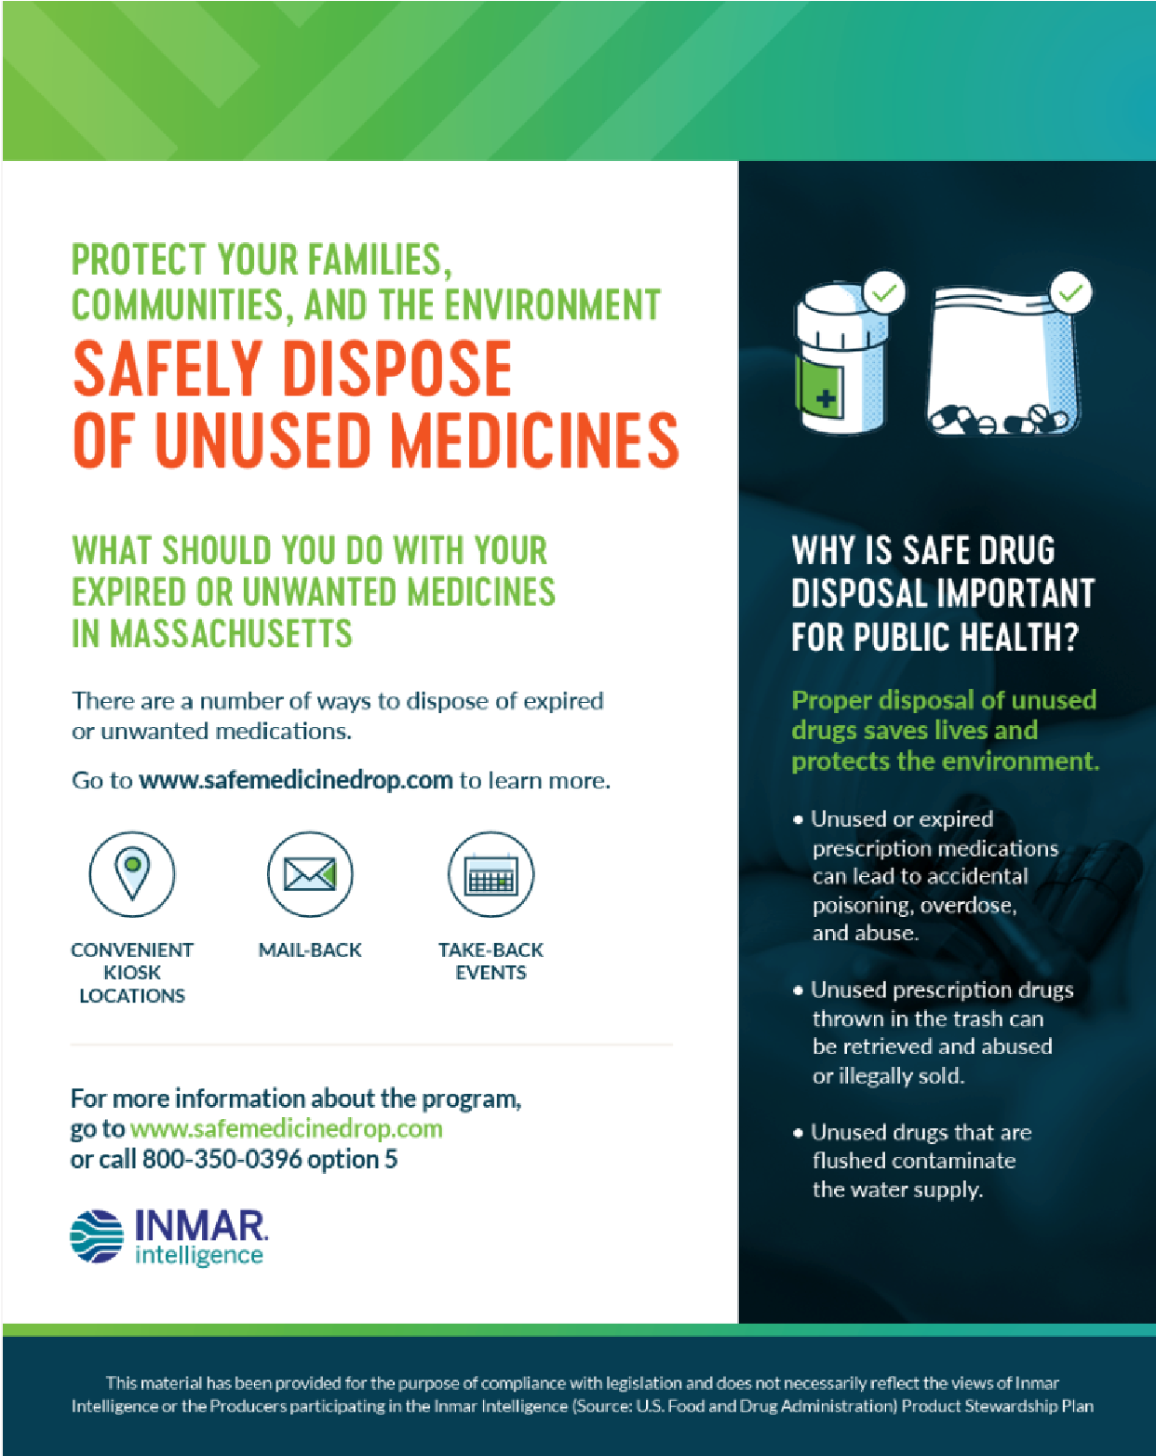

Figure 1 - Sample Educational Material: English

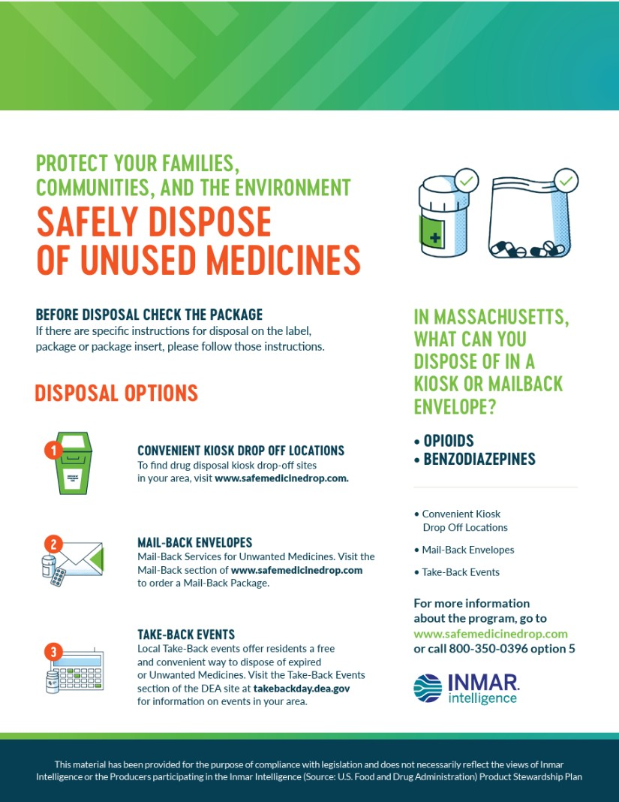

Figure 2 - Sample Educational Brochure: English (cont.)

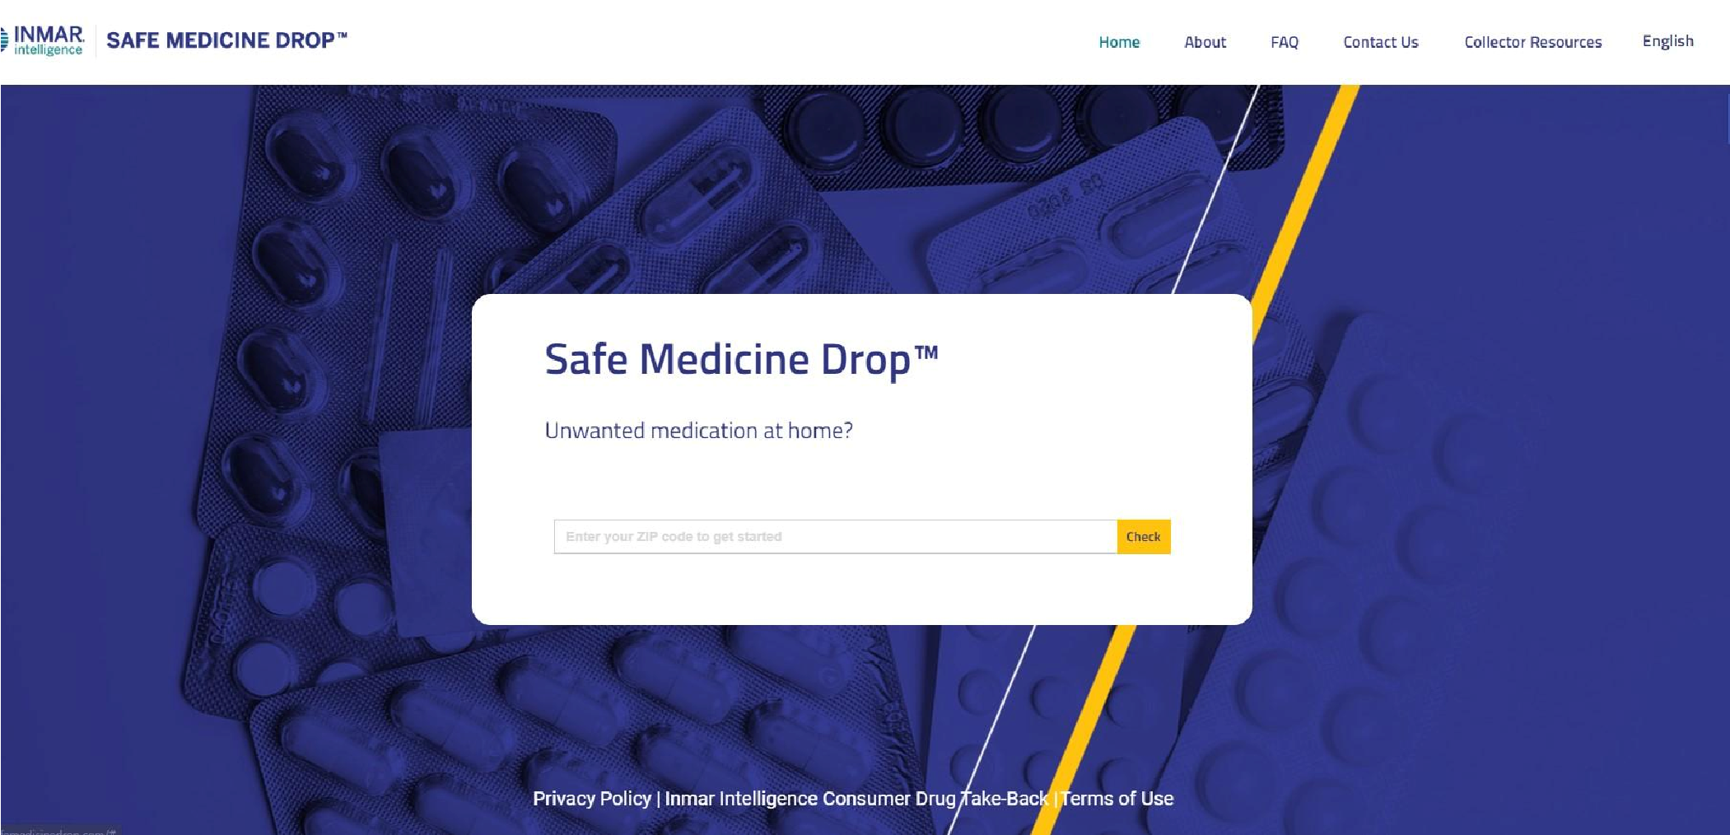

Figure 3 - Sample of SafeMedicineDrop.com Landing Page

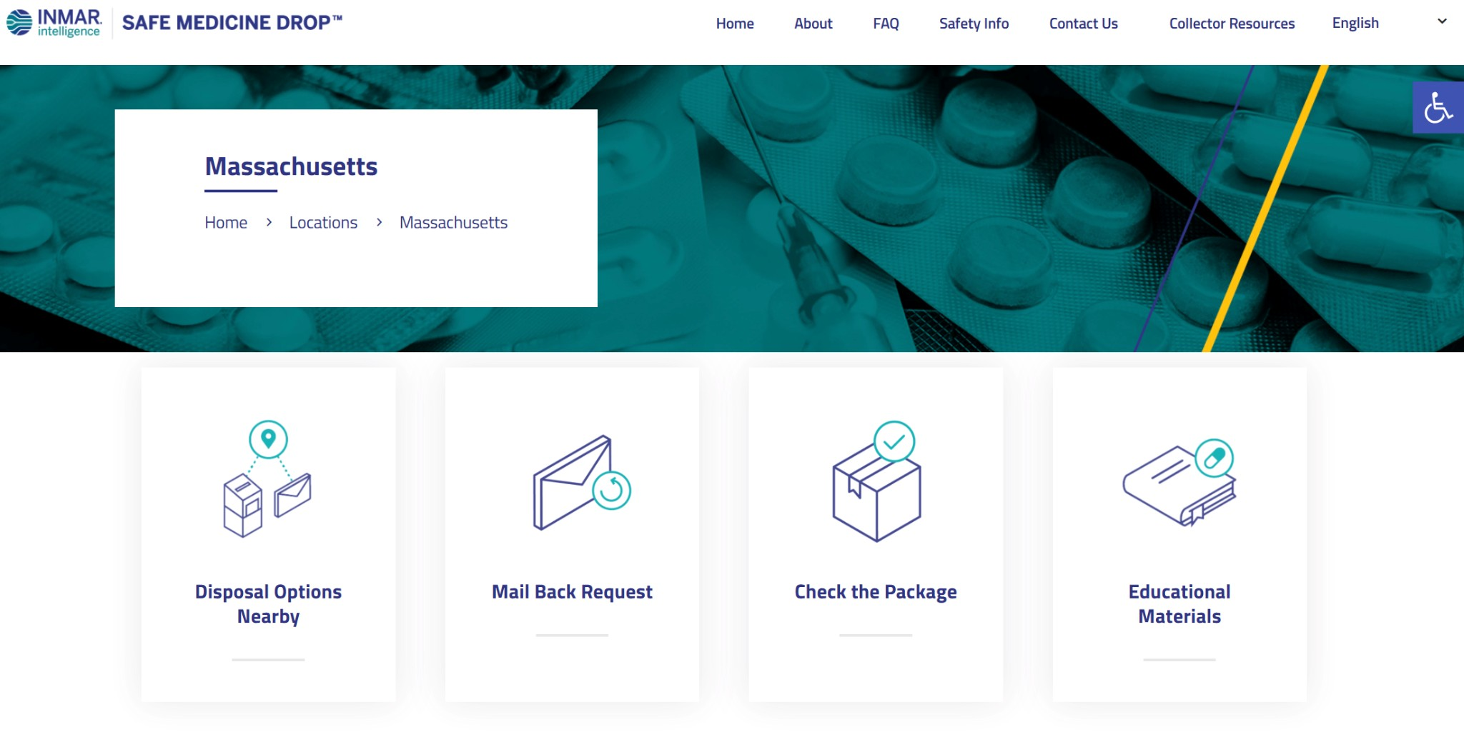
Figure 4 - Sample of SafeMedicineDrop.com State of Massachusetts Landing Page
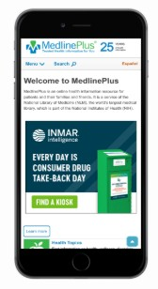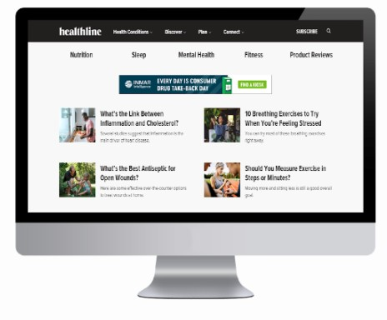

Figure 5 - Sample Programmatic Campaign Ad

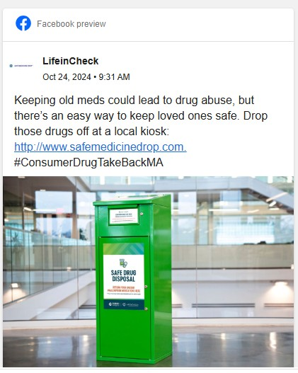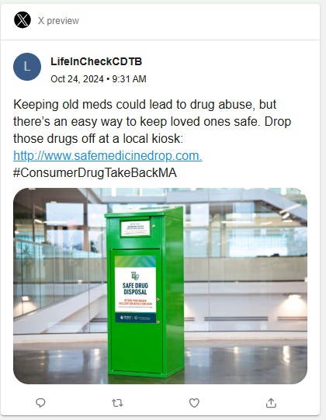

Figure 6 - Sample Social Media Post
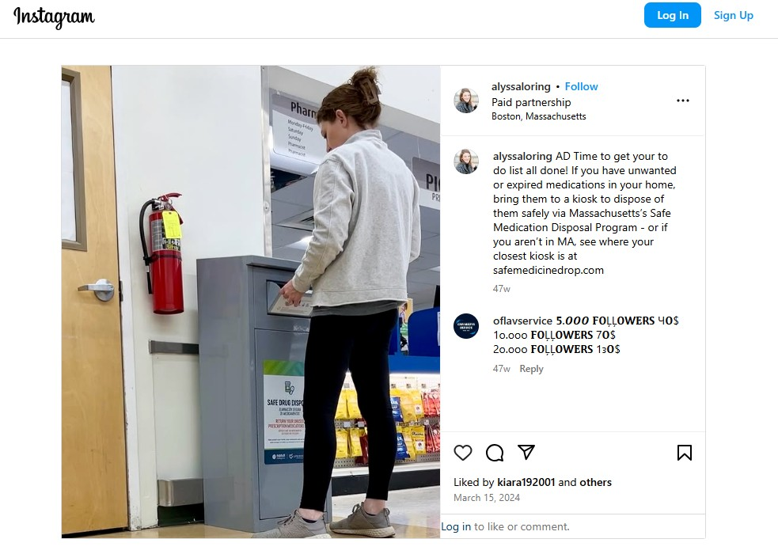

Figure 7 - Sample Influencer Post

