WATER DAMAGE/MOLD INVESTIGATION

Massachusetts Life Science Center
1000 Winter Street
Waltham, Massachusetts

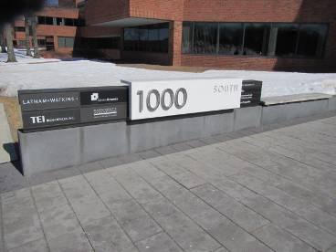

Prepared by:
Massachusetts Department of Public Health
Bureau of Environmental Health
Indoor Air Quality Program
July 2014

Background/Introduction
At the request of Katie Joyce, Vice President for Policy and Domestic & International Government Relations, Massachusetts Life Science Center (MLSC), the Massachusetts Department of Public Health (MDPH), Bureau of Environmental Health (BEH) conducted an assessment at the MLSC Office, 1000 Winter Street, Waltham, Massachusetts. On March 6, 2014, a visit was made by Michael Feeney, Director of BEH’s Indoor Air Quality (IAQ) Program, and Sharon Lee, an Environmental Analyst/Inspector within BEH’s IAQ Program.
The assessment was prompted by concerns related to water damage and mold growth in two offices that had experienced water damage. Upon discovering the water damage, building management contacted Covino Environmental Associates Inc. to conduct a mold assessment and remediation work. At the time of the BEH/IAQ assessment, gypsum wallboard (GW) and vinyl-based coving removed from beneath the windowsill in one office (JR office) created an opening in the wall; this opening was covered with plastic.

Methods
BEH/IAQ staff performed a visual inspection of building materials for water damage and/or microbial growth. Moisture content of porous building materials (i.e. GW, carpeting) was measured using a Delmhorst, BD-2000 Model Moisture Detector. Room temperature and relative humidity levels were taken with a TSI, Q-Trak, IAQ Monitor, Model 7565. Results are included as Table 1.

Results and Discussion
In order for building materials to support mold growth, a source of water exposure is necessary. Identification of the location of materials with increased moisture levels can indicate an existing or potential location of mold colonization. To determine if GW and carpeting had elevated moisture content that would be conducive to or indicative of mold growth, BEH/IAQ staff conducted moisture testing of these materials.
As mentioned, affected materials in JR office had largely been removed prior to the BEH/IAQ assessment (Picture 1). Water-damaged materials had been removed along a south-facing exterior wall. All remaining materials were dry at the time of assessment; however, when BEH/IAQ removed vinyl base coving, dark staining consistent with mold growth was observed on intact GW (Pictures 2 and 3). Other signs of water damage, as evidenced by the presence of rust on metal wall studs, were observed in the impacted office (Picture 1). Rust is caused by prolonged moisture exposure. While rust is a characteristic sign of water penetration, it is not mold growth.
BEH/IAQ staff found water-damaged GW in another office (SWB office) located adjacent to JR office. When vinyl coving was removed in the SWB office, BEH/IAQ staff observed evidence of mold growth on GW. BEH/IAQ staff also conducted moisture testing and found damp GW on the same south-facing wall that had been impacted in the JR office (Table 1; Pictures 4 and 5). At the time of assessment, BEH/IAQ recommended that the affected materials be removed.
The US Environmental Protection Agency (US EPA) and the American Conference of Governmental Industrial Hygienists (ACGIH) recommends that porous materials be dried with fans and heating within 24 to 48 hours of becoming wet (US EPA, 2001; ACGIH, 1989). If porous materials are not dried within this time frame, mold growth may occur.
The source of the moisture is likely water that is penetrating through the exterior foundation wall. In order to explain how water penetration occurs through exterior wall systems, the following concepts concerning moisture and wall systems must be understood:
- Brick, cement, and mortar have pore spaces, which allow moisture movement through these materials;
- Wind driven precipitation increases water penetration through brick, cement, and mortar;
- Gravity will direct water in a building towards the ground; and
- Brick, cement, and mortar must dry in a timely manner to prevent prolonged moistening of porous building materials (e.g. GW) and opportunistic microbial growth.
It is also important to understand the components within a wall system that allow water to drain out and away from a building.
A drainage plane is one component of an exterior wall system that is typically designed to prevent moisture penetration into the building interior. The drainage plane within the wall system is typically installed in a manner that redirects water out, allowing building components to remain dry. An exterior wall system should also have the following components to drain water (Figure 1):
- An exterior curtain wall forming the outer cladding of the building;
- An air space behind the curtain wall to allow water to drain downward and prevent the exterior cladding system from becoming wet;
- A drainage plane located opposite the exterior wall, across the air space. The drainage plane should consist of a continuous, water-resistant material adhered to a wall (the backup wall). The purpose of the drainage plane is to prevent moisture that crosses the air space from penetrating into interior building system. Moisture that penetrates the exterior wall is directed downward to the weep holes by the water-resistant material of the drainage plane. Water-resistant materials may include tarpaper or plastic wraps.
- Flashing to direct water to weep holes is typically installed around breaks/penetrations in the drainage plane (e.g., window systems, door systems, and fresh air intakes). If the drainage plane is discontinuous, missing flashing, or lacking an air space, rainwater can accumulate inside the wall cavity and penetrate the building.
- Weep holes at the base of the curtain wall that allow for water drainage. Weep holes are customarily installed at or near the foundation slab/exterior wall system junction (Figure 1). Weep holes allow for accumulated water to drain from a wall system (Dalzell, 1955). Lack of weep holes in brickwork, burial of weep holes below grade, or sealing of weep holes with cement will allow water to accumulate in the base of walls, resulting in seepage and possible moistening of building components (Figure 2).

BEH/IAQ staff examined the exterior wall system to identify the location and condition of weep holes. Weep holes on the south-facing wall were observed approximately at the brick wall/foundation junction (Picture 6); these weep holes were blocked with cement or accumulated sediment from bricks/mortar (Picture 7). In some areas, the building foundation was not visible. Weep holes in the wall beneath the overhang appear to be buried beneath layers of mulch. Without appropriate drainage, moisture can build up inside the wall’s drainage plane, resulting in increased water/moisture problems.
As mentioned, the two adjacent offices with moistened GW are located on a south-facing wall. Unlike other offices/spaces along the exterior of the building, these offices do not have an overhang that protects the exterior wall from driving precipitation (Picture 8). Direct impingement of water on the foundation can result in water penetration. Movement of water to the building interior is further aided by other conditions:
- Poor drainage from the exterior wall drainage plane, resulting in water directed towards the building
- Damaged/eroded waterproof coating on the exterior foundation (Picture 6), which may allow for water entry into the building via capillary action through foundation concrete and masonry (Lstiburek and Brennan, 2001).
- An opening in the exterior wall, which would allow water to accumulate against the foundation (Picture 9).
- Poor insulation of building materials. The purpose of insulating the interior wall cavity is to provide resistance to temperature changes of the outdoors (e.g., air, ground/soil). When insulation is inadequate, condensation can accumulate in the wall cavity as a result of the foundation wall being buried beneath the ground/soil. In this configuration, the cement temperature becomes that of the ground/soil.
BEH staff conducted surface temperature sampling of the foundation walls open in the impacted offices. If the exterior walls of the building were properly insulated, the temperature of the interior side of exterior walls and floors would be closer to the indoor temperature (Table 1), roughly in a range of 75° F to 76° F. The temperature of the foundation wall was measured in a range of 54° F to 56° F, approximately 20° F below room temperature. The temperature measurement of the cement wall supports BEH/IAQ staff observation that the foundation wall in the impacted offices has inadequate insulation to prevent heat loss.
The difference in temperature indicates that the foundation wall can serve as a thermal bridge. Where a thermal bridge exists, condensation is likely to form on the warm-air side of a cold object. Condensation within the wall cavity can result in moistening of materials such as GW. Given that the exterior slab and brick were buried in places below soil, both of these building components would have a temperature similar to the ground that it is in contact with. In hot, humid weather, the lowering of temperature of the slab/exterior brickwork would likely lead to condensation along the interior side at the base of the exterior wall. In addition, inadequately insulated objects that transverse the exterior wall system may also serve as a thermal bridge. BEH staff observed an exposed pipe outside the impacted offices that appears to pass into the building the impacted office (Picture 7). The section of pipework attached to the outdoor pipe should have been adequately insulated to prevent condensation accumulation. BEH staff could not determine if this pipe run was insulated since it is located inside intact interior walls.
Indoor temperature measurements ranged from 73° F to 76° F (Table 1), which were within or very close to the MDPH recommended comfort range the day of assessment. The MDPH recommends that indoor air temperatures be maintained in a range of 70° F to 78° F in order to provide for the comfort of building occupants. In many cases concerning indoor air quality, fluctuations of temperature in occupied spaces are typically experienced, even in a building with an adequate fresh air supply. The two impacted offices, especially in the JR office, are reported to have issues with temperature control in warm weather. Unlike the rest of the office spaces, these two offices have windows that receive direct sunlight, which may make each of these offices warmer due to solar gain.
The relative humidity measured in the building ranged from 13 to 17 percent, which was below the MDPH recommended comfort range in all areas surveyed during the assessment (Table 1). The MDPH recommends a comfort range of 40 to 60 percent for indoor relative humidity. Relative humidity levels in the building would be expected to drop during the winter months due to heating. The sensation of dryness and irritation is common in a low relative humidity environment. Low relative humidity is a very common problem during the heating season in the northeast part of the United States.

Conclusions/Recommendations
The remediation effort to remove water-damaged materials in one office was largely successful; however, BEH/IAQ staff identified damp GW in an adjacent office. At the time of assessment, BEH/IAQ staff observed conditions that can contribute to moisture penetrating into the building. Based on the findings at the time of assessment, the following is recommended:
- Remove remaining water-damaged materials (e.g. GW) in a manner consistent with recommendations found in “Mold Remediation in Schools and Commercial Buildings” published by the US Environmental Protection Agency (US EPA, 2001).
- Cover employee workstations in areas of remediation to protect items and facilitate cleanup.
- Place water-damaged/mold-colonized materials in plastic bags for transport.
- Insulate wall cavity with a material that can withstand New England temperature extremes, and created particularly on this wall by constant exposure to heat and moisture.
- Consider using a water/mold-resistant material such as green board instead of GW in areas of chronic water leaks.
- Ensure AHUs are deactivated during removal/remediation of GW.
- Ensure areas are thoroughly cleaned and vacuumed using a high efficiency particulate arrestance (HEPA) filter equipped vacuum cleaner after remediation is complete.
- If possible, relocate susceptible persons and those with pre-existing medical conditions (e.g., hypersensitivity, asthma) away from the general areas of remediation until activities are complete.
- Ensure all exterior wall weep holes are open and above the soil line.
- Seal hole in exterior wall shown in Picture 3.
- Ensure interior section of pipe in Picture 7 is properly insulated.
- Consult with building engineer/drainage specialist to improve drainage adjacent to impacted offices to prevent further water infiltration.
- Examine waterproofing material on the building exterior and maintain its integrity.
- Consider installing window pane film and/or use shades/blinds to reduce solar gain.

References
ACGIH. 1989. Guidelines for the Assessment of Bioaerosols in the Indoor Environment. American Conference of Governmental Industrial Hygienists, Cincinnati, OH.
Dalzell, J.R. 1955. Simplified Masonry Planning and Building. McGraw-Hill Book Company, Inc. New York, NY.
Lstiburek, J. & Brennan, T. 2001. Read This Before You Design, Build or Renovate. Building Science Corporation, Westford, MA. U.S. Department of Housing and Urban Development, Region I, Boston, MA
US EPA. 2001. Mold Remediation in Schools and Commercial Buildings. US Environmental Protection Agency, Office of Air and Radiation, Indoor Environments Division, Washington, D.C. EPA 402-K-01-001. http://www.epa.gov/mold/mold_remediation.html.

Figure 1

Drainage Plane Function: Weep Holes Drain Water from the Wall System to

Prevent Moisture Penetration into the Interior

Drainage Plane

Driving Rain

Water
Movement

Exterior Curtain Wall

Figure 2

Blocked Weep Hole: Water Accumulates in the Drainage Plane

Drainage Plane

Exterior Curtain Wall

Accumulate Water

Moisture Weep Hole Blocked with Wick

Picture

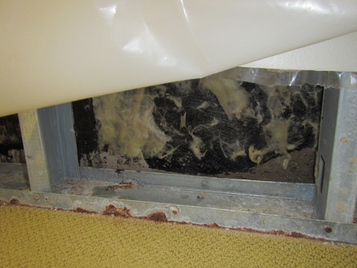

GW removed from JR office, note rust on metal frame and studs

Picture

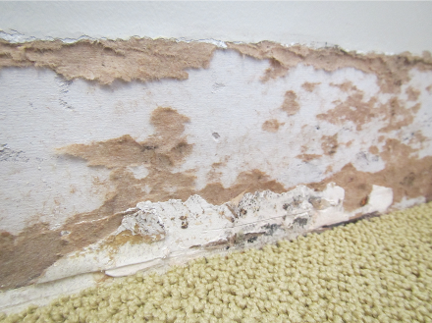

GW behind coving in JR office, note black staining, indicative of mold growth

Picture

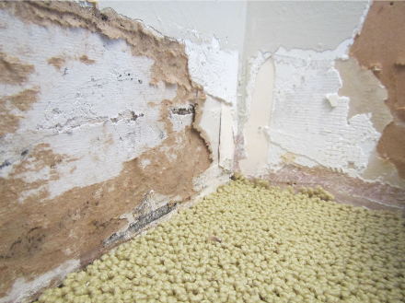

GW behind coving in JR office, note black staining indicative of mold growth

Picture

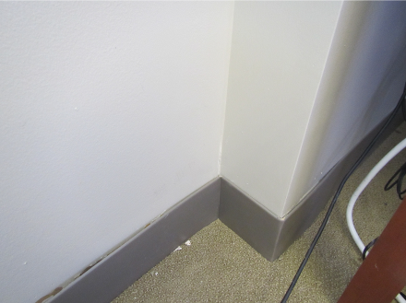

Water-damaged corner wall in SWB office

Picture

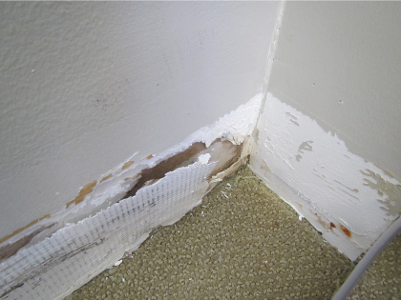

Water-damaged/mold growth on GW in SWB office, note rusted stud

Picture

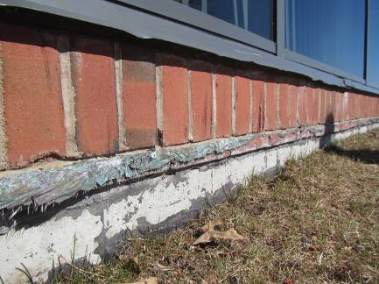

Weep holes approximately at the brick wall/foundation junction; also note damage to waterproof coating at foundation

Picture

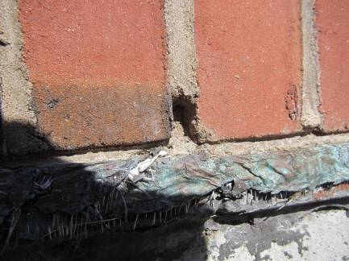

Weep holes blocked with cement or accumulated sediment from bricks/mortar

Picture

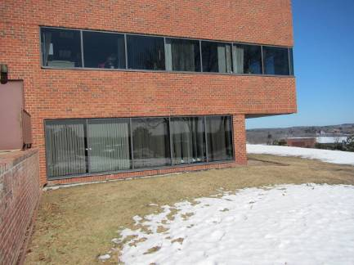

Offices experiencing water damage are located on a south-facing wall not protected by an overhang

Picture

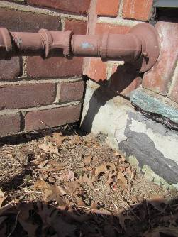

Opening in brick of exterior wall

Location/ Room | Temp  (°F) | Relative  Humidity  (%) | Dew Point  (°F) | Remarks
Background |  |  |  | Sunny, cool
JR office | 76 | 17 | 28 | Gypsum wallboard removed, opening covered with plastic; evidence of mold growth behind coving; foundation wall temperature: of 54º F to 56º F
SWB office | 75 | 13 | 23 | Gypsum wallboard wet in corner along south facing wall, previous mold growth reported
BR office | 75 | 13 | 23
Cubicle area | 73-74 | 14 | 21

