Background/Introduction

INDOOR AIR QUALITY ASSESSMENT

Massachusetts Lottery
Computer Operations Area
60 Columbian Street
Braintree, Massachusetts

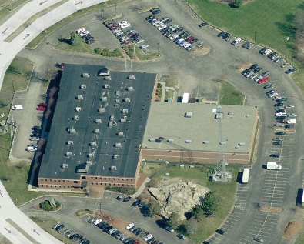

Prepared by:
Massachusetts Department of Public Health
Bureau of Environmental Health
Indoor Air Quality Program
December 2014

In response to an employee complaint, the Massachusetts Department of Public Health (MDPH), Bureau of Environmental Health (BEH) provided assistance and consultation regarding indoor air quality (IAQ) at the Massachusetts State Lottery Building (MLB) located at 60 Columbian Street, Braintree, Massachusetts. The request was prompted by reports of elevated particulates, lack of air exchange, humidity control, lack of dust control and respiratory symptoms (e.g., coughing) in the Computer Operations Area (COA). On October 28, 2014, the MLB/COA was visited by Cory Holmes, Environmental Analyst/Regional Inspector in BEH’s IAQ Program to conduct an IAQ assessment. The assessment was coordinated through Ms. Martha Goldsmith, Director of Leasing, Division of Capital Asset Management and Maintenance and Mr. Jim Mello, Facilities Manager, Massachusetts State Lottery. Since complaints/concerns were specifically reported in the COA, the assessment was limited to that area and the adjacent Ticket Return Unit area.
The MLB is a two-story, brick-faced building that was constructed in the mid-1980s. The building reportedly underwent interior renovations in 2004 including updated lighting, carpeting and duct cleaning. The building has a flat roof with a black rubber membrane surface. The building houses lottery offices, general work areas, shipping/receiving and storage. The COA is located on the first floor, and is the main network and computer operations center for the building. The COA is a centrally located interior area with no windows, a dropped ceiling tile system and a non-carpeted raised-paneled floor. It was reported that a preventative maintenance program is in-place for heating, ventilation and air-conditioning (HVAC) systems building-wide. It was also reported that dust control/cleaning of flat surfaces in the COA is conducted monthly by an outside contractor with additional cleaning below floor panels once per quarter.

Methods
Air tests for carbon monoxide, carbon dioxide, temperature, and relative humidity were conducted with the TSI, Q-Trak, IAQ Monitor, Model 7565. Air tests for airborne particle matter with a diameter less than 2.5 micrometers were taken with the TSI, DUSTTRAK™ Aerosol Monitor Model 8520. Screening for total volatile organic compounds (TVOCs) was conducted using a RAE Systems, MiniRAE Lite Model, Photoionization Detector. BEH/IAQ staff also performed a visual inspection of building materials for water damage and/or microbial growth.

Results
The COA operates 24 hours a day and has an employee population of 25. The tests were taken during normal operations and appear in Table 1.

Discussion

Ventilation
It can be seen from Table 1 that carbon dioxide levels were below 800 parts per million (ppm) in all areas tested, indicating optimal air exchange in areas surveyed at the time of the assessment. Mechanical ventilation is provided by an air-handling unit (AHU) located on the roof (Picture 1). Fresh air is drawn into the AHU through a manually adjusted intake (Pictures 2 and 3), through a bank of high efficiency pleated air filters (Pictures 2 and 4), and ducted to floor vents that distribute air to occupied areas (Picture 5). In addition, a supplemental system was installed to increase air exchange. This system draws air from a vent on the rooftop (Picture 6) pulled by a fan encased in the ductwork (Picture 7) and exhausted by a rooftop powered vent (Picture 8). As previously mentioned, the system is maintained by a professional HVAC contractor that changes filters quarterly, and that they had all been changed in the week prior to the assessment, including the supplementary unit.
To maximize air exchange, the MDPH recommends that both supply and exhaust ventilation operate continuously during periods of occupancy. In order to have proper ventilation with a mechanical supply and exhaust system, the systems must be balanced to provide an adequate amount of fresh air to the interior of a room while removing stale air from the room. It is recommended that HVAC systems be re-balanced every five years to ensure adequate air systems function (SMACNA, 1994).
Minimum design ventilation rates are mandated by the Massachusetts State Building Code (MSBC). Until 2011, the minimum ventilation rate in Massachusetts was higher for both occupied office spaces and general classrooms, with similar requirements for other occupied spaces (BOCA, 1993). The current version of the MSBC, promulgated in 2011 by the State Board of Building Regulations and Standards (SBBRS), adopted the 2009 International Mechanical Code (IMC) to set minimum ventilation rates. Please note that the MSBC is a minimum standard that is not health-based. At lower rates of cubic feet per minute (cfm) per occupant of fresh air, carbon dioxide levels would be expected to rise significantly. A ventilation rate of 20 cfm per occupant of fresh air provides optimal air exchange resulting in carbon dioxide levels at or below 800 ppm in the indoor environment in each area measured. MDPH recommends that carbon dioxide levels be maintained at 800 ppm or below. This is because most environmental and occupational health scientists involved with research on IAQ and health effects have documented significant increases in indoor air quality complaints and/or health effects when carbon dioxide levels rise above the MDPH guidelines of 800 ppm for schools, office buildings and other occupied spaces (Sundell et al., 2011). The ventilation must be on at all times that the room is occupied. Providing adequate fresh air ventilation with open windows and maintaining the temperature in the comfort range during the cold weather season is impractical. Mechanical ventilation is usually required to provide adequate fresh air ventilation.
Carbon dioxide is not a problem in and of itself. It is used as an indicator of the adequacy of the fresh air ventilation. As carbon dioxide levels rise, it indicates that the ventilating system is malfunctioning or the design occupancy of the room is being exceeded. When this happens, a buildup of common indoor air pollutants can occur, leading to discomfort or health complaints. The Occupational Safety and Health Administration (OSHA) standard for carbon dioxide is 5,000 parts per million parts of air (ppm). Workers may be exposed to this level for 40 hours/week, based on a time-weighted average (OSHA, 1997).
The MDPH uses a guideline of 800 ppm for publicly occupied buildings. A guideline of 600 ppm or less is preferred in schools due to the fact that the majority of occupants are young and considered to be a more sensitive population in the evaluation of environmental health status. Inadequate ventilation and/or elevated temperatures are major causes of complaints such as respiratory, eye, nose and throat irritation, lethargy and headaches. For more information concerning carbon dioxide, please see Appendix A.
Temperature readings during the assessment ranged from 71ºF to 75ºF, which were within the MDPH recommended comfort guidelines (Table 1). The MDPH recommends that indoor air temperatures be maintained in a range of 70ºF to 78ºF in order to provide for the comfort of building occupants. In many cases concerning indoor air quality, fluctuations of temperature in occupied spaces are typically experienced, even in a building with an adequate fresh air supply.
The relative humidity measured during the assessment ranged from 41 to 48 percent (Table 1), which was also within the MDPH recommended comfort range. The MDPH recommends a comfort range of 40 to 60 percent for indoor air relative humidity. Relative humidity levels in the building would be expected to drop during the winter months due to heating. The sensation of dryness and irritation is common in a low relative humidity environment. Low relative humidity is a very common problem during the heating season in the northeast part of the United States.

Other IAQ Evaluations
Indoor air quality can be negatively influenced by the presence of respiratory irritants, such as products of combustion. The process of combustion produces a number of pollutants. Common combustion emissions include carbon monoxide, carbon dioxide, water vapor, and smoke (fine airborne particle material). Of these materials, exposure to carbon monoxide and particulate matter with a diameter of 2.5 micrometers (μm) or less (PM2.5) can produce immediate, acute health effects upon exposure. To determine whether combustion products were present in the indoor environment, BEH/IAQ staff obtained measurements for carbon monoxide and PM2.5.

Carbon Monoxide
Carbon monoxide is a by-product of incomplete combustion of organic matter (e.g., gasoline, wood and tobacco). Exposure to carbon monoxide can produce immediate and acute health effects. Several air quality standards have been established to address carbon monoxide and prevent symptoms from exposure to these substances. The MDPH established a corrective action level concerning carbon monoxide in ice skating rinks that use fossil-fueled ice resurfacing equipment. If an operator of an indoor ice rink measures a carbon monoxide level over 30 ppm, taken 20 minutes after resurfacing within a rink, that operator must take actions to reduce carbon monoxide levels (MDPH, 1997).
The American Society of Heating Refrigeration and Air-Conditioning Engineers (ASHRAE) has adopted the National Ambient Air Quality Standards (NAAQS) as one set of criteria for assessing indoor air quality and monitoring of fresh air introduced by HVAC systems (ASHRAE, 1989). The NAAQS are standards established by the US EPA to protect the public health from six criteria pollutants, including carbon monoxide and particulate matter (US EPA, 2006). As recommended by ASHRAE, pollutant levels of fresh air introduced to a building should not exceed the NAAQS levels (ASHRAE, 1989). The NAAQS were adopted by reference in the Building Officials & Code Administrators (BOCA) National Mechanical Code of 1993 (BOCA, 1993), which is now an HVAC standard included in the Massachusetts State Building Code (SBBRS, 2011). According to the NAAQS, carbon monoxide levels in outdoor air should not exceed 9 ppm in an eight-hour average (US EPA, 2006).
Carbon monoxide should not be present in a typical, indoor environment. If it is present, indoor carbon monoxide levels should be less than or equal to outdoor levels. On the day of the assessment, outdoor carbon monoxide concentrations ranged from non-detect (ND) to 0.5 ppm (Table 1). No measureable levels of carbon monoxide were detected inside the building during the assessment (Table 1).

Particulate Matter
The US EPA has established NAAQS limits for exposure to particulate matter. Particulate matter includes airborne solids that can be irritating to the eyes, nose and throat. The NAAQS originally established exposure limits to PM with a diameter of 10 μm or less (PM10). In 1997, US EPA established a more protective standard for fine airborne particulate matter with a diameter of 2.5 μm or less (PM2.5). This more stringent PM2.5 standard requires outdoor air particle levels be maintained below 35 μg/m³ over a 24-hour average (US EPA, 2006). Although both the ASHRAE standard and BOCA Code adopted the PM10 standard for evaluating air quality, MDPH uses the more protective PM2.5 standard for evaluating airborne PM concentrations in the indoor environment.
Outdoor PM2.5 concentrations were measured at 10 to 15 μg/m³ (Table 1). PM2.5 levels indoors ranged from 3 to 12 μg/m³ (Table 1), which were below the NAAQS PM2.5 level of 35 μg/m³. Frequently, indoor air levels of particulates (including PM2.5) can be at higher levels than those measured outdoors. A number of activities that occur indoors and/or mechanical devices can generate particulate matter during normal operations. Sources of indoor airborne particulates may include but are not limited to particles generated during the operation of fan belts in the HVAC system, use of stoves and/or microwave ovens in kitchen areas; use of photocopiers, fax machines and computer printing devices; operation of an ordinary vacuum cleaner and heavy foot traffic indoors.

Volatile Organic Compounds
Indoor air concentrations can be greatly impacted by the use of products containing volatile organic compounds (VOCs). VOCs are carbon-containing substances that have the ability to evaporate at room temperature. Total volatile organic compounds (TVOCs) can result in eye and respiratory irritation if exposure occurs. For example, the application of pesticides, the use of certain cleaning products or chemicals evaporating from a paint can stored at room temperature would most likely contain VOCs. In an effort to determine whether VOCs were present in the building, air monitoring for TVOCs was conducted.
Outdoor air samples were taken for comparison. Outdoor TVOC concentrations were ND (Table 1). No measureable levels of TVOCs were detected inside the building during the assessment (Table 1).

Other Conditions
Other conditions that can affect indoor air quality were observed during the assessment. It was reported that as a supplement to cleaning protocols in-place in the COA, several high efficiency particulate arrestance (HEPA) filter units are available for use. During the assessment, it was brought to the attention of BEH/IAQ staff that filters on one of the units were in need of attention, as indicated by the “pre-filter” alert light on the unit (Picture 9). Air purifiers/cleaners are typically equipped with filters (e.g., pre-filter, HEPA filter) that should be cleaned/changed as per manufacturer’s instructions.
Dust control issues on flat surfaces were reported in the Ticket Return Unit. This area does not receive the same cleaning as the other COA areas. Surfaces should be cleaned periodically in order to prevent reaerosolized of particulates.

Conclusions/Recommendations
In view of the findings at the time of the visit, the following recommendations are made:
- Continue with HVAC preventative maintenance program and cleaning protocols in-place.
- Improve cleaning of flat surfaces in Ticket Return Unit.
- Clean/change filters for air purifiers as per the manufacturer’s instructions.
- Consider adopting a balancing schedule of every 5 years for all mechanical ventilation systems, as recommended by ventilation industrial standards (SMACNA, 1994).
- For buildings in New England, periods of low relative humidity during the winter are often unavoidable. Therefore, scrupulous cleaning practices should be adopted to minimize common indoor air contaminants whose irritant effects can be enhanced when the relative humidity is low. To control for dusts, a high efficiency particulate arrestance (HEPA) filter equipped vacuum cleaner in conjunction with wet wiping of all surfaces is recommended. Avoid the use of feather dusters. Drinking water during the day can help ease some symptoms associated with a dry environment (throat and sinus irritations).
- Refer to resource manuals and other related indoor air quality documents for further building-wide evaluations and advice on maintaining public buildings. Copies of these materials are located on the MDPH’s website: http://mass.gov/dph/iaq.

References
ASHRAE. 1989. Ventilation for Acceptable Indoor Air Quality. American Society of Heating, Refrigeration and Air Conditioning Engineers. ANSI/ASHRAE 62-1989.
BOCA. 1993. The BOCA National Mechanical Code/1993. 8th ed. Building Officials & Code Administrators International, Inc., Country Club Hills, IL.
MDPH. 1997. Requirements to Maintain Air Quality in Indoor Skating Rinks (State Sanitary Code, Chapter XI). 105 CMR 675.000. Massachusetts Department of Public Health, Boston, MA.
OSHA. 1997. Limits for Air Contaminants. Occupational Safety and Health Administration. Code of Federal Regulations. 29 C.F.R 1910.1000 Table Z-1-A.
SBBRS. 2011. Mechanical Ventilation. State Board of Building Regulations and Standards. Code of Massachusetts Regulations, 8th edition. 780 CMR 1209.0.
SMACNA. 1994. HVAC Systems Commissioning Manual. 1st ed. Sheet Metal and Air Conditioning Contractors’ National Association, Inc., Chantilly, VA.
Sundell. 2011. Sundell, J., H. Levin, W. W. Nazaroff, W. S. Cain, W. J. Fisk, D. T. Grimsrud, F. Gyntelberg, Y. Li, A. K. Persily, A. C. Pickering, J. M. Samet, J. D. Spengler, S. T. Taylor, and C. J. Weschler. Ventilation rates and health: multidisciplinary review of the scientific literature. Indoor Air, Volume 21: pp 191–204.
US EPA. 2006. National Ambient Air Quality Standards (NAAQS). US Environmental Protection Agency, Office of Air Quality Planning and Standards, Washington, DC. http://www.epa.gov/air/criteria.html.
Picture 1
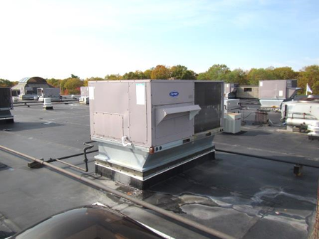
Rooftop air handling unit

Picture 2
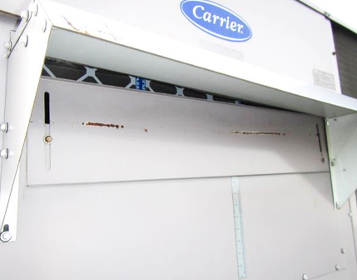
Manually adjusted fresh air intake for AHU and pleated filters
Picture 3
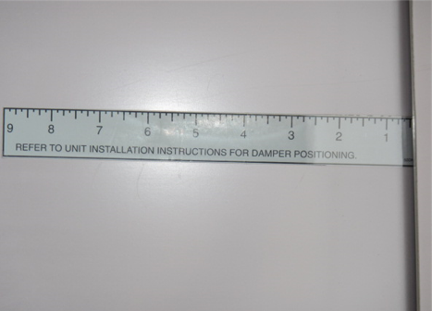
Damper adjustment guide on AHU

Picture 4
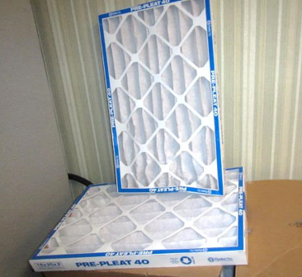
Pleated filters for AHUs
Picture 5
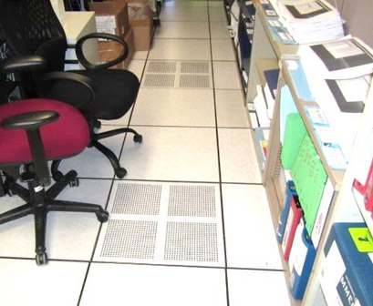
Ducted floor vents

Picture 6
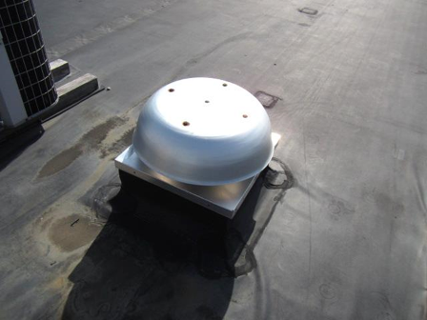
Air intake for Computer Room supplemental/auxiliary unit
Picture 7
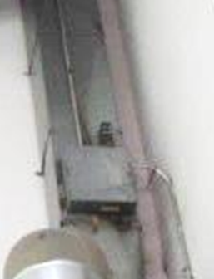
Powered fan (Arrow) for Computer Room supplemental/auxiliary unit

Picture 8
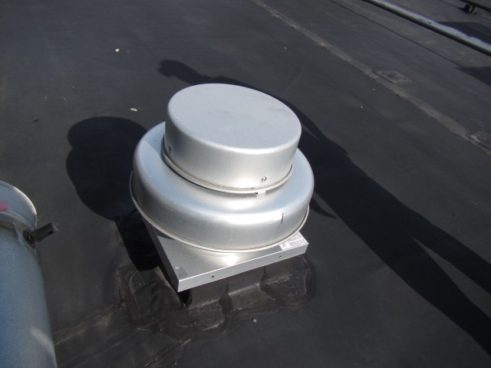
Rooftop exhaust motor for Computer Room supplemental/auxiliary unit
Picture 9
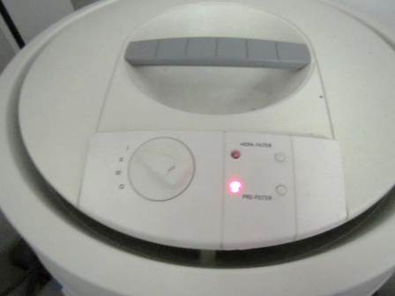
HEPA filtration unit, note alert that pre-filter is in need of cleaning/changing (arrow)

Location | Carbon  Dioxide  (ppm) | Carbon Monoxide  (ppm) | Temp  (°F) | Relative  Humidity  (%) | TVOCs  (ppm) | PM2.5  (µg/m³) | Occupants  in Room | Windows  Openable | Ventilation |  |  | Remarks
 |  |  |  |  |  |  |  |  | Intake | Exhaust
Background (outdoors) | 389 | ND-0.5 | 61 | 55 | ND | 10-15 |  |  |  |  |  | Partly sunny, South winds 2 to 12 mph, gusts up to 18 mph
Computer Room Center | 611 | ND | 72 | 47 | ND | 3 | 0 | N | Y |  | Y
Network Area | 599 | ND | 75 | 46 | ND | 3 | 0 | N | Y |  | Y
Tape Library | 666 | ND | 73 | 47 | ND | 3 | 0 | N | Y |  | Y
Salucci/Dubrawski Office | 650 | ND | 73 | 47 | ND | 4 | 1 | N | Y |  | Y
Common Operations Area | 679 | ND | 72 | 48 | ND | 3 | 3 | N | Y |  | Y | Air purifier-reportedly not maintained/filter light on, photocopier
Breakroom | 687 | ND | 72 | 46 | ND | 4 | 0 | N | Y |  | Y | Dry erase materials
ICS Control Room | 651 | ND | 71 | 46 | ND | 4 | 0 | N | Y |  | Y
Foley/Cattaneo | 664 | ND | 71 | 48 | ND | 9 | 1 | N | Y |  | Y | Dry erase materials
Fire Suppression Area | 640 | ND | 72 | 47 | ND | 4 | 0 | N | Y |  | Y | Dry erase materials
Tech Support Office | 629 | ND | 72 | 47 | ND | 4 | 1 | N | Y |  | Y | Spray cleaning products, hand sanitizer
Ticket Return Unit | 622 | ND | 72 | 41 | ND | 12 | 1 | N | Y |  | Y | Dust control issues, auxiliary air unit for computer area

