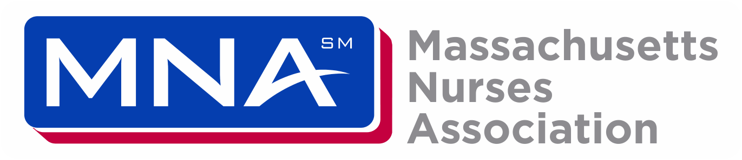

TO: Department of Public Health
FROM: Katie Murphy, RN, President
DATE: February 13, 2025
RE: Proposed amendments to 105 CMR 210.00: The administration of prescription medications in public and private schools
As President of the Massachusetts Nurses Association representing over 25,000 nurses and healthcare professionals across the Commonwealth, including school nurses, I offer this testimony regarding proposed changes to 105 CMR 210.00: The administration of prescription medications in public and private schools.

104 210.04 (A)
Proposed language: A school nurse shall be on duty in the school system while prescription medications are being administered by designated unlicensed school personnel, and available by telephone virtually (telephonic or web-based) should consultation be required.
MNA Proposed Changes: A school nurse shall be on duty in the school system while prescription medications are being administered by designated unlicensed school personnel, and available by telephone virtually (telephonic or web-based) should consultation be required. The school nurse shall be compensated at the negotiated rate for after-hours consultation.

105 CMR 210.05 (G)(4)
Proposed Language: The first time that an unlicensed school personnel administers medication, the delegating school nurse shall provide supervision at the work site. In extenuating circumstances, as determined by the school nurse, the skills competency for p.r.n. emergency rescue medications administered through inhalation or through the mucous membranes of the nose, mouth, or lungs (such as inhalers and nasal preparations of glucagon and diazepam) may be demonstrated without administration of the medication to the student. When a p.r.n. emergency rescue medication is administered, the medication plan shall address notification of the local emergency medical services system, followed by notification of the student’s caregiver.
MNA Proposed Changes: An unlicensed school personnel should never administer the first dose of medication unless it is in an emergency rescue situation. The first time that an unlicensed school personnel administers medication, the delegating school nurse shall provide supervision at the work site. In extenuating circumstances, as determined by the school nurse, the skills competency for p.r.n. emergency rescue medications administered through inhalation or through the mucous membranes of the nose, mouth, or lungs (such as inhalers and nasal preparations of glucagon and diazepam) may be demonstrated without administration of the medication to the student. When a p.r.n. emergency rescue medication is administered, the medication plan shall address notification of the local emergency medical services system, followed by notification of the student’s caregiver.
This clarification is proposed to differentiate between the first time a medication is administered to an individual versus the first time any school personnel administers the medication to the individual. Non-emergency/rescue medication should never be administered for the first time by school personnel.

105 CMR 210.06 (G)(6)(b)
Language: administer the first dose of the prescription medication, if:
      - there is reason to believe there is a risk to the child student as indicated by the health assessment, or
      - the student has not previously received this prescription medication in any setting.
MNA Proposed Changes: administer the first dose of the prescription medication, if:
      - there is reason to believe there is a risk to the child student as indicated by the health assessment, or
      - the student has not previously received this prescription medication in any setting.

This deletion is proposed to differentiate between the first time a medication is administered to an individual versus the first time any school personnel administers the medication to the individual. Non-emergency/rescue medication should never be administered for the first time by school personnel.

105 CMR 210.08 (E)
Language: Parents or guardians Caregivers may retrieve the prescription medications from the school at any time.
MNA Proposed Changes: Caregivers may retrieve the prescription medications from the school at any time during school hours from the school nurse or the medication program manager. This language would clarify when medication can be retrieved, as the current language leaves open the possibility of retrieving medication during non-school hours. Additionally, for safety and tracking purposes, the medication should only be retrieved by the school nurse or unlicensed school personnel.

Please reach out with any questions.

Thank you.

Submitted electronically to Reg.Testimony@mass.gov

