Massachusetts PACE Evaluation
Nursing Facility Residency and Mortality
Summary Report

November 23, 2015

 | JEN Associates, Inc.  5 Bigelow Street  Cambridge, MA 02139  Phone: (617) 868-5578 • Fax: (617) 868-7963

Contents
Executive Summary 3
The PACE Care Model 4
Massachusetts PACE 5
Assessment Hurdles 5
Data Sources 6
Cohort Selection 7
Descriptive Statistics 7
Selection of a Control Population 10
Analytic Design 11
Results 12
Mortality in 5+ Year Follow-up Period 14
Mortality in First Year 15
Conclusions 17

Executive Summary
PACE (Program of All-Inclusive Care for the Elderly) follows a comprehensive community-based care model for frail, chronically ill adults aged 55 and older who are nursing facility eligible. PACE’s goal is to help enrollees remain in the community for as long as possible by providing integrated care and support services delivered through an interdisciplinary team (IDT). There are, however, few published studies of nursing facility residency among PACE versus comparative populations.
The goal of the present study was to help fill the gap in assessing PACE’s effect on nursing facility residency. Nursing facility residency (NF residency) in the analysis is defined as a nursing facility stay that lasts 4+ months and is unlikely to result in a discharge to the community. The study first created a blended dataset for all dually eligible Massachusetts residents by integrating 2006-2012 Medicare and Medicaid claims and enrollment data as well as Nursing Home Minimum Data Set (MDS) records. This detailed dataset enabled the creation of matched cohorts consisting of new PACE participants (cases) and a matched comparison population (controls). Initiation of NF residency is frequently associated with elevated mortality. A supplementary analysis was designed to examine PACE impact on short- and long-term mortality rates.
The study results showed that PACE in Massachusetts achieves its primary goal. Compared to the non-PACE control population, nursing facility residency was reduced in the PACE population. PACE is associated with a significantly lower level of nursing facility entry in the first 20 months of program enrollment compared to a matched control population. A 14% reduction in NF residency months is attributable to the PACE program over the 5+ year follow-up period. Focusing on individuals with NF residency the average episode length is 20% shorter for PACE enrollees than for controls, 14.8 vs 18.5 months. An analysis of mortality in the 12 months following PACE enrollment shows an 18% reduction in the risk of death attributable to the program. Over a 5 year period overall mortality is not significantly different. As mortality is deferred in the case population, the survivors become collectively older and the average age of the cases increases relative to the controls; at 3 to 5 years post enrollment PACE mortality risk catches up with the controls.

The PACE Care Model
PACE follows a comprehensive community-based care model for frail, chronically ill adults aged 55 and older who are nursing facility eligible. PACE’s goal is to maintain enrollees in the community for as long as possible by providing integrated care and support services.
PACE “participants” must be 55 or older, deemed nursing facility certifiable by their state, and live in a PACE service area [National PACE Association, www.npaonline.org]. Although eligible for nursing facility entry, participants also must be deemed capable of safely receiving community-based care when they join PACE.
The national PACE population on average is 80 years-old and has eight acute or chronic medical conditions plus three ADL deficits [Hirth et al, Journal of the American Medical Directors Association, 2009]. Participants are 75% female, and 95% are dual eligible Medicare-Medicaid beneficiaries [Gross et al, Milbank Quarterly, 2004] (In 2012, Massachusetts PACE enrollees were 70% female and the average age is 80).
Upon enrollment, PACE becomes participants’ sole source of Medicare- and Medicaid-covered services, including drugs [Hirth et al., Journal of the American Medical Directors Association, 2009]. PACE continues as care provider even after participants become institutionalized. While residing in the community, participants typically attend a PACE center three to five days a week, and it serves as their main medical center as well as their social services base. Medical care is coordinated by the PACE interdisciplinary team (IDT) assigned to each participant. The IDTs include physicians, nurse practitioners, behavioral health specialists, nurses, social workers, therapists, van drivers, aides and other staff. This group meets regularly as the status of a PACE participant evolves. The IDT establishes a care plan when participants enroll, and reassessments are conducted every six months.
The PACE program is predominantly financed through dual Medicaid and Medicare capitation. The combined payments cover the complete spectrum of care, acute interventions through long-term support services. Medicare capitated payments are calculated according to the county’s fee-for-service rates multiplied by a participant’s risk score and the PACE site’s frailty score [CMS, Payments to PACE Organizations, 2012, http://www.cms.gov‌/Regulations-and-Guidance/Guidance/Manuals/Downloads/‌pace111c13.pdf]. Medicaid capitation is based on the cost of nursing facility and community-based care for the frail elderly. The benefits of PACE enrollment are hypothesized to lead to reductions in Medicare financed hospitalization episodes and reductions in Medicaid financed nursing facility utilization.
A 1998 evaluation of PACE outcomes [Chatterji et al., Abt Associates, 1998, http://www.npaonline.org/website/download.asp?id=1933&title=CMS:__Impact_of_‌PACE_on_Participant_Outcomes] found that PACE participants had much lower rates of nursing facility utilization and in-patient hospitalization than a comparison population, but they also had higher utilization of ambulatory services. PACE participants reported better health status and quality of life with lower rates of functional decline. These benefits were concentrated in the PACE population with high numbers of ADL limitations. There was a narrowing of the gap between the overall PACE and comparator populations over the two-year study period. A number of other studies have confirmed the hospitalization advantage [Moore 2013, http://claudepeppercenter.fsu.edu/sites/claudepeppercenter.‌fsu.edu/files/PACE%20updated.pdf. There are, however, few published assessments of comparative nursing facility rates even though reducing long-term nursing facility stays is PACE’s main goal.

Massachusetts PACE
There are eight PACE programs with 22 sites across Massachusetts. The sites are located in are Boston (East Boston, Savin Hill, Roxbury, Jamaica Plain and Mattapan), Beverly, Cambridge, Charlton, Gloucester, Leominster, Lynn, Metheun, Springfield, West Springfield, Winthrop, and Worcester. Massachusetts PACE programs are generally well-established. The oldest, East Boston Elder Service Plan, opened in 1990, and five others opened in the mid-nineties. Mercy LIFE in Holyoke opened in March, 2014, and the newest program, Springfield-based Serenity Care, commenced in June, 2014. As of January 1, 2014 the Massachusetts PACE sites had 3,159 enrollees.
In 2005, the Massachusetts Division of Health Care Finance and Policy conducted an evaluation of the state’s PACE programs [DHCFP, 2005, http://archives.lib.state.ma.us/‌bitstream/handle/2452/70646/ocn707399514.pdf?sequence=1]. PACE’s statewide enrollment amounted to only 898 at that time. The evaluation compared PACE hospitalization rates with those of nursing facility and Medicaid waiver patients. It found that PACE hospitalization rates were similar to those of nursing facility patients but that the length of inpatient stays and the rate of outpatient ED visits were lower. The PACE group also had lower hospitalization rates, lengths of inpatient stay, and ED visits than the Medicaid waiver population.
The present report intends to update these results, in particular as regards to PACE’s poorly studied main goal, preventing nursing facility entry.

Assessment Hurdles
The PACE program is difficult to evaluate for reasons relating to data availability and the obstacles to identifying appropriate comparison populations. Health care services delivered by PACE do not go through the traditional Medicaid and Medicare claims systems. In exchange for fixed per-patient capitation payments, PACE programs assume the economic risk of covering all medical and support services. When beneficiaries transfer from traditional fee-for-service Medicare and Medicaid to PACE, the stream of claims data dries up. The loss of the data stream makes it challenging to perform comparisons of care patterns before and after PACE enrollment or between PACE and non-PACE populations.
PACE does collect its own data on patient status and service utilization. However, this idiosyncratic dataset (DataPACE) is difficult to link to PACE participants’ previous records, to say nothing to those of a non-PACE comparator population.
The lack of usable data is an especially acute issue when evaluating nursing facility rates. In analyses of fee-for-service care, the key measurement is the initiating and continuation of nursing facility claims in the claims records. With this data missing due to PACE’s capitated payments, there is no clear way to isolate the PACE nursing facility population and link it to similar non-PACE comparator populations. In order to proceed, researchers are forced to find a common alternative source of information on nursing facility admissions and residency.
One such alternative source is the national Nursing Home Minimum Dataset (MDS). CMS requires licensed nursing facilities to perform detailed medical assessments of their patients upon entry and periodically thereafter. This information is recorded in the MDS filings. MDS data on PACE enrollees can serve as a direct measure of nursing facility utilization. Avoidance of long-term institutionalized custodial care represents the bulk of PACE’s expected savings. An episode grouper applied to MDS assessment dates can separate these long-term residencies from short-term rehabilitative stays, which also require MDS records.
A complete, risk-adjusted analysis of long-term nursing facility stays can take advantage of patients’ previous claims data for PACE and comparator populations alike. These records will indicate the presence of chronic disease and disability as well as measures of prior care. Meanwhile, the MDS records will indicate the rate of nursing facility entry both before and after PACE enrollment. Including in the follow-up period person-time after PACE discharge is necessary since the transition to nursing facility residency may be to a facility that is not affiliated with PACE.

Data Sources
This study collected 2006-2012 Medicare and Medicaid claims and enrollment data for all Massachusetts resident Medicaid and Medicare dually eligible beneficiaries. For the same period, Nursing Home MDS records were individually linked to the Medicaid and Medicare claims histories. The integration of data from the three sources resulted in the creation of person-level longitudinal analytic records summarizing monthly service utilization by hospitalization episodes, disease and disability diagnoses, program administrative status, beneficiary residence, MDS nursing facility status and other key indicators. The blended data source was designed for the tracking of PACE participants before and after the identification of comparison study subjects.

Cohort Selection
New PACE enrollees were then identified from 2007 through 2012. The study period for each subject included one-year Medicare enrollment prior to PACE with at least one quarter under fee-for-service financing (in order to assess baseline healthcare service utilization for PACE enrollees and matched controls). MDS nursing facility episodes were analyzed through 2012.

Descriptive Statistics
The PACE population consists of Medicare and Medicaid beneficiaries with a high level of need for long term supportive services, the standard for enrollment is patient eligibility for a nursing facility level of care. The statistics below focus on new PACE enrollees.
The population is growing at a gross annual rate of approximately 26% with about 680 new enrollees per year (Figure 1). Steady growth in new enrollees is to some degree offset with a PACE population annual mortality rate of 13% and an annual disenrollment rate of 4%. The net effect of the enrollment rate, mortality and disenrollment rates is an 11% overall annual growth rate.
Figure 1: New PACE Enrollees CY 2006-2011
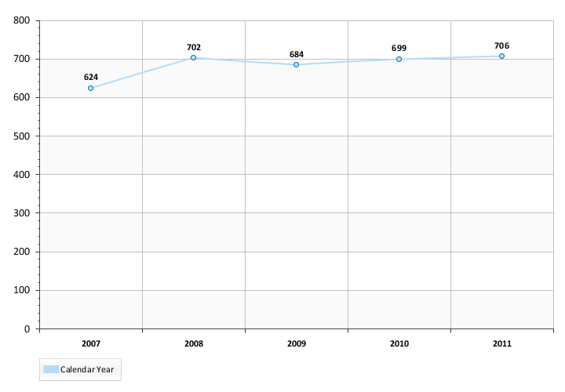
The enrolling population is predominantly over 85 years of age and female (Figure 2) and Caucasian (Table 2). The demographic distribution is very similar to a Medicaid-Medicare dual eligible nursing facility resident population. The rates of Alzheimer’s/dementia (AD) are 20% (Figure 3), which is much lower than found in a new nursing facility population which exhibits close to a 36% AD prevalence. Heart Failure shows a similar contrast with 16% prevalence in PACE enrollees and 34% in new to nursing facility populations. The frailty score profile in Figure 4 shows a 49% low frailty (index levels 0-3), a new nursing resident population typically exhibits an 18% low frailty rate. The PACE population is concentrated (Table 1) in the second, third and fourth largest counties for Medicaid-Medicare beneficiaries: Worcester, Essex and Suffolk. The first and fifth largest counties for Medicaid-Medicare dually eligibles are Middlesex and Bristol, which contain relatively few PACE enrollees.
The PACE new enrollee population presents as similar in demographics to a Massachusetts new to nursing facility population but with lower levels of dementia, complex disease combinations and frailty related morbidity.
Figure 2: New PACE Enrollees Demographic Distribution CY 2007-2011
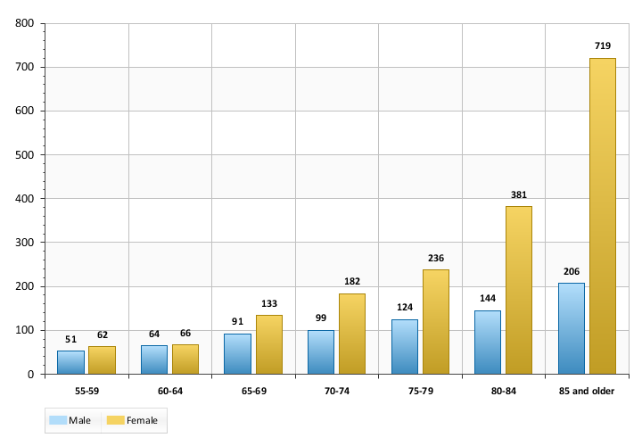
Figure 3: Selected Condition Prevalence in New PACE* Enrollees CY 2007-2011
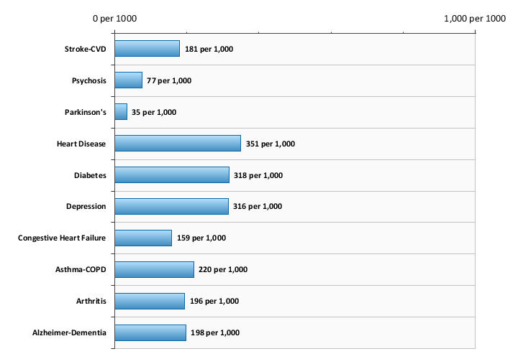
*Restricted to FFS in quarter prior to index date
Figure 4: New PACE Enrollee* Frailty Index Distribution CY 2007-2011
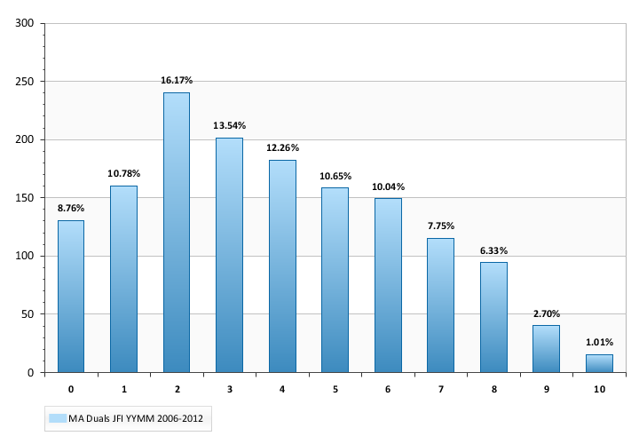
*Restricted to FFS in quarter prior to index date
Table 1: New PACE Enrollee County of Residence CY 2007-2011
FIPS County | Population
Essex | 25%
Middlesex | 9%
Norfolk | 8%
Plymouth | 1%
Suffolk | 20%
Worcester | 37%
Table 2: New PACE Enrollee Race-Ethnicity Distribution CY 2007-2011
Race-Ethnicity | Population
Caucasian / White | 87%
Hispanic | 8%
Native American/Alaskan Native | 1%
Asian | 1%
Black/African American | 3%

Selection of a Control Population
The premise of PACE enrollment is that potential participants are nursing facility certifiable but could remain in the community if they received sufficient support from personalized, integrated social and medical services. This qualification can be due to the effects of long-term degenerative disease or the impact of a recent acute event. In either case, ideal control selection includes finding non-PACE patients with the same disease and utilization trajectory culminating in nursing facility certifiable status.
To address the challenge of identifying a valid comparison population, the study developed a 1:1 matching strategy based on both static and time-varying personal characteristics (Table 3). The static characteristics included individual demographics and the presence of long-standing chronic diseases and disabilities. For cases (new PACE enrollees) and controls (matched non-PACE comparison population), the time-varying matching factors, including recent history of acute and post-acute care utilization, were mapped by month relative to an index date (PACE enrollment date or proxy). The result was the production of a matched comparison population with disease and utilization histories that effectively mimic the patterns observed in PACE population prior to enrollment.
Table 3: Case-Control Direct Matching Characteristics
Characteristic | Time Window
Medicaid Eligibility Type | At Index Month
Medicaid Full Eligibility Yes/No | 1-3 Months before Index
Medicaid Full Eligibility Yes/No | 4-6 Months before Index
Medicaid Full Eligibility Yes/No | 7-12 Months before Index
Medicare A-B Eligibility Type | At Index
Medicare A-B Eligibility/MA Type | 1-3 Months before Index
Medicare A-B Eligibility/MA Type | 4-6 Months before Index
Medicare A-B Eligibility/MA Type | 7-12 Months before Index
Medicare SNF Utilization Yes/No | 1-3 Months before Index
Medicare SNF Utilization Yes/No | 4-12 Months before Index
Medicare Acute Inpatient Utilization Yes/No | 1 Month before Index
Medicare Acute Inpatient Utilization Yes/No | 2-3 Months before Index
Medicare Acute Inpatient Utilization Yes/No | 4-12 Months before Index
Long-Term Institutional Status Yes/No | 1-6 Months before Index
High Frailty Score Status Yes/No | At Index
Heart Failure Yes/No | 0-12 Months before Index
Alzheimer's/Dementia Diagnosis Yes/No | 0-12 Months before Index
Chronic Mental Illness Diagnosis Yes/No | 0-12 Months before Index
Age Band, Sex, Race | At Index from Medicare
Index Year | Case enrollment year
Medicare Original Entitlement Reason | Index Year
Head-to-head comparison in matched populations of nursing facility status post index date provides basic measures of potential effects. The matching case and control experience effectively adjusts for underlying factors related to demographics, Medicaid and Medicare administrative status, history of chronic disease, frailty and prior service utilization. Characteristics that are matched cannot be further analyzed through the application of multivariate methods. The result is that statistical analyses based on two sample t-tests or chi-square tests are sufficient for measurements of overall differences. The major dependent variable is the number of months in a long stay nursing facility episode during the post-index, follow-up period.

Analytic Design
All PACE enrollees with a pre-index Medicare eligibility history are included in the analysis. New PACE enrollees (index date is the enrollment date) were identified in 2007 and were required to have12 months of pre-index Medicare history. At least 3 months in the pre-index period were required to be fee-for-service Medicare in order to account for baseline utilization history and diagnoses. A challenge is that individuals with Medicare Advantage (MA) enrollment near the index date will not be match-able on utilization or diagnoses in the immediate pre-index period. A history of MA status in the pre-index period was a matching factor. All study subjects were required to be dually eligible at the index date. The timing of the pre-index full Medicaid (not QMB-Only) eligibility status is incorporated into the matching algorithm.
The outcome of interest was a count of the number of months of NF residency in the post index observation period (2007-2012). NF residency was counted as episodes of stay of 4+ months – exceeding the window for the period of post-acute recovery/rehabilitation. The data source for the determination of NF residency was the Nursing Home Minimum Dataset (MDS) 2.0 and 3.0. The MDS data includes patient assessments that are administered on a periodic basis. CMS requires that MDS assessment be conducted for all individuals in a NH/NF stay regardless of payer. The exact periodicity of the assessments varies depending on length of stay. In order to determine monthly NF status an episode grouping algorithm was used to link assessments related to the same stay and to generate from monthly study subject status. Episodes were only generated for stays that could be classified as long-stay/permanent residency. The study period includes assessment data from MDS 2.0 and MDS 3.0 sources. The difference in the instruments was not significant in regard to the assessment dates. The result of the algorithm was a person-level longitudinal monthly database with a flag for NF residency.
Control study time was censored based on the number of eligible follow-up months through CY 2012. Case follow-up time also ran through CY 2012 but data was censored for PACE enrollees who left the program and resided in the community for the subsequent 3 months. The time truncation was implemented to ensure that NF residency that started after a PACE was not counted as a PACE outcome. Discharged PACE subjects, with NF residency status within 3 months of discharge, were followed to the end of the database. The impact of the censoring did not substantially affect the results.

Results
Figure 5 profiles the long-term institutionalized rate for PACE enrollees (cases) and comparison subjects (controls) over a 5+ year observation period 2007-2012. The onset of PACE enrollment results in an immediate decrease in the risk of nursing facility residency compared to the controls. This benefit appears sustained through month 20. Nursing facility residency rates averages over 5% in the study population prior to the index date. Starting the month before index there is a marked elevation in nursing facility residency among the controls. The sharp increase in the controls plateaus at month 4. Nursing facility residency slowly increases among the PACE enrollees until the curves for the two groups converge close to month 20. The difference in nursing facility residency is statistically significant for the period ending in month 20: From months 0-20, the cases’ and controls’ respective nursing facility residency rates averaged 15% and 19%, p <0.0001. After the month 20 convergence, there is no statistically significant difference through month 42.
Figures 5: Nursing Facility Residency in Months from Study Index
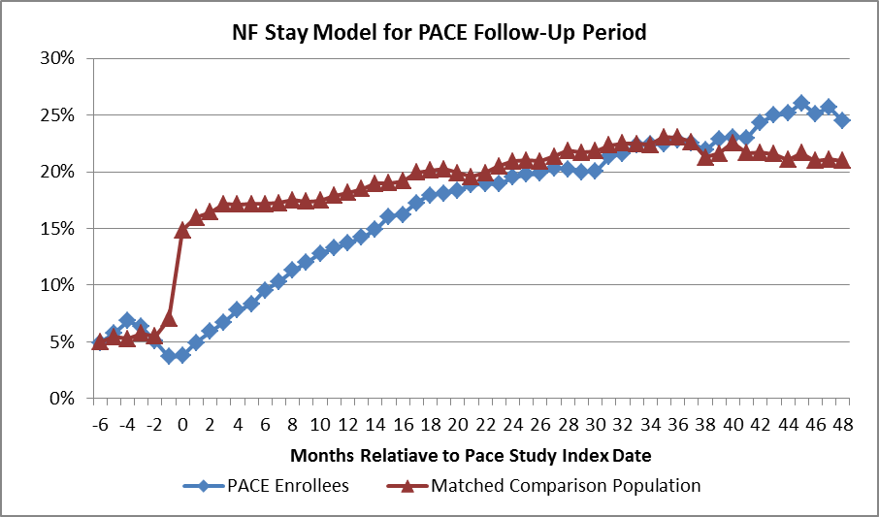
There is a significant uptick in PACE NF residency in months 42-57 (not shown in chart but included in Table 2 summary statistics). The rates re-converge later in the timeline at month 58. It should be noted that the individuals contributing to the statistics decline over time, e.g. data in months 60+ are restricted to study subjects with index dates in 2007 and outcome dates in 2012. Analyzing data for the 2007-2011 new PACE enrollees the Table 4 summary statistics show a significant and substantial reduction in NF residency months relative to the control population.
Table 4: Summary PACE and Comparison in Months 1-60 from Study Index
 | Study Subjects | Average Follow-up Months | Average Months of NF in Total Population | Average Months of NF Residency in Outcome Population | Total NF Residency Months | Total Follow-up Months
PACE Enrollees | 2,558 | 29.8 | 4.9 | 14.8 | 12,835 | 77,988
Comparison | 2,558 | 28.7 | 5.7 | 18.5 | 14,415 | 72,707
The observed difference in NF residency months of 1,580 represents an absolute reduction. The PACE population exhibits a 14% lower population average for NF residency months: 4.9 months for PACE enrollees and 5.7 months for the controls. In the population with NF residency the average number of episode months is 14.8 for the PACE enrollees and 18.5 for the comparison subjects: a 20% reduction in episode duration in the PACE population.
All of the statistics in Table 4 are statistically significant to the 95th percentile confidence level (p-value ≤0.05) as determined by two-sample T-tests. The difference in follow-up time of 29.8 versus 28.7 months may be due to several factors, e.g. loss of Massachusetts Medicare eligibility, time from index month to end of data and death. Since the matching factors include the index year, the difference in follow-up months is perhaps indicative of greater longevity in the PACE population.
Mortality Risk Analysis
To determine the potential impact of PACE enrollment on mortality a Proportional Hazards model was designed and implemented. The study period was truncated to only include PACE enrolled months for the cases. Death of cases which occurred within 1 month after discharge were attributed to PACE. Controls were followed to the end of the database.

Mortality in 5+ Year Follow-up Period
The model accounts for variable follow-up time and other factors in determining the relationship between a set of covariates and death. The covariate list in the model is based on a step-wise selection of candidate correlated factors. The variable for PACE status is forced in the model to measure the impact of case status. Figure 6 shows the unadjusted probability of death by month from index. Model results are presented in Table 5. The overall mortality rate in the cases and controls is approximately 33%. The observed mortality rate over the total follow-up period for the cases is 32.8% and 33.9% for the controls. The difference is not statistically significant.
The total period survival probability curve shows some evidence of a reduced probability for PACE enrollees in the early months after index and an increased probability in the later months. The model over the complete period does not show a significant case effect on the odds of survival over 5+ years. The monthly risk of death in the study population dovetails in month 12. The risk of death increases for PACE enrollees after 36 months of program exposure as the deferral of death is counterbalanced by the aging of the surviving population.
Figure 6: Monthly Survival Probability after Index Date
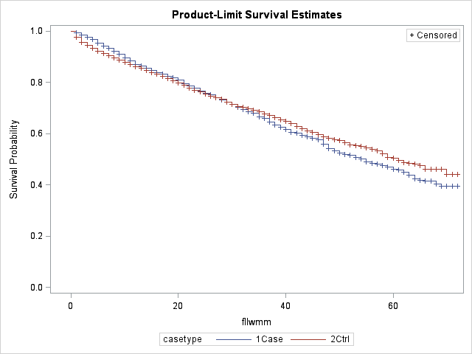
Table 5: Mortality Risk in the Follow-up Period
Covariate | Estimate | StdErr | ChiSq | Prob ChiSq | Hazard Ratio | HR Lower CL | HR Upper CL
PACE-Yes | -0.0498 | 0.0496 | 1.0106 | 0.3148 | 0.95 | 0.86 | 1.05
ESRD | 0.5746 | 0.2146 | 7.1688 | 0.0074 | 1.78 | 1.17 | 2.71
Part B Buy-in | -0.5930 | 0.0497 | 142.3501 | <.0001 | 0.55 | 0.50 | 0.61
The correlated covariates include End Stage Renal Disease and Medicare Part B Premium Buy-In. The Buy-In is an indicator of dual eligibles whose Medicaid income eligibility is attained only after deducting medical expenditures, i.e. a medically needy population.

Mortality in First Year
In Figure 7 and Table 6 survival probability in the 12 month period following the study index date is analyzed. It can be hypothesized that there is an aversion to joining a new program if death is expected in the near term, e.g. next 60 days. Under these circumstances, the controls could be expected to show an immediate and temporary increase in mortality. The 12 month survival curve demonstrates that elevated mortality in the controls is not isolated to the first months; the effect smoothly extends over 12 months. In post-index month12, the monthly survival case and control probabilities dovetail. The deferral of death over any period is a valid benefit, however lower death probabilities in one period must be made by higher death risks later in patient trajectories.
A question is whether the higher survival probability is a natural outcome of a deferral effect, with an early reduction in probability balanced by an eventual increased mortality. A natural deferral pattern is suggested since the initial survival benefit in the cases is persistent over the first 12 months from enrollment and subsequently, in the complete period analysis, a higher case mortality probability is observed after month 36.
Figure 7: Monthly Survival Probability in 12 Months after Index Date
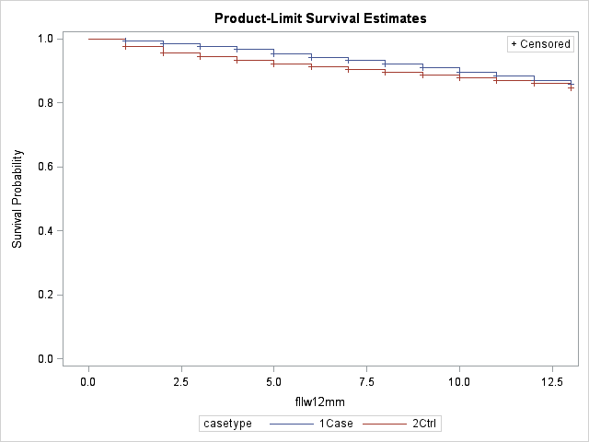
Table 6: Mortality Risk in the first 12 Months of Follow-up
Covariate | Estimate | StdErr | ChiSq | Prob ChiSq | Hazard Ratio | HR Lower CL | HR Upper CL
PACE-Yes | -0.2007 | 0.0756 | 7.0581 | 0.0079 | 0.82 | 0.71 | 0.95
ESRD | 0.6980 | 0.3184 | 4.8072 | 0.0283 | 2.01 | 1.08 | 3.75
Part B Buy-in | -0.7173 | 0.0757 | 89.8737 | <.0001 | 0.49 | 0.42 | 0.57

Conclusions
PACE in Massachusetts meets its goal of maintaining enrollees in a community care setting - at least through the first 20 months after enrollment. Nursing facility residency increases rapidly in the controls after the index date but climbs more slowly among the PACE enrollees. Both groups plateau at 20%-25% monthly nursing facility residency after month 20. The effect is sustained and is statistically significantly, representing a PACE population reduction of 14% in any residency months and a reduction of 20% in NF residency episode length.
The survival probability over 5+ years do not differ significantly between the PACE and comparison populations. PACE enrollees are associated with an 18% reduction in mortality risk in the first 12 months after the program index date.

CMS data sends Medicare data based on state of residency at the end of a year. If a study subject leaves the state in a year the Medicare data is not sent for analysis. Even if the individual maintains residence in Massachusetts but the Social Security mailing address is changed out of state the Medicare data will be missing.
The JEN Frailty Index is based is the sum of 13 designated frailty categories that may be found in a patient’s Medicare claims. Past observation has found that these 13 categories are significantly correlated with concurrent or future long-term care services and with the costs incurred for medical care. The categories are minor ambulatory limitations, severe ambulatory limitations, cognitive developmental disability, chronic mental illness, dementia, sensory disorders, self-care impairment, syncope, cancer, chronic medical disease, pneumonia, renal disorders, and systemic disorders (e.g., septicemia). Each category with diagnoses present in a patient’s claims for the previous year contributes 1 point to the overall frailty score. Scores of seven or above are considered “high frailty.”
http://www.cms.gov/Medicare/Quality-Initiatives-Patient-Assessment-Instruments/NursingHomeQualityInits/NHQIMDS30.html
Sensitivity tests were performed to determine if capturing death within 6 months of discharge had an impact on the analysis. No significant difference was observed in the mortality statistics.

