Massachusetts PACE Evaluation
Nursing Home Residency
Summary Report

July 24, 2014

 | JEN Associates, Inc.  5 Bigelow Street  Cambridge, MA 02139  Phone: (617) 868-5578 • Fax: (617) 868-7963

Contents
Executive Summary 3
The PACE Care Model 3
Massachusetts PACE 4
Matched Case-Control Evaluation Strategy 5
Assessment Hurdles 5
Data Source 6
Case-Control Matching Techniques 6
Analytic Methods 7
Findings 7
Conclusions 12

Executive Summary
PACE (Program of All-Inclusive Care for the Elderly) follows a comprehensive community-based care model for frail, chronically ill older adults whose significant functional and cognitive impairments make them nursing home eligible. PACE’s goal is to help enrollees remain in the community for as long as possible by providing integrated care and support services. There are, however, few published studies of nursing home rates among PACE versus comparative populations.
The goal of the present study was to help fill the gap in assessing PACE’s effect on nursing home residency. The study first created a blended dataset for all dually eligible Massachusetts residents by integrating 2006-2011 Medicare and Medicaid claims and enrollment data as well as Nursing Home Minimum Data Set (MDS) records. This detailed dataset enabled the creation of matched cohorts consisting of new PACE (cases) and similar controls.
The study results showed that PACE in Massachusetts achieves its primary goal. Compared to the non-PACE control population, nursing home residency was substantially reduced in PACE’s high-risk population. Nursing home residency rates increase rapidly in the immediate pre-index period among cases and controls. PACE enrollment is associated with an immediate slowing of that increase during the immediate post-index. PACE enrollee nursing home residency rates remain significantly below the comparison population for up to 20 months after enrollment.

The PACE Care Model
PACE (Program of All-Inclusive Care for the Elderly) follows a comprehensive community-based care model for frail, chronically ill older adults whose significant functional and cognitive impairments make them nursing home eligible. PACE’s goal is to maintain enrollees in the community for as long as possible by providing integrated care and support services.
PACE participants must be 55 or older, deemed nursing home certifiable by their state, and live in a PACE service area [National PACE Association, www.npaonline.org]. Although eligible for nursing home entry, participants also must be deemed capable of safely receiving community-based care when they join PACE.
The national PACE population on average is 80 years-old and has eight acute or chronic medical conditions plus three ADL deficits [Hirth et al, Journal of the American Medical Directors Association, 2009]. Participants are 75% female, and 95% are dual eligible Medicare-Medicaid beneficiaries [Gross et al, Milbank Quarterly, 2004] In 2011, Massachusetts PACE enrollees were 70% female and the average age was 80.
Upon enrollment, PACE becomes participants’ sole source of Medicare- and Medicaid-covered services, including drugs [Hirth et al., Journal of the American Medical Directors Association, 2009]. PACE continues as care provider even after participants become institutionalized. While residing in the community, participants typically attend a PACE center three to five days a week, and it serves as their main medical center as well as their social services base. Medical care is coordinated by the PACE interdisciplinary team (IDT) assigned to each participant. The IDTs include physicians, nurse practitioners, behavioral health specialists, nurses, social workers, therapists, van drivers, aides and other staff. This group meets regularly as the status of a PACE participant evolves. The IDT establishes a care plan when participants enroll, and reassessments are conducted every six months.
The PACE program is predominantly financed through dual Medicaid and Medicare capitation. The combined payments cover the complete spectrum of care, acute interventions through long-term support services. Medicare capitated payments are calculated according to the county’s fee-for-service rates multiplied by a participant’s risk score and the PACE site’s frailty score [CMS, Payments to PACE Organizations, 2011, http://www.cms.gov‌/Regulations-and-Guidance/Guidance/Manuals/Downloads/‌pace111c13.pdf]. Medicaid capitation is based on the cost of nursing home and community-based care for the frail elderly. The benefits of PACE enrollment are hypothesized to include reductions in Medicare financed hospitalization episodes and reductions in Medicaid financed nursing home utilization.
A 1998 evaluation of PACE outcomes [Chatterji et al., Abt Associates, 1998, http://www.npaonline.org/website/download.asp?id=1933&title=CMS:__Impact_of_‌PACE_on_Participant_Outcomes] found that PACE participants had much lower rates of nursing home utilization and in-patient hospitalization than a comparison population, but they also had higher utilization of ambulatory services. PACE participants reported better health status and quality of life with lower rates of functional decline. These benefits were concentrated in the PACE population with high numbers of ADL limitations. The gap narrowed between the overall PACE and comparator populations over the two-year study period. A number of other studies have confirmed the hospitalization advantage [Moore 2013, http://claudepeppercenter.fsu.edu/sites/claudepeppercenter.‌fsu.edu/files/PACE%20updated.pdf.] There are, however, few published assessments of comparative nursing home rates even though reducing long-term nursing home stays is PACE’s main goal.

Massachusetts PACE
There are eight PACE programs with 22 sites across Massachusetts. The sites are located in Boston, (East Boston, Savin Hill, Roxbury, Jamaica Plain and Mattapan) Beverly, Cambridge, Charlton, Gloucester, Leominster, Lynn, Methuen , Springfield, West Springfield, Winthrop, and Worcester. Massachusetts PACE programs are generally well-established. The oldest, East Boston Elder Service Plan, opened in 1990, and five others opened in the mid-nineties. Mercy LIFE in Holyoke opened in March, 2014, and the newest program, Springfield-based Serenity Care, commenced in June, 2014. As of January 1, 2014 the Massachusetts PACE sites had 3,159 enrollees.
In 2005, the Massachusetts Division of Health Care Finance and Policy conducted an evaluation of the state’s PACE programs [DHCFP, 2005, http://archives.lib.state.ma.us/‌bitstream/handle/2452/70646/ocn707399514.pdf?sequence=1]. PACE’s statewide enrollment amounted to only 898 at that time. The evaluation compared PACE hospitalization rates with those of nursing home and Medicaid waiver patients. It found that PACE hospitalization rates were similar to those of nursing home patients but that the length of inpatient stays and the rate of outpatient ED visits were lower. The PACE group also had lower hospitalization rates, lengths of inpatient stay, and ED visits than the Medicaid waiver population.
The present report intends to update these results, in particular as regards to PACE’s poorly studied main goal, preventing nursing home entry.

Matched Case-Control Evaluation Strategy

Assessment Hurdles
The PACE program is difficult to evaluate for reasons relating to data availability and the obstacles to identifying appropriate comparison populations. Health care services delivered by PACE do not go through the traditional Medicaid and Medicare claims systems. In exchange for fixed per-patient capitation payments, PACE programs assume the economic risk of covering all medical and support services. When beneficiaries transfer from traditional fee-for-service Medicare and Medicaid to PACE, the stream of claims data dries up, resulting in challenges to compare care patterns before and after PACE enrollment or between PACE and non-PACE populations.
PACE does collect its own data on patient status and service utilization. However, this idiosyncratic dataset (DataPACE) is difficult to link to PACE participants’ previous records, to say nothing to those of a non-PACE comparator population.
The lack of usable data is an especially acute issue when evaluating nursing home rates. In analyses of fee-for-service care, the key measurement is the initiation and continuation of nursing home claims in the claims records. With this data missing due to PACE’s capitated payments, there is no clear way to isolate the PACE nursing home population and link it to similar non-PACE comparator populations. In order to proceed, researchers are forced to find a common alternative source of information on nursing home admissions and residency.
One such alternative source is the national Nursing Home Minimum Dataset (MDS). CMS requires licensed nursing facilities to perform detailed medical assessments of their patients upon entry and periodically thereafter. This information is recorded in the MDS filings. MDS data on PACE enrollees can serve as a direct measure of nursing home utilization. Avoidance of long-term institutionalized custodial care represents the bulk of PACE’s expected savings. An episode grouper applied to MDS assessment dates can separate these long-term residencies from short-term rehabilitative stays, which also require MDS records.
A complete, risk-adjusted analysis of long-term nursing home stays can take advantage of patients’ previous claims data for PACE and comparator populations alike. These records will indicate the presence of chronic disease and disability as well as measures of prior care. Meanwhile, the MDS records will indicate the rate of nursing home entry both before and after PACE enrollment.

Data Source
This study collected 2006-2011 Medicare and Medicaid claims and enrollment data for all Massachusetts Medicaid and Medicare dually eligible beneficiaries. For the same period, Nursing Home MDS records were individually linked to the Medicaid and Medicare claims histories. The integration of data from the three sources resulted in the creation of person-level longitudinal analytic records summarizing monthly service utilization by hospitalization episodes, disease and disability diagnoses, program administrative status, beneficiary residence, MDS nursing home status, and other key indicators. The blended data source was designed to track PACE participants before and after the identification of comparison study subjects.
New PACE enrollees were then identified from 2007 through 2011. The study period for each subject included one-year of fee-for-service Medicare enrollment prior to PACE (in order to assess baseline healthcare service utilization for PACE enrollees and matched controls). MDS nursing home episodes were analyzed through 2011.

Case-Control Matching Techniques
The premise of PACE enrollment is that potential participants are nursing home certifiable but could remain in the community if they received sufficient support from personalized, integrated social and medical services. This qualification can be due to the effects of long-term degenerative disease or the impact of a recent acute event. In either case, ideal control selection includes finding non-PACE patients with the same disease and utilization trajectory culminating in nursing home certifiable status.
To address the challenge of identifying a valid comparison population, the study developed a 1:1 matching strategy based on both static and time-varying personal characteristics (Table 1). The static characteristics included individual demographics and the presence of long-standing chronic diseases and disabilities. For cases and controls, the time-varying matching factors, including recent history of acute and post-acute care utilization, were mapped by month relative to an index date defined as a case’s date of PACE enrollment. The result was the production of a matched comparison population with disease and utilization histories that effectively mimic the patterns observed in the PACE population prior to enrollment.
Table 1. Case-Control Matching Characteristics
Characteristic | Time Window*
Medicaid Eligibility | At Index
Medicaid Full Eligibility Yes/No | 2-6 Months before Index
Medicaid Full Eligibility Yes/No | 7-12 Months before Index
Medicare A-B Eligibility | At Index
Medicare A-B Eligibility | 2-6 Months before Index
Medicare A-B Eligibility | 7-12 Months before Index
Medicare SNF Utilization | 1-3 Months before Index
Medicare SNF Utilization | 4-12 Months before Index
Medicare Acute Inpatient Utilization | 1 Month before Index
Medicare Acute Inpatient Utilization | 2-3 Months before Index
Medicare Acute Inpatient Utilization | 4-12 Months before Index
Long-Term Nursing Home Status | 1-6 Months before Index
High Frailty Score Status | 0-6 Months before Index
Heart Failure | 0-12 Months before Index
Alzheimer's/Dementia Diagnosis | 0-12 Months before Index
Chronic Mental Illness Diagnosis | 0-12 Months before Index
Age | At Index
Sex | N/A
*Index = Date of PACE participant’s enrollment

Analytic Methods
Head-to-head comparison in matched populations of nursing home status post index date provides basic measures of potential effects. The matching case and control experience effectively adjusts for underlying factors related to demographics, Medicaid and Medicare administrative status, history of chronic disease, frailty and prior service utilization. Characteristics that are matched cannot be further analyzed through the application of multivariate methods. The result is that statistical analyses based on two sample t-tests or chi-square tests are sufficient for measurements of overall differences. The major dependent variable is the proportion of patients in long-term care during the post-index follow-up period.

Findings
Figure 1 compares the long-term institutionalized rate for cases and controls over the entire observation period. PACE enrollment results in an immediate decrease in the risk of nursing home residency. This benefit is sustained for 20 months.
Nursing home residency increases as the index date approaches, with a small but statistically significant elevation in the controls relative to the cases. The nursing home rate continues to increase for the controls whereas it decreases sharply for the PACE enrollees. The sharp increase in the controls plateaus at month four post-index while nursing home residency slowly increases among the PACE enrollees until the curves for the two groups meet at month 20. The difference in nursing home residency is highly statistically significant during this period: From months 0-19, the cases’ and controls’ respective nursing home residency rates averaged 11.8% and 18.1%, p <0.0001. After the month 20 convergence, there is no statistically significant difference between the two groups.
Figure 1. Residency in a Long-term Nursing Facility over the Entire Observation Period
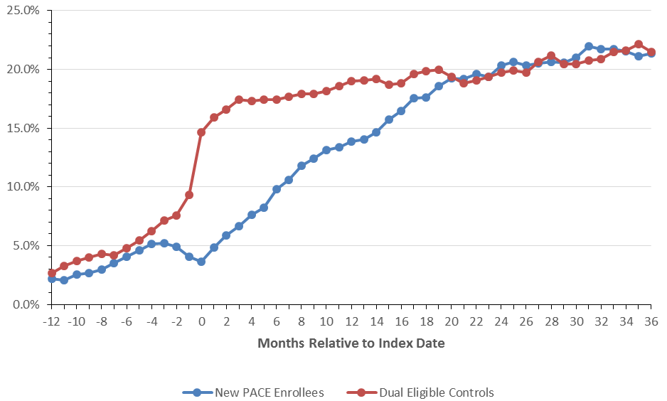
PACE gained many new enrollees during the study period. As shown in Figure 2, 2,542 enrolled in PACE during the 2007-2011 study period.
Figure 2. New PACE Enrollment during the Study Period
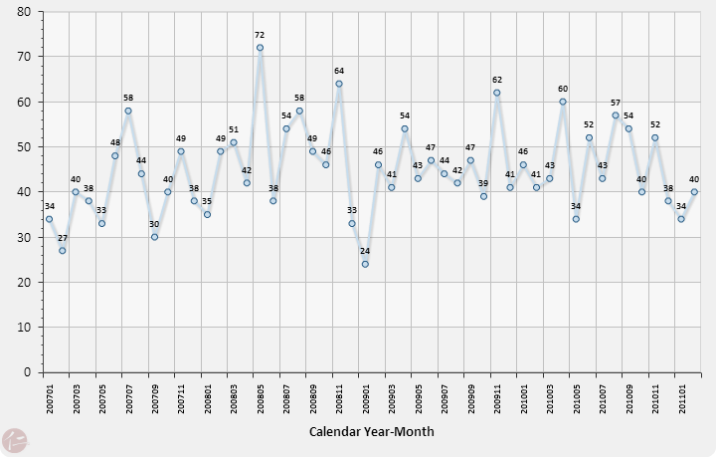
The difference in nursing home residency could conceivably arise from differences in length-of-follow-up between PACE enrollees and controls. In particular, the steady rate of new enrollees implies that many PACE participants did not have lengthy follow-up before the observation period terminated. The last 12 months includes almost a quarter of PACE enrollment. However, the size of the case and control populations declined in an identical manner post-index (Figure 2), showing that the difference in nursing home residency is not the result of external events that truncate the observable data.
Figure 3. Case and Control Population during the Entire Observation Period
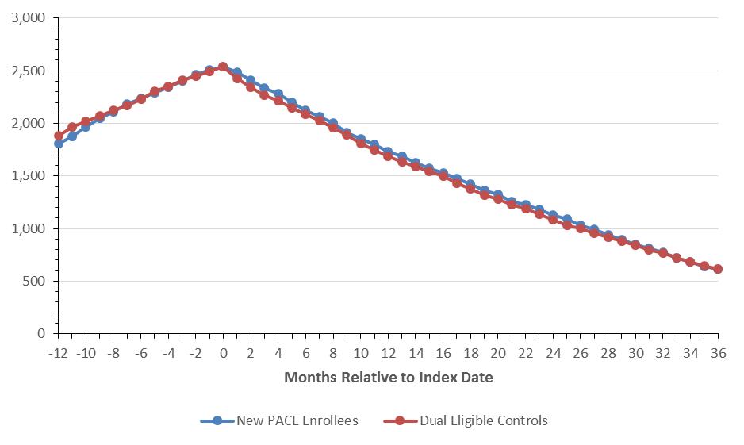
The data confirms that PACE enrolls frail elderly individuals with a high risk of mortality (Figures 4-7). PACE enrollment is frequently preceded by both a period of intensive utilization of medical service and first time entry into Medicaid. The decision to enroll in PACE is evidently correlated with changes in individual health status as well as the availability of personal financing for non-Medicare covered long-term support services.
Figures 4-7 show that the study match managed to duplicate cost and utilization trends in the case and control population, with the eventual PACE enrollees having a slightly higher level of service utilization and cost throughout the pre-index year. In addition, the PACE enrollees’ service utilization and costs peaked three months before the index date.
Figure 4. Hospitalization during Each Pre-Index Month
(Pre-index fee-for-service population only)
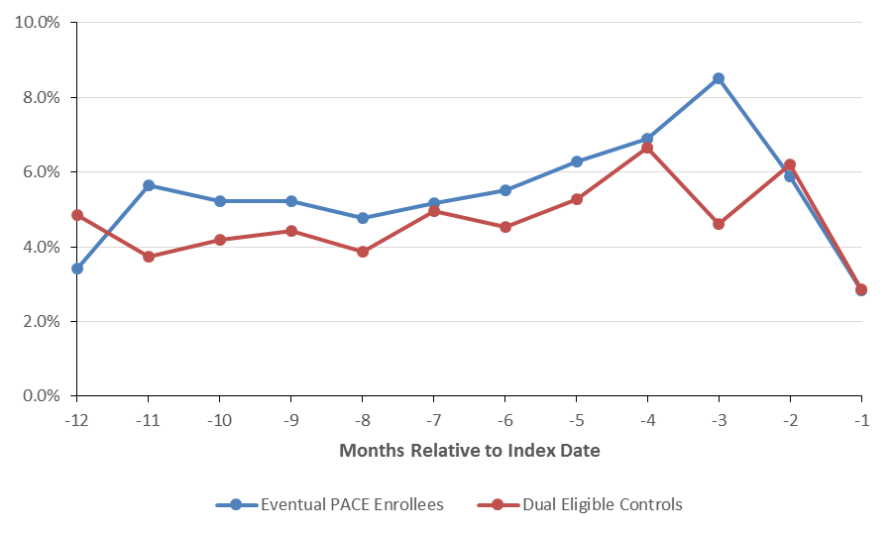
Figure 5. Outpatient Emergency Room Use during Each Pre-Index Month
(Pre-index fee-for-service population only)
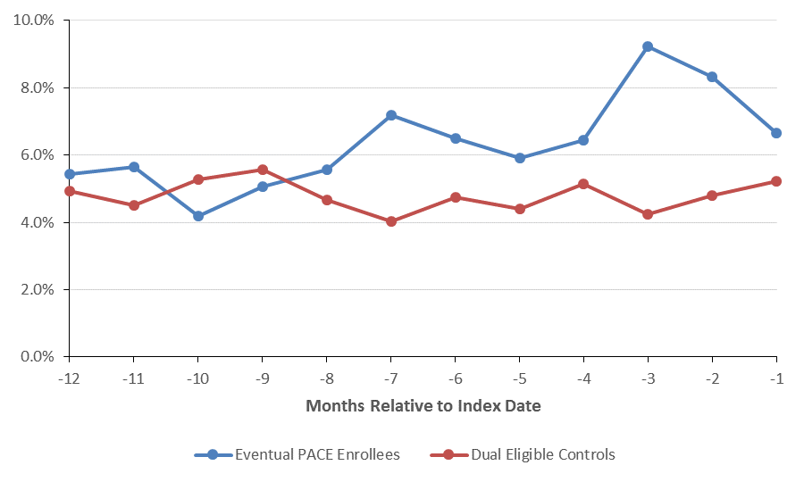
Figure 6. Residency in a Skilled Nursing Facility during the Pre-Index Period
(Pre-index fee-for-service population only)
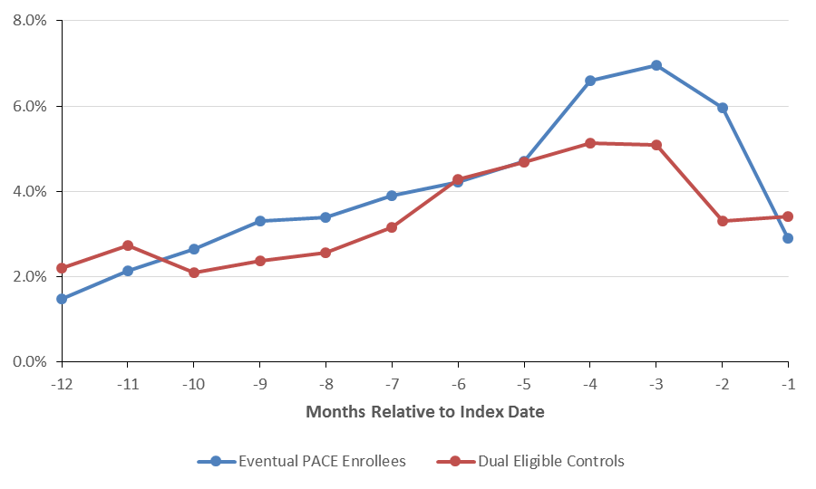
Figure 7. Medicare Parts A-B Expenditures per Patient in the Pre-Index Period
(Pre-index fee-for-service population only)
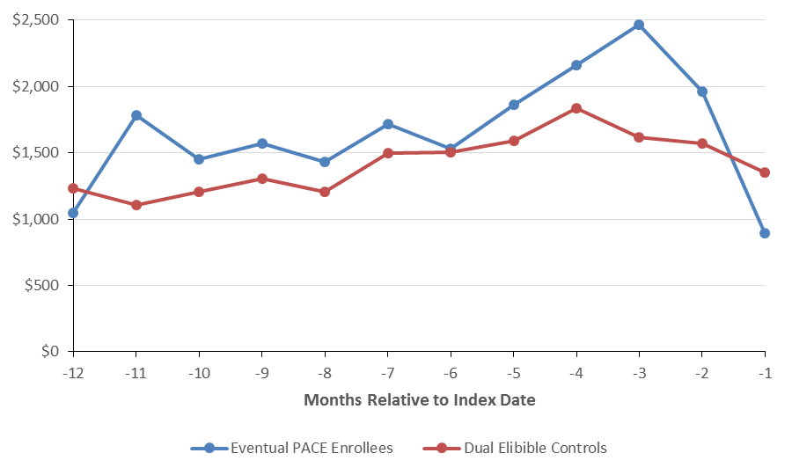

Conclusions
PACE in Massachusetts meets its primary goal of reducing nursing home admission rates at least through the first 20 months after enrollment. Nursing home residency increases rapidly in the immediate pre-index period among cases and controls but climbs more slowly among the PACE enrollees in the immediate post-index. Both groups eventually plateau at 20% nursing home residency.
Additional investigation is needed to elicit the association of PACE with other costly health care services such as hospitalization and short-term institutional stays for rehabilitation. Health care cost savings analyses are also an area for further research.

The JEN Frailty Index is based is the sum of 13 designated frailty categories that may be found in a patient’s Medicare claims. Past observation has found that these 13 categories are significantly correlated with concurrent or future long-term care services and with the costs incurred for medical care. The categories are minor ambulatory limitations, severe ambulatory limitations, cognitive developmental disability, chronic mental illness, dementia, sensory disorders, self-care impairment, syncope, cancer, chronic medical disease, pneumonia, renal disorders, and systemic disorders (e.g., septicemia). Each category with diagnoses present in a patient’s claims for the previous year contributes 1 point to the overall frailty score. Scores of seven or above are considered “high frailty.”

