Massachusetts Photovoice Project Impact Brief
Office of Problem Gambling Services
2019

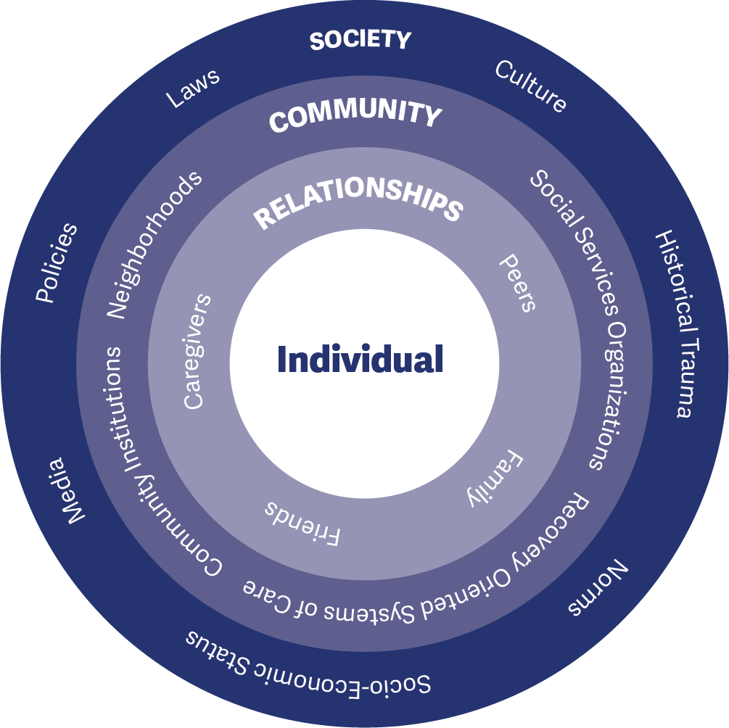
The Massachusetts Photovoice Project is an innovative approach, led by the Massachusetts Department of Public Health Office of Problem Gambling Services (OPGS), to prevent or reduce the occurrence of underage gambling (UG) among youth and problem gambling (PG) among all age groups. The project is implemented within youth-serving social service agencies in Massachusetts to leverage existing prevention infrastructure, assets, and resources within communities at disproportionate levels of risk. The approach is:
- Community-Centered
- Participatory
- Empowerment-Based
- Culturally Responsive
- Equity-Focused
- Grounded in Evidence-Based Principles
Each participating social service agency recruits successive cohorts of up to 12 youth to implement the evidence- informed Photovoice model. Based on empowerment theory, principles of social justice, and documentary photography, Photovoice is intended to enhance the power of community members to become catalysts of change.1 Youth participants receive extensive training and use photography to visually document the issues facing their community and to develop prevention-focused messaging. These efforts work to raise awareness and prompt action among community members and decision-makers.
The project is grounded in the socio-ecological model (Figure 1), which stresses the importance of focusing on the connections between individuals, their social circles and neighborhoods, and the communities in which they live.
This impact brief focuses on early outcomes associated with the implementation of the Massachusetts Photovoice Project within two social service agencies supported during fiscal year 2019. Specifically, it examines early indicators of reach (engaging the community in adequate numbers) and effectiveness (implementing a project that has the potential to achieve its ultimate goal to prevent/reduce UG and PG).

To date, the Massachusetts Photovoice Project has had extensive reach. At a total seed investment of $30,000 to
$33,000 per site across two sites, the project achieved the following during fiscal year 2019:

47

Youth
were trained to be catalysts of change to raise awareness, motivate action, and encourage
attitudes and behaviors incompatible with UG and PG
58

Caregivers
received education on the importance of UG and PG prevention and ways to increase their ability to enhance protective factors and reduce
risk factors among their children

6,088

community members
were exposed to UG and PG prevention messaging – including information on environmental exposure to gambling and the need to promote help-seeking behavior in the community among those in need of UG and PG support.

Early evidence also suggests that the project is positively affecting the knowledge, attitudes, and behaviors that serve as precursors to longer-term community-level change on the ultimate outcomes of interest. The project is poised to have a positive impact and become a replicable model for other states.

1 See for example, Wang, C., & Burris, M.A. (1997). Photovoice: Concept, methodology, and use for participatory needs assessment. Health Education and Behavior, 24(3), 369-387.

Goal 1: Prevent or reduce the occurrence and prevalence of underage gambling (UG) among youth 12-18 years of age and problem gambling (PG) among all age groups
Goal 2: Help youth ages 12-18 develop and maintain the skills and behaviors needed to protect them against developing problems with gambling later in life
OBJECTIVES – WAYS TO ACHIEVE THE GOALS

Socio-Ecological Level: Individual Priority Group: Photovoice Youth
Objective 1: Train and empower youth to be catalysts of change to raise awareness, motivate action, and encourage attitudes and behaviors incompatible with UG and PG

Socio-Ecological Level: Interpersonal Priority Group: Caregivers
Objective 2: Increase caregivers’ understanding of the importance of UG and PG prevention and their ability to enhance protective factors and reduce risk factors

Socio-Ecological Level: Organizational Priority Group: Organizations
Objective 3: Enhance the capacity of youth-serving community organizations to reach diverse youth and incorporate UG and PG prevention into their services and discussions

Socio-Ecological Level: Community Priority Group: Community-Wide
Objective 4: Increase awareness of UG and PG among individuals, subpopulations, and historically marginalized and oppressed communities
EXTERNAL INPUTS – SUPPORT PROVIDED TO THE PROJECT
Each social service agency received between $30,000 and $33,000 in support during fiscal year 2019 from OPGS. Additional non-financial support and technical assistance was provided by the OPGS Program Management Team, the MA Center of Excellence on Problem Gambling Prevention (MCOE PGP) at Education Development Center, Inc., and the Evaluation Team at Social Science Research and Evaluation, Inc.
TIMELINE – TIME PERIOD COVERED
This impact brief covers the initial 16-month implementation period of the Massachusetts Photovoice Project (March 1, 2018 – June 30, 2019). The brief focuses on two social service agencies in the Plainville/Southeast region of Massachusetts.

Kick-Off Meeting
Mar 28, 2018
Pilot Cycle
Fiscal Years 2018 and 2019
(Apr 1, 2018 – Aug 31, 2019)
Curriculum Enhancement
Fiscal Year 2019
(Sept 1, 2018 – Dec 30, 2018)
Second Cycle
Fiscal Year 2019
(Jan 1, 2019 – Jun 30, 2019)

Mar Apr May Jun Jul Aug Sep Oct Nov Dec Jan Feb Mar Apr May Jun
2018
2019
FIGURE 2

Each participating youth-serving social service agency is expected to implement two (2) cycles of Photovoice each calendar year with a new group of youth. Each cycle lasts approximately 5-6 months. During a cycle:
- Project staff work with community partners (e.g., schools) to identify and recruit youth participants.
- Youth who agree to be part of the project and whose parents/caregivers provide consent receive a 16- lesson curriculum to enhance their knowledge and skills related to UG and PG prevention.
- Following training, youth engage in guided photography exercises and participate in weekly facilitated discussions with their peers.
- Once a sufficient number of photographs have been taken, youth collaboratively develop captions for each
photograph that illustrate their perspectives on UG and PG.
- Youth participants share the final product with their caregivers during an educational and recreational event.
- The youth then plan and deliver a community exhibition event to share their work with the broader community (including official representatives and policymakers).
- Following the community exhibition, youth help plan for extended dissemination of their messages in other
community settings and through digital/social media.
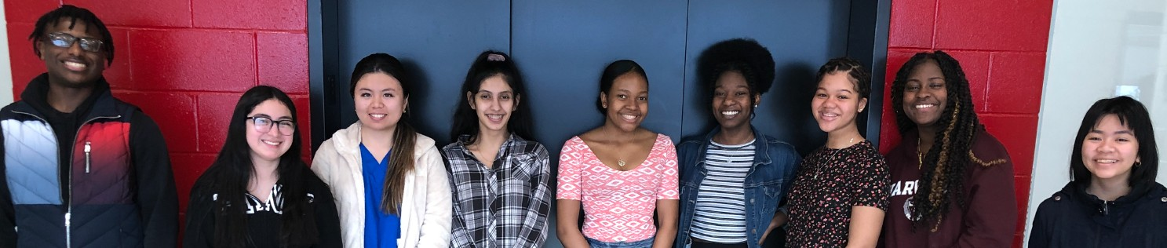

Socio-Ecological Level: Individual Priority Group: Photovoice Youth
Youth Training: Each site recruits up to twelve (12) youth to participate in the project. Youth receive a 16-lesson curriculum on UG and PG prevention, communication skills, public speaking, media literacy, social justice, health disparities, and how to be agents of change within their community.
Youth Groups: Youth take UG and PG related photographs in their community and engage in critical discussion in a facilitated group setting with their peers.
Call to Action: Youth collaboratively develop captions for their photographs that illustrate their perspectives on UG and PG and develop a collective call to action to the community.

Socio-Ecological Level: Interpersonal
Priority Group: Caregivers
Caregiver Education and Recreational Event: Parents/caregivers are convened to learn about UG prevention, celebrate the group’s achievements, and participate in an extracurricular activity with their child(ren) to strengthen family bonds.

Socio-Ecological Level: Organizational Priority Group: Organizations
Professional Development: Adult staff at each program site receive training to increase their knowledge of UG and PG, learn how to deliver the 16- lesson youth curriculum and supplemental project activities, and enhance their group facilitation skills. Ongoing training, technical assistance, and peer support opportunities are provided throughout the project period.

Socio-Ecological Level: Community Priority Group: Community-Wide
Community Exhibition: Youth present their captioned photographs at a community exhibition event and help develop a plan for broader dissemination within their community.
Extended Message Dissemination: Message dissemination activities continue in both physical and digital settings (e.g., community settings, school events, social media).

Socio-Ecological Level: Individual Priority Group: Photovoice Youth
Sites implemented a pilot cycle with 23 youth from April to August 2018. After the pilot, MCOE PGP worked with each site to identify lessons learned and develop a formal curriculum.
Between January and June 2019, sites implemented a second cycle with 24 youth using the formal 16-lesson curriculum to enhance their UG and PG prevention knowledge, awareness, and skills (see figure 3).

47

Youth
Participants
The 47 youth who participated in the pilot and second cycle were mostly in high school and evenly split by gender. Overall, 92% of the youth participants identified as a person of color, including Black, Asian American, and Latinx youth. Exact demographics varied by site.

Knowledge Photovoice UG Prevention PG Prevention Ethics

Awareness Gambling Prevalence and impact
Media Literacy Social Justice Health Disparities

Skill Communication and Public Speaking Photography and Composition Leadership and Empowerment

FIGURE 3

Socio-Ecological Level: Interpersonal Priority Group: Caregivers
During the pilot, a total of 27 caregivers across both sites participated in an educational event to learn about underage gambling, problem gambling, and youth development. Caregivers also had an opportunity to view, recognize, and celebrate their child’s work. Beginning in the second cycle, 31 parents/caregivers were invited to participate in a joint educational and recreational event. The first
portion of the evening included educational content in the same manner as the pilot
58

Caregiver Participants
cycle. The second part of the evening consisted of a recreational activity (e.g., laser tag) to strengthen family bonding.

Socio-Ecological Level: Organizational Priority Group: Organizations
Adult staff from each site received training, technical assistance, and peer support throughout the project. Support consisted of monthly meetings with OPGS and MCOE PGP staff and peers from other sites. In addition to implementation support, the purpose of this assistance was to: (1) increase organizational capacity to support UG and PG prevention programming, (2) embed UG and PG prevention into other initiatives within the organization, and (3) increase organizational capacity to address disparities related to PG within the community.

Socio-Ecological Level: Community Priority Group: Community-Wide

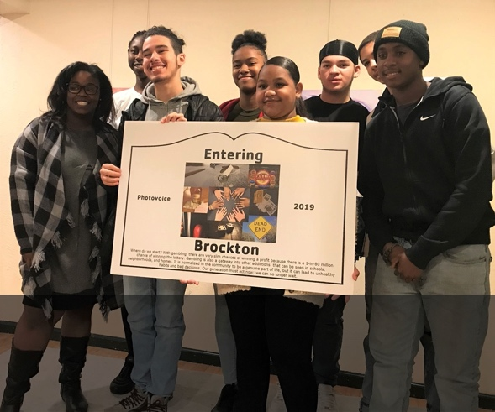
Each Photovoice cycle culminates in an exhibition at a public facility (e.g., library) where youth present their work to increase awareness of and discussions about UG and PG within the community. Across both cycles, 148 individuals attended these events.

6,088 Individuals Reached
Completed Photovoice projects were also displayed during community events (e.g., school open houses, regional meetings, conferences), as part of displays in the community (e.g., coffee house galleries), and through social media (e.g., Facebook and Instagram). In addition to the individuals reached during the public exhibition, 760 individuals were reached through community events, 3,115 individuals were reached through community displays, and 2,065 individuals were reached through posts and articles on social media.

Public Exhibition
148
Community Event
760
Community Display
3,115
Social Media
2,065
FIGURE 4
PROJECT OUTPUTS AND EARLY IMPACT – VOICES FROM THE FIELD

Photovoice Youth Voices

“I feel like gambling isn’t talked about much. Nobody talks to us about it in a serious manner. It is glamorized. It was nice to take the time to discuss it. We are way more aware of it now.”
- Youth Participant

“I realized that society doesn’t focus on gambling on as much as other issues like alcohol and drug abuse. I was not aware of how severe gambling can be – it is one of many things in the world that can have serious consequences but is viewed as being normal.”
- Youth Participant

“My public speaking has gotten a lot better. I am not as afraid to talk to as many people anymore. It does not make me as nervous. I want to thank the staff for giving us all an opportunity to make our voices heard.”
- Youth Participant

Photovoice Adult Staff Voices

“After the first cycle, I noticed youth inquiring about further opportunities to be involved in prevention work in their community as a result of their enthusiasm for this project.”
- Adult Staff

“When taking photos in the community, youth observed multiple scratch tickets discarded on the ground. They realized that when some people just throw losing tickets on the ground creating litter in our community. They began to see gambling not only from a health equity lens, but from an environmental justice lens.“
- Adult Staff

“The youth noted how easy it was to identify places that had the lottery because of the bright blue logo in the window. Many noted that the constant visual reminder of gambling opportunities in our community makes it hard to escape – even if you are not intending to gamble.”
- Adult Staff
PROJECT OUTPUTS AND EARLY IMPACT – LESSONS LEARNED FROM ADULT STAFF

Group Composition
- Youth with and without experience gambling both bring unique perspectives to the group.
- There may be value to having gender-specific groups. Youth participants may be more open to engaging in critical dialogue in a single-gender environment.
- Vocational Technical students can benefit the group because they often have technical skills that other students may not possess (e.g., instruction in photography, graphic design, access to software, etc.).

Implementation
- Youth group facilitation skills are essential for the person running the group. The facilitator needs to be on an equal level with the youth rather than being viewed as being a supervisor – listen more and talk less.
- It is better to meet with the youth twice a week to keep momentum and promote group bonding.
- Youth engagement and retention can be facilitated by providing food and ensuring that school-based or public trans- portation is available around meeting times and locations.
- It is important to leave time at the end of each lesson to debrief with the youth, let them ask questions, and make sure that they understand the concepts and skills addressed in the group.
- The project should be firmly tied to the academic calendar. School vacations, summer jobs, and summer schedules make it difficult for youth and adults to participate in groups or attend community events.
- Work with existing groups and coalitions in the community to broaden the reach of the project and to leverage access to different individuals and groups of people.

Opportunities for Enhancement
- It may be beneficial to be able to work with the same cohort of youth over a longer period of time (multiple academic semesters or years) so they can actualize their long-term vision to impact the community.
- The project should make greater use of social media to reach a broader audience of community members.
- Project messages and materials should be professionally translated to match the cultural and linguistic composition of the community (e.g., Spanish, Portuguese).

In alignment with these findings, the Photovoice Project will continue to make iterative improvements to implementation activities, including increased use of social media and strengthened long-term efforts through an enhanced call to action component. Youth will continue to act as catalysts of change in their communities.
For further information, please visit our website at
mass.gov/problemgambling

