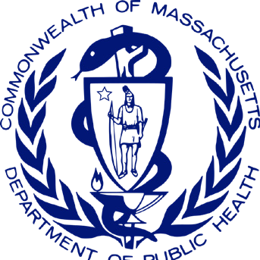
Massachusetts Photovoice Project Impact Brief Office of Problem Gambling Services
Cumulative Impact Report for July 1, 2018 – December 31, 2020

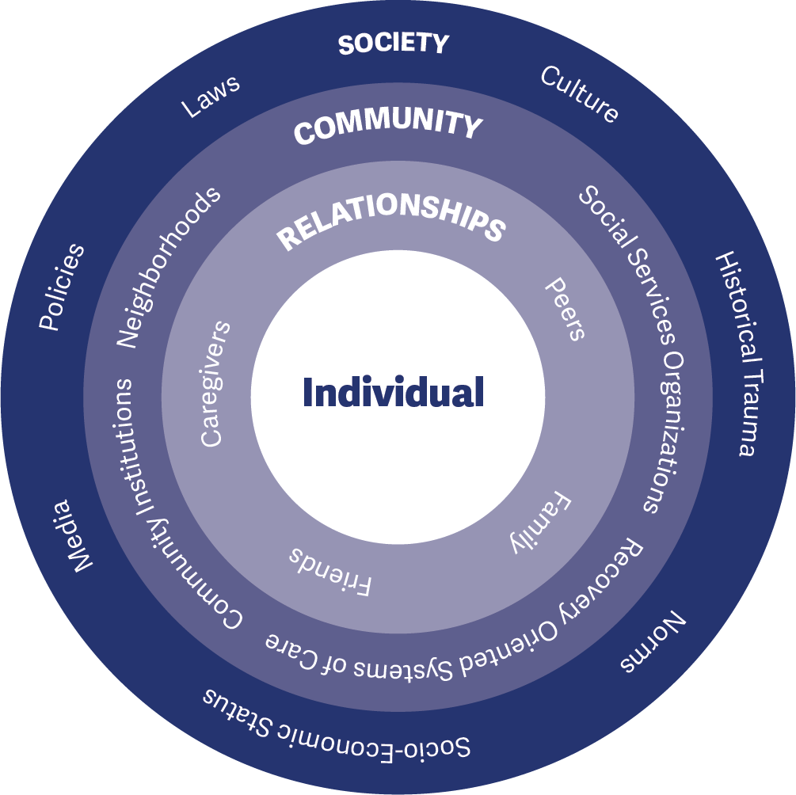
The Massachusetts Photovoice Project is an innovative approach to prevent or reduce the occurrence of underage gambling (UG) among youth and problem gambling (PG) among all age groups. The project was established after a comprehensive community engagement and planning process to promote equity, engagement, and empowerment throughout problem gambling programs. The MA Photovoice Project was piloted during fiscal year 2019 and moved to full program implementation during fiscal year 2020. The project is grounded in the socio-ecological model (Figure 1), which stresses the importance of focusing on the connections between individuals, their social circles and neighborhoods, and the communities in which they live.
The MA Photovoice Project is led by the Massachusetts Department of Public Health Office of Problem Gambling Services (OPGS) and implemented within five youth-serving social service agencies in Massachusetts to leverage existing prevention infrastructure, assets, and resources within communities at disproportionate levels of risk. The approach is:
- Community-Centered
- Participatory
- Empowerment-Based
- Culturally Responsive
- Equity-Focused
- Grounded in Evidence-Based Principles
Each participating social service agency recruits successive cohorts of up to 12 youth to implement the evidence-informed Photovoice model. Based on empowerment theory, principles of social justice, and documentary photography, Photovoice is intended to enhance the power of community members to become catalysts of change. Youth participants receive extensive training and use photography to visually document the issues facing their community and to develop prevention-focused messaging. These efforts work to raise awareness and prompt action among community members and decision-makers.
This impact brief focuses on early outcomes associated with the implementation of the Massachusetts Photovoice Project within five social service agencies supported between July 2018 and December 2020. Specifically, it examines early indicators of reach (engaging the community in adequate numbers) and effectiveness (implementing a project that has the potential to achieve its ultimate goal to prevent/reduce UG and PG).
This is a cumulative brief that covers July 2018 (project development and pilot) to December 2020 (implementation). The first iteration of this brief, detailing July 2018-June 2019, can be found here: MA Photovoice Project Impact Brief 2019. Please see the Timeline section for more details.
The Photovoice Project has had extensive reach. At an annual investment of $50,000 per organization, the project has achieved the following between July 2018 and December 2020:

15

Groups
of diverse youth across five different social service agencies have taken part in the Photovoice project
161

Youths
were trained to be catalysts of change to raise awareness, motivate action, and encourage attitudes and behaviors incompatible with UG and PG
124

Caregivers
received education on the importance of UG and PG prevention and ways to increase their ability to enhance protective factors and
reduce risk factors among their children

7,258

Community Members
were exposed to UG and PG prevention messaging
– including information on environmental exposure to gambling and the need to promote help-seeking behavior among those needing support

Early evidence also suggests that the project is positively affecting the knowledge, attitudes, and behaviors that serve as precursors to longer-term community-level change on the ultimate outcomes of interest. The project is poised to have a positive impact and
become a replicable model for other states. 1

GOALS – PURPOSE OF THE PROJECT

Goal 1:
Prevent or reduce the occurrence and prevalence of underage gambling (UG) among youth 12-18 years of age and problem gambling (PG) among all age groups

Goal 2:
Help youth ages 12-18 develop and maintain the skills and behaviors needed to protect them against developing problems with gambling later in life
OBJECTIVES – WAYS TO ACHIEVE THE GOALS

Socio-Ecological Level: Individual Priority Group: Photovoice Youth
Objective 1: Train and empower youth to be catalysts of change to raise awareness, motivate action, and encourage attitudes and behaviors incompatible with UG and PG

Socio-Ecological Level: Interpersonal Priority Group: Caregivers
Objective 2: Increase caregivers’ understanding of the importance of UG and PG prevention and their ability to enhance protective factors and reduce risk factors

Socio-Ecological Level: Organizational Priority Group: Organizations
Objective 3: Enhance the capacity of youth-serving community organizations to reach diverse youth and incorporate UG and PG prevention into their services and discussions

Socio-Ecological Level: Community Priority Group: Community-Wide
Objective 4: Increase awareness of UG and PG among individuals, subpopulations, and historically marginalized and oppressed communities
EXTERNAL INPUTS – SUPPORT PROVIDED TO THE PROJECT

Fiscal Support
Office of Problem Gambling Services (OPGS): Each of the five social service agencies receives $50,000 annually from the Office of Problem Gambling Services to implement the Photovoice Project.

Management and Operations Support
Office of Problem Gambling Services (OPGS): The Program Management Team at OPGS actively monitors and supports each implementing site, including fiscal management, roles and responsibilities, scope of work, and adherence to requirements.

Training and Technical Assistance Support
MA Center of Excellence on Problem Gambling Prevention (MCOE PGP): The Training and Technical Assistance (TA) Team at MCOE PGP provides support to each implementing site. Subject matter experts assist sites, individually and collectively, to problem-solve implementation challenges and enhance capacity.

Evaluation Support
Social Science Research and Evaluation, Inc. (SSRE): The Evaluation Team at SSRE assists implementing sites with data collection, activity tracking, and monthly reporting requirements through the development and management of a series of data collection forms and databases.

TIMELINE – TIME PERIOD COVERED
This brief covers July 2018 to December 2020 (early implementation period). During this time, OPGS has supported and continues to support one social service agency in Region A (Eastern MA), two agencies in Region B (Western MA), and two agencies in Region C (Southeastern MA). Milestones are summarized below.

Regional Planning Process, Project Development, and Start-Up (January 2017 – April 2018)
Beginning in January 2017, the first 16-months of the project involved assessing needs, resources, and concerns in each region through a structured regional planning process; development of the Photovoice Project model; identification of the initial Region C pilot sites; and training and start-up activities.

Pilot Implementation, Curriculum Enhancement, and Second Cycle (May 2018 – June 2019)
The pilot implementation period began in May 2018 and lasted through August 2018 with two sites in Region C. This was followed by a structured debriefing process with the sites and an intensive period of revising and refining the final Photovoice curriculum. The second cycle with the revised curriculum was implemented in the two Region C sites between March 2019 and June 2019 (see MA Photovoice Project Impact Brief 2019).

Addition of New Sites and Third Cycle (July 2019 – March 2020)
One site in Region A and two sites in Region B joined the two existing Region C sites in July 2019 and all five sites implemented the third Photovoice cycle between October 2019 and early March 2020. The third cycle of Photovoice was interrupted near the end by the COVID-19 pandemic and physical distancing restrictions.

Virtual Instagram Project (March 2020 – August 2020)
Due to the COVID-19 pandemic, sites implemented an Instagram project in spring and summer 2020 while enhancing their capacity and infrastructure to facilitate virtual implementation of Photovoice in fall 2020.

Fourth Cycle – Full Virtual (September 2020 – December 2020)
Beginning in September 2020 and lasting into early 2021, all five sites initiated a fully virtual fourth cycle of Photovoice – all youth sessions and community events were held online. This cycle was still ongoing as of the writing of this brief – complete data from this cycle will be reported in the 2021 Impact Brief.

First Cycle (Pilot)
Initial Pilot Implementation Begins in Two Region C Photovoice Sites
(5/1/18 – 8/31/18)

Training and Planning with Region C Photovoice Sites (4/1/18 – 4/30/18)

Second Cycle
Two Region C Sites Begin Implementation of Second Photovoice Cycle
(3/1/19 – 6/30/19)
Transition to Instagram Project The Five Sites Transition to Planning
and Implementing a Virtual Instagram Project Due to the COVID-19 Pandemic

OPGS and MCOE PGP Develop the
Curriculum Enhancement
Third Cycle
(3/10/20 – 6/30/20)

Massachusetts Photovoice Model
(8/1/17 – 12/31/17)
Region A and B Planning Processes
Begin(12/1/17)

Region C
Project Kick-off
Revisions and Enhancement to Photovoice Curriculum (9/1/18 – 12/31/18)

Region A and B Planning Reports Released (12/31/18)
All Five Sites Implement Photovoice Cycle with Youth
(10/1/19 – 12/31/19)

Two Region B Sites and One Region A Site Join Project

Fourth Cycle (Full Virtual)
All Sites Implement Virtual Photovoice Cycle with Youth (9/1/20 – 12/31/20)

Region C
Planning Process and Preparation of Report
Meeting (3/28/18)

Two Region C
Two Region C Sites Receive Training
on Revised
(7/1/19)

Preparation for Next Photovoice
Third Photovoice Cycle Continues
Planning and Preparation for Transition to Virtual

Region C
Planning Process Begins
FIGURE 2
Region C Planning Process Report Released
Sites Selected for Photo- voice Project
Curriculum and Begin Planning (1/1/19 – 2/28/19)
Cycle
(7/1/19 – 9/30/19)
in All Five Sites
(1/1/20 – 3/9/20)
Photovoice Cycle
(7/1/20 – 8/31/20)
3

J | F | M | A | M | J | J | A | S | O | N | D | J | F | M | A | M | J | J | A | S | O | N | D | J | F | M | A | M | J | J | A | S | O | N | D | J | F | M | A | M | J | J | A | S | O | N | D
2017 |  |  |  |  |  |  |  |  |  |  |  | 2018 |  |  |  |  |  |  |  |  |  |  |  | 2019 |  |  |  |  |  |  |  |  |  |  |  | 2020

PROJECT ACTIVITIES – HOW THE PROJECT OPERATES
Each participating youth-serving social service agency is expected to implement two (2) cycles of Photovoice each calendar year with a new group of youth. Each cycle lasts approximately 5-6 months. During a cycle:
- Project staff work with community partners (e.g., schools) to identify and recruit youth participants.
- Youth who agree to be part of the project and whose parents/caregivers provide consent receive a 16-lesson curriculum to enhance their knowledge and skills related to UG and PG prevention.
- Following training, youth engage in guided photography exercises and participate in weekly facilitated discussions with their peers.
- Once a sufficient number of photographs have been taken, youth collaboratively develop captions for each photograph that illustrate their perspectives on UG and PG.
- Youth participants share the final product with their caregivers during an educational and recreational event.
- The youth then plan and deliver a community exhibition event to share their work with the broader community (including official representatives and policymakers).
- Following the community exhibition, youth help plan for extended dissemination of their messages in other community settings and through digital/social media.
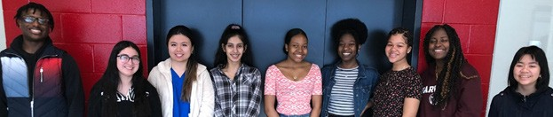

Socio-Ecological Level: Individual Centered Group: Photovoice Youth
Youth Training: Each site recruits up to twelve (12) youth to participate in the project. Youth receive a 16-lesson curriculum on UG and PG prevention, communication skills, public speaking, media literacy, social justice, health disparities, and how to be agents of change within their community.
Youth Groups: Youth take UG and PG related photographs in their community and engage in critical discussion in a facilitated group setting with their peers.
Call to Action: Youth collaboratively develop captions for their photographs that illustrate their perspectives on UG and PG and develop a collective call to action to the community.

Socio-Ecological Level: Interpersonal Centered Group: Caregivers
Caregiver Education and Recreational Event: Parents/ caregivers are convened to learn about UG prevention, celebrate the group’s achievements, and participate in an extracurricular activity with their child(ren) to strengthen family bonds.

Socio-Ecological Level: Organizational Centered Group: Organizations
Professional Development: Adult staff at each program site receive training to increase their knowledge of UG and PG, learn how to deliver the 16-lesson youth curriculum and supplemental project activities, and enhance their group
facilitation skills. Ongoing training, technical assistance, and peer support opportunities are provided throughout the project period.

Socio-Ecological Level: Community Centered Group: Community-Wide
Community Exhibition: Youth present their captioned photographs at a community exhibition event and help develop a plan for broader dissemination within their community.
Extended Message Dissemination: Message dissemination activities continue in both physical and digital settings (e.g., community settings, school events, social media).
(NEW) Instagram Project: Implemented during the COVID-19 pandemic, youth across the different sites shared an Instagram page and took turns posting images to raise awareness of UG and PG (see Youth Photovoice MA Instagram Page)

PROJECT OUTPUTS – PROGRESS TOWARD GOALS

Socio-Ecological Level: Individual Centered Group: Photovoice Youth
On average, each site has successfully recruited 11 youth for each cycle. Between July 2018 and December 2020, the five sites collectively engaged 161 youth in the Photovoice project to enhance their knowledge, awareness, and skills as catalysts of change.
Approximately three-quarters of these youth (77%) were in grades 9-12 with the remainder in grades 6-8. Two- thirds of these youth were female (66%) and 34% were male.

161

Youth
Participants
Nearly half of the youth identified as Black or African American (45%) and 38% reported Latinx ancestry. Overall, 88% of the 161 youth participants identified as a person of color.
Exact demographics varied by site.

Knowledge Photovoice UG Prevention PG Prevention Ethics
Awareness Gambling Prevalence and impact
Media Literacy Social Justice Health Disparities
Skill Communication and Public Speaking Photography and Composition Leadership and Empowerment

Socio-Ecological Level: Interpersonal Centered Group: Caregivers
FIGURE 3

124

Caregiver
Participants
Between July 2018 and December 2020, a total of 124 parents/caregivers of Photovoice youth participants attended a caregiver event. These events consist of an educational component and a recreational component. During the educational component, caregivers learn about underage gambling, problem gambling, and youth development. Caregivers also have an opportunity to view, recognize, and celebrate their child’s work. In addition to the educational component, caregivers and their child(ren) are invited to participate in a recreational activity (e.g., laser tag, game night) to strengthen family bonding.
During 2020, caregiver events were held online in adherence with COVID-19 physical distancing restrictions and recreational activities included things that families could do together without being in close proximity to others (e.g., drive-in movie tickets).

Socio-Ecological Level: Interpersonal Centered Group: Caregivers
Adult staff from each site have received intensive training, technical assistance, and peer support throughout the project. Support consists of monthly meetings with OPGS and MCOE PGP staff and peers from other sites. The purpose of this assistance is to: (1) increase organizational capacity to support UG and PG prevention programming, (2) embed UG and PG prevention into other initiatives within the organization, and (3) increase organizational capacity to address disparities related to PG within the community.

Socio-Ecological Level: Community Centered Group: Community-Wide
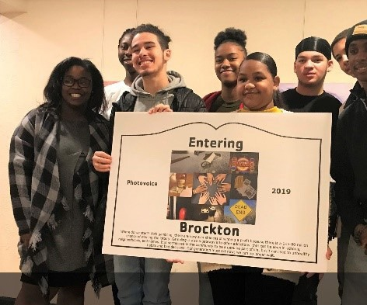
Each Photovoice cycle culminates in an exhibition at a public facility (e.g., library, event hall) where youth present their work to increase awareness of and discussions about UG and PG within the community. Between July 2018 and December 2020, a total of 275 individuals attended these events.
Completed Photovoice projects were also displayed during community events (e.g., school open houses, conferences), as part of displays in the community (e.g., coffee house galleries), and through social media (e.g., Facebook and Instagram). In addition to the individuals reached during the public exhibition, 760 individuals were reached through community events, 3,115 individuals through community displays, and 3,108 through

7,258

Individuals Reached
posts and articles on social media. Most individuals (1,170) reached during calendar year 2020 were reached through the Instagram Project due to COVID-19 physical distancing restrictions.

Public Exhibition
275
Community Event
760
Community Display
3,115
Social Media
3,108
FIGURE 4
PROJECT OUTCOMES – VOICES FROM THE FIELD

Photovoice Adult Staff Voices

“The youth have a way of voicing what matters to them in a way that is sometimes foreign to adults. They knew what they were doing.”
- Program Staff

“I am super proud of our youth that we have worked with this year. It’s been amazing to see how they were still engaged through all the changes around them. They adapted.”
- Program Director

“The youth are always what makes it go well and be worthwhile. Taking photos during COVID-19 is powerful. We’re in a historical moment. This is the best part of it. The kids may look back on these photos someday and show their kids.”
- Program Staff

“Our last caregiver event was amazing. We encouraged caregivers to share their own experiences and speak about problem gambling from their perspective. We also asked them to listen to the youth and build their understanding together.”
- Program Director

Photovoice Youth Voices

“I learned about equality and equity, that youth gambling is actually a problem, and that pandemics are not fun.”
- Photovoice Youth

“We talked a lot about social justice because of all the things that were going on this year. It’s our future, whether it’s gambling or some other thing… if we want to change our communities, we will have to take action ourselves.”
- Photovoice Youth

“When school was all remote, this was a way for me to still see my friends and talk to people outside of class…. even if it was still on the computer. We got our work done, but it was the social piece too.”
- Photovoice Youth

“These opportunities are so great because we, as students, get to learn about things that we usually don’t get to learn in school. I never knew the risks of problem gambling before this…. how much it pulls you in.”
- Photovoice Youth
LESSONS LEARNED

- The social media component (Instagram) that was added to the project during the COVID-19 pandemic should be retained as a method for recruiting new youth and expanding the reach of the project. Potentially recruiting youth who are specifically interested in managing a social media arm of the project.
- Engage youth who have already taken part in the project in past cycles to be peer leaders for future cycles. This can be a way to continue to support their personal growth and development and to leverage the knowledge that they gained to help support new groups of youth.
- Explore opportunities for youth from the five project sites to meet together (virtually or in-person) to share their work, experiences, and knowledge with each other – including having youth from each site attend (virtually) each group’s community exhibition.
- This is a youth-led project with adult facilitation. Opportunities should be created for youth-centric decision-making and youth voice should always be centered in the work.
- Continue offering supplemental virtual options for the parent/caregiver event and community exhibition is a way to increase reach and to allow multiple caregivers to participate who might not otherwise have the opportunity given scheduling and other obligations.
- Consider extending the implementation cycle from 16 weeks to 20 or 24 weeks to account for additional messaging and call to action work within a cycle.
- It may be beneficial to work with the same cohort of youth over longer periods of time (multiple semesters or years) so they can actualize their long-term vision to impact the community.
- All outward facing project messages and materials should be professionally translated to match the cultural and linguistic composition of the community (e.g., Spanish, Portuguese).

Additional lessons learned, many of which have already been adopted, can be found in the Photovoice Project Impact Brief 2019. Lessons learned will be iteratively integrated into the project.
For further information, please visit our website at www.mass.gov/problemgambling

