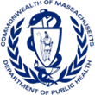
Massachusetts Photovoice Project Impact Brief Office of Problem Gambling Services
Cumulative Impact Report for January 1, 2021 – June 30, 2023

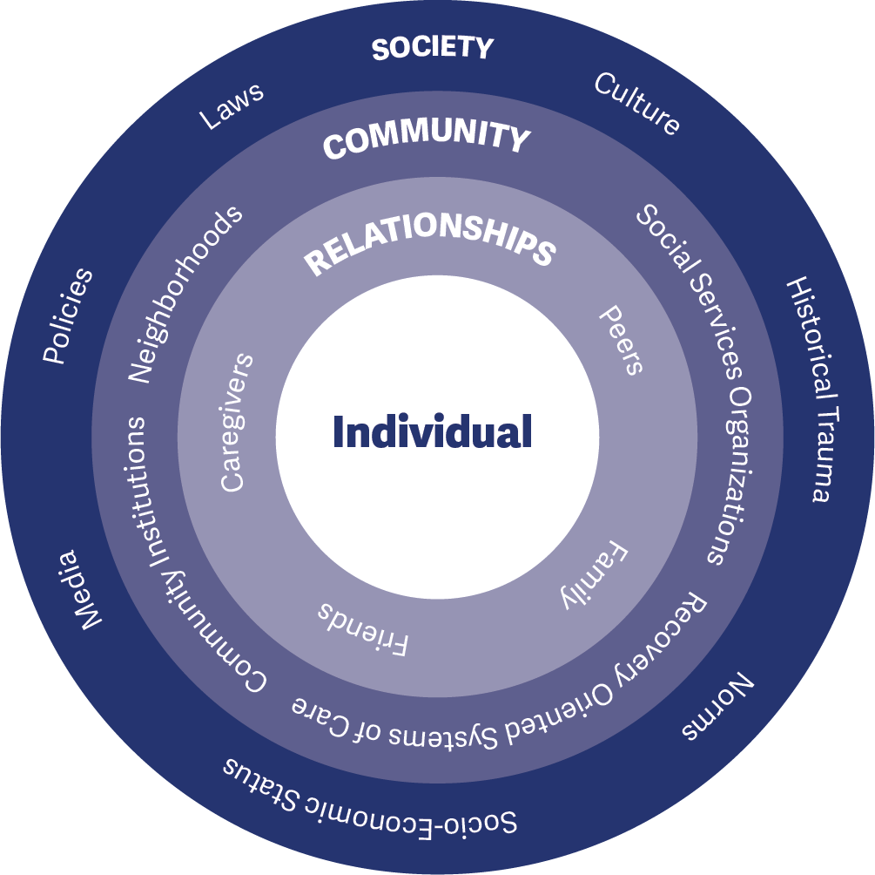
The Massachusetts Photovoice Project is an innovative, youth-centered approach to prevent or reduce the occurrence of underage gambling among youth and problem gambling among all age groups by engaging and training youth to document environmental community conditions and factors related to gambling behaviors and its associated consequences using photography and storytelling to raise awareness and generate calls to action for change.
The project was established by the Massachusetts Department of Public Health Office of Problem Gambling Services (OPGS) as a direct result of a multi-year comprehensive planning process that engaged over 200 residents and stakeholders across the Commonwealth to discuss the issue of problem gambling and to explore ways in which it affects people, places, and spaces. The planning process and project design were both guided by a universal shared commitment to respect for persons, authentic engagement, the promotion of racial and health equity, and community empowerment.
Historically, efforts to mitigate gambling-related harms have centered on the promotion of individual responsibility and have ignored the broader life and community contexts in which these behaviors, harms, and consequences occur. The MA Photovoice Project is centered on the socio-ecological model (Figure 1) – a comprehensive approach rooted in public health principles that stresses the importance of focusing on the interconnectedness between individuals, their social circles and neighborhoods, and aspects of the communities in which they live.
Since May 2018, the Photovoice project has been implemented within eight youth-serving social service agencies in Massachusetts. Each participating youth-serving social service agency recruits successive cohorts of up to 15 youth (ages 12-18) to implement Photovoice – an evidence-informed model based on empowerment theory, principles of social justice, and documentary photography that enhances the power of community members to become catalysts of change. Youth participants receive extensive training on problem gambling prevention and use photography and storytelling to depict how gambling and gambling imagery around them impact their communities. Youth showcase their photography projects with parents/caregivers, stakeholders, and community members to raise awareness and encourage community-level change. Each Photovoice group also develops and implements a 16-week youth-led community action project on an issue related to underage and problem gambling.
This approach is:
- Community-Centered
- Participatory
- Empowerment-Based
- Culturally Responsive and Equity-Focused
- Grounded in Evidence-Based Principles
The MA Photovoice Project is focused on having a strong impact – ultimately preventing or reducing problem gambling in centered populations. Impact involves having both the necessary reach (visibility and comprehensive coverage) and effectiveness (achievement of desired goals and objectives). This brief focuses on the period between January 1, 2021, and June 30, 2023.
Impact briefs on earlier periods are referenced in the Timeline section.
The Photovoice Project has had extensive reach. At an average annual investment of $86,000 per organization, the project has achieved the following between January 2021 and June 2023:

23

Groups
of diverse youth across eight different social service agencies participated in Photovoice
215

Youth
were trained to be catalysts of change to raise awareness and motivate action to prevent or reduce underage and problem gambling
210

Caregivers
received education on problem gambling prevention and ways to modify risk and protective factors among their children
14,478
Community Members
were exposed to prevention messages – including information on exposure to gambling and the need to promote help-seeking behavior among those needing support
Evidence suggests the project is positively affecting the knowledge, attitudes, and behaviors that serve as precursors to longer-term community-level change. The MA Photovoice project is a replicable model for other states working to prevent problem gambling.

GOALS – PURPOSE OF THE PROJECT

Goal 1
Prevent or reduce the occurrence and prevalence of underage gambling among youth 12-18 years of age and problem gambling among all age groups.

Goal 2
Help youth ages 12-18 develop and maintain the skills and behaviors needed to protect them against developing problems with gambling later in life.
OBJECTIVES – WAYS TO ACHIEVE THE GOALS

Socio-Ecological Level: Individual Priority Group: Photovoice Youth
Objective 1: Train and empower youth to be catalysts of change to raise awareness, motivate action, and encourage attitudes and behaviors incompatible with underage and problem gambling.

Socio-Ecological Level: Interpersonal Priority Group: Caregivers
Objective 2: Increase caregivers’ understanding of the importance of underage and problem gambling prevention and their ability to enhance protective factors and reduce risk factors.

Socio-Ecological Level: Organizational Priority Group: Organizations
Objective 3: Enhance the capacity of youth-serving community organizations to reach diverse youth and incorporate underage and problem gambling into their services and discussions.

Socio-Ecological Level: Community Priority Group: Community-Wide
Objective 4: Increase awareness of underage and problem gambling among individuals, subpopulations, and historically marginalized and oppressed communities.
EXTERNAL INPUTS – SUPPORT PROVIDED TO THE PROJECT

Fiscal Support
Office of Problem Gambling Services (OPGS): Each of the youth-serving social service agencies received an average of $86,000 annually from OPGS to implement the Photovoice Project during the period covered in this brief.

Management and Operations Support
Office of Problem Gambling Services (OPGS): The Program Management Team at OPGS actively monitors and supports each youth-serving agency, including fiscal management, roles and responsibilities, scope of work, and adherence to project requirements.

Training and Technical Assistance Support
Massachusetts Center of Excellence on Problem Gambling Prevention (MCOE PGP): The Training and Technical Assistance Team at MCOE PGP provides support to each implementing site. Subject matter experts assist sites, individually and collectively, to problem-solve implementation challenges and enhance capacity.

Evaluation Support
Social Science Research and Evaluation, Inc. (SSRE): The Evaluation Team at SSRE assists implementing sites with data collection, activity tracking, and monthly reporting requirements through the development and management of a series of data collection forms and databases.

TIMELINE – TIME PERIOD COVERED
This impact brief covers January 2021 to June 2023 (Cohorts 4-7). During this time, OPGS supported two youth-serving organizations in Region A (Boston Area), three organizations in Region B (Western MA), and three organizations in Region C (Southeast MA). Milestones and key dates are summarized below.

Regional Planning Process, Project Development, and Start-Up (January 2017 – April 2018)
Beginning in January 2017, the first 16-months of the project involved assessing needs, resources, and concerns in each OPGS region through a structured planning process; development of the Massachusetts Photovoice Project model; identification of the initial Region C pilot sites; and hiring, training, and start-up activities.
Region C Planning Process (January – June 2017) (see Region C Report)
OPGS and MCOE PGP develop the Massachusetts Photovoice model (August – December 2017)
Region A and B planning processes (December 2017 – December 2018) (see Region A Report and Region B Report)
Two Region C sites selected for the Photovoice Project and begin start-up activities (January – April 2018)

Pilot Implementation Phase (May 2018 – June 2019)
The pilot implementation period began in May 2018 and lasted through August 2018 with two sites in Region C. This was followed by a structured debriefing process with the sites and an intensive period of revising and refining the Photovoice curriculum. The second cohort, using the revised curriculum, was implemented in the two Region C sites between March 2019 and June 2019.
Cohort 1: Initial pilot implementation begins in two Region C Photovoice sites (May 2018 – August 2018)
Cohort 2: Two Region C Photovoice sites implement the revised curriculum (March 2019 – June 2019)
MA Photovoice Project Impact Brief released (see MA Photovoice Project Impact Brief 2019)

Phase 1 Implementation (July 2019 – June 2022)
One site in Region A and two sites in Region B joined the two existing Region C sites in July 2019 and all five sites implemented Photovoice between October 2019 and early March 2020. This cycle of was interrupted by the COVID-19 pandemic and physical distancing restrictions. Due to the pandemic, sites implemented a virtual Instagram project in spring and summer 2020 while enhancing their capacity and infrastructure to facilitate virtual implementation of Photovoice in fall 2020.
Two additional Region B sites and one Region A site join the project (July 2019)
Cohort 3: One Region A, two Region B, and two Region C sites implement Photovoice (October 2019 – March 2020)
COVID-19 pandemic state of emergency declared – sites shift to a virtual Instagram project (March 2020 – June 2020)
MA Photovoice Project Impact Brief released (see MA Photovoice Project Impact Brief 2020)
Cohort 4: Five sites deliver a fully virtual Photovoice cycle (October 2020 – June 2021)
Cohort 5: Four sites deliver a hybrid virtual and in-person Photovoice cycle (September 2021 – February 2022)
Cohort 6: Three program sites deliver a fully in-person Photovoice cycle (March 2022 – June 2022)

Phase 2 Implementation (July 2022 – June 2023)
The Phase 2 implementation period started in July 2022 following a competitive Request for Response (RFR) issued by OPGS that sought to identify up to eight implementation sites in the Commonwealth. This phase of the project, expected to continue through June 2029, supports full implementation of the revised Photovoice 2.0 project.
OPGS funds two Region A, two Region B, and three Region C sites (see OPGS MA Photovoice 2.0 Project RFR)
OPGS and MCOE PGP modify the Photovoice model to last a full academic year rather than two cycles per academic year along with additional program requirements and re-brand model as Photovoice 2.0 (July 2022 – October 2022)
Cohort 7: Seven program sites implement the Photovoice 2.0 model (November 2022 – June 2023)
Sports betting (online and in-person) is legalized in Massachusetts for residents 18 and older (January 31, 2023)

PROJECT ACTIVITIES – HOW THE PROJECT OPERATES
Prior to July 2022, each participating youth-serving social service agency was expected to implement two cycles of Photovoice each academic year (fall and spring) with a new group of youth. Beginning in July 2022, each agency is expected to implement one cycle of Photovoice spanning the full academic year. During a cycle:
September - December
- Project staff work with community partners (e.g., schools) to identify and recruit youth for after-school Photovoice project.
- Youth who agree to be part of the Photovoice project (with parent/caregiver consent) take part in an eight session youth education curriculum to enhance their knowledge and skills related to underage and problem gambling prevention.
- Youth engage in guided photography exercises and participate in weekly facilitated discussions with their peers to collaboratively develop photo captions that illustrate their perspectives on underage and problem gambling.
January - February
- Parents and caregivers are invited to participate with their children in a family education and recreational event where they learn about underage and problem gambling, view their child’s photographs and captions, and bond as a family.
- Youth plan and deliver a community exhibition event to share their work with the broader community (including municipal representatives, administrators, policymakers, and residents).
March – June
- Youth identify an issue related to underage and problem gambling about which they are passionate and develop a community action plan to build awareness about the issue.
- Youth implement the community action plan through a combination of awareness raising activities, direct service work, and calls to action to people, places, or groups that have power or influence to create community change.

July – August
- The youth-serving social service agency begins planning and preparation for the next cycle with a new cohort of youth.
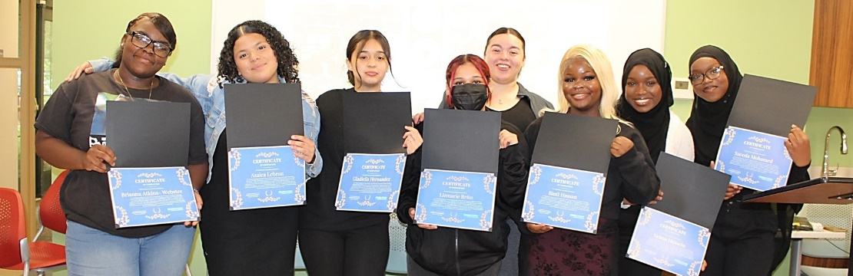

Socio-Ecological Level: Individual Centered Group: Photovoice Youth
Education: Each site recruits up to 15 youth (ages 12-18) to participate in the Photovoice project. Youth receive an eight session curriculum on underage and problem gambling, communication skills, public speaking, media literacy, social justice, health disparities, and how to be agents of change.
Photographs and Discussion: Youth take photographs in their community related to underage and problem gambling and engage in critical discussion in a facilitated group setting with their peers to develop captions.

Socio-Ecological Level: Interpersonal Centered Group: Caregivers
Caregiver Education and Recreational Event: Parents and caregivers are invited to learn about underage gambling prevention, celebrate the group’s achievements, and participate in an extracurricular activity with their child(ren) to strengthen family bonds.

Socio-Ecological Level: Organizational Centered Group: Organizations
Professional Development: Adult staff at each site receive training to increase their knowledge of underage and problem gambling, learn how to implement the Photovoice model, and enhance their group facilitation skills. Ongoing training, technical assistance, and peer support opportunities are provided throughout the project.

Socio-Ecological Level: Community Centered Group: Community-Wide
Community Exhibition: Youth present their captioned photographs at a community exhibition event and identify ways to share this information and raise awareness in the broader community (e.g., school events, print media, social media).
Community Action Plan: Youth identify an issue related to underage and problem gambling (e.g., mental health promotion), develop a community action plan to raise awareness and motivate action, and implement the plan in collaboration with people, places, and groups that have the power to influence or remove barriers to community action.

PROJECT OUTPUTS – PROGRESS TOWARD GOALS

Socio-Ecological Level: Individual
Centered Group: Photovoice Youth
215 youth were recruited and trained to be catalysts of change to raise awareness and motivate action to prevent or reduce underage and problem gambling. On average, each site successfully recruited 9 youth for each cycle. See (Sample Recruitment Materials).
Most youth who participated (80%, 171 youth) were in grades 9-12 and 44 youth (20%) were in grades 6-8. Approximately two-thirds of youth (62%, 134 youth) identified as female, one-third (33%, 72 youth) identified as male, and 4% (9 youth) identified their gender in some other way. Over three-quarters of youth (78%, 137 youth) identified as a person of color – with the largest proportions identifying as Black or African American (42%, 74 youth), more than one race (11%, 19 youth), and Asian (9%, 16 youth). Over one-third of youth (36%, 56 youth) reported Hispanic/Latino/Latina/Latine ancestry.

Socio-Ecological Level: Interpersonal
Centered Group: Caregivers
210 parents and caregivers attended a caregiver event to learn about what adults can do to prevent or reduce underage and problem gambling. On average, 10 caregivers participated in each event.
These events consisted of educational and recreational components. During the educational component, caregivers learned about underage gambling, problem gambling, and youth development with an emphasis on ways to enhance protective factors and reduce risk factors among their children. Caregivers also had an opportunity to view, recognize, and celebrate their child’s work. In addition to the educational component, caregivers and their child(ren) were invited to participate in a recreational activity (e.g., laser tag, bowling, game night) to strengthen family bonding. See (Sample Caregiver Education Materials).

Socio-Ecological Level: Organizational
Centered Group: Organizations
23 photovoice groups were facilitated by eight different youth-serving social service agencies.
Adult staff from each site received intensive training, technical assistance, and peer support throughout the project. Support consisted of monthly meetings with OPGS and MCOE PGP staff and peers from other sites. The purpose of this assistance was to: (1) increase organizational capacity to support underage and problem gambling prevention programming, (2) embed underage and problem gambling prevention into other initiatives within the organization, and (3) increase organizational capacity to address disparities related to problem gambling within the community. Training and technical assistance topics included: underage and problem gambling prevention (including co-occurrence with substance use and suicide), social justice, equity and culture, community building and partnerships, and mental health and well-being.

Socio-Ecological Level: Community
Centered Group: Community-Wide
7,105 community members received information on exposure to gambling, underage and problem gambling prevention, and the need to promote help-seeking behavior among those needing support.
Each Photovoice cycle included a community exhibition at a public facility (e.g., school, library, event hall, art gallery) where youth presented their work to increase awareness of and discussions about underage and problem gambling within the community. The exhibitions were widely promoted and were attended by community residents, representatives from OPGS, mayors, district attorneys, state senators, school superintendents and administrators, and other influential policymakers and decision-makers. Between January 2021 and June 2023, a total of 1,138 individuals participated in these events (both virtually and in person) and 5,967 individuals were reached through social and print media outlets. See (Sample Exhibition Print Materials).
7,373 community members were exposed to prevention messages on an issue related to underage and problem gambling through community action plan projects.
Community action plan projects included preparing and sending call to action letters to school administrators and municipal government representatives, community beautification efforts such as park clean-ups, establishing donation bins for local food pantries and family resource centers, and planning and implementing community mental health resource fairs with representation from local social service providers (with mental health promotion and problem gambling prevention resources and materials). See (Sample Community Action Plan Materials)

PROJECT OUTCOMES – VOICES FROM THE FIELD

Socio-Ecological Level: Individual
Youth Development and Skill-Building: Adult staff consistently highlighted enhancements in the youths’ knowledge and awareness of gambling, teamwork and collective leadership, communication and public speaking skills, ability to analyze and evaluate gambling messages in their environment, and ability to raise awareness and motivate action in the community.

“Students displayed increased knowledge/awareness of the many forms gambling can take. They began with a very limited understanding of gambling and moved towards a more nuanced framework of understanding.” (Adult Staff)

“Youth became more aware of the impact of underage gambling on the brain, coping and refusal skills, alternatives to gambling, and the potential ramifications of legalized sports betting and online gambling in Massachusetts.” (Adult Staff)

“[The youth] learned to work together with people that they wouldn't typically get along with outside the project. They expanded their conflict resolution skills by working through various challenges associated with planning the exhibition, caregiver event, and community action plan. Some of the more soft-spoken youth began to speak up when they felt strongly about an issue and our more outspoken youth learned how to sit back and let others lead.” (Adult Staff)

“Students’ communication and public speaking skills showed tremendous improvement. Each student was able to speak eloquently in front of school administration, the mayor, and other adults at the exhibition.” (Adult Staff)

“Each student displayed a deep knowledge of how gambling works and were, therefore, able to analyze gambling messages in their environment with a tremendous amount of insight. By the end of the project, students were able to see how prevalent gambling messaging is in all aspects of their environment.” (Adult Staff)

Socio-Ecological Level: Interpersonal
Caregiver Engagement and Education: Caregivers and adult staff provided praise for youth participating in the Photovoice project, including their ability to clearly communicate prevention messages related to underage and problem gambling.

“The event was very positive, providing an opportunity for the youth to share with their parents/caregivers what they learned and to think more about the impact of a casino/gambling in the community as well as other conditions to improve quality of life in their community.” (Adult Staff)

“The caregivers were all very impressed with the youth who spoke at the event and shared what they learned along the way. All the youth seemed very proud of the hard work they have put in over the last few months.” (Adult Staff)

“Thank you for hosting such a great group! The youth were amazing. You did awesome leading them to this day, a very big accomplishment. [Youth's Name] talked about it all the time, but it wasn't till these last few days where I got to see the impact!" (Parent/Caregiver)

Socio-Ecological Level: Organizational
Organizational Capacity and Systems Change: Agency administrators and adult staff noted increases in their agency’s capacity to implement prevention programming and described the increased visibility of their agency’s efforts in the community.

“This cycle we learned about gambling and how to integrate it into our prevention work. The Photovoice implementation guide has become a resource for us to use when creating our own guides for other projects.” (Agency Administrator)

“The superintendent of schools called us and shared excitement about the youth Photovoice project along with the work and investment of our agency for offering extracurricular programming.” (Agency Administrator)

“The school principal reached out after the exhibition reiterating how beautiful it was, how wonderful all the youth did, and expressed interest in working together on more projects like this one in the coming school year.” (Program Staff)

Socio-Ecological Level: Community
Raising Awareness in the Community About Problem Gambling: Adult staff and agency administrators consistently commented on the Photovoice project’s ability to empower youth voice in the community to raise awareness related to underage and problem gambling.

“State Senator [name] was able to attend the community exhibition and spoke to the youth and the guests about the power of youth voice and shared appreciation and interest in the issue. The Senator was encouraging, supportive, and looked forward to future endeavors youth voices can bring to the community dialogue.” (Agency Administrator)

“The mayor and members of the school committee provided very positive feedback, including how impressed they were with the students’ public speaking and photography skills.” (Program Staff)

“Through the enactment of the community action plan, youth became more empowered and engaged in confronting the challenges within their community. Youth learned the process of completing outreach to stakeholders at the school and city level, as well as the process of collaborating in a team setting to design and launch a campaign fueling the community action plan.” (Program Staff)
LESSONS LEARNED

Building Partnerships in the Community
- Forge connections with school faculty and teachers of specialized classes, groups, and extracurricular activities (e.g., photography, graphic design, social media, debate, culinary arts) to assist with youth recruitment and explore areas of collaboration such as having culinary students cater Photovoice events.
- Partner with other groups, agencies, and organizations involved in similar work to leverage resources and highlight connections to other health and behavioral health issues related to underage and problem gambling (e.g., substance misuse prevention, mental health promotion, suicide prevention).

Recruitment and Retention
- Engage school leaders, administrators, and teachers to assist with youth identification and recruitment efforts through school-wide announcements, recruitment flyers, and referrals.
- Reduce barriers to participation by providing youth stipends, ensuring that school-based or public transportation is available around group meeting times and locations, providing snacks/food during groups, and identifying meeting days and times that minimize conflicts with academic and school sports calendars.
- Incorporate photographs from earlier cohorts and testimonials from past youth participants into recruitment materials.
- Early and repeated contact with parents/caregivers helps keep them engaged with the project and facilitates the ability of adult staff to proactively respond to and support youths’ ability to engage with and participate in the project.
Groupwork and Skill Building
- Photovoice youth groups should have a dedicated meeting space within the hosting facility that minimizes external interruptions and promotes a safe and comfortable environment for learning and sharing.
- Engage youth who have already taken part in the project in past cycles to be peer leaders for future cycles. This is a way to continue to support their personal growth and leverage their knowledge and skills to help support new cohorts.
- Allow sufficient time at the end of each lesson to debrief with youth, let them ask questions, and make sure they understand the concepts and skills addressed in the group.
- Certain topics and lessons that arise during group discussion (social justice, race and culture, historical trauma) may be difficult for some group members to process. Implementing agencies should be prepared to engage in these discussions with youth participants and to make external referrals and support available, as needed.
- Photovoice groups need more information and resources related to online sports betting – including counter-advertising messages to protect against the use of celebrities in advertisements and widespread advertising on social media.
- Opportunities should be provided for youth to meet (virtually or in-person) with Photovoice youth at other project sites to share their work, experiences, and knowledge with each other.
Community Work
- Photovoice groups should actively reach out to local government officials (mayor, city council), school leadership (superintendent, school committee, school principals), local leaders, policymakers, and other influential individuals to promote their work and engage these groups and individuals in discussions about positive community change around underage and problem gambling and related issues.
- Photovoice projects should make use of a balanced collection of print, digital, and social media to reach a broader audience of peers and community members.
- All outward facing project messages and materials should be professionally translated to match the cultural and linguistic composition of the community (e.g., Spanish, Portuguese, Brazilian, Haitian Creole).

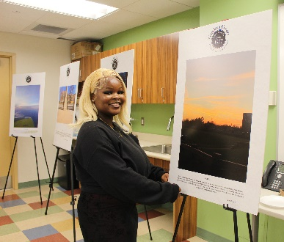
Additional information about the Massachusetts Photovoice project can be found at the Office of Problem Gambling Services website (see www.mass.gov/opgs),
the Massachusetts Center of Excellence on Problem Gambling Prevention website (see www.mcoepgp.org), and in Our Voices Matter: Using Lived Experience to Promote Equity in Problem Gambling Prevention (see Ortiz, et. al., 2021).
The Office of Problem Gambling Services provides a range of programs and services across the continuum of care. If you or a loved one need immediate assistance regarding problem gambling, please call the Massachusetts Problem Gambling Helpline at 1-800-327-5050, visit www.gamblinghelplinema.org, or text: “GAMB” to 800327.

