INDOOR AIR QUALITY ASSESSMENT

Massachusetts Probation Service Office
One Ashburton Place, 4th floor
Boston, MA

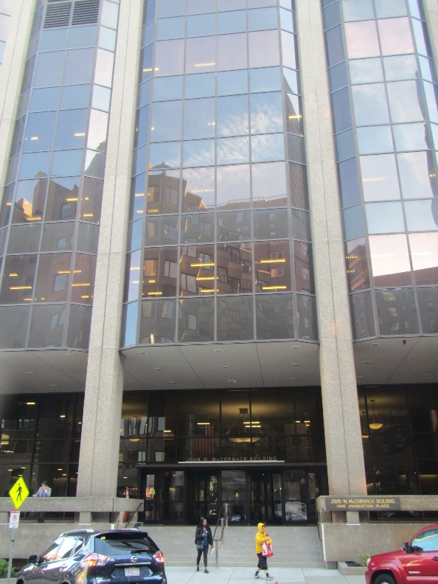

Prepared by:
Massachusetts Department of Public Health
Bureau of Climate and Environmental Health
Indoor Air Quality Program
November 2023

BACKGROUND
Building: | Massachusetts Probation Service (MPS) Office
Address: | One Ashburton Place, 4th floor
Assessment Requested by: | Michael Lane,  Environmental, Health & Safety Manager, Office of Court Management, Facilities Management & Capital Planning
Reason for Request: | Pre-occupancy assessment for sources of respiratory irritation
Date of Assessment: | October 25, 2023
Massachusetts Department of Public Health/Bureau of Climate and Environmental Health (MDPH/BCEH) Staff Conducting Assessment: | Ruth Alfasso, Environmental  Engineer, IAQ Program
Building Description: | One Ashburton Place, also known as The McCormack Building, is a large state office building constructed in the 1970s.
Windows: | Not openable

METHODS
Please refer to the IAQ Manual for methods, sampling procedures, and interpretation of results (MDPH, 2015). The MPS office has just recently moved into this building, and a small section of the workspace was assessed during this visit to address an employee’s concern.
This building has been visited previously by the IAQ program. Reports from those visits are available on the MDPH website at: https://www.mass.gov/info-details/indoor-air-quality-reports-cities-and-towns-b or on request.

RESULTS AND DISCUSSION
The following is a summary of indoor air testing results (Table 1).
- Carbon dioxide measurements were below the MDPH guideline of 800 parts per million (ppm) indicating adequate fresh air in the space.
- Temperature was just below the recommended range of 70°F to 78°F.
- Relative humidity was within the recommended range of 40% to 60% in all areas tested.
- Carbon monoxide levels were non-detectable (ND) in all areas tested.
- Fine particulate matter (PM2.5) concentrations were below the National Ambient Air Quality Standard (NAAQS) level of 35 μg/m³ in all areas tested.
- Total Volatile Organic Compounds (TVOC) were non-detectable (ND).

Ventilation
A heating, ventilating, and air conditioning (HVAC) system has several functions. First it provides heating and, if equipped, cooling. Second, it is a source of fresh air. Finally, an HVAC system will dilute and remove normally occurring indoor environmental pollutants by not only introducing fresh air, but by filtering the airstream and ejecting stale air to the outdoors via exhaust ventilation. Even if an HVAC system is operating as designed, point sources of respiratory irritation may exist and cause symptoms in sensitive individuals.
Fresh air in the areas assessed is supplied by induction units located along the outer edges of the building under the windows (Picture 1). Return air is drawn through ceiling-mounted vents around light fixtures. The induction unit in the office of concern was opened from the top and dust, debris, and some amount of corrosion was noted inside (Picture 2). Induction units in the building are reportedly cleaned regularly, but the area assessed had been unoccupied prior to the most recent move and may not have been accessible for cleaning. Dust and debris in vents can be a source of odors and may become aerosolized.
It is also important that the induction units are not blocked by furniture in front of the unit, or items placed on top. Supply and exhaust ventilation should operate continuously during occupied periods.

Microbial/Moisture Concerns
A few water-damaged ceiling tiles were found in an adjacent set of offices (Picture 3). Based on the location and pattern of the damage, these appear to stem from the sprinkler or HVAC system, and do not appear to be new. No dark staining indicating mold growth, nor moldy odors were detected. Water-damaged ceiling tiles should be removed and replaced when the leak is fixed.
Small refrigerators were located on carpet in several of the locations assessed (Picture 4; Table 1). These appliances can be a source of leaks that can moisten carpeting and lead to mold growth. If refrigerators are not kept clean, they can be a source of odors.

Other Issues
Sampling for total volatile organic compounds (TVOC) was conducted, with all readings being non-detect (ND). An examination was conducted for products that may be a source of VOCs in indoor air. Products such as hand sanitizers and cleaners were found (Table 1). These products should be used with adequate ventilation and in accordance with package instructions to avoid excess VOCs. Scented products such as air fresheners should not be used.
Cooking equipment (toaster, microwave) was found in the hallway outside the offices assessed (Picture 4). Cooking equipment can be a source of odors and smoke, particularly in areas without local exhaust ventilation such as the hallway. This equipment and the surrounding area can also become attractive to pests if not kept scrupulously clean.
A large shredder is also located in the hallway (Picture 5). Heavy use of shredders without sufficient exhaust ventilation can lead to increases in particulates indoors which may become irritating to mucous membranes.
Floors in this office are carpeted. Carpets should be cleaned regularly in accordance with Institute of Inspection, Cleaning and Restoration Certification (IICRC) recommendations (IICRC, 2012).

CONCLUSIONS AND RECOMMENDATIONS
Based on observations at the time of assessment, the following is recommended:

Ventilation Recommendations
- Operate supply and exhaust ventilation continuously in all areas during occupied periods. Ensure all HVAC equipment is cleaned/maintained in accordance with manufacturer’s instructions.
- Regularly clean induction unit fins to reduce accumulated debris.
- Avoid placing furniture or items on top of or in front of induction units.

Water Damage Recommendations
- Replace water-damaged ceiling tiles.
- Keep refrigerators clean. Consider placing a waterproof mat underneath them to prevent water damage to carpeting.

Other Recommendations
- Use VOC-containing cleaning products in accordance with package instructions and do not overuse or mix incompatible products.
- Keep food preparation equipment clean to prevent smoke, odors, and pests.
- If possible, do large amounts of shredding when the office is not heavily occupied.
- Clean carpeting in accordance with IICRC recommendations (IICRC, 2012).
- Once the MPS offices have occupied the 4th floor for at least three weeks, a full post-occupancy assessment of the space could be conducted on request.
- Refer to resource manual and other related IAQ documents located on the MDPH’s website for further building-wide evaluations and advice on maintaining public buildings. These documents are available at: http://mass.gov/dph/iaq.

REFERENCES
IICRC. 2012. Carpet Cleaning FAQ 4 Institute of Inspection, Cleaning and Restoration Certification. Institute of Inspection Cleaning and Restoration, Vancouver, WA.
MDPH. 2015. Massachusetts Department of Public Health. Indoor Air Quality Manual: Chapters I-III. Available at: https://www.mass.gov/lists/indoor-air-quality-manual-and-appendices .

Picture 1
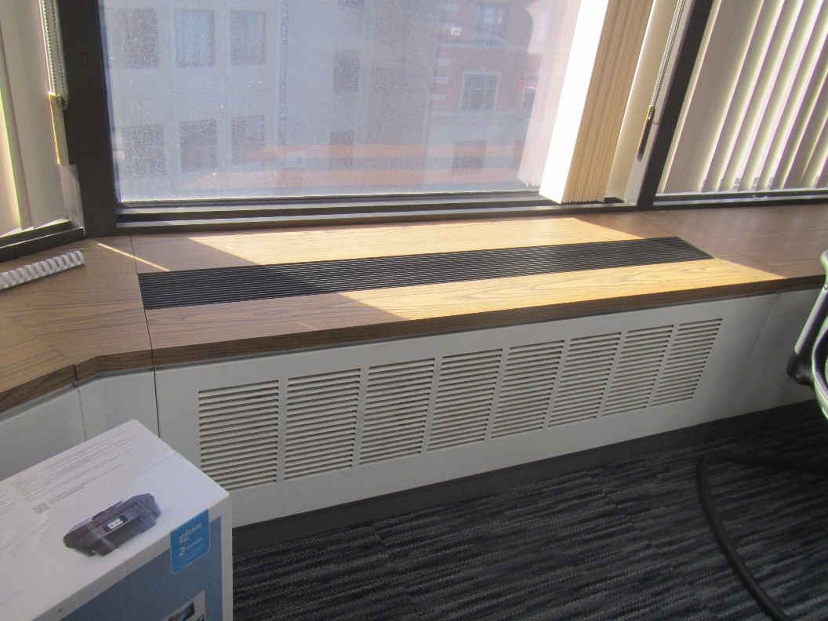
Induction unit
Picture 2
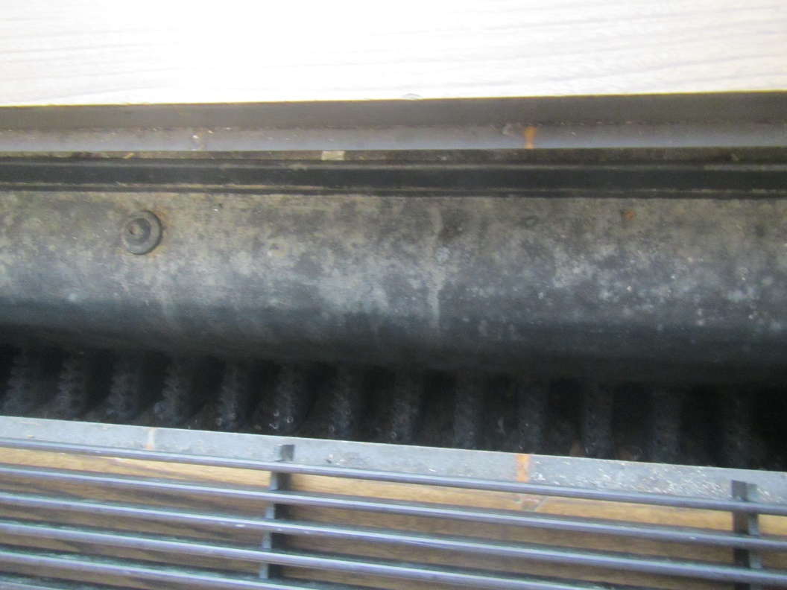
Inside of induction unit showing dust and debris
Picture 3
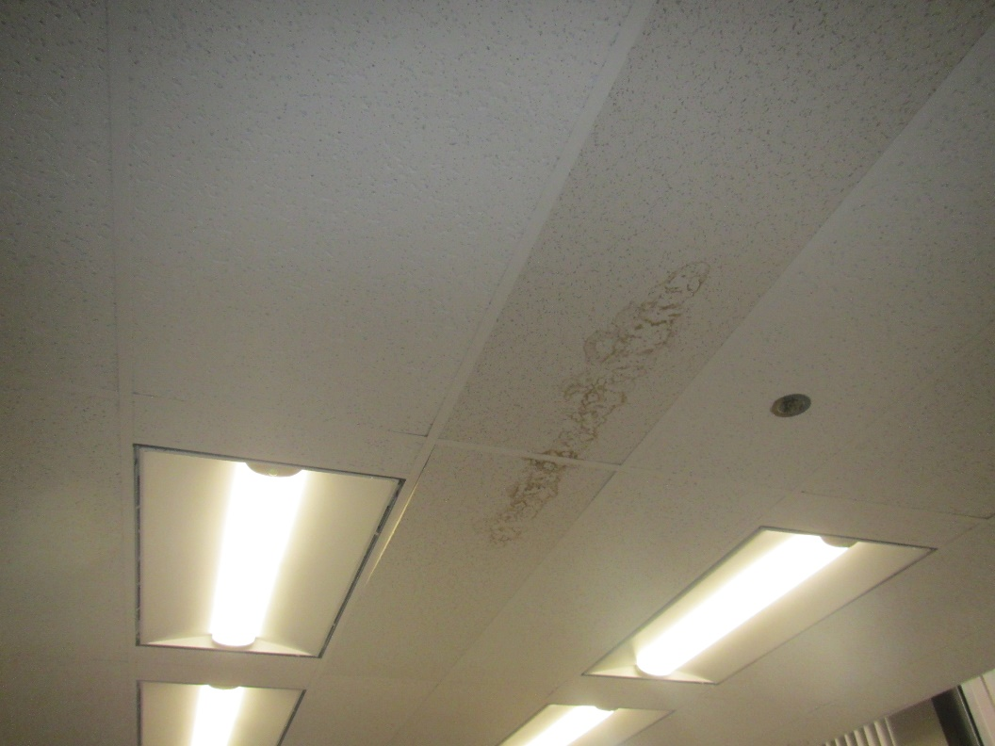
Water-damaged ceiling tiles in adjacent set of offices
Picture 4
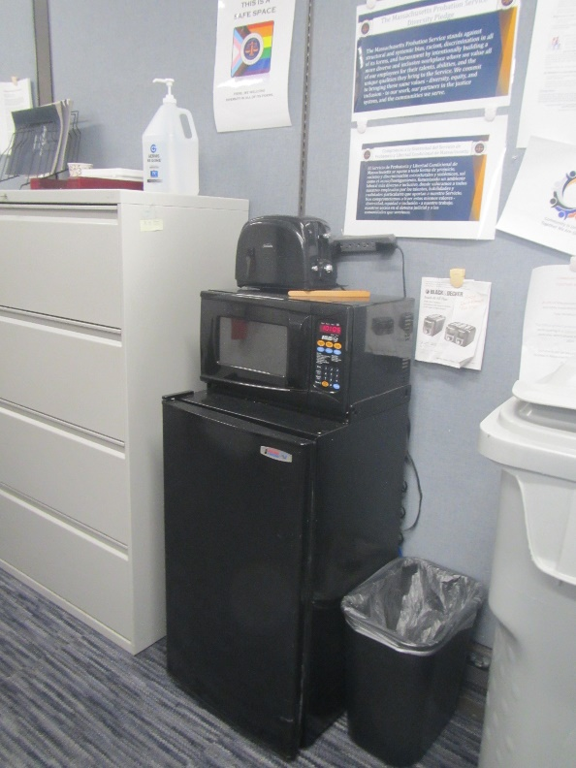
Refrigerator, microwave and toaster in hallway outside
Picture 5
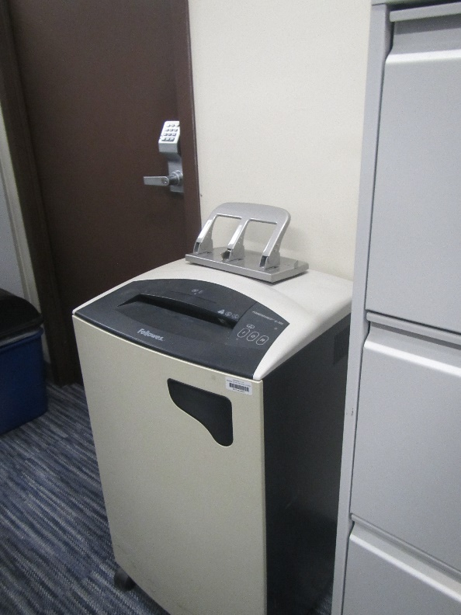
Large shredder in hallway

Location | Carbon  Dioxide  (ppm) | Carbon Monoxide  (ppm) | Temp  (°F) | Relative  Humidity  (%) | PM2.5  (µg/m³) | TVOC  (ppm) | Occupants  in Room | Windows  Openable | Ventilation |  | Remarks
 |  |  |  |  |  |  |  |  | Supply | Exhaust
Suite across from computer room | 550 | ND | 69 | 56 | ND | ND | 1 | N | Y | Y | Fridge on carpet, induction vent dusty inside, cleaning products
Suite to the right | 453 | ND | 69 | 55 | ND | ND | 0 | N | Y | Y | Sunlight
Suite to the left | 477 | ND | 69 | 55 | ND | ND | 0 | N | Y | Y | 3 water-damaged ceiling tiles, likely from sprinkler
Hallway outside office suites |  |  |  |  |  |  |  |  |  |  | Large shredder, fridge and microwave, hand sanitizer

