Massachusetts Rare Disease Advisory Council: Prevalence Outline Draft
- Introduction
  - Definition of Rare Diseases: Less than 200,000 people in the U.S. as defined by the Orphan Drug Act of 1983¹
  - Estimated 10,000 known rare diseases, according to GARD²
    - More diseases are constantly being identified and described
  - Brief overview of MA RDAC
    - Mission statement
    - Importance of state-specific prevalence

- Estimate of Rare Disease prevalence in Massachusetts

- Number of people in MA with a Rare Disease is estimated:
  - Option 1: 246,047 - 435,854
    - Based on MA 2020 census count of 7,029,917 population
    - Low range based on the lowest range using the estimates using Orphanet data
  - Option 2: 702,991
    - Based on 10% assertion from NORD, NIH etc.

- The sections that follow contain the rationale for our calculations. Importantly, these numbers are conservative and likely to underestimate the true burden of Rare Disease, for reasons we will discuss in the following sections.

- Prevalence
  - Definition³
    - Proportion of persons who have a condition at or during a particular time period
    - It includes both new and old cases of the disease

  - Importance of prevalence^{4,5}
    - Policy decisions
    - Used to support patient and caregiver needs, including access to care
    - Better disease management and diagnosis
    - Allocation of healthcare resources
    - Clinical trial design and participation and understanding the number of people who would benefit from drug development

  - International Prevalence Estimates
    - Rationale/ assumptions for why international estimates are relevant

    - Global 2020 estimate based on Orphanet Data ⁶
      - Orphanet contains information on 6,172 unique rare diseases
      - Conservative, evidence-based estimate for the population prevalence of rare diseases of 3.5-5.9%
      - 77.3-80.7% of the population burden of rare diseases is attributable to the 4.2% (n = 149) diseases in the most common prevalence range (1-5 per 10 000)
      - Uses the European definition of 5 per 10 000; and excludes rare cancers, infectious diseases, and poisonings
    - Estimate based on Orphanet data by adding the prevalence estimates provided for 798 rare diseases, found a cumulative prevalence of 6,221.2/100,000 people, or 6.2% of the general population⁷
    - In 2010, living rare disease patients represented approximately 2% of the Western Australian population based on matching Orpha codes and ICD-10 codes⁸
    - Hong Kong study matching Orpha codes and ICD-10 codes and hospital data, estimated that at least 1.5% of the population of Hong Kong⁹
    - In a Taiwanese study, the estimated prevalence of rare diseases increased at an average rate of 19.46% per year ¹⁰
    - U.S. Rare Cancer Estimates ¹¹

  - MA Estimates Based on National Prevalence Estimates
    - Suggest using the conservative numbers, however, concerned that the Wakap paper excludes rare cancers (the NIH states that all childhood cancers are considered rare)
      - Could also use the 10% number provided by NORD for the national estimate
    - Undiagnosed individuals are also uncounted in these estimates
      - Would like to include an estimate of the number of undiagnosed patients
    - Special considerations for MA
      - Patients coming to MA hospitals and researchers,
        - Some evidence that patients will move for access to healthcare
      - Potential for unique disease discovery based on leading hospitals, resarch studies, and the number of pharmaceutical companies in the state

  - Validation of the MA vs. National Estimates/ Extrapolations (See individual breakdowns below in the “Appendix”)
    - In this section, we will identify diseases that have a national and MA state based prevalence estimate, preferably that utilizes full population estimates from sources such as newborn screening, registries, or other complete data sources. We will then see if the MA estimate of the disease population from that data source is the same as if the estimate was simply based on population. We will use these examples to show why we believe using a national estimation strategy (as we plan to do), is a reasonable approach. If there are any special considerations (e.g. the MA numbers from the data sources are consistently higher than the expected estimations just by population), we will take these in to account with the final number we provide.
    - Sickle cell anemia
      - National newborn screening data 2005-2007 were used to estimate US (138,923) and MA (3,261) Sickle Cell Disease prevalence
      - Given that this ratio (3,261/138,923 = 2.3%) is similar to the ratio of total population of MA to the US (7,029,917/331,449,520 = 2.1%), it is reasonable to estimate MA total rare disease prevalence based on a similar proportion of US rare disease prevalence
    - Ehlers-Danlos Syndrome
    - Cystic Fibrosis
    - Hemophilia
    - Duchenne Muscular Dystrophy
    - Spinal Muscular Atrophy
    - Fabry
    - X-Linked Hypophosphatemia

  - Limitations and Challenges
    - General challenges for estimating prevalence⁴
      - Rare diseases are poorly understood, difficult to diagnose, and may not have a clear disease definition
      - New diseases are constantly being identified, especially as there are an increasing number of treatments that are tied to genetic mutations, even in some common conditions
      - Access to diagnostics, including genetic testing, which is often not covered by insurance
        - Estimated 50% of genetic syndromes are undiagnosed (reference?)
      - Diseases can change over time
      - Patients are geographically dispersed and often not followed by consistent healthcare providers
      - Undiagnosed patients are even harder to identify, capture, and count
      - No centralized infrastructure to identify and track patients
        - RD patients are likely to be under-recognized and under-estimated in HCS databases and in cost estimates for their medical care. This underestimation results in the lack of recognition of the true scope of the public health impact of RD on HCS, as well as the vast unmet and ongoing medical needs for RD patients.¹²

- Burden of Disease
  - Financial
    - Individual medical costs for people with a rare disease are 3-5 times greater than those who do not have a rare disease¹²
      - The Eversana HCS database estimates, which were extracted from a mix of commercial and public insurance/payors (2006–2020), showed per patient per year (PPPY) costs ranged from $8812 to $140,044 for RD patients vs. $5862 for the control.
      - The NCATS estimates, which were extracted from an almost exclusively Medicaid data source for the 5-year period 2007–2012, PPPY costs ranged from $4859 to 18,994 for RD patients versus $2211 for the control.
      - The weighted average for the Eversana analysis was $16,644 for an average RD patient versus $5862 for the control (2.8-fold higher for RD vs control), and for the NCATS analysis was $10,695 for a RD patient versus $2211 for the control (4.8-fold higher).
    - Everylife Burden of Disease Study, 2019¹³
      - There were an estimated 15.5 million U.S. children (N = 1,322,886) and adults (N = 14,222,299) with any of the 379 RDs in 2019 with a total economic burden of $997 billion.
      - Includes a direct medical cost of $449 billion (45%), $437 billion (44%) in indirect costs, $73 billion in non-medical costs (7%), and $38 billion (4%) in healthcare costs not covered by insurance.
      - The top drivers for excess medical costs associated with RD are hospital inpatient care and prescription medication
      - The top indirect cost categories are labor market productivity losses due to absenteeism, presenteeism, and early retirement.
    - A study of orphan drugs on the Health Insurance Exchange Plans, which were established by the Patient Protection and Affordable Care Act (ACA), found that coverage varied within and across states from 2-82% depending on the drug¹⁴
  - Ferreria provides a comprehensive overview of the burden of disease across a number of categories including healthcare costs, mortality statistics, and the cost of orphan drugs in his 2019 article⁷
  - Difficulty finding appropriate medical information and scientific knowledge related to their disease^{15–17}
  - Delayed diagnosis and insufficient treatment options, ^{15–17}
  - Isolation and feeling unsupported^{15,16,18}

- MA specific information
  - Inclusion of patient and caregiver stories? (Perhaps we could include an appendix with a few patient stories that highlight some of the major issues)

Appendix Items
(To be incorporated in the Section Validation of the MA vs. National Estimates/ Extrapolations)
Published prevalence figures on Sickle Cell Disease (SCD)

Citation | Country & Methodology | Estimated prevalence
CDC | US | SCD: 1 in 365 Black or African-American births  1 in 16,300 Hispanic-American births  SC trait: 1 in 13 African-American births
Hassell, et al. 2010 | US; state specific birth cohort estimates, newborn screening, mortality estimates | US: 115,442 (based on 2008 census data)  Massachusetts (range, by different methods):  1,598 (based on 1993 AHCPR) - 3,261 (based on 2005-2007 birth cohort)
Wilson-Frederick et al. 2012  HHS / CMS / Medicaid | US; state-specific estimates in Medicaid population | Massachusetts 2012:  877 with SCD, among 1,651,901 Medicaid beneficiaries

Population of Massachusetts (2022): 6,981,974

Using Hassell data and 2006 MA census bureau estimated population of 6,410,084, correcting for 2022 population, the estimated range for prevalence of SCD in MA is:

1740-3551 persons living with SCD in MA

Caveats

- SCD prevalence is heavily dependent on population representation of specific ancestry: sub-Saharan Africa; Spanish-speaking regions in the Western Hemisphere (South America, the Caribbean, and Central America); Saudi Arabia; India; and Mediterranean countries such as Turkey, Greece, and Italy.
- Most comprehensive CDC prevalence data are collected in other states with public newborn screening data, but reasonable to extrapolate to MA.
- Most estimates are for classical sickle cell disease (Hemoglobin SS) but may not include less common but important genetic variants such as Hemoglobin SC disease or Sickle beta thalassemia.
- These estimates also do not include sickle cell trait carriers, who may have clinically important phenotypes in certain situations (e.g., athletes).

References

Aluc A, Zhou M, Paulukonis ST, Snyder AB, Wong D, Hulihan MM. Using surveillance to determine the number of individuals with sickle cell disease in California and Georgia, 2005-2016. Pediatr Hematol Oncol. 2020 Nov;37(8):747-751. doi: 10.1080/08880018.2020.1779886. Epub 2020 Aug 12. PMID: 32783588; PMCID: PMC7855365.

Hassell, K.L. Population Estimates of Sickle Cell Disease in the US. American Journal of Preventive Medicine, 2010. 38(4): p. S512-S521.

Wilson-Frederick SM, Hulihan M, Anderson KK. Prevalence of Sickle Cell Disease among Medicaid Beneficiaries in 2012. CMS Office of Minority Health Data Highlight, No. 16. Baltimore, MD. 2019.

CDC Sickle Cell Data Collection
https://www.cdc.gov/ncbddd/sicklecell/index.html

NIH Genetic and Rare Diseases Information Center (GARD)
https://rarediseases.info.nih.gov/

RuSH (CDC Registry and Surveillance System for Hemoglobinopathies; CA, FL, GA, MI, NY, NC, and PA)
- Wang Y, Kennedy J, Caggana M, Zimmerman R, Thomas S, Berninger J, Harris K, Green NS, Oyeku S, Hulihan M, Grant AM, Grosse SD. Sickle cell disease incidence among newborns in New York State by maternal race/ethnicity and nativity. Genet Med. 2013 Mar;15(3):222–8.
- Paulukonis ST, Harris WT, Coates TD, Neumayr L, Treadwell M, Vichinsky E, Feuchtbaum LB. Population based surveillance in sickle cell disease: methods, findings and implications from the California registry and surveillance system in hemoglobinopathies project (RuSH). Pediatr Blood Cancer. 2014 Dec;61(12):2271–6.
- Hulihan MM, Feuchtbaum L, Jordan L, Kirby RS, Snyder A, Young W, Greene Y, Telfair J, Wang Y, Cramer W, Werner EM, Kenney K, Creary M, Grant AM. State-based surveillance for selected hemoglobinopathies. Genet Med. 2015 Feb;17(2):125–30.
- Wang Y, Liu G, Caggana M, Kennedy J, Zimmerman R, Oyeku SO, Werner EM, Grant AM, Green NS, Grosse SD. Mortality of New York children with sickle cell disease identified through newborn screening. Genet Med. 2015 Jun;17(6):452–9.

PHRESH (CDC Public Health Research, Epidemiology, and Surveillance for Hemoglobinopathies; CA, GA, and MS)
- Neunert CE, Gibson RW, Lane PA, Verma-Bhatnagar P, Barry V, Zhou M, Snyder A. Determining Adherence to Quality Indicators in Sickle Cell Anemia Using Multiple Data Sources. Am J Prev Med. 2016 Jul;51(1 Suppl1):S24–30.

Published prevalence figures on Ehlers-Danlos syndrome (EDS)

Citation | Country & Methodology | Estimated prevalence
Pyeritz NEJM (2000) | No country stated: “perhaps 1 in 5000 people is affected by Ehlers–Danlos syndrome [10]”  Reference: Pyeritz RE. Ehlers-Danlos syndromes. In: Goldman L, Bennett JC, eds. Cecil textbook of medicine. 21st ed. Vol. 1. Philadelphia: W.B. Saunders, 2000:1119-20. | 1/5,000
Cederlöf et al. BMC Psychiatry (2016) | Sweden: Nationwide population-based matched cohort study. Swedish national registries for EDS (ICD-10 Q79.6) & hypermobility syndrome (HMS: ICD-10 M35.7). The Swedish Patient Registry started in 1964 and became nationwide in 1987. ICD-9 codes used 1987-1996, ICD-10 introduced in 1997. | EDS & HLS: 120/100,000 (6/5,000)  n=1,780 EDS & 10,019 HMS (HMS ~5X prevalence of EDS)
Kulas Søborg et al. Rheumatology (2017) | Denmark: population-based cohort study (database of living Danish population)  Dates: 01/01/2000 – 12/31/2012) | 20/100,000 (1/5,000)  n=1,427 unique persons with EDS 🡪 national prevalence of 0.02%
Demmler et al. BMJ Open (2019) | Wales: Nationwide linked electronic cohort and nested case–control study. ICD-10 diagnosis of EDS or joint hypermobility syndrome (JHS= some but not all EDS features).  Dates: 07/01/1990 – 06/30/2017). | diagnosed point prevalence of 194.2 per 100,000 (EDS +JHS)  n=6,021 individuals with a diagnostic code of EDS or JHS.

Population of Massachusetts (2022): 6,981,974

Based on data from Kulas Søborg et al. (2017):
1,396 individuals are estimated to have EDS in the Commonwealth of Massachusetts

Based on data from Demmler et al. (2019):
13,599 individuals are estimated to have EDS/hypermobility syndrome (JHS) in the Commonwealth. However, prevalence of JHS based on the Beighton Criteria does NOT qualify as a rare disease (i.e., JHS occurs in ~1/600-900).

Caveats

- Distinct types of EDS have different prevalence rates.

- Prevalence estimates may very well be underestimates - many people do not get diagnosed, or undergo a lengthy diagnostic odyssey, or may be misdiagnosed.

- Prevalence estimates do not necessarily account for all subtypes delineated in the Villefranche Classification or the 2017 International Classification of EDS (below).

The 1997 revised Villefranche Criteria identifies a number of EDS sub-types.

Beighton et al., Ehlers-Danlos Syndromes: Revised Nosology Villefranche, 1997. American Journal of Medical Genetics. 1998; 77(1):31-37.
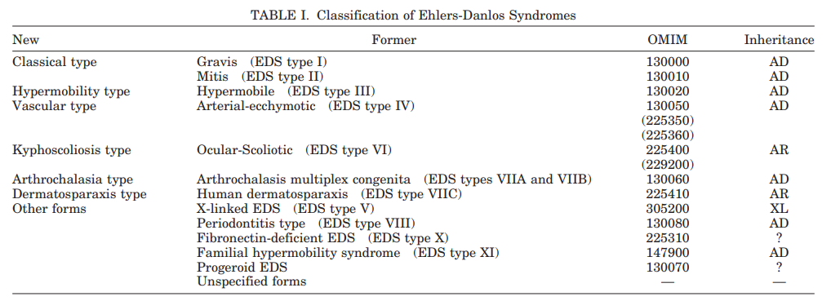

Moreover, the 2017 International Classification of EDS includes 13 sub-types (2° to NGS)

Malfait et al., The 2017 International Classification of the Ehlers–Danlos Syndromes. American Journal of Medical Genetics Part C (Seminars in Medical Genetics). 2017; 175C:8–26.
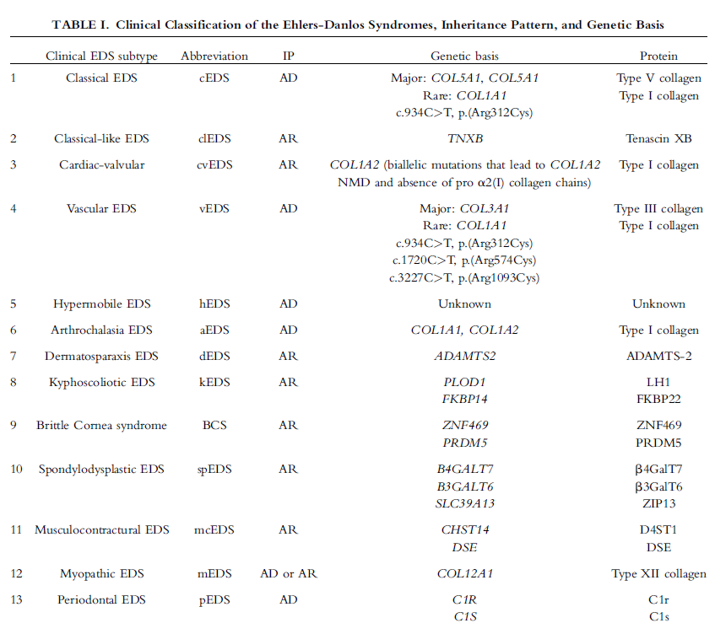

Incidence/Prevalence figures on Spinal Muscular Atrophy (SMA)

Citation | Country & Methodology | Estimated prevalence
Verhaart IEC et al.(2017) | Published literature on prevalence, incidence or carrier frequency of SMA was identified through PubMed searches. | It has been suggested that the overall prevalence of SMA is between one and two per 100,000 people. Incidence is about 1 in 10,000 live births
Hale et al. (2021) | Based on MA newborn screening program (the most applicable to MA). Screened 179,467 neonates and identified 9 SMA-affected infants | Birth incidence was 1 in 19,941 (at least 2.5 times the number from Verhaart et al.)
Vill et al. (2021) | Report of newborn screening. It is important to include this information because it may provide more accurate estimates. Unfortunately, most of this data is only available from more developed countries, and may not be representative of all populations. | Birth incidence was 1 in 6,910

Notes
Incidence is important to capture because poor survival without treatment will impact prevalence numbers.

References
- Hale et al. (2021). Massachusetts’ Findings from Statewide Newborn Screening for Spinal Muscular Atrophy. Int J Neonatal Screen 7(2): 26.
- Verhaart IEC, Robertson A, Wilson IJ, Aartsma-Rus A, Cameron S, Jones CC, Cook SF, Lochmüller H. Prevalence, incidence and carrier frequency of 5q-linked spinal muscular atrophy - a literature review. Orphanet J Rare Dis. 2017;12:124.
- Vill k et al. (2021). Newborn screening for spinal muscular atrophy in Germany: clinical results after 2 years. Orphanet J Rare Dis 16(1):153.

Incidence/Prevalence figures on Spinal Muscular Atrophy (SMA)

Citation | Country & Methodology | Estimated prevalence
Verhaart IEC et al.(2017) | Published literature on prevalence, incidence or carrier frequency of SMA was identified through PubMed searches. | It has been suggested that the overall prevalence of SMA is between one and two per 100,000 people. Incidence is about 1 in 10,000 live births
Hale et al. (2021) | Based on MA newborn screening program (the most applicable to MA). Screened 179,467 neonates and identified 9 SMA-affected infants | Birth incidence was 1 in 19,941 (at least 2.5 times the number from Verhaart et al.)
Vill et al. (2021) | Report of newborn screening. It is important to include this information because it may provide more accurate estimates. Unfortunately, most of this data is only available from more developed countries, and may not be representative of all populations. | Birth incidence was 1 in 6,910

Notes
Incidence is important to capture because poor survival without treatment will impact prevalence numbers.

References
- Hale et al. (2021). Massachusetts’ Findings from Statewide Newborn Screening for Spinal Muscular Atrophy. Int J Neonatal Screen 7(2): 26.
- Verhaart IEC, Robertson A, Wilson IJ, Aartsma-Rus A, Cameron S, Jones CC, Cook SF, Lochmüller H. Prevalence, incidence and carrier frequency of 5q-linked spinal muscular atrophy - a literature review. Orphanet J Rare Dis. 2017;12:124.
- Vill k et al. (2021). Newborn screening for spinal muscular atrophy in Germany: clinical results after 2 years. Orphanet J Rare Dis 16(1):153.

Incidence/Prevalence figures on Hemophilia
From CDC:
- Community Counts data: Community Counts is a public health monitoring program funded by CDC’s Division of Blood Disorders. The purpose of this project is to gather and share information about common health issues, medical complications, and causes of death that affect people with bleeding disorders cared for in U.S. Hemophilia Treatment Centers (HTCs).
o HTC Population Profile Patient Characteristics, Factor VIII and Factor IX Deficiencies, Data Reported from 1/1/2012 through 9/29/2022 https://www.cdc.gov/ncbddd/hemophilia/communitycounts/data-reports/2022-09/table-2-factor.html
▪ Hemophilia A (Factor VIII deficiency): n=22870
▪ Hemophilia B (Factor IX deficiency): n=7396
o Geographic Distribution of Males with Hemophilia A or B Attending Federally Funded Integrated-Care Hemophilia Treatment Centers by State of Residence, 1/1/2012-9/29/2022 https://www.cdc.gov/ncbddd/hemophilia/communitycounts/data-reports/2022-09/hemo-map.html This map presents the number of individuals with hemophilia A or B (including people with factor levels ≥40%) who attended a federally supported hemophilia treatment center (HTC) from 1/1/2012 to 9/29/2022 and who were entered into the HTC Population Profile as of 9/29/2022. Individuals were counted only once, regardless of the number of visits made to an HTC during this period. The first 3 digits of a participant’s ZIP code are reported for the HTC Population Profile and are used to determine state of residence.
▪ Massachusetts: 500-699
o Geographic Distribution of Females with Hemophilia A or B Attending Federally Funded Integrated-Care Hemophilia Treatment Centers by State of Residence, 1/1/2012-9/29/2022 https://www.cdc.gov/ncbddd/hemophilia/communitycounts/data-reports/2022-09/hemo-map-females.html This map presents the number of individuals with hemophilia A or B (including people with factor levels ≥40%) who attended a federally supported hemophilia treatment center (HTC) from 1/1/2012 to 9/29/2022 and who were entered into the HTC Population Profile as of 9/29/2022. Individuals were counted only once, regardless of the number of visits made to an HTC during this period. The first 3 digits of a participant’s ZIP code are reported for the HTC Population Profile and are used to determine state of residence.
▪ Massachusetts: 50-99

Soucie JM, Miller CH, Dupervil B, Le B, Buckner TW. Occurrence rates of haemophilia among males in the United States based on surveillance conducted in specialized haemophilia treatment centres. Haemophilia. 2020 May;26(3):487-493. doi: 10.1111/hae.13998. Epub 2020 Apr 24. PMID: 32329553; PMCID: PMC8117262.
- During the period 2012–2018, 21,748 males with haemophilia visited the HTCs resulting in an age-adjusted prevalence of 15.7 cases per 100 000 males (12 for haemophilia A and 3.7 for haemophilia B). Prevalence was higher among whites (15.1) than blacks (12.4) or Hispanics of either race (12.4). State-specific prevalence varied from 1.6 to 23.3 cases per 100 000. Based on 9587 males born during the index period, the average haemophilia incidence was 1 case per 4334 live male births. Based on these data, we estimate that there are between 29,761 and 32,985 males with haemophilia living in the United States today, the majority of whom receive comprehensive care in specialized clinical centres.
- Note – Figure 2 gives estimate by state but I was not able to access a color version and I can’t differentiate the different shades of gray on map to determine population in MA

Miller CH, Soucie JM, Byams VR, Payne AB, Sidonio RF Jr, Buckner TW, Bean CJ. Women and girls with haemophilia receiving care at specialized haemophilia treatment centres in the United States. Haemophilia. 2021 Nov;27(6):1037-1044. doi: 10.1111/hae.14403. Epub 2021 Sep 4. PMID: 34480812; PMCID: PMC8663793.
- HTC population data collected on people receiving care at an HTC from January 2012 through September 2020 with haemophilia A and B were evaluated by sex for demographic and clinical characteristics. A factor level < 40% was reported for 23,196 males (97.8%) and 1667 females (47.6%) attending HTCs; 51 (.48%) severe, 79 (1.4%) moderate, and 1537 (17.9%) mild haemophilia patients were female.

References
1. The Orphan Drug Act: Implementation and Impact (OEI-09-00-00380; 5/01).
2. About - Genetic and Rare Diseases Information Center. Accessed February 22, 2023. https://rarediseases.info.nih.gov/about
3. Principles of Epidemiology | Lesson 3 - Section 2. Published December 20, 2021. Accessed February 22, 2023. https://www.cdc.gov/csels/dsepd/ss1978/lesson3/section2.html
4. Groft SC, Posada de la Paz M. Rare Diseases: Joining Mainstream Research and Treatment Based on Reliable Epidemiological Data. In: Posada de la Paz M, Taruscio D, Groft SC, eds. Rare Diseases Epidemiology: Update and Overview. Advances in Experimental Medicine and Biology. Springer International Publishing; 2017:3-21. doi:10.1007/978-3-319-67144-4_1
5. Bruckner-Tuderman L. Epidemiology of rare diseases is important. J Eur Acad Dermatol Venereol. 2021;35(4):783-784. doi:10.1111/jdv.17165
6. Nguengang Wakap S, Lambert DM, Olry A, et al. Estimating cumulative point prevalence of rare diseases: analysis of the Orphanet database. Eur J Hum Genet EJHG. 2020;28(2):165-173. doi:10.1038/s41431-019-0508-0
7. Ferreira CR. The burden of rare diseases. Am J Med Genet A. 2019;179(6):885-892. doi:10.1002/ajmg.a.61124
8. Walker CE, Mahede T, Davis G, et al. The collective impact of rare diseases in Western Australia: an estimate using a population-based cohort. Genet Med. 2017;19(5):546-552. doi:10.1038/gim.2016.143
9. Atg C, Ccy C, Whs W, Sl L, Bhy C. Healthcare burden of rare diseases in Hong Kong - adopting ORPHAcodes in ICD-10 based healthcare administrative datasets. Orphanet J Rare Dis. 2018;13(1). doi:10.1186/s13023-018-0892-5
10. Hsu JC, Wu HC, Feng WC, Chou CH, Lai ECC, Lu CY. Disease and economic burden for rare diseases in Taiwan: A longitudinal study using Taiwan’s National Health Insurance Research Database. PloS One. 2018;13(9):e0204206. doi:10.1371/journal.pone.0204206
11. About Rare Cancers - NCI. Published February 27, 2019. Accessed February 22, 2023. https://www.cancer.gov/pediatric-adult-rare-tumor/rare-tumors/about-rare-cancers
12. Tisdale A, Cutillo CM, Nathan R, et al. The IDeaS initiative: pilot study to assess the impact of rare diseases on patients and healthcare systems. Orphanet J Rare Dis. 2021;16(1):429. doi:10.1186/s13023-021-02061-3
13. Yang G, Cintina I, Pariser A, Oehrlein E, Sullivan J, Kennedy A. The national economic burden of rare disease in the United States in 2019. Orphanet J Rare Dis. 2022;17(1):163. doi:10.1186/s13023-022-02299-5
14. Robinson SW, Brantley K, Liow C, Teagarden JR. An early examination of access to select orphan drugs treating rare diseases in health insurance exchange plans. J Manag Care Spec Pharm. 2014;20(10):997-1004. doi:10.18553/jmcp.2014.20.10.997
15. A K, F F. Rare diseases social epidemiology: analysis of inequalities. Adv Exp Med Biol. 2010;686. doi:10.1007/978-90-481-9485-8_14
16. Sc G. Rare diseases: identifying needs. Report of the National Commission on Orphan Diseases. Am Pharm. 1990;NS30(4). Accessed February 23, 2023. https://pubmed.ncbi.nlm.nih.gov/2321528/
17. Rk P, K J. Rare cancers: Challenges & issues. Indian J Med Res. 2017;145(1). doi:10.4103/ijmr.IJMR_915_14
18. Pelentsov LJ, Fielder AL, Laws TA, Esterman AJ. The supportive care needs of parents with a child with a rare disease: results of an online survey. BMC Fam Pract. 2016;17. doi:10.1186/s12875-016-0488-x

