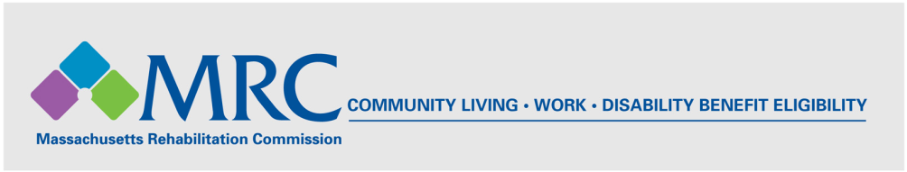
MRC TRANSPORTATION RESOURCE: Regional Transit Authorities

Massachusetts Regional Transit Authorities

Boston Area Transit Authorities:
- Massachusetts Bay Transportation Authority (MBTA)
MBTA CharlieCard Store, Downtown Crossing T Station
Chauncy Underground Concourse, 7 Chauncy St., Boston, MA 02111
(617) 222-3200, TTY: (617) 222-5854, http://www.mbta.com/

- Metrowest Regional Transit Authority (MWRTA)

MWRTA administrative offices

37 Waverley St.

Framingham, MA 01702

(508) 935-2222, Toll Free: (888) 996-9782, http://www.mwrta.com/

Northern Massachusetts Transit Authorities:
- Cape Ann Transit Authority (CATA)
3 Pond Road, Rear
Gloucester, MA 01930

(978) 283-7916, http://canntran.com/

- Lowell Regional Transit Authority (LRTA)

Paratransit Management of Lowell Inc.
113 Thorndike St.
Lowell, MA 01852
(978) 459-0152, http://lrta.com/

- Merrimack Valley Regional Transit Authority (MVRTA)
85 Railroad Avenue

Haverhill, MA 01835
(978) 469-6878, http://www.mvrta.com/

Central Massachusetts Transit Authorities:
- Montachusett Regional Transit Authority (MART)
Administrative Office
1427R Water Street
Fitchburg, MA 01420
(800) 922-5636, (978) 345-7711, http://mrta.us/

- Worcester Regional Transit Authority (WRTA)

Paratransit Office (PBSI)

317 Main Street
Worcester, MA 01608
(508) 752-9283, http://www.therta.com/

Southeastern Massachusetts Transit Authorities:
- Brockton Area Transit Authority (BAT)
155 Court St.
Brockton, MA 02302-4608
(508) 588-1000, http://www.ridebat.com/

- Greater Attleboro-Taunton Regional Transit Authority (GATRA)
Administrative Offices
10 Oak Street
Taunton, MA 02780
(800) 483-2500, http://www.gatra.org/

- Southeastern Regional Transit Authority (SRTA)
700 Pleasant Street
New Bedford, MA 02740
(508) 997-6767, http://www.srtabus.com/

Cape Cod & the Islands Transit Authorities:
- Cape Cod Regional Transit Authority (CCRTA)
Hyannis Transportation Center
215 Iyannough Road
PO Box 1988
Hyannis, MA 02601
(508) 775-8504, http://www.capecodtransit.org/

- Martha’s Vineyard Transit Authority (VTA)
11A Street, Airport Business Park
Edgartown, MA 02539
(508) 693-9440, http://www.vineyardtransit.com/Pages/index

- Nantucket Regional Transit Authority (NRTA)
3 East Chestnut Street
Nantucket, MA 02554
(508) 325-9571, TTY: (508) 325-7516, http://www.nrtawave.com/

Western Massachusetts Transit Authorities:
- Berkshire Regional Transit Authority (BRTA)
1 Columbus Ave.
Pittsfield, MA 01201
(800) 292-2782, (413) 499-2782, http://www.berkshirerta.com/

- Franklin Regional Transit Authority (FRTA)
The John W. Olver Transit Center
12 Olive Street, Suite 1
Greenfield, MA 01301
(413) 774-2262, http://www.frta.org/

- Pioneer Valley Transit Authority (PVTA)
2808 Main Street
Springfield, MA 01107
(413) 781-7882, http://www.pvta.com/

