INDOOR AIR QUALITY ASSESSMENT

Massachusetts Registry of Motor Vehicles
165 Liberty Street
Springfield, Massachusetts

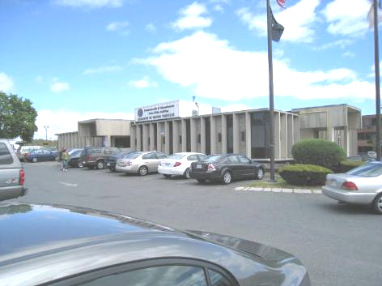

Prepared by:
Massachusetts Department of Public Health
Bureau of Environmental Health
Indoor Air Quality Program
August 2012

Background/Introduction
In response to a request from Aric Warren, Director of Administrative Services, Massachusetts Registry of Vehicles (RMV), the Massachusetts Department of Public Health (MDPH), Bureau of Environmental Health (BEH), provided assistance and consultation regarding indoor air quality (IAQ) concerns at the Springfield RMV office located at 165 Liberty Street, Springfield, Massachusetts. The request was prompted by occupant symptoms of headache and respiratory irritation in the Registry Agents Cooperative Express (RACE) office in the lower level of the building. On April 27, 2012, a visit to conduct an IAQ assessment was made by Michael Feeney, Director of BEH’s IAQ Program.
The RMV is a state-owned, two-level building constructed in the early 1970s. The RMV is made up of a large open service area/waiting room with offices on the upper floor. The lower floor contains other RMV offices, the license plate storeroom (Picture 1), and general storage space. The building has no openable windows.

Methods
Air tests for carbon monoxide, carbon dioxide, temperature and relative humidity were conducted with the TSI, Q-Trak, IAQ Monitor, Model 7565. Air tests for airborne particle matter with a diameter less than 2.5 micrometers were taken with the TSI, DUSTTRAK™ Aerosol Monitor Model 8520. BEH staff also performed visual inspection of building materials for water damage and/or microbial growth.

Results
The RMV has an employee population of approximately 30 and is visited by up to several hundred individuals daily. The tests were taken during normal operations. Test results appear in Table 1.

Discussion

Ventilation
It can be seen from Table 1 that carbon dioxide levels were above 800 parts per million (ppm) in 12 of 17 areas, indicating less than optimal air exchange at the time of the assessment. It is important to note that a number of areas were sparsely populated or unoccupied at the time measurements were taken, which generally results in reduced carbon dioxide levels. Carbon dioxide levels would be expected to be higher with full occupancy. The fact that levels were above 800 ppm in the RMV service area/waiting room (a large open area with high ceilings) further illustrates the lack of adequate air exchange. Without adequate air exchange, ordinary indoor pollutants can build up over the course of the business day and lead to IAQ/comfort complaints.
Mechanical ventilation on the upper floor is provided by rooftop air-handling units (AHUs). Fresh air is drawn into the AHUs and delivered to occupied areas via ductwork. Recirculated air is directed into the office space by ceiling-mounted fresh air diffusers. Return air is ducted back to the rooftop AHUs. At the time of the assessment, the HVAC system on the upper floor appeared to be deactivated. Mechanical ventilation on the lower floor is provided by ceiling-mounted AHUs located in the license plate storeroom. Fresh air for these AHUs is drawn through an intake vent on the east exterior wall that is roughly at the same level as the parking lot (Picture 2). Exhaust ventilation appears to be provided by an exhaust fan located beneath the front entrance walkway (Picture 3), which was not operating at the time of the assessment. The AHUs in the license plate storeroom show signs of corrosion, which has led to significant damage to the AHU cabinets (Pictures 4 and 5). The corrosion indicates likely failure of the drip pans to provide appropriate drainage of condensation when the AHUs are operating in cooling mode. The corrosion has affected the structural integrity of the cabinets, resulting in air from the license plate storeroom being drawn into the AHUs (Pictures 6 and 7). In addition, the corrosion is an indication that the AHUs are aging/becoming damaged through routine use and nearing the end of their useful service life. These AHUs are likely original equipment, over 40 years old. According to the American Society of Heating, Refrigeration and Air-Conditioning Engineers (ASHRAE), the service life for a unit heater (hot water or steam) is 20 years, assuming routine maintenance of the equipment (ASHRAE, 1991).
To maximize air exchange, the MDPH recommends that both supply and exhaust ventilation operate continuously during periods of occupancy. In order to have proper ventilation with a mechanical supply and exhaust system, the systems must be balanced to provide an adequate amount of fresh air to the interior of a room while removing stale air from the room. It is recommended that HVAC systems be re-balanced every five years to ensure adequate air systems function (SMACNA, 1994). The date of the last balancing of these systems was not available at the time of the assessment.
The Massachusetts Building Code requires a minimum ventilation rate of 20 cubic feet per minute (cfm) per occupant of fresh outside air or have openable windows in each room (SBBRS, 1997; BOCA, 1993). The ventilation must be on at all times that the room is occupied. Providing adequate fresh air ventilation with open windows and maintaining the temperature in the comfort range during the cold weather season is impractical. Mechanical ventilation is usually required to provide adequate fresh air ventilation.
Carbon dioxide is not a problem in and of itself. It is used as an indicator of the adequacy of the fresh air ventilation. As carbon dioxide levels rise, it indicates that the ventilating system is malfunctioning or the design occupancy of the room is being exceeded. When this happens, a buildup of common indoor air pollutants can occur, leading to discomfort or health complaints. The Occupational Safety and Health Administration (OSHA) standard for carbon dioxide is 5,000 parts per million parts of air (ppm). Workers may be exposed to this level for 40 hours/week, based on a time-weighted average (OSHA, 1997).
The MDPH uses a guideline of 800 ppm for publicly occupied buildings. A guideline of 600 ppm or less is preferred in schools due to the fact that the majority of occupants are young and considered to be a more sensitive population in the evaluation of environmental health status. Inadequate ventilation and/or elevated temperatures are major causes of complaints such as respiratory, eye, nose and throat irritation, lethargy and headaches. For more information concerning carbon dioxide, please see Appendix A.
Temperature readings ranged from 71°F to 78°F during the assessment, which were within the MDPH recommended comfort guidelines in all areas surveyed (Table 1). The MDPH recommends that indoor air temperatures be maintained in a range of 70° F to 78°F in order to provide for the comfort of building occupants. In many cases concerning indoor air quality, fluctuations of temperature in occupied spaces are typically experienced, even in a building with an adequate fresh air supply.
The relative humidity measured during the assessment ranged from 23 to 32 percent, which was below the MDPH recommended comfort range in all areas surveyed on the day of the assessment (Table 1). The MDPH recommends a comfort range of 40 to 60 percent for indoor air relative humidity. Relative humidity levels in the building would be expected to drop during the winter months due to heating. The sensation of dryness and irritation is common in a low relative humidity environment. Low relative humidity is a very common problem during the heating season in the northeast part of the United States. Therefore, scrupulous cleaning practices should be adopted to minimize common indoor air contaminants whose irritant effects can be enhanced when the relative humidity is low.

Microbial/Moisture Concerns
A few areas had water-damaged ceiling tiles (Table 1). Of note were missing ceiling tiles below the AHUs in the license plate storeroom. The missing ceiling tiles are likely a result of repeated water damage due to condensation from the failed AHU drip pan/drainage system as well as failed pipe insulation (Pictures 8 and 9). Water-damaged ceiling tiles can provide a source of mold and should be replaced after a water leak is discovered and repaired.
The boat registration office had an odor. The offices in this location have wall-to-wall carpeting, which was found to be wet; this could be a source of the odor and possible mold colonization/growth. Carpeting is not recommended in below-grade spaces.
The US Environmental Protection Agency (US EPA) and the American Conference of Governmental Industrial Hygienists (ACGIH) recommend that porous materials be dried with fans and heating within 24 to 48 hours of becoming wet (US EPA, 2001; ACGIH, 1989). If not dried within this time frame, mold growth may occur. Once mold has colonized porous materials, they are difficult to clean and should be removed.

Other IAQ Evaluations
Indoor air quality can be negatively influenced by the presence of respiratory irritants, such as products of combustion. The process of combustion produces a number of pollutants. Common combustion emissions include carbon monoxide, carbon dioxide, water vapor, and smoke (fine airborne particle material). Of these materials, exposure to carbon monoxide and particulate matter with a diameter of 2.5 micrometers (μm) or less (PM2.5) can produce immediate, acute health effects upon exposure. To determine whether combustion products were present in the indoor environment, BEH staff obtained measurements for carbon monoxide and PM2.5.

Carbon Monoxide
Carbon monoxide is a by-product of incomplete combustion of organic matter (e.g., gasoline, wood and tobacco). Exposure to carbon monoxide can produce immediate and acute health effects. Several air quality standards have been established to address carbon monoxide and prevent symptoms from exposure to these substances. The MDPH established a corrective action level concerning carbon monoxide in ice skating rinks that use fossil-fueled ice resurfacing equipment. If an operator of an indoor ice rink measures a carbon monoxide level over 30 ppm, taken 20 minutes after resurfacing within a rink, that operator must take actions to reduce carbon monoxide levels (MDPH, 1997).
The American Society of Heating Refrigeration and Air-Conditioning Engineers (ASHRAE) has adopted the National Ambient Air Quality Standards (NAAQS) as one set of criteria for assessing indoor air quality and monitoring of fresh air introduced by HVAC systems (ASHRAE, 1989). The NAAQS are standards established by the US EPA to protect the public health from six criteria pollutants, including carbon monoxide and particulate matter (US EPA, 2006). As recommended by ASHRAE, pollutant levels of fresh air introduced to a building should not exceed the NAAQS levels (ASHRAE, 1989). The NAAQS were adopted by reference in the Building Officials & Code Administrators (BOCA) National Mechanical Code of 1993 (BOCA, 1993), which is now an HVAC standard included in the Massachusetts State Building Code (SBBRS, 1997). According to the NAAQS, carbon monoxide levels in outdoor air should not exceed 9 ppm in an eight-hour average (US EPA, 2006).
Carbon monoxide should not be present in a typical, indoor environment. If it is present, indoor carbon monoxide levels should be less than or equal to outdoor levels. Outdoor carbon monoxide concentrations were non-detect (ND) at the time of the assessment (Table 1). No measureable levels of carbon monoxide were detected in the building during the assessment (Table 1). As reported by building occupants, the RMV does not have parking to accommodate all patrons at peak times, which results in lines of cars circling the building. Given that the lower level’s fresh air intakes are at ground level (Picture 2) and that the rear exterior door of the building has large gaps (Picture 10), heavy traffic around the RMV may result in vehicle exhaust and associated odors penetrating the building.

Particulate Matter
The US EPA has established NAAQS limits for exposure to particulate matter. Particulate matter is airborne solids that can be irritating to the eyes, nose and throat. The NAAQS originally established exposure limits to particulate matter with a diameter of 10 μm or less (PM10). According to the NAAQS, PM10 levels should not exceed 150 micrograms per cubic meter (μg/m³) in a 24-hour average (US EPA, 2006). These standards were adopted by both ASHRAE and BOCA. Since the issuance of the ASHRAE standard and BOCA Code, US EPA established a more protective standard for fine airborne particles. This more stringent PM2.5 standard requires outdoor air particle levels be maintained below 35 μg/m³ over a 24-hour average (US EPA, 2006). Although both the ASHRAE standard and BOCA Code adopted the PM10 standard for evaluating air quality, MDPH uses the more protective PM2.5 standard for evaluating airborne particulate matter concentrations in the indoor environment.
Outdoor PM2.5 concentration was measured at 15 μg/m³ (Table 1). PM2.5 levels measured indoors ranged from 2 to 6 μg/m³ (Table 1), which were below the NAAQS PM2.5 level of 35 μg/m³. Frequently, indoor air levels of particulates (including PM2.5) can be at higher levels than those measured outdoors. A number of activities that occur indoors and/or mechanical devices can generate particulates during normal operations. Sources of indoor airborne particulates may include but are not limited to particles generated during the operation of fan belts in the HVAC system, use of stoves and/or microwave ovens in kitchen areas; use of photocopiers, fax machines and computer printing devices; operation of an ordinary vacuum cleaner and heavy foot traffic indoors.

Other Concerns
The RMV RACE office in lower level of the building has a number of conditions that may lead to the reported symptoms of headache and respiratory irritation.
- Damage to the AHUs allows air to be drawn into the fresh air system from the license plate storage room, which contains a large number of cardboard boxes and freshly made license plates. Both cardboard and freshly made license plates can off-gas volatile organic compounds (VOCs), which can be irritating to the eyes, nose and respiratory system. VOCs can then be drawn into the AHUs and distributed into the RACE office.
- The license plate room does not appear to have exhaust ventilation to remove odors from stored materials.
- The water damage to the AHU cabinets indicates that standing water likely exists in the cabinets when the system is in its cooling mode, which can ultimately lead to microbial growth.
The aforementioned conditions may play a role regarding the conditions reported by occupants in the RACE office.

Conclusions/Recommendations
In view of the findings at the time of the visit, the following recommendations are made:
- Operate the ventilation system during business hours on the upper and lower levels of the building. Repair all supply and exhaust equipment as needed to improve ventilation and reduce noise.
- Repair the AHUs in the license plate storeroom to provide adequate drainage and to prevent air from being drawn from the room. If not repairable, consideration should be given to replacing the damaged AHU that services the lower level.
- Examine methods to provide exhaust ventilation for the license plate storeroom.
- Render the rear exterior door weather-tight. Ensure tightness of doors by monitoring for light penetration and drafts around doorframes.
- Consideration should be given to reconfiguration of the traffic pattern around the RMV to minimize vehicle exhaust entrainment by the lower level AHUs. If not feasible, consideration should be give to relocating the fresh air intakes for this system.
- Consider posting signs regarding vehicle idling near the building. M.G.L. c. 90, § 16A prohibits the idling of vehicles in excess of 5 minutes.
- Remove the carpet in the boat registration office; carpet should not be used in below-grade areas.
- For buildings in New England, periods of low relative humidity during the winter are often unavoidable. Therefore, scrupulous cleaning practices should be adopted to minimize common indoor air contaminants whose irritant effects can be enhanced when the relative humidity is low. To control for dusts, a high efficiency particulate arrestance (HEPA) filter equipped vacuum cleaner in conjunction with wet wiping of all surfaces is recommended. Drinking water during the day can help ease some symptoms associated with a dry environment (throat and sinus irritations).
- Ensure leaks are repaired and replace water-damaged ceiling tiles.
- Refer to resource manuals and other related indoor air quality documents for further building-wide evaluations and advice on maintaining public buildings. Copies of these materials are located on the MDPH’s website: http://mass.gov/dph/iaq.

References
ACGIH. 1989. Guidelines for the Assessment of Bioaerosols in the Indoor Environment. American Conference of Governmental Industrial Hygienists, Cincinnati, OH.
ASHRAE. 1989. ASHRAE Standard: Ventilation for Acceptable Indoor Air Quality. Sections 5.11, 5.12. American Society of Heating, Refrigerating and Air-Conditioning Engineers, Inc. Atlanta, GA.
ASHRAE. 1991. ASHRAE Applications Handbook, Chapter 33 “Owning and Operating Costs”. American Society of Heating, Refrigeration and Air Conditioning Engineers, Atlanta, GA.
BOCA. 1993. The BOCA National Mechanical Code/1993. 8th ed. Building Officials and Code Administrators International, Inc., Country Club Hill, IL. Section M-308.1.1.
MDPH. 1997. Requirements to Maintain Air Quality in Indoor Skating Rinks (State Sanitary Code, Chapter XI). 105 CMR 675.000. Massachusetts Department of Public Health, Boston, MA.
OSHA. 1997. Limits for Air Contaminants. Occupational Safety and Health Administration. Code of Federal Regulations. 29 C.F.R 1910.1000 Table Z-1-A.
SBBRS. 1997. Mechanical Ventilation. State Board of Building Regulations and Standards. Code of Massachusetts Regulations. 780 CMR 1209.0.
SMACNA. 1994. HVAC Systems Commissioning Manual. 1st ed. Sheet Metal and Air Conditioning Contractors’ National Association, Inc., Chantilly, VA.
US EPA. 2001. Mold Remediation in Schools and Commercial Buildings. US Environmental Protection Agency, Office of Air and Radiation, Indoor Environments Division, Washington, DC. EPA 402-K-01-001. March 2001.
US EPA. 2006. National Ambient Air Quality Standards (NAAQS). US Environmental Protection Agency, Office of Air Quality Planning and Standards, Washington, DC. http://www.epa.gov/air/criteria.html.
Picture 1

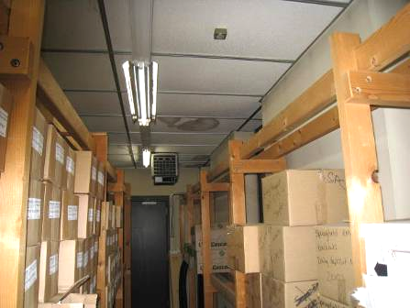

License Plate Storeroom

Picture 2

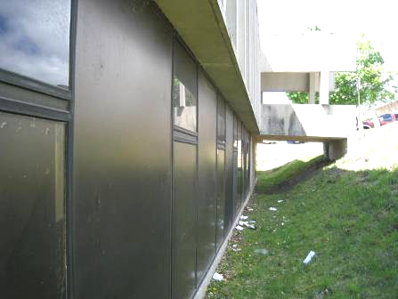

Fresh Air Intake, Lower Level (Arrow)

Picture 3

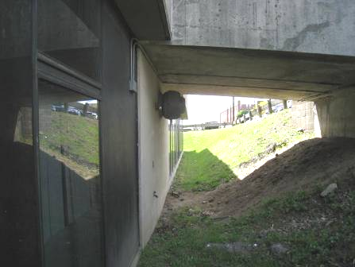

Deactivated Exhaust Vent under Main Entrance Walkway

Picture 4

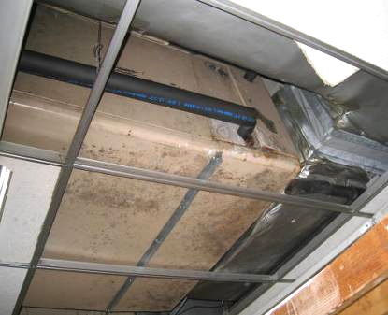

Damaged AHU in License Plate Storeroom
Picture 5

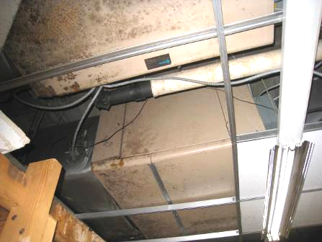

Damaged AHU in License Plate Storeroom
Picture 6

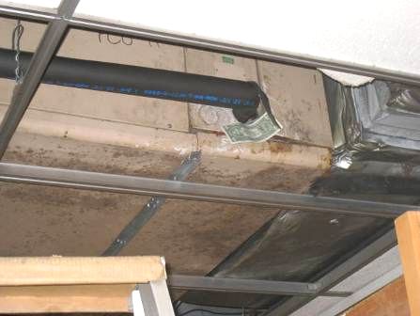

Air Draw through Damaged AHU Cabinet in License Plate Storeroom
See Dollar Bill (Bracket) as Demonstration

Picture 7

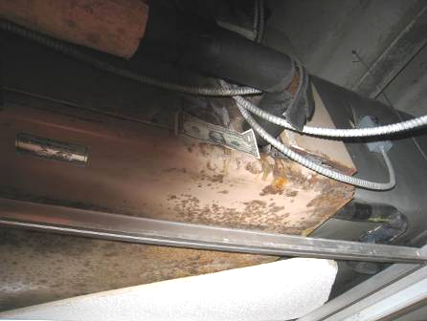

Air Draw through Damaged AHU Cabinet in License Plate Storeroom
See Dollar Bill (Bracket) as Demonstration

Picture 8

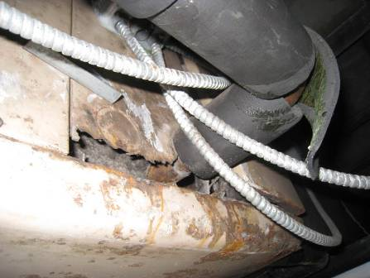

Corrosion Damage to AHU Cabinet and Insulation
Picture 9

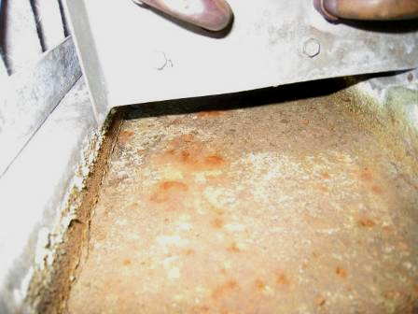

Heavily Corroded Drip Pan inside AHU

Picture 10

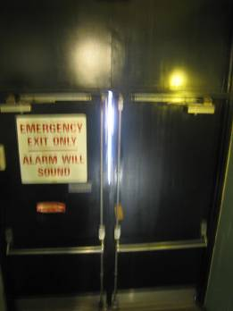

Gap between Rear Exterior Doors (Arrow)
Location | Carbon  Dioxide  (ppm) | Carbon Monoxide  (ppm) | Temp  (°F) | Relative  Humidity  (%) | PM2.5  (µg/m³) | Occupants  in Room | Windows  Openable | Ventilation |  | Remarks
 |  |  |  |  |  |  |  | Supply | Exhaust | Remarks
Background (Outdoors) | 361 | ND | 56 | 25 | 15
Counting room | 657 | ND | 77 | 25 | 2 | 0 | N | Y | Y | 3 water-damaged ceiling tiles
RACE office | 547 | ND | 74 | 28 | 4 | 3 | N | Y | Y | 10+ water-damaged ceiling tiles  Door open
License plate store room | 534 | ND | 74 | 29 | 4 | 3 | N | Y | Y
Boat Registration | 626 | ND | 72 | 29 | 2 | 1 | N | Y | Y | Odor from carpeting
Ground floor hallway | 610 | ND | 71 | 26 | 3 | 10 | N | Y | Y
Main desk waiting | 944 | ND | 75 | 30 | 5 | 100+ | N | Y | Y
Title | 1159 | ND | 76 | 30 | 5 | 0 | N | Y | Y | 2 water-damaged ceiling tiles  Door open
File room | 1208 | ND | 76 | 30 | 5 | 0 | N | Y | Y
Vehicle inspection | 1134 | ND | 74 | 24 | 4 | 0 | N | Y | Y | 1 water damaged ceiling tile
Manager’s office | 1139 | ND | 74 | 31 | 4 | 0 | N | Y | Y | 1 water damaged ceiling tile
Road test | 1165 | ND | 76 | 30 | 5 | 0 | N | N | Y | No supply vent, egg crate installed in suspended ceiling
Main Desk east side | 1342 | ND | 77 | 32 | 4 | 20+ | N | Y | Y | Supply off  1 water-damaged ceiling tile
Permit room | 1122 | ND | 77 | 29 | 4 | 2 | N | Y | Y
License Waiting Area | 1460 | ND | 77 | 32 | 6 | 30+ | N | Y | Y | Supply off
4 | 1030 | ND | 75 | 27 | 4 | 0 | N | Y | Y
Break room | 1140 | ND | 78 | 29 | 4 | 6 | N | Y | Y | Supply off  1 water-damaged ceiling tile
Hearing room | 936 | ND | 77 | 23 | 4 | 2 | N | Y | Y

