INDOOR AIR QUALITY ASSESSMENT

Massachusetts Registry of Motor Vehicles
490 Forest Avenue
Brockton, Massachusetts



Prepared by:
Massachusetts Department of Public Health
Bureau of Environmental Health
Indoor Air Quality Program
December 2012

Background/Introduction
In response to a request from Mr. Aric Warren, Deputy Director of General Services, Massachusetts Department of Transportation (MDOT), the Massachusetts Department of Public Health (MDPH), Bureau of Environmental Health (BEH) provided assistance and consultation regarding indoor air quality (IAQ) concerns at the Brockton Area Branch of the Massachusetts Registry of Motor Vehicles (RMV), located at 490 Forest Avenue, Brockton, Massachusetts.
On October 18, 2012, a visit to conduct an IAQ assessment was made by Cory Holmes, Environmental Analyst/Regional Inspector within BEH’s IAQ Program. Mr. Holmes was accompanied by Robert Northrup, Program Coordinator, MDOT.
The RMV is located in a one-story brick building with a peaked, shingled roof that was constructed in 1981 specifically for the RMV. The RMV takes up the large majority of the building; a private insurance agency occupies a small portion of the east part of the building. The RMV space is made up of a large open service area/waiting room, testing/class rooms, offices, an employee break room and storage space. The space has a dropped ceiling tile system, floor tile and wall-to-wall carpeting in some areas. Some perimeter areas have openable windows.

Methods
Air tests for carbon dioxide, carbon monoxide, temperature and relative humidity were taken with the TSI, Q-Trak, IAQ Monitor 7565. Air tests for airborne particle matter with a diameter less than 2.5 micrometers were taken with the TSI, DUSTTRAK™ Aerosol Monitor Model 8520. BEH staff also performed visual inspection of building materials for water damage and/or microbial growth.

Results
The RMV has an employee population of approximately 25 and can be visited by up to 500-600 members of the public on a daily basis. The tests were taken during normal operations. Test results appear in Table 1.

Discussion

Ventilation
It can be seen from Table 1 that carbon dioxide levels were above 800 parts per million (ppm) in all areas surveyed, indicating a lack of air exchange at the time of the assessment. According to Tom Clifford, Property Manager, Brockton RMV, the heating, ventilation and air conditioning (HVAC) system is made up of four air-handling units (AHUs) and four air-to-air heat exchangers located in an attic crawlspace. Conditioned air is supplied by ducted ceiling-mounted fresh air diffusers (Pictures 1 and 2). Air is exhausted from the occupied space through ceiling mounted return vents (Picture 3). AHUs are controlled by digital wall-mounted thermostats (Picture 4). Subsequent to the assessment, BEH/IAQ staff were contacted by Mr. Clifford who reported that one of the units was not operating during the assessment and has since been repaired by an HVAC firm. The audit room is an interior, windowless room that had no supply or exhaust ventilation.
Digital wall-mounted thermostats that control the HVAC system typically have fan settings of “on” and “automatic”. The automatic setting on the thermostat activates the HVAC system at a preset temperature. Once the preset temperature is reached, the HVAC system is deactivated. Therefore, no mechanical ventilation is provided until the thermostat re-activates the system. In the fan “on” mode, air will be continuously circulated and filtered, which should improve temperature/comfort control. MDPH recommends that thermostats be set to the fan “on” setting during occupied periods to provide continuous air circulation and filtration.
To maximize air exchange, the MDPH recommends that both supply and exhaust ventilation operate continuously during periods of occupancy. In order to have proper ventilation with a mechanical supply and exhaust system, the systems must be balanced to provide an adequate amount of fresh air to the interior of a room while removing stale air from the room. It is recommended that HVAC systems be re-balanced every five years to ensure adequate air systems function (SMACNA, 1994). The date of the last balancing of these systems was not available at the time of the assessment.
Minimum design ventilation rates are mandated by the Massachusetts State Building Code (MSBC). Until 2011, the minimum ventilation rate in Massachusetts was higher for both occupied office spaces and general classrooms, with similar requirements for other occupied spaces (BOCA, 1993). The current version of the MSBC, promulgated in 2011 by the State Board of Building Regulations and Standards (SBBRS), adopted the 2009 International Mechanical Code (IMC) to set minimum ventilation rates. Please note that the MSBC is a minimum standard that is not health-based. At lower rates of cubic feet per minute (cfm) per occupant of fresh air, carbon dioxide levels would be expected to rise significantly. A ventilation rate of 20 cfm per occupant of fresh air provides optimal air exchange resulting in carbon dioxide levels at or below 800 ppm in the indoor environment in each area measured. MDPH recommends that carbon dioxide levels be maintained at 800 ppm or below. This is because most environmental and occupational health scientists have documented significant increases in indoor air quality complaints and/or health effects when carbon dioxide levels rise above the MDPH guidelines of 800 ppm for schools, office buildings and other occupied spaces (Sundell et al., 2011). The ventilation must be on at all times that the room is occupied. Providing adequate fresh air ventilation with open windows and maintaining the temperature in the comfort range during the cold weather season is impractical. Mechanical ventilation is usually required to provide adequate fresh air ventilation.
Carbon dioxide is not a problem in and of itself. It is used as an indicator of the adequacy of the fresh air ventilation. As carbon dioxide levels rise, it indicates that the ventilating system is malfunctioning or the design occupancy of the room is being exceeded. When this happens, a buildup of common indoor air pollutants can occur, leading to discomfort or health complaints. The Occupational Safety and Health Administration (OSHA) standard for carbon dioxide is 5,000 parts per million parts of air (ppm). Workers may be exposed to this level for 40 hours/week, based on a time-weighted average (OSHA, 1997).
The MDPH uses a guideline of 800 ppm for publicly occupied buildings. A guideline of 600 ppm or less is preferred in schools due to the fact that the majority of occupants are young and considered to be a more sensitive population in the evaluation of environmental health status. Inadequate ventilation and/or elevated temperatures are major causes of complaints such as respiratory, eye, nose and throat irritation, lethargy and headaches. For more information concerning carbon dioxide, please see Appendix A.
Temperature readings ranged from 65º F to 71º F during the assessment, which were within or near the lower end of the MDPH recommended comfort guidelines. The MDPH recommends that indoor air temperatures be maintained in a range of 70º F to 78º F in order to provide for the comfort of building occupants. In many cases concerning indoor air quality, fluctuations of temperature in occupied spaces are typically experienced, even in a building with an adequate fresh air supply. The lowest temperature measurement (65º F) was in the plate room, where employees frequently enter/exit the building via an exterior door.
To supplement the HVAC system, the building utilizes fan coil units (FCUs) to provide heat. The FCUs throughout the building appeared to be outdated and in disrepair, several were missing covers, exposing moving fans (Picture 5), which could be a hazard. In addition, the interiors of the FCUs examined had accumulated dust and debris (Picture 6). FCUs are typically equipped with filters; no filters were installed in FCUs at the RMV.
The relative humidity measured during the assessment ranged from 43 to 55 percent, which was within the MDPH recommended comfort range in all areas surveyed. The MDPH recommends a comfort range of 40 to 60 percent for indoor air relative humidity. Relative humidity levels in the building would be expected to drop during the winter months due to heating.

Microbial/Moisture Concerns
A number of areas had water-damaged ceiling tiles (Table 1; Pictures 7 through 11). Water-damaged ceiling tiles indicate leaks from either the roof or plumbing system and can provide a source for mold growth. Water-damaged ceiling tiles should be replaced after a water leak is discovered and repaired. Roof leaks were reported by occupants outside the Clerk 5 office, where the carpet was water-stained.
The US Environmental Protection Agency (US EPA) and the American Conference of Governmental Industrial Hygienists (ACGIH) recommend that porous materials be dried with fans and heating within 24 to 48 hours of becoming wet (US EPA, 2001; ACGIH, 1989). If not dried within this time frame, mold growth may occur. Once mold has colonized porous materials, they are difficult to clean and should be removed.
Other potential issues that could lead to water/moisture penetration were noted including:
- Light penetrating through the spaces around/underneath the exterior door in the plate room, which can also serve as pathways for insects, rodents and other pests into the building;
- Missing/damaged mortar around exterior brick (Pictures 12 and 13);
- Damaged roof eaves (Pictures 14 and 15); and
- Damaged attic crawlspace vent/bird screen (Picture 16).
The aforementioned conditions represent potential water penetration sources. Over time, these conditions can undermine the integrity of the building envelope and provide a means of water entry into the building, including via capillary action through foundation concrete and masonry (Lstiburek & Brennan, 2001). In addition, these breaches may provide a means for pests such as rodents and, in the case of the damaged attic/crawlspace vent, birds to enter the building.

Other IAQ Evaluations
Indoor air quality can be negatively influenced by the presence of respiratory irritants, such as products of combustion. The process of combustion produces a number of pollutants. Common combustion emissions include carbon monoxide, carbon dioxide, water vapor and smoke (fine airborne particle material). Of these materials, exposure to carbon monoxide and particulate matter with a diameter of 2.5 micrometers (μm) or less (PM2.5) can produce immediate, acute health effects upon exposure. To determine whether combustion products were present in the indoor environment, BEH/IAQ staff obtained measurements for carbon monoxide and PM2.5.

Carbon Monoxide
Carbon monoxide is a by-product of incomplete combustion of organic matter (e.g., gasoline, wood and tobacco). Exposure to carbon monoxide can produce immediate and acute health affects. Several air quality standards have been established to address carbon monoxide and prevent symptoms from exposure to these substances. The MDPH established a corrective action level concerning carbon monoxide in ice skating rinks that use fossil-fueled ice resurfacing equipment. If an operator of an indoor ice rink measures a carbon monoxide level over 30 ppm, taken 20 minutes after resurfacing within a rink, that operator must take actions to reduce carbon monoxide levels (MDPH, 1997).
The American Society of Heating Refrigeration and Air-Conditioning Engineers (ASHRAE) has adopted the National Ambient Air Quality Standards (NAAQS) as one set of criteria for assessing indoor air quality and monitoring of fresh air introduced by HVAC systems (ASHRAE, 1989). The NAAQS are standards established by the US EPA to protect the public health from six criteria pollutants, including carbon monoxide and particulate matter (US EPA, 2006). As recommended by ASHRAE, pollutant levels of fresh air introduced to a building should not exceed the NAAQS levels (ASHRAE, 1989). The NAAQS were adopted by reference in the Building Officials & Code Administrators (BOCA) National Mechanical Code of 1993 (BOCA, 1993), which is now an HVAC standard included in the Massachusetts State Building Code (SBBRS, 2011). According to the NAAQS, carbon monoxide levels in outdoor air should not exceed 9 ppm in an eight-hour average (US EPA, 2006).
Carbon monoxide should not be present in a typical, indoor environment. If it is present, indoor carbon monoxide levels should be less than or equal to outdoor levels. On the day of the assessment, outdoor carbon monoxide concentrations were non-detect (ND) (Table 1). No measurable levels of carbon monoxide were detected inside the building during the assessment (Table 1).

Particulate Matter
The US EPA has established NAAQS limits for exposure to particulate matter. Particulate matter is airborne solids that can be irritating to the eyes, nose and throat. The NAAQS originally established exposure limits to particulate matter with a diameter of 10 μm or less (PM10). According to the NAAQS, PM10 levels should not exceed 150 micrograms per cubic meter (μg/m³) in a 24-hour average (US EPA, 2006). These standards were adopted by both ASHRAE and BOCA. Since the issuance of the ASHRAE standard and BOCA Code, US EPA established a more protective standard for fine airborne particles. This more stringent PM2.5 standard requires outdoor air particle levels be maintained below 35 μg/m³ over a 24-hour average (US EPA, 2006). Although both the ASHRAE standard and BOCA Code adopted the PM10 standard for evaluating air quality, MDPH uses the more protective PM2.5 standard for evaluating airborne particulate matter concentrations in the indoor environment.
Outdoor PM2.5 concentrations were measured at 13 μg/m³ (Table 1). PM2.5 levels measured indoors ranged from 4 to 7 μg/m³ (Table 1), which were below the NAAQS PM2.5 level of 35 μg/m³. Frequently, indoor air levels of particulates (including PM2.5) can be at higher levels than those measured outdoors. A number of mechanical devices and/or activities that occur indoors can generate particulate during normal operations. Sources of indoor airborne particulates may include but are not limited to particles generated during the operation of fan belts in the HVAC system, use of stoves and/or microwave ovens in kitchen areas; use of photocopiers, fax machines and computer printing devices; operation of an ordinary vacuum cleaner and heavy foot traffic indoors.

Other Conditions
Other conditions that can affect indoor air quality were observed during the assessment. AHUs are equipped with air filters that should be cleaned or changed per the manufacturer’s instructions to avoid the reaerosolization of dusts and particulates. Mr. Clifford reported that the AHUs are equipped with pleated corrugated filters that are replaced three times a year. The filters at the RMV could not be accessed; however the digital thermostats had an indicator that read “Filter Renew”, which likely means filters are in need of changing. As mentioned previously, FCUs are also typically equipped with filters; FCUs at the RMV did not have any filters installed.
In order to decrease aerosolized particulates, disposable filters with an appropriate dust spot efficiency should be installed. The dust spot efficiency is the ability of a filter to remove particulates of a certain diameter from air passing through the filter. Filters that have been determined by ASHRAE to meet its standard for a dust spot efficiency of a minimum of 40 percent would be sufficient to reduce many airborne particulates (Thornburg, D., 2000; MEHRC, 1997; ASHRAE, 1992). Pleated filters with a Minimum Efficiency Reporting Value dust-spot efficiency of 9 or higher are recommended. Note that increasing filtration can reduce airflow (called pressure drop), which can subsequently reduce the efficiency of the unit due to increased resistance. Prior to any increase of filtration, each AHU/FCU should be evaluated by a ventilation engineer to ascertain whether it can maintain function with more efficient filters.
A number of air diffusers, exhaust/return vents and FCUs were observed to have accumulated dust (Pictures 1, 2, and 6). The exhaust vent in the women’s restroom was severely occluded (Pictures 8 and 17), which inhibits its ability to function and may also lead to damage of the fan itself. If exhaust vents are not functioning, backdrafting can occur, which can re-aerosolize accumulated dust particles. Re-activated vents and FCUs can also reaerosolize dust accumulated on vents, fans and internal components.
Many areas had water-damaged or soiled carpeting (Pictures 18 and 19). Mr. Clifford reported that carpets at the RMV were installed in 2003-2004 and are spot cleaned by in-house staff several times a year as needed. Additionally, all carpets are professionally cleaned once a year by a carpet cleaning vendor. The Institute of Inspection, Cleaning and Restoration Certification (IICRC), recommends that carpeting be cleaned annually (or semi-annually in soiled high traffic areas) (IICRC, 2005). Since the average lifespan of a carpet is approximately eleven years, consideration should be given to replacing flooring over the next few years (Bishop, 2002).
Of note are old mercury-containing thermostats located in several areas of the RMV (Picture 20). The mercury in these thermostats is in an airtight glass ampoule. While the mercury is not evaporating into the environment, these glass ampoules pose a hazard by accidental breakage. Accidental breakage could result in a costly hazardous material clean up/remediation.
Missing ceiling tiles and open utility holes in walls were noted in several areas throughout the building (Pictures 7, 9, 21 and 22; Table 1). Missing ceiling tiles and open utility holes can provide a means of transport for odors, fumes, dusts and vapors between rooms and floors.
Lastly, RMV staff frequently use volatile organic compound (VOC)-containing cleaning materials (Picture 23) to clean personal work areas. These materials contain several VOCs (e.g., isopropyl alcohol and monoethanolamine) that can be irritating to the eyes, nose and throat (3M, 2000).

Conclusions/Recommendations
In view of the findings at the time of the visit, the following recommendations are made:
- Have building management consult with an HVAC engineer to determine whether the existing fresh air intake system has the capability to provide a sufficient supply of outside air and exhaust for the number of occupants that conduct business at the RMV. Elevated carbon dioxide levels indicate that the HVAC design occupancy is being exceeded. Increased fresh air supply and/or exhaust capabilities are recommended given the elevated levels of carbon dioxide measured during the assessment.
- Operate all ventilation systems (e.g., AHUs) throughout the building continuously during occupied periods. Operate FCUs for heating as needed.
- Work with an HVAC engineer to provide a means of mechanical ventilation to the audit room.
- Contact an HVAC engineering firm to have FCUs fully evaluated for proper operation (and replacement if needed), as well as possible retrofit of filter racks and missing panels. This measure is strongly recommended given the age and present condition of FCUs.
- Consider adopting a balancing schedule of every 5 years for all mechanical ventilation systems, as recommended by ventilation industry standards (SMACNA, 1994).
- For buildings in New England, periods of low relative humidity during the winter are often unavoidable. Therefore, scrupulous cleaning practices should be adopted to minimize common indoor air contaminants whose irritant effects can be enhanced when the relative humidity is low. To control for dusts, a high efficiency particulate arrestance (HEPA) filter equipped vacuum cleaner in conjunction with wet wiping of all surfaces is recommended. Drinking water during the day can help ease some symptoms associated with a dry environment (throat and sinus irritations).
- Ensure leaks are repaired and replace water-damaged ceiling tiles (and light fixtures). Examine the area above and around these areas for mold growth. Disinfect areas of water leaks with an appropriate antimicrobial as needed.
- Ensure that all missing/damaged ceiling tiles are replaced and that they fit snugly within their frames.
- Install weather stripping around exterior doors (e.g., plate room) to prevent drafts, water penetration and pest entry.
- Re-point missing/damaged mortar around exterior brick to prevent further damage and water intrusion.
- Repair/replace damaged attic/crawlspace vent/bird screen.
- Continue to clean carpeting annually or semi-annually in soiled high traffic areas as per the recommendations of the Institute of Inspection, Cleaning and Restoration Certification (IICRC). Copies of the IICRC fact sheet can be downloaded at: http://1.cleancareseminars.net/?page_id=185 (IICRC, 2005)
- Over the next several years, consider replacing carpeting as it nears the end of its useful lifespan with carpet squares or a non-porous surface such as vinyl tile.
- Reinstall wall socket (Picture 22); ensure this and other breaches in wall cavities are sealed to eliminate potential pollutant paths of migration.
- Clean air diffusers, FCUs and return/exhaust vents periodically of accumulated dust/debris.
- Ensure FCUs and AHUs are on a preventative maintenance (PM) program. Ensure filters are changed as per the manufacturers’ instructions or more frequently if needed. Use pleated MERV 9 (or higher) dust-spot efficiency filters. Prior to any increase of filtration, HVAC system components should be evaluated by a ventilation engineer as to whether they can maintain function with more efficient filters.
- Consider replacing mercury containing thermostats with digital/programmable thermostats to improve temperature control. Have the mercury-containing items removed for proper disposal.
- Consider discontinuing the use of VOC-containing cleaners. Less irritating materials such as soap and water may be sufficient to clean in these areas.
- Refer to resource manuals and other related indoor air quality documents for further building-wide evaluations and advice on maintaining public buildings. Copies of these materials are located on the MDPH’s website: http://mass.gov/dph/iaq.

References
3M. 2000. Material Safety Data Sheet (MSDS Document No: 10-0157-7). 3M Brand Desk and Office Cleaner 573. Minnesota Mining and Manufacturing Company. St. Paul, MN.
ACGIH. 1989. Guidelines for the Assessment of Bioaerosols in the Indoor Environment. American Conference of Governmental Industrial Hygienists, Cincinnati, OH.
ASHRAE. 1992. Gravimetric and Dust-Spot Procedures for Testing Air-Cleaning Devices Used in General Ventilation for Removing Particulate Matter. American Society of Heating, Refrigeration and Air Conditioning Engineers. ANSI/ASHRAE 52.1-1992.
Bishop, J. & Institute of Inspection, Cleaning and Restoration Certification. 2002. A Life Cycle Cost Analysis for Floor Coverings in School Facilities.
BOCA. 1993. The BOCA National Mechanical Code/1993. 8th ed. Building Officials and Code Administrators International, Inc., Country Club Hill, IL. Section M-308.1.1.
IMC, 2009. 2009 International Mechanical Code. International Code Council Inc., Country Club Hills, IL.
IICRC. 2005. Carpet Cleaning FAQ 4 Institute of Inspection, Cleaning and Restoration Certification. Institute of Inspection Cleaning and Restoration, Vancouver, WA.
Lstiburek, J. & Brennan, T. 2001. Read This Before You Design, Build or Renovate. Building Science Corporation, Westford, MA. U.S. Department of Housing and Urban Development, Region I, Boston, MA
MDPH. 1997. Requirements to Maintain Air Quality in Indoor Skating Rinks (State Sanitary Code, Chapter XI). 105 CMR 675.000. Massachusetts Department of Public Health, Boston, MA.
MEHRC. 1997. Indoor Air Quality for HVAC Operators & Contractors Workbook. MidAtlantic Environmental Hygiene Resource Center, Philadelphia, PA.
OSHA. 1997. Limits for Air Contaminants. Occupational Safety and Health Administration. Code of Federal Regulations. 29 C.F.R 1910.1000 Table Z-1-A.
SBBRS. 2011. Mechanical Ventilation. State Board of Building Regulations and Standards. Code of Massachusetts Regulations, 8th edition. 780 CMR 1209.0.
SMACNA. 1994. HVAC Systems Commissioning Manual. 1st ed. Sheet Metal and Air Conditioning Contractors’ National Association, Inc., Chantilly, VA.
Sundell. 2011. Sundell, J., H. Levin, W. W. Nazaroff, W. S. Cain, W. J. Fisk, D. T. Grimsrud, F. Gyntelberg, Y. Li, A. K. Persily, A. C. Pickering, J. M. Samet, J. D. Spengler, S. T. Taylor, and C. J. Weschler. Ventilation rates and health: multidisciplinary review of the scientific literature. Indoor Air, Volume 21: pp 191–204.
Thornburg, D. 2000. Filter Selection: a Standard Solution. Engineering Systems 17:6 pp. 74-80.
US EPA. 2001. Mold Remediation in Schools and Commercial Buildings. US Environmental Protection Agency, Office of Air and Radiation, Indoor Environments Division, Washington, DC. EPA 402-K-01-001. March 2001.
US EPA. 2006. National Ambient Air Quality Standards (NAAQS). US Environmental Protection Agency, Office of Air Quality Planning and Standards, Washington, DC. http://www.epa.gov/air/criteria.html.

Picture 1

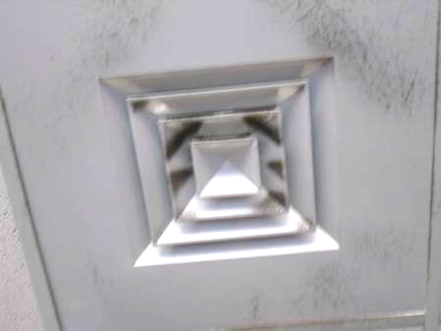

Ceiling-mounted supply vent, note dust/debris accumulation on louvers

Picture 2

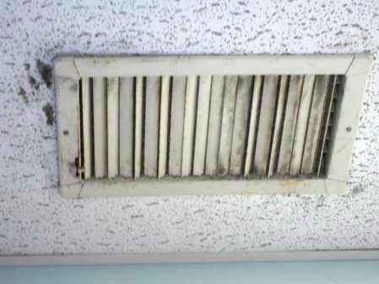

Ceiling-mounted supply vent, note dust/debris accumulation on louvers

Picture 3

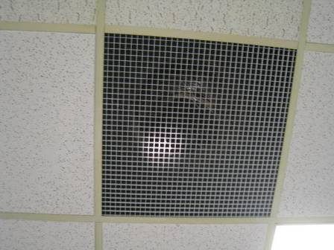

Ceiling-mounted return grill

Picture 4

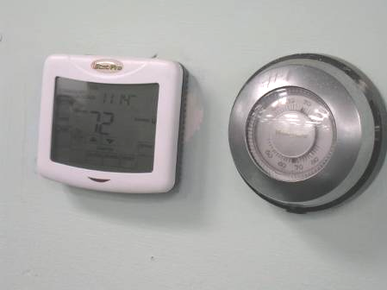

Digital wall thermostat, adjacent to old dial thermostat

Picture 5

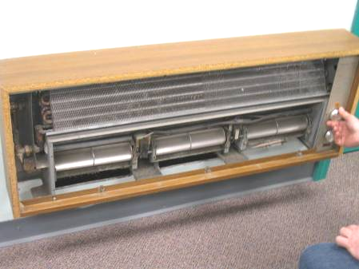

Fan coil unit missing cover

Picture 6

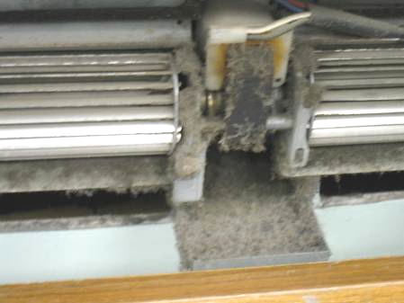

Accumulated dust/debris in fan coil unit

Picture 7

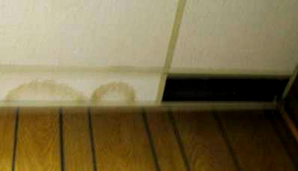

Missing/water-damaged ceiling tiles

Picture 8

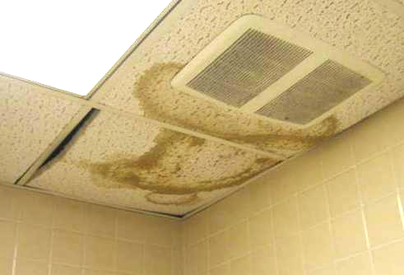

Water-damaged ceiling tiles in women’s restroom, note dust/debris accumulation on vent

Picture 9

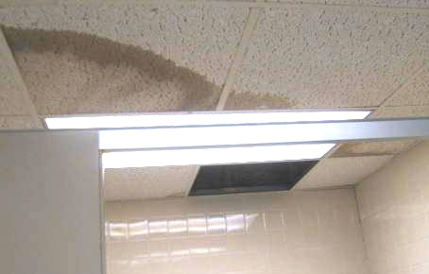

Missing/water-damaged ceiling tiles in men’s restroom

Picture 10

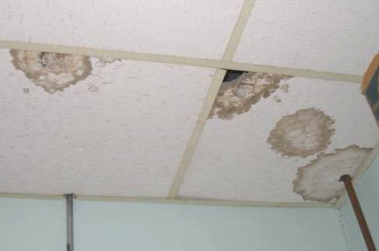

Water-damaged ceiling tiles in plate room

Picture 11

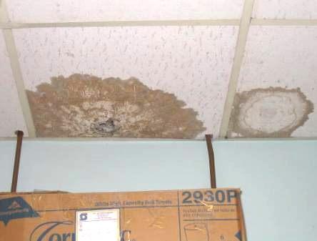

Water-damaged ceiling tiles in plate room

Picture 12

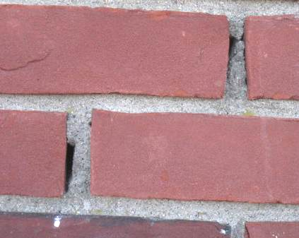

Missing/damaged mortar around exterior brick

Picture 13



Missing/damaged mortar around exterior brick

Picture 14

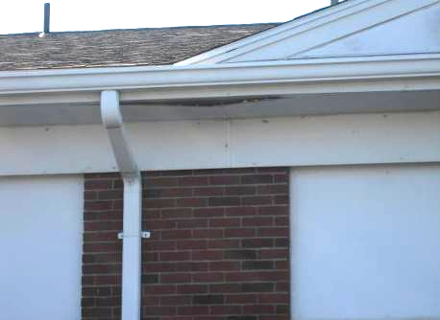

Damaged roof eave (arrow)

Picture 15

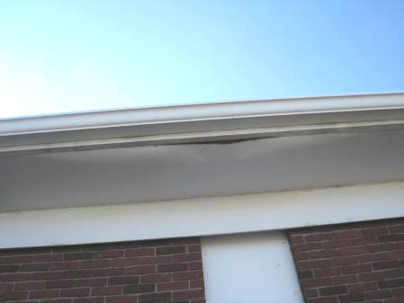

Damaged roof eave (arrow)

Picture 16

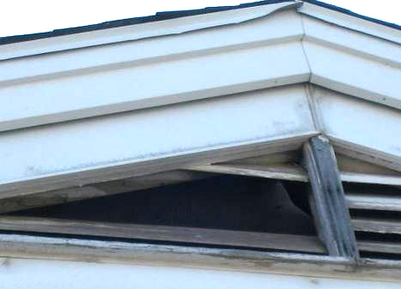

Damaged attic crawlspace vent/bird screen

Picture 17

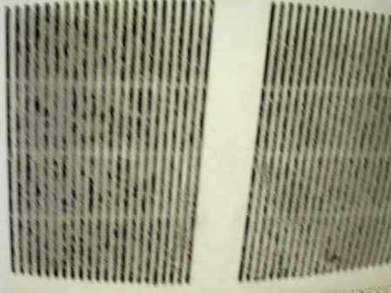

Close-up of occluded exhaust vent in women’s employee restroom (Picture 8)

Picture 18

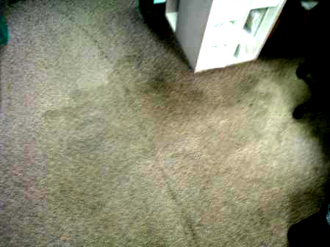

Soiled/stained carpeting

Picture 19

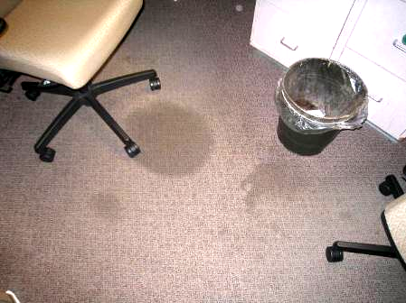

Soiled/stained carpeting

Picture 20

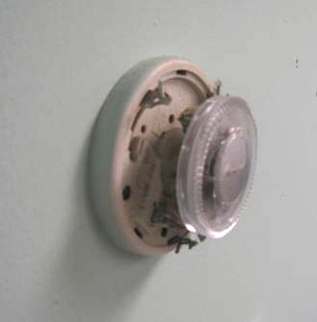

Mercury-containing thermostat (cover removed by BEH/IAQ staff)
Picture 21

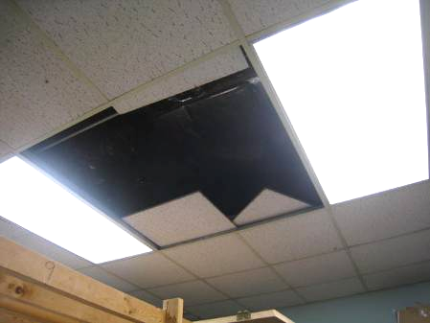

Missing ceiling tiles in plate room

Picture 22

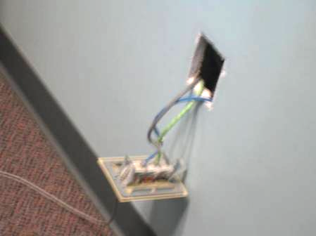

Wall socket removed from wall

Picture 23

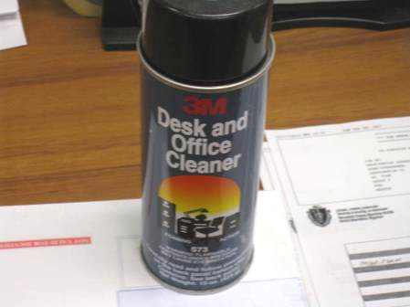

VOC-containing spray cleaner, note label warning: flammable and may cause eye irritation
Location | Occupants  in Room | Temp  (°F) | Relative  Humidity  (%) | Carbon  Dioxide  (ppm) | Carbon  Monoxide  (ppm) | PM2.5 (ug/m³) | Windows  Openable | Ventilation |  | Remarks
Outside  (Background) |  | 60 | 62 | 394 | ND | 13 |  |  |  | Clear, cool, sunny, south winds 1-9 mph, busy traffic area/parking lot
Training Room | 0 | 69 | 55 | 1000 | ND | 4 | Y | Y | Y | Stained carpeting-dry
Clerks 5 Office | 0 | 70 | 52 | 1100 | ND | 4 | Y | Y | Y | WD CTs
Stock Room | 0 | 70 | 49 | 1241 | ND | 4 | N | Y | N | WD CTs, MTs
Stations 1-3 | 1 | 70 | 49 | 1315 | ND | 4 | N | Y | Y | Stained carpeting-dry
Stations 4-6 | 0 | 70 | 48 | 1362 | ND | 5 | N | Y | Y
Stations 7-10 | 8 | 70 | 47 | 1480 | ND | 5 | N | Y | Y | FCU-no cover, dust/debris
Computer/Network Room | 0 | 70 | 43 | 1369 | ND | 4 | N | Y | N | WD CTs
Audit | 0 | 70 | 47 | 1448 | ND | 6 | N | N | N | No windows or mechanical ventilation, WD CTs
Stations 11-13 | 2 | 70 | 49 | 1480 | ND | 5 | N | Y | Y | Stained carpeting-dry
Stations 14-15 | 3 | 70 | 49 | 1407 | ND | 5 | N | Y | Y | Hole in wall behind file cabinet
Testing Room (Front) | 1 | 69 | 47 | 1216 | ND | 5 | N | Y | Y | WD CT
Waiting Area (East) | ~25 | 69 | 49 | 1504 | ND | 7 | N | Y | Y | Dust/debris-vents
Waiting Area (Center) | ~25 | 69 | 51 | 1700 | ND | 6 | N | Y | Y | Dust/debris-vents
Waiting Area (West) | ~50 | 70 | 51 | 1683 | ND | 7 | N | Y | Y | Dust/debris-vents
Customer Service Desk | 9 | 71 | 50 | 1720 | ND | 7 | N | Y | Y | Old mercury-containing thermostat
Road Test | 0 | 70 | 49 | 1504 | ND | 6 | Y | Y | N | Dust/debris-vents, WD CTs
Employee Restroom Men’s |  |  |  |  |  |  | Y | Y | Y | WD/MTs, WD light fixture
Employee Restroom Women’s |  |  |  |  |  |  | N | Y | Y | WD CTs, clogged exhaust vent-dust/debris, missing supply vent, clogged sink
Plate Room | 0 | 65 | 48 | 1251 | ND | 7 | N | Y | Y | Spaces under exterior door, WD/MTs, FCU-missing cover

