INDOOR AIR QUALITY ASSESSMENT

Massachusetts Registry of Motor Vehicles
116 Pleasant Street
Easthampton, Massachusetts



Prepared by:
Massachusetts Department of Public Health
Bureau of Environmental Health
Indoor Air Quality Program
February 2013

Background/Introduction
In response to a request from Mr. Aric Warren, Deputy Director of General Services, Massachusetts Department of Transportation (MDOT), the Massachusetts Department of Public Health (MDPH), Bureau of Environmental Health (BEH) provided assistance and consultation regarding indoor air quality (IAQ) concerns at the Easthampton Area Branch of the Massachusetts Registry of Motor Vehicles (RMV), located at 116 Pleasant Street, Easthampton, Massachusetts.
On December 20, 2012, a visit to conduct an IAQ assessment was made by Ruth Alfasso, Environmental Engineer/Inspector and Kathleen Gilmore, Environmental Analyst/Regional Inspector within BEH’s IAQ Program. Ms. Alfasso and Ms. Gilmore were accompanied by Robert Northrup, Program Coordinator, MDOT. Based on the measurement of carbon monoxide (CO) during the December 20th visit, Michael Feeney, Director of BEH’s IAQ program returned to the RMV Easthampton facility on December 21, 2012, accompanied by Ms. Gilmore to conduct further assessment.
The RMV is located in a refurbished mill building composed of red brick and concrete. The building has two floors and an occupied basement. Several other businesses operate in this building, including two restaurants, a health club, a hair salon, other retail businesses, artist studios, office space, storage space and a business that manufactures custom concrete.
The RMV consists of a single room with a high ceiling subdivided by 8-foot-high dividers into several sections: the waiting area; the locked area for employees only, which includes storage for license plates and the break room; and the area where the clerks serve customers. The RMV is separated from other areas of the building via wallboard; the door into the suite from the common areas of the building is glass and wood. Additional space and benches for waiting customers are in this common area, as well as common restroom facilities used by RMV staff and customers.
The windows, which exist along the back wall of the RMV suite, are of a large industrial style, and were once openable, but most are now painted shut, with others covered with several heavy layers of plastic to prevent drafts.

Methods
Air tests for carbon dioxide, carbon monoxide, temperature and relative humidity were taken with the TSI, Q-Trak, IAQ Monitor 7565. Air tests for airborne particle matter with a diameter less than 2.5 micrometers were taken with the TSI, DUSTTRAK™ Aerosol Monitor Model 8520. On the December 20, 2012 visit, sampling for total volatile organic compounds was performed using a mini-RAE 2000 photoionization detector. On the December 21, 2012 visit, screening for ultrafine particulates was conducted with a P-Trak Ultrafine Particle Counter (UPC) Model 8525. BEH staff also performed visual inspection of building materials for water damage and/or microbial growth.

Results
The RMV has an employee population of approximately 7 and can be visited by up to 150-180 members of the public on a daily basis. The tests were taken during normal operations. Test results from the December 20, 2012 visit appear in Table 1 and results from the December 21, 2012 visit appear in Table 2.

Discussion

Ventilation
It can be seen from Table 1 that carbon dioxide levels were above 800 parts per million (ppm) in all areas surveyed within the RMV on the December 20, 2012 visit, indicating a lack of air exchange at the time of the assessment. Fresh air is supplied to the RMV through an air intake duct from the side of the building (Picture 1) to an air handling unit (AHU) mounted to the ceiling (Picture 2). Air is distributed via ductwork with supply vents along its length (Picture 3). Reportedly, the AHU does not provide heating or cooling. In addition, the duct which carries the fresh air from outside to the AHU is equipped with a lever which appears to control a damper with a summer and winter setting (Picture 4). It is likely that with the damper set to the winter setting, little or no outside air can be drawn into the space. Additionally, it was noted that the outside intake of this duct was covered with plywood, eliminating the ability of the duct to provide fresh air during the winter. It was also noted that several of the supply vents along the duct from the AHU had closed louvers or were covered with plastic/cardboard (Picture 5), reportedly due to staff complaints of drafts or cold.
During the visit conducted on December 21, 2012, some first floor exterior doors of the building were found propped open, but carbon dioxide levels inside the RMV were also above 800 ppm (Table 2). These carbon dioxide levels indicate that under typical operating conditions even with additional outside air into the building, there is insufficient ventilation in the RMV.
There is a digital wall-mounted thermostat in the space connected to the AHU (Picture 6). It has fan settings of “on” and “automatic”. The automatic setting on the thermostat activates the AHU at a preset temperature. Once the preset temperature is reached, the system is deactivated. Therefore, no mechanical ventilation is provided until the thermostat re-activates the system. In the fan “on” mode, air will be continuously circulated and filtered, which should improve temperature/comfort control. MDPH recommends that thermostats be set to the fan “on” setting during occupied periods to provide continuous air circulation and filtration. The staff reports that since the AHU provides no heat, this thermostat only activates the fan on the AHU. In addition, the location of the thermostat, behind partition walls from most of the office, does not allow it to detect a temperature representative of the rest of the office.
There appears to be a return vent to the duct supplying the AHU (Picture 2) but there are no other exhaust vents in the RMV space nor do there appear to be any in the hallway areas. The core-area bathrooms have exhaust vents that were functioning at the time of the visits.
To maximize air exchange, the MDPH recommends that both supply and exhaust ventilation operate continuously during periods of occupancy. In order to have proper ventilation with a mechanical supply and exhaust system, the systems must be balanced to provide an adequate amount of fresh air to the interior of a room while removing stale air from the room. It is recommended that HVAC systems be re-balanced every five years to ensure adequate air systems function (SMACNA, 1994). The date of the last balancing of this system was not available at the time of the assessment, and it is unclear if the system can be balanced in its current configuration.
Minimum design ventilation rates are mandated by the Massachusetts State Building Code (MSBC). Until 2011, the minimum ventilation rate in Massachusetts was higher for both occupied office spaces and general classrooms, with similar requirements for other occupied spaces (BOCA, 1993). The current version of the MSBC, promulgated in 2011 by the State Board of Building Regulations and Standards (SBBRS), adopted the 2009 International Mechanical Code (IMC) to set minimum ventilation rates. Please note that the MSBC is a minimum standard that is not health-based. At lower rates of cubic feet per minute (cfm) per occupant of fresh air, carbon dioxide levels would be expected to rise significantly. A ventilation rate of 20 cfm per occupant of fresh air provides optimal air exchange resulting in carbon dioxide levels at or below 800 ppm in the indoor environment in each area measured. MDPH recommends that carbon dioxide levels be maintained at 800 ppm or below. This is because most environmental and occupational health scientists involved with research on IAQ and health effects have documented significant increases in indoor air quality complaints and/or health effects when carbon dioxide levels rise above the MDPH guidelines of 800 ppm for schools, office buildings and other occupied spaces (Sundell et al., 2011). The ventilation must be on at all times that the room is occupied. Providing adequate fresh air ventilation with open windows and maintaining the temperature in the comfort range during the cold weather season is impractical. Mechanical ventilation is usually required to provide adequate fresh air ventilation.
Carbon dioxide is not a problem in and of itself. It is used as an indicator of the adequacy of the fresh air ventilation. As carbon dioxide levels rise, it indicates that the ventilating system is malfunctioning or the design occupancy of the room is being exceeded. When this happens, a buildup of common indoor air pollutants can occur, leading to discomfort or health complaints. The Occupational Safety and Health Administration (OSHA) standard for carbon dioxide is 5,000 parts per million parts of air (ppm). Workers may be exposed to this level for 40 hours/week, based on a time-weighted average (OSHA, 1997).
The MDPH uses a guideline of 800 ppm for publicly occupied buildings. A guideline of 600 ppm or less is preferred in schools due to the fact that the majority of occupants are young and considered to be a more sensitive population in the evaluation of environmental health status. Inadequate ventilation and/or elevated temperatures are major causes of complaints such as respiratory, eye, nose and throat irritation, lethargy and headaches. For more information concerning carbon dioxide, please see Appendix A.
Temperature readings ranged from 71º F to 72º F in the RMV on December 20, 2012 (Table 1) and ranged from 69º F to 72º F on December 21, 2012 (Table 2), which were within or close to the MDPH recommended comfort guidelines. The MDPH recommends that indoor air temperatures be maintained in a range of 70º F to 78º F in order to provide for the comfort of building occupants. In many cases concerning indoor air quality, fluctuations of temperature in occupied spaces are typically experienced, even in a building with an adequate fresh air supply.
The relative humidity measured in the RMV on December 20, 2012 ranged from 29 to 31 percent (Table 1), which was below the MDPH recommended comfort range in all areas surveyed. On December 21, 2012, the relative humidity measured in the RMV ranged from 33 to 34 percent (Table 2), which was also below the MDPH comfort range. The MDPH recommends a comfort range of 40 to 60 percent for indoor air relative humidity. Relative humidity levels in the building would be expected to drop during the winter months due to heating.

Microbial/Moisture Concerns
There were reports of leaks from upstairs tenants in the recent past but no evidence of water damage or mold was noted in the RMV. The primary construction materials of the building are brick, cement and plaster; materials that are not prone to growing mold.
The windows along the back of the RMV space, as mentioned, are covered in a thick layer of plastic sheeting taped to the window frames (Pictures 7 and 8). It was reported that the windows behind the plastic may be broken/unsealed which may result in leaks into the window well. Porous materials should not be stored in proximity to the windows to prevent damage in case of water infiltration.
The US Environmental Protection Agency (US EPA) and the American Conference of Governmental Industrial Hygienists (ACGIH) recommend that porous materials be dried with fans and heating within 24 to 48 hours of becoming wet (US EPA, 2001; ACGIH, 1989). If not dried within this time frame, mold growth may occur. Once mold has colonized porous materials, they are difficult to clean and should be removed.

Other IAQ Evaluations
Indoor air quality can be negatively influenced by the presence of respiratory irritants, such as products of combustion. The process of combustion produces a number of pollutants. Common combustion emissions include carbon monoxide, carbon dioxide, water vapor and smoke (fine airborne particle material). Of these materials, exposure to carbon monoxide and particulate matter with a diameter of 2.5 micrometers (μm) or less (PM2.5) can produce immediate, acute health effects upon exposure. To determine whether combustion products were present in the indoor environment, BEH/IAQ staff obtained measurements for carbon monoxide, PM2.5 and ultrafine particles.

Carbon Monoxide
Carbon monoxide is a by-product of incomplete combustion of organic matter (e.g., gasoline, wood and tobacco). Exposure to carbon monoxide can produce immediate and acute health affects. Several air quality standards have been established to address carbon monoxide and prevent symptoms from exposure to these substances. The MDPH established a corrective action level concerning carbon monoxide in ice skating rinks that use fossil-fueled ice resurfacing equipment. If an operator of an indoor ice rink measures a carbon monoxide level over 30 ppm, taken 20 minutes after resurfacing within a rink, that operator must take actions to reduce carbon monoxide levels (MDPH, 1997).
The American Society of Heating Refrigeration and Air-Conditioning Engineers (ASHRAE) has adopted the National Ambient Air Quality Standards (NAAQS) as one set of criteria for assessing indoor air quality and monitoring of fresh air introduced by HVAC systems (ASHRAE, 1989). The NAAQS are standards established by the US EPA to protect the public health from six criteria pollutants, including carbon monoxide and particulate matter (US EPA, 2006). As recommended by ASHRAE, pollutant levels of fresh air introduced to a building should not exceed the NAAQS levels (ASHRAE, 1989). The NAAQS were adopted by reference in the Building Officials & Code Administrators (BOCA) National Mechanical Code of 1993 (BOCA, 1993), which is now an HVAC standard included in the Massachusetts State Building Code (SBBRS, 2011). According to the NAAQS, carbon monoxide levels in outdoor air should not exceed 9 ppm in an eight-hour average (US EPA, 2006).
Carbon monoxide should not be present in a typical, indoor environment. If it is present, indoor carbon monoxide levels should be less than or equal to outdoor levels. At the time of the December 20, 2012 assessment, outdoor carbon monoxide concentrations ranged from 1-2 ppm (Table 1) and carbon monoxide levels from 8 to 10 ppm were measured inside the RMV (Table 1). In common areas of the building, carbon monoxide concentrations measured lower than the RMV space, but were still above outdoor background readings (up to 5 ppm; Table 1). These carbon monoxide levels were at a level below which acute health concerns might be experienced, however when measured, it is important to identify the source of products of combustion in order to evaluate whether there is adequate exhaust ventilation and take steps to ensure such.
The elevated levels of carbon monoxide are believed to be due to the use of a forklift in the basement area below the RMV (Picture 9). The forklift is powered by combustible fuel (i.e., Propane), which, similarly to ice resurfacing equipment can produce carbon monoxide, which can build up if used indoors. The floors of the RMV that overlay the basement are composed of wooden beams which do not provide an air-tight seal between the RMV and the basement (Picture 10), allowing carbon monoxide to migrate between floors. In addition, there is a stairwell between the basement and the first floor with doors that were open or not tightly sealed at the time of the visit. Because carbon monoxide and related combustion gases have a high temperature, these gases, vapors and particles can rise to the ceiling and pass through the floor/stairwell into the RMV occupied space.
On December 21, 2012, the forklift had been moved from the location it had been the day before and could therefore not be evaluated/identified as a carbon monoxide source by BEH/IAQ staff. Levels of carbon monoxide measured in the RMV on this visit were non-detect (ND) (Table 2). The landlord reported that use of the forklift was forbidden inside the shared areas of the core building.
It is proper operating procedure to provide adequate exhaust ventilation when a fuel-fired forklift needs to be used indoors via mechanical ventilation, opening doors to the outside and/or using fans to remove exhaust during and for a period after use. Replacement of this forklift with an electric model would eliminate the potential for products of combustion to enter occupied spaces.

Particulate Matter
The US EPA has established NAAQS limits for exposure to particulate matter. Particulate matter is airborne solids that can be irritating to the eyes, nose and throat. The NAAQS originally established exposure limits to particulate matter with a diameter of 10 μm or less (PM10). According to the NAAQS, PM10 levels should not exceed 150 micrograms per cubic meter (μg/m³) in a 24-hour average (US EPA, 2006). These standards were adopted by both ASHRAE and BOCA. Since the issuance of the ASHRAE standard and BOCA Code, US EPA established a more protective standard for fine airborne particles. This more stringent PM2.5 standard requires outdoor air particle levels be maintained below 35 μg/m³ over a 24-hour average (US EPA, 2006). Although both the ASHRAE standard and BOCA Code adopted the PM10 standard for evaluating air quality, MDPH uses the more protective PM2.5 standard for evaluating airborne particulate matter concentrations in the indoor environment.
On December 20, 2012, outdoor PM2.5 concentrations were measured at 10 μg/m³ (Table 1). PM2.5 levels measured in the RMV on that day ranged from 8 to 10 μg/m³ (Table 1), which were below the NAAQS PM2.5 level of 35 μg/m³. On December 21, 2012, outdoor PM2.5 concentrations were measured at 4 μg/m³ (Table 2). In the RMV, PM2.5 levels ranged from 9 to 10 μg/m³ (Table 2), which were also below the NAAQS PM2.5 level of 35 μg/m³. Frequently, indoor air levels of particulates (including PM2.5) can be at higher levels than those measured outdoors. A number of mechanical devices and/or activities that occur indoors can generate particulate during normal operations. Sources of indoor airborne particulates may include but are not limited to particles generated during the operation of fan belts in the HVAC system, use of stoves and/or microwave ovens in kitchen areas; use of photocopiers, fax machines and computer printing devices; operation of an ordinary vacuum cleaner and heavy foot traffic indoors.

Ultrafine Particulates
On December 21, 2012, air monitoring for airborne ultrafine particulates was also conducted to assist in the identification of the source of carbon monoxide detected during the December 20, 2012 visit. An ultrafine particle has a diameter of 0.02 micrometers (μm) to 1 μm and is produced by combustion of fuels, cutting processes and other operations that aerosolize particles. This type of air monitoring is useful as a screening device, in that it can be used to track sources of airborne pollutants by counting the actual number of airborne particles. The source of particles can be identified by moving the ultrafine particle counter (UPC) through a building towards the highest measured concentration of airborne particles. Measured levels of particles per cubic centimeter of air (pt/cc) increases as the UPC is moved closer to the source of particle production. While this equipment can ascertain whether unusual sources of ultrafine particles exist in a building or that particles are penetrating through spaces in doors or walls, it cannot be used to quantify whether the NAAQS PM10 or PM2.5 standard was exceeded. The primary purpose of these tests was to identify and reduce/prevent pollutant pathways.
At the time of the December 21, 2012 assessment, outdoor ultrafine particulate concentrations were measured at 2,000 pt/cc (Table 2). Ultrafine particulate levels measured in the RMV ranged from 3,000 to 8,000 pt/cc (Table 2). Levels ranging from 3,000 to 15,000 pt/cc were measured in other areas of the building. In the area where the forklift had been observed the previous day, the levels were measured at 12,000 pt/cc, and levels were measured at 15,000 pt/cc near the stairwell leading to the basement area where the forklift had been observed (Table 2). The forklift was not observed in that location during the December 21, 2012 visit. An operating fuel-powered forklift would be a significant source of measurable ultrafine particulate. The hallways of the basement area as well as the base of the stairwell do not contain any mechanical exhaust ventilation. In this configuration, products of combustion that consist of particulates may linger, which may be indicated by the ultrafine particle counts, above background, measured during the December 21, 2012 visit.

Volatile Organic Compounds
Indoor air concentrations can be greatly impacted by the use of products containing volatile organic compounds (VOCs). VOCs are carbon-containing substances that have the ability to evaporate at room temperature. Frequently, exposure to low levels of total VOCs (TVOCs) may produce eye, nose, throat and/or respiratory irritation in some sensitive individuals. For example, chemicals evaporating from a paint can stored at room temperature would most likely contain VOCs.
In an effort to determine whether VOCs were present in the RMV, air monitoring for TVOCs was conducted during the December 20, 2012 visit. An outdoor air sample was taken for comparison. Outdoor TVOC concentrations were ND. On December 20, 2012, no measureable levels of TVOCs were detected in the RMV (Table 1). Please note, that the TVOC air measurements are only reflective of the indoor air concentrations present at the time of sampling. Indoor air concentrations can be greatly impacted by the use TVOC containing products and the presence of other sources.
The new license plates for the RMV were stored in a room that is used for several other purposes, including an employee break room (Picture 11). When newly printed, license plates can give off TVOCs and associated odors. Improved ventilation in this area would decrease the potential for irritation effects from new license plates.

Other Conditions
Other conditions that can affect indoor air quality were observed during the assessment. AHUs are equipped with air filters that should be cleaned or changed per the manufacturer’s instructions to avoid the reaerosolization of dusts and particulates. It was reported that the filter in the single AHU is changed approximately monthly. This has reportedly been done due to a high rate of fouling of the filter due to heavy amounts of dust present in the space which settles on the tops of the room dividers and other flat surfaces.
In order to decrease aerosolized particulates, disposable filters with an appropriate dust spot efficiency should be installed. The dust spot efficiency is the ability of a filter to remove particulates of a certain diameter from air passing through the filter. Filters that have been determined by ASHRAE to meet its standard for a dust spot efficiency of a minimum of 40 percent would be sufficient to reduce many airborne particulates (Thornburg, D., 2000; MEHRC, 1997; ASHRAE, 1992). Pleated filters with a Minimum Efficiency Reporting Value dust-spot efficiency of 9 or higher are recommended. Note that increasing filtration can reduce airflow (called pressure drop), which can subsequently reduce the efficiency of the unit due to increased resistance. Prior to any increase of filtration, the AHU should be evaluated by a ventilation engineer to ascertain whether it can maintain function with more efficient filters.
A number of air vents were observed to have accumulated dust. Vents, room dividers and other surfaces should be cleaned of dust regularly using a damp cloth to prevent this material from being repeatedly aerosolized.
There were reports of insects in the summer, described as fruit flies or fleas. It is believed that these insects enter the RMV from the area below, which serves as a trash room for the facility (Pictures 12 and 13), through the same non-air-tight floorboards described previously. This area was free of trash and appeared clean and well-maintained at the time of the assessments, but it was noted that the trash bins do not have lids. It was not known how much trash may accumulate in this area or how often it may be emptied. Trash areas, especially when adjacent to occupied areas, should be kept as clean and neat as possible and the containers should be kept covered and in good repair, with trash being removed to outside containers or taken away for disposal regularly. If odors or pests from trash become a problem in warmer months, the area needs to be emptied and cleaned more frequently until the problem is eliminated. Consultation with a pest control professional experienced in Integrated Pest Management (IPM) should be sought if the problem becomes severe or continues to reoccur.
The RMV offices are crowded with dividers, furniture and items, including papers, books, stored materials, custodial supplies, food preparation equipment and other items. The presence of these items and the crowded conditions may make it difficult to clean and remove dust which can become aerosolized. Used license plates are also stored in the employee area; these can contain contaminants and debris from automobiles which can then become distributed in the room. The use of food preparation equipment may produce odors and particulates which cannot be removed without a functioning ventilation system.
Lastly, the fresh air intake for the HVAC system in the RMV does not have a bird screen. Bird screens are necessary to prevent roosting inside the ductwork. Waste products from birds can be a source or respiratory irritants.

Conclusions/Recommendations
In view of the findings at the time of the visit, the following recommendations are made:
- Discontinue the use of the fossil fuel powered forklift inside the building. Consider replacing the forklift with electric powered mode and use of carbon monoxide detectors within the occupied RMV space.
- Operate all ventilation systems (e.g., AHUs) continuously during occupied periods.
- Have building management consult with an HVAC engineer to ensure that there is sufficient fresh air for the RMV area during both summer and winter months.
- Examine the feasibility of installing mechanical exhaust ventilation for the RMV.
- Consider relocating thermostat to a more representative area of the building to maintain comfort.
- Once mechanical ventilation is installed, consider adopting a balancing schedule of every 5 years for all mechanical ventilation systems, as recommended by ventilation industry standards (SMACNA, 1994).
- Consider installing carbon monoxide detectors in the RMV.
- For buildings in New England, periods of low relative humidity during the winter are often unavoidable. Therefore, scrupulous cleaning practices should be adopted to minimize common indoor air contaminants whose irritant effects can be enhanced when the relative humidity is low. To control for dusts, a high efficiency particulate arrestance (HEPA) filter equipped vacuum cleaner in conjunction with wet wiping of all surfaces is recommended. Drinking water during the day can help ease some symptoms associated with a dry environment (throat and sinus irritations).
- If feasible, repair and restore windows so that they provide a barrier to the infiltration of water without the use of layers of plastic and, if possible, so they can be partially opened to provide ventilation during periods of clement weather.
- Clean vents, the tops of room dividers and stored items periodically of accumulated dust/debris.
- Consider finding an alternative location to store both new and used license plates to prevent exposure to dirt and VOCs.
- Install a bird screen over the fresh air intake of the HVAC system.
- Refer to resource manuals and other related indoor air quality documents for further building-wide evaluations and advice on maintaining public buildings. Copies of these materials are located on the MDPH’s website: http://mass.gov/dph/iaq.

References
ACGIH. 1989. Guidelines for the Assessment of Bioaerosols in the Indoor Environment. American Conference of Governmental Industrial Hygienists, Cincinnati, OH.
ASHRAE. 1989. Ventilation for Acceptable Indoor Air Quality. American Society of Heating, Refrigeration and Air Conditioning Engineers. ANSI/ASHRAE 62-1989.
ASHRAE. 1992. Gravimetric and Dust-Spot Procedures for Testing Air-Cleaning Devices Used in General Ventilation for Removing Particulate Matter. American Society of Heating, Refrigeration and Air Conditioning Engineers. ANSI/ASHRAE 52.1-1992.
BOCA. 1993. The BOCA National Mechanical Code/1993. 8th ed. Building Officials and Code Administrators International, Inc., Country Club Hill, IL. Section M-308.1.1.
IMC, 2009. 2009 International Mechanical Code. International Code Council Inc., Country Club Hills, IL.
MDPH. 1997. Requirements to Maintain Air Quality in Indoor Skating Rinks (State Sanitary Code, Chapter XI). 105 CMR 675.000. Massachusetts Department of Public Health, Boston, MA.
MEHRC. 1997. Indoor Air Quality for HVAC Operators & Contractors Workbook. MidAtlantic Environmental Hygiene Resource Center, Philadelphia, PA.
OSHA. 1997. Limits for Air Contaminants. Occupational Safety and Health Administration. Code of Federal Regulations. 29 C.F.R 1910.1000 Table Z-1-A.
SBBRS. 2011. Mechanical Ventilation. State Board of Building Regulations and Standards. Code of Massachusetts Regulations, 8th edition. 780 CMR 1209.0.
SMACNA. 1994. HVAC Systems Commissioning Manual. 1st ed. Sheet Metal and Air Conditioning Contractors’ National Association, Inc., Chantilly, VA.
Sundell. 2011. Sundell, J., H. Levin, W. W. Nazaroff, W. S. Cain, W. J. Fisk, D. T. Grimsrud, F. Gyntelberg, Y. Li, A. K. Persily, A. C. Pickering, J. M. Samet, J. D. Spengler, S. T. Taylor, and C. J. Weschler. Ventilation rates and health: multidisciplinary review of the scientific literature. Indoor Air, Volume 21: pp 191–204.
Thornburg, D. 2000. Filter Selection: a Standard Solution. Engineering Systems 17:6 pp. 74-80.
US EPA. 2001. Mold Remediation in Schools and Commercial Buildings. US Environmental Protection Agency, Office of Air and Radiation, Indoor Environments Division, Washington, DC. EPA 402-K-01-001. March 2001.
US EPA. 2006. National Ambient Air Quality Standards (NAAQS). US Environmental Protection Agency, Office of Air Quality Planning and Standards, Washington, DC. http://www.epa.gov/air/criteria.html.
Picture 1

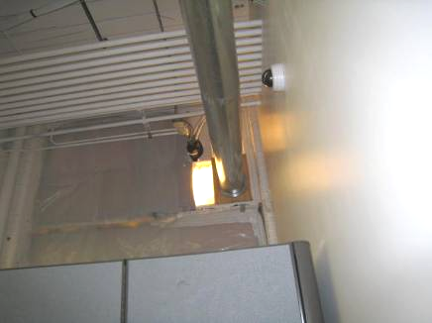

Fresh air duct from outside into air handling unit

Picture 2

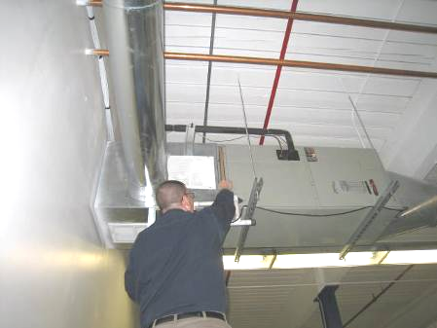

Ceiling-mounted air-handling unit
Picture 3

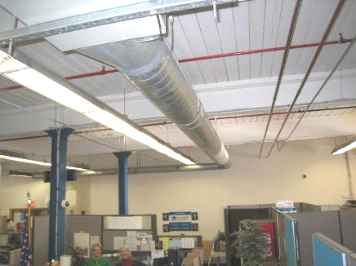

Supply duct from AHU to the rest of the RMV office space

Picture 4

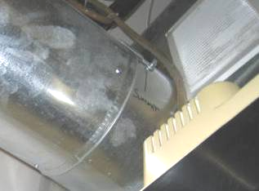

Summer/winter lever (arrow) controlling damper on fresh air duct turned
from summer setting (oval)

Picture 5

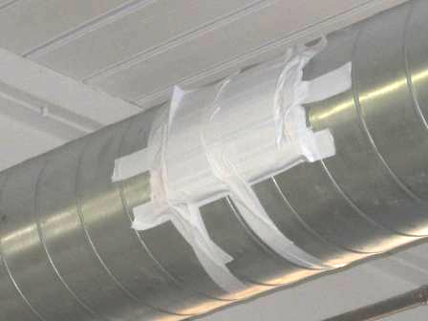

Sealed supply vent

Picture 6

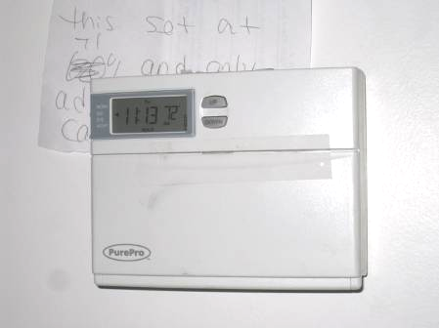

Thermostat in RMV

Picture 7

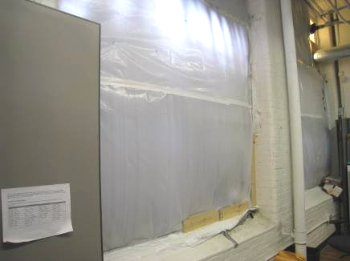

Plastic covering windows in the RMV

Picture 8

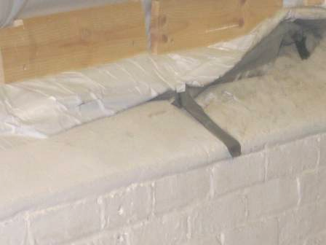

Tape holding plastic on RMV windows

Picture 9

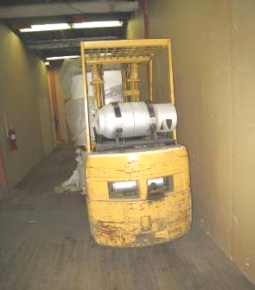

Fuel-burning (Propane) forklift in basement area

Picture 10

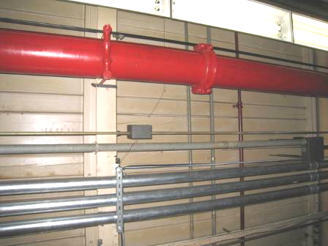

Ceiling of basement area below the RMV, note gaps between beams

Picture 11

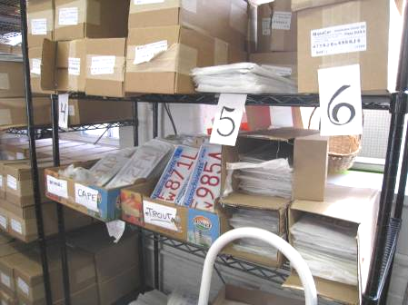

Boxes of new license plates stored in employee area

Picture 12

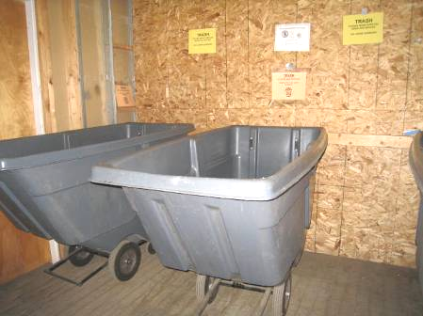

Trash bins in the basement below the RMV

Picture 13

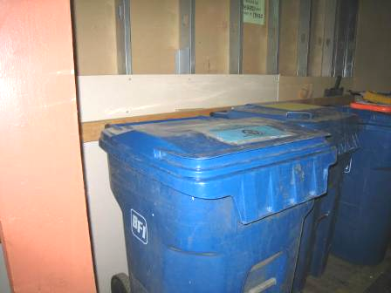

Recycling/trash bins in basement below the RMV
Location | Carbon  Dioxide  (ppm) | Carbon Monoxide  (ppm) | Temp  (°F) | Relative  Humidity  (%) | TVOCs  (ppm) | PM2.5  (µg/m³) | Occupants  in Room | Windows  Openable | Ventilation |  | Remarks
 |  |  |  |  |  |  |  |  | Intake | Exhaust | Remarks
Background | 367 | 1.1 | 35 | 26 | ND | 10 |  |  |  |  | Chilly, mostly sunny, breezy
RMV Offices
RMV main/break room | 1078 | 9.9 | 72 | 29 | ND | 9 | 4 | N | Y | N | Items, cooking equipment (microwave and fridge), storage of license plates
RMV waiting area | 1500 | 8.2 | 72 | 29 | ND | 10 | 10-15 | N | Y | N
RMV clerk station 1 | 1106 | 8 | 71 | 29 | ND | 10 | 3 | N | Y | N
RMV money office | 1221 | 8.7 | 72 | 31 | ND | 10 | 1 | N | N | N | Windows sealed with double layer of plastic, cannot be opened but are known to leak/blow into plastic
RMV clerk core area | 1234 | 8.4 | 72 | 30 | ND | 8 | 5 | N | Y | N
Other First Floor Locations
First floor central hallway/extra waiting area outside RMV | 902 | 4.6 | 71 | 24 | ND | 10 | 5-10 | N | Y | N
Stairwell/back door outside RMV office | 1027 | 3 | 67 | 28 | ND | 11 | 0 | N | N | N
First floor west hallway | 759 | 1 | 72 | 33 | ND | 10 | 0 | N | N | N
First floor east hallway | 619 | 3.3 | 68 | 26 | ND | 10 | 0 | N | Y | N
Basement Areas
Basement east hallway | 689 | 1 | 71 | 31 | ND | 9 | 0 | N | N | N
Basement below RMV office | 524 | 2 | 69 | 22 | ND | 10 | 0 | N | Y | N | Garbage room, no lids on bins. Bins clean. Reports of summer insect problem (fruit flies or fleas) up through the floors from this area
Basement west hallway | 721 | ND | 70 | 33 | ND | 8 | 0 | N | N | N
Basement central hallway (forklift area) | 1109 | 5.3 | 70 | 32 | ND | 10 | 1 | N | N | N
Second Floor
Second floor central hallway | 744 | ND | 73 | 37 | ND | 9 | 0 | N | Y | N
Second floor east hallway | 698 | ND | 71 | 32 | ND | 9 | 0 | N | Y | N
Second floor west hallway | 766 | ND | 69 | 29 | ND | 10 | 0 | N | Y | N
Second floor hallway business area | 1056 | 4 | 72 | 31 | ND | 21-25 | 5 | Y | Y | N | Items for sale, cooking equipment, no cooking

Location | Carbon  Dioxide  (ppm) | Carbon Monoxide  (ppm) | Temp  (°F) | Relative  Humidity  (%) | Ultrafine Particles (pt/cc) | PM2.5  (µg/m³) | Occupants  in Room | Windows  Openable | Ventilation |  | Remarks
 |  |  |  |  |  |  |  |  | Intake | Exhaust | Remarks
Background | 367 | ND | 42 | 48 | 2,000 | 4 |  |  |  |  | Heavy rain
RMV Offices
RMV main/break room | 1252 | ND | 70 | 33 | 3,000 | 10 | 5 | N | Y | N | Items, cooking equipment (microwave and fridge), storage of license plates
RMV waiting area | 1352 | ND | 71 | 33 | 8,000 | 10 | 9 | N | Y | N
RMV clerk station 1 | 1189 | ND | 70 | 33 | 4,000 | 10 | 2 | N | Y | N
RMV money office | 1201 | ND | 69 | 33 | 5,000 | 9 | 1 | N | Y | N | Windows sealed with double layer of plastic, cannot be opened but are known to leak/blow into plastic
RMV clerk core area | 1253 | ND | 72 | 34 | 6,000 | 10 | 7 | N | Y | N
Other First Floor Locations
First floor central hallway/extra waiting area outside RMV | 824 | ND | 68 | 25 | 15,000 | 6 | 12 | N | Y | N | Front door open
Stairwell/back door area outside RMV office | 542 | ND | 69 | 28 | 15,000 | 2 | 0 | N | N | N
First floor east hallway | 698 | ND | 70 | 25 | 8,000 | 10 | 0 | N | Y | N | Door to outside open
First floor east door (outside) | 468 | ND | 46 | 47 | 12,000 | 7
First floor west hallway | 845 | ND | 68 | 30 | 9,000 | 5 | 0 | N | Y | N | Door to outside open
First floor women’s rest room | 712 | ND | 68 | 27 | 9,000 | 10 | 0 | N | N | Y | Exhaust vent on
First floor men’s rest room | 732 | ND | 70 | 27 | 8,000 | 9 | 0 | N | N | Y | Exhaust vent on
Basement Areas
Basement below RMV office | 653 | ND | 68 | 32 | 3,000 | 8 | 0 | N | Y | N | Garbage room, no lids on bins. Bins clean. Reports of summer insect problem (fruit flies or fleas) up through the floors from this area
Basement east hallway | 722 | ND | 68 | 35 | 5,000 | 6 | 0 | N | N | N
Basement west hallway | 677 | ND | 67 | 33 | 7,000 | 8 | 0 | N | Y | N
Basement floor central hallway (forklift area) | 1032 | ND | 68 | 35 | 12,000 | 10 | 1 | N | Y | N | Forklift moved from area
Second Floor
Second floor retail business space | 901 | ND | 72 | 28 | 10,000 | 23 | 2 | Y | Y | N | Items for sale, cooking equipment, no cooking
Second floor central hallway | 698 | ND | 72 | 32 | 4,000 | 8 | 0 | N | Y | N
Second floor east hallway | 789 | ND | 74 | 36 | 5,000 | 10 | 0 | N | Y | N
Second floor west hallway | 699 | ND | 70 | 34 | 6,000 | 9 | 0 | N | Y | N

