Background/Introduction

INDOOR AIR QUALITY ASSESSMENT

Massachusetts Registry of Motor Vehicles
490 Forest Avenue
Brockton, MA

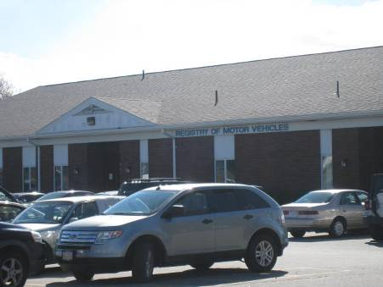

Prepared by:
Massachusetts Department of Public Health
Bureau of Environmental Health
Indoor Air Quality Program
March 2015

On the evening of Wednesday, February 4, 2015, the Massachusetts Department of Public Health’s Bureau of Environmental Health (DPH/BEH) was contacted by Mr. Aric Warren, Deputy Director of General Services, Massachusetts Department of Transportation (MassDOT), regarding a building evacuation due to natural gas odors at the Brockton branch of the Registry of Motor Vehicles (RMV), located at 490 Forest Avenue.
It was reported that employees began noticing odors at approximately 11:00 AM on the morning of February 4, 2015. Building maintenance and fire officials were notified subsequent to employee reports of odors. The Brockton Fire Department (BFD), building maintenance staff and the gas utility provider took steps to vacate the building and investigate possible sources of gas leaks. The building was ventilated and once odors dissipated the building was reoccupied. No obvious source of leakage was identified. Later that afternoon odors reoccurred; as a result, building maintenance staff contacted a licensed plumber for further investigation. The boiler for this building is in an attached mechanical room at the rear of the building (Pictures 1 and 2). It was determined that a faulty valve was the source of leaks; this valve was promptly replaced (Pictures 3 and 4). During the afternoon, several building occupants reported symptoms (e.g., nausea and dizziness), and one was transported to a local hospital for medical evaluation.
Following discussion with MDPH Associate Commissioner Suzanne Condon, Mike Feeney, Director of BEH’s Indoor Air Quality (IAQ) Program coordinated response efforts with Mr. Warren. On the morning of Thursday, February 5, 2015, Cory Holmes, Environmental Analyst/Regional Inspector within BEH’s IAQ Program conducted an IAQ walkthrough of the RMV prior to allowing for reoccupancy. It is important to note that upon entry into the RMV no gas odors were detected, nor were any odors detected throughout the space including in the mechanical room.

Methods
Air tests for carbon monoxide were taken with the TSI, Q-Trak, IAQ Monitor 7565. Air tests for airborne particle matter with a diameter less than 2.5 micrometers were taken with the TSI, DUSTTRAK™ Aerosol Monitor Model 8520. Screening for total volatile organic compounds (TVOCs) was conducted using a RAE Systems, MiniRAE Lite Model, Photoionization Detector. These tests were conducted to rule out any association of the odors with incomplete combustion products and/or chemical exposures.

Results
Testing was conducted while the building was empty prior to reoccupation. Test results are included as Table 1.

Air Testing
Testing results for carbon monoxide (CO) and total volatile organic compounds (TVOCs) were non-detectable (ND). Particulate matter (PM2.5) results were below background levels (Table 1).

Other Conditions
During the assessment several pathways were identified for odors in the mechanical room to migrate into occupied areas. A number of utility penetrations (pipes, wiring, etc.) were observed in the common wall between the RMV and mechanical room (Picture 5). Also observed were two abandoned vents that served the former boiler system (Pictures 6 and 7). In their current condition (i.e., open to the elements) the vents allow drafts/winds to pressurize the mechanical room forcing odors and particulate matter into occupied space via any open utility holes/breaches in the common wall. Finally, the configuration of the new intake and exhaust vents for the current boiler system can also allow for pressurization (Picture 8), therefore BEH/IAQ recommends extending and turning the vent ducts 90º to prevent wind from pressurizing the space through the vents.

Conclusions/Recommendations
Based on test results and observations at the time of the assessment, there were no environmental conditions of note/concern that presented concerns for reoccupancy of the Brockton RMV. In view of the findings at the time of the visit, the following recommendations are made:
- Seal any open utility holes/ penetrations/breaches in the common wall between the mechanical room and RMV, with a fire-rated sealant. Observe for light penetration and/or drafts to ensure proper sealing.
- Seal abandoned supply/exhaust vents for the former boiler system.
- Consider extending the current supply/exhaust vents (e.g., ~90º), to prevent pressurization of boiler/mechanical room.
- If additional assistance is required, contact the MDPH IAQ program.

Picture 1
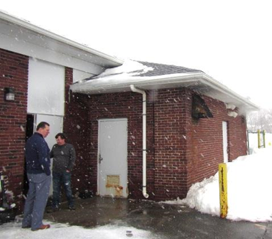
Mechanical room attached to rear of building

Picture 2
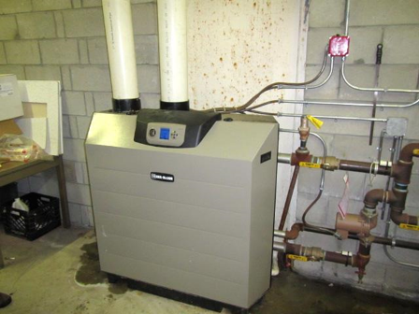
Boiler in mechanical room
Picture 3
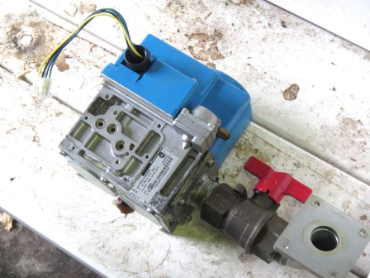
Faulty gas valve removed from boiler

Picture 4
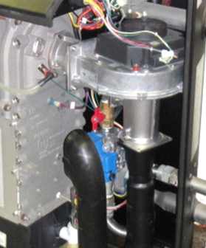
New gas valve (arrow) installed in boiler
Picture 5
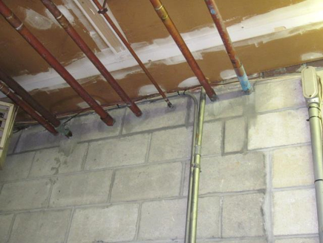
Utilities penetrating the common wall between the mechanical room and RMV

Picture 6
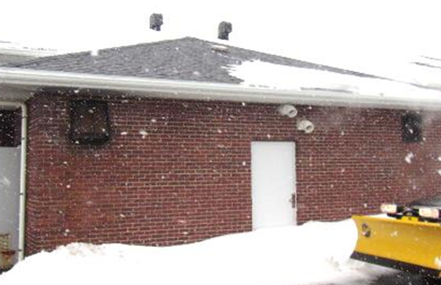
Abandoned vents (arrows) for former boiler system
Picture 7
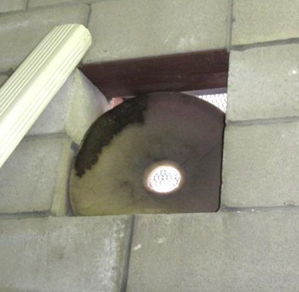
Abandoned supply vents for former boiler system

Picture 8
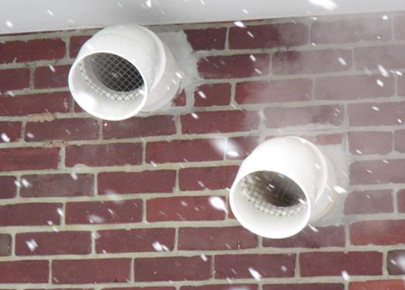
Intake/exhaust vents for current boiler system
Location | Carbon Monoxide  (ppm) | TVOCs  (ppm) | PM2.5  (µg/m³) | Windows  Openable | Ventilation |  |  | Remarks
 |  |  |  |  | Intake | Exhaust
Background (outdoors) | ND | ND | 12 |  |  |  |  | Cold, moderate snowfall, winds: north 4-6 mph
Work Stations 1-5 | ND | ND | 6 | N | Y |  | Y
Work Stations 6-10 | ND | ND | 7 | N | Y |  | Y
Work Stations 11-15 | ND | ND | 6 | N | Y |  | Y
Server Room | ND | ND | 6 | N
Testing Room | ND | ND | 8 | N | Y |  | Y
Main Waiting Area | ND | ND | 6 | N | Y |  | Y
Customer Service | ND | ND | 6 | N | Y |  | Y
Hearing Room | ND | ND | 6 | N | Y |  | Y
Assistant Manager Office | ND | ND | 6 | N | Y |  | Y
Managers Office | ND | ND | 5 | N | Y |  | Y
Training Room | ND | ND | 5 | N | Y |  | Y
Storeroom | ND | ND | 9 | N
Break Room | ND | ND | 5 | N | Y |  | Y
Plate Room | ND | ND | 8 | N | Y |  | Y

