Background/Introduction

INDOOR AIR QUALITY ASSESSMENT

Massachusetts Rehabilitation Commission
85 Main Street
North Adams, Massachusetts

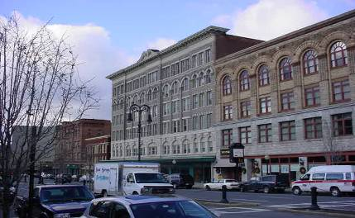

Prepared by:
Massachusetts Department of Public Health
Center for Environmental Health
Emergency Response/Indoor Air Quality Program
January 2007

At the request of Mr. Robert Burgess, Director of Facilities, Executive Office of Health and Human Services, an indoor air quality assessment was conducted at the Massachusetts Rehabilitation Commission (MRC), Regional Office, 85 Main Street, North Adams, Massachusetts. The assessment was conducted by the Massachusetts Department of Public Health (MDPH), Center for Environmental Health (CEH) and was requested following flooding in the restroom on the floor above an occupied office are in November of 2006. Attempts were reportedly made by building management to dry the carpet at the time of the incident. The assessment was conducted in response to remaining concerns about water damage to building materials and the potential for mold growth.
On December 5, 2006, a visit to conduct an indoor air quality assessment at the MRC was made by Michael Feeney, Director of CEH’s Emergency Response/Indoor Air Quality (ER/IAQ) Program. The MRC is located on the fourth floor of a six-story brick building constructed circa 1920 (cover picture). Windows are openable throughout the MRC.

Methods
Air tests for temperature and relative humidity were taken with the TSI, Q-Trak, IAQ Monitor, Model 8551. CEH staff also performed a visual inspection of building materials for water damage and/or microbial growth. Moisture content of water-damaged materials was measured using a Delmhorst, BD-2000 Model, Moisture Detector with a Delmhorst Standard Probe.

Results
The MRC has an employee population of approximately 10 and can be visited by up to 25 individuals on a daily basis. The tests were taken under normal operating conditions and appear in Table 1.

Discussion
It can be seen from Table 1 that carbon dioxide levels were below 800 parts per million (ppm) in all areas surveyed, indicating adequate ventilation. It is important to note however, that the MRC has no means to mechanically introduce outside air. Openable windows are the sole source of fresh air in these offices. A centralized air conditioning (AC) system provides cooling during warm weather, but is not connected to a fresh air supply. Conditioned air is delivered to occupied areas via ducted supply diffusers and ducted back to the AHUs via return vents.
In order to have proper ventilation with a mechanical supply and exhaust system, the systems must be balanced to provide an adequate amount of fresh air to the interior of a room while removing stale air from the room. It is recommended that existing ventilation systems be re-balanced every five years to ensure adequate air systems function (SMACNA, 1994). The date of the last balancing of the air conditioning system was not available at the time of the assessment.
The Massachusetts Building Code requires a minimum ventilation rate of 20 cubic feet per minute (cfm) per occupant of fresh outside air or have openable windows in each room (SBBRS, 1997; BOCA, 1993). The ventilation must be on at all times that the room is occupied. Providing adequate fresh air ventilation with open windows and maintaining the temperature in the comfort range during the cold weather season is impractical. Mechanical ventilation is usually required to provide adequate fresh air ventilation.
Carbon dioxide is not a problem in and of itself. It is used as an indicator of the adequacy of the fresh air ventilation. As carbon dioxide levels rise, it indicates that the ventilating system is malfunctioning or the design occupancy of the room is being exceeded. When this happens a buildup of common indoor air pollutants can occur, leading to discomfort or health complaints. The Occupational Safety and Health Administration (OSHA) standard for carbon dioxide is 5,000 parts per million parts of air (ppm). Workers may be exposed to this level for 40 hours/week based on a time-weighted average (OSHA, 1997).
The Department of Public Health uses a guideline of 800 ppm for publicly occupied buildings. A guideline of 600 ppm or less is preferred in schools due to the fact that the majority of occupants are young and considered to be a more sensitive population in the evaluation of environmental health status. Inadequate ventilation and/or elevated temperatures are major causes of complaints such as respiratory, eye, nose and throat irritation, lethargy and headaches. For more information concerning carbon dioxide, see Appendix A.
Temperature measurements ranged from 73º F to 75º F, which were within the MDPH recommended comfort range the day of the assessment. The MDPH recommends that indoor air temperatures be maintained in a range of 70º F to 78º F in order to provide for the comfort of building occupants. In many cases concerning indoor air quality, fluctuations of temperature in occupied spaces are typically experienced, even in a building with an adequate fresh air supply.
The relative humidity measurements in the building ranged from 27 to 31 percent, which were below the MDPH comfort guidelines range the day of the assessment. The MDPH recommends a comfort range of 40 to 60 percent for indoor air relative humidity. The sensation of dryness and irritation is common in a low relative humidity environment. Humidity is more difficult to control during the winter heating season. Low relative humidity is a very common problem during the heating season in the northeast part of the United States.

Mold and Moisture Concerns
As discussed, the assessment was prompted by flooding from a restroom above the MRC space. Water damage to building materials in the MRC appeared to be isolated to a particular cubicle (Lamarre/Table 1). A distinct musty odor was detected in this area. CEH staff conducted moisture testing on the carpeting in this cubicle as well as other (non-affected) carpeting in these offices (Picture 1).
In order for building materials to support mold growth, a source of moisture is necessary. Identification and elimination of water moistening building materials is necessary to control mold growth. Identification of building materials with increased moisture content over normal concentrations may indicate a possible source for mold growth.
As mentioned previously, moisture content was measured with a Delmhorst Moisture Detector equipped with a Delmhorst Standard Probe. The Delmhorst probe is equipped with three lights that function as visual aids to indicate moisture level. Readings that activate the green light indicate a sufficiently dry or low moisture level, those that activate the yellow light indicate borderline conditions and those that activate the red light indicate elevated moisture content.
Please note moisture content is detected as a real-time measurement of the conditions present in the building at the time of assessment. The building was evaluated on a dry, cloudless day with an outdoor temperature of 34°F and relative humidity of 19 percent. Moisture content of materials may increase or decrease depending on building and weather conditions. For example, moisture can be introduced into a building through open windows and/or during the normal operation of a heating, ventilating and air-conditioning (HVAC) system. As indoor relative humidity levels increase, porous building materials, such as GW, plywood or carpeting can absorb moisture. The moisture content of materials can fluctuate with increases or decreases in indoor relative humidity.
Elevated moisture levels (8-15.2 percent) were measured in carpet/flooring in the water damaged cubicle (Picture 2). These measurements were taken at least one week after the flooding incident, indicating that the carpet and the flooring were wet for well over 48 hours. In comparison, moisture measurements in all other carpeted areas measured at the MRC were non-detectable/normal (Table 1, Picture 3).
The type of flooding (i.e. toilets) that occurred in the restroom above the MRC space should be considered to be sewage contamination for the purpose of clean up (IICRC, 1999). In general, it is recommended that absorbent materials (gypsum wallboard, wall insulation, carpeting, fabrics, books, cardboard, etc.) be discarded once in contact with sewage (IICRC, 1999). Flooring and sub flooring (such as wood and tile) should be evaluated, cleaned, disinfected, dried and sealed when appropriate (IICRC, 1999). These measures should be implemented.
Water damage to porous building materials (e.g., carpeting and GW) can result in microbial growth. The US Environmental Protection Agency (US EPA) and the American Conference of Governmental Industrial Hygienists (ACGIH) recommend that porous materials be dried with fans and heating within 24 to 48 hours of becoming wet (US EPA, 2001; ACGIH, 1989). If not dried within this time frame, mold growth may occur. Once mold has colonized porous materials, they are difficult to clean and should be removed.
Also of note were the AC units. The areas outside the AC cabinets appeared to be water damaged (Picture 4). Cooling pipes, cooling coils and other uninsulated surfaces can be subjected to condensation. The AC cabinet in the hallway of the MCR has wall-to-wall carpet installed in contact with its outer surface (Picture 5), which may moisten the carpet.
Examination of the windows of the MRC offices found sills and windows panes coated with pigeon waste (Picture 6). While the bird wastes are on the exterior of the building, windows are used to introduce fresh air from outdoors. Bird wastes in a building raise three concerns: 1) diseases that may be caused by exposure to bird wastes, 2) the need for clean up of bird waste and 3) appropriate disinfection. MDPH guidelines concerning the remediation of bird wastes are included as Appendix B.

Other IAQ Evaluations
Air filters in the AC units consist of metal screens that provide minimal filtration of respirable dust (Picture 7). This can result in dust, dirt and other debris being distributed by the AC system. Filters are designed to strain particulates from airflow. In order to decrease aerosolized particulates, disposable filters with an increased dust spot efficiency can be installed. The dust spot efficiency is the ability of a filter to remove particulates of a certain diameter from air passing through the filter. Filters that have been determined by ASHRAE to meet its standard for a dust spot efficiency of a minimum of 40 percent would be sufficient to reduce airborne particulates (Thornburg, D., 2000; MEHRC, 1997; ASHRAE, 1992). Note that increased filtration can reduce airflow produced by increased resistance (called pressure drop). Prior to any increase of filtration, each piece of air handling equipment should be evaluated by a ventilation engineer to ascertain whether it can maintain function with more efficient filters.
Finally, holes for utilities were observed in walls around the AC units (Picture 8). Breaches in walls can serve as pathways for odors and particulates in wall cavities to migrate into occupied areas.

Conclusions/Recommendations
While the remediation efforts to remove water from the MRC space below a restroom that flooded on the floor above appeared to have prevented widespread damage, porous materials that came into contact with the flood water (e.g., carpeting and ceiling tiles) should be removed. In view of the findings at the time of the assessment, the following recommendations are made:
- Remove water-damaged materials (e.g., carpeting, and ceiling tiles) in a manner consistent with recommendations found in “Mold Remediation in Schools and Commercial Buildings” published by the US Environmental Protection Agency (US EPA, 2001). Consider replacing carpeting with a non-slip, nonporous material (e.g., rubber matting, tile).
- Once carpet is removed, use ventilation and dehumidifiers to draw moisture from the cement floor that exists above the slab vapor barrier.
- During removal of building materials use local exhaust ventilation and isolation techniques to control remediation pollutants. Precautions should be taken to avoid the re-entrainment of these materials into the building's HVAC system. The design of each system must be assessed to determine how it may be impacted by renovation activities. Specific HVAC protection requirements pertain to the return, central filtration and supply components of the ventilation system. This may entail shutting down systems (when possible) during periods of heavy construction and demolition, ensuring systems are isolated from contaminated environments, sealing ventilation openings with plastic and utilizing filters with a higher dust spot efficiency where needed (SMACNA, 1995).
- If possible, relocate susceptible persons and those with pre-existing medical conditions (e.g., hypersensitivity, asthma) away from the general areas of remediation until activities are complete.
- Establish communications between all parties involved with remediation efforts (including building occupants) to prevent potential IAQ problems. Develop a forum for occupants to express concerns about remediation efforts, as well as a program to resolve IAQ issues.
- Develop a notification system for building occupants to report remediation related odors and/or dusts problems to the building administrator. Have these concerns relayed to the contractor in a manner that allows for a timely remediation of the problem.
- When possible, schedule projects which produce large amounts of dusts, odors and emissions during unoccupied periods or periods of low occupancy.
- Disseminate scheduling itinerary to all affected parties. This can be done in the form of meetings, newsletters or weekly bulletins.
- Obtain Material Safety Data Sheets (MSDS) for all remediation/decontamination materials used during renovations and place them in an area that is accessible to all individuals during periods of building operations as required by the Massachusetts Right-To-Know Act (MGL, 1983).
- Consult MSDS' for any materials applied to the effected area during renovation(s) including any sealant, carpet adhesive, tile mastic, flooring and/or roofing materials. Provide proper ventilation and allow sufficient curing time as per the manufacturer's instructions concerning these materials.
- Implement prudent housekeeping and work site practices to minimize exposure to spores. This may include constructing barriers, sealing off areas, and temporarily relocating furniture and supplies. To control for dusts, a high efficiency particulate air filter (HEPA) equipped vacuum cleaner is recommended. Non porous materials (e.g., linoleum, cement) should be disinfected with an appropriate antimicrobial agent is recommended. Non-porous surfaces should also be cleaned with soap and water after disinfection.
- For buildings in New England, periods of low relative humidity during the winter are often unavoidable. Therefore, scrupulous cleaning practices should be adopted to minimize common indoor air contaminants whose irritant effects can be enhanced when the relative humidity is low. To control for dusts, a high efficiency particulate arrestance (HEPA) filter equipped vacuum cleaner in conjunction with wet wiping of all surfaces is recommended. Drinking water during the day can help ease some symptoms associated with a dry environment (throat and sinus irritations).
- Clean bird waste from windows and sills in accordance with MDPH guidelines (Appendix B).
- Install anti-roosting spikes on the top surface of all air conditioners as well as on window ledges.
- Replace wire mesh screens with appropriate air filters in AC units. Prior to any increase of filtration, each piece of air handling equipment should be evaluated by a ventilation engineer as to whether it can maintain function with more efficient filters.
- Seal all holes around the AC units. (i.e., floors, ceilings and walls) to eliminate draw of air from building cavities.

References
ACGIH. 1989. Guidelines for the Assessment of Bioaerosols in the Indoor Environment. American Conference of Governmental Industrial Hygienists, Cincinnati, OH.
ASHRAE. 1992. Gravimetric and Dust-Spot Procedures for Testing Air-Cleaning Devices Used in General Ventilation for Removing Particulate Matter. American Society of Heating, Refrigeration and Air Conditioning Engineers. ANSI/ASHRAE 52.1-1992.

BOCA. 1993. The BOCA National Mechanical Code/1993. 8th ed. Building Officials and Code Administrators International, Inc., Country Club Hill, IL.
IICRC. 1999. IICRC S500. Standard and Reference Guide for Professional Water Damage Restoration, 2nd Edition. Institute of Inspection Cleaning and Restoration, Vancouver, WA.

MEHRC. 1997. Indoor Air Quality for HVAC Operators & Contractors Workbook. Mid Atlantic Environmental Hygiene Resource Center, Philadelphia, PA.

MGL. 1983. Hazardous Substances Disclosure by Employers. Massachusetts General Laws. M.G.L. c. 111F.
OSHA. 1997. Limits for Air Contaminants. Occupational Safety and Health Administration. Code of Federal Regulations. 29 C.F.R 1910.1000 Table Z-1-A.

SBBRS. 1997. Mechanical Ventilation. State Board of Building Regulations and Standards. Code of Massachusetts Regulations. 780 CMR 1209.0
SMACNA. 1994. HVAC Systems Commissioning Manual. 1st ed. Sheet Metal and Air Conditioning Contractors’ National Association, Inc., Chantilly, VA.
SMACNA. 1995. IAQ Guidelines for Occupied Buildings Under Construction. 1st ed. Sheet Metal and Air Conditioning Contractors' National Association, Inc., Chantilly, VA.

Thornburg, D. Filter Selection: a Standard Solution. Engineering Systems 17:6 pp. 74-80.

US EPA. 2001. Mold Remediation in Schools and Commercial Buildings. US Environmental Protection Agency, Office of Air and Radiation, Indoor Environments Division, Washington, D.C. EPA 402-K-01-001. March 2001.
http://www.epa.gov/iaq/molds/mold_remediation.html
Picture 1

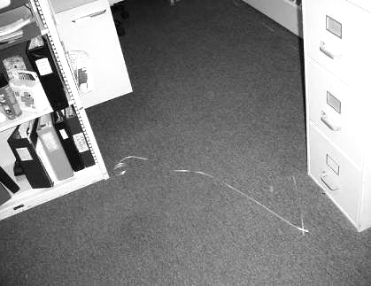

Cubicle with Water Damaged Carpet, (Area of Wet Carpet Marked With Ribbon)

Picture 2

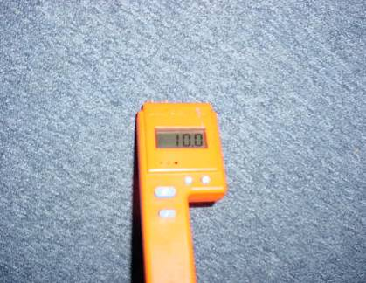

Carpet with Elevated Moisture Measurement

Picture 3

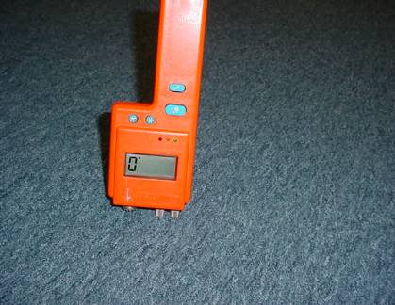

Carpet with Non-Detectable/Normal Moisture Measurement

Picture 4

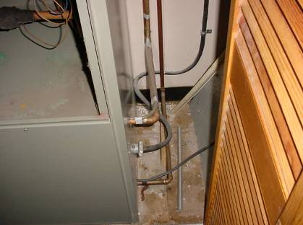

Water Damaged Floor of Air Conditioning Closet

Picture 5

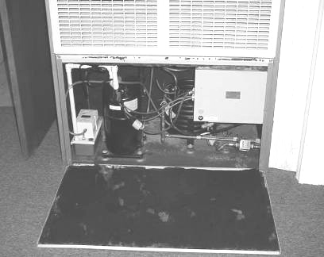

Carpet Adjacent To Air Conditioning Unit

Picture 6

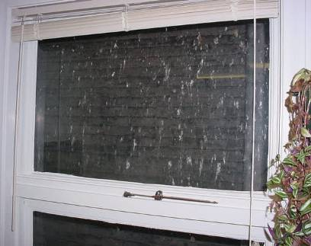

Window Pane Coated With Bird Waster

Picture 7

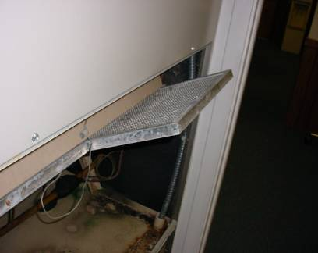

Wire Screen Used As Filter

Picture 8

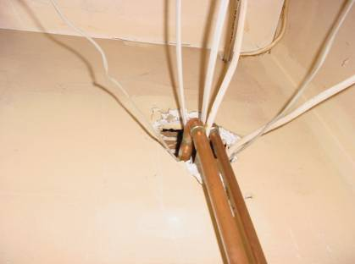

Hole for Utility Pipe
Location | Carbon  Dioxide  (*ppm) | Temp  (°F) | Relative  Humidity  (%) | Occupants  in Room | Windows  Openable | Ventilation |  | Remarks
 |  |  |  |  |  | Supply | Exhaust | Remarks
Outside  (Background) | 381 | 34 | 19
Meeting room | 562 | 75 | 28 | 0 | N | Y | N | Door open  Moisture content carpet = non-detect
Kenny | 622 | 75 | 28 | 0 | Y | Y | N | Door open  Moisture content carpet = non-detect
Kelly | 623 | 74 | 29 | 1 | Y | Y | N | Door open  Moisture content carpet = non-detect
Borowski | 542 | 74 | 27 | 0 | Y | Y | N | Moisture content carpet = non-detect
Grey | 539 | 74 | 28 | 0 | Y | Y | N | Moisture content carpet = non-detect
Daniel | 581 | 73 | 28 | 1 | Y | Y | N | Door open  Moisture content carpet = non-detect
Boland | 683 | 74 | 29 | 0 | N | Y | N | Moisture content carpet = non-detect
Fisher | 612 | 74 | 30 | 2 | Y | Y | N | Moisture content carpet = non-detect
Lamarre | 637 | 74 | 31 | 0 | Y | Y | N | Moisture content carpet = 8-15.2 percent
Mainframe room | 592 | 74 | 29 | 0 | Y | Y | N | Moisture content carpet = non-detect
Main Desk | 596 | 74 | 29 | 1 | N | Y | N | Door open  Moisture content carpet = non-detect

Condensation is the collection of moisture on a surface that has a temperature that is below the dew point. The dew point is a temperature that is determined by air temperature and relative humidity. As an example, at a temperature of 76º F and relative humidity of 30%, the dew point for water to collect on a surface is approximately 43 º F.

