**INDOOR AIR QUALITY ASSESSMENT**

**Massachusetts Rehabilitation Commission**

**888 Purchase Street**

**New Bedford, Massachusetts**

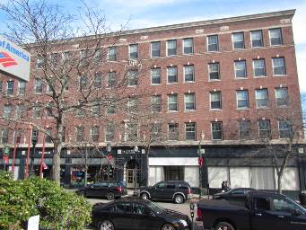

Prepared by:

Massachusetts Department of Public Health

Bureau of Environmental Health

Indoor Air Quality Program

December 2015

**Executive Summary**

The general indoor air quality (IAQ) symptoms reported (burning/itchy eyes, sneezing, congestion, stuffiness) are typical in a building of this age with no mechanical ventilation system and a lack of air exchange (as evidenced by elevated carbon dioxide levels). Recommendations are made to increase air circulation/filtration, general maintenance and dust control to improve air quality in the space.

**Background**

|  |  |
| --- | --- |
| **Building:** | Massachusetts Rehabilitation Commission (MRC) |
| **Address:** | 888 Purchase Street, New Bedford, MA |
| **Assessment Requested by:** | Joel Posner, EOHHS |
| **Date of Assessment:** | November 20, 2015 |
| **Bureau of Environmental Health/Indoor Air Quality (BEH/IAQ) Program Staff Conducting Assessment:** | Cory Holmes, Environmental Analyst/Inspector |
| **Date of Building Construction:** | 1890s |
| **Reason for Request:** | General IAQ concerns |

**Building Description**

The MRC is located on the 4th floor of the Olympia-Times Building, which is a five-story, brick-faced building that formerly served as a hotel and now contains multiple state and private offices. MRC has occupied the space for several decades. The building has a flat roof with rubber membrane. The building contains a kitchen, breakroom, office and storage areas. Windows are openable throughout the building.

# Results and Discussion

This space is occupied by approximately 15 employees and can be visited by 20 to 50 individuals daily. Test results are presented in Table 1. Methods and indoor air related sampling information can be found in the IAQ Manual and Appendices for IAQ Reports at:

<http://www.mass.gov/eohhs/gov/departments/dph/programs/environmental-health/exposure-topics/iaq/iaq-rpts/general-appendices-for-iaq-reports.html>

## Ventilation

It can be seen from Table 1 that carbon dioxide levels were above 800 parts per million (ppm) in twelve of seventeen areas tested, indicating a lack of air exchange at the time of assessment. There is no mechanical ventilation system that introduces/exhausts outside air in these offices, instead there are four air handling units (AHUs) which heat/cool and recirculate air only. Two of these AHUs are in mechanical closets (Picture 1) and two are located above ceiling tiles (Picture 2). Fresh air to this space is introduced solely through the use of openable windows.

## Temperature and Relative Humidity

Temperature readings in occupied areas during the assessment ranged from 71ºF to 75ºF, which were within the MDPH recommended comfort guidelines (Table 1). The MDPH recommends that indoor air temperatures be maintained in a range of 70ºF to 78ºF in order to provide for the comfort of building occupants. In many cases concerning IAQ, fluctuations of temperature in occupied spaces are typically experienced, even in a building with an adequate fresh air supply. The heating/cooling system is controlled by digital wall-mounted thermostats. In a few areas, supply vents were blocked with folders in an attempt to maintain comfort (Picture 3).

The relative humidity measured during the assessment ranged from 45 to 62 percent (Table 1), which was within or close to the MDPH recommended comfort range. The MDPH recommends a comfort range of 40 to 60 percent for indoor air relative humidity. Relative humidity levels in the building would be expected to drop during the winter months due to heating. The sensation of dryness and irritation is common in a low relative humidity environment. Low relative humidity is a very common problem during the heating season in the northeast part of the United States.

## Microbial/Moisture Concerns

Water infiltration was reported and observed in the form of peeling paint on interior plaster walls (Pictures 4 and 5) along the rear/east wall facing the waterfront (Picture 6). This water damage is likely the result of water infiltration through exterior brickwork (Pictures 7 and 8), which is probably in need of repointing.

## Other IAQ Evaluations

Indoor air quality can be negatively influenced by the presence of respiratory irritants, such as products of combustion. The process of combustion produces a number of pollutants. Common combustion emissions include carbon monoxide, carbon dioxide, water vapor, and smoke (fine airborne particle material). Of these materials, exposure to carbon monoxide and particulate matter with a diameter of 2.5 micrometers (μm) or less (PM2.5) can produce immediate, acute health effects upon exposure. To determine whether combustion products were present in the indoor environment, BEH/IAQ staff obtained measurements for carbon monoxide and PM2.5.

### Carbon Monoxide

*Carbon monoxide should not be present in a typical, indoor environment*. If it *is* present, indoor carbon monoxide levels should be less than or equal to outdoor levels. On the day of assessment, outdoor carbon monoxide concentrations were 1.0 ppm (Table 1). This low level detected outside is most likely attributable to vehicle exhaust from local/downtown traffic. Slight levels of carbon monoxide at or below background (<1.0 ppm) were detected inside the building during the assessment (Table 1).

### Particulate Matter

Outdoor PM2.5 concentrations were measured at 4 μg/m3 (Table 1). Indoor PM2.5 levels ranged from 2 to 6 μg/m3 (Table 1), which were below the NAAQS PM2.5 level of 35 μg/m3. Frequently, indoor air levels of particulates (including PM2.5) can be at higher levels than those measured outdoors. A number of activities that occur indoors and/or mechanical devices can generate particulate during normal operations. Sources of indoor airborne particulates may include but are not limited to particles generated during the operation of fan belts in the HVAC system, use of stoves and/or microwave ovens in kitchen areas; use of photocopiers, fax machines and computer printing devices; operation of an ordinary vacuum cleaner and heavy foot traffic indoors.

## Other Conditions

Other conditions that can affect IAQ were observed during the assessment. Most occupied areas are carpeted, however it was reported that there was not a routine preventative maintenance plan in place. The Institute of Inspection, Cleaning and Restoration Certification (IICRC) recommends that carpeting be cleaned annually (or semi-annually in soiled high traffic areas) (IICRC, 2012). Regular cleaning with a high efficiency particulate air (HEPA) filtered vacuum in combination with an annual cleaning will help to reduce accumulation and potential aerosolization of materials from carpeting.

Finally, AHUs were equipped with a filter medium that provides minimal filtration (Pictures 9 and 10). Pleated filters with a dust spot efficiency of 40 percent are typically recommended. The dust spot efficiency is the ability of a filter to remove particulates of a certain diameter from air passing through the filter. Filters that have been determined by ASHRAE to meet its standard for a dust spot efficiency of a minimum of 40 percent would be sufficient to reduce many airborne particulates (Thornburg, 2000; MEHRC, 1997; ASHRAE, 1992). Pleated filters with a Minimum Efficiency Reporting Value dust-spot efficiency of 9 or higher are recommended. Note that increasing filtration can reduce airflow (called pressure drop), which can subsequently reduce the efficiency of the unit due to increased resistance. Prior to any increase of filtration, each AHU unit should be evaluated by a ventilation engineer to ascertain whether it can maintain function with more efficient filters.

# Conclusions/Recommendations

In view of the findings at the time of the visit, the following recommendations are made:

1. Use windows (weather-permitting) to introduce fresh/outside air.
2. Consider setting digital thermostats to the fan “on” setting to provide continuous airflow/filtration.
3. To avoid comfort complaints, consider installing adjustable/louvered air diffusers.
4. The building envelope/exterior brickwork along the east-facing wall should be thoroughly examined to identify missing/damaged mortar, cracks or breaches and be properly repaired/repointed to prevent further water intrusion/damage to interior building materials.
5. Peeling paint and water-damaged plaster surfaces should be repaired/painted.
6. For buildings in New England, periods of low relative humidity during the winter are often unavoidable. Therefore, scrupulous cleaning practices should be adopted to minimize common indoor air contaminants whose irritant effects can be enhanced when the relative humidity is low. To control for dusts, a high efficiency particulate arrestance (HEPA) filter equipped vacuum cleaner in conjunction with wet wiping of all surfaces is recommended. Avoid the use of feather dusters. Drinking water during the day can help ease some symptoms associated with a dry environment (throat and sinus irritation).
7. Change AHU filters 2 to 4 times a year or as per the manufacturer’s instructions.
8. Consider upgrading existing filter media to pleated filters with a MERV dust-spot efficiency of 9 (40%) or higher accounting for manufacturer limitations with pressure drop.
9. Clean carpeting annually or semi-annually in soiled high traffic areas as per the recommendations of the Institute of Inspection, Cleaning and Restoration Certification (IICRC, 2012).
10. Refer to resource manuals and other related indoor air quality documents for further building-wide evaluations and advice on maintaining public buildings. Copies of these materials are located on the MDPH’s website: <http://mass.gov/dph/iaq>.

# References

ASHRAE. 1992. Gravimetric and Dust-Spot Procedures for Testing Air-Cleaning Devices Used in General Ventilation for Removing Particulate Matter. American Society of Heating, Refrigeration and Air Conditioning Engineers. ANSI/ASHRAE 52.1-1992.

IICRC. 2012. Institute of Inspection, Cleaning and Restoration Certification*. Carpet Cleaning: FAQ*. Retrieved from <http://www.iicrc.org/consumers/care/carpet-cleaning/#faq>.

MEHRC. 1997. Indoor Air Quality for HVAC Operators and Contractors Workbook. MidAtlantic Environmental Hygiene Resource Center, Philadelphia, PA.

Thornburg, D. 2000. Filter Selection: a Standard Solution. *Engineering Systems* 17:6 pp. 74-80.

**Picture 1**

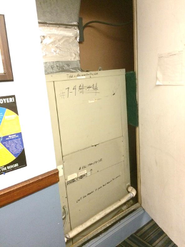

**Air handling unit in mechanical closet**

**Picture 2**

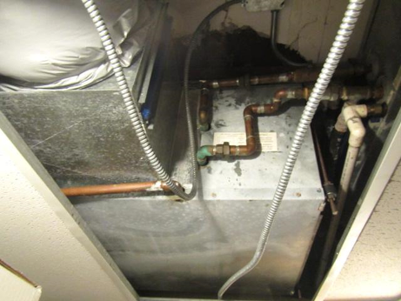

**Air handling unit above ceiling tiles**

**Picture 3**

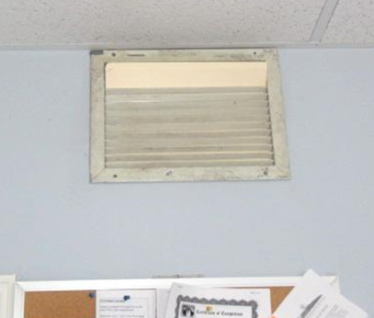

**Supply vent blocked with folder**

**Picture 4**

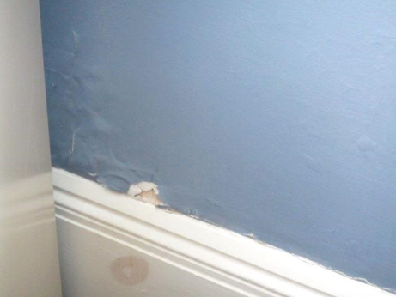

**Peeling paint along rear interior wall**

**Picture 5**

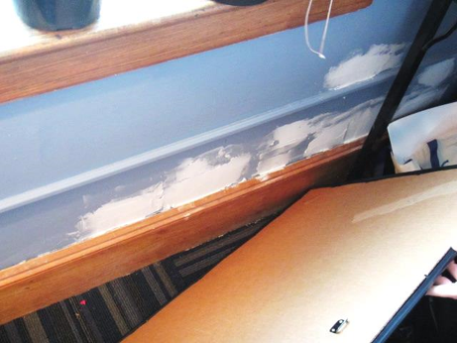

**Repaired water damage along rear interior wall**

**Picture 6**

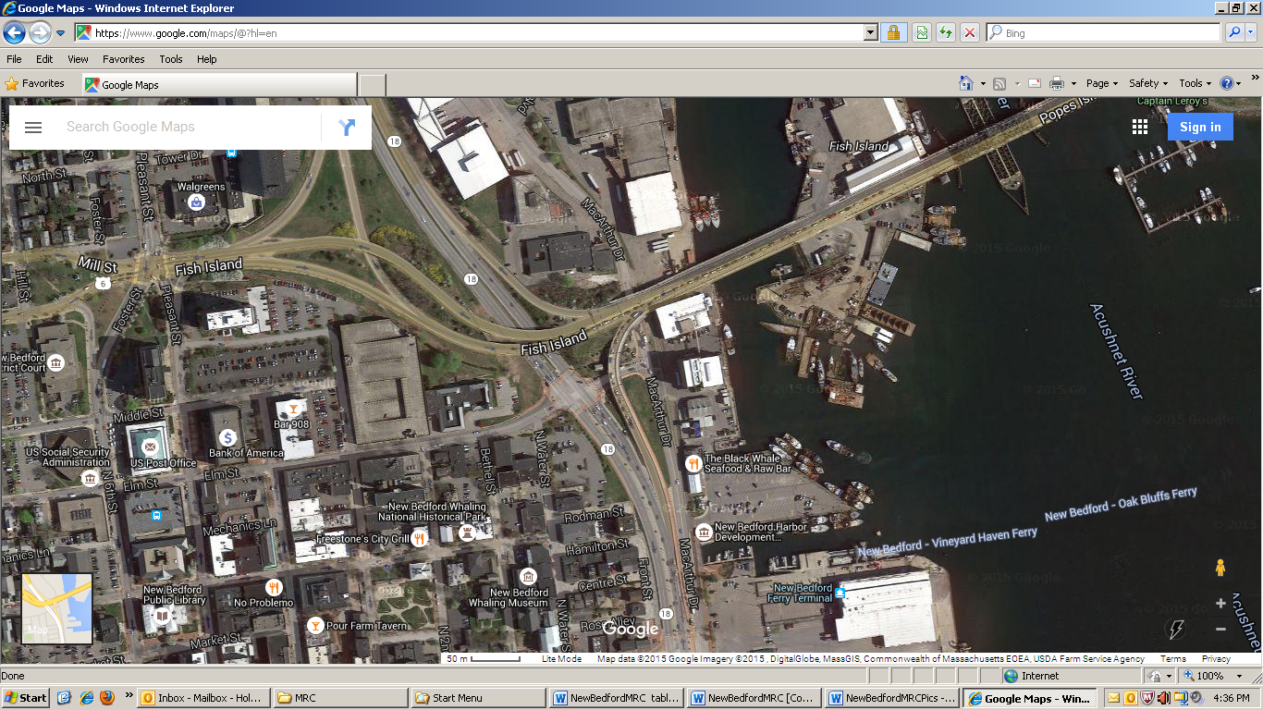

**Arrow indicates rear/east-facing wall where peeling paint/water damage occurs**

**Picture 7**

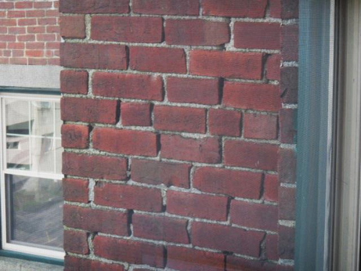

**Missing/damaged mortar around exterior brick on east-facing wall**

**Picture 8**

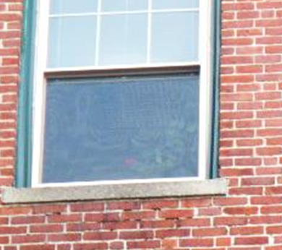

**Missing/damaged mortar around exterior brick on east-facing wall (below window)**

**Picture 9**

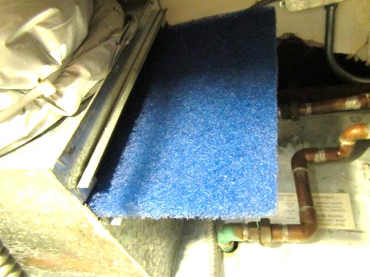

**Filter media installed in AHU above ceiling**

**Picture 10**

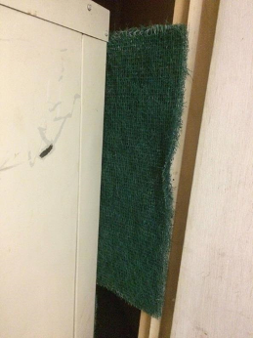

**Filter media installed in AHU in mechanical room**

| **Location** | **Carbon**  **Dioxide**  **(ppm)** | **Carbon Monoxide**  **(ppm)** | **Temp**  **(°F)** | **Relative**  **Humidity**  **(%)** | **PM2.5**  **(µg/m3)** | **Occupants**  **in Room** | **Windows**  **Openable** | **Ventilation** | | | **Remarks** |
| --- | --- | --- | --- | --- | --- | --- | --- | --- | --- | --- | --- |
| **Intake** | **Exhaust** | |
| Background (outside) | 421 | 1.0 | 64 | 69 | 4 |  |  |  | |  | Cloudy, heavy to moderate rain early AM, winds SSW 13 to 20 mph, gusts up to 33 mph |
| Waiting Room | 1205 | ND | 71 | 62 | 5 | 3 | N | N | | N |  |
| Main Office Area | 773 | 1.0 | 73 | 56 | 4 | 3 | Y | N | | N | PC, plants |
| Small Conference Room | 647 | <1.0 | 73 | 52 | 6 | 1 | Y  Open | N | | N | Plants |
| Maria Office | 676 | <1.0 | 74 | 50 | 3 | 0 | Y | N | | N |  |
| O’Neill Office | 946 | <1.0 | 75 | 50 | 6 | 1 | Y | N | | N |  |
| Storeroom | 808 | <1.0 | 75 | 48 | 3 | 0 | N | N | | N |  |
| Hubert Office | 877 | <1.0 | 75 | 49 | 3 | 0 | Y | N | | N | Heat/AC vent obstructed with folder, plants |
| Mello Office | 909 | <1.0 | 75 | 48 | 3 | 1 | Y | N | | N | Heat/AC vent obstructed with folder |
| Break Room | 795 | <1.0 | 74 | 47 | 3 | 0 | Y | N | | N |  |
| Kitchen | 907 | <1.0 | 75 | 48 | 3 | 0 | N | N | | N |  |
| Extra Office | 793 | <1.0 | 75 | 45 | 2 | 0 | N | N | | N |  |
| Tavares Office | 913 | <1.0 | 75 | 46 | 2 | 0 | N | N | | N |  |
| Harrison Office | 1020 | <1.0 | 75 | 49 | 5 | 0 | Y | N | | N | Peeling paint/exterior wall |
| Scales Office | 1547 | <1.0 | 73 | 53 | 6 | 1 | Y | N | | N | Peeling paint/exterior wall |
| Sykes Office | 1347 | <1.0 | 73 | 52 | 6 | 2 | Y | N | | N | Water-damaged wall/paint repaired exterior wall |
| Conference Room | 1453 | <1.0 | 74 | 54 | 4 | 0 | Y | N | | N |  |
| Moore Office | 1280 | <1.0 | 74 | 51 | 4 | 0 | Y | N | | N |  |