INDOOR AIR QUALITY ASSESSMENT

Massachusetts Rehabilitation Commission
1 Federal Street, Building 102-1
Springfield, Massachusetts



Prepared by:
Massachusetts Department of Public Health
Bureau of Environmental Health
Indoor Air Quality Program
April 2008

Background/Introduction

At the request of Roger Tremblay, Human Resources Director for the Massachusetts Executive Office of Health and Human Services (EOHHS), the Massachusetts Department of Public Health (MDPH), Bureau of Environmental Health (BEH) was asked to provide assistance and consultation regarding indoor air quality issues at the Massachusetts Rehabilitation Commission (MRC).
On February 29, 2008, a visit was made to this building by Michael Feeney, Director, and Lisa Hébert, Inspector in BEH’s Indoor Air Quality (IAQ) Program. Mr. Feeney and Ms. Hébert were accompanied by Cheryl Marrewa, Area Director, MRC during the assessment.
The MRC office is in the first floor of a three-story brick building constructed between 1794 and 1890. The building is one of over twenty buildings constructed during this period within a two block radius for use as the main arsenal for the Continental Army during the Revolutionary War. At that time, the buildings stored muskets and cannons, and even housed barracks, but did not manufacture weapons (History of Springfield Armory). The Armory eventually manufactured weapons for the U.S. military until 1968, at which time the Armory was closed by the U.S. Army. The Armory was best known for the creation and manufacture of fully interchangeable weapons. It is believed that building 102-1 may have been part of the Water Shops of the Armory. In the Water Shops, heavy metal forging, machining and gun stock shaping took place (FAQ Springfield Armory). The exterior walls on this floor are three bricks thick and the portion of the brick wall that forms the interior window sill slants from the base of the window casing downward (Picture 1). BEH staff was informed that the building does have a basement level; however, staff were unable to gain access to it at the time of the assessment.
Methods
Air tests for carbon dioxide, temperature, relative humidity and carbon monoxide were taken with the TSI, Q-Trak ™, IAQ Monitor Model 8551.

Results
The office has a staff of 25. The tests were taken during normal operations at the office. Test results appear in Table 1.

Discussion
Ventilation
It can be seen from Table 1 that carbon dioxide levels were elevated above 800 parts per million (ppm) in only one of the twenty-eight areas surveyed on February 29, 2008, indicating adequate air exchange in nearly all areas surveyed during the assessment. It is important to note that several areas were empty or sparsely populated, which can greatly reduce carbon dioxide levels in these areas. Carbon dioxide levels would be expected to be higher with increased occupancy.
Air is supplied to each room by a series of ducted fresh air diffusers (Pictures 2, 3). Stale air and contaminants are removed from each office by means of ducted exhaust vents (Picture 4). It is believed by BEH staff that fresh air enters the system by means of fresh air intakes located on the exterior of the building and air is exhausted by means of rooftop exhaust vents (Pictures 5, 6). Since the staff of the MRC did not have access to those portions of the building, the location and condition of the air handling unit (AHU) components could not be confirmed by BEH staff.
In all of the offices examined, functioning fresh air supply and exhaust ventilation is necessary to provide for the comfort of the occupants in this building. In order to have proper ventilation with a mechanical supply and exhaust system, the system must be balanced to provide an adequate amount of fresh air to the interior of a room while removing stale air from the room. It is unknown by MRC staff when the system was last balanced.
The Massachusetts Building Code requires a minimum ventilation rate of 15 cubic feet per minute (cfm) per occupant of fresh outside air or must have openable windows in each room (SBBRS, 1997). The ventilation must be on at all times that the rooms are occupied. Providing adequate fresh air ventilation with open windows and maintaining the temperature in the comfort range during the cold weather season is impractical. Mechanical ventilation is usually required to provide adequate fresh air ventilation.
Carbon dioxide is not a problem in and of itself at levels measured in this building. It is used as an indicator of the adequacy of the fresh air ventilation. As carbon dioxide levels rise, it indicates that the ventilating system is malfunctioning or the design occupancy of the room is being exceeded. When this occurs, a buildup of common indoor air pollutants can occur, leading to discomfort or health complaints. The Occupational Safety and Health Administration (OSHA) standard for carbon dioxide is 5,000 parts per million parts of air (ppm). Workers may be exposed to this level for 40 hours/week based on a time weighted average (OSHA, 1997).
The MDPH uses a guideline of 800 ppm for publicly occupied buildings. A guideline of 600 ppm or less is preferred in schools due to the fact that the majority of occupants are young and considered to be a more sensitive population in the evaluation of environmental health status. Inadequate ventilation and/or elevated temperatures are major causes of complaints such as respiratory, eye, nose and throat irritation, lethargy and headaches. For more information concerning carbon dioxide, consult Appendix A.
Temperature readings ranged from 61°F to 73°F, which were, with the exception of two readings, within the BEH recommended guidelines. The BEH recommends that indoor air temperatures be maintained in a range between 70°F to 78°F in order to provide for the comfort of building occupants. In many cases concerning indoor air quality, fluctuations of temperature in occupied spaces are typically experienced, even in a building with an adequate fresh air supply. BEH was not informed of any complaints related to temperature.
The relative humidity in this building was below BEH recommended comfort range in all areas sampled. Relative humidity measurements ranged from 14 to 32 percent during our visit. The BEH recommends that indoor air relative humidity is comfortable in a range of 40 to 60 percent. The sensation of dryness and irritation is common in a low relative humidity environment. Low relative humidity is a very common problem during the heating season in the northeast part of the United States.

Microbial/Moisture Concerns
Numerous areas suggested evidence of microbial/moisture invasion on both the interior and exterior of the building. Efflorescence was observed on numerous brick surfaces throughout the interior of the building (Picture 8). Efflorescence is caused by water penetration dissolving minerals within the brick/mortar as it flows through. The water evaporates on the surface leaving behind a dry white residue. While efflorescence is a characteristic sign of water penetration, it is not mold growth. This condition was observed primarily on the beveled window sills in numerous offices, but was also observed on walls throughout the office space (Picture 9). Brick walls on which photographs or posters were displayed revealed mold if the surface touching the wall was permeable to water and efflorescence if it was not (Pictures 10-14). It was reported by MRC staff that numerous documents such as diplomas hung on these walls had developed mold over time and had to be removed from the office. The large amount of efflorescence observed on these slanted window sills may be due to water penetration below each window casing. Therefore, each exterior window casing should be examined for deteriorated areas of mortar and caulking and should be repaired as required. The efflorescence observed on the interior walls may be caused by one of the following conditions:
- Brick and mortar on the exterior of the building has deteriorated.
- Water is currently being directed toward the building due to the slant of the apron adjacent to the building (Picture 15)
- Numerous open utility holes were observed in the walls, which can serve as pathways for moisture, drafts, dust and debris into occupied areas (Picture 16). Penetrations of pipes were not properly sealed between offices as well (Picture 17).
- Rusted nail in wall is indicative of a temperature bridge, which can generate condensation in the heating season (Picture 18).
The wall adjacent to the supply area exhibited a large amount of efflorescence as well as water damaged plaster/joint compound and missing/damaged mortar. Moisture entering the interior wall space would create mold if the brick was adjacent to gypsum wallboard (GW). Further investigation revealed that the interior wall surfaces adjacent to the brick was not GW, but was wood coated with plaster/joint compound. Wood is much more resistant to mold growth, however, with repeated saturation, may eventually support mold growth (Picture 19). Additionally, water-damaged wall plaster can, under certain circumstances, provide a medium for mold and mildew growth especially if wetted repeatedly. These materials should be repaired/replaced after moisture damage is discovered.
Many offices exhibited numerous plants. Moistened plant soil and drip pans can provide a source of mold growth and pollen. Plants should be located away from the air stream of ventilation sources to prevent the aerosolization of mold, pollen or particulate matter. Plants should have drip pans to prevent wetting of porous building materials and subsequent mold colonization. Over watering of plants should be avoided and drip pans should be inspected periodically for mold growth. Plants should not be placed on carpeting (Picture 20). Additionally, some plants were resting on newspaper on the brick window sills. This practice allows moisture to enter the newspaper in two ways, from over-watering the plant and from seepage from the brick sill surface into the newspaper from below (Picture 21). This practice should be eliminated at wet newspaper provides a medium for mold growth.
A water bubbler was observed in a carpeted area. The carpet below the water bubbler can become moistened by use of the cooler, although it was not observed to be wet at the time of the BEHA inspection. Porous materials that are wet repeatedly can serve as media for mold growth. The American Conference of Governmental Industrial Hygienists (ACGIH) recommends that carpeting be dried with fans and heating within 24 hours of becoming wet (ACGIH, 1989). If carpets are not dried within this time frame, mold growth may occur. Water-damaged carpeting cannot be adequately cleaned to remove mold growth. The application of a mildewcide to moldy carpeting is not recommended. A plastic mat could be utilized beneath the bubbler to eliminate any moisture from spilling onto the carpet area and to reduce the potential for mold growth.
Several interior wall areas exhibited cracked and broken brick surfaces, potentially due to moisture traveling from the exterior of the building inward, particularly if a sealant was applied to the interior brick surface (Picture 22).

Other IAQ Evaluations
Upon entering the foyer of the office, BEH staff immediately became aware of what was initially described as a “new carpet”/chemical odor. Upon further investigation, it was determined that no new carpet had been installed in the office for five years. This odor was noticeable to greater and lesser extents throughout the entire office space. It was reported to BEH staff that a strong odor has existed near a closet storage space adjacent to the foyer for a significant period of time. Upon opening the closet door, BEH staff encountered a strong fuel-like odor in the room. The source of the odor could not be readily identified since this room contained filing cabinets and other stored materials.
It appears that the heating, ventilating and air-conditioning (HVAC) is responsible for distributing the fuel odor throughout the MRC space. A large return vent duct exists in this closet, which has unsealed seams (Picture 7). It is likely that the fuel odor is drawn through these seams to the air handling unit (AHU), which then distributes the odor. Due to the depressurization of the closet, it is likely that the odor is being pulled into the storage room through either a hole or crack in the floor or by a penetration of pipe or conduit that has not been properly sealed. Fuel odors should not be present in a typical, indoor environment. Fuel vapor can cause eye, nose, throat and respiratory system irritation.
A number of areas throughout the MRC office contained conditions that can result in the aerosolization of irritating materials into the office environment. The identification, proper storage of or elimination of these materials would serve to enhance the indoor air quality in this building. An air freshener was noted in one of the offices examined (Picture 23). Air fresheners contain chemicals that can be irritating to the eyes, nose and throat of sensitive individuals. Furthermore, air fresheners do not remove materials causing odors, but rather mask odors that may be present in the area. Dry erase markers and boards were observed in the conference room (Picture 24). Materials such as dry erase markers and cleaners may contain VOCs, (e.g., methyl isobutyl ketone, n-butyl acetate and butyl-cellusolve) (Sanford, 1999).
In the storage closet off the foyer, a fluorescent light fixture that lacked a protective cover was observed and materials were being stored very close to the light fixture. Breakage of a fluorescent light fixture can result in a release of mercury into the office environment. Therefore, care should be taken not to store items in a manner that could cause breakage of these bulbs by MRC staff.
BEH was informed that staff routinely apply pesticides to indoor plants to rid them of gnats. MRC should reconsider this policy and may wish to remove infested plants from the office space as an alternative.
Hallway ceilings exhibited grates into ceiling plenum (Picture 25). If these grates are not necessary for the ventilation system, MRC should consider replacing them with ceiling tiles. Open ceilings can be a source, of dust, dirt and other pollutants.
To determine whether combustion products were present in the office environment, MDPH staff obtained measurements for carbon monoxide. Carbon monoxide (CO) was not detected during this visit. Carbon monoxide is a by-product of incomplete combustion of organic matter (e.g., gasoline, wood and tobacco). Indoor air quality can be negatively influenced by the presence of respiratory irritants, such as products of combustion. The process of combustion produces a number of pollutants. Common combustion emissions include carbon monoxide, carbon dioxide, water vapor and smoke (fine airborne particle material). Of these materials, exposure to carbon monoxide can produce immediate, acute health effects upon exposure.. Exposure to carbon monoxide can produce immediate and acute health affects. Several air quality standards have been established to address carbon monoxide and prevent symptoms from exposure to these substances. The MDPH established a corrective action level concerning carbon monoxide in ice skating rinks that use fossil-fueled ice resurfacing equipment. If an operator of an indoor ice rink measures a carbon monoxide level over 30 ppm, taken 20 minutes after resurfacing within a rink, that operator must take actions to reduce carbon monoxide levels (MDPH, 1997).
The American Society of Heating Refrigeration and Air-Conditioning Engineers (ASHRAE) has adopted the National Ambient Air Quality Standards (NAAQS) as one set of criteria for assessing indoor air quality and monitoring of fresh air introduced by HVAC systems (ASHRAE, 1989). The NAAQS are standards established by the US EPA to protect the public health from six criteria pollutants, including carbon monoxide and particulate matter (US EPA, 2000a). As recommended by ASHRAE, pollutant levels of fresh air introduced to a building should not exceed the NAAQS levels (ASHRAE, 1989). The NAAQS were adopted by reference in the Building Officials & Code Administrators (BOCA) National Mechanical Code of 1993 (BOCA, 1993), which is now an HVAC standard included in the Massachusetts State Building Code (SBBRS, 1997). According to the NAAQS, carbon monoxide levels in outdoor air should not exceed 9 ppm in an eight-hour average (US EPA, 2000a).
Carbon monoxide should not be present in a typical, indoor environment. If it is present, indoor carbon monoxide levels should be less than or equal to outdoor levels. On the day of assessment, outdoor carbon monoxide concentrations were non-detect (ND). Carbon monoxide levels measured inside the building were also ND.

Conclusions/Recommendations
The conditions noted at MRC raise a number of complex issues. The combination of the design of the building, maintenance, work hygiene practices and the condition of stored materials in the building, present an environment that can adversely influence indoor air quality in this building. For these reasons a two-phase approach is required, consisting of immediate measures to improve air quality at MRC and long-term measures that will require planning and resources to adequately address overall indoor air quality concerns.
In view of the findings at the time of the visit, the following short-term recommendations are made:
- Empty and investigate storage closet for pathways that are not properly sealed.
- Identify and eliminate the source of the fuel odors.
- Seal the pathways in the vents and in the closet itself.
- Remove pictures/diplomas from resting directly against brick wall, particularly on south side of the building.
- Remove newspapers and any porous materials from below plants.
- Remove plants that are resting on the carpet.
- Ensure all plants have drip pans that are periodically examined for mold growth.
- Eliminate use of air fresheners.
- Seal penetrations of interior and exterior walls in addition to those observed in the brick ceiling surfaces.
- Investigate ceiling grates in hallways and replace with ceiling tiles if necessary.
- Eliminate use of pesticides on plants in the indoor environment.
- Consider placing plastic mat below water bubbler placed on carpeting.
- Remove broken portions of brick and brick dust as they occur. Repair interior brick and mortar as necessary.
- Periodically examine walls that have been constructed against brick surfaces for signs of mold or chronic dampness, particularly on the south side of the building. If identified, the area should be addressed in accordance with EPA Guidelines for Mold Remediation in Schools and Commercial Buildings.
- Adopt scrupulous cleaning practices. For buildings in New England, periods of low relative humidity during the winter are often unavoidable. Therefore, scrupulous cleaning practices should be adopted to minimize common indoor air contaminants whose irritant effects can be enhanced when the relative humidity is low. To control for dusts, a HEPA filter equipped vacuum cleaner in conjunction with wet wiping of all surfaces is recommended. Drinking water during the day can help ease some symptoms associated with a dry environment (throat and sinus irritations).
- Consider installing a light shield for the fluorescent light in the closet, or at the very least, eliminate storing items in the closet in a manner which could cause inadvertent breakage of the bulbs.
The following long-term measures should be considered:
- An HVAC engineer should be consulted to balance the system, to recommend an appropriate sealant for the ducts and to resolve any additional air supply/exhaust issues for the building.
- Consider consulting a civil engineer regarding exterior apron and to assist in determining a remedy for the water which currently drains toward the base of the building.
- Consider contracting with a mason to repair and repoint bricks on the exterior of the building.
- Consider examining and sealing areas around windows that are no longer in good repair and which may now be allowing moisture to enter the building.
References
ACGIH. 1989. Guidelines for the Assessment of Bioaerosols in the Indoor Environment. American Conference of Governmental Industrial Hygienists, Cincinnati, OH.
ASHRAE. 1989. Ventilation for Acceptable Indoor Air Quality. American Society of Heating, Refrigeration and Air Conditioning Engineers. ANSI/ASHRAE 62-1989.
BOCA. 1993. The BOCA National Mechanical Code/1993. 8th ed. Building Officials and Code Administrators International, Inc., Country Club Hill, IL.
History of the Springfield Armory. (n.d.) Retrieved March 3, 2008 from http://www.nps.gov/archive/spar/history,html.
IICR. 2000. IICR S001 Reference Guideline for Professional On-Location Cleaning of Textile Floor Covering Materials Institute of Inspection, Cleaning and Restoration Certification. Institute of Inspection Cleaning and Restoration, Vancouver, WA.

MDPH. 1997. Requirements to Maintain Air Quality in Indoor Skating Rinks (State Sanitary Code, Chapter XI). 105 CMR 675.000. Massachusetts Department of Public Health, Boston, MA.
OSHA. 1997. Limits for Air Contaminants. Occupational Safety and Health Administration. Code of Federal Regulations. 29 C.F.R 1910.1000 Table Z-1-A.

Sanford. 1999. Material Safety Data Sheet (MSDS No: 198-17). Expo® Dry Erase Markers Bullet, Chisel, and Ultra Fine Tip. Sanford Corporation. Bellwood, IL.

SBBRS. 1997. Mechanical Ventilation. State Board of Building Regulations and Standards. Code of Massachusetts Regulations. 780 CMR 1209.0.

Springfield Armory National Historic Site Frequently Asked Questions. (n.d.) Retrieved on March 3, 2008 from http://www.nps.gov/spar/faqs.htm.

US EPA. 2000a. National Ambient Air Quality Standards (NAAQS). U.S. Environmental Protection Agency, Office of Air Quality Planning and Standards, Washington, DC. http://www.epa.gov/air/criteria.html.
Picture 1

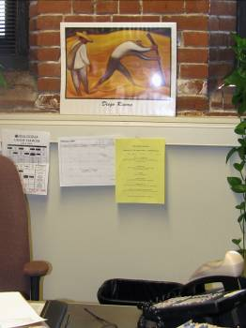

Note Slope on Brick Window Sill

Picture 2

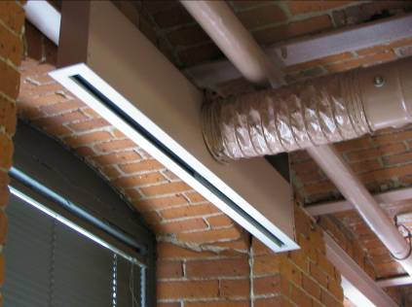

Fresh Air Diffuser

Picture 3

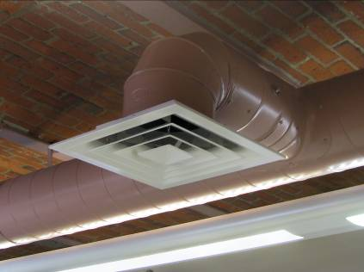

Fresh Air Diffuser

Picture 4

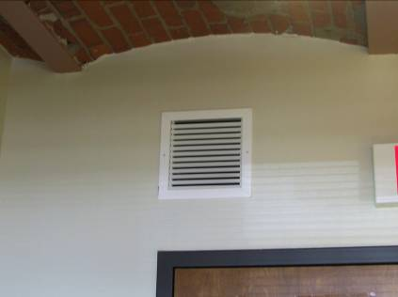

Exhaust Vent

Picture 5

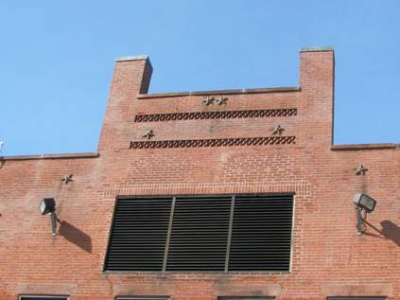

Typical Fresh Air Intake

Picture 6



Typical Exhaust Vent

Picture 7

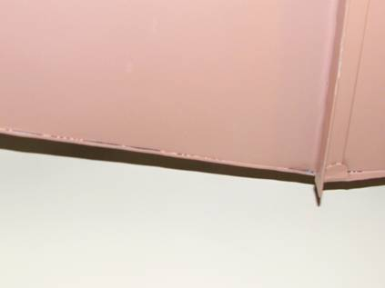

Unsealed Seams on Duct

Picture 8

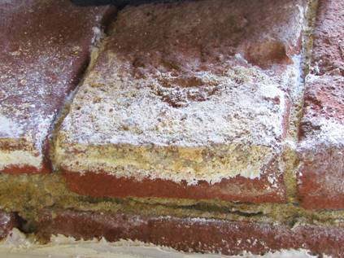

Efflorescence on Brick of Slanted Window Sill

Picture 9

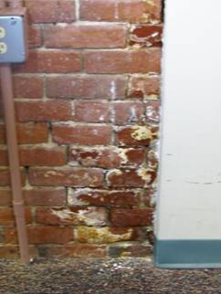

Efflorescence and Missing Mortar on Interior Wall

Picture 10

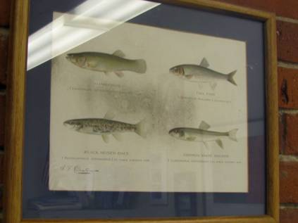

Mold Growth on Picture Hung On Brick Wall

Picture 11



Paper Backing on Fish Picture Supports Mold Growth

Picture 12



Picture Wrapped In Plastic Leaning Against Wall

Picture 13

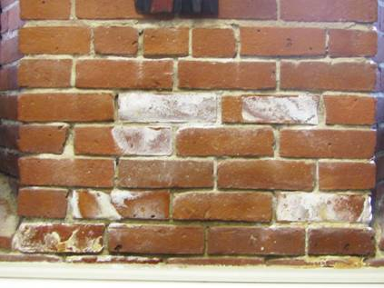
Efflorescence Observed On Wall behind Picture

Picture 14

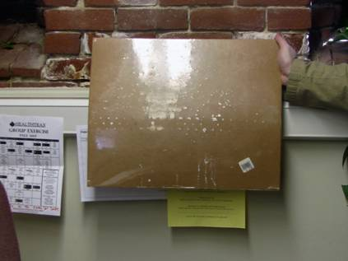

Efflorescence Observed On Impervious Plastic
Wrap On Back Of Picture

Picture 15

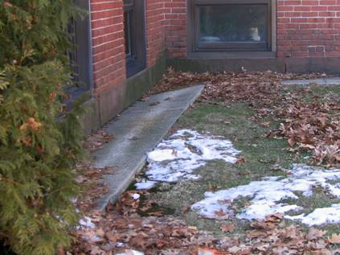

Picture 16

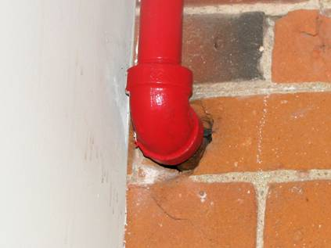

Penetration of Pipe through Wall Is Not Properly Sealed

Picture 17

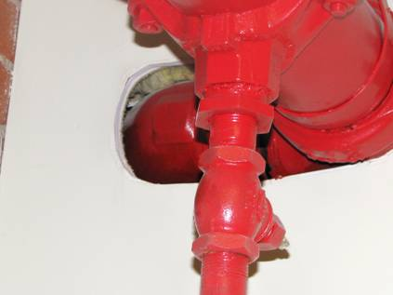

Penetration of Pipes through Office Walls Is Not Properly Sealed

Picture 18

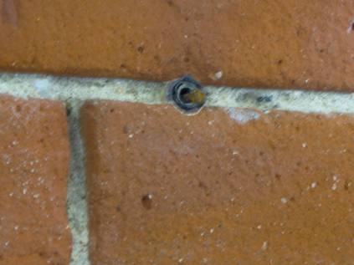

Rusted Nail in Wall

Picture 19

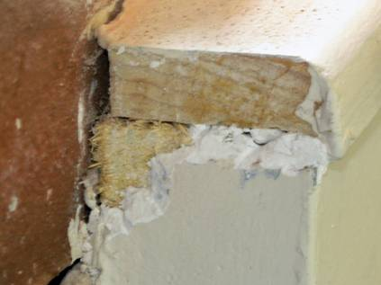

Wall Adjacent To Brick Is Composed Of Wood

Picture 20



Plant Resting On Carpeting

Picture 21

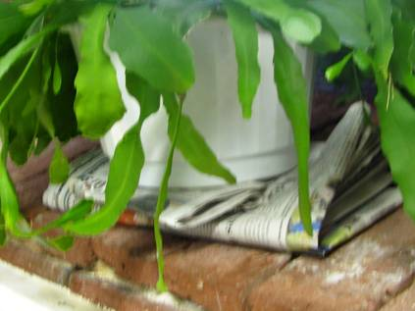

Plant Stored On Top Of Newspaper

Picture 22

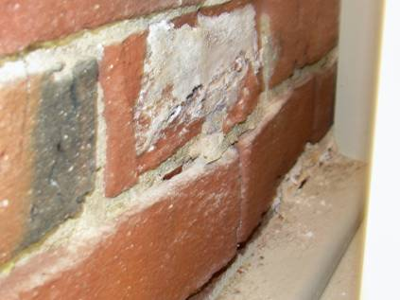

Brick Surface Peeling Away

Picture 23

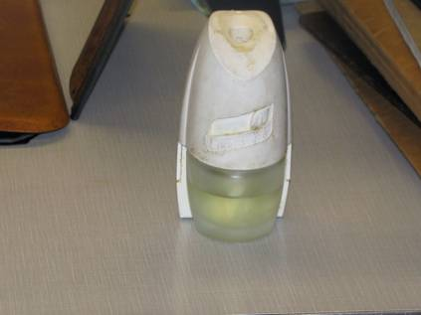

Air Freshener Located On Desk

Picture 24

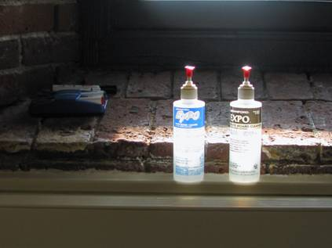

Dry Erase Board Markers and Cleaners

Picture 25

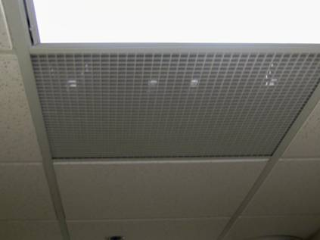

Grate Covering Ceiling Plenum

Location | Carbon  Dioxide  (*ppm) | Carbon  Monoxide  (*ppm) | Temp  °(F) | Relative  Humidity  (%) | Occupants  in Room | Windows  Openable | Ventilation |  | Remarks
 |  |  |  |  |  |  | Supply | Exhaust | Remarks
Outdoors | 392 | ND | 32 | 12 | - | - | - | - | -
Room 124 | 531 | ND | 61 | 32 | 0 | Y | Y | Y | DO, Efflorescence on brick, Pest issues, DEM, odor
Front Office | 490 | ND | 66 | 24 | 3 | N | Y | Y
Back hall | 488 | ND | 70 | 15 | 0 | Y | Y | Y | DC, odor, Space between doors, air entering office space  Through space between doors
Room 130 | 508 | ND | 70 | 15 | 0 | Y | Y | Y | DO, carpet, odor
Room 126 | 492 | ND | 72 | 15 | 0 | Y | Y | Y | DO, Odor
Room 127 | 623 | ND | 72 | 14 | 0 | Y | Y | Y | DO, Odor
Room 125 | 534 | ND | 71 | 14 | 0 | Y | Y | Y | DO, penetrations not sealed in wall and ceiling, odor
Room 123 | 515 | ND | 71 | 14 | 0 | Y | Y | Y | DO, Odor
Room 122 | 570 | ND | 71 | 14 | 0 | Y | Y | Y | DO, Odor
Room 121 | 548 | ND | 71 | 14 | 0 | Y | Y | Y | DC, Penetration not sealed, Plant on brick
Room 102 Lounge | 564 | ND | 71 | 16 | 1 | Y | Y | Y | DO, Odor
Copy Room | 588 | ND | 71 | 15 | 0 | Y | Y | Y | DO, Odor
Room 104 | 662 | ND | 71 | 18 | 0 | Y | Y | Y | DO, additional odor
Room 105 | 591 | ND | 71 | 15 | 0 | Y | Y | Y | DO, Air freshener, Odor
Room 106 | 673 | ND | 71 | 18 | 1 | Y | Y | Y | DO, Odor
Room 107 | 624 | ND | 71 | 16 | 1 | Y | Y | Y | DO, Odor
Room 109 | 620 | ND | 71 | 16 | 0 | Y | Y | Y | DO, Odor
Room 108 | 634 | ND | 71 | 17 | 0 | Y | Y | Y | DO, Odor
Room 110 | 848 | ND | 71 | 17 | 0 | Y | Y | Y | DO, Efflorescence on window sills
Room 111 | 612 | ND | 71 | 16 | 0 | Y | Y | Y | DO, perfume odor
Room 112 | 570 | ND | 72 | 15 | 0 | Y | Y | Y | DO, Odor
Room 114 | 566 | ND | 73 | 16 | 0 | Y | Y | Y | DO, Chunk of brick coming off wall, plant on sill
Room 115 | 617 | ND | 73 | 15 | 0 | Y | Y | Y | DO, rusty nail in wall, pesticide odor, plants on sill
Room 116 | 633 | ND | 72 | 16 | 0 | Y | Y | Y | DO, Odor
Room 117 | 567 | ND | 71 | 15 | 0 | Y | Y | Y | DO, Odor
Room 118 | 586 | ND | 71 | 17 | 0 | Y | Y | Y | DO, Odor, Plants on newspaper, Efflorescence on picture
Room 119 | 663 | ND | 72 | 17 | 0 | N | Y | Y | DO, Odor, End of vent. system

