WATER DAMAGE ASSESSMENT

Massachusetts Rehabilitation Commission
6 Clinton Avenue
Pittsfield, Massachusetts

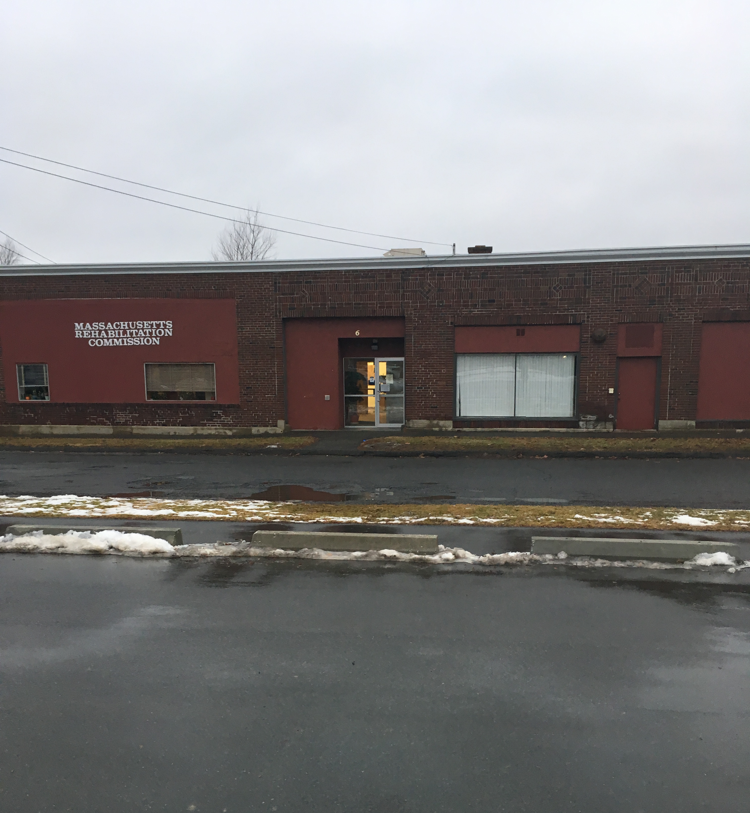

Prepared by:
Massachusetts Department of Public Health
Bureau of Environmental Health
Indoor Air Quality Program
January 2020

Background
Building: | Massachusetts Rehabilitation Commission (MRC)
Address: | 6 Clinton Avenue, Pittsfield, MA
Assessment Requested by: | Asya Rozental, Capital and Strategic Planning Manager, EHS Facilities
Reason for Request: | Water damage following a flood
Date of Assessment: | December 27, 2019
Massachusetts Department of Public Health/Bureau of Environmental Health (MDPH/BEH) Staff Conducting Assessment: | Mike Feeney, Director, indoor air quality (IAQ) Program
Building Description: | Single-story brick building with a flat roof formerly used as a car dealership
Windows: | Not openable

Introduction
Over the weekend of December 20, 2019, a water pipe burst, wetting the majority of occupied space in this office (Picture 1). Following the discovery of this flooding event, a disaster remediation contractor was retained to begin remediation. The following activities were conducted:
- Removal of existing wall-to-wall carpeting from a number of locations to expose the wood floor;
- Removal of water-damaged ceiling tiles that were moistened by the burst pipe;
- Use of a floor fan to dry the exposed surface of the wood sheet floor; and
- Removal of coving from impacted paneling walls.
It was reported to IAQ staff that the office has a false floor, which consists of a wood sheet on 2x4s installed over the original floor. The original floor was not examined directly, but is likely to be cement, since the original use of this building was a car dealership. This false floor creates a space called a floor cavity. During the visit on December 27, 2019, The IAQ Program found the following conditions:
- Carpeting in a number of areas was left intact (Picture 2);

- Office furniture was not removed from the remediation areas and was not protected using plastic sheets or other covering materials;
- No containment was used to separate occupied areas from areas under remediation. Containment and separation are recommended by mold remediation guidelines issued by the US EPA “Mold Remediation in Schools and Commercial Buildings” http://www.epa.gov/mold/mold-remediation-schools-and-commercial-buildings-guide or the MA Department of Public Health “Quick Reference: Water Damage Response in Buildings” https://www.mass.gov/info-details/quick-reference-water-damage-response-in-buildings; and
- No holes or other means to remove accumulated water that likely exists in the floor cavity or to remove water vapor wetting wood floor components could be identified. Without a means to dry the floor cavity, these areas would have remained moistened since the flooding event.

Methods
Please refer to the IAQ Manual for methods, sampling procedures, and interpretation of results (MDPH, 2015). In addition, visual observations were made of water-damaged materials, drying procedures being used, and other conditions that may impact IAQ. Some moisture measurements in GW and carpeting were conducted as is discussed further below.

Results and Discussion
The following is a summary of indoor air testing results (Table 1).
- Air Temperature was below the MDPH recommended comfort range of 70°F to 78°F in all but one area tested.
- Relative humidity was below the MDPH recommended comfort range of 40 to 60% in all areas, which is typical for New England during the heating season.

Microbial Concerns

Pipe Breakage Water Damage

During the course of this assessment, IAQ staff noted that the spaces between wood sheets composing the exposed under-flooring were darkened (Picture 3). In the experience of IAQ staff, such darkening in consistent with the wood becoming moistened by water/water vapor trapped within the floor cavity, which indicates the under-flooring, and supporting 2x4s, were continuously moistened from December 20 to December 27 for over 160 hours. In general, the US EPA recommends beginning drying strategies “to respond to water damage within 24-48 hours” (US EPA, 2008). It is important to note that “[i]f mold growth has occurred or materials have been wet for more than 48 hours, consult Table 2 [Mold Remediation Guidelines]. Even if materials are dried within 48 hours, mold growth may have occurred” (US EPA, 2008).
IAQ staff conducted moisture sampling of darkened wood sheet floor seams as well as existing carpet. Both wood floor seams and carpeting had elevated moisture measurements, indicating that a significant water source exists in the floor cavity throughout the MRC office space that was moistening both floor wood and carpeting.

Building Materials Prone to Condensation
Since floor fans with heaters were in use to dry the floor, IAQ staff measured floor temperatures using a laser thermometer throughout the office space to ascertain if remediation methods were sufficient to remove water vapor from the floor cavity through the floor seams. Floor temperatures ranged from 50°F to 68°F, which were all below the measured air temperature throughout the space (Table 1). These measurements indicate the fans in use were not warming the floor cavity to aid drying. These measurements may also indicate that the floors may be prone to condensation in hot, humid weather when the HVAC system is operating in chilling mode. A method to locate areas in a building prone to condensation would be to measure air and building material temperatures. If a wide temperature range exists between measurements, the building materials at the colder end of the range may be prone to becoming moistened with condensation in hot, humid weather, particularly when the HVAC system is chilling air.

Conclusions and Recommendations
The following recommendations are made to assist in the completion of remediation and improve IAQ:
- Move or remove any items and furniture from the floor and away from walls in the affected areas to inspect underneath and behind them for additional water damage.
- Water-damaged porous materials such as boxes/papers, laminated tables or other items may need to be discarded if they show signs of mold colonization such as musty odors.
- Remediate and investigate conditions in the floor cavity in a manner consistent with US EPA guideline “Mold Remediation in Schools and Commercial Buildings” (US EPA, 2008). This may include:
  - Inspecting and cleaning the floor cavity;
  - Removing all floor covering materials throughout the MRC offices; and
  - Removal of all mold-contaminated flooring materials.
- Activities that may be disruptive or lead to dust and odors should be conducted during off-hours (evenings and weekends) to the greatest extent practical.
- Remove or separate staff from areas under remediation or construction to prevent exposure to dust and odors. Plastic sheeting and tape may be used for containment where needed.
- Increase cleaning in the affected areas to remove dust and debris from carpeting and flat surfaces. Clean carpeting and surfaces thoroughly (with wet wiping and HEPA vacuuming) once the rest of the remediation is completed.
- Ensure the ventilation system is operating continuously during occupied periods. This includes setting thermostats to “fan on” to ensure fresh air circulation occurs even when temperature settings are satisfied.
- Refer to resource manual and other related IAQ documents located on the MDPH’s website for further building-wide evaluations and advice on maintaining public buildings. These documents are available at: http://mass.gov/dph/iaq.

References
MDPH. 2015. Massachusetts Department of Public Health. Indoor Air Quality Manual: Chapters I-III. Available at: http://www.mass.gov/eohhs/gov/departments/dph/programs/environmental-health/exposure-topics/iaq/iaq-manual/.
US EPA. 2008. “Mold Remediation in Schools and Commercial Buildings”. Office of Air and Radiation, Indoor Environments Division, Washington, DC. EPA 402-K-01-001. September 2008. Available at: http://www.epa.gov/mold/mold-remediation-schools-and-commercial-buildings-guide
Picture 1
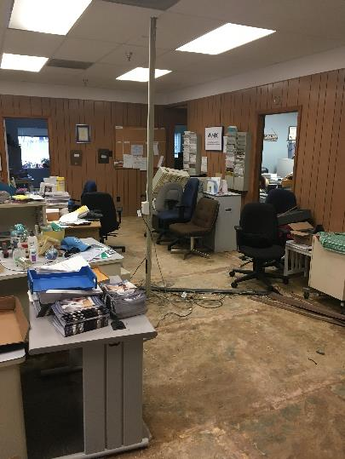
Water-damaged office floor
Picture 2
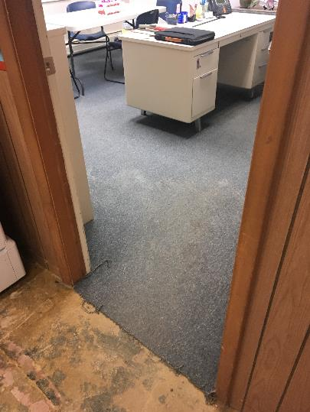
Intact carpeting in an office
Picture 3
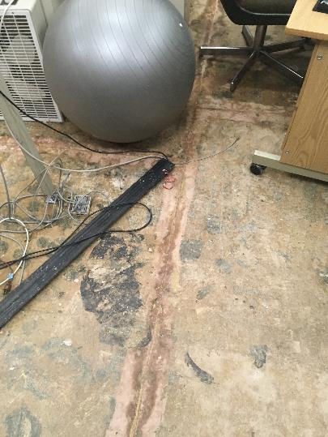
Dark stain at seam

Location | Air Temperature  (ºF) | Relative Humidity  (%) | Temperature of Floor 5′ from Exterior Wall/hallway door  (ºF) | Temperature at Floor/Exterior Wall Junction  (ºF) | Difference in Temperature of Air v. lowest Floor Measurement  (ºF) | Moisture Percentage in carpeting, seams of floor wood sheets or beneath floor tile  (%)
1 | 68 | 34 | 59 | 50 | -18 | 8-9 seam
2 | 68 | 32 | 62 |  | -6 | 9 seam
3 | 69 | 34 | 64 |  | -5 | 70-86 seam
4 | 68 | 33 | 58 | 55 | -10 | 21-86 seam  6-11 carpet
5 | 68 | 34 | 58 | 56 | -12 | 5-28 carpet
6 | 68 | 34 | 57 | 54 | -14 | 3-19 carpet
7 | 67 | 34 | 59 | 54 | -13 | 3-13 carpet
8 | 68 | 34 | 62 |  | -6 | 23-86 seam
9 | 69 | 32 | 63 |  | -6 | 55-86 seam
10 | 69 | 33 | 63 |  | -6 | 32-56 seam
11 | 69 | 33 | 64 |  | -5 | 71-87 floor tile
12 | 69 | 32 | 63 |  | -6 | 73-55 floor tile
13 | 70 | 33 | 68 |  | -2 | 38-80 tile
14 | 69 | 33 | 66 | 55 | -13 | 2-8 carpet
Conference room | 69 | 33 | 56 |  | -13 | 2-5 carpet
Front door | 69 | 33 | 55 | 55 | -14 | 64 floor tile

