INDOOR AIR QUALITY ASSESSMENT

Massachusetts Rehabilitation Commission
238 Main Street
Greenfield, Massachusetts

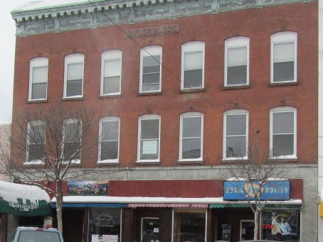

Prepared by:
Massachusetts Department of Public Health
Bureau of Environmental Health
Indoor Air Quality Program
March 2014

Background/Introduction
At the request of Pamela Jackson, Children, Youth and Family Services (CYF), Director of Human Resources, Executive Offices of Health and Human Services (EOHHS), the Massachusetts Department of Public Health (MDPH), Bureau of Environmental Health (BEH), Indoor Air Quality (IAQ) Program was asked to provide assistance and consultation regarding IAQ conditions at the Massachusetts Rehabilitation Commission (MRC) office, located at 238 Main Street, Greenfield, Massachusetts. The request was prompted by occupant complaints of respiratory irritation and concerns that health effects were associated with IAQ. On February 14, 2014, a visit to conduct an indoor air quality assessment was made by Michael Feeney, Director of Indoor Air Quality Program and Kathleen Gilmore, Environmental Inspector in BEH’s IAQ Program.
The building was constructed prior to 1940 as a three-story commercial building with penthouse. The MRC offices are located on the third floor of the building and include a portion on the second floor, which houses their a conference room. The first floor and basement contain commercial and retail space. Windows are openable throughout the floor.
BEH/IAQ staff previously visited this building in May of 2003 and a copy of the report is on the IAQ Program website (http://mass.gov/dph/iaq). There were numerous recommendations made following the 2003 assessment to improve IAQ conditions in the building. Appendix A contains a summary of those recommendations and actions that have been taken at the MRC to respond to them.

Methods
Air tests for carbon dioxide, carbon monoxide, temperature and relative humidity were conducted with the TSI, Q-Trak, IAQ Monitor, Model 7565. Air tests for airborne particle matter with a diameter less than 2.5 micrometers were taken with the TSI, DUSTTRAK™ Aerosol Monitor Model 8520. BEH/IAQ staff also performed visual inspection of building materials for water damage and/or microbial growth.

Results
The MRC has a daily employee population of approximately 15-20, with over 20 individuals visiting on a daily basis. The tests were taken under normal operating conditions. Test results appear in Table 1. Locations listed in Table 1 correspond to locations depicted in Figure 1.

Discussion

Ventilation
It can be seen from Table 1 that the carbon dioxide levels were above 800 ppm in all areas surveyed (with the exception of the second floor conference room), indicating that insufficient fresh air is being provided to occupied spaces. Ventilation is provided by a natural gas-fueled air-handling unit (AHU), which is located in a mechanical room/closet in the center of the third floor (Table 1, Figure 1). The AHU is connected to ductwork located above the ceiling which distributes air to ceiling-mounted air diffusers throughout the space.
The ventilation system in the MRC does not appear to be designed to provide either mechanical fresh air supply or exhaust ventilation. BEH/IAQ staff could not identify a fresh air supply source for the AHU. Two vents installed behind the AHU appeared to provide cold, untempered air into this room which likely serves as the source of combustion air for the gas-fired furnace portion of the AHU.
Return air is drawn to the AHU by a passive vent that is located on the wall of the hallway (Pictures 1 and 2) adjacent to the door of the mechanical room. In this configuration, the hallway becomes depressurized, which then draws air from offices through spaces around doors. With a lack of fresh air supply and/or exhaust ventilation, odors, pollutants and particulates within the building interior will remain inside and be continuously recirculated. This situation can produce irritant symptoms and comfort complaints by building occupants.
Of note is the configuration of the mechanical room and the AHU. The AHU is a Williamson Temp-O-Matic fueled by natural gas (Picture 3). The exhaust from the firebox (combustion chamber) is vented into a duct inside a wall, which is presumed to exit outside the building. Of note were holes in the exhaust duct that can allow products of combustion to vent into the mechanical room (Picture 4). Since a major product of combustion is carbon dioxide, carbon dioxide measurements may be reflective of pollutants venting into the MRC in addition to the typical sources of carbon dioxide (i.e. building occupants). The source of air for combustion appears to be a vent in the wall behind the AHU/furnace that draws cold air from the outdoors.
The process of combustion produces a number of pollutants. The type of pollutant produced is dependent on the composition of the material combusted. In general, common combustion emissions can include carbon dioxide, carbon monoxide (CO), water vapor and smoke. As previously discussed, carbon dioxide measurements were taken throughout the office space. Indoor carbon dioxide concentrations ranged from 935 ppm to 1171 ppm. The background level or outdoor measurement of carbon dioxide was 496 ppm. It is important to note that the offices were occupied by only eleven individuals during the assessment, hence the likelihood that combustion products may be contributing to carbon dioxide levels. Carbon dioxide levels similar those measured in the MRC offices are more typical in single rooms with a high number of occupants (20+) with an inactive ventilation system. In this instance, the low number of individuals present combined with the existence of an open window in the main reception area suggests that that the source of carbon dioxide production may be independent of occupancy.
To maximize air exchange, the MDPH recommends that both supply and exhaust ventilation operate continuously during periods of occupancy. In order to have proper ventilation with a mechanical supply and exhaust system, the systems must be balanced to provide an adequate amount of fresh air to the interior of a room while removing stale air from the room. It is recommended that heating, ventilating and air conditioning (HVAC) systems be re-balanced every five years to ensure adequate air systems function (SMACNA, 1994). The date of the last balancing of these systems was not available at the time of the assessment.
Minimum design ventilation rates are mandated by the Massachusetts State Building Code (MSBC). Until 2011, the minimum ventilation rate in Massachusetts was higher for both occupied office spaces and general offices, with similar requirements for other occupied spaces (BOCA, 1993). The current version of the MSBC, promulgated in 2011 by the State Board of Building Regulations and Standards (SBBRS), adopted the 2009 International Mechanical Code (IMC) to set minimum ventilation rates. Please note that the MSBC is a minimum standard that is not health-based. At lower rates of cubic feet per minute (cfm) per occupant of fresh air, carbon dioxide levels would be expected to rise significantly. A ventilation rate of 20 cfm per occupant of fresh air provides optimal air exchange resulting in carbon dioxide levels at or below 800 ppm in the indoor environment in each area measured. MDPH recommends that carbon dioxide levels be maintained at 800 ppm or below. This is because most environmental and occupational health scientists involved with research on IAQ and health effects have documented significant increases in indoor air quality complaints and/or health effects when carbon dioxide levels rise above the MDPH guidelines of 800 ppm for schools, office buildings and other occupied spaces (Sundell et al., 2011). The ventilation must be on at all times that the room is occupied. Providing adequate fresh air ventilation with open windows and maintaining the temperature in the comfort range during the cold weather season is impractical. Mechanical ventilation is usually required to provide adequate fresh air ventilation.
Carbon dioxide is not a problem in and of itself. It is used as an indicator of the adequacy of the fresh air ventilation. As carbon dioxide levels rise, it indicates that the ventilating system is malfunctioning or the design occupancy of the room is being exceeded. When this happens, a buildup of common indoor air pollutants can occur, leading to discomfort or health complaints. The Occupational Safety and Health Administration (OSHA) standard for carbon dioxide is 5,000 parts per million parts of air (ppm). Workers may be exposed to this level for 40 hours/week, based on a time-weighted average (OSHA, 1997).
The MDPH uses a guideline of 800 ppm for publicly occupied buildings. A guideline of 600 ppm or less is preferred in schools due to the fact that the majority of occupants are young and considered to be a more sensitive population in the evaluation of environmental health status. Inadequate ventilation and/or elevated temperatures are major causes of complaints such as respiratory, eye, nose and throat irritation, lethargy and headaches. For more information concerning carbon dioxide, consult Appendix B.
Temperature readings during the assessment ranged from 66°F to 72°F; readings were within the MDPH recommended comfort range, with the exception of the mechanical room (Table 1). The MDPH recommends that indoor air temperatures be maintained in a range of 70°F to 78°F in order to provide for the comfort of building occupants.
MRC staff reported temperature control issues in areas along the south wall of the floor. Supply air diffusers are flush with the ceiling and are installed above fluorescent light fixtures (Picture 5), which blocks over half of the airflow. In this condition, tempered air is not diffused along wall areas evenly, which can make temperature control difficult. In addition, the sun was observed to be streaming in through some south-facing windows in the building. Window shades/blinds should be used to moderate solar gain. In many cases concerning indoor air quality, fluctuations of temperature in occupied spaces are typically experienced, even in a building with an adequate fresh air supply.
The relative humidity at the time of the assessment ranged from 21 to 24 percent, which was below the MDPH recommended comfort range. The MDPH recommends a comfort range of 40 to 60 percent for indoor air relative humidity. Relative humidity levels in the building would be expected to drop during the winter months due to heating. The sensation of dryness and irritation is common in a low relative humidity environment. Low relative humidity is a very common problem during the heating season in the northeast part of the United States.

Microbial/Moisture Concerns
In order for building materials to support mold growth, a source of water exposure is necessary. No active leaks were observed, however, water damage and likely mold growth was noted on the gypsum wallboard (GW) used to enclose the mechanical room (Picture 6). The likely source of moisture to the GW is the delivery of unconditioned, moist air into the mechanical room by the combustion air vent. Unconditioned outdoor air from the combustion air vent can repeatedly moisten the GW, resulting in mold growth.
The floor of the mechanical room also showed signs of water damage. BEH/IAQ staff found a towel, likely colonized with mold, placed beneath the AHU motor (Picture 7). The towel was most likely an effort to absorb water leakage/overflow from the AHU drip pan. AHU drip pans must adequately drain to prevent mold growth.
The US Environmental Protection Agency (US EPA) and the American Conference of Governmental Industrial Hygienists (ACGIH) recommend that porous materials (e.g., carpeting, gypsum wallboard) be dried with fans and heating within 24 to 48 hours of becoming wet (US EPA, 2001; ACGIH, 1989). If not dried within this time frame, mold growth may occur. Once mold has colonized porous materials, they are difficult to clean and should be removed/discarded.
Several areas also had a number of plants (Table 1, Picture 8). Plant soil, standing water and drip pans can be potential sources of mold growth. Drip pans should be inspected periodically for mold growth and over watering should be avoided.

Other IAQ Evaluations
IAQ can be negatively influenced by the presence of respiratory irritants, such as products of combustion. The process of combustion produces a number of pollutants. Common combustion emissions include carbon monoxide, carbon dioxide, water vapor and smoke (fine airborne particle material). Of these materials, exposure to carbon monoxide and particulate matter with a diameter of 2.5 micrometers (μm) or less (PM2.5) can produce immediate, acute health effects upon exposure. To determine whether combustion products were present in the indoor environment, BEH/IAQ staff obtained measurements for carbon monoxide and PM2.5.

Carbon Monoxide
Carbon monoxide is a by-product of incomplete combustion of organic matter (e.g., gasoline, wood and tobacco). Exposure to carbon monoxide can produce immediate and acute health effects. Several air quality standards have been established to address carbon monoxide and prevent symptoms from exposure to these substances. The MDPH established a corrective action level concerning carbon monoxide in ice skating rinks that use fossil-fueled ice resurfacing equipment. If an operator of an indoor ice rink measures a carbon monoxide level over 30 ppm, taken 20 minutes after resurfacing within a rink, that operator must take actions to reduce carbon monoxide levels (MDPH, 1997).
The American Society of Heating Refrigeration and Air-Conditioning Engineers (ASHRAE) has adopted the National Ambient Air Quality Standards (NAAQS) as one set of criteria for assessing indoor air quality and monitoring of fresh air introduced by HVAC systems (ASHRAE, 1989). The NAAQS are standards established by the US EPA to protect the public health from six criteria pollutants, including carbon monoxide and particulate matter (US EPA, 2006). As recommended by ASHRAE, pollutant levels of fresh air introduced to a building should not exceed the NAAQS levels (ASHRAE, 1989). The NAAQS were adopted by reference in the Building Officials & Code Administrators (BOCA) National Mechanical Code of 1993 (BOCA, 1993), which is now an HVAC standard included in the Massachusetts State Building Code (SBBRS, 2011). According to the NAAQS, carbon monoxide levels in outdoor air should not exceed 9 ppm in an eight-hour average (US EPA, 2006).
Carbon monoxide should not be present in a typical, indoor environment. If it is present, indoor carbon monoxide levels should be less than or equal to outdoor levels. The day of assessment, outdoor carbon monoxide concentrations were non-detect (ND) (Table 1). Levels of carbon monoxide in the building during the assessment were also ND (Table 1).

Particulate Matter (PM2.5)
The US EPA has established NAAQS limits for exposure to particulate matter. Particulate matter is airborne solids that can be irritating to the eyes, nose and throat. The NAAQS originally established exposure limits to particulate matter with a diameter of 10 μm or less (PM10). According to the NAAQS, PM10 levels should not exceed 150 microgram per cubic meter (μg/m³) in a 24-hour average (US EPA, 2006). These standards were adopted by both ASHRAE and BOCA. Since the issuance of the ASHRAE standard and BOCA Code, US EPA established a more protective standard for fine airborne particles. This more stringent PM2.5 standard requires outdoor air particle levels be maintained below 35 μg/m³ over a 24-hour average (US EPA, 2006). Although both the ASHRAE standard and BOCA Code adopted the PM10 standard for evaluating air quality, MDPH uses the more protective PM2.5 standard for evaluating airborne particulate matter concentrations in the indoor environment.
Outdoor PM2.5 concentrations measured 18 μg/m³ on the day of the visit (Table 1). PM2.5 levels measured inside the building ranged from 12 to 16 μg/m³ (Table 1). Frequently, indoor air levels of particulate matter can be at higher levels than those measured outdoors. A number of mechanical devices and/or activities that occur in buildings can generate particulate during normal operations. Sources of indoor airborne particulates may include but are not limited to particles generated during the operation of fan belts in the HVAC system, use of stoves and/or microwave ovens in kitchen areas;, use of photocopiers, fax machines and computer printing devices, operation of an ordinary vacuum cleaner and heavy foot traffic indoors.

Volatile Organic Compounds
Indoor air concentrations can be greatly impacted by the use of products containing volatile organic compounds (VOCs). VOCs are carbon-containing substances that have the ability to evaporate at room temperature. Frequently, exposure to low levels of total VOCs (TVOCs) may produce eye, nose, throat and/or respiratory irritation in some sensitive individuals. For example, chemicals evaporating from a paint can stored at room temperature would most likely contain VOCs. In an effort to identify materials that can potentially increase indoor VOC concentrations, BEH/IAQ staff examined the offices for products containing respiratory irritants.
Many rooms contained dry erase boards and related materials. In some areas, dry erase debris was accumulated on the marker tray. Materials such as dry erase markers and dry erase board cleaners may contain VOCs, such as methyl isobutyl ketone, n-butyl acetate and butyl-cellusolve (Sanford, 1999), which can be irritating to the eyes, nose and throat
There are a few photocopiers in the building. Photocopiers can be sources of pollutants such as VOCs, ozone, heat and odors, particularly if the equipment is older and in frequent use. Both VOCs and ozone are respiratory irritants (Schmidt Etkin, 1992). Photocopiers and laminators should be kept in well ventilated rooms, and should be located near windows or exhaust vents.

Other Conditions
The AHU is equipped with filters that strain particulates from airflow. The AHU for the MRC office was operating with a filter in place that was undersized for the return vent opening (Picture 9). In this condition, any airborne particles drawn into the hallway vent can be distributed via the ventilation system as air bypasses the filter. Particulate sources can include the AHU, photocopiers and materials stored in the mechanical room. In order to decrease aerosolized particulates, disposable filters with an increased dust spot efficiency can be installed. The dust spot efficiency is the ability of a filter to remove particulates of a certain diameter from air passing through the filter. Filters that have been determined by ASHRAE to meet its standard for a dust spot efficiency of a minimum of 40 percent would be sufficient to reduce many airborne particulates (Thornburg, D., 2000; MEHRC, 1997; ASHRAE, 1992). Pleated filters with a Minimum Efficiency Reporting Value dust-spot efficiency of 9 or higher are recommended. Note that increasing filtration can reduce airflow (called pressure drop), which can subsequently reduce the efficiency of the unit due to increased resistance. Prior to any increase of filtration, each AHU component should be evaluated by a ventilation engineer to ascertain whether it can maintain function with more efficient filters.
Finally, much of the occupied space contained area carpets. The Institute of Inspection, Cleaning and Restoration Certification (IICRC), recommends that carpeting be cleaned annually (or semi-annually in soiled high traffic areas) (IICRC, 2005).

Conclusions/Recommendations
The conditions found within the MRC building raise a number of indoor air quality issues. The configuration of the AHU (and associated equipment), lack of filtration on the AHU and water damaging the mechanical room are conditions that can degrade indoor air quality. The mechanical ventilation system does not dilute or remove environmental pollutants from the building. This can result in a buildup of dust, dirt, and other pollutants in the indoor environment. In view of the findings at the time of the visit, the following recommendations are provided:
- Implement all the recommendations made in the previous 2003 MDPH assessment, and notable those associated with the air-handling unit (Appendix A).
- Consult an HVAC engineering firm to install ductwork from the combustion air supply directly to the existing AHU.
- Consult an HVAC engineering firm to determine if the existing AHU can be retrofitted with fresh air supply and exhaust ventilation.
- Seal holes in furnace exhaust vents with a fire rated material.
- Use window blinds to moderate fluctuations in temperature due to solar gain.
- Consider reducing the number of plants in work areas. Avoid over-watering and examine drip pans periodically for mold growth. Disinfect with an appropriate antimicrobial where necessary.
- For buildings in New England, periods of low relative humidity during the winter are often unavoidable. Therefore, scrupulous cleaning practices should be adopted to minimize common indoor air contaminants whose irritant effects can be enhanced when the relative humidity is low. To control dusts, a high efficiency particulate arrestance (HEPA) filter equipped vacuum cleaner in conjunction with wet wiping of all surfaces is recommended. Avoid the use of feather dusters. Drinking water during the day can help ease some symptoms associated with a dry environment (throat and sinus irritations).
- Install filters of a proper size to completely cover the return air intake to prevent air bypass.
- Consult an HVAC engineering firm to examine better methods to air distribution for offices with fresh air supplies partially blocked by ceiling light fixtures.
- Clean dry-erase marker trays of accumulated dust and debris regularly using a damp cloth.
- Clean carpeting annually or semi-annually in soiled high traffic areas as per the recommendations of the Institute of Inspection, Cleaning and Restoration Certification (IICRC). Copies of the IICRC fact sheet can be downloaded at: http://1.cleancareseminars.net/?page_id=185.
- Refer to resource manual and other related indoor air quality documents located on the MDPH’s website for further building-wide evaluations and advice on maintaining public buildings. These documents are available at: http://mass.gov/dph/iaq.

References
ACGIH. 1989. Guidelines for the Assessment of Bioaerosols in the Indoor Environment. American Conference of Governmental Industrial Hygienists, Cincinnati, OH.
ASHRAE. 1989. Ventilation for Acceptable Indoor Air Quality. American Society of Heating, Refrigeration and Air Conditioning Engineers. ANSI/ASHRAE 62-1989
ASHRAE. 1992. Gravimetric and Dust-Spot Procedures for Testing Air-Cleaning Devices Used in General Ventilation for Removing Particulate Matter. American Society of Heating, Refrigeration and Air Conditioning Engineers. ANSI/ASHRAE 52.1-1992.
BOCA. 1993. The BOCA National Mechanical Code-1993. 8th ed. Building Officials & Code Administrators International, Inc., Country Club Hills, IL.
IICRC. 2005. Carpet Cleaning FAQ 4 Institute of Inspection, Cleaning and Restoration Certification. Institute of Inspection Cleaning and Restoration, Vancouver, WA.
MDPH. 1997. Requirements to Maintain Air Quality in Indoor Skating Rinks (State Sanitary Code, Chapter XI). 105 CMR 675.000. Massachusetts Department of Public Health, Boston, MA.
MEHRC. 1997. Indoor Air Quality for HVAC Operators & Contractors Workbook. MidAtlantic Environmental Hygiene Resource Center, Philadelphia, PA.
OSHA. 1997. Limits for Air Contaminants. Occupational Safety and Health Administration. Code of Federal Regulations. 29 C.F.R 1910.1000 Table Z-1-A.
Sanford. 1999. Material Safety Data Sheet (MSDS No: 198-17). Expo® Dry Erase Markers Bullet, Chisel, and Ultra Fine Tip. Sanford Corporation, Bellwood, IL.
SBBRS. 2011. Mechanical Ventilation. State Board of Building Regulations and Standards. Code of Massachusetts Regulations. 780 CMR 1209.0.
Schmidt Etkin, D. 1992. Office Furnishings/Equipment & IAQ Health Impacts, Prevention & Mitigation. Cutter Information Corporation, Indoor Air Quality Update, Arlington, MA.
SMACNA. 1994. HVAC Systems Commissioning Manual. 1st ed. Sheet Metal and Air Conditioning Contractors’ National Association, Inc., Chantilly, VA
Sundell. 2011. Sundell, J., H. Levin, W. W. Nazaroff, W. S. Cain, W. J. Fisk, D. T. Grimsrud, F. Gyntelberg, Y. Li, A. K. Persily, A. C. Pickering, J. M. Samet, J. D. Spengler, S. T. Taylor, and C. J. Weschler. Ventilation rates and health: multidisciplinary review of the scientific literature. Indoor Air, Volume 21: pp 191–204.
Thornburg, D. 2000. Filter Selection: a Standard Solution. Engineering Systems 17:6 pp. 74-80.
US EPA. 2001. Mold Remediation in Schools and Commercial Buildings. US Environmental Protection Agency, Office of Air and Radiation, Indoor Environments Division, Washington, D.C. EPA 402-K-01-001. March 2001.
US EPA. 2006. National Ambient Air Quality Standards (NAAQS). US Environmental Protection Agency, Office of Air Quality Planning and Standards, Washington, DC. http://www.epa.gov/air/criteria.html
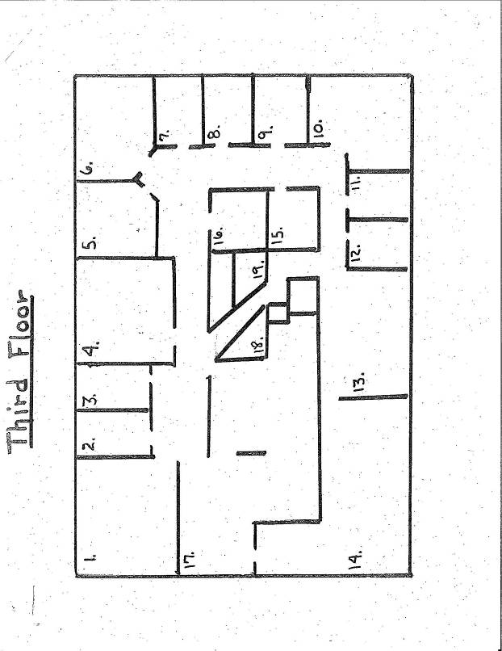
Picture 1
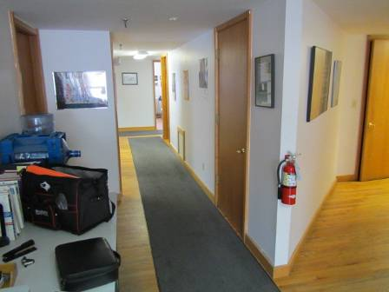
Return air is drawn to the AHU by a passive vent that is located on the wall of the mechanical room
Picture 2
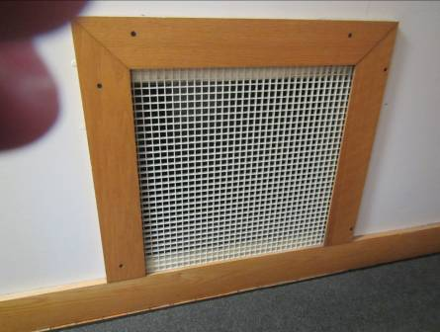
Close-up of return vent in hallway
Picture 3
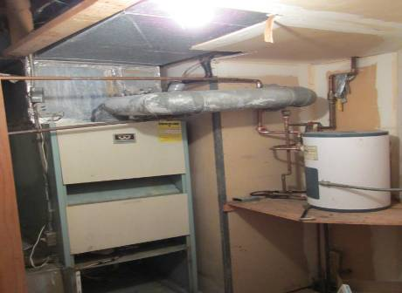
Williamson Temp-O-Matic furnace; note exhaust duct vented into wall (arrow)
Picture 4
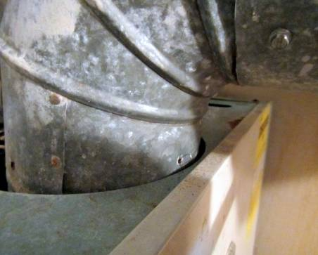
Hole in AHU furnace exhaust duct (arrow)
Picture 5
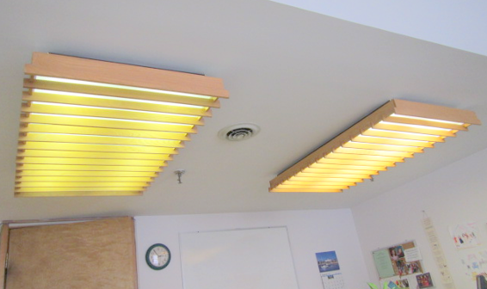
Ceiling-mounted diffuser located between light fixtures
Picture 6
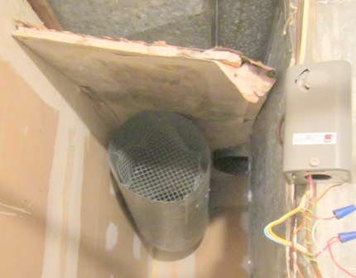
Combustion air vent in wall behind the AHU; note mold colonized GW above duct

Picture 7
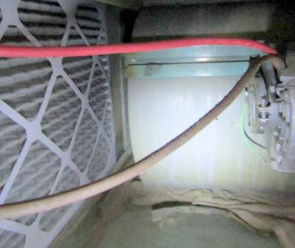
Towel placed beneath motor inside AHU (arrow)
Picture 8
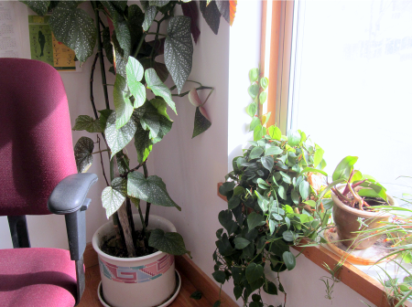
Plants in office

Picture 9
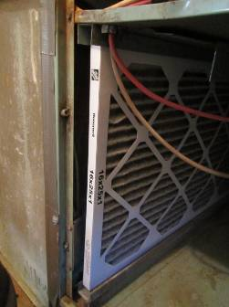
Poorly-fitted filter inside AHU

Location | Carbon  Dioxide  (ppm) | Carbon Monoxide  (ppm) | Temp  (°F) | Relative  Humidity  (%) | PM2.5  (µg/m³) | Occupants  in Room | Windows  Openable | Ventilation |  | Remarks
 |  |  |  |  |  |  |  | Supply | Exhaust | Remarks
Background | 496 | ND | 33 | 52 | 18 |  |  |  |  | Partly cloudy, windy
1 | 1013 | ND | 71 | 23 | 13 | 6 | Y | Y | N | PF, plants, DEM, PF, solar gain
2 | 935 | ND | 71 | 22 | 13 | 0 | N | N | N | Area rug
3 | 973 | ND | 71 | 21 | 14 | 2 | N | Y | N
4 | 969 | ND | 71 | 22 | 14 | 0 | N | Y | N | Plants
5 | 1040 | ND | 70 | 22 | 14 | 1 | N | Y | N
6 | 1015 | ND | 70 | 23 | 14 | 1 | Y | Y | N | DO
7 | 1171 | ND | 70 | 22 | 16 | 0 | Y | Y | N
8 | 984 | ND | 71 | 21 | 13 | 1 | Y | Y | N | DO
9 | 1024 | ND | 70 | 23 | 13 | 0 | Y | Y | N | DO
11 | 1010 | ND | 71 | 24 | 12 | 0 | N | Y | N
12 | 1008 | ND | 70 | 21 | 13 | 0 | N | Y | N | PF, area rug
14 | 1143 | ND | 70 | 24 | 12 | 4 | Y | Y | N | DO, plants, DEM, PF, area carpet, boxes on floor, solar gain
15 | 1021 | ND | 71 | 21 | 13 | 0 | N | Y | N | DO
16 (Mechanical room) | 994 | ND | 66 | 22 | 15 | 0 | N | Y | N | Passive return vent in wall from hallway, no fresh air supply
17 | 1027 | ND | 71 | 22 | 13 | 0 | N | Y | N | DO
18 | 1067 | ND | 71 | 23 | 14 | 0 | N | Y | N
Hallway | 1039 | ND | 71 | 21 | 12 | 0 | N | Y | N | Return vent to mechanical room, PC/scanner, area rug
Kitchen | 985 | ND | 71 | 22 | 15 | 0 | N | Y | N | Refrigerator, microwave, toaster
Resource room | 1042 | ND | 70 | 24 | 14 | 2 | N | Y | N | DO, multiple computers, PF, DEM area carpet
Restroom (Men) | 978 | ND | 71 | 23 | 12 |  | N | Y | Y  off | DO
Restroom (Women) | 991 | ND | 72 | 24 | 12 |  | N | Y | Y  off | DO

Actions on MDPH Recommendations
Greenfield Massachusetts Rehabilitation Commission (MRC)
238 Main Street, Greenfield, MA

The following is a status report of action(s) taken on recommendations made in the 2003 MDPH IAQ report (in bold) based on BEH/IAQ observations and test results.
- Install a wall-mounted CO alarm with digital readout near the gas-fired AHU. CO levels should be checked daily after the AHU is fired up during the heating season.

Action: No carbon monoxide detector(s) could be located in the building.

- Improve the amount of combustion air provided to the AHU. A mechanical fan to introduce more fresh air may be necessary. Consult with the local fire prevention officer/building code officials to determine an appropriate method to provide combustion air for the AHU. If not feasible, consider replacing current AHU with an electric model.

Action: No information was available regarding this recommendation. Cold, outdoor air was noted in the mechanical room.

- Install a boiler room style, fire-rated door in the mechanical room portal.

Action: The door to the mechanical room had not been replaced.

- Install weather-stripping along the door frame of the mechanical room door.

Action: The door to the mechanical room did not have weather-stripping installed.

- Install a door sweep at the bottom of the mechanical room door.

Action: A door sweep was not installed.

- Seal the spaces around utility pipes within the mechanical room.

Action: Spaces around utility pipes were not sealed.

- Seal all window frames and seams along the front of the building in a proper manner.

Action: Windows appeared to be sealed and were free of water damage.

- Remove and replace any mold contaminated/water-damaged GW and insulation along the exterior walls and around affected windowsills.

Action: GW was removed and replaced following the 2003 MDPH visit.

- Consider reducing the number of plants in work areas. Avoid over-watering and examine drip pans periodically for mold growth.

Action: Numerous plants were observed in office spaces.

- Consider obtaining a vacuum cleaner equipped with a high efficiency particulate arrestance (HEPA) filter to trap respirable dusts.

Action: It was not known if a vacuum with a HEPA filter was used in the MRC offices.

- Consult with a ventilation engineering firm to balance fresh air supply and exhaust ventilation every five years to ensure adequate system function, if systems are installed.

Action: Fresh air and exhaust ventilation were not installed at the time of the 2014 assessment.

- Consult with an HVAC engineering firm to determine if the existing AHU can be retrofitted with fresh air supply and exhaust.

Action: It was not known if a HVAC engineering firm was consulted regarding retrofitting the AHU. Fresh air supply and exhaust ventilation did not exist at the time of the 2014 assessment.

