INDOOR AIR QUALITY ASSESSMENT

Massachusetts Rehabilitation Commission
40 Industrial Park Road
Plymouth, Massachusetts



Prepared by:
Massachusetts Department of Public Health
Bureau of Environmental Health
Indoor Air Quality Program
May 2008

Background/Introduction
At the request of Mr. Ted Mello, Area Director for the Massachusetts Rehabilitation Commission (MRC), the Massachusetts Department of Public Health (MDPH), Bureau of Environmental Health (BEH) provided assistance and consultation regarding indoor air quality concerns at the MRC office located at 40 Industrial Park Road, Plymouth, Massachusetts. The request for assistance was communicated through Roger Tremblay [Human Resources Director, Office of Disabilities and Community Services, Executive Office of Health and Human Resources (EOHHS)] and prompted due to employee concerns of water damage and potential mold growth due to leaks in the building.
On April 8, 2008, a visit to conduct an indoor air quality assessment was made to the MRC by Cory Holmes, Southeast Regional Environmental Analyst in BEH’s Indoor Air Quality (IAQ) Program. Mr. Holmes was accompanied by Mr. Mello during the course of the assessment. The MRC is located on the second floor of a two-story red brick office building built in 1985. The MRC space is made up of small offices and common areas with wall to wall carpeting and dropped ceilings. The MRC does not have openable windows and is entirely reliant on the heating, ventilation and air-conditioning (HVAC) system for air exchange. The MRC has reportedly been in the building since 1985; the space is scheduled for interior renovations over the next several months.

Methods
Air tests for carbon monoxide, carbon dioxide, temperature and relative humidity were conducted with the TSI, Q-Trak, IAQ Monitor, Model 8551. Air tests for airborne particle matter with a diameter less than 2.5 micrometers were taken with the TSI, DUSTTRAK™ Aerosol Monitor Model 8520. MDPH staff also performed visual inspection of building materials for water damage and/or microbial growth. Moisture content of porous building materials (e.g., gypsum wallboard, ceiling tiles, carpet) was measured with Delmhorst, BD-2000 Model, Moisture Detector with a Delmhorst Standard Probe.

Results
The MRC has an employee population of approximately 11 and is visited by up to 30 members of the public daily. The tests were taken during normal operations and results appear in Table 1.

Discussion
Ventilation
It can be seen from Table 1 that carbon dioxide levels were below 800 ppm (parts per million) in all areas surveyed, indicating adequate air exchange at the time of the assessment. The HVAC system consists of a rooftop air handling unit (AHU) (Picture 1), which draws in outside air through an air intake and distributes it to occupied areas via ceiling-mounted air diffusers (Pictures 2 through 4). Return air is ducted back to rooftop AHUs by ceiling-mounted grills (Picture 2). The HVAC system is maintained by a private HVAC engineering firm, who were on site the day of the assessment changing filters and performing preventative maintenance.
To maximize air exchange, the MDPH recommends that both supply and exhaust ventilation operate continuously during periods of occupancy. In order to have proper ventilation with a mechanical ventilation system, the systems must be balanced subsequent to installation to provide an adequate amount of fresh air to the interior of a room while removing stale air from the room. It is recommended that HVAC systems be re-balanced every five years to ensure adequate air systems function (SMACNA, 1994). The date of the last balancing of these systems was not available at the time of the assessment. However, the system will reportedly be re-balanced after renovations are completed.
The Massachusetts Building Code requires that each room have a minimum ventilation rate of 20 cubic feet per minute (cfm) per occupant of fresh outside air or openable windows (SBBRS, 1997; BOCA, 1993). The ventilation must be on at all times that the room is occupied. Providing adequate fresh air ventilation with open windows and maintaining the temperature in the comfort range during the cold weather season is impractical. Mechanical ventilation is usually required to provide adequate fresh air ventilation.
Carbon dioxide is not a problem in and of itself. It is used as an indicator of the adequacy of the fresh air ventilation. As carbon dioxide levels rise, it indicates that the ventilating system is malfunctioning or the design occupancy of the room is being exceeded. When this happens, a buildup of common indoor air pollutants can occur, leading to discomfort or health complaints. The Occupational Safety and Health Administration (OSHA) standard for carbon dioxide is 5,000 parts per million parts of air (ppm). Workers may be exposed to this level for 40 hours/week, based on a time-weighted average (OSHA, 1997).
The MDPH uses a guideline of 800 ppm for publicly occupied buildings. A guideline of 600 ppm or less is preferred in schools due to the fact that the majority of occupants are young and considered to be a more sensitive population in the evaluation of environmental health status. Inadequate ventilation and/or elevated temperatures are major causes of complaints such as respiratory, eye, nose and throat irritation, lethargy and headaches. For more information concerning carbon dioxide, please see Appendix A.
Temperature readings ranged from 73º F to 75 º F, which were within the MDPH recommended comfort guidelines on the day of the assessment. The MDPH recommends that indoor air temperatures be maintained in a range of 70 º F to 78 º F in order to provide for the comfort of building occupants. In many cases concerning indoor air quality, fluctuations of temperature in occupied spaces are typically experienced, even in a building with an adequate fresh air supply. Although measurements were within MDPH parameters during the assessment, temperature control complaints were expressed by occupants in several areas. As mentioned previously, the HVAC system is scheduled for re-balancing once interior renovations are complete, which should improve temperature control/comfort.
The relative humidity measurements in the building ranged from 26 to 30 percent, which were below the MDPH comfort range in all areas during the assessment. The MDPH recommends a comfort range of 40 to 60 percent for indoor air relative humidity. Relative humidity levels in the building would be expected to drop during the winter months due to heating. The sensation of dryness and irritation is common in a low relative humidity environment. Low relative humidity is a very common problem during the heating season in the northeast part of the United States.

Microbial/Moisture Concerns
Several areas had evidence of water penetration in the form of water-damaged ceiling plaster below the skylight in the mezzanine (Pictures 5) and stained windows, walls and carpeting in the Area Director’s and in the Head Clerk’s office (Pictures 6 through 8). Occupants reported leakage in these areas during heavy, wind-driven rain. According to Jim Schulze, Facilities Manager, water penetration was reportedly occurring due to masonry water penetration (Pictures 9 through 11) and that plans were in the process to have exterior walls sealed to prevent further water penetration.
BEH staff removed ceiling tiles/carpeting in a number of areas impacted by water penetration for examination. All areas appeared dry at the time of the assessment and no visible mold growth and/or associated odors were observed/detected, with one exception. An area of dark staining that may have been mold was observed on a small section of carpeting in the Head Clerk’s office directly under the area of leakage (Picture 12). With the assistance of Mr. Mello, Mr. Holmes removed the stained section of carpet and recommended that the floor surface be cleaned and disinfected (Picture 13).
Mr. Mello reported that previous leaks were observed in the waiting room. Mr. Holmes removed tiles to examine conditions in the ceiling plenum and found a bucket stationed to catch water with a hose attached draining into an adjacent custodial closet (Pictures 14 and 15). At the time of the assessment it was not clear if the leak in this area had been repaired.
BEH staff also conducted moisture testing of carpeting, ceiling tiles and gypsum wallboard in areas that MRC staff reported had become wet due to previous leaks. In order for building materials to support mold growth, a source of water exposure is necessary. Identification and elimination of water moistening building materials is necessary to control mold growth. Materials with increased moisture content over normal concentrations may indicate the possible presence of mold growth. All porous materials testing in these areas were found to have low moisture content at the time of the assessment. Moisture content of materials measured is a real-time measurement of the conditions present at the time of the assessment.
The US Environmental Protection Agency and the American Conference of Governmental Industrial Hygienists (ACGIH) recommends that porous materials (carpeting, ceiling tiles, etc.) be dried with fans and heating within 24 to 48 hours of becoming wet (US EPA, 2001; ACGIH, 1989). If porous materials are not dried within this time frame, mold growth may occur. Water-damaged porous materials cannot be adequately cleaned to remove mold growth. The application of a mildewcide to moldy porous materials is not recommended.
Visible mold growth was observed in an area unrelated to leaks in the building envelope. A dark staining was observed along the sink countertop/backsplash in the kitchen (Picture 16). This area should be cleaned and disinfected with a mild detergent or antimicrobial agent.

Other IAQ Evaluations
Indoor air quality can be negatively influenced by the presence of respiratory irritants, such as products of combustion. The process of combustion produces a number of pollutants. Common combustion emissions include carbon monoxide, carbon dioxide, water vapor and smoke (fine airborne particle material). Of these materials, exposure to carbon monoxide and particulate matter with a diameter of 2.5 micrometers (μm) or less (PM2.5) can produce immediate, acute health effects upon exposure. To determine whether combustion products were present in the school environment, BEH staff obtained measurements for carbon monoxide and PM2.5.
Carbon monoxide is a by-product of incomplete combustion of organic matter (e.g., gasoline, wood and tobacco). Exposure to carbon monoxide can produce immediate and acute health affects. Several air quality standards have been established to address carbon monoxide and prevent symptoms from exposure to these substances. The MDPH established a corrective action level concerning carbon monoxide in ice skating rinks that use fossil-fueled ice resurfacing equipment. If an operator of an indoor ice rink measures a carbon monoxide level over 30 ppm, taken 20 minutes after resurfacing within a rink, that operator must take actions to reduce carbon monoxide levels (MDPH, 1997).
The American Society of Heating Refrigeration and Air-Conditioning Engineers (ASHRAE) has adopted the National Ambient Air Quality Standards (NAAQS) as one set of criteria for assessing indoor air quality and monitoring of fresh air introduced by HVAC systems (ASHRAE, 1989). The NAAQS are standards established by the US EPA to protect the public health from six criteria pollutants, including carbon monoxide and particulate matter (US EPA, 2006). As recommended by ASHRAE, pollutant levels of fresh air introduced to a building should not exceed the NAAQS levels (ASHRAE, 1989). The NAAQS were adopted by reference in the Building Officials & Code Administrators (BOCA) National Mechanical Code of 1993 (BOCA, 1993), which is now an HVAC standard included in the Massachusetts State Building Code (SBBRS, 1997). According to the NAAQS, carbon monoxide levels in outdoor air should not exceed 9 ppm in an eight-hour average (US EPA, 2006).
Carbon monoxide should not be present in a typical, indoor environment. If it is present, indoor carbon monoxide levels should be less than or equal to outdoor levels. On the day of assessment, outdoor carbon monoxide concentrations were non-detect (ND) (Table 1). Carbon monoxide levels measured in the building were also ND.
The US EPA has established NAAQS limits for exposure to particulate matter. Particulate matter is airborne solids that can be irritating to the eyes, nose and throat. The NAAQS originally established exposure limits to particulate matter with a diameter of 10 μm or less (PM10). According to the NAAQS, PM10 levels should not exceed 150 microgram per cubic meter (μg/m³) in a 24-hour average (US EPA, 2006). These standards were adopted by both ASHRAE and BOCA. Since the issuance of the ASHRAE standard and BOCA Code, US EPA established a more protective standard for fine airborne particles. This more stringent PM2.5 standard requires outdoor air particle levels be maintained below 35 μg/m³ over a 24-hour average (US EPA, 2006). Although both the ASHRAE standard and BOCA Code adopted the PM10 standard for evaluating air quality, MDPH uses the more protective PM2.5 standard for evaluating airborne particulate matter concentrations in the indoor environment.
Outdoor PM2.5 concentrations were measured at 9 μg/m³ (Table 1). PM2.5 levels measured indoors in the MRC were between 3 to 6 μg/m³ (Table 1), which were below the NAAQS PM2.5 level of 35 μg/m³. Frequently, indoor air levels of particulates (including PM2.5) can be at higher levels than those measured outdoors. A number of mechanical devices and/or activities that occur in buildings can generate particulate during normal operations. Sources of indoor airborne particulates may include but are not limited to particles generated during the operation of fan belts in the HVAC system, cooking in stoves and microwave ovens; use of photocopiers, fax machines and computer printing devices; operation of an ordinary vacuum cleaner and heavy foot traffic indoors.
A number of supply diffusers, return vents and adjacent ceiling tiles were observed to have accumulated dust/debris (Pictures 2 through 4). Finally, missing/dislodged ceiling tiles were noted in the fax room and in the Bookkeeper’s office, which can provide a pathway for accumulated dusts/debris to migrate into occupied areas. Dust can be irritating to eyes, nose and respiratory tract.

Conclusions/Recommendations
In view of the findings at the time of the visit, the following recommendations are made:
- Ensure that area where carpet was removed (Pictures 12 and 13) and mold growth around kitchen sink (Picture 14) is cleaned/disinfected. This measure will remove actively growing mold colonies that may be present. For more information on mold consult with “Mold Remediation in Schools and Commercial Buildings” published by the US Environmental Protection Agency (US EPA, 2001). Copies of this document can be downloaded from the US EPA website at: http://www.epa.gov/iaq/molds/mold_remediation.html.
- Continue with plans to waterproof exterior brickwork. Examine all roof and window flashing for proper installation/integrity, make repairs as needed.
- Until exterior measures are taken to prevent further water penetration, consider removing carpeting from the edge of exterior walls prone to leakage (~1-foot).
- Operate the HVAC system continuously in the fan “on” mode during periods of occupancy to maximize air exchange.
- Continue with plans to re-balance the ventilation system once interior renovations are complete. To improve thermal comfort/temperature control it is highly recommended that MRC staff work in conjunction with building management and their HVAC vendor to examine the configuration of floor space and the placement of thermostats/sensors/diffusers. Ventilation industrial standards recommend that mechanical ventilation systems be balanced every five years (SMACNA, 1994).
- For buildings in New England, periods of low relative humidity during the winter are often unavoidable. Therefore, scrupulous cleaning practices should be adopted to minimize common indoor air contaminants whose irritant effects can be enhanced when the relative humidity is low. To control for dusts, a high efficiency particulate arrestance (HEPA) filter equipped vacuum cleaner in conjunction with wet wiping of all surfaces is recommended. Drinking water during the day can help ease some symptoms associated with a dry environment (e.g., throat and sinus irritations).
- Ensure leak is repaired above ceiling system in waiting room. If repaired, remove drainage system installed in ceiling plenum (Pictures 14 and 15). Continue to work with building management to identify and repair any water leaks as they may occur.
- Discard water damaged items. Do not store porous materials (e.g., cardboard, paper) in areas prone to water damage.
- Replace missing/dislodged ceiling tiles.
- Refer to resource manuals and other related indoor air quality documents located on the MDPH’s website for further building-wide evaluations and advice on maintaining public buildings. These documents are available at: http://www.state.ma.us/dph/MDPH/iaq/iaqhome.htm.
- Clean air diffusers, exhaust, return vents and adjacent ceiling tiles periodically of accumulated dust. If soiled ceiling tiles cannot be cleaned, replace.
- Due to pending interior renovations, MDPH guidance is included on Methods Used to Reduce/Prevent Exposure to Construction/Renovation Generated Pollutants in Occupied Buildings (Appendix B). The MDPH has prepared this guidance document in order to prevent/reduce the migration of renovation-generated pollutants into occupied areas.

References
ACGIH. 1989. Guidelines for the Assessment of Bioaerosols in the Indoor Environment. American Conference of Governmental Industrial Hygienists, Cincinnati, OH.

ASHRAE. 1989. Ventilation for Acceptable Indoor Air Quality. American Society of Heating, Refrigeration and Air Conditioning Engineers. ANSI/ASHRAE 62-1989
BOCA. 1993. The BOCA National Mechanical Code/1993. 8th ed. Building Officials & Code Administrators International, Inc., Country Club Hills, IL.

MDPH. 1997. Requirements to Maintain Air Quality in Indoor Skating Rinks (State Sanitary Code, Chapter XI). 105 CMR 675.000. Massachusetts Department of Public Health, Boston, MA.
OSHA. 1997. Limits for Air Contaminants. Occupational Safety and Health Administration. Code of Federal Regulations. 29 C.F.R 1910.1000 Table Z-1-A.

SBBRS. 1997. Mechanical Ventilation. State Board of Building Regulations and Standards. Code of Massachusetts Regulations. 780 CMR 1209.0

SMACNA. 1994. HVAC Systems Commissioning Manual. 1st ed. Sheet Metal and Air Conditioning Contractors’ National Association, Inc., Chantilly, VA.

US EPA. 2001. “Mold Remediation in Schools and Commercial Buildings”. Office of Air and Radiation, Indoor Environments Division, Washington, DC. EPA 402-K-01-001. March 2001. Available at: http://www.epa.gov/iaq/molds/mold_remediation.html

US EPA. 2006. National Ambient Air Quality Standards (NAAQS). US Environmental Protection Agency, Office of Air Quality Planning and Standards, Washington, DC. http://www.epa.gov/air/criteria.html.
Picture 1

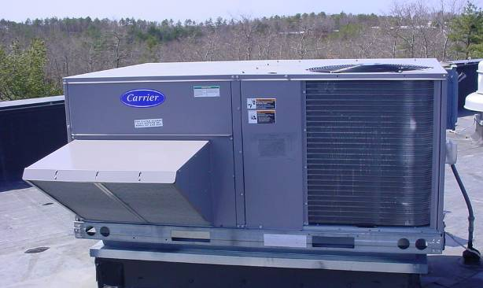

Rooftop Air Handling Unit

Picture 2

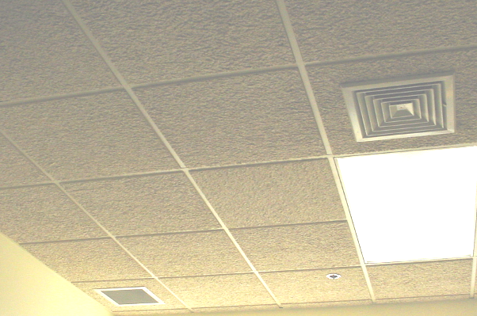

Supply Diffuser (Top Right) and Return Vent (Bottom Left)
Picture 3

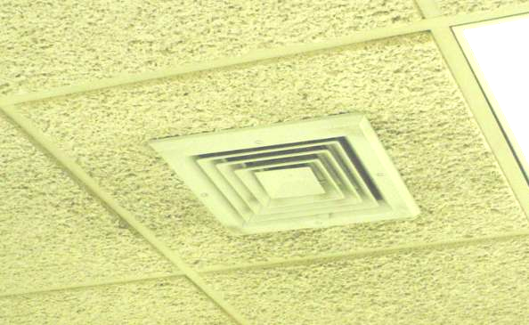

Ceiling-Mounted Supply Diffuser, Note Dust/Debris Accumulation on Louvers
and Adjacent Ceiling Tiles

Picture 4

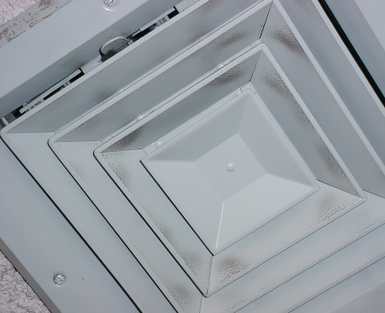

Ceiling-Mounted Supply Diffuser, Note Dust/Debris Accumulation on Louvers
Picture 5

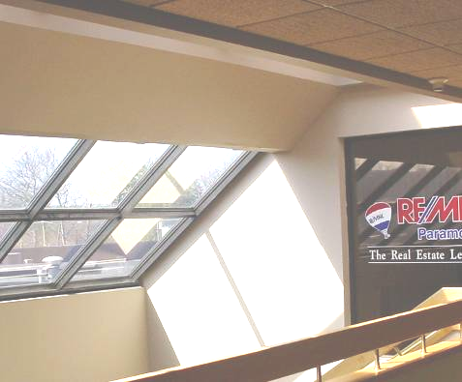

Water Damaged Ceiling around Skylight

Picture 6

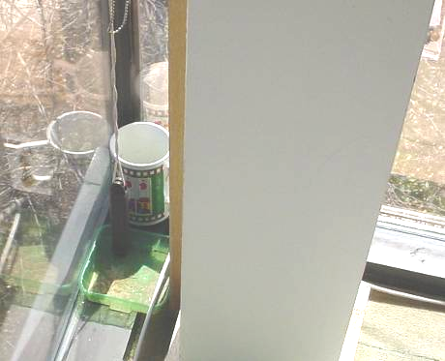

Containers Stationed on Floor behind Column (Left) to Catch Leaks in Area Director’s Office
Picture 7

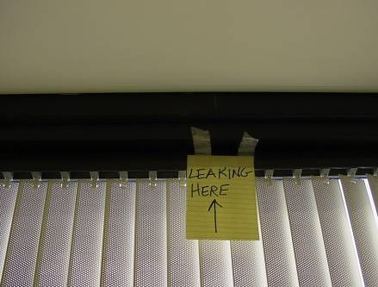

Area of Reported Leaks along Window Frame/Ceiling in Head Clerk’s Office,
Sign Courtesy of Occupant

Picture 8

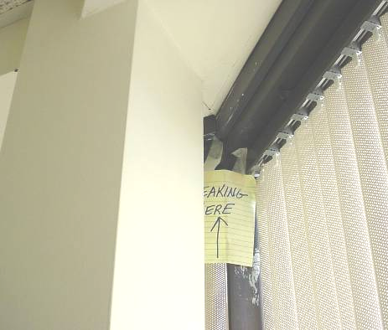

Area of Reported Leaks along Window Frame/Ceiling in Head Clerk’s Office,
Sign Courtesy of Occupant
Picture 9

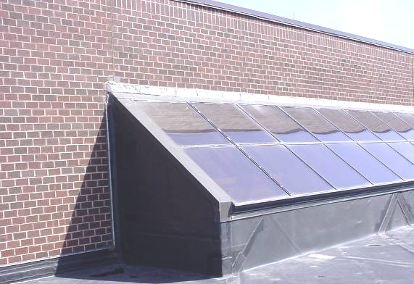

Masonry Wall and Skylight above Mezzanine Leak

Picture 10

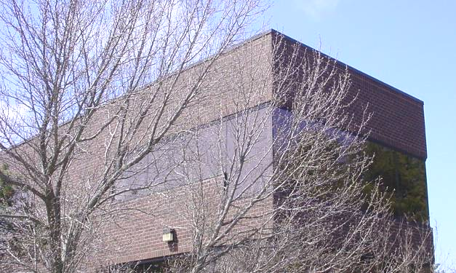

Northwest Corner of Leakage/Area Director’s Office
Picture 11



Northern Exterior Wall Area of Leakage, Approximate Area of Head Clerk’s Office

Picture 12

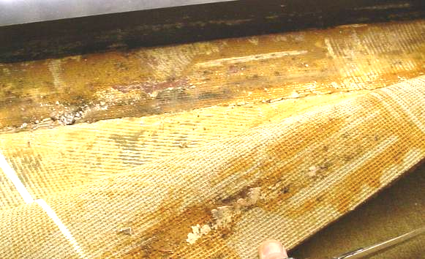

Dark Staining beneath Carpet in Head Clerk’s Office
Picture 13

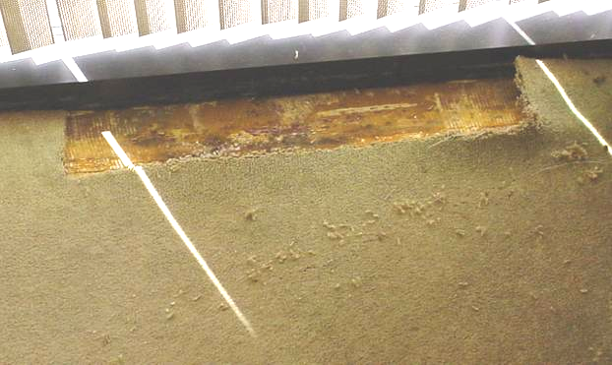

Section of Carpeting Removed (Shown in Preceding Picture)

Picture 14

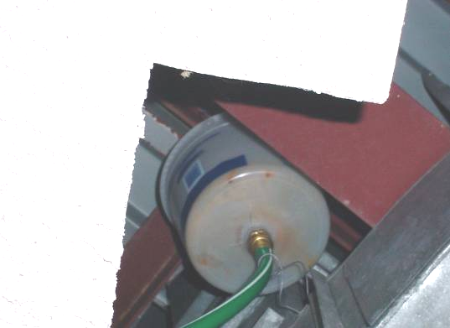

Bucket with Hose Attached above Ceiling in Waiting Room
Picture 15

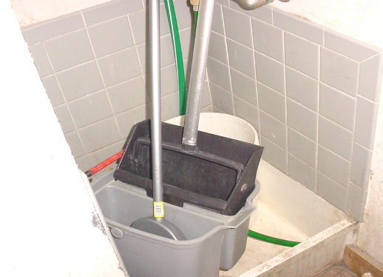

Terminus of Drainage Hose (Shown in Preceding Picture)

Picture 16

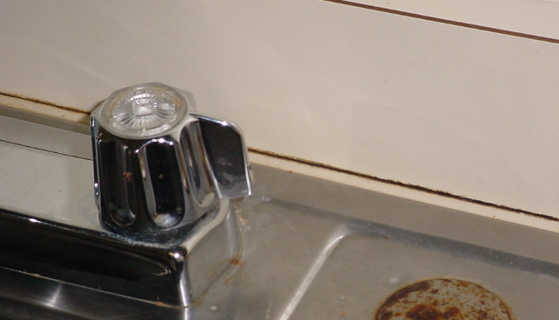

Mold Growth (Dark Staining) between Sink Countertop and Backsplash
Location/ Room | Occupants  in Room | Temp  (°F) | Relative  Humidity  (%) | Carbon  Dioxide  (ppm) | Carbon Monoxide  (ppm) | PM2.5  (µg/m³) | Windows  Openable | Ventilation |  | Remarks
 |  |  |  |  |  |  |  | Supply | Exhaust | Remarks
background |  | 41 | 70 | 371 | ND | 9 |  |  |  | Scattered clouds-cold, winds NE 7-18 mph
Area Dir Office | 2 | 78 | 26 | 692 | ND | 3 | N | Y | Y | Water damage-leak corner-standing water in container-mold growth in container, removed carpet-dry/no visible mold, DO
Head Clerk’s Office | 0 | 74 | 27 | 708 | ND | 6 | N | Y | Y | Leaks around top of windows/ceiling, carpet-dry, dark material under carpet edge-possible mold-carpet removed
Karen’s Office | 1 | 74 | 30 | 718 | ND | 4 | N | Y | Y | Plants, DO, air purifier
Joanne’s Office | 0 | 74 | 28 | 705 | ND | 5 | N | Y | Y | DO, air purifier
Patrick’s Office | 0 | 74 | 27 | 684 | ND | 5 | N | Y | Y | DO
Carrean’s Office | 0 | 73 | 28 | 659 | ND | 5 | N | Y | Y | DO, plant
Wendy’s Office | 0 | 73 | 29* | 654 | ND | 4 | N | Y | Y | DO, plant
Empty Office near Kitchen | 0 | 74 | 28 | 656 | ND | 6 | N | Y | Y | DO
Kitchen | 0 | 74 | 28 | 656 | ND | 6 | N | Y | Y | Dark staining-likely mold along countertop/backsplash, dust/debris build-up on air diffusers
Conference Room | 0 | 73 | 28 | 630 | ND | 5 | N | Y | Y | Previous leak, above CTs-dry no visible WD/mold growth
Store Room | 0 | 73 | 28 | 657 | ND | 6 | N | Y | Y
Fax Room | 0 | 73 | 27 | 666 | ND | 6 | N | Y | Y | Dislodged CT
Waiting Room | 0 | 73 | 28 | 700 | ND | 6 | N | Y | Y | Previous leak, drainage system above CT-bucket into hose into adjacent custodial closet
Reception | 1 | 73 | 27 | 659 | ND | 6 | N | Y | Y
Bookkeeper’s Office | 0 | 74 | 28 | 710 | ND | 6 | N | Y | Y | Missing CT-wiring
Robert’s Office | 0 | 75 | 27 | 721 | ND | 6 | N | Y | Y | DO

