Executive Summary

INDOOR AIR QUALITY ASSESSMENT

Massachusetts Rehabilitation Commission
40 Dimock Street, 3rd Floor
Roxbury, Massachusetts

Prepared by:
Massachusetts Department of Public Health
Bureau of Environmental Health
Indoor Air Quality Program
March 2017

The attic contains a bird carcass and debris that needs to be removed from the attic. Breaches in the roof and exterior wall should be sealed to prevent entry of birds and other pests. Other recommendations typically found in office space were noted.

Background
Building: | Massachusetts Rehabilitation Commission (MRC) at the Dimock Center, 3rd Floor
Address: | 40 Dimock Street, Roxbury
Assessment Requested by: | Sharlene Sharif, Field Operations Unit, Executive Office of Health and human Services (EHS) Facilities
Reason for Request: | General indoor air quality (IAQ) assessment
Date of Assessment: | November 3, 2016
Massachusetts Department of Public Health/Bureau of Environmental Health (MDPH/BEH) Staff Conducting Assessment: | Sharon Lee, Environmental Analyst, IAQ Program
Date of Building Construction: | Built in the mid-1800s as the New England Hospital for Women and Children
Building Description: | The MRC is located on the third floor of a three-story brick building. The building has undergone many interior renovations over the years. The MRC space, which consists of small offices and common work areas, has wall-to-wall carpeting, plaster walls, and dropped ceilings.
Building Population: | The MRC has a staff population of approximately 20.
Windows: | Openable

Methods
Please refer to the IAQ Manual and appendices for methods, sampling procedures, and interpretation of results (MDPH, 2015).

Results and Discussion
The following is a summary of indoor air testing results (Table 1).
- Carbon dioxide measurements were below the MDPH recommended level of 800 parts per million (ppm) in all but four areas surveyed.
- Temperature was at the upper end of to the MDPH recommended range of 70°F to 78°F at the time of assessment.
- Relative humidity (RH) was within the MDPH recommended range of 40 to 60% in areas assessed.
- Carbon monoxide levels were non-detectable in all areas tested.
- Particulate matter (PM2.5) concentrations measured were below the National Ambient Air Quality (NAAQS) level of 35 μg/m³ in all areas tested.

Ventilation
This building is not equipped with a mechanical ventilation system to provide fresh air or exhaust ventilation. The sole source of fresh air is via openable windows. Staff should consider opening windows periodically to allow fresh air to circulate.
Radiators provide heated air to the space in cold weather. A centralized cooling system provides chilled recycled air in the summer months. Chilled air is provided to occupied spaces via ceiling-mounted supply vents (Picture 1). This system is designed to create positive pressure in the office space to force air out of offices through undercut doors and into the hallway, where ceiling-mounted vents return air to the system. Filters are installed directly above return vents (Picture 2).
The centralized cooling system is controlled by thermostats, which are located throughout the office space. A number of thermostats had alert messages indicated the need for replacing batteries and filters (Picture 3). It should also be noted that the thermostat fan setting was in the “auto” mode, which does not provide a continuous source of air circulation. The “fan on” setting is preferred in occupied areas to provide air circulation.
The centralized cooling systems are located in the attic (Picture 4). A number of small breaches were observed in the ductwork for these systems (Picture 5). These breaches should be permanently sealed to prevent any draw of air from the attic into the system and/or leakage of chilled air into the attic. It is recommended that HVAC systems be re-balanced every five years to ensure adequate air systems function (SMACNA, 1994). It is unknown when the last time these systems were balanced.
Staff reported that an odor had been emanating from the cooling systems in one area of the building during a time when the systems were undergoing service. Staff reported that the odor was leading to irritation to eyes and respiratory system. No odor was noted at the time of assessment.

Microbial/Moisture Concerns
Plants were observed in several areas, some placed on porous materials (i.e., paper products; Table 1). Plants, soil, and drip pans can serve as sources of mold/bacterial growth. Plants can be a source of pollen and mold, which can be respiratory irritants to some individuals. Plants should be properly maintained and equipped with drip pans to prevent water damage to porous materials. Plants should also be located away from air diffusers to prevent the aerosolization of dirt, pollen, and mold. Plants in one area were located on top of carpeting (Picture 6). Carpeting is a porous material that can provide a medium for mold growth, especially if wetted repeatedly.
Although no current leaks were reported by building staff, evidence of historic water damage has resulted in peeling paint, water stains, as well as water-damaged carpeting, walls, and ceilings in a few areas (Pictures 2 and 7; Table 1). In some areas, repairs were made to water-damaged walls and ceilings. Measures should be taken to ensure damaged materials are dried and cleaned or replaced in a manner consistent with the U.S. Environmental Protection Agency’s (US EPA, 2008). The US EPA and the American Conference of Governmental Industrial Hygienists (ACGIH) recommend that porous materials (e.g., carpeting, GW) be dried with fans and heating within 24 to 48 hours of becoming wet (US EPA, 2008; ACGIH, 1989). If not dried within this time frame, mold growth may occur. Once mold has colonized porous materials, they are difficult to clean and should be removed/discarded.
Water dispensers were observed in carpeted areas (Table 1; Picture 8). These appliances may spill or leak and lead to carpet damage and microbial growth. It is recommended that these appliances be located in areas without carpeting or on waterproof mats.

Other IAQ Evaluations
BEH staff noted an odor upon entering the attic space. This odor was attributed to a decomposing bird carcass observed near the entrance of the attic (Picture 9). This carcass should be removed. Measures should be taken to seal breaches and install appropriate screens to prevent birds from entering the space.
Outdoor PM2.5 concentrations were measured at 46 μg/m³ (Table 1), which were above the NAAQS PM2.5 level of 35 μg/m³. However, PM2.5 levels measured indoors were below the NAAQS. A number of activities that occur indoors and/or mechanical devices can generate particulate during normal operations. Sources of indoor airborne particulates may include but are not limited to particles generated during the operation of fan belts in the HVAC system, use of stoves and/or microwave ovens in kitchen areas; use of photocopiers, fax machines and computer printing devices; operation of an ordinary vacuum cleaner and heavy foot traffic indoors. PM2.5 levels may also be elevated due to lack of fresh air ventilation.
Breaches/gaps were observed around all the fireplaces observed in the office (Pictures 10 and 11). These spaces around the fireplace can also allow pests into the office space. Measures should be taken to seal around the fireplace. In addition, ensure dampers for the fireplaces are closed. Back drafting of air can cause debris, dust, and other irritants to move into occupied spaces.
Exposure to low levels of total volatile organic compounds (TVOCs) may produce eye, nose, throat, and/or respiratory irritation in some sensitive individuals. BEH/IAQ staff examined rooms for products containing VOCs and noted hand sanitizers, cleaners, air deodorizers/scented products, and dry erase materials in use within the building (Table 1). All of these products have the potential to be irritants to the eyes, nose, throat, and respiratory system of sensitive individuals.
Other conditions that can affect indoor air quality were observed during the assessment. A pile of debris was observed in the attic (Picture 12). The composition of this fine material is unknown. This debris can become entrained in the central cooling system, which can distribute the material through occupied areas. Other items, including broken glass, were observed in the attic (Picture 13). A full cleaning of the attic is strongly recommended once ductwork is sealed.
A number of air supply diffusers and return vents and ceiling tiles adjacent to supply diffusers were observed to have accumulated dust/debris (Picture 1). Similarly, dust was observed on the blades of personal fans. Dust can be reaerosolized and cause irritation when air flows across the vents and fan blades, so these items should be cleaned periodically.
In several areas, items were observed on windowsills, tabletops, counters, bookcases, and desks. The large number of items stored in offices provides a source for dusts to accumulate. These items (e.g., papers, folders, boxes) make it difficult for custodial staff to clean. Items should be relocated and/or be cleaned periodically to avoid excessive dust build up. In addition, dust can accumulate on flat surfaces (e.g., desktops, shelving and carpets) in occupied areas and subsequently be re-aerosolized causing further irritation.
The majority of floor surfaces are covered by wall-to-wall carpeting. Carpets appeared soiled, stained, and lifting in some areas (Picture 14). The Institute of Inspection, Cleaning and Restoration Certification (IICRC), recommends that carpeting be cleaned annually (or semi-annually in soiled high traffic areas) (IICRC, 2012). Regular cleaning with a high efficiency particulate air (HEPA) filtered vacuum in combination with an annual cleaning will help to reduce accumulation and potential aerosolization of materials from carpeting. Consideration should be given to replacing carpeting that is beyond its service.
Window screens throughout the office were damaged. Screens should be repaired or replaced to prevent pests from entering through open windows.

Conclusions/Recommendations
In view of the findings at the time of the assessment, the following is recommended:
- Remove bird carcass from attic space to prevent odors. Periodically inspect attic for pests.
- Clean/change filters for cooling systems as per the manufacturer’s instructions or more frequently if needed. Ensure filters fit properly.
- Seal breaches around cooling system ductwork to prevent entrainment of dust, debris, and odors from the attic.
- Ensure thermostats are operating appropriately. Replace batteries as needed.
- Open windows (weather permitting) to temper rooms and provide fresh outside air. Care should be taken to ensure windows are properly closed at night and weekends to avoid the freezing of pipes and potential flooding.
- Avoid overwatering of plants. Ensure flat surfaces around plants are free of potting soil and other plant debris. Examine drip pans periodically for mold growth and disinfect with an appropriate antimicrobial where necessary. Do not place plants on porous materials (e.g., paper/cardboard, carpeting). Consider reducing number of plants in some areas.
- Ensure leaks are repaired. Once repairs are completed, water-damaged plaster ceilings and walls should be prepped and refinished. Water-damaged gypsum wallboard not dried within 24 to 48 hours should be removed and replaced.
- Place waterproof mats under water dispensers to prevent damage to carpets.
- For buildings in New England, periods of low relative humidity during the winter are often unavoidable. Scrupulous cleaning practices should be adopted to minimize common indoor air contaminants whose irritant effects can be enhanced when the relative humidity is low. To control for dusts, a HEPA filter equipped vacuum cleaner in conjunction with wet wiping of all surfaces is recommended. Drinking water during the day can help ease some symptoms associated with a dry environment (throat and sinus irritations).
- Seal breaches and gaps around the fireplaces and ensure the dampers are closed to prevent movement of movements of dusts, debris, and pests into occupied areas.
- Refrain from using air deodorizers and products containing fragrances.
- Clean air supply diffusers and return vents periodically of accumulated dust/debris.
- Relocate or consider reducing the amount of stored materials to allow for more thorough cleaning. Clean items regularly with a wet cloth or sponge to prevent excessive dust build-up.
- Conduct cleaning of attic space to remove debris, broken glass, and other items. Use a HEPA vacuum to ensure particulates that can be entrained into the ductwork are removed.
- Clean carpeting annually or semi-annually in soiled high traffic areas as per the recommendations of the IICRC. Copies of the IICRC fact sheet can be downloaded at: http://www.iicrc.org/consumers/care/carpet-cleaning (IICRC, 2012).
- Consider a plan for replacement of carpeting that is beyond its service life.
- Replace damaged window screens to prevent pest entry.
- Refer to resource manuals and other related indoor air quality documents for further building-wide evaluations and advice on maintaining public buildings. Copies of these materials are located on the MDPH’s website: http://www.mass.gov/dph/iaq.

References
American Conference of Governmental Industrial Hygienists (ACGIH). 1989. Guidelines for the Assessment of Bioaerosols in the Indoor Environment. American Conference of Governmental Industrial Hygienists, Cincinnati, OH.
Institute of Inspection, Cleaning and Restoration Certification (IICRC). 2012. Carpet Cleaning: FAQ. Retrieved from http://www.iicrc.org/consumers/care/carpet-cleaning.
Massachusetts Department of Public Health. (MDPH). 2015. Indoor Air Quality Manual: Chapters I-III. Available at: http://www.mass.gov/eohhs/gov/departments/dph/programs/environmental-health/exposure-topics/iaq/iaq-manual/.
Sheet Metal and Air Conditioning Contractors’ National Association, Inc. (SMACNA). 1994. HVAC Systems Commissioning Manual. 1st ed. Sheet Metal and Air Conditioning Contractors’ National Association, Inc., Chantilly, VA.
United States Environmental Protection Agency (US EPA). 2008 “Mold Remediation in Schools and Commercial Buildings”. Office of Air and Radiation, Indoor Environments Division, Washington, DC. EPA 402-K-01-001. September 2008. Available at: http://www.epa.gov/mold/mold-remediation-schools-and-commercial-buildings-guide.

Picture 1
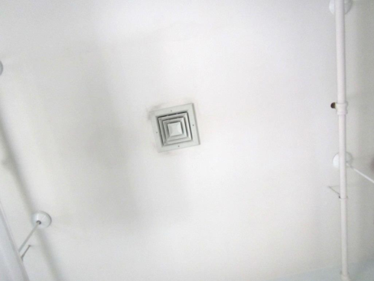
Ceiling-mounted supply diffuser, note dust collected on ceiling
Picture 2
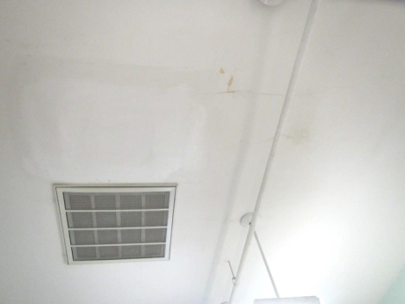
Ceiling-mounted return vent, note repaired water-damaged ceiling near vent
Picture 3
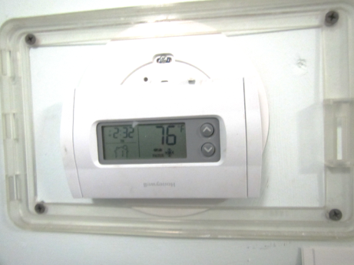
Thermostat with filter change and low battery light on
Picture 4
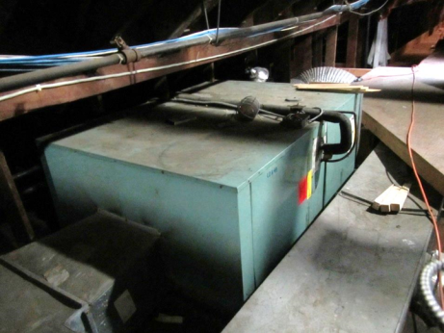
Central AC unit in attic space
Picture 5
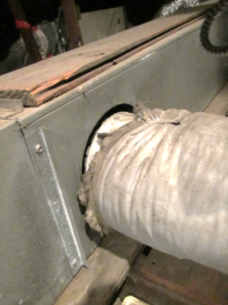
Breaches around AC unit ductwork
Picture 6
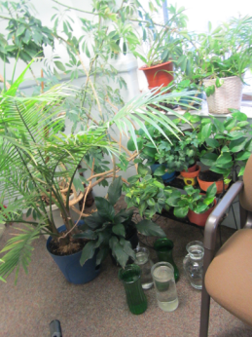
Plants and containers of water on carpeting
Picture 7
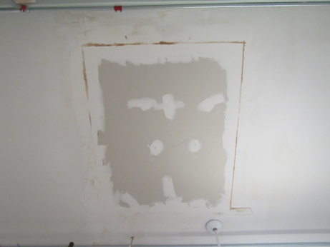
Evidence of previous water damage
Picture 8
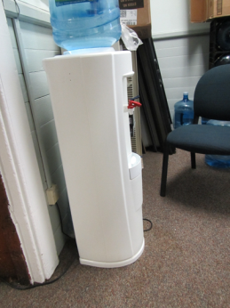
Water dispenser on carpeting
Picture 9
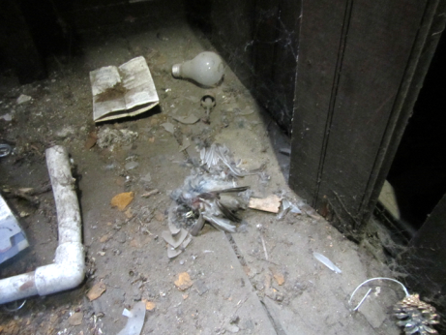
Bird carcass in attic
Picture 10
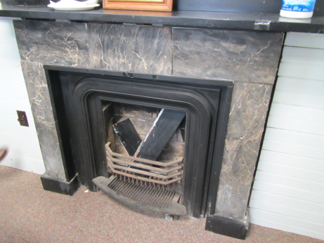
Breaches around fireplace
Picture 11
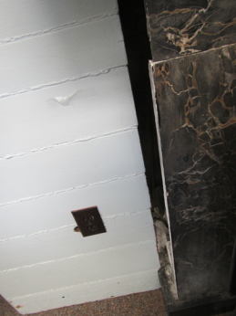
Breach around fireplace, note debris at the base
Picture 12
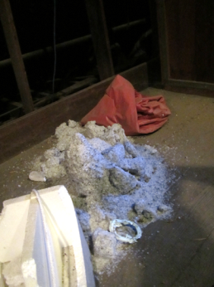
Debris pile in attic
Picture 13
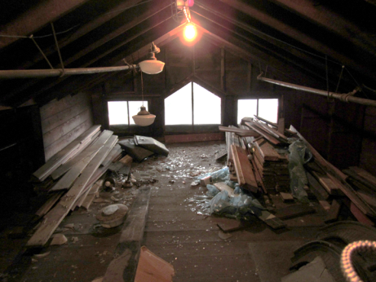
Broken glass and other miscellaneous items in attic space
Picture 14
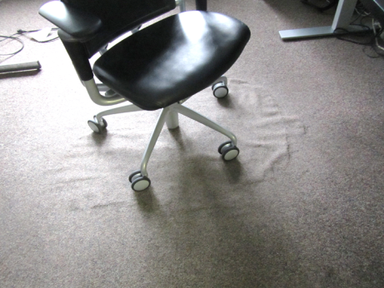
Aged carpet no longer adhered to floor
Location | Carbon  Dioxide  (ppm) | Carbon Monoxide  (ppm) | Temp  (°F) | Relative  Humidity  (%) | PM2.5  (µg/m3) | Occupants  in Room | Windows  Openable | Ventilation |  | Remarks
 |  |  |  |  |  |  |  | Supply | Exhaust
Background (outdoors) | 452 | ND | 72 | 57 | 46 |  |  |  |  | Bird waste at entrance
305 | 693 | ND | 76 | 48 | 20 | 0 | Y | Y | N | Plants, DO
307 | 898 | ND | 77 | 49 | 29 | 1 | Y | Y | N | CPs, plants
308 | 809 | ND | 76 | 49 | 19 | 0 | Y | Y | N | Plants, DO
310 | 762 | ND | 78 | 48 | 17 | 1 | Y | Y | N | Plants, CPs, area where odors observed during cooling season
311 | 898 | ND | 77 | 50 | 21 | 0 | Y | Y | N | CPs
313 | 621 | ND | 76 | 50 | 17 | 0 | N | Y | N | Clutter, AD
314 | 719 | ND | 76 | 51 | 22 | 1 | Y | Y | N | AD, plants, DO, window sealed with plastic
316 | 594 | ND | 76 | 48 | 21 | 0 | Y | Y | N | Fireplace, plants on carpet, PF, DO
316 inner | 549 | ND | 76 | 47 | 20 | 0 | y | y | n | CPs, clutter
318 | 635 | ND | 77 | 47 | 20 | 0 | Y | Y | N | DO
323 | 560 | ND | 76 | 56 | 20 | 0 | Y | Y | N | Water dispenser on carpet
324 (kitchen) | 526 | ND | 76 | 52 | 26 | 0 | Y | Y | N | Food storage
325 | 627 | ND | 74 | 56 | 24 | 0 | Y | Y | N | No window screen, plants, CP, PF, DO
326 | 606 | ND | 75 | 49 | 20 | 0 | Y | Y | N | CPs, plants, fans, broken fireplace, DEM
328 | 771 | ND | 76 | 49 | 21 | 1 | Y | Y | N | Plants, CPs
329 | 696 | ND | 77 | 50 | 20 | 1 | Y | Y | N | PF, clutter, CPs
Hallway | 827 | ND | 77 | 50 | 22 | 2 | Y | N | Y

