INDOOR AIR QUALITY ASSESSMENT

Massachusetts Rehabilitation Commission Office
170 Pleasant Street
Fall River, Massachusetts

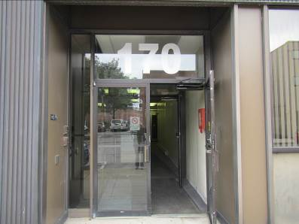

Prepared by:
Massachusetts Department of Public Health
Bureau of Environmental Health
Indoor Air Quality Program
October 2015

Background
Building: | Massachusetts Rehabilitation Commission (MRC)
Address: | 170 Pleasant Street, Fall River, MA
Assessment Requested by: | Erin McCabe, Field Operations Manager, EOHHS
Date of Assessment: | September 11, 2015
BEH/IAQ/EOHHS Staff Conducting Assessment: | Cory Holmes, Inspector  Ruth Alfasso, Inspector  Sharlene Sharif, EHS Facilities
Date of Building Construction: | 1897
Reason for Request: | Mold concerns and odors

Building Description
The MRC occupies the third floor of a building in downtown Fall River that was two separate buildings that later were connected. The occupied area in the second building is referred to as “the Annex”. The space has open areas, offices, meeting rooms and storage areas. Windows are openable.

Results
This space is occupied by approximately 10 to 15 employees. Members of the public also visit the space daily. Test results are presented in Table 1.

Discussion

Ventilation
It can be seen from Table 1 that carbon dioxide levels were above 800 parts per million (ppm) in all areas surveyed in the main section of the building and in two out of three areas surveyed in the Annex. Note that many areas were empty or sparsely populated, which would be expected to reduce carbon dioxide levels. Closed windows and higher occupancy would be expected to result in higher carbon dioxide levels.
Several air handling units (AHUs) were located in closets/utility rooms (Picture 1). It could not be determined if any of the units had fresh air intakes on the outside of the building. AHUs distribute tempered air to occupied spaces via ducted supply vents (Picture 2). AHU return vents are located mostly in hallways (Picture 3); offices do not have return vents. Most office doors were open at the time of the assessment, but these doors did not appear to be undercut to create a means for air to exit these spaces when the doors are closed. Without undercut doors hallway return vents cannot remove stale air from offices if the doors are closed. Restrooms are equipped with exhaust vents.
To maximize air exchange, the MDPH recommends that both supply and exhaust ventilation operate continuously during periods of occupancy. Thermostats were observed in several areas set to the “automatic” setting (Picture 4), which will activate the HVAC system only when the thermostats call for heating or cooling. The MDPH recommends that thermostats be set to the fan “on” setting during occupied hours to provide a continuous source of fresh air and filtration.

Temperature and Relative Humidity
Indoor temperature measurements ranged from 71°F to 76°F (Table 1), which were within the MDPH recommended comfort range. The MDPH recommends that indoor air temperatures be maintained in a range of 70°F to 78°F in order to provide for the comfort of building occupants.
Indoor relative humidity ranged from 50 to 70 percent (Table 1). All were within the MDPH comfort range except for the Annex conference room. The MDPH recommends a comfort range of 40 to 60 percent for indoor air relative humidity. In addition, conditions of relative humidity above 70 percent can be conducive to water damage and microbial growth on porous materials. The elevated relative humidity in the Annex conference room is reflective of other conditions there, which are described further under “Microbial/Moisture Concerns” below.
Relative humidity levels in the building would be expected to drop during winter months due to heating. The sensation of dryness and irritation is common in a low relative humidity environment. Low relative humidity is a very common problem during the heating season in the northeast part of the United States.

Microbial/Moisture Concerns
The concerns regarding mold and odors, particularly in the Annex, initiated the request for assessment. BEH IAQ staff provided a letter detailing findings and recommendations relative to water damage/mold growth in the Annex and the women’s public restroom; it is attached as Appendix A. It was subsequently reported by Ms. McCabe that repairs to the women’s public restroom were completed, and remediation of the Annex was being coordinated.
Additional moisture-related issues were noted in the MRC space. Water-damaged ceiling tiles were observed in some offices and utility/storage areas (Picture 5). Water-stained walls were observed in the hallway between the main area and the Annex (Picture 6). These conditions reportedly stem from leaks from the roof through a non-MRC-accessible storage area on the fourth (top) floor. Water-damaged ceiling tiles can be a source of mold and should be replaced once the leaks are repaired. In addition, water damage to building materials and items in storage on the fourth floor may become a source of mold or odors to MRC-occupied space if any pathways exist between floors.
Water-damaged windowsills were observed in the main conference room (Picture 7). The windows in this area do not seal well and should be repaired. The water-damaged windowsill materials should be repaired/replaced. Until the windows have been repaired, no items, particularly porous ones, should be placed in areas with known water infiltration issues.
Carpeting in the Annex hallway was found to be damp, likely due to elevated relative humidity in this area due to infiltration of water and moist air through damaged brickwork; possibly spills/leaks from the water cooler located on the carpet in this area may have also contributed (Picture 8). Water coolers should be placed in tiled areas or on waterproof mats. In an attempt to reduce humidity and dry building materials, a dehumidifier was placed in the Annex conference room (Picture 9). These appliances need to be regularly emptied and maintained to prevent odors from stagnant water/accumulated debris.
Plants were observed in some offices and open areas (Pictures 7 and 10). Plants can be a source of pollen and mold, which can be respiratory irritants to some individuals. Plants should be properly maintained, over-watering of plants should be avoided and drip pans should be inspected periodically for mold growth and cleaned or replaced as necessary.

Other IAQ Evaluations
Indoor air quality can be negatively influenced by the presence of respiratory irritants, such as products of combustion. The process of combustion produces a number of pollutants. Common combustion emissions include carbon monoxide, carbon dioxide, water vapor, and smoke (fine airborne particle material). Of these materials, exposure to carbon monoxide and particulate matter with a diameter of 2.5 micrometers (μm) or less (PM2.5) can produce immediate, acute health effects upon exposure. To determine whether combustion products were present in the indoor environment, BEH/IAQ staff obtained measurements for carbon monoxide and PM2.5

Carbon Monoxide
Carbon monoxide should not be present in a typical, indoor environment. If it is present, indoor carbon monoxide levels should be less than or equal to outdoor levels. Carbon monoxide levels outdoors were measured at 1.4 ppm likely due to traffic outside the building. No measureable levels of carbon monoxide were detected in the building during the assessment (Table 1).

Particulate Matter
Outdoor PM2.5 concentrations were measured at 21 to 39 μg/m³ (Table 1), which was slightly above the NAAQS limit of 35 μg/m³, likely due to traffic outside the building. Indoor PM2.5 levels ranged from 2 to 14 μg/m³ (Table 1), which were below the NAAQS PM2.5 level of 35 μg/m³. Frequently, indoor air levels of particulate matter (including PM2.5) can be at higher levels than those measured outdoors.

Volatile Organic Compounds (VOCs)
Frequently, exposure to low levels of total VOCs (TVOCs) may produce eye, nose, throat and/or respiratory irritation in some sensitive individuals. Hand sanitizer, cleaning products, dry erase boards and photocopiers were observed in offices and common areas (Table 1).

Other Concerns
Filters in some of AHUs were examined and were found to be of a type that provides minimal filtration (Picture 11). The dust spot efficiency is the ability of a filter to remove particulate matter of a certain diameter from air passing through the filter. Filters that have been determined by ASHRAE to meet its standard for a dust spot efficiency of a minimum of 40 percent would be sufficient to reduce many airborne particulates (Thornburg, 2000; MEHRC, 1997; ASHRAE, 1992). Pleated filters with a Minimum Efficiency Reporting Value (MERV) dust-spot efficiency of 9 or higher are recommended. Note that increasing filtration may require evaluation and adjustments to the AHUs to deal with the increased resistance to flow of higher MERV value filters.
Other conditions that can affect IAQ were observed during the assessment. Personal fans and supply vents were observed to be dusty. Dust on these items can be reaerosolized and cause irritation or odors.
In some areas, accumulation of items, including papers, boxes and personal items were stored on floors desks, tables and counters. Large numbers of items provide a source for dusts to accumulate. These items make it difficult for custodial staff to clean. Items should be relocated and/or cleaned periodically to avoid excessive dust build up.
Used clothing was found stored in several areas. If these items are not clean, they may release odors.

Conclusions/Recommendations
In view of the findings at the time of the visit, the following recommendations are made:
- Complete repairs of items indicated in the letter included as Appendix A.
- Investigate whether there is a supply of fresh air for the building. Consider building modifications to supply fresh outside air to the AHUs. Use openable windows during temperate times of the year to supply additional fresh air. Ensure windows are closed tightly at the end of each day.
- For buildings in New England, periods of low relative humidity during the winter are often unavoidable. Therefore, scrupulous cleaning practices should be adopted to minimize common indoor air contaminants whose irritant effects can be enhanced when the relative humidity is low. To control for dusts, a high efficiency particulate arrestance (HEPA) filter equipped vacuum cleaner in conjunction with wet wiping of all surfaces is recommended. Avoid the use of feather dusters. Drinking water during the day can help ease some symptoms associated with a dry environment (throat and sinus irritations).
- Seal/make repairs to windows in conference room and make repairs/replace damaged windowsill materials.
- Replace water-damaged ceiling tiles once the sources of water have been repaired.
- Consider placing water dispensers on non-carpeted areas or place a waterproof mat underneath them.
- Remove any water-damaged/mold-contaminated building materials/stored items on the 4th floor.
- Maintain indoor plants, use non-porous drips pans and prevent overwatering.
- Reduce the use of dry erase materials, hand sanitizer and cleaning/scented products to avoid exposure to TVOCs.
- Replace filters in AHUs with those providing improved filtration. Consider upgrading to a MERV value of 9; change filters regularly.
- Clean vents and personal fans to avoid reaerosolizing dusts.
- Store items in an organized manner and move them to clean periodically to prevent a buildup of dust.
- Ensure that used clothing stored in the office has been cleaned.
- Refer to resource manuals and other related indoor air quality documents for further building-wide evaluations and advice on maintaining public buildings. These materials are located on the MDPH’s website: http://mass.gov/dph/iaq.
References
ASHRAE. 1992. Gravimetric and Dust-Spot Procedures for Testing Air-Cleaning Devices Used in General Ventilation for Removing Particulate Matter. American Society of Heating, Refrigeration and Air Conditioning Engineers. ANSI/ASHRAE 52.1-1992.
MEHRC. 1997. Indoor Air Quality for HVAC Operators & Contractors Workbook. MidAtlantic Environmental Hygiene Resource Center, Philadelphia, PA.
Thornburg, D. 2000. Filter Selection: a Standard Solution. Engineering Systems 17:6 pp. 74-80.

Picture

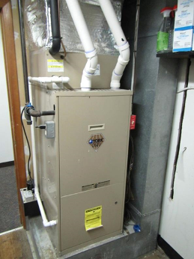

One of the air-handling units for the MRC space

Picture 2

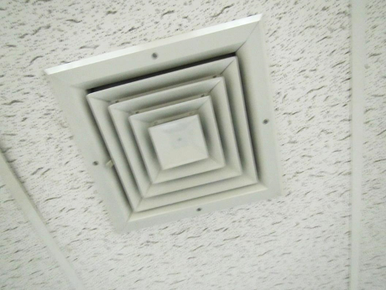

Supply vent
Picture 3

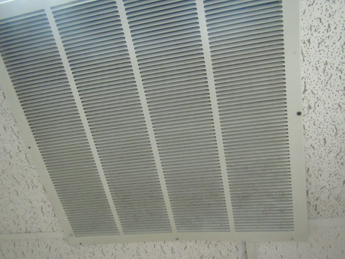

Return vent in hallway

Picture 4

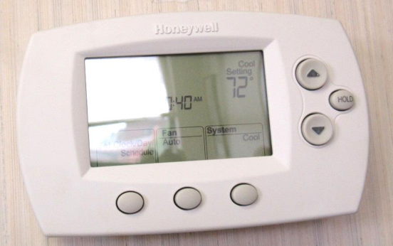

Electronic thermostat, note fan set to “auto” (arrow)
Picture 5

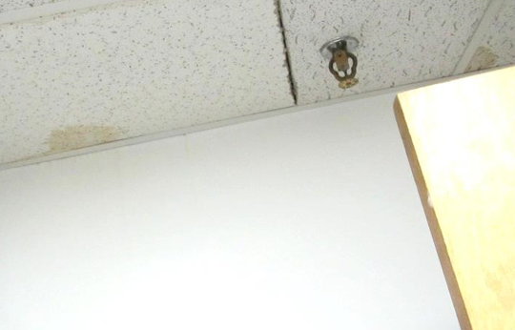

Water-damaged ceiling tiles

Picture 6

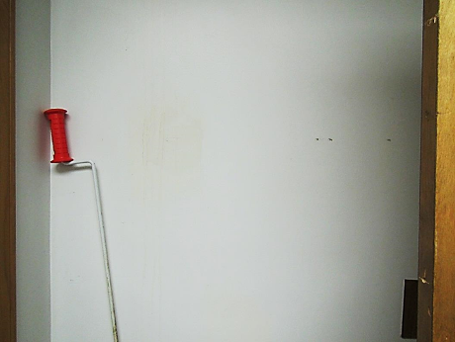

Water-damaged paint (stains and streaks) in hallway between main area and the Annex
Picture 7

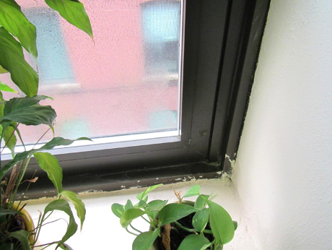

Water-damaged windowsill and plant

Picture 8

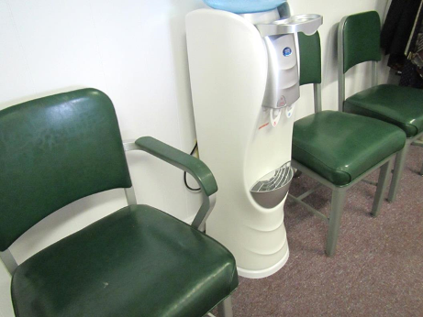

Water cooler on carpet
Picture 9

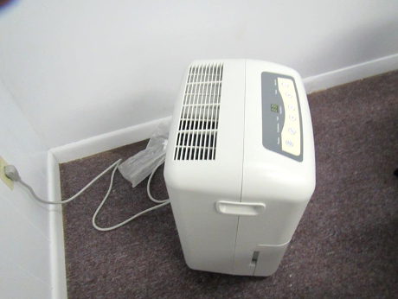

Dehumidifier in Annex conference room

Picture 10

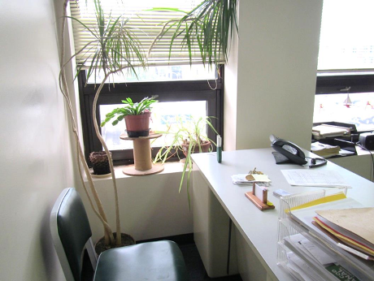

Plants in an office
Picture 11

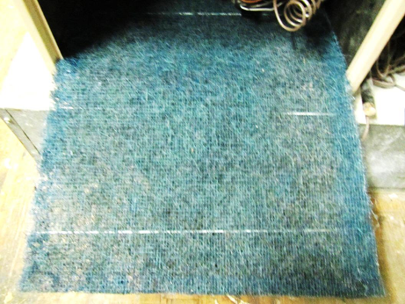

Mesh filter in AHU
Location | Carbon  Dioxide  (ppm) | Carbon Monoxide  (ppm) | Temp  (°F) | Relative  Humidity  (%) | PM2.5  (µg/m³) | Occupants  in Room | Windows  Openable | Ventilation |  |  | Remarks
 |  |  |  |  |  |  |  | Intake | Exhaust
Background | 460 | 1.4 | 70 | 60 | 21-39 |  |  |  |  |  | Cloudy, drizzle
Computer | 1020 | ND | 72 | 52 | 2 | 0 | N | Y |  | N | 2 computers and a printer
Files | -- | -- | -- | -- | -- | 0 | N | N |  | N | WD CTs
Lobby/waiting | 1019 | ND | 72 | 53 | -- | 0 | N | Y |  | N | HS
Lunchroom | 1157 | ND | 76 | 50 | 2 | 0 | Y | N |  | Y | Non carpeted, fridge, items under sink, CP, microwave and toasters
Main conference | 1006 | ND | 75 | 50 | 3 | 0 | N | Y |  | Y | Plants, WD windowsills (spongy), windows don’t seal well, DO, microwave
1 | 1054 | ND | 73 | 51 | 3 | 0 | Y | Y |  | N | Plants, AI
2 | 1066 | ND | 73 | 51 | 4 | 0 | Y | Y |  | N | Plants, DO
3 | 1120 | ND | 73 | 51 | 14 | 4 | Y | Y |  | N | PF, plants, CP, DO
4 | 1058 | ND | 72 | 52 | 14 | 1 | Y | Y |  | N | Plants, PF, DO
5 | 1075 | ND | 72 | 53 | 5 | 1 | Y | Y |  | N | Plant, item hanging from CT
6 | 1106 | ND | 73 | 54 | 6 | 1 | Y | Y |  | N | DEM, plant, DO
8 | 1115 | ND | 74 | 53 | 11 | 1 | N | Y |  | N | Plants
9 | 1089 | ND | 73 | 53 | 3 | 1 | N | Y |  | Y | No door, CF
10 | 1076 | ND | 75 | 50 | 2 | 0 | Y | Y |  | N | Plants, coffee
14 | 1094 | ND | 72 | 53 | 3 | 1 | N | Y |  | N | CF, dirty vent, DO
Annex
Hallway | -- | -- | -- | -- | -- | -- | N | Y |  | Y | Carpets damp, water cooler on carpet, odor on entering
Office next to door | 773 | ND | 75 | 53 | 5 | 0 | Y | N |  | Y | PF, feels cold
Office | 760 | ND | 73 | 59 | 11 | 0 | Y | Y |  | Y | Missing CT, damp carpet and wall near window, damaged carpet
Conference | 846 | ND | 71 | 70 | 6 | 1 | Y | Y |  |  | Missing CT, wet wood frame, wet wall and carpet, bubbling paint, mold staining on metal ceiling above the hanging CT

