INDOOR AIR QUALITY ASSESSMENT

Massachusetts Rehabilitation Commission
35 Congress Street
Salem, Massachusetts

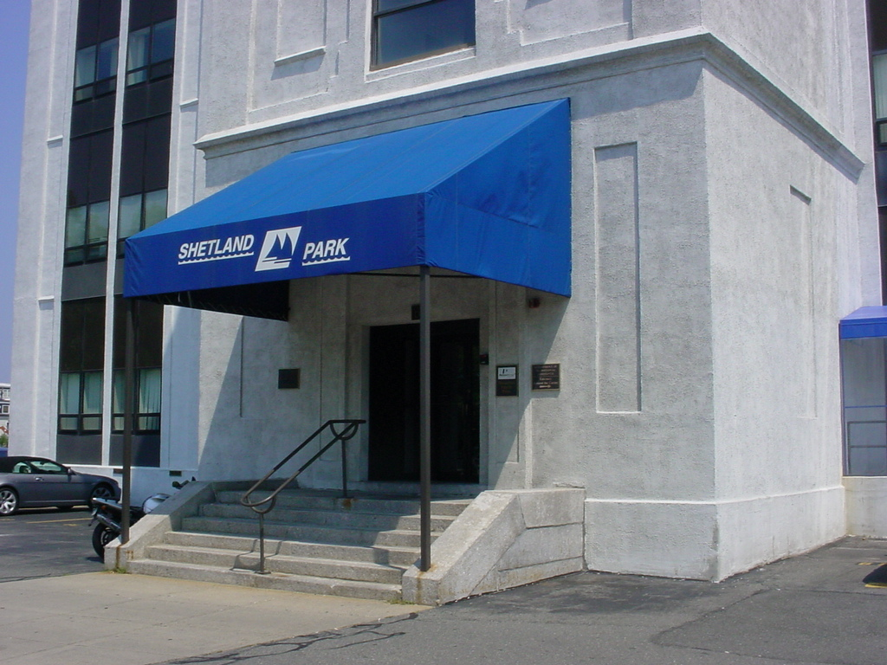

Prepared by:
Massachusetts Department of Public Health
Bureau of Environmental Health
Indoor Air Quality Program
March 2011

Background/Introduction
At the request of Doug Shatkin, Human Resources Director for the Massachusetts Executive Office of Health and Human Services’ (EOHHS) Department of Children and Families (DCF), the Massachusetts Department of Public Health (MDPH), Bureau of Environmental Health (BEH) provided assistance and consultation regarding indoor air quality concerns at the offices for the Massachusetts Rehabilitation Commission (MRC). The MSC is located in the Shetland Park Office Complex at 35 Congress Street, Salem, Massachusetts. On November 10, 2010 a visit to conduct an indoor air quality assessment was made to the MRC offices by Michael Feeney, Director of BEH’s Indoor Air Quality (IAQ) Program.
The Shetland Park Complex at 35 Congress Street is a four-story office building, reportedly constructed as a factory in the late 1800s to early 1900s. The building was renovated in the mid-1990s, prior to occupancy by state offices. The MRC occupies space on the ground floor. Windows are openable throughout the building.

Methods
Air tests by MDPH for carbon dioxide, carbon monoxide, temperature and relative humidity were taken with the TSI, Q-TRAK™ IAQ Monitor, Model 7565. Screening for total volatile organic compounds (TVOCs) was conducted using a Thermo Environmental, 580-B Model, Photo Ionization Detector (PID). Air tests for airborne particle matter with a diameter less than 2.5 micrometers (PM2.5) were taken with the TSI, DUSTTRAK™ Aerosol Monitor Model 8520. MDPH staff also performed a visual inspection of building materials for water damage and/or microbial growth.

Results
The MRC offices have a combined employee population of approximately 20 and can be visited by up to 20 individuals daily. The tests were taken during normal operations and appear in Table 1.

Discussion
Ventilation
It can be seen from Table 1 that carbon dioxide levels were below 800 parts per million (ppm) in all but three areas surveyed during the assessment, indicating adequate air exchange in the majority of the MRC space. Fresh, heated air is supplied by air-handling units (AHUs) equipped with high-efficiency pleated air filters. AHUs are located in mechanical rooms. Fresh air is drawn into the AHUs through fresh air intakes located on the exterior of the building and provided to occupied areas via ceiling-mounted air diffusers. Return air is drawn into ceiling-mounted vents and ducted back to AHUs. The majority of these systems were operating at the time of the assessment.
To maximize air exchange, the MDPH recommends that both supply and exhaust ventilation operate continuously during periods of occupancy. In order to have proper ventilation with a mechanical supply and exhaust system, the systems must be balanced to provide an adequate amount of fresh air to the interior of a room while removing stale air from the room. It is recommended that HVAC systems be re-balanced every five years to ensure adequate air systems function (SMACNA, 1994). The date of the last balancing was not available at the time of the assessment.
The Massachusetts Building Code requires a minimum ventilation rate of 20 cubic feet per minute (cfm) per occupant of fresh outside air or have openable windows in each room (SBBRS, 1997; BOCA, 1993). The ventilation must be on at all times that the room is occupied. Providing adequate fresh air ventilation with open windows and maintaining the temperature in the comfort range during the cold weather season is impractical. Mechanical ventilation is usually required to provide adequate fresh air ventilation.
Carbon dioxide is not a problem in and of itself. It is used as an indicator of the adequacy of the fresh air ventilation. As carbon dioxide levels rise, it indicates that the ventilating system is malfunctioning or the design occupancy of the room is being exceeded. When this happens, a buildup of common indoor air pollutants can occur, leading to discomfort or health complaints. The Occupational Safety and Health Administration (OSHA) standard for carbon dioxide is 5,000 parts per million parts of air (ppm). Workers may be exposed to this level for 40 hours/week, based on a time-weighted average (OSHA, 1997).
The MDPH uses a guideline of 800 ppm for publicly occupied buildings. A guideline of 600 ppm or less is preferred in schools due to the fact that the majority of occupants are young and considered to be a more sensitive population in the evaluation of environmental health status. Inadequate ventilation and/or elevated temperatures are major causes of complaints such as respiratory, eye, nose and throat irritation, lethargy and headaches. For more information concerning carbon dioxide, please see Appendix A.
Temperatures ranged from 71º F to 74 º F, which were within the MDPH recommended comfort guidelines. The MDPH recommends that indoor air temperatures be maintained in a range of 70 º F to 78 º F in order to provide for the comfort of building occupants. In many cases concerning indoor air quality, fluctuations of temperature in occupied spaces are typically experienced, even in a building with an adequate fresh air supply.
The relative humidity measured in the building during the assessment ranged from 32 to 42 percent, which was below the MDPH recommended comfort range in all but two areas. The MDPH recommends a comfort range of 40 to 60 percent for indoor air relative humidity. Relative humidity levels in the building would be expected to drop during the winter months due to heating. The sensation of dryness and irritation is common in a low relative humidity environment. Low relative humidity is a very common problem during the heating season in the northeast part of the United States.

Microbial/Moisture Concerns
No water damage or visible mold growth was observed during the assessment.

Other IAQ Evaluations
Indoor air quality can be negatively influenced by the presence of respiratory irritants, such as products of combustion. The process of combustion produces a number of pollutants. Common combustion emissions include carbon monoxide, carbon dioxide, water vapor and smoke (fine airborne particle material). Of these materials, exposure to carbon monoxide and particulate matter with a diameter of 2.5 micrometers (μm) or less (PM2.5) can produce immediate, acute health effects upon exposure. To determine whether combustion products were present in the indoor environment, BEH staff obtained measurements for carbon monoxide and PM2.5.

Carbon Monoxide
Carbon monoxide is a by-product of incomplete combustion of organic matter (e.g., gasoline, wood and tobacco). Exposure to carbon monoxide can produce immediate and acute health affects. Several air quality standards have been established to address carbon monoxide and prevent symptoms from exposure to these substances. The MDPH established a corrective action level concerning carbon monoxide in ice skating rinks that use fossil-fueled ice resurfacing equipment. If an operator of an indoor ice rink measures a carbon monoxide level over 30 ppm, taken 20 minutes after resurfacing within a rink, that operator must take actions to reduce carbon monoxide levels (MDPH, 1997).
The American Society of Heating Refrigeration and Air-Conditioning Engineers (ASHRAE) has adopted the National Ambient Air Quality Standards (NAAQS) as one set of criteria for assessing indoor air quality and monitoring of fresh air introduced by HVAC systems (ASHRAE, 1989). The NAAQS are standards established by the US EPA to protect the public health from six criteria pollutants, including carbon monoxide and particulate matter (US EPA, 2006). As recommended by ASHRAE, pollutant levels of fresh air introduced to a building should not exceed the NAAQS levels (ASHRAE, 1989). The NAAQS were adopted by reference in the Building Officials & Code Administrators (BOCA) National Mechanical Code of 1993 (BOCA, 1993), which is now an HVAC standard included in the Massachusetts State Building Code (SBBRS, 1997). According to the NAAQS, carbon monoxide levels in outdoor air should not exceed 9 ppm in an eight-hour average (US EPA, 2006).
Carbon monoxide should not be present in a typical, indoor environment. If it is present, indoor carbon monoxide levels should be less than or equal to outdoor levels. Outdoor carbon monoxide concentrations were non-detect (ND) at the time of the assessment (Table 1). No measurable levels of carbon monoxide were detected inside the building during the assessment (Table 1). However, of note is the location of parking spaces immediately below the MRC windows. If vehicles are idling in the parking spaces, vehicle exhaust (including carbon monoxide) may enter the MRC space through windows under northerly/westerly wind conditions. Massachusetts law limits vehicle idling to 5 minutes (M.G.L. 1986).

Particulate Matter
The US EPA has established NAAQS limits for exposure to particulate matter. Particulate matter is airborne solids that can be irritating to the eyes, nose and throat. The NAAQS originally established exposure limits to particulate matter with a diameter of 10 μm or less (PM10). According to the NAAQS, PM10 levels should not exceed 150 micrograms per cubic meter (μg/m³) in a 24-hour average (US EPA, 2006). These standards were adopted by both ASHRAE and BOCA. Since the issuance of the ASHRAE standard and BOCA Code, US EPA established a more protective standard for fine airborne particles. This more stringent PM2.5 standard requires outdoor air particle levels be maintained below 35 μg/m³ over a 24-hour average (US EPA, 2006). Although both the ASHRAE standard and BOCA Code adopted the PM10 standard for evaluating air quality, MDPH uses the more protective PM2.5 standard for evaluating airborne particulate matter concentrations in the indoor environment.
Outdoor PM2.5 concentrations the day of the assessment were measured at 6 μg/m³. PM2.5 levels measured inside the building ranged from 3 to 5 μg/m³ (Table 1). Both indoor and outdoor PM 2.5 levels were below the NAAQS PM2.5 level of 35 μg/m³. Frequently, indoor air levels of particulates (including PM2.5) can be at higher levels than those measured outdoors. A number of activities that occur indoors and/or mechanical devices can generate particulate during normal operations. Sources of particulates in the indoor environment may include but are not limited to particles generated during the operation of fan belts in the HVAC system, use of stoves and/or microwave ovens in kitchen areas; use of photocopiers, fax machines and computer printing devices; operation of an ordinary vacuum cleaner and heavy foot traffic indoors.

TVOCs
Indoor air quality can also be negatively influenced by the presence of materials containing volatile organic compounds (VOCs). VOCs are carbon-containing substances that have the ability to evaporate at room temperature. Frequently, exposure to low levels of total VOCs (TVOCs) may produce eye, nose, throat and/or respiratory irritation in some sensitive individuals. Typical sources of VOCs from indoor sources include photocopiers, cleaners, health care/beauty products, dry erase materials, permanent markers, combustion sources, fabrics/textiles and paints. In an effort to determine whether VOCs were present in the building, air monitoring for TVOCs was conducted during the assessment. An outdoor air sample was taken for comparison. Outdoor TVOC concentrations were ND (Table 1). Indoor TVOC concentrations were ND in all areas surveyed (Table 1).

Conclusions/Recommendations
In view of the findings at the time of the visit, the following recommendations are made:
- Operate all ventilation systems throughout the building continuously during occupied periods.
- To avoid entrainment of vehicle exhaust, consider posting signs in parking area adjacent to the building instructing vehicle operators to shut off engines as required by Massachusetts General Laws 90:16A.
- Consider adopting a balancing schedule of every 5 years for all mechanical ventilation systems, as recommended by ventilation industrial standards (SMACNA, 1994).
- For buildings in New England, periods of low relative humidity during the winter are often unavoidable. Therefore, scrupulous cleaning practices should be adopted to minimize common indoor air contaminants whose irritant effects can be enhanced when the relative humidity is low. To control for dusts, a high efficiency particulate arrestance (HEPA) filter equipped vacuum cleaner in conjunction with wet wiping of all surfaces is recommended. Drinking water during the day can help ease some symptoms associated with a dry environment (throat and sinus irritations).
- Refer to resource manuals and other related indoor air quality documents for further building-wide evaluations and advice on maintaining public buildings. Copies of these materials are located on the MDPH’s website: http://mass.gov/dph/iaq.
References
ASHRAE. 1989. Ventilation for Acceptable Indoor Air Quality. American Society of Heating, Refrigeration and Air Conditioning Engineers. ANSI/ASHRAE 62-1989
BOCA. 1993. The BOCA National Mechanical Code/1993. 8th ed. Building Officials and Code Administrators International, Inc., Country Club Hill, IL. Section M-308.1.1.
MDPH. 1997. Requirements to Maintain Air Quality in Indoor Skating Rinks (State Sanitary Code, Chapter XI). 105 CMR 675.000. Massachusetts Department of Public Health, Boston, MA.
M.G.L. 1986. Stopped motor vehicles; Operation of Engine; Time Limit; Penalty. Massachusetts General Laws. M.G.L. c. 90:16A.

OSHA. 1997. Limits for Air Contaminants. Occupational Safety and Health Administration. Code of Federal Regulations. 29 C.F.R 1910.1000 Table Z-1-A.

SBBRS. 1997. Mechanical Ventilation. State Board of Building Regulations and Standards. Code of Massachusetts Regulations. 780 CMR 1209.0
SMACNA. 1994. HVAC Systems Commissioning Manual. 1st ed. Sheet Metal and Air Conditioning Contractors’ National Association, Inc., Chantilly, VA.
US EPA. 2006. National Ambient Air Quality Standards (NAAQS). US Environmental Protection Agency, Office of Air Quality Planning and Standards, Washington, DC. http://www.epa.gov/air/criteria.html.
Location | Occupants  in Room | Temp  (°F) | Relative  Humidity  (%) | Carbon  Dioxide  (ppm) | Carbon Monoxide  (ppm) | TVOCs  (ppm) | PM2.5 (ug/m3) | Windows  Openable | Ventilation |  | Remarks
Outside  (Background) |  | 48 | 37 | 489 | ND | ND | 6
Area Director | 1 | 74 | 32 | 726 | ND | ND | 4 | Y | Y | Y
23 | 0 | 74 | 33 | 706 | ND | ND | 3 | Y | Y | Y
Kitchen | 0 | 73 | 32 | 648 | ND | ND | 4 | Y | Y | Y
1 storeroom | 0 | 73 | 33 | 642 | ND | ND | 4 | Y | N | Y | Door open
14 | 0 | 74 | 33 | 649 | ND | ND | 5 | N | Y | Y
24 | 1 | 74 | 33 | 678 | ND | ND | 5 | N | Y | Y | Door open
17 | 0 | 74 | 32 | 667 | ND | ND | 4 | N | Y | Y
21 | 2 | 74 | 32 | 868 | ND | ND | 3 | N | Y |  | Door open
12 | 1 | 74 | 32 | 709 | ND | ND | 4 | N | Y | Y
13 | 1 | 74 | 32 | 709 | ND | ND | 3 | N | Y | Y
2 | 2 | 74 | 34 | 883 | ND | ND | 4 | N | Y | Y
Hallway outside MRC |  | 74 | 32 | 723 | ND | ND | 4 | N | N | N
22 | 1 | 71 | 42 | 771 | ND | ND | 5 | N | Y | Y
Conf 1 | 0 | 72 | 40 | 691 | ND | ND | 4 | N | Y | Y
Conf B | 0 | 72 | 37 | 664 | ND | ND | 4 | N | Y | Y
Reception | 1 | 72 | 37 | 676 | ND | ND | 5 | N | Y | Y
7 | 1 | 72 | 39 | 746 | ND | ND | 3 | N
4 | 1 | 73 | 34 | 707 | ND | ND | 4 | N | Y | Y
5 | 0 | 73 | 34 | 721 | ND | ND | 4 | N | Y | Y
9 | 2 | 73 | 36 | 961 | ND | ND | 4 | Y | Y | Y
10 | 1 | 74 | 33 | 733 | ND | ND | 4 | Y | Y | Y | Vehicle exhaust odor
2 | 1 | 74 | 35 | 776 | ND | ND | 4 | Y | Y | Y
Cubicle outside 2 | 0 | 74 | 34 | 761 | ND | ND | 4 | Y | Y | Y

