INDOOR AIR QUALITY ASSESSMENT

Massachusetts Rehabilitation Commission
59 Temple Place, 9th Floor
Boston, Massachusetts

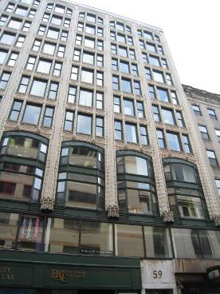

Prepared by:
Massachusetts Department of Public Health
Bureau of Environmental Health
Indoor Air Quality Program
August 2010

Background/Introduction
In response to a request from Roger Tremblay, Human Resources Director, Office of Disabilities & Community Services, Executive Office of Health and Human Services (EOHHS), an indoor air quality assessment was done at the Massachusetts Rehabilitation Commission (MRC), 59 Temple Place, Boston, Massachusetts. This assessment was conducted by the Massachusetts Department of Public Health (MDPH), Bureau of Environmental Health (BEH). The assessment was prompted by concerns of water damage/potential mold growth due to sprinkler system activation during a fire that occurred. On June 3, 2010, a visit to conduct an indoor air quality assessment was made to the MRC offices by Michael Feeney, Director of BEH’s Indoor Air Quality (IAQ) Program and Cory Holmes, Environmental Analyst/Regional Inspector for BEH’s Indoor Air Quality (IAQ) Program.
The MRC offices are located on the 9th floor of a multi-story office building in downtown Boston. Windows are openable and face north on Temple Place and east on Washington Street. Windows on the rear of the building face west.

Methods
Air tests for carbon monoxide, carbon dioxide, temperature and relative humidity were conducted with the TSI, Q-Trak, IAQ Monitor, Model 8551. Air tests for airborne particle matter with a diameter less than 2.5 micrometers were taken with the TSI, DUSTTRAK™ Aerosol Monitor Model 8520. BEH staff also performed visual inspection of building materials for water damage and/or microbial growth.

Results
The MRC has a population of approximately 20 employees. Tests were taken under normal operating conditions and results appear in Table 1.

Discussion

Ventilation
It can be seen from Table 1 that carbon dioxide levels were above 800 parts per million (ppm) in three of twenty-five areas, indicating adequate air exchange in the majority of areas surveyed at the time of the assessment (Table 1). Ventilation is provided by air handling units (AHUs) located in mechanical rooms/AHU closets in various locations on the 9th floor. However, it appears that only one AHU introduces outside air, via a fresh air intake on the rear wall of the building (Picture 1). Fresh air is then directed into a mechanical room and distributed to the remainder of the floor. Other AHUs in the MRC appear to recirculate air only, which can result in some locations having less fresh air distribution.
Conditioned air is supplied to occupied areas through ceiling and/or wall-mounted air diffusers (Pictures 2 and 3). Air is returned to the AHUs by use of a ceiling plenum system, which uses the space between the suspended ceiling and the 10th floor deck as a large, open duct. An opening connects the ceiling plenum to each mechanical room (Picture 4). Air is drawn into each AHU by an opening in the unit’s cabinet, which in turn makes each mechanical room a part of the airflow/duct system.
Conference room 914 has no mechanical ventilation but uses openable windows for air circulation. Cooling is provided by two window-mounted air conditioning (AC) units.
To maximize air exchange, the MDPH recommends that both supply and exhaust ventilation operate continuously during periods of occupancy. In order to have proper ventilation with a mechanical supply and exhaust system, the systems must be balanced to provide an adequate amount of fresh air to the interior of a room while removing stale air from the room. It is recommended that HVAC systems be re-balanced every five years to ensure adequate air systems function (SMACNA, 1994). The date of the last balancing of these systems was not available at the time of the assessment.
The Massachusetts Building Code requires that each room have a minimum ventilation rate of 20 cubic feet per minute (cfm) per occupant of fresh outside air or openable windows (SBBRS, 1997; BOCA, 1993). The ventilation must be on at all times that the room is occupied. Providing adequate fresh air ventilation with open windows and maintaining the temperature in the comfort range during the cold weather season is impractical. Mechanical ventilation is usually required to provide adequate fresh air ventilation.
Carbon dioxide is not a problem in and of itself. It is used as an indicator of the adequacy of the fresh air ventilation. As carbon dioxide levels rise, it indicates that the ventilating system is malfunctioning or the design occupancy of the room is being exceeded. When this happens, a buildup of common indoor air pollutants can occur, leading to discomfort or health complaints. The Occupational Safety and Health Administration (OSHA) standard for carbon dioxide is 5,000 parts per million parts of air (ppm). Workers may be exposed to this level for 40 hours/week, based on a time-weighted average (OSHA, 1997).
The MDPH uses a guideline of 800 ppm for publicly occupied buildings. A guideline of 600 ppm or less is preferred in schools due to the fact that the majority of occupants are young and considered to be a more sensitive population in the evaluation of environmental health status. Inadequate ventilation and/or elevated temperatures are major causes of complaints such as respiratory, eye, nose and throat irritation, lethargy and headaches. For more information concerning carbon dioxide, please see Appendix A.
Temperature readings ranged from 69º to 78º F, which were within or very close to the lower end of the MDPH recommended guidelines (Table 1). The MDPH recommends that indoor air temperatures be maintained in a range of 70º to 78º F in order to provide for the comfort of building occupants. In many cases concerning indoor air quality, fluctuations of temperature in occupied spaces are typically experienced, even in a building with an adequate fresh air supply.
Occupants expressed complaints of uneven heating and cooling. Fresh air supply diffusers have fixed louvers, which cause air to be directed straight down into the space, frequently on building occupants. In some instances, vents were observed to be blocked with cardboard or paper (Picture 3). These types of alterations can affect the airflow and balance of the ventilation system, resulting in the creation of uneven heating/cooling conditions in other areas.
Relative humidity measurements ranged from 49 to 68 percent, which were above the MDPH recommended comfort range in several areas surveyed and were reflective of outdoor levels (80%) due to open windows. The MDPH recommends a comfort range of 40 to 60 percent for indoor air relative humidity. While temperature is mainly a comfort issue, relative humidity in excess of 70 percent for extended periods of time can provide an environment for mold and fungal growth (ASHRAE, 1989). During periods of high relative humidity (late spring/summer months), windows and exterior doors should be closed to keep moisture out when the HVAC system is in air conditioning mode to prevent condensation issues, which can lead to mold growth. During the heating season, relative humidity levels would be expected to drop below the recommended comfort range. The sensation of dryness and irritation is common in a low relative humidity environment.

Microbial/Moisture Concern
In February 2010, an arson fire activated the sprinkler system, causing subsequent water damage to the walls, ceilings, floors and contents in the southern section of the office (Pictures 5 through 9). Due to a lack of visible smoke damage above the suspended ceiling, it appears the sprinkler system extinguished the fire rapidly, which limited smoke damage (Picture 9). As reported by MRC staff, extensive fire restoration was conducted after the fire, including the use of dehumidifiers and the removal of carpet and gypsum wallboard (GW). While smoke penetration into the HVAC system was limited, activation of the sprinkler system likely created a significant amount of water vapor, which would have been captured by the HVAC system if it were activated. Materials such as cardboard blocking fresh air supplies (Picture 4), would become moistened and provide a possible source of mold colonization.
The US Environmental Protection Agency (US EPA) and the American Conference of Governmental Industrial Hygienists (ACGIH) recommend that porous materials be dried with fans and heating within 24 to 48 hours of becoming wet (US EPA, 2001; ACGIH, 1989). If not dried within this time frame, mold growth may occur. Once mold has colonized porous materials, they are difficult to clean and should be removed/discarded.
At the time of the IAQ assessment, a number of plants were observed in several areas. Plant soil and drip pans can serve as a source of mold growth. A number of these plants did not have drip pans, which can lead to water pooling and mold growth on windowsills. Wet paper materials colonized with mold were observed near an open window in office 19 (Picture 10).
A visual inspection of AHUs was conducted to determine proper drainage and whether condensation was accumulating. Since the HVAC system provides air conditioning, each unit with cooling coils is attached to a PVC pipe system that drains condensate. Drainage for AHUs is provided by a clear plastic flexible hose. At the time of the assessment, the interior of the flexible hose was coated with a heavy deposition of scale and debris, which can provide a source of microbial growth and/or foul odors (Picture 11). As the AHU operates, negative pressure is created which can draw air from the drain system through these hoses and into the unit. This can be a means for microbial growth and/or odors to be drawn into the unit and be distributed by the HVAC system.
Examination of the interior of the building found no visible signs of bird infestation. However, evidence of pigeon roosting in the form of bird wastes and nesting materials was observed on top of/under window-mounted ACs (Picture 12). While the bird wastes are on the exterior of the building, ACs have the ability to introduce fresh air from outdoors. As air is drawn into the AC, bird waste particulate can be entrained (drawn into) the building. Bird wastes in a building raise three concerns: 1) diseases that may be caused by exposure to bird wastes, 2) the need for clean up of bird waste and 3) appropriate disinfection.
Certain molds are associated with bird waste and are of concern for immune compromised individuals. Other diseases of the respiratory tract may also result from exposure to bird waste. Exposure to bird wastes is thought to be associated with the development of hypersensitivity pneumonitis in some individuals. Psittacosis (bird fancier's disease) is another condition closely associated with exposure to bird wastes in either the occupational or bird raising setting. While immune compromised individuals have an increased risk of health impacts following exposure to the materials in bird waste, these impacts may also occur in healthy individuals exposed to these materials.

Other IAQ Evaluations
Indoor air quality can be negatively influenced by the presence of respiratory irritants, such as products of combustion. The process of combustion produces a number of pollutants. Common combustion emissions include carbon monoxide, carbon dioxide, water vapor and smoke (fine airborne particle material). Of these materials, exposure to carbon monoxide and particulate matter with a diameter of 2.5 micrometers (μm) or less (PM2.5) can produce immediate, acute health effects upon exposure. To determine whether combustion products were present in the building environment, BEH staff obtained measurements for carbon monoxide and PM2.5.

Carbon Monoxide
Carbon monoxide is a by-product of incomplete combustion of organic matter (e.g., gasoline, wood and tobacco). Exposure to carbon monoxide can produce immediate and acute health affects. Several air quality standards have been established to address carbon monoxide and prevent symptoms from exposure to these substances. The MDPH established a corrective action level concerning carbon monoxide in ice skating rinks that use fossil-fueled ice resurfacing equipment. If an operator of an indoor ice rink measures a carbon monoxide level over 30 ppm, taken 20 minutes after resurfacing within a rink, that operator must take actions to reduce carbon monoxide levels (MDPH, 1997).
The American Society of Heating Refrigeration and Air-Conditioning Engineers (ASHRAE) has adopted the National Ambient Air Quality Standards (NAAQS) as one set of criteria for assessing indoor air quality and monitoring of fresh air introduced by HVAC systems (ASHRAE, 1989). The NAAQS are standards established by the US EPA to protect the public health from six criteria pollutants, including carbon monoxide and particulate matter (US EPA, 2006). As recommended by ASHRAE, pollutant levels of fresh air introduced to a building should not exceed the NAAQS levels (ASHRAE, 1989). The NAAQS were adopted by reference in the Building Officials & Code Administrators (BOCA) National Mechanical Code of 1993 (BOCA, 1993), which is now an HVAC standard included in the Massachusetts State Building Code (SBBRS, 1997). According to the NAAQS, carbon monoxide levels in outdoor air should not exceed 9 ppm in an eight-hour average (US EPA, 2006).
Carbon monoxide should not be present in a typical, indoor environment. If it is present, indoor carbon monoxide levels should be less than or equal to outdoor levels. On the day of the assessment, outdoor carbon monoxide concentrations were non-detect (ND) (Table 1). No measurable levels of carbon monoxide were detected in the building at the time of the assessment (Table 1).

Particulate Matter (PM2.5)
The US EPA has established NAAQS limits for exposure to particulate matter. Particulate matter is airborne solids that can be irritating to the eyes, nose and throat. The NAAQS originally established exposure limits to particulate matter with a diameter of 10 μm or less (PM10). According to the NAAQS, PM10 levels should not exceed 150 micrograms per cubic meter (μg/m³) in a 24-hour average (US EPA, 2006). These standards were adopted by both ASHRAE and BOCA. Since the issuance of the ASHRAE standard and BOCA Code, US EPA established a more protective standard for fine airborne particles. This more stringent PM2.5 standard requires outdoor air particle levels be maintained below 35 μg/m³ over a 24-hour average (US EPA, 2006). Although both the ASHRAE standard and BOCA Code adopted the PM10 standard for evaluating air quality, MDPH uses the more protective PM2.5 standard for evaluating airborne particulate matter concentrations in the indoor environment.
Outdoor PM2.5 concentrations were measured at 37 μg/m³ (Table 1), which were above the NAAQS PM2.5 level of 35 μg/m³ the day of the assessment. This elevation was likely due to a lingering haze that blanketed the northeast during several days in early late May early June due to particulates generated from Canadian forest fires (NOAA, 2010). With one exception, PM2.5 levels measured indoors were below the NAAQS PM2.5 level of 35 μg/m³ (Table 1). The PM2.5 level measured in conference room 914 was reflective of outdoor levels due to open windows and spaces around window-mounted ACs that allow outside air to infiltrate into the room.
Frequently, indoor air levels of particulates (including PM2.5) can be at higher levels than those measured outdoors. A number of mechanical devices and/or activities that occur in buildings can generate particulate during normal operations. Sources of indoor airborne particulates may include but are not limited to particles generated during the operation of fan belts in the HVAC system, use of stoves and/or microwave ovens in kitchen areas; use of photocopiers, fax machines and computer printing devices; operation of an ordinary vacuum cleaner and heavy foot traffic indoors.

Other Conditions
Several other conditions were noted during the assessment which can affect indoor air quality. The AHUs installed at the MRC are designed to have filters, however many of the filters were ill-fitting, held to the units with duct tape or missing altogether (Pictures 13 through 16). As air bypasses filters, the opportunity exists for airborne dirt, dust, odors and particulates to be drawn into the HVAC system and be distributed to occupied areas. Aerosolized dust, particulates and odors can provide a source of eye, skin and respiratory irritation to certain individuals. In addition, accumulated debris in the cooling fins/coils from lack of proper filtration can decrease the efficiency of air conditioning, accelerate the degradation of HVAC equipment, and provide a source of mold growth when the fins/coils become moistened during hot, humid weather (Picture 15).
Window-mounted ACs in conference room 914 were also inspected and found to be occluded with dust and debris. Filters for air handling equipment should be changed as per the manufacture’s instructions or more frequently if needed.
Pollutants from stored materials in the AHUs closets (e.g., water-damaged carpeting, paint cans and other debris) can be drawn into the AHUs and distributed into occupied spaces (Pictures 17 and 18). Open utility holes were also observed in mechanical room ceilings, walls and floors (Picture 19). These breaches can provide a pathway for odors, fumes, dusts and vapors to enter the mechanical room from adjacent rooms and floors.
Of note are loose/damaged floor tiles in the main mechanical room (Picture 20). Other areas that were water-damaged due to by the sprinkler activation include carpeting installed over asbestos-containing floor tiles, mastic and paper backing (Vertex, 2010). Since floor tiles in the mechanical room are similar to those removed during the fire restoration, it can be assumed that this tile, mastic and paper backing likely contains asbestos. Damaged flooring materials containing asbestos must be remediated and disposed of in a manner consistent with Massachusetts asbestos disposal laws.
Finally, evidence of rodent/pest infestation was observed in the form of mouse traps in several areas, including the AHU closets. Rodent infestation can result in indoor air quality related symptoms due to materials in their wastes. Mouse urine contains a protein that is a known sensitizer (US EPA, 1992). A three-step approach is necessary to eliminate rodent infestation:
- Removal of rodents/pests;
- Cleaning of waste products from the interior of the building; and
- Reduction/elimination of pathways/food sources that are attracting rodents.
To eliminate exposure to allergens, rodents must be removed from the building. Please note that removal, even after cleaning, may not provide immediate relief since allergens can exist in the interior for several months after rodents are eliminated (Burge, 1995). A combination of cleaning, increase in ventilation and filtration should serve to reduce rodent associated allergens once the infestation is eliminated.

Conclusions/Recommendations
In view of these findings at the time of assessment, the following is recommended:
- Remove cardboard from fresh air supplies. Consideration should be given to installing wall mounted fresh air supply diffusers with movable louvers to direct airflow away from work stations in private offices.
- Have the AHU coils/fins cleaned.
- Remove all stored materials from mechanical rooms, clean and disinfect floors.
- Seal all unnecessary openings (floors/walls/ceilings) in mechanical rooms.
- A preventative maintenance program for all HVAC equipment should be developed and implemented, which should include changing filters for HVAC equipment (including window-mounted ACs) as per the manufacturer’s instructions or more frequently if needed, as well as the examination of all HVAC equipment periodically for maintenance and function.
- Ensure filters for all ACs, AHUs fit flush in their racks with no spaces to prevent bypass of unfiltered air.
- Examine flexible hosing connecting the condensation drains to the AHUs for debris/mold growth during routine changing of filters. Replace or disinfect this tubing with an appropriate antimicrobial prior to the air-conditioning season on a routine basis.
- Consult with a ventilation engineer to ascertain the most appropriate method to prevent further water damage to building materials within mechanical rooms. This may include regular cleaning of the AHU chiller coils, installation of pre-filters and re-insulation of exposed chilled water pipes. If not insulated, drip pans with adequate drainage should be installed.
- Ventilation industrial standards recommend that mechanical ventilation systems be balanced every five years (SMACNA, 1994). Consult a ventilation engineer concerning re-balancing of the ventilation systems.
- Keep windows closed during hot, humid weather to maintain indoor temperatures and to avoid condensation problems when air conditioning is activated.
- Discard water-damaged/mold-colonized paper materials in office 19.
- Consider reducing the number of plants in offices. Ensure plants have drip pans. Examine drip pans periodically for mold growth and disinfect with an appropriate antimicrobial where necessary.
- For buildings in New England, periods of low relative humidity during the winter are often unavoidable. Therefore, scrupulous cleaning practices should be adopted to minimize common indoor air contaminants whose irritant effects can be enhanced when the relative humidity is low. To control for dusts, a high efficiency particulate arrestance (HEPA) filter equipped vacuum cleaner in conjunction with wet wiping of all surfaces is recommended. Avoid the use of feather dusters. Drinking water during the day can help ease some symptoms associated with a dry environment (throat and sinus irritations).
- Clean bird wastes and contaminated materials around ACs. Remove accumulated bird wastes from flat, non-porous surfaces and disinfect with an appropriate antimicrobial agent. Once disinfected, each treated area should be cleaned to ensure the removal of residual bird waste and cleaning materials.
- Ascertain whether floor tiles in the main mechanical room contains asbestos, remediate or remove in a manner consistent with Massachusetts asbestos remediation laws.
- Use the following three-step approach to eliminate rodent infestation:
  - Remove rodents/pests;
  - Clean waste products from the interior of the building; and
  - Reduce/eliminate pathways/food sources that are attracting rodents.
- Refer to resource manual and other related indoor air quality documents located on the MDPH’s website for further building-wide evaluations and advice on maintaining public buildings. These documents are available at: http://mass.gov/dph/iaq.

References
ACGIH. 1989. Guidelines for the Assessment of Bioaerosols in the Indoor Environment. American Conference of Governmental Industrial Hygienists, Cincinnati, OH.
ASHRAE. 1989. Ventilation for Acceptable Indoor Air Quality. American Society of Heating, Refrigeration and Air Conditioning Engineers. ANSI/ASHRAE 62-1989.
BOCA. 1993. The BOCA National Mechanical Code-1993. 8th ed. Building Officials & Code Administrators International, Inc., Country Club Hills, IL. M-308.1
Burge, H.A. 1995. Bioaerosols. Lewis Publishing Company, Boca Raton, FL.
MDPH. 1997. Requirements to Maintain Air Quality in Indoor Skating Rinks (State Sanitary Code, Chapter XI). 105 CMR 675.000. Massachusetts Department of Public Health, Boston, MA.
NOAA. 2010. National Oceanic and Atmospheric Administration. National Weather Service Forecast Office. The May 31, 2010, Memorial Day Smoke Out. http://www.erh.noaa.gov/btv/events/31May2010/
OSHA. 1997. Limits for Air Contaminants. Occupational Safety and Health Administration. Code of Federal Regulations. 29 C.F.R 1910.1000 Table Z-1-A.
SBBRS. 1997. Mechanical Ventilation. State Board of Building Regulations and Standards. Code of Massachusetts Regulations. 780 CMR 1209.0
SMACNA. 1994. HVAC Systems Commissioning Manual. 1st ed. Sheet Metal and Air Conditioning Contractors’ National Association, Inc., Chantilly, VA.
US EPA. 1992. Indoor Biological Pollutants. US Environmental Protection Agency, Environmental Criteria and Assessment Office, Office of Health and Environmental Assessment, research Triangle Park, NC. EPA 600/8-91/202. January 1992.
US EPA. 2001. “Mold Remediation in Schools and Commercial Buildings”. Office of Air and Radiation, Indoor Environments Division, Washington, DC. EPA 402-K-01-001. March 2001. Available at: http://www.epa.gov/iaq/molds/mold_remediation.html
US EPA. 2006. National Ambient Air Quality Standards (NAAQS). US Environmental Protection Agency, Office of Air Quality Planning and Standards, Washington, DC. http://www.epa.gov/air/criteria.html.
Vertex. 2010. Asbestos Monitoring Services: 59 Temple Place, Boston, MA 5th, 6th & 9th Floor Vertex Air Quality Services, LLC Project #15715 Task #3. Vertex Air Quality Services, LLC, Weymouth, MA.
Picture 1

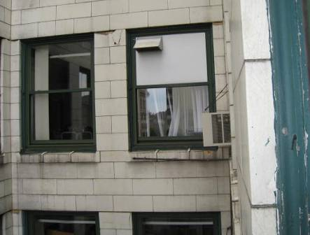

Fresh Air Intake

Picture 2

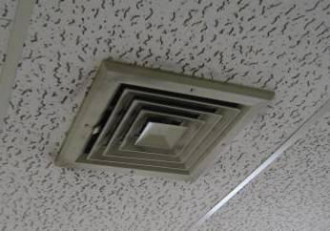

Ceiling-Mounted Air Diffuser, Note Dust/Debris Accumulation on Vent
and Surrounding Ceiling Tiles

Picture 3

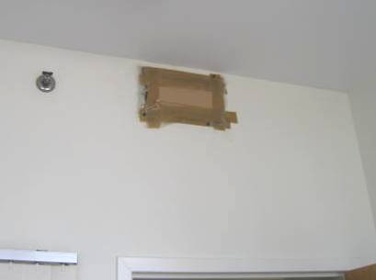

Wall-Mounted Supply Vent Blocked with Cardboard and Tape

Picture 4

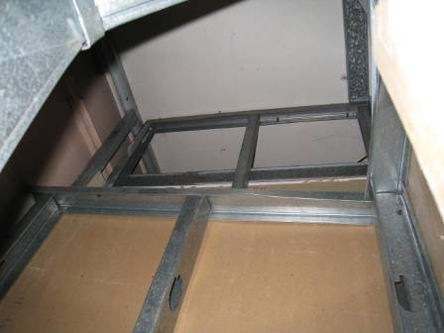

Opening into Ceiling Plenum in Mechanical Room

Picture 5

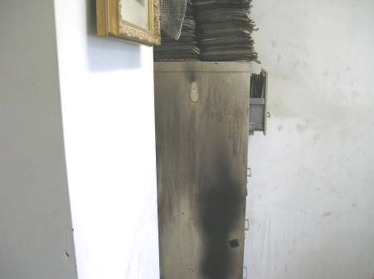

Water Damage to Filing Cabinet (Photo Taken by MRC Staff)

Picture 6

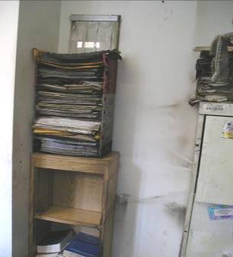

Fire Damage to Office (Photo Taken by MRC Staff)

Picture 7

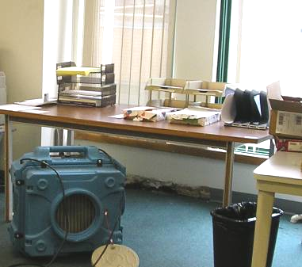

Water Damage to Gypsum Wallboard (below Table), Note Dehumidifier

Picture 8

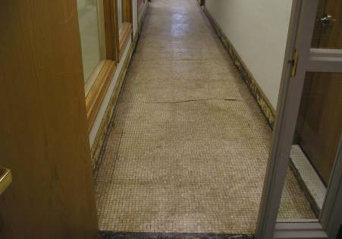

Water-Damaged Main Hallway outside MRC, Note Removed Gypsum Wallboard
at Base of Walls

Picture 9

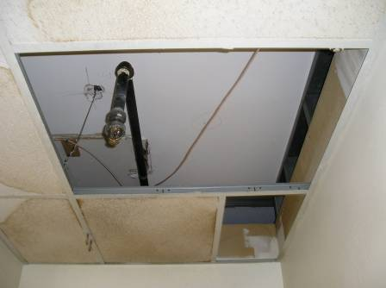

Ceiling Plenum above Fire, Note Lack of Soot Deposition Indicating Rapid
Suppression of Fire

Picture 10

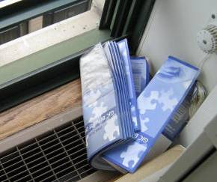

Wet Paper Materials Colonized with Mold near open Window in Office 19

Picture 11

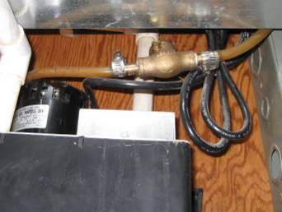

Flexible Tubing, Note Tubing Should be Clear in Color

Picture 12

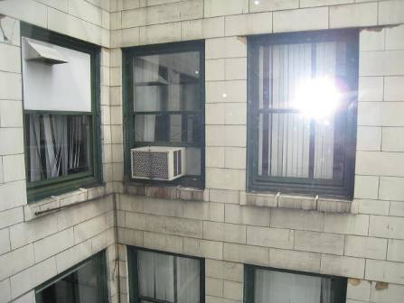

Bird Wastes on Air Conditioner and Window Ledges

Picture 13

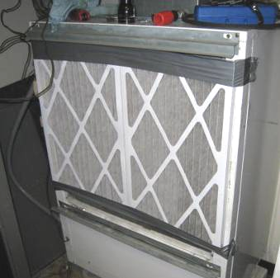

Filter Duct-Taped to AHU, Note Exposed Cooling Fins and Spaces around Filter at Bottom/Top

Picture 14

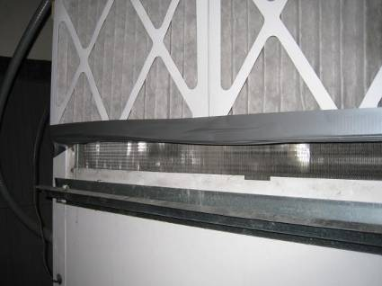

Close-Up of Filter Duct-Taped to AHU, Note Exposed Cooling Fins at Bottom

Picture 15

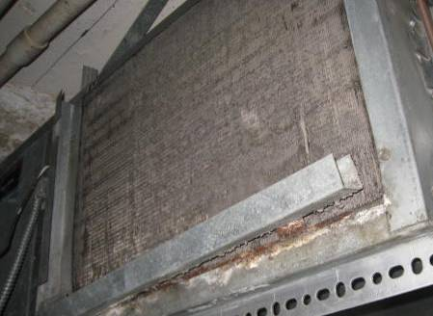

AHU Missing Filter, Note Empty Rack (Arrow) and Fins Occluded with Dust/Debris

Picture 16

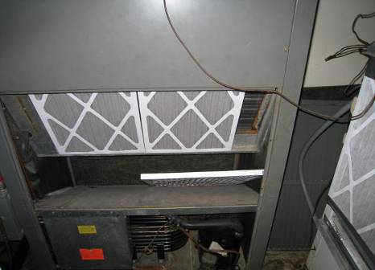

AHU with Undersized Filter, Note Space on Right for Filter Bypass

Picture 17

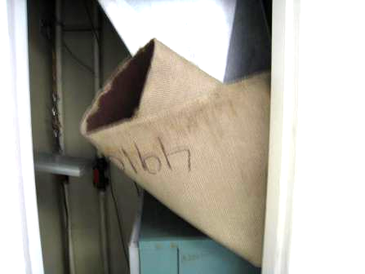

Water-Damaged Carpet in AHU Closet, Note Stain

Picture 18

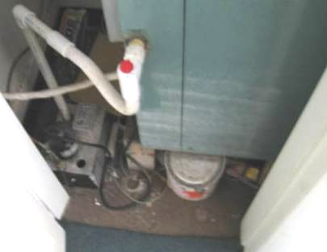

Paint Can Stored in Mechanical Room beneath AHU

Picture 19

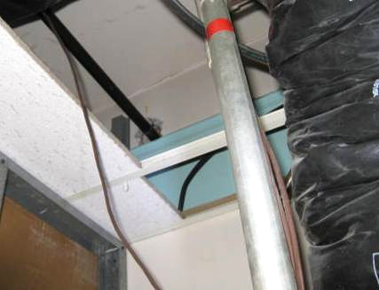

Holes in AHU Closet Wall

Picture 20

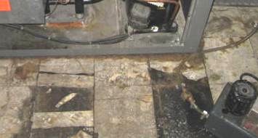

Water-Damaged/Cracked Floor Tile in Main AHU Closet
Location | Occupants  in Room | Temp  (°F) | Relative  Humidity  (%) | Carbon  Dioxide  (ppm) | Carbon  Monoxide  (ppm) | PM2.5 (ug/m3) | Windows  Openable | Ventilation |  | Remarks
Outside  (Background) |  | 82 | 80 | 356 | ND | 37 |  |  |  | Hazy, hot and humid
Reception | 1 | 75 | 50 | 561 | ND | 17 | N | Y | N | Hole in ceiling tile, plants
Mail Box Area | 3 | 73 | 52 | 536 | ND | 16 | Y | Y | Y
Computer Stations | 0 | 71 | 49 | 531 | ND | 15 | Y | Y | Y
1 | 1 | 69 | 52 | 540 | ND | 10 | Y | Y | N | DO
2 | 0 | 70 | 51 | 539 | ND | 18 | Y | Y | Y | Plant
3 | 0 | 70 | 59 | 627 | ND | 22 | Y | Y | Y
4 | 0 | 71 | 57 | 599 | ND | 19 | Y | Y | Y | Mechanical room-carpeted, clear plastic condensate tube-caked with debris, AHU missing filter
5 | 1 | 70 | 57 | 885 | ND | 19 | N | Y | Y | Supply vent blocked, DO
6 | 0 | 71 | 54 | 518 | ND | 16 | N | Y | Y | Ajar ceiling tile
7 | 0 | 72 | 53 | 521 | ND | 17 | N | Y | Y
9 | 0 | 75 | 51 | 554 | ND | 17 | N | Y | Y | Ajar ceiling tile
10 | 0 | 78 | 56 | 558 | ND | 23 | N | Y | Y | DO, holes in wall
11 | 0 | 77 | 54 | 632 | ND | 20 | N | Y | Y
12 | 1 | 77 | 56 | 885 | ND | 22 | N | Y | Y
13 | 0 | 77 | 56 | 649 | ND | 22 | N | Y | Y
14 | 1 | 76 | 55 | 869 | ND | 21 | N | Y | Y
15 | 0 | 75 | 55 | 682 | ND | 22 | N | Y | N | DO, photocopier
16 | 1 | 75 | 51 | 620 | ND | 19 | Y | Y | N | DO, supply vent-blocked with paper, mechanical room: old carpeting, paint can and debris, mech room floor is carpeted, mouse traps
17 | 1 | 75 | 59 | 693 | ND | 23 | Y | Y | N
18 | 1 | 76 | 61 | 758 | ND | 24 | Y | Y | N | Window open, AC-on
19 | 0 | 78 | 63 | 506 | ND | 27 | Y | Y | N | Vents blocked, plants, mold growth on wet paper from open window
20 | 0 | 77 | 55 | 628 | ND | 23 | Y | Y | N | Vent blocked with paper, DO
21 | 1 | 78 | 63 | 580 | ND | 28 | Y | Y | N | Window open, DO, fan on, dust/debris on vents
23 | 0 | 72 | 58 | 581 | ND | 18 | Y | Y | Y | DO, dust/debris on vents
Conf Room 914 | 0 | 77 | 68 | 435 | ND | 35 | Y | N | N | Window mounted AC (2), pigeon roosting, uninsulated sheet metal around ACs-spaces, windows open

