INDOOR AIR QUALITY
POST-OCCUPANCY ASSESSMENT

Massachusetts Rehabilitation Commission
Worcester Branch
340 Main Street
Worcester, Massachusetts

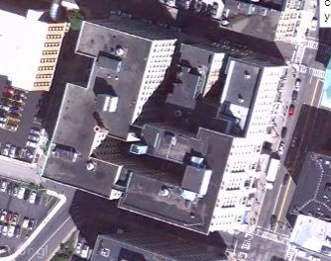

Prepared by:
Massachusetts Department of Public Health
Bureau of Environmental Health
Indoor Air Quality Program
April 2011

Background/Introduction
In response to a request from Ms. Virginia Platt, Project Manager, Office of Leasing and State Office Planning for the Massachusetts Division of Capital Asset Management, the Massachusetts Department of Public Health (MDPH), Bureau of Environmental Health (BEH) conducted post-occupancy air testing at the Massachusetts Rehabilitation Commission (MRC) located at 340 Main Street, 5th floor, Worcester, Massachusetts. On January 7, 2011, a visit to conduct indoor air quality (IAQ) testing was made by Lisa Hébert, Environmental Analyst/Regional Inspector in BEH’s IAQ Program. Ms. Hébert was accompanied by Ms. Platt during the assessment.

Methods
Air tests for carbon monoxide, carbon dioxide, temperature and relative humidity were conducted with the TSI, Q-Trak, IAQ Monitor, Model 7565. Air tests for airborne particle matter with a diameter less than 2.5 micrometers were taken with the TSI, DUSTTRAK™ Aerosol Monitor Model 8520. Screening for total volatile organic compounds was conducted using a MiniRAE 2000 Series Photo Ionization Detector (PID). BEH staff also performed visual inspection of building materials for water damage and/or microbial growth.

Results
The tests were taken during normal operations. Test results appear in Table 1.

Discussion

Ventilation
It can be seen from Table 1 that carbon dioxide levels were below 800 parts per million (ppm) in all areas indicating optimal air exchange at the time of testing (Table 1). Mechanical ventilation is provided by a series of heating, ventilation and air conditioning (HVAC) air handling units (AHUs) located in closets throughout the floor. Fresh air is drawn through vents located above select window frames. Ductwork connects the AHUs to ceiling-mounted air supply diffusers. By design, air diffusers are equipped with fixed louvers that direct air along the ceiling to flow down the walls and create airflow. Air returns to the AHUs through the fixed louvers in the doors of the AHU closets.
To maximize air exchange, the MDPH recommends that both supply and exhaust ventilation operate continuously during periods of occupancy. In order to have proper ventilation with a mechanical supply and exhaust system, the systems must be balanced to provide an adequate amount of fresh air to the interior of a room while removing stale air from the room. It is recommended that HVAC systems be re-balanced every five years to ensure adequate air systems function (SMACNA, 1994). The HVAC system balancing was reportedly in progress at the time of the assessment.
The Massachusetts Building Code requires that each room have a minimum ventilation rate of 20 cubic feet per minute (cfm) per occupant of fresh outside air or openable windows (SBBRS, 1997; BOCA, 1993). The ventilation must be on at all times that the room is occupied. Providing adequate fresh air ventilation with open windows and maintaining the temperature in the comfort range during the cold weather season is impractical. Mechanical ventilation is usually required to provide adequate fresh air ventilation.
Carbon dioxide is not a problem in and of itself. It is used as an indicator of the adequacy of the fresh air ventilation. As carbon dioxide levels rise, it indicates that the ventilating system is malfunctioning or the design occupancy of the room is being exceeded. When this happens, a buildup of common indoor air pollutants can occur, leading to discomfort or health complaints. The Occupational Safety and Health Administration (OSHA) standard for carbon dioxide is 5,000 parts per million parts of air (ppm). Workers may be exposed to this level for 40 hours/week, based on a time-weighted average (OSHA, 1997).
The MDPH uses a guideline of 800 ppm for publicly occupied buildings. A guideline of 600 ppm or less is preferred in schools due to the fact that the majority of occupants are young and considered to be a more sensitive population in the evaluation of environmental health status. Inadequate ventilation and/or elevated temperatures are major causes of complaints such as respiratory, eye, nose and throat irritation, lethargy and headaches. For more information concerning carbon dioxide, consult Appendix A.
Indoor temperatures ranged from 70º F to 76º F, which were within the MDPH recommended comfort range (Table 1). The MDPH recommends that indoor air temperatures be maintained in a range of 70º F to 78º F in order to provide for the comfort of building occupants. In many cases concerning indoor air quality, fluctuations of temperature in occupied spaces are typically experienced, even in a building with an adequate fresh air supply.
The relative humidity measured in the building ranged from 10 to 14 percent, which was below the MDPH recommended comfort range in all areas surveyed during the assessment (Table 1). The MDPH recommends a comfort range of 40 to 60 percent for indoor air relative humidity. Relative humidity levels in the building would be expected to drop during the winter months due to heating. The sensation of dryness and irritation is common in a low relative humidity environment. Low relative humidity is a very common problem during the heating season in the northeast part of the United States.

Microbial/Moisture Concerns
Water-damaged acoustic tile was noted in an AHU closet (Picture 1). Several condensation pumps were located on the carpeted floors of the AHU closets (Picture 2). At the time of the post-occupancy assessment, the condensation pumps were observed sitting within aluminum pans to prevent spillage. If these condensation pumps are not routinely monitored for leakage, water could accumulate and moisten carpets in the AHU closets, which could lead to mold colonization. Gypsum wallboard (GW) and adjacent carpeting in these closets shows evidence of water damage (Picture 3). The US Environmental Protection Agency (US EPA) and the American Conference of Governmental Industrial Hygienists (ACGIH) recommend that porous materials be dried with fans and heating within 24 to 48 hours of becoming wet (US EPA, 2001; ACGIH, 1989). If not dried within this time frame, mold growth may occur. Once mold has colonized porous materials, they are difficult to clean and should be removed and discarded.

Other Indoor Air Evaluations
Indoor air quality can be negatively influenced by the presence of respiratory irritants, such as products of combustion. The process of combustion produces a number of pollutants. Common combustion emissions include carbon monoxide, carbon dioxide, water vapor, and smoke (fine airborne particle material). Of these materials, exposure to carbon monoxide and particulate matter with a diameter of 2.5 micrometers (μm) or less (PM2.5) can produce immediate, acute health effects upon exposure. To determine whether combustion products were present in the building environment, BEH staff obtained measurements for carbon monoxide and PM2.5.

Carbon Monoxide
Carbon monoxide is a by-product of incomplete combustion of organic matter (e.g., gasoline, wood and tobacco). Exposure to carbon monoxide can produce immediate and acute health effects. Several air quality standards have been established to address carbon monoxide and prevent symptoms from exposure to these substances. The MDPH established a corrective action level concerning carbon monoxide in ice skating rinks that use fossil-fueled ice resurfacing equipment. If an operator of an indoor ice rink measures a carbon monoxide level over 30 ppm, taken 20 minutes after resurfacing within a rink, that operator must take actions to reduce carbon monoxide levels (MDPH, 1997).
The American Society of Heating Refrigeration and Air-Conditioning Engineers (ASHRAE) has adopted the National Ambient Air Quality Standards (NAAQS) as one set of criteria for assessing indoor air quality and monitoring of fresh air introduced by HVAC systems (ASHRAE, 1989). The NAAQS are standards established by the US EPA to protect the public health from six criteria pollutants, including carbon monoxide and particulate matter (US EPA, 2006). As recommended by ASHRAE, pollutant levels of fresh air introduced to a building should not exceed the NAAQS levels (ASHRAE, 1989). The NAAQS were adopted by reference in the Building Officials & Code Administrators (BOCA) National Mechanical Code of 1993 (BOCA, 1993), which is now an HVAC standard included in the Massachusetts State Building Code (SBBRS, 1997). According to the NAAQS, carbon monoxide levels in outdoor air should not exceed 9 ppm in an eight-hour average (US EPA, 2006).
Carbon monoxide should not be present in a typical, indoor environment. If it is present, indoor carbon monoxide levels should be less than or equal to outdoor levels. Outdoor carbon monoxide concentrations were non-detect (ND) the day of the assessment (Table 1). No measureable levels of carbon monoxide were detected in the building during the assessment (Table 1).

Particulate Matter
The US EPA has established NAAQS limits for exposure to particulate matter. Particulate matter is airborne solids that can be irritating to the eyes, nose and throat. The NAAQS originally established exposure limits to particulate matter with a diameter of 10 μm or less (PM10). According to the NAAQS, PM10 levels should not exceed 150 micrograms per cubic meter (μg/m³) in a 24-hour average (US EPA, 2006). These standards were adopted by both ASHRAE and BOCA. Since the issuance of the ASHRAE standard and BOCA Code, US EPA established a more protective standard for fine airborne particles. This more stringent PM2.5 standard requires outdoor air particle levels be maintained below 35 μg/m³ over a 24-hour average (US EPA, 2006). Although both the ASHRAE standard and BOCA Code adopted the PM10 standard for evaluating air quality, MDPH uses the more protective PM2.5 standard for evaluating airborne particulate matter concentrations in the indoor environment.
Outdoor PM2.5 concentrations measured 25 μg/m³ (Table 1). PM2.5 levels measured indoors ranged from 4 to 13 μg/m³ (Table 1), which were below the NAAQS PM2.5 level of 35 μg/m³. Frequently, indoor air levels of particulates (including PM2.5) can be at higher levels than those measured outdoors. A number of activities that occur indoors and/or mechanical devices can generate particulate during normal operations. Sources of indoor airborne particulates may include but are not limited to particles generated during the operation of fan belts in the HVAC system, use of stoves and/or microwave ovens in kitchen areas; use of photocopiers, fax machines and computer printing devices; operation of an ordinary vacuum cleaner and heavy foot traffic indoors.

Volatile Organic Compounds
Indoor air concentrations can be greatly impacted by the use of products containing volatile organic compounds (VOCs). VOCs are carbon-containing substances that have the ability to evaporate at room temperature. Frequently, exposure to low levels of total VOCs (TVOCs) may produce eye, nose, throat and/or respiratory irritation in some sensitive individuals. For example, chemicals evaporating from a paint can stored at room temperature would most likely contain VOCs. In an effort to determine whether VOCs were present in the building, air monitoring for TVOCs was conducted. Outdoor air samples were taken for comparison. Outdoor TVOC concentrations the day of the assessment ranged from ND-1.4 ppm. Slight detections of TVOCs were measured indoors in a few areas (ranging from 0.1 to 1.6 ppm). These measurements are consistent with measured background levels (Table 1), and are likely attributed to odors from fresh paint, adhesives and new building furnishings (carpeting, desks/furniture, work space dividers, etc.) and/or personal products (e.g., perfumes) and cleaners used in the building.

Other Conditions
Other conditions that can affect indoor air quality were observed during the assessment. In general, the interior of the AHU closets are in need of attention. Many closets had large utility openings in walls and/or ceilings. These openings allow dusts, odors, vapors and particulates to travel between rooms where they can be taken up by the AHUs. Peeling paint was also observed on the walls of some of the closets (Picture 4). Fine dust was observed in these closets, on flat surfaces and on AHU components, likely due to recent construction activities (Pictures 5 and 6). In some cases, AHU filters were bent and/or ill-fitting, which can allow air to bypass the filter and many AHUs lacked covers. These AHU closets were also being used for storage of construction materials, refuse and debris (Picture 7). In order to ensure proper operation of AHUs, the issues noted in the AHU closets must be remedied.
Finally, plastic sheeting was observed covering a light fixture (Room 146) (Picture 8). The heat from the lights could cause odors to be emitted from the warmed plastic sheeting and also pose as a fire hazard.

Conclusions/Recommendations
In view of the findings at the time of the visit, the following recommendations are made:
- Clean the interior of AHU closets to eliminate stored construction materials, peeling paint, refuse and debris.
- Seal open utility holes in floors, walls and ceilings of AHU closets.
- Remove and replace water-damaged building materials in AHU closets.
- In order to prevent water damage and potential mold growth, remove carpeting from AHU closets.
- Ensure filters are properly sized and in good repair and that AHU covers fit securely.
- Change filters for air handling equipment as per the manufacturers’ instructions or more frequently if needed.
- Vacuum dust and particulate in AHU closets and on ventilation components with a HEPA (High Efficiency Particulate Arrestance) vacuum cleaner.
- Remove plastic sheeting from light fixtures.
- Consider adopting a balancing schedule of every 5 years for all mechanical ventilation systems, as recommended by ventilation industrial standards (SMACNA, 1994).
- Refer to resource manual and other related indoor air quality documents located on the MDPH’s website for further building-wide evaluations and advice on maintaining public buildings. These documents are available at: http://mass.gov/dph/iaq.

References
ACGIH. 1989. Guidelines for the Assessment of Bioaerosols in the Indoor Environment. American Conference of Governmental Industrial Hygienists, Cincinnati, OH.
ASHRAE. 1989. Ventilation for Acceptable Indoor Air Quality. American Society of Heating, Refrigeration and Air Conditioning Engineers. ANSI/ASHRAE 62-1989
BOCA. 1993. The BOCA National Mechanical Code/1993. 8th ed. Building Officials and Code Administrators International, Inc., Country Club Hill, IL.
MDPH. 1997. Requirements to Maintain Air Quality in Indoor Skating Rinks (State Sanitary Code, Chapter XI). 105 CMR 675.000. Massachusetts Department of Public Health, Boston, MA.
OSHA. 1997. Limits for Air Contaminants. Occupational Safety and Health Administration. Code of Federal Regulations. 29 C.F.R 1910.1000 Table Z-1-A.
SBBRS. 1997. Mechanical Ventilation. State Board of Building Regulations and Standards. Code of Massachusetts Regulations. 780 CMR 1209.0
SMACNA. 1994. HVAC Systems Commissioning Manual. 1st ed. Sheet Metal and Air Conditioning Contractors’ National Association, Inc., Chantilly, VA.
US EPA. 2001. “Mold Remediation in Schools and Commercial Buildings”. Office of Air and Radiation, Indoor Environments Division, Washington, DC. EPA 402-K-01-001. March 2001. Available at: http://www.epa.gov/iaq/molds/mold_remediation.html
US EPA. 2006. National Ambient Air Quality Standards (NAAQS). US Environmental Protection Agency, Office of Air Quality Planning and Standards, Washington, DC. http://www.epa.gov/air/criteria.html.
Picture 1

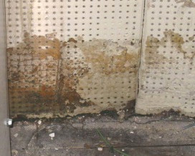

Water-Damaged, Deteriorated Acoustic Tile

Picture 2

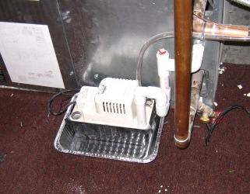

AHU and Condensation Pump Located on Carpeted Floor
Picture 3

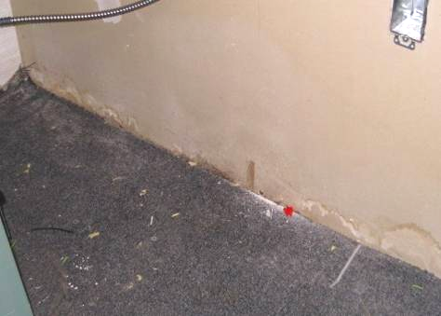

Water-Damaged GW and Carpeting in AHU Closet

Picture 4

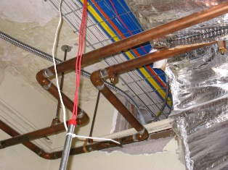

Peeling Paint on Ceiling
Note Large Penetration through Wall
Picture 5

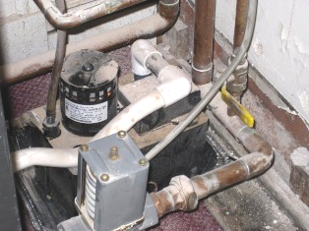

Dust and Particulate Accumulated on Surfaces in AHU Closet

Picture 6

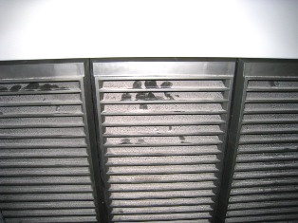

Dust Accumulation on Front of AHU

Picture 7

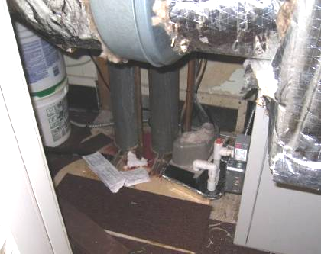

Construction Materials, Carpet Remnants and
Paper on Floor of AHU Closet

Picture 8

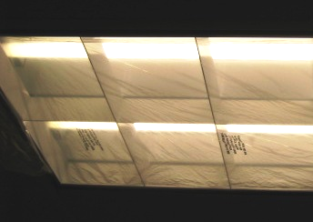

Plastic Sheeting Covering Light Fixture
Location/ Room | Occupants  in Room | Temp  (°F) | Relative  Humidity  (%) | Carbon  Dioxide  (ppm) | Carbon Monoxide  (ppm) | PM2.5  (µg/m³) | TVOCs  (ppm) | Windows  Openable | Ventilation |  | Remarks
 |  |  |  |  |  |  |  |  | Supply | Exhaust | Remarks
Background: | - | 36 | 17 | 286 | ND | 25 | 0-1.4 | - | - | - | Clear, visibility 10 miles, wind direction ENE, average wind speed 7 mph (Weather Underground). Heavy traffic in front of building.
Receptionist | 1 | 74 | 13 | 475 | ND | 5 | ND | N | N | N
01 | 0 | 71 | 12 | 484 | ND | 4 | ND | Y | Y | Y | Carpet in AHU closet
02 | 0 | 72 | 11 | 511 | ND | 5 | ND | Y | Y | Y
04 | 0 | 70 | 13 | 435 | ND | 6 | ND | Y | Y | N
06 | 0 | 71 | 13 | 451 | ND | 6 | ND | N | Y | N
08 | 0 | 72 | 12 | 475 | ND | 5 | ND | N | Y | N
09 | 0 | 73 | 12 | 733 | ND | 7 | ND | N | Y | Y
11 | 0 | 74 | 11 | 520 | ND | 8 | ND | Y | Y | Y
12 | 0 | 74 | 11 | 484 | ND | 9 | ND | Y | Y | Y | DO
14 | 0 | 74 | 14 | 497 | ND | 7 | ND | N | Y | Y
18 | 1 | 73 | 11 | 492 | ND | 8 | ND | Y | Y | Y
23 | 0 | 74 | 11 | 554 | ND | 7 | ND | Y | Y | Y
25 | 1 | 74 | 11 | 565 | ND | 8 | ND | Y | Y | Y
27 | 1 | 73 | 11 | 493 | ND | 9 | ND | Y | Y | Y
31 | 0 | 73 | 11 | 488 | ND | 8 | ND | Y | Y | Y
36 (office) | 1 | 74 | 11 | 544 | ND | 9 | ND | Y | Y | N | Space heater noted
37 (office) | 2 | 74 | 11 | 499 | ND | 7 | ND | Y | Y | N | MTs (2)
39 | 0 | 73 | 11 | 514 | ND | 9 | ND | Y | Y | Y
41 | 1 | 73 | 11 | 524 | ND | 10 | ND | N | Y | Y
43 | 0 | 74 | 11 | 564 | ND | 9 | ND | N | Y | Y
45 | 0 | 73 | 11 | 503 | ND | 8 | ND | Y | Y | Y
51 | 0 | 74 | 10 | 506 | ND | 10 | ND | Y | Y | Y
53 | 1 | 74 | 11 | 477 | ND | 10 | ND | Y | Y | Y
54 (office) | 1 | 73 | 13 | 652 | ND | 10 | ND | Y | Y | N
55 (office) in front of door | 0 | 74 | 12 | 593 | ND | 12 | ND | N | Y | Y
56 | 1 | 73 | 12 | 519 | ND | 9 | ND | Y | Y | Y
58 (adjacent to) | 0 | 72 | 12 | 493 | ND | 10 | ND | N | Y | Y
59 | 0 | 71 | 13 | 488 | ND | 9 | ND | Y | Y | Y
62 (Records) | 0 | 72 | 13 | 477 | ND | 13 | ND | N | Y | N
64 (training room) | 0 | 73 | 11 | 456 | ND | 10 | ND | Y | Y | Y | Outside training room near elevator VOCs measured ND-0.4 ppm
75 | 0 | 75 | 11 | 541 | ND | 8 | ND | Y | Y | Y
67 | 1 | 75 | 10 | 480 | ND | 8 | ND | N | Y | Y
68 | 1 | 75 | 11 | 536 | ND | 8 | ND | N | Y | Y
72 | 0 | 75 | 11 | 520 | ND | 9 | ND | N | Y | Y
78 (office) | 0 | 75 | 11 | 522 | ND | 8 | ND | Y | Y | Y
82 (office) | 1 | 75 | 11 | 561 | ND | 9 | ND | Y | Y | N | DO
86 | 1 | 75 | 11 | 558 | ND | 9 | ND | Y | Y | Y
87 (cafeteria) | 1 | 75 | 11 | 545 | ND | 10 | ND | N | Y | Y | DO
96 | 0 | 75 | 11 | 547 | ND | 8 | ND | N | Y | Y
89 (office) | 1 | 75 | 11 | 539 | ND | 10 | ND | Y | Y | N | DO
92 | 0 | 75 | 11 | 531 | ND | 11 | ND | Y | Y | Y
102 | 1 | 76 | 12 | 749 | ND | 8 | ND-1.2 | N | Y | Y
105 | 1 | 74 | 11 | 556 | ND | 9 | ND | N | Y | Y
108 (office) | 1 | 73 | 10 | 538 | ND | 11 | ND | Y | Y | N
114 | 0 | 74 | 11 | 533 | ND | 11 | ND | N | Y | Y
142 | 1 | 76 | 11 | 668 | ND | 8 | ND | N | Y | Y
143 (office) | 1 | 75 | 11 | 569 | ND | 10 | ND | N | Y | N | DO
122 | 0 | 74 | 11 | 549 | ND | 9 | ND-0.4 | Y | Y | Y | Perfume odor noted
124 | 0 | 73 | 12 | 558 | ND | 8 | ND | Y | Y | Y
127 | 1 | 75 | 12 | 589 | ND | 9 | ND-1.6 | N | Y | Y
130 | 1 | 74 | 11 | 599 | ND | 9 | ND | N | Y | Y
133 (office) | 0 | 74 | 12 | 553 | ND | 8 | ND | Y | Y | N | DO
137 | 0 | 75 | 12 | 617 | ND | 9 | ND | N | Y | Y
141 | 2 | 76 | 11 | 583 | ND | 9 | ND | N | Y | Y
145 (office) | 0 | 75 | 11 | 523 | ND | 9 | ND | Y | Y | N
146 (office) | 0 | 74 | 11 | 518 | ND | 7 | ND | N | Y | N
150 | 0 | 73 | 11 | 454 | ND | 9 | ND-0.1 | N | Y | N

