INDOOR AIR QUALITY ASSESSMENT

Massachusetts Rehabilitation Commission/
Disability Determination Services
110 Chauncy Street, Boston

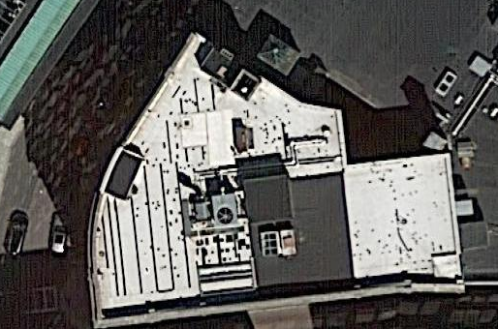

Prepared by:
Massachusetts Department of Public Health
Bureau of Environmental Health
Indoor Air Quality Program
January 2019

Background
Building: | Massachusetts Rehabilitation Commission/Disability Determination Services (MRC/DDS)
Address: | 110 Chauncy Street floors 2-8, Boston
Assessment Requested by: | Erin McCabe, EHS Facilities Deputy Director for Finance and Operations
Reason for Request: | Odor and Indoor Air Quality (IAQ) concerns
Date of Assessment: | January 4, 2019
Massachusetts Department of Public Health/Bureau of Environmental Health (MDPH/BEH) Staff Conducting Assessment: | Ruth Alfasso, Environmental Engineer, indoor air quality (IAQ) Program
Building Description: | This building has eight stories, a brick façade and large glass windows. It is located in downtown Boston near Chinatown. It has a rounded triangular shape which borders on both Chauncy and Essex Street and directly abuts other buildings. Note that the MRC/DSS offices will occupy this building for less than two more years.
Windows: | Openable

Methods
Please refer to the IAQ Manual for methods, sampling procedures, and interpretation of results (MDPH, 2015).

IAQ Testing Results
The following is a summary of indoor air testing results (Table 1).
- Carbon dioxide levels were below MDPH guideline of 800 parts per million (ppm) in all but one areas surveyed, indicating adequate air exchange for the occupancy, which was low in many areas.
- Temperature was within the MDPH recommended range of 70°F to 78°F in most areas tested, however a few were below or above. Temperature complaints in this building are common.
- Relative humidity was below the MDPH recommended range of 40 to 60% in all areas tested which is typical of the heating season.
- Carbon monoxide levels were non-detectable (ND) in all indoor areas tested.
- Fine particulate matter (PM2.5) concentrations measured were below the National Ambient Air Quality (NAAQS) limit of 35 μg/m³ in the areas tested, however the instrument did not function for the majority of the assessment so many areas were not tested for PM2.5.
- Total Volatile Organic Compounds (TVOC) were not detected (ND) in the building apart from two areas with low levels.

Ventilation
A heating, ventilating and air conditioning (HVAC) system has several functions. First it provides heating and, if equipped, cooling. Second, it is a source of fresh air. Finally, an HVAC system will dilute and remove normally-occurring indoor environmental pollutants by not only introducing fresh air, but by filtering the airstream and ejecting stale air to the outdoors via exhaust ventilation. Even if an HVAC system is operating as designed, point sources of respiratory irritation may exist and cause symptoms in sensitive individuals.
Fresh air is provided by air handling units which are located in mechanical closets on each floor. Air from the AHUs is filtered, heated/cooled, and delivered to rooms via ducted supply vents (Picture 1). Air is returned to the AHU through return vents via the ceiling plenum (Picture 2). Additional heating is provided by radiators along outside edges of the building (Picture 3). Each room should have a source of fresh air.
The AHUs draw air in from vents on the exterior of the building. In those AHU rooms examined, the louvers for the outside vents were closed (Picture 4). This is often done as an energy-saving measure to avoid bringing in and heating cold outside air, however without a fresh air supply, carbon dioxide levels and any other indoor pollutants will build up leading to indoor air complaints. On the second and third floors, the AHUs did not appear to be on at all, and no air circulation was being provided.
Note that at least one AHU had a filter that was improperly fitted into the cabinet, and was visibly soiled (Picture 5). Filters should be tightly seated inside each AHU filter frame to prevent air bypass. In addition, filters should be changed a minimum of 2 times a year. It was also noted that AHU rooms appeared open to the ceiling plenum through gaps (Picture 6). If this is intentional, the ceiling plenum is used for return air through these gaps, and the entire AHU room will function as a mixing room. This means that along with ensuring that filters are of good quality, well-seated, and changed frequently enough, the entire AHU room should be kept scrupulously clean to prevent dust and odors from being distributed to occupied areas. If these gaps are not used for air mixing, they should be sealed to prevent any back drafting of dust and odors through exhaust vents. Note that one occupant located on the fifth floor near that AHU room reported periodic odors that the occupant identified as emanating from an exhaust vent (Table 1).
Lack of temperature control was reported by many occupants. A number of thermostats were reportedly deactivated during an energy upgrade project. Occupants reported that the only form of temperature control available were dials on heater vents (Picture 7). A few supply vents were found blocked (Picture 8) reportedly due to temperature concerns. Vents should be unblocked to allow for air circulation.
In some areas, these heater vents were obstructed by items placed on top of them, including plants and paper (Table 1). Not only do these items block heat and circulation, but they can give off odors, especially when heated, and plants can be a source of mold and pollen which can be distributed throughout the space. Some windows were open during the assessment (Table 1). Open windows can be a source of fresh air and assist with thermal comfort, however they should be closed tightly during wet weather and when the air conditioner is in use to prevent water infiltration and condensation.
In some areas, sunlight could be seen streaming in windows. This can be a source of heating and glare. Blinds should be adjusted to prevent discomfort due to sunlight/solar heating.
It is recommended that HVAC systems be re-balanced every five years to ensure adequate air systems function (SMACNA, 1994). It is unknown when the last time this system was balanced.

Odor/Microbial/Moisture Concerns
The main reason for this visit was concerns about odors which reportedly occur some days throughout all floors, including the lobby area, and are similar in strength on all floors when they occur. These odors were described as “like feces/sewage”. No odor was reported or observed the day of the assessment, so direct observation/investigation could not be conducted. Sewage odors can originate from drain traps that have dried out and no longer provide an airtight seal between the sewer and occupied spaces. Occupants reported that there are no unused drains known in the building, but that during previous issues with this odor, bleach was poured into drains which reportedly helped somewhat. Occupants also reported that this odor may correlate with wet or humid weather. The City of Boston is known to have some combined sewers, where both storm and sanitary wastewater drain to the same piping network, and separated sanitary sewers may be subject to infiltration and inflow if pipes are not in good condition. Under these conditions, the air pressure created from increased storm water influx may drive more sewer gases through the vent stacks in the building. If these vents have cracks or gaps, sewer odor may penetrate occupied areas. It may be helpful to have a plumber test the vent system to identify any leaks.
Other signs of water damage were observed, including water-damaged ceiling tiles, paint (Picture 9), and carpeting (Picture 10). The water-damaged ceiling tiles indicate leaks from the building envelope, plumbing, or HVAC system. Water-damaged tiles should be replaced once the leak is repaired. As shown in Picture 10, water damage to carpeting is often the result of spills or leaks from water dispensing equipment. It is recommended that refrigerators and water dispensers be placed in areas without carpeting or on a waterproof mat.
The US Environmental Protection Agency (US EPA) and the American Conference of Governmental Industrial Hygienists (ACGIH) recommends that porous materials (e.g., wallboard, carpeting) be dried with fans and heating within 24 to 48 hours of becoming wet (US EPA, 2008; ACGIH, 1989). If porous materials are not dried within this time frame, mold growth may occur. It is important to have a system to inspect, identify and report leaks and other problems so that drying can begin promptly.
Plants should be well maintained, not overwatered and kept away from the airstream of ventilation equipment to prevent odors, water damage, and pests.

Other IAQ Evaluations
Exposure to low levels of total volatile organic compounds (TVOCs) may produce eye, nose, throat, and/or respiratory irritation in some sensitive individuals. To determine if VOCs were present, BEH/IAQ staff took measurements for TVOCs and examined rooms for products containing VOCs. TVOCs levels above background were detected in two areas, one near a hand sanitizer dispenser and one in the mailroom where printed materials are handled. Other sources of TVOCS such as dry erase markers, cleaning products and air freshening products were also present in the building (Picture 11; Table 1). All of these products have the potential to be irritants to the eyes, nose, throat, and respiratory system of sensitive individuals. It is especially important that there be good ventilation in areas where pollutants may be generated. The mailroom had a supplementary vent installed in the wall to a hallway to draw air from the room (Picture 12). This vent was not in use or inoperable at the time of the visit, however even if it is used, it will distribute odors and TVOCs from the mailroom into other occupied spaces.
Cooking equipment, including toasters, microwave ovens, and coffee machines, were located in various parts of the office space (Picture 13). Food was even used in some of the seasonal decorations. Food areas and cooking equipment need to be kept clean to prevent odors and pests. Unsealed food should not be used as decorations.
In many areas, stored materials and accumulated items make it more difficult for custodial staff to clean (Table 1). Seasonal decorations, which were present on every floor at the time of the assessment, can also be a source of dust and odors and prevent thorough cleaning. Items should be stored neatly and moved periodically to allow for wet-wiping and vacuuming of surfaces. As noted above, items should also not be stored on top of radiators or in the airstream of ventilation equipment as heating and moving air can cause items to release dusts and odors. Some decorations were also hung from the ceiling tile system. This can dislodge dust and debris from and above the ceiling tiles. And since the ceiling plenum is used as a return, it is even more important that the ceiling tile grid remain intact and undisturbed.
Carpets and area rugs should be vacuumed regularly with a high efficiency particulate arrestance (HEPA)-filter-equipped vacuum cleaner and cleaned annually (or semi-annually in soiled/high traffic areas) in accordance with Institute of Inspection, Cleaning and Restoration Certification (IICRC) recommendations, (IICRC, 2012). It was reported that carpets had not been cleaned for several years prior to the BEH/IAQ site visit but that cleaning had been scheduled for the following week.
Some supply and return vents were dusty. Vents and personal fans should be cleaned periodically to remove dust and debris that may become reaerosolized, or moistened and become a source of mold.

Conclusions/Recommendations
Note that the MRC/DDS offices will be leaving this space within the next two years when the lease is over. Therefore, items that require capital investment are unlikely to take place before the move. These recommendations consist of items that will assist in improving and maintaining IAQ in the short time this building will be occupied by the MRC/DDS:
- Keep a log of any odors, including time, location of occurrence, and weather/other conditions to better track potential sources. The BEH/IAQ program is available to revisit the site when odors are occurring to assist with determining a source.
- Consider contracting with a plumber to test building drain pipes/vents for any leaks and repair as needed.
- Operate supply and return ventilation continuously during occupied periods. Ensure any inactive/inoperable AHUs are returned to function.
- Change filters for HVAC equipment 2-4 times a year. Use pleated filters of MERV 8 (or higher), which are adequate in filtering out pollen and mold spores (ASHRAE, 2012), if these can be used with current equipment.
- Ensure AHU filters are well-fitted into each AHU so that no air bypasses them.
- Consider adjusting the louvers for the AHUs to allow more fresh air.
- Since the AHU rooms may serve as mixing rooms, ensure they are kept clean.
- Unblock any blocked supply vents and remove obstructions from heater vents.
- Consider having the HVAC system balanced if it has not been done in the last 5 years in accordance with SMACNA recommendations (SMACNA, 1994).
- Ensure the ceiling plenum is continuous with all ceiling tiles flush in the grid. Avoid hanging items from the ceiling tile grid.
- Ensure there is a system to report temperature complaints and other concerns and to report that they have been resolved.
- Mark inoperable/unused thermostats as such or remove.
- Ensure windows are closed tightly at the end of each day, and that they remain closed during wet weather and when the air conditioning is operating.
- Adjustable blinds should be used to control for solar heating and glare.
- Remove and replace water-damaged ceiling tiles.
- Ensure carpeting that was moistened is properly dried and cleaned within 24-48 hours, or consider replacing.
- Remediate areas of water-damaged building materials in accordance with the EPA guideline “Mold Remediation in Schools and Commercial Buildings” (US EPA, 2008.
- Keep plants in good condition, avoid overwatering, and remove from the airstream of heating and ventilation equipment.
- Use a waterproof mat under refrigerators and water dispensers to prevent spills onto carpeting or consider moving them to areas without carpeting. Keep refrigerators clean.
- Reduce the use of cleaning products, sanitizers, and other items that contain VOCs. Minimize the use of scented products.
- Increase supply and exhaust ventilation for the mailroom if possible.
- Ensure that all cooking equipment is kept clean. Ensure all food is enclosed in tight containers to prevent pests.
- Reduce the amount of materials on surfaces to allow for more thorough cleaning.
- Avoid hanging anything from the ceiling tile system.
- Clean dust and debris from ventilation equipment, including supply and exhaust vents, radiators and the blades of personal fans to prevent aerosolization of dust.
- Clean carpeting annually or more frequently per the recommendations of the Institute of Inspection, Cleaning and Restoration Certification (IICRC).
- Refer to resource manual and other related IAQ documents located on the MDPH’s website for further building-wide evaluations and advice on maintaining public buildings. These documents are available at: http://mass.gov/dph/iaq.

References
ACGIH. 1989. Guidelines for the Assessment of Bioaerosols in the Indoor Environment. American Conference of Governmental Industrial Hygienists, Cincinnati, OH.
ASHRAE. 2012. American Society of Heating, Refrigeration and Air Conditioning Engineers (ASHRAE) Standard 52.2-2012 -- Method of Testing General Ventilation Air-Cleaning Devices for Removal Efficiency by Particle Size (ANSI Approved). 2012.
IICRC. 2012. Institute of Inspection, Cleaning and Restoration Certification. Carpet Cleaning: FAQ.
MDPH. 2015. Massachusetts Department of Public Health. Indoor Air Quality Manual: Chapters I-III. Available at: http://www.mass.gov/eohhs/gov/departments/dph/programs/environmental-health/exposure-topics/iaq/iaq-manual/.
SMACNA. 1994. HVAC Systems Commissioning Manual. 1st ed. Sheet Metal and Air Conditioning Contractors’ National Association, Inc., Chantilly, VA.
US EPA. 2008. “Mold Remediation in Schools and Commercial Buildings”. Office of Air and Radiation, Indoor Environments Division, Washington, DC. EPA 402-K-01-001. September 2008. Available at: http://www.epa.gov/mold/mold-remediation-schools-and-commercial-buildings-guide.
Picture 1
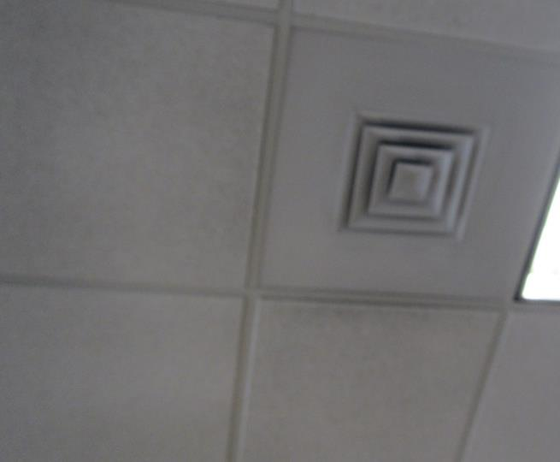
Supply vent
Picture 2
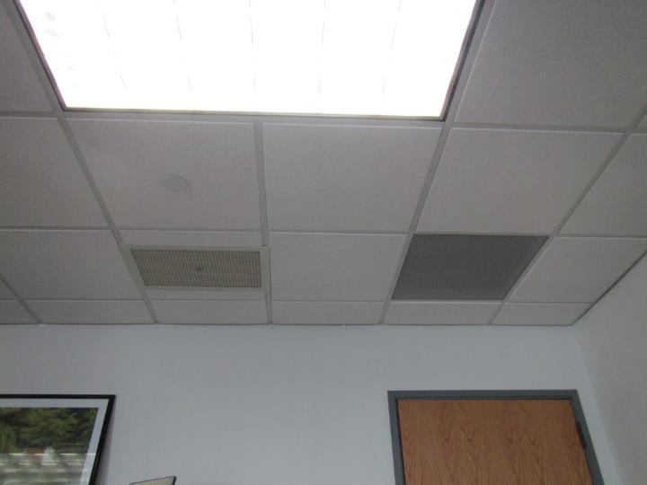
Return vents
Picture 3
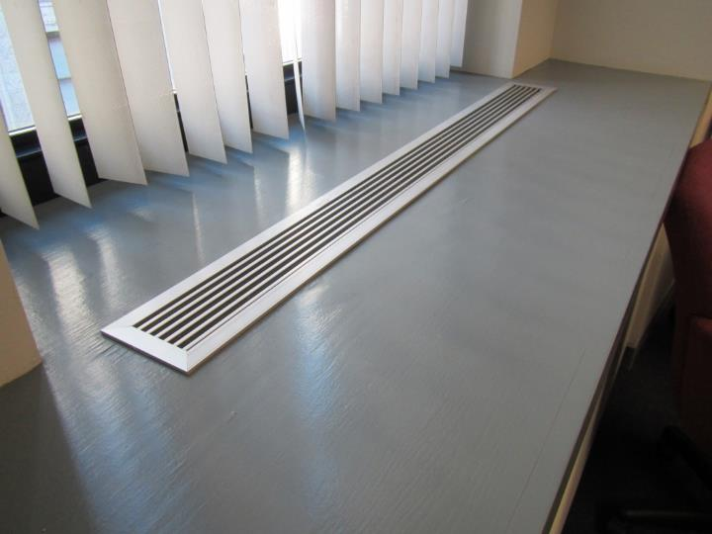
Heater
Picture 4
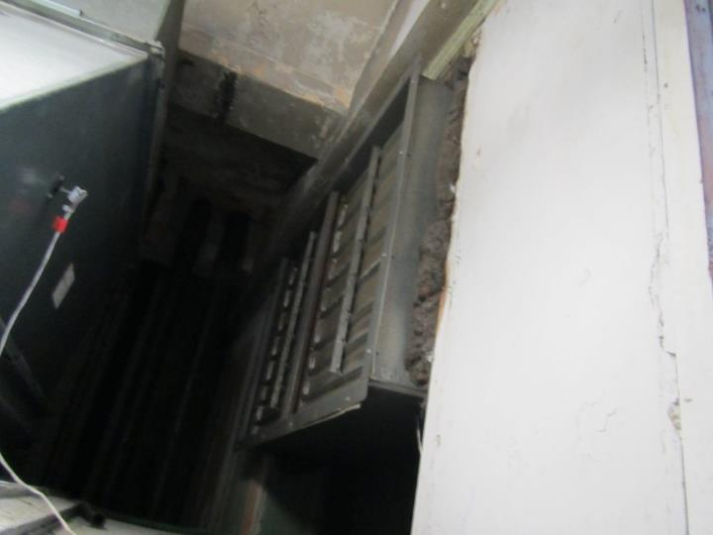
Closed louvers in AHU room
Picture 5
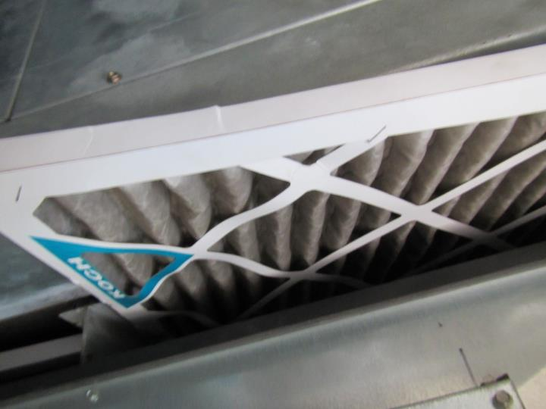
Poorly-fitted, soiled AHU filter
Picture 6
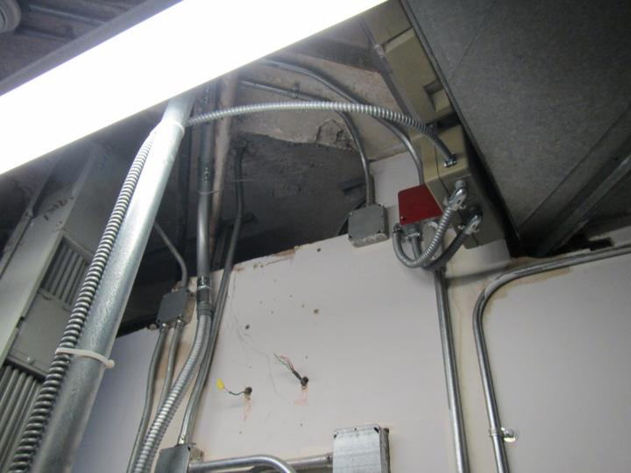
AHU room appears connected to ceiling plenum through this gap
Picture 7
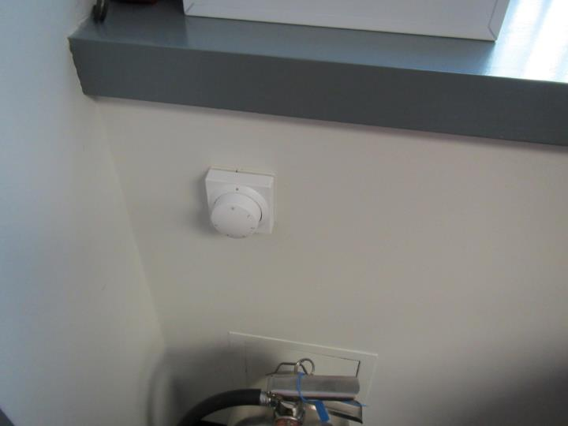
Heater adjustment knob
Picture 8
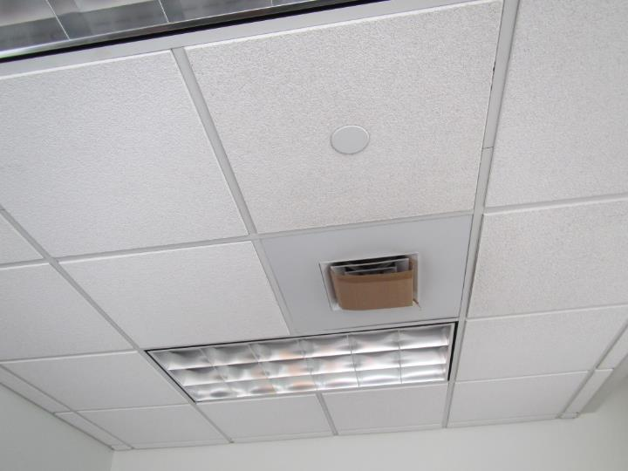
Supply vent blocked with cardboard
Picture 9
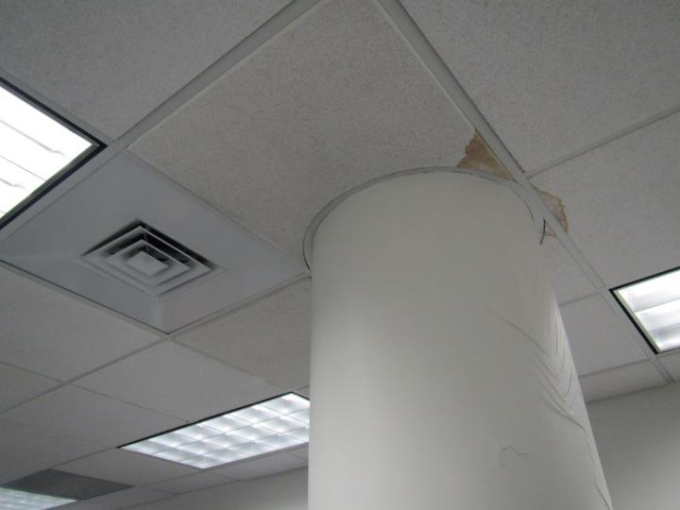
Water-damaged ceiling tiles and paint on a column
Picture 10
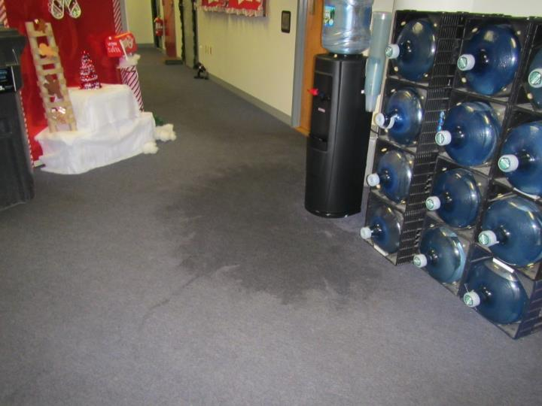
Wet carpeting from a water dispenser leak
Picture 11
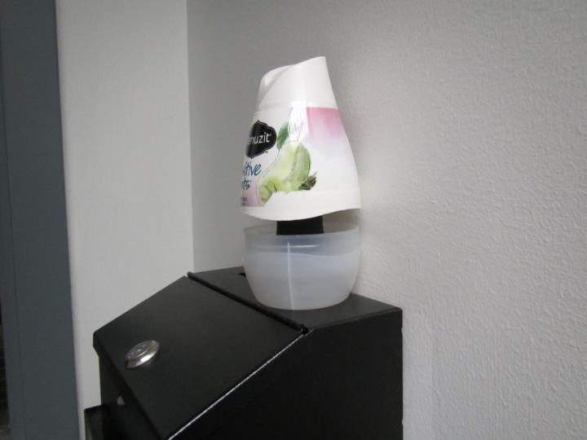
Air freshener
Picture 12
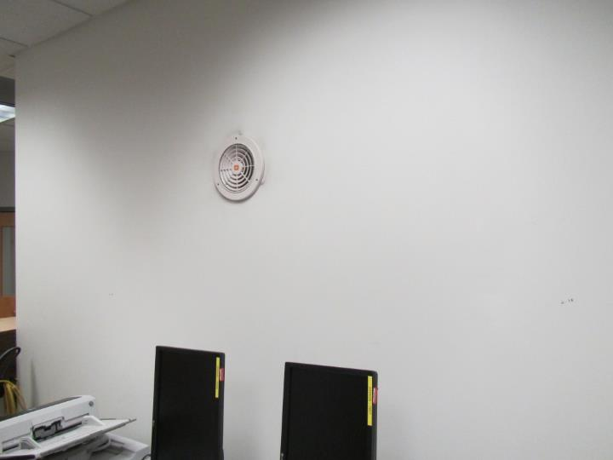
Retrofitted wall fan for the mail room
Picture 13
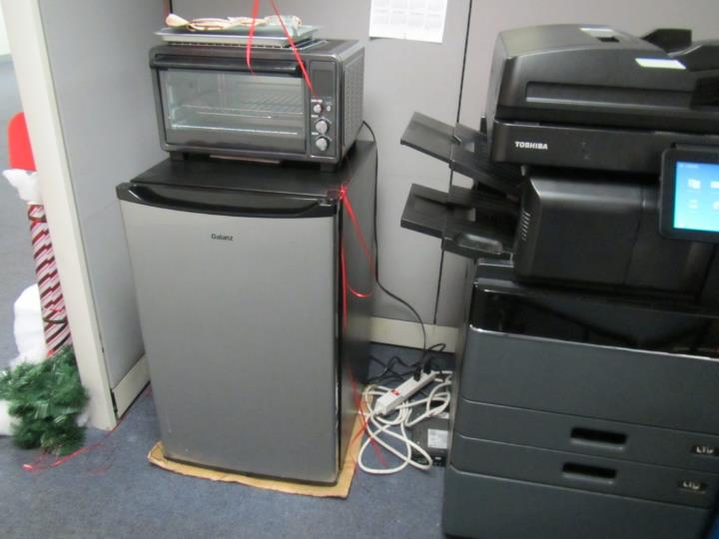
Toaster and refrigerator

Location | Carbon  Dioxide  (ppm) | Carbon Monoxide  (ppm) | Temp  (°F) | Relative  Humidity  (%) | PM2.5  (µg/m³) | TVOCs  (ppm) | Occupants  in Room | Windows  Openable | Ventilation |  | Remarks
 |  |  |  |  |  |  |  |  | Supply | Exhaust
Background | 395 | 0.1 | 57 | 18 | NA | ND |  |  |  |  | Sunny, street level a block away
8th floor
Conference room | 713 | ND | 69 | 26 | 4 | ND | 4 | Y | Y | Y | Stand fan
Area outside conference | 687 | ND | 70 | 25 | 13 | ND | 1 | Y | Y | Y | Dead plant, items on heater, PF, WD CT, WD plaster
8-21 | 613 | ND | 71 | 23 | 5 | ND | 0 | Y | Y | Y | Supply vents blocked with cardboard (temperature complaints)
Fiscal | 575 | ND | 72 | 23 | 5 | ND | 3 | Y | Y | Y | Items, WD CT (6), WD carpet, food
Area outside mechanical room | 566 | ND | 71 | 22 | 4 | ND | 0 | Y | Y | Y | WD carpet (water cooler leaked)
Kitchen/  conference | 559 | ND | 70 | 23 | 5 | ND | 0 | Y | Y | Y | Microwave and food
8-41 | 569 | ND | 70 | 23 | 5 | ND | 1 | Y | Y | Y | Plants on heater vent
8-28 | 615 | ND | 70 | 23 | NA | 1.5 | 1 | Y | Y | Y | Plant on heater vent, HS
7th floor
Waiting | 661 | ND | 72 | 21 | NA | ND | 0 | N | Y | Y
7-28 | 539 | ND | 72 | 18 | NA | ND | 0 | Y | Y | N | PF – on, salt lamp
7-14 | 532 | ND | 71 | 18 | NA | ND | 0 | Y | Y | N | Items hanging from ceiling
7-12 | 577 | ND | 72 | 18 | NA | ND | 1 | Y | Y | N
7-15 | 715 | ND | 72 | 19 | NA | ND | 1 | N | Y | Y
7-11 | 578 | ND | 72 | 18 | NA | ND | 0 | Y | Y | N | Items on heater vents
7-9 cube area | 551 | ND | 72 | 18 | NA | ND | 1 | Y | Y | Y
Server office | 636 | ND | 72 | 21 | NA | ND | 1 | Y | Y | Y | Stained carpet
6th floor
Essex street side cubes | 696 | ND | 74 | 20 | NA | ND | 3 | Y | Y | Y
Essex side interior cube area | 623 | ND | 75 | 19 | NA | ND | 3 | N | Y | Y | Refrigerator on carpet, items hanging from ceiling
6-14 cube area | 576 | ND | 74 | 18 | NA | ND | 3 | Y 1 open | Y | Y
6-52/53 office | 752 | ND | 76 | 19 | NA | ND | 1 | Y | Y | Y | PF
6-21 cube area | 551 | ND | 75 | 17 | NA | ND | 3 | Y 1 open | Y | Y | Food
6-49 | 538 | ND | 73 | 17 | NA | ND | 0 | N | Y | Y | Refrigerator, microwave and toaster, CP
5th floor
5-25 cube area | 660 | ND | 74 | 23 | NA | ND | 1 | Y | Y | Y
5-13 | 723 | ND | 75 | 24 | NA | ND | 5 | Y | Y | Y | Plants and flowers, PF, sun
5-10 cube area | 726 | ND | 76 | 25 | NA | ND | 3 | Y | Y | Y | AI, PF, reports of periodic fumes
4th floor
4-12 cube area | 683 | ND | 76 | 31 | NA | ND | 2 | Y | Y | Y | AI, plant on heater vent
4-05 cube area | 713 | ND | 75 | 32 | NA | ND | 5 | N | Y | Y | PF
4-51 cube area | 686 | ND | 76 | 32 | NA | ND | 2 | Y | Y | Y | Plants on heater vent
4-42 cube area | 692 | ND | 76 | 31 | NA | ND | 5 | Y | Y | Y | Plants
4-48 cube area | 678 | ND | 76 | 30 | NA | ND | 1 | N | Y | Y | CP
4-27 | 740 | ND | 76 | 32 | NA | ND | 1 | N | Y | N | Reed scent diffusers
4-26 | 737 | ND | 77 | 31 | NA | ND | 1 | N | Y | N | PF on, AI
4-50 cube area | 736 | ND | 77 | 31 | NA | ND | 0 | N | Y | Y
3rd floor
3-49 cube area | 617 | ND | 76 | 18 | NA | ND | 0 | Y | Y | Y
3-11 cube area | 619 | ND | 76 | 18 | NA | ND | 2 | Y | Y | Y | PF – dusty
3-16 | 686 | ND | 76 | 19 | NA | ND | 1 | N | Y | Y | Area rug
3-52 cube area | 622 | ND | 76 | 18 | NA | ND | 1 | N | Y | Y | Water cooler on carpet
Kitchen | 662 | ND | 77 | 18 | NA | ND | 0 | Y | Y | Y | Refrigerator, microwave and toaster
3-01 | 575 | ND | 77 | 18 | NA | ND | 1 | Y | Y | Y
3-02 | 628 | ND | 77 | 18 | NA | ND | 0 | Y | Y | Y | Plants
3-03 | 586 | ND | 77 | 18 | NA | ND | 0 | Y | Y | Y | AI
Lactation/rest | 545 | ND | 77 | 16 | NA | ND | 0 | N | Y | Y | Bed with sheets, used
Training (in use)
3-05 | 530 | ND | 76 | 16 | NA | ND | 0 | Y | Y | Y
3-06 | 568 | ND | 76 | 16 | NA | ND | 0 | Y | Y | Y
2nd floor
2-30 | 868 | ND | 78 | 16 | NA | ND | 0 | Y | Y | Y | Slight burning rubber odor, food
2-32 | 622 | ND | 77 | 17 | NA | ND | 1 | Y | Y | N | Refrigerator on carpet
2-29 | 680 | ND | 78 | 18 | NA | ND | 0 | Y | Y | N | Plants
2-20 cube area | 600 | ND | 78 | 17 | NA | ND | 2 | Y | Y | Y | Solar heating
QA office | 593 | ND | 79 | 18 | NA | ND | 3 | Y | Y | Y
2-06 | 632 | ND | 79 | 16 | NA | ND | 1 | Y | Y | Y | AI – paper
2-03 | 600 | ND | 79 | 16 | NA | ND | 1 | N | Y | Y | Dusty exhaust vent, dead plants
2-34 cube area | 575 | ND | 79 | 16 | NA | ND | 3 | N | Y | Y | PCs
Mailing | 570 | ND | 80 | 16 | NA | 0.8 | 0 | N | Y | Y
Waiting | 604 | ND | 80 | 15 | NA | ND | 4 | N | Y | Y | WD CT

