Massachusetts SCO Evaluation
Nursing Facility Residency and Mortality
Summary Report

November 23, 2015

 | JEN Associates, Inc.  5 Bigelow Street  Cambridge, MA 02139  Phone: (617) 868-5578 • Fax: (617) 868-7963
Contents
Executive Summary 3
Introduction 4
Cohort Selection 4
Assessment Hurdles 5
Data Sources 5
Descriptive Statistics 6
Comparison with a Control Population 10
Analytic Design 11
NF Residency Months 12
Mortality in Potential 8 Year Follow-up Period 17
Conclusions 18

Executive Summary
Senior Care Options (SCO) is an integrated Medicare-Medicaid managed care program offered to elderly dually eligible Massachusetts residents since 2004. MassHealth and the federal Centers for Medicare & Medicaid Services (CMS) contract with qualified managed care plans to provide SCO enrollees with a unified benefits package that includes the full range of Medicaid and Medicare services plus additional, program determined, care support.
The present SCO evaluation focused on patterns of nursing facility (NF) entry subsequent to SCO enrollment. The study population consisted of community-dwelling Massachusetts residents enrolling in a SCO plan from 2004 through 2011 and a matched control cohort covered by the traditional, separate fee-for-service (FFS) Medicaid and Medicare programs. A case/control cohort study design balanced many inter-cohort differences using direct matching methods for morbidity, utilization history and demographics.
All annual cohorts were followed through the end of calendar year 2012. Follow-up was censored on the basis of death, loss of Medicare FFS eligibility, or loss of SCO enrollment status. The model directly addressed censoring due to the variable follow-up times experienced by cases and controls. Nursing facility residency was identified through the Nursing Home Minimum Data Set (MDS) assessment records filed with CMS (new enrollees in 2007-2011). These records are equally available for the SCO and FFS control populations. In addition a multivariate proportional hazards model adjusted for additional confounding factors before yielding the independent association between SCO enrollment and death (new enrollees in 2004-2011).
Aside from SCO enrollment, the pre-index presence of certain chronic diseases and use of community-based or short-term nursing facility services had strong, independent correlations with future outcomes among SCO enrollees and their matched controls. High scores in the JEN frailty index (a morbidity measure using pre-enrollment period diagnoses) were associated with a 170%-192% increase in the risk of NF residency months.
Over the follow up periods, new SCO enrollees exhibit reduced nursing facility entry (12% reduction in NF residency months) and mortality (17% risk reduction in death rate) compared to non-enrollees, possibly due to the care improvements brought about by integrating Medicare and Medicaid services and adding special service types based on enrollee need. The lack of service utilization data after SCO enrollment obscures the mechanism driving these benefits, however. Medicaid’s collection of SCO encounter data, starting in 2013, and Medicare’s new Encounter Data System (EDS), initiated in January 2012, will provide abundant new utilization data for its managed care beneficiaries. Besides helping to explain the nursing facility and mortality reductions found in the present evaluation, EDS records will provide further information on SCO’s overall advantages as related to specific patterns of services.

Introduction
The MassHealth Office of Long-Term Services and Supports has contracted with JEN Associates, to provide analytical and statistical consulting support for the MassHealth Senior Care Options (SCO) program. JEN linked the administrative data for Medicare and Medicaid and then developed and provided critical descriptive and financial information needed to structure and implement the SCO model.
SCO is an integrated Medicare and Medicaid managed care program available to aged 65 and older Medicaid-eligible beneficiaries since 2004. Massachusetts Medicaid and the federal Centers for Medicare & Medicaid Services (CMS) contract with qualified managed care plans to provide a complete benefit package that includes the full range of Medicaid and Medicare services for enrollees of all disability levels.
The SCO program’s goal is to take advantage of Medicare-Medicaid integration to enhance coordination of care. A Medicaid capitation structure that is responsive to changing levels of frailty make SCO plans especially well-suited for providing flexible and extended community care to enrollees. The standard Medicare capitation rate based on the previous year’s diagnoses is used for Medicare services.
It is hypothesized that the impact of the SCO model is based on the dynamic nature of the Medicaid capitation rate and the requirement to perform regular assessments. This financing feature differentiates SCOs from other capitated programs. There is a financial incentive to recognize a high-risk case and to manage both the Medicaid and Medicare benefits to reduce adverse events. One of the most costly events to Medicaid is long-term entry into a nursing facility (NF). By increasing access to community long-term care in a timely way, it is hypothesized that SCO will reduce NF rates.

Cohort Selection
To assess SCO’s actual impact on nursing facility entry, JEN identified annual cohorts of SCO enrollees matched control cohorts for the 2004-2011 period and followed them through 2012. SCO enrollees included in the study were community-dwelling Massachusetts residents with dual Medicaid/Medicare eligibility and no Medicare managed care participation during the three months prior to their SCO enrollment month. Follow-up could be truncated by death, loss of Medicare FFS eligibility, or either SCO discontinuation (cases) or enrollment (controls). The year-month of SCO enrollment, as observed in the Medicaid eligibility data, served as the index month.
The analytic challenge was to identify an equivalent non-SCO control population so that unbiased comparisons could be made with the SCO enrollees. The control selection specification aimed for 3 controls to be selected for each case. Controls were assigned the same index month as their cases and required to have dual Medicaid/Medicare eligibility without Medicare managed care participation during the three months prior to the index month.

Assessment Hurdles
The SCO program is difficult to evaluate for reasons relating to data availability and the obstacles to identifying appropriate comparison populations. Health care services delivered by SCO do not go through the traditional Medicaid and Medicare claims systems. In exchange for fixed per-patient capitation payments, SCO programs assume the economic risk of covering all medical and support services. When beneficiaries transfer from traditional fee-for-service Medicare and Medicaid to SCO, the stream of claims data dries up. The loss of the data stream makes it challenging to perform comparisons of care patterns before and after SCO enrollment or between SCO and non-SCO populations.
The lack of usable data is an especially acute issue when evaluating nursing facility rates. In analyses of fee-for-service care, the key measurement is the initiating and continuation of nursing facility claims in the claims records. With this data missing due to SCO’s capitated payments, there is no clear way to isolate the SCO nursing facility population and link it to similar non-SCO comparator populations. In order to proceed, researchers are forced to find a common alternative source of information on nursing facility admissions and residency.
One such alternative source is the national Nursing Home Minimum Dataset (MDS). CMS requires licensed nursing facilities to perform detailed medical assessments of their patients upon entry and periodically thereafter. This information is recorded in the MDS filings. MDS data on SCO enrollees can serve as a direct measure of nursing facility utilization. Avoidance of long-term institutionalized custodial care represents the bulk of SCO’s expected savings. An episode grouper applied to MDS assessment dates can separate these long-term residencies from short-term rehabilitative stays, which also require MDS records.
A complete, risk-adjusted analysis of long-term nursing facility stays can take advantage of patients’ previous claims data for SCO and comparator populations alike. These records will indicate the presence of chronic disease and disability as well as measures of prior care. Meanwhile, the MDS records will indicate the rate of nursing facility entry and use both before and after SCO enrollment. Including in the follow-up period person-time after SCO discharge is necessary since the transition to nursing facility residency may be to a facility that is not affiliated with SCO.

Data Sources
This study collected 2003-2012 Medicare and Medicaid claims and enrollment data for all Massachusetts resident Medicaid and Medicare dually eligible beneficiaries. For the same period, Nursing Home MDS records were individually linked to the Medicaid and Medicare claims histories. The integration of data from the three sources resulted in the creation of person-level longitudinal analytic records summarizing monthly service utilization by hospitalization episodes, disease and disability diagnoses, program administrative status, beneficiary residence, MDS nursing home status and other key indicators. The blended data source was designed for the tracking of SCO participants before and after the identification of comparison study subjects.

Descriptive Statistics
The enrollees profiled here consist of new SCO enrollees identified from 2007 through 2011 (the study period was determined by the availability of MDS data). The study period for each subject included one-year Medicare enrollment prior to SCO with at least one quarter under fee-for-service financing (in order to assess baseline healthcare service utilization for SCO enrollees and matched controls). MDS nursing facility episodes were analyzed through 2012.
The SCO population consists of Medicare and Medicaid beneficiaries. At the time of enrollment, SCO performs a patient assessment to determine LTSS need. The statistics below focus on new SCO enrollees.
The population is growing at an annual rate of 26.9% (Figure 1) between CY2007-CY2012. Steady growth in new enrollees is to some degree offset with a SCO population annual mortality rate of 6.4% and an annual disenrollment rate of 10.1%. The net effect of the enrollment rate, mortality and disenrollment rates is a 10.4% overall annual growth rate.
Figure 1: New SCO Enrollees CY 2007-2012
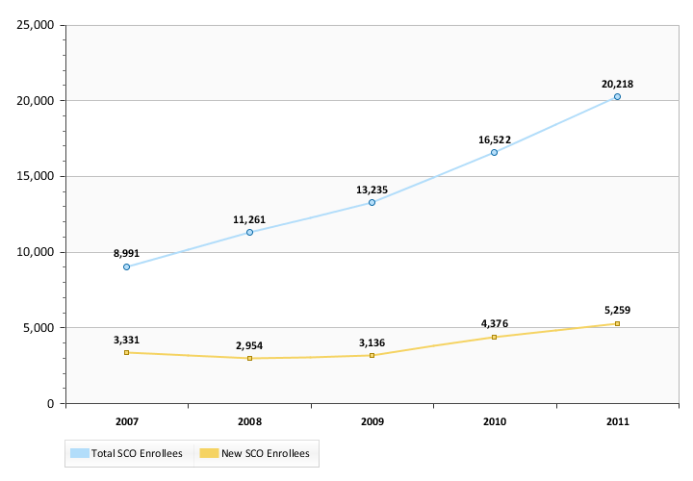
The enrolling population is to some degree bimodal in years of age (Figure 2) with peak for both younger populations and the very old. The population is overall predominantly Female and Caucasian (Table 2). The demographic distribution is very similar to a Medicaid-Medicare FFS and elderly dual population. The rates of Alzheimer’s/dementia (AD) are 15% (Figure 3), which is similar to the rate in the FFS dual eligibles of 27%. Heart Failure shows a similar pattern with 14% prevalence in SCO enrollees and 20% the elderly FFS dual eligibles. The frailty score profile in Figure 4 shows a 56% low frailty (index levels 0-3), in the FFS population the rate is 45%. The SCO population, in comparison to FFS elderly dually eligibles, is generally distributed proportionally across the counties (Table 1) - with the exception of a higher concentration of SCO new enrollees in Worcester. The overall community and NF resident populations entering SCOs are distributed proportional to a dual eligible FFS population. The main part of departure is a significantly lower level of community dwelling LTSS users in the SCO enrollees.
The SCO new enrollee population presents as similar in demographics to a Massachusetts elderly dual eligible population. The morbidity and frailty measures show SCO new enrollees to be healthier and less likely to be using community LTSS services prior to enrollment. It should be noted that there are significant variations in enrollee populations between SCO plans.
Figure 2: New SCO Enrollees Demographic Distribution CY 2007-2012
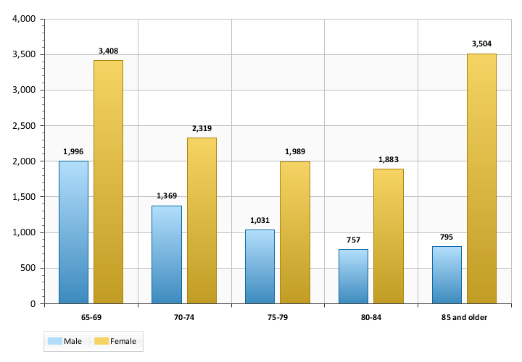
Figure 3: Selected Condition Prevalence in New SCO* Enrollees CY 2007-2011
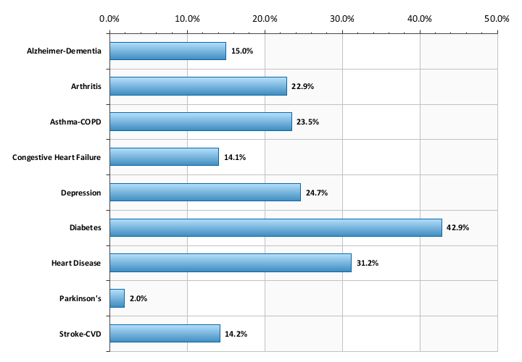
*Restricted to FFS in quarter prior to index date
Figure 4: New SCO Enrollee* Frailty at Index Distribution CY 2007-2011
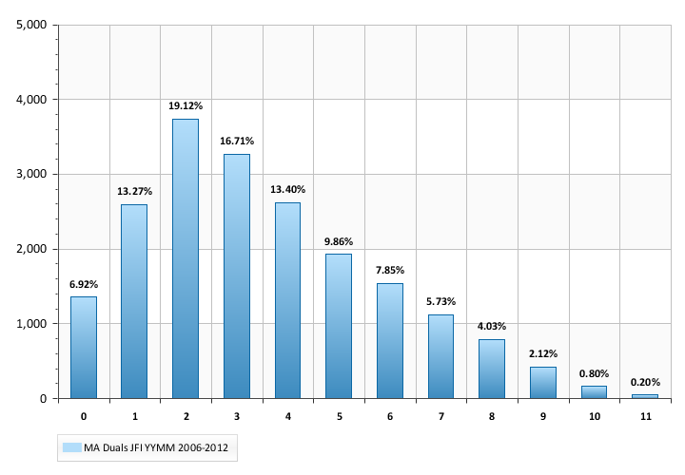
*Restricted to FFS in quarter prior to index date
Figure 5: New SCO Enrollee LTSS Status at Index CY 2007--2011
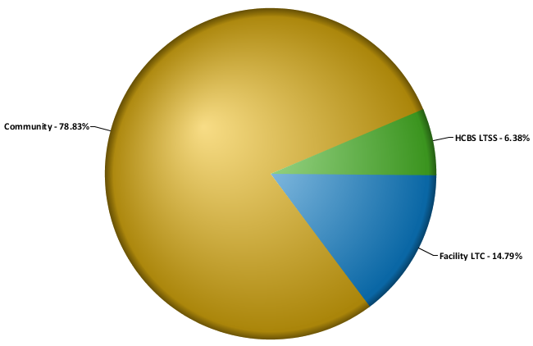

Table 1: New SCO Enrollee County of Residence CY 2007-2012
FIPS County | Population
Barnstable | 0.1%
Bristol | 12.4%
Essex | 11.9%
Hampden | 7.5%
Middlesex | 15.5%
Norfolk | 6.0%
Plymouth | 4.2%
Suffolk | 21.6%
Worcester | 20.9%
Table 2: New SCO Enrollee Race-Ethnicity Distribution CY 2007-2012
Race-Ethnicity | Population
Unknown | 1.2%
Caucasian / White | 60.0%
Hispanic | 11.7%
Native American/Alaskan Native | 4.2%
Asian | 13.0%
Black/African American | 9.9%
Asian Indian | 0.1%

Comparison with a Control Population
The premise of SCO enrollment is that new participants are subject to initial and follow-up health and functional status assessments. Triggers for follow-up assessments are determined on an individual basis. The SCO Medicaid rate increases for individuals assessed as requiring community LTSS services. The changes in rate level are observable but the disease patterns and utilization leading to the change are not observable. The ideal control selection includes finding non-SCO, FFS dual eligibles with the same expected disease and utilization trajectory based on matching in a pre-enrollment/index date period.
To address the challenge of identifying a valid comparison population, the study developed a 1:1 matching strategy based on both static and time-varying personal characteristics (Table 3). The static characteristics included individual demographics and the presence of long-standing chronic diseases and disabilities. For cases (new SCO enrollees) and controls (matched non-SCO comparison population), the time-varying matching factors, including recent history of acute and post-acute care utilization, were mapped by month relative to an index date (SCO enrollment date or proxy). The result was the production of a matched comparison population with disease and utilization histories that effectively mimic the patterns observed in SCO population prior to enrollment. The direct match group served as a first level approximation for detailed comparison. In a later step a direct/propensity matched control selection was implemented to generate a 3:1 match.
Table 3: Case-Control Matching Characteristics
Characteristic | Time Window
Medicaid Eligibility Type | At Index Month
Medicaid Full Eligibility Yes/No | 1-3 Months before Index
Medicaid Full Eligibility Yes/No | 4-6 Months before Index
Medicaid Full Eligibility Yes/No | 7-12 Months before Index
Medicare A-B Eligibility Type | At Index
Medicare A-B Eligibility/MA Type | 1-3 Months before Index
Medicare A-B Eligibility/MA Type | 4-6 Months before Index
Medicare A-B Eligibility/MA Type | 7-12 Months before Index
Medicare SNF Utilization Yes/No | 1-3 Months before Index
Medicare SNF Utilization Yes/No | 4-12 Months before Index
Medicare Acute Inpatient Utilization Yes/No | 1 Month before Index
Medicare Acute Inpatient Utilization Yes/No | 2-3 Months before Index
Medicare Acute Inpatient Utilization Yes/No | 4-12 Months before Index
Long-Term Institutional Status Yes/No | 1-6 Months before Index
High Frailty Score Status Yes/No | At Index
Heart Failure Yes/No | 0-12 Months before Index
Alzheimer's/Dementia Diagnosis Yes/No | 0-12 Months before Index
Chronic Mental Illness Diagnosis Yes/No | 0-12 Months before Index
Age Band, Sex, Race | At Index from Medicare
Index Year | Case enrollment year
Medicare Original Entitlement Reason | Index Year
Head-to-head comparison in matched populations of nursing facility status and death post index date provides basic measures of potential effects. The matching case and control experience effectively adjusts for underlying factors related to demographics, Medicaid and Medicare administrative status, history of chronic disease, frailty and prior service utilization. Characteristics that are matched cannot be further analyzed through the application of multivariate methods. The result is that statistical analyses based on two sample t-tests or chi-square tests are sufficient for measurements of overall differences. The major dependent variables are the number of months in a long stay nursing facility episode and death during the post-index, follow-up period.

Analytic Design
All SCO enrollees with a pre-index Medicare eligibility history are included in the analysis. New SCO enrollees (index date is the enrollment date) were identified in 2004-2011 and were required to have12 months of pre-index Medicare history. At least 3 months in the pre-index period were required to be fee-for-service Medicare in order to account for baseline utilization history and diagnoses. Due to the availability of MDS data, the analysis of long stay nursing facility utilization was restricted to the new SCO enrollees and their matched controls from 2007-2011. A challenge is that individuals with Medicare Advantage (MA) enrollment near the index date will not be matchable on utilization or diagnoses in the immediate pre-index period. A history of MA status in the pre-index period was a matching factor. All study subjects were required to be dually eligible at the index date. The timing of the pre-index full Medicaid (not QMB-Only) eligibility status is incorporated into the matching algorithm. SCO enrollees identified as NF residents at the time of index were not included in this analysis. The SCO plans included in the analysis were Ever Care, Senior Whole Health and CCA.

NF Residency Months
The outcome of interest was a count of the number of months of NF residency in the post index observation period (2007-2012). NF residency was counted as episodes of stay of 4+ months – exceeding the window for the period of post-acute recovery/rehabilitation. The data source for the determination of NF residency was the Nursing Home Minimum Dataset (MDS) 2.0 and 3.0. The MDS data includes patient assessments that are administered on a periodic basis. CMS requires that MDS assessment be conducted for all individuals in a NH/NF stay regardless of payer. The exact periodicity of the assessments varies depending on length of stay. In order to determine monthly NF status an episode grouping algorithm was used to link assessments related to the same stay and to generate from monthly study subject status. Episodes were only generated for stays that could be classified as long-stay/permanent residency. The study period includes assessment data from MDS 2.0 and MDS 3.0 sources. The difference in the instruments was not significant in regard to the assessment dates. The result of the algorithm was a person-level longitudinal monthly database with a flag for NF residency.
Control study time was censored based on the number of eligible follow-up months through CY 2012. Case follow-up time also ran through CY 2012 but data was censored for SCO enrollees who left the program and resided in the community for the subsequent 3 months. The time truncation was implemented to ensure that NF residency that started substantially after a SCO discharge was not counted as a SCO outcome. Discharged SCO subjects, with NF residency status within 3 months of discharge, were followed to the end of the database. The impact of the censoring did not substantially affect the results.
Figure 6 profiles the long-term institutionalized rate for SCO enrollees (cases) and comparison subjects (controls) over a 5 year observation period 2007-2012. Both cases and control were community dwelling on the index date. The onset of SCO enrollment does not have an immediate substantial effect on monthly NF residency rates. There is a significant decrease for SCO enrollees over the observation period but the range of the difference is to some degree limited but the low levels of long stay NF utilization in the overall population. The stratification of the profiles by NF-entry risk as determined on the index date (using diagnoses from the 12 months prior) is more illustrative of SCO impact. The cases and controls are matched on frailty. Figures 7-9 show the stratified results. The x-axis are the calendar years from the index date.
Figure 6: Total SCO New Enrollees Population CY 2007-2011
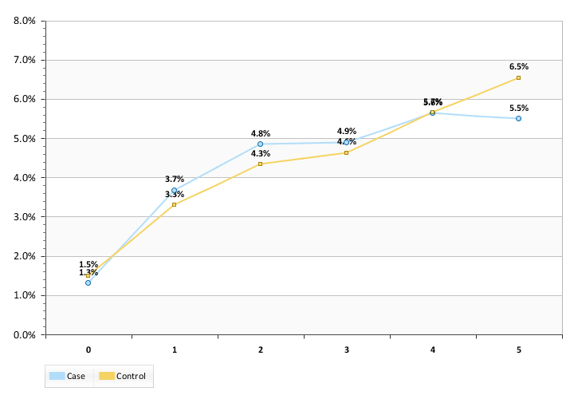
Figure 7: Low Risk at Index SCO new Enrollees Population CY 2007-2011
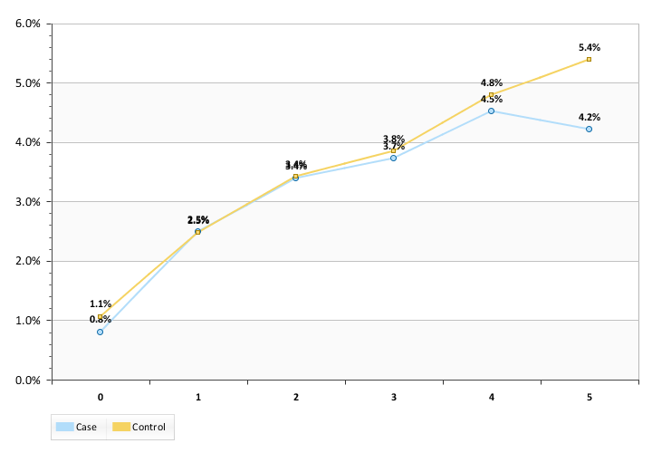
Figure 8: Medium Risk at Index SCO new Enrollees Population CY 2007-2011
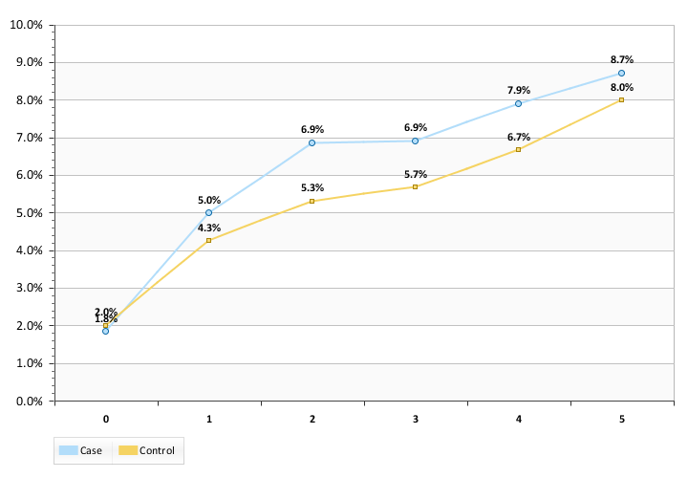
Figure 9: High Risk at Index SCO new Enrollees Population CY 2007-2011
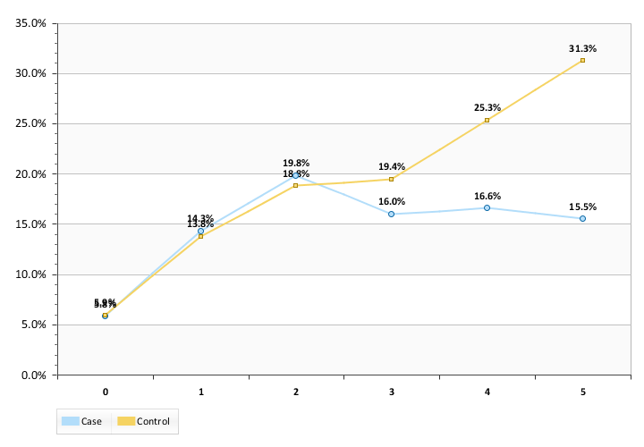
The effect of SCO on NF monthly residency is markedly different based on the index date risk stratification. Low risk enrollees potentially demonstrate a small impact starting in year 3. Medium risk enrollees do not appear to benefit from SCO and after year1 present as higher risk for NF residency. The high risk population cases and controls present with comparable risk through year 2; subsequently the SCO enrollees show a marked decrease in risk compared to the controls.
There are several differences between both the data and the current analytic approach relative to previous studies: 1) the study focuses on counts of NF residency months, not the risk of NF initiation; 2) the data includes study subjects from new plans. In order to correct for plan level differences introduced by plan start-ups we chose to focus on the historical SWH, EC and CCA plans. The other SCO plans have limited follow up time in the current data. Figure 10 provides a descriptive profile of the NF residency model in data from just the selected plans.
Figure 10: Total SCO New Enrollees Population Follow-up NF Residency CY 2007-2011
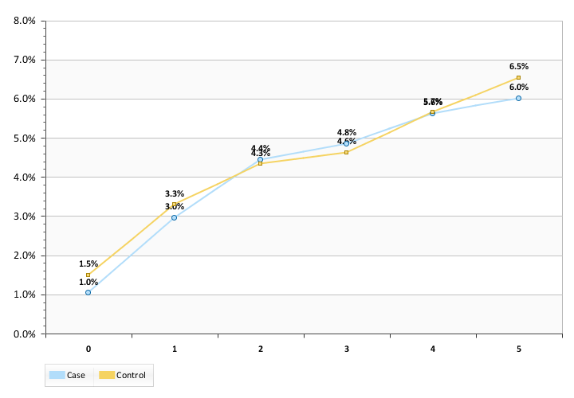
To increase the power of the statistical analysis and to maintain continuity with previous analyses a new comparison population was drawn using propensity methods (described in earlier JEN reports) to identify a 3:1 match. A multivariate linear regression model was implemented to correct for remaining imbalances in control characteristics. In Figure 10 the monthly NF residency is again plotted but restricted to the 3 historical plans. Analyzing data for the 2007-2011 new SCO enrollees restricted to the 3 long standing plans the Table 5 summary statistics.
Table 4: Summary SCO and Comparison in Months 1-60 from Study Index
Study Population | Average Follow-up Months | Average Months of NF in Total Population | Average Months of NF Residency in Outcome Population
SCO Enrollees | 30.7 | 1.0 | 12.5
Comparison | 31.2 | 1.1 | 13.9
The monthly NF residency rate in the SCO enrollees is 3.3% and 3.4% for the comparison group. The multivariate model adjusts for differences between the study populations not controlled for in the case-control direct matching. The results of the multivariate model for the selected case population and the expanded controls are presented in Table 7.
Table 5: Summary SCO and Comparison in Months 1-60 from Study Using Index Multivariate Linear Regression Methods
Variable Label | Estimate | Standard Error | tValue | Pr > |t|
Dep Variable Mean | 1.0554 | . | . | .
R-Square | 0.0655 | . | . | .
Adj R-Sq | 0.0652 | . | . | .
Intercept | -0.5847 | 0.0682 | -8.57 | <.0001
SCO Enrollee | -0.1451 | 0.0535 | -2.72 | 0.0066
Home Health Utilization 1-3 Months Pre-Index | 1.0522 | 0.0955 | 11.02 | <.0001
Assisted Living Utilization 1-3 Months Pre-Index | 4.5419 | 0.2688 | 16.90 | <.0001
Day Habilitation Utilization 1-3 Months Pre-Index | -0.5253 | 0.1059 | -4.96 | <.0001
MCD Waiver Utilization 1-3 Months Pre-Index | 1.3814 | 0.0907 | 15.23 | <.0001
NF Utilization 1-3 Months PreIndex | 1.6079 | 0.1176 | 13.67 | <.0001
SNF Utilization 1-3 Months PreIndex | 0.9730 | 0.2068 | 4.71 | <.0001
FFS-Dual Eligible from July Indexyy-1 | -0.4601 | 0.0683 | -6.73 | <.0001
Indexyy-1 Eligibility/JEN Frailty Score 4-6 | 0.3548 | 0.0611 | 5.81 | <.0001
Indexyy-1 Eligibility/JEN Frailty Score 7+ | 0.9040 | 0.0982 | 9.21 | <.0001
Indexyy-1 Eligibility/Diabetes | -0.1499 | 0.0543 | -2.76 | 0.0058
Indexyy-1 Eligibility/CVD | 0.5375 | 0.0844 | 6.37 | <.0001
Indexyy-1 Eligibility/CHF | 0.5007 | 0.0867 | 5.78 | <.0001
Follow-up Months through 2012 | 0.0449 | 0.0013 | 33.91 | <.0001
The dependent variable in the model is the number of NF residency months in the follow-up period. The calculated impact of SCO enrollment is a 0.14 month reduction in NF residency per person over the observation period. The monthly average NF residency in the study population is 1.1 months. The adjusted SCO program impact is a statistically significant 12% reduction in NF residency months. Prior JEN studies of using data through 2010 found a 16% reduction in the risk of long stay NF residency entry; the earlier studies did not look at the number of reduced NF Residency months.
Mortality Risk Analysis
To determine the potential impact of SCO enrollment on mortality a Proportional Hazards model was designed and implemented. New SCO enrollees from 2004-2011 and their matched controls were included in the analysis. The study period was truncated to only include SCO enrolled months for the cases. Case deaths that occur within 1 month after discharge were attributed to SCO. Controls were followed to the end of the database. The NF status at the index date was not restricted.

Mortality in Potential 8 Year Follow-up Period
The mortality risk model is designed to evaluate risk of an outcome in data with variable follow-up time. The model establishes the correlation between a set of covariates and death. The covariate list in the model is based on a step-wise selection of candidate correlated factors. The variable for SCO status is forced in the model to measure the impact of case status. Figure 11 shows the unadjusted probability of death by month from index. Model results are presented in Table 7. The overall mortality rate in the cases and controls is approximately 20%. The study population used the 3:1 direct/propensity matched populations employed for NF residency analysis as well as the cases and controls excluded for NF residency at index.
The total period survival probability curve shows some evidence of reduced mortality probability for SCO enrollees. The observed mortality rate over the total follow-up period for the cases is 19.3% and 23.7% for the controls. The difference is statistically significant.
Figure 11: Monthly Survival Probability after Index Date
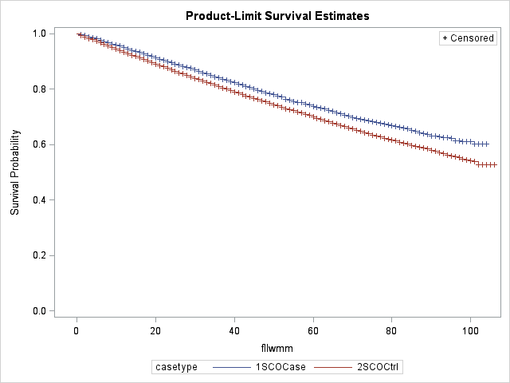
The results from the adjusted model are presented in Table 7 and validate the size and significance of the observed mortality differences. The findings are similar to previous analyses conducted on data through 2010.
Table 6: Mortality Risk in the Follow-up Period Hazards Model
Covariate | Estimate | StdErr | ChiSq | Prob ChiSq | Hazard Ratio | HR Lower | HR Upper
SCO Enrollee | -0.19 | 0.02 | 89.46 | <.0001 | 0.83 | 0.80 | 0.86
Pre-Index Date Covariates
Inpatient Utilization 1-3 Months | 0.34 | 0.02 | 200.22 | <.0001 | 1.41 | 1.35 | 1.48
Home Health Utilization 1-3 Months | 0.38 | 0.02 | 283.75 | <.0001 | 1.46 | 1.39 | 1.52
Assisted Living Utilization 1-3 Months | 0.24 | 0.07 | 11.81 | 0.0006 | 1.27 | 1.11 | 1.45
MCD Waiver Utilization 1-3 Months | 0.33 | 0.03 | 130.76 | <.0001 | 1.40 | 1.32 | 1.48
Hospice Utilization 1-3 Months | 1.49 | 0.15 | 103.38 | <.0001 | 4.44 | 3.33 | 5.92
NF Utilization 1-3 Months | 1.44 | 0.02 | 4906.16 | <.0001 | 4.20 | 4.04 | 4.37
SNF Utilization 1-3 Months | 0.56 | 0.05 | 121.34 | <.0001 | 1.75 | 1.59 | 1.94
FFS-Dual Eligible in Prior Year | -0.49 | 0.03 | 269.59 | <.0001 | 0.61 | 0.58 | 0.65
JEN Frailty Score 4-6 | 0.38 | 0.02 | 235.58 | <.0001 | 1.46 | 1.39 | 1.53
JEN Frailty Score 7+ | 0.59 | 0.03 | 367.20 | <.0001 | 1.81 | 1.70 | 1.92
Diabetes | -0.09 | 0.02 | 26.59 | <.0001 | 0.91 | 0.88 | 0.94
CHD | 0.17 | 0.02 | 72.46 | <.0001 | 1.19 | 1.14 | 1.24
CVD | 0.03 | 0.02 | 2.21 | 0.1368 | 1.03 | 0.99 | 1.08
COPD | 0.18 | 0.02 | 91.46 | <.0001 | 1.20 | 1.16 | 1.25
Arthritis | -0.19 | 0.02 | 98.16 | <.0001 | 0.83 | 0.80 | 0.86
CHF | 0.49 | 0.02 | 492.00 | <.0001 | 1.63 | 1.56 | 1.70
The interpretation of the multivariate model is a 17% reduction in mortality over the study period is attributable to SCO enrollment.

Conclusions
A comparison of new SCO enrollee cohorts matched to control cohorts showed that the SCO program has a beneficial impact on enrollees in both NF residency and risk of death.
- NF residency months were 3.3 in SCO enrollees and 3.4 in the comparison population. A multivariate regression adjusting for population differences estimated the SCO impact as a 12% reduction in the number of NF residency months.

- The SCO enrollees experienced a 19.3% mortality rate over the study period and the controls are observed with 23.7% mortality. A multivariate hazards analysis estimates that a mortality risk reduction of 17% (95% confidence 14%-20%) is associated with SCO program enrollment. As mortality is deferred in the case population, the survivors become collectively older and the average age of the cases increases relative to the controls. The survival curves will merge as the study time period increases, i.e. mortality can only be postponed.

CMS data sends Medicare data based on state of residency at the end of a year. If a study subject leaves the state in a year the Medicare data is not sent for analysis. Even if the individual maintains residence in Massachusetts but the Social Security mailing address is changed out of state the Medicare data will be missing.
The JEN Frailty Index is based is the sum of 13 designated frailty categories that may be found in a patient’s Medicare claims. Past observation has found that these 13 categories are significantly correlated with concurrent or future long-term care services and with the costs incurred for medical care. The categories are minor ambulatory limitations, severe ambulatory limitations, cognitive developmental disability, chronic mental illness, dementia, sensory disorders, self-care impairment, syncope, cancer, chronic medical disease, pneumonia, renal disorders, and systemic disorders (e.g., septicemia). Each category with diagnoses present in a patient’s claims for the previous year contributes 1 point to the overall frailty score. Scores of seven or above are considered “high frailty.”
http://www.cms.gov/Medicare/Quality-Initiatives-Patient-Assessment-Instruments/NursingHomeQualityInits/NHQIMDS30.html
Sensitivity tests were performed to determine if capturing death within 6 months of discharge had an impact on the analysis. No significant difference was observed in the mortality statistics.

