Special Emphasis Report:

2019 Data
MASSACHUSETTS

Traumatic Brain Injury
UNDERSTANDING TBI

Traumatic brain injury (TBI) is a serious public health problem in the United States. A TBI is caused by a bump, blow, jolt, or penetration to the head that disrupts the normal function of the brain. Each year, traumatic brain injuries contribute to a substantial number of deaths and cases of permanent disability.

Impact and Magnitude of TBI*

In 2019, more than 25,000 Massachusetts (MA) residents sustained a TBI. Among those injured, 825 residents died (9.9 per 100,000 population). There were 5,817 TBI-related hospital stays (72/100,000) and an additional 18,947 TBI-related emergency department (ED) visits (273.8/100,000).**

Cause and Intent of TBI***
Unintentional fall was the leading cause of TBI-related injury deaths (Fig. 2) followed by firearm and suicide. The leading cause of TBI-related hospital stays was unintentional fall-related injuries (44.8/100,000) followed by unintentional motor vehicle (MV) traffic injuries
(11.4 /100,000). Unintentional fall was also the leading cause of TBI-related ED visits (107.6/100,000).

TBI Rates by Age and Sex
Among TBI-related hospital stays, total rates were higher among males (91.9/100,000) than females (53.8/100,000). The highest age-specific rates were among those aged 85 and older for both males and females (824.8/100,000 and 660.0/100,000 respectively).

* Calendar year was used for deaths, federal fiscal year (Oct 2018-Sep 2019) was used for hospital stays and ED Visits. Patients may be seen more than once for an injury, so hospital stays and ED visits are number of visits, not "individual" counts. All rates are for 100,000 population.
Figure 1: Percentage of Annual TBI-Related Deaths, Hospital Stays and ED Visits by Cause or Intent, 2019

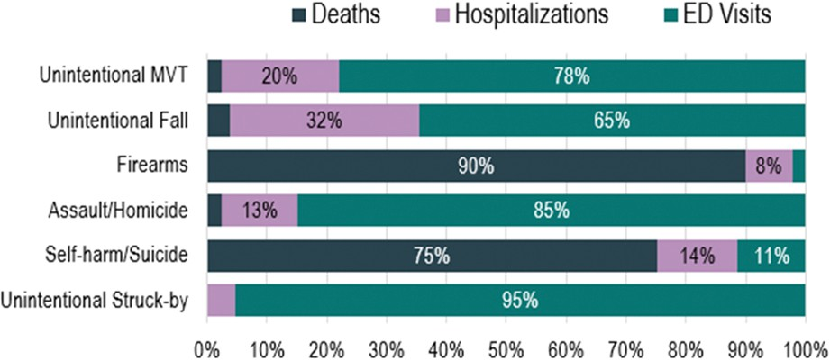

Figure 2: Number and Rate (per 100,000 population) of TBI-Related Deaths by Cause and Intent***, 2019

Cause | Count | Rate per 100K People
Unintentional Fall | 461 | 5.1
Firearm | 161 | 2.2
Suicide | 133 | 1.7
Unintentional MV Traffic | 99 | 1.3
Homicide | 43 | 0.6
Unintentional Struck-by Object | 5 | 0.1

*Counts and rates presented in this report may differ from other MA Injury Surveillance Program analyses that include “unspecified head injury” (ICD-10-CM code S09.90) as part of the TBI definition.
***Cause and intent are not mutually exclusive categories. For example, all firearms are included in the firearm category, but homicides and suicides can also be firearm-related. Therefore, counts above will sum to more than the total number of TBI deaths.

This document was produced by the CSTE Injury Surveillance Workgroup with support from CDC Cooperative Agreement Number NU38OT000297-03-00.

Figure 3: TBI-Related Rates per 100,000 Hospital Stays by Age and Sex, 2019
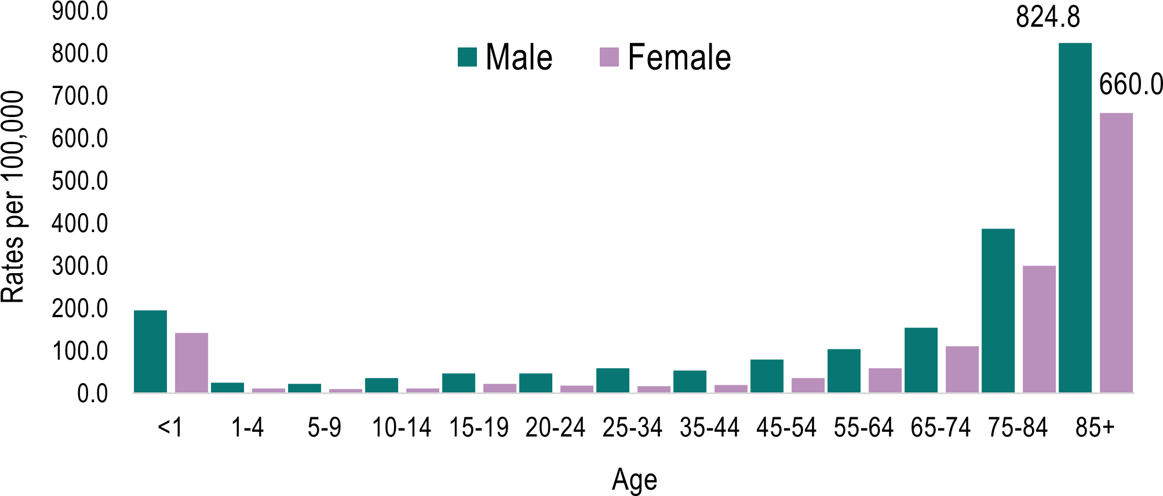

TBI Prevention Strategies

CDCs National Center for Injury Prevention and Control (Injury Center) is committed to protecting people against preventable TBI by putting science into action.

To help older adults, make CDCs STEADI part of every medical practice.

STEADI (Stopping Elderly Accidents, Deaths, and Injuries) is a toolkit to help health care providers incorporate fall risk assessment and individualized fall interventions (e.g., exercise, medication management, and Vitamin D supplementation) into their practice.
Learn more at www.cdc.gov/STEADI.

To help young athletes: get a HEADS UP on creating a culture of concussion safety in sports.

HEADS UP educational materials are designed to support individuals (such as coaches and health care providers) and organizations (such as schools and sports programs) with their concussion safety efforts. Learn more at www.cdc.gov/HEADSUP.
To help parents and teen drivers: "Parents Are the Key" to Teen Driver Safety.

Parents Are the Key materials helps parents, pediatricians, and communities keep teen drivers safe on the road. Parents Are the Key includes evidence-based strategies and can be customized with an organizations logo. Learn more at www.cdc.gov/ParentsAretheKey.

TBI Rates by Race and Ethnicity, 2019
The highest rates for TBI-related hospital stays were among White, non-Hispanic and Black, non-Hispanic residents. Advocates should consider populations with higher rates to inform prevention efforts.

Race and Ethnicity | Count | Rate/100K
White, non-Hispanic | 4,457 | 89.9
Black, non-Hispanic | 351 | 68.0
Hispanic | 456 | 53.2
Asian, non-Hispanic | 200 | 40.0
Native American/Alaskan Native, NH | <11 | - -

Massachusetts TBI Activities

PREVENTION
The Massachusetts Department of Public Health (MDPH) provides training and technical assistance (TTA) and information to a wide array of family support service providers such as home visitors, social workers, early intervention specialists, youth workers, and early education and care providers. TTA is focused on prevention, screening, and management of sports concussions, and brain injuries caused by intimate partner violence, abusive head trauma, falls, and transportation crashes. Through various legislative bodies, MDPH also provides analysis and policy recommendations that, if implemented, could prevent traumatic brain injuries.

SURVEILLANCE
MDPH's sports concussion regulations (105 CMR 201.000) requires that all public, charter, and private schools subject to the rules of the Massachusetts Interscholastic Athletic Association (MIAA) with extracurricular athletic activities for grades 6-12 provide data on the number of "Report of Head Injury Forms" received by the school annually. MDPH collects and compiles this information annually. In addition, school districts also submit a biannual letter to MDPH affirming that they have and update their sports concussion management policies.

MDPH analysts provided data and technical assistance on a report developed by the Massachusetts Rehabilitation Commission (MRC) and the Massachusetts Brain Injury Association (MA BIA) on the burden of TBI in Massachusetts.

PARTNERSHIPS
MDPH partners with the MRC, the Legislative Commission on Brain Injury, and MA BIA to understand the causes and consequences of brain injury and needs of brain injury survivors.

ACCOMPLISHMENTS / SUCCESSES
MDPH in collaboration with the MRC provided training on screening for brain injury, making accommodations for people living with brain injuries and referring people with brain injuries to programs and services for front-line domestic violence shelter staff.

Additional notes: Total rates are age-adjusted per 100,000 MA residents, rates by age group and sex are age-specific rates, and rates by race and ethnicity are crude rates. Hospital Stays combine inpatient hospitalizations and observation stays. Observation stays are typically of short duration and include medical monitoring to assess whether a patient requires hospital admission. For methodology and definition, go to: https://resources.cste.org/Injury-Surveillance-Methods-Toolkit/Home/GeneralInjuryIndicators.

