INDOOR AIR QUALITY ASSESSMENT

Massachusetts State Lottery Commission Building
60 Columbian Street
Braintree, Massachusetts

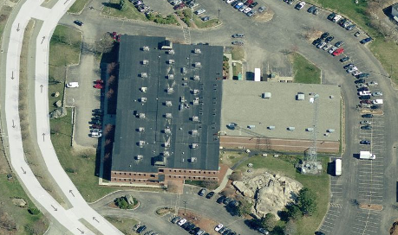

Prepared by:
Massachusetts Department of Public Health
Bureau of Environmental Health
Indoor Air Quality Program
October 2015

Background
Building: | MA State Lottery Commission Building
Address: | 60 Columbian Street, Braintree, MA
Assessment Requested by: | Paul Burke, Senior Project Manager,  Division of Capital Assessment Management and Maintenance (DCAMM)
Date of Assessment: | September 29, 2015
Bureau of Environmental Health/Indoor Air Quality (BEH/IAQ) Program Staff Conducting Assessment: | Cory Holmes, Inspector  Ruth Alfasso, Inspector
Date of Building Construction: | Mid-1980s
Reason for Request: | General IAQ

Building Description
The Massachusetts State Lottery Commission (Lottery) is housed in a two-story, brick-faced building that reportedly was renovated in 2004. Renovations included updated lighting, carpeting, and duct cleaning. The building has a flat roof with a black rubber membrane. The building houses offices, general work areas, repair shops, TV studio, shipping/receiving and storage. Windows are openable.

Results and Discussion
This space is occupied by approximately 240 employees. Members of the public also visit the space daily. Test results are presented in Table 1.

Ventilation
It can be seen from Table 1 that carbon dioxide levels were below 800 parts per million (ppm) in all areas surveyed. Many areas were sparsely populated, and windows were open in a few areas (Table 1). Closed windows and higher occupancy would be expected to result in higher carbon dioxide levels.
Mechanical ventilation is provided by 27 rooftop air handling units (AHUs) (Picture 1). Ducts carry air from the AHUs to offices and distribute tempered air via supply vents (Pictures 2 and 3). Return air is drawn into wall or ceiling-mounted vents (Picture 4) and ducted back to AHUs. The HVAC system was reportedly recently balanced by a certified engineering firm; deficiencies identified during system’s balances are being corrected.
It is also important to note that fresh air is drawn into the AHUs through manually adjusted intakes (Pictures 5 and 6), which can make maintaining comfort during weather changes/extremes difficult. In addition, accessing the roof to adjust air intakes during extreme weather conditions could potentially be hazardous to personnel.
Thermostats were observed in several areas set to the “automatic” setting (Picture 7), which will activate the HVAC system only when the thermostats call for heating or cooling. To maximize air exchange, the Massachusetts Department of Public Health (MDPH) recommends that both supply and exhaust ventilation operate continuously during periods of occupancy. The MDPH recommends that thermostats be set to the fan “on” setting during occupied hours to provide a continuous source of fresh air and filtration.

Temperature and Relative Humidity
Indoor temperature measurements ranged from 70°F to 76°F (Table 1), which were within the MDPH recommended comfort range. The MDPH recommends that indoor air temperatures be maintained in a range of 70°F to 78°F in order to provide for the comfort of building occupants.
Indoor relative humidity (RH) ranged from 47 to 69 percent (Table 1), with RH above the MDPH comfort range a number of areas. It should be noted that the assessment occurred on an usually humid day for early fall (average outdoor RH was 90% on the day of assessment). The MDPH recommends a comfort range of 40 to 60 percent for indoor air relative humidity. Relative humidity levels in the building would be expected to drop during winter months due to heating. The sensation of dryness and irritation is common in a low relative humidity environment. Low relative humidity is a very common problem during the heating season in the northeast part of the United States.

Microbial/Moisture Concerns
Water-damaged ceiling tiles were observed in some offices, common areas, and storage areas (Pictures 8 and 9). A roof leak above the legal file room was reportedly recently repaired (Picture 9). BEH/IAQ staff observed water-damaged/mold-colonized files in the area of the leak (Pictures 10 and 11). Several ceiling tiles were missing in the public women’s restroom, reportedly removed after damage from a water-heater leak.
Plants were observed in some offices and open areas. Plants can be a source of pollen and mold, which can be respiratory irritants to some individuals. Plants should be properly maintained, over-watering of plants should be avoided and drip pans should be inspected periodically for mold growth and cleaned or replaced as necessary.
Water dispensing equipment and small refrigerators were observed in carpeted areas (Table 1). Spills or leaks from this equipment can moisten carpet and lead to microbial growth and carpet degradation.

Other IAQ Evaluations
Indoor air quality can be negatively influenced by the presence of respiratory irritants, such as products of combustion. The process of combustion produces a number of pollutants. Common combustion emissions include carbon monoxide, carbon dioxide, water vapor, and smoke (fine airborne particle material). Of these materials, exposure to carbon monoxide and particulate matter with a diameter of 2.5 micrometers (μm) or less (PM2.5) can produce immediate, acute health effects upon exposure. To determine whether combustion products were present in the indoor environment, BEH/IAQ staff obtained measurements for carbon monoxide and PM2.5

Carbon Monoxide
Carbon monoxide should not be present in a typical, indoor environment. If it is present, indoor carbon monoxide levels should be less than or equal to outdoor levels. Carbon monoxide levels outdoors were measured at 0.5 ppm. Slight indoor carbon monoxide were detected in the shop/warehouse areas during the assessment ranging from 1.6-3.2 ppm (Table 1). These measurements are likely due to idling vehicles parked in the loading dock area.

Particulate Matter
Outdoor PM2.5 concentrations were measured at 24 μg/m³ (Table 1), which were below the NAAQS limit of 35 μg/m³. Indoor PM2.5 levels ranged from 1 to 24 μg/m³ (Table 1), which were below the NAAQS PM2.5 level of 35 μg/m³. Frequently, indoor air levels of particulate matter (including PM2.5) can be at higher levels than those measured outdoors.

Volatile Organic Compounds (VOCs)
Frequently, exposure to low levels of total VOCs (TVOCs) may produce eye, nose, throat and/or respiratory irritation in some sensitive individuals. Outdoor air samples were taken for comparison. Outdoor TVOC concentrations were measured at non-detect (ND) (Table 1). Indoor measurements of TVOCs ranged from ND to 0.3 ppm (Table 1). These low levels of TVOCs are likely associated with sprays/cleaners/solutions used in the repair shop and stored bulk printed materials and cardboard boxes in the warehouse.
Hand sanitizer, cleaning products, dry erase boards and photocopiers were also observed in some offices and common areas (Table 1). Printed items, including brochures and promotional items were found in several offices. These items may off-gas VOCs and odors; boxes should be kept closed and these items should be stored in storerooms when at all possible rather than in occupied areas.

Other Concerns
Other conditions that can affect IAQ were observed during the assessment. Personal fans and supply vents were observed to be dusty. Dust on these items can be reaerosolized and cause irritation or odors. It was reported that vents are on a regular cleaning schedule.
In some areas, accumulation of items, including papers, boxes, and personal items, were stored on floors desks, tables, and counters. Large numbers of items provide a source for dusts to accumulate. These items make it difficult for custodial staff to clean. Items should be relocated and/or cleaned periodically to avoid excessive dust build up.

Conclusions/Recommendations
In view of the findings at the time of the visit, the following recommendations are made:
- Continue with plans to make adjustments to HVAC system identified in balancing report.
- Examine the feasibility of retrofitting rooftop AHUs with pneumatic/automated intake controls.
- Consider setting digital thermostats to the fan “on” setting to provide continuous airflow/filtration, particularly in areas of IAQ/comfort complaints.
- For buildings in New England, periods of low relative humidity during the winter are often unavoidable. Therefore, scrupulous cleaning practices should be adopted to minimize common indoor air contaminants whose irritant effects can be enhanced when the relative humidity is low. To control for dusts, a high efficiency particulate arrestance (HEPA) filter equipped vacuum cleaner in conjunction with wet wiping of all surfaces is recommended. Avoid the use of feather dusters. Drinking water during the day can help ease some symptoms associated with a dry environment (throat and sinus irritations).
- Replace water-damaged ceiling tiles once the sources of leaks have been repaired.
- Inspect/remove water-damaged/mold-colonized files in legal file room.
- Consider placing water dispensers on non-carpeted areas or place a waterproof mat underneath them.
- Maintain indoor plants, use non-porous drips pans and prevent overwatering.
- Consider placing signs in the loading dock area indicating that vehicles should not idle to avoid possible vehicle exhaust entrainment. M.G.L. chapter 90 section 16A prohibits the unnecessary operation of the engine of a motor vehicle for a foreseeable time in excess of five minutes (MGL, 1996). Local police and health agents are given the authority to enforce this law.
- Continue to clean surfaces, carpets, and vents on preventative maintenance schedule.
- Consider storing printed/promotional items in storerooms away from occupied areas.
- Store items in an organized manner and move them to clean periodically to prevent a buildup of dust.
- Refer to resource manuals and other related indoor air quality documents for further building-wide evaluations and advice on maintaining public buildings. These materials are located on the MDPH’s website: http://mass.gov/dph/iaq.

References
MGL. 1996. Stopped motor vehicles; Operation of Engine; Time Limit; Penalty. Massachusetts General Laws. M.G.L. c. 90:16A.

Picture 1
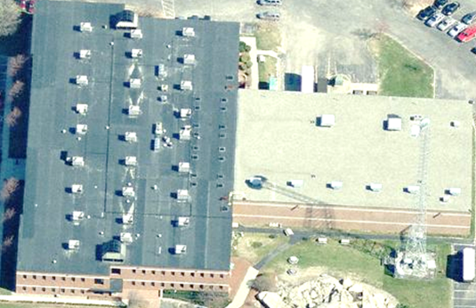
Rooftop Air Handling Units
Picture 2
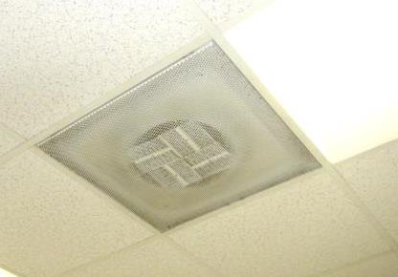
Ceiling-mounted supply diffuser
Picture 3
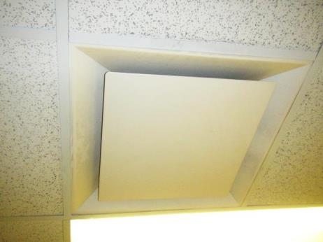
Ceiling-mounted supply diffuser
Picture 4
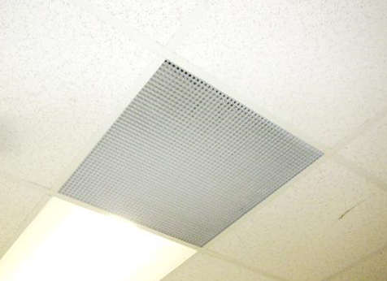
Ceiling-mounted return vent
Picture 5
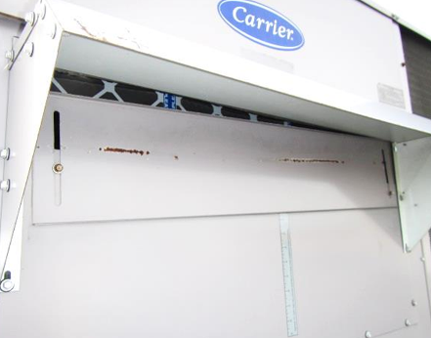
Manually-adjusted fresh air intake for AHU
Picture 6
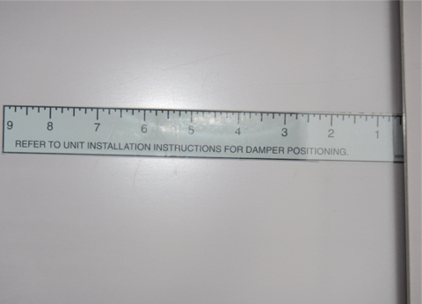
Damper adjustment guide on AHU
Picture 7
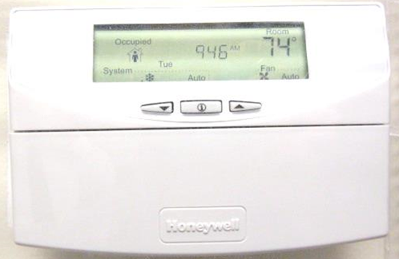
Digital thermostat, note fan set to “auto”
Picture 8
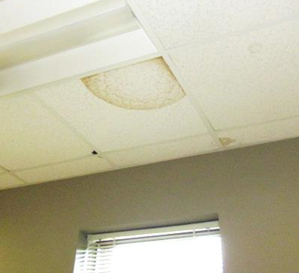
Water-damaged ceiling tiles
Picture 9
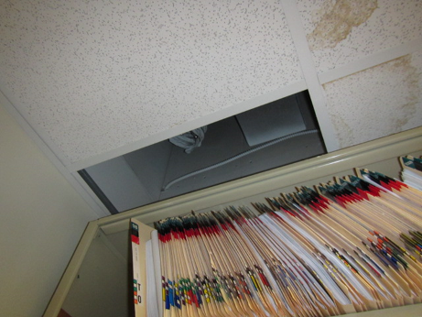
Area of roof leak/water-damaged tiles in legal file room
Picture 10
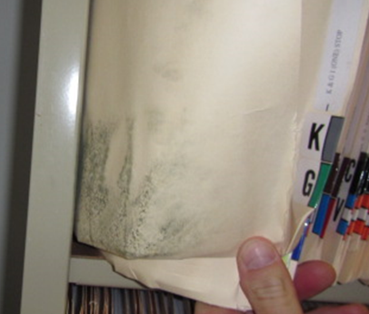
Water-damaged/mold-colonized folders in legal file room
Picture 11
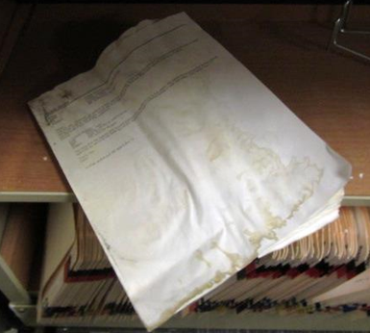
Water-damaged/mold-colonized paper in legal file room

Location | Carbon  Dioxide  (ppm) | Carbon Monoxide  (ppm) | Temp  (°F) | Relative  Humidity  (%) | PM2.5  (µg/m³) | Occupants  in Room | Windows  Openable | Ventilation |  |  | Remarks
 |  |  |  |  |  |  |  | Intake | Exhaust
Background | 460 | 0.5 | 76 | 78-90 | 24 |  |  |  |  |  | Humid
Second Floor
Mello | 771 | ND | 75 | 56 | 10 | 4 | Y | Y |  | N | DO, HS
Kelly | 756 | ND | 74 | 56 | 11 | 0 | N | Y |  | Y | Outside of office: WC on carpet, microwave, plant
Marketing file area | 683 | ND | 73 | 56 | 6 | 0 | N | Y |  | Y
½ wall office in marketing | 628 | ND | 73 | 56 | 6 | 1 | N | Y |  | Y | WD CT, fridge on carpet
½ wall office in marketing | 626 | ND | 73 | 56 | 6 | 2 | N | Y |  | Y | AI
2nd floor drawing area | 641 | ND | 73 | 55 | 6 | 0 | N | Y |  | Y | WC on carpet, fridge and microwave
Cagen ½ wall | 649 | ND | 73 | 55 | 5 | 1 | N | Y |  | Y | DEM
Vacant ½ wall | 640 | ND | 72 | 54 | 6 | 0 | N | Y |  | Y
Irwin | 662 | ND | 72 | 55 | 6 | 1 | N | Y |  | N | DO, PF, couch
Harney | 662 | ND | 72 | 55 | 7 | 0 | N | Y |  | N | 2 WD CT, PF
Main hallway | 676 | ND | 72 | 55 | 10 | 1 | N | Y |  | N | DO, WD CT, food, DEM
Kassis | 655 | ND | 72 | 55 | 7 | 1 | N | Y |  | Y | PF-on, DEM, HS
Greenridge cube area | 646 | ND | 71 | 55 | 11 | 0 | N | Y |  | Y | Fridge on carpet, boxes, printed matter
Ryan cube area | 675 | ND | 71 | 57 | 6 | 0 | N | Y |  | N | Construction materials
Vahey cube area | 689 | ND | 71 | 57 | 8 | 1 | N | Y |  | Y | Boxes, pants
Buckley ½ wall | 693 | ND | 72 | 57 | 13 | 1 | N | Y |  | Y | DEM, fake plant, area rug
Conference | 732 | ND | 72 | 57 | 6 | 4 | N | Y |  | Y | WD CT, missing CT, DEM
Volpe | 702 | ND | 72 | 57 | 6 | 0 | N | Y |  | Y
Amarra cube area | 684 | ND | 72 | 57 | 6 | 2 | N | Y |  | Y | CP, AI
Finance area ½ wall office | 736 | ND | 72 | 57 | 4 | 1 | N | N |  | N | Plant, kettle
Chochrek cube already | 730 | ND | 72 | 57 | 6 | 2 | N | Y |  | Y
O’Reilly | 698 | ND | 72 | 57 | 6 | 0 | N | Y |  | Y | DO, PF
Perna | 731 | ND | 73 | 56 | 6 | 1 | N | Y |  | Y | DO, DEM, PF
Player | 716 | ND | 73 | 55 | 13 | 0 | Y | Y |  | N | DO, DEM, thermostat unset
Richardson | 776 | ND | 73 | 55 | 8 | 1 | Y | Y |  | Y | DEM
Chipman cube | 715 | ND | 73 | 55 | 6 | 0 | N | Y |  | Y
Computer training | 617 | ND | 72 | 59 | 6 | 0 | Y AND DOOR | Y |  | Y | 8 computers, DEM
Wholley ½ wall | 629 | ND | 72 | 58 | 5 | 0 | N | N |  | N | Food
Kirwan | 624 | ND | 73 | 58 | 8 | 1 | Y | Y |  | Y | Small office, DEM, AI
McGuire | 651 | ND | 73 | 58 | 6 | 2 | Y | Y |  | Y | HS
½ wall office | 640 | ND | 73 | 58 | 9 | 1 | Y | Y |  | N | DO
Conason | 687 | ND | 73 | 57 | 6 | 1 | Y | Y |  | Y | DEM
Small conference | 629 | ND | 73 | 56 | 7 | 0 | Y | Y |  | Y
Teixiera office | 647 | ND | 73 | 56 | 7 | 0 | Y | Y |  | N | DO
LaForest office | 632 | ND | 73 | 57 | 5 | 1 | Y | Y |  | Y
Ladies room |  |  |  |  |  |  |  | Y |  | Y | Cleaning products
Moore | 667 | ND | 73 | 58 | 18 | 0 | Y | Y |  | Y | Aquarium
Open staircase area | 653 | ND | 74 | 59 | 10 | 2 | N | Y |  | Y
Bivetsky | 700 | ND | 73 | 65 | 3 | 1 | Y | Y |  | Y | DO
HR conference room | 643 | ND | 74 | 58 | 3 | 0 | Y | Y |  | Y | Thermostat-fan “auto”
Condon | 661 | ND | 74 | 58 | 3 | 2 | Y | Y |  | Y
Cullin/Woods | 669 | ND | 74 | 58 | 3 | 0 | Y | Y |  | Y | Plant, fridge on carpet, toaster and microwave
Kirwin | 623 | ND | 74 | 58 | 3 | 0 | Y | Y |  | Y | DO
Farly | 581 | ND | 74 | 63 | 2 | 0 | Y | Y |  | Y | DO, wall to wall carpet
Coyne | 618 | ND | 74 | 61 | 1 | 1 | N | Y |  | N | DO, PF
Teja | 644 | ND | 73 | 60 | 3 | 1 | Y | Y |  | Y | DO
Legal | 653 | ND | 73 | 60 | 3 | 1 | Y | Y |  | Y | 2 WD CT corner, plants
Legal library | 664 | ND | 73 | 60 | 4 | 2 | N | Y |  | Y | DO
Legal file room | 641 | ND | 74 | 57 | 3 | 0 | N | Y |  | Y | WD/MT, leak fixed, moldy files
Noble | 730 | ND | 74 | 59 | 3 | 1 | N | Y |  | Y | PF, plants, dust/debris vents
Luttrell | 636 | ND | 73 | 59 | 3 | 0 | Y | Y |  | Y | DO
First Floor
Service area reception | 531 | ND | 71 | 63 | 11 | 1 | Y | Y |  | N | Fridge (some staining)
Sales | 680 | ND | 72 | 64 | 6 | 0 | N | Y |  | N
Hotline | 733 | ND | 72 | 63 | 3 | 3 | N | Y |  | Y
Customer service work area | 592 | ND | 72 | 65 | 4 | 2 | N | Y |  | Y | Thermostat-fan “auto”
Adams | 792 | ND | 72 | 65 | 3 | 0 | Y | Y |  | Y | DO
Caron | 633 | ND | 71 | 64 | 3 | 0 | Y | Y |  | Y
Lyons | 640 | ND | 72 | 65 | 4 | 0 | Y | Y |  | Y
Customer service desk | 638 | ND | 71 | 60 | 3 | 2 | N | Y |  | Y | Portable AC unit
Brill ½ office | 538 | ND | 71 | 66 | 8 | 0 | Y | N |  | N | Boxes on floor
Job control | 649 | ND | 72 | 50 | 1 | 2 | N | Y |  | Y
Operations | 653 | ND | 72 | 51 | 1 | 2 | N | Y |  | Y | 2 AP-off
Break room | 688 | ND | 71 | 50 | 1 | 0 | n | Y |  | Y
Central computer room | 621 | ND | 73 | 56 | 3 | 0 | N | Y |  | Y
Mandeville | 556 | ND | 73 | 69 | 3 | 3 | Y | Y |  | Y | DO
Calabrese | 464 | ND | 76 | 64 | 4 | 0 | Y | Y |  | Y | Windows open (2)
Dooley | 557 | ND | 73 | 61 | 3 | 3 | Y | Y |  | Y
Catelina/Joy | 577 | ND | 72 | 59 | 3 | 2 | Y | Y |  | Y
Meade/Kallmerten | 568 | ND | 72 | 59 | 3 | 3 | N | Y |  | Y
O’Sullivan/Gatie | 593 | ND | 72 | 61 | 3 | 0 | N | Y |  | Y
Shop | 508 | ND | 71 | 65 | 24 | 0 | Y | Y |  | Y | NC, AT
Field service hallway | 569 | ND | 71 | 65 | 11 | 0 | N | N |  | N | NC
Tech service | 536 | ND | 72 | 60 | 21 | 8 | N | Y |  | y | 0.1 – 0.3 ppm TVOC, NC, CF, plants, shop equipment, fridge
Warehouse | 690 | 3.0 | 71 | 53 | 9 | 0 | N, doors | Y |  | Y | High ceilings, doors to outside open, truck, NC
Allen | 661 | 3.2 | 71 | 51 | 15 | 1 | N | Y |  | Y | AC in wall (rarely used), AT
Brennan | 670 | 3.0 | 70 | 57 | 12 | 1 | Y | Y |  | Y | NC, DEM
Cincotta | 755 | 1.6 | 70 | 60 | 12 | 1 | N | Y |  | Y | NC
Esposito | 682 | ND | 71 | 59 | 10 | 1 | N | Y |  | Y | Fridge, supply vent blocked
Rogato | 700 | ND | 72 | 57 | 6 | 0 | N | Y |  | Y | Boxes, DO, CP
Solari | 701 | ND | 72 | 56 | 17 | 1 | N | Y |  | Y (direct/ open) | DO
Liracy | 622 | ND | 71 | 61 | 8 | 0 | N | Y |  | Y | Plants, PF
Lorden | 651 | ND | 71 | 61 | 5 | 1 | Y | Y |  | Y | DO
Conference | 638 | ND | 71 | 61 | 8 | 0 | Y | Y |  | Y | DEM, DO
Reno 1/2 wall | 630 | ND | 71 | 62 | 8 | 0 | N | Y |  | Y
Shanahan | 611 | ND | 70 | 62 | 5 | 1 | Y | Y |  | Y | HS, CP
LeLievre | 627 | ND | 72 | 61 | 5 | 1 | Y | Y |  | Y | DO
Waiting/lobby | 630 | ND | 72 | 62 | 9 | 3 | Y door | Y |  | Y | Worn couches
Public women’s room |  |  |  |  |  | 0 | N | Y |  | Y | 2 MT, reportedly water damage from water heater in ceiling, NC
Security office | 539 | ND | 73 | 61 | 11 | 2 | Y | Y |  | Y | NC, DEM
Drawing studio | 638 | ND | 72 | 61 | 7 | 2 | Y open | Y |  | Y
Computer main | 614 | ND | 73 | 53 | 4 | 0 | N | Y |  | Y
Salvucci ½ wall | 661 | ND | 73 | 50 | 2 | 1 | N | Y |  | Y
½ wall | 687 | ND | 73 | 48 | 2 | 1 | N | Y |  | Y
Locker area | 636 | ND | 73 | 47 | 13 | 0 | N | Y |  | Y
Network room | 634 | ND | 74 | 47 | 2 | 0 | N | Y |  | Y
Mail warehouse | 639 | ND | 74 | 54 | 6 | 0 | N | Y |  | Y | NC, skylights
Mail room | 585 | ND | 73 | 54 | 5 | 0 | N | Y |  | Y | NC, mail machines, WT CT
Agent training | 531 | ND | 72 | 60 | 7 | 0 | N | Y |  | Y | NC, machines
Auditorium/conference | 502 | ND | 72 | 60 | 11 | 0 | Y | Y |  | Y | 2 rooftop units service this room, thermostat is next room over
Cafeteria | 528 | ND | 72 | 67 | 14 | 5 | Y open | Y |  | Y | NC
Cube area next to cafeteria | 538 | ND | 72 | 63 | 16 | 1 | N | Y |  | Y | Plants, DEM
Office | 574 | ND | 73 | 63 | 14 | 1 | N | Y |  | Y | Fridge on carpet, PF, door to mail warehouse open
QA area | 525 | ND | 73 | 58 | 16 | 0 | N | Y |  | Y | DEM, machines, MT, heater
Women’s restroom |  |  |  |  |  |  | N | Y |  | Y | Shower, drain trap reportedly filled daily

