INDOOR AIR QUALITY ASSESSMENT

Massachusetts State Lottery
11 Cummings Park
Woburn, Massachusetts

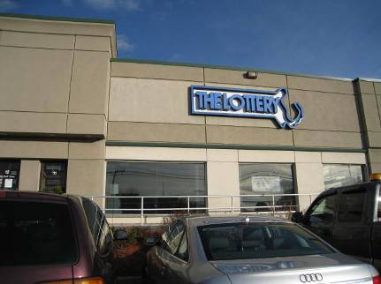

Prepared by:
Massachusetts Department of Public Health
Bureau of Environmental Health
Indoor Air Quality Program
March 2012

Background/Introduction
In response to a request from Ms. Lisa Verrochi, Project Manager, Division of Capital Asset Management, the Massachusetts Department of Public Health (MDPH), Bureau of Environmental Health (BEH), provided assistance and consultation regarding indoor air quality (IAQ) concerns at the Massachusetts State Lottery (MSL) office located at 11 Cummings Park, Woburn, Massachusetts. The request was prompted by occupant complaints/concerns of respiratory irritation and thermal discomfort. On December 22, 2011, a visit to conduct an IAQ assessment was made by Michael Feeney, Director, and Ruth Alfasso Environmental Engineer/Inspector in BEH’s IAQ Program. BEH staff were accompanied by Ms. Verrochi during the assessment.
The MSL occupies office and warehouse space in a strip mall-type building. Other tenants in the building include an Indian restaurant, a window replacement company and various other businesses. The MSL is physically separated from adjacent spaces by fire-rated walls. The MSL is made up of a customer waiting room, office space, a lottery machine repair shop and warehouse. The MSL space has no openable windows.

Methods
Air tests for carbon dioxide, carbon monoxide, temperature and relative humidity were taken with the TSI, Q-Trak, IAQ Monitor model 7565. Air tests for airborne particle matter with a diameter less than 2.5 micrometers were taken with the TSI, DUSTTRAK™ Aerosol Monitor Model 8520. Air tests for volatile organic compounds were conducted with a MiniRAE 2000 photoionization detector. BEH staff also performed visual inspection of building materials for water damage and/or microbial growth.

Results
The MSL has an employee population of approximately 48, although the majority of occupants are reportedly not in the office for most of the day. The office can be visited daily by several hundred members of the public. The tests were taken during normal operations and results appear in Table 1.

Discussion

Ventilation
It can be seen from Table 1 that carbon dioxide levels were above 800 parts per million (ppm) in all but one area, indicating inadequate air exchange at the time of the assessment. A number of areas were sparsely populated or unoccupied at the time carbon dioxide measurements were taken, which generally results in lower carbon dioxide levels. Carbon dioxide levels would be expected to be higher with full occupancy.
Mechanical ventilation is provided by rooftop air-handling units (AHUs). Fresh air is drawn into the AHUs and delivered to occupied areas via ductwork through supply vents (Picture 1). Return air is drawn into vents connected to the rooftop AHUs by ductwork in the ceiling plenum.
Digital wall-mounted thermostats control the heating, ventilation and air-conditioning (HVAC) system. These thermostats have fan settings of on and automatic. All thermostats examined were set to the automatic setting. The automatic setting on the thermostat activates the heating, ventilation and air-conditioning (HVAC) system for a preset temperature. Once a preset temperature is reached by the thermostat, the HVAC system is deactivated. Therefore, no mechanical ventilation is provided until the thermostat re-activates the system. MDPH recommends that thermostats be set to the on position during occupied periods, as this setting provides a continuous source of air circulation.
In addition, one of the thermostats was located on an interior pillar above a filing cabinet which obstructs airflow to its temperature sensor (Picture 2). Thermostats should be located in a manner to allow air circulation so that they accurately measure room temperatures and respond accordingly.
Exhaust ventilation to the space is provided by ceiling-mounted exhaust grates in the main office area (Picture 3). Additional exhaust ventilation is located in restrooms and is activated via light switches. It is recommended that exhaust ventilation in bathrooms be continuous during occupied hours rather than in response to a light switch.
To maximize air exchange, the MDPH recommends that both supply and exhaust ventilation operate continuously during periods of occupancy. In order to have proper ventilation with a mechanical supply and exhaust system, the systems must be balanced to provide an adequate amount of fresh air to the interior of a room while removing stale air from the room. It is recommended that HVAC systems be re-balanced every five years to ensure adequate air systems function (SMACNA, 1994). The date of the last balancing of these systems was reported to be in 2009.
The Massachusetts Building Code requires a minimum ventilation rate of 20 cubic feet per minute (cfm) per occupant of fresh outside air or have openable windows in each room (SBBRS, 1997; BOCA, 1993). The ventilation must be on at all times that the room is occupied. Providing adequate fresh air ventilation with open windows and maintaining the temperature in the comfort range during the cold weather season is impractical. Mechanical ventilation is usually required to provide adequate fresh air ventilation.
Carbon dioxide is not a problem in and of itself. It is used as an indicator of the adequacy of the fresh air ventilation. As carbon dioxide levels rise, it indicates that the ventilating system is malfunctioning or the design occupancy of the room is being exceeded. When this happens, a buildup of common indoor air pollutants can occur, leading to discomfort or health complaints. The Occupational Safety and Health Administration (OSHA) standard for carbon dioxide is 5,000 parts per million parts of air (ppm). Workers may be exposed to this level for 40 hours/week, based on a time-weighted average (OSHA, 1997).
The MDPH uses a guideline of 800 ppm for publicly occupied buildings. A guideline of 600 ppm or less is preferred in schools due to the fact that the majority of occupants are young and considered to be a more sensitive population in the evaluation of environmental health status. Inadequate ventilation and/or elevated temperatures are major causes of complaints such as respiratory, eye, nose and throat irritation, lethargy and headaches. For more information concerning carbon dioxide, please see Appendix A.
Temperature readings ranged from 70° F to 74° F during the assessment, which were within the MDPH recommended comfort guidelines in all areas surveyed. The MDPH recommends that indoor air temperatures be maintained in a range of 70º F to 78º F in order to provide for the comfort of building occupants. In many cases concerning indoor air quality, fluctuations of temperature in occupied spaces are typically experienced, even in a building with an adequate fresh air supply.
Note that the customer service area at the front of the building has a large single-paned window along the front (Picture 4), which faces approximately west. During the assessment, the temperature of this window was measured with an infrared thermometer at 82 º F when the sun was shining on it with an outdoor temperature of 66 º F. This window may be a source of significant solar heating (e.g., solar gain) which would heat the customer service area independent of the HVAC system during clear weather and, because it is single-paned, may also allow for heat to escape on cold, cloudy days.
The relative humidity measured during the assessment ranged from 28 to 35 percent, which was below the MDPH recommended comfort range in all areas surveyed. The MDPH recommends a comfort range of 40 to 60 percent for indoor air relative humidity. The sensation of dryness and irritation is common in a low relative humidity environment. Low relative humidity is a common problem during the heating season in the northeast part of the United States.

Microbial/Moisture Concerns
A water-damaged ceiling tile was found in the server room (Picture 5). Water-damaged ceiling tiles indicate leaks from either the roof or plumbing system. If repeatedly moistened, ceiling tiles can be a medium on which mold can grow. Water-damaged tiles should be replaced after a water leak is discovered and repaired.
The US Environmental Protection Agency (US EPA) and the American Conference of Governmental Industrial Hygienists (ACGIH) recommend that porous materials be dried with fans and heating within 24 to 48 hours of becoming wet (US EPA, 2001; ACGIH, 1989). If not dried within this time frame, mold growth may occur. Once mold has colonized porous materials, they are difficult to clean and should be removed/discarded.

Other IAQ Evaluations
Indoor air quality can be negatively influenced by the presence of respiratory irritants, such as products of combustion. Common combustion emissions include carbon monoxide, carbon dioxide, water vapor and smoke (fine airborne particle material). To determine whether combustion products were present in the indoor environment, BEH staff obtained measurements for carbon monoxide and particulate matter.

Carbon Monoxide
Carbon monoxide is a by-product of incomplete combustion of organic matter (e.g., gasoline, wood and tobacco). Exposure to carbon monoxide can produce immediate and acute health affects. Several air quality standards have been established to address carbon monoxide and prevent symptoms from exposure to these substances. The MDPH established a corrective action level concerning carbon monoxide in ice skating rinks that use fossil-fueled ice resurfacing equipment. If an operator of an indoor ice rink measures a carbon monoxide level over 30 ppm, taken 20 minutes after resurfacing within a rink, that operator must take actions to reduce carbon monoxide levels (MDPH, 1997).
The American Society of Heating Refrigeration and Air-Conditioning Engineers (ASHRAE) has adopted the National Ambient Air Quality Standards (NAAQS) as one set of criteria for assessing indoor air quality and monitoring of fresh air introduced by HVAC systems (ASHRAE, 1989). The NAAQS are standards established by the US EPA to protect the public health from six criteria pollutants, including carbon monoxide and particulate matter (US EPA, 2006). As recommended by ASHRAE, pollutant levels of fresh air introduced to a building should not exceed the NAAQS levels (ASHRAE, 1989). The NAAQS were adopted by reference in the Building Officials & Code Administrators (BOCA) National Mechanical Code of 1993 (BOCA, 1993), which is now an HVAC standard included in the Massachusetts State Building Code (SBBRS, 1997). According to the NAAQS, carbon monoxide levels in outdoor air should not exceed 9 ppm in an eight-hour average (US EPA, 2006).
Carbon monoxide should not be present in a typical, indoor environment. If it is present, indoor carbon monoxide levels should be less than or equal to outdoor levels. Outdoor carbon monoxide concentrations were non-detect (ND) on the day of the assessment (Table 1). No measureable levels of carbon monoxide were detected inside the building during the assessment (Table 1). MSL employees reported that the rear of the building is a high traffic area for trucking, which can be a source for products of combustion to enter through the back door of the facility. Idling of trucks behind the building should be limited to the greatest extent possible. It is also important to note that Massachusetts law limits vehicle idling to 5 minutes (M.G.L. 1986).

Particulate Matter
The US EPA has established NAAQS limits for exposure to particulate matter. Particulate matter is airborne solids that can be irritating to the eyes, nose and throat. The NAAQS originally established exposure limits to particulate matter with a diameter of 10 μm or less (PM10). According to the NAAQS, PM10 levels should not exceed 150 micrograms per cubic meter (μg/m³) in a 24-hour average (US EPA, 2006). These standards were adopted by both ASHRAE and BOCA. Since the issuance of the ASHRAE standard and BOCA Code, US EPA established a more protective standard for fine airborne particles. This more stringent PM2.5 standard requires outdoor air particle levels be maintained below 35 μg/m³ over a 24-hour average (US EPA, 2006). Although both the ASHRAE standard and BOCA Code adopted the PM10 standard for evaluating air quality, MDPH uses the more protective PM2.5 standard for evaluating airborne particulate matter concentrations in the indoor environment.
Outdoor PM2.5 concentrations were measured at 6 μg/m³ (Table 1). PM2.5 levels measured indoors ranged from 5 to 9 μg/m³ (Table 1), which were below the NAAQS PM2.5 level of 35 μg/m³. Frequently, indoor air levels of particulates (including PM2.5) can be at higher levels than those measured outdoors. A number of mechanical devices and/or activities that occur indoors can generate particulate during normal operations. Sources of indoor airborne particulates may include but are not limited to vehicle exhaust; particles generated during the operation of fan belts in the HVAC system, use of stoves and/or microwave ovens in kitchen areas; use of photocopiers, fax machines and computer printing devices; operation of an ordinary vacuum cleaner and heavy foot traffic indoors.

Volatile Organic Compounds
Indoor air concentrations can be greatly impacted by the use of products containing volatile organic compounds (VOCs) within the building. VOCs are carbon-containing substances that have the ability to evaporate at room temperature. Frequently, exposure to low levels of total volatile organic compounds (TVOCs) may produce eye, nose, throat and/or respiratory irritation in some sensitive individuals. For example, chemicals evaporating from a paint can stored at room temperature would most likely contain VOCs.
In an effort to determine whether VOCs were present in the building, air monitoring for TVOCs was conducted. Outdoor air samples were taken for comparison. Outdoor TVOC concentrations the day of the assessment were ND (Table 1). As shown in Table 1, slight TVOC readings of 0.4 ppm were found in various areas tested in the office space and readings above 1 ppm were found in several locations in the warehouse area. Not unexpected, the highest readings were found in the storage room containing stored materials (Picture 6), which also had a detectable “plastic” odor emanating from plastic–coated/vinyl banners. Other printed materials found in the warehouse may also emit TVOCs.
The warehouse did not appear to have any means of mechanical ventilation. The MSL has a garage style door at the rear of the building that is not weathertight, which allows cold air to infiltrate the warehouse. In addition, no doors exist to separate the warehouse from office space. Under certain wind/weather conditions air from the garage door can pressurize the warehouse, which forces VOCs/odors from printed/plastic materials into offices areas, where the HVAC system may capture and recirculate these pollutants. This likely occurs due to the lack of mechanical exhaust ventilation in the warehouse to remove VOCs/odors from stored materials coupled with the lack of doors separating office areas from the warehouse. Since the operation of the HVAC system in the offices is intermittent due to the thermostat setting, no fresh air to dilute or exhaust ventilation to remove VOCs was occurring during the assessment. VOCs may be irritating to the eyes, nose and respiratory system.

Other Conditions
An ajar ceiling tile was observed in one area of the building (Table 1, Picture 7). Ceiling tiles should be flush with the tile system to prevent movement of materials from the plenum into occupied space. Accumulated dust, dirt and particulates may be disturbed and serve as a source of eye and respiratory irritation.
Personal fans and heaters were observed in some areas. Fan blades from these units can accumulate dust/debris. Re-activated fans can aerosolize accumulated dust. Fans should be cleaned regularly to prevent aerosolization of dust. Dust and debris was also noted on some supply and exhaust vents (Table 1, Picture 1); these should be cleaned regularly to prevent the aerosolization of dust/debris.
In a number of areas, items were observed on the floor, windowsills, tabletops, counters, bookcases and desks. The large number of items stored provides a source for dusts to accumulate. These items (e.g., papers, folders, boxes) make it difficult for custodial staff to clean. Items should be relocated and/or be cleaned periodically to avoid excessive dust build up. In addition, these materials can accumulate on flat surfaces (e.g., desktops, windowsills and carpets) in occupied areas and subsequently be re-aerosolized causing further irritation.
Many of the floor surfaces are covered by wall-to-wall carpeting. It was not known if the building had a carpet cleaning program in place. The Institute of Inspection, Cleaning and Restoration Certification (IICRC), recommends that carpeting be cleaned annually (or semi-annually in soiled high traffic areas) (IICRC, 2005).

Conclusions/Recommendations
In view of the findings at the time of the visit, the following recommendations are made:
- Consideration should be given to separating the warehouse and storage areas from the office areas as feasible to prevent VOC/odor infiltration from stored printed and plastic materials. While VOC levels are not suggestive of health impacts, related odors can result in irritant symptoms for some individuals. This may be achieved by installing doors or plastic strip doors in two locations as shown in Figure 1.
- Consideration should be give to installing adequate exhaust ventilation in the warehouse to remove odors and VOCs directly.
- To maximize air exchange, set thermostats to the fan “on” position to operate the ventilation system continuously during business hours.
- Ensure that thermostats are operable and are placed in a location to readily measure room temperature. The areas around and beneath thermostats should be clear of obstructions, and heat-producing office equipment should not be located in close proximity.
- In order to improve indoor air quality, an increase in the percentage of fresh air supply into the HVAC system may be necessary. Consult with a ventilation engineer to determine methods to increase fresh air intake.
- Consider adopting a balancing schedule of every 5 years for all mechanical ventilation systems, as recommended by ventilation industrial standards (SMACNA, 1994).
- To avoid entrainment of vehicle exhaust, consider posting signs in parking area adjacent to the building instructing vehicle operators to shut off engines as required by Massachusetts General Laws 90:16A.
- Clean air diffusers, return vents and personal fans periodically of accumulated dust/debris.
- Remove water-damaged ceiling tiles and examine for source of water. Replace all missing and ajar ceiling tiles and monitor for future leaks.
- Relocate or consider reducing the amount of stored materials to allow for more thorough cleaning. Clean items regularly with a wet cloth or sponge to prevent excessive dust build-up.
- For buildings in New England, periods of low relative humidity during the winter are often unavoidable. Therefore, scrupulous cleaning practices should be adopted to minimize common indoor air contaminants whose irritant effects can be enhanced when the relative humidity is low. To control for dusts, a high efficiency particulate arrestance (HEPA) filter equipped vacuum cleaner in conjunction with wet wiping of all surfaces is recommended. Drinking water during the day can help ease some symptoms associated with a dry environment (throat and sinus irritations).
- Clean carpeting annually or semi-annually in soiled high traffic areas as per the recommendations of the Institute of Inspection, Cleaning and Restoration Certification (IICRC). Copies of the IICRC fact sheet can be downloaded at: http://www.certifiedcleaners.org/faq.shtml (IICRC, 2005).
- Refer to resource manuals and other related indoor air quality documents for further building-wide evaluations and advice on maintaining public buildings. Copies of these materials are located on the MDPH’s website: http://mass.gov/dph/iaq.

References
ACGIH. 1989. Guidelines for the Assessment of Bioaerosols in the Indoor Environment. American Conference of Governmental Industrial Hygienists, Cincinnati, OH.
ASHRAE. 1989. Ventilation for Acceptable Indoor Air Quality. American Society of Heating, Refrigeration and Air Conditioning Engineers. ANSI/ASHRAE 62-1989.
BOCA. 1993. The BOCA National Mechanical Code/1993. 8th ed. Building Officials and Code Administrators International, Inc., Country Club Hill, IL. Section M-308.1.1.
IICRC. 2005. Carpet Cleaning FAQ 4 Institute of Inspection, Cleaning and Restoration Certification. Institute of Inspection Cleaning and Restoration, Vancouver, WA.
M.G.L. 1986. Stopped motor vehicles; Operation of Engine; Time Limit; Penalty. Massachusetts General Laws. M.G.L. c. 90:16A.
MDPH. 1997. Requirements to Maintain Air Quality in Indoor Skating Rinks (State Sanitary Code, Chapter XI). 105 CMR 675.000. Massachusetts Department of Public Health, Boston, MA.
OSHA. 1997. Limits for Air Contaminants. Occupational Safety and Health Administration. Code of Federal Regulations. 29 C.F.R 1910.1000 Table Z-1-A.
SBBRS. 1997. Mechanical Ventilation. State Board of Building Regulations and Standards. Code of Massachusetts Regulations. 780 CMR 1209.0.
SMACNA. 1994. HVAC Systems Commissioning Manual. 1st ed. Sheet Metal and Air Conditioning Contractors’ National Association, Inc., Chantilly, VA.
US EPA. 2001. Mold Remediation in Schools and Commercial Buildings. US Environmental Protection Agency, Office of Air and Radiation, Indoor Environments Division, Washington, D.C. EPA 402-K-01-001. March 2001.
US EPA. 2006. National Ambient Air Quality Standards (NAAQS). US Environmental Protection Agency, Office of Air Quality Planning and Standards, Washington, DC. http://www.epa.gov/air/criteria.html.
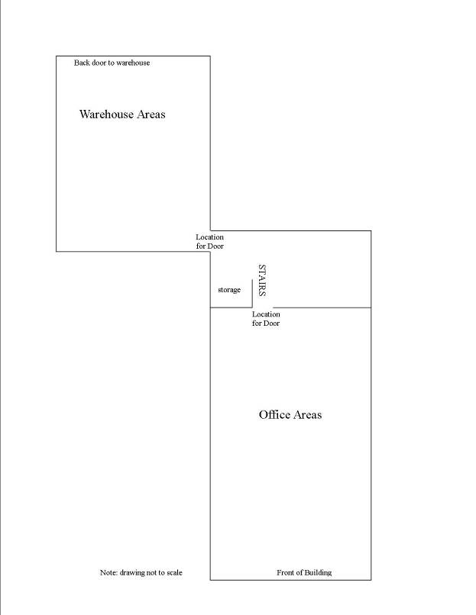
Picture 1

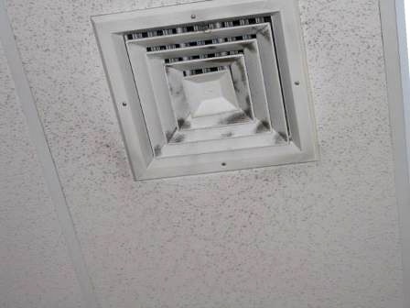

Supply vent (note dirt on diffuser)

Picture 2

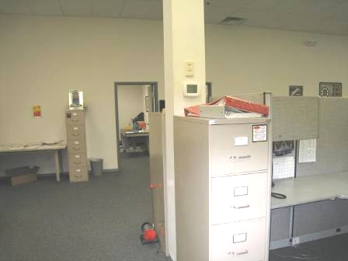

Thermostat located on pillar next to filing cabinet

Picture 3

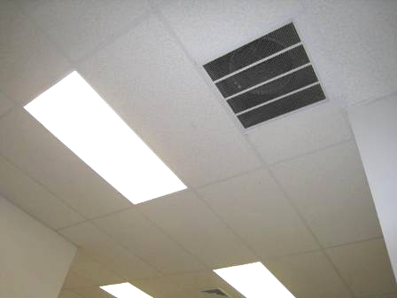

Exhaust vent

Picture 4

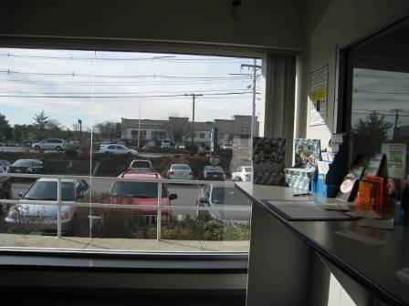

Large single-paned window in front area of State Lottery building

Picture 5

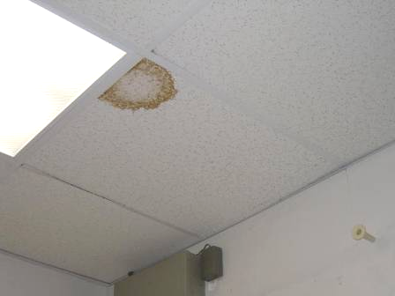

Water-damaged ceiling tile in server room

Picture 6

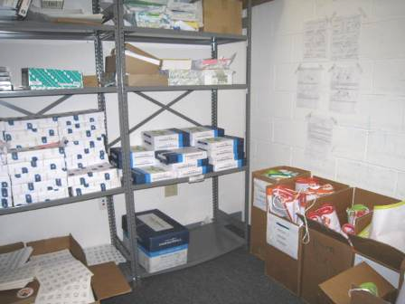

Storage room for papers and new banners (arrows showing banners in boxes)

Picture 7

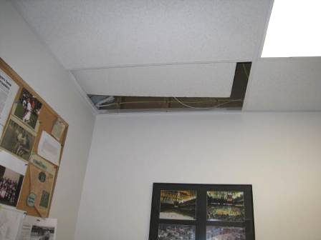

Ajar ceiling tile

Location | Carbon  Dioxide  (ppm) | Carbon Monoxide  (ppm) | Temp  (°F) | Relative  Humidity  (%) | PM2.5  (µg/m³) | TVOCs  (ppm) | Occupants  in Room | Windows  Openable | Ventilation |  | Remarks
 |  |  |  |  |  |  |  |  | Supply | Exhaust | Remarks
Background | 413 | ND | 66 | 27 | 6 | ND |  |  |  |  | Windy, cars in lot
Conference room | 1135 | ND | 73 | 35 | 5 | 0.4 | 5 | N | Y | N | DEM, thermostats on auto
Benton | 909 | ND | 73 | 32 | 6 | 0.4 | 0 | N | Y | N | Fake plant, PF/heater
McHugh | 922 | ND | 73 | 33 | 6 | 0.4 | 1 | N | Y | N | Items
Retail resource | 881 | ND | 73 | 31 | 6 | 0.4 | 0 | N | Y | N
Zebniak | 908 | ND | 73 | 32 | 7 | 0.4 | 0 | N | Y | N
Thibeault | 894 | ND | 74 | 32 | 6 | 0.4 | 1 | N | Y | N | Minifridge, food in plastic box
Downstairs adjacent to warehouse | 815 | ND | 73 | 31 | 7 | ND | 0 | N | Y | Y | PC, no carpet (tiled)
Paper/banner storage | 831 | ND | 72 | 31 | 6 | 1.4 | 0 | N | Y | N | Tile floor, paper and banners in boxes
Minicube area | 872 | ND | 72 | 32 | 6 | ND | 0 | N | Y (not directly over) | N
Kitchenette | 888 | ND | 72 | 32 | 7 | 0.4 | 0 | N | Y | N | Tile floor, fridge, microwave, sink, CP and paper under sink
Open area, left side | 875 | ND | 73 | 32 | 6 | 0.4 | 0 | N | Y | Y | Skylight
Open area, front | 880 | ND | 73 | 32 | 6 | 0.4 | 0 | N | Y | Y | PC, shredder
Women’s restroom | 890 | ND | 73 | 32 | 7 | ND | 0 | N | N | Y | Exhaust vent on light switch, dirty, AF
Open area, right side | 912 | ND | 73 | 32 | 7 | 0.4 | 1 | N | Y | Y | PC
Asset protection 1 | 880 | ND | 73 | 32 | 6 | 0.4 | 0 | N | Y | N | AT, items, fridge
Asset protection 2 | 925 | ND | 73 | 31 | 6 | 0.4 | 0 | N | Y | N | Slight odor of tobacco, DEM, items, shredder
T-shirt storage | 887 | ND | 73 | 29 | 7 | 1.4 | 0 | N | Y | N | Big pile of paper and printed T-shirts
Server room | 873 | ND | 71 | 28 | 7 | ND | 0 | N | N | N | 1 WD-CT, separate AC system
Stephens | 881 | ND | 70 | 33 | 8 | 0.4 | 1 | N | Y | N | Papers/files
Warehouse (large area) | 860 | ND | 71 | 33 | 7 | 1.0 | 1 | N | Y | N | CF off, big doors to second warehouse area
Back warehouse | 745 | ND | 70 | 32 | 7 | 0.4 | 0 | N | Y | N | Door to outside, light visible under
Service department | 808 | ND | 70 | 34 | 9 | ND | 2 | N | Y | N | Machinery, oils
Service area lunchroom | 824 | ND | 72 | 34 | 7 | ND | 0 | N | Y | N | Coffee, fridge
Office in warehouse | 804 | ND | 73 | 33 | 7 | ND | 1 | N | Y | N | Items
Front of house, right | 923 | ND | 73 | 32 | 8 | 0.4 | 2 | N | Y dusty | Y | Items/paper, PF/heater
Front of house, left | 941 | ND | 73 | 32 | 7 | 0.4 | 0 | N | Y | Y
Customer waiting area | 1157 | ND | 74 | 35 | 9 | 0.4 | 7 | N | Y | N | Big front window, facing west, high solar gain

