INDOOR AIR QUALITY ASSESSMENT/ODOR INVESTIGATION

Massachusetts Lottery Commission
Woburn Office
11 Cummings Park Drive
Woburn, Massachusetts

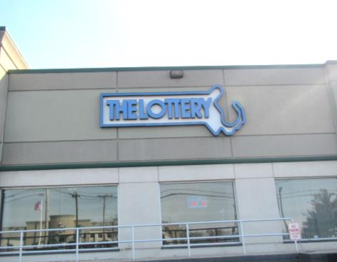

Prepared by:
Massachusetts Department of Public Health
Bureau of Environmental Health
Indoor Air Quality Program
March 2017

Background
Building: | Massachusetts Lottery Commission (MLC)
Address: | 11 Cummings Park Drive, Woburn, Massachusetts
Assessment Requested by: | Paul Burke, Project Manager, Division of Capital Asset Management and Maintenance (DCAMM)
Reason for Request: | Odor concerns and general indoor air quality (IAQ)
Date of Assessment: | February 27, 2017
Massachusetts Department of Public Health/Bureau of Environmental Health (MDPH/BEH) Staff Conducting Assessment: | Ruth Alfasso, Environmental Engineer/Inspector, IAQ Program
Building Description: | One-story building as part of a strip mall, with warehouse and loading dock in the rear of the building+
Building Population: | Approximately 45 employees and up to several hundred visitors from the public
Windows: | Not openable

Methods
Please refer to the IAQ Manual for methods, sampling procedures, and interpretation of results (MDPH, 2015).
Note that this building has been visited by the BEH/IAQ program before to address general IAQ concerns. Reports from the previous visits are available on the MDPH website at http://www.mass.gov/eohhs/gov/departments/dph/programs/environmental-health/exposure-topics/iaq/iaq-rpts/cities-and-towns-w.html.

IAQ Testing Results
The following is a summary of indoor air testing results (Table 1).
- Carbon dioxide levels were above 800 parts per million (ppm) in about two thirds of areas assessed, indicating that more fresh air could be supplied to the space.
- Temperature was within or close to the recommended range of 70°F to 78°F in all areas assessed.
- Relative humidity was below the recommended range of 40% to 60% in all areas assessed, which is typical of winter conditions.
- Carbon monoxide levels were non-detectable in all but one area assessed, which had a slight reading of <1 ppm.
- Fine particulate matter (PM2.5) concentrations measured were below the National Ambient Air Quality Standard (NAAQS) level of 35 micrograms per cubic meter (μg/m³) in all areas assessed.

Ventilation
A heating, ventilating and air conditioning (HVAC) system has several functions. First it provides heating and, if equipped, cooling. Second, it is a source of fresh air. Finally, an HVAC system will dilute and remove normally-occurring indoor environmental pollutants by not only introducing fresh air, but by filtering the airstream and ejecting stale air to the outdoors via exhaust ventilation. Even if an HVAC system is operating as designed, point sources of respiratory irritation may exist and cause symptoms in sensitive individuals.
Mechanical ventilation for the front portion of the building, which provides office and customer support functions, is provided by heating, ventilation and air conditioning (HVAC) air handling units (AHUs) located on the roof (Picture 1). Fresh air is drawn into vents in these units, filtered, heated/cooled and distributed through ceiling-mounted supply vents. Air is returned through ceiling-mounted exhaust vent grills (Picture 2). Note that most offices did not have exhaust vents – airflow is designed to exit offices through undercuts in office doors and be returned by vents in the main open area. The carbon dioxide readings in this area were mainly above 800 ppm. Note also that there is no visible exhaust vent in the waiting room, which was occupied by over 20 people at times during the visit and a carbon dioxide reading of 1141 ppm. In addition, the thermostat nearest the waiting room was in the “fan auto” setting which would only provide fresh air when the temperature needs adjustment. Without exhaust ventilation in this area, and without a continuous source of fresh air circulation, carbon dioxide and related pollutants would be expected to build up.
It is recommended that all systems be operated in the “fan on” mode during occupied periods to provide for air circulation. It is also recommended that HVAC systems be re-balanced every five years to ensure adequate air systems function (SMACNA, 1994); it is not known if these systems were balanced since 2009.
The rear part of the building, where lottery machines are maintained and promotional items are stored, has no mechanical source of fresh air. HVAC equipment is located in closets to heat/cool and recirculate air in this area. Picture 3 shows a return vent on the side of the AHU closet; note that it is partially blocked and had no draw of air at the time of the visit indicating that it was turned off. Exhaust vents located in restrooms remove pollutants and odors generated there as well as provide some overall exhaust for the nearby areas.
There is no mechanical ventilation for the warehouse. It is heated by gas-fired heaters hanging from the ceiling and there are ceiling fans to provide some circulation during warmer months. There was a trace of carbon monoxide (0.7 ppm) detected in the loading dock area (Table 1), and the door in this area lacked a sweep (Picture 4). It is important that this door remain closed/sealed when not in use, and that vehicles outside do not idle. Another door separating the warehouse and machine area was marked “keep door closed” but was open (Picture 5).

Odor Concerns
The main reason for this assessment is that occupants of the office reported strong spice/food odors during certain parts of the day in the front office areas, along with eye and respiratory tract irritation. A log kept by employees indicated that these odors were most prominent both at mid-morning and mid-afternoon. Nearby this office in the same building is the Godavari Restaurant, which serves both lunch and dinner daily, including highly spiced food. An examination of the equipment located on the roof showed that the exhaust vent for the restaurant is less than 100 feet away from the intake for the MLC HVAC equipment serving the front of the building. At the time of the visit, a strong odor of cooking/spices was noticeable from the restaurant’s exhaust vent on the roof, although no odors were observed inside the MLC office, possibly due to wind conditions. During other weather conditions, it is likely that these odors are able to penetrate the fresh air vents for the MLC and become distributed around the office.
Currently, the restaurant is undergoing renovations, including expansion into the tenant space between the current restaurant and the MLC space. Part of this renovation includes all new exhaust equipment, much of which was present on the roof, but not yet connected. The current exhaust vents are elevated in comparison to the new ones. It may be beneficial to raise the new exhaust vents to a greater discharge height than the old ones to ensure that odors have a chance to disperse instead of being drawn into the MLC air intake.
Improving the filtration on the MLC HVAC system might also assist in reducing the impact of restaurant odors on the space. The current filters on the HVAC equipment could not be examined, but typical filters for an office space might have a Minimum Efficiency Reporting Value (MERV) of 8 which is sufficient to remove most pollen and dust (ASHRAE 2012). Increasing filtration to MERV 10 or 11 will remove smaller particles including some associated with odors (ASHRAE, 2012). Use of filters containing activated carbon designed to remove odors may also be an option. Note that increasing filtration may create additional stress on the HVAC equipment through increased resistance to flow; the system should be evaluated to determine if the new filters will be appropriate.

Microbial/Moisture Concerns
Two water-damaged ceiling tiles were observed in the open area of the front office (Table 1; Picture 1). Water-damaged tiles indicate a leak from plumbing or the building envelope and should be replaced once the source has been repaired. Note also that the skylight over the warehouse is cracked (Picture 6) which may lead to leakage if not repaired.
A water dispenser was located over carpet in the waiting room hallway (Picture 7). Leaks from these appliances can damage carpeting. Replacement of carpeting with floor tiles in this area or the use of plastic or rubber mats with raised edges would prevent water damage.
The computer room had a ductless air conditioning unit on the wall (Picture 8). This unit has a condensate drain and pump which directs the water to the building’s drain system. The drains and pumps should be inspected periodically for proper operation to avoid clogs and leaks. Porous items such as cardboard boxes were stored underneath this unit; they should be moved to avoid water damage in the case of a leak. Porous items (boxes, paper towels) were also found stored under the kitchen sink which is a moist environment.

Other Concerns
Exposure to low levels of total volatile organic compounds (TVOCs) may produce eye, nose, throat, and/or respiratory irritation in some sensitive individuals. In addition to testing, BEH/IAQ staff examined spaces for products containing VOCs. BEH/IAQ staff noted hand sanitizers, cleaning products, and dry erase materials in a number of areas throughout the office space (Table 1). All of these products have the potential to be irritants to the eyes, nose, throat, and respiratory system of sensitive individuals. Of particular note is the use of various cleaners and degreasers in the machine repair area, where there is no mechanical fresh air supply. Increasing the exhaust ventilation from the existing restroom vents in this area will assist in removing VOCs from these areas. In the 2012 BEH/IAQ Program report on this facility, printed promotional materials (e.g., brochures, banners) were identified as being a source of TVOCs and odors to occupied areas. At that time, it was recommended that these materials be stored in closed containers and away from occupied areas to the greatest extent possible, and mostly this appeared to be the case during this visit, however, care should be taken to close containers and storeroom doors when not in use to contain odors and TVOCs from these materials.
Items were observed on a number of flat surfaces, such as windowsills, tabletops, counters, bookcases, and desks as well as hanging on walls. The large number of items stored in offices provides a source for dusts to accumulate. These items (e.g. papers, folders, boxes) also make it difficult for custodial staff to clean. Items should be stored neatly, cleaned and relocated periodically to avoid excessive dust build up.
Most of the front part of the office is carpeted. The Institute of Inspection, Cleaning and Restoration Certification (IICRC), recommends that carpeting be cleaned annually, or semi-annually in soiled high traffic areas (IICRC, 2012).
High efficiency particulate arrestance (HEPA)-filtered air purifiers were observed in some offices. These appliances should be maintained in accordance with manufacturers’ instructions including filter changes.

Conclusions/Recommendations
Based on observations at the time of assessment, the following is recommended:
- Operate the HVAC systems in the “fan on” setting in all office areas including the waiting room.
- Consider adjusting settings on the HVAC system to bring in more fresh air where possible.
- Investigate if additional exhaust ventilation is possible for the waiting room.
- Continue to investigate options for mitigating odors from the restaurant next door, including:
  - Having the exhaust vents from the restaurant raised five to ten feet above the roofline to allow for improved dispersion;
  - Increasing filtration on MLC HVAC intakes to MERV 10 or 11; and/or
  - Using activated-carbon enhanced filters in the HVAC intakes. Note that the HVAC system should be evaluated before changing filtration on an HVAC equipment to ensure that it will not cause excessive obstruction to flow and prevent proper operation.
- Ensure that the door to the loading dock remains closed and has a tight-fitting door sweep. Keep other doors necessary for separating work areas closed.
- Avoid truck idling outside the building.
- Have the HVAC system balanced every 5 years in accordance with SMACNA recommendations (SMACNA, 1994).
- For buildings in New England, periods of low relative humidity during the winter are often unavoidable. Therefore, scrupulous cleaning practices should be adopted to minimize common indoor air contaminants whose irritant effects can be enhanced when the relative humidity is low. To control for dusts, a high efficiency particulate arrestance (HEPA) filter equipped vacuum cleaner in conjunction with wet wiping of all surfaces is recommended. Avoid the use of feather dusters. Drinking water during the day can help ease some symptoms associated with a dry environment (throat and sinus irritations).
- Replace water-damaged ceiling tiles after repairing leaks.
- Inspect the skylight over the warehouse and repair if necessary to prevent leaks.
- Consider replacing carpeting under the water fountain in the waiting area with floor tile to prevent damage due to leaks or place a waterproof mat in this area.
- Regularly inspect the drain and pump to the ductless air conditioning unit in the computer room to avoid leaks, and avoid storing materials below the unit.
- Avoid storing porous items under sinks.
- Continue to enclose/contain promotional/printed items that may off-gas VOCs and odors.
- Clean carpeting annually or semi-annually in soiled high traffic areas as per the recommendations of the Institute of Inspection, Cleaning and Restoration Certification (IICRC, 2012).
- Refer to resource manual and other related IAQ documents located on the MDPH’s website for further building-wide evaluations and advice on maintaining public buildings. These documents are available at: http://mass.gov/dph/iaq.

References
ASHRAE. 2012. American Society of Heating, Refrigeration and Air Conditioning Engineers Standard 52.2-2012 -- Method of Testing General Ventilation Air-Cleaning Devices for Removal Efficiency by Particle Size (ANSI Approved).
IICRC. 2012. Carpet Cleaning FAQ 4 Institute of Inspection, Cleaning and Restoration Certification. Institute of Inspection Cleaning and Restoration. Vancouver, WA. Retrieved from http://www.iicrc.org/consumers/care/carpet-cleaning.
MDPH. 2015. Massachusetts Department of Public Health. Indoor Air Quality Manual: Chapters I-III. Available at: http://www.mass.gov/eohhs/gov/departments/dph/programs/environmental-health/exposure-topics/iaq/iaq-manual/.
SMACNA. 1994. HVAC Systems Commissioning Manual. 1st ed. Sheet Metal and Air Conditioning Contractors’ National Association, Inc., Chantilly, VA.
Picture 1
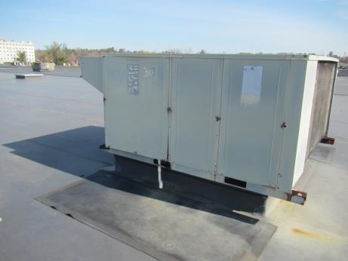
Air handling unit on the roof
Picture 2
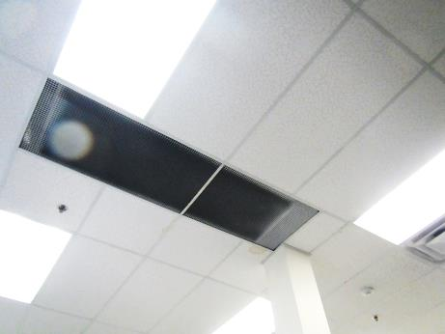
Exhaust vents in open part of front area, note water-damaged ceiling tiles
Picture 3
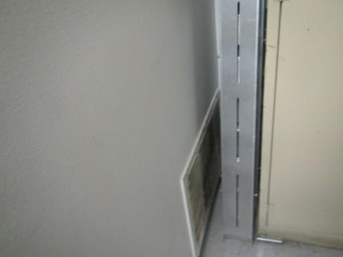
Return vent for recirculation-only AHU in rear section of the building
Picture 4
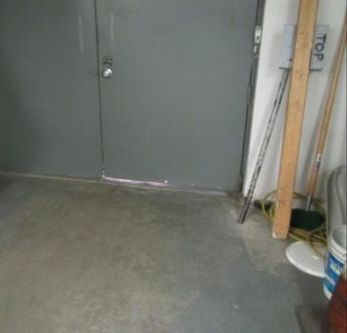
Light visible beneath loading dock door showing that door sweep is missing
Picture 5
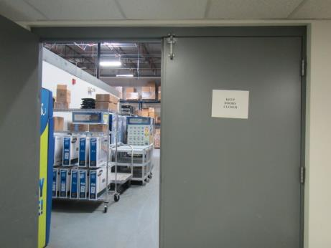
Door propped open with “keep door closed” sign
Picture 6
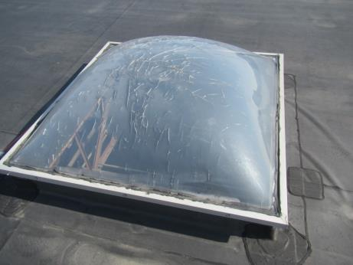
Skylight showing cracks
Picture 7
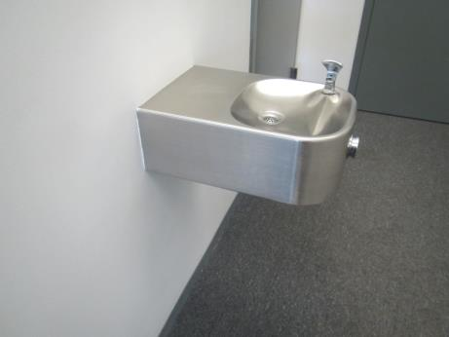
Water fountain over carpeting in waiting room area
Picture 8
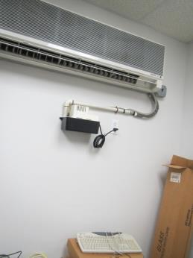
Ductless air conditioning unit, drain pump, and items stored below
Location | Carbon  Dioxide  (ppm) | Carbon Monoxide  (ppm) | Temp  (°F) | Relative  Humidity  (%) | PM2.5  (µg/m³) | Occupants  in Room | Windows  Openable | Ventilation |  | Remarks
 |  |  |  |  |  |  |  | Supply | Exhaust
Background (outdoors) | 363 | 0.8 | <32 | 21 | 9 |  |  |  |  | Chilly and breezy, active parking lot
Sheila’s office | 1027 | ND | 68-69 | 25 | 5 | 6 | N | Y | Y | AP
Zebniak office | 928 | ND | 71 | 24 | 5 | 0 | N | Y | N | CP
Office | 864 | ND | 71 | 23 | 4 | 0 | N | Y | N | DEM
Open area under skylight | 879 | ND | 72 | 23 | 5 | 3 | N | Y | Y | PC, WD-CT
Beaton | 972 | ND | 72 | 24 | 5 | 0 | N | Y | N | Perfume odor
McCure | 970 | ND | 72 | 23 | 5 | 1 | N | Y | N | Food
Conference room | 868 | ND | 72 | 23 | 5 | 0 | N | Y | Y | Items, t-shirts in boxes
Side open area | 916 | ND | 72 | 23 | 5 | 1 | N | Y | Y
Kitchen | 905 | ND | 72 | 23 | 5 | 0 | N | Y | N | Fridge, toaster, microwave, paper and CP under sink, NC
Office | 920 | ND | 73 | 23 | 6 | 3 | N | Y | Y
West office | 861 | ND | 72 | 22 | 5 | 1 | N | Y | N | DEM
Computer/MDF room | 859 | ND | 70 | 22 | 5 | 0 | N | N | N | Wall-mounted ductless air conditioner
T-shirt storage | 893 | ND | 70 | 32 | 5 | 0 | N | Y | N | Stored items including printed shirts stored
Ticket Restocking | 762 | ND | 70 | 25 | 7 | 3 | N | Y | N | NC, items on floor, fridge, CP
Lower level office | 755 | ND | 70 | 24 | 8 | 0 | N | Y | N | PC
Printed materials storage | 700 | ND | 70 | 24 | 8 | 0 | N | Y | N | Printed materials and vinyl banners
Open warehouse | 811 | ND | 70 | 21 | 11 | 0 | N | N | N | CF, gas-fired heater, electric forklift, warehouse items, skylight with some damage
Machine storage | 553 | ND | 71 | 21 | 11 | 0 | N | N | N | Recirculating air system, currently off. CP
Machine repairs | 630 | ND | 72 | 21 | 10 | 3 | N | Y | N | Recirculating air system
Former restroom |  |  |  |  |  |  | N | N | Y | Slop sink, had a toilet, now capped, bathroom-type exhaust fan, unknown if operational
Rear kitchen | 697 | ND | 72 | 21 | 11 | 0 | N | Y | Y | Recirculating air system
Rear restroom |  |  |  |  |  |  | N | Y | Y | Exhaust ducted to roof
Carpeted area in back office | 602 | ND | 72 | 20 | 10 | 0 | N | Y |  | Recirculating air system
Office | 557 | ND | 72 | 21 | 10 | 0 | N | Y |  | Recirculating air system, CP and degreasers, food, items on floor
Loading dock | 629 | 0.7 | 71 | 20 | 12 | 0 | N | Y | N | Door needs sweep
Waiting room | 1141 | ND | 71 | 23 | 10 | ~20 | N | Y | N
Waiting room restroom |  |  |  |  |  |  | N | N | Y | CP

