Background

INDOOR AIR QUALITY
PRE-OCCUPANCY ASSESSMENT

Massachusetts State Lottery Operations Center
700 Longwater Drive
Norwell, MA

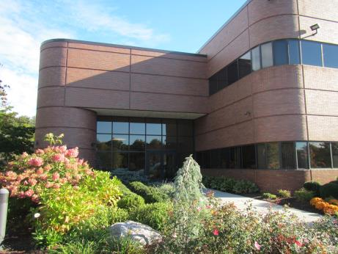

Prepared by:
Massachusetts Department of Public Health
Bureau of Environmental Health
Indoor Air Quality Program
November 2018
Building: | Mass State Lottery Operations Center
Address: | 700 Longwater Drive, Norwell, MA
Division of Capital Asset Management and Maintenance (DCAMM) Project Manager: | Walter Jenkins, Division of Capital Asset Management & Maintenance Office of Leasing and State Office Planning
Date of Pre-Occupancy Assessment: | October 17, 2018
Massachusetts Department of Public Health/Bureau of Environmental Health (MDPH/BEH) Staff Conducting Assessment: | Ruth Alfasso, Environmental Engineer/Inspector, Indoor Air Quality (IAQ) Program
Date of Building Construction: | 1980s
Discussion:

The building at 700 Longwater Drive in Norwell, MA is part of a large office park (Assinippi Park) located near Route 3 in Norwell, with various commercial and retail businesses nearby. This building currently contains the South Shore Charter School on the first floor, a call center for a financial company, and a data center for the Massachusetts Lottery System (the Lottery). The Lottery is planning to convert a portion of the data center, which is on the second floor, to house three shifts of employees, 6-11 people per shift. This conversion will include a fresh air ventilation system to serve the rooms that will be occupied. Data center operations will continue in the rest of the space. Additionally, this office has a secondary Lottery Drawing Room which is planned to be used on a regular basis once the space is occupied.
A separate room outside the data center is planned to be outfitted as a break room, with a refrigerator, microwave and vending machines. This room had formerly been used by the lottery for data transmission and fire suppression equipment, which has been removed. This room appeared to have a fresh air supply and return. Restrooms for the employees in this building are part of the core facilities on the second floor and were not investigated.

Previous Relevant Environmental History:
No Massachusetts Contingency Plan projects for this building or property were found in the Massachusetts Department of Environmental Protection database.

Methods
Air tests for carbon monoxide, temperature and relative humidity were taken with the TSI, Q-Trak, IAQ Monitor 7575x. Air tests for airborne particle matter with a diameter less than 2.5 micrometers were taken with the TSI, DUSTTRAK™ Aerosol Monitor Model 8520. BEH/IAQ staff also performed visual inspection of building materials for water damage and/or microbial growth and examined the space for the presence of odors or other environmental concerns.

Air Testing Results
Media sampled |  | MDPH Guideline/  Comparison Value |  | Measured Range |  |  | Comments
 |  |  |  | Outdoors/  Background |  | Indoors
Carbon Dioxide (CO₂) |  | < 800 parts per million (ppm) is preferred |  | NA |  | 651-792 ppm | HVAC system for cooling equipment only, new HVAC will be in place before occupancy, location was not occupied
Carbon Monoxide (CO) |  | Non-detectable (ND) or equal to or below background level measured |  | NA |  | ND
Particulate Matter 2.5 (PM2.5) |  | US EPA National Ambient Air Quality Standards (NAAQS) 35 μg/m³ or less |  | NA |  | ND-1 μg/m³ | Readings were all very low
Temperature |  | 70 to 78 ºF |  | 45 ºF |  | 65 to 70 ºF | HVAC system for cooling equipment only, new HVAC will be in place before occupancy
Relative Humidity (RH) |  | 40% to 60% |  | 57% |  | 44 to 48% | HVAC system for cooling equipment only, new HVAC will be in place before occupancy
Total Volatile Organic Compounds |  | Non-detectable (ND) or equal to or below background level measured |  | ND |  | ND - 0.2 | Not occupied, computer equipment in use
ppm = parts per million | µg/m³ = microgram per cubic meter |  | ND = non-detectable

Discussion/Visual Observations
As discussed, the space is currently in use as a data center for the Lottery. The space to be used for 24/7 occupancy will have its own fresh air supply and heat/air conditioning. This HVAC unit is planned to be installed on the roof. The HVAC systems should be equipped with filters with a minimum efficiency rating value of 8 or better (MERV 8) which are adequate to filter out common irritants like pollen. The existing and new HVAC systems in the building should be balanced prior to occupancy to ensure that sufficient fresh air and stale air removal is supplied to the occupied area of the building without interrupting the cooling required for the rest of the data center.
It was not known at the time of the visit if additional HVAC capacity will be added to the Lottery Drawing Room. It is recommended that any occupied area have a supply of fresh air and a means to remove stale air. Areas where pollutants are generated, such as bathrooms and kitchens, should be equipped with exhaust vents that move air directly out of the building.
A water-damaged ceiling tile was observed in the back of the data center near the fire suppression system (Picture 1). This damage is likely from a clog or leak in a condensate pump located in the ceiling. Lottery staff did not think this pump was a part of their operation. Another water-damaged ceiling tile was noted in the break room. Water-damaged ceiling tiles can be a source of mold and odors. These tiles should be removed and replaced after the source of water has been fixed. Other missing tiles were observed in the space; the ceiling tile system should be made flush and complete to prevent dust and debris from above the tiles entering occupied space.
The floor of the data center is part of the cooling system for the room so there is an air space and air flowing under the floor. It is important that this area be kept scrupulously clean and free of debris as this can be a source of odors and attractive to pests. At the time of the visit, one area under the raised floor was examined and found to be clean and in good condition (Picture 2).
Lottery staff were concerned about black dust/residue on some of the computer equipment. A small amount of residue was observed on surfaces inside a rack of computers. While floors in this area are cleaned regularly, it is not likely that computer racks are cleaned/dusted with any frequency. Given that there is regular airflow of recirculated cooled air in the room, including fans for individual computers, small amounts of dust are likely to settle inside equipment over the long term. The dust/debris did not have an oily or rubbery odor; however all belts and other moving equipment in the cooling system and elsewhere in the room should be checked regularly for fluid leaks and wear.
The data center is equipped with a fire suppression system which uses an inert gas. It was reported that this system may be replaced during the upgrades. Any waterless fire suppression system needs to be properly installed, inspected and alarmed. A leak or release of inert gas in an occupied area can be an asphyxiation risk.
The data center included some computer equipment which appeared to be very outdated. Removal of unneeded, outdated equipment during the remodeling project will make the room easier to keep clean.

Recommendations
In view of the findings at the time of assessment, the following recommendations are made:
- Continue with plans to install fresh air supply for the area to be occupied in the data center. Ensure that this system is balanced along with the existing air conditioning system to ensure that each area is properly supplied with fresh, tempered air. If the Lottery Drawing Room will be used regularly, consider adding a fresh air supply to this area as well.
- Inspect the HVAC system for the break room to see if it is operational. If possible, install a direct vent to remove cooking odors and smoke from this room.
- Use filters with a Minimum Efficiency Reporting Value (MERV) 8 or better in the AHU and ensure they are changed a minimum of twice per year.
- Replace water-damaged ceiling tiles and monitor for any new leaks. Ensure any condensate collection systems are monitored for proper operation.
- Inspect moving parts of the existing cooling system for wear of belts and other sources of dust and debris.
- Ensure that cleaning can be conducted regularly, including removal of trash and cleaning of surfaces. If the Drawing Room is used regularly, ensure a carpet cleaning program is in place.
- Ensure that the existing or new fire suppression system is inspected regularly and has visible and audible alarms in case of inert gas leaks.
- Consider removal of any outdated, unneeded equipment from the data center to allow for easier cleaning.
- Upon completion of renovations, perform a final, thorough cleaning of the office space including wet-wiping of all surfaces and use of a HEPA vacuum on all carpeting prior to staff moving into the space. Ensure the space under the raised floor is also clean and free of debris.
- Consistent with previously established protocol, once the space has been occupied for a minimum of three weeks, contact the BEH/IAQ Program to conduct a follow-up assessment of the space.
Picture 1
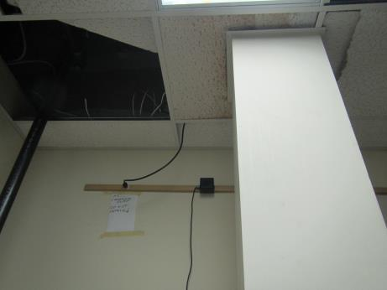
Water-damaged ceiling tile and ajar tile in fire suppression room
Picture 2
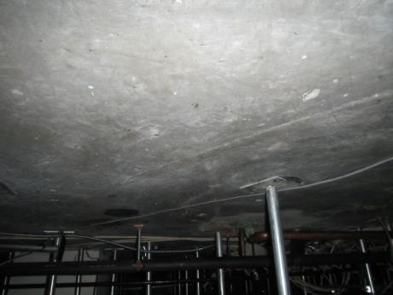
Area underneath the raised floor, note no debris or dust

