INDOOR AIR QUALITY
POST-OCCUPANCY ASSESSMENT

Massachusetts State Retirement Board
One Winter Street
7th floor
Boston

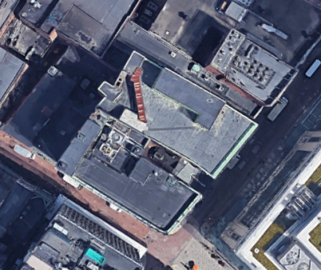

Prepared by:
Massachusetts Department of Public Health
Bureau of Environmental Health
Indoor Air Quality Program
August 2020

Background
Building: | Massachusetts State Retirement Board (MSRB)
Address: | One Winter Street, 7th floor, Boston
Assessment Requested by: | Paul Burke, Project Manager, Division of Capital Asset Management and Maintenance (DCAMM)
Reason for Request: | Post-occupancy indoor air quality (IAQ) assessment
Date of Assessment: | March 6, 2020
Massachusetts Department of Public Health/Bureau of Environmental Health (MDPH/BEH) Staff Conducting Assessment: | Ruth Alfasso, Environmental Engineer, IAQ Program
Building Description: | The new MSRB offices are located on the 7th floor of One Winter Street, an 8-story building in downtown crossing, Boston. The space contains offices, workstations, conference rooms and auxiliary spaces. Other state offices occupy the upper floors of the building; the first floor is retail and food service.
Windows: | Not openable

This building has been visited by the DPH IAQ program several times in the past, including in October of 2019 for a water damage assessment that included the 7th floor area to be occupied by MSRB. That report can be found at: https://www.mass.gov/info-details/indoor-air-quality-reports-cities-and-towns-b.

Methods
Please refer to the IAQ Manual for methods, sampling procedures, and interpretation of results (MDPH, 2015).

IAQ Testing Results
The following is a summary of indoor air testing results (Table 1). Note that offices and cubicle areas in the office space are not numbered/labeled:
- Carbon dioxide levels were below the MDPH guideline of 800 parts per million (ppm) in all of the areas surveyed.
- Temperature was within the MDPH recommended range of 70°F to 78°F in all areas tested.
- Relative humidity was below the MDPH recommended range of 40 to 60% in all areas which is typical of the heating season.
- Carbon monoxide levels were non-detectable (ND) in all areas tested.
- Fine particulate matter (PM2.5) concentrations measured were below the National Ambient Air Quality Standard (NAAQS) limit of 35 μg/m³ in all areas tested.
- Total volatile organic compounds (TVOCs) were ND in all areas tested.

Ventilation
A heating, ventilating, and air conditioning (HVAC) system has several functions. First it provides heating and, if equipped, cooling. Second, it is a source of fresh air. Finally, an HVAC system will dilute and remove normally-occurring indoor environmental pollutants by not only introducing fresh air, but by filtering the airstream and ejecting stale air to the outdoors via exhaust ventilation. Even if an HVAC system is operating as designed, point sources of respiratory irritation may exist and cause symptoms in sensitive individuals.
Air from the HVAC system is ducted to ceiling-mounted supply air vents (Picture 1). Ceiling-mounted return vents return air to the air handling units (AHUs). Note that many return vents for offices are located near the door (Picture 2). These will function most effectively at removing stale air from the office, rather than the hallway, with the doors closed.
The HVAC system in this office is computer controlled. It is recommended that the system be set to provide continuous air circulation during occupied periods.
It is recommended that HVAC systems be re-balanced every five years to ensure adequate air systems function (SMACNA, 1994). The date of the last HVAC balancing in this building was not available.

Microbial/Moisture Concerns
No water-damaged materials, water stains or musty odors were observed during the visit. Plants were noted in some areas (Picture 3; Table 1). Plants should be properly maintained and equipped with drip pans and should be located away from airflow to prevent the aerosolization of dirt, pollen, and mold. Plants should not be placed on porous surfaces including carpet.
A ductless air conditioning unit is located in the MDF room. These units create condensation which needs to be drained. The pumps and tubing for condensation drains should be checked periodically to prevent leaks.

Other Concerns
Exposure to low levels of total volatile organic compounds (TVOCs) may produce eye, nose, throat, and/or respiratory irritation in some sensitive individuals. To determine if VOCs were present, BEH/IAQ staff took measurements for TVOCs, which were all ND. BEH/IAQ examined other areas for products containing VOCs. BEH/IAQ staff noted hand sanitizers, cleaners, and dry erase materials in the office space (Picture 3; Table 1). All of these products have the potential to be irritants to the eyes, nose, throat, and respiratory system of sensitive individuals.
A personal air purifier was located in one office (Picture 4). These units should be maintained in accordance with manufacturer’s instructions including placement, cleaning and filter changes. Note that these units will be more effective if the filtered airstream is in the breathing zone of the occupants rather than on the floor. No air purifiers that create ozone should be used in occupied spaces as ozone is a respiratory irritant (US EPA, 2003).
This office space has a kitchen area with all new appliances. Care should be taken to keep food preparation equipment clean to prevent smoke, odors and pests.
Most of the offices are carpeted. Carpets should be cleaned annually (or semi-annually in soiled/high traffic areas) in accordance with Institute of Inspection, Cleaning and Restoration Certification (IICRC) recommendations, (IICRC, 2012).

Conclusions/Recommendations
Based on observations at the time of assessment, the following is recommended:
- Operate supply and exhaust ventilation continuously in all areas during occupied periods. Ensure all HVAC equipment is cleaned/maintained in accordance with manufacturer’s instructions.
- Change filters for HVAC equipment 2-4 times a year. Use pleated filters of Minimum Efficiency Reporting Value (MERV) 8 (or higher), which are adequate in filtering out pollen and mold spores (ASHRAE, 2012).
- Balance the HVAC system every 5 years in accordance with Sheet Metal and Air Conditioning Contractors’ National Association (SMACNA) recommendations (SMACNA, 1994).
- Consider placing refrigerators and water dispensers in areas without carpeting or use a waterproof mat to protect carpeting.
- Keep plants and flowers in good condition, avoid overwatering, and remove from the airstream of heating and ventilation equipment.
- Periodically check the pump and tubing for ductless air conditioners to prevent leaks.
- Reduce the use of cleaning products, sanitizers, and other items that contain VOCs. Keep containers sealed when not in use.
- For buildings in New England, periods of low relative humidity during the winter are often unavoidable. Therefore, scrupulous cleaning practices should be adopted to minimize common indoor air contaminants whose irritant effects can be enhanced when the relative humidity is low. To control for dusts, a high efficiency particulate arrestance (HEPA) filter equipped vacuum cleaner in conjunction with wet wiping of all surfaces is recommended. Avoid the use of feather dusters. Drinking water during the day can help ease some symptoms associated with a dry environment (throat and sinus irritations).
- Ensure all surfaces are cleaned periodically, including supply and return vents, personal fans and flat surfaces.
- Ensure air purifiers are located, maintained and cleaned in accordance with manufacturer’s instructions.
- Keep food preparation equipment clean, and clean out refrigerators, including the gaskets, regularly.
- Clean carpeting in accordance with IICRC recommendations (IICRC, 2012).
- Refer to resource manual and other related IAQ documents located on the MDPH’s website for further building-wide evaluations and advice on maintaining public buildings. These documents are available at: http://mass.gov/dph/iaq.

References
ASHRAE. 2012. American Society of Heating, Refrigeration and Air Conditioning Engineers (ASHRAE) Standard 52.2-2012 -- Method of Testing General Ventilation Air-Cleaning Devices for Removal Efficiency by Particle Size (ANSI Approved).
IICRC. 2012. Institute of Inspection, Cleaning and Restoration Certification. Carpet Cleaning: FAQ.
MDPH. 2015. Massachusetts Department of Public Health. Indoor Air Quality Manual: Chapters I-III. Available at: http://www.mass.gov/eohhs/gov/departments/dph/programs/environmental-health/exposure-topics/iaq/iaq-manual/.
SMACNA. 1994. HVAC Systems Commissioning Manual. 1st ed. Sheet Metal and Air Conditioning Contractors’ National Association, Inc., Chantilly, VA.
US EPA. 2003. “Ozone Generators that are Sold as Air Cleaners: An Assessment of Effectiveness and Health Consequences”. US Environmental Protection Agency, Office of Air and Radiation, Indoor Environments Division, Washington, D.C. https://www.epa.gov/indoor-air-quality-iaq/ozone-generators-are-sold-air-cleaners.
Picture 1
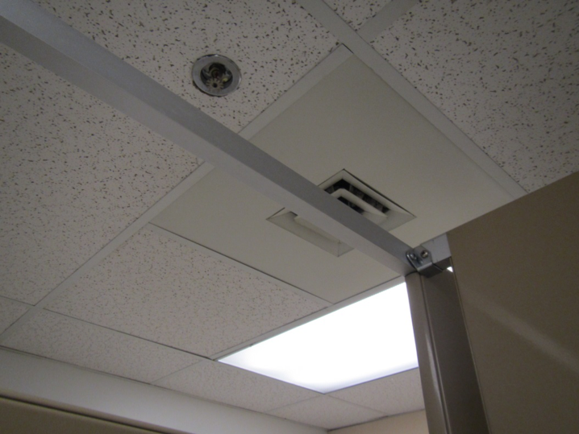
One style of supply vent
Picture 2
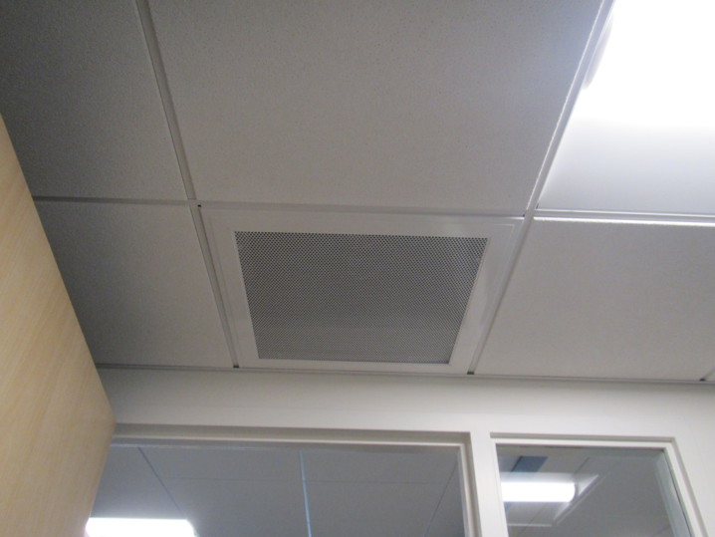
Typical return vent, note proximity to door
Picture 3
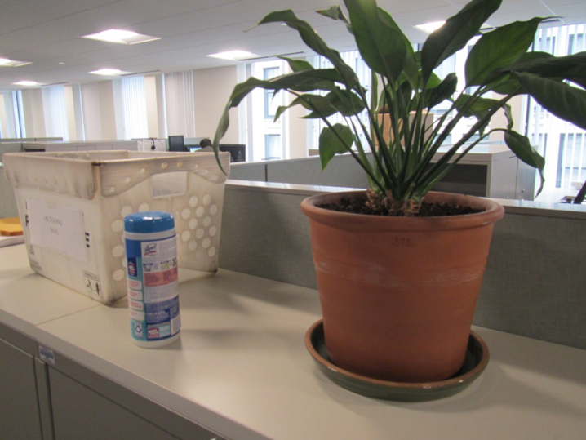
Plant in a common area, also note cleaning wipes
Picture 4
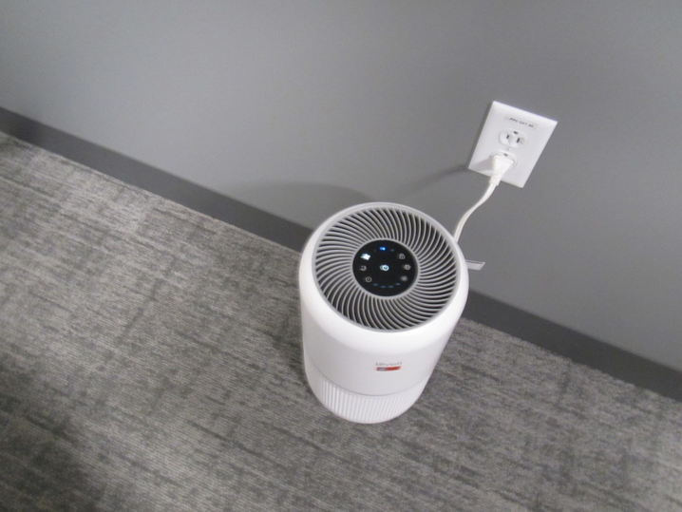
Air purifier in an office
Location | Carbon  Dioxide  (ppm) | Carbon Monoxide  (ppm) | Temp  (°F) | Relative  Humidity  (%) | PM2.5  (µg/m³) | Occupants  in Room | TVOCs  (ppm) | Windows  Openable | Ventilation |  | Remarks
 |  |  |  |  |  |  |  |  | Supply | Exhaust
Office | 533 | ND | 73 | 27 | 2 | 1 | ND | N | Y | Y | Plants, air purifier
Office | 576 | ND | 72 | 28 | 6 | 1 | ND | N | Y | Y | DO
Office (communications) | 531 | ND | 72 | 26 | 6 | 0 | ND | N | Y | Y | Lysol
Office | 557 | ND | 72 | 27 | 6 | 0 | ND | N | Y | Y | Plant
Cubes | 558 | ND | 72 | 27 | 6 | 1 | ND | N | Y | Y | DO, plant
Cube area 1 | 521 | ND | 73 | 27 | 6 | 2 | ND | N | Y | Y
Cube area 2 | 517 | ND | 73 | 27 | 6 | 0 | ND | N | Y | Y
Cube area 3 | 499 | ND | 73 | 26 | 7 | 2 | ND | N | Y | Y
Pierce cube area | 482 | ND | 73 | 26 | 6 | 1 | ND | N | Y | Y
Conference room | 485 | ND | 72 | 26 | 7 | 0 | ND | N | Y | Y
Kitchen | 463 | ND | 72 | 27 | 6 | 0 | ND | N | Y | Y | NC, sink, refrigerator, toasters, microwaves
MDF |  |  |  |  |  |  |  | N | Y | Y | Ductless air conditioner, NC
Women’s restroom |  |  |  |  |  |  |  | N | Y | Y | Two supply-style vents, assuming one or both is exhaust
Huddle room | 738 | ND | 74 | 27 | 7 | 5 | -- | N | Y | Y | Food

