Massachusetts Statewide Helplines

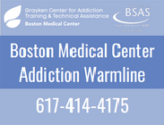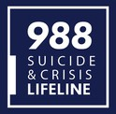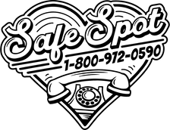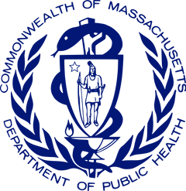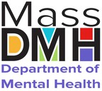

**Massachusetts Department of Public Health (DPH)**

**988 Lifeline**—The 988 Lifeline is managed by the Bureau of Community Health and Prevention (BCHAP). This service connects individuals with trained Suicide and Crisis Lifeline specialists who are available to provide free, confidential emotional support to all callers. 988 Lifeline is available 24/7 and can be accessed via phone call, text, or online chat. Phone Number: 988. Website: [988lifeline.org](http://988lifeline.org/).

**Women and Family Referral Center (WFRC)—**Funded by BSAS, the WFRC provides referral support and information to anyone in Massachusetts with questions about Substance Use Disorder (SUD) treatment and recovery supports for pregnant and parenting people. The WFRC connects callers with services and provides them with interim phone counseling services to those unable to be placed immediately in treatment. Phone number: 866-705-2807.

**The Massachusetts Substance Use Helpline**—The MA Substance Use Helpline is funded by the Bureau of Substance Addiction Services (BSAS). The Helpline provides the public with resource information about harm reduction, treatment, and recovery services for Substance Use Disorder available in Massachusetts and a warm hand off to these programs when needed. This free, 24/7 service is available by phone via call and live text, website search and online chat. Phone number: 800-327-5050. Website: [helplinema.org](http://helplinema.org/).

**The MA Problem Gambling Helpline—**Funded by DPH, the Problem Gambling Helpline provides referrals to licensed problem gambling treatment and recovery support services and is a resource for problem gambling awareness and education. This is a free, 24/7 service that is available online via website search and online chat and by phone call and live texting.

Phone number: 800-327-5050. Website: [gamblinghelplinema.org](https://gamblinghelplinema.org/).

**Boston Medical Center Addiction Warmline—**Funded by BSAS, the BMC Addiction Warmline assists in providing rapid access to medications to treat opioid and alcohol use disorders including buprenorphine (Suboxone), Sublocade, injectable naltrexone (Vivitrol), and other medications for alcohol use disorder. The Warmline also provides assistance with linkage to treatment on demand (including methadone) and referral to long term treatment. The Warmline is a 24/7, free service with providers on call and can be accessed by phone. Phone number: 617-414-4175.

**SafeSpot—**Formerly known as the Massachusetts Overdose Prevention Helpline, SafeSpot is funded by BSAS. SafeSpot provides virtual spotting services to people who use drugs to prevent overdose.

An individual using drugs alone calls the line, uses the substance, and stays in verbal communication with the operator until both the caller and the operator have decided that they are safe to disconnect. If there is an emergency, the operator will call the designated responder given by the caller who may be a person at the caller’s location or emergency response services. The free, 24/7 hotline is operated by a team with lived and living experience with overdose.

Phone number: 800-972-0590. Website: [safe-spot.me](https://safe-spot.me/).

**Massachusetts Department of Mental Health (DMH)**

**The Behavioral Health Help Line (BHHL)—**The BHHL is funded by DMH. It connects individuals and families to the full range of treatment services for mental health and substance use offered in Massachusetts, including outpatient, urgent, and immediate crisis care. The BHHL provides real-time support, initial clinical assessment, and connection to the right evaluation and treatment. This is a free, 24/7 service and can be accessed by phone via call or text and online chat. Phone Number: 833- 773-2445. Website: [masshelpline.com](http://masshelpline.com/).