Legal Framework for Stormwater Management

In 1996, MassDEP issued the Stormwater Policy that established the Stormwater Management Standards. Since that time, MassDEP has applied the Stormwater Management Standards pursuant to its authority under the Massachusetts Clean Waters Act, M.G.L.c. 21, §§ 26-53, and the Wetlands Protection Act, M.G.L .c. 131, § 40. In accordance with the Wetlands Regulations, 310 CMR 10.05(6)(b), Conservation Commissions and MassDEP issue Final Orders of Conditions that require that stormwater be managed in accordance with the Stormwater Management Standards. Pursuant to the Massachusetts Clean Waters Act and 314 CMR 9.06, MassDEP also applies the Stormwater Management Standards when reviewing projects that require a Water Quality Certification. MassDEP has incorporated the Stormwater Management Standards into the Wetlands Protection Act Regulations, 310 CMR 10.05(6)(b)(1)(a), and the Water Quality Certification Regulations, 314 CMR 9.06(1)(a).

MassDEP continues to apply the Stormwater Management Standards pursuant to its authority under the Massachusetts Clean Waters Act. Acting jointly with the EPA, MassDEP issues general permits regulating certain municipal separate storm sewer systems and construction dewatering. Through the State’s Water Quality Certification, the general permit for municipal separate storm sewer systems (the MS4 Permit) requires compliance with the Stormwater Management Standards.

Pursuant to the Massachusetts Clean Waters Act and the regulations promulgated thereunder at 314 CMR 3.04 and 314 CMR 5.04, MassDEP has authority to require that certain existing stormwater discharges obtain a permit. More specifically, MassDEP may require an existing stormwater discharge to obtain a permit under the Clean Waters Act if it determines that the discharge is contaminated with process wastes, raw materials, toxic pollutants, hazardous substances, or oil and grease. MassDEP may also determine that a stormwater discharge that does not comply with the Stormwater Management Standards is a significant contributor of pollutants to the waters of the Commonwealth and thus requires a permit.

Stormwater Management and the Wetlands Protection Act Regulations

The Wetlands Protection Act establishes a public review and permitting process to protect wetland resources and further the interests identified in the Act. These interests are as follows:

- Protection of public and private water supply;
- Protection of groundwater supply;
- Flood control;
- Storm damage prevention;
- Pollution prevention;
- Protection of fisheries;
- Protection of land containing shellfish; and,
- Protection of wildlife habitat.

If not properly managed and treated, stormwater discharges to areas subject to jurisdiction under the Act have the potential to impair some or all of these interests. To address this potential impairment, the Wetlands Regulations, 310 CMR 10.05(6)(k), provide that except as expressly provided therein, all industrial, commercial, institutional, office, residential and transportation projects, including site preparation, construction, and redevelopment in an Area Subject to Protection under the Act or the Buffer Zone, and all point source stormwater discharges from said projects within an Area Subject to Protection Under the Act and the Buffer Zone, shall be managed according to the Stormwater Management Standards. The exceptions are set forth in 310 CMR 10.05(6)(l) and (m). For information on the exceptions, see Chapter 1, pp. 2-3.

Proponents are not allowed to alter wetland resource areas to comply with the Stormwater Management Standards. Thus, the Wetland Regulations, 310 CMR 10.05(6)(k), expressly provide that stormwater best management practices may not be constructed in a wetland resource area other than isolated land subject to flooding, bordering land subject to flooding, riverfront area, or land subject to coastal storm flowage.

Point Source Discharges

A point source discharge is a discernible, confined and discrete conveyance of pollutants as opposed to a diffuse non-point source of pollution, which generally involves overland flow. Because a direct point source discharge may result in wetland alterations by changing drainage characteristics, sedimentation patterns, flood storage areas, and water temperature, thereby affecting the physical, chemical or biological characteristics of the receiving waters, the Wetlands Regulations, 310 CMR 10.05(6)(b)(1), require that all Final Orders of Conditions regulate the quality and quantity of point source stormwater discharges.

The Wetland Regulations, 310 CMR 10.03(4), provide that if the Department has issued a surface water discharge permit in conjunction with a National Pollutant Discharge Elimination System Permit (NPDES) for a point source discharge of pollutants, the effluent limits set forth in that permit shall be presumed to protect the interests identified in the Wetlands Protection Act. The Wetlands Regulations, 310 CMR 10.03(4), further provide that this presumption may be rebutted by creditable evidence. The purpose of the rebuttable presumption is to avoid subjecting a point source discharge to possibly conflicting requirements under the Clean Waters Act, M.G.L. c. 21, §§ 26-53, and the Wetlands Protection Act, M.G.L. c. 131 § 40.

When 310 CMR 10.03(4) took effect, the presumption applied only to NPDES permits that established specific numerical effluent limits for discharges from wastewater treatment facilities. At that time, there were no NPDES permits for stormwater discharges. As more fully detailed below, there are now many NPDES permits for stormwater discharges, including individual permits as well as general permits such as the Construction General Permit, the Multi-Sector General Permit, and the general permit for Municipal Separate Storm Sewer Systems (the MS4 Permit). The vast majority of the NPDES general stormwater permits do not establish specific numerical effluent limits. An NPDES Permit that does not establish such limits should not be presumed to protect the interests of the Wetlands Protection Act in place of the one specific numerical effluent limit established by the Stormwater Management Standards, the 80% TSS removal standard set forth in Standard 4.

Moreover, there is little chance for conflicts between the requirements of the NPDES general stormwater permits and the Stormwater Management Standards. Through the state’s water quality certification, the Construction General Permit requires compliance with the Stormwater Management Standards. New development and redevelopment of industrial sites that are required to obtain coverage under the Multi-Sector General Permit are also required to comply with the Stormwater Management Standards through the State’s Water Quality Certification. Like other development or redevelopment projects, projects covered by a general NPDES general stormwater permit must comply with the Stormwater Management Standards.

Erosion and Sedimentation Control

The Wetlands Regulations also recognize that stormwater discharges may adversely impact wetland resource areas during construction. To prevent this impact, the Wetlands Regulations, 310 CMR 10.05(6)(b)(1), provide that the Order of Conditions shall impose conditions to control erosion and sedimentation within resource areas and the Buffer Zone. Erosion and sedimentation control is required, even if the project is a single-family house that is exempt from the requirement to comply with the Stormwater Management Standards. For projects subject to the Stormwater Management Standards, Standard 8, set forth in the Wetlands Regulations at 310 CMR 10.06(6)(k)(8), requires the development and implementation of a construction-period erosion, sedimentation and pollution prevention plan.

Wetland Resource Areas and Buffer Zones

The Wetlands Regulations, 310 CMR 10.02, define Areas Subject to Protection under the Act (Wetland Resource Areas) to include the following:

- Coastal wetland areas, i.e. coastal banks, coastal beaches, coastal dunes, land under the ocean, designated port areas, barrier beaches, rocky intertidal shores, land under salt ponds, land containing shellfish, land subject to coastal storm flowage, and salt marsh; and

- Inland wetland resource areas, i.e. bordering vegetated wetlands (wet meadows, marsh, swamp or bog bordering any creek, river, stream, pond or lake), bank, land under water, land subject to flooding, and the riverfront area.

The Wetlands Regulations, 310 CMR 10.02(2), further define the Buffer Zone to mean the area within 100 feet of certain Wetland Resource Areas. The Wetland Resource Areas that have a Buffer Zone are:

Any bank
any freshwater wetland
any coastal wetland
any beach
any dune
any flat
any pond
any marsh
or any swamp

the ocean
any estuary
any creek
any river
any stream
any pond
or any lake

BORDERING
ON

Stormwater Discharges Outside Wetland Resource Areas

In some cases, a stormwater discharge to Wetland Resource Areas may originate outside any Wetland Resource Area and outside the Buffer Zone. Consistent with 310 CMR 10.05(6)(b)(1), local conservation commissions and MassDEP have the authority to impose conditions on the quality and quantity of the discharge even though it comes from a source that is located outside wetlands jurisdiction. In light of this authority, the Final Order of Conditions should require that the stormwater be managed so that when the stormwater is discharged within the Wetland Resource Area or Buffer Zone, it complies with the Stormwater Management Standards. Moreover, the Final Order of Conditions should include this requirement, even if the project proponent has to install additional stormwater BMPs in an area outside Wetlands jurisdiction.

For example, a developer proposes to locate an overflow discharge pipe within the Buffer Zone from an extended dry detention basin that is installed outside the Buffer Zone. Although the issuing authority cannot regulate the extended dry detention basin, the Final Order of Conditions should require that the Stormwater Management Standards be met at the point of discharge, since the overflow pipe is located within jurisdiction. To ensure that the discharge can meet this requirement, the developer should design the extended dry detention basin in accordance with the specifications and procedures set forth in Volumes 2 and 3 of the Stormwater Management Handbook, and the issuing authority should request information about the design of the extended dry detention basin during the permitting process.

Regulatory Requirements After the Fact

As stated earlier, jurisdiction under the Wetlands Protection Act does not extend beyond Wetland Resource Areas and the Buffer Zone. The situation changes if an activity occurring outside jurisdiction results in the alteration of a Wetland Resource Area. In that event, the activity may be regulated after the fact. The Wetlands Regulations, 310 CMR 10.02(2)(d) and 310 CMR 10.05(6)(b)(1), provide that if the issuing authority determines that an activity outside the Areas Subject to Protection Under MGL c. 131, sec. 40 and outside the Buffer Zone, has in fact altered an Area Subject to Protection Under MGL c. 131, sec. 40, it may require the filing of a Notice of Intent, issue an Enforcement Order, or include in an Order of Conditions any conditions that are necessary to protect the interests of the Act. If the issuing authority exercises after-the-fact jurisdiction, it may be extremely costly to a developer, since s/he may have to redesign the project to accommodate stormwater BMPs.

For example, a conservation commission or MassDEP does not have jurisdiction over a stormwater discharge pipe located 105 feet from a bordering vegetated wetland or 205 feet from a perennial stream. Given this location, it is likely that the first heavy rainstorm will erode the channel and alter the wetland resource area. To avoid the additional costs that may arise from being subject to after-the-fact jurisdiction, a prudent developer should be proactive and implement stormwater management practices to prevent any unauthorized wetland alterations.

Issuing authorities also have authority to regulate activities outside Wetlands jurisdiction, when additional stormwater is routed through an existing outfall pipe and results in an alteration of a wetland resource area. Project proponents and municipal officials should work together to ensure adequate pretreatment prior to discharge to the municipal storm drain system. Municipal separate storm drain systems covered by the MS4 permit can ensure such pretreatment by establishing and implementing adequate post construction stormwater controls as required by that permit.

Conversion of Impervious Surfaces to Pervious Surfaces

The Wetlands Regulations, 310 CMR 10.02(1)(f), exempt from regulation under the Act the conversion of impervious to vegetated surfaces in the Buffer Zone and the Riverfront Area, provided erosion and sedimentation controls are implemented during construction and the work does not take place in a wetland resource area other than the Riverfront Area. Through this exemption, the Wetlands Regulations make it easy for property owners to decrease impervious surfaces.

Operation and Maintenance of Stormwater Management Systems

The Wetlands Regulations, 310 CMR 10.02(3), provide that a bordering vegetated wetland, land under water, land subject to flooding, or riverfront area created for stormwater management purposes may be maintained without the filing of a Notice of Intent, provided the work is limited to the maintenance of the system and conforms to an Order of Conditions issued after 1983. The Wetlands Regulations, 310 CMR 10.02(3), have been revised to provide that all stormwater management systems designed and constructed after November 18, 1996, the effective date of the Stormwater Management Standards, may be maintained without the filing of a Notice of Intent. This exemption from filing a Notice of Intent applies to subsurface structures or leaching catch basins within a Wetland Resource Area or Buffer Zone and water quality swales or bioretention areas constructed in an area outside Wetlands jurisdiction for which no Order of Conditions has been issued, provided the stormwater management system was designed and constructed in accordance with the Stormwater Management Standards. If the system was constructed in a wetland resource area or associated Buffer Zone, this exemption applies only if the system was constructed in accordance with all applicable provisions of the Wetlands Regulations.

To qualify for this provision, the work must be limited to maintenance and best practical measures must be used to avoid and minimize impacts to wetland resource areas outside the footprint of the stormwater management system. Best practical measures are technologies, designs, measures or engineering practices that are in general use to protect similar interests. Work done in accordance with an Operation and Maintenance Plan qualifies for this exemption, provided the plan requires implementation of best practical measures to minimize wetland impacts during maintenance. In the absence of an Operation and Maintenance Plan, the party responsible for maintenance may file a Request for Determination of Applicability requesting the issuing authority to determine whether the proposed maintenance activities fall within the exemption.

Jurisdiction Over Stormwater Management Systems

To encourage increased use of low impact development techniques that rely on above-ground stormwater BMPs that mimic natural hydrologic conditions, the Wetlands Regulations, 310 CMR 10.02(2)(d), have been modified to provide that the installation of stormwater management systems designed and constructed on or after January 2, 2008 in accordance with the Stormwater Management Standards do not create any additional Wetland Resource Area or Buffer Zone. The Wetland Regulations, 310 CMR 10.02(4), further provide that review of future modifications to any such systems located within a wetland resource area or Buffer Zone shall be limited to the stormwater functions of the system, compliance with the Stormwater Management Standards, and those performance standards that would apply in the absence of the stormwater management system.

For example, a stormwater management system that includes a water quality swale, an infiltration basin, and a riprap outlet is designed and constructed in accordance with the Stormwater Management Standards on or after January 2, 2008 in a portion of the site that is outside any wetland resource area and outside the Buffer Zone. No additional wetland resource area or Buffer Zone is created solely as a result of the installation of the stormwater management system. Ten years later, the project proponent proposes to fill in the infiltration basin and replace it with a subsurface structure also located outside a wetland resource area or Buffer Zone. The project proponent can fill in the infiltration basin and replace it with a subsurface structure without filing a Notice of Intent, Notice or Resource Area Delineation or Request for Determination of Applicability, since both the infiltration basin and the subsurface structure are located in upland. See Figure 1.

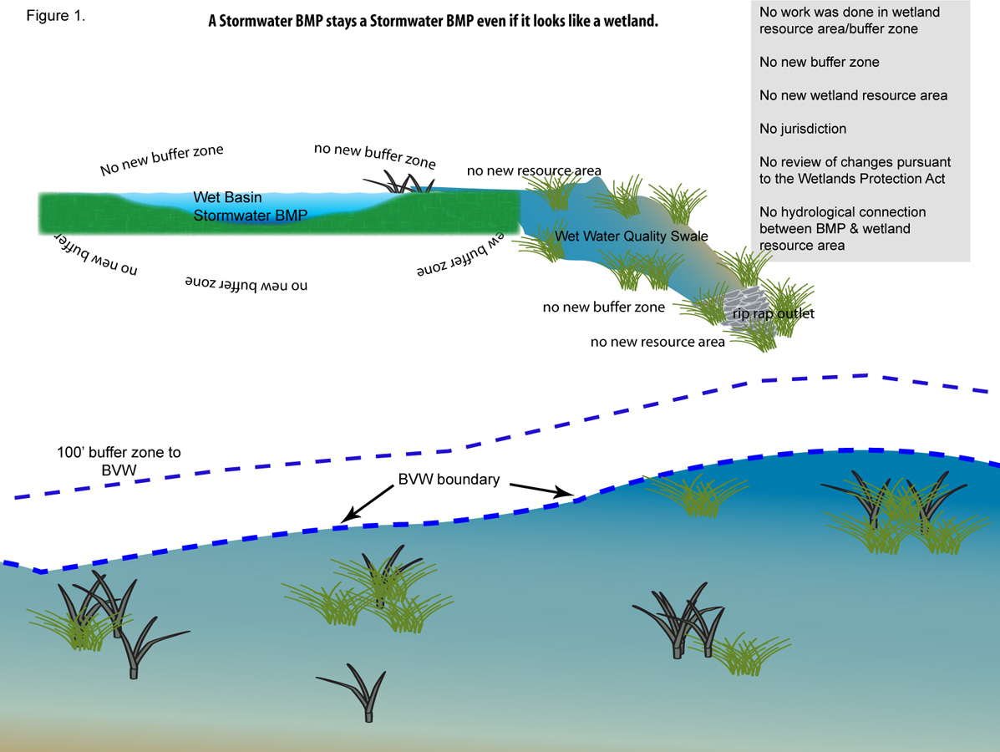

Alternatively, suppose the entire stormwater management system, including the water quality swale, infiltration basin, and riprap outlet, is constructed for stormwater management purposes in the Buffer Zone in accordance with the Stormwater Management Standards on or after January 2, 2008. As with the earlier example, no additional wetland resource area or Buffer Zone is created solely as a result of the installation of the stormwater management system. See Figure 2.

Ten years later, the project proponent proposes to fill in the infiltration basin and replace it with a subsurface structure outside a wetland resource area or Buffer Zone. The project proponent is required to file a Notice of Intent, Notice of Order for Resource Area Delineation, or Request for Determination of Applicability, since the original stormwater management system is located in the Buffer Zone. As part of this filing, the project proponent has to show that the water quality swale, infiltration basin and riprap outlet are components of a stormwater management system constructed in the Buffer Zone on or after January 2, 2008, in accordance with the Stormwater Management Standards.

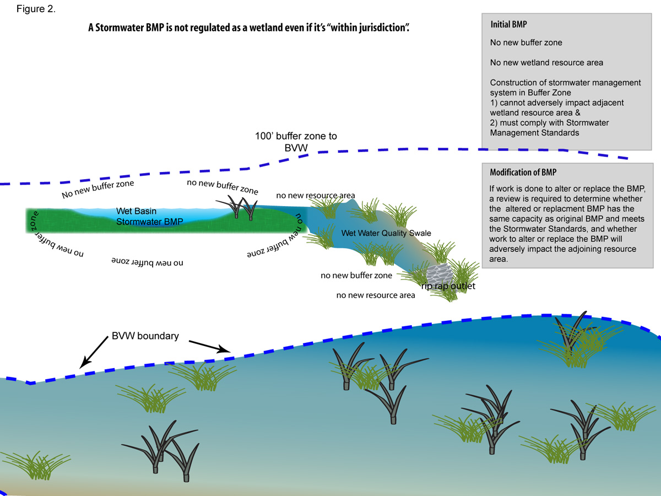

Ten years later, the project proponent proposes to fill in the stormwater management system and relocate it outside the Buffer Zone. In this scenario, it is clear that the

In this case, it should be easy for the proponent to meet this burden by submitting the Order of Conditions permitting the installation of the original stormwater management system and the plans referenced therein. The Conservation Commission would then review the proposed change to determine whether (a) the replacement system provides the same design capacity as the initial system to attenuate the peak discharge rate, recharge the groundwater and remove total suspended solids; (b) the replacement system complies with the Stormwater Management Standards to the extent they are applicable including, without limitation, Standard 8 - the erosion and sedimentation control standard; and (c) whether the alteration of the system located in the Buffer Zone adversely affects the adjacent wetland resource area.

Additionally, suppose a proponent designs and constructs, in accordance with the Stormwater Management Standards on or after January 2, 2008, a stormwater management system that includes a water quality swale, infiltration basin, and riprap outlet located on a portion of the site that is outside a wetland resource area and outside the Buffer Zone. The construction of the infiltration basin and water quality swale does not by itself create any additional wetland resource area or Buffer Zone subject to regulation under the Wetlands Protection Act. Over time, however, the wetland resource area expands, moving the wetland boundary and the boundary of the Buffer Zone. The entire wetland resource area, including the expansion, is an Area Subject to Protection Under M.G.L .c. 131, § 40, and any work in that area and associated Buffer Zone requires the Filing of a Notice of Intent, Request for Determination of Applicability, or Notice of Resource Area Delineation. See Figure 3

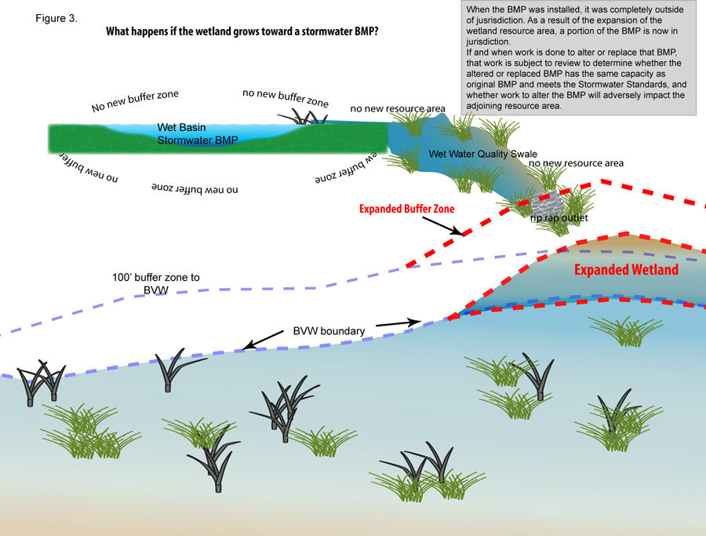

Ten years later, the proponent proposes to fill in the water quality swale, infiltration basin, and riprap outlet, and replace it with a vegetated filter strip, subsurface structure, and riprap outlet, all located outside the boundaries of the expanded wetland resource area and associated Buffer Zone. Because the wetland resource area has expanded, the original riprap outlet is within the Buffer Zone at the time of the proposed work. The alteration of the original riprap outlet within the Buffer Zone requires the filing of a Notice of Intent, Request for Determination of Applicability, or Notice of Resource Area Delineation. See Figure 3.

Once again, the project proponent has the burden of proving that the stormwater management system was constructed on or after January 2, 2008 in accordance with the Stormwater Management Standards and that the system was originally constructed outside any wetland resource area or Buffer Zone. It would be easy for the proponent to meet this burden if, prior to constructing the stormwater management system, s/he had obtained a Negative Determination of Applicability, an Order of Resource Area Delineation (ORAD), or an Order of Conditions for any work on the project that occurred within a resource area or Buffer Zone.

In the absence of a Negative Determination, ORAD, or Order of Conditions, the project proponent would have to rely on whatever credible evidence is available to prove that the original water quality swale, infiltration basin and riprap outlet is a stormwater management system that was originally constructed on or after January 2, 2008 in accordance with the Stormwater Management Standards in a portion of the site that was outside a wetland resource area or associated Buffer Zone. Obtaining the necessary credible evidence may not be easy. To establish that the system was designed on or after January 2, 2008, the project proponent may be able to rely on the local approvals, if any, for the stormwater management system. To establish that the basin was constructed outside wetlands jurisdiction, the proponent may be able to rely on other available information, such as wetland maps prepared by MassDEP or other state or local agencies, any Orders or Determinations issued for the site prior to the project or subsequent to the project, any Orders or Determinations for nearby sites, and existing conditions (soils, plants, hydrology) within the portion of the site surrounding the infiltration basin.

Assuming the project proponent meets the required burden of proof, the Conservation Commission would then review the proposed alteration to determine whether the proposed replacement system provides the same capacity as the original design to attenuate peak discharge rates, recharge the groundwater, and remove total suspended solids, and complies with the Stormwater Management Standards including, without limitation, Standard 8 - the erosion and sedimentation control standard. The Conservation Commission would also determine whether the elimination of the original riprap outlet in the Buffer Zone adversely affects the adjoining wetland resource area

The Right to Appeal the Order of Conditions

Conservation Commissions and MassDEP issue Orders of Conditions that require compliance with the Stormwater Management Standards. Applicants and others may appeal these conditions to MassDEP in the same way as they appeal any other requirements of the Order of Conditions. Moreover, if a Commission issues an Order of Conditions that is inconsistent with the Stormwater Management Standards, MassDEP may intervene unilaterally and issue a Superseding Order that requires compliance with the Standards.

Underground Injection Control Program
The Underground Injection Control Regulations, 310 CMR 27.00, require the registration of certain infiltration best management practices. As of the date of publication of this manual, all dry wells, infiltration trenches, subsurface structures, and leaching catch basins must be registered. Depending on the design, bioretention areas may have to be registered.
Stormwater, the Federal Clean Water Act, and the State Clean Waters Act.

Stormwater and the 401 Water Quality Certification

Under Section 401 of the federal Clean Water Act, an applicant for a federal permit for any activity resulting in a discharge to waters of the United States must obtain certification that the discharge will comply with state water quality standards and other appropriate requirements of state law. Section 404 permits for the discharge of dredged or fill material issued by the U.S. Army Corps of Engineers frequently trigger the state’s 401 jurisdiction. Discharges include the filling of wetlands, the redeposit of dredged or excavated material from activities such as mechanized land clearing or ditching, and the placement of piling when it has the effect of fill. Waters of the United States include navigable waters, their tributaries, wetlands adjacent to navigable waters, and other wetlands that possess a significant nexus with navigable waters. States may add conditions to certify that state water quality standards will be met.

The 401 Water Quality Certification Program has been coordinated with the state’s Wetlands Protection Act Program. As a result, most projects approved by the Conservation Commission under the Wetland Protection Act do not need further state review under the 401 Program. These projects meet the Stormwater Management Standards through compliance with the Wetlands Protection Act. Some types of projects, including those with potentially large wetland impacts and those that are not subject to the Wetlands Protection Act, require an individual 401 certification. Projects requiring an individual 401 Water Quality Certification include activities that will result in the loss of more than 5,000 square feet of bordering and isolated vegetated wetlands and land under water, the discharge of dredged or fill material to Outstanding Resource Waters, real estate subdivisions unless there is a recorded deed restriction providing notice to subsequent purchasers limiting the amount of fill, and the discharge of dredged or fill material to a salt marsh or to rare and endangered species habitat in an isolated vegetated wetland.

For these projects, the 401 Water Quality Certification regulations include specific provisions for stormwater discharges. The Water Quality Certification Regulations, 314 CMR 9.06(5), provide:

- No discharge of dredged or fill material is permitted for the impoundment or detention of stormwater for purposes of controlling sedimentation or other pollutant attenuation.

- Discharge of dredge or fill material may be permitted to manage stormwater for flood control purposes only where there is no practicable alternative and provided that best management practices are implemented to prevent sedimentation or other pollution. No discharge of dredged or fill material is permitted for the impoundment or detention of stormwater in Outstanding Resource Waters for any purposes

The Water Quality Certification Regulations, 314 CMR 9.06(6), provide that stormwater discharges shall be provided with stormwater best management practices to attenuate pollutants and to provide a setback from the receiving water or wetland in accordance with the Stormwater Management Standards. The Water Quality Certification Regulations, 314 CMR 9.06, incorporate the Stormwater Management Standards.

Designation of Stormwater Discharges

Under the Surface Water Discharge Regulations, 314 CMR 3.00, stormwater discharges other than discharges from municipal separate storm sewer systems that require coverage under the MS4 general permit, are exempt from the requirement to obtain an individual or general surface water discharge permit unless MassDEP has made a designation in accordance with 314 CMR 3.04(2). MassDEP may make a designation if it determines that: (1) the discharge is or may be a significant contributor of pollution to waters of the Commonwealth, (2) the discharge is contaminated by contact with process wastes, raw materials, toxic pollutants, hazardous substances, oil or grease, and does not meet the Stormwater Management Standards, (3) the discharge is subject to effluent limitation guidelines or toxic pollutant effluent standards, or (4) the discharge is located in an industrial plant or plant-associated area and there is a potential for significant discharge of stormwater contaminated by contact with process wastes, raw materials, toxic pollutants or hazardous substances, and the discharge has not obtained coverage under a general permit. Any stormwater discharge designated by MassDEP will be required to obtain a discharge permit or to take other corrective action. Designated stormwater discharges may be permitted by an individual permit, a general permit or an alternative general permit.

Stormwater Discharges and Total Maximum Daily Loads

A total maximum daily load (TMDL) is the greatest amount of a pollutant that a water body can accept and still meet water quality standards for protecting public health and maintaining the designated beneficial uses of those waters for drinking, swimming, recreation, and fishing. A TMDL specifies how much of a specific pollutant can come from various sources, including stormwater discharges, and identifies strategies for reducing the pollutant discharges from these sources. MassDEP has prepared TMDLs that indicate that in many watersheds action is needed to reduce the concentrations of bacteria, phosphorus, and nitrogen in stormwater discharges, including, without limitation, implementation of specific stormwater BMPs.

Proper selection of non-structural and structural stormwater management practices is an essential component of any plan to reduce these pollutants. These non-structural BMPs begin with environmentally sensitive site design, pollution prevention and source control. By reducing impervious surfaces and allowing stormwater to infiltrate into the ground and by selecting a landscape design that minimizes the need for fertilizers and pesticides, developers can substantially reduce the concentration of pollutants in stormwater runoff from development and redevelopment projects. Once a project is complete, ongoing action is needed to prevent additional pollutants from entering the stormwater management system. Raw materials and wastes should be stored inside or under cover with adequate containment. Snow, sand, deicing chemicals, fertilizers, pesticides, and solid waste should be properly managed. An effective street-sweeping program should be implemented. Structural BMPs that can remove the pollutants of concern must be designed, constructed, operated and maintained. Infiltration BMPs, bioretention areas, constructed stormwater wetlands, and filter systems may be effective tools for reducing the concentration of nutrients and bacteria in stormwater discharges.

If a proponent is proposing a project that is in the watershed of a water body with a TMDL, and if the project is subject to wetlands jurisdiction, the proponent must select structural BMPs that are consistent with the TMDL. Because pollution prevention is an interest identified in the Wetlands Protection Act, conservation commissions and MassDEP may require use of such BMPs when reviewing projects subject to jurisdiction under the Act. The TMDL may contain information on appropriate BMPs. See http://mass.gov/dep/water/resources/tmdls.htm.

Stormwater and the National Pollutant Discharge Elimination System (NPDES) Permitting Program

The federal Clean Water Act authorizes the United States Environmental Protection Agency (the EPA) to regulate point sources that discharge pollutants into waters of the United States, including stormwater runoff from drainage systems. Under the NPDES Phase 1 Stormwater Program, the EPA, since 1990, has issued general permits for municipal separate storm sewer systems in cities and counties with populations of 100,000 or more, stormwater runoff from specific industrial activities, and stormwater runoff from construction sites that disturb 5 acres or more of land. In 2003, the NPDES Phase II Stormwater Program took effect, and EPA began regulating municipal separate storm sewer systems in additional urbanized areas, and stormwater runoff from construction activities that disturb one acre or more of land, through a general permit.

Stormwater and the NPDES General Permit for Municipal Separate Storm Sewer Systems (the MS4 Permit)

MassDEP and EPA jointly issue the permit for municipal separate small sewer systems or MS4 Permit. See 314 CMR 3.06(11)(b). The MS4 general permit requires the development and implementation of a stormwater management plan that includes six specified minimum measures.

These measures are as follows:

- Public education and outreach. The public education program must provide information on the impact of stormwater discharges and identify steps the public can take to reduce pollutants in stormwater, such as actions to ensure the proper use and disposal of landscape and garden chemicals including fertilizers and pesticides, protecting and restoring riparian vegetation, and properly disposing of used motor oil or hazardous waste.

- Public involvement and education. The public involvement program shall be done in compliance with all applicable state and local public notice requirements, including, without limitation, the Open Meetings Law and the Public Records Act. The public must be involved in developing, implementing and reviewing the stormwater management program.

- Illicit discharge detection and elimination. An illicit discharge is any discharge to a municipal separate storm sewer that is not comprised entirely of stormwater, discharges from fire-fighting activities, and certain designated non-stormwater discharges. An illicit discharge detection and elimination program requires a map of the storm sewer system that identifies the location of all outfalls and the names of all surface waters that receive discharges from those outfalls. As part of this program, there must be a regulatory mechanism that prohibits non-stormwater discharges into the municipal separate storm sewer system and provides for appropriate enforcement. The program must include a plan to detect and address non-stormwater discharges, including illegal dumping, and to inform public employees, businesses and the general public of the hazards associated with illicit connections and improper waste disposal.

- Construction site runoff control program. The construction site runoff control program must reduce pollutants from construction activities that result in a land disturbance of greater than or equal to one acre. The construction site runoff control program must include a regulatory mechanism that requires proper management of construction sites, with sanctions to ensure compliance. The program shall require (a) sediment and erosion controls including BMPs and LID techniques to minimize land disturbance; (b) proper management of wastes, including construction debris, concrete truck wash-out chemicals, litter and sanitary wastes; (c) procedures for site plan review that examine water quality impacts; (d) procedures for public input; and (e) procedures for inspection and enforcement of control measures. The program may rely on Standard 8 of the Stormwater Management Standards for construction site runoff control. To apply Standard 8 to areas outside the jurisdiction of the Wetlands Protection Act requires a local ordinance, bylaw or regulation.

- Post-Construction stormwater management. The post-construction stormwater management program must apply to projects that disturb one acre or more. The program must include a regulatory mechanism with sanctions, requirements for the long-term operation and maintenance of best management practices, and controls to prevent or minimize impacts to water quality. The program may rely on the Stormwater Management Standards for post-construction stormwater management. To apply those standards to areas outside the jurisdiction of the Wetlands Protection Act requires a local ordinance, bylaw, or regulation.

- Pollution prevention and good housekeeping in municipal operations. The pollution prevention and good housekeeping program must include the development and implementation of a program for preventing and reducing the concentration of pollutants found in stormwater runoff from municipal operations, including parks and open space, fleet maintenance, building maintenance, new construction and land disturbance, roadway drainage system maintenance, and the stormwater system.

The MS4 permit requires the permittee to develop measurable goals for the implementation of the stormwater management program and to report on its progress on meeting those goals. Based on a Total Maximum Daily Load or equivalent water quality assessment, the MS4 permit may require the implementation of measures in addition to the six minimum controls, if EPA and/or MassDEP determine that such additional measures are necessary to protect water quality.

The first MS4 general permit was issued in 2003 and is due to expire in 2008. In Massachusetts, 237 cities and towns have applied for and obtained coverage under the 2003 MS4 general permit. For a map showing Massachusetts municipalities covered by the MS4 Permit, see EPA’s site at http://www.epa.gov/region1/npdes/stormwater/ma.html.

To comply with the MS4 general permit, many cities and towns have enacted local ordinances, bylaws, and regulations that apply to existing stormwater discharges as well as stormwater discharges from new development and redevelopment, both during and after construction. These local requirements include construction and post-construction controls on development and redevelopment projects that disturb one acre or more of land, including projects outside the jurisdiction of the Wetlands Protection Act, and regulations requiring the removal of illicit connections to the municipal separate storm sewer system. If a TMDL has been established, these regulations may address pollutants other than TSS. Proponents of projects located in municipalities that are covered by the MS4 permit must comply with these local requirements.

Stormwater Discharges from Construction Activities (Construction General Permit)

Construction sites that disturb one or more acres and that discharge stormwater to a surface water of the United States, or to a municipal separate storm sewer system that discharges to a surface water of the United States, are required to obtain coverage under the NPDES General Permit for Storm Water Discharges from Construction Activities (also known as the "Construction General Permit" or "CGP") issued by the EPA. Although the state has not joined with EPA in issuing the construction general permit, Massachusetts has issued a 401 Water Quality Certification for the permit. The Water Quality Certification requires compliance with certain state regulations and policies, including the Massachusetts Clean Waters Act, the Massachusetts Water Quality Standards, the Surface Water Discharge Permit Program Regulations, the Wetlands Protection Act, the Wetlands Regulations, Final Orders of Conditions issued pursuant to the Wetlands Protection Act, the Massachusetts Stormwater Management Policy, and the Massachusetts Endangered Species Act. If the requirements of the water quality certification are violated, MassDEP has the authority to require that the violations be corrected and to take any action authorized by the General Laws of the Commonwealth, the Massachusetts Clean Waters Act, and the regulations promulgated thereunder.

The CGP requires the preparation of a Stormwater Pollution Prevention Plan (SWPPP). The SWPPP must include a plan to implement both pollution prevention and erosion and sedimentation control during construction. If the permit covers a stormwater discharge to a water body for which a TMDL has been developed, the SWPPP must document compliance with the TMDL. If the permit covers a discharge to an Outstanding Resource Water, the SWPPP must be submitted to MassDEP so that the Department may review it for compliance with the surface water quality standards. The Construction General Permit is scheduled to expire in 2008.

Stormwater Discharges from Construction Dewatering

Stormwater and/or groundwater discharges that are pumped and drained from excavations or other points of accumulation are required to obtain an individual or general NPDES permit from EPA and MassDEP. A notice of intent must be submitted to both EPA and MassDEP at least 30 days prior to the discharge. MassDEP reviews and approves all discharges into Class A or Class SA waters. If the discharge is to an impaired water, an individual permit is required. If EPA or MassDEP believes that the general permit does not adequately protect actual environmental conditions, including the preservation of endangered species, it may require an individual permit for other discharges. For discharges to the Fort River in Amherst, the Mill River in Easthampton, and the Mill River in Whately, EPA and MassDEP are required to make a case-by-case determination of whether a general permit is sufficient to protect the federally listed endangered dwarf wedge mussel.

The general permit prohibits the discharge of materials or chemicals in amounts that would be toxic and discharge that violates state or federal water quality standards. The general permit requires that all discharges pass through settling basins or other treatment systems to remove total suspended solids. The general permit establishes specific effluent limitations and monitoring requirements for Total Suspended Solids, oil and grease, and pH.

Stormwater Discharges from Industrial Activities
Stormwater discharges associated with certain industrial sectors are required to obtain an individual NPDES permit or coverage under the NPDES Storm Water Multi-Sector General Permit. This permit is issued only by EPA and requires that the discharger comply with the surface water quality standards, 314 CMR 4.00 and prepare a SWPPP. If there are stormwater discharges to an Outstanding Resource Water, the discharger must submit the SWPPP to MassDEP.

The SWPPP must identify potential sources of pollutants that may reasonably be expected to affect the quality of the stormwater discharges, describe and ensure implementation of practices to reduce pollutants in stormwater discharges, and ensure compliance with the permit. The SWPPP must include BMPs to minimize pollutants in the discharge so that the discharge will not cause or contribute to violations of water quality standards. The BMPs should be a suite of stormwater controls that prevent pollution and are economically reasonable and appropriate in light of current industry practice.

If a TMDL has been approved for the receiving water, the SWPPP must be consistent with the TMDL. If at any time after authorization under a general permit, EPA determines that the discharge may cause or have the reasonable potential to cause or contribute to a violation of water quality standards, EPA may require the permittee to develop a supplemental action plan to address the water quality concerns or to apply for an individual permit.

The Multi-Sector General Permit provides that the discharges must comply with 314 CMR 3.00, 314 CMR 4.00, 314 CMR 9.00 and 310 CMR 10.00. New development and the redevelopment of existing industrial facilities subject to the multi-sector general permit must comply with the state regulations and policy, including the Massachusetts Stormwater Standards. Existing discharges subject to the multi-sector general permit do not need to obtain an individual or general state discharge permit unless the discharge is designated by MassDEP in accordance with 314 CMR 3.04(2).

See 314 CMR 3.00. At the time of the publication of this handbook, the MS4 permit currently in effect is due to expire in 2008. When a new permit is issued, there will be a new water quality certification. EPA has also issued other NPDES general stormwater permits: a general permit for construction sites that disturb one acre or more of land, the Construction General Permit, and a general permit for certain industrial activities, the Multi-Sector General Permit. The Construction General Permit is due to expire in 2008 and the Multi-Sector General Permit has been administratively continued after expiring in 2005. For the latest information on all the NPDES stormwater permits, see http://cfpub1.epa.gov/npdes/home.cfm?program_id=6 and http://www.epa.gov/region1/topics/water/stormwater.html.
A continuing condition providing that the stormwater management system may not be changed without the approval of the issuing authority must be included in the Order of Conditions and Certificate of Compliance.
Applicants and others may appeal a Superseding Order issued by MassDEP by requesting an adjudicatory hearing. The rules for requesting an adjudicatory hearing are set forth in 310 CMR 10.05(7)(j).
For information on the UIC program and its application to infiltration BMPs, see http://www.epa.gov/npdes/pubs/sw_class_v_wells_fs.pdf. See also http://www.mass.gov/eea/agencies/massdep/water/drinking/shallow-injection-well-closure-q-and-a-summary-for-the-.html.
MassDEP has similar authority to require certain stormwater discharges to the groundwater to obtain a permit. See 314 CMR 5.04.
Through the State’s Water Quality Certification, the 2003 MS 4 Permit requires compliance with the Stormwater Management Standards and the Surface Water Quality Standards. The 2003 permit required permittees in high and medium stressed basins to meet the recharge standard in areas outside of jurisdiction under the Wetlands Protection Act.
The SWPPP should be submitted along with BRP WM09. See http://www.mass.gov/eea/agencies/massdep/service/approvals/brp-wm-09.html.
. For information on the latest Construction General Permit see http://www.epa.gov/region1/topics/water/stormwater.html and http://cfpub2.epa.gov/npdes/stormwater/cgp.cfm.
The SWPPP should be submitted along with BRP WM09. See http://www.mass.gov/eea/agencies/massdep/service/approvals/brp-wm-09.html.
EPA has developed guidance on preparing a SWPPP for the Multi-Sector General Permit. Proponents preparing long-term pollution prevention plans for sites with land uses with higher potential pollutant loads may find this information helpful. See http://cfpub2.epa.gov/npdes/stormwater/msgp.cfm.

