
Massachusetts
Stormwater Management
Handbook

Appendix A

SCM
Specifications for the
Massachusetts Stormwater Handbook

Introduction
This Appendix lists the Stormwater Control Measure (SCMs) specifications and criteria that must be met in order for the practices to be deemed acceptable to meet the Stormwater Management Standards listed in MassDEP Wetland and WQC regulations at 310 CMR 10.05(6)(k) and 314 CMR 9.06(6)(a). If these specifications and criteria are not met, the practice is not acceptable to meet the MassDEP Wetlands and WQC regulations. These specifications are minimum criteria.
The SCM Specifications provided by this Appendix are split into four primary categories (see Table of Contents):
- Environmentally Sensitive Site Design (ESSD) Credits;
- Nonstructural Stormwater Control Measures;
- Structural Stormwater Control Measures (including Low Impact Development Practices); and
- Operating and Source Controls.
Refer to Section 4 of the Stormwater Handbook “Site Planning and Design” for definitions of each SCM category and guidance on how to incorporate these SCMs into site designs. Also refer to Section 6.2 of the Stormwater Handbook “Required Documentation and Computations” for detailed information on sizing SCMs to meet specific Stormwater Standards. Finally, Table 2-7 of the Stormwater Handbook includes a summary of each SCM’s ability to meet specific Stormwater Standards.
ESSD Credits
A suite of ESSD Credits is available to encourage project Applicants to implement MassDEP recognized Environmentally Sensitive Site Design (ESSD) and Low Impact Development (LID) techniques. ESSD and LID must be used unless demonstrated to be impracticable based on a written alternatives analysis submitted with the Notice of Intent. Other SCMs shall only be used to the meet those portions Standard 3 (i.e., Required Recharge Volume) and Standard 4 (i.e., TSS / TP removal) that cannot be fully met by ESSD and LID techniques. See Section 6.1.4 for more information on the written alternatives analysis.
Each MassDEP recognized ESSD / LID technique listed by Section 4.2 of the Stormwater Handbook has an applicable Fact Sheet that describes the practice in more detail – fact Sheets are available in this Appendix. Most recognized ESSD / LID techniques also have an associated ESSD Credit to help Applicants meet the ESSD and LID Implementation Requirement as summarized by Table A-1.
Table A-1. Summary of ESSD / LID Fact Sheets and associated ESSD Credits

Fact Sheet Name | ESSD Credit Name
Environmentally Sensitive Site Design (ESSD) | Credit 1: Environmentally Sensitive Site Design
Credit 2: Environmentally Sensitive Site Design for Solar Arrays
Disconnection to Qualifying Pervious Areas | Credit 3: Rooftop Runoff Directed to Qualifying Pervious Areas
 | Credit 4: Roadway, Driveway, or Parking Lot Rooftop Runoff Directed to Qualifying Pervious Areas
Tree Canopy Runoff Reduction | Credit 5: Tree Canopy Enhancement and Protection
Minimize Impervious Cover | Credit 6: Reduce Impervious Area at Redevelopment Sites
Protect or enhance Buffer Area | Credit 7: Protect or Enhance Buffer Areas
Preserve and Use Natural Drainage Systems | N/A – There is no numerical credit available for implementation of this MassDEP recognized ESSD / LID technique.
No Disturbance to Wetland Resource Area | N/A – There is no numerical credit available for implementation of this MassDEP recognized ESSD / LID technique.
Small Scale Controls | N/A – There is no numerical credit available for implementation of this MassDEP recognized ESSD / LID technique.

ESSD Credit Eligibility
An Applicant of a project that is eligible for ESSD Credits is required to comply with all Stormwater Management Standards as described in Section 2.3 of the Stormwater Handbook. The application of these credits does not relieve the design engineer or reviewer from the standard of engineering practice associated with safe conveyance of stormwater runoff and good drainage design. Refer to the sections below for eligibility, implementation criteria, and the ability of each ESSD Credit to meet specific Stormwater Standards.
Calculating Pollutant Removals for Structural SCMs
The EPA Performance Removal Curves (EPA-PRCs) must be used to determine pollutant removal credits for SCMs with an established curve. Refer to the SCM Convention Crosswalk in the Massachusetts Stormwater Handbook for a list of SCMs with an available EPA-PRC (Table 2-2). The EPA-PRCs are available in graphical and tabular form in Appendix B of the Massachusetts Stormwater Handbook, or can be accessed from the most recent version of the EPA Best Management Practice Accounting and Tracking Tool (BMP-BATT).
Some commonly used SCMs do not have an established EPA Performance Curve. MassDEP SCMs without an approved EPA Performance Curve or “Crosswalk” equivalent must use a 1.0 inch Water Quality Volume (WQv) to size the treatment practice. Pollutant removal credit may be calculated using MassDEP assigned values from Table 2-2 for SCMs without an EPA Performance Curve or DEP Crosswalk equivalent.
Refer to the Massachusetts Stormwater Handbook for more information on pollutant removal calculation requirements (Section 6.2.4).

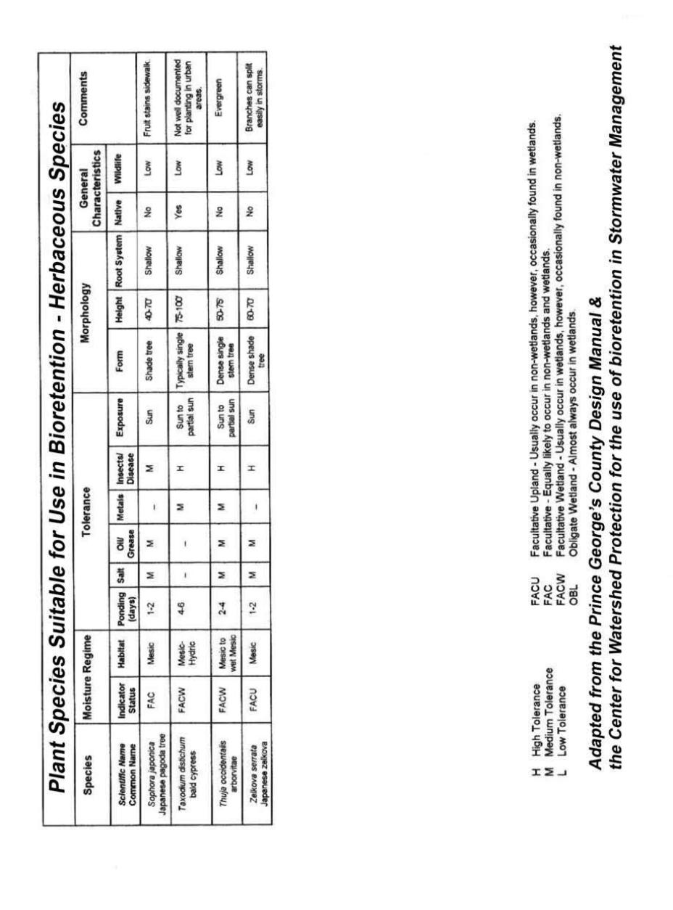
Contents
Environmentally Sensitive Site Design (ESSD) 1
General ESSD 2
Disconnection of Impervious Surfaces 8
Tree Canopy Implementation for Runoff Reduction 16
Minimize Impervious Cover 27
Protecting and Enhancing Buffer Areas 30
Preserve and Use Natural Drainage Systems 36
No Disturbance to Wetland Resource Areas 38
Small Scale Controls 39
Nonstructural 41
Street and Parking Lot Cleaning 42
Structural Pretreatment 44
Deep Sump Catch Basin 45
Oil/Grit Separators 49
Proprietary Manufactured Separators 53
Sediment Forebays 56
Vegetated Filter Strips 60
Pea Gravel Diaphragm with Filter Strip 64
Structural Treatment 67
Bioretention Areas 68
Constructed Stormwater Wetlands 82
Extended Dry Detention Basin 95
Proprietary Media Filters 100
Sand and Organic Filters 103
Tree Box Filter 108
Wet Basins 110
Roof Dripline Filter 115
Structural Conveyance 121
Drainage Channels 122
Grass Channel 125
Water Quality Swale 129
Structural Infiltration 135
Dry Wells 136
Infiltration Basins 139
Infiltration Trenches 146
Leaching Catch Basins 152
Porous Pavement 155
Subsurface Infiltrators 160
Other Structural 166
Dry Detention Basin 167
Green Roofs 170
Rain Barrels & Cisterns 175
Accessories 180
Level Spreaders 181
Check Dams 182
Outlet Structures 184
Catch Basin Inserts 185
Vertical Curb Inlet Grates 186
Operating and Source Controls 188
Auto Salvage Yards 189
Auto Fueling Facilities (gas stations) 190
Building, Repair, and Maintenance of Boats and Ships 192
Commercial Animal Handling Areas 194
Commercial and Municipal Composting 195
Commercial Printing Operations 196
Loading and Unloading Areas for Liquid or Solid Material 197
Painting, Finishing, and Coating of Vehicles, Boats, Buildings and Equipment 199
Railroad Yards 200
Retail and Wholesale 201
Service Industries 203
Vehicle Washing 207
Road Salt Storage and Snow Disposal 209


- Environmentally Sensitive Site Design
  - Credit 1: Environmentally Sensitive Site Design
  - Credit 2: Environmentally Sensitive Site Design for Solar Arrays
- Disconnection to Qualifying Pervious Areas
  - Credit 3: Rooftop Runoff Directed to a QPA
  - Credit 4: Roadway, Driveway, or Parking Lot Runoff Directed to a QPA
- Tree Canopy Implementation for Runoff Reduction
  - Credit 5: Tree Canopy Enhancement and Protection
- Minimize Impervious Cover
  - Credit 6: Reduce Impervious Area at Redevelopment Sites
- Protect or Enhance Buffer Areas
  - Credit 7: Protect or Enhance Buffer Areas
- Natural Drainage Systems
- No Disturbance to Wetland Resource Areas
- Small Scale Controls

Environmentally Sensitive
Site Design Techniques (ESSD)

Massachusetts
Stormwater Management
Handbook

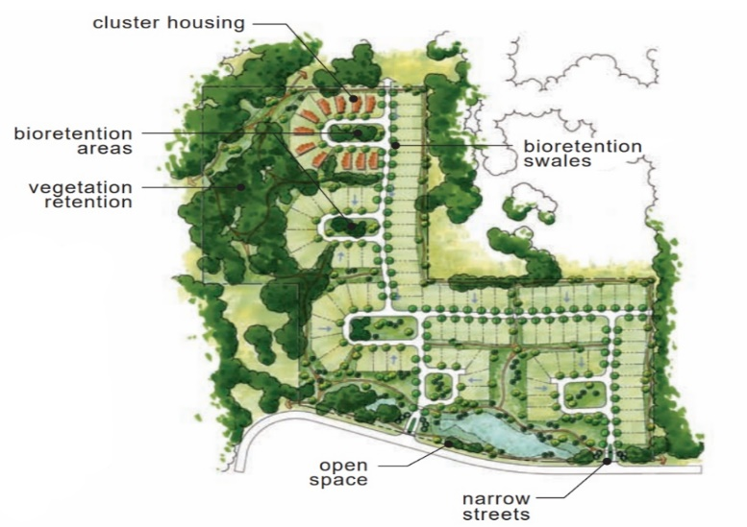
General Environmentally Sensitive Site Design
Image Credit: Puget Sound Technical Guidance Manual

Description and Purpose
Environmentally sensitive site design (ESSD) applies low impact development (LID) techniques to minimize stormwater runoff and nonpoint source pollution by reducing impervious surfaces, disconnecting flow paths, treating stormwater at its source, minimizing disturbance, maximizing open space, protecting natural features and processes, and/or enhancing wildlife habitat.
In general, these non-structural approaches to drainage improvements should be given preference and ESSD should be the first priority consideration to meet the Stormwater Management Standards. Some ESSD techniques that minimize the creation of new runoff, enhance groundwater recharge, and remove suspended solids include: minimizing impervious surfaces, fitting the development to the terrain, preserving and capitalizing on natural drainage systems, and reproducing pre-development hydrologic conditions. Refer to Section 4.2 for more information on ESSD and LID techniques, including a list of MassDEP recognized techniques.
ESSD Credits
As indicated in the “Introduction” section of this Appendix, a suite of ESSD Credits is available to encourage project Applicants to implement MassDEP recognized Environmentally Sensitive Site Design (ESSD) and Low Impact Development (LID) techniques. There are two ESSD Credits associated with this Fact Sheet.
- Credit 1: Environmentally Sensitive Site Design.
- Credit 2. Environmentally Sensitive Site Design for Solar Arrays.
See below for more information on these credits.
Components of ESSD
Conventional development strategies treat stormwater as a secondary aspect of site design, usually managed with “pipe-and-basin” systems that collect rainwater and discharge it off-site. In contrast, ESSD embraces hydrology as a critical factor for site design. Existing conditions influence the location of roadways, buildings, and parking areas, as well as design of the stormwater management system.
ESSD is a multi-step process that involves identifying important natural features, placing buildings and roadways in areas less sensitive to disturbance, and designing stormwater management systems that create relationships between development and natural hydrology. The attention to natural hydrology, stormwater “micromanagement,” nonstructural approaches, and vegetation results in a more attractive, multifunctional landscape with development and maintenance costs comparable to or less than conventional strategies that rely on pipe-and-basin approaches.
Landscaping is an important component of environmentally sensitive site design. Ecological landscaping strategies seek to minimize the amount of lawn area and enhance the property with native, drought-resistant species; as a result, property owners use less water, pesticides, and fertilizers. A creative landscape can be used for a smaller lawn or applied at a larger scale for subdivisions. The maintenance of vegetated buffers along waterways can also enhance the site and help protect water quality. Re-establishment of vegetated buffers through removal of impervious surfaces at Redevelopment sites is also ESSD.
Planning Considerations
ESSD can be applied to both residential and non-residential developments as well as Redevelopment projects to limit land disturbance and preserve important natural features. ESSD begins with assessing the environmental and hydrologic conditions of a site and identifying important natural features such as streams and drainage ways, floodplains, wetlands, water supply protection areas, high-permeability soils, steep slopes, erosion-prone soils, woodland conservation areas, farmland, and meadows. This investigation helps to determine which “conservation areas” should be protected from development and construction impacts, and which site features (i.e., natural swales) should be incorporated into the stormwater management system.
The site analysis also identifies a “development envelope” where development can occur with minimal impact to hydrology and other ecologic, scenic, or historic features. In general, the development envelope includes upland areas, ridge lines and gently sloping hillsides, and soils prone to ponding and runoff production outside of wetlands, leaving the remainder of the site in a natural undisturbed condition. Clustering building lots to create a more compact development reduces the amount of clearing and grading required. It is important to protect mature trees and to limit clearing and grading to the minimum amount needed for buildings, access, and fire protection. Converting wooded areas to lawns increases the volume of runoff that must be managed. The design should confine construction activity, including stockpiles and storage areas, to those areas that will be permanently altered, and clearly delineate the construction fingerprint.
Some environmentally sensitive site designs that seek to cluster development and reduce lot coverage may conflict with local land use regulations or public perceptions about what type of development is desirable. For example, a compact multi-story building may be more visible than a single-story building with a larger footprint. To address this concern, developers, advocates and regulators who recognize the benefits of ESSD must educate the public about these benefits.

ESSD Examples
ESSD implementation can take many forms depending on the site type. Examples of three different development and Redevelopment projects are provided below. Most of the ESSD techniques shown on these examples are described in additional fact sheets provided in this Appendix.
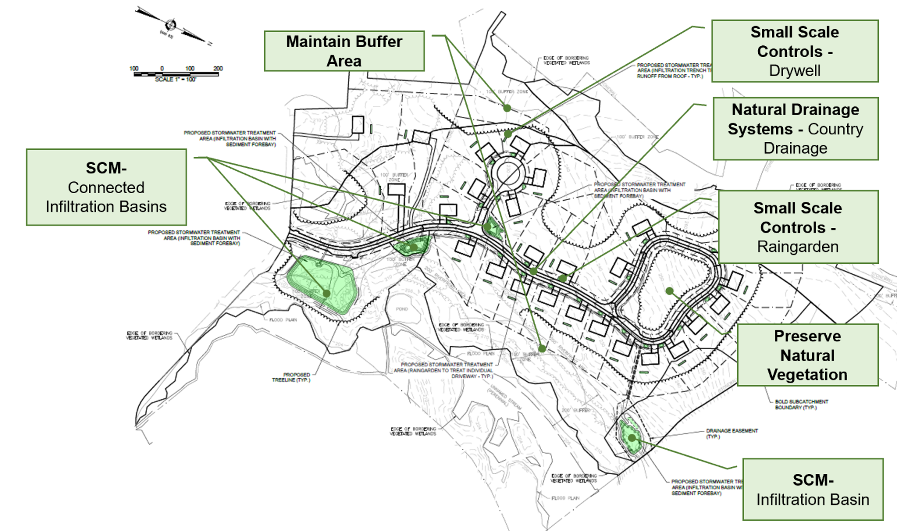
Example new development site with ESSD techniques
This example site implements ESSD in the following ways:
- Wetland Resource Area buffer is maintained and not disturbed throughout the site.
- Small scale controls (i.e., raingardens, drywells) capture runoff from each driveway and roof.
- Front yard setbacks and driveway lengths are minimized, which reduces impervious site cover.
- All roadside runoff is conveyed through country drainage rather than curb and gutters.
- The remaining runoff not captured by upgradient small scale controls is captured by infiltration basins.

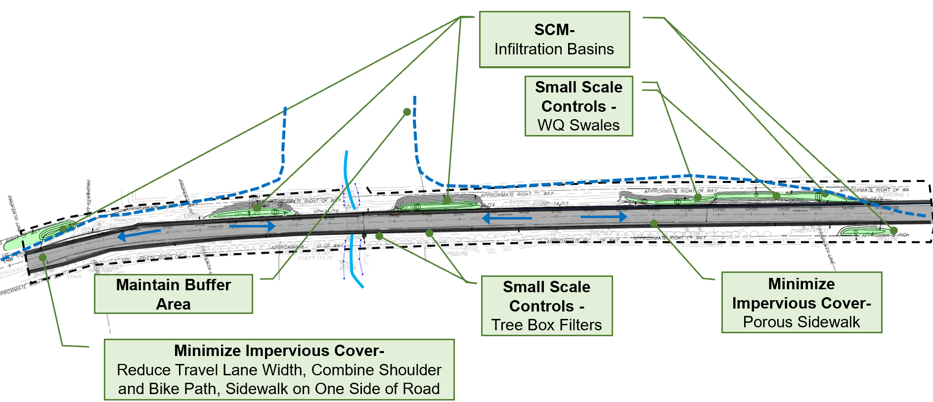
Example road Redevelopment project with ESSD techniques
This example site implements ESSD in the following ways:
- The Wetland Resource Area is maintained and not disturbed throughout the site.
- Small scale controls (i.e., water quality swales, tree box filters, porous pavement) capture runoff.
- Impervious area is reduced by narrowing road width and using a combined shoulder / bike path.
- The remaining runoff not captured by upgradient small scale controls is captured by infiltration basins.

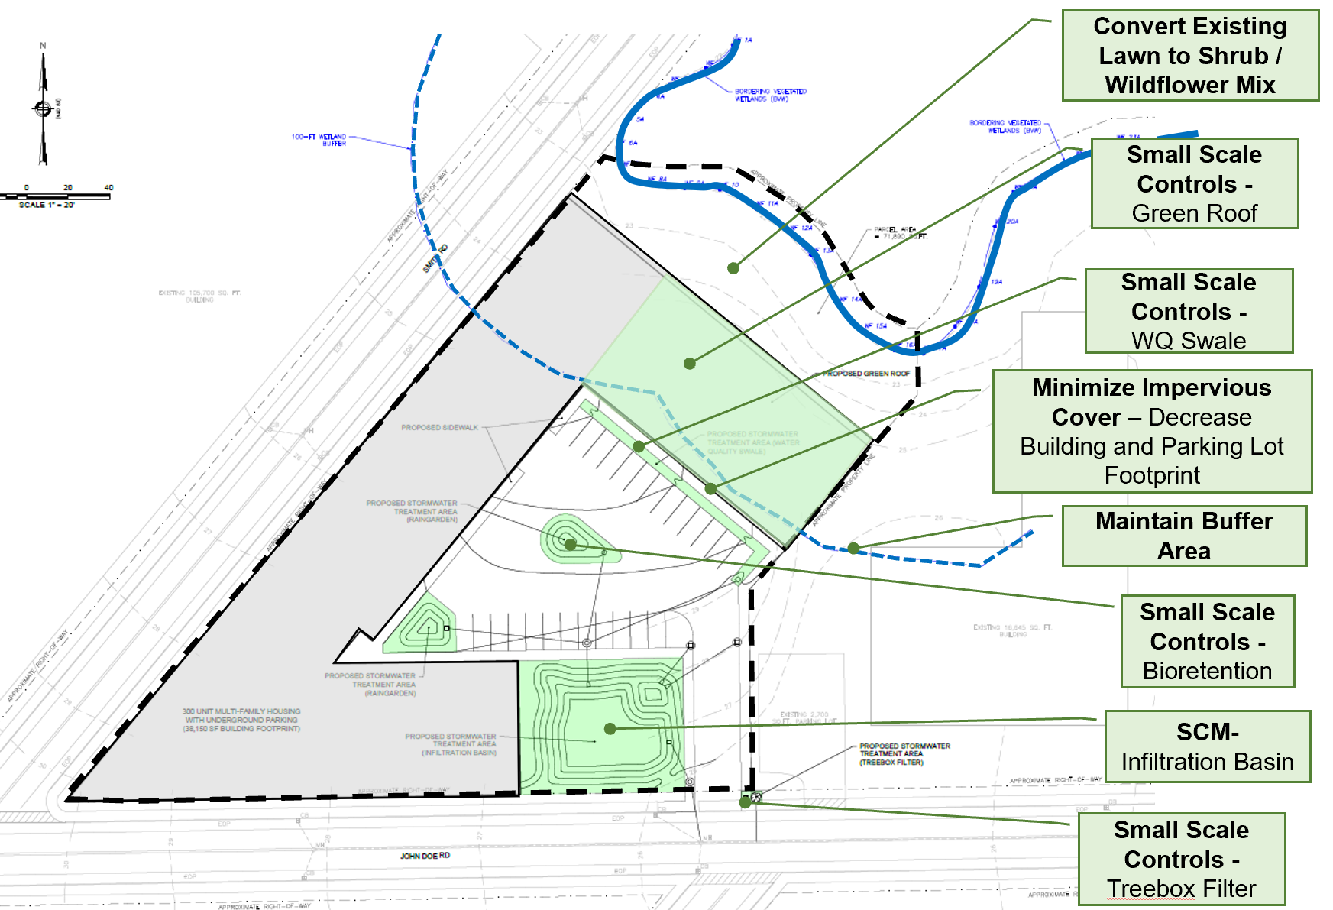
Example commercial Redevelopment project with ESSD techniques
This example site implements ESSD in the following ways:
- Wetland Resource Area is maintained and not disturbed throughout the site.
- Small scale controls (i.e., green roof, water quality swales, bioretention, tree box filters) capture runoff from the parking lot and roof.
- The building and parking lot footprint are reduced, which reduces impervious site cover.
- The remaining runoff not captured by upgradient small scale controls is captured by an infiltration basin.

ESSD Credit 1: Environmentally Sensitive Site Design

This ESSD Credit is given for ESSD techniques that “cluster” development or reduce development scale to leave a significant amount of the site undisturbed in its natural state. This credit is applicable to new development and Redevelopment projects. If a site is designed, constructed, operated, and maintained in accordance with the requirements of this credit, a project Applicant need not develop and implement additional structural stormwater SCMs to meet Standard 3, Standard 4, and the pollutant removal requirements of Standard 7.
Ability to meet specific standards
Standard | Description
2 - Peak Flow | Provides no peak flow attenuation.
3 - Recharge | Provides 1-inch of groundwater recharge if minimum criteria are met.
4 - TSS/ TP Removal | Provides 90% TSS and 60% TP removal if minimum criteria are met.
5 - Higher  Pollutant  Loading | May not be used for runoff from land uses with Higher Potential Pollutant Loads (LUHPPLs).
6 - Discharges  near or to  Critical Areas | May be used for discharges near or to Critical Areas.
7 - Redevelopment | May be used for Redevelopment.
8 - Construction Phase Pollution Controls | Not to be used for construction period runoff control.
11 - Total Maximum Daily Loads | May be used to treat all TMDL pollutants specified in Table 2-6 of the Stormwater Handbook if minimum criteria are met.
ESSD / LID? | Yes, this practice is a MassDEP recognized ESSD / LID technique.

Minimum Required Criteria
This ESSD Credit is only available when the following criteria are met:

- The total impervious cover footprint must be less than 15% of the base lot area.
- The site does not have the following characteristics:
  - Land Use with Higher Potential Pollutant Loads (LUHPPL);
  - Urban fill, unless the fill is removed and soil replaced with clean topsoil or hydrogeological testing is conducted indicating the filled soils are relatively homogeneous horizontally and vertically with a vertical Ks equivalent to a Hydrologic Soil group A, B, or C soil in accordance with Table 6-4 of the Stormwater Handbook;
  - Soils classified as contaminated pursuant to the Massachusetts Contingency Plan (MCP);
  - Soils with seasonal high groundwater-groundwater elevation within 2 feet of the land surface.
- The following Wetland Resource Areas (WRAs) may not be included in the base lot area used for purposes of determining compliance with ≤ 15% impervious cover footprint requirement:
  - Any vegetated wetlands (Bordering Vegetated Wetland (BVW), Isolated Vegetated Wetland (IVW), Salt Marsh);
  - Land Under Water and Waterways;
  - Land Under Ocean;
  - Bank;
  - Coastal Bank; or
  - 5,000 square feet or 10% of the Riverfront Area, whichever is greater.
- Alteration of base lot cannot occur in any coastal WRA other than Land Subject to Coastal Storm Flowage; or BVW or IVW.

Example Calculation for ESSD Credit 1
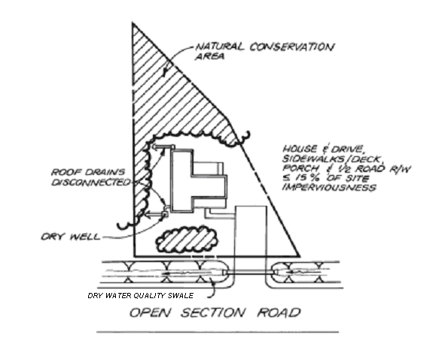
Problem Statement: A single-family lot that is part of a low-density subdivision is located in a Critical Area.
Example of ESSD for Credit 1
- The base lot area is 2.5 acres.
- The post-development impervious area is determined to be 0.35 acres (14%).
- All other “minimum criteria” area met.
Solution:
- Determine eligibility based on “minimum required criteria.”
- Required Recharge Volume (Standard 3) and Pollutant Removal (Standard 4, Standard 7) are considered to be met by site design.
- Other applicable Standards must still be met, including peak rate attenuation (Standard 2).

ESSD Credit 2: ESSD for Solar Arrays

Photovoltaic System (PVS) solar projects within the Buffer Zone to a Wetland Resource Area may receive ESSD Credit as detailed below. If a PVC solar Project Site is designed, constructed, operated, and maintained in accordance with the requirements of this credit, a project Applicant need not develop and implement additional structural stormwater SCMs to meet Standard 3, Standard 4, and the pollutant removal requirements of Standard 7. This credit is applicable to new development and Redevelopment projects.
Ability to meet specific standards
Standard | Description
2 - Peak Flow | Provides no peak flow attenuation.
3 - Recharge | Provides 1-inch of groundwater recharge if minimum criteria are met.
4 - TSS/ TP Removal | Provides 90% TSS and 60% TP removal if minimum criteria are met.
5 - Higher  Pollutant  Loading | May not be used for runoff from land uses with Higher Potential Pollutant Loads (LUHPPLs).
6 - Discharges  near or to  Critical Areas | May not be used for discharges near or to Critical Areas.
7 - Redevelopment | May be used for Redevelopment.
8 - Construction Phase Pollution Controls | Not to be used for construction period runoff control.
11 - Total Maximum Daily Loads | May be used to treat all TMDL pollutants specified in Table 2-6 of the Stormwater Handbook if minimum criteria are met.
ESSD / LID? | Yes, this practice is a MassDEP recognized ESSD / LID technique.

Minimum Required Criteria
This ESSD Credit is only available when the following criteria are met:

- Permanent slopes on which the PVS arrays are placed must be no greater than 5%, naturally or as graded.
- The final grading must not include direct discharges to WRAs, and must avoid or minimize channelized stormwater flow from the Buffer Zone directly into wetland Resource Areas.
- Native topsoil is preserved or supplemented sufficient to maintain vegetation cover. Soil must be of sufficient depth to maintain vegetation.
- Natural vegetative cover consisting solely of native grass and herbaceous plant species shall be planted or maintained at the site to meet NRCS TR55 “good condition” or better (>75%).
- Solar panel rows are spaced in a manner to allow sunlight penetration sufficient to support vegetation between the solar panel rows.
- Where panel rows follow the slope (i.e. the panel arrays are constructed down, rather than across, a slope) provide intermittent gaps between adjacent panels sufficient to accommodate anticipated runoff so that runoff occurs from individual panels rather than from the length of the entire array;
- Panel drip edges (or leading edge of panels) are no greater than 2-3 feet above the ground surface to minimize splash erosion.
- No point source discharges are allowable except for emergency overflows or flow from level spreaders.
- No work is proposed in a Buffer Zone of a Resource Areas that borders a Critical Area, as defined at 310 CMR 10.04 and 314 CMR 9.02, or in the estimated habitat identified on the most recent Estimated Habitat Map of State Listed Rare Species prepared by the Natural Heritage and Endangered Species Program.
- To qualify for the credit, no structural SCMs may be constructed, except for the following: infiltration trenches and water bar/log bars.
- For the peak runoff rate analysis, TR55 curve numbers for fully developed urban areas must be utilized to determine the post construction runoff conditions (e.g., curve numbers for open space - lawns, parks). Curve numbers intended for commercial agricultural areas such as the “meadow” curve numbers or “brush” curve numbers are not appropriate to characterize post construction runoff conditions.

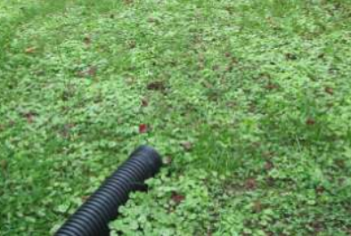
Disconnection of Impervious Surfaces
ESSD Techniques
Description and Purpose
An impervious area is considered “connected” if runoff from it flows directly into the drainage system. It is also considered “connected” if runoff occurs as shallow concentrated flow that runs over a pervious area and then into the drainage system (USDA, 1986). Disconnection of impervious surfaces is the practice of directing stormwater runoff from impervious surfaces to a Qualifying Pervious Area (QPA).
QPAs are natural or vegetated areas where discharge is directed via sheet flow and not as a point source discharge. They must be stabilized and have runoff characteristics at or lower than the NRCS Runoff Curve Numbers in Table QPA 1.
Disconnection directs runoff from rooftops and impervious roads, driveways, and parking lots to QPAs where it can either infiltrate into the soil or flow over it with sufficient time and reduced velocity to allow for filtering. This practice can reduce demand on system capacity and reduce pollutant loads to Surface Waters.
Table QPA 1. Maximum NRCS Runoff Curve Numbers for Qualifying Pervious Area
Cover Type | HSG A | HSG B | HSG C
Natural: Woods Good Condition | 30 | 55 | 70
Natural: Brush Good Condition | 30 | 48 | 65
Landscaped: Good Condition (grass cover > 75% or equivalent herbaceous plants) | 39 | 61 | 74
Environmentally Sensitive Site Design (ESSD) Credits
As indicated in the “Introduction” section of this Appendix, a suite of ESSD Credits is available to encourage project Applicants to implement MassDEP recognized Environmentally Sensitive Site Design (ESSD) and Low Impact Development (LID) techniques. There are two ESSD Credits associated with this Fact Sheet.
- Credit 3: Rooftop runoff directed to Qualifying Pervious Areas
- Credit 4: Parking lots, driveways, and roadways directed to Qualifying Pervious Areas.
See following pages for more information on these credits.
General Requirements and Design Considerations
There are multiple design considerations for QPAs and disconnection of impervious surfaces that must be implemented to obtain ESSD Credit. A list of general requirements is provided below. Refer to the below credits for more detailed eligibility requirements and design criteria.
- No work, including any alteration for stormwater management, may be proposed within any Wetland Resource Area except for Riverfront Area (RA), Bordering Land Subject to Flooding (BLSF), Isolated Land Subject to Flooding (ILSF), or Land Subject to Coastal Storm Flowage (SCSF). The underlying Performance Standards in these Resource Areas must be met.
- Where a portion of the Buffer Zone is proposed to serve as part of the QPA, the area shall not extend into the inner 50 feet of the Buffer Zone. Refer to ESSD Credit 7 for a credit for protecting or enhancing buffer areas.
- The QPA must be owned or controlled (e.g., drainage easement) by the property owner.
- The QPA must be a fully stabilized natural or landscaped area with runoff characteristics at or lower than the NRC Runoff Curve Numbers presented on Table QPA 1.
- The average contributing overland slope to and across the QPA must be less than or equal to 5%.
- Runoff shall enter the QPA uniformly across its entire length as sheet flow and not a point discharge. The flow path to the QPA shall be no more than 75-feet long. Use of practices such as level spreading may be needed to meet this requirement.
- Use a pea gravel diaphragm or grass / gravel combination for pretreatment (see Specification in this Appendix).
- A soil evaluation must be performed to verify Hydrologic Soil Group (HSG) of the underlying soils in accordance with Section 6.3.2 of the Stormwater Handbook. Ponding of water directed to a QPA must be avoided. The receiving QPA must be comprised of HSG A, B, or C soils.
- The flow path through the QPA must comply with the setbacks in Table 2-8 of the Stormwater Handbook (e.g., 50 feet away from any septic system components – such as a soil absorption system or leach field, 50 feet from vegetated wetlands and land under water).
- This ESSD Credit may not be used in locations where information is submitted during the public hearing or introduced by the Conservation Commission that there is a demonstrated history of groundwater flooding.
- To prevent compaction of the soil in the QPA, construction vehicles must not be allowed to drive over the area. If it becomes compacted, the soil must be amended, tilled, and revegetated to restore its infiltrative capacity once construction is complete.
- Must not receive runoff from upgradient areas that have sealcoats containing coal-tar emulsions.
- The Operation and Maintenance (O&M) Plan required by Stormwater Standard 9 must include measures to inspect the QPA at least yearly for evidence of ponding. The O&M Plan shall incorporate measures to address any ponding that is observed during the inspection. The O&M Plan shall also include measures to replace any soil eroded from the QPA and to replace any vegetation detrimentally impacted by the drainage.
Maintenance
QPAs require an Operation and Maintenance (O&M) Plan that should include:
- Measures to inspect the QPA at least yearly for evidence of ponding, sediment deposition, and vegetation dieback.
- Measures to remove deposited sediment (e.g., sand from winter sanding operations), address any ponding, and replant vegetation that has died (e.g., vegetation impacted by winter road salting).
- Measures to replace any eroded soil from the QPA.
- Methods for how future scarifying and repaving operations will be conducted to ensure that stormwater contaminated during repaving operations will not detrimentally impact regulatory wetland areas and Buffer Zones.

References
USDA, 1986. Urban Hydrology for Small Watershed (TR 55). Available at: https://www.nrcs.usda.gov/Internet/FSE_DOCUMENTS/stelprdb1044171.pdf.
Photo credit: NCDENR Stormwater BMP Manual (4/1/2014)

ESSD Credit 3: Rooftop Runoff Directed to a QPA
This ESSD Credit is available when rooftop runoff is directed to a Qualifying Pervious Area (QPA). This credit is applicable to new development and Redevelopment projects. See below for the ability of this ESSD Credit to meet specific Stormwater Standards. The Applicant must meet all required criteria to be eligible for this credit.
Note: this credit is only applicable to the impervious area discharged to and treated by the QPA and not the entire site.
Ability to meet specific standards
Standard | Description
2 - Peak Flow | Provides peak flow attenuation for smaller storms by reducing the composite Runoff Curve Number that is used for TR-55 peak runoff calculations (see required criteria).
3 - Recharge | Use Table QPA 2 to determine recharge credit. Provides 1-inch of groundwater recharge credit for the portion of the site that drains to the QPA if all minimum criteria herein are met.
4 - TSS/ TP Removal | Use Table QPA 2 to determine pollutant removal credit. Provides 90% TSS removal and 60% TP removal for the portion of the site that drains to the QPA if all minimum criteria are met.
5 - Higher  Pollutant  Loading | May be used for runoff from LUHPPL if minimum criteria are met.
6 - Discharges  near or to  Critical Areas | May be used for discharges near or to Critical Areas.
7 - Redevelopment | May be used for Redevelopment.
8 - Construction Phase Pollution Controls | Not to be used for construction period runoff control.
11 - Total Maximum Daily Loads | May be used to treat all TMDL pollutants specified in Table 2-6 of the Stormwater Handbook if minimum criteria are met.
ESSD / LID? | Yes, this practice is a MassDEP recognized ESSD / LID technique.

Recharge and Pollutant Removal Credit
Recharge and pollutant removal credit for directing rooftop runoff to a QPA is based on the Hydrologic Soil Group Type of the receiving QPA and the ratio of impervious area to impervious area (Table QPA 2).
If the ratio of impervious area to pervious area does not match those provided by the table, use the ratio that is nearest to, but more than, the determined ratio. For example, if the impervious area to pervious area ratio is 3:1, calculate pollutant removal credit based on a ratio of 4:1.
Note: Many QPAs will not be able to meet pollutant removal requirements for an entire subcatchment. See ESSD Credit 4 for an example calculation which demonstrates how to use an area weighted average to evaluate subcatchment-wide pollutant removals for multiple SCMs in accordance with Section 2.3.4 of the Stormwater Handbook.
Table QPA 2. Recharge and pollutant removal credits for directing rooftop runoff to a QPA
Impervious Area to Pervious Area Ratio | HSG A | HSG B | HSG C
8:1 | NC | NC | NC
6:1 | NC | NC | NC
4:1 | NC | NC | NC
2:1 | NC | NC | NC
1:1 | ü | ü | NC
1:2 | ü | ü | ü
1:4 | ü | ü | ü
1:10 | ü | ü | ü
1:30 | ü | ü | ü
1:50 | ü | ü | ü
Table Key:
- Check Mark (ü) = Credit is provided for 1-inch recharge, 90% TSS removal, and 60% TP removal.
- NC = No credit is provided for recharge or pollutant removal.
- Assumes that all minimum required criteria are met.

Minimum Required Criteria
This ESSD Credit is only available when the following criteria are met:
- General QPA requirements are met (see “Disconnection of Impervious Surfaces” Fact Sheet above).
- The lot is greater than 6,000 ft².
- The receiving QPA does not have the following characteristics:
  - Urban fill, unless the fill is removed and soil replaced with clean topsoil or hydrogeological testing is conducted indicating the filled soils are relatively homogeneous horizontally and vertically with a vertical Ks equivalent to a Hydrologic Soil group A, B, or C soil in accordance with Section 6.3.2 of the Stormwater Handbook. Also, see Section 6.3.4 of the Stormwater Handbook, “When Fill Materials are Determined to be Present”, for additional requirements.
- The rooftop area meets the following criteria:
  - The rooftop area contributing runoff to any one downspout cannot exceed 1,000 ft².
  - The rooftop can only be a metal roof if the building is located outside a Zone II or Interim Wellhead Protection Area.
  - The building must not be used for industrial purposes.
  - The rooftop area contributing runoff is not a “Green Roof.”
- QPAs treating rooftop runoff must also meet the following criteria:
- Calculate pollutant removal and recharge credit based on the receiving HSG and the ratio of impervious area to pervious area in accordance with Table QPA 2.
- Downspouts must be at least 10 feet away from the nearest impervious surface to prevent reconnection to the stormwater management system. If a gutter/downspout system is not used, the rooftop runoff must be designed to sheet flow at low velocity away from the structure housing the roof.
- To take credit for rooftop disconnection associated with a Land Use with Higher Potential Pollutant Loads (LUHPPL), the rooftop runoff must not commingle with runoff from any paved surfaces or activities or areas on the site that may generate higher pollutant loads.
- In locations where information is submitted during the public hearing or introduced by the Conservation Commission that there is a demonstrated history of groundwater flooding, this ESSD credit may not be utilized.
- To take credit for peak flow attenuation, a composite Runoff Curve Number (RCN) must be calculated using procedures from TR-55 for subcatchments that include unconnected impervious area (i.e., for subcatchments where an impervious rooftop discharges to a QPA). Refer to Figure 2-2 of TR-55 for a flow chart depicting the required calculation methodology based on the impervious area percentage within the subcatchment.
- The site plans submitted with the NOI or WQC Application must include a tabulation and visual representation that all required dimensions from the “general requirements” and “minimum required criteria” area met (e.g., average slope, maximum contributing drainage area, ratio of impervious to pervious area).
- Note: Credit is not given for a Qualifying Pervious Area that discharges to a Buffer Area that is being credited as part of ESSD Credit 7 (i.e., credit cannot be double counted).

Example Calculation for ESSD Credit 3
Problem Statement: 25 single-family residential lots (~1/2 acre lots) are part of a new development. The site has just one drainage subcatchment. The roof area of each house will be 2,000 ft². Each roof will be connected to two downspouts, each with a contributing area of 1,000 ft². Discharge from each roof is to be directed to a Qualifying Pervious Area (QPA). The QPAs are located in HSG B Soils. Determine the minimum required area of each QPA to obtain a credited recharge volume of 1 inch, credited TSS removal of 90%, and credited TP removal of 60%.
Note: See ESSD Credit 4 for an example calculation which demonstrates how to use an area weighted average to evaluate subcatchment-wide pollutant removals for multiple SCMs in accordance with Section 2.3.4 of the Stormwater Handbook.
- Step 1, Determine the required number of QPAs. The rooftop area contributing runoff to any one downspout cannot exceed 1,000 ft². Therefore, discharge from each roof will be directed to two (2) QPAs.
- Step 2, Determine required sizing of each QPA. As indicated by Table QPA 2, the ratio of impervious area to the area of the QPA must be at least 1:1 to obtain a credited recharge volume of 1 inch, credited TSS removal of 90%, and credited TP removal of 60%. Therefore, the area of each QPA must be at least 1,000 ft².
- Step 3, Verify eligibility. Verify that all “Minimum Required Criteria” are met. For example, the QPA must be designed such that runoff enters the QPA uniformly across its entire length as sheet flow and not a point discharge.
- Step 4, Calculate credits. The disconnection to QPA results in 1 inch of groundwater recharge (Standard 3), 90% TSS / 60% TP removal (Standard 4) for each roof’s contributing impervious area – i.e., 25 roofs x 2,000 ft² / roof = 50,000 sf. Runoff from all other impervious areas on site must be managed in accordance with the Stormwater Standards.

ESSD Credit 4: Roadway, Driveway, or Parking Lot Runoff Directed to a QPA
This ESSD Credit is available for practices that direct runoff from impervious roads, driveways, and parking lots to Qualifying Pervious Areas (QPAs). This credit is applicable to new development and Redevelopment projects. See below for the ability of this ESSD Credit to meet specific Stormwater Standards. The Applicant must meet all required criteria to be eligible for this credit.
Note: This credit is only applicable to the impervious area discharged to and treated by the QPA and not the entire site.
Ability to meet specific standards
Standard | Description
2 - Peak Flow | Provides peak flow attenuation for smaller storms by reducing the composite Runoff Curve Number that is used for TR-55 peak runoff calculations (see required criteria).
3 - Recharge | Use Table QPA 3 to determine recharge credit. Provides 1-inch of groundwater recharge credit for the portion of the site that drains to the QPA if all minimum criteria herein are met.
4 - TSS/ TP Removal | Use Table QPA 3 to determine pollutant removal credit. Provides 90% TSS removal and 60% TP removal for the portion of the site that drains to the QPA if all minimum criteria are met.
5 - Higher  Pollutant  Loading | May not be used for runoff from LUHPPL.
6 - Discharges  near or to  Critical Areas | May be used for discharges near or to Critical Areas.
7 - Redevelopment | May be used for Redevelopment.
8 - Construction Phase Pollution Controls | Not to be used for construction period runoff control.
11 - Total Maximum Daily Loads | May be used to treat all TMDL pollutants specified in Table 2-6 of the Stormwater Handbook if minimum criteria are met.
ESSD / LID? | Yes, this practice is a MassDEP recognized ESSD / LID technique.
Recharge and Pollutant Removal Credit
Recharge and pollutant removal credit for directing roadway, driveway, or parking lot runoff to a QPA is based on the Hydrologic Soil Group Type of the receiving QPA and the ratio of impervious area to impervious area (Table QPA 3).
If the ratio of impervious area to pervious area does not match those provided by the table, use the ratio that is nearest to, but more than, the determined ratio. For example, if the impervious area to pervious area ratio is 3:1, calculate pollutant removal credit based on a ratio of 4:1.
Note: Many QPAs will not be able to meet pollutant removal requirements for an entire subcatchment. See ESSD Credit 4 for an example calculation which demonstrates how to use an area weighted average to evaluate subcatchment-wide pollutant removals for multiple SCMs in accordance with Section 2.3.4 of the Stormwater Handbook.
Table QPA 3. Recharge and pollutant removal credits for directing rooftop runoff to a QPA
Impervious Area to Pervious Area Ratio | HSG A | HSG B | HSG C
8:1 | NC | NC | NC
6:1 | NC | NC | NC
4:1 | NC | NC | NC
2:1 | NC | NC | NC
1:1 | ü | ü | NC
1:2 | ü | ü | ü
1:4 | ü | ü | ü
1:10 | ü | ü | ü
1:30 | ü | ü | ü
1:50 | ü | ü | ü
Table Key:
- Check Mark (ü) = Credit is provided for 1-inch recharge, 90% TSS removal, and 60% TP removal.
- NC = No credit is provided for recharge or pollutant removal.
- Assumes that all minimum required criteria are met.
Minimum Required Criteria
This ESSD Credit is only available when the following criteria are met:

- General QPA requirements are met (see “Disconnection of Impervious Surfaces” Fact Sheet above).
- This credit is available for paved driveways, roads, and parking lots associated with all land uses, except for high-intensity parking lots that generate 1,000 or more vehicle trips per day or runoff not segregated from LUHPPL.
- The receiving QPA does not have the following characteristics:
  - Urban fill, unless the fill is removed and soil replaced with clean topsoil or hydrogeological testing is conducted indicating the filled soils are relatively homogeneous horizontally and vertically with a vertical Ks equivalent to a Hydrologic Soil group A, B, or C soil in accordance with with Section 6.3.2 of the Stormwater Handbook. Also, see Section 6.3.4 of the Stormwater Handbook, “When Fill Materials are Determined to be Present”, for additional requirements.
- Driveways, roadways, and parking lots, or the contributing impervious area must meet the following criteria:
- The contributing impervious area draining to any one discharge cannot exceed 1,000 ft².
- The flow path from the contributing impervious area must be less than 75 feet in length.
- Runoff from driveways, roadways and parking lots may be directed over soft shoulders, through curb cuts, or level spreaders to QPAs. Measures must be employed at the discharge point to the QPAs to prevent erosion and ensure uniform sheet flow.
- QPAs treating runoff from driveways, roadways and parking lots must also meet the following criteria:
- Calculate pollutant removal and recharge credit based on the receiving HSG and the ratio of impervious area to pervious area in accordance with Table QPA 3.
- This ESSD credit may not be utilized in locations where information is submitted during the public hearing or introduced by the Conservation Commission that there is a demonstrated history of groundwater flooding.
- To take credit for peak flow attenuation, a composite Runoff Curve Number (RCN) must be calculated using procedures from TR-55 for subcatchments that include unconnected impervious area (i.e., for subcatchments where an impervious roadway, driveway, or parking lot discharges to a QPA). Refer to Figure 2-2 of TR-55 for a flow chart depicting the required calculation methodology based on the impervious area percentage within the subcatchment.
- The site plans submitted with the NOI or WQC Application must include a tabulation and visual representation that all required dimensions from the “general requirements” and “minimum required criteria” area met (e.g., average slope, maximum contributing drainage area, ratio of impervious to pervious area).
- Note: Credit is not given for a Qualifying Pervious Area that discharges to a Buffer Area that is being credited as part of ESSD Credit 7 (i.e., credit cannot be double counted).

Example Calculation for ESSD Credit 4
Problem Statement: A new development will include a building and a parking lot with a resulting impervious area of 0.60 acres. The site has just one drainage subcatchment. The Applicant has proposed to sheet runoff from three (3) portions of the parking lot to three (3) separate QPAs. The remaining impervious area will be treated by other SCMs. The underlying soils of the entire site have been determined to be HSG A in accordance with procedures described by Section 6.3 of the Stormwater Handbook. Determine the required sizing of each QPA and other SCMs to meet the Required 1 inch Recharge Volume (Standard 3), and the required 90% TSS / 60% TP removal (Standard 4).
- Step 1, Determine QPA Sizing. The Applicant has calculated the maximum contributing impervious area and available area for each QPA as listed by Table QPA 4 (below). The ratio of impervious area to pervious area must be rounded up to the nearest value based on Table QPA 3. For example, the ratio of impervious area to pervious area is 1.80 for QPA No. 1; therefore, the ratio to be used for crediting is 2:1.
- Step 2, Verify eligibility. Verify that all “Minimum Required Criteria” are met for all three proposed QPAs. For example, the upstream flow path must be less than 75 feet long.
- Step 3, Calculate the credited recharge volume (Standard 3) and pollutant removal (Standard 4).
- Recharge volume. As indicated by the Table QP 4, the ratio of impervious area to pervious area for each QPA is at most 2:1. Each QPA is therefore eligible to receive credit to recharge 1 inch of upstream impervious area per Table QPA 3.
- Pollutant removals. As indicated by the Table QP 4, the ratio of impervious area to pervious area for each QPA is at most 2:1. Each QPA is therefore eligible to receive credit for 90% TSS and 60% TP removal from upstream impervious area per Table QPA 3
- Step 4, Calculate the required sizing of other SCMs to meet Standard 3 and Standard 4 requirements. As indicated by Table QP 4, the three (3) QPAs treat and recharge 2,750 sf upstream impervious area (appx. one tenth of the site’s impervious area). Additional SCMs are required to meet subcatchment-wide pollutant removals on an area weighted basis. Area weighted averages can be calculated based on Equation 6-9 of the Stormwater Handbook.
- Other SCMs on the 0.60 acre site (26,136 sf) would be required to recharge a depth of at least 1.0 inch of the remaining contributing upstream area of 23,386 square feet to meet the 1.0 inch recharge requirement (Standard 3).
- Other SCMS on the 0.60 acre site (26,136 sf) would be required to remove at least 90% TSS and 60% TP of the remaining contributing upstream area of 23,386 square feet to meet the 90% TSS and 60% TP removal requirement (Standard 4).
- For example, an infiltration basin or other infiltrating SCM could be designed to meet these criteria in HSG B soils.
Table QP 4. Example solution for ESSD Credit 4
SCM ID | Contributing Imp. Area, A_{IMP} (sf) | QPA Area, A_{QPA} (sf) | Ratio  A_{IMP} to A_{QPA} (actual) | Ratio  A_{IMP} to A_{QPA} (rounded) | Recharge Depth, F  (in) | Pollutant Removals (%)
 |  |  |  |  |  | TSS | TP
QPA No. 1 | 900 | 500 | 1.80 | 2:1 | 1.0 | 90.0% | 60.0%
QPA No. 2 | 850 | 910 | 0.93 | 1:1 | 1.0 | 90.0% | 60.0%
QPA No. 3 | 1,000 | 1,350 | 0.74 | 1:1 | 1.0 | 90.0% | 60.0%
Other SCMs | 23,386 | N/A | N/A | N/A | 1.0 | 90.0% | 60.0%
Imp. Area Total: | 26,136 | Area Weighted Averages: |  |  | 1.0 | 90.0% | 60.0%


Tree Canopy Implementation for Runoff Reduction
ESSD Techniques

Description and Purpose
Environmental Condition | Species Selection Guidance
USDA plant hardiness zone | Select species appropriate to hardiness zone. However, consider tolerance of species to potential shift in temperature regime associated with climate change.
Sunlight exposure | Select species tolerant of sun exposure at site.
Microclimate features | Select drought tolerant species for areas subject to high wind exposure or high heat reflection.
Topography | Consider landscape position in assessing tree exposure to excessive drainage or flooding.
Regional forest association | Where feasible, select native species from regional forest association in preference to other species.
Soil texture | Select species based on tolerance to site conditions. In urban settings and Redevelopment sites, sites for tree plantings may need to be modified or existing soils be replaced to provide conditions supportive of healthy tree growth.
Soil drainage
Soil compaction
Soil pH | Select species tolerant of existing pH conditions. If trees will be planted where concrete pavement surfaces or prepared soil mixtures may alter soil pH, select species with a tolerance to alkaline soil conditions.
Soil chemistry | Consider salt content of existing soils, and select salt tolerant species as warranted.
Stormwater runoff to planting site | Assess whether the planting site will likely receive runoff from adjacent areas, in determining whether species should be flood tolerant and drought tolerant.
Floodplain connection | Consider position relative to floodplain in assessing whether species should be flood tolerant.
Space limitations | Consider location of surface features, subsurface features, and above surface features in selecting species and mature tree size.
Other limiting factors | Consider other limiting factors that may be specific to the site or its local context, including disease and pest resistance, cultural factors, potential exposure to animal and human impacts, and other factors.
A leafy tree canopy can help intercept and retain precipitation and transfer water back to the atmosphere through evapotranspiration reducing the overall volume of stormwater. Additionally, the shade, tree litter, and roots beneath the canopy can help promote infiltration reducing runoff volume, slow the travel of runoff lowering peak runoff rates, and stabilize the soil surface preventing erosion and associated impacts. Trees and their roots capture and use water to sustain the tree and help it grow. Trees can infiltrate and filter pollutants carried by stormwater, helping to maintain good water quality at nearby Surface Waters. There are many potential configurations that can implement tree canopy for a parking lot, subdivision road, urban street, and more.
ESSD Credits
As indicated in the “Introduction” section of this Appendix, a suite of ESSD Credits is available to encourage project Applicants to implement MassDEP recognized Environmentally Sensitive Site Design (ESSD) and Low Impact Development (LID) techniques. There is one ESSD Credit associated with this Fact Sheet:
- Credit 5: Tree Canopy Enhancement and Protection
See below for more information on this credit.
Selecting Trees
The selection of tree species for street plantings and the landscaping of development projects should be based on site-specific assessment of environmental conditions and on the desired tree functions. Preferably, trees selected for urban plantings should comprise native species because they are adapted to local conditions and are likely to require less maintenance. However, given the space constraints and the environmental conditions associated with urban environments, selection of appropriate trees may require consideration of hardy, non-invasive, non-native species, consistent with regional horticultural practices. The table below outlines environmental conditions affecting the selection of tree species for planting in the urban environment (CEI June 2017).

The table below presents tree height, mature spread, and area of average mature spread for a limited selection of native and non-native street trees recommended by Massachusetts Department of Transportation (MassDOT) and Department of Conservation and Recreation (DCR) (https://masstreewardens.org/wp-content/uploads/Tree-Selection-1.pdf ).
Scientific Name | Common Name | Tree Height | Mature Spread | Area of Avg. Mature Spread
Scientific Name | Common Name | ft | ft | sq ft
Large Trees
Acer rubrum | Red Maple | 40-75 | 25-35 | 707
Celtis occidentalis | Northern Hackberry | 40-60 | 40-50 | 1,590
Fraxinus pennsylvanica | Green Ash | 50-60 | 45-50 | 1,771
Ginkgo biloba | Ginkgo | 50-80 | 50-60 | 2,375
Gleditsia triacanthos | Honeylocust | 30-70 | 35-50 | 1,418
Platanus hybrida* | London Planetree | 70-100 | 50-70 | 2,826
Quercus palustris | Pin Oak | 60-70 | 35-40 | 1,104
Quercus robur | English Oak | 40-50 | 40-60 | 1,963
Quercus rubra | Northern Red Oak | 60-80 | 50-60 | 2,375
Tilia cordata | Littleleaf Linden | 60-70 | 35-50 | 1,418
Ulmus americana | American Elm | 60-80 | 50-70 | 2,826
Ulmus parvifolia | Chinese Elm | 40-50 | 35-50 | 1,418
Zelkova serrata | Japanese Zelkova | 50-80 | 50-75 | 3,066
Medium Trees
Acer campestre | Hedge Maple | 25-35 | 30-35 | 829
Koelreuteria paniculata | Goldenraintree | 30-40 | 30-40 | 962
Pyrus calleryana | Callery Pear | 30-35 | 30-40 | 962
Small Trees
Amelanchier sp. | Common Serviceberry | 15-25 | 15-20 | 240
Crataegus phaenopyrum | Washington Hawthorn | 25-30 | 20-25 | 397
Cornus kousa | Kousa Dogwood | 30 | 15-20 | 240
Malus sp. | Crabapple (Indian Summer) | 15-30 | 10-25 | 240
Malus sp. | Crabapple (Harvest Gold) | 15-30 | 10-25 | 240
Ostrya virginiana | Eastern Hophornbeam | 30 | 25-30 | 594

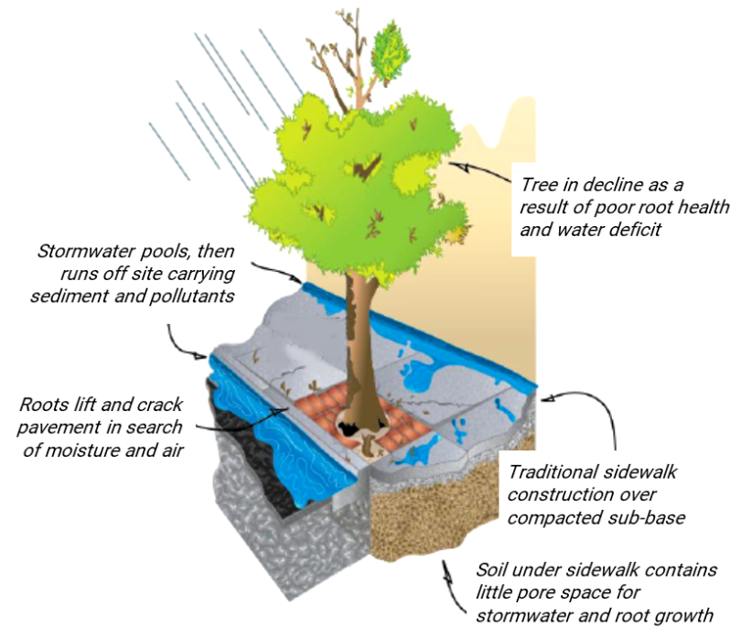
Installing Trees
Impervious pavement prevents infiltration
In addition to selecting the correct tree species for the environmental conditions on a site, provisions for its initial planting and care are essential to the long-term viability of the tree. The designer should provide either for adequate landscape islands or tree lawns to support the required soil volume, or explore the use of structural measures to provide for root growth beneath adjacent impervious surfaces.
Trees are often installed near pavements without providing sufficient soil volume to support development of a healthy, mature canopy. As a general rule, for optimal growth, the volume of useable soil for a tree should be approximately 2 cubic feet of soil for each square foot of crown projection orthe area of the tree within the "drip line" of the overhanging leaf canopy.

Maintenance
Local maintenance programs are required when tree canopies are used for stormwater management for trees located within public property or within approved projects. Recommended maintenance practices include:
- Routine care of the trees for the life of the project or until Redevelopment occurs to maintain healthy, vigorous trees. Instructions should be prepared by a qualified professional.
- Frequent irrigation to initiate root establishment for young trees.
- Timely care for damaged and diseased trees.
- Replacement of dead or severely damaged trees within six months.
- Annual sweeping following leaf-drop in the fall to remove leaf litter that can contribute nutrients to stormwater runoff.
More information on the use of tree canopies as SCMs is provided in the Tree Canopy Stormwater Implementation and Outreach Report.

Tree Canopy Implementation Examples
Some examples of potential tree canopy implementation are provided below. There are many more potential configurations that can used to implement tree canopy.

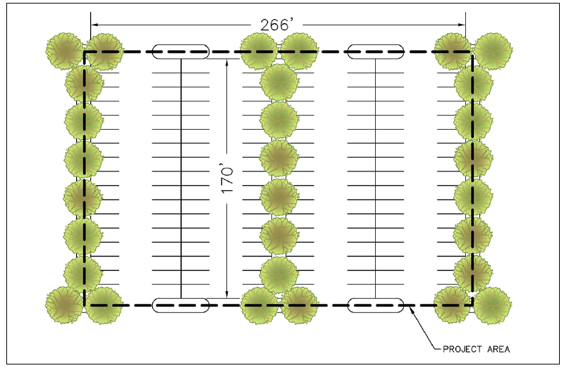
Tree canopy implementation example for a parking lot.

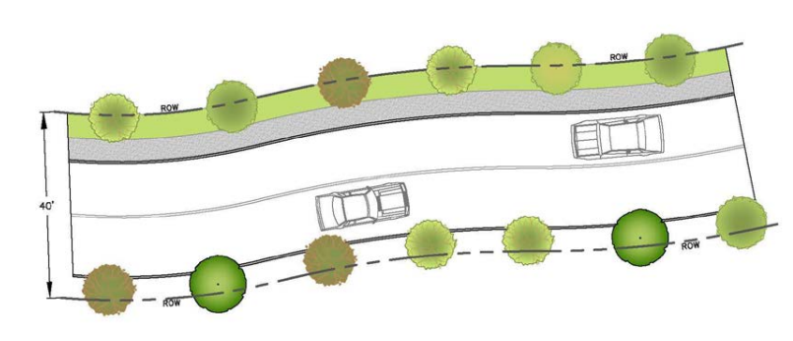
Tree canopy implementation example for subdivision road (small trees on both sides of road).

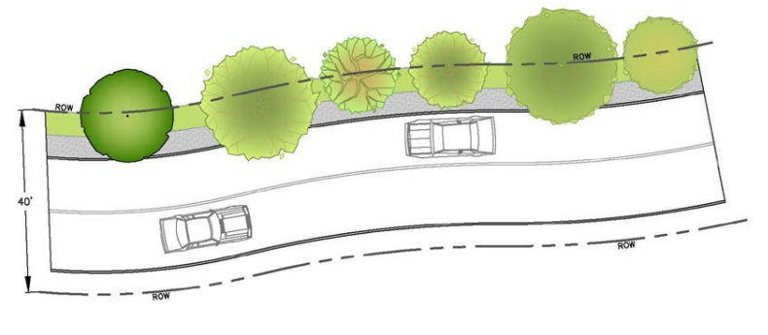
Tree canopy implementation example for subdivision road (large trees on one side of road).
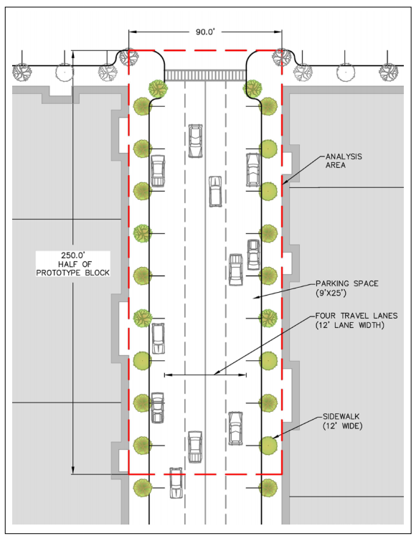
Tree canopy implementation example for urban street (small trees on both sides of street).

References
Comprehensive Environmental Inc (CEI). June 2017. Tree Canopy Stormwater Implementation & Outreach Program. http://treecanopybmp.org/uploads/files/CEI%20Tree%20Canopy%20Stormwater%20Technical%20Report%202017.pdf
Photo credit: https://www.epa.gov/sites/production/files/2015-11/documents/stormwater2streettrees.pdf

ESSD Credit 5: Tree Canopy Enhancement and Protection

This ESSD Credit is available when new or existing tree canopy extends over ground level impervious cover. The credit consists of a reduction in Effective Impervious Cover (EIC) which may be deducted from the total area of impervious surface that must be managed as required by Standard 3, Standard 4, and the pollutant removal requirements of Standard 7.
This EIC Reduction credit is available for new development and Redevelopment projects; and applies to all ground level impervious cover and all land use types. The tree canopy credit shall not be used to reduce the area of impervious surface for the analysis of peak runoff rates or volumes. Note: All calculations must be performed based on drainage subcatchment and not the entire site.
Ability to meet specific standards
Standard | Description
2 - Peak Flow | Provides no peak flow attenuation.
3 - Recharge | Results in a reduction in Effective Impervious Cover which may be deducted from the total area of impervious surface that must be managed as required by Standard 3.
4 - TSS/ TP Removal | Results in a reduction in Effective Impervious Cover which may be deducted from the total area of impervious surface that must be managed as required by Standard 4 and the pollutant removal requirements of Standard 7.
5 - Higher  Pollutant  Loading | May be used for runoff from land uses with Higher Potential Pollutant Loads (LUHPPLs).
6 - Discharges  near or to  Critical Areas | May be used for discharges near or to Critical Areas.
7 - Redevelopment | May be used for Redevelopment.
8 - Construction Phase Pollution Controls | Not to be used for construction period runoff control.
11 - Total Maximum Daily Loads | May be used to treat all TMDL pollutants specified in Table 2-6 of the Stormwater Handbook if minimum criteria are met.
ESSD / LID? | Yes, this practice is a MassDEP recognized ESSD / LID technique.
Minimum Required Criteria
This ESSD Credit is only available when the following criteria are met:

- The tree canopy must extend over ground level impervious cover. Ground level impervious cover includes paved streets, parking areas, sidewalks, and other impervious surfaces at grade. Ground level impervious cover does not include the roofs of structures.
- New trees:
- Must be a non-invasive species suitable for use in an urban environment.
- Must be species included on the MassDEP approved tree list for this credit (See Fact Sheet above).
- Must be deciduous trees at least 2-inch diameter at breast height (dbh). (Coniferous trees are not typically installed to overhang impervious surfaces, and are not included as qualifying trees for the purposes of this credit.)
- Must be installed in a planting bed or trench with a soil volume available for rooting to sustain a tree at maturity (use 40 years) (see below calculations).
- Soils must consist of native natural soil materials or installed planting media meeting standard horticultural practices, designed to promote normal, healthy root penetration and tree growth. The required soil volume shall not extend under pavement or other compacted surfaces, unless the Applicant provides for specialized structural soils systems specifically designed for tree plantings.
- The soil shall have a depth of at least 3 feet.
- Existing trees:
- Must be a non-invasive species suitable for use in an urban environment.
- Must be protected during construction.
- Shall be at least 4-inch diameter at breast height (dbh) to be eligible for the reduction.
- A qualified professional (Massachusetts Registered Landscape Architect or Massachusetts Certified Arborist, or other professional such as a tree warden) must document the following:
- Suitability of location of each existing tree proposed for credit for continued growth health of the tree (including but not limited to consideration of proximity to power lines, overshadowing by larger trees, proximity to buildings and pavements, etc.);
- Condition of the tree, based on visual examination of factors including but not necessarily limited to evidence of disease, pest infestation, foliage dieback, and structural deficiencies.
- NOI/WQC Application Requirements:
  - Project Narrative describes:
    - How the credit will be achieved.
    - Where and how the project provides for preservation of existing trees or the installation of new trees for which runoff reduction credits will be claimed.
    - How existing trees will be preserved.
    - How new trees will be installed.
    - Who is responsible for maintenance and replanting.
    - How the tree canopy will be permanently maintained for the life of the project (40 years) or until Redevelopment occurs.
- Site Plan includes:
- Indicate existing trees to be preserved and for which ESSD Credit is claimed.
- Document the size, species, and dimensions of existing tree crown for each tree qualifying for runoff reduction credit.
- Provide a tabulation of the total area of ground-level impervious surface that will be located beneath existing tree canopy.
- Indicate proposed (i.e., new) trees to be installed for which ESSD Credit is claimed.
- Indicate size, species, and projected dimensions of mature tree crown (use an age of 40 years for estimating mature crown diameter).
- Provide a tabulation of the total area of ground level impervious surface that will be located beneath proposed canopy at maturity.
- Required Calculations Include (see below for example):
  - Qualifying Canopy Area (CA)
  - Required Soil Volume (Sv) (new trees)
  - Effective Impervious Cover Reduction credit for preservation of existing trees and/or provision of new trees. (EIC_{R}).
  - Total Impervious Cover (IC) within the design subcatchment.
  - Effective impervious cover (EIC) to be used for Standard 3 and Standard 4.
- The Operation and Maintenance Plan includes:
  - Long term tree care and replacement provisions.
  - Pavement sweeping each fall following leaf-drop.
- The project design ensures the existing trees will be viable following project completion.
- Except as otherwise provided by a qualified professional, the trees shall be protected during construction according to the practices outlined in the publication Protecting Trees from Construction Damage (Nancy Miller, David Rathke, and Gary Johnson, 1993, rev. 1999, Saint Paul, MN: Minnesota Extension Service).
- New earth disturbance within the essential root zone, defined as the area located on the ground between the tree trunk and 10 feet beyond the drip line of an existing tree, is prohibited unless the following provisions are followed.
    - The disturbance is conducted in strict accordance with written tree preservation/protection instructions prepared by a qualified professional (Massachusetts Registered Landscape Architect, Massachusetts Certified Arborist, or other professional approved by the municipality).
    - Finished grade shall be no higher than the trunk flare of each tree to be retained. If a grade change of six inches or more at the base of a tree is proposed, a retaining wall or tree well shall be required, unless alternative measure is specified by a qualified professional.
    - The Applicant shall provide performance surety approved by the local Conservation Commission, providing for the replacement with a qualifying new tree in the case that the existing tree dies within five years of the date of issuance of a certificate of compliance under these regulations.

Calculations for ESSD Credit 6
What Variables are Considered for Calculation of this Credit?
This credit is provided only for impervious surfaces that are within the drip line of the tree canopy as illustrated by the figure below. The qualifying Canopy Area (CA) is the area of ground level impervious surface beneath the Canopy Projection Area (CP) at maturity (i.e., within the drip line) of new and existing trees for which credit is claimed. Pervious surfaces beneath the canopy are not included in this tabulation.
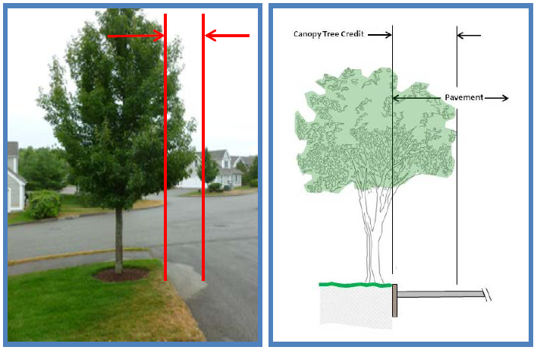
Runoff reduction credit based on the area of pavement beneath tree canopy
The reduction is dependent on the provision of sufficient soil volume (S_{v}) to sustain a mature tree. Each new tree must be installed in a planting bed or trench with a soil volume available for rooting equal to two (2) times the CP of the tree at maturity (use 40 years as the age at maturity). This volume must be adjusted for the soil volume actually provided for each tree.
These variables are used to calculate the Effective Impervious Cover Reduction (EIC_{R}) from implementation of tree canopies. The EIC_{R} may be deducted from the total area of impervious surface within the design subcatchment that must be managed as required by Standard and Standard 4.

Calculating the Effective Impervious Cover Reduction (EIC_{R}) for New Trees:
    - Step 1: Tabulate the qualifying Canopy Area (CA) consisting of the area of ground level impervious surface beneath the canopy projection area (i.e., within the drip line) of new trees for which this credit is claimed (Equation A-1). The area shall assume the tree Canopy Projection (CP) at maturity (40 years) (Equation A-2). Pervious surfaces beneath the canopy shall not be included in this tabulation.
CA= CP-APerv | Equation (A-1)

CP=(π)∙(DCrown)2 | Equation (A-2)
Where,
CA is the Qualifying Canopy Area for each tree
CP is the Canopy Projection Area for each tree (Equation A-2)
A_{Perv} is the Pervious Area beneath the CP (e.g., area of planter)
D_{Crown} is the crown diameter of the tree at maturity (see Fact Sheet)
    - Step 2: Calculate the Maximum Potential EIC_{R} for New Trees using Equation A-3. This formula accounts for the average interception benefit of a tree from the time it is installed (2-inch caliper) until the time it reaches its mature size.
EICR(Max,New)=(0.075)∙(CA) | Equation (A-3)
    - Step 3: Verify that there is sufficient soil volume to sustain a mature tree. For full credit, each new tree shall be installed in a planting bed or trench with a soil volume (Sv) available for rooting equal to two (2) times the total canopy projection area (CP) of the tree at maturity (use 40 years as the age at maturity) (Equation A-4). For example, a tree with a mature crown diameter of 30 feet has an area at the drip line equal to 707 square feet. The required soil volume for this tree would be 2 x 707 = 1414 cubic feet. At four feet of soil depth, the required planting area for this tree would be 354 square feet of suitable planting material.
If the actual provided Sv is less than the required Sv, the tree may receive partial credit, prorated based on soil volume according Equation A-5.
SvRequired=(2)∙(CP) | Equation (A-4)

F=(SvActual)(2)∙(CP) | Equation (A-5)
Where F is an adjustment factor trees without adequate Sv for rooting.
    - Step 4: Calculate the Credited EIC_{R} for New Trees using Equation A-6. For example, in the above case, if the designed planting bed has only 400 cubic feet of soil volume (e.g., 10 ft. x 10 ft. x 4 ft. depth), then the tree credit shall be multiplied by the adjustment factor (F) = 400/1414 = 0.28. That is, only 28% of the maximum allowable credit shall be allowed for that tree.
EICR(Credited, new)=F∙EICR(Max) | Equation (A-6)
Calculating the Effective Impervious Cover Reduction (EIC_{R}) for Existing Trees:
    - Step 1: Tabulate the qualifying Canopy Area (CA) consisting of the area of ground level impervious surface beneath the canopy projection area (i.e., within the drip line) of existing trees for which credit is claimed. Project plans should document the extent of existing canopy.
    - Step 2: Calculate the Credited EIC_{R} for Existing Trees using Equation A-7. This formula accounts for the interception benefit of the tree at the time of permit issuance, and assumes no increase in benefit over time.
EICR(Credited, Existing)=(0.15)∙(CA) | Equation (A-7)
Calculating the resulting Effective Impervious Cover (EIC):
    - Step 1: Tabulate the total area of the design subcatchment’s Impervious Cover (IC).
    - Step 2: Tabulate the total Credited EIC_{R} for new and existing tree canopy (see previous calculations).
    - Step 3: Compute the Effective Impervious Cover (EIC) for use in calculations for Standard 3 and Standard 4 using Equation A-8.
EIC=IC-EICR(Credited) | Equation (A-8)

Example Calculation for ESSD Credit 5
Problem Statement: A project will result in the development of 60,000 square feet of impervious surface. The site has just one drainage subcatchment. The site plans document the preservation of existing trees to provide 6,000 square feet of canopy extending over parking areas, walks, and drives. The site plans also provide for 36 new trees whose estimated crown diameter at maturity will be 40 feet (20-foot radius), if the trees are planted with sufficient space for root growth. Assume that the remainder of the site within the subcatchment will be treated by an infiltration basin (i.e., all new trees and preserved existing trees are installed over impervious cover that drains to the infiltration basin).
  - 12 of the new trees will each be planted in a 10-foot by 20-foot landscaped island located in a parking area, with suitable soils extending to at least 4 feet of depth.
  - The remaining 24 new trees will be planted in lawn areas and spaced so that available soil for root penetration exceeds 2600 cubic feet for each tree. The drawings document that the canopy overhanging pavement at full maturity would be 8,000 square feet.
Calculate the allowable reduction in effective impervious cover (EIC_{R}).
Solution:
- Step 1: Determine eligibility using Checklist above.
- Step 2: Calculate the EIC for existing trees:
  - EIC_{R} existing trees = 0.15 x 6,000 sq. ft. = 900 sq. ft. (Eq. A-7)
- Step 3: Calculate the EIC for new trees planted in islands:
  - Canopy Projection Area, each tree: CP = (π) x (20 ft.)² = 1,257 sq. ft. (Eq. A-2)
  - Pervious area of each planter: A = 10 ft. x 20 ft. = 200 sq. ft.
  - Impervious area beneath crown: CA_{each} = 1,257 ft. - 200 ft.= 1,057 sq. ft. (Eq. A-1)
  - Total area of impervious under canopy: CA = 12 trees x 1,057 sq. ft. = 12,684 sq. ft.
  - Maximum credit: EIC_{R} max. = 0.075 x CA = 0.075 x 12,684 sq. ft. = 951 sq. ft. (Eq. A-3)
  - Required soil volume each tree: S_{v} = 2 x CP = 2 x 1,257 sq. ft. = 2,514 cu. ft. (use Eq. A-4)
  - Soil volume provided each tree: S_{v} actual = 10 ft. x 20 ft. x 4 ft. = 800 cu. ft.
  - Adjustment soil volume: Adj. Factor = 800 cu. ft. / 2,514 sq. ft. = 0.32 (use Eq. A-5)
  - Final credit for trees in planters:
  - EIC_{R} trees in islands = 0.32 x EIC_{R} max = 0.32 x 951 sq. ft. = 304 sq. ft. (use Eq. A-6)
- Step 4: Calculate the EIC for new trees in lawn areas, with tree canopy overhanging pavement:
  - EIC_{R} trees in lawns = 0.075 x 8,000 sq. ft. = 600 square feet. (use Eq. A-3)
- Step 5: Calculate the total credit for all qualifying trees:
  - EIC_{R} = 900 + 304 + 600 = 1,804 sq. ft.
  - The credited EIC_{R} can be deducted from the total impervious area used for Standard 3, Standard 4, and Standard 7 pollutant removal computations – i.e., 60,000 sq. ft. minus 1,804 sq. ft. = 58,196 sq. ft.
- Step 6: Apply the credited EIC_{R} to Standard 3. Assume that the “Static Method” is used to compute the Required Recharge Volume (Rv) based on Equation 6-1 of the Stormwater Handbook. The Rv is based on a target runoff depth of at least 1 in (0.083̅3 ft.) times the total impervious area the post-development site of 60,000 sq. ft.
    - The Rv without the Tree Canopy EIC reduction is therefore 0.083̅3 ft. x 60,000 sq. ft. = 5,000 cu. ft.
    - The Rv with the Tree Canopy Credit and a 1,804 sq. ft. reduction in impervious area is therefore 0.083̅3 ft. x (60,000 sq. ft. – 1,804 sq. ft) = 4,850 cu. ft.
- Step 7: Apply the credited reduction in EIC to Standard 4 (or the pollutant removal requirements of Standard 7). Assume that the EPA Performance Curve presented by Figure 6-10 of the Stormwater Handbook is used for an Infiltration Basin. According to Figure 6-10, a depth of runoff from upstream impervious area (D_{WQ}) of at least 0.3 in (i.e., 0.025 ft) would be required to meet the 90% TSS / 60% TP removal requirement. The required volume of the infiltration basin would therefore be computed using Equation 6-7 of the Stormwater Handbook as the D_{WQ} times the upstream impervious area.
    - The required basin sizing to meet Standard 4 without the Tree Canopy EIC reduction is therefore 0.025 ft x 60,000 sq. ft. = 1,500 cu. ft.
    - The required basin sizing to meet Standard 4 with the Tree Canopy EIC reduction is therefore 0.025 ft x (60,000 sq. ft. – 1804 sq. ft.) = 1,455 cu. ft.

Minimize Impervious Cover
ESSD Techniques

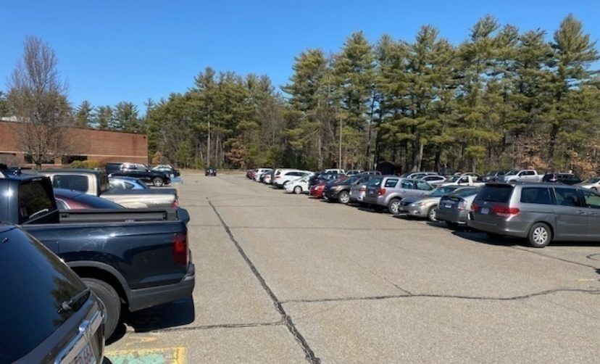
Description and Purpose

Impervious surfaces include streets, parking lots, driveways, roofs, and other areas where water cannot infiltrate naturally into soil. Replacing natural vegetation and soils with impervious surfaces leads to increased runoff volume and velocity, larger pollutant loads, and may adversely affect long-term hydrology and natural systems through flooding and channel erosion. Research demonstrates a decrease in fish, amphibian, and insect species when the percent imperviousness within a watershed exceeds 15%.
By minimizing impervious cover, a Applicant can decrease stormwater runoff, increase infiltration and evapotranspiration, and minimize the collection, concentration, and conveyance of runoff. In urban development, streets usually account most of the impervious area, while parking lots and rooftops are the largest contributors on commercial sites. The techniques incorporated into overall road design will depend on the soils, development density, zoning, and use of the receiving water.
ESSD Credits
As indicated in the “Introduction” section of this Appendix, a suite of ESSD Credits is available to encourage project Applicants to implement MassDEP recognized Environmentally Sensitive Site Design (ESSD) and Low Impact Development (LID) techniques. There is one ESSD Credit associated with this Fact Sheet:
- Credit 6: Reduce Impervious Area at Redevelopment Sites
See below for more information on this credit.
Planning Considerations
Careful site planning can reduce the impervious area created by pavement and roofs and the volume of runoff and pollutant loading requiring control. As the impervious surface area of a development increases, the size and expense of the stormwater control facilities also increase. Minimizing impervious surfaces mitigates this problem and provides more space for conservation of natural features and design of more functional SCMs. Local zoning and development standards, such as those addressing road widths or cluster zoning, affect the amount of runoff generated by projects.

Applicable Regulations
To ensure a reliable source of safe drinking water, it is essential that impervious areas be minimized in certain recharge areas. To further that goal, the Massachusetts Drinking Water Regulations (310 CMR 22.00) require that municipalities proposing new groundwater sources for a public water system enact land use controls to prohibit land uses within the Zone II that create impervious cover exceeding 2,500 square feet or 15% of a lot, whichever is greater. These standards can only be exceeded if a system for artificial recharge of precipitation is provided which ensures that there is no degradation of groundwater quality. The Drinking Water Regulations impose a similar requirement on municipalities proposing new Surface Water sources.
Common Approaches
- Maintain as much of the pre-development vegetation as possible, especially larger trees that may be on site. Vegetation absorbs water and reduces the amount of stormwater runoff.
- Reduce frontage and other setbacks to reduce driveway length.
- Modify zoning to allow planned unit developments that limit the density while maximizing the amount of undisturbed open space and cluster developments that cluster or group buildings closer together to maximize undisturbed open space.
- Reduce the horizontal footprint of buildings. Footprint size can be reduced by constructing a taller building, including parking facilities within the building itself, while maintaining the same floor to area (FAR) ratio.
- Reduce the size of parking areas: Parking areas can be reduced by shrinking the parking lot stalls, reducing the circulation area, using a diagonal parking stall configuration, or building structured parking garages. Parking areas with adjacent or nearby facilities can be shared.
- Reduce to one lane, or eliminate if practical, on-street parking lanes on local access roads.
- Limit sidewalks to one side, or eliminate if practical, on local low-traffic roads.
- Implement shared driveways to provide access to several homes.
- Reduce driveway length or width.
Examples of Common Approaches
- Cluster Development (Puget Sound Action Team 2005)
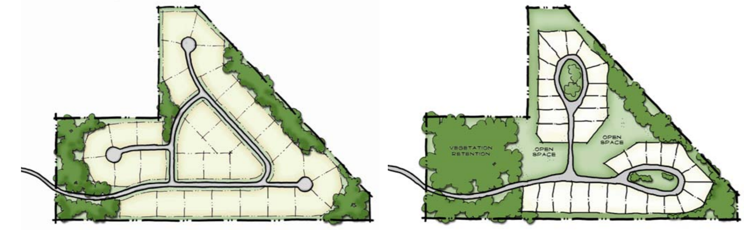

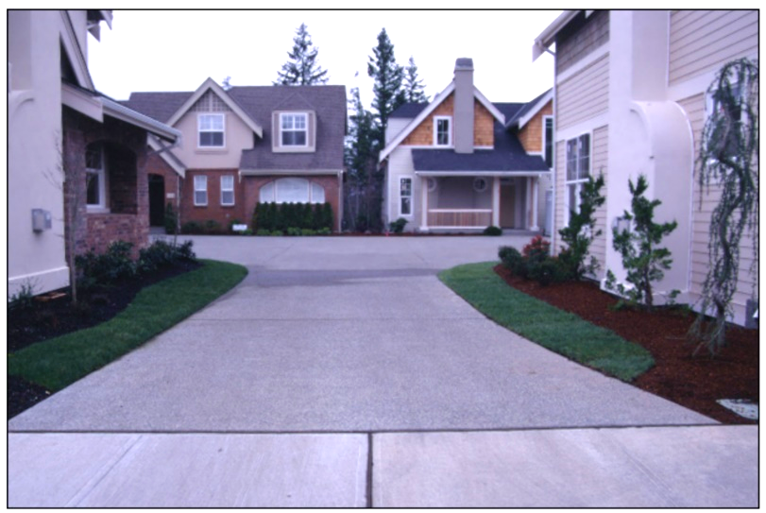
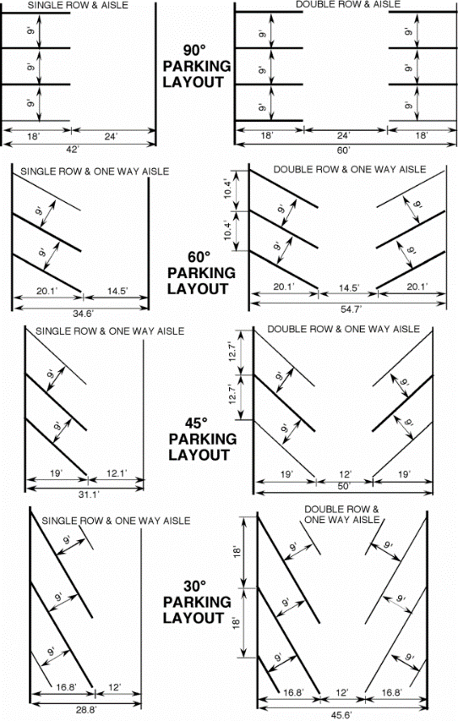
- Shared Driveways (Puget Sound Action Team 2005) 3. Parking Angle (Virginia Asphalt Association

References
Puget Sound Action Team, Office of the Governor, Olympia, Washington. 2005. Low Impact Development Technical Guidance Manual for Puget Sound https://www.psp.wa.gov/downloads/LID/20121221_LIDmanual_FINAL_secure.pdf
Virginia Asphalt Association, Parking Lot Design - https://vaasphalt.org/pavement-guide/pavement-design-by-use/parking-lot-design/

ESSD Credit 6: Reduce Impervious Area at Redevelopment Sites

This ESSD Credit is available for the reduction of total impervious area (TIA) at Redevelopment sites. If all requirements of this credit are met, a project Applicant need not implement any additional ESSD / LID techniques to satisfy the ESSD / LID implementation requirement summarized by Section 4.2 of the Stormwater Handbook. This credit also consists of a reduction in TIA which, by definition, is deducted from the total area of impervious surface that must be managed as required by Standard 2, Standard 3, Standard 4, and the pollutant removal requirements of Standard 7
Ability to meet specific standards
Standard | Description
2 - Peak Flow | Consists of a reduction in Total Impervious Area (TIA) which, by definition, is deducted from the total area of impervious surface that must be managed as required by Standard 2.
3 - Recharge | Consists of a reduction in Total Impervious Area (TIA) which, by definition, is deducted from the total area of impervious surface that must be managed as required by Standard 3.
4 - TSS/ TP Removal | Consists of a reduction in Total Impervious Area (TIA) which, by definition, is deducted from the total area of impervious surface that must be managed as required by Standard 4 or the pollutant removal requirements of Standard 7.
5 - Higher  Pollutant  Loading | May be used for runoff from land uses with Higher Potential Pollutant Loads (LUHPPLs).
6 - Discharges  near or to  Critical Areas | May be used for discharges near or to Critical Areas.
7 - Redevelopment | May be used for Redevelopment.
8 - Construction Phase Pollution Controls | Not to be used for construction period runoff control.
11 - Total Maximum Daily Loads | May be used to treat all TMDL pollutants specified in Table 2-6 of the Stormwater Handbook if minimum criteria are met.
ESSD / LID? | Yes, this practice is a MassDEP recognized ESSD / LID technique.

Minimum Required Criteria
This ESSD Credit is only available when the following criteria are met:

- The project is a Redevelopment.
- Total Imperious Area (TIA) of the site must be reduced by at least 15% from existing conditions.
- The resulting TIA of the site must be less than 75% of the base lot area.
- The Site Plan must clearly demonstrate the existing TIA, the proposed TIA, and the resulting percent reduction.
Example Calculation for ESSD Credit 6
Problem Statement: Assume a 10.0-acre site to be redeveloped for a retail use. The existing impervious area is 2.0 acres, including a parking lot. The developer proposes to reduce the impervious area by 0.5 acres by reducing the size of the parking lot and reducing the size of the proposed building’s footprint.
Solution:
- Step 1: Determine the change Total Impervious Area using Equation A-9.
∆TIA= AIMP proposed-AIMP initialAIMP initial

Where,
∆TIA is the precent change in TIA Impervious Area
A_{IMP(initial)} is the Initial Impervious Area
A_{IMP(proposed)} is the Proposed Impervious Area
∆TIA = (1.5 acres – 2 acres) / 2 acres = 25% reduction in TIA
- Step 2: Use the resulting TIA to design SCMs to meet all Stormwater Standards.

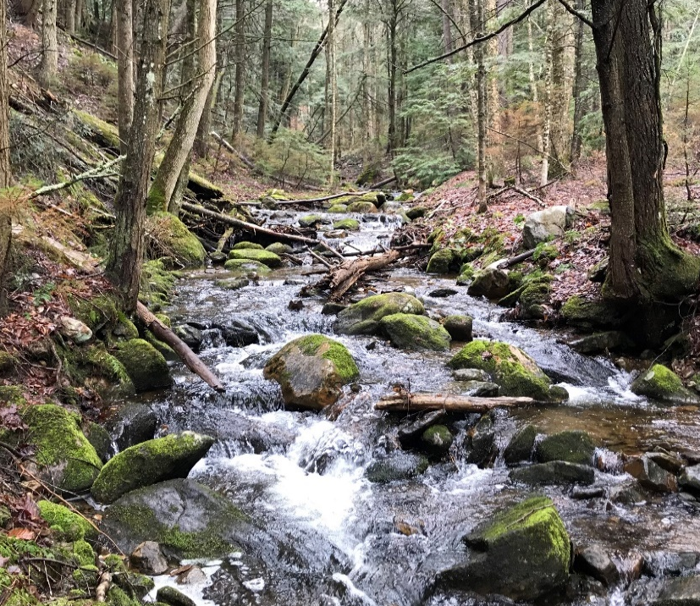
Protecting and Enhancing Buffer Areas
ESSD Techniques
Description and Purpose

A Buffer Zone is an area of land extending outward from the boundary of any area specified in 310 CMR 10.02(1)(a) (e.g., Bordering Vegetated Wetland). Buffers can be used to protect water quality and to prevent erosion and sedimentation along wetlands, streams and other Surface Waters. Buffers can also be incorporated into natural landscaping of an area.
Buffers provide a living filter to reduce erosion and runoff velocities, especially on unstable steep slopes. Through protecting or enhancing buffer areas, a project Applicant can partially or completely prevent discharge of nonpoint source pollutants such as sediment, organic material, nutrients, and pesticides. Buffers can also provide benefits beyond those related to water and drainage, including protection of critical habitat adjacent to streams and wetlands, corridors for wildlife movement, aesthetic benefits, and a visibility and noise screening.
ESSD Credits
As indicated in the “Introduction” section of this Appendix, a suite of ESSD Credits is available to encourage project Applicants to implement MassDEP recognized Environmentally Sensitive Site Design (ESSD) and Low Impact Development (LID) techniques. There is one ESSD Credit associated with this Fact Sheet:
- Credit 7: Protect or Enhancing Buffer Areas
See below for more information on this credit.
Common Applications
The following approaches are commonly used to enhance or protect buffer areas:
- Acquisition and Protection: Involves obtaining easements or full fee acquisition rights for wetlands and riparian areas along inland and coastal Surface Waters and wetland resources areas. May also rely on regulation to restrict activities that have negative impacts on wetlands and riparian areas through special area zoning and transferable development rights.
- Restoration: Restoration is the return of an area to conditions similar to those present prior to disturbance, by re-establishing the characteristics of buffer areas that promote vegetative composition and cover, flow characteristics of Surface Water and groundwater, hydrology and geochemical characteristics of substrate, and species composition.
Effectiveness
The ability of a buffer to remove pollutants is dependent on the width of the buffer, the type of vegetation, the manner in which runoff traverses the vegetated areas, the slope, and the soil composition within the buffer area (Cohen 1997). Effectiveness increases with increased detention time, and is reduced significantly in the absence of sheet flow. If the buffer is intended to function as a stormwater control measure (SCM), it may be used in conjunction with other SCMs, such as grass filter strips on the outer edge of the buffer to help diffuse runoff.
Planning Considerations
The following impact a buffer’s capacity to remove pollutants from runoff:
- Soil type influences infiltration and pollutant removal. Hydrologic Soil Group (HSG) A soils have desirable high infiltration rates and are optimal for removal of Total Suspended Solids (TSS) and Total Phosphorus (TP).
- Historically forested soils are beneficial to a buffer’s pollutant removal capacity because they have high organic content, can closely mimic hydric soils, and typically have limited compaction.
- Hydrologic flow path is determined by topography and soil. Wetlands and areas with a high-water table increase hydraulic residence time, which allows for greater pollutant removal from runoff.
- Slope impacts the sediment removal, with buffer slopes less than 5% being good for removal. Slopes above 5% may be less effective.
- Land use intensity (e.g., amount and type of developed land and impervious surfaces) of the area draining into the buffer and the buffer itself will affect pollutant removal performance.
- The pollutant removal effectiveness is typically optimal in diverse buffers that are densely vegetated with woody species (e.g., forested buffers with dense growth of canopy trees and under-canopy tree and shrub species). Buffers that become forested or more diverse over time are expected to become more effective.

Healthy, intact buffers protect water quality by reducing pollutants from entering water bodies. The following should be considered when protecting or enhancing existing Buffer Areas:
- Preserving existing natural vegetation is generally the easiest and most successful method.
- Establishing new buffer areas requires an appropriate soil planting layer – typically a loamy topsoil 12-18 inches in depth. Depending on the site, the existing soils may need to be amended to ensure success of tree and shrub plantings. Careful maintenance is important to ensure establishment of healthy vegetation, particularly in the first growing season.
- Leave all unstable steep slopes in natural vegetation.
- Fence or flag clearing limits and keep all equipment and construction debris out of the natural areas.
- Keep all excavations outside the dripline of trees and shrubs.
- Do not push debris or extra soil into the Buffer Zone area because it will cause damage from burying and smothering.
Maintenance
Potential maintenance activities include watering for the first year of replanting or in drought conditions, selective cutting, replanting and weed control (hand weeding or careful spraying). Existing buffer areas need little or no maintenance. Fertilization should be avoided. It is important that maintenance activities do not cause soil compaction, excessive disturbance or impact close to the river (CH2MHILL 1998). Fallen or decaying vegetation in established areas should not be removed. Excessive raking, brush clearing or plant removal can reduce water detention time and breakdown of pollutants by plants and microorganisms (Cohen 1997).
References

CH2MHILL. 1998. Pennsylvania Handbook of Best Management Practices for Developing Areas.
Cohen, R. 1997. Fact Sheet # 8: Functions of Riparian Areas for Pollution Prevention. Massachusetts Department of Fisheries, Wildlife and Environmental Law Enforcement, Massachusetts Riverways Program.
MassDEP Massachusetts Clean Water Toolkit, Buffer Zones, Stream Corridors and Riparian Areas - https://megamanual.geosyntec.com/npsmanual/bufferzones.aspx
MassDEP Massachusetts Clean Water Toolkit, Riparian Forest Buffers - https://megamanual.geosyntec.com/npsmanual/riparianforestbuffers.aspx
Roca Communications, June 2019, Pollutant Removal Credits for Buffer Restoration in MS4 Permits Final Panel Report, http://nerrssciencecollaborative.org/media/files/CGG/Green_Credit_%20Report_June2019.pdf

ESSD Credit 7: Protect or Enhance Buffer Areas
This ESSD Credit is available when runoff from upgradient impervious surfaces is directed to a vegetated buffer via sheet flow. This credit is applicable to new development and Redevelopment projects that plant a new buffer, expand (enhance) an existing buffer, or protect an existing buffer. See below for the ability of this ESSD Credit to meet specific Stormwater Standards. The Applicant must meet all required criteria to be eligible for this credit.
Note: This credit is only applicable to the impervious area discharged to the vegetated buffer and not the entire site. All calculations must be performed based on drainage subcatchment and not the entire site. Run-on from any offsite areas must be included in any subcatchment calculations.
Ability to meet specific standards
Standard | Description
2 - Peak Flow | Peak rate attenuation requirement is assumed to be met for the portion of the site that drains to the buffer area if all minimum criteria are met. The peak rate attenuation requirement for this credit does not need to be demonstrated by modeling.
3 - Recharge | Use Table Buffer 1 to determine recharge credit. Provides 1-inch of groundwater recharge credit for the portion of the site that drains to the buffer area if all minimum criteria herein are met.
4 - TSS/ TP Removal | Use Table Buffer 1 to determine pollutant removal credit. Provides 90% TSS removal and 60% TP removal for the portion of the site that drains to the buffer if all minimum criteria are met.
5 - Higher  Pollutant  Loading | May not be used for runoff from land uses with Higher Potential Pollutant Loads (LUHPPLs) except for parking lots with high-intensity uses that generate more than 1,000 vehicle trips per day or more.
6 - Discharges  near or to  Critical Areas | May be used for discharges near or to Critical Areas.
7 - Redevelopment | May be used for Redevelopment.
8 - Construction Phase Pollution Controls | Not to be used for construction period runoff control.
11 - Total Maximum Daily Loads | May be used to treat all TMDL pollutants specified in Table 2-6 of the Stormwater Handbook if minimum criteria are met.
ESSD / LID? | Yes, this practice is a MassDEP recognized ESSD / LID technique.
Recharge and Pollutant Removal Credit
Recharge and pollutant removal credit for protecting and enhancing buffer areas is based on the Hydrologic Soil Group Type of the buffer area and the ratio of impervious area to impervious area (Table Buffer 1).
If the ratio of impervious area to pervious area does not match those provided by the table, use the ratio that is nearest to, but more than, the determined ratio. For example, if the impervious area to pervious area ratio is 3 to 1, calculate pollutant removal credit based on a ratio of 4 to 1.
Table Buffer 1. Recharge and pollutant removal credits for protecting and enhancing buffers.
Impervious Area to Pervious Area Ratio | HSG A | HSG B | HSG C
8:1 | NC | NC | NC
6:1 | NC | NC | NC
4:1 | NC | NC | NC
2:1 | NC | NC | NC
1:1 | ü | ü | NC
1:2 | ü | ü | ü
1:4 | ü | ü | ü
1:10 | ü | ü | ü
1:30 | ü | ü | ü
1:50 | ü | ü | ü
Table Key:
- Check Mark (ü) = Credit is provided for 1-inch recharge, 90% TSS removal, and 60% TP removal.
- NC = No credit is provided for recharge or pollutant removal.
- Assumes that all minimum required criteria are met.

Minimum Required Criteria
This ESSD Credit is only available when the following criteria are met.
- No work, including any alteration for stormwater management, may be proposed within any Wetland Resource Area except for Riverfront Area (RA), Bordering Land Subject to Flooding (BLSF), Isolated Land Subject to Flooding (ILSF), or Land Subject to Coastal Storm Flowage (SCSF). The underlying Performance Standards in these Resource Areas must be met.
- The buffer width shall be measured horizontally outwards (i.e., upgradient) from the boundary of the Wetland Resource Area.
- The minimum buffer width shall be 50 feet for Redevelopment Projects and 75 feet for New Development Projects except for projects within Riverfront Area. The minimum buffer width shall be at least 100 feet for all projects within the Riverfront Area.
- Buffer improvements must protect or enhance the entire length of any Buffer Zone within the design subcatchment.
- The flow path to the buffer shall be no more than 75-feet long on impervious surfaces, and no more than 300-feet long on landscaped areas, so flow won't concentrate.
- The average contributing overland slope to and across the buffer shall be less than or equal to 5%.
- Recharge and pollutant removal credit must be calculated based on Table Buffer 1.
- Runoff shall enter the buffer uniformly across its entire length as sheet flow. If needed, use a level spreader to accomplish this. No closed drainage is allowed. Curb cuts that direct flow, swales, pipes, or other conveyances would be considered point sources and are not allowed.
- The elevation at the interface between the impervious surface and landscaped / vegetated areas needs to be equal. There can be no drop in slope at the interface for at least 20-feet. A gravel strip may also be established at the interface to induce interflow (see “Pea Gravel Diaphragm with Filter Strip”).
- For flow from parking lots to buffer area, establish a hard edge with no reveal at the interface of impervious surface and landscaped / vegetated areas (see Figure Buffer 1 for example schematic).
- The underlying soils must be classified as Hydrologic Soils Group A, B, or C in accordance with procedures outlined in Section 6.3.2 of the Stormwater Handbook.
  - Urban Fill is not acceptable at locations where a new buffer is being planted or an existing buffer is being expanded unless the Urban Fill is removed and replaced with clean topsoil or hydrogeological testing is conducted indicating the filled soils are relatively homogeneous horizontally and vertically with a vertical saturated hydraulic conductivity (K_{sat}) equivalent to a Hydrologic Soil group A, B, or C in accordance with Section 6.3.2 of the Stormwater Handbook. Also, see Section 6.3.4 of the Stormwater Handbook, “When Fill Materials are Determined to be Present”, for additional requirements.
- This credit may not be used for runoff from a LUHPPL except for for high-intensity parking lots that generate 1,000 or more vehicle trips per day.
- This credit may not be used for runoff from a metal roof unless the building is located outside a Zone II or Interim Wellhead Protection Area and the building must not be used for industrial purposes.
- All buffer improvements shall include a deed restriction with a restrictive covenant indicating that the new, expanded, or protected buffer must not be disturbed and must be unmanaged with the exception of routine debris and litter removal. The provisions contained within the deed restriction shall bind the landowners and their heirs, devisees, legal representatives, successors and assigns.
- Once planted, the boundary of the new, expanded, or protected buffer must be demarcated with permanent stone or concrete markers. Each marker must be at least 4 inches wide by 4 inches long by 30 inches tall. Each marker shall include a weatherproof permanent plaque or engraving with clearly visible writing that reads: “Protected Buffer Area, Do not Disturb”. Markers must be placed in coordination with the Conservation Commission. It Is recommended that permanent markers be placed along the entire perimeter of the new, expanded, or protected buffer with at least one marker being placed every 200 feet. Markers must also be installed at all prominent angles (e.g., corners).
- The buffer must be unmanaged with the exception of routine debris and litter removal. The Operation and Maintenance Plan (O&M Plan) required by Standard 9 must specify how the buffer area will be managed. If used, the O&M Plan must also include provision to maintain level spreaders and gravel strips.
- This ESSD Credit may not be used in locations where information is submitted during the public hearing or introduced by the Conservation Commission that there is a demonstrated history of groundwater flooding.
- All planting requirements must be met as listed directly below.
Planting Requirements
- All new, expanded, or protected buffers must be comprised predominantly by woody species (trees or shrubs). Grassed or predominantly herbaceous buffers are not allowable.
For existing buffers to be protected:
- The Applicant must document that the areal coverage of canopy from tree and shrub species is at least 75% of the buffer area. Documentation can be provided based on a field assessment from a forester, wetland scientist, or other qualified botanist with experience in estimating the areal coverage of vegetation, and may be supported by the use of recent aerial imagery that represents conditions which are similar to those at the time of application submittal (i.e., no tree cutting or land clearing has occurred after the date of the imagery).
For new or expanded buffers:
- All plantings shall be native to New England.
- Shrubs and trees must be planted with uniform density throughout the buffer.
- At least 200 trees shall be planted per acre (minimum spacing between plantings of 15-feet on center).
- At least 450 shrubs shall be planted per acre (minimum spacing between plantings of 10-feet on center).
- If planting a mixture of trees and shrubs, the planting densities and spacing listed above must be maintained. If a shrub is planted directly adjacent to a tree, the on center spacing between the shrub and the tree must be a maximum of 10 feet.
- Planted shrubs shall be at least 18-24 inches tall. Planted trees shall be at least 24-26 inches tall. Larger plantings will generally have a higher survival rate than smaller plantings.
- Upon planting, stabilize areas between woody species with a New England native seed mix that is appropriate for the planted location based on moisture, sun, shade, and other factors such as proximity to roads.
- The buffer will be considered established when 75% of the planted trees and shrubs are alive after 2 growing seasons. If there are less than 75% live planted trees or seasons and natural regeneration (i.e., growth of volunteer woody species) has not made up the loss, re-planting must be performed.

Site Plans
In addition to requirements described in Section 6.1.3 of the Stormwater Handbook, the site plans submitted with the NOI or WQC Application must include the following:
For all new, expanded, or protected buffers:
  - Provide a tabulation and visual representation that all required dimensions from the “minimum required criteria” area met (e.g., width, length, average slope, maximum upland flow path, ratio of impervious to pervious area).
For existing buffers to be protected:
  - The planting plan must visually depict the areal coverage of canopy from woody species described previously. Woody species must comprise at least 75% of the buffer area.
  - The planting plan must include a summary table that indicates that proposed buffer area and dimensions.
For new or expanded buffers:
- The planting plan must visually depict proposed planting locations, proposed planting type (i.e., shrub vs. tree), proposed New England native species type, and proposed spacing.
- The planting plan must include summary tables that provide a list of each species type, whether the species is a tree or a shrub, what the proposed minimum spacing is, and how many are proposed to be planted.
- The summary tables must clearly indicate the proposed buffer area, the total number of proposed shrubs and trees, and the total number of proposed shrubs and trees to be planted per acre.
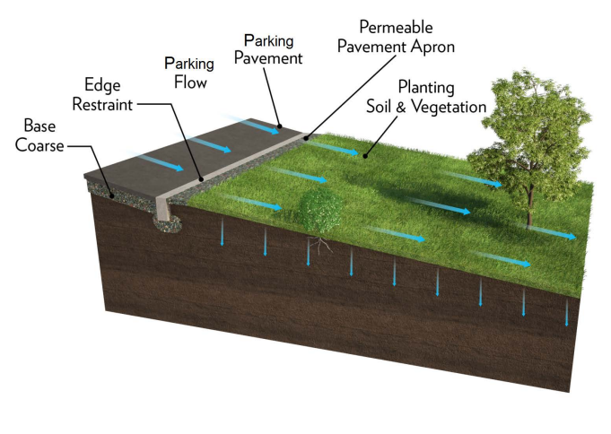
Figure Buffer 1. Example schematic of interface between impervious and pervious surface with a zero reveal edge restraint.
(Image source: 2019 RIDOT Linear Stormwater Manual)

Example Calculation for ESSD Credit 7
Problem Statement: Assume a 3.0 ac site to be redeveloped for a retail use. The resulting impervious area of the proposed Redevelopment will be 1.6 ac. The existing site is comprised of a strip mall surrounded by impervious pavement. The impervious pavement along the northern portion of the site is located in the Buffer Zone of a Bordering Vegetated Wetland (BVW) with an approximate length of 250 ft. The Redevelopment proposes to remove the pavement located within the Buffer Zone and plant a new vegetated buffer. Determine the physical criteria that would be required to implement a new buffer at this location, then calculate the credited reduction in Required Recharge Volume (Standard 3) and TSS / TP removal (Standard 4 or Standard 7) that will result from implementation of the buffer.
- Step 1, Design the physical characteristics of the proposed buffer.
- The new vegetated buffer will be planted along the entire 250 ft length of Buffer Zone that borders on the BWV. The new buffer will have a minimum width of 50 ft. The buffer will not be planted within the Wetland Resource Area. The overall area of the proposed buffer will be 14,000 sf.
- The new buffer will receive uniform sheet flow from an upgradient parking lot with an average contributing overland slope to the buffer of 2% and a maximum contributing upland distance of 65 ft. The average slope across the buffer will also be 2%. The overall area of the contributing upgradient parking lot will be 15,000 sf.
- The ratio of impervious area to buffer area will be 15,00 sf / 14,000 sf = 1.1). This number must be rounded up to select the nearest ratio of 2:1 for use in calculating pollutant removals and recharge (Table Buffer 1).
- Based on a soil evaluation performed in accordance with Section 6.3.2, the subgrade (i.e., native material) that underlies the existing pavement and aggregate subbase is classified as Hydrologic Soil Group B. The existing pavement and aggregate sub-base will be removed prior to planting and replaced with clean topsoil prior to planting.
- The buffer will be comprised entirely of New England native tree species planted with a uniform density of at least 200 trees per acre with a spacing of at least 15-feet on center. The area of the proposed buffer is 14,000 sf (0.32 ac). The minimum number of tree plantings is therefore 0.32 x 200 = 64 trees.
- Step 2, Verify that the buffer meets all other minimum required criteria and requirements as listed previously (e.g., site plan preparation, zero percent drop at impervious/pervious interface, preparation for permanent markers, etc.).
- Step 3, Calculate the credited reduction in recharge volume.
  - Assume that the “Static Method” is used to compute the Required Recharge Volume (Rv) based on Equation 6-1 of the Stormwater Handbook. The Rv is based on a target runoff depth of at least 1 in (0.083̅3 ft) times the total impervious area of the post-development condition of 1.6 ac (69,696 sf). The Rv for the entire site is therefore 0.083̅3 ft x 69,696 sf = 5,808 cf.
  - The buffer will capture 15,000 sf of upgradient impervious area from the contributing parking lot. Implementation of the buffer is credited with 1 in of groundwater recharge from the impervious area directed to the buffer via uniform sheet flow. The site’s Rv will therefore be reduced by 0.083̅3 ft x 15,000 = 1,249.5 cf. Additional ESSD / LID techniques will be required to recharge the remaining Rv (i.e., 5,808 – 1249.5 = 4558.5 cf).
- Step 4, Calculate the credited pollutant TSS and TP removal.
  - Implementation of the buffer is credited with a removal of 90% TSS and 60% TP from 15,000 sf of impervious area directed to the buffer via uniform sheet flow from the contributing parking lot (i.e., based on a ratio of impervious area to pervious area of 2:1 in accordance with Table Buffer 1)
  - The remaining impervious area of the site must be treated with additional ESSD / LID techniques to meet the overall 80% TSS and 50% TP removal requirement of Standard 7.

Preserve and Use Natural Drainage Systems
ESSD Techniques
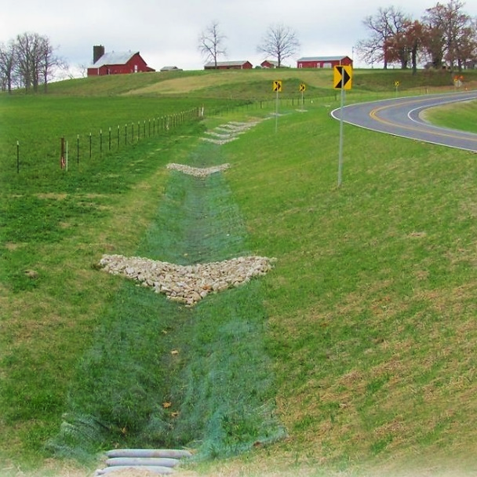

Description and Purpose
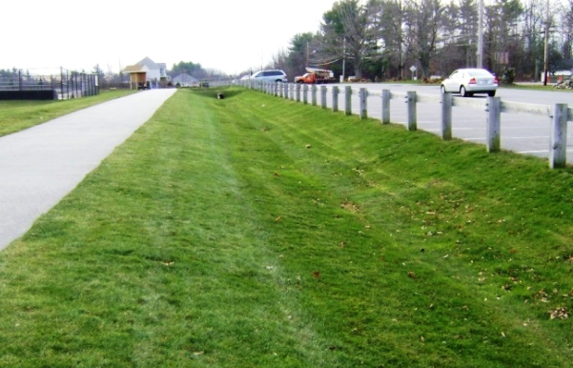
Instead of replacing natural drainage features with engineered systems that rapidly convey runoff downstream, existing natural drainage features such as “country drainage” can be incorporated into the design. Natural drainage systems can help to reduce or eliminate the need for structural drainage systems by helping to maintain flood volumes, peak discharges, and base flows at pre-development levels. Trace metals, hydrocarbons, and other pollutants will also bind to the underlying soils and organic matter. The infiltration process allows for separation of the nutrients and other contaminants from stormwater as it percolates through the subsurface soils.
ESSD Credits
As indicated in the “Introduction” section of this Appendix, a suite of ESSD Credits is available to encourage project Applicants to implement MassDEP recognized Environmentally Sensitive Site Design (ESSD) and Low Impact Development (LID) techniques. There are no numerical ESSD Credits associated with this Fact Sheet; however, practices that preserve that use natural drainage systems are recognized to be ESSD / LID by MassDEP as defined by Section 4.2.1 of the Stormwater Handbook.
Applicability
Natural drainage systems are best used in residential development, particularly lower density single-family areas. Protecting and conserving natural drainage features or designing a road with country drainage becomes more difficult in higher density developments with more impervious cover, such as commercial and industrial developments.
Standard Approach
The standard approach of using curbing on streets and parking areas impairs natural drainage systems. Curbs are widely held to be the signature of quality development; they provide a neat, “improved” appearance and also help delineate roadway edges. Because curb-and-gutter streets trap runoff in the roadbed, storm inlets and drains are logical solutions to providing good drainage for the roadbed. Unfortunately, a requirement for curb-and-gutter streets can create significant stormwater management problems. Because storm drains operate on gravity flow, their efficiency is maximized if they are located in the lowest areas of the site.
Storm drain pipes are usually located in valleys and low areas, destroying natural drainage ways. Natural filtration and infiltration capacities are lost in the most strategic locations.
Further, in most instances, storm drains are designed for short-duration, high-frequency storms and not for flood flows, which are handled by street and gutter flows after the storm drain capacity is exceeded. The result is that the natural drainage ways are converted from slow-moving, permeable, absorptive, vegetated waterways to fast-moving, impervious, self-cleaning, paved waterways, thereby increasing hydraulic efficiency, peak discharges and flood volumes.
When natural waterways are paved and designed to quickly drain to the culverted stormwater management system, this will minimize channel storage times as well as reduce base flows and groundwater recharge. When examined in the context of environmentally sensitive site design, the net effect of the seemingly beneficial decision to use curbs can initiate a snowball effect that amplifies the extremes in the hydrologic cycle, increasing flood flows and reducing base flows.
Curb-and-gutter developments also affect water quality. Trace metals from automobile emissions and hydrocarbons from automobile crankcase oil and fuel spillage are directly deposited on paved surfaces. For the most frequent rainfalls, the first flush of stormwater runoff washes these deposits into the storm drain system, which is designed to keep in suspension the particles to which the pollutants adhere. The particles, together with their attached pollutants, are delivered via the runoff water to receiving waters where reductions in velocity permit them to settle out. Nutrient-rich runoff from surrounding lawns quickly moves through the paved system with no opportunity to come into contact with plant roots and soil surfaces. The result is rapid delivery of contaminants to lakes, streams, estuaries, and wetlands.
Design Considerations
Preserving or incorporating natural drainage pathways into site designs can reduce or eliminate the need for stormwater pipe networks, which can reduce costs, maintenance burdens, and site disturbance related to pipe installation. Natural drainage features should be identified during the site analysis and used to guide site design. Natural drainage features may include, but aren’t limited to:
- swales;
- drainage pathways;
- natural depressions;
- wetlands;
- perennial and intermittent streams; and
- water bodies.
These existing features should be protected during construction with any disturbance minimized. When incorporating natural drainage features into site design, they should be planted with native vegetation. Upstream conditions need to be considered when preserving or incorporating natural drainage, since runoff volumes and rates can be significantly increased by development. Stormwater control measures (SCMs) may be necessary in the design to prevent the erosion and degradation of the natural drainage features.
References
Photo credit: https://megamanual.geosyntec.com/npsmanual/waterqualityswales.aspx https://megamanual.geosyntec.com/npsmanual/checkdams.aspx

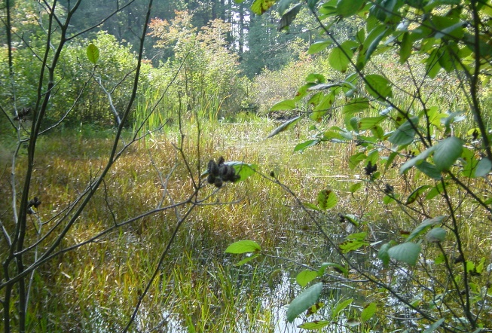
No Disturbance to Wetland Resource Areas
ESSD Techniques
Description and Purpose
Protection of Wetland Resource Areas (WRAs) is one of the most important considerations when designing a stormwater management system. WRAs provide a variety of ecological functions, including water quality improvement for receiving waters, flood storage, groundwater recharge, wildlife habitat, etc. WRA and their Buffer Zone are protected under the Massachusetts Wetlands Protection Act (WPA).
A primary objective of the site planning and design process should be to avoid direct wetland impacts. Where impacts are unavoidable, they must be minimized and mitigation (e.g., constructed wetlands, wildlife habitat improvements) must be provided. Proper design of stormwater systems is necessary to prevent excess sediment and other pollutants from discharging to wetlands, which can lead to impairment of the important functions that they provide.
ESSD Credits
As indicated in the “Introduction” section of this Appendix, a suite of ESSD Credits is available to encourage project Applicants to implement MassDEP recognized Environmentally Sensitive Site Design (ESSD) and Low Impact Development (LID) techniques. There are no numerical ESSD Credits associated with this Fact Sheet; however, practices that preserve that use natural drainage systems are recognized to be ESSD / LID by MassDEP as defined by Section 4.2.1 of the Stormwater Handbook.
Applicability
The WPA regulations, at 310 CMR 10.02(1)(a) through (f), define WRAs as the following “Areas Subject to Protection under the Act”:
Inland wetlands, e.g., bordering vegetated wetlands (wet meadows, marsh, swamp or bog bordering any creek, river, stream, pond or lake), bank, land under water, land subject to flooding, and the riverfront area.
Coastal wetlands, e.g., coastal banks, coastal beaches, coastal dunes, land under the ocean, designated port areas, barrier beaches, rocky intertidal shores, land under salt ponds, land containing shellfish, land subject to coastal storm flowage, and salt marsh; and
Maintenance
The Operations and Maintenance Plan required by Standard 9must provide that best practical measures be implemented to conduct maintenance activities in a manner that avoids, minimizes and mitigates adverse impacts to WRAs.
Additional Information
Refer to Section 2.3 for more information on stormwater management and wetland protection regulations, including:
- Point source and non-point source discharges
- Erosion and Sedimentation control
- Stormwater discharges outside WRAs
- Regulatory requirements after the fact
- Conversion of impervious surfaces to pervious surfaces
- Operation and maintenance
- Jurisdiction over stormwater management systems
References
MassDEP Massachusetts Clean Water Toolkit, Wetlands, Vernal Pools, and Forestry Operations in Massachusetts. https://megamanual.geosyntec.com/npsmanual/wetlandsvernalpoolsandforestry.aspx
Photo credit: https://megamanual.geosyntec.com/npsmanual/wetlandsvernalpoolsandforestry.aspx

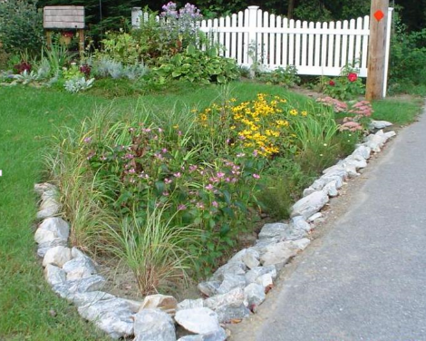
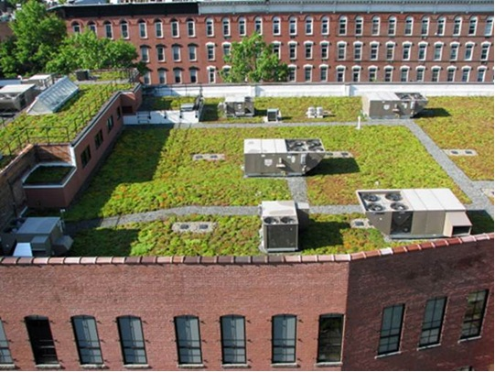
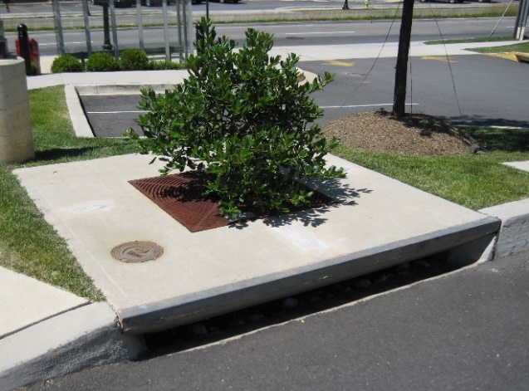
Small Scale Controls
Example rain garden
Example green roof
Example tree box filter
ESSD Techniques
Description and Purpose

Small scale controls, including some Low Impact Development (LID) techniques, are small-footprint stormwater control measures that can be variably sized to treat storms that generate less than 1-inch of runoff and, in aggregate, can account for the total pollutant removal required on-site. Small-scale control measures are designed to reduce, treat, and infiltrate stormwater at its source and are meant to provide stormwater management options on sites that have limited space for traditional sized Stormwater Control Measures (SCMs), or within rights-of-ways.
ESSD Credits
As indicated in the “Introduction” section of this Appendix, a suite of ESSD Credits is available to encourage project Applicants to implement MassDEP recognized Environmentally Sensitive Site Design (ESSD) and Low Impact Development (LID) techniques. There are no numerical ESSD Credits associated with this Fact Sheet; however, practices that preserve that use natural drainage systems are recognized to be ESSD / LID by MassDEP as defined by Section 4.2.1 of the Stormwater Handbook.
Types of Small Scale Controls
Small scale controls are intended to capture the first flush of stormwater runoff. The Stormwater Standards define the first flush as the first inch of stormwater runoff from the beginning of a storm, which carries concentrated pollutants including suspended sediments. Pollutant concentrations are typically higher at the beginning of a storm than at the middle or end of the storm.
Small scale controls are often possible using existing or proposed site features and can be replicated over an entire site. Implementation of small scale controls can conserve natural drainage pathways and open space and significantly reduce the impact from development. Small scale controls can also provide additional benefits beyond those related to water quality and drainage, such as increased property values, reduced energy costs, noise control, and habitat for wildlife.

Examples of small scale LID practices include the following:
- Bioretention and rain gardens, tree box filters, stormwater planters
- Dry wells and infiltration trenches
- Roadside water quality swales
- Vegetated filter strips
- Porous pavement
- Green roofs
Small scale controls must be designed, installed, and maintained in accordance with the Stormwater Standards. Refer to the Structural SCM Specifications in this appendix.

Planning Considerations
- During the planning process, an Applicant should identify small scale source controls that could reduce the requirements for structural stormwater SCMs and prevent the discharge of pollutants to receiving waters.
- When planning to use small scale controls that include vegetation, Applicants should develop a planting plan with drought-tolerant native species that typically require less maintenance.
References

MassDEP Massachusetts Clean Water Toolkit, Low Impact Development Site Design: https://megamanual.geosyntec.com/npsmanual/lowimpactdevelopmentsitedesign.aspx


Nonstructural SCMs
- Street Cleaning
Massachusetts
Stormwater Management
Handbook

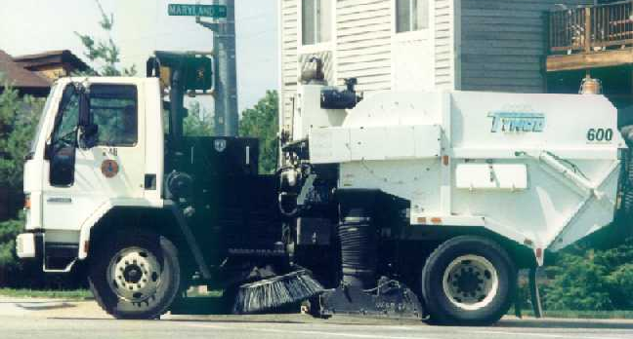
Street and Parking Lot Cleaning
Nonstructural SCMs Techniques
Description and Purpose

Street and parking lot cleaning is a nonstructural method of controlling pollutants in storm water. It involves the use of mechanical, vacuum, or regenerative air pavement cleaning equipment (and sometimes manual labor), to remove particulates from the pavement surface prior to wash-off by storm water runoff. Many municipalities and some private entities have street cleaning programs.
Ability to meet specific standards
Standard | Description
2 - Peak Flow | Provides no peak flow attenuation.
3 - Recharge | Provides no groundwater recharge.
4 - TSS/ TP Removal | Provides TSS and TP removal if minimum criteria are met in accordance with Table SC.1.
5 - Higher  Pollutant  Loading | May be used for runoff from LUHPPL if minimum criteria are met.
6 - Discharges  near or to  Critical Areas | May be used for discharges near or to Critical Areas.
7 - Redevelopment | May be used for Redevelopment.
8 - Construction Phase Pollution Controls | Not to be used for construction period runoff control.
11 - Total Maximum Daily Loads | Does not meet any TMDL treatment requirements
ESSD / LID? | No, this practice is not a MassDEP recognized ESSD / LID technique.
Minimum Required Criteria
Street cleaning can qualify for pollutant removal credit at the discretion of the Issuing Authority as listed by Table SC.1. To obtain pollutant removal credit, street cleaning must be performed on a monthly basis for at least 10 months of the year (excluding January and February).
Credit is contingent on a signed agreement by the Owner that specifies sweeping frequency, type of technology, the impervious area or road miles cleaned, and the general land use type(s) of the impervious area cleaned. Street and parking lot cleaning are applicable to new development and Redevelopment projects.
Pollutant Removal Credit
TSS and TP removal credit for street and parking lot cleaning is based on the following table.
Table SC.1 Pollutant removal credits for street and parking lot cleaning
Sweeper Equipment | TSS (%) | TP (%)
Mechanical Broom | 3 | 2
Vacuum Assisted | 5 | 3
Regenerative Air | 16 | 7
Effectiveness
Although intended to provide nonpoint source pollution control, many street cleaning programs are not effective at capturing peak sediment loads. There are many reasons that some street cleaning programs are not effective, including:
- The period immediately following winter snowmelt, when road sand and other accumulated sediment and debris is washed off, is frequently missed by street cleaning programs.
- Larger particles of street dirt may prevent smaller particles from being collected.
- The entire width of roadway may not be swept.
- Sweepers may be driven too quickly to achieve maximum efficiency.
- Land surfaces along the paved surfaces may not be entirely stabilized.
Studies have also shown that street cleaning can be highly effective if conducted properly (Breault 2005, Zarriello 2002). As described below, there are three primary factors that can have a major influence on the effectiveness of a street cleaning program: access, sweeper type, and frequency of cleaning.
Access
Parked cars impede street cleaning. Studies have shown that up to 95% of the solids on a paved surface accumulate within 9 feet of the curb, regardless of land use (Sorenson, 2013). It is essential that entities responsible for stormwater maintenance have the authority to impose parking regulations to facilitate proper cleaning, particularly in densely populated or heavily traveled areas, to allow sweepers to get as close to curbs as possible.
Equipment
There are three types of street cleaners: mechanical broom, vacuum assisted, and regenerative air. Each has a different ability to remove TSS and TP (see Table SC.1).
- Mechanical Broom: Mechanical sweepers use brooms or rotary brushes to scour the pavement. Although most sweepers currently in use in Massachusetts are mechanical sweepers, they are not as effective as other methods and are especially ineffective at picking up fine particles.
- Vacuum Assisted: These cleaners use gutter brooms to remove particles from the street and the refuse is then placed in the path of a vacuum intake that transports the dirt to the hopper. The transported dirt is often saturated with water. The overall efficiency of vacuum-assisted cleaners is generally higher than that of mechanical cleaners, especially for particles larger than the dust and dirt range (USDOT).
- Regenerative Air: These cleaners blow air onto the road or parking lot surface, causing fines to rise where they are vacuumed. Regenerative air cleaners may blow fines off the vacuumed portion of the surface. Regenerative air cleaners are generally more effective than mechanical and vacuum sweepers.
Regardless of the type chosen, the efficiency of street cleaning is increased when cleaners are operated in tandem.
Frequency
Unlike other stormwater treatment practices that function whenever it rains, street cleaning picks up dirt only when streets and parking lots are swept. Pollutant removal efficiency is based on annual loading rates. If a road were swept only once a year with a sweeper that is 100% efficient, it would remove only a small fraction of the annual pollutant load. The efficiency of all sweeper types increases with increased frequency.
Planning Considerations
In deciding whether street cleaning is an effective option, consider factors such as whether road and parking lot shoulders are stabilized, the speed at which the sweepers will need to be driven (safety factor for busy roads and highways), whether access is available to the curb (i.e., if vehicles parked along the curb line will preclude cleaning to edge of curb), the type of sweepers, and if sweepers will be operated in tandem.
Maintenance
Street cleaning materials must be handled and disposed of properly. MassDEP’s Bureau of Waste Prevention has issued a written policy regarding the reuse and disposal of street cleanings. These materials are regulated as a solid waste, and can be used in three ways:
- In one of the ways already approved by MassDEP (e.g., daily cover in a landfill, additive to compost, fill in a public way)
- If approved under a Beneficial Use Determination
- Disposed in a landfill
MassDEP provides guidance and standards for handling, reusing, and disposing of materials collected by street cleanings.
References

Breault, Robert F., Smith, Kirk P. and Sorenson, Jason R., 2005, Residential Street-Dirt Accumulation Rates and Chemical Composition, and Removal Efficiencies by Mechanical-and Vacuum-Type Sweepers, New Bedford, Massachusetts, 2003–04 - https://pubs.er.usgs.gov/publication/sir20055184
Donner, Sebastian., et al., May 2016, Recommendations of the Expert Panel to Define Removal Rates for Street and Storm Drain Cleaning Practices - https://www.chesapeakebay.net/documents/FINAL_APPROVED_Street_and_Storm_Drain_Cleaning_Expert_Panel_Report_--_Complete2.pdf
Smith, Kirk P., 2002, Effectiveness of Three Best Management Practices for High-Runoff Quality along the Southeast Expressway, Boston, Massachusetts, USGS, Water-Resources Investigations Report 02-4059, http://water.usgs.gov/pubs/wri/wri024059/
Sorenson, Jason R., 2013, Potential Reductions of Street Solids and Phosphorus in Urban Watersheds from Street Cleaning, Cambridge, Massachusetts -https://pubs.usgs.gov/sir/2012/5292/pdf/sir2012-5292_rev030613.pdf
U.S Department of Transportation (USDOT) Federal Highway Administration. Stormwater Best Management Practices in an Ultra-Urban Setting: Selection and Monitoring. Fact Sheet – Street Sweepers. https://www.environment.fhwa.dot.gov/env_topics/water/ultraurban_bmp_rpt/3fs16.aspx
United States Environmental Protection Agency (US EPA). 1983. Results of the Nationwide Urban Runoff Program. Vol. 1. Final Report. Office of Water, US EPA. Washington, DC. https://www3.epa.gov/npdes/pubs/sw_nurp_vol_1_finalreport.pdf
Zarriello, Phillip J., Robert F. Breault, and Peter K. Weiskel, 2002, Potential Effects of Structural Controls and Street Sweeping on Stormwater Loads to the Lower Charles River, Massachusetts, USGS, Water Resources Investigation Report 02-4220, http://water.usgs.gov/pubs/wri/wri024220/

Massachusetts
Stormwater Management
Handbook

Structural Pretreatment

- Deep Sump Catch Basin
- Oil and Grit Separators
- Proprietary Separators
- Sediment Forebays
- Vegetated Filter Strips
- Pea Gravel Diaphragm with Filter Strip

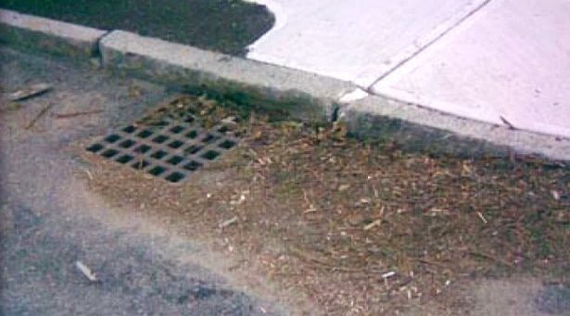
Deep Sump Catch Basin
Structural Pretreatment

Ability to meet specific standards

Standard | Description
2 - Peak Flow | Provides no peak flow attenuation
3 - Recharge | Provides no groundwater recharge. May be used as a pretreatment practice.
4 - TSS/ TP Removal | No EPA Curve.  TSS: MassDEP 25% pretreatment removal credit  TP: MassDEP 0% TP removal credit.  Because of their limited effectiveness and storage capacity, deep sump catch basins receive TSS removal credit only if they are used for pretreatment, have hoods, have an inlet grate that screens out gross solids, have no curb inlet, and are designed as off-line systems.
5 - Higher  Pollutant  Loading | Suitable for TSS pretreatment.  Although provides some spill control capability, a deep sump catch basin may not be used in place of an oil/grit separator or sand filter for land uses that have the potential to generate runoff with high concentrations of oil and grease such as: high-intensity-use parking lots, gas stations, fleet storage areas, vehicle and/or equipment maintenance and service areas.
6 - Discharges  near or to  Critical Areas | May be used as pretreatment SCM.  Not an adequate spill control device for discharges near or to critical areas.
7 - Redevelopment | Suitable for pretreatment only
8 - Construction Phase Pollution Controls | Not to be used for construction period runoff control.
9 - O&M Plan | An O&M Plan is required. See maintenance section.
11 - Total Maximum Daily Loads | Suitable for TSS pretreatment. Does not meet any TMDL treatment requirements as a stand-alone treatment practice.
ESSD / LID? | No, this practice is not a MassDEP recognized ESSD / LID technique.
Description
Deep sump catch basins with a hood are underground retention systems designed to remove trash, debris, and coarse sediment from stormwater runoff trough gravity separation, and may serve as temporary spill containment devices for floatables such as oils and greases.

Advantages/Benefits

- Located underground, so limited lot size is not a deterrent.

- Compatible with subsurface storm drain systems.

- Can be used to provide TSS pretreatment when retrofitting small urban lots where larger pretreatment SCMs may not feasible.

- Provide TSS pretreatment of runoff before it is delivered to other SCMs.

- Easily accessed for maintenance.

- Longevity is high with proper maintenance.

Disadvantages/Limitations

- Limited pollutant removal.

- Expensive to install and maintain, resulting in high cost per unit area treated.

- No ability to control volume of stormwater

- No ability to reduce peak runoff rate
- Frequent maintenance is essential

- Requires proper disposal of trapped sediment and oil and grease

- Entrapment hazard for amphibians and other small animals

Suitability to Treat TMDL Pollutants
- While some pretreatment SCMs are capable of removing certain TMDL pollutants, they cannot be used as a standalone practice.
- Pretreatment SCMs are encouraged to be implemented as part of a larger treatment train.

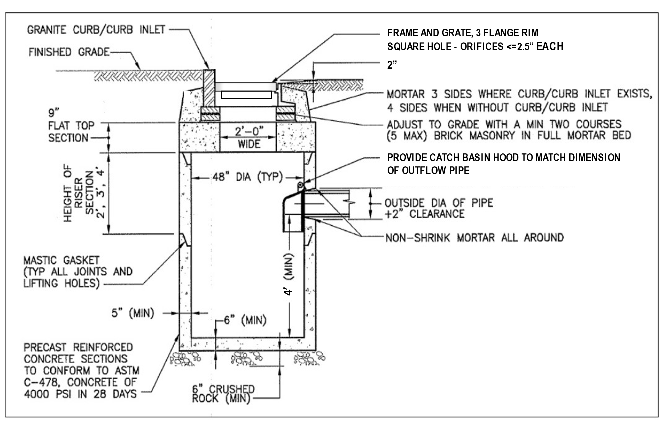
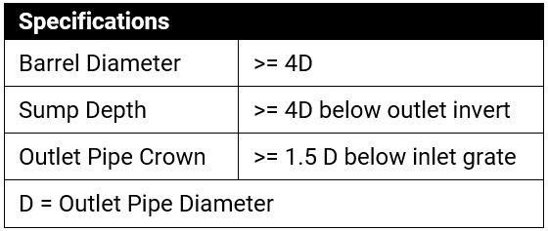
Example Deep Sump Catch Basin (Adapted from University of New Hampshire)

Unit Treatment Process
Gravity separation

Special Features

All deep sump catch basins must include hoods and be placed offline to receive the TSS pretreatment credit. If the deep sump catch basin contains a curb inlet, a vertical curb inlet grate must be installed to receive TSS pretreatment credit. See Design Considerations (directly below) and the “Vertical Curb Inlet Grates” Specification of this Appendix for more information. For MassDOT Highway projects, see Highway Specific Considerations in Section 5.7.
ESSD / LID Alternatives
Not applicable. This is a pretreatment practice.

Suitable Applications

- Pretreatment
- Residential subdivisions
- Office
- Retail
Setback Requirements
Stormwater Control Measures (SCMs) and other components of the Stormwater Management System must be setback from wetlands, building foundations, and other features in accordance with 310 CMR 10.05(6)(q). SCMs must also include vertical separation between certain features, such as the depth to seasonally high groundwater. Refer to Section 2.5 of the Stormwater Handbook for horizontal setback and vertical separation distance requirements. Horizontal setbacks also include maintenance access requirements around the perimeter of certain SCMs.

Design Considerations

- Design and construct deep sump catch basins as off-line systems.

- Space the inlets so that the contributing drainage area to any deep sump catch basin does not exceed ¼ acre of impervious cover
- Flow rate does not exceed the maximum capacity of the inlet grate. The inlet grate flow rate shall not exceed 3 cubic feet per second during any design storm.

- Divert excess flows to another SCM intended to meet the water quantity requirements (peak rate attenuation) or to a storm drain system. An off-line design enhances pollutant removal efficiency, because it reduces the resuspension of sediments in large storms.

Sump Depth: Make the sump depth (distance from the bottom invert of the outlet pipe to the inside bottom of the basin) at least four feet times the diameter of the outlet pipe and more if the contributing drainage area has a high sediment load. The minimum sump depth is 4 feet below the outlet pipe invert. Double catch basins, those with 2 inlet grates, may require deeper sumps. Install the invert of the outlet pipe at least 4 feet from the bottom of the catch basin grate.

Inlets: Inlets provide primary treatment, by preventing gross solids, including trash, from entering the catch basin and contaminating the runoff. Inlets serve to prevent larger debris from entering the sump.
The Federal Highway Administration (FHWA) HEC12 identifies 4 types of inlets: grate inlets, curb-opening inlets, slotted inlets, and combination inlets. Of the four inlet types, grate inlets are the preferred method to receive 25% TSS pretreatment removal credit since they do not allow gross solids such as trash to bypass primary treatment by the grate. However, curb opening inlets or combination inlets are eligible to receive 25% TSS pretreatment removal credit provided that a curb guard (i.e., vertical curb inlet grate) be installed in the curb opening. The curb-guard is a vertical grate that fits into the curb opening. See the “Vertical Curb Inlet Grates” Specification of this Appendix for more information. Slotted inlets are not eligible to receive 25% TSS pretreatment removal credit.
- Inlet Grate Sizing: To be effective, the orifices in the grate inlet must be ≤ 2.5-square inches and grate openings must not allow flows greater than 3 cfs to enter the deep sump catch basin.
- Curb Opening Sizing: If the grate inlet is designed with a curb opening, the grate must reach to the back of the curb opening to prevent bypass. See “Vertical Inlet Grates” section of this Specification for sizing criteria.
All inlets must be constructed

of a durable material and fit tightly into the frame so it won’t be dislodged by automobile traffic. The grate inlet must not be welded to the frame so that sediments may be easily removed and must be placed flush with the curb to prevent trash, leaves, and sediment from bypassing the coarse screening provided by the inlet grates. To facilitate maintenance, the grate inlet must be placed along the road shoulder or curb line rather than a traffic lane. For MassDOT projects, see Section 5.7 for Highway Specific Considerations related to inlets.

Hoods: May be fabricated from cast iron, high-density polyethylene (HDPE), or similar materials. To receive the 25% removal credit, hoods must be used in deep sump catch basins. Hoods also help contain oil spills. For MassDOT Highway projects, see Section 5.7 for Highway Specific Considerations related to hoods.
Inserts: Proprietary baskets and filters are marketed that install under the grate to enhance pollutant removal efficiency. See “Catch Basin Insert” Specification in this Appendix. Inserts should be considered an option for retrofits and Redevelopments, especially to improve the performance of any existing catch basin that does not contain a deep sump. Silt sacks used to provide construction period sediment control are not a post construction Catch Basin Insert. Some designs of Catch Basin Inserts contain hydrocarbon-absorbing polymers, so may be capable of removing oils and greases contained in runoff. The inserts, depending on their design, may also be capable of removing gross solids such a trash. When a Catch Basin Insert is proposed, to determine if additional pollutant removal credit for TSS and/or TP is warranted, follow the process specified in Section 5.3 of the Stormwater Handbook. Remember deep sump catch basins are only a pretreatment practice, so insets should never be relied upon as stand-alone treatment practices. When proposed as part of a NOI or WQC application, the O&M plan for any inserts that may be proposed must follow the manufacturer’s recommendations.
The catch basin must be designed and installed to be watertight. Risers need to be grouted, mortared, or gasketed. Similarly, the outlet pipe junction with the catch basin must be watertight.
Note that within parking garages, the State Plumbing Code regulates inlet grates and other stormwater management controls.

Inlet grates inside parking garages are currently required to have much smaller openings than those described herein. Drainage within parking garages is considered wastewater, not stormwater, and must be directed to a Sanitary Sewer, following the provisions in the State Plumbing Code. Parking garage drainage must not be directed to wetland Resource Areas, to groundwater, or to the stormwater drainage system. Further parking garage drainage is not allowed to be directed to an Underground Floor Drain or Title 5 subsurface treatment system

Any weep holes must be

above the outlet pipe crown. Never install the weep hole below the outlet pipe invert or in the bottom of the catch basin barrel. The contributing catchment is typically a street with curb and gutter flow or paved parking area. If the catchment has soft road shoulders (i.e., no curb/gutter) higher than the paved surface, no TSS or TP removal credit is appropriate.

Site Constraints

Deep sump catch basins must not be installed in the following situations
- When seasonal high groundwater would be within 2-feet of the bottom of the sump.
An Applicant may not be able to install a deep sump catch basin because of:

- Depth to bedrock;

- Presence of utilities; or

- Other site conditions that limit depth of excavation because of stability.

Maintenance
Activity | Frequency
Inspect Units | Four times per year
Remove sediment and debris buildup from units | Four times per year minimum or when depth of deposits is greater than or equal to one half the depth from bottom of the invert of the outlet pipe in catch basin.
Regular maintenance is essential. Deep sump catch basins remain effective at removing pollutants only if they are cleaned out frequently. Pitt 1985 found that once 50% of the sump volume is filled, the catch basin is not able to retain additional sediments. Woodward-Clyde Consultants on behalf of the Alameda County Urban Runoff Clean Water Program found that more frequent cleanings improved the removal efficiencies of catch basins.

Inspect deep sump basins at least four times per year and at the end of the foliage and snow-removal seasons. Sediments must also be removed four times per year or whenever the depth of deposits is greater than or equal to one half the depth from the bottom of the invert of the lowest pipe in the basin. If handling runoff from land uses with higher potential pollutant loads or discharging runoff near or to a critical area, more frequent cleaning may be necessary.

Clamshell buckets are typically used to remove sediment in Massachusetts. However, vacuum trucks are preferable, because they remove more trapped sediment and supernatant than clamshells. Vacuuming is also a speedier process and is less likely to snap a cast iron or HDPE hood within the deep sump catch basin.

Always consider the safety of the staff cleaning deep sump catch basins. Cleaning a deep sump catch basin within a road with active traffic or even within a parking lot is dangerous, and a police detail may be necessary to safeguard workers.

MassDEP classifies solids retained in catch basins as solid waste. Unless there is evidence that they have been contaminated by a spill or other means, MassDEP does not routinely require catch basin cleanings to be tested before disposal. Contaminated catch basin cleanings must be evaluated in accordance with the Hazardous Waste Regulations, 310 CMR 30.000, and handled as hazardous waste.

In the absence of evidence of contamination, catch basin cleanings may be taken to a sanitary landfill or other facility permitted by MassDEP to accept solid waste, without any prior approval by MassDEP. However, some sanitary landfills may require catch basin cleanings to be tested before they are accepted.

With prior MassDEP approval, catch basin cleanings may be used as grading and shaping materials at landfills undergoing closure (see Revised Guidelines for Determining Closure Activities at Inactive Unlined Landfill Sites) or as daily cover at active landfills. MassDEP also encourages the beneficial reuse of catch basin cleanings whenever possible. A Beneficial Reuse Determination must be sought and obtained in such instances (see 310 CMR 19.060).

MassDEP regulations prohibit landfills from accepting materials that contain free- draining liquids. One way to remove liquids is to use a hydraulic lift truck during cleaning operations so that the material can be decanted at the site. After loading material from several catch basins into a truck, elevate the truck so that any free- draining liquid can flow back into a catch basin. If there is no free water in the truck, the material may be deemed to be sufficiently dry. Otherwise, the catch basin cleanings must undergo a Paint Filter Liquids Test before they can be disposed of at a sanitary landfill.
Go to https://www.mass.gov/doc/catch-basin-cleanings-management-guidelines/download for information on all of the MassDEP requirements pertaining to the disposal of catch basin cleanings.

References
Center for Watershed Protection, Pollution Prevention Fact Sheets: Catch Basins.
Massachusetts Department of Environmental Protection, Management of Catch Basin Cleanings, WEB: https://www.mass.gov/files/documents/2018/03/09/catch-basins.pdf
Pitt, R., 1985 Bellevue Urban Runoff Project. Final Report. Mineart, R and S. Singh. 1994. Storm Inlet Pilot Study.
U.S. EPA, 1999, Stormwater O&M Fact Sheet Catch Basin Cleaning, EPA 832-F-99-011, Stormwater O&M Fact Sheet Catch Basin Cleaning
U.S. EPA, undated, Catch Basin Inserts, https://www.epa.gov/npdes/stormwater-maintenance
Woodward-Clyde Consultants. Alameda County Urban Runoﬀ Clean Water Program, Oakland, CA.

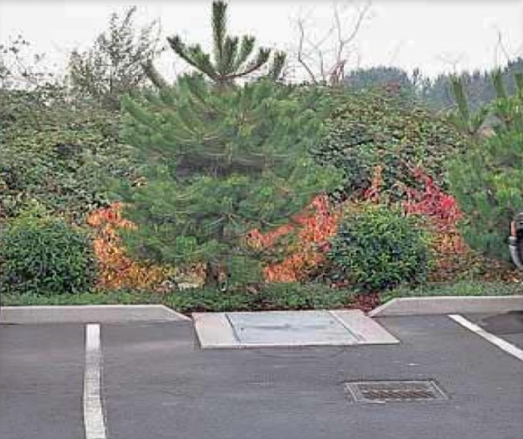
Oil/Grit Separators

Ability to meet specific standards

Standard | Description

2 - Peak Flow | Provides no peak flow attenuation
3 - Recharge | Provides no groundwater recharge. May be used as a TSS pretreatment practice.
4 - TSS/TP  Removal | No EPA Curve,  TSS: MassDEP 25% pretreatment removal credit when placed off-line  TP: MassDEP 0% TP removal credit.
5 - Higher  Pollutant  Loading | MassDEP requires a pretreatment, such as an oil/grit separator that is capable of removing oil and grease, for land uses with higher potential pollutant loads where there is a risk of petroleum spills such as: high intensity use parking lots, gas stations, fleet storage areas, vehicle and/or equipment maintenance and service areas.
6 - Discharges  near or to  Critical Areas | May be a TSS pretreatment SCM when combined with other practices.  May serve as a spill control  device.
7 - Redevelopment | Highly suitable.
8 - Construction Phase Pollution Controls | Not to be used for construction period runoff control.
9 - O&M Plan | An O&M Plan is required. See maintenance section.
11 - Total Maximum Daily Loads | Does not meet any TMDL requirements as a stand-alone treatment practice. May be used for TSS pretreatment.
ESSD / LID? | No, this practice is not a MassDEP recognized ESSD / LID technique.
Structural Pretreatment

Description
Oil/grit separators are underground storage tanks. There are several types: baffle boxes, API separators, and Coalescing Plate Separators. Baffle boxes have three chambers designed to remove heavy particulates, floating debris and hydrocarbons from stormwater. API separators are used where significant quantities of oil may be encountered. The liquid is considered industrial wastewater and must not be directed to a wetland Resource Area or stormwater drainage system, so the API type separator is not discussed further in this section. Coalescing Plate Separators contain plates to separate oil from water.

Baffle boxes are the Oil/Grit Separator type most commonly used with non-industrial land uses. The three chambers consist of a forebay, oil-separation bay, and afterbay. Note that the forebay is not considered a sediment forebay for purposes of the Stormwater Handbook Specifications. Stormwater enters the first chamber, or forebay, where heavy sediments and solids drop out. The flow moves into the oil-separation bay, or second chamber, where oils and greases are designed to be trapped and further settling of suspended solids takes place. Trapped oil and grease are stored in this second chamber for future removal. After moving into

the third outlet chamber, the clarified stormwater runoff is then discharged to a pipe and another SCM.

Advantages/Benefits

- Located underground so limited lot size not a deterrent in urban areas with small lots

- Can be used for retrofits

- Can be installed in any soil or terrain.

- Public safety risks are low.

Disadvantages/Limitations

- Limited pollutant removal; cannot effectively remove soluble pollutants, fine particles, or bacteria
- Can become a source of pollutants due to resuspension of sediment unless properly maintained
- Susceptible to flushing during large storms

- Limited to relatively small drainage areas

- Requires proper disposal of trapped sediments/oils

- May be expensive to construct and maintain

- Entrapment hazard for amphibians, other small animals

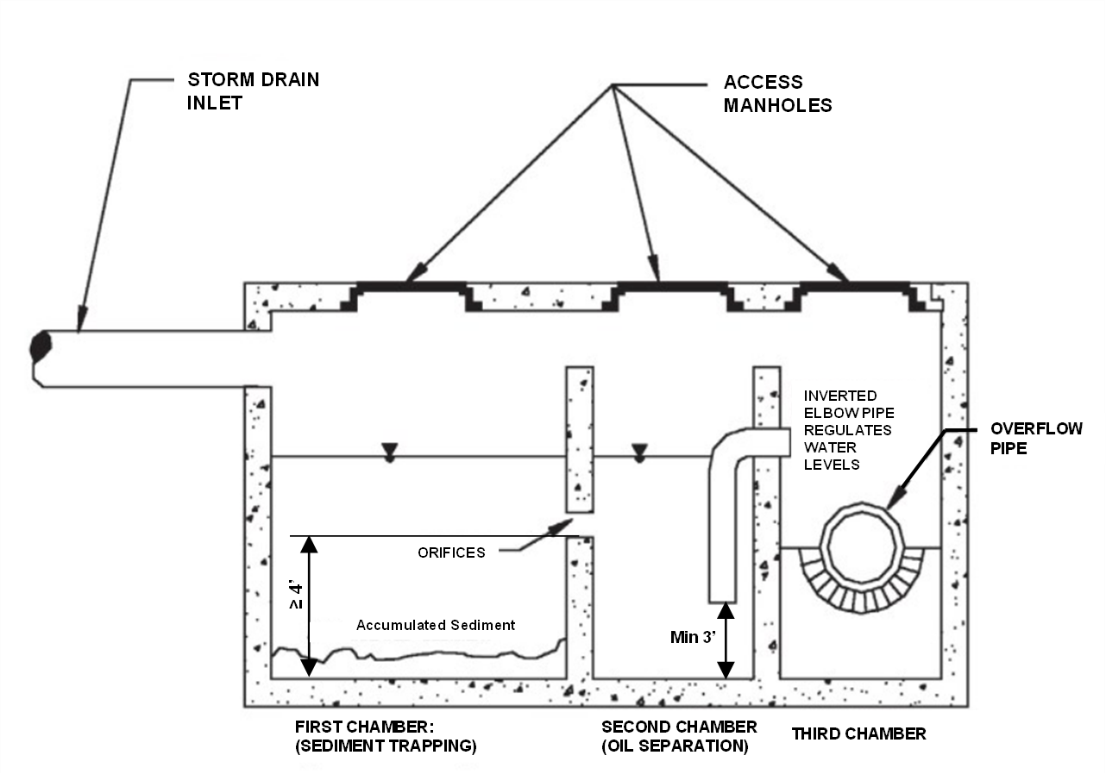
Example Baffle Box-type Oil/Grit Separator
(Typical Cross Section, Adapted from Schueler, 1987)

Suitability to Treat TMDL Pollutants
- While some pretreatment

- SCMs are capable of removing certain TMDL pollutants, they cannot be used as a standalone practice.
- TSS Pretreatment SCMs are required to be implemented as part of a larger treatment train.
Unit Treatment Process
- Gravity Separation.

ESSD / LID Alternatives
Not applicable. This is a pretreatment practice.

Applicability

Oil/

grit separators must be used to manage runoff from those particular land uses with higher potential pollutant loads where there is a risk that the stormwater may be contaminated with oil or grease. Such industrial land uses require source control practices to minimize or prevent oil and greases from co-mingling with stormwater (see Section 4.4.2). These uses include the following:

- High-Intensity-Use Parking Lots (1,000+ uses/day)

- Gas Fueling Stations

- Fuel Storage Depots
- Vehicles (including boats, buses, cars, and trucks) and Equipment Service and Maintenance Areas

- Fleet Storage Areas

The term “grit” originated from its use in wastewater treatment. For Stormwater purposes, “grit” refers to sand, gravel, and other solids material “heavier” (higher specific gravity) than organic biodegradable solids present in stormwater (EPA 2003) Grit is defined differently for wastewater purposes.

Setback Requirements
Stormwater Control Measures (SCMs) and other components of the Stormwater Management System must be setback from wetlands, building foundations, and other features in accordance with 310 CMR 10.05(6)(q). SCMs must also include vertical separation between certain features, such as the depth to seasonally high groundwater. Refer to Section 2.5 of the Stormwater Handbook for horizontal setback and vertical separation distance requirements. Horizontal setbacks also include maintenance access requirements around the perimeter of certain SCMs.
Design Considerations

- Dovetail design practices, source controls and pollution prevention measures with separator design.
- Place separators before all other structural stormwater treatment practices (except for structures associated with source control/ pollution prevention such as drip pans and structural treatment practices such as deep sump catch basins that double as inlets).The bottom of the separator and any associated manholes necessary to install the separator offline must be set in elevation to be at least 2-feet above seasonal high groundwater.

- Limit the contributing drainage area to the oil/grit separator to one acre or less of impervious cover.

- Use oil/grit separators only in off-line configurations to treat the required water quality volume.

- Provide pool storage in first chamber of no less than 400 cubic feet per acre of impervious surface. The first two chambers must be able to collectively store at least the 1-inch Water Quality Volume (3,630 cubic feet/acre)

- Make the permanent pool in the first two chambers at least 4 feet deep.

- The O/G separator must be designed to be offline. This requires at least two manholes, one at the inlet and one at the outlet, with a diversion pipe connecting the two manholes.
- Runoff greater than the 1-inch Water Quality Volume must be designed to bypass the separator to prevent resuspension and discharge of previously trapped solids. The diversion pipe, or bypass, must be designed to bypass storms greater than the first 1-inch of runoff.
- Make oil/grit separator units watertight to prevent possible groundwater contamination.

- Use a trash rack or screen to cover the discharge outlet and orifices between chambers.

- Provide each chamber with manholes and access stepladders to facilitate maintenance and allow cleaning without confined space entry.
- Seal potential mosquito entry points.

- Install any pump mechanism downstream of the separator to prevent oil emulsification.

- Locate an inverted elbow pipe (hood) between the second and third chambers and with the bottom

- of the elbow pipe at least 3 feet below the second chamber’s permanent pool. The inverted elbow may be constructed from cast iron, high-density polyethylene (HDPE), or similar materials.

- Provide appropriate removal covers that allow access for observation and maintenance.

- Where the structure is located below the seasonal high groundwater table, design the structure to prevent flotation.
For gas stations, automobile maintenance and service areas, and other areas where large volumes of petroleum and oil are handled, consider adding coalescing plates to increase the effectiveness of the device and reduce the size of the units. A series of coalescing plates constructed of oil-attracting materials such as polypropylene typically spaced one inch apart attracts small droplets of oil, which begin to concentrate until they are large enough to float to the surface.

Maintenance

Activity | Frequency

Inspect units | After every storm of at least 1-inch/day or greater but at least monthly
Remove accumulated sediment and liquid | Twice a year
Sediments and associated pollutants and trash are removed only when inlets or sumps are cleaned out, so regular maintenance is essential. Most studies have linked the failure of oil/grit separators to the lack of regular maintenance. The more frequent the cleaning, the less likely sediments will be re-suspended and subsequently discharged. In addition, frequent cleaning also makes more volume available for future storms and enhances overall performance. Cleaning includes removal of accumulated oil and grease and sediment using a vacuum truck. In areas of high sediment loading, inspect and clean inlets after every 1 inch/day or greater storm event. At a minimum, inspect oil/grit separators monthly, and clean them out at least twice per year. Polluted water or sediments removed from a oil/grit separator should be disposed of in accordance with all applicable local, state and federal laws and regulations including M.G.L.c. 21C and 310 CMR 30.00.

Note: Maintenance requirements for coalescing plate separators are different from those described for the baffle box types.

References

American Petroleum Institute, 2002, Management of Water Discharges: Design and Operations of Oil-Water Separators, 1st Edition, Revision 90, American Petroleum Institute.

Arizona Department of Environmental Quality, 1996, BADCT Guidance Document for Pretreatment with Oil/ Water Separators, OFR 96-15, http://www.azdeq.gov/environ/water/permits/download/owsbadct.pdf

Beychok, Milton, Wikipedia, API Oil-Water Separator, http://en.wikipedia.org/wiki/API_oil-water_separator

Center for Watershed Protection, Performance of Oil-Grit Separators in Removing Pollutants at Small Sites, Technical Note #101 from Watershed Protection Techniques. 2(3): 539-542

Houston, City of, Harris County, Harris County Flood Control District, 2001, Storm Water Quality Management Guidance Manual, Section 4.4.2, p. 4-84 to 4-89, http://www.cleanwaterclearchoice.org/downloads/ professional/guidance_manual_full.pdf

Idaho Department of Environmental Quality, 2005, Storm Water Best Management Practices Catalog, Oil/ Water Separator, SCM 18, pp. 91 to 95, http://www.deq.idaho.gov/media/622263-Stormwater.pdf

Minton, Gary. 2002, Stormwater Treatment, RPA Associates, Seattle, WA, p. 120

New Zealand Water Environment Research Foundation, 2004, On-Site Stormwater Management Guideline, Section 5.10, pp. 23 to 24, On-Site Stormwater Management Guideline

Schueler, T.R., 1987, Controlling Urban Runoff: A Practical Manual for Planning and Designing Urban SCMs, Metropolitan Washington Council of Governments, Washington, DC.

U.S. EPA, 1999, Storm Water Technology Fact Sheet, Water Quality Inlets, EPA 832-F-99-029, EPA 832-F-99-029

U.S. EPA, 2003, Wastewater Technology Fact Sheet, Screening and Grit Removal, EPA 832-F-03-011.

Proprietary Manufactured Separators
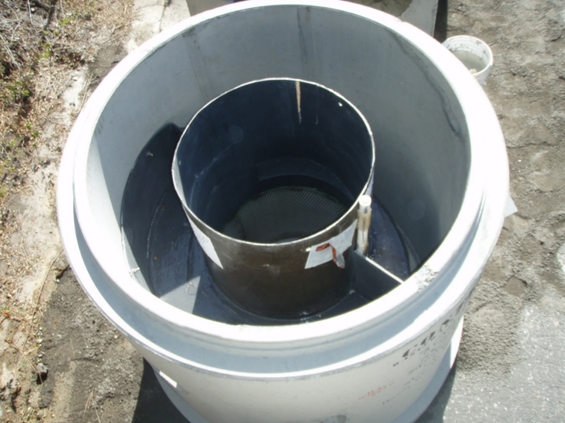
Ability to meet specific standards

Standard | Description

2 - Peak Flow | Provides no peak flow attenuation
3 - Recharge | Provides no groundwater recharge.
4 - TSS/ TP Removal | No EPA Curve.  TSS: MassDEP Variable pretreatment removal credit, up to 44%  TP: MassDEP 0% TP removal credit.  TSS removal varies by unit. Must be used for pretreatment, be placed first in the treatment, and configured offline to receive removal credit(s) Follow procedures described in Section 5.3 to determine removal credit(s).
5 – Higher Pollutant Loading | Suitable as pretreatment device.
6 – Discharges near or to Critical Areas | Suitable as pretreatment device or potentially a spill control device.
7 - Redevelopment | Suitable for pretreatment. Must be placed first in the treatment train to receive removal credit(s).
8 - Construction Phase Pollution Controls | Not to be used for construction period runoff control.
9 - O&M Plan | An O&M Plan is required. See maintenance section.
11 - Total Maximum Daily Loads | Does not meet any TMDL requirements as a stand-alone treatment practice
ESSD / LID? | No, this practice is not a MassDEP recognized ESSD / LID technique.

Structural Pretreatment
Description
A proprietary manufactured separator is a flow-through structure with a settling or separation chamber/sump to remove sediments and other pollutants. They rely upon gravity separation and swirling to separate floatables and coarser sediments. They are typically designed and manufactured by private businesses, and come in different sizes to accommodate different runoff volumes and flow conditions. Some rely solely on gravity separation and contain

no swirl chamber. Since proprietary separators can be placed in almost any location on a site, they are particularly useful when either site constraints prevent the use of other stormwater techniques or as part of a larger treatment train. The effectiveness of proprietary manufactured separators varies greatly by size and design, so make sure that the units are sized correctly for the site’s soil conditions and flow profiles, otherwise the unit will not work as designed. See the Design section.

Advantages/Benefits

- Removes coarser sediment.

- Useful on constrained sites.

- Can be custom-designed to fit specific needs of a specific site.

Disadvantages/Limitations

- Removes only coarse sediment fractions

- Provides no recharge to groundwater

- No control of the volume of runoff
- No peak rate runoff attenuation
- Frequent maintenance is essential

- For pretreatment only for both new development and Redevelopment.
Suitability to Treat TMDL Pollutants
- While some pretreatment SCMs are capable of removing certain TMDL pollutants, they cannot be used as a standalone practice.
- Pretreatment SCMs are encouraged to be implemented as part of a larger treatment train.
Unit Treatment Process
Physical settling

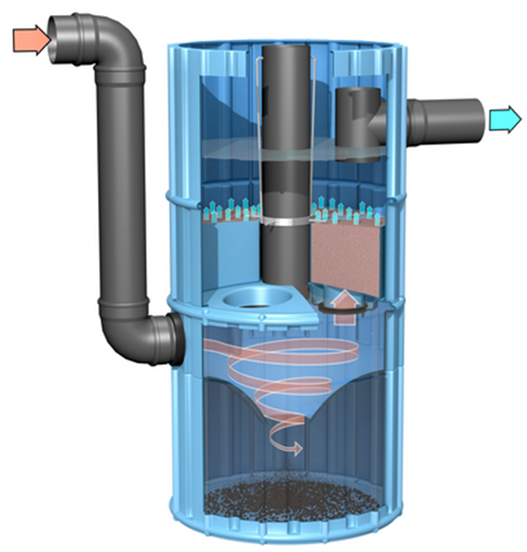
Special Features
Example Proprietary Separator (adapted from the Massachusetts Clean Water Toolkit)

Useful in highly urban areas as part of Redevelopment or retrofit due to small footprint, where larger traditional practices may be site constrained
ESSD / LID Alternatives
Not applicable. This is a pretreatment practice.
Applicability

Because they have limited pollutant removal and storage capacity, proprietary separators must be used for pretreatment only. Because they are placed underground, proprietary separators may be the only structural pretreatment SCMs feasible on certain constrained Redevelopment sites where space or storage is not available for more effective SCMs. They may be especially useful in ultra-urban settings such as Boston or Worcester. Some proprietary separators may be used for spill control.
Effectiveness

Proprietary separators have a wide range of TSS removal efficiencies. To assess the ability of proprietary separators to remove TSS and other pollutants, an Applicant should follow the procedures set forth in Section 5.3. The specific units proposed for a particular project cannot be effective unless they are sized correctly. Proprietary separators are usually sized based on flow rate. A proprietary separator must be sized to treat the 1-inch required water quality volume, using the MassDEP WQV to Peak Flow conversion method. To be effective at removing TSS and other pollutants the system must be designed, constructed, and maintained in accordance with the manufacturer’s specifications and the specifications in this Handbook.
Planning Considerations

To receive TSS removal credit, proprietary separators must be used for pretreatment, placed at the beginning of a stormwater treatment train, and be configured to operate offline. They must be configured off-line to reduce scouring and re-entrainment of previously trapped sediment. They must be sized to treat the 1-inch WQV in accordance with the manufacturer’s specifications and the specifications in this Handbook. Proprietary separators used as spill control devices may have to be sized differently than those used for TSS removal. They may only be used for pretreatment for new development or Redevelopment

Setback Requirements
Stormwater Control Measures (SCMs) and other components of the Stormwater Management System must be setback from wetlands, building foundations, and other features in accordance with 310 CMR 10.05(6)(q). SCMs must also include vertical separation between certain features, such as the depth to seasonally high groundwater. Refer to Section 2.5 of the Stormwater Handbook for horizontal setback and vertical separation distance requirements. Horizontal setbacks also include maintenance access requirements around the perimeter of certain SCMs.
Design Considerations

The design of proprietary separators varies by manufacturer. Units are typically precast concrete, but larger systems may be cast in place. Units may have baffles or other devices to direct incoming water into and through a series of chambers, slowing the water down to allow sediment to drop out into internal storage areas, then directing this pre -treated water to exit to other treatment or infiltration devices. In some cases, flow will be introduced tangentially, to induce swirl or vortex. Units may include skirts or weirs, to keep trapped sediments from becoming re-entrained.

Generally, they are placed below ground on a gravel or stone base. The bottom of the separator must be placed at least 2-feet in elevation above seasonal high groundwater. Make sure all units contain inspection and access ports so that they may be inspected and cleaned. During design, take care to place

the inspection and access ports where they will be accessible. Do not place the ports in locations such as travel lanes of roadways/highways and parking stalls.

Manufactured separators are typically available in different sizes. Larger sizes accommodate runoff from larger areas. The treatment chamber/sump must be sized to hold the 1-inch water quality volume. What this means is that the separator treatment chamber/sump must be able to hold a volume of 1-inch of runoff times the contributing impervious drainage area, without surcharging or bypass. If the separators are sized using the peak flow rate, they must be sized using the MassDEP 1-inch Water Quality Volume to Peak Flow Rate conversion method. Other methods to convert the 1-inch Water Quality Volume to Peak Flow Rate are not acceptable. The method to convert the 1-inch Water Quality Volume to Peak Flow Rate is listed in Appendix D.
All proprietary manufactured separators must be designed to ensure the first 1-inch Water Quality Volume is treated without any bypass. Some proprietary manufactured separators may contain an internal weir to prevent bypass. If the proprietary manufactured separator does not contain an internal weir to prevent bypass of the 1-inch Water Quality Volume, external manholes must be included in the design to route flows in excess of 1-inch around the proprietary manufactured separator.
Additionally, the proprietary manufactured separator must be designed to operate offline, and must be placed first in the treatment train.
Construction

Install construction barriers around the excavation area to prevent access by pedestrians. Use diversions and other soil erosion practices up-slope of the proprietary separator to prevent runoff from entering the site before construction of the units is complete. Implement practices to prevent construction period runoff from being discharged to the units until construction is complete and the soil is stabilized. Stabilize all surrounding area and any established outlets. Remove temporary structures after vegetation is established.
Maintenance
Activity | Frequency

Inspect in accordance with manufacturer requirements, but no less than twice a year following installation, and no less than once a year thereafter. | See activity
Remove sediment and other trapped pollutants at frequency or level specified by manufacturer. | See manufacturer information

Inspect and clean these units in strict accordance with manufacturers’ recommendations and requirements. Clean the units using the method specified by the manufacturer. Vactor trucks are typically used to clean these units. Clamshell buckets typically used for cleaning catch basins are almost never allowed by manufacturers. Sometimes it will be necessary to remove sediment manually.

References
Example image on first page was sourced from Tahoe Regional Planning Agency Best Management Practices Handbook, May 2014, Chapter 4.4, https://tahoebmp.org/Documents/BMPHandbook/Chapter%204/4.4/g_HydDySep.pdf.

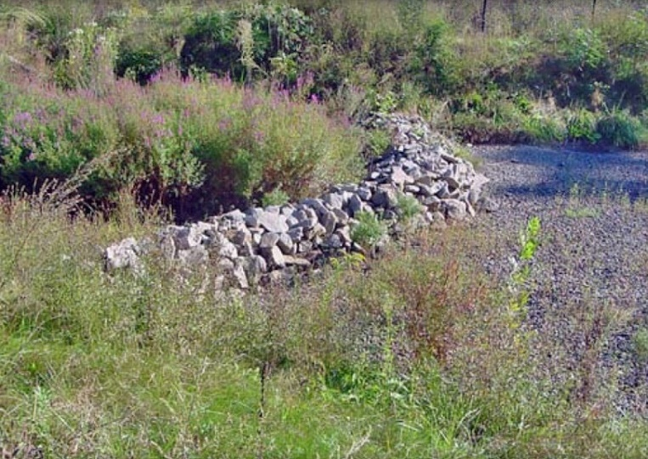
Sediment Forebays

Ability to meet specific standards

Standard |  | Description
2 - Peak Flow |  | Provides no peak flow attenuation

3 - Recharge | Provides no groundwater recharge.
4 - TSS/ TP Removal | No EPA Curve.  TSS: MassDEP 25% pretreatment removal credit.  TP: MassDEP 0% TP removal credit.  MassDEP requires a sediment forebay as pretreatment before stormwater is discharged to an extended dry detention basin, wet basin, constructed stormwater wetland or infiltration basin. No separate credit is given for the sediment forebay. When they provide pretreatment for other SCMs, sediment forebays receive a 25% TSS removal credit.
5 – Higher Pollutant Loading | Suitable for TSS pretreatment.
6 – Discharges near or to Critical Areas | Suitable for TSS pretreatment.
7 - Redevelopment | Usually not suitable due to land use constraints.
8 - Construction Phase Pollution Controls | Not to be used for construction period runoff control.
9 - O&M Plan | An O&M Plan is required. See maintenance section.
11 - Total Maximum Daily Loads | Does not meet any TMDL requirements as a stand-alone treatment practice
ESSD / LID? | No, this practice is not a MassDEP recognized ESSD / LID technique.

Structural Pretreatment
Description
A sediment forebay is a post-construction practice consisting of an excavated pit, bermed area, or cast structure combined with a weir, designed to slow incoming stormwater runoff and facilitate the gravity separation of suspended solids. This practice is different from a sediment trap used as a construction period SCM.

Advantages/Benefits

- Provides pretreatment of runoff before delivery to other SCMs.

- Slows velocities of incoming stormwater

- Easily accessed for sediment removal

- Longevity is high with proper maintenance

- Relatively inexpensive compared to other SCMs

- Greater detention time than proprietary separators

Disadvantages/Limitations

- Removes only coarse sediment fractions

- No removal of soluble pollutants

- Provides no recharge to groundwater

- No control of the volume of runoff

- Frequent maintenance is essential

Suitability to Treat TMDL Pollutants
- While some pretreatment SCMs are capable of removing certain TMDL pollutants, they cannot be used as a standalone practice.
- Pretreatment SCMs are encouraged to be implemented as part of a larger treatment train.
Unit Treatment Process
- Gravity separation

Special Features
Example Post-Construction Sediment Forebay
(Adapted from the 2006 Vermont Stormwater Handbook)
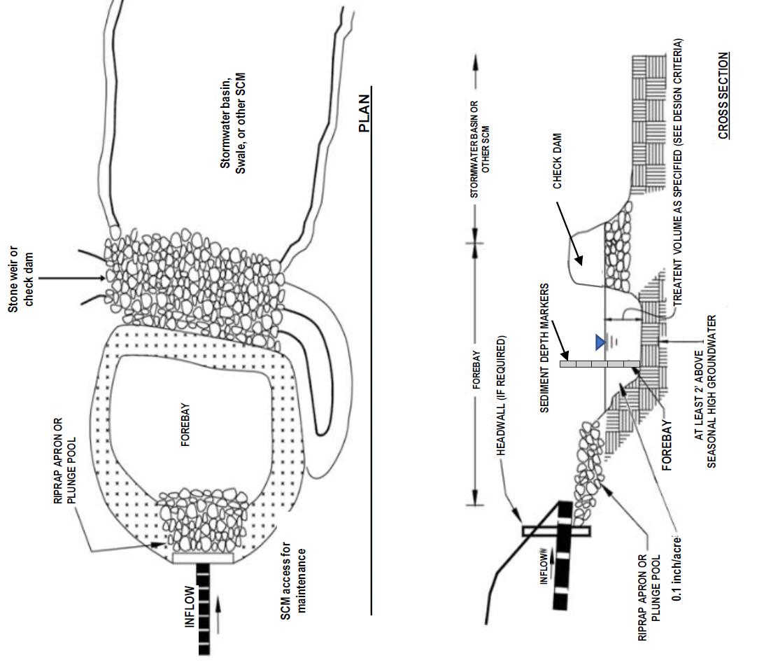

MassDEP requires a sediment forebay as pretreatment before discharging to a dry extended detention basin, wet basin, constructed stormwater wetland, or infiltration basin.

MassDEP uses the term “sediment forebay” for permanent SCMs used to pretreat stormwater after construction is complete and the site is stabilized. MassDEP uses the term “sediment trap” to refer to temporary SCMs used for erosion and sedimentation control during construction. For information on the design and construction of sediment traps used during construction, consult the Massachusetts Erosion and Sediment Control Guidelines for Urban and Suburban Areas: A Guide for Planners, Designers and Municipal Officials (see Appendix C).

ESSD / LID Alternatives
Not applicable. This is a pretreatment practice.

Setback Requirements
Stormwater Control Measures (SCMs) and other components of the Stormwater Management System must be setback from wetlands, building foundations, and other features in accordance with 310 CMR 10.05(6)(q). SCMs must also include vertical separation between certain features, such as the depth to seasonally high groundwater. Refer to Section 2.5 of the Stormwater Handbook for horizontal setback and vertical separation distance requirements. Horizontal setbacks also include maintenance access requirements around the perimeter of certain SCMs.
Design Considerations

Sediment forebays are typically on-line units, designed to slow stormwater runoff and settle out sediment.

The bottom of the sediment forebay must be placed at least 2-feet in elevation above seasonal high groundwater. It must be designed to fully dewater within 72-hours of a storm.
At a minimum, size the volume of the sediment forebay to hold 0.1-inch of runoff for each impervious acre to pretreat the water quality volume.

When routing the 2-year and 10-year storms through the sediment forebay, design the forebay to withstand anticipated velocities without scouring.

A typical forebay is excavated below grade with earthen sides and a stone check dam.

Design elevated embankments to meet applicable safety standards.

Stabilize earth slopes and bottoms using grass seed mixes recommended by the NRCS and capable of resisting the anticipated shearing forces associated with velocities to be routed through the forebay. Use only grasses. Using other vegetation will reduce the storage volume in the forebay. Make sure that the selected grasses can withstand periodic inundation under water, and drought- tolerant during the summer. MassDEP recommends using a mix of grasses rather than relying upon a single grass species.

Alternatively, the bottom floor may be designed with concrete or stone to aid maintenance. Concrete floors or pads, greatly facilitate the removal of accumulated sediment.

Design sediment forebays to make maintenance accessible and easy. Incorporate equipment access around the forebay perimeter as part of the design to facilitate maintenance. Provide an access way for maintenance, with a minimum width of 15 feet and a maximum slope of 15%, by public or private right-of-way Sediment forebays may require excavation so concrete flooring may not always be appropriate. Sediment forebays with concrete flooring require notched weirs in order to fully drain within 72-hours of a storm.

Include sediment depth markers to simplify inspections. Sediment markers make it easy to determine when the sediment depth is between 3 and 6 feet and needs to be removed. Make the side slopes of sediment forebays no steeper than 3:1. Design the sediment forebay so that the discharge or outflow velocity can control the 2-year peak discharge without scour. Design the channel geometry to prevent erosion from the 2-year peak discharge.

Do not confuse post-construction sediment forebays with the sediment traps used as a construction-period control. Construction-period sediment control traps are sized larger than forebays, because there is a greater amount of suspended solids in construction period runoff. Construction-period sediment traps are sized based on drainage area and not impervious acre (see Appendix C). Never use a construction-period sediment trap for post-construction drainage purposes unless it is first brought off-line, thoroughly cleaned (including check dam), and stabilized before being made re-operational.

Refer to the Check Dam section of this Appendix for information on the design of the check dam component of the sediment forebay. Set the minimum elevation of the check dam crown to hold a volume of 0.1-inch of runoff/ impervious acre. In no case shall the upper crown of the check dam be less than 1-foot in height above the forebay floor. Check dam crown elevations are generally uniform..

Unless part of a wet basin, post construction sediment forebays must be designed to completely dewater between storms. Set the bottom of the forebay at a minimum of 2 feet above seasonal high groundwater, and place pervious material on the bottom floor to facilitate dewatering between storms. When using a concrete floor, the outlet invert must be set flush with the concrete floor, to allow for dewatering. For design purposes, when using a pervious bottom, use 72 hours to evaluate dewatering in the vertical direction through infiltration, assuming a volume of at least 0.1 inch

of runoff times the impervious contributing drainage area is in the forebay, using half of the in-situ saturated hydraulic conductivity of the underlying soil. A stone check dam can act as a filter berm, allowing water to percolate through the check dam. Depending on the head differential, a stone check dam may allow greater dewatering than an earthen berm. For a sediment forebay with a concrete floor, the notch in the weir needs to be sized to release the captured 0.1-inch times impervious area volume over a period ≥ 24-hours, to provide for gravity separation of solids suspended in the runoff. The Weir Equation Q = CLH^{3/2} should be used to evaluate whether the runoff is retained for at least 24-hours, where Q is the discharge in cubic feet per second, C is the discharge coefficient, L is the effective length of the weir crest in feet, H is the depth of flow in feet above the crest. Q is divided by the brimfull volume in the sediment forebay (0.1-inch times the impervious area), to obtain the retention time in seconds. Seconds is converted to hours (3600 seconds = 1 hour).
Maintenance

Sediments and associated pollutants are removed only when sediment forebays are cleaned out, so regular maintenance is essential. Frequently removing accumulated sediments will make it less likely that sediments will be resuspended. At a minimum, inspect sediment forebays monthly and clean them out at least four times per year. Stabilize the floor and sidewalls of the sediment forebay before making it operational, otherwise the practice will discharge excess amounts of suspended sediments.

When mowing grasses, keep the grass height no greater than 6-inches. Set mower blades no lower than 3 to 4 inches. Check for signs of rilling and gullying and repair as needed. After removing the sediment, replace any vegetation damaged during the clean-out by either reseeding or re-sodding. When reseeding, incorporate practices such as hydroseeding with a tackifier, blanket, or similar practice to ensure that no scour occurs in the forebay, while the seeds germinate and develop roots.

When the bottom floor is vegetated, during maintenance operations, it may be necessary to remove accumulated sediment by hand, along with re-seeding or re-sodding grasses removed during maintenance.

Activity | Frequency
Inspect sediment forebays | Monthly
Remove sediment, debris, and other trapped pollutants from sediment forebays | Four times per year and when sediment depth reaches 40% of the depth capacity

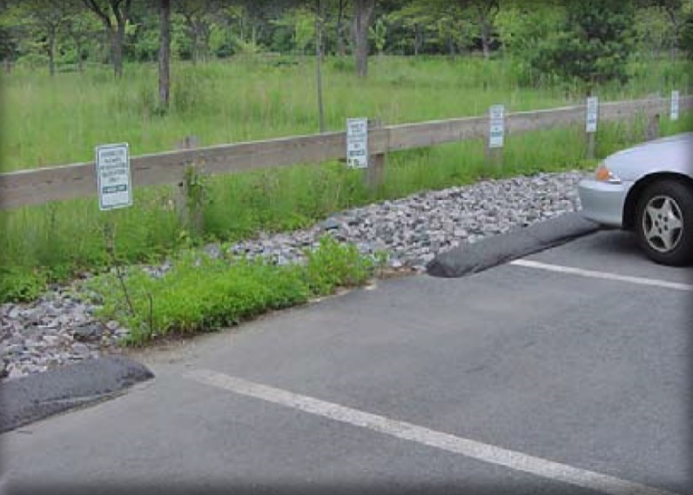
Vegetated Filter Strips
Ability to meet specific standards
Standard | Description

2 - Peak Flow | Does not provide peak flow attenuation.
3 - Recharge | Provides no groundwater recharge.
4 - TSS/ TP Removal | No EPA Curve.  TSS: MassDEP Variable pretreatment removal credit, 25% when greater than or equal to 25’ and less than 50’ wide; 45% when greater than or equal to 50’ wide  TP: MassDEP 0% TP removal credit.
5 - Higher Pollutant Loading | May be used to provide pretreatment as part of a pretreatment train if lined.
6 - Discharges near or to Critical Areas | May be used as part of a pretreatment train if lined. May be used near Cold-Water Fisheries.
7 - Redevelopment | Suitable for pretreatment
8 - Construction Phase Pollution Controls | Not to be used for construction period runoff control.
9 - O&M Plan | An O&M Plan is required. See maintenance section.
11 - Total Maximum Daily Loads | Does not meet any TMDL requirements as a stand-alone treatment practice
ESSD / LID? | No, this practice is not a MassDEP recognized ESSD / LID technique. It is a pretreatment practice. Refer to ESSD Credits 4 and 5 for information on how a Qualifying Pervious Area can be used for treatment and recharge.

Description
Structural Pretreatment
Vegetated filter strips, also known as filter strips, grass buffer strips and grass filters, are uniformly graded vegetated surfaces (i.e., grass or close-growing native vegetation) that receive runoff from adjacent impervious areas. Vegetated filter strips typically treat sheet flow or small concentrated flows that can be distributed along the width of the strip using a level spreader. Vegetated filter strips are designed to slow runoff velocities, trap sediment, and promote infiltration, thereby reducing runoff volumes.

Advantages/Benefits

- Reduces runoff volumes and peak flows.

- Slows runoff velocities and removes sediment.

- Low maintenance requirements.

- Serves as an effective pretreatment for bioretention cells

- Can mimic natural hydrology

- Small filter strips may be used in certain urban settings.

- Ideal for residential settings and to treat runoff from small parking lots and roads.

- Can be used as part of runoff conveyance system in combination with other SCMs

- Little or no entrapment hazard for amphibians or other small creatures

Disadvantages/Limitations

- Variability in removal efficiencies, depending on design

- Little or no treatment is provided if the filter strip is short-circuited by concentrated flows.

- Often a poor retrofit option due to large land requirements.

- Effective only on drainage areas with gentle slopes (less than 6 percent).

- Improper grading can greatly diminish pollutant removal.

Suitability to Treat TMDL Pollutants
- While some pretreatment SCMs are capable of removing certain TMDL pollutants, they cannot be used as a standalone practice.
- Pretreatment SCMs are encouraged to be implemented as part of a larger treatment train.
Example Vegetated Filter Strip - Adapted from Claytor and Schueler 1996
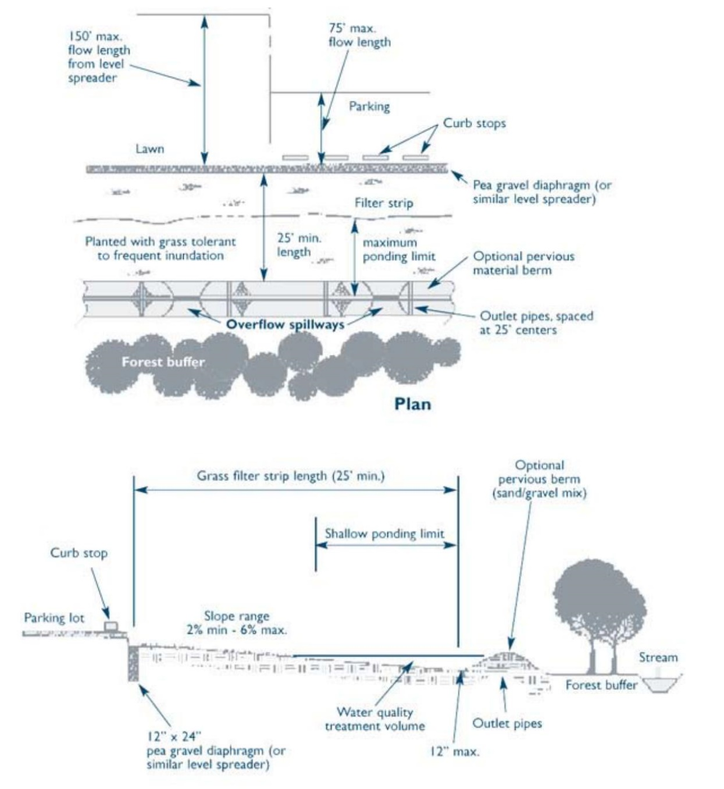
Unit Treatment Process
- Physical settling
- Biological uptake
- Possible filtration and chemical treatment (sorption to soil)
Special Features
Deconcentrates runoff. Appropriate to use when disconnecting runoff, provided slope is no greater than 2%.
ESSD / LID Alternatives
Not applicable. This is a pretreatment practice. Refer to ESSD Credits 4 and 5 for information on how a Qualifying Pervious Area can be used for treatment and recharge.

Applicability

Vegetated filter strips are used to pretreat sheet flow from roads, highways, and small parking lots. In residential settings, they are useful in pretreating sheet flow from driveways. They provide effective pretreatment, especially when combined with bioretention areas and stream buffers. Urban areas can sometimes accommodate small filter strips depending on available land area, making them potential retrofit options in certain urban settings. Vegetated filter strips can also be used as side slopes of grass channels or water quality swales to enhance infiltration and remove sediment.
Effectiveness

Variable TSS and TP removal efficiencies have been reported for filter strips, depending on the size of the contributing drainage area, the width of the filter strip, the underlying parent soil, the land slope, the type of vegetation, how well the vegetation is established, and maintenance practices. Vegetated filter strips may remove nutrients and metals depending on the length and slope of the filter, soil permeability, size and characteristics of the drainage area, type of vegetative cover, and runoff velocity.
Planning Considerations

Vegetated filter strips may be used as a stand-alone practice for Redevelopments, only where other practices are not feasible. Vegetated filter strips can be designed to fit within the open space and rights of way that are available along roads and highways. Do not design vegetated filter strips to accept runoff from land uses with higher potential pollutant loads (LUHPPL) without a liner. Vegetated filter strips function best for drainage areas of one acre or less with gentle slopes.
Cold Climate Considerations
In cold climates such as Massachusetts, the depth of soil media that serves as the planting bed must extend below the frost line to minimize the effects of freezing. Avoid using peat and compost media, which retain water and freeze during the winter, and become impermeable and ineffective.

Setback Requirements
Stormwater Control Measures (SCMs) and other components of the Stormwater Management System must be setback from wetlands, building foundations, and other features in accordance with 310 CMR 10.05(6)(q). SCMs must also include vertical separation between certain features, such as the depth to seasonally high groundwater. Refer to Section 2.5 of the Stormwater Handbook for horizontal setback and vertical separation distance requirements. Horizontal setbacks also include maintenance access requirements around the perimeter of certain SCMs.
Design Considerations

Do not locate vegetated filter strips in soils with high clay content that have limited infiltration or in soils that cannot sustain grass cover.

The filter strip cannot extend more than 50 feet into a Buffer Zone to a wetland Resource Area.

The contributing drainage area to a vegetated filter strip is limited to one acre of less.

Design vegetated filter strips with slopes between 2 and 6 percent. Steeper slopes tend to create

concentrated flows. Flatter slopes may cause ponding and create mosquito-breeding habitat.

Design the top and toe of the slope to be as flat as possible. Use a level spreader at the top of the slope to evenly distribute overland flows or concentrated runoff across the entire length of the filter strip. Many variations of level spreader designs may be used including level trenches, curbing and concrete weirs. The key to any level spreader design is creating a continuous overflow elevation along the entire width of the filter strip.
Include an impermeable liner and underdrain for discharges from Land Use with Higher Potential Pollutant Loads and for discharges within Zone IIs and Interim Wellhead Protection Areas; for discharges near or to other critical areas or in soils with rapid infiltration rates greater than 2.4 inches per hour.

Velocity dissipation (e.g., by using riprap) may be required for concentrated flows.

Design the filter strip to drain within 24 hours after a storm. The design flow depth must not exceed 0.5 inches.

To receive TSS removal credit, make the filter strip at least 25 feet long and generally as wide as the area draining to the strip. To prevent high-velocity concentrated flows, the length of the flow path must be limited to 75 feet if the filter strip handles runoff from impervious surfaces, and 150 feet if the filter strip handles runoff from pervious surfaces. The minimum width of the filter strip must be 20% of the length of the flow path or 8 feet, whichever is greater.

To minimize groundwater contamination and optimize hydraulic performance, the filter strip must be constructed at least 2 feet above seasonal high groundwater and 2 to 4 feet above bedrock.

The filter strip must be planted with grasses that are relatively salt-tolerant. Select grasses to withstand high flow velocities under wet weather conditions.

A vegetated filter strip may be used as a qualifying pervious area for the LID Site Design Credits for disconnecting rooftop and non-roof top runoff. If designing the vegetated filter strip for pretreatment to a bioretention area/rain garden, see the “Bioretention Areas” section of this Appendix.
Construction

- Proper grading is essential to establish sheet flow from the level spreader and throughout filter strip.

- Implement soil stabilization measures until permanent vegetation is established.

- Protect the area to be used for the filter strip by using upstream sediment traps.

- Use as much of the existing topsoil on the site as possible to enhance plant growth.

Maintenance
Activity | Frequency

Inspect the level spreader for sediment buildup and the vegetation for signs of erosion, bare spots, and overall health. | Every six months during the first year. Annually thereafter.
Regularly mow the grass. | As needed
Remove sediment from toe of slope or level spreader and reseed bare spots. | As needed
Maintaining full turf coverage is essential to ensure TSS removal. If the turf is not properly established, filter strips will export sediment, resulting in no TSS removal. On-going regular maintenance is therefore critical for filter strips to be effective and to ensure that flow does not short-circuit the system. Conduct semi-annual inspections during the first year (and annually thereafter). Inspect the level spreader for sediment buildup and the vegetation for signs of erosion, bare spots, and overall health. Regular, frequent mowing of the grass is required. Remove sediment from the toe of slope or level spreader, and reseed bare spots as necessary. Periodically, remove sediment that accumulates near the top of the strip to maintain the appropriate slope and prevent formation of a “berm” that could impede the distribution of runoff as sheet flow.

Fertilize only when necessary. Use fertilizers that do not contain phosphorus. In nitrogen impaired waters where a TMDL has been established, use low nitrogen fertilizers (for example 5-0-5). Remove and compost grass clippings at an appropriate facility.
When the filter strip is located in the Buffer Zone to a wetland Resource Area, the operation and maintenance plan must include strict measures to ensure that maintenance operations do not alter the wetland Resource Areas. Please note, filter strips are restricted to the outer 50 feet of the Buffer Zone.

References

Center for Watershed Protection, Stormwater Management Fact Sheet: Grassed Filter Strip, http://www.stormwatercenter.net/Assorted%20Fact%20Sheets/Tool6_Stormwater_Practices/Filtering%20Practice/Grassed%20Filter%20Strip.htm

Claytor, R.A. and T.R. Schueler. 1996. Design of Stormwater Filtering Systems. Center for Watershed Protection. Silver Spring, Maryland.

Connecticut Department of Environmental Protection. 2004. Connecticut Stormwater Quality Manual.

International Stormwater SCM Database, Biofilter – Grass Strip, http://www.SCMdatabase.org

Knox County, Stormwater Management Manual, Volume 2, Section 4.3.9, Filter Strip, Pp. 4-155 to 4-164, Knox County Stormwater Management Manual 4.3.9 Filter Strip

Knoxville, City of, 2003, Knoxville SCM Manual Stormwater Treatment, Filter Strips and Swales, Practice No. ST – 05, City of Knoxville Filter Strips and Swales

Maine Department of Environmental Protection. 2006, Maine Stormwater Best Management Practices Manual, Chapter 5, Pp. 5-1 to 5-18, https://www.maine.gov/dep/land/stormwater/stormwaterSCMs/vol3/chapter5.pdf

Maryland Department of the Environment, 2000, Maryland Stormwater Design Manual, Volume I, Chapter 2, Unified Sizing Criteria, P. 2.39, http://www.mde.state.md.us/assets/document/chapter2.pdf

Massachusetts Highway Department. 2004. Storm Water Handbook for Highways and Bridges.

Metropolitan Council. 2001. Minnesota Urban Small Sites SCM Manual: Stormwater Best Management Practices for Cold Climates. Prepared by Barr Engineering Company. St. Paul, Minnesota.

New Jersey Department of Environmental Protection, 2004, Best Management Practice Manual, Chapter 9.10, Standard for Vegetated Filter Strip, Pp. 9.10-1 to 9.11-10,https://dep.nj.gov/stormwater/bmp-manual/

New York State Department of Environmental Conservation (NYDEC). 2001. New York State Stormwater Management Design Manual. Prepared by Center for Watershed Protection. Albany, New York.

United States Environmental Protection Agency (EPA). 1999. Preliminary Data Summary of Urban Storm Water Best Management Practices. EPA 821-R99-012.

United States Environmental Protection Agency

(EPA). 2002. National Menu of Best Management

Practices for Stormwater Phase II. URL:

https://www.epa.gov/npdes/national-menu-best-management-practices-bmps-stormwater , Last

Modified January 24, 2002.

Virginia Department of Conservation and Recreation, Chapter 3, Minimum Standard 3.14, Vegetated Filter Strip, Pp. 3.14-1 to 3.14.-14, http://dcr.state.va.us/soil_&_water/documents/Chapter_3-14.pdf

Yu, S.L., S.L. Barnes, and V.W. Gerde, 993. Testing of Best Management Practices for Controlling Highway Runoff. Virginia Transportation Research Council, Charlottesville, VA.

Pea Gravel Diaphragm with Filter Strip
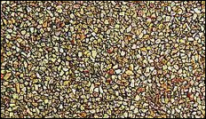
Important: Can only be used for the following SCMs: bioretention areas, infiltration trenches, ESSD Credit 3, ESSD Credit 4, ESSD Credit 7. May only be used when sheet flow is directed to these SCMs.
Ability to meet specific standards
Standard | Description
2 - Peak Flow | Provides no peak flow attenuation
3 - Recharge | Provides no groundwater recharge.
4 - TSS/ TP Removal | No EPA Curve.  TSS: MassDEP 45% pretreatment credit when properly designed.  TP: MassDEP 0% TP removal credit.
5 - Higher Pollutant Loading | Not suitable as a pretreatment device
6 - Discharges near or to Critical Areas | May be used as a pretreatment device for certain SCMs except for those with discharges to/near bathing beaches and Shellfish Growing Areas
7 - Redevelopment | Suitable for pretreatment for certain SCMs
8 - Construction Phase Pollution Controls | Not to be used for construction period runoff control.
9 - O&M Plan | An O&M Plan is required. See maintenance section.
11 - Total Maximum Daily Loads | Does not meet any TMDL requirements as a stand-alone treatment practice.
ESSD / LID? | No, this practice is not a MassDEP recognized ESSD / LID technique.

Structural Pretreatment
Description
A combination of two pretreatment practices for runoff sheeted to certain SCMs. The pea gravel diaphragm, also known as a stone diaphragm, is a stone trench filled with small river-run gravel, used as pretreatment device for sheet flow dosed to bioretention areas. The “filter strip” component is smaller than the “Vegetated Filter Strip.”
A gravel / grass combination is also suitable in lieu of the pea gravel diaphragm with filter strip. This should consist of a gravel strip at least 8 inches wide and at least 12-inches deep, followed by a sod strip that is at least 3 to 5 feet wide. The grass/gravel combination must encircle the entire bioretention area (Source: North Carolina Stormwater Manual, 2007.)
Advantages/Benefits
- Allows pretreatment of sheet flow dosed to certain SCMs.
- Smaller footprint than vegetated filter strips
Disadvantages/Limitations
- Limited pollutant removal.
- Gravel must be protected from traffic by curbs or other stops. Otherwise, the gravel will spread onto paved surfaces and into the bioretention area.
Suitability to treat TMDL Pollutants
- While some pretreatment SCMs are capable of removing certain TMDL pollutants, they cannot be used as a standalone practice.
- Pretreatment SCMs are encouraged to be implemented as part of a larger treatment train.

Unit Treatment Process

- Dispersion
ESSD /

LID Alternatives

Not applicable. This is a pretreatment practice.
Suitable Applications
- Pretreatment for bioretention areas, infiltration trenches, ESSD Credit 3, ESSD Credit 4, and ESSD Credit 7.

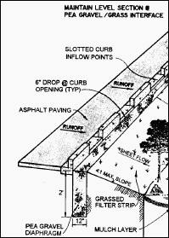
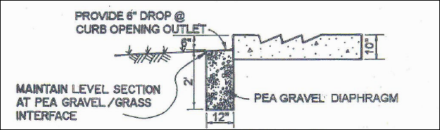
Setback Requirements
Stormwater Control Measures (SCMs) and other components of the Stormwater Management System must be setback from wetlands, building foundations, and other features in accordance with 310 CMR 10.05(6)(q). SCMs must also include vertical separation between certain features, such as the depth to seasonally high groundwater. Refer to Section 2.5 of the Stormwater Handbook for horizontal setback and vertical separation distance requirements. Horizontal setbacks also include maintenance access requirements around the perimeter of certain SCMs.
Design Considerations

The pea gravel diaphragm with filter strip serves several purposes . First, it reduces the velocity of runoff from small storms. Second, it settles out coarser fractions of suspended sediment before they reach the bioretention area or rain garden. Third, it acts as a spreader, converting concentrated flow from impervious areas to sheet flow. The coarse fractions of sediment present in runoff as suspended sediment settle into the voids between the gravel. The filter strip component further lags incoming runoff from smaller storms and may provide some filtration of coarser sediments in the runoff.

Design Specifications

Pea Gravel Diaphragm component: A trench must be excavated. The trench must be a minimum of at least 12
inches wide. The depth of the trench must be a minimum
of at least 24 inches. The trench must be located in the runoff flow path. The trench must be long enough to allow capture of runoff with bypass around the ends of the trench. Where bioretention areas or other applicable SCMs are located within landscaped areas and are not located immediately adjacent to paved areas such as parking lots, driveways, or roads, the pea gravel diaphragm must be located around the entire perimeter of the bioretention area in order to pretreat all sheet flow.
Example Pea Gravel Diaphragm (from Claytor and Schueller, 1996)
Pea gravel for the diaphragm must be ASTM D 448 size No. 6 (1/8” to ¼”). Use clean bank-run gravel only. The pea gravel must be back filled into the trench. The gravel should be hand shoveled into the trench when feasible to minimize disturbance of the trench by machinery. The gravel needs to be graded to provide a 6-inch drop below the curb openings from the adjacent paved surfaces to direct flow to the bioretention area.
When stormwater is first directed across lawns, landscaped areas, vegetated filter strips, and then to the pea gravel diaphragm, curbs or stops are not needed to protect the gravel or induce sheet flow.

Filter Strip component:
- The filter strip component must be located to pick up the runoff after it has flowed across the pea gravel diaphragm.
- The filter strip must be a minimum of 10 feet wide. Note this is less than the stand-alone “Vegetated Filter Strip” described in this Appendix.
- The filter strip slope must be no more than 2%. It must be planted with grasses to stabilize the surface, lag flow, and provide some further physical separation of suspended solids.
- For filter strips where road or parking lot runoff is directed, grasses selected to be planted in the filter strip should be salt tolerant.
- The filter strip component may be part of the bioretention area or rain garden. The bottom of rain garden or filtering bioretention area the pea gravel diaphragm with filter strip drains to must be at least 2-feet in elevation above seasonal high groundwater.
- Pea gravel diaphragm combined with a vegetated filter strip specially designed to provide pretreatment for a bioretention area as set forth in the following table.
Dimensions for Filter Strip Designed Specially to Provide Pretreatment for Bioretention Area
(Table source: Georgia Stormwater Manual and Claytor and Schuler 1996)

Parameter | Impervious Area |  |  |  | Pervious Areas  (lawns, etc.)
Max. inflow approach length (ft) | 35 |  | 75 |  | 75 |  | 100
Filter strip slope (max=6%) | <2% | >2% | <2% | >2% | <2% | >2% | <2% | >2%
Filter strip min. length (ft) | 10 | 15 | 20 | 25 | 10 | 12 | 15 | 18
Maintenance
Activity | Frequency
Replace pea gravel as needed | Every 2 to 3 years
Maintain filter strip, including seasonally reseeding as necessary | Mowing as needed. Seasonally reseeding each spring and/or fall as needed

References

Georgia, 2001, Georgia Stormwater Management Manual, Bioretention, pages 3.23-43 to 3.23-58.

Claytor, Richard A. and Schueler, Thomas R., 1996. Design of Stormwater Filtering Systems. The Center for Watershed Protection. Silver Springs, MD.

Massachusetts
Stormwater Management
Handbook

Structural Treatment

- Bioretention Areas
- Constructed Stormwater Wetlands
- Extended Dry Detention Basin
- Proprietary Media Filters
- Sand and Organic Filters
- Wet Basins
(formerly wet retention ponds)

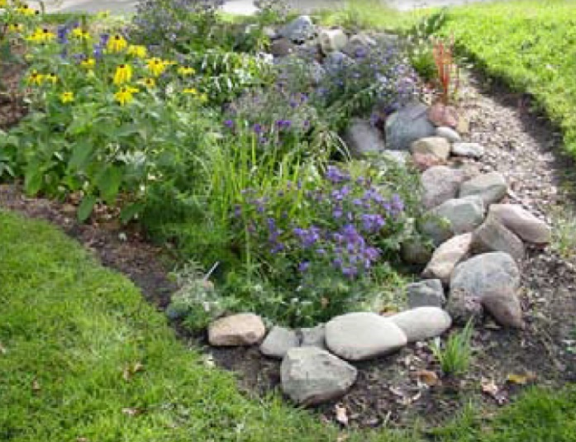
Bioretention Areas
Structural Treatment

Ability to meet specific standards

Standard | Description
2 - Peak Flow | Bioretention (filtering and exfiltrating) can both be designed to provide peak flow attenuation. See below for more information
3 - Recharge | Bioretention (filtering) does not provide groundwater recharge.  Bioretention (exfiltrating) provides groundwater recharge.
4 - TSS/TP Removal | Bioretention (filtering)  - Use EPA Performance Curve for Biofiltration.  Bioretention (exfiltrating)  - Use EPA Performance Curve for Infiltration Basin.  Adequate pretreatment must be provided per Specification. See “Introduction” Section of this Appendix for more information the EPA Performance Curves.
5 - Higher Pollutant Loading | Can be used for certain land uses with higher potential pollutant loads if lined and sealed and adequate pretreatment is provided. Adequate pretreatment must include 44% TSS removal prior to infiltration.  For land uses that have the potential to generate runoff with high concentrations of oil and grease such as high intensity use parking lots and gas stations, adequate pretreatment may also include an oil/grit separator, sand filter or equivalent. In lieu of a separator or sand filter, a filtering bioretention area also may be used as a pretreatment device for infiltration practices exfiltrating runoff from land uses with a potential to generate runoff with high concentrations of oil and grease.
6 - Discharges near or to Critical Areas | Suitable for discharges near Cold-Water Fisheries, bathing beaches and Shellfish Growing Areas, with adequate pretreatment and liners (if necessary).
7 - Redevelopment | Suitable with appropriate pretreatment
8 - Construction Phase | Construction phase runoff is not to be diverted to these areas; divert stormwater runoff to these areas only once the site has been stabilized.
11 - Total Maximum Daily Loads | See suitability to treat TMDL pollutant Tables (below). Must be properly designed, sized, and maintained.
ESSD / LID? | Yes, this practice is a MassDEP recognized ESSD / LID technique.

Description
Bioretention is a technique that uses soils, plants, and microbes to treat stormwater before it is infiltrated and/or discharged. Bioretention cells are shallow depressions filled with sandy soil topped with a thick layer of mulch and planted with dense native vegetation. Stormwater runoff is directed into the cell via piped or sheet flow. The runoff percolates through the soil media that acts as a filter. Bioretention areas may be designed to act as a filtering practice or an infiltration practice. Filtering bioretention areas do not infiltrate and cannot be used receive recharge credit towards Standard 3 – they have an underdrain that captures and conveys runoff downstream. Filtering bioretention areas may be lined. Exfiltrating bioretention areas are designed to provide infiltration.

There are two types of bioretention areas:
- Filtering Bioretention Areas (designed solely as an organic filter): These areas contain an underdrain and do not infiltrate. A filtering bioretention area includes an impermeable liner, an overflow drain set to the maximum ponding depth, and an underdrain that intercepts the runoff before it reaches the water table so that it may be conveyed to a discharge outlet, other best management practices, or the municipal storm drain system

- Exfiltrating Bioretention Areas: exfiltrating bioretention areas (i.e., raingardens) configured to recharge groundwater in addition to acting as a filter. These areas may be configured as cells in series to provide additional recharge/overflow. This type does not contain an underdrain that connects to a stormwater treatment system outlet.

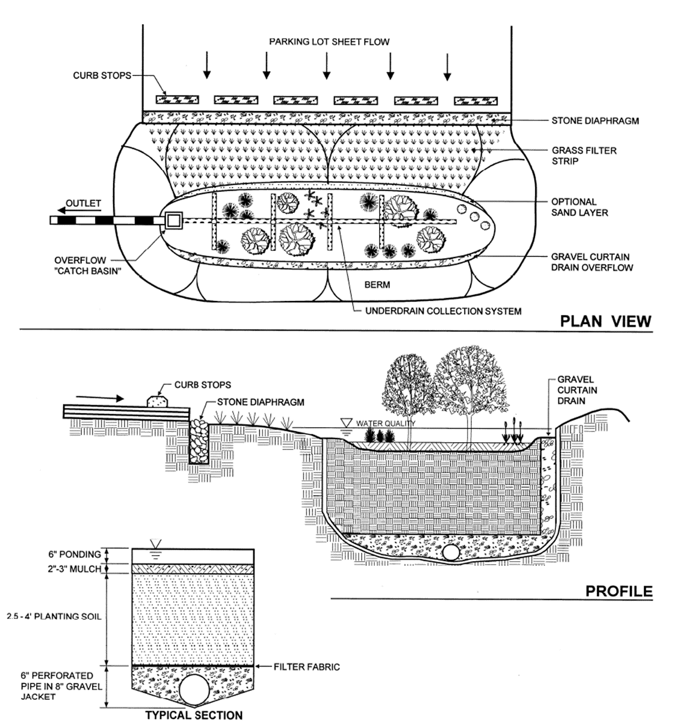
Example Filtering Bioretention Area
(Source: 2006 Vermont Stormwater Handbook)

Filtering Bioretention Suitability to Treat TMDL Pollutants
Pollutant | Suitable to Treat?
TSS | Y
Total Nitrogen | N
Total Phosphorous | N
Pathogens | Y
Metals | Y

Notes:
- Pathogens category includes: fecal coliform, E. coli, and enterococcus.

- Metals category includes Zinc, Cadmium, Lead, Aluminum, and Iron.

Exfiltrating Bioretention Suitability to Treat TMDL Pollutants

Pollutant | Suitable to Treat?
TSS | Y
Total Nitrogen | Y
Total Phosphorous | Y
Pathogens | Y
Metals | Y
Notes:
- Pathogens category includes: fecal coliform, E. coli, and enterococcus.
- Metals category includes Zinc, Cadmium, Lead, Aluminum, and Iron.
Special Features

- Adequate pretreatment is essential.

- Not recommended in areas with steep slopes.

- Depth of soil media depends on type of vegetation that is proposed.
- Soil media must be at least 30 inches deep to promote anoxic removal of nitrogen
Not all bioretention cells are designed to exfiltrate.

- Infiltration requirements are applicable only to bioretention cells intended to exfiltrate.
Advantages/Benefits

- Bioretention Areas are Low Impact Development practices.
- Exfiltrating Bioretention Areas provide groundwater recharge and preserve the natural water balance of the site.

- Filtering Bioretention Areas filter pollutants
- Depending on mix of vegetation community, may provide shade, absorb noise, and provide windbreak.

- Removes other pollutants besides TSS and TP, including nitrogen, pathogens, and metals (dependent on filtering/exfiltrating design).

- Can be lined and sealed to prevent recharge where appropriate (filtering Bioretention).
- Can be used as a stormwater retrofit by modifying existing landscape or if a parking lot is being resurfaced.

- Can be used on small lots with space constraints.

- Exfiltrating Bioretention Areas minimize mosquito breeding compared to other SCMs.
- Little or no hazard for amphibians or other small animals

Disadvantages/Limitations

- Requires careful landscaping and maintenance

- Not suitable for large drainage areas

ESSD / LID Alternatives
This practice is a MassDEP recognized ESSD / LID technique.
Unit Process for Treatment
Physical settling, infiltration, chemical (sorption) and biological.
Applicability
Bioretention areas can provide excellent pollutant removal for the “first flush” of stormwater runoff. Properly designed and maintained cells remove suspended solids, metals, and nutrients, and can infiltrate an inch or more of rainfall. Distributed around a property, vegetated bioretention areas can enhance site aesthetics. In residential developments they are often described as “rain gardens” and marketed as property amenities. Routine maintenance is simple and can be handled by homeowners or conventional landscaping companies, with proper direction.

Bioretention systems can be applied to a wide range of commercial, residential, and industrial developments in many geologic conditions; they work well on small sites and on large sites divided into multiple small drainage areas. Bioretention systems are often well suited for ultra-urban settings where little pervious area exists. Although they require significant space (approximately 5% to 7% of the area that drains to them), they can be integrated into parking lots, parking lot islands, median strips, and traffic islands. Sites can be retrofitted with bioretention areas by replacing existing parking lot islands or by re- configuring a parking lot during resurfacing. On residential sites, they are commonly used for rooftop and driveway runoff.

Effectiveness

Bioretention areas remove pollutants through filtration, microbe activity, and uptake by plants; contact with soil and roots provides water quality treatment better than conventional infiltration structures. Studies indicate that bioretention areas can remove from 80% to 90% of TSS. If properly designed and installed, bioretention areas remove phosphorus, nitrogen, metals, organics, and bacteria to varying degrees.

Bioretention areas help reduce stress in watersheds that experience severe low flows due to excessive impervious cover. Low-tech, decentralized bioretention areas are also less costly to design, install, and maintain than conventional stormwater technologies that treat runoff at the end of the pipe.

Decentralized bioretention cells can also reduce the size of storm drainpipes, a major component of stormwater
treatment costs. Bioretention areas enhance the landscape in a variety of ways: they improve the appearance of developed sites, provide windbreaks, absorb noise, provide wildlife habitat, and reduce the urban heat island effect.

Planning Considerations

Filtering bioretention areas are designed with an impermeable liner and underdrain so that the stormwater may be transported to additional SCMs for treatment and/or discharge. Exfiltrating bioretention areas are designed so that following treatment by the bioretention area the stormwater may recharge the groundwater.

Filtering bioretention areas are suitable to treat runoff from land uses with higher potential pollutant loads. Exfiltrating bioretention areas (rain gardens) may be used to treat runoff from high intensity parking areas, when source control is implemented and when pretreatment has been provided to achieve TSS removal of at least 44%. If the land use with higher potential pollutant load has the potential to generate runoff with high concentrations of oil and grease, other types of pretreatment, i.e., a deep sump catch basin and oil/grit separator or a sand filter, is required prior to discharge of runoff to an exfiltrating bioretention area.

A filtering bioretention area may also be used as a pretreatment device for an exfiltrating bioretention area or other infiltration practice that exfiltrates runoff from land uses with a potential to generate runoff with high concentrations of oil and grease.

Bioretention areas must not be located immediately adjacent to steep slopes. When the bioretention area is designed to infiltrate, the design must ensure vertical separation of at least 2 feet from the seasonal high groundwater table to the bottom of the bioretention cell.
For residential rain gardens, pick a low spot on the property, and route water from a downspout or sump pump into it. It is best to choose a location with full sun, but if that is not possible, make sure it gets at least half-day of sunlight.
Do not excavate an extensive rain garden or bioretention area under large trees. Digging up shallow feeder roots can weaken or kill a tree. If the tree is not a species that prefers hydric soil, the additional groundwater could damage it. The horizontal footprint of Rain gardens (exfiltrating type) must be sized using the same iterative process for infiltration practices (the 72-hour drawdown analysis – see Section 6.2.3).
Pre-treatment
To receive TSS and TP removal credit utilizing the EPA curves, pretreatment with at least 25% TSS removal must be provided. The following methods are credited to meet the pretreatment requirement.
If the flow is piped to the bioretention area:
- a deep sump catch basin combined with a sediment forebay will provide the 44% TSS removal.
For flow directed through an open channel:
- a grass channel; or
- water quality swale
For sheet flow, there are a number of pretreatment options to receive the 44% TSS removal credit. These options are:

- A vegetated filter strip that must be at least 25-feet wide, designed in accordance with the “Vegetated Filter Strip” specifications presented in this Appendix.
- A grass and gravel combination. This should consist of a gravel strip at least 8 inches wide and at least 12-inches deep, followed by a sod strip that is at least 3 to 5 feet wide. The grass/gravel combination must encircle the entire bioretention area (Source: North Carolina Stormwater Manual, 2007.)

- Pea gravel diaphragm combined with a vegetated filter strip specially designed to provide pretreatment for a bioretention area as set forth in the “Pea Gravel Diaphragm with Filter Strip” Specification included in this Appendix.

Setback Requirements
Stormwater Control Measures (SCMs) and other components of the Stormwater Management System must be setback from wetlands, building foundations, and other features in accordance with 310 CMR 10.05(6)(q). SCMs must also include vertical separation between certain features, such as the depth to seasonally high groundwater. Refer to Section 2.5 of the Stormwater Handbook for horizontal setback and vertical separation distance requirements. Horizontal setbacks also include maintenance access requirements around the perimeter of certain SCMs.
Design Considerations
Size the bioretention area to be 5% to 7% of the area draining to it. Determine the vertical saturated hydraulic conductivity of the underlying native soil in accordance with the methods specified in Section 6.3 of the Stormwater Handbook. Do not use a percolation test (i.e., Title 5) to determine the saturated hydraulic conductivity.
For exfiltrating bioretention, the bottom of the underlying gravel layer must be set in elevation at least 2-feet above seasonal high groundwater. For filtering bioretention, the bottom of the PVC membrane, geotextile fabric, clay liner, or media of filtering bioretention must be placed at least 2-feet in elevation above seasonal high groundwater.
The depth of the soil media must be between 2 to 4 feet. This range reflects the fact that most of the pollutant removal occurs within the first 2 feet of soil and that excavations deeper than 4 feet become expensive. The depth selected should accommodate the vegetation. If the minimum depth is used, only shallow rooted plants and grasses may be used.
If there is a Total Maximum Daily Load that requires nitrogen to be removed from the stormwater discharges, the bioretention area must have a soil media with a depth of at least 30 inches to create anoxic conditions. If trees and shrubs are to be planted within the bioretention area or rain garden, the soil media must be at least 3 feet deep
Size the cells (based on void spacing and ponding area) at a minimum to capture and treat:
- The runoff volume associated with the MassDEP Crosswalk Curves for TSS and TP removal (for new development, Stormwater Standard 4 90% TSS Removal/60% TP Removal and for Redevelopment, Stormwater Standard 7: 80% TSS removal and 50% TP removal);
- The required recharge volume when used only for recharge (Stormwater Standard 3); or the larger of the two when used to achieve compliance with Standards 3 and 4.
For exfiltrating bioretention, cover the bottom of the excavation with coarse gravel, over pea gravel, over sand. Earlier designs used geotextile fabric as a bottom blanket, but more recent experiences show that filter fabric is prone to clogging. Consequently, do not use geotextile fabrics or sand curtains. Use the Engineered Soil Mix below. Geotextile or PVC liners may be used for filtering bioretention.
Engineered Soil Mix for Both Infiltrating and Filtering Bioretention
The soil mix for bioretention areas must be a mixture of sand, triple shredded wood chips, and soil, blended together.
- 60% sand;
- 20 topsoil, (Clay content must not exceed 5%.); and
- 20% triple shredded wood chips blended into the sand and topsoil mix. The mix must not include any compost.
- The soil mix must be uniform, free of stones, stumps, roots or similar objects larger than 2 inches.
- Soil pH should generally be between 5.5-6
- 5, a range that is optimal for microbial activity and adsorption of nitrogen, phosphorus, and other pollutants.
- Use soils with 1.5% -3% organic content and maximum 500 ppm soluble salts.
- The sand component should be gravelly sand that meets ASTM D 422.
Sieve Size Percent Passing
2-inch 100
¾ inch 70-100
¼ inch 50-80
U.S. No. 40 15-40
U.S. No. 200 0-3
- The topsoil component shall be a sandy loam, loamy sand, or loam texture.
On-site soil mixing or placement is not allowed if soil is saturated or subject to water within 48 hours. Cover and store soil to prevent wetting or saturation. Test soil for fertility and micro-nutrients and, only if necessary, amend mixture to create optimum conditions for plant establishment and early growth.
Grade the area to create a maximum ponding depth of 6-inches for infiltrating bioretention and 12-inches for filtering bioretention. Excessive ponding depth will cause vegetation mortality and scouring of the bioretention media.
Peak Reduction Modeling: For peak runoff reduction modeling, the depth of the “ponds” in the runoff model shall never exceed 12-inches. For exfiltrating bioretention areas, it is acceptable to discard loss to infiltration as detailed in Section 6.3.3 of the Stormwater Handbook. Loss to infiltration may not be discarded for filtering bioretention areas. No storage shall be assumed to be provided by the bioretention media. The excess runoff in the peak runoff model shall be directed to a properly sized overflow. To receive peak credit, overflow must not be directed to an underdrain for exfiltrating bioretention areas.
Planting Plan: The planting plan shall include a mix of herbaceous perennials, shrubs, and (if conditions permit) understory trees that can tolerate intermittent ponding, occasional saline conditions due to road salt, and extended dry periods. A list of plants that are suitable for bioretention areas can be found at the end of this section. To avoid a monoculture, it is a good practice to include one tree per 175 square feet, and one per 50 square feet of bioretention area, with at least 3 species each of herbaceous perennials and shrubs. Invasive and exotic species are prohibited. The planting plan should also meet any applicable local landscaping requirements.
Drawdown: All exfiltrating bioretention areas must be designed to drain within 72 hours. However, rain gardens are typically designed to drain water within a day and are thus unlikely to breed mosquitoes.
For both bioretention types, the infiltration rate for design purposes for Stormwater Standard 3 must be based on the underlying parent material. (Generally, the underlying soil may have lower saturated hydraulic conductivity rate.) See Section 6.2.3.
Maximum Ponding Depth: The maximum ponding depth shall be set to 12-inches for both infiltrating and exfiltrating bioretention types.
Overflow: Must have an overflow to safely convey runoff during major storm events. Most filtering types include an overflow drain to direct ponded water to the underdrain.
Underdrains: Rain gardens (exfiltrating bioretention) shall not contain an underdrain.
Filtering bioretention area shall include an underdrain. The underdrain must be connected to an outlet to discharge or a conveyance directed to additional stormwater control measures.
Construction
Construction: During construction, avoid excessively compacting soils around the bioretention areas and accumulating salt around the drain field. To minimize sediment loading in the treatment area, direct runoff to the bioretention area only from the areas that are stabilized; always divert construction runoff elsewhere.
To avoid compaction of the parent material, work from the edge of the area proposed as the location of the cell until the cell and the contributing drainage areas are fully stabilized.
Place planting soils in 1-foot to 2-foot lifts and compact them with minimal pressure until the desired elevation is reached. Some engineers suggest flooding the cell between each lift placement in lieu of compaction.

Maintenance

Activity | Time of Year | Frequency
Inspect / remove trash | Year round | Monthly
Mow | Growing season | 2 -12 times / year
Mulch | Spring | Annually
Fertilize | Growing season | Annually
Replace dead vegetation | Spring | Annually
Prune | Spring or fall | Annually
Replace entire media and all vegetation | Late spring / early summer | As needed*
* “As needed” in this context for rain gardens means when runoff is observed to be ponding for greater than 3-days. Additionally, for filtering bioretention, when the runoff is observed to be ponding for greater than 3-days, the overflow drain and underdrain must be first checked for blockage. If the overflow drain and underdrain are not blocked, only then shall the media and vegetation be replaced.

Premature failure of bioretention areas is a significant issue caused by lack of regular maintenance. Ensuring long-term maintenance involves sustained public education and deed restrictions or covenants for privately owned cells. Bioretention areas require careful attention while plants are being established and seasonal landscaping maintenance thereafter.
In many cases, a landscaping contractor working elsewhere on the site can complete maintenance tasks. Inspect pretreatment devices and bioretention cells regularly for sediment build-up, structural damage, and standing water.

Inspect soil and repair eroded areas monthly. Remove litter and debris monthly. Treat diseased vegetation as needed. Remove and replace dead vegetation twice per year (spring and fall).

Proper selection of plant species and support during establishment of vegetation should minimize—if not eliminate—the need for fertilizers and pesticides.

Remove invasive species as needed to prevent these species from spreading into the bioretention area. When runoff ponds in a rain garden for greater than three days, it indicates the media is becoming clogged and failure is occurring. When this occurs, excavate the bioretention area, scarify bottom and sides, replace gravel, sand, triple shredded woodchips, and soil, and replant.

Soil media should also be replaced if the soil media becomes disturbed, over-compacted, or contaminated with foreign or deleterious materials or liquids. For filtering bioretention, replace geotextile fabric or PVC liner. For rain gardens, there shall be no geotextile fabric or PVC liner, as it inhibits exfiltration. Disposal of used bioretention media shall be disposed of in accordance with MassDEP’s Catch Basin Cleaning Policy (WEB: https://www.mass.gov/doc/catch-basin-cleanings-management-guidelines/download)
A summary of maintenance activities can be found on the previous page.

Because the soil medium filters contaminants from runoff, the cation exchange capacity of the soil media will eventually be exhausted. When the cation exchange capacity of the soil media decreases, change the soil media to prevent contaminants from migrating to the groundwater, or from being discharged via an underdrain outlet. Using small shrubs and plants instead of larger trees will make it easier to replace the media with clean material when needed.

Plant maintenance is critical. Concentrated salts in roadway runoff may kill plants, necessitating removal of dead vegetation each spring and replanting. The operation and maintenance plan must include measures to make sure the plants are maintained. This is particularly true in residential subdivisions, where the operation and maintenance plan may assign each homeowner the legal responsibility

to maintain a bioretention cell or rain garden on his or her property. Including the requirement in the property deed for new subdivisions may alert residential property owners to their legal responsibilities regarding the bioretention cells constructed on their lot.

Cold Climate Considerations

Never store snow in bioretention areas. The Operation and Maintenance plan must specify where on-site snow will be stored. All snow dumps must comply with MassDEP’s Snow Disposal guidance (As of 2020, WEB: https://www.mass.gov/doc/2020-snow-disposal-policy-and-guidance/download). When bioretention areas are located along roads, care must be taken during plowing operations to prevent snow from being plowed into rain gardens and bioretention areas.

If snow is plowed into the rain gardens and filtering bioretention area, runoff may bypass the rain garden/bioretention area and drain into downgradient wetlands without first receiving the required water quality treatment, and without recharging the groundwater comply with MassDEP’s Snow Removal guidance. When bioretention areas are located along roads, care must be taken during plowing operations to prevent snow from being plowed into the bioretention areas. If snow is plowed into the cells, runoff may bypass the cell and drain into downgradient wetlands without first receiving the required water quality treatment, and without recharging the groundwater.

References

Low Impact Development Center, 2003, Drainage

– Bioretention Specification, http://www.lowimpactdevelopment.org/epa03/biospec.htm

Prince Georges County, 2002, Bioretention Manual, http://www.goprincegeorgescounty.com/der/bioretention.asp

Puget Sound Action Team, 2005, Low Impact Development, Pp. 174 - 184 pdf http://www.psat.wa.gov/Publications/LID_tech_manual05/LID_manual2005.pdf

U.S. Environmental Protection Agency, 1999, Stormwater Technology Fact Sheet, Bioretention, EPA 832-F-99-012, http://www.epa.gov/owm/mtb/biortn.pdf

U.S. Environmental Protection Agency, 2005, National Management Measures to Control Nonpoint Source Pollution from Urban Areas, Publication Number EPA 841-B-05-004, Pp. 5-29, http://www.epa.gov/nps/urbanmm/

University of North Carolina, www.bae.ncsu.edu/topic/bioretention www.bae.ncsu.edu/stormwater/PublicationFiles/DesigningRainGardens2001.pdf

University of New Hampshire Stormwater Center, Specifications and Fact Sheets, https://www.unh.edu/unhsc/specs-and-fact-sheets-0.

Plantings for Bioretention Areas
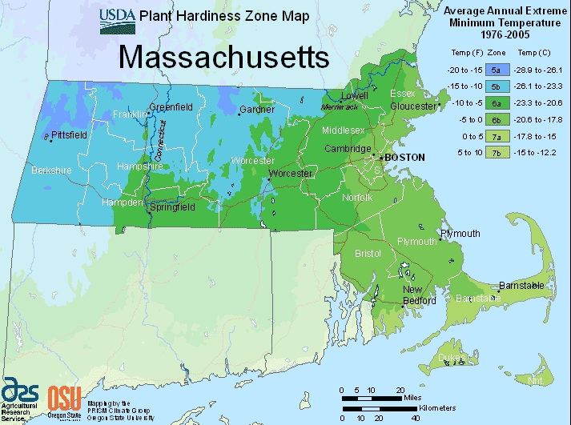
When selecting species for bioretention areas (and other SCMs that include plantings such as raingardens, buffer zones, etc.), general considerations include the following:
USDA Plant Hardiness Zone Map
- It is important to select species that are well-suited to the expected hydrology of the site. For example, species planted in center of a bioretention area should be able to withstand periodic inundation, while those planted on the upper margins should be drought-tolerant.
- To select native species that are appropriate for the regional climate, check the USDA Plant Hardiness Zone Map to see what planting zone the site is in. The hardiness zones in Massachusetts range from 5a in the Berkshire mountains to 7a on Cape Cod.
- Consider using a mix of species with varied height, texture, and color to add visual interest.

- What is the desired plant size at maturity? Although some shrub and small tree species can be easily pruned to maintain a desired size, consider how frequently such maintenance will be performed, or if there are other aesthetic considerations (such as maintaining views).
Links to additional resources with planting lists and other guidance are provided below:
Rain Gardens: A Way to Improve Water Quality
Native Plants for New England Rain Gardens
StormSmart Coasts - Coastal Landscaping in Massachusetts
The Vermont Rain Garden Manual
The Native Plant Trust
USDA Plants Database
Although larger trees may be suitable for some settings, make sure the site design (soil depth) can accommodate the full depth of the root zone at maturity, and that trees would not pose a potential risk to nearby structures, parking areas, etc.

- Salt tolerance: For bioretention areas that receive runoff from areas where salt is used for winter de-icing, special attention should be given to selecting salt-tolerant species. Look for the “salt-tolerant” icon in the table below.
- Wildlife considerations: In addition to their function within a bioretention area, plantings can benefit wildlife by providing food sources and habitat. However, it is also important to select species that will not be destroyed by wildlife and require replacement. For example, if deer are common in site vicinity, select deer-resistant species. For shoreline plantings in areas where beavers are present, avoid woody species that are preferred by beavers, such as birch, aspen, alder, and willows.
- To help ensure plant survival, water immediately after planting, and then water weekly (if there is no significant rainfall) or as needed based on weather conditions during the first growing season. More frequent watering may be needed during hot weather.

A list of recommended New England native species for bioretention areas is provided on the following pages.


Bioretention Planting List
Full
Sun
Partial
Sun
Shade
Symbol Key
Salt Tolerant

The species list below is adapted primarily from Rain Gardens: A Way to Improve Water Quality (University of Massachusetts Extension) and Native Plants for New England Rain Gardens (University of New Hampshire Extension), with additional information from the USDA Plants Database and The Native Plant Trust - Go Botany. This list includes examples of native species that are recommended for use in bioretention areas in Massachusetts, but is not intended to be a comprehensive list of all suitable species.

Type | Scientific Name  Common Name | Sun Exposure | Soil  Moisture | Mature Height | USDA Hardiness Zone | Comments
Trees | Acer negundo  box elder maple |  | dry to moist | 30'-50' | 3-8 | Medium height, fast-growing tree; tolerates wide range of soil conditions; song birds and squirrels eat the seeds
Trees | Acer rubrum  red maple |  | dry to wet | 40'-60' | 3-9 | Shallow root system; attractive red flowers and fruit; tolerates moist or dry sites; red/yellow/orange fall color
Trees | Betula populifolia  gray birch |  | dry to moist | 20’-40′ | 3-6 | Fast-growing smaller tree; a pioneer species; tolerates wide range of soil conditions
Trees | Betula nigra  river birch |  | dry to wet | 40'-70’ | 4-9 | Adaptable to wide range of moisture conditions; beautiful peeling bark; yellow fall color
Trees | Carpinus caroliniana  American hornbeam |  | moist | 20'-30' | 3-9 | Tolerates sun if soil is moist; tolerates periodic flooding; unique fluted silver-gray bark; yellow, red, or orange fall color
Trees | Fraxinus pennsylvanica  green ash |  | moist to wet | 50’-70’ | 3-9 | Fast-growing tall tree; tolerates a wide range of soil conditions and sun exposure; provides food and cover for various birds
Trees | Nyssa sylvatica  tupelo/black gum |  | dry to wet | 40'-70' | 3-9 | Tolerates seasonal flooding or dry, rocky uplands; blue-black berries eaten by birds; brilliant scarlet fall foliage
Shrubs | Amelanchier canadensis  Canada serviceberry |  | dry to moist | 15’-25’ | 4-7 | Tall shrub (or small tree) with white flowers and reddish fruit in early summer; adaptable to many soil types and moisture conditions
Shrubs | Aronia arbutifolia  red chokeberry |  | dry to wet | 6'-10' | 4-9 | White flowers in spring/summer; red fall foliage and bright red, edible berries in fall that persist into winter
Shrubs | Arctostaphylos uva-ursi  bearberry |  | dry to moist | 1’-2’ | 2-6 | Low-growing evergreen, highly tolerant of variable moisture conditions; requires acidic soil; small, shiny leaves and red berries
Shrubs | Aronia melanocarpa  black chokeberry |  | dry to wet | 3'-6' | 3-8 | White flowers with red stamens; black berries persist in winter; dark purple-red fall color
Shrubs | Clethra alnifolia  sweet pepperbush |  | dry to moist | 6'-8' | 4-9 | Fragrant white flower spikes; yellow fall color; butterfly nectar plant; well-suited to lower planting zone for bioretention areas
Shrubs | Comptonia peregrina  sweet fern |  | dry | 2’-4’ | 2-6 | Low-growing, deciduous shrub with sweet-scented, fern-like leaves; prefers acidic, sandy soil; best suited for upper margins/berms of bioretention areas
Shrubs | Hamamelis virginiana  common witch hazel |  | dry to moist | 15'-20’ | 3-8 | Spice-scented yellow flowers begin blooming in fall; tolerates irregular flooding or dry sites; yellow fall color
Shrubs | Hydrangea arborescens  smooth hydrangea |  | dry to moist | 3'-5' | 3-9 | Creamy white flowers on new wood
Shrubs | Ilex glabra  inkberry |  | dry to wet | 6'-12' | 5-9 | Slow-growing evergreen; greenish-white flowers and black-blue fruits; tolerates wet soils; periodic pruning recommended
Shrubs | Ilex verticillata  winterberry holly |  | moist to wet | 6'-10' | 3-9 | White flowers; yellow fall color; both male and female needed for scarlet berries; tolerates wet soil; best suited for lowest/wettest portions of a bioretention area
Shrubs | Leucothoe racemosa  fetterbush |  | moist to wet | 4'-6' | 5-9 | White drooping flowers; evergreen leaves turn red/purple after frost
Shrubs | Rhododendron viscosum  swamp azalea |  | moist to wet | 6'-8' | 4-9 | Intensely fragrant white flowers; bronze fall color
Shrubs | Salix discolor  pussy willow |  | moist to wet | 20’-40’ | 3-8 | White flowers; silky gray catkins; provide a critical source of pollen for native bees that emerge early in the season
Shrubs | Salix humilis  small pussy willow |  | dry to moist | 4’-8’ | 3-8 | Vibrant green shrub with green catkins; deer resistant; attracts bees
Shrubs | Salix purpurea  purple osier willow |  | moist to wet | 8’-10’ | 3-7 | Fast-growing; low-maintenance; deer resistant; red catkins
Shrubs | Sambucus canadensis  elderberry |  | dry to wet | 4'-12' | 3-9 | Large white flower clusters; purple berries eaten by a wide range of birds and mammals; fast-growing
Shrubs | Swida amomum  silky dogwood |  | moist to wet | 6’-12’ | 4-8 | Clusters of blue berries in summer
Shrubs | Swida racemosa  gray dogwood |  | moist to wet | 10’-15’ | 4-8 | Creamy, white flowers and berries in late summer
Shrubs | Swida sericea  red osier dogwood |  | moist to wet | 6’-10’ | 3-8 | White flowers; blue or white berries; red/maroon fall color; scarlet twigs in winter; highly adaptable
 | Vaccinium angustifolium  lowbush blueberry |  | dry to wet | 6'-12' | 2-5 | Does well in acidic, poor soil; small edible blueberries; attractive bronze/red fall foliage

Type | Scientific Name  Common Name | Sun Exposure | Soil  Moisture | Mature Height | USDA Hardiness Zone | Comments
Shrubs | Viburnum dentatum  arrowwood |  | dry to moist | 5'-10' | 3-8 | Creamy white flowers; blue berries; crimson fall color
Shrubs | Viburnum lentago  nannyberry |  | dry to moist | 14'-20' | 2-8 | Tall shrub with arching branches; white flowers in spring and black berries in late summer/ fall; attractive fall color
Shrubs | Viburnum trilobum  American cranberrybush |  | moist to wet | 6'-10' | 2-7 | Densely branched shrub with creamy white flowers; edible red berries in fall that persist in winter; scarlet fall foliage
Perennials | Actaea racemosa  black cohosh/bugbane |  | moist | 3'-6' | 3-9 | Flowers in large, white spikes; attracts pollinators
Perennials | Ageratina altissima  white snakeroot |  | moist to wet | 2’-3' | 4-9 | Summer blooms of long lasting, fuzzy white flower clusters; attracts pollinators
Perennials | Andropogon gerardii  big bluestem |  | dry to moist | 3'-5' | 3-8 | Clumping perennial grass with purplish, tassel-like flowers; tolerant of acid soil, sandy soil, flooding and drought.
Perennials | Aquilegia canadensis  red columbine |  | moist | 1’-2' | 3-9 | Flowers attract bees, hummingbirds, and butterflies; red flowers in late spring/early summer
Perennials | Asclepias incarnata  swamp milkweed |  | moist to wet | 2'-4' | 3-9 | Pink blooms in midsummer; butterfly nectar plant; monarch butterfly larval host plant
Perennials | Asclepias tuberosa  butterfly milkweed |  | moist to wet | 2'-4' | 3-9 | Orange summer blooms; monarch butterfly larval host; plant on a dry berm or upper margins of bioretention area
Perennials | Chelone glabra  white turtlehead |  | moist to wet | 2'-3' | 3-9 | White snapdragon type flowers; good fall bloomer; attracts butterflies and hummingbirds; best suited for lowest/wettest portions of a bioretention area
Perennials | Dennstaedtia punctilobula  hay-scented fern |  | dry to moist | 1'-3' | 3-8 | Spreads rapidly; fragrant, light-green foliage turns yellow in fall
Perennials | Dryopteris marginalis  marginal wood fern |  | dry to moist | 1'-3' | 3-8 | Fern with a leathery blue-green frond; spring fiddleheads are golden brown and furry
Perennials | Eupatorium perfoliatum  common boneset |  | moist to wet | 2'-5' | 3-8 | Prefers soil with relatively high organic matter content; excellent for attracting pollinators; deer and rabbit resistant
Perennials | Eurybia divaricata  white wood aster |  | dry to moist | 1'-3' | 3-8 | Good for dry shade or moist woods; white flowers attract butterflies
Perennials | Eutrochium purpureum  sweet Joe Pye weed |  | moist to wet | 5'-8' | 3-9 | Huge, dusty-pink flowers attract bees, birds, and butterflies; good fall color
Type | Scientific Name  Common Name | Sun Exposure | Soil  Moisture | Mature Height | USDA Hardiness Zone | Comments
Perennials | Gentiana clausa  meadow bottle gentian |  | moist to wet | 1'-3' | 3-8 | Bottle-shaped blue-purple flowers that never truly open; attracts bees and butterflies
Perennials | Geranium maculatum  wild geranium, cranesbill |  | dry to moist | 1’-2’ | 4-8 | Showy pink flowers; very adaptable; important pollinator for native bees
Perennials | Hibiscus moscheutos  swamp rose mallow |  | moist to wet | 3'-6' | 5-8 | Shrub-like plant with large pink or white flowers; hummingbird nectar plant; best suited for lowest/wettest portions of a bioretention area
Perennials | Iris versicolor  blue flag |  | moist to wet | 2'-3' | 2-7 | Deep blue blooms on attractive grass-like foliage; can grow with roots in water; best suited for placing at bioretention low spots or near inlet/outlet
Perennials | Lobelia cardinalis  cardinal flower |  | moist to wet | 2’-3' | 3-9 | Will grows in full sun if kept moist; red flowers attract hummingbirds; best suited for placing at bioretention low spots or near inlet/outlet
Perennials | Lobelia siphilitica  great blue lobelia |  | moist | 2'-3' | 4-9 | Bell-shaped blue flowers remain in bloom for 3 to 4 weeks (Note: This species in endangered in Massachusetts)
Perennials | Matteuccia struthiopteris  fiddlehead fern, ostrich fern |  | moist to wet | 4'-5' | 2-8 | Plants form colonies by underground rhizomes; tall arching fronds; best suited for placing at bioretention low spots or near inlet/outlet
Perennials | Osmunda cinnamomea  cinnamon fern |  | moist to wet | 2'-4' | 3-10 | Grows in clumps with cinnamon-colored fronds; needs constant moisture if in sun; best suited for placing at bioretention low spots or near inlet/outlet
Perennials | Osmunda regalis  royal fern |  | moist to wet | 3'-6' | 3-10 | A tall, clump-forming fern producing a large rosette of bright green fronds; best planted in partial shade, but will grow in sun with ample moisture
Perennials | Panicum virgatum  switch grass |  | dry to moist | 3'-6' | 3-9 | Attractive and adaptable grass; tolerates flooding; airy seed heads in summer
Perennials | Schizachyrium scoparium  little bluestem |  | dry to moist | 3'-4' | 3-9 | Attractive native grass, blooms in August; dense root system; tolerant of poor soils
Perennials | Solidago spp.  goldenrod |  | dry to moist | 18" – 6' | Varies by species | Over 20 Solidago species native to New England; yellow/golden late season color
Perennials | Symphyotrichum laeve  smooth aster |  | dry to moist | 2'-4' | 3-9 | Pale blue flowers attract birds, bees, and butterflies
Perennials | Symphyotrichum novae-angliae New England aster |  | moist to wet | 2'-3' | 4-8 | Nectar source for butterflies; important pollinator plant in late fall
Perennials | Symphyotrichum novi-  belgii New York aster |  | moist to wet | 3' | 4-8 | Purple flower with orange centers; attracts bees
Type | Scientific Name  Common Name | Sun Exposure | Soil  Moisture | Mature Height | USDA Hardiness Zone | Comments
Perennials | Tiarella cordifolia  foam flower |  | moist | 1' | 3-8 | Attractive groundcover with spikes of foamy white flowers in spring
Perennials | Verbena hastata  blue vervain |  | moist to wet | 3’-5’ | 3-9 | Tall blue/purple flower spikes which bloom from summer through fall; attract birds, bees, and butterflies
Perennials | Vernonia noveboracensis  New York ironweed |  | moist to wet | 4’-6’ | 5-8 | Good nectar source for monarch butterflies; best suited for placing at bioretention low spots or near inlet/outlet
References

University of Massachusetts Extension, Landscape, Nursery and Urban Forestry Program. Rain Gardens: A Way to Improve Water Quality. https://ag.umass.edu/landscape/fact-sheets/rain-gardens-way-to-improve-water-quality.
University of New Hampshire Extension. Native Plants for New England Rain Gardens. https://www4.des.state.nh.us/SoakNH/wp-content/uploads/2016/03/Native-Plants-for-NH-Rain-Gardens_20160322.pdf.
USDA, NRCS. 2021. The PLANTS Database, 12/16/2021. National Plant Data Team, Greensboro, NC USA. http://plants.usda.gov.

The Native Plant Trust - Go Botany website. https://gobotany.nativeplanttrust.org/

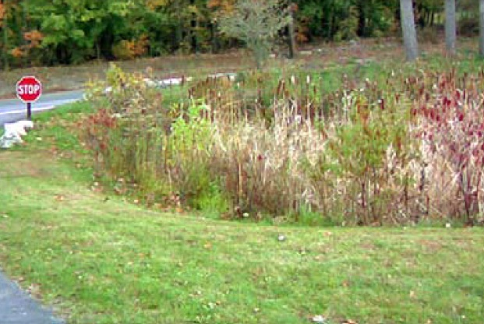
Constructed Stormwater Wetlands
Structural Treatment

Ability to meet specific standards

Standard | Description

2 - Peak Flow | If properly designed, can provide peak flow attenuation. Only volume in elevation above the permanent “pond” may be claimed for peak runoff rate reduction.
3 - Recharge | Provides no groundwater recharge
4 - TSS/TP Removal | Use EPA Performance Curve for Gravel Wetland to calculate required sizing to meet pollutant removal requirements. See “Introduction” Section of this Appendix for more information the EPA Performance Curves. Sediment forebay required for pretreatment.
5 - Higher Pollutant Loading | May be used as treatment SCM provided basin bottom is lined and sealed. When used for LUHPL drainage, the bottom must be placed at least 2-feet above the Seasonal High Groundwater elevation
6 - Discharges near or to Critical Areas | Do not use near Coldwater Fisheries or vernal pools. Suitable for use near other critical areas.
7 - Redevelopment | Suitable if sufficient space is available.
8 - Construction Phase | Construction phase runoff is not to be diverted to these areas; divert stormwater runoff to these areas only once the site has been stabilized.
11 - Total Maximum Daily Loads | See suitability to treat TMDL Pollutants Table (below). Must be properly designed, sized, and maintained.
ESSD / LID? | Yes, this practice is a MassDEP recognized ESSD / LID technique.

Description
Constructed stormwater wetlands are stormwater wetland systems that maximize the removal of pollutants from stormwater runoff through wetland vegetation uptake, retention and settling. Constructed stormwater wetlands temporarily store runoff in shallow pools that support conditions suitable for the growth of wetland plants. Like extended dry detention basins and wet basins, constructed stormwater wetlands must be used with other SCMs, such as sediment forebays. There are five basic types of constructed stormwater wetlands: shallow marsh systems, basin/wetland systems, extended detention wetlands, pocket wetlands, and gravel wetlands. Information on gravel wetlands is presented at the end of this section.

Advantages/Benefits

- High pollutant removal efficiencies for soluble pollutants and particulates.

- Removes nitrogen, phosphorus, oil and grease

- Enhances the aesthetics of a site and provides recreational benefits.

- Provides wildlife habitat.

Disadvantages/Limitations

- Depending upon design, more land requirements than other SCMs.

- Until vegetation is well established, pollutant removal efficiencies may be lower than anticipated.
- Relatively high construction costs compared to other SCMs.

- May be difficult to maintain during extended dry periods.

- Does not provide recharge

- Creates potential breeding habitat for mosquitoes

- May present a safety issue for nearby pedestrians

- Can serve as decoy wetlands, intercepting breeding amphibians moving toward vernal pools. Any fencing must be designed and constructed so as not to create a barrier to wildlife movement. Generally, this means the bottom of any fencing must be at least 6-inches above the ground.

Suitability to Treat TMDL Pollutants
Pollutant | Suitable to Treat?
TSS | Y
Total Nitrogen | Y
Total Phosphorous | Y
Pathogens | Y
Metals | Y

Notes:
- Pathogens category includes: fecal coliform, E. coli, and enterococcus.
- Metals category includes Zinc, Cadmium, Lead, Aluminum, and Iron.
Unit Process for Treatment
- Physical settling
- Biological uptake
Special Features

Like other stormwater SCMs, constructed stormwater wetlands may not be located within wetland Resource Areas regulated under the Massachusetts Wetlands Protection Act other than Riverfront Area, Land Subject to Coastal Storm Flowage, Isolated Land Subject to Flooding or Bordering Land Subject to Flooding.

The Operation and Maintenance Plan for constructed stormwater wetlands must include measures for monitoring and preventing the spread of invasive species

ESSD / LID Alternatives
This practice is a MassDEP recognized ESSD / LID technique.

The Five Basic Types of Constructed Stormwater Wetlands

Like wet basins, most constructed stormwater wetlands require relatively large contributing drainage areas and dry weather base flows. Ten acres is the minimum contributing drainage area, although pocket type wetlands may be appropriate for smaller sites, if sufficient groundwater flow is available.

As described on the following pages, there are five basic constructed wetland designs:
- Shallow Marsh
- Basin/Wetland (formerly Pond/Wetland)
- Extended Detention (ED) Wetland,
Pocket Wetland

- Gravel Wetlands (also known as Subsurface Gravel Wetlands)
Shallow Marsh Systems
Most shallow marsh systems consist of pools ranging from 6 to 18 inches deep during normal conditions. Shallow marshes may be configured with different low marsh and high marsh areas, which are referred to as cells. Shallow marshes are designed with sinuous pathways to increase retention time and contact area. Shallow marshes may require larger contributing drainage areas than other systems, as runoff volumes are stored primarily within the marshes, not in deeper pools where flow may be regulated and controlled over longer periods of time.

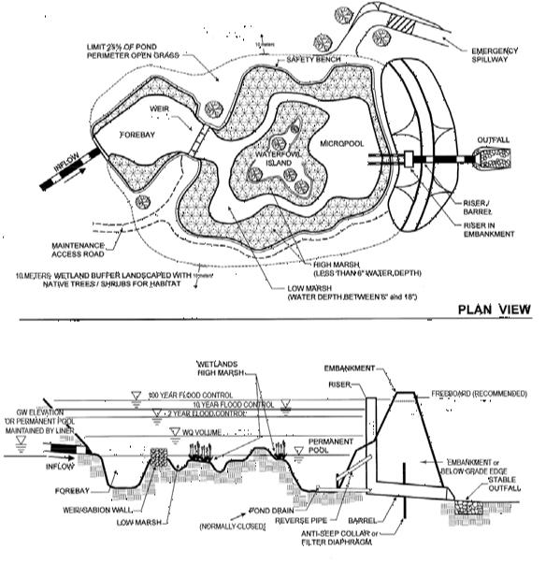
Example Shallow Marsh Wetland - Adapted from Schueler 1992

Basin/Wetland Systems
(formerly pond/wetland system)

Multiple cell systems, such as basin/wetland systems, use at least one wet basin along with a shallow marsh component. The first cell is a sediment forebay that outlets to a wet basin, which removes particulate pollutants. The wet basin also reduces the velocity of the runoff entering the system. Stormwater then travels to the next cell, which contains a plunge pool. The plunge pool acts as an energy dissipator. Shallow marshes provide additional treatment of runoff, particularly for dissolved pollutants. These systems require less space than the shallow marsh systems and generally achieve a higher pollutant removal rate than other stormwater wetland systems.

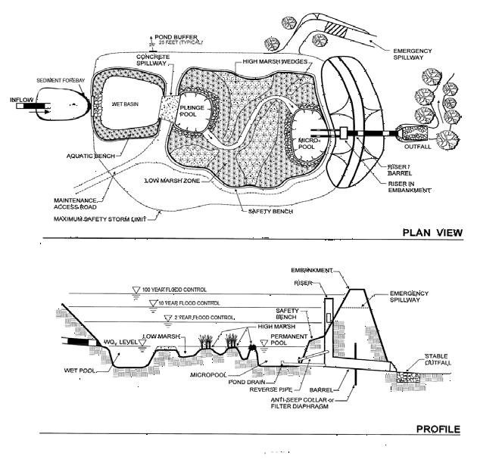
Example Basin Wetland - Adapted from Schueler 1992

Extended Detention Wetlands
Extended detention wetlands provide a greater degree of downstream channel protection. These systems require less space than shallow marsh systems, because temporary vertical storage substitutes for shallow marsh storage. The additional vertical storage area also provides extra runoff detention above normal elevations. Water levels in the extended detention wetlands may increase by as much as three feet after a storm, and return gradually to normal within 24 hours of the rain event. The growing area in extended detention wetlands expands from the normal pool elevation to the maximum Surface Water elevation. Wetlands plants that tolerate intermittent flooding and dry periods should be selected for the extended detention area above the shallow marsh elevations.

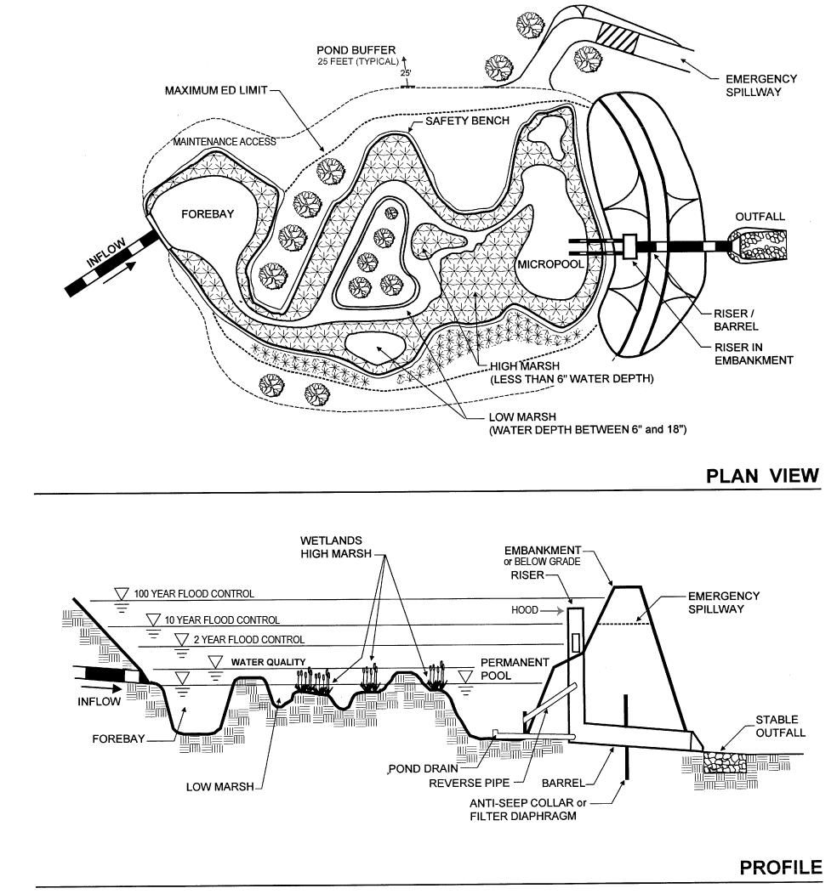
Example Extended Detention Wetland - Adapted from Schueler 1992

Pocket Wetlands
Use these systems for smaller drainage areas from one to ten acres. To maintain adequate water levels, excavate pocket wetlands to the groundwater table. Pocket wetlands that are supported exclusively by stormwater runoff generally will have difficulty maintaining marsh vegetation during normal dry periods each summer.

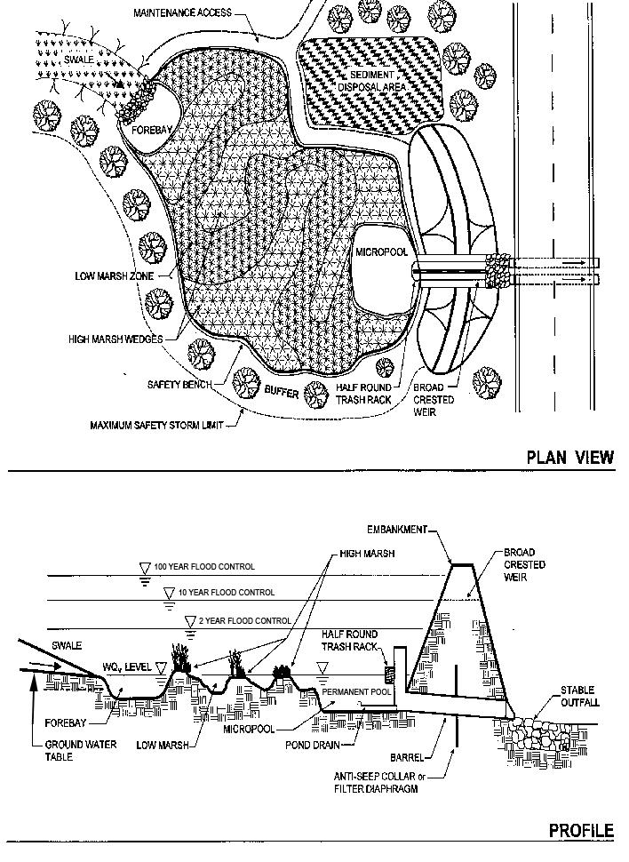
Example Pocket Wetland - Adapted from Schueler 1992

Gravel Wetlands
The gravel wetland consists of a series of horizontal flow through treatment cells preceded by a sediment forebay. The University of New Hampshire (UNH) has developed specifications that allow the gravel wetland to treat the required water quality volume; 10% in the forebay and 45% in each treatment cell. The UNH design calls for excess runoff to overflow into an adjacent swale with side slopes graded at 3:1 or flatter.
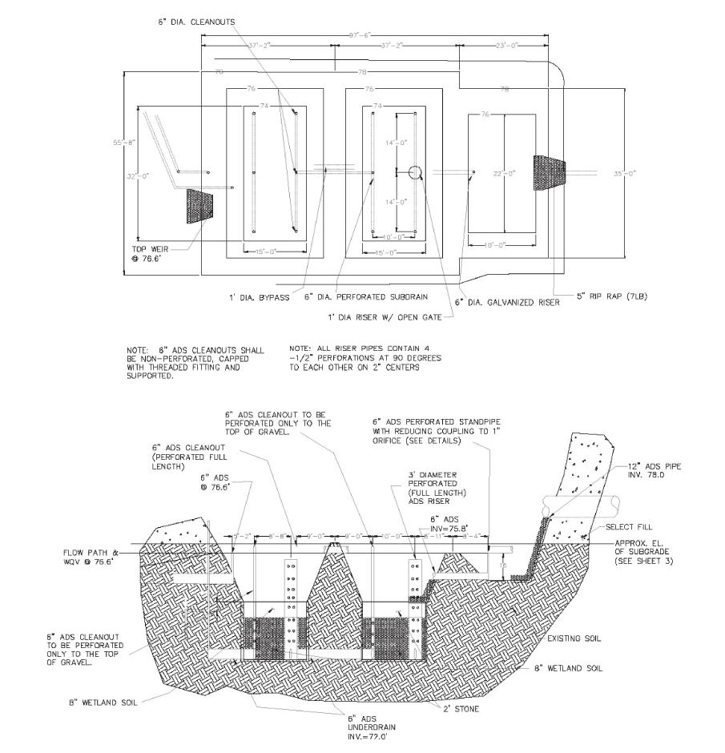
Treatment occurs in each cell as stormwater passes horizontally through the microbe rich gravel substrate. The wetland is designed to continuously saturate at a depth that begins four inches below the treatment’s surface. This design permits treatment and vegetation growth. To generate this condition, UNH designs the device with an outlet pipe that has an invert 4 inches below the surface. For information on gravel wetland design, see https://www.unh.edu/unhsc/sites/default/files/media/unhsc_gravel_wetland_spec_6-2016.pdf.
Example Gravel Wetland

Applicability

Never use constructed stormwater wetlands to manage runoff during site grading and construction. Site constraints that can limit the suitability

of constructed stormwater wetlands include inappropriate soil types, depth to groundwater, contributing drainage area, and available land area. Soils consisting entirely of sands are inappropriate unless the groundwater table intersects the bottom of the constructed wetland or the constructed stormwater wetland is installed over the sand to hold water. Where land area is not a limiting factor, several wetland design types may be possible. Consider pocket wetlands where land area is limited.

Do not locate constructed stormwater wetlands within natural wetland areas. These engineered stormwater wetlands differ from wetlands created for restoration or replication. Typically, constructed stormwater wetlands will not have the full range of ecological functions of natural wetlands. Constructed stormwater wetlands are designed specifically to improve water quality. Note that constructed stormwater wetlands do not create any additional wetland Resource Area or Buffer Zones as discussed in Section 3.

Before designing and siting constructed stormwater wetlands, investigate soil types, depth to bedrock, and depth to water table. Medium-fine texture soils (such as loams and silt loams) are best at establishing vegetation, retaining Surface Water, facilitating groundwater discharge, and capturing pollutants.

At sites where infiltration is too rapid to sustain permanent soil saturation (such as sandy soils), consider using an impermeable liner. Liners are also required where the potential for groundwater contamination from runoff is high, such as from sites with high potential pollutant loads.

At sites where bedrock is close to the surface, high excavation costs may make constructed stormwater wetlands infeasible. Table CSW.1 lists the recommended minimum design criteria for constructed stormwater wetlands.

Effectiveness
A review of the existing performance data indicates that the removal efficiencies of constructed stormwater wetlands are significantly higher than the removal efficiencies of dry extended detention basins. Constructed stormwater wetlands are among the most effective treatment practices.

To preserve their effectiveness, MassDEP requires placing a sediment forebay as pretreatment for all constructed stormwater wetlands.

Studies indicate that removal efficiencies of constructed stormwater wetlands decline when they are covered by ice or receive runoff derived from snow melt. Performance also declines during the non- growing season and the fall when vegetation dies off. Expect lower pollutant removal efficiencies until vegetation is re-established.

One preferred wetland installation is to combine an off-line stormwater wetland design, for runoff quality treatment, with an on-line runoff quantity control, because large surges of water can damage wetlands. Further, the shallow depths required to maintain the wetlands conflict with the need to store large volumes to control runoff quantity.

Planning Considerations

Carefully evaluate sites when planning constructed stormwater wetlands. Investigate soils, depth to bedrock, and depth to water table before designing, permitting, and siting constructed wetlands. Applicants must consider a “pond-scaping plan” for each constructed stormwater wetland. The plan must contain the location, quantity and propagation methods for the wetland plants as well as site preparation and maintenance. The plan should also include a wetland design and configuration, elevations and grades, a site/soil analysis, estimated depth zones, and hydrological calculations or water budgets.
The water budget must demonstrate that a continuous supply of water is available to sustain the constructed stormwater wetland. Develop the water budget during site selection and then check it after the preliminary site design. The water budget analysis must be based on the Thornwaite method, arranging data in a “bookkeeping” or “spreadsheet” format. The water budget must take into account precipitation, runoff, evapotranspiration, soil moisture, and groundwater inputs. Drying periods of longer than two months adversely affect the richness of the plant community, so make sure that the water budget confirms that the drying time will not exceed two months.

Setback Requirements
Stormwater Control Measures (SCMs) and other components of the Stormwater Management System must be setback from wetlands, building foundations, and other features in accordance with 310 CMR 10.05(6)(q). SCMs must also include vertical separation between certain features, such as the depth to seasonally high groundwater. Refer to Section 2.5 of the Stormwater Handbook for horizontal setback and vertical separation distance requirements. Horizontal setbacks also include maintenance access requirements around the perimeter of certain SCMs.

Table CSW.1
Recommended Design Criteria for Stormwater Constructed Wetlands Designs

Design Criteria | Shallow Marsh | Basin/Wetland | ED Wetland | Pocket Wetland | Gravel Wetland (sub-Surface)
Minimum Drainage Area (acres) | ≥25 | ≥25 | ≥10 | ≥1 to 10 | SEE  SPECIFICATIONS
Constructed Wetland Surface Area¹/Watershed Area Ratio | ≥0.02 | ≥0.01 | ≥0.01 | ≥0.01
Length to Width Ratio (minimum) | ≥2:1 | ≥2:1 | ≥2:1 | ≥2:1
Extended Detention (ED)² | NOT ALLOWED | OPTIONAL | YES | OPTIONAL
Allocation of WQv Volume  (wet pools³/low and high marsh/ED) in % | 30/70/0 | 70/30/02 | 20/30/50 | 20/80/02
Allocation of Surface Area (wet pools/low marsh/high marsh/semi-wet) in % | 15/40/40/5 | 45/25/25/5 | 10/40/40/10 | 10/45/40/5
Sediment Forebay | REQUIRED | REQUIRED | REQUIRED | REQUIRED
Micropool | REQUIRED | REQUIRED | REQUIRED | REQUIRED
Outlet Configuration | Reverse slope pipe or hooded broad crested weir | Reverse slope pipe or hooded broad crested weir | Reverse slope pipe or hooded broad crested weir | Hooded broad crested weir
Target Allocations | Shallow Marsh | Basin/Wetland | ED Wetland | Pocket Wetland
 | % Surface Area
Percent Wetland Plants |  | 85% | >55% | >90% | >90%
Sediment Forebay⁴ | 5% | 0%⁵ | 5% | 5%
Micropool | 5% | 5% | 5% | 5%
Deep Water Channel | 5% | 40% | 0% | 0%
Low Marsh | 40% | 25% | 40% | 45%
High Marsh | 40% | 25% | 40% | 40%
Semi Wet | 5% | 5% | 10% | 5%
% WQv Volume
Sediment Forebay | 10% | 0%⁵ | 10% | 10%
Micropool | 10% | 10% | 10% | 10%
Deep Water Channel⁶ | 10% | 60% | 0% | 0%
Low Marsh | 45% | 20% | 20% | 55%
High Marsh | 25% | 10% | 10% | 25%
Semi Wet | 0% | 0% | 50%(ED) | 0%
Low/High/Semi Wet Depth | 6/18/24 inches | 6/18/24 inches | 6/18/24 inches | 6/18/24 inches

Notes:
- Constructed Wetland Surface Area includes wet pool, deep water channel, marshes, and semi-wet zone.

- ED volume shall be an additional volume above the WQv (except for the ED Wetland)

- Wet Pool = Forebay+Micropool+Deep Water

- Sediment Forebay for 1/2-inch WQv is 20% of WQv. Only 10% of that Volume may be included in the Constructed Wetland.

- Basin Wetland Forebay: Forebay sizing must not be counted as part of WQv. Sediment Forebay Volume = 0.1-inch x Impervious area

- Includes “basin” volume in Basin/Wetland Design

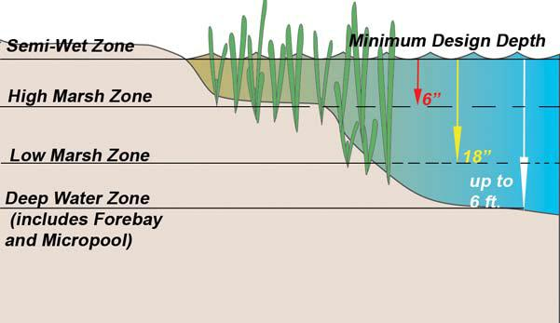
Design Considerations

Constructed stormwater wetlands may be designed as on-line systems with permanent pools for both treatment and storage of peak flows. Constructed stormwater wetlands can also be designed as off-line systems with high flows routed around the wetland. The basic constructed stormwater wetland design sizing criteria is set forth in Table CSW.1. Whether designed as an on-line or off-line system, a constructed stormwater wetland must be sized for the required water quality volume. The required water quality volume to achieve 90% TSS/60% TP removal or 80% TSS/50% TP removal is determined using the EPA curve for gravel wetlands.

All types of Constructed Stormwater Wetlands may be designed so as to intersect the groundwater table, except for the gravel wetland types. Gravel wetlands types must be designed to have the lowest portion of the gravel layer at least 2 feet above seasonal high groundwater. Siting CSWs in relation to seasonal high groundwater table is critical to ensure adequate hydrology to support hydrophytic vegetation. See Section 6.3 for procedures to identify seasonal high groundwater. When CSWs are constructed above the groundwater table, the designer needs to ensure that the contributing impervious area will be large enough to provide adequate hydrology to support the growth of hydrophytic vegetation.
The ratio of the surface area of the constructed stormwater wetland to longer flow paths through the constructed stormwater wetlands to the contributing watershed area must meet the criteria specified in Table CSW.1. The reliability of pollutant removal tends to increase as the ratio of constructed stormwater wetlands area to watershed area increases.

Design the constructed stormwater wetlands with the required proportion of “depth zones.” Each of the constructed wetland designs other than the gravel wetland, has depth zone allocations, which are given as a percentage of the stormwater wetland surface area. Target allocations for these constructed wetland designs are listed in Table CSW.1. The four basic depth zones are (see Figure CSW.1):

Deepwater zone

From 1.5 feet to six feet below normal pool elevation. This zone supports little emergent vegetation, but may support submerged or floating vegetation.

This zone can be further broken down into forebay, micropool and deepwater channels.

Low marsh zone

Ranges from 6 inches to s18 inches below the normal pool elevation. This area is suitable for growing several emergent wetland plant species.

Figure CSW.5 Example Design Depth Zones (see Table CSW.1 for actual recommended design criteria)
High marsh zone

Ranges from the normal pool elevation to 6 inches below normal pool elevation. This zone will support a greater density and diversity of emergent wetland species than the low marsh zone. The high marsh zone must have a higher surface area to volume ratio than the low marsh zone (see Table CSW.1).

Semi-wet zone

This zone includes those areas above the normal pool elevation that are intermittently inundated and that can be expected to support wetland plants.

Design each constructed stormwater wetland with the required proportion of treatment volumes, which have been represented as a percentage of the three basic depth zones (pool, marsh, extended detention). Table CSW.1 specifies the allocations of treatment volume per zone.

Increase the contact time over the surface area of the marsh, thereby improving treatment efficiency. The constructed stormwater wetland must be designed to achieve a dry weather flow path of 2:1 (length: width) or greater.

Prepare a water budget to demonstrate that the water supply to the constructed stormwater wetland is greater than the expected loss rate. The water budget must be based on the Thornwaite method.

Provide extended detention (ED) for smaller storms. Schueler 1992 lists the following design standards for ED wetlands:

- The volume of the extended detention must be no more than 50% of the total treatment volume.

- The target ED detention time for this volume must be 12 to 24 hours.

- Use V-shaped or proportional weirs to ensure constant detention time for all storm events.

- Extended detention is defined here as the retention and gradual release of a fixed volume of stormwater runoff. For ED wetlands less than 100 acres, the extended detention volume can be assumed to fill instantaneously for design purposes.

- Use a reverse slope pipe and increase the actual diameter of the orifice to the next greatest diameter on the standard pipe schedule. The pipe must be equipped with a gate valve.
- Protect the ED orifice from clogging.

- Make the maximum ED water surface elevation

- no greater than three feet above the normal pool elevation.

Design each constructed stormwater wetland with a separate cell near the inlet to act as a sediment forebay. Design the forebay with a capacity of at least 10% of the total treatment volume, normally 4 to 6 feet deep. Provide a direct and convenient access for cleanout.

Surround all deep-water cells with a safety bench that is at least ten feet wide, and zero to 18 inches below the normal water depth of the pool.

Place above-ground berms or high marsh wedges at approximately 50-foot intervals, and at right angles to the direction of the flow to increase the dry-weather flow path within the wetland.

Include a four- to six-foot deep micropool before the outlet to prevent the outlet from clogging. Provide a micropool capacity of at least ten percent of the total treatment volume. Use a reverse slope pipe or a hooded, broad- crested weir for outlet control. Locate the outlet from the micropool at least one foot below the normal pool surface.

To prevent clogging, install trash racks or hoods on the riser. To facilitate access for maintenance, install the riser within the embankment. Install anti-seep collars on the outlet barrel to prevent seepage losses and pipe failures. Install a bottom drainpipe with an inverted elbow to prevent clogging and to facilitate complete draining of the wetland for emergency purposes or routine maintenance. Fit both the outlet pipe and the bottom drainpipe with adjustable valves at the outlet ends to regulate flows. Design embankments and spillways in accordance with the state regulations and criteria for dam safety.

All constructed stormwater wetlands must have an emergency spillway capable of bypassing runoff from large storms without damage to the impounding structure.

Provide an access for maintenance, with a minimum width of 15 feet and a maximum slope of 15%, through public or private rights-of-way. Make sure this access extends to the forebay, safety bench, outflow structure, and entire perimeter. It need not cross the emergency spillway, unless the spillway has been designed and constructed for this purpose.

Locate vegetative buffers around the perimeter of the constructed stormwater wetland to control erosion and provide additional sediment and nutrient removal for sheet flow discharging to the constructed stormwater wetland.

Construction

This seven-step process is recommended to prepare a wetland bed prior to planting (Shueler 1992):
- Prepare final pond-scaping and grading plans for the constructed stormwater wetland. At the same time, order wetland plant stocks from aquatic nurseries.

- Once the constructed stormwater wetland volume has been excavated, grade the wetland to create the major internal features (pool, aquatic bench, deep water channels, etc.).

- Because deep subsoils often lack the nutrients and organic matter needed to support vigorous plant growth, add topsoil and/or wetland mulch to the wetland excavation. If available, wetland mulch is preferable to topsoil.

- After the mulch or topsoil has been added, grade the constructed stormwater wetland to its final elevations. Temporarily stabilize all wetland features above the normal pool. After final grading, close the pool drain to allow the pool to fill. MassDEP recommends evaluating the wetland elevations during a standing period of approximately six months to assess how the constructed stormwater wetland responds to storm flows and inundation, where the pond-scaping zones are located, and whether the final grade and micro-topography will persist over time.

- Before planting, measure the constructed stormwater wetland depths to the nearest inch to confirm planting depth. If necessary, modify the pond-scape plan at this time to reflect altered depths or availability of plant stock.

- Aggressively apply erosion controls during the standing and planting periods. Stabilize the vegetation in all areas above the normal pool elevation during the standing period (typically by hydroseeding).

- Dewater the constructed stormwater wetland at least three days before planting, because a dry wetland is easier to plant than a wet one.

Wetland Vegetation

The Plans to be submitted with the Wetlands NOI or WQC application must state the wetland plant species proposed to be established. Phragmites must not be established or maintained in CSWs. The required O/M plan must include measures to remove or eliminate any invasive Phragmites. Cat tails (Typha latifolia and other Typha species) must not be established in CSWs because they create monocultures, limiting diversity. Establishing and maintaining wetland vegetation is important when creating a constructed stormwater wetland. Horner et al. (1994) recommend the following actions when constructing stormwater wetlands:

- In selecting plants, consider the prospects for success over the specific pollutant removal capabilities and plant species growing in nearby natural wetlands. Plant uptake is an important removal mechanism for nutrients, but not for other pollutants. The most versatile genera for pollutant removal are Carex, Scirpus, Juncus, and Lemna. Consult the NRCS plant database to determine if the plant is appropriate. The NRCS database lists the plants prohibited for sale in Massachusetts.

- Select native species, avoiding those that are invasive. Because diversification will occur naturally, use a minimum of species adaptable to the various elevation zones within the stormwater wetland.

- Give priority to perennial species that establish themselves rapidly.

- Select species adaptable to the broadest ranges of depth, frequency and duration of inundation (hydroperiod).
- Match site conditions to the environmental requirements of plant selections.

- Take into account hydroperiod and light conditions.

- Give priority to species that have already been used successfully in constructed stormwater wetlands and that are commercially available.
- Avoid using only species that are foraged by the wildlife expected on site.

- Establish woody species after herbaceous species.

- Where applicable, add vegetation that will achieve other objectives, in addition to pollution control.

Plants will develop best when soils are enriched. Use a “mulch mixture” to enhance the diversity of the plant community and speed its establishment.

A mulch mixture utilizes sediments removed during cleaning and dredging of stormwater drainage channels, swales, sedimentation basins, dry detention basins, and infiltration basins. Hydric soils that may be commercially available may also be utilized. The upper 6-inches of the donor mulch mixture or soil

should be obtained at the end of the growing season, and kept moist until installation. Drawbacks to using a mulch mixture are the unpredictable content, limited donor sites, and the potential for the introduction of opportunistic species, such as Phragmites, Typha species, and Japanese knotweed (Polygonum cuspidatum Sieb. & Zucc.). Measures in the Operation and Maintenance Plan required by Stormwater Standard No. 9 must address invasive species removal. Wetland plants are commercially available through wetland plant nurseries.
Maintenance

Activity | Frequency
Inspect wetland during both growing and non-growing seasons | Twice a year for the first three years of construction.
Remove debris and sediment from the forebays. | Once a year
Remove sediment in basin/wetland systems. | Once every ten (10) years

Unlike conventional wet basin systems that require large-scale sediment removal at infrequent intervals, constructed stormwater wetlands require small- scale maintenance at regular intervals to evaluate the health and composition of the plant species.

Applicants must carefully observe the constructed stormwater wetland system over time. In the

first three years after construction, inspect the constructed stormwater wetlands twice a year during both the growing and non-growing seasons. This requirement must be included in the Operation & Maintenance plan. During these inspections, record and map the following information:

- Whether the Constructed Stormwater Wetlands have appropriate hydrology (sufficiently wet to support hydrophytic vegetation community). The following are not appropriate hydrology: too dry or too wet to support a hydrophytic vegetation community;
- The types and distribution of the dominant wetland plants in the marsh;

- The presence and distribution of planted wetland species;

- Whether the Constructed Stormwater Wetland has obtained the design percent hydrophytic vegetation coverage (e.g., >90% spatial coverage for pocket wetlands).
- The presence and distribution of invasive and opportunistic wetland species (invasives species such as Phragmites and opportunistic species such as Typha must be removed);

- Indications that other species are replacing the planted wetland species;

- Percentage of standing water that is unvegetated (excluding the deep water cells which are not suitable for emergent plant growth);
- The maximum elevation and the vegetative condition in this zone, if the design elevation of the normal pool is being maintained for wetlands with extended zones;

- Stability of the original depth zones and the micro-topographic features; and

- Accumulation of sediment in the forebay and micropool; and survival rate of plants (cells with dead plants must be replanted).

Operation and Maintenance Plans must include the corrective actions that will be taken be correct the hydrology and establish the appropriate percent coverage of the hydrophytic plant community, when inspection indicates the hydrology and hydrophytic plant community have failed to meet the design specifications listed herein.
Any deficiencies noted in the first three years after construction must be corrected before the Applicant requests a Certificate of Compliance.
Maintenance of Sediment Forebay

Another important maintenance activity is regulating the sediment loading into the constructed stormwater wetland. All constructed stormwater wetlands are required to have a sediment forebay. Sediment accumulating in wetlands reduces water depths, changes the growing conditions for emergent plants, and alters the wetland plant community. Most sediment should be trapped and removed by the forebay or other type of basin before it reaches the wetland.

The sediment in the forebay should be removed

at least once a year.

References
Shuler, Thomas, 1992. Design of Stormwater Wetlands Systems: Guidelines for Creating Diverse and Effective Stormwater Wetlands in the Middle Atlantic Regions, Metropolitan Washington Council of Governments, Washington, D.C.

Carleton, J.N., Grizzard, T.J., Godrej, A.N., and Post, H.E., 2001, Factors Affecting the Performance of Stormwater Treatment Wetlands, Water Research, Volume 35, No. 6, pp 1552-1562

UNH Stormwater Center, 2016, Gravel Wetland Fact Sheet,

https://www.unh.edu/unhsc/sites/default/files/media/unhsc_gravel_wetland_spec_6-2016.pdf

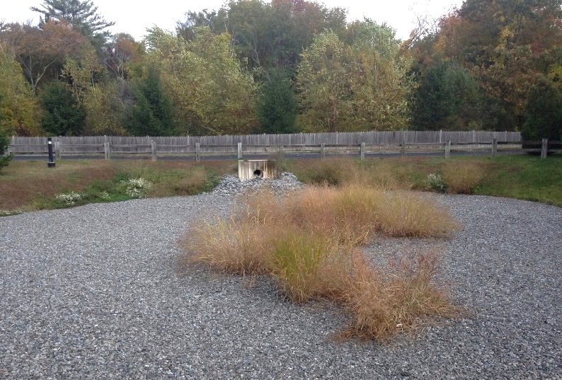
Extended Dry Detention Basin

Ability to meet specific standards

Standard | Description
2 - Peak Flow | If properly designed, can provide peak flow attenuation.
3 - Recharge | Provides no groundwater recharge
4 - TSS/TP Removal | Use EPA Dry Pond Performance Curve to calculate required sizing to meet pollutant removal requirements. See “Introduction” Section of this Appendix for more information the EPA Performance Curves. Sediment forebay required for pretreatment.
5 - Higher Pollutant Loading | May be used as treatment SCM provided basin bottom is lined and sealed. For some land uses with higher potential pollutant loads, may also need oil/grit separator, sand filter, lined bioretention area, or equivalent prior to discharge to extended dry detention basin.
6 - Discharges near or to Critical Areas | Shall not be used for discharges near or to critical areas.
7 - Redevelopment | Existing dry detention basins bay be retrofitted to become extended dry detention basins.
8 - Construction Phase | Construction phase runoff is not to be diverted to these areas; divert stormwater runoff to these areas only once the site has been stabilized.
9 - O&M | An O&M plan is required for this SCM.
11 - Total Maximum Daily Loads | See suitability to treat TMDL Pollutants Table (below). Must be properly designed, sized, and maintained.
ESSD / LID? | No, this practice is not a MassDEP recognized ESSD / LID technique.

Description
Structural Treatment
Structural Treatment
Extended dry detention basins are modified conventional dry detention basins, designed to hold stormwater for

at least 24 hours to allow solids to settle and to reduce local and downstream flooding. Extended dry detention basins may be designed with either a fixed or adjustable outflow device. Pretreatment is a fundamental design component of an extended dry detention basin to reduce the potential for clogging. Other components such as a micropool or shallow marsh may be added to enhance pollutant removal.

Advantages/Benefits

- Least costly SCM that controls both stormwater quantity and quality.

- Good retrofitting option for existing basins.

- Can remove significant levels of sediment and absorbed pollutants.

- Potential for beneficial terrestrial and aquatic habitat.

- Less potential for hazards than deeper permanent pools.

Disadvantages/Limitations

- Infiltration and groundwater recharge is negligible, resulting in minimal runoff volume reduction.
- Removal of soluble pollutants is minimal.

- Requires relatively large land area.

- Moderate to high maintenance requirements.

- Potential contributor to downstream warming.

- Sediment can be resuspended after large storms if not removed.

Suitability to Treat TMDL Pollutants

Pollutant | Suitable to Treat?
TSS | N
Total Nitrogen | N
Total Phosphorous | N
Pathogens | N
Metals | Y

Notes:
- Pathogens category includes: fecal coliform, E. coli, and enterococcus.
- Metals category includes Zinc, Cadmium, Lead, Aluminum, and Iron.
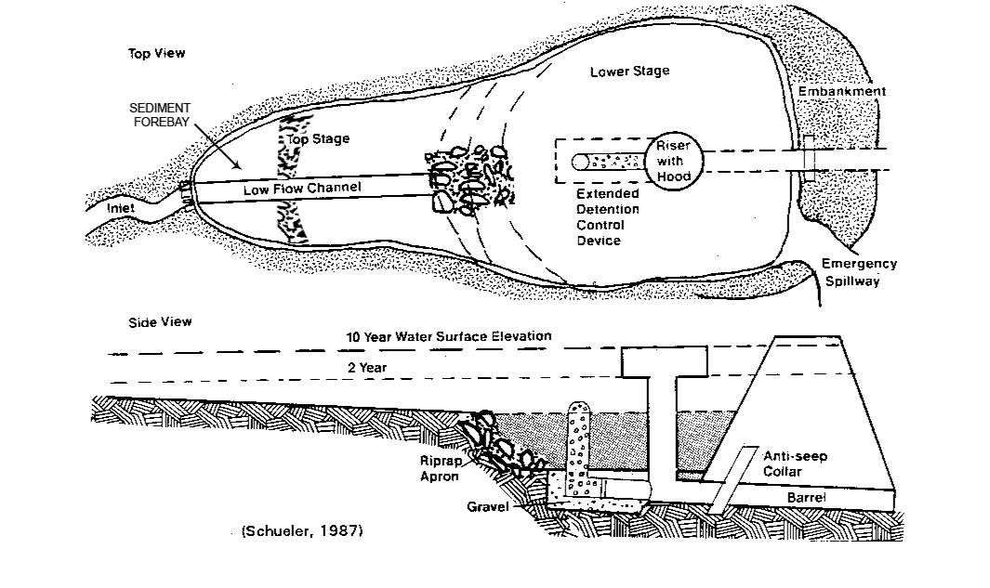
Unit Process for Treatment
Example Extended Dry Detention Basin -adapted from Controlling Urban Runoff, Schueler 1987
- Gravity Separation
Special Features

Design extended dry detention basins with three distinct stages;
- The upper stage should have the capacity to regulate peak flow rates of large, infrequent storms (10, 25, or 100 -year recurrence intervals).

- The middle stage is designed to regulate peak flow from the 2-year storm.
- Design the lowest stage of the basin to detain the water quality volume for at least 24 hours to remove pollutants from the runoff. The water quality volume stage is determined using the EPA curve for dry ponds. For example, the water quality volume needed to provide 49% TSS/36% TP removal using the EPA curve is approximately 2-inches times the impervious area of the site.
ESSD/LID Alternatives
This practice is not a MassDEP recognized ESSD / LID technique. ESSD and LID techniques must be used unless demonstrated to be impracticable based on a written alternatives analysis. Other SCMs shall only be used to the meet those portions of Standard 3 (i.e., Required Recharge Volume) and Standard 4 (i.e., TSS / TP removal) that cannot be fully met by ESSD and LID techniques. See Section 4.2 of the Stormwater Handbook for a list of MassDEP recognized ESSD / LID techniques. Most recognized ESSD / LID techniques also have an associated ESSD Credit (see Table A-1) of this Appendix.
Applicability
Generally, extended dry detention basins are not practical if the contributing watershed area is less than ten acres. MassDEP recommends four acres of drainage area for each acre -foot of storage in the basin. Extended dry detention basins can be used at residential, commercial and industrial sites.

Because they have a limited capability for removing soluble pollutants, extended dry detention basins are more suitable for commercial applications where there are high loadings of sediment, metals and hydrocarbons. Do not use extended dry detention basins by themselves in low-density residential areas, where soluble nutrients from pesticides and fertilizers may be a concern. Combine extended dry detention basins with a shallow marsh system or other SCMs for more efficient pollutant removal.

Existing dry detention basins can be retrofitted as extended dry detention basins at a relatively low cost by simply modifying the outlet structure. Because of the land requirements, extended dry detention basins are not feasible at sites where land costs or space is at a premium. Investigate soils, depth to bedrock, and depth to water table before designing an extended dry detention basin for a site.

Effectiveness

The primary pollutant removal mechanism in extended dry detention basins is settling; therefore, the degree of pollutant removal depends on whether the pollutant is in the particulate or dissolved form. Expect limited removal for soluble pollutants, but high removal rates for particulate pollutants. When designed properly, extended dry detention basins are effective in reducing pollutant loads and controlling post-development peak discharge rates. Extended dry detention basins may be used to meet Stormwater Management Standards 2 and 4. However, extended dry detention basins do not reduce post- development increases in runoff volume. Additionally, extended dry detention basins provide no groundwater recharge.

Planning Considerations

Check the soils, depth to bedrock and depth to water table before designing an extended dry detention basin. Where bedrock is close to the surface, high excavation costs may make extended dry detention basins infeasible. Maximum depth of the extended dry detention basin may range from 3 to 12 feet. The depth of the basin may be limited by groundwater conditions or by soils.

If soils on -site are relatively impermeable such as soil group D (as defined by the NRCS), or the water table is within two feet of the bottom of the basin, the basin may experience problems with standing water, Therefore, design the bottom of extended dry detention basin to be at least 2 feet in elevation above the seasonal high groundwater elevation. If runoff is from a land use with a higher potential pollutant load, provide adequate pretreatment and a greater separation between the bottom of the basin and the seasonal high groundwater table. Separation of the bottom of the basin from groundwater is needed to ensure that the basin fully dewaters between storms.

To be effective in reducing peak runoff rates, the extended dry detention basin is ordinarily located where it can intercept most of the runoff from the site, usually at the lowest elevation of the site where freshwater wetlands are frequently found. Like all other best management practices, extended dry detention basins may not be constructed in wetland Resource Areas other than isolated land subject to flooding (ILSF), bordering land subject to flooding (BLSF), land subject to coastal storm flowage and riverfront areas. Select a location that will not adversely affect wetland Resource Areas but will still provide the peak rate attenuation required by Standard 2.

Embankments, or dams, created to store more than 15 acre-feet, or that are more than 6 feet high, are under the jurisdiction of the state Office of Dam Safety and are subject to regulation. Placing stormwater treatment structures in ILSF and BLSF can be challenging in part because high groundwater levels may limit suitable locations. If constructed in ILSF or BLSF, compensatory storage is required pursuant to 310 CMR 10.57 for any fill. The design water level should be considered fill for purposes of any compensatory flood storage computations, as the volume will not be available for flood storage when the basin is occupied by stormwater. Locating these basins in ILSF and BLSF, although allowed, is not advisable because they will not function when they are inundated with flood waters. Extended dry detention basin shall not to be credited as compensatory flood storage.
Setback Requirements
Stormwater Control Measures (SCMs) and other components of the Stormwater Management System must be setback from wetlands, building foundations, and other features in accordance with 310 CMR 10.05(6)(q). SCMs must also include vertical separation between certain features, such as the depth to seasonally high groundwater. Refer to Section 2.5 of the Stormwater Handbook for horizontal setback and vertical separation distance requirements. Horizontal setbacks also include maintenance access requirements around the perimeter of certain SCMs.
Design Considerations

[See the following document for complete design references: Design of Stormwater Pond Systems. 1996. Schueler. Center for Watershed Protection.]

Extended dry detention basin design must accommodate large, infrequent storm events for runoff quantity control, as well as small, frequent storm events for runoff quality control. Typically, the first flush of runoff contains the highest concentrations of pollutants. Consequently, design the extended dry detention basin to maximize the detention time for the most frequent storms. Routing calculations for a range of storms should provide the designer with the optimal basin size.

The bottom of the extended dry detention basin must be set in elevation at least 2-feet above seasonal high groundwater.
Generally, most particulates settle within the first 12 hours of detention; however, finer particulates may require additional time to settle. The minimum detention time for the Water Quality Volume is

24- hours. The most traditional and easiest method for extended detention routing is the 24 hour brimfull draw down (Required Water Quality Volume/24 hours = Qavg). This sets the average discharge rate. An orifice is then sized based on a max Q = 2*Qavg, using the brimfull head (Qmax = (CA(2gh)^{1/2}) where h is the head when the basin is full to the Required Water Quality Volume (WQv) elevation, g is acceleration due to gravity, A is the net opening area, and C is the orifice coefficient. The orifice coefficient is determined by consulting tables in standard references such as the Civil Engineering Reference Manual for the PE Exam, 10th Edition, by Michael R. Lindeburg, P.E., 2006.

For extended detention basins proposed in ILSF or BLSF, the peak runoff rate computations shall assume the runoff dosed to the extended detention basin is operating under tailwater conditions and not free discharge.
The critical parameters in sizing an extended dry detention basin are storage capacity and the maximum rate of runoff released from the basin. To meet the requirements of Standard 2, design the storage volume to hold the pre-development peak flow.

To maximize sedimentation, design the extended dry detention basin to lengthen the flow path, thereby increasing detention time. To maximize the detention time, locate the inflow points as far from the outlet structure as possible. Long, narrow configurations with length to width ratios of 2:1 provide better removal efficiencies than small deep basins. Consider using internal berms and other baffles to minimize short-circuiting of flows and increase detention times.

Reducing inflow velocities lengthens detention times,

enhances sedimentation of solids in incoming runoff, and minimizes the potential for resuspension of settled pollutants. Design all inflow points with riprap or other energy dissipators, such as a baffle below the inflow structure. MassDEP requires a sediment forebay to enhance the removal rates of particulates, decrease the velocity of incoming runoff, and reduce the potential for failure due to clogging.

Design sediment forebays for ease of maintenance. Hard bottom forebays, such as those constructed from concrete, make sediment removal easier. All forebays must be accessible for maintenance by heavy machinery, if necessary.

A low flow channel routes the last remaining runoff, dry weather flow and groundwater to the outlet, which should be installed in the upper stage of the basin to ensure that the extended dry detention basin dries out completely. The maximum flow velocity (which should be set at the 2-year peak discharge rate) depends on the nature of the material used to line the channel. Consider whether a pervious or impervious channel lining is most appropriate.

Pervious linings are preferred as they allow runoff to interact with soil and vegetation, thereby increasing the sorption of pollutants. Make design velocities in pervious low flow channels high enough to prevent sedimentation but low enough to prevent scouring and erosion.

Impervious channels are simple to construct, easy to maintain, and empty completely after a storm event. Runoff flows and differential settling can undermine impervious channels unless constructed and maintained properly. Locate the top of the impervious channel lining at or below the level of the adjacent grassed areas to ensure thorough drainage of these areas. When designing impervious channels, take into account settlement of the lining and the adjacent areas as well as the potential for frost impacts on the lining. Provide impervious lining with broken stone foundations and weep holes. Consider the potential for erosion or scour along the edges of the lining caused by bank-full velocities. Maintain

a low outflow discharge rate at the downstream end of the impervious channel to ensure sufficient treatment of runoff, which backs up and overflows onto the grassed basin bottom.

Use low flow underdrains connected to the principal outlet structure or other downstream discharge point to promote thorough drying of the channel and the basin bottom. Take into account the depth of the

low flow channel when preparing the final bottom grading plan. Establish wetland vegetation in a shallow marsh component or on an aquatic bench in the lower stage of the extended dry detention basin to enhance removal of soluble nutrients, increase sediment trapping, prevent sediment resuspension, and provide wildlife and waterfowl habitat. Proper soils and surface depth or groundwater depth are needed to maintain wetland vegetation.

Make the side slopes of the extended dry detention basin no steeper than 3:1, and use intermittent benches to foster vegetative growth and provide for safety. Flatter slopes help to prevent bank erosion during larger storms, make routine bank maintenance tasks (such as mowing) easier, prevent animals from getting trapped, and allow easier access to the basin. Include a multi-stage outlet structure to provide an adequate level of water quality and flood control. To meet the water quantity control standards, use the required design storm runoff rates as the outlet release rates. For water quality control, the release rate will vary with the design storm selected. For extended dry detention basins with shallow marshes or permanent pools, place the lowest stage outlet at an elevation that will create a permanent pool of water.

The type of outlet structure needed will depend on factors such as the type of spillway, basin configuration and extended detention outflow rate. Design the outlet to control the outflow rate without clogging. Locate the outlet structure in the embankment for maintenance, access, safety and aesthetics. Design the outlet to facilitate maintenance; the vital parts of the structure must be accessible during normal maintenance and emergency situations. It also must contain a draw-down valve for complete detention basin draining within 24 hours.

To prevent scour at the outlet, use a flow transition structure, such as a lined apron or plunge pad, to absorb the initial impact of the flow and reduce the velocity to a level that will not erode the receiving channel or area. Design embankments and spillways in accordance with the state regulations for Dam Safety (302 CMR 10.00). All extended dry detention basins must have an emergency spillway capable of bypassing runoff from large storms without damaging the impounding structure.

Provide a public or private right-of-way access for maintenance that is at least 15 feet wide with a

maximum slope of 5:1. Make sure this access extends to the forebay, safety bench, outflow structure and entire perimeter. The access way need not cross the emergency spillway, unless the spillway has been designed for that purpose. Use vegetative buffers around the perimeter of the basin for erosion control and additional sediment and nutrient removal.

Maintenance
Activity | Frequency
Inspect extended dry detention basins | At least twice a year and during and after major storms
Examine the outlet structure for evidence of clogging or outflow release velocities that are greater than design flow | At least twice a year
Mow the upper-stage, side slopes, embankment, and emergency spillway. | At least twice a year
Remove trash and debris | At least twice a year
Remove sediment from the basin | At least once every 5 years
A major storm event for on-going post-construction monitoring is defined as equal to or greater than 1 inch in a 24-hour period.
Inspect extended dry detention basins at least once per year to ensure that the basins are operating as intended. Inspect extended dry detention basins during and after 1 inch/day or greater storm events to determine if the basin is meeting the expected detention times.
Examine the outlet structure for evidence of clogging, subdrain failure, or outflow release velocities that are greater than design flow. Potential problems that should be checked include: subsidence, erosion, cracking or tree growth on the embankment; damage to the emergency spillway; sediment accumulation around the outlet; inadequacy of the inlet/outlet channel erosion control measures; changes in the condition of the pilot channel; and erosion within the basin and banks. Commence any necessary repairs within 24-hours after inspection indicates a deficiency, and no later than the next storm. During inspections, note any changes to the extended dry detention basin or the contributing watershed, because these could affect basin performance.

Mow the upper- stage, side slopes, embankment, and emergency spillway at least twice per year. Also remove trash and debris at this time. Remove sediment from the extended dry detention basin as necessary, but at least once every 5 years. Providing an on-site sediment disposal area will reduce the overall sediment removal costs.

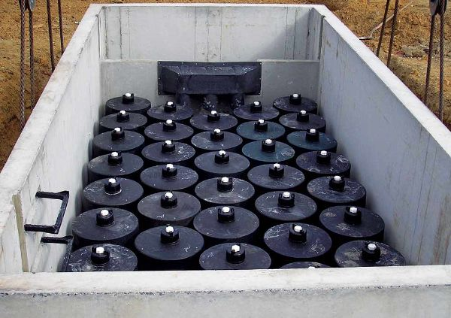
Proprietary Media Filters
Ability to meet specific standards

Standard | Description

2 - Peak Flow | N/A

3 - Recharge | N/A
4 - TSS/TP Removal | No EPA Curve.  TSS: MassDEP variable credit, up to 60%  TP: MassDEP variable credit, up to 30%.  Pollutant removal credit must be determined on a case-by-case basis in accordance with procedures described in Section 5.3 of the Stormwater Handbook
5 - Higher Pollutant Loading | Suitable as treatment device.
6 - Discharges near or to Critical Areas | Suitable as treatment device for some critical areas.
7 - Redevelopment | Suitable; if site is severely constrained, may be preferred.
8 - Construction Phase | May not be used for construction phase runoff.
9 - O&M | An O&M plan is required for this SCM.
11 - Total Maximum Daily Loads | See suitability to treat TMDL Pollutants Table (below). Must be properly designed, sized, and maintained.
ESSD / LID? | No, this practice is not a MassDEP recognized ESSD / LID technique.

Structural Treatment
Description
Media Filters are typically proprietary two -chambered underground concrete vaults that reduce both TSS and other pollutants (e.g., organics, heavy metals, soluble nutrients). After larger particles settle out in the first chamber, stormwater flows through the specific filter media in the second chamber. Selection of the specific media largely depends on the pollutant targeted.

Advantages/Benefits

- Suitable for specialized applications, such as industrial sites, for specific target pollutants

- Preferred for Redevelopments or in the ultra-urban setting when LID or larger conventional practices are not practical

Disadvantages/Limitations

- Requires intensive maintenance

- Performance varies depending upon media

- TSS/TP removal variable, depending on media

- “Wet” systems that are designed to retain water can cause mosquito and vector problems unless access points are sealed

Suitability to Treat TMDL Pollutants

Pollutant | Suitable to Treat?³
TSS | Varies
Total Nitrogen | Varies
Total Phosphorous | Varies
Pathogens | Varies
Metals | Varies
Notes:
- Pathogens category includes: fecal coliform, E. coli, and enterococcus.

- Metals category includes Zinc, Cadmium, Lead, Aluminum, and Iron.
- Pollutant removal ability must be determined on a case-by-case basis in accordance with procedures described in Section 5.3
Unit Treatment Process
- Filtration

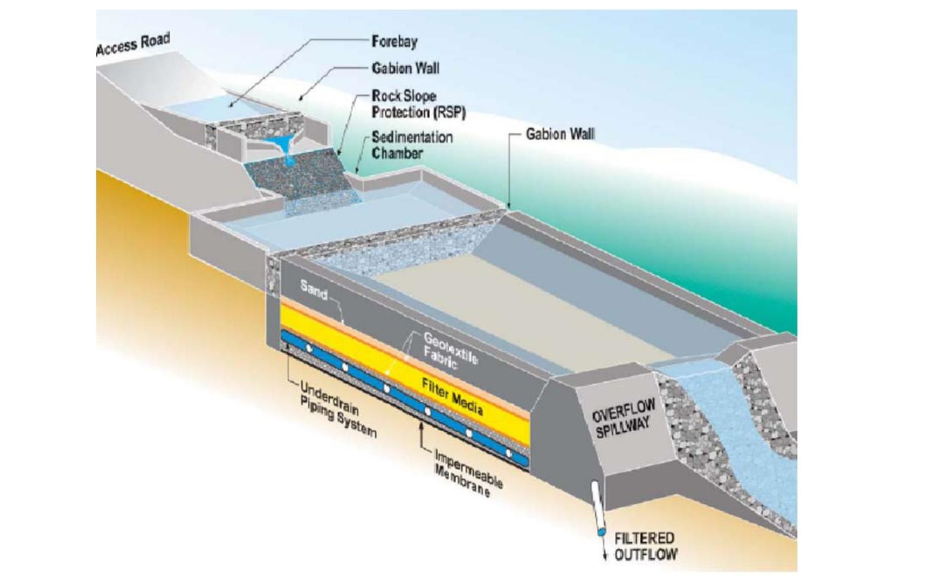
Example Proprietary Media Filter:
Public domain media filter: CALTRANS - California Department of Transportation.

Special Features

Redevelopment, pretreatment for LUHPPL and Critical Areas, and removal of pollutants in addition to TSS

ESSD / LID Alternatives
This practice is not a MassDEP recognized ESSD / LID technique. ESSD and LID techniques must be used unless demonstrated to be impracticable based on a written alternatives analysis. Other SCMs shall only be used to the meet those portions of Standard 3 (i.e., Required Recharge Volume) and Standard 4 (i.e., TSS / TP removal) that cannot be fully met by ESSD and LID techniques. See Section 4.2 of the Stormwater Handbook for a list of MassDEP recognized ESSD / LID techniques. Most recognized ESSD / LID techniques also have an associated ESSD Credit (see Table A-1) of this Appendix.
Applicability

Media Filters are typically two-chambered underground concrete vaults designed to reduce both TSS and other pollutants. The first chamber is usually a pretreatment
settling basin. The second chamber is a filter bed containing either sand or other filtering media or an array of media- containing cartridge filters. After larger particles (e.g., TSS) settle out in the first chamber, stormwater flows through the specific filter media in the second chamber, and a portion of the target pollutants are sorbed to the filter media.

Various media are used, including leaf compost, pleated fabric, activated charcoal, perlite, amended sand and perlite, and zeolite, and tend to vary by manufacturer. Selection of the specific media largely depends on the pollutant targeted. Because MassDEP regulates both TSS and TP, and additional constituents when a TMDL has been established, the media selected must be capable of removing a range of different contaminates. Media filters must have the filter medium in the filter beds or the cartridges replaced periodically; following the manufacturer’s schedule for operation and maintenance is critical to successful continued effectiveness.

Since Media Filters are Proprietary SCMs, MassDEP has not assigned this group of SCMs a TSS or TP removal rate. Their performance varies depending upon the specific unit selected, the targeted pollutants, and successful design of the system. The procedure described in Section 5.3 of the Stormwater Handbook, must be used by the Issuing Authority to establish the TSS removal rate that will be used for permitting purposes.

Setback Requirements
Stormwater Control Measures (SCMs) and other components of the Stormwater Management System must be setback from wetlands, building foundations, and other features in accordance with 310 CMR 10.05(6)(q). SCMs must also include vertical separation between certain features, such as the depth to seasonally high groundwater. Refer to Section 2.5 of the Stormwater Handbook for horizontal setback and vertical separation distance requirements. Horizontal setbacks also include maintenance access requirements around the perimeter of certain SCMs.
Design Considerations

Media filters may require an upgradient storage chamber to queue or store runoff. Some media filters may require pretreatment, just like many traditional types of treatment practices. Media Filters are most efficient when designed to operate off-line. Media Filters must contain a by-pass device to allow large stormwater flows from intense precipitation to by-pass the media filters, so as to not cause resuspension of material trapped by the filters. Media Filters must be sized to treat the water quality volume (1.0 inch), depending on whether there is a discharge to a critical area, if the drainage is from a land use with higher potential pollutant load (LUHPPL), or is being directed to a soil with a rapid infiltration rate (hydraulic permeability >2.4 inches/hour). Since most Media Filter designs are based on flow rate, the flow rate must be converted to a Volume MassDEP method to convert the WQV to a peak flow rate. See Appendix D for the standard method to perform this calculation.

Media Filters can be either “dry” or “wet” design. “Dry” Media Filters are designed to dewater completely between storms.

For design purposes, use 72 hours to evaluate dewatering, using the storm that produces 1.0 inch of runoff (water quality volume) in a 24-hour period. “Wet” Media Filters maintain a permanent pool of water as part of the treatment system.

For media filters constructed or placed below grade, inspection ports and cleanout ports must be included in the design to allow access to the system for maintenance.

Maintenance

For proprietary systems, maintenance must be conducted in strict accordance with the manufacturer’s requirements. Spare filters must be stored on site, so filters can be replaced quickly when inspection indicates replacement is necessary. Clean-out of trapped sediment in the concrete vaults housing the media filters may require the party conducting the maintenance to be trained for confined space entry under OSHA requirements.

“Dry” Media Filters are designed to dewater completely in 72 hours. Prevention of mosquito and vector breeding in dry designs depends on maintenance that ensures that dewatering occurs in 72 hours, that filters are not clogged and trapping water, and that associated SCM accessories (such as level spreaders) dewater as designed. “Wet” Media Filters are more conducive to mosquito and vector problems. Tight-fitting seals can be used to keep mosquitoes and vectors from entering and breeding in the permanent pools, and maintenance may include routine inspection and treatment.
Activity | Frequency
Inspect for standing water, sediment, trash, and debris and clogging | At least twice a year; follow manufacturer’s schedule
Remove accumulated trash and debris | During every inspection

Inspect to determine if system drains in 72 hours | Once a year during wet season, and after large storms
Inspect filtering media for clogging; replace if clogged | Per manufacturer’s specifications
References
California Stormwater Quality Association, 2003, California Stormwater SCM Handbook, Media Filter, Practice No. TC-40, http://www.caSCMhandbooks. com/Documents/Development/TC-40.pdf

Connecticut Department of Environmental Protection, 2004, Connecticut Stormwater quality Manual, Media Filters, pp. II-S11-1 to II-S11-3, http:// https://portal.ct.gov/DEEP/Water-Regulating-and-Discharges/Stormwater/Stormwater-Manual

Idaho Department of Environmental Quality, 2005, Storm Water Best Management Practices Catalog, Media Filter, SCM 7, pp. 43-44, http://www.deq.idaho. gov/water/data_reports/storm_water/catalog/sec_4/ SCMs/7.pdf

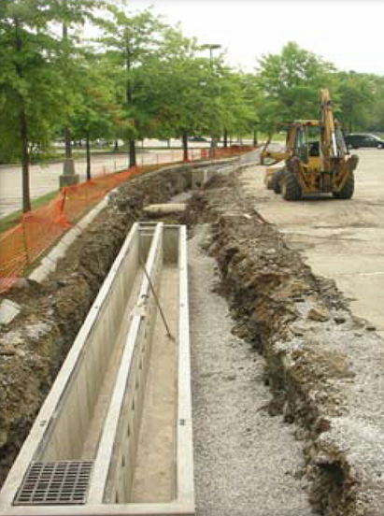
Sand and Organic Filters

Ability to meet specific standards

Standard | Description
2 - Peak Flow | N/A
3 - Recharge | N/A
4 - TSS/TP Removal | Use EPA Sand Filter Performance Curve to calculate required sizing to meet pollutant removal requirements. See “Introduction” Section of this Appendix for more information the EPA Performance Curves. Pretreatment is required.
5 - Higher Pollutant Loading | Can be used in lieu of an oil/grit separator for certain land uses with higher potential pollutant loads of oil and grease, such as high intensity parking lots and gas stations.
6 - Discharges near or to Critical Areas | Suitable for discharges near or to Critical Areas.
7 - Redevelopment | Suitable when combined with pretreatment SCM. Good option for ultra-urban areas, since they consume no surface space.
8 - Construction Phase | May not be used for construction phase runoff.
9 - O&M | An O&M plan is required for this SCM.
11 - Total Maximum Daily Loads | See suitability to treat TMDL Pollutant Table (below). Must be properly designed, sized, and maintained.
ESSD / LID? | No, this practice is not a MassDEP recognized ESSD / LID technique.
Structural Treatment
Description
Also known as filtration basins, sand and organic filters consist of self-contained beds of sand or peat (or combinations of these and other materials) either underlaid with perforated underdrains or designed with cells and baffles with inlets/outlets. Stormwater runoff is filtered through

the sand, and in some designs may be subject to biological uptake. Runoff is discharged or conveyed to another SCM for further treatment. Another type of filter is the tree box filter. Information on this practice appears at the end of this section.

Advantages/Benefits

- Applicable to small drainage areas of 1 to 10 acres, although some designs may accept runoff of up to 50 acres.

- Good retrofit capability.

- Long design life if properly maintained

- Good for densely populated urban areas and parking lots with high intensity use

Disadvantages/Limitations

- Pretreatment required to prevent the filter media from clogging.

- Frequent maintenance required.

- Without grass cover, the surface of sand filters can be extremely unattractive.

- May have odor problems, which can be overcome with design and maintenance.

- May not be able to be used on certain sites because of inadequate depth to bedrock or high groundwater
- May not be effective in winter

Suitability to Treat TMDL Pollutants

Pollutant | Suitable to Treat?
TSS | Y
Total Nitrogen | N
Total Phosphorous | N
Pathogens | Y
Metals | Y
Notes:
- Pathogens category includes: fecal coliform, E. coli, and enterococcus.
- Metals category includes Zinc, Cadmium, Lead, Aluminum, and Iron.

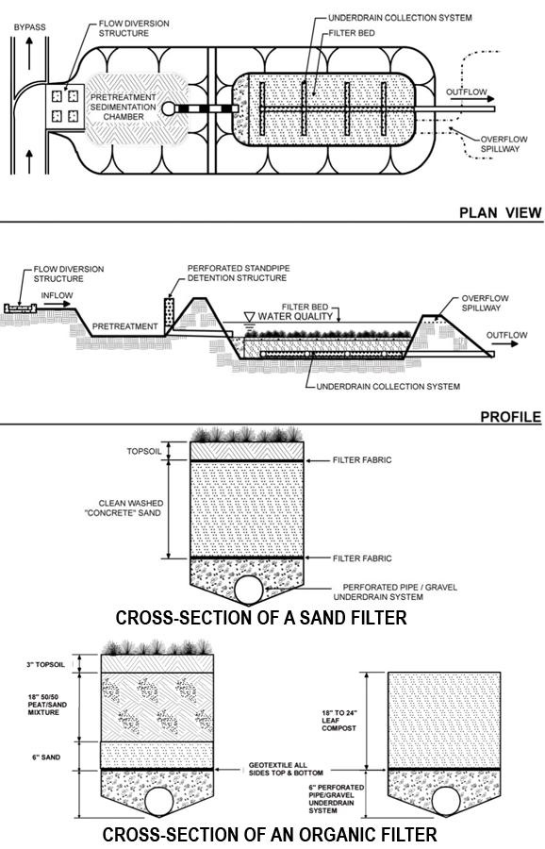
Example Sand and Organic Filter (adapted from the Vermont Stormwater Manual) (Note: Concrete boxes backfilled with sand are also acceptable)

Unit Treatment Process
- Filtration
Special Features

Design as off-line device. Include a Sediment Forebay or equivalent pretreatment device.
ESSD / LID Alternatives
This practice is not a MassDEP recognized ESSD / LID technique. ESSD and LID techniques must be used unless demonstrated to be impracticable based on a written alternatives analysis. Other SCMs shall only be used to the meet those portions of Standard 3 (i.e., Required Recharge Volume) and Standard 4 (i.e., TSS / TP removal) that cannot be fully met by ESSD and LID techniques. See Section 4.2 of the Stormwater Handbook for a list of MassDEP recognized ESSD / LID techniques. Most recognized ESSD / LID techniques also have an associated ESSD Credit (see Table A-1) of this Appendix.
Applicability

Sand filters are adaptable to most developments. They can be installed in areas with thin soils, high evaporation rates, low soil infiltration rates and limited space. Sand filters can be used in ultra-urban sites with small drainage areas that are completely impervious, such as small parking lots and fast food restaurants. They are suitable for many areas that are difficult to retrofit due to space limitations.

Sand filters can be used in areas with poor soil infiltration rates, where groundwater concerns restrict the use of infiltration, or for high pollutant loading areas. Design sand filters as off-line SCMs; they are intended primarily for quality control, not quantity control. A diversion structure, such as a flow splitter or weir, typically routes a portion of the runoff into the sand filter, while the remainder continues on to a stormwater quantity control SCM. Large sand filters can be designed to play a role in the control of peak discharge rates.

Because of the potential for clogging, install sand filters only at sites that have been stabilized. Never use sand filters as sedimentation traps during construction.

Effectiveness

Sand filters improve water quality by straining pollutants through a filtering media and by settling pollutants on top of the sand bed and/or in a pretreatment basin.

Planning Considerations

The surface of sand filters can be unattractive and create odors and may not be appropriate for residential areas. The location selected to site the sand or organic filter must be accessible via road or driveway for maintenance purposes. Maintenance access with a width of at least 15-feet is needed around the full perimeter of the filter.
Cold Weather Modifications
Surface sand filters will not provide treatment during the winter. To ensure treatment occurs year-round, including the winter, design the filters to be placed underground, below the frost line. Underground filters are not effective in winter unless the filter bed is placed below the frost line. Peat and compost media may be ineffective during the winter in cold climates. These filters retain water and can freeze solid, and thus become impervious.
To prevent freezing, the diameter of the underdrain pipe should be at least 8 inches, and the slope of the underdrain pipe should be at least 1%. Place eighteen inches of gravel at the base of the filter. Make the slope of the inflow pipes at least 2%. In addition, place the filter below the frost line. If freezing cannot be prevented, remove snow from the contributing area and place it elsewhere.

Setback Requirements
Stormwater Control Measures (SCMs) and other components of the Stormwater Management System must be setback from wetlands, building foundations, and other features in accordance with 310 CMR 10.05(6)(q). SCMs must also include vertical separation between certain features, such as the depth to seasonally high groundwater. Refer to Section 2.5 of the Stormwater Handbook for horizontal setback and vertical separation distance requirements. Horizontal setbacks also include maintenance access requirements around the perimeter of certain SCMs.
Design Considerations
Sand filters require a sediment forebay or equivalent pretreatment device. Locate sand filters off-line from the primary conveyance/ detention systems This may require two manholes to act as flow diverters. Design sand filters large enough to handle runoff from the storm event and the water quality volume associated with the EPA curve for sand filters to achieve 90% TSS removal/60% TP removal if new development or 80% TSS removal/50% TP removal for Redevelopment.

Fit stormwater conveyances with flow splitters or weirs to route the required volume of runoff to the sand filter. Sand filters must be designed to be offline. Allow runoff in excess of the design volume to bypass the sand filter and continue on to another SCM designed to provide peak runoff rate reduction

Two key design principles for sand filters are visibility and simplicity. A visible sand filter is more apt to

be adequately operated and maintained. Complex designs are more expensive and difficult to operate and maintain. Typically, sand filter systems are designed with two components, a pretreatment component and a filtering component. The pretreatment component is a sediment forebay or vegetated filter strip designed to reduce the sediment load to the filtering component. Pre-settling also slows the runoff velocity and spreads it evenly across the top of the filter component.

The bottom of sand filters must be installed at least 2-feet above Seasonal High Groundwater. Maintenance access must be provided in the design. Sand filters need to meet setback requirements.
Generally, the volume of the sediment forebay should be equal to or greater than the filtering capacity. Design the filter to capture finer silt and clay particles and other pollutants in the runoff. Sand filters

are designed to function as a stormwater quality control practice, and not to provide detention for downstream areas. Therefore, locate them as off-line systems, away from the primary conveyance/detention system. Design the pretreatment component to settle out coarse sediments that may clog the sand filter and reduce its effectiveness.

Use a design filtration rate of 2 inches/hour. Although this rate is low compared to published values for sand, it reflects actual rates achieved by sand filters in urban areas. Using Darcy’s Law, design the sand filter to completely drain within 24 hours or less, because there is little storm storage available in the sand filter if a second storm occurs.

Use eighteen inches of 0.02-inch to 0.04-inch diameter sand (smaller sand is acceptable) for the sand bed. Consider that sand may consolidate during construction. Stabilize the depth of the bed by wetting the sand periodically, allowing it to consolidate, and then adding extra sand. There are several possible sand bed configurations; most use a gravel bed at the bottom overlaid with a layer of sand and/or peat, leaf compost, or topsoil/grass. In

all configurations, make sure the top surface layer of the bed is level to provide equal distribution of the runoff in the bed. The gravel bed layer is generally composed of 4 to 6 inches of 0.5-inch to 2-inch diameter gravel. Separate the gravel and top media layers with a layer of geotextile fabric to prevent sand from infiltrating into the gravel layer and the underdrain piping.

Recent research (Erickson, et al., 2007) shows that enhancing sand filters with steel wool can reduce phosphorus concentrations by as much as 80%.

Organic Media Filters

Organic media filters are essentially the same as sand filters with the sand media replaced or supplemented with another medium. Two examples are the peat sand filter and the compost sand filter. According to the Center for Watershed Protection, many practitioners believe that organic sand filter systems have enhanced pollutant removal for many compounds due to the increased cation exchange capacity achieved by increasing the organic matter. See Performance of Delaware Sand Filter Assessed, Article 107 of the Practice of Watershed Protection.

Maintenance Features Incorporated in Filter Design

Ease of access is essential for sand filter maintenance. Some designs use a geotextile layer, surface screen, or grating at the top to filter out coarse sediment and debris and for ease

of maintenance. Typical maintenance for sand filters includes removing the top several inches of discolored sand and replacing it with clean media. Designs should include ramps, manhole steps,

or ringbolts that allow a maintenance worker to manually remove this material. In addition, avoid heavy grates or manhole covers that cannot be lifted manually.

Trench Design

Trench designs have lateral underdrain pipes that are covered with 0.5- inch to 2-inch diameter gravel and geotextile fabric. The underdrains are underlaid with drainage matting, which is necessary to provide adequate hydraulic conductivity to the lateral pipes. Reinforce the underdrain piping so it withstands the weight of the overburden. The minimum grade of the piping should be 1/8 inch per foot (at 1% slope). An impermeable liner (clay, geomembrane, concrete) may be required under the filter to protect groundwater. If the impermeable liner is not required, install a geotextile liner, unless the bed has been excavated to bedrock. Make sure that the side

slopes of the earthen embankments do not exceed 3:1 (horizontal: vertical). Fencing around sand filters may be needed to reduce safety hazards. Carefully selecting topsoil and sod for natural cover will help reduce the potential for failure. Sod with fine silts and clays will clog the top of the sand filter. Maximize the life of the sand filter by limiting its use to treating runoff from impervious areas only.

Construction

- Take care during construction to minimize the risk of premature failure of the sand filter.

- Diversion berms should be placed around the perimeter of the sand filters during all phases of construction.
- Sand filters should not be used as temporary sediment traps for construction activities.

- Consolidation of material in the sand filters during construction must be taken into consideration. The depth of the bed can be stabilized by wetting the sand periodically, allowing it to consolidate, and then adding extra sand.

- During and after excavation, all excavated materials should not be placed in an area upgradient from the sand filters, to prevent redeposition during runoff events. All excavated materials should be handled properly and disposed of properly during and after construction.

Maintenance
Activity | Frequency
Inspect filters and remove debris | After every .25 inch/day or greater storm event for the first three months after construction is complete to ensure proper function; and every 6 months thereafter.
Inspect sand filters after every significant storm of at least 0.25-inch/day of precipitation in the first three

months after construction to ensure proper function. Thereafter, inspect the sand filter at least once every 6 months. Sand filters require frequent manual maintenance. Important maintenance tasks include raking the sand and removing surface

sediment, trash and debris. Eventually a layer of sediment will accumulate on the top of the sand, which can be easily scraped off using rakes or other devices. Finer sediments will penetrate deeper into the sand over time, necessitating replacement of some (several inches) or all of the sand. Discolored sand indicates the presence of fine sediments. De-water and properly dispose of sand removed from the filter.
References
Erickson, Andrew J., et al., Enhanced Sand Filtration for Storm Water Phosphorus Removal, Journal of Environmental Engineering. Volume 133, Issue 5, pp. 485-497, May 2007.

Developments in Sand Filter Technology to Treat Stormwater Runoff, Article 105, and Further Developments in Sand Filter Technology, Article 106, in the Practice of Stormwater Protection

Center for Watershed Protection, Stormwater Design Example: Sand Filter, WEB: https://www.stormwatercenter.net/Manual_Builder/sand_filter_design_example.htm
Georgia Stormwater Manual 2016, Volume 2, Appendix B3, page 510, Georgia Stormwater Manual 2016.
2004 Connecticut Stormwater Manual, https://portal.ct.gov/DEEP/Water-Regulating-and-Discharges/Stormwater/Stormwater-Manual.
North Carolina Department of Environment and Natural Resources Stormwater SCM Manual 2007, https://deq.nc.gov/about/divisions/energy-mineral-land-resources/energy-mineral-land-permit-guidance/stormwater-bmp-manual/archive.

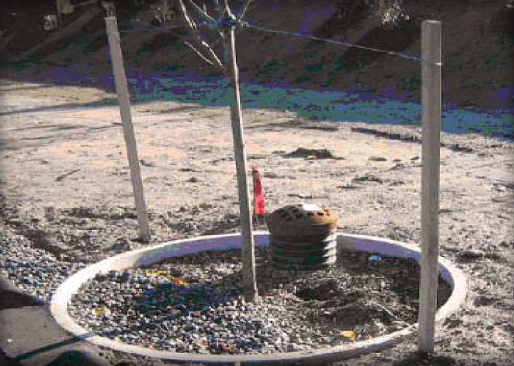
Tree Box Filter

Ability to meet specific standards
Standard | Description
2 - Peak Flow | Does not provide peak flow attenuation.
3 - Recharge | Tree Box Filter (filtering) does not provide groundwater recharge.  Tree Box Filter (exfiltrating) provides groundwater recharge.
4 - TSS/ TP Removal | Tree Box Filter (filtering)  - Use EPA Performance Curve for Biofiltration.  Tree Box Filter (exfiltrating)  - Use EPA Performance Curve for Infiltration Basin.  See “Introduction” Section of this Appendix for more information the EPA Performance Curves.
5 - Higher  Pollutant  Loading | May be used as pretreatment device if lined
6 - Discharges  near or to  Critical Areas | Not suitable for vernal pools or swimming areas.
7 - Redevelopment | May be used for Redevelopment
8 - Construction Phase Pollution Controls | Not to be used for construction period runoff control.
9 - O&M Plan | An O&M Plan is required.
11 - Total Maximum Daily Loads | See suitability to treat TMDL Pollutants Table (below). Must be properly designed, sized, and maintained.
ESSD / LID? | Yes, this practice is a MassDEP recognized ESSD / LID technique.

Description
The Tree Box Filter consists of an open bottom concrete structure filled with a porous soil media. Stormwater is directed from surrounding impervious surfaces through the top of the soil media. Stormwater percolates through the media to the underlying ground. Treated stormwater beyond the design capacity is typically directed to an underdrain where it may be directed to a storm drain, other device, or Surface Water discharge.
Structural Treatment

Tree Box Filters may be designed to act as a filtering practice or an infiltration practice. Filtering Tree Box Filters do not infiltrate and cannot be used receive recharge credit towards Standard 3 – they have an underdrain that captures and conveys runoff downstream. Filtering Tree Box Filters may be lined. Exfiltrating Tree Box Filters are designed to provide infiltration.
Advantages/Benefits

- Provides decentralized stormwater treatment

- Ideal for new development, Redevelopment or retrofits, especially in ultra-urban settings

Disadvantages/Limitations
- Treats small volumes

Suitability to Treat TMDL Pollutants
- Filtering

Tree Box Filter
Pollutant | Suitable to Treat?
TSS | Y
Total Nitrogen | N
Total Phosphorous | N
Pathogens | Y
Metals | Y
Exfiltrating Tree Box Filter
Pollutant | Suitable to Treat?
TSS | Y
Total Nitrogen | Y
Total Phosphorous | Y
Pathogens | Y
Metals | Y
Table Notes:
- Pathogens category includes: fecal coliform, E. coli, and enterococcus.
- Metals category includes Zinc, Cadmium, Lead, Aluminum, and Iron.

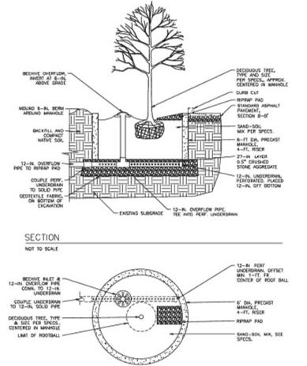
ESSD/LID Alternatives
This practice is a MassDEP recognized ESSD / LID technique.
Setback Requirements
Stormwater Control Measures (SCMs) and other components of the Stormwater Management System must be setback from wetlands, building foundations, and other features in accordance with 310 CMR 10.05(6)(q). SCMs must also include vertical separation between certain features, such as the depth to seasonally high groundwater. Refer to Section 2.5 of the Stormwater Handbook for horizontal setback and vertical separation distance requirements. Horizontal setbacks also include maintenance access requirements around the perimeter of certain SCMs.
Design Considerations
Example Tree Box Filter – adapted from the Vermont Stormwater Manual
When designed to infiltrate, geotextile fabric shall not be used. When designed as a filter without infiltration, fabric may be used. When designed to infiltrate, the underdrain shall not be connected to a drainage system and stormwater outlet.
Maintenance

- Check tree at least annually. Expected tree life is 5 to 10 years.
- Rake media surface to maintain permeability at least twice per year.
- Replace media when tree is replaced.

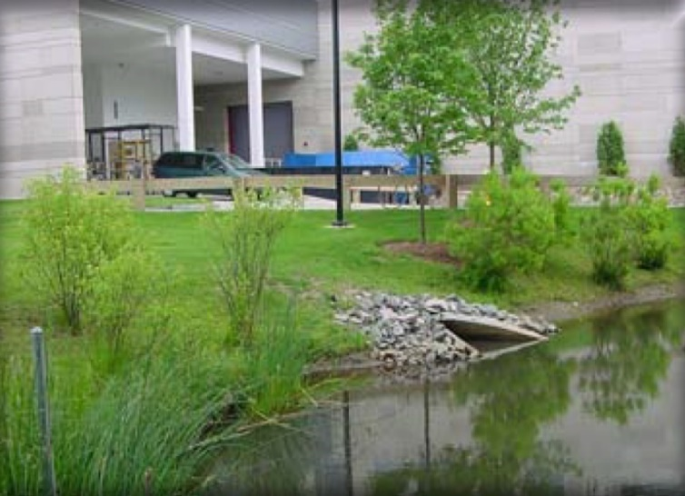
Wet Basins
(formerly wet retention ponds)

Ability to meet specific standards
Standard | Description

2 - Peak Flow | Can be designed to provide peak flow attenuation. Only elevations above permanent wet pool may be credited toward peak rate reduction.
3 - Recharge | Provides no groundwater recharge.
4 - TSS/ TP Removal | Use EPA Wet Pond Performance Curve to calculate required sizing to meet pollutant removal requirements. See “Introduction” Section of this Appendix for more information the EPA Performance Curves. Sediment forebay required for pretreatment.
5 - Higher  Pollutant  Loading | May be used as pretreatment SCM provided basin bottom is lined and sealed. For some land uses with higher potential pollutant loads, may require pretreatment by oil/grit separator, sand filter, or equivalent prior to discharge to wet basin.
6 - Discharges  near or to  Critical Areas | Do not use for discharges to Cold-Water Fisheries.
7 - Redevelopment | Not usually suitable due to space constraints.
8 - Construction Phase Pollution Controls | Not to be used for construction period runoff control.
9 - O&M Plan | An O&M Plan is required for this SCM
11 - Total Maximum Daily Loads | See suitability to treat TMDL Pollutants Table (below). Must be properly designed, sized, and maintained.
ESSD / LID? | No, this practice is not a MassDEP recognized ESSD / LID technique.

Structural Treatment

Description
Wet basins use a permanent pool of water as the primary mechanism to treat stormwater. The pool allows sediments to settle (including fine sediments) and removes soluble pollutants. Wet basins must have additional dry storage capacity to control peak discharge rates. Wet basins have a moderate to high capacity to remove most urban pollutants, depending on how large the volume of the permanent pool is in relation to the runoff from the surrounding watershed.

Advantages/Benefits

- Capable of removing both solid and soluble pollutants

- Capable of removing nutrients and metals

- Aesthetically pleasing SCM.

- Can increase adjacent property values when properly planned and sited.

- Sediment generally needs to be removed less frequently than for other SCMs.

- Can be used in retrofits

Disadvantages/Limitations

- More costly than extended dry detention basins.

- Larger storage volumes for the permanent pool and flood control require more land area.

- Infiltration and groundwater recharge is minimal, so runoff volume control is negligible.
- Moderate to high maintenance requirements.

- Can be used to treat runoff from land uses with higher potential pollutant loads if bottom is lined and sealed.
- Invasive species control required

Suitability to Treat TMDL Pollutants
Pollutant | Suitable to Treat?
TSS | Y
Total Nitrogen | N
Total Phosphorous | N
Pathogens | N
Metals | Y
Notes:
- Pathogens category includes: fecal coliform, E. coli, and enterococcus.
- Metals category includes Zinc, Cadmium, Lead, Aluminum, and Iron.

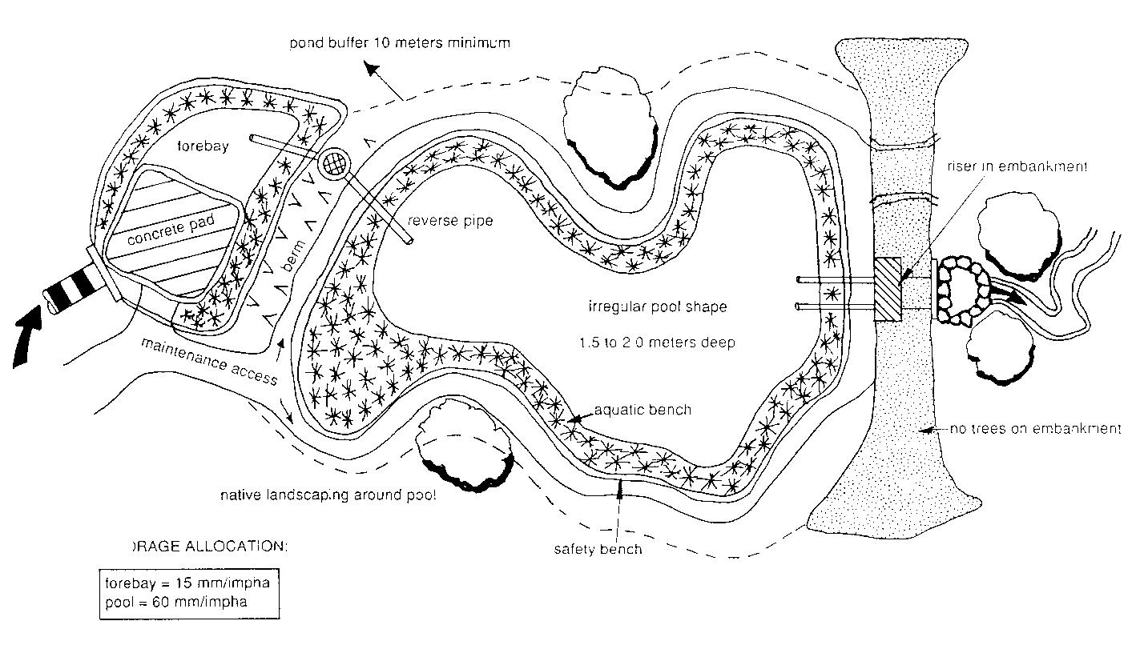
Example Wet Basin (Adapted from Schueler, 1992)
Unit Treatment Process
- Gravity separation
Special Features

- MassDEP requires a sediment forebay as pretreatment to a wet basin.

ESSD/LID Alternatives
This practice is not a MassDEP recognized ESSD / LID technique. ESSD and LID techniques must be used unless demonstrated to be impracticable based on a written alternatives analysis. Other SCMs shall only be used to the meet those portions of Standard 3 (i.e., Required Recharge Volume) and Standard 4 (i.e., TSS / TP removal) that cannot be fully met by ESSD and LID techniques. See Section 4.2 of the Stormwater Handbook for a list of MassDEP recognized ESSD / LID techniques. Most recognized ESSD / LID techniques also have an associated ESSD Credit (see Table A-1) of this Appendix.
Applicability

A wet basin may be created by constructing an embankment or excavating a pit. The primary component of a wet basin is the deep, permanent pool, but other components, such as a shallow marsh, may be added to the design (see basin/ wetland design in constructed wetlands section). MassDEP requires a sediment forebay as pretreatment to a wet basin.

The basic operation of a wet basin allows incoming stormwater to displace the water present in the pool. This stormwater remains until displaced by runoff from another storm event. Increased retention time allows particulates, including fine sediments, to settle out of the water column. The permanent pool also serves to protect deposited sediments from resuspending during large storm events. Another advantage of wet basins is the biological activity of algae and fringe wetland vegetation, which reduces the concentration of soluble pollutants. Wet basins may be designed with a multi-stage outlet structure to control peak rate discharges from different design storms. When properly designed and maintained, wet basins can add recreation, open space, fire protection, wildlife habitat, and aesthetic values to a property.

Generally, dry weather base flow and/or large contributing drainage areas are required to maintain pool elevations. The minimum contributing drainage area must be at least 10 acres, but not more than one square mile. Sites with less than 10 acres of contributing drainage area may be suitable only if sufficient groundwater flow is available to maintain the permanent pool. Use wet basins at residential, commercial and industrial sites. Because wet basins remove soluble pollutants, they are ideal for sites where nutrient loadings are expected to be high. In such instances, source controls must also be implemented to further reduce nutrient loadings.
Planning Considerations

Evaluate soils and depth to bedrock and groundwater before designing a wet basin. At sites where bedrock is close to the surface, high excavation costs may make wet basins infeasible. If the soils are permeable (A and B soils), heavy drawdown of the basin may occur during dry periods. In these situations, compact the basin soils or install a liner at the bottom of the basin to minimize the potential for drawdown. Specifications for basin materials include (in order of decreasing costs):

- 6-inch clay
- Polyvinyl liner
- Bentonite
- 6 inches of silt loam or finer material
To be effective in reducing peak runoff rates, locate the basin where it can intercept most of the runoff from the site, typically a low elevation that is near freshwater wetlands.

Like all stormwater best management practices, wet basins must not be constructed in wetland Resource Areas other than isolated land subject to flooding, bordering land subject to flooding, land subject to coastal storm flowage, and riverfront area. Select a location that can accommodate the need to attenuate peak discharge rates without adversely impacting nearby wetland resources.
Designing wet basins for multiple storms will provide peak rate control. In such instances, design the upper stages of wet basins to provide temporary storage of larger storms (i.e., 10, 25, and 100-year 24-hr. storms). Wet basins are generally ineffective in controlling the post-development increase in runoff volume, although some infiltration does occur, as well as evaporation in summer months.

It is preferable to create the wet basin by excavating a pit below the grade of land. When this is not feasible, an earthen embankment can be created. Embankments or dams created to store more than 15 acre-feet, or that are more than 6 feet high, are under the jurisdiction of the Massachusetts Department of Conservation and Recreation (DCR) Office of Dam Safety and must be constructed, inspected, and maintained according to DCR guidelines.

Setback Requirements
Stormwater Control Measures (SCMs) and other components of the Stormwater Management System must be setback from wetlands, building foundations, and other features in accordance with 310 CMR 10.05(6)(q). SCMs must also include vertical separation between certain features, such as the depth to seasonally high groundwater. Refer to Section 2.5 of the Stormwater Handbook for horizontal setback and vertical separation distance requirements. Horizontal setbacks also include maintenance access requirements around the perimeter of certain SCMs.
Design Considerations
See the following for complete design references:
Wet Extended Detention Pond Design: Step by Step Design.
1995. Claytor.
Volume and geometry are the critical parameters in a wet basin design; the relationship of the volume in the permanent pool to the contributing runoff volume directly affects pollutant removal rates. Generally, bigger is better; however, after a certain threshold level, increasing the pool size results in only marginal increases in pollutant removal. The permanent pool must be sized at a minimum to hold twice the water quality volume (this is equivalent to a VB/VR of 2) when a wet basin is designed to provide peak rate attenuation in addition to water quality treatment. The peak rate volume is an additional volume above the permanent pool. The permanent pool volume must not be counted as part of the volume devoted to storage associated with peak rate attenuation. When designing a wet basin to also accommodate peak rate attenuation, a multiple stage outlet must be included as part of the design.
Pool depth is an important design factor, especially for sediment deposition. Use an average pool depth of 3 to 6 feet. Settling column studies and modeling analyses show that shallow basins remove more solids than deeper ones. However, resuspension of settled materials by wind action might be a problem in shallow basins that are less than two feet deep.
Depths greater than eight feet may cause thermal stratification. Stratified pools tend to become anoxic (low or no oxygen) more often than shallower ponds. If possible, vary depths throughout the basin.
Providing deeper pools can provide fish habitat. It may be advantageous to introduce fish to the wet basins to reduce mosquito breeding. When designing wet basins to support fish, a fisheries biologist should be consulted. Fish habitat features may include trees to provide shading over the deeper depths. Selection of trees should be done carefully to avoid embankment or sidewall failure. Use intermittent benches around the perimeter of the basin for safety and to promote vegetation. Design the safety bench to be at least ten feet wide and above normal pool elevations. Make the aquatic bench at least ten feet wide and maintain depths of 12 to 18 inches at normal elevations to support aquatic vegetation. Shallow depths near the inlet will concentrate sediment deposition in a smaller, more accessible area. Deeper depths near the outlet will yield cooler bottom water discharges that may mitigate downstream thermal effects. Use a minimum pool surface area of 0.25 acres. Enhance the performance of the wet basin by enlarging the surface area to increase volume, instead of deepening the pool, although this increases water temperatures and evaporation rates. The original design of wet basin depths and volumes should take into account the gradual accumulation of sediment. Accumulating sediment in the pool will decrease storage volume and reduce pollutant removal efficiency.
MassDEP requires a sediment forebay to pretreat stormwater before it enters the wet basin. Forebays trap sediment before the runoff enters the primary pool, effectively enhancing removal rates and minimizing long-term operation and maintenance problems. Removing sediment from the forebay is easier and less costly than from the wet basin pool, so design sediment forebays for ease of maintenance. Hard bottom forebays make sediment removal easier. Make forebays accessible by heavy machinery to facilitate maintenance.

To avoid reducing the pollutant removal capability and to maximize travel distance, locate the inflow points as far from the outlet structure as possible. To maximize stormwater contact and retention time in the pool, use a length to width ratio of at least 3:1.

Set the invert elevation of the inlet pipe at or below the surface of the permanent pool, preferably within one foot of the pool. Pipes discharging above the pool can erode the banks and side slopes. Design all inflow points with riprap or other energy dissipators to reduce inflow velocities.

Establish wetland vegetation on the aquatic bench to enhance the removal of soluble nutrients, facilitate sediment trapping, prevent sediment resuspension, provide wildlife and waterfowl habitat, and conceal trash and debris that may accumulate near the outlet. Six to eighteen inches of water depth are needed for wetland vegetation growth.

Make the slopes of the pools no steeper than 3:1. Flatter slopes help to prevent bank erosion during larger storms and facilitate routine bank maintenance tasks, such as mowing. Flat slopes also provide for public safety, and allow easier access. In addition, design the sides of the pool that extend below the safety and aquatic benches to the bottom of the pool at a slope that will remain stable, usually no steeper than 2:1 (horizontal to vertical).

Design the invert of the wet basin outlet pipe to convey stormwater from approximately one foot below the pool surface and to discharge into the riser in the pond embankment. To prevent clogging, install trash racks or hoods on the riser.

To facilitate access for maintenance, install the riser within the embankment. Place anti-seep collars or filter and drainage diaphragms on the outlet barrel to prevent seepage and pipe failure. Make the vital parts of the structure accessible to maintenance personnel during normal and emergency conditions. Install a bottom drainpipe to allow complete draining of the wet basin in case of emergencies or for routine maintenance.

Fit both the outlet pipe and the bottom drain pipe with adjustable valves at the outer end of the outlet to permit adjustment of the detention time, if necessary.

To prevent scour at the outlet, install a flow transition structure, such as a lined apron or plunge pad, to absorb the initial impact of the flow and reduce the velocity to a level that will not erode the receiving channel or area.

Design embankments and spillways to conform with DCR Dam Safety regulations, if applicable. All wet basins must have an emergency spillway capable of bypassing runoff from large storms without damaging the impounding structure.

Provide an access way for maintenance, with a minimum width of 15 feet and a maximum slope of 15%, by public or private right-of-way. Equipment that will be used for maintenance must be capable of using this access way. This access should extend to the forebay, safety bench, outflow structure, and around the entire perimeter. It need not cross the emergency spillway, unless the spillway has been designed for that purpose. Place vegetative buffers around the perimeter of the wet basin to control erosion and remove additional sediment and nutrients. The vegetative buffer must be at least 33 feet (10 meters). Vegetation must be designed to prevent the introduction of invasive species.

Wet Basin Design Criteria
Factor | Criteria
Max. Drainage Area | ≥ 20 acres unless sufficient groundwater flow
Permanent Pool Volume | ≥ 2 x WQV (equivalent to Vb/Vr ratio of 2)
Min. Pool Surface Area | ≥ 0.25 acres
Min. Length to Width Ratio | ≥ 3:1
Mean Permanent Pool Depth | 3 to 6 feet
Max. Permanent Pool Depth | 8 feet
Max. Pool Slopes | ≤ 3H:1V
Max. Safety and Aquatic Bench Slopes | ≤ 2H:1V
Perimeter Accessway Width | ≥ 15 feet
Perimeter Vegetative Buffer | ≥ 25 feet
Sediment Forebay | Required (not included in wet basin sizing)
Pool Drain (for maintenance) | Required maximum pool drain time: 40 hours

Maintenance
Activity | Frequency
Inspect wet basins to ensure they are operating as designed | At least once a year
Mow the upper stage, side slopes, embankment, and emergency spillway. | At least twice per year
Inspect to make sure emergent or submergent plants are not present | At least twice per year, remove all emergent or submergent plants. Assess whether design changes are necessary to discourage emergent or submergent plant growth.
Check the sediment forebay for accumulated sediment, trash, and debris and remove it. | At least twice per year
Remove sediment from the basin. | As necessary, and at least once every 10 years.
Inspect wet basins at least once per year to ensure they are operating as designed. Inspect the outlet structure for evidence of clogging or excessive outflow releases.

Potential problems to check include: subsidence, erosion, cracking or tree growth on the embankment, damage to the emergency spillway, sediment accumulation around the outlet, inadequacy of the inlet/outlet channel erosion control measures, changes in the condition of the pilot channel, erosion within the basin and banks, and the emergence of invasive species. Make any necessary repairs immediately. During inspections, note any changes to the wet basin or the contributing watershed area because these may affect basin performance. At least twice a year, mow the upper-stage, side slopes, embankment and emergency spillway. At this time, also check the sediment forebay for accumulated material, sediment, trash, and debris and remove it. Remove sediment from the basin as necessary, and at least once every 10 years. Providing an on on-site sediment disposal area will reduce the overall sediment removal costs.

References

Galli, J. 1990, Thermal Impacts Associated with Urbanization and Stormwater Best Management Practices. Prepared for the Maryland Department of Environment, Baltimore, MD, by the Metropolitan Council of Governments, Washington, D.C.

Roof Dripline Filter
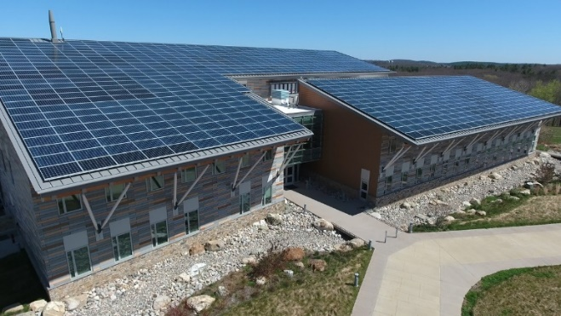

Ability to meet specific standards

Standard | Description
2 - Peak Flow | Does not provide peak flow attenuation.
3 - Recharge | Roof Dripline Filter (filtering) does not provide groundwater recharge.  Roof Dripline Filter (exfiltrating) provides groundwater recharge.
4 - TSS/TP Removal | Roof Dripline Filter (filtering)  - Use EPA Performance Curve for Biofiltration.  Roof Dripline Filter (exfiltrating)  - Use EPA Performance Curve for Infiltration Basin.  See “Introduction” Section of this Appendix for more information the EPA Performance Curves.
5 - Higher Pollutant Loading | May be used to treat rooftop runoff of buildings located in LUHPPL except for LUHPPL that have metal roofs.
6 - Discharges near or to Critical Areas | May be used for discharge near Critical Areas.
7 - Redevelopment | Good option for suburban and residential areas - requires surface area adjacent to building foundations.
8 - Construction Phase | May not be used for construction phase runoff.
9 - O&M | An O&M plan is required for this SCM.
11 - Total Maximum Daily Loads | See suitability to treat TMDL Pollutant Table (below). Must be properly designed, sized, and maintained.
ESSD / LID? | Yes, this practice is a MassDEP recognized ESSD / LID technique.

Description
Structural Treatment
Dripline filters are designed to capture and treat runoff from a peaked roof without gutters. They provide temporary storage of runoff in the void spaces of a surface, stone reservoir layer. The reservoir layer is typically underlain with a sand filter course for treatment of runoff and a layer of crushed stone underdrain material prior to discharge by way of a perforated pipe. The filtration trench extends along the full length of the building or roof area to be treated.
Roof Dripline Filters may be designed to act as a filtering practice or an infiltration practice. Filtering Roof Dripline Filters do not infiltrate and cannot be used receive recharge credit towards Standard 3 – they have an underdrain that captures and conveys runoff downstream. Filtering Roof Dripline Filters may be lined. Exfiltrating Roof Dripline Filters are designed to provide infiltration.
Advantages/Benefits
- Applicable to peaked rooftop drainage areas
- Long design life if properly maintained
- Good for stormwater retrofits
- Good for residential subdivisions, and single-family homes.
- Reduces back splash to protect foundation
- Reduces soil erosion from rooftop runoff
- Improves the quality of runoff flowing from rooftops to storm drains or infiltration areas.
Disadvantages/Limitations
- Require frequent maintenance
- May not be effective in winter
- May not be able to be used on certain sites because of inadequate depth to bedrock or high groundwater
- Not effective in controlling peak discharge.

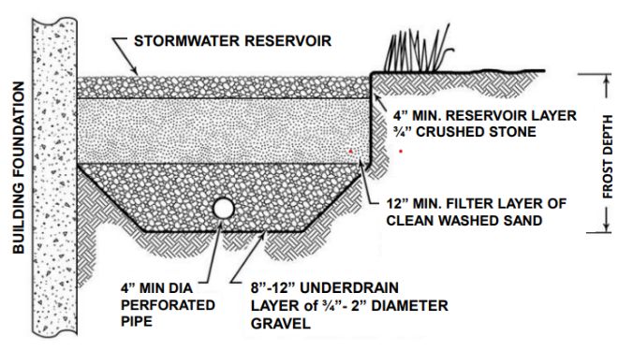
Cross Section
Example Dripline Filter
(adapted from the Maine Stormwater Manual)
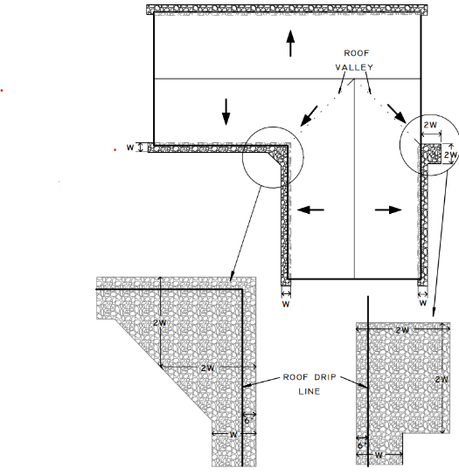

Detail - Additional Armoring at Roof Valleys
Suitability to Treat TMDL Pollutants
Filtering Roof Dripline Filter
Pollutant | Suitable to Treat?
TSS | Y
Total Nitrogen | N
Total Phosphorous | N
Pathogens | Y
Metals | Y
Exfiltrating Roof Dripline Filter
Pollutant | Suitable to Treat?
TSS | Y
Total Nitrogen | Y
Total Phosphorous | Y
Pathogens | Y
Metals | Y
Notes:
- Pathogens category includes: fecal coliform, E. coli, and enterococcus.
- Metals category includes Zinc, Cadmium, Lead, Aluminum, and Iron.
Unit Treatment Process
Filtration
Special Features
Design as off-line small-scale control.
ESSD / LID Alternatives
This practice is a MassDEP recognized ESSD / LID technique.
Applicability
Dripline filters are adaptable to most residential developments with relatively few constraints and can apply in commercial settings. See Massachusetts Division of Fisheries and Wildlife – Field Headquarters Building. They are a variation of surface sand filters that can be installed in areas with high evaporation rates, low soil infiltration rates, and where groundwater concerns restrict the use of infiltration. Drip line filters can be used as stormwater controls for roof drainage areas that are completely impervious such as single-family homes. They are intended primarily for quality control, not quantity control.
This SCM may not be appropriate for home designs with at grade entrances (i.e., walkout basements) where frozen conditions could direct Surface Water into the house.
Effectiveness
The stormwater filtration improves water quality by straining through a sand filtering media and by settling particulate pollutants on top of the sand bed.

Planning Considerations
The location of this filter is adjacent to the foundation must be accessible from a driveway or landscaped area for maintenance purposes.
Because of the potential for clogging, install dripline filters only at sites that have been stabilized. Never use these filters as sedimentation traps during construction.
Cold Weather Modifications
Dripline filters retain water and may freeze or have limited functionality during the winter. To ensure year-round treatment, including the winter, design the filter layer to be below the frost line when possible. If freezing cannot be prevented, remove snow from the contributing area and place it elsewhere.
This SCM may not be appropriate for home designs with at grade entrances where frozen conditions could direct Surface Water into the house.
Setback Requirements
Stormwater Control Measures (SCMs) and other components of the Stormwater Management System must be setback from wetlands, building foundations, and other features in accordance with 310 CMR 10.05(6)(q). SCMs must also include vertical separation between certain features, such as the depth to seasonally high groundwater. Refer to Section 2.5 of the Stormwater Handbook for horizontal setback and vertical separation distance requirements. Horizontal setbacks also include maintenance access requirements around the perimeter of certain SCMs.
Design Considerations
Dripline filters are adjacent to building foundations and off-line from the primary conveyance systems.
These filter designs do not include a sediment forebay or equivalent pretreatment component. However, since rooftop runoff is considered relatively free from pollutants, the pretreatment requirement is waived.
Basement waterproofing is essential. The bottom of filter and/or infiltration practice must be at least 2-feet above Seasonal High Groundwater. Surface grading away from the foundation and robust waterproofing of basement walls are required to prevent the penetration of water into a basement. Maintenance access must be provided in the design.
This SCM may not be appropriate for all foundation types. Freeze-thaw cycles could cause damage to the foundation. If the site has potential freeze/thaw issues, or general concerns of water buildup outside of the foundation walls, use of this SCM must be restricted to pile or slab or foundations.
These practices function as a stormwater quality control practice and do not provide detention for downstream areas. Therefore, locate them as off-line systems, away from the primary conveyance/detention system. Dripline filters must not be connected to any municipal closed drainage system.
Use a design filtration rate of 2 inches/hour. Although this rate is low compared to published values for sand, it reflects actual rates achieved by sand filters in urban areas. Using Darcy’s Law, design the sand filter to completely drain within 24 hours or less, because there is little storm storage available in the sand filter if a second storm occurs.
Drip line edge: The drip line trench should extend the length of the building or area of roof.
Reservoir Layer: The reservoir layer at the drip line should consist of clean washed stone with a porosity of 40%. The width and depth of the reservoir course is sized based on the desired runoff volume from the roof. For example, a 30-foot wide roof panel will need a 4 foot wide by 1.5 foot deep rock storage bed to store 1” of runoff.
Filter Layer: Use a minimum of 12 inches of 0.02-inch to 0.04-inch diameter sand (smaller sand is acceptable) for the sand bed. Consider that sand may consolidate during construction. Stabilize the depth of the bed by wetting the sand periodically, allowing it to consolidate, and then add extra sand.
Underdrain Layer (for filtering type): An underdrain layer consisting of a 4” diameter slotted underdrain pipe bedded in 8 to 12 inches of underdrain backfill material consisting of ¾ inch to 2-inch diameter gravel. Separate the gravel and top media layers with a layer of geotextile fabric to prevent sand from infiltrating into the gravel layer and the underdrain piping.
Detention Time: Stored volume needs to fully drain within 24 hours. An overflow should be provided for runoff above the combined capacity of the reservoir and drainage layers.
Basement Waterproofing: Surface grading away from the foundation and robust waterproofing of basement walls is required to prevent the penetration of water into a basement.

Maintenance Features Incorporated in Filter Design
Ease of access is essential feature for drip line filter maintenance. Designs should include easy access from a driveway or landscaped area to allow for removal of material as needed.
Geotextile fabric placed between the filter course and underdrain material will prevent sand from infiltrating into the gravel layer and the underdrain piping.
Construction
Take care during construction to minimize the risk of premature failure of the sand filter.
Appropriate construction phase SCMs should be placed around the perimeter of the sand filters during all phases of construction.
Sand filters should not be used as temporary sediment traps for construction activities.
Consolidation of material in the sand filters during construction must be taken into consideration. The depth of the bed can be stabilized by wetting the sand periodically, allowing it to consolidate, and then adding extra sand.
During and after excavation, all excavated materials should not be placed in an area upgradient from the sand filters, to prevent redeposition during runoff events. All excavated materials should be handled properly and disposed of properly during and after construction.
Maintenance
The dripline filter bed requires regular post-construction maintenance to ensure full function. Periodic inspections, especially following significant storm events of 0.25-inch/day of precipitation or greater for the first few months should be conducted. Check for stability, proper function, and damage to components. Thereafter, schedule inspections at 6-month intervals to remove leaves, debris, and sediment from the surface reservoir course, to control vegetation adjacent to trench, and look for signs of stress or potential failure. Check and promptly repair any damage to the foundation waterproofing or filtration system components.

Activity | Frequency

Inspect filters and remove debris | After every .25 inch/day or greater storm event for the first few months after construction is complete to ensure proper function; and every 6 months thereafter.
Over time, a layer of sediment can accumulate on top of the sand clogging the system. When the system clogs, clean out the accumulated sediment on the surface of the sand filter and replace an appropriate amount of sand needed to reestablish free flowing characteristics of washed sand. De-water and properly dispose of sand removed from the filter.
The post-construction maintenance plan should address that these filter structures are part of the stormwater management plan for the project and cannot be paved over or altered in anyway. No gutter may be installed on the roof line.
References
Erickson, Andrew J., et al., Enhanced Sand Filtration for Storm Water Phosphorus Removal, Journal of Environmental Engineering. Volume 133, Issue 5, pp. 485-497, May 2007.
Developments in Sand Filter Technology to Treat Stormwater Runoff, Article 105, Further Developments in Sand Filter Technology, Article 106, in the Practice of Stormwater Protection, Center for Watershed Protection, Stormwater Design Example: Sand Filter, WEB: https://www.stormwatercenter.net/Manual_Builder/sand_filter_design_example.htm
Georgia Stormwater Manual 2016, Volume 2, Appendix B3, page 510, Georgia Stormwater Manual 2016.
2004 Connecticut Stormwater Manual, https://portal.ct.gov/DEEP/Water-Regulating-and-Discharges/Stormwater/Stormwater-Manual.
North Carolina Department of Environment and Natural Resources Stormwater SCM Manual 2007, https://deq.nc.gov/about/divisions/energy-mineral-land-resources/energy-mineral-land-permit-guidance/stormwater-bmp-manual/archive.
Maine Department of Environmental Protection Stormwater Management Manual, Vol. 3 BMP Technical Design Manual, Chapter 7.5, Roof Dripline Filtration BMP
https://www.maine.gov/dep/land/stormwater/stormwaterbmps/vol3/chapter7_5.pdf
http://www.state.me.us/dep/blwq/docstand/stormwater/stormwaterbmps/index.htm
Maine Department of Environmental Protection Stormwater Management Manual, Vol. 3 BMP Technical Design Manual, Chapter 7.3, Underdrained Subsurface Sand Filter BMP
https://www.maine.gov/dep/land/stormwater/stormwaterbmps/vol3/chapter7_3.pdf
NH Department of Environmental Services, A Shoreland Homeowner’s Guide to Stormwater Management, Protecting your Home and Environment - NH Lakes https://nhlakes.org
MAPC, U.S. EPA, Massachusetts Low Impact Development Toolkit, https://www.mapc.org/resource-library/low-impact-development-toolkit/
Fact Sheet #7, Infiltration Trenches and Dry Wells. https://www.mapc.org/resource-library/trenches-drywells/

Massachusetts
Stormwater Management
Handbook
Structural Conveyance

- Drainage Channels
- Grassed Channel (Biofilter Swale)
- Water Quality Swale

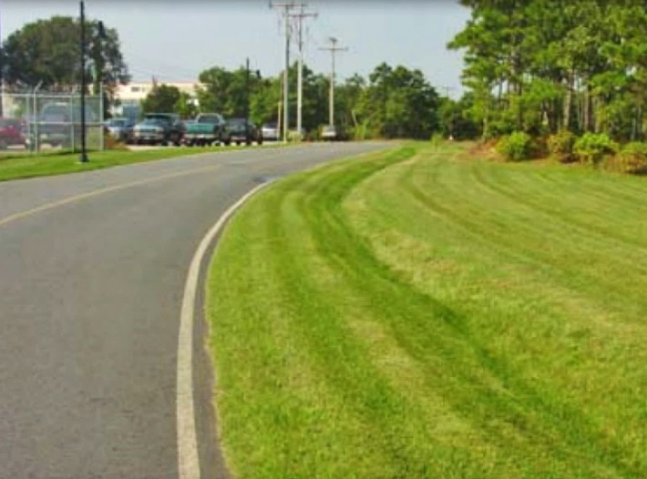
Drainage Channels

Ability to meet specific standards
Standard | Description
2 - Peak Flow | Provides no peak flow attenuation.
3 - Recharge | Provides no groundwater recharge.
4 - TSS/ TP Removal | No MassDEP removal credit.
5 – Higher Pollutant Loading | Use as conveyance.
6 – Discharges near or to Critical Areas | May be used to achieve temperature reduction for runoff discharging to coldwater fisheries, provided the channel in lined with vegetation and has a hydraulic residence time of at least 9 minutes as calculated using Manning’s Equation.
7 - Redevelopment | Limited applicability.
11 - Total Maximum Daily Loads | See suitability to treat TMDL Pollutants Table (below). Must be properly designed, sized, and maintained..
ESSD / LID? | No, this practice is not a MassDEP recognized ESSD / LID technique.

Structural Conveyance

Description
Drainage channels are traditional vegetated open channels that are designed to provide for non-erosive conveyance. They receive no infiltration or TSS/TP removal credit (Standards 3 and 4).

Advantages/Benefits

- Conveys stormwater

- Accents natural landscape.

- Compatible with LID design practices

- Roadside channels reduce driving hazards by keeping stormwater flows away from street surfaces during storms

Disadvantages/Limitations

- Higher degree of maintenance required than for curb and gutter systems.
- Roadside channels are subject to damage from off-street parking and snow removal.

- Provides limited pollutant removal compared to water quality swales

- May be impractical in areas with flat grades, steep topography or poorly drained soils

- Large area requirements for highly impervious sites.

Suitability to Treat TMDL Pollutants

Pollutant | Suitable to Treat?
TSS | N
Total Nitrogen | N
Total Phosphorous | N
Pathogens | N
Metals | N
Notes:
- Pathogens category includes: fecal coliform, E. coli, and enterococcus.
- Metals category includes Zinc, Cadmium, Lead, Aluminum, and Iron.
Unit Treatment Process
- No treatment provided
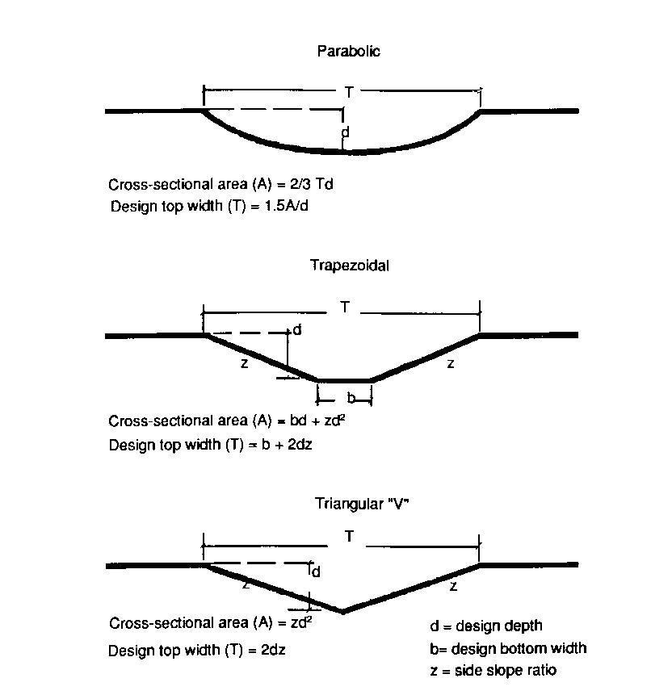
Example Drainage Channel (Adapted from the University of New Hampshire)
Special Features
Drainage channels cannot be used to meet the Stormwater Management Standards. They are a component of a larger stormwater management system and serve to convey runoff from impervious surfaces to or from stormwater treatment SCMs.

ESSD / LID Alternatives
This practice is not a MassDEP recognized ESSD / LID technique. ESSD and LID techniques must be used unless demonstrated to be impracticable based on a written alternatives analysis. Other SCMs shall only be used to the meet those portions of Standard 3 (i.e., Required Recharge Volume) and Standard 4 (i.e., TSS / TP removal) that cannot be fully met by ESSD and LID techniques. See Section 4.2 of the Stormwater Handbook for a list of MassDEP recognized ESSD / LID techniques. Most recognized ESSD / LID techniques also have an associated ESSD Credit (see Table A-1) of this Appendix.
Drainage Channels versus Water Quality Swales

The distinction between drainage channels and water quality swales lies in the design and planned use of the open channel conveyance. Drainage channels are designed to have sufficient capacity to convey runoff safely during large storm events without causing erosion. Drainage channels typically have a cross-section with sufficient hydraulic capacity to handle the peak discharge for the 10-year storm. The dimensions (slope and bottom width)

of a drainage channel must not exceed a critical erosive velocity during the peak discharge. They must be vegetated with grasses to maintain bank and slope integrity. Other than basic channel size and geometry, there are no other design modifications to enhance pollutant removal capabilities. Therefore, pollutant removal efficiency is typically low for drainage channels.

Water quality swales and grass channels, on the other hand, are designed for the required water quality volume and incorporate specific features to enhance their stormwater pollutant removal effectiveness. Pollutant removal rates are significantly higher for water quality swales and grass channels. A water quality swale or grass channel must be used in place of the drainage channel when a water quality treatment credit is sought.

Applicability

Drainage channels are suitable for residential and institutional areas of low to moderate density. The percentage of impervious cover in the contributing areas must be less than 50%. Drainage channels can also be used in parking lots to break up areas of impervious cover.

Along the edge of roadways, drainage channels can be used in place of curb and gutter systems. However, the effectiveness of drainage channels may decrease as the number of driveway culverts increases. They are also generally not compatible with extensive sidewalk systems. When using drainage channels in combination with roadways and sidewalks, it is most appropriate to place the channel between the two impervious covers (e.g., between the sidewalk and roadway).

Planning Considerations
The two primary considerations when designing a drainage channel are maximizing channel capacity and minimizing erosion. Use the maximum expected retardance when checking drainage channel capacity. The greatest flow retardance usually occurs when vegetation is at its maximum growth for the year. This usually occurs during the early growing season and dormant periods.

Other factors to be considered when planning for the drainage channel are land availability, maintenance requirements and soil characteristics. The topography of the site should allow for the design of a drainage channel with sufficient slope and cross-sectional area to maintain a non-erosive flow velocity, generally less than five feet per second.

The shape of the cross-sectional channel is also an important planning consideration. Figure DC 1 shows three different design shapes. The V- shaped or triangular cross-section can result in higher velocities than other shapes, especially when combined with steeper side slopes, so use this design only if the quantity of flow is relatively small. The parabolic cross-section results in a wide shallow channel that is suited to handling larger flows and blends in well with natural settings. Use trapezoidal channels when deeper channels are needed to carry larger flows and conditions require relatively high velocities. Select a grass type for the channel lining that is appropriate for site conditions, including one that is able to resist shear from the design flow, is shade tolerant, is drainage tolerant, and has low maintenance requirements. Use vegetation that is water tolerant and has a dense root system. Alternatively, the drainage channel may be lined with stone.
Setback Requirements

Stormwater Control Measures (SCMs) and other components of the Stormwater Management System must be setback from wetlands, building foundations, and other features in accordance with 310 CMR 10.05(6)(q). SCMs must also include vertical separation between certain features, such as the depth to seasonally high groundwater. Refer to Section 2.5 of the Stormwater Handbook for horizontal setback and vertical separation distance requirements. Horizontal setbacks also include maintenance access requirements around the perimeter of certain SCMs.
Design Considerations

See the following for complete design references: Site Planning for Urban Stream Protection. 1995. Schueler. Center for Watershed Protection.
The length of the drainage channel depends on the slope, contributing impervious surface area, and runoff volume. Because drainage channels with low velocities can act as sediment traps, add extra capacity to address sediment accumulation without reducing design capacity. Add an extra 0.3 to 0.5

feet of freeboard depth, if sediment accumulation is expected. Use side slopes of 3:1 or flatter to prevent side slope erosion. The longitudinal slope of the drainage channel should be as close to zero as possible and not greater than 5%.

Install check dams in drainage channels when necessary to achieve velocities of 5 feet per second or less. Do not use earthen check dams because they tend to erode on the downstream side, and it is difficult to establish and maintain grass on the dams. The maximum ponding time behind the check dam should not exceed 24 hours. Use outlet protection at discharge points from a drainage channel to prevent scour at the outlet.

The design for the drainage channel must include access for maintenance. When located along a highway, provide a breakdown lane with a width of 15 feet. When located along a street, off-street parking can be doubled up as the access, provided signs are posted indicating no parking is allowed during maintenance periods. When locating drainage channels adjacent to pervious surfaces, include a 15-foot-wide grass strip to provide access for maintenance trucks.

Construction

Use temporary erosion and sediment controls during construction. Soil amendments, such as aged compost that contains no biosolids, may be needed to encourage vegetation growth. Select a vegetation mix that suits the characteristics of the site. Seeding will require mulching with appropriate materials, such as mulch matting, straw, wood chips, other natural blankets, or synthetic blankets. Anchor blanket immediately after seeding. Provide new seedlings with adequate water until they are well established. Refer to the “Massachusetts Erosion and Sediment Control Guidelines for Urban and Suburban Areas: A Guide for Planners, Designers, and Municipal Officials” for information regarding seeding, mulching, and use of blankets.

Maintenance
Activity | Frequency
Inspect channels to make sure vegetation is adequate and for signs of rilling and gullying. Repair any rills or gullies. Replace dead vegetation. | The first few months after construction and twice a year thereafter.
For stone lined channels, grade the stone to original design elevation | At least once every 5-years
Mow | As necessary. Grass height shall not exceed 6 inches.
Remove sediment and debris manually | At least once a year
Reseed. | As necessary. Use of road salt or other deicers during the winter will necessitate yearly reseeding in the spring.

The maintenance and inspection schedule should take into consideration the effectiveness of the drainage channel. Inspect drainage channels the first few months after construction to make sure that there is no rilling or gullying, and that vegetation in the channels is adequate. Thereafter, inspect the

channel twice a year for slope integrity, soil moisture, vegetative health, soil stability, soil compaction, soil erosion, ponding, and sediment accumulation.

Regular maintenance tasks include mowing, fertilizing, liming, watering, pruning, weeding, and pest control. Mow channels at least once per year. Do not cut the grass shorter than three to four inches. Keep grass height under 6 inches to maintain the design depth necessary to serve as a conveyance. Do not mow excessively, because it may increase the design flow velocity.

Remove sediment and debris manually at least once per year. Re- seed periodically to maintain the dense growth of grass vegetation. Take care to protect drainage channels from snow removal procedures and off-street parking. When drainage channels are located on private residential property, the operation and maintenance plan must clearly specify the private property owner who is responsible for carrying out the required maintenance. If the operation and maintenance plan call for maintenance of drainage channels on private properties to be performed by a public entity or an association (e.g., homeowners association), maintenance easements must be obtained.

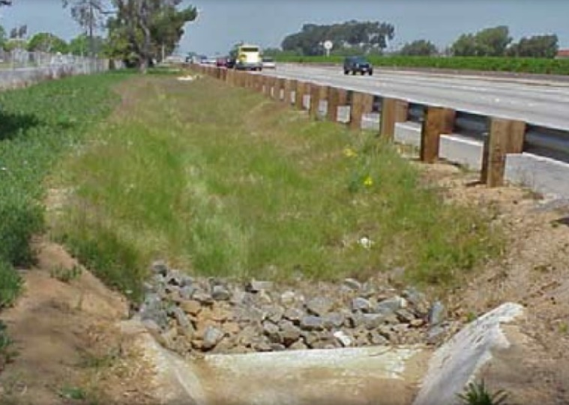
Grass Channel
(Biofilter Swale)

Ability to meet specific standards

Standard | Description

2 - Peak Flow | Does not provide peak attenuation.
3 - Recharge | Provides no groundwater recharge.
4 - TSS/ TP Removal | Use EPA Grass Swale Performance Curve to calculate required sizing to meet pollutant removal requirements. See “Introduction” Section of this Appendix for more information the EPA Performance Curves. Pretreatment must be provided such as a sediment forebay, or equivalent.
5 - Higher  Pollutant  Loading | N/A
6 - Discharges  near or to  Critical Areas | Not suitable for discharges near or to vernal pools or bathing beaches. At other critical areas, may be used as pretreatment practice.
7 - Redevelopment | Typically not suited for retrofits.
8 - Construction Phase Pollution Controls | Construction phase runoff is not to be diverted to these areas; divert stormwater runoff to these areas only once the site has been stabilized.
9 - O&M Plan | An O&M Plan is required for this SCM
11 - Total Maximum Daily Loads | See suitability to treat TMDL Pollutants Table (below). Must be properly designed, sized, and maintained.
ESSD / LID? | Yes, this practice is a MassDEP recognized ESSD / LID technique.

Structural Conveyance
Description
Grassed Channels (formerly known as Biofilter swales) are treatment systems with a longer hydraulic residence time than drainage channels. The removal mechanisms are sedimentation and gravity separation, rather than filtration. To receive TSS/TP credit, a sediment forebay or equivalent must be provided for pretreatment. Note that the sediment forebay does not receive a separate TSS/TP removal credit.

Advantages/Benefits

- Provides pretreatment if used as the first part of a treatment train.

- Open drainage system aids maintenance

- Accepts sheet or pipe flow

- Compatible with LID design measures.

- Little or no entrapment hazard for amphibians or other small animals

Disadvantages/Limitations

- Does not provide peak attenuation
- Short retention time does not allow for full gravity separation·

- Limited biofiltration provided by grass lining.
- Must be trained with other SCMs to meet TSS and TP removal requirements.

- Must be designed carefully to achieve low flow rates for Water Quality Volume purposes (<1.0 fps)
- Mosquito control considerations

Suitability to Treat TMDL Pollutants

Pollutant | Suitable to Treat?
TSS | Y
Total Nitrogen | N
Total Phosphorous | N
Pathogens | N
Metals | N
Notes:
- Pathogens category includes: fecal coliform, E. coli, and enterococcus.
- Metals category includes Zinc, Cadmium, Lead, Aluminum, and Iron.

Example Grass Channel (adapted from the Vermont Stormwater Manual)

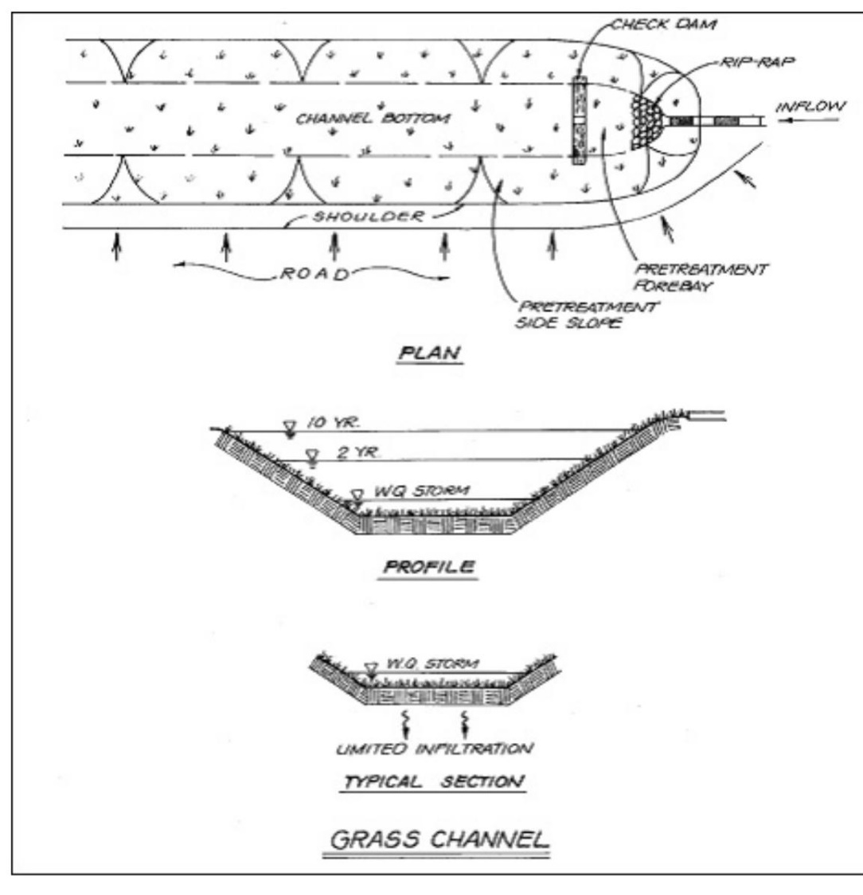
Unit Treatment Process
- Sedimentation & gravity separation
ESSD / LID Alternatives
This practice is a MassDEP recognized ESSD / LID technique.
Applicability

Grass channels convey and treat stormwater. Grass channels were referred to as biofilter swales in the 1996 MassDEP/CZM Stormwater Handbook, based on the nomenclature coined by the Center for Watershed Protection (CWP). The CWP is now referring to biofilter swales as grass channels – so MassDEP is adopting the same name as the CWP to minimize confusion.

Properly designed grass channels are ideal when used adjacent to roadways or parking lots, where runoff from the impervious surfaces can be directed to the channel via sheet flow. Runoff can also be piped to the channel. If piped, locate the sediment forebay at the pipe outlet and include a check dam separating the forebay from the channel. For sheet flow, use a vegetated filter strip on a gentle slope or a pea gravel diaphragm. Make the longitudinal slope as flat as possible. This increases the Hydraulic Residence Time (HRT) and allows gravity separation of solids and maximizes sediment removal. Install check dams to further increase the HRT.

Differences from dry water quality swales, wet water quality swales, bioretention cells, and drainage channels:
Dry water quality swales contain a specific soil media mix and underdrain, providing greater treatment than grass channels. Wet water quality swales are designed with a permanent wet channel, whereas grass channels must be designed to completely drain between storms. Bioretention areas, including rain gardens, are designed solely as a treatment practice, and not for conveyance. Lastly, drainage channels act solely as a conveyance, in contrast to properly designed grass channels where runoff flow is deliberately lagged to provide treatment.
Planning Considerations
An Applicant may not be able to install a grass channel swale because of:
- High groundwater;
- Presence of utilities; or
- Other site conditions that limit depth of excavation because of stability.

Setback Requirements
Stormwater Control Measures (SCMs) and other components of the Stormwater Management System must be setback from wetlands, building foundations, and other features in accordance with 310 CMR 10.05(6)(q). SCMs must also include vertical separation between certain features, such as the depth to seasonally high groundwater. Refer to Section 2.5 of the Stormwater Handbook for horizontal setback and vertical separation distance requirements. Horizontal setbacks also include maintenance access requirements around the perimeter of certain SCMs.
Design Considerations

Water Quality Volume: Design grass channels to maximize contact with vegetation and soil surface to promote greater gravity separation of solids during the storm associated with the water quality event. Design the channel such that the velocity does not exceed 1 foot per second during the 24-hour storm associated with the water quality event. Do not allow the water depth during the storm associated with the water quality event to exceed 4 inches (for design purposes). Make sure the selected design storm provides at least 9 minutes of HRT within the channel. Increasing the HRT beyond 9 minutes increases the likelihood of achieving pollutant removal efficiency. Adding meanders to the swale increases its length and may increase the HRT.

2-year and 10-year conveyance capacity: Design grass channels to convey both the 2-year and

10-year 24-hour storms. Provide a minimum of

1-foot freeboard above the 10 -year storm. Make sure that the runoff velocities during the 2-year 24-hour storm do not cause erosion problems.
Channel Length: Length depends on design factors to achieve the minimum 9-minute residence time for the storm associated with the water quality event.

Channel Crossings: In residential settings, driveways will cross over the channel, typically via culverts (pre-cast concrete, PVC, or corrugated metal pipe).

Soils: Grass channels may be constructed from most parent soils, unless the soils are highly impermeable. Any imported soils must be brought to a minimum 6-inch depth prior to being tilled into the parent material. Soils must be able to support a dense grass growth. MassDEP recommends sandy loams, with an organic content of 10

to 20%, and no more than 20% clay. Highly impermeable soils, such as clays, are not suitable for grass channels, because they do not support dense grass stands. Similarly, gravelly and coarse soils may not be suitable due to their lower moisture retention capability, leading to potential die-back of the grass lining during the summer when the inter-event period between storms is longer than during other times of the year.
Grasses: The grasses serve to stabilize the channel, and promote conditions suitable for sedimentation, such as offering resistance to flow, which reduces water velocities and turbulence. Select a grass height of 6 inches or less. Grasses over that height tend to flatten when water flows

over them, inhibiting sedimentation. Select grasses that produce a fine, uniform and dense cover that can withstand varying moisture conditions. Select grasses that are salt tolerant to withstand winter deicing of roadways. In the spring, replant any areas where grasses died off due to deicing. (Franklin 2002 and Knoxville 2003 provide recommendations for the best grass species.)
Pea Gravel Diaphragm: Use clean bank-run gravel, conforming to ASTM D 448, varying in size from 1/8 inch to 3/8 inch (No. 6 stone).

Outlet Protection: Must be used at discharge points to prevent scour downstream of the outlet.
Construction Considerations: Stabilize the channel after it is shaped before permanent turf is established, using natural or synthetic blankets. Never allow grass channels to receive construction period runoff.

Maintenance

Activity | Frequency
Remove sediment from forebay | Annually
Remove sediment from grass channel | Annually
Mow | Once a month during growing season

Repair areas of erosion and revegetate | As needed, but no less than once a year.
Access: Maintenance access must be designed as part of the grass channel.
When combined with on- street parking, post signs prohibiting parking when the swale is to be inspected and cleaned. Do not use travel lanes along highways and streets as the required maintenance access.

Mowing: Set the mower blades no lower than 3 to 4 inches above the ground. Do not mow beneath the depth of the design flow during the storm associated with the water quality event (e.g., if the design flow is no more than 4 inches, do not cut the grass shorter than 4 inches). Mow on an as-needed basis during the growing season so that the grass height does not exceed 6 inches.
Inspection: Inspect semi-annually the first year, and at least once a year thereafter. Inspect the grass for growth and the side slopes for signs of erosion and formation of rills and gullies. Plant an alternative grass species if the original grass

cover is not successfully established. If grass growth is impaired by winter road salt or other deicer use, re-establish the grass in the spring.
Trash/Debris Removal: Remove accumulated trash and debris prior to mowing.

Sediment Removal: Check on a yearly basis and clean as needed. Use hand methods (i.e., a person with a shovel) when cleaning to minimize disturbance to vegetation and underlying soils. Sediment build-up in the grass channel reduces its capacity to treat and convey the water quality event, 2-year and 10-year 24-hour storm.

References

Atlanta Regional Commission et al, 2001, Georgia Stormwater Management Manual, Volume 2, Section 3-3-2, Grass Channel, https://atlantaregional.org/what-we-do/natural-resources/georgia-stormwater-management-manual/

Center for Watershed Protection, undated, Stormwater Management Fact Sheet: Grass Channel, https://www.stormwatercenter.net/Assorted%20Fact%20Sheets/Tool6_Stormwater_Practices/Open%20Channel%20Practice/Grassed%20Channel.htm (accessed October 23, 2007)

Shanti R. Colwell, Richard R. Horner, Derek B.
Booth, 2000, Characterization of Performance Predictors and Evaluation of Mowing Practices in Biofiltration Swales, https://digital.lib.washington.edu/researchworks/bitstream/handle/1773/19550/Colwell%20thesis.pdf?sequence=1.

Franklin, City of, 2002, PTP-05, Biofilters: Swales and Strips, http://www.franklin-gov.com/engineering/ STORMWATER/SCM/ptp/ptp-05.pdf

Idaho Department of Environmental Quality, 2005, Storm Water Best Management Practices Catalog, SCM 1, Biofiltration Swale (Vegetated Swale).

International Stormwater SCM Data Base, 2016

Minton, G., 2002, Stormwater Treatment, Resource Planning Associates, Seattle, WA, p. 174

Atlanta Regional Commission et al, 2001, Georgia Stormwater Manual, Volume 2, Section 3-3-2, http://georgiastormwater. com/vol2/3-3-2.pdf

International Stormwater Database, based on MassDEP analysis of raw influent & effluent values reported in 2005.

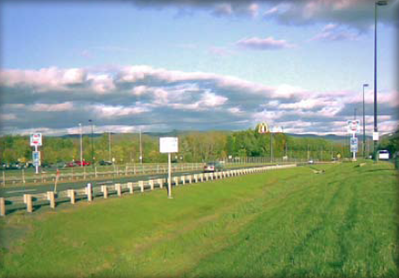
Water Quality Swale

Ability to meet specific standards

Standard | Description
2 - Peak Flow | Does not provide peak attenuation.
3 - Recharge | Provides no groundwater recharge.
4 - TSS/ TP Removal | No EPA Curve. MassDEP Removal.  TSS: 70% removal  TP: 0% removal
5 - Higher  Pollutant  Loading | Dry swale recommended as pretreatment SCM. Must be lined. For some land uses with higher potential pollutant load, an oil/grit separator or equivalent may be required before discharge to the swale.
6 - Discharges  near or to  Critical Areas | Not suitable for discharges near or to vernal pools or bathing beaches. At other critical areas, may be used as pretreatment practice.
7 - Redevelopment | Suitable for Redevelopments and urban applications if sufficient land is available.
8 - Construction Phase Pollution Controls | Construction phase runoff is not to be diverted to these areas; divert stormwater runoff to these areas only once the site has been stabilized.
9 - O&M Plan | An O&M Plan is required for this SCM
11 - Total Maximum Daily Loads | See suitability to treat TMDL Pollutants Table (below). Must be properly designed, sized, and maintained.
ESSD / LID? | Yes, this practice is a MassDEP recognized ESSD / LID technique.

Structural Conveyance
Description
Water quality swales are vegetated open channels designed to treat the required water quality volume and to convey runoff from the 10-year storm without causing erosion.

There are two different types of water quality swales that may be used to satisfy the Stormwater Management Standards:
- Dry Swales
- Wet Swales

Unlike drainage channels which are intended to be used only for conveyance, water quality swales and grass channels are designed to treat the required water quality volume and incorporate specific features to enhance their stormwater pollutant removal effectiveness. Water quality swales have higher pollutant removal efficiencies than grass channels.
Advantages/Benefits
- May be used to replace more expensive curb and gutter systems.
- Roadside swales provide water quality and quantity control benefits, while reducing driving hazards by keeping stormwater flows away from street surfaces.
- Accents natural landscape.
- Compatible with LID designs
- Can be used to retrofit drainage channels and grass channels
- Little or no entrapment hazard for amphibians or other small animals
Disadvantages/Limitations
- Higher degree of maintenance required than for curb and gutter systems.

- Roadside swales are subject to damage from off-street parking, snow removal, and winter deicing.
- Subject to erosion during large storms
- Individual dry swales treat a relatively small area
- Impractical in areas with very flat grades, steep topography, or poorly drained soils
- Wet swales can produce mosquito breeding

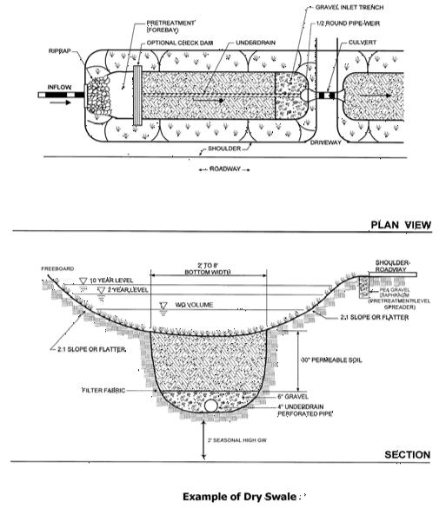
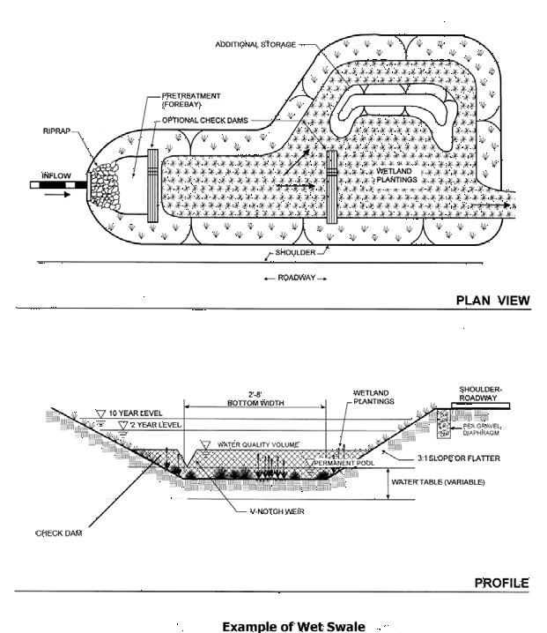
Suitability to Treat TMDL Pollutants
Pollutant | Suitable to Treat?
TSS | Y
Total Nitrogen | N
Total Phosphorous | N
Pathogens | N
Metals | N
Notes:
- Pathogens category includes: fecal coliform, E. coli, and enterococcus.
- Metals category includes Zinc, Cadmium, Lead, Aluminum, and Iron.

Special Features

May be configured as either a dry swale or a wet swale.
ESSD / LID Alternatives
This practice is a MassDEP recognized ESSD / LID technique.
Dry Swale

Dry swales are designed to temporarily hold the water quality volume of a storm in a pool or series of pools created by permanent check dams at culverts or driveway crossings. The soil bed consists of native soils or highly permeable fill material, underlaid by an underdrain system.

Wet Swale

Wet swales also temporarily store and treat the required water quality volume. However, unlike dry swales, wet swales are constructed directly within existing soils and are not underlaid by a soil filter bed or underdrain system. Wet swales store the water quality volume within a series of cells within the channel, which may be formed by berms or check dams and may contain wetland vegetation (Metropolitan Council, 2001). The pollutant removal mechanisms in wet swales are similar to those of stormwater wetlands, which rely on sedimentation, adsorption, and microbial breakdown.
Applicability

Use water quality swales:

- As part of a treatment train

- As one of the best SCMs for areas discharging to Cold-Water Fisheries if they are lined.

- As one of the best SCMs for Redevelopments and urban applications.

- For residential and institutional settings (especially dry swales)

Water quality swales have many uses. Dry swales are most applicable to residential and institutional land uses of low to moderate density where the percentage of impervious cover in the contributing areas is relatively low. Wet swales may not be appropriate for some residential applications, such as frontage lots, because they contain standing water that may attract mosquitoes.

Water quality swales may also be used in parking lots to break up areas of impervious cover. Along the edge of small roadways, use water quality swales in place of curb and gutter systems. Water quality swales may not be suitable for sites with many driveway culverts or extensive sidewalk systems. When combining water quality swales with roadways and sidewalks, place the swale between the two impervious areas (e.g., between road and sidewalk or in-between north and south bound lanes of a roadway/highway).

Planning Considerations
The primary factors to consider when designing a water quality swale are soil characteristics, flow capacity, erosion resistance, and vegetation. Site conditions and design specifications limit the use of water quality swales.
The topography and soils on the site will determine what is appropriate. The topography should provide sufficient slope and cross-sectional area to maintain non-erosive flow velocities. Porous soils are best suited to dry swales, while soils with poor drainage or high groundwater conditions are more suited to wet swales.

Other important factors to consider are land availability, maintenance requirements and soil characteristics. The topography of the site should allow for the design of a swale with sufficient slope and cross-sectional area to maintain a non-erosive flow rate, and to retain or detain the required water quality volume. The longitudinal slope of the swale should be as close to zero as possible and not greater than 5%.
Setback Requirements
Stormwater Control Measures (SCMs) and other components of the Stormwater Management System must be setback from wetlands, building foundations, and other features in accordance with 310 CMR 10.05(6)(q). SCMs must also include vertical separation between certain features, such as the depth to seasonally high groundwater. Refer to Section 2.5 of the Stormwater Handbook for horizontal setback and vertical separation distance requirements. Horizontal setbacks also include maintenance access requirements around the perimeter of certain SCMs.
Design Considerations
Design water quality swales to retain and treat the required water quality volume (1 inch). Because they must also be designed to convey the 2-year and 10-year 24 -hour storms, they may have to convey additional runoff volume to other downgradient SCMs.
The grass or vegetation types used in swales should be suited to the soil and water conditions. Wetland hydrophytes (plants adapted to grow in water) or obligate species (i.e., species that

occur99% of the time under natural conditions in wetlands) are generally more water-tolerant than facultative species (i.e., species that occur 67% to 99% of the time under natural conditions in wetlands) and are good selections for wet swales, while dry swales should be planted with species that produce fine and dense cover and are adapted to varying moisture conditions.

Swale storage capacity should be based on the maximum expected reduction in velocity that occurs during the annual peak growth period. Usually, the maximum expected drop in velocity occurs when vegetation is at its maximum growth for the year. Use the minimum level when checking velocity through the swale or the ability of the swale to convey the 2-year 24-hour storm without erosion. This usually occurs during the early growing season and dormant periods.

Access for maintenance must be incorporated into both designs. The maintenance access way must be a minimum of 15 feet wide on at least one longitudinal side of the swale to enable a maintenance truck to drive along the swale and gain access to any one point. When constructed along a highway, the breakdown lane can be used as the access. When constructed in a residential subdivision, an on-street parking lane may double as the maintenance access, provided signs are posted indicating no parking is allowed during periods when the swales are being maintained.

Dry Swales

- Size dry swales to provide adequate residence time for the required water quality volume. Hydraulic Residence Time (HRT) must be a minimum of 9 minutes. Use Manning’s Equation to determine the HRT.

- Dry swales should have a soil bed that is a minimum of 18 inches deep and composed of approximately 50% sand and 50% loam.
- Pretreatment is required to protect the filtering and infiltration capacity of the swale bed. Pretreatment of piped flows is generally a sediment forebay behind a check dam with a pipe inlet. For lateral inflows (sheet flow), use a vegetated filter strip on a gentle slope or a “pea gravel diaphragm.”

- Design dry swales to completely empty between storms. Where soils do not permit full dewatering between storms, place a longitudinal perforated underpipe on the bottom of the swale bed. The inter-event period used in design to dewater the swale must be no more than 72 hours.

- Dry swales must have parabolic or trapezoidal cross-sections, with side slopes no greater than 3:1 (horizontal: vertical) and bottom widths ranging from 2 to 8 feet.
- Size dry swales to convey the 10-year storm and design swale slopes and backs to prevent erosion during the 2-year event. At least one foot of freeboard must be provided above the volume expected for the 10-year storm.

- Make sure that the seasonal high water table is not within 2 to 4 feet of the dry swale bottom.

- Use outlet protection at any discharge point from a dry swale to prevent scour at the outlet.

Wet Swales

- Size wet swales to retain the required water quality volume.

- Pretreatment is required to protect the filtering and infiltration capacity of the wet swale bed. Pretreatment is generally a sediment forebay behind a check dam with a pipe inlet. For lateral inflows, use gentle slopes or a pea gravel diaphragm.

- Use check dams in wet swales to achieve multiple cells. Use V-notched weirs in the check dams to direct low flow volumes. The height of the check dam shall be no less than the elevation associated with the 1 inch Water Quality Volume.
- Plant emergent vegetation or place wetland soils on the wet swale bottom for seed stock.

- Wet swales are parabolic or trapezoidal in cross-section, with side slopes no greater than 3:1 (horizontal: vertical) and bottom widths ranging from 2 to 8 feet.
- Size wet swales to convey the 10-year 24-hour storm and design wet swale slopes to prevent erosion during the 2-year 24-hour event.
- Use outlet protection at any discharge point from wet swales to prevent scour at the outlet.

Construction

Use temporary erosion and sediment controls during construction. Select the vegetation mix to suit the characteristics of the site. Seeding will require mulching with appropriate materials, such as mulch matting, straw, and wood chips. Anchor the mulch immediately after seeding. Water new seedlings well until they are established. Refer to “Massachusetts Erosion and Sediment Control Guidelines for Urban and Suburban Areas: A Guide for Planners, Designers, and Municipal Officials” for information on seeding and mulching.

Maintenance
Activity | Frequency
Inspect swales to make sure vegetation is adequate and slopes are not eroding. Check for rilling and gullying. Repair eroded areas and revegetate. | The first few months after construction and twice a year thereafter.
Mow dry swales. Wet swales may not need to be mowed depending on vegetation. | As needed.
Remove sediment and debris manually | At least once a year

Re-seed | As necessary.
Incorporate a maintenance and inspection schedule into the design to ensure the effectiveness of water quality swales. Inspect swales during the first

few months after installation to make sure that the vegetation in the swales becomes adequately established. Thereafter, inspect swales twice a year.
During the inspections, check the swales for slope integrity, soil moisture, vegetative health, soil stability, soil compaction, soil erosion, ponding and sedimentation.

Regular maintenance includes mowing, fertilizing, liming, watering, pruning, and weed and pest control. Mow swales as needed for vegetation growth. Do not cut the grass shorter than three to four inches, otherwise the effectiveness of the vegetation in reducing flow velocity and removing pollutants may be reduced. Do not let grass height exceed 6 inches in Dry Swales.

Manually remove sediment and debris at least once per year, and periodically re -seed, if necessary, to maintain a dense growth of vegetation.
Take care to protect water quality swales from snow removal and disposal practices and off- street parking.
When grass water quality swales are located on private residential property, the operation and maintenance plan must clearly identify the property owner who is responsible for carrying out the required maintenance. If the operation and maintenance plan calls for maintenance of water quality swales on private properties to be accomplished by a public entity or an association (e.g., homeowners association), maintenance easements must be secured
References
Site Planning for Urban Stream Protection. 1995. Schueler. Center for Watershed Protection.

Watershed Protection Techniques, Volume 2, Number 2, 1996. Center for Watershed Protection.
Biofiltration swale performance, recommendations, and design considerations.
1992. Metro Seattle: Water Pollution Control Department, Seattle, WA.

Massachusetts
Stormwater Management
Handbook
Structural Infiltration

- Dry Wells
- Infiltration Basins
- Infiltration Trenches
- Leaching Catch Basins
- Porous Pavement
- Subsurface Structures

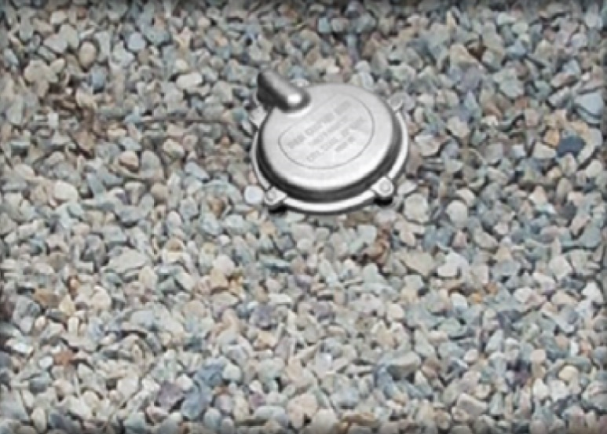
Dry Wells

Ability to meet specific standards

Standard | Description
2 – Peak Flow | Does not provide peak attenuation.
3 – Recharge | Provides groundwater recharge.
4 – TSS/TP Removal | Use EPA Infiltration Trench Performance Curves to calculate required sizing to meet pollutant removal requirements. See “Introduction” Section of this Appendix for more information the EPA Performance Curves. Provides TSS and TP removal credit from non-metal roofs and runoff from metal roofs that are located outside of the Zone II or Interim Wellhead Protection Area of a Public Water Supply or outside an industrial site.
5 – Higher Pollutant Loading | May not be used for runoff from land uses with higher potential pollutant loads, May not be used for runoff from metal roofs located at industrial sites.
6 – Discharges near or to Critical Areas | Within a Zone II or IWPA may be used only for runoff from nonmetal roofs. Outside a Zone II or Interim Wellhead Protection Area, may be used for both metal and nonmetal roofs provided the roof is not located on an industrial site.
7 – Redevelopment | For rooftop runoff from non-metal roofs and from metal roofs located outside a Zone II or IWPA and outside industrial sites.
11 – Total Maximum Daily Loads | See suitability to treat TMDL Pollutants table (below). Must be properly designed, sized, and maintained.
ESSD / LID? | Yes, this practice is a MassDEP recognized ESSD / LID technique.

Description
Structural Infiltration
Dry wells are small excavated pits, backfilled with aggregate, and used to infiltrate uncontaminated runoff from non-metal roofs or metal roofs located outside the Zone II or Interim Wellhead Protection Area of a Public Water Supply and outside an industrial site.

Advantages/Benefits

- Applicable for runoff from non-metal roofs and metal roofs located outside of the Zone IIs or IWPA of a Public Water Supply, and outside industrial sites

- Can reduce the size and cost of downstream SCMs and/or storm drains.

- Feasible for new development and retrofit areas

- Provides groundwater recharge

Disadvantages/Limitations

Clogging likely when used for runoff other than

- that from residential rooftops.

May experience high failure rate due to

- clogging.

Only applicable in small drainage areas of one

- acre or less.

When located near buildings, potential issues

with water seeping into cellars or inducing

- cracking or heaving in slabs.

Overflow from roof leader must be directed

- away from sidewalks or driveways.

Suitability to Treat TMDL Pollutants
Pollutant | Suitable to Treat?
TSS | Y
Total Nitrogen | Y
Total Phosphorous | Y
Pathogens | Y
Metals | Y

Notes:
- Pathogens category includes: fecal coliform, E. coli, and enterococcus.
- Metals category includes Zinc, Cadmium, Lead, Aluminum, and Iron.

Special Features
Small footprint practice, highly compatible with residential land uses in suburban and rural areas.
ESSD / LID Alternatives
This practice is a MassDEP recognized ESSD / LID technique.
Applicability

Stormwater dry wells must only be used for rooftop runoff. Dry wells must not be used for runoff generated from impervious or pervious surfaces located at ground level. The use of dry wells is limited by a number of site constraints, including soil type, contributing drainage area, depth to bedrock, and depth to groundwater.
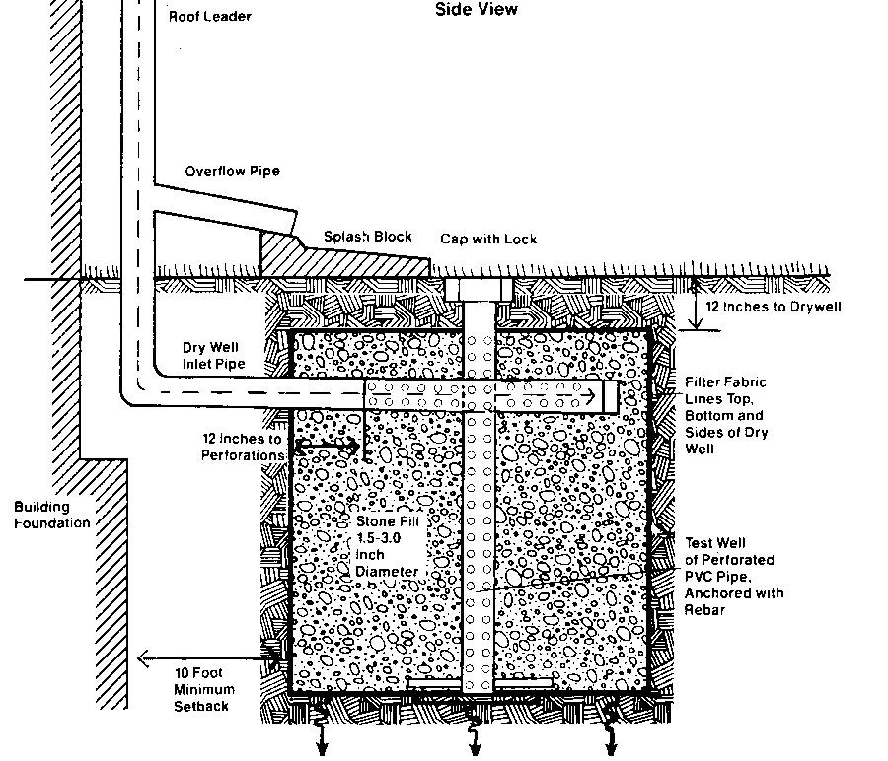
Dry wells are intended to only infiltrate roof runoff that is unlikely to contribute significant loadings of sediment or pollutants. Do not infiltrate runoff from buildings that are classified as Land Uses with Higher Potential Pollutant Loads (LUHPPL) or contaminated rooftop runoff (metal roofs located in a Zone II of a public drinking water supply). Under no circumstances shall dry wells be used to infiltrate any runoff that potentially contains sediment and pollutants, such as that from parking lots. These requirements are necessary to minimize the potential for dry wells to clog. When pore spaces surrounding dry wells clog, infiltration occurs at a much slower rate. This potentially leads to surcharge and failure of the dry well. Use dry wells where space is limited. They are ideally used in residential subdivisions consisting of detached dwellings.
Example Dry Well (adapted from the University of New Hampshire)

Effectiveness
Dry wells are effective in two ways. First, dry wells when sited and designed properly, infiltrate runoff assisting sites with meeting Stormwater Standard No. 3 requiring recharge. Second, dry wells are credited with TSS and TP removal rate utilizing crosswalk for Infiltration trenches with meeting Stormwater Standard No. 4, provided the dry wells are designed to meet the criteria specified herein.
Planning Considerations
Parent soils must have a minimum saturated hydraulic conductivity rate of 0.01 inches/hour. Where the parent soils have a saturated hydraulic conductivity rate of 2.4 in/hour or higher (soil with a rapid infiltration rate), pretreatment is required prior to infiltration.
Dry wells must only be used to infiltrate runoff from non-metal rooftops, from metal rooftops of non-industrial buildings, or metal rooftops located outside of Zone IIs of a public drinking water supply. Runoff that is expected to contain sediment or other pollutants must be directed away from the dry well, and towards another type of SCM.
Stormwater dry wells must be sited at least ten (10) feet away building foundations. They should be located down-gradient of foundations. They should not be located up-gradient of foundations to minimize groundwater seepage into basements or cellars. This up-gradient recommendation does not apply at locations where sites are graded flat. However, keep in mind though that the piezometric surface of the groundwater slope may be different than the topographic land surface slope.
Underground Injection Control (UIC): Dry wells are typically deeper than they are wider and require UIC registration through MassDEP. The UIC programs allows for a region wide registration for multiple dry wells located at a single location, such as a residential subdivision. For information on the UIC program and its application to infiltration BMPs, see https://www.mass.gov/underground-injection-control-uic
State Plumbing Code: Roof leader connections to a dry well may require compliance with the State Plumbing Code. If compliance is required, the connection must be made by a licensed plumber. Check with the local plumbing or building official.
Setback Requirements
Stormwater Control Measures (SCMs) and other components of the Stormwater Management System must be setback from wetlands, building foundations, and other features in accordance with 310 CMR 10.05(6)(q). SCMs must also include vertical separation between certain features, such as the depth to seasonally high groundwater. Refer to Section 2.5 of the Stormwater Handbook for horizontal setback and vertical separation distance requirements. Horizontal setbacks also include maintenance access requirements around the perimeter of certain SCMs.
Design Considerations
Dry wells are a variation of infiltration trench, designed to infiltrate only good quality runoff. Roof leaders discharge runoff to the dry well. Roof top gutter screens trap particles, leaves, and other debris, and must be cleaned regularly. Site and install dry wells at least ten (10) feet from building foundations. Do not install a dry well until the drainage area has been stabilized. The roof leader must be able to bypass flows when the dry well is saturated. The dry well must contain an observation well.
The volume and surface area of dry wells is a function of: the quantity of runoff being discharged to the dry well from the contributing roof area and the overlying soil, the void space, and the vertical saturated hydraulic conductivity. At a minimum, size the dry well to hold the full recharge volume for rooftop runoff from new developments, and to the maximum extent practicable for Redevelopments. Because the dry well is filled with stone, only the space between the stone is available for runoff storage. Fill dry wells with 1.5 - 3.0 inch diameter, clean washed stone. This size stone will yield a void space of approximately 30 - 40%. Assume no more than 40% for designed purposes. When saturated hydraulic conductivity is based on soil texture as provided in Section 6.3 of the Stormwater Handbook, take at least one soil sample at the actual location of each proposed dry well to detect localized soil conditions. Do not assume any sidewall exfiltration for purposes of any analyses.
Determine the maximum depth of the dry well from the infiltration rate, the allowable storage time, and the void space. Design storage times to be a minimum of 48 hours and a maximum of 72 hours.
Install the bottom of the dry well at least two (2) feet above the seasonal high water table and below the frost line. Place excavated material away from the excavated sides to increase wall stability. Trim large roots so they are flush with the sides to prevent fabric puncturing or tearing during installation. Roughen sidewalls where sheared and sealed by heavy equipment. Install an observation well to monitor the runoff clearance from the system. This well should consist of a well-anchored, vertical perforated PVC pipe with a lockable above ground cap. Where bedrock is near the land surface, evaluate whether a dry well is suitable. Bedrock close to the ground surface reduces the amount of treatment provided by the soil and can lead to break-out or failure of the dry well; unless there are fissures or cracks in it, bedrock causes exfiltrated water to only move laterally, and not downward.
Note that these criteria applies to stormwater dry wells, and not to dry wells that may be used for other applications pursuant to other MassDEP regulations.
Site Criteria
Summary Criteria for Stormwater Dry Wells
1. The contributing drainage area to any individual dry well typically should not exceed one rooftop.
2. The minimum depth to the seasonal high groundwater table, bedrock, or impermeable layer must be at least 2 feet from the bottom of the dry well.
3. The minimum saturated hydraulic conductivity rate is 0.01 inches/hour. Dry wells must be sized in accordance with the procedures set forth in Section 6.2.
4. One soil test pit or boring per dry well is required to conduct the textural analysis to determine the design saturated hydraulic conductivity rate. This is to allow detection of any localized soil conditions.
5. Dry wells must not be sited where soils have 30% or greater clay content, or 40% or greater silt clay content.
6. Dry wells must not be placed over fill materials.
Construction
Take care during construction to minimize the risk of failure of the dry well. The Construction Period Control Plan required by Stormwater Standard No. 8 must include measures to prevent runoff from entering the dry well during construction. The Construction Period Control Plan must also include provisions to prevent construction operations atop dry well locations and prevent construction vehicles from driving across sites intended for stormwater exfiltration. Typically, the Construction Period Plan should specify construction fence or similar measure to prevent vehicles from driving over dry well locations. High fencing made from a brightly colored material (e.g., orange polypropylene) is more visible from bull dozers than smaller fence or hay bales. During construction, the measures specified in the Construction Period Control Plan must be implemented to prevent construction vehicles from driving across the area intended for exfiltration. Inspections conducted by the Construction Contractor or Conservation Commissions should examine fencing or other measures installed to meet this requirement, to ensure it is being maintained properly.
Maintenance
Activity | Frequency
Inspect dry wells. | After every significant storm of at least 0.25-inches or more in the first six months after construction to ensure proper stabilization and function. Thereafter, inspect annually.
Measure the water depth in the observation  well at 24- and 48-hour intervals after a storm of at least 0.25-inches. | After every significant storm of at least 0.25 inch/day or more in the first six months after construction. Thereafter measure clearance rate at least once annually after a storm of at 0.25 inches in depth over a day.
Calculate clearance rates by dividing the drop in
water level (inches) by the time elapsed (hr.).

Because these structures are often installed at single-family dwellings, it is important that developers clearly outline the maintenance requirements to property purchasers.
Check and clean the screens in the roof leaders once a year. Check the bypass leader once a year to determine if it is clear.
Inspect dry wells after every significant storm (as defined in table above) in the first few months after construction to ensure proper stabilization and function. Thereafter, inspect the dry well at least once per year. Measure the water depth in the observation well at 0, 24, and 48-hour intervals after a storm. Calculate clearance rates by dividing the drop in water level (inches) by the time elapsed (hours). A comparison of clearance rate measurements taken over the years provides a useful tool for tracking any clogging problems within the dry well.
The Operation and Maintenance Plan required by Stormwater Standard No. 8 must provide for repair if the exfiltration rate decreases over time. Repair consists of digging up the stone, removing any asphalt or grit from the void space in the stone, and raking the stone to restore the void space. A simple way to check for clogging is to block the bypass pipe during a rain storm. Observe the roof leader to determine if surcharge or a tailwater condition occurs (e.g., water starts dripping from roof gutter overhead or water starts seeping out from joints in the roof leaders. After the rain stops, unblock the bypass pipe. If rain pours out of the bypass, the system has failed and needs repair.

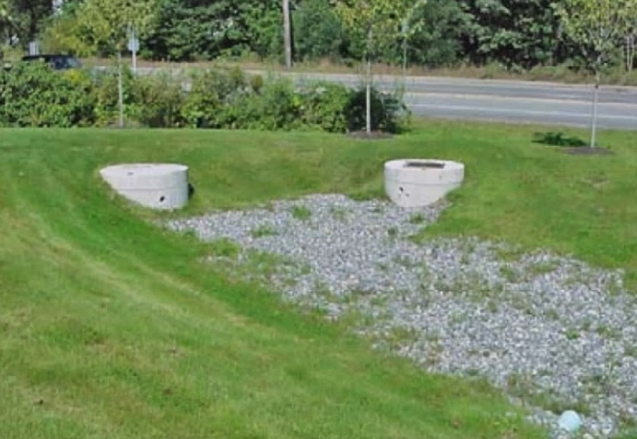
Infiltration Basins

Ability to meet specific standards

Standard | Description
2 - Peak Flow | Can be designed to provide peak flow attenuation (see Section 6.2.2 of the Stormwater Handbook).
3 - Recharge | Provides groundwater recharge.

4 - TSS/ TP | Use EPA Infiltration Basin Performance Curves to calculate required sizing to meet pollutant removal requirements. See “Introduction” Section of this Appendix for more information the EPA Performance Curves. Provide one or more pretreatment SCMs.
5 - Higher Pollutant Loading | May be used if 44% of TSS is removed with a pretreatment SCM prior to infiltration. For some land uses with higher potential pollutant loads, use an oil/grit separator, sand filter or equivalent for pretreatment prior to discharge to the infiltration basin. Infiltration must be done in compliance with 314 CMR 5.00
6 - Discharges  near or to  Critical Areas | Suitable for discharges near or to Critical Areas, especially for discharges near Cold-Water Fisheries. Requires 44% removal of TSS prior to discharge to infiltration basin.
7 - Redevelopment | Typically not an option due to land area constraints
11 - Total Maximum Daily Loads | See suitability to treat TMDL Pollutants Table (below). Must be properly designed, sized, and maintained.
ESSD / LID? | Yes, this practice is a MassDEP recognized ESSD / LID technique.

Description
Structural Infiltration
Infiltration basins are stormwater runoff impoundments that are constructed over permeable soils. Pretreatment is critical for effective performance of infiltration basins. Runoff from the design storm is stored until it exfiltrates through the soil of the basin floor.

Advantages/Benefits

- Provides groundwater recharge.

- Reduces local flooding.

- Preserves the natural water balance of the site.

- Can be used for larger sites than infiltration trenches or structures.

Disadvantages/Limitations

- High failure rates due to improper siting, inadequate pretreatment, poor design and lack of maintenance.
- Restricted to fairly small drainage areas.

- Not appropriate for treating significant loads of sediment and other pollutants.

- Requires frequent maintenance.

Suitability to Treat TMDL Pollutants
Pollutant | Suitable to Treat?
TSS | Y
Total Nitrogen | Y
Total Phosphorous | Y
Pathogens | Y
Metals | Y

Notes:
Pathogens category includes: fecal

- coliform, E. coli, and enterococcus.
- Metals category includes Zinc, Cadmium, Lead, Aluminum, and Iron.
Special Features

Provides groundwater recharge

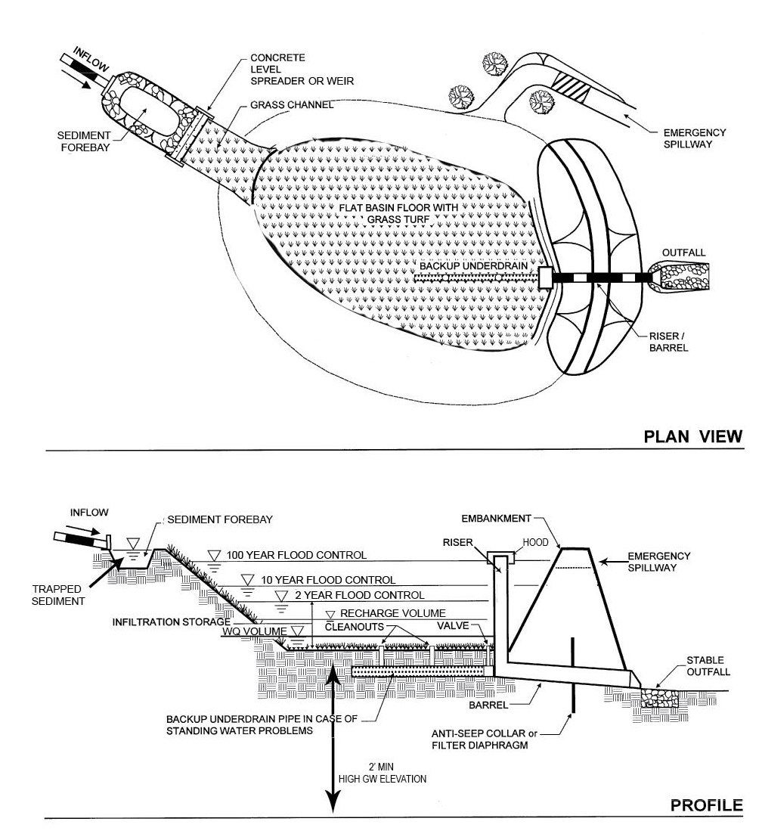
ESSD/
Example Infiltration Basin (adapted from the Vermont Stormwater Manual)

LID Alternatives

This practice is a MassDEP recognized ESSD / LID technique.
Infiltration Basin Design Variations

Full Exfiltration Basin Systems

These basin systems are sized to provide storage and exfiltration of the required recharge volume and treatment of the required water quality volume. They also attenuate peak discharges. Designs typically include an emergency overflow channel to discharge runoff volumes in excess of the design storm.

Partial or Off-line Exfiltration Basin Systems

Partial basin systems exfiltrate a portion of the runoff (usually the first flush or the first inch), with the remaining runoff being directed to other SCMs. Flow splitters or weirs divert flows containing the first flush into the infiltration basin. This design is useful at sites where exfiltration cannot be achieved by downstream detention SCMs because of site condition limitations.

Applicability

The suitability of infiltration basins at a given site is restricted by several factors, including soils, slope, depth to water table, depth to bedrock, the presence of an impermeable layer, contributing

watershed area, proximity to wells, Surface Waters, and foundations. Generally, infiltration basins are suitable at sites with gentle slopes, permeable soils, relatively deep bedrock and groundwater levels, and a contributing watershed area of approximately 2 to 15 acres. Table IB.1 presents the recommended site criteria for infiltration basins.

Pollution prevention and pretreatment are particularly important at sites where infiltration basins are located, to minimize the potential for clogging. Pollution prevention limits the particulates that are generated. Pretreatment removes the gross solids and coarser suspended solids. Removing solids and the coarser suspended solids by pollution prevention and pretreatment will minimize the potential for clogging and failure of the infiltration basin. The Pollution Prevention and Source Control Plan required by Stormwater Standard 4 must address measures to reduce particulate generation, such as not applying sand to roads and parking areas during winter months.

For land uses with higher potential pollutant loads, provide a bypass to divert contaminated stormwater from the infiltration basin in storms larger than the design storm.

Prior to pretreatment, implement the pollution prevention and source control program specified in the Pollution Prevention and Source Control Plan to reduce the concentration of pollutants in the discharge. Program components include careful management of snow and deicing chemicals, fertilizers, herbicides, and pest control. The Plan must prohibit snow disposal in the basin and include measures to prevent runoff of stockpiled snow from entering the basin. Stockpiled snow contains concentrations of sand and deicing chemicals. At industrial sites, keep raw materials and wastes from being exposed to precipitation. Select pretreatment SCMs that remove coarse sediments, oil and grease, and floatable organic and inorganic materials, and soluble pollutants.

Effectiveness
Infiltration basins are highly effective treatment systems that remove many contaminants, including TSS and TP. However, infiltration basins are not intended to remove coarse particulate pollutants. Use a pretreatment device to remove them before they enter the basin. The pollutant removal efficiency of the basin depends on how much runoff is exfiltrated by the basin.

Infiltration basins can be made to control peak discharges by incorporating additional elevation stages in the design. To do this, design the riser outlet structure or weir with multiple orifices, with the lowest orifice set to achieve storage of the full recharge volume required by Standard 3. Design the upper orifices using the same procedures as extended detention basins. The basins can also be designed to achieve exfiltration of storms greater than the required recharge volume. However, in such cases, make sure the soils are permeable enough to allow the basin to exfiltrate the entire volume in a 72-hour period. This may necessitate increasing the size of the floor area of the basin. Generally, it is not economically feasible to provide storage for large infrequent storms, such as the 100-year 24-hour storm.

Planning Considerations

Carefully evaluate sites before planning infiltration basins, including investigating soils, depth to bedrock, and depth to water table. Suitable parent soils should have a minimum infiltration rate of 0.01 inches per hour. Infiltration basis must be sized in accordance with the procedures set forth in Section 6.2.

The infiltration basin must be sited a minimum of 50-feet from any slope greater than 15% gradient.
Setback Requirements
Stormwater Control Measures (SCMs) and other components of the Stormwater Management System must be setback from wetlands, building foundations, and other features in accordance with 310 CMR 10.05(6)(q). SCMs must also include vertical separation between certain features, such as the depth to seasonally high groundwater. Refer to Section 2.5 of the Stormwater Handbook for horizontal setback and vertical separation distance requirements. Horizontal setbacks also include maintenance access requirements around the perimeter of certain SCMs.

Design Considerations

Table IB.1 - Site Criteria for Infiltration Basins
- The contributing drainage area to any individual infiltration basin should be restricted to 15 acres or less.
- The minimum depth to the seasonal high ground water table, bedrock, and/or impermeable layer must be at least 2 ft. from the bottom of the basin.
- The minimum infiltration rate is 0.01 inches per hour. Infiltration basins must be sized in accordance with the procedures set forth in Section 6.2.
- At least one soil test pit or boring for every 5000 ft. of basin area is required, with a minimum of three test pits or borings for each infiltration basin. Soil analyses and in-situ saturated hydraulic conductivity must be performed at the actual location of the proposed infiltration basin so that any localized soil conditions are detected.
- Infiltration basins must not be used at sites where soil have 30% or greater clay content, or 40% or greater silt clay content.
- Infiltration basins must not be placed over fill materials.
Infiltration basins are highly effective treatment and disposal systems when designed properly. The first step before design is providing source control and implementing pollution prevention measures to minimize sediment and other contaminants in runoff discharged to the infiltration basin. Next, consider the appropriate pretreatment SCMs.

Design pretreatment SCMs to pretreat runoff before stormwater reaches the infiltration basin. For Critical Areas, land uses with potentially higher pollutant loads, and soils with rapid infiltration rates (greater than 2.4 inches/hour), pretreatment must remove at least 44% of the TSS. Applicants may comply with this requirement by proposing two pretreatment SCMs capable of removing 25% TSS. However, the issuing authorities (i.e., Conservation Commissions or MassDEP) may require additional pretreatment for other constituents beyond TSS for land uses with higher potential pollutant loads. If the land use has the potential to generate stormwater runoff with high concentrations of oil and grease, treatment by an oil/grit separator or equivalent is required before discharge to the infiltration basin.

For discharges from areas other than Critical Areas, land uses with potentially higher pollutant loads, and soils with rapid infiltration rates, MassDEP also requires some TSS and TP pretreatment. Common pretreatment for infiltration basins includes aggressive street sweeping, deep sump catch basins, oil/grit separators, vegetated filter strips, water quality swales, or sediment forebays. Fully stabilize all land surfaces contributing drainage to the infiltration practice after construction is complete to reduce the amount of sediment in runoff that flows to the pretreatment devices.

Always investigate site conditions. Infiltration basins must have a minimum separation from seasonal high groundwater of at least 2 feet. Groundwater mounding calculations are required when separation to seasonal high groundwater is less than 4 feet from the proposed bottom elevation of the basin and the infiltration basin is used to attenuate the 10-year 24-hour or higher storm (see Section 6.2.3 for more detail). Greater separation is necessary for bedrock. If there is bedrock on the site, conduct an analysis to determine the appropriate vertical separation. The greater the distance in elevation above the bottom of the basin media to the seasonal high groundwater elevation, the less likely the basin will fail to drain in the 72-hour period following precipitation.

Determine soil infiltration rates using samples collected at the proposed location of the basin. Take one soil boring or dig one test pit for every 5,000 feet

of basin area, with a minimum of three borings for each infiltration basin. Conduct the borings or test pits in the layer where infiltration is proposed. For example, if the A and B horizons are to be removed and the infiltration will be through the C horizon, conduct the borings or test pits through the C horizon. MassDEP requires that borings be at least 60 inches below the lowest engineered depth of any SCM in accordance with Section 6.3.

For each bore hole or test pit, evaluate the saturated hydraulic conductivity of the soil, depth to seasonal high groundwater, NRCS soil textural class, NRCS Hydrologic Soil Group, and the presence of fill materials in accordance with Section 6.3. Never locate infiltration basins above existing manmade fill, except when a mounded infiltration basin is being created using newly placed well graded sand. Mounded infiltration systems must be carefully constructed to prevent compaction of the sand being placed as well as the underlying parent material. The minimum acceptable final soil infiltration rate is 0.01 inches per hour. Design the infiltration basin based on the soil evaluation set forth in Section 6.3.

If the proposed basin is determined to be in Hydrologic Soil Group “C” soils, incorporate measures in the design to reduce the potential for clogging, such as providing more pretreatment or greater media depth to provide additional storage. Never use the results of a Title 5 percolation test to estimate a saturated hydraulic conductivity rate, because it tends to greatly overestimate the rate that water will infiltrate into the subsurface.

Estimate seasonal high groundwater based on soil mottles or through direct observation when borings are conducted in April or May, when groundwater levels are likely to be highest. If it is difficult to determine the seasonal high groundwater elevation from the borings or test pits, then use the Frimpter method developed by the USGS (Massachusetts/ Rhode Island District Office) to estimate seasonal high groundwater. After estimating the seasonal high groundwater using the Frimpter method, re-examine the bore holes or test pits to determine if there are any field indicators that corroborate the Frimpter method estimate.

Stabilize inlet channels to prevent incoming flow velocities from reaching erosive levels, which can scour the basin floor. Riprap is an excellent inlet stabilizer. Design the riprap so it terminates in a broad apron, thereby distributing runoff more evenly over the basin surface to promote better infiltration.

At a minimum, size the basin to hold the required recharge volume. Determine the required recharge

volume using either the static or dynamic methods set forth in Section 6.2.3. Remember that the required storage volume of an infiltration basin is the sum of the quantity of runoff entering the basin from the contributing area and the precipitation directly entering the basin. Include one foot of freeboard above the total of the required recharge volume and the direct precipitation volume to account for design uncertainty. When applying the dynamic method to size the basin, use only the bottom of the basin (i.e., do not include side wall exfiltration) for the effective infiltration area.

Design the infiltration basin to exfiltrate in less than 72 hours. See Section 6.2.3 for description of the drawdown analysis. Consider only the basin floor as the effective infiltration area when determining whether the basin meets this requirement.

Design the basin floor to be as flat as possible to provide uniform ponding and exfiltration of the runoff. Design the basin floor to have as close to a 0% slope as possible. In no case shall the longitudinal slope exceed 1%. Enhanced deposition of sediment in low areas may clog the surface soils, resulting

in reduced infiltration and wet areas. Design the side slopes of the basin to be no steeper than 3:1 (horizontal: vertical) to allow for proper vegetative stabilization, easier mowing, easier access, and better public safety.

For basins with a 1% longitudinal slope, it will be necessary to incorporate cells into the design, making sure that the depth of ponded water does not exceed 2 feet, because sloped basin floors cause water to move downhill, thereby decreasing the likelihood of infiltration. Make lateral slopes flat (i.e., 0% slope).

After the basin floor is shaped, place soil additives on the basin floor to amend the soil. The soil additives shall include compost, properly aged to kill any seed stock contained within the compost. Do not put biosolids in the compost. Mix native soils that were excavated from the A or B horizons, cover the compost, and then scarify the native

materials and compost into the parent material using a chisel plow or rotary device to a depth of 12 inches. Immediately after constructing the basin, stabilize its bottom and side slopes with a dense turf of water-tolerant grass. Use low-maintenance, rapidly germinating grasses, such as fescues. The selected grasses must be capable of surviving in both wet and dry conditions. Do not use sod, which can prevent roots from directly contacting the underlying soil. During the first two months, inspect the newly established vegetation several times to determine if any remedial actions (e.g., reseeding, irrigating) are necessary.

Never plant trees or shrubs within the basin or on the impounding embankments as they increase the chance of basin failure due to root decay or subsurface disturbance. The root penetration and thatch formation of the turf helps to maintain and may even enhance the original infiltration capacity. Soluble nutrients are taken up by the turf for growth, improving the pollutant removal capacity. Dense turf will impede soil erosion and scouring of the basin floor.

As an alternative to turf, use a basin liner of 6 to 12 inches of fill material, such as coarse sand. Clean and replace this material as needed. Do not use loose stone, riprap, and other irregular materials requiring hand removal of debris and weeds (i.e., stone linings are not acceptable).

Design embankments and spillways to conform to the regulatory guidelines of the state’s Office of Dam Safety (302 CMR 10.00). Design infiltration basins to be below surrounding grade to avoid issues related to potential embankment failure. All infiltration basins must have an emergency spillway capable of bypassing runoff from large storms without damage to the impounding structure. Design the emergency spillway to divert the storm associated with brimful conditions without impinging upon the structural integrity of the basin. The brimful condition could be the required recharge volume or a design storm (such as the 2-year, 10-year, or 100-year storm if the basin is designed to provide peak rate attenuation in addition to exfiltration). The storm associated with the brimful conditions should not include the one foot of freeboard required to account for design uncertainty.
Design the emergency spillway to shunt water toward a location where the water will not damage wetlands or buildings. A common error is to direct the spillway

runoff toward an adjoining property or roadway not owned by an Applicant. If the emergency spillway is designed to drain the emergency overflow toward an adjoining property, obtain a drainage easement and submit

it to the Conservation Commission as part of the Wetlands NOI submission. Place vegetative buffers around the perimeter of the basin for erosion control and additional sediment and nutrient removal.

Monitoring wells: Install one monitoring well in the basin floor per every 5,000 square feet of basin floor. Monitoring well(s) must extend at least 5 feet below the lowest engineered depth of the SCM, or to the limiting layer.

Access: Include access in the basin design. There must be unimpeded vehicular access around the entire basin perimeter. The access area shall be at least 15 feet wide.

Inlet Structures: Place inlet structures at one longitudinal end of the basin, to maximize the flow path from the inlet to the overflow outlet. A common error is to design multiple inlet points around the entire basin perimeter.

Outlet structures: Infiltration basins must include an overflow outlet in addition to an emergency spillway. Whether using a single orifice or multiple orifices in the design, at a minimum, set the lowest orifice at or above the required recharge volume.

Drawdown device: Include a device to draw the basin down for maintenance purposes. If the basin includes multiple cells, include a drawdown device for each cell.

Fences: Do not place fences around basins located in Riverfront Areas, as required by 310 CMR 10.58(4) (d)1.d. to avoid impeding wildlife movement. In such cases, consider including a safety bench as part of the design.

Construction

- Prior to construction, rope or fence off the area selected for the infiltration basin. Never allow construction equipment to drive across the area intended to serve as the infiltration basin.

- Never use infiltration basins as temporary sediment traps for construction activities.

- Construction-phase sedimentation basins should never be located within or above the footprint of a proposed infiltration basin, as this may result in clogging of the underlying soils
- To limit smearing or compacting soils, never construct the basin in winter or when it is raining. Use light earth-moving equipment to excavate the infiltration basin because heavy equipment compacts the soils beneath the basin floor and side slopes and reduces infiltration capacity. Because some compaction of soils is inevitable during construction, add the required soil amendments and deeply till the basin floor with a rotary tiller or a disc harrow to a depth of 12 inches to restore infiltration rates after final grading.

Use proper erosion/sediment control during construction. Immediately following basin construction, stabilize the floor and side slopes of the basin with a dense turf of water-tolerant grass. Use low maintenance, rapidly germinating grasses, such as fescues. Do not sod the basin floor or side slopes. After the basin is completed, keep the basin roped or fenced off while construction proceeds on other parts of the site. Never direct construction period drainage to the infiltration basin. After construction is completed, do not direct runoff into the basin until the bottom and side slopes, and contributing drainage areas are fully stabilized.
Maintenance
Activity | Frequency
Preventative maintenance | Twice a year

Inspect to ensure proper functioning | After every major storm during first 3 months of operation and twice a year thereafter and when there are discharges through the high outlet orifice
Mow the buffer area, side slopes, and basin bottom if grassed floor; rake if stone bottom; remove trash and debris; remove grass clippings and accumulated organic matter | Twice a year
Inspect and remove sediment/pollutants from pretreatment devices | Every other month recommended. At a minimum, twice a year, and after every major storm event.
A major storm event for on-going post-construction monitoring is defined as equal to or greater than 1 inch in a 24-hour period.
Infiltration basins are prone to clogging and failure, so it is imperative to develop and implement aggressive maintenance plans and schedules. Installing the required pretreatment SCMs will significantly reduce maintenance requirements for the basin.

The Operation and Maintenance Plan required by Standard 9 must include inspections and preventive maintenance at least twice a year, and after every time drainage discharges through the high outlet orifice or over the emergency spillway. The Plan must require inspecting the pretreatment SCMs after every major storm event and regularly twice a year, at a minimum (ideally every other month).

Once the basin is in use, inspect it after any storm of 0.25-inches or more for the first 3 months to ensure it is stabilized and functioning properly and, if necessary, take corrective action. Note how long water remains standing in the basin after a storm; standing water within the basin 72 hours after a storm indicates that the infiltration capacity may

have been overestimated. If the ponding is due to clogging, immediately address the reasons for the clogging (such as upland sediment erosion, excessive compaction of soils, or low spots).

Thereafter, inspect the infiltration basin at least twice per year. Important items to check during the inspection include:

- Signs of differential settlement,

- Cracking,

- Erosion,

- Leakage in the embankments

- Tree growth on the embankments

- Condition of riprap,

- Sediment accumulation and

- The health of the turf.

At least twice a year, mow the buffer area, side slopes, and basin bottom. Remove grass clippings and accumulated organic matter to prevent an impervious organic mat from forming. Remove trash and debris at the same time. Use deep tilling to break up clogged surfaces, and revegetate immediately.

Remove sediment from the basin as necessary, but wait until the floor of the basin is thoroughly dry. Use light equipment to remove the top layer so as to not compact the underlying soil. Deeply till the remaining soil, and revegetate as soon as possible.

References:

Center for Watershed Protection, http://www.stormwatercenter.net/Manual_Builder/Construction%20Specifications/Infiltration%20Trench%20Specifications.htm

Center for Watershed Protection, http://www. stormwatercenter.net/Manual_Builder/Performance%20 Criteria/Infiltration.htm

Center for Watershed Protection, Stormwater Management

Fact Sheet, Infiltration Basin,

http://www.stormwatercenter.net/Assorted%20Fact%20

Sheets/Tool6_Stormwater_Practices/Infiltration%20

Practice/Infiltration%20Basin.htm

Ferguson, B.K., 1994. Stormwater Infiltration. CRC Press,

Ann Arbor, MI.

Galli, J. 1992. Analysis of Urban SCM Performance

and Longevity in Prince George’s County, Maryland.

Metropolitan Washington Council of Governments,

Washington, DC.

Maryland Department of the Environment, 2000, Maryland Stormwater Design Manual, Appendix B-2, Construction Specifications for Infiltration Practices, http://www.mde. state.md.us/assets/document/appendixb2.pdf

Pitt, R., et al. 1994, Potential Groundwater Contamination from Intentional and

Nonintentional Stormwater Infiltration, EPA/600/R-94/051, Risk Reduction Engineering Laboratory, U.S. EPA, Cincinnati, OH

Schroeder, R.A., 1995, Potential for Chemical Transport

Beneath a Storm-Runoff Recharge (Retention) Basin

for an Industrial Catchment in Fresno, CA, USGS Water-

Resource Investigations Report 93-4140.

Wisconsin Department of Natural Resources, 2004, Conservation Practice Standard 1003, Infiltration Basin, http://www.dnr.state.wi.us/org/water/wm/nps/stormwater/ technote.htm

Winiarski, T. Bedell, J.P., Delolme, C., and Perrodin,

Y., 2006, The impact of stormwater on a soil profile in

an infiltration basin, Hydrogeology Journal (2006) 14:

1244–1251

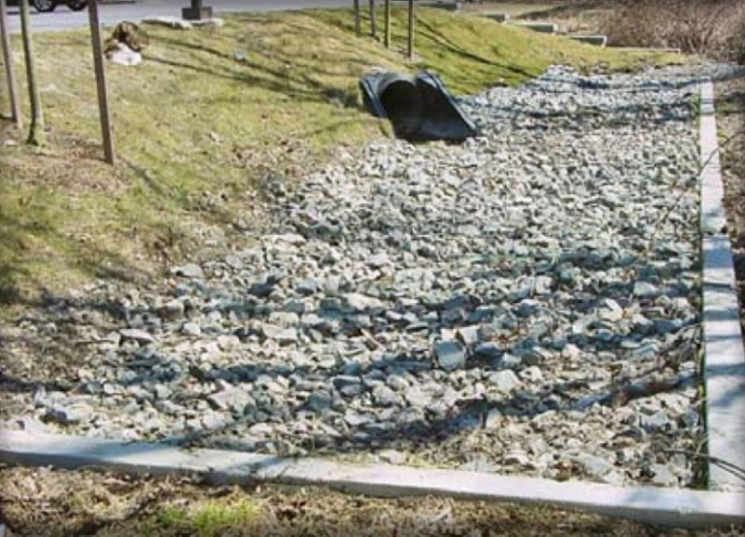
Infiltration Trenches

Ability to meet specific standards

Standard |  | Description
2 - Peak Flow |  | Does not provide peak attenuation.
3 - Recharge |  | Provides groundwater  recharge.
4 - TSS/TP Removal |  | Provide one or more pretreatment SCMs and use EPA Infiltration Trench Performance Curves to calculate required sizing to meet pollutant removal requirements. See “Introduction” Section of this Appendix for more information the EPA Performance Curves.
5 - Higher Pollutant Loading |  | May be used if 44% of TSS is removed with pretreatment SCMs prior to infiltration. For some land uses with higher potential pollutant loads an Oil/grit separator or equivalent must be used prior to discharge to the infiltration structure. Infiltration must be done in compliance with 314 CMR 5.00.
6 - Discharges  near or to Critical Areas |  | Suitable for discharges near or to Critical Areas, requires removal of 44% TSS prior to discharge.
7 - Redevelopment |  | Suitable with pretreatment.
11 - Total Maximum Daily Loads |  | See suitability to treat TMDL Pollutants Table (below). Must be properly designed, sized, and maintained.
ESSD / LID? |  | Yes, this practice is a MassDEP recognized ESSD / LID technique.

Structural Infiltration

Description
Infiltration trenches are shallow excavations filled with stone. They can be designed to capture sheet flow or piped inflow. The stone provides underground storage for stormwater runoff. The stored runoff gradually exfiltrates through the bottom and/or sides of the trench into the subsoil and eventually into the water table.

Advantages/Benefits

- Provides groundwater recharge.

- Reduces downstream flooding and protects stream bank integrity for small storms.

- Preserves the natural water balance of the site.

- Provides a high degree of runoff pollution control when properly designed and maintained.
- Reduces the size and cost of downstream stormwater control facilities and/or storm drain systems by infiltrating stormwater in upland areas.
- Suitable where space is limited.

Disadvantages/Limitations

- High failure rates due to improper siting, inadequate pollution prevention and pretreatment, poor design, construction and maintenance.
- Use restricted to small drainage areas.

- Depending on runoff quality, potential risk of groundwater contamination.

- Requires frequent maintenance.

- Susceptible to clogging with sediment.

Suitability to Treat TMDL Pollutants

Pollutant | Suitable to Treat?
TSS | Y
Total Nitrogen | Y
Total Phosphorous | Y
Pathogens | Y
Metals | Y

Notes:
- Pathogens category includes: fecal coliform, E. coli, and enterococcus.
- Metals category includes Zinc, Cadmium, Lead, Aluminum, and Iron.

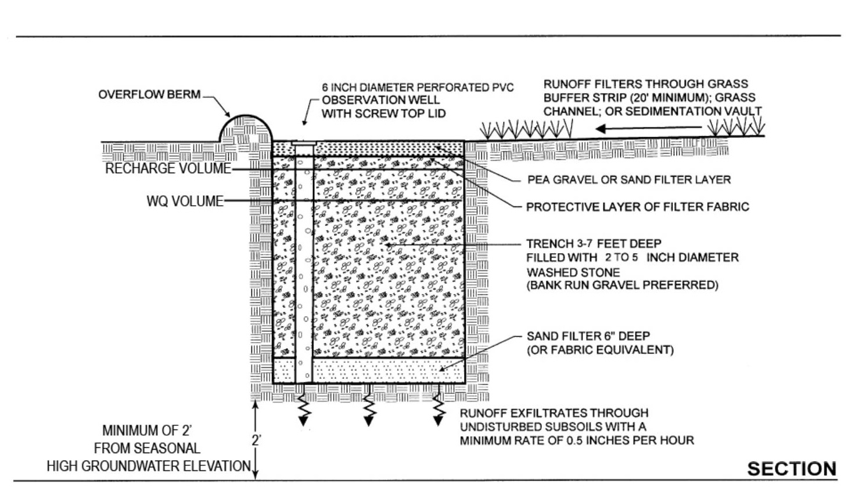
Example Infiltration Trench (adapted from the University of New Hampshire)
Special Features

Treats nonconcentrated sheet flow runoff
ESSD/LID Alternatives

This practice is a MassDEP recognized ESSD / LID technique.
Design Types
Infiltration trenches can be designed for complete exfiltration or partial exfiltration, where a portion of the runoff volume is directed to the trench and the remainder is conveyed to other SCMs.

Full Exfiltration Trench Systems

Infiltration trenches must be sized to provide storage and exfiltration of the required water quality volume.

An emergency overflow channel is required to discharge runoff volumes in excess of the design storm. Economic and physical constraints can restrict the use of full exfiltration systems. Generally, it is not practical to provide storage for large infrequent storms, such as the 100-year storm.

Partial or Water Quality Exfiltration Trench Systems

These systems exfiltrate a portion of the runoff, while the remainder is conveyed to other SCMs. At a minimum, they must be sized to exfiltrate the recharge volume required by Stormwater Management Standard 3. There are two methods of partial infiltration. The first relies on off-line treatment where a portion of the runoff, or the 1-inch “first-flush,” is routed from the main channel to the trench by means of a weir or other diversion structure. The second method is on-line, and uses a perforated pipe at the top of the trench. This underdrain must be placed near the top of the trench. Refer to the design section below. After the trench fills to capacity, excess runoff is discharged through the perforated pipe and directed to other SCMs.

Applicability
Table IT.1 – Site Criteria for Infiltration Trenches
- The contributing drainage area to any individual infiltration trench should be restricted to 5 acres or less.
- The minimum depth to the seasonal high ground water table, bedrock, and/or impermeable layer must be at least 2 ft. from the bottom of the trench.
- The minimum acceptable soil infiltration rate is 0.01 inches per hour. Infiltration trenches must be sized in accordance with the procedures set forth in Section 6.3.
- A minimum of 2 soil borings or test pits must be taken for each infiltration trench. Trenches over 100 ft. in length must include at least one additional boring or test pit location for each 50 ft. increment. Borings and test pits must be located at the actual location of the proposed infiltration trench so that any localized soil conditions are detected.
- Infiltration trenches must not be used at sites where soils have 30% or greater clay content, or 40% or greater silt clay content. Infiltration trenches will not function adequately in areas with hydrologic soils in group D and infiltration will be limited for hydrologic soils in group C.
- Infiltration trenches must not be placed over fill materials.

Infiltration trenches always require a pretreatment SCM. For sheet flow, pretreatment SCM structures that may be used include vegetated filter strips and pea stone gravel diaphragms. For piped flow, a sediment forebay should be used.

Infiltration trenches are feasible at sites with gentle slopes, permeable soils, and where seasonal high groundwater levels are at least two feet below the bottom of the trench. MassDEP recommends

providing greater depths from the bottom of the trench to seasonal high groundwater elevation to reduce the potential for failure. Depth to bedrock will need to be evaluated to determine if use of an infiltration trench is feasible.

Contributing drainage areas must be relatively small and not exceed 5 acres. Infiltration trenches are suitable for parking lots, rooftop areas, local roads, highways, and small residential developments.

Infiltration trenches are adaptable to many sites because of their thin profile. Table IT.1 lists the recommended site criteria. Infiltration trenches can be used in upland areas of larger sites to reduce the overall amount of runoff and improve water quality while reducing the size and costs of downgradient SCMs.

Infiltration trenches are effective at mimicking the natural, pre-development hydrological regime at a site. Full exfiltration systems that have been carefully designed may be capable of controlling peak discharges from the 2-year and 10-year 24-hour storm.

Planning Considerations

MassDEP highly recommends using infiltration trenches near Critical Areas. They may be used to treat stormwater discharges from areas of higher potential pollutant loads, provided 44% of TSS is removed prior to infiltration. For some land uses with higher potential pollutant load, an oil/grit separator or equivalent device may be required prior to discharge to the infiltration trench. When an oil/grit separator is used, pipe the runoff to the infiltration trench. Discharges from land uses with higher potential pollutant loads require compliance with 314 CMR 5.00.

Before planning infiltration trenches, carefully evaluate the subsurface of the site including soils, depth to bedrock, and depth to the water table. Make sure soils have a minimum saturated hydraulic conductivity rate of 0.01 inches per hour.

Make the slopes of the contributing drainage area less than 5%. Infiltration trenches have extremely high failure rates, usually due to clogging, so pretreatment is essential. Infiltration trenches are not intended to remove coarse particulate pollutants, and generally are difficult to rehabilitate once clogged. Typical pretreatment SCMs for infiltration trenches

- include oil/

grit separators, deep sump catch basins, vegetated filter strips, pea stone gravel diaphragms, or sediment forebays.

Clogging can be an issue even when infiltrating uncontaminated rooftop runoff as well, so it is important to implement some form of pretreatment to remove sediments, leaf litter, and debris to ensure the proper functioning of the trench and allow for longer periods between maintenance.

Consider the impacts of infiltrating stormwater on nearby resources. Infiltration trenches need to be set back outside Zone Is and Zone As for public drinking water supplies. Finally, avoid creating groundwater mounds near Chapter 21e sites that could alter subsurface flow patterns and spread groundwater pollution.

Setback Requirements
Stormwater Control Measures (SCMs) and other components of the Stormwater Management System must be setback from wetlands, building foundations, and other features in accordance with 310 CMR 10.05(6)(q). SCMs must also include vertical separation between certain features, such as the depth to seasonally high groundwater. Refer to Section 2.5 of the Stormwater Handbook for horizontal setback and vertical separation distance requirements. Horizontal setbacks also include maintenance access requirements around the perimeter of certain SCMs.
Design Considerations

See the following for complete design references:

Maryland Stormwater Design Manual, Volumes I and II. October 2000. Maryland Department of Environment. Baltimore, MD.

The volume and surface area of an infiltration trench relate to the quantity of runoff entering the trench from the contributing area, the void space, and the infiltration rate. Because the infiltration trench is filled with stone, only the space between the stone is available for runoff storage.

Effective designs call for infiltration trenches to be filled with 1.5-inch to 3.0-inch diameter clean washed stone. Conduct a geotechnical study to determine the final soil infiltration rate below the trench. For sizing purposes, assume a void ratio of 0.4.

Take a minimum of two borings or observation pits for each infiltration trench. For trenches over 100 feet long, include at least one additional boring or pit for each 50-foot increment. Take borings or dig observation pits at the actual location of the proposed infiltration trench to determine localized soil conditions.

Base the design of the infiltration trench on the soil evaluation set forth in Section 6.3. The minimum acceptable rate is 0.01 inches per hour. Never use the results of a Title 5 percolation test to estimate an infiltration rate, as these tend to greatly overestimate the rate that water will infiltrate into the subsurface.

Place the maximum depth of the trench at least two feet above the seasonal high water table or bedrock, and below the frost line.

Include vegetated buffers (20-foot minimum) around surface trenches. Use filter fabric, only at the surface to prevent clogging; if failure does occur, it can be alleviated without reconstructing the infiltration trench. Never place fabric at the bottom or sides of the infiltration trench, as fabric will blind, causing premature failure of the infiltration trench. Place twelve inches of sand at the bottom of the trench.

Install an observation well at the center of the trench to monitor how quickly runoff is clearing the system. Use a well-anchored, vertical perforated PVC pipe with a lockable above-ground cap.

The visible surface of the trench may either be stone or grassed. Stone is easier to rake out when clogged. If it is vegetated with grasses, use fabric above the stone to keep the soil that serves as the planting medium from clogging the stone. When trenches are designed to accept sheet flow, take into account the grass surface when determining how much of the runoff will exfiltrate into the trench.

A perforated pipe underdrain is sometimes used as part of the design. The purpose of the underdrain is to facilitate exfiltration into the parent soil. Except for underdrains placed between different trench cells, MassDEP does not allow underdrains placed near the bottom of the trench. Placement of an underdrain near the bottom of the trench reduces the amount of treatment and exfiltration, because more water is conveyed through the underdrain to the outlet point when it rains than exfiltrates into the surrounding soils.

Include an overflow berm on the downgradient side of the infiltration trench no more than 4 inches high to allow for shallow ponding and to discourage potential bypass of the infiltration trench.
Construction

Table IT.2 presents the minimum construction criteria for infiltration trenches. Take precautions before and during construction to minimize the risk of premature failure of the infiltration trench. First, prevent heavy equipment from operating at the locations where infiltration trenches are planned. Heavy equipment will compact soil and adversely affect the performance of the trench. Isolate the areas where the trenches will be located by roping them off and flagging them.

Construct infiltration trenches only after the site has been stabilized. Never use trenches as temporary sediment traps during construction. Use diversion berms or staked and lined hay bales around the perimeter of the trenches during their construction. Excavate and build the trench manually or with light earth-moving equipment. Deposit all excavated material downgradient of the trench to prevent re-deposition during runoff events.

Place twelve inches of sand (clean, fine aggregate) on the bottom. Place one to three inches of clean, washed stone in the trench and lightly compact the stone with plate compactors, to within approximately one foot of the surface. Place fabric filter over the top, with at least a 12- inch overlap on both sides. While fabric may be placed over the top, never place fabric in the bottom or on the sides. An underground trench may be filled with topsoil and planted. A surface trench may be filled with additional aggregate stone.
Divert drainage away from the infiltration trench until the contributing drainage area is fully stabilized, including full establishment of any vegetation.

Table IT.2 – Construction Criteria for Infiltration Trenches
- Infiltration trenches should never serve as temporary sediment traps for construction.
- Before a development site is graded, the infiltration trench area should be roped off and flagged to prevent heavy equipment from compacting the underlying soils.
- Infiltration trenches should not be constructed until the entire contributing drainage area has been stabilized. Diversion berms should be placed around the perimeter or the infiltration trench during all phases of construction. Sediment and erosion controls should be used to keep runoff and sediment away from the trench area.
- During and after excavation, all excavated materials should be placed downstream, away from the infiltration trench, to prevent redeposition of these materials during runoff events. These materials should be properly handled and disposed of during and after construction.
- Light earth-moving equipment should be used to excavate the infiltration trench. Use of heavy equipment causes compaction of the soils in the trench floor, resulting in reduced infiltration capacity.
Maintenance

Activity | Frequency
Inspect units and remove debris | Every 6 months and after every major storm
Remove sediment from pretreatment SCMs | Every 6 months and after every major storm
A major storm event for on-going post-construction monitoring is defined as equal to or greater than 1 inch in a 24-hour period.
Because infiltration trenches are prone to failure due to clogging, it is imperative that they be aggressively maintained on a regular schedule. Using pretreatment SCMs will significantly reduce the maintenance requirements for the trench itself. Removing accumulated sediment from a deep sump catch basin or a vegetated filter strip is considerably less difficult and less costly than rehabilitating a trench. Eventually, the infiltration trench will have to be rehabilitated, but regular maintenance will prolong its operational life and delay the day when rehabilitation is needed. With appropriate design and aggressive maintenance, rehabilitation can be delayed for a decade or more. Perform preventive maintenance at least twice a year.

Inspect and clean pretreatment SCMs every six months and after every major storm. Check inlet and outlet pipes to determine if they are clogged. Remove accumulated sediment, trash, debris, leaves and grass clippings from mowing. Remove tree seedlings, before they become firmly established.

Inspect the infiltration trench after the first several rainfall events, after all major storms, and on regularly scheduled dates every six months. If the top of the trench is grassed, it must be mowed on a seasonal basis. Grass height must be mowed to a height of no more than four inches. Routinely remove grass clippings leaves and accumulated sediment from the surface of the trench.

Inspect the trench 24 hours or several days after a rain event, to look for ponded water. If there is ponded water at the surface of the trench, it is likely that the trench surface is clogged. To address surface clogging, remove and replace the topsoil or first layer of stone aggregate and the filter fabric. If water is ponded inside the trench, it may indicate that the bottom of the trench has failed. To rehabilitate a failed trench, all accumulated sediment must be stripped from the bottom, the bottom of the trench must be scarified and tilled to induce infiltration, and all of the stone aggregate and filter fabric or media must be removed and replaced.

Observation wells should be assessed as part of infiltration trench inspections. If water depths in the well are getting higher, this indicates clogging and that the well should be needs to re-dug to restore infiltrative surfaces.
References
California Stormwater Quality Association, 2003, California Stormwater SCM Handbook 1 of 7, New Development and Redevelopment, Infiltration Trench, Practice TC-10, http:// www.caSCMhandbooks.com/Documents/Development/ TC-10.pdf

Center for Watershed Protection, Stormwater Management Fact Sheet, Infiltration Trench, http://www. stormwatercenter.net/Assorted%20Fact%20Sheets/ Tool6_Stormwater_Practices/Infiltration%20Practice/ Infiltration%20Trench.htm

Center for Watershed Protection, Stormwater Design Example, Infiltration Trench, http://www.stormwatercenter.net/Manual_Builder/infiltration_design_ example.htm

Duchene, M., McBean, E.A., Thomson, N.R., 1994, Modeling of Infiltration from Trenches for Storm-Water Control, Journal of Water Resources Planning and Management, Vol. 120, No. 3, pp. 276-293

Dewberry Companies, 2002, Land Development Handbook, McGraw Hill, New York, pp. 521, 523.

Georgia Stormwater Management Manual, Section 3.2.5, Infiltration Trench, Pp. 3.2-75 to 3.2-88, http://www. georgiastormwater.com/vol2/3-2-5.pdf

Guo, James C.Y., 2001, Design of Infiltration Basins for Stormwater, in Mays, Larry W. (ed.), 2001, Stormwater Collection Systems Design Handbook, McGraw-Hill, New York, pp. 9.1 to 9.35

Livingston, E.H. 2000. Lessons Learned about Successfully Using Infiltration Practices. Pp 81- 96 in National Conference on Tools for Urban Water Resource Management and Protection Proceedings of Conference held February 7-10, 2000 in Chicago, IL. EPA/625/R-00/001 Metropolitan Council, 2001, Minnesota Urban Small Sites SCM Manual, Infiltration Trenches, Pp. 3-169 to 3-180 http://www.metrocouncil.org/Environment/Watershed/SCM/ CH3_STInfilTrenches.pdf

U.S. EPA, 1999, Stormwater Technology Fact Sheet, Infiltration Trench, EPA 832-F-99-019, http://www.epa.gov/owm/mtb/infltrenc.pdf

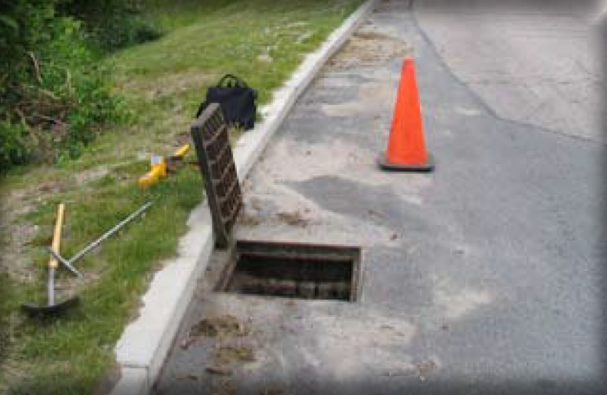
Leaching Catch Basins

Ability to meet specific standards
Standard | Description

2 - Peak Flow | May provide some limited amount of peak rate attenuation if sufficient number of leaching catch basins are provided. Each leaching chamber must be modeled as a separate pond and the sump volume discarded to the unsaturated zone. See Section 6.2.2 of the Stormwater Handbook.
3 - Recharge | Provides groundwater recharge.
4 - TSS/TP Removal | Use EPA Infiltration Trench Performance Curves to calculate required sizing to meet pollutant removal requirements. See “Introduction” Section of this Appendix for more information the EPA Performance Curves. Use deep sump catch basin for pretreatment.
5 - Higher Pollutant Loading | For land uses that have the potential to generate runoff with high concentrations of oil and grease, an oil/grit separator or equivalent may be required for pretreatment prior to discharge to the leaching catch basin. Infiltration must be done in compliance with 314 CMR 5.00.
6 - Discharges near or to Critical Areas | Not suitable except as terminal treatment for discharges to or near cold water fisheries. Must include a practice to provide for shut down and containment.
7 - Redevelopment | May be a good retrofit for sites with existing catch basins.
11 - Total Maximum Daily Loads | See suitability to treat TMDL Pollutants Table (below). Must be properly designed, sized, and maintained.
ESSD / LID? | No, this practice is not a MassDEP recognized ESSD / LID technique.

Description
Structural Infiltration
A leaching catch basin is pre-cast concrete barrel and riser with an open bottom that permits runoff to infiltrate into the ground. There are two configurations:

- Stand-alone barrel/riser and

- Barrel/riser combined with a deep sump catch basins that provides pretreatment.

TSS pretreatment removal is awarded to a deep sump catch basin/leaching catch basin pretreatment combination provided the system is off-line.

Advantages/Benefits

- Provide groundwater recharge.

- Remove coarse sediment

Disadvantages/Limitations

- Need frequent maintenance. Can become a source of pollutants via resuspension if not properly maintained.
- Cannot effectively remove soluble pollutants or fine particles.

- Do not provide adequate treatment of runoff unless combined with deep sump catch basin

- Entrapment hazard for amphibians and other small animals

Suitability to Treat TMDL Pollutants
Pollutant | Suitable to Treat?
TSS | Y
Total Nitrogen | Y
Total Phosphorous | Y
Pathogens | Y
Metals | Y

Notes:
- Pathogens category includes: fecal coliform, E. coli, and enterococcus.
- Metals category includes Zinc, Cadmium, Lead, Aluminum, and Iron.

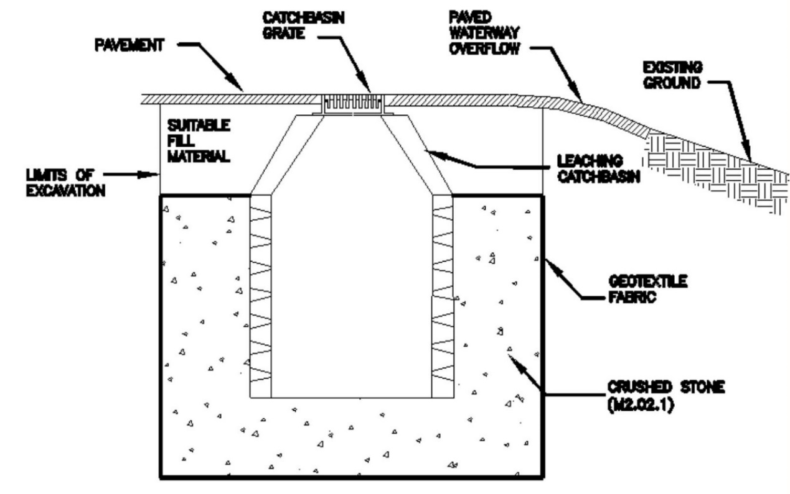
Example Leaching Catch Basin (adapted from MassDOT)
(Note: example image does not show pretreatment. Deep sump catch basin is required for pretreatment.)

Special Features:

Use as off-line device

ESSD / LID Alternatives

This practice is not a MassDEP recognized ESSD / LID technique. ESSD and LID techniques must be used unless demonstrated to be impracticable based on a written alternatives analysis. Other SCMs shall only be used to the meet those portions of Standard 3 (i.e., Required Recharge Volume) and Standard 4 (i.e., TSS / TP removal) that cannot be fully met by ESSD and LID techniques. See Section 4.2 of the Stormwater Handbook for a list of MassDEP recognized ESSD / LID techniques. Most recognized ESSD / LID techniques also have an associated ESSD Credit (see Table A-1) of this Appendix.
Planning Considerations
Leaching

catch basins must be installed as off-line devices only. They shall only be utilized in areas with highly permeable soils. Provide for the safe overflow onto streets, potentially tied into the MS4, from these devices in severe storm events. Because leaching catch basins discharge runoff to groundwater, do not use them in areas

of higher potential pollutant loadings (such as gas stations) without adequate pretreatment, such as an oil/grit separator.

Setback Requirements
Stormwater Control Measures (SCMs) and other components of the Stormwater Management System must be setback from wetlands, building foundatio
ns, and other features in accordance with 310 CMR 10.05(6)(q). SCMs must also include vertical separation between certain features, such as the depth to seasonally high groundwater. Refer to Section 2.5 of the Stormwater Handbook for horizontal setback and vertical separation distance requirements. Horizontal setbacks also include maintenance access requirements around the perimeter of certain SCMs.
Design Considerations

Leaching catch basins are typically set in an excavation lined with a geotextile liner to prevent fine soil particles from migrating into the void spaces of the stone. The basin is placed on a pad of free-draining crushed stone, with the excavation around the basin back-filled with similar material. The base and barrel of the basin are perforated so that water entering the basin can enter the surrounding stone fill and infiltrate into the ground.

Use stone material with a void ratio of 0.35 or less. Make the depth to seasonal high groundwater at least 2 feet below the bottom of the leaching catch basin. When designing structural components, design for dead and live loads as appropriate. Include provisions for overflows such as redundant devices and paved chutes.

The basin inlet cover is an important component. For the first chamber, the Deep Sump Catch Basin, the orifice openings in the inlet grate must be no larger than 2.5-inch square to prevent coarse debris larger than 2.5 inches from entering the basin. The maximum flow through the inlet grate or into the leaching catch sump shall not exceed 3 cubic feet per second. Smaller openings in the inlet grate are preferred to minimize the potential for debris to clog the infiltrating surfaces. The inlet grate must fit tightly into the underlying steel frame to prevent it from being dislodged by traffic. Do not weld the inlet grate to the underlying frame. The second chamber, the leaching barrel, must have a tight fitting manhole cover, to prevent inflow from the street level or at grade level.

The riser section shall be mortared, grouted, gasketed, or otherwise sealed, to prevent exfiltration through the joint. Leaching catch basins shall contain no weep holes. Do not perforate the barrel section.

Make sure leaching catch basins contain no outlet pipes. The only pipe that is allowed in a leaching catch basin is an inlet pipe from an off-line deep sump catch basin paired with that leaching catch basin. Seal all pipe joints.

Site Criteria
- Maximum distance of flow in driveway, parking lot, or road to leaching catch basin: Not to exceed 350 feet.
- Building foundation minimum of 10 feet.
- All other general rules for criteria for infiltration specified in Table 2-1 of the Stormwater Handbook apply.
Construction

Install construction barriers around the excavation area to prevent access by pedestrians. Use diversions and other erosion control practices up -slope of the leaching catch basin to prevent runoff from entering the site before catch basins are complete. Stabilize the surrounding area and any established outlet. Put controls in place to prevent any drainage from being discharged to the leaching catch basin until the contributing drainage area is fully stabilized. Remove all temporary structures after the contributing drainage area and vegetation is stabilized.

Maintenance
Activity | Frequency
Inspect units and remove debris | Inspect annually or more frequently as indicated by structure performance
Remove sediment | When the basin is 50% filled
Rehabilitate the basin if it fails due to clogging | As needed

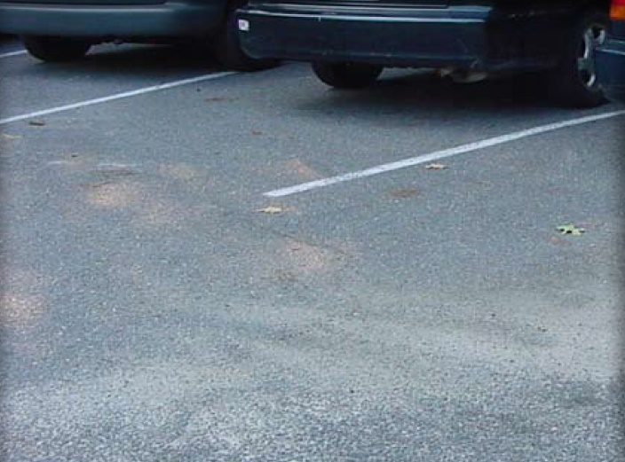
Porous Pavement

Ability to meet specific standards
Standard | Description
2 - Peak Flow | Provides peak flow attenuation  for small storms through a reduced Runoff Curve Number.
3 - Recharge | Provides groundwater recharge. Storage bed must be designed and sized to drain within 72 hours
4 - TSS/TP Removal | Use EPA Porous Pavement Performance Curves to calculate required sizing to meet pollutant removal requirements. See “Introduction” Section of this Appendix for more information the EPA Performance Curves. Pretreatment consists of use of vacuum or regenerative air street cleaners and good housekeeping practices such as not applying traction agents (e.g., sand) to the pavement during the winter.
5 - Higher Pollutant Loading | Suitable for high intensity parking lots but not suitable for other types of LUHPPLs.
6 - Discharges near or to Critical Areas | Must not be located within Zone Is or Zone As of public water supplies.
7 - Redevelopment | Suitable.
8 - Construction Phase | Not to be used for construction period runoff control.
9 - O&M | An O&M is required for this SCM
11 - Total Maximum Daily Loads | See suitability to treat TMDL Pollutants Table (below). Must be properly designed, sized, and maintained.
ESSD / LID? | Yes, this practice is a MassDEP recognized ESSD / LID technique.

Description
Structural Infiltration
Porous pavement is a paved surface with a higher-than-normal percentage of air voids to allow water to pass through it and infiltrate into the subsoil. This porous surface replaces traditional hot mix asphalt or dense concrete pavement, allowing parking lot, driveway, and roadway runoff to infiltrate directly into the soil and receive water quality treatment. All permeable paving systems consist of a durable, load-bearing, pervious surface overlying a stone bed that stores rainwater before it infiltrates into the underlying soil. Permeable paving techniques include porous asphalt, pervious concrete, paving stones, and manufactured “grass pavers” made of concrete or plastic. Permeable paving may be used for walkways, patios, plazas, driveways, roadways, parking stalls, and overflow parking areas.
Advantages/Benefits:
- Reduce stormwater runoff volume from paved surfaces.
- Reduce peak discharge rates.
- Increase recharge through infiltration.
- Reduce pollutant transport through direct infiltration.
- Can last for decades in cold climates if properly designed, installed, and maintained
- Improved site landscaping benefits (grass pavers only).

- Can be used as a retrofit when parking lots are replaced.
Disadvantages/Limitations:

- Prone to clogging so aggressive maintenance with jet washing and vacuum street sweepers is required.
- No winter sanding is allowed.
- Winter road salt and deicer runoff concern near drinking water supplies for both porous pavements and impervious pavements.
- Soils need to have a permeability of at least 0.01 inches per hour
- Special care is needed to avoid compacting underlying parent soil
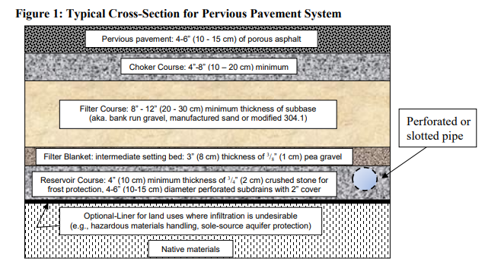
Figure PP.1 Example Cross-section of a Porous Pavement System
(from 2016 UNH Stormwater Center Design Specifications for Porous Asphalt)

Suitability to Treat TMDL Pollutants
Pollutant | Suitable to Treat?
TSS | Y
Total Nitrogen | Y
Total Phosphorous | Y
Pathogens | Y
Metals | Y

Notes:
- Pathogens category includes: fecal coliform, E. coli, and enterococcus.
- Metals category includes Zinc, Cadmium, Lead, Aluminum, and Iron.
ESSD / LID Alternatives
This practice is a MassDEP recognized ESSD / LID technique.
Applicability
Porous pavement, also known as permeable paving, is appropriate for pedestrian-only areas, low volume roadways, roadway shoulders, parking areas, parking stalls, residential driveways, alleys, bike paths, shared use paths, walkways, and patios. It can be constructed where the underlying soils have a permeability of at least 0.01 inches per hour. Porous paving is an excellent technique for dense urban areas, because it does not require any additional land. Porous pavement can be successfully installed in cold climates as long as the design includes features to reduce frost heaving.
Porous pavements may be used on high intensity parking lots, but not in other types of land uses with higher potential pollutant loads because stormwater cannot be pretreated prior to infiltration. Heavy winter sanding will clog joints and void spaces. On some highways, MassDOT Highway Division uses an Open Graded Friction Course (OGFC) that has a permeable top coat but an impermeable base course. MassDEP provides no Water Quality or Recharge Credit for OGFC, because it does not provide treatment or recharge. The primary benefit of OGFC pavements is reductions in noise and hydroplaning.
Effectiveness
Porous pavement provides groundwater recharge and reduces stormwater runoff volume. Depending on design, paving material, soil type, and rainfall, porous paving can infiltrate as much as 70% to 80% of annual rainfall. To qualify for the Water Quality and Recharge Credits, the depth of the reservoir course must be sized to fully store the entire water quality volume or the required recharge volume, whichever is greater, in the void spaces between the stones. Calculate the Required Water Quality or Required Recharge Volume, whichever is larger, using the Static Method, and design the system to dewater within 72 hours. The required Water Quality Volume is determined using the EPA curve for porous pavements. Porous pavement may reduce peak discharge rates significantly by diverting stormwater into the ground and away from pipe- and-basin stormwater management systems, up to the volume housed in the storage layer. Grass pavers can improve site appearance by providing vegetation where there would otherwise be pavement. Porous paving can increase the effective developable area of a site, because the infiltration provided by permeable paving can significantly reduce the need for large stormwater management structures.
Planning Considerations
Porous paving must not receive stormwater from other drainage areas, especially any areas that are not fully stabilized.
Use porous paving only on gentle slopes (less than 5%). Do not use it in high -traffic areas or where it will be subject to heavy axle loads.
The setbacks listed below are required:
- Porous paving reduces the need for other stormwater conveyances and treatment structures, resulting in cost savings.
- Permeable paving also reduces the amount of land needed for stormwater management.
Setback Requirements
Stormwater Control Measures (SCMs) and other components of the Stormwater Management System must be setback from wetlands, building foundations, and other features in accordance with 310 CMR 10.05(6)(q). SCMs must also include vertical separation between certain features, such as the depth to seasonally high groundwater. Refer to Section 2.5 of the Stormwater Handbook for horizontal setback and vertical separation distance requirements. Horizontal setbacks also include maintenance access requirements around the perimeter of certain SCMs.
Design Considerations
There are three major types of permeable paving:
Porous asphalt and pervious concrete Although it appears to be the same as traditional asphalt or concrete pavement, it is mixed with a very low content of fine sand, so that it has from 10%-25% void space.
Paving stones (also known as unit pavers) are impermeable blocks made of brick, stone, or concrete, set on a prepared sand base. The joints between the blocks are filled with sand or stone dust to allow water to percolate to the subsurface. Some concrete paving stones have an open cell design to increase permeability.
Grass pavers (also known as turf blocks) are a type of open-cell unit paver in which the cells are filled with soil and planted with turf. The pavers, made of concrete or synthetic material, distribute the weight of traffic and prevent compression of the underlying soil.
Each of these products is constructed over a storage bed.
Storage Bed Design
The University of New Hampshire has developed specifications for storage beds used in connection with porous asphalt or pervious concrete. According to UNH, the storage bed should be constructed as indicated in Figure PP.1 with the following components from top to bottom:

- a 4-to-8-inch choker course comprised of uniformly graded crushed stone
- a filter course, at least 8- 12 inches thick, of poorly graded sand (aka bank run gravel or modified 304.1) to provide enhanced filtration and delayed infiltration
- a filter blanket, at least 3 inches thick, of pea stone gravel to prevent material from entering the reservoir course, and
- a reservoir course of uniformly graded crushed stone with a high void content to maximize the storage of infiltrated water and to create
- a capillary barrier to winter freeze thaw. The bottom of the stone reservoir must be completely flat so that runoff can infiltrate through the entire surface. The reservoir course must be sized to fully store the water quality volume or required recharge volume (whichever is larger) within the void spaces between the stones.
If paving stones or grass pavers are used, a top course of sand that is one inch thick should be placed above the choker course.
Overflow Edge
Some designs incorporate an “overflow edge,” which is a trench surrounding the edge of the pavement. The trench connects to the stone reservoir below the surface of the pavement and acts as a backup in case the surface clogs.
Preparation of Porous Asphalt
Care must be taken in batching and placing porous asphalt. Unless batched and installed properly, porous pavement may have a reduced exfiltration ability. At Walden Pond State Reservation, several of the areas paved with porous asphalt did not meet the target exfiltration rate. Cores were taken and it was found that the batches had more sand and/or asphalt than was specified, and those sections had to be removed and repaved.
It is critical to minimize the amount of asphalt binder. Using greater amounts of asphalt binder could lead to a greater likelihood of “binder” or asphalt drawdown and clogging of voids. Sun light heating can liquefy the asphalt. The liquefied asphalt then drains into the voids, clogging them.
Such clogging is not remedied by power washing and vacuuming. The topcoat in such instances needs to be scarified and resurfaced. The University of New Hampshire has prepared detailed specifications for preparing and installing porous asphalt that are intended to prevent asphalt problems.
Additional Design Considerations
- Provide an open-graded subbase with minimum 40% void space.
- Use surface and stone beds to accommodate design traffic loads
- Generally, do not use porous pavement for slopes greater than 5 %.
- Do not place bottom on compacted fill.
- Provide perforated pipe network along bed bottoms for distribution
- Provide minimum of two feet of separation between the bed bottom and the seasonal high groundwater elevation, and also for bedrock.
Cold Weather Design Considerations
Porous pavement performs well in cold climates. Porous pavement can reduce meltwater runoff and avoid excessive water on the road during the snowmelt period.
In cold climates, the major concern is the potential for frost heaving. The storage bed specifications prepared by the University of New Hampshire address this concern.
Maintenance
In most porous pavement designs, the pavement itself acts as pretreatment to the stone reservoir below. Consequently, frequent cleaning and maintenance of the pavement surface is critical to prevent clogging. To keep the surface clean, frequent vacuum sweeping along with jet washing of asphalt and concrete pavement is required. No winter sanding shall be conducted on the porous surface.
As discussed, designs that include an “overflow edge” provide a backup in case the surface clogs. If the surface clogs, stormwater will flow over the surface and into the trench, where some infiltration and treatment will occur. For proper maintenance:

- Post signs identifying porous pavement areas.
- Minimize salt use during winter months. If drinking water sources are located nearby (see setbacks), porous pavements may not be allowed.
- No winter sanding is allowed.

- Keep landscaped areas well maintained to prevent soil from being transported onto the pavement.
- Clean the surface using vacuum sweeping machines as needed. For paving stones, periodically add joint material (sand) to replace material that has been transported.
- Regularly monitor the paving surface to make sure it drains properly after storms.
- Never reseal or repave with impermeable materials.
- Inspect the surface annually for deterioration or spalling.
- Periodically reseed grass pavers to fill in bare spots.
- Attach rollers to the bottoms of snowplows to prevent them from catching on the edges of grass
- Pavers and some paving stones.

Activity | Frequency
Monitor to ensure that the paving surface drains properly after storms | As needed
For porous asphalts and concretes, clean the surface using power washer to dislodge trapped particles and then vacuum sweep the area. For paving stones, add joint material (sand) to replace material that has been transported. | As needed
Inspect the surface annually for deterioration | Annually
Assess exfiltration capability at least once a year. When exfiltration capacity is found to decline, implement measures from the Operation and Maintenance Plan to restore original exfiltration capacity. | As needed, but at least once a year
Reseed grass pavers to fill in bare spots. | As needed
References
Adapted from MassDEP, Massachusetts Nonpoint Source Pollution Management Manual, 2006.

Ferguson, Bruce, K., Porous Pavements, 2005, CRC Press. Taylor and Francis Group, Boca Raton UNH, 2016, UNHSC Design Specifications for Porous Asphalt Pavement and Infiltration Beds, Revised September 2016, https://scholars.unh.edu/cgi/viewcontent.cgi?article=1012&context=stormwater. Asphalt Pavement for Stormwater Management, http://www.unh.edu/erg/cstev/pubs_specs_info/ porous_ashpalt_fact_sheet.pdf

University of New Hampshire Center for Stormwater Technology Evaluation and Verification; this research group tests and evaluates stormwater SCMs on the UNH campus.

- An article about the use of permeable pavers at the Westfarms Mall in Connecticut.

- Case Studies from Uni-Group USA, a block paver manufacturer.

- The Nonpoint Education for Municipal Officials program at the University of Connecticut has been involved in numerous permeable paving pilot projects.
- Permeable paver specifications courtesy of the Low Impact Development Center.

- Porous pavement design and operational criteria from the US Environmental Protection Agency, which also publishes a Low Impact Development Page. Also see this report on a Field Evaluation of Permeable Pavements for Stormwater Management (PDF.)

- New Jersey Stormwater Best Management Practices Manual February 2004.

Subsurface Infiltrators

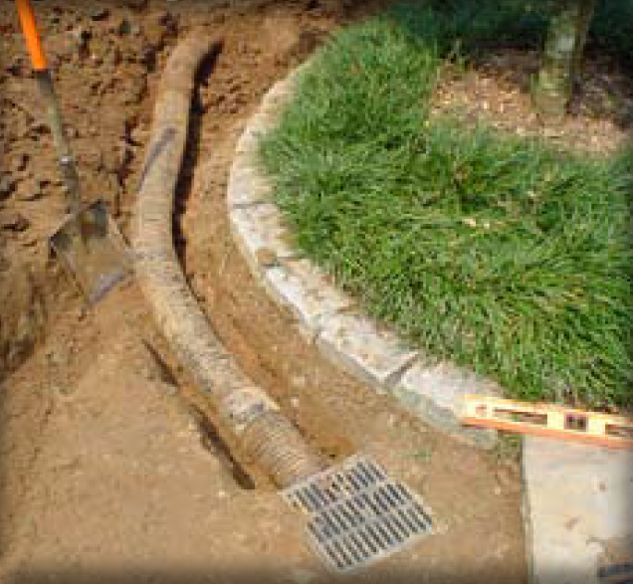

Ability to meet specific standards
Standard | Description
2 - Peak Flow | Can be designed to provide peak flow attenuation (see requirements listed in this Specification)
3 - Recharge | Provides groundwater recharge
4 - TSS/TP  Removal | Provide one or more pretreatment SCMs and use EPA Infiltration Trench Performance Curves to calculate required sizing to meet pollutant removal requirements. See “Introduction” Section of this Appendix for more information the EPA Performance Curves.
5 - Higher Pollutant Loading | May be used if 44% of TSS is removed with a pretreatment SCM prior to infiltration. Land uses with the potential to generate runoff with high concentrations of oil and grease require an oil/grit separator or equivalent prior to discharge to the infiltration structure. Infiltration must be done in accordance with 314 CMR 5.00.
6 - Discharges  near or to  Critical Areas | Suitable for discharges near or to Critical Areas.
7 - Redevelopment | Suitable with pretreatment
8 - Construction Phase | Not to be used for construction period runoff control.
9 - O&M | An O&M is required for this SCM
11 - Total Maximum Daily Loads | See suitability to treat TMDL Pollutants Table (below). Must be properly designed, sized, and maintained.
ESSD / LID? | No, this practice is not a MassDEP recognized ESSD / LID technique.

Description
Structural Infiltration
Subsurface infiltrators are underground systems that capture runoff, and gradually infiltrate it into the groundwater through rock and gravel. There are a number of underground infiltration systems that can be installed

to enhance groundwater recharge. The most common types include pre-cast concrete or plastic pits, chambers (manufactured pipes), perforated pipes, and galleys.

Advantages/Benefits

- Provides groundwater recharge

- Reduces downstream flooding

- Preserves the natural water balance of the site

- Can remove other pollutants besides TSS

- Can be installed on properties with limited space

- Useful in stormwater retrofit applications

Disadvantages/Limitations

- Limited data on field performance

- Susceptible to clogging by sediment

- Potential for mosquito breeding due to standing water if system fails

Suitability to Treat TMDL Pollutants
Pollutant | Suitable to Treat?
TSS | Y
Total Nitrogen | Y
Total Phosphorous | Y
Pathogens | Y
Metals | Y
Notes:
- Pathogens category includes: fecal coliform, E. coli, and enterococcus.

- Metals category includes Zinc, Cadmium, Lead, Aluminum, and Iron.
ESSD / LID Alternatives
This practice is not a MassDEP recognized ESSD / LID technique. ESSD and LID techniques must be used unless demonstrated to be impracticable based on a written alternatives analysis. Other SCMs shall only be used to the meet those portions of Standard 3 (i.e., Required Recharge Volume) and Standard 4 (i.e., TSS / TP removal) that cannot be fully met by ESSD and LID techniques. See Section 4.2 of the Stormwater Handbook for a list of MassDEP recognized ESSD / LID techniques. Most recognized ESSD / LID techniques also have an associated ESSD Credit (see Table A-1) of this Appendix.
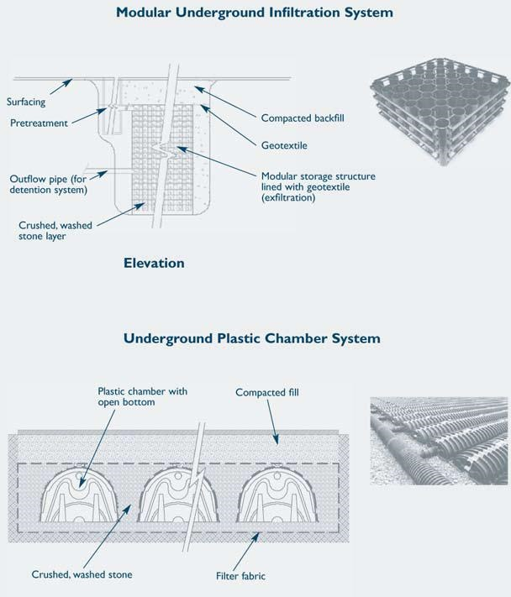
Subsurface Infiltrator Types
Example Subsurface Infiltrator (adapted from the Connecticut Stormwater Handbook)

There are different types of subsurface structures:

Infiltration Pit: A pre-cast concrete or plastic barrel with uniform perforations. The bottom of the pit should be closed with the lowest row of perforations at least 6 inches above the bottom, to serve as a sump. Infiltration pits typically include an observation well. The pits may be placed linearly, so that as the infiltrative surfaces in the first pit clog, the overflow moves to the second pit for exfiltration. Place an outlet near the top of the infiltration pit to accommodate emergency overflows. Filter fabric may be used on the top of the structure, but never on the bottom or along the sides. MassDEP provides recharge credit for storage below the emergency outflow invert. To make an infiltration pit, excavate the pit, wrap fabric around the barrel, place stone in the bottom of the pit, place the barrel in the pit, and then backfill stone around the barrel. Take a boring or dig an observation trench at the site of each proposed pit.

Chambers: These are typically

manufactured pipes containing

open bottoms and sometimes

perforations. The chambers are placed atop a

stone bed. Take the same number of borings or

observation pits as for infiltration trenches. Do not

confuse these systems with underground detention

systems (UDS) that use similar chambers. UDS are

designed to attenuate peak rates of runoff--not to

recharge groundwater.

Perforated Pipes: In this system, pipes containing perforations are placed in a leaching bed, similar to a Title 5 soil absorption system (SAS). The pipes dose the leaching bed. Take the same number of borings or observation pits as for infiltration trenches. Perforated pipes by themselves do not constitute a stormwater recharge system and receive no credit pursuant to Stormwater Standard No. 3. Do not confuse recharge systems that use perforated pipes with perforated pipes installed to lower the water table or divert groundwater flows.

Galleys: Similar to infiltration pits. Some designs consist of concrete perforated rectangular vaults. Others are modular systems usually placed under parking lots. When the galley design consists of a single rectangular perforated vault, conduct one boring or observation trench per galley. When the galleys consist of interlocking modular units, take the same number of borings or observation pits as for infiltration trenches. Do not confuse these galleys with vaults storing water for purposes of underground detention, which do not contain perforations.

Without adequate pretreatment, subsurface structures are not suitable for stormwater runoff from land uses or activities with the potential for high sediment or pollutant loads. Structural pretreatment SCMs for these systems include, but are not limited to, deep sump catch basins, proprietary separators, and oil/grit separators. They are suitable alternatives to traditional infiltration trenches and basins for space-limited sites. These systems can be installed beneath parking lots and other developed areas provided the systems can be accessed for routine maintenance.
Subsurface systems are highly prone to clogging. Pretreatment is always required unless the runoff is strictly from residential rooftops.

Effectiveness
Performance of subsurface systems varies by manufacturer and system design. Although there are limited field performance data, pollutant removal efficiency is expected to be similar to those of infiltration trenches and basins.

Planning Considerations
Subsurface structures are excellent groundwater recharge alternatives where space is limited. Because infiltration systems discharge runoff to groundwater, they are inappropriate for use in areas with potentially higher pollutant loads (such as gas stations), unless adequate pretreatment is provided.
In that event, oil/grit separators, sand filters or equivalent SCMs must be used to remove sediment, floatables and grease prior to discharge to the subsurface structure.
Applicability
Subsurface structures are constructed to store stormwater temporarily and let it percolate into the underlying soil. These structures are used for small drainage areas (typically less than 2 acres). They are feasible only where the soil is adequately permeable and seasonal high groundwater table and/or bedrock elevation is at least 2 feet below the bottom of the structures. They can be used to control the quantity as well as quality of stormwater runoff, if properly designed and constructed. The structures serve as storage chambers for captured stormwater, while the soil matrix provides treatment.

Setback Requirements
Stormwater Control Measures (SCMs) and other components of the Stormwater Management System must be setback from wetlands, building foundations, and other features in accordance with 310 CMR 10.05(6)(q). SCMs must also include vertical separation between certain features, such as the depth to seasonally high groundwater. Refer to Section 2.5 of the Stormwater Handbook for horizontal setback and vertical separation distance requirements. Horizontal setbacks also include maintenance access requirements around the perimeter of certain SCMs.
Design Considerations

Unlike infiltration basins, widely accepted design standards and procedures for designing subsurface structures are not available. Generally, a subsurface structure is designed to store a ‘‘capture volume’’ of runoff for a specified period of ‘‘storage time.’’ The definition of capture volume differs depending on the

purpose of the subsurface structure and the stormwater management program being used. Subsurface structures should infiltrate good quality runoff only. Pretreatment prior to infiltration is essential.

The composition, configuration and layout of subsurface structures varies considerably depending on the manufacturer. Follow the design criteria specified by vendors or system manufacturers. Install subsurface structures in areas that are easily accessible for routine and non-routine maintenance.

As with infiltration trenches and basins, install subsurface structures only in soils having suitable infiltration capacities as determined through field testing. Determine the infiltrative capacity of the underlying native soil through the soil evaluation set forth in Section 6.3. Never use a standard septic system percolation test to determine soil permeability because this test tends to greatly overestimate the infiltration capacity of soils.

Subsurface structures are typically designed to function off-line. Place a flow bypass structure upgradient of the infiltration structure to convey high flows around the structure during large storms.

Design the subsurface structure so that it drains within 72 hours after the storm event and completely dewaters between storms. Use a minimum draining time of 6 hours to ensure adequate pollutant removal. Design all ports to be mosquito-proof, i.e., to inhibit or reduce the number of mosquitoes able to breed within the SCM.

The minimum acceptable field infiltration rate is 0.01 inches per hour. Subsurface structures must be sized in accordance with the procedures set forth in Section 6.2.

- Manufactured structures must also be sized in accordance with the manufacturers’ specifications.

Design the subsurface structure for live and dead loads appropriate for their location. Provide measures to dissipate inlet flow velocities and prevent channeling of the stone media. Generally, design the system so that inflow velocities are less than 2 feet per second (fps).

All of these devices must have an appropriate number of observation wells, to monitor the water surface elevation within the well, and to serve as a sampling port.

Each of these different types of structures, with the exception of perforated pipes in leaching fields similar to Title 5 systems, must have entry ports to allow worker access for maintenance, in accordance with OSHA requirements.

Peak Rate Attenuation
Use the following guidelines to design Subsurface Infiltrators to reduce peak runoff rates:
  - Subsurface chambers need to contain 5 stages for design purposes.
    - ​Stage 1: The lowest stage may only be used to store the volume associate with recharge or TSS/TP removal, whichever is larger, and must not be included in the volumetric storage for peak runoff rate.
    - Stages 2-5: The next stage is 2-year storm, next upper stage is 10-year storm, the next upper is 100-year storm, and top most stage is freeboard, to minimize air compression effects on water flow in the chambers.
  - ​The system must attenuate peak discharge for the 2-, 10-, and 100-year storms in accordance with Standard 2. Only runoff in elevation above the max design storm but below the freeboard elevation stage may be routed to a surface discharge. As such, free draining must not be assumed when using TR20 or TR55 methods.
  - At least 4-feet of separation to seasonal high groundwater must be provided. The bottom elevation of the stone jacket or stone bed must be assumed to be the bottom of the system, not the lowest elevation of the chamber.
  - A mounding analysis is required if results from soil testing indicates that there is less than 4-feet of separation between the lowest engineered portion of the Subsurface Infiltrator and seasonal high groundwater (see Section 6.3 of the Stormwater Handbook for soil evaluation procedures). Conduct a mounding analysis to demonstrate the groundwater mound does not break upwards into the stone or the chambers, above the ground surface, penetrate through a slope, upwards into a nearby building foundation, or upwards into the nearest wetland Resource Area(s). The mounding analysis must be conducted with MODFLOW. Hantush is not an acceptable method as it assumes a circular or rectangular shape and not a linear shape. See Section 6.2.3 for more information on mounding analysis.
  - The chambers are not allowed in BLSF, ILSF, on LSCSF (as the subsurface is saturated during floods). The chambers shall also not be double counted as compensatory flood storage.
  - The overflow drainage must be designed to be by gravity flow, and not rely on pumps. The overflow drainage may not be designed to be surcharged upwards through manholes.
  - The system must not be sized using the static method (including the volume to store the peak runoff rate) and not the simple or dynamic field methods.
  - The chambers must be situated downgradient of building foundations. Normal setbacks from buildings of greater than 10 feet must be evaluated by the design engineer to determine if further setback is warranted to prevent envelope failure.
Construction

Stabilize the site prior to installing the subsurface structure. Do not allow runoff from any disturbed areas on the site to flow to the structure. Rope off the area where the subsurface structures are to be placed. Accomplish any required excavation with equipment placed just outside of this area. If the size of the area intended for exfiltration is too large to accommodate this approach, use trucks with low-pressure tires to minimize compaction. Do not allow any other vehicles within the area to be excavated. Keep the area above and immediately surrounding the subsurface structure roped off to all construction vehicles until the final top surface is installed (either paving or landscaping). This prevents additional compaction. When installing the final top surface, work from the edges to minimize compaction of the underlying soils.

Before installing the top surface, implement erosion and sediment controls to prevent sheet flow or windblown sediment from entering the leach field. This includes, but is not limited to, minimizing land disturbances at any one time, placing stockpiles away from the area intended for infiltration, stabilizing any stockpiles through use of vegetation or tarps, and placing sediment fences around the perimeter of the infiltration field.

Provide an access port, man-way, and observation well to enable inspection of water levels within the system. Make the observation well pipe visible at grade (i.e., not buried).
Maintenance

- Because subsurface structures are installed underground, they are extremely difficult to maintain. Manholes need to be placed in accessible locations to allow ease of inspections.
- When water levels are observed to be higher, this may indicate that clogging is occurring and failure could be imminent unless corrective action is taken quickly. Corrective action may including flushing the subsurface infiltrators with water and vactoring out water and trapped sediment.
- Inspect inlets at least twice a year. Remove any debris that might clog the system.
- Include mosquito controls in the Operation and Maintenance Plan.

Adapted from:

Connecticut Department of Environmental Conservation. Connecticut Stormwater Quality Manual. 2004

Massachusetts
Stormwater Management
Handbook

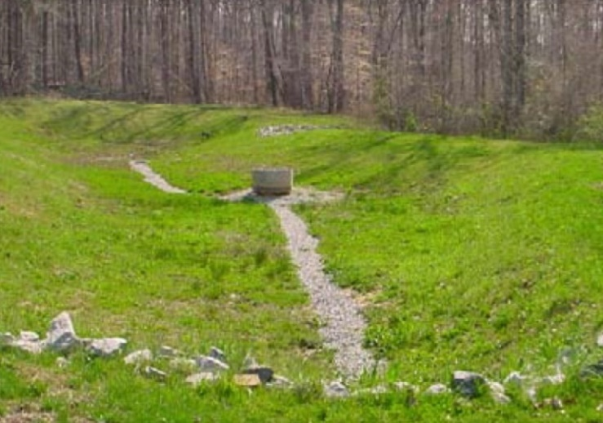
Dry Detention Basin
Other Structural

- Dry Detention Basins
- Green Roofs
- Rain Barrels / Cisterns

Ability to meet specific standards
Standard | Description
2 - Peak Flow | Provides peak flow attenuation
3 - Recharge | Provides no groundwater recharge
4 - TSS/TP Removal | - No EPA Performance Curve.  - TSS: MassDEP 0% TSS Removal  - TP: MassDEP 0% TP Removal
5 - Higher Pollutant Loading | May be used if bottom is lined and sealed
6 - Discharges near or to Critical Areas | Do not use for discharges near or to critical areas
7 - Redevelopment | Dry Detention Basins may be able to be retrofit to function as Extended Dry Detention Basin
8 - Construction Phase Pollution Controls | Not to be used for construction period runoff control. All inlets must be protected until all tributary areas are stabilized.
9 - O&M Plan | An O&M Plan is required. See maintenance section.
11 - Total Maximum Daily Loads | Does not meet any TMDL requirements as a stand-alone treatment practice.
ESSD / LID? | No, this practice is not a MassDEP recognized ESSD / LID technique.

Description
Other Structural
A dry detention basin is an impoundment or excavated basin for the short-term detention of stormwater runoff from a completed development that allows a controlled release from the structure at downstream, pre -development flow rates. Conventional dry detention basins typically control peak runoff for 2-year,10-year and larger 24-hour storms. They are not specifically designed to provide extended dewatering times, wet pools, or groundwater recharge. Sometimes flows can be controlled using an outlet pipe of the appropriate size but this approach typically cannot control multiple design storms. The sections describing Extended Dry Detention Basins and Wet Basins provide information about detention basin designs that provide stormwater pollutant treatment.

Advantages/Benefits

- Controls peak runoff flows for 2-year and 10-year storms

- Low cost SCM

Disadvantages/Limitations

- Provides negligible removal of TSS/TP compared to extended dry detention basins and wet basins.

- Provides negligible groundwater recharge.

- Frequently clogs at inlets and outlets, dramatically affecting retention times and pollutant removal efficiency.

- Susceptible to resuspension of settled materials by subsequent storms

- Requires large land area

- Cannot be used in watersheds with Cold-Water Fisheries

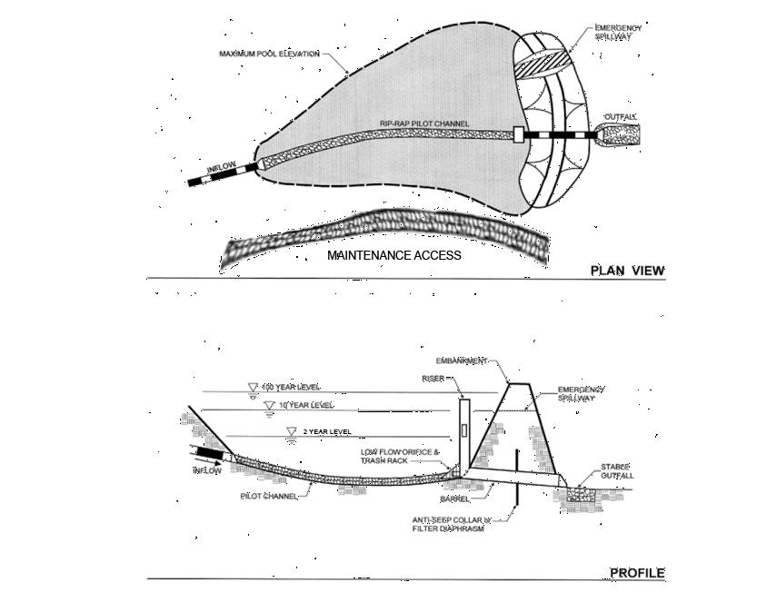
Adapted from the Vermont Stormwater Manual

Suitability to Treat TMDL Pollutants
Notes:
- Pathogens category includes: fecal coliform, E. coli, and enterococcus

- Metals category includes Zinc, Cadmium, Lead, Aluminum, and Iron

Special Features
Include a multiple stage outlet structure to control peak discharges for the 2-year, 10-year, and 24-hour storms.

ESSD / LID Alternatives

Pollutant | Suitable to Treat?
TSS | N
Total Nitrogen | N
Total Phosphorous | N
Pathogens | N
Metals | N
This practice is not a MassDEP recognized ESSD / LID technique. ESSD and LID techniques must be used unless demonstrated to be impracticable based on a written alternatives analysis. Other SCMs shall only be used to the meet those portions of Standard 3 (i.e., Required Recharge Volume) and Standard 4 (i.e., TSS / TP removal) that cannot be fully met by ESSD and LID techniques. See Section 4.2 of the Stormwater Handbook for a list of MassDEP recognized ESSD / LID techniques. Most recognized ESSD / LID techniques also have an associated ESSD Credit (see Table A-1) of this Appendix.

Applicability

Because they have a limited capability for removing soluble pollutants, dry detention basins are used solely for water quantity control to attenuate peak flows and limit downstream flooding. Generally, dry detention basins are not practical if the contributing watershed area is less than ten acres. MassDEP recommends at least four acres of drainage area for each acre-foot of storage in the basin.

Dry detention basins may be used as part of a stormwater treatment train in combination with other treatment practices that are effective at removing TSS and providing recharge. The size of a dry detention basin can be substantially reduced if it is placed

at the end of a treatment train to take advance of reduced runoff volume resulting from upstream practices that provide infiltration.

Effectiveness

Compared to extended dry detention basins or wet basins, dry detention basins have an extremely limited ability to remove TSS. A dry detention basin is designed to empty out completely in less than

24 hours, resulting in limited settling of sediments and the potential for resuspension of sediments in subsequent storms. Extended dry detention basins provide a minimum 24-hour detention time and incorporate in their design additional features aimed at enhancing pollutant removal, such as a sediment forebay, micropool, or shallow marsh.

Planning Considerations

Investigate soils, depth to bedrock, and depth to water table at a site before designing a dry detention basin. At sites where bedrock is close to the surface, high excavation costs may make dry detention basins infeasible. If soils on site are relatively impermeable (such as Soil Group D), a dry detention basin may experience problems with standing water. In this case, building a wet basin may be more appropriate.

The maximum depth of dry detention basins typically ranges from 3 to 12 feet. The depth of the basin may be limited by groundwater conditions or by soils. Locate dry detention basins above the normal groundwater elevation (i.e., the basin bottom should not intercept groundwater). Investigate the effects of seepage on the basin if the basin intercepts the groundwater table.

Like all stormwater SCMs, dry detention basins may not be constructed in wetland Resource Areas except for bordering land subject to flooding, isolated land subject to flooding, land subject

to coastal storm flowage, and riverfront areas. Embankments or dams that store more than 15 acre-feet or that are more than 6 feet high are regulated by the state Office of Dam Safety.

Setback Requirements
Stormwater Control Measures (SCMs) and other components of the Stormwater Management System must be setback from wetlands, building foundations, and other features in accordance with 310 CMR 10.05(6)(q). SCMs must also include vertical separation between certain features, such as the depth to seasonally high groundwater. Refer to Section 2.5 of the Stormwater Handbook for horizontal setback and vertical separation distance requirements. Horizontal setbacks also include maintenance access requirements around the perimeter of certain SCMs.
Design Considerations

[Note: For complete design references, see: Design of Stormwater Pond Systems. 1996. Schueler. Center for Watershed Protection.]
The critical parameters in determining the size of the basin are the storage capacity and the maximum rate of runoff released from the basin. Design dry detention basins to store the volume required to meet the peak rate attenuation requirements of Standard

for the 2-year and 10-year 24-hour storms. In some cases, compliance with Standard 2 may require flood storage volume to prevent an increase in off-site flooding from the 100-year 24-hour storm.

Design a multiple stage outlet structure to control peak discharges for the 2-year,10-year, and larger 24-hour storms. Provide an emergency spillway. Build the spillway in the existing ground--not in the embankment. Make the interior embankment slopes no greater than 3:1. To provide drainage, make the minimum slope of the bottom 2%. Provide access for maintenance. Design embankments to meet safety standards. Stabilize the earthen slopes and the bottom of the basins using seed mixes recommended by the NRCS.

Pervious or impervious channels may be used to

direct runoff to or from the Dry Detention Basin. Drainage channels must be designed to empty completely after a storm. Channels can be undermined by runoff velocity and differential settling if

they are not constructed and maintained properly. Locate the top of the impervious channel lining at or below the level of the adjacent grassed areas to ensure thorough drainage of these areas. When designing the channels, consider settlement of the lining and the adjacent areas, the potential for frost impacts on the lining and the potential for erosion or scour along the edges of the lining caused by bank-full velocities. Provide impervious linings with broken stone foundations and weep holes. Design the channel to maintain a low outflow discharge rate at the downstream end of the channel.

Use low-flow underdrains, connected to the principal outlet structure or other downstream discharge point, to promote thorough drying of the channel and the basin bottom. Consider the depth of the low flow channel when preparing the final bottom-grading plan.

Design dry detention basin side slopes to be no steeper than 3:1. Flatter slopes help to prevent erosion of the banks during larger storms, make routine bank maintenance tasks (such as mowing) easier, and allow access to the basin.

Design the outlet to control the outflow rate without clogging. Locate the outlet structure in the embankment for maintenance, access, safety and aesthetics. Design the outlet to facilitate maintenance; the vital parts of the structures should be accessible during normal maintenance and emergency situations. Include a draw-down valve to allow the dry detention basin to completely drain within 24 hours. To prevent scour at the outlet, include a flow transition structure, such as a lined apron or plunge pad, to absorb the initial impact of the flow and reduce the velocity to a level that will not erode the receiving channel or area.

Design embankments and spillways in conformance with the state regulations for Dam Safety (302 CMR 10.00). All dry detention basins must have an emergency spillway capable of bypassing runoff from large storms without damaging the impounding structure. Provide an access for maintenance by public or private right- of-way, using a minimum width of 15 feet and a maximum slope of 5:1. This access should extend to the forebay, safety bench and outflow structure, and should never cross the

emergency spillway, unless the spillway has been designed for that purpose. Use vegetative buffers around the perimeter of the basin for erosion control and additional sediment and nutrient removal.

Maintenance
Activity | Frequency
Inspect basins to ensure they are operating as designed | At least once a year.
Mow the upper-stage, side slopes, embankment and emergency spillway. | At least twice a year.
Check the sediment forebay, if applicable, for accumulated sediment, trash, and debris and remove it. | At least twice a year.
Remove sediment from the basin. | As necessary, and at least once every 10 years.

It is critical to provide access for maintenance, especially to the interior of the basin. Inspect dry detention basins at least once per year to ensure that they are operating as intended.
Inspect basins during and after storms to determine if the basin is meeting the expected detention times. Inspect the outlet structure for evidence of clogging or outflow release velocities that are greater than design flow. Potential problems that should be checked include: subsidence, erosion, cracking or tree growth on the embankment; damage to the emergency spillway; sediment accumulation around the outlet; inadequacy of the inlet/outlet channel erosion control measures; changes in the condition of the pilot channel; and erosion within the basin and banks. Make any necessary repairs immediately.
During inspections, note changes to the detention basin or the contributing watershed because these changes could affect basin performance. Mow the side slopes, embankment, and emergency spillway at least twice per year. Remove trash and debris at this time. Remove sediment from the basin as necessary, and at least once every 10 years or when the basin is 50% full. Provide for an on-site sediment disposal area to reduce the overall sediment removal costs.

References

T.R. Schueler. Center for Watershed Protection.

Design of Stormwater Pond Systems. 1996.

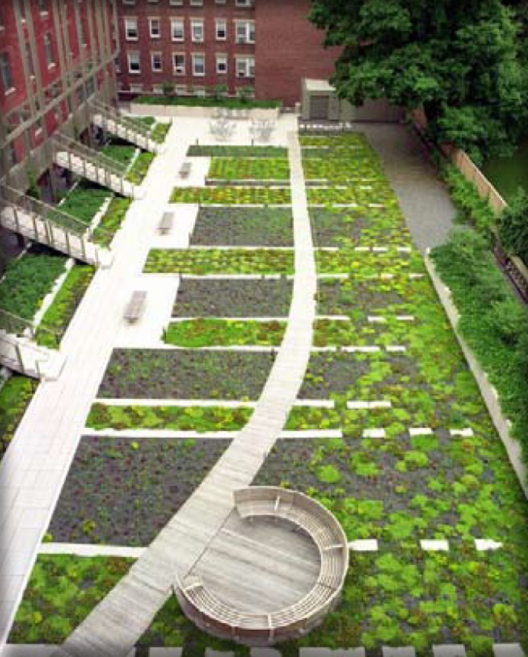
Green Roofs

Ability to meet specific standards

Standard | Description
2 - Peak Flow | Provides peak flow attenuation  for small storms through a reduced Runoff Curve Number.
3 - Recharge | If sized to retain the required 1-inch Water Quality Volume, consists of a reduction in Effective Impervious Cover (EIC) from the roof which may be deducted from the total area of impervious surface that must be managed as required by Standard 3 (Groundwater Recharge).
4 - TSS/TP  Removal | If sized to retain the required 1-inch Water Quality Volume, consists of a reduction in Effective Impervious Cover (EIC) from the roof which may be deducted from the total area of impervious surface that must be managed as required by Standard 4 (Pollutant Removal).
5 - Higher  Pollutant Loading | Not suitable.
6 - Discharges  near or to  Critical Areas | Suitable for discharges to or near to Cold-Water Fisheries.
7 - Redevelopment | Suitable.
11 - Total Maximum Daily Loads | Does not meet any TMDL requirements as a stand-alone treatment practice
ESSD / LID? | Yes, this practice is a MassDEP recognized ESSD / LID technique.

Other Structural
Description
A “Green roof” is a permanent rooftop planting system containing live plants in a lightweight engineered soil medium designed to retain precipitation where the water is taken up by plants and transpired into the air. As a result, much less water runs off the roof compared to conventional rooftops. Green roofs have been in use in Europe for more than 30 years; they are easy to incorporate into new construction, and can be used on many existing buildings. There are two main types:

- Extensive: minimal maintenance with restricted variety of plants, resistant to frost, wind and drought: sedum, herbs and grasses, located on almost any flat or low slop roof deck that maximizes water retention;

- Intensive: regular maintenance required (irrigation, fertilizing, pruning, mowing); greater variety of plants (sod grass lawns, perennial, annual flowers, shrubs, small trees); deeper, heavier and richer soil.

Advantages/Benefits

- Reduces volume and peak rate of runoff from more frequent storms.

- Reduces heating and cooling costs for buildings

- Conserves space

- May extend life expectancies of the roof by shielding the roof from UV and temperature

- Provides sound insulation

- Ideal for Redevelopment or in the ultra-urban setting

Disadvantages/Limitations

- Precipitation captured by green roofs (through interception, storage, plant uptake, evapotranspiration) is not recharged to groundwater.
- If green roofs require irrigation to maintain plants, they may reduce the volume of water available for other purposes.
- May require additional structural strengthening if used for retrofit.

ESSD / LID Alternatives
This practice is a MassDEP recognized ESSD / LID technique.

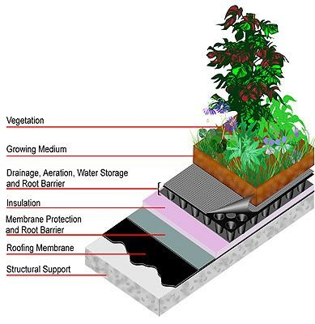
Example Green Roof (from www.greenroofs.com)

Suitability to Treat TMDL Pollutants
Pollutant | Suitable to Treat?
TSS | N
Total Nitrogen | N
Total Phosphorous | N
Pathogens | N
Metals | N
Notes:
Pathogens category includes: fecal coliform, E. coli

- , and enterococcus.

- Metals category includes Zinc, Cadmium, Lead, Aluminum, and Iron.
Applicability
Green roofs contribute to stormwater management by attenuating the peak rate of runoff for small storms. Green roofs are appropriate for commercial, industrial, and residential structures, especially those with wide roofs. They can be incorporated into new construction or added to existing buildings during renovation or re-roofing.
If adding a green roof as part of Redevelopment, assess the structural integrity of the roof to determine whether the support structure can withstand the additional loading of the green roof when it is fully saturated. Most green roofs are built on flat or low-angle rooftops, but some have been installed on pitched roofs up to 40% slope, with special design features to prevent slumping and ensure plant survival.

Green roofs are appropriate anywhere it is desirable to reduce the overall amount of stormwater runoff, including areas of chronic flooding or where combined sewer overflows (CSOs) are compromising water quality. Green roofs can incrementally reduce the amount of runoff that contributes to flooding and overflow problems. They are an excellent technique to use in dense urban areas, in areas where infiltration is difficult due to tight soils or shallow bedrock, or on sites where infiltration is undesirable due to existing soil contamination. Because green roofs return rainwater to the atmosphere, they should not be used in situations where groundwater recharge is a priority, such as in stressed basins with chronic low-flow conditions. The roof runoff should be infiltrated instead.

Effectiveness

Many studies indicate that properly designed green roofs are highly effective in intercepting and retaining at least 40% of annual precipitation (e.g., DiNardo, 2003). Green roofs reduce peak discharge rates by retaining runoff and creating longer flow paths. Research indicates that peak flow rates are reduced by 50% to 90% compared to conventional roofs, and that peak discharges are delayed by an hour or more. The main mechanism for peak rate reduction appears to be the depth of the soil media rather than the plants (Forrester, 2007).

Fewer studies have evaluated the water quality of the effluent discharged from green roofs. Berndtsson (2006) indicates that, except for nitrogen, vegetated

roofs behave as a source of contaminants. He indicates that while effluent from a green roof contains lower concentrations than those normally found in urban runoff, some metals appear in concentrations that would correspond to moderately polluted natural waters. In addition, the runoff often contains phosphate-phosphorus. Moran (2003) investigated nutrient runoff from a green roof in North Carolina and found that phosphorus increased in the runoff. For this reason, the runoff from green roofs should not be
discharged to nutrient-impaired Surface Waters. If using green roofs in such circumstances, treat the rooftop overflow discharge to remove nutrients prior to discharge to the Surface Water. Because total phosphorus binds up in most soils, it is preferable to direct the overflow to a stormwater exfiltration treatment system, rather than a Surface Water body.

Green roofs lower heating and cooling costs, because the trapped air in the underdrain layer and in the root layer help to insulate the roof of the building. During summer, sunlight drives evaporation and plant growth, instead of heating the roof surface. During winter, a green roof can reduce heat loss by 25% or more.

Because green roofs shield roof membranes from intense heat and direct sunlight, the entire roofing system has a longer lifespan than conventional roofs. The presence of a green roof helps to reduce air temperatures around the building, reducing the “heat island” effect and reducing the production of smog and ozone, which forms in the intense heat (175 degrees) created by large conventional roofs. The vegetation on green roofs also consumes carbon dioxide and increases the local levels of oxygen and humidity. Green roofs have demonstrated aesthetic benefits that can increase community acceptance of a high-visibility project; if marketed effectively, they may also increase property values.

Planning Considerations

Green roof slopes greater than 15% require a wooden lath grid or other retention system to hold substrate in place until plants form a thick vegetative mat. Do not use green roofs where groundwater recharge is a priority, such as in aquifer recharge areas or watersheds experiencing chronic low flows.

Setback Requirements
Stormwater Control Measures (SCMs) and other components of the Stormwater Management System must be setback from wetlands, building foundations, and other features in accordance with 310 CMR 10.05(6)(q). SCMs must also include vertical separation between certain features, such as the depth to seasonally high groundwater. Refer to Section 2.5 of the Stormwater Handbook for horizontal setback and vertical separation distance requirements. Horizontal setbacks also include maintenance access requirements around the perimeter of certain SCMs.
Design Considerations

Conform to the Massachusetts State Building Code when designing green roofs. In particular, consider structural support requirements, waterproof membranes, and fire-resistant materials (some plants such as sedums are flammable). State Plumbing Code requirements must be met for overflow discharge directed to roof leaders.

Us a Runoff Curve Number (RCN) of 86 when performing calculations for peak rate attenuation.
A green roof must include the following elements:

- A synthetic, high quality waterproof membrane;

- A drainage layer;
- A soil layer;

- A geotextile membrane;
- Light-weight plants.
Membranes
To prevent leaks, install a waterproof membrane with a root barrier between the drainage layer and the roof sheeting. To prevent the growth medium from clogging the drainage layer, install a geotextile between the drainage layer and the soil layer as well as a root retardant.

Drainage Layer

The drainage layer shall be capable of conveying the storm associated with the water quality volume (one half inch or one inch volume) without ponding on top of the roof cover. It may be constructed of perforated plastic sheets or a thin layer of gravel. Direct runoff from the drainage layer to a roof leader to discharge precipitation that exceeds the storage capacity of the soil.

Soil Layer

Type of Soil: Use lightweight soils with good water retention capacity such as perlite, clay shale, pumice or crushed terracotta with no more than 5% organic content. Substrates should not be too rich in organic material such as compost, because of the potential for settling, nutrient export and too rapid plant growth.

Soil Depth: Select the thickness of the soil to store precipitation. Only the void spaces in the soil are credited with storage. Void spaces in the soil shall not exceed 0.4 inch for purposes of sizing. The green roof should be designed to retain the required water quality volume (1.0 inch times roof area).

Plants

Vegetation on green roofs usually consists of hardy, low-growing, drought-resistant, spreading perennials or self-sowing annuals that provide dense cover and are able to withstand heat, cold, and high winds. Appropriate varieties include sedum (stonecrop), delospermum (ice plant), sempervivium, creeping thyme, allium, phloxes, anntenaria, ameria, and abretia. During dry periods, these plants droop but do not die; when it rains, they quickly revive and absorb large amounts of water. Grasses and herbs are less common on green roofs, because they require irrigation or deep substrates that retain water to survive dry periods.

Vegetation may be planted as vegetation mats, plugs or potted plants, sprigs (cuttings), or seeds. Vegetation mats are the most expensive but achieve immediate full coverage. Potted plants are also expensive and labor-intensive to install. Sprigs are often the most cost-effective option, even considering that initial irrigation is necessary and repeat installations may be required due to mortality. Do not use conventional sod, because it requires irrigation, mowing, and maintenance.

Irrigation systems

To maintain plant materials during Massachusetts’s summers, consider installing an irrigation system depending on the type of plants selected. For green roofs built with irrigation systems, make sure that the Operation and Maintenance Plan addresses irrigation needs to minimize the amount of water needed for irrigation. Depending on the water source, excessive irrigation during the summer can reduce base flows in nearby wetland Resource Areas.

Cold Climate Considerations

Green roofs may provide limited peak rate attenuation during winter months when plants are inactive and the soil medium is frozen. Due to changing weather that produces intermittent periods of snow and then rain, design green roofs with an overflow bypass.

Overflow Bypass Connection

Design overflow bypasses to roof leaders in accordance with State Plumbing Code requirements. Never direct the bypass to a wastewater treatment system. Direct the bypass to a drywell to infiltrate the excess rooftop runoff. Although green roofs

significantly reduce peak rate of runoff for small storms, they typically do not attenuate the full peak for the 2-year and higher storms (e.g., 10-year and 100-year 24-hour storm). Additional peak rate attenuation measures are usually needed to achieve full compliance with Standard 2.

Construction

Waterproof membranes are made of various materials, such as modified asphalts (bitumens), synthetic rubber (EPDM), hypolan (CPSE), and reinforced PVC. The most common design used in Europe is 60-80 mil PVC single- ply roof systems. Modified asphalts usually require a root barrier, while EPDM and reinforced PVC generally do not. Attention to seams is critical, because some glues and cements are not always root impermeable. The underdrain layer may be constructed of perforated plastic sheets or a thin layer of gravel. Pitched roofs and small flat roofs may not require an underdrain.

A common concern about green roofs is the potential for leaks. The performance of green roofs has improved dramatically since the 1970s, when many leak problems were associated with the first generation of green roofs. Current waterproofing materials, root barriers, and rigorous design and construction standards have largely eliminated these problems. Low-cost electronic grids installed under the membrane during construction can help to pinpoint leaks and minimize repair costs.

Maintenance
Activity & Frequency
Green roofs require active maintenance, including irrigating, weeding, mulching, and pruning. For intensive green roofs, use fertilizers containing nitrogen, phosphorus, potassium and micronutrients to support the living plants. Regularly remove any woody plants that become established on the roof.
Both extensive and intensive green roofs require active maintenance. The vegetation in green roofs requires support during establishment and yearly maintenance thereafter. Plants or sprigs must be irrigated until established, and additional plants or sprigs added to ensure good plant coverage. With drought-resistant vegetation, irrigation of an extensive green roof is rarely necessary after the two-year establishment period. Weeding and mulching may be needed during the establishment period and periodically thereafter throughout the life of the roof.

Regularly remove any woody plants that become established on the roof. Many plants can survive on deposition of airborne nitrogen and biomass breakdown. If necessary, however, apply a slow-release fertilizer once a year to ensure continued vigorous growth of the vegetation. Do not use soluble nitrogen fertilizers and compost due to the potential for nutrient and bacteria export.

If fertilizers containing nitrogen, phosphorus, potassium and micronutrients are necessary to support the living plants, the long- term Operation and Maintenance/Pollution Prevention Plan must include an Integrated Fertilizer Management Plan (IFMP). The IFMP should address fertilizer requirements and ensure that no more than the appropriate amount of fertilizer is used. By reducing the potential for excess nitrogen and phosphorus in the green roof runoff, an Integrated Fertilizer Management Plan is an essential component of the pollution prevention plan.

References
- www.greenroofs.org (Green roof industry association; training and design courses)

- www.greenroofs.com (The Green Roof Industry Resource Portal)

- www.bae.ncsu.edu/greenroofs/ (North Carolina State University)

- www.roofmeadow.com (North American Green Roof Provider)

Berndtsson J.C., Emilsson T., Bengtsson L., The influence of extensive vegetated roofs on runoff water quality, Science of the Total Environment, 355 (1-3):

48-63 February 15, 2006

Carter, Timothy L., Rasmussen Todd C., Hydrologic behavior of vegetated roofs, Journal of the American Water Resources Association, 42 (5): 1261-1274 October 2006.

Julia C. DeNardo, A. R. Jarrett, H. B. Manbeck, D. J. Beattie, R. D. Berghage, Green Roof Mitigation of Stormwater and Energy Usage, American Society of Agricultural and Biological Engineers, Paper number 032305, 2003 ASAE Annual Meeting, 2003

J. C. DeNardo, A. R. Jarrett, H. B. Manbeck, D. J. Beattie, R. D. Berghage, Stormwater Mitigation and Surface Temperature Reduction by Green Roofs, American Society of Agricultural and Biological Engineers, 2005

Earth Pledge Foundation, Green Roofs: Ecological Design and Construction, Schiffer Publishing, February 5, 2004.

Forrester, K. Jost, V., Luckett, K., Morgan, S, Yan, T. and Retzlaff, W, 2007, Evaluation of storm water runoff from a Midwest green roof system. Illinois State Academy of Science Annual meeting, Springfield, Illinois.

Doug Hutchinson, Peter Abrams, Ryan Retzlaff,

Tom Liptan, Stormwater Monitoring Two Ecoroofs

in Portland, OR., Greening Rooftops for Sustainable

Communities: Chicago 2003.

M.A. Monterusso, D.B. Rowe, C.L. Rugh, D.K. Russell, Runoff Water Quantity and Quality from Green Roof Systems, ISHS Acta Horticultureae 639: XXVI International Horticultural Congress: Expanding Roles for Horticulture in Improving Human Well-Being and Life Quality.

Moran, Amy, Bill Hunt, and Dr. Greg Jennings, 2003, A North Carolina Field Study to Evaluate Greenroof Runoff Quality, Runoff Quantity, and Plant Growth, World Water Congress 2003, World Water Environmental Resources Congress and Related Symposia, World Water and Environmental Resources Congress 2003, Paul Bizier, Paul DeBarry – Editors, June 23-26, 2003, Philadelphia, Pennsylvania, USARowe DB, Monterusso MA, Rugh CL, Assessment of heat-expanded slate and fertility requirements in green roof substrates, Horttechnology 1 (3): 471-477 JUL-SEP 2006.

Nicholaus D. VanWoert, D. Bradley Rowe, Jeffrey A.

Andersen, Clayton L. Rugh,

R Thomas Fernandez, and Lan Xiao, Green Roof Stormwater Retention: Effects of Roof Surface, Slope, and Media Depth, Journal of Environmental Quality, 34:1036-1044, 2005.

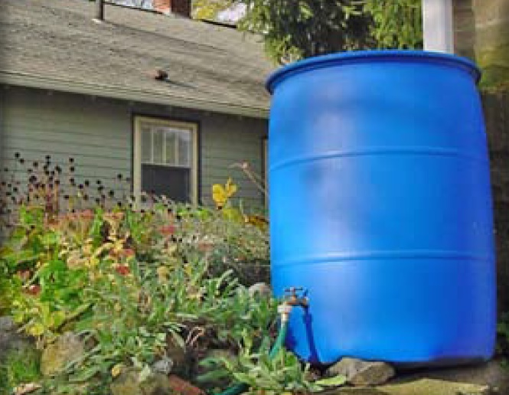
Rain Barrels & Cisterns
Ability to meet specific standards

Standard | Description
2 - Peak Flow | Does not provides peak flow attenuation.
3 - Recharge | If sized to retain the required 1-inch Water Quality Volume, consists of a reduction in Effective Impervious Cover (EIC) from the roof which may be deducted from the total area of impervious surface that must be managed as required by Standard 3 (Groundwater Recharge).
4 - TSS/TP  Removal | If sized to retain the required 1-inch Water Quality Volume, consists of a reduction in Effective Impervious Cover (EIC) from the roof which may be deducted from the total area of impervious surface that must be managed as required by Standard 4 (Pollutant Removal).
5 – Higher Pollutant Loading | Not suitable.
6 – Discharges near or to Critical Areas | Not suitable.
7 - Redevelopment | Suitable.
11 – Total Maximum Daily Loads | Does not meet any TMDL requirements as a stand-alone treatment practice.
ESSD / LID? | Yes, this practice is a MassDEP recognized ESSD / LID technique.

Note: Although MassDEP presumes rooftop runoff from non-metal, non-industrial roofs to be ‘clean” for purposes of the Stormwater Management Standards, research indicates higher PAHs in runoff from asphalt shingled roofs and zinc from metal roofs. USGS research in Texas indicates rooftop runoff contains mercury. Before using rooftop runoff for vegetable gardens, investigate the quality of the runoff, especially when using larvicides in rain barrels or cisterns for mosquito control.

Description
Other Structural
Cisterns and rain barrels are structures that store rooftop runoff and reuse it for landscaping and other non-potable uses. Instead of a nuisance to get rid of, consider rooftop runoff as a resource that can be reused or infiltrated. In contrast, conventional stormwater management strategies take rooftop runoff, which is often relatively free of pollutants, and direct it into the stormwater treatment system along with runoff from paved areas.

Advantages/Benefits

- Can reduce water demand for irrigation or other non-potable uses.

- Property owners save money on water bills by using stored water for landscape purposes.

- Public water systems may experience lower peak demand in summer.

- When properly installed, rain barrels and cisterns reduce stormwater runoff volume for small storms.

Disadvantages/Limitations

- Provides mosquito-breeding habitat unless properly sealed.

- May need to be disconnected and drained in winter to avoid cracking of storage structure

ESSD / LID Alternatives
This practice is a MassDEP recognized ESSD / LID technique.
Suitability to Treat TMDL Pollutants
Pollutant | Suitable to Treat?
TSS | N
Total Nitrogen | N
Total Phosphorous | N
Pathogens | N
Metals | N

Notes:
- Pathogens category includes: fecal coliform, E. coli, and enterococcus.
- Metals category includes Zinc, Cadmium, Lead, Aluminum, and Iron

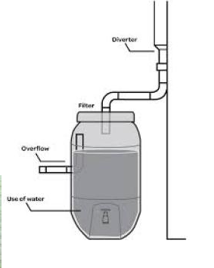
Special Features

Direct overflow from rain barrels and cisterns to a dry well, infiltration trench, rain garden, bioretention area, or other infiltration SCM sized to recharge the overflow volume.

Applications and Design Principles

The most common approach to roof runoff storage involves directing each downspout to a 55- gallon rain barrel. A hose is attached to a faucet at the bottom of the barrel and water is distributed by gravity pressure. A more sophisticated and effective technique is

to route multiple downspouts to a partially or fully buried cistern with an electric pump for distribution. Where site designs permit, cisterns may be quite large, and shared by multiple households, achieving economies of scale. Stored rainwater can be used for lawn irrigation, vegetable and flower gardens, houseplants, car washing, and cleaning windows.

The roof surface can be deducted from the impervious surfaces used to determine the Required Water Quality Volume for sizing other structural treatment practices, only when: 1) the cistern or barrel can store the required water quality volume for the roof surface; 2) the stored water is used or discharged to an infiltration SCM within 72-hours, and 3) the system is designed to operate 365 days a year.

Cisterns and rain barrels can provide benefits by reducing the required water quality volume and peak discharge rates depending on the amount of storage available at the beginning of each storm. One rain barrel may provide a useful amount of water for garden irrigation, but it will have little effect on overall runoff volumes, especially if the entire tank is not drained between storms. Improve effectiveness by having more storage volume and by designing the system with a continuous discharge to an infiltration structure, so that there is always storage available for retention. To operate the system year-round, bury or insulate the unit. State Plumbing Code requirements apply to cisterns and rain barrels located within 10 feet of a building. All applicable requirements of the Massachusetts State Plumbing or State Building Codes must be met.

Cisterns and rain barrels are applicable to most commercial and residential properties where there is a gutter and downspout system to direct roof runoff to the storage tank. They take up little room and can be used in dense urban areas. Rain barrels and cisterns are excellent retrofit techniques for almost any circumstance. Rain barrels are covered plastic tanks that can hold from 50 to 100 gallons with a hole in the top for downspout discharge, an overflow

outlet, and a valve and hose adapter at the bottom. They are used almost exclusively on residential properties. Plastic rain barrels are typically installed above ground. They must be disconnected prior to the winter, and the barrel drained completely to prevent the barrel from cracking.

Because rain barrels rely on gravity flow, place them near, and slightly higher than, the point of use (whether a garden, flower bed, or lawn). Route the overflow outlet to a dry well, bioretention area, rain garden or other infiltration SCM. It is important for property owners to use the water in rain barrels on a regular basis, otherwise the barrels can fill up and prevent additional roof runoff from being stored. Each house should have the appropriate number of rain barrels or an appropriately sized cistern. A one-inch storm produces over 620 gallons of water from a 1,000 square foot roof. Assuming a rain barrel capacity of 55 gallons, it would take 11 rain barrels to store one inch of runoff from 1,000 square feet of roof.

Cisterns are partially or fully buried tanks with a secure cover and a discharge pump; they provide considerably more storage than barrels, as well as pressurized distribution. They are less susceptible to cracking induced by expansion of freezing water when buried below grade. Cisterns can collect water from multiple downspouts or even multiple roofs, and then distribute this water wherever it needs to go via an electric pump. Property owners may use one large tank or multiple tanks in series. Either way, direct the overflow for the systems to a dry well or other infiltration mechanism so that if the cistern is full, excess roof runoff is infiltrated, and not discharged to the stormwater treatment system. Some cisterns are designed to continuously discharge water into infiltration units at very slow rates, so that the tank slowly empties after a storm, providing more storage for the next storm. The cisterns must also be designed to dewater in 72 hours or less.

Setback Requirements
Stormwater Control Measures (SCMs) and other components of the Stormwater Management System must be setback from wetlands, building foundations, and other features in accordance with 310 CMR 10.05(6)(q). SCMs must also include vertical separation between certain features, such as the depth to seasonally high groundwater. Refer to Section 2.5 of the Stormwater Handbook for horizontal setback and vertical separation distance requirements. Horizontal setbacks also include maintenance access requirements around the perimeter of certain SCMs.
Design Considerations

Because of the low pressure of the discharge, rain barrels are most effectively used with a drip irrigation system. Secure rain barrels against disturbance

by children or animals. Seal any openings with mosquito netting. If present, place the cistern’s continuous discharge outlet so that the tank does not empty completely. This ensures water availability at all times, and provides some storage capacity for every storm. A diverter at the cistern inlet can redirect

the “first flush” of runoff, which is more likely to have particulates, leaves, and air-deposited contaminants washed off the roof. Keep leaves and debris out

of the storage tank by placing a screen at the top of the downspout. Hide rain barrels and cisterns with shrubs or other landscaped features. Direct overflow from rain barrels and cisterns to a dry well, infiltration trench, rain garden, bioretention area, or other infiltration SCM sized to recharge the overflow volume. Use pond routing methods to design cisterns or rain barrels to account for retention of early runoff in the storage tank. Include access ports for any subsurface cisterns. Confined space entry training may be needed to enter large cisterns. MassDEP does not require treatment of runoff from non-metal roofs prior to infiltration. winter, unless the runoff is directed to a qualifying stormwater infiltration practice.

Maintenance

Activity
Maintenance requirements for cisterns and rain barrels are minimal. These requirements include the following: Inspect the unit twice a year, use larvicide for mosquito control, disconnect and drain the system prior to winter to prevent cracking, and replace or repair any worn-out pieces.

Maintenance requirements for rain barrels are

minimal and consist only of inspecting the unit

as a whole and any of its constituent parts and

accessories twice a year. The following components

should be routinely inspected and either repaired or

replaced as needed:

Roof catchment, to ensure that trash and

particulate matter are not entering the gutter and

- downspout to the rain barrel.

- Gutters, to ensure that no leaks or obstructions are occurring.

Downspouts, to assure that no leaks or

- obstructions are occurring.

Entrance at rain barrel, to ensure that there are

- no obstructions and/or leaks occurring.

Rain barrel, to check for potential leaks, including

- barrel top and seal.

Runoff / overflow pipe, to check that overflow is

- draining in non-erosive manner.

- Spigot, to ensure that it is functioning correctly.

Any accessories, such as rain diverter, soaker

- hose, linking kit, and additional guttering.

- Apply larvicides in strict accordance with all Mass.

- Department of Agricultural Resources Pesticide

Bureau regulations to prevent mosquitoes from

- reaching adulthood.

Add bleach or other chemicals annually to

kill bacteria present in the system. A qualified

professional should determine appropriate

- treatment.

Drain the system before winter if it is located

above ground or partially exposed, to prevent

- cracking.

- Disconnect the system from roof leaders in the fall, if it is not intended to be used during the winter.

- When the cistern or barrel is connected to a stormwater recharge system, remove particulates trapped in the cistern or rain barrel annually to limit clogging of the stormwater infiltration system.
References
Adapted from: MAPC Low Impact Development Toolkit. For more information, go to www.mapc.org/lid and www.arc-of-innovation.org .
Other Resources:

http://www.rainwaterrecovery.com/about.html

Charles River Watershed Association: www.crwa.org

Massachusetts
Stormwater Management
Handbook
Accessories

- Level Spreaders
- Check Dams
- Outlet Structures
- Catch Basin Inserts
- Vertical Curb Inlet Grates

SCM accessories are not SCMs themselves, but are required to facilitate the operation and function of SCMs. This section presents four of the most common and important SCM accessories: level spreaders, check dams, outlet structures, and catch basin inserts.

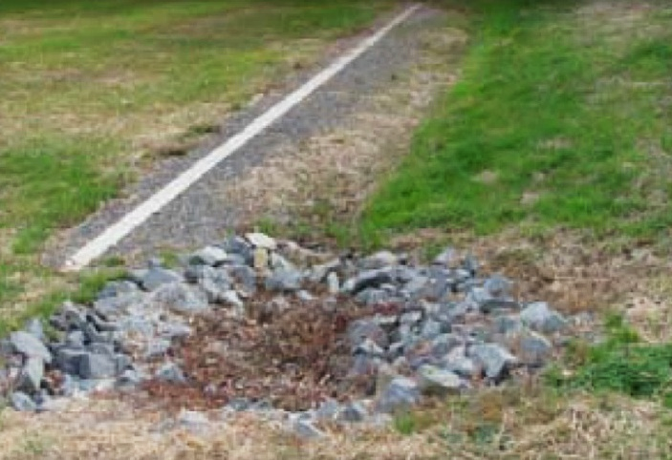
Level Spreaders
Description

A level spreader receives concentrated flow from channels, outlet structures, or other conveyance structures, and converts it to sheet flow where it can disperse uniformly across a stable slope. A level spreader is not a pollutant reduction device. It improves the efficiency of other SCMs, such as vegetated swales, filter strips, or infiltration systems that depend on sheet flow to operate properly.

Accessories

Applicability and Planning Considerations

Level spreaders are used in wide, level areas where concentrated runoff occurs. They should be placed on undisturbed soil that has been stabilized with vegetation. Disturbed soils are more erodible. If the spreader is not absolutely level, flow will concentrate at the low point and may worsen erosion problems. Flows to the level spreader should be relatively free of sediment, or the level spreader could be quickly overwhelmed by sediment and lose its effectiveness.

Design and Construction

Level spreaders are usually made of rocks, lumber, or concrete. Typical depths of flow behind each spreader range from 6 to 12 inches.

Construct level spreaders to be absolutely level. Small variations in height of even 0.25 inches can cause water to quickly concentrate and create erosion problems. A 4-inch variation in ground elevation across the entire length of the level spreader can make level construction difficult.

The height of the spreader is based on design flow, allowing for sediment and debris deposition. Design the length of the spreader based on the 10-year design flow for the site or the sheet flow path width, whichever is greater. When designing for the 10-year design flow, use the following table:

Example Section View of Level Spreader
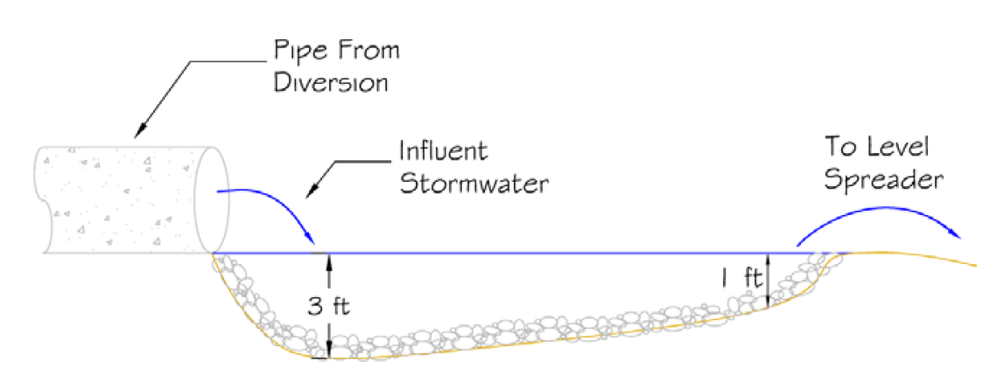

adapted from the North Carolina State University

Drainage Area (length) | Minimum Spreader
1 acre | 10 feet
2 acres | 10 feet
3 acres | 15 feet
4 acres | 18 feet
5 acres | 20 feet
The slope leading to the level spreader should be less than 1% for at least 20 feet immediately upstream, to keep runoff velocities less than 2 feet per second during the 10-year storm event. The slope at the outlet of the spreader should be 6% or less.
Maintenance

Inspect level spreaders regularly, especially after large rainfall events. Note and repair any erosion or low spots in the spreader.
References
Adapted from:

Idaho Department of Environmental Quality. Catalog of

Stormwater SCMs for Cities and Counties, 209-210.

MassDEP, Massachusetts Nonpoint Source Pollution

Management Manual, 2006.

http://www.mass.gov/dep/water/laws/policies.htm#storm

Additional Resources:

Hunt, W.F. et al. Designing Level Spreaders to Treat Stormwater Runoff. North Carolina State University, as presented at North Carolina Department of Transportation Level Spreader Workshop, February 19, 2001, Raleigh, NC.

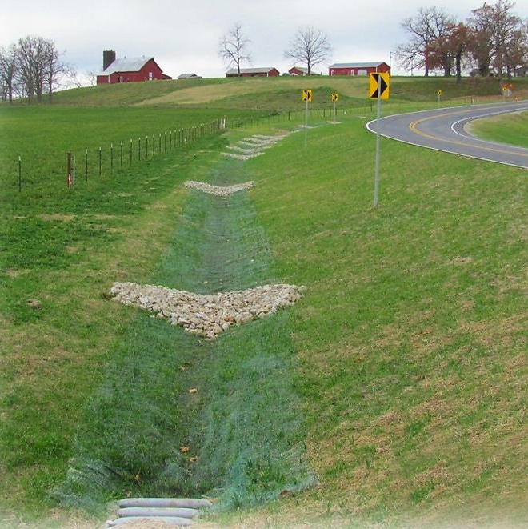
Check Dams
Accessories
Description

A check dam is a small dam constructed across a drainage ditch, swale, or channel to lower the velocity of flow. Reduced runoff velocity reduces erosion and gullying in the channel and allows sediments to settle out. A check dam may be built from stone, sandbags (filled with pea gravel), logs, or concrete. Check dams are relatively easy and inexpensive to construct. Permanent check dams should be constructed from stone or concrete. Sandbag dams filled with pea gravel or logs are suitable only as temporary practices. Never use a filter fence or a hay bale as a check dam, either on a temporary or permanent basis.

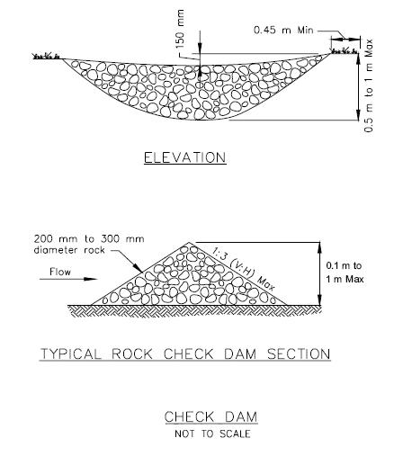
Adapted from Caltrans
Applicability
Use check dams where temporary channels or permanent channels are not yet vegetated, channel lining is infeasible, where velocity checks are needed, or to induce stormwater exfiltration into the ground within a SCM such as a dry water quality swale. Check dams may also be used as a temporary or emergency measure to limit erosion by reducing flow in small open channels. Other uses for check dams include:

- To reduce flow in small temporary channels that are presently undergoing degradation,

- Where permanent stabilization is impractical due to the temporary nature of the problem,

- To reduce flow in small eroding channels where construction delays or weather conditions prevent timely installation of non-erosive liners.

Check dams can be installed in small open channels that drain 10 acres or less, or channels where stormwater velocities exceed 5 feet per second. Note that some SCMs such as grass channels require flows to not exceed 1 foot per second for the water quality volume. Check dams cause water to pond. Under low-flow situations, water ponds behind the structure and then slowly seeps through the check dam and/or exfiltrates into the underlying soil, depending on the soil permeability. Under high-flow situations, water flows over and/or through the structure.

Advantages

- Inexpensive and easy to install.

- Reduces velocity and may provide aeration of the water.

- Prevents gully erosion from occurring before vegetation is established, and also causes a high proportion of the sediment load in runoff to settle out.

- In some cases, if carefully located and designed, check dams can remain as permanent installations with very minor regrading, etc.
- They may be left as either spillways, in which case accumulated sediment would be graded and seeded, or as check dams to capture sediment coming off that site.
- They must be constructed in dry water quality swales to reduce velocity and induce exfiltration.

Disadvantages

- May kill grass linings in channels if the water level remains high after rainstorms or if there is significant sedimentation.
- Clogging by leaves in the fall may be a problem.

- Should not be used in live streams

- Require extensive maintenance following high velocity flows

- Should not be made from straw bales or silt fences

Design

Install check dams at a distance and a height to allow small pools to form behind them. Install the first check dam about 15 feet from the outfall device and at regular intervals after that, depending on slope and soil type. In multiple check dam installations, design the system so that backwater from the downstream check dam reaches the toe of the next upstream dam. High flows (typically a 2-year or larger storm) should flow over the check dam without increasing upstream flooding or damaging the dam. Form check dams by hand or mechanically. Never dump rock directly into the channel or swale. Rock check dams should consist of well-graded stone consisting of a mixture of rock sizes.

When used in wet or dry water quality swales, the height of the check dam shall be no less than the elevation associated with the Water Quality Volume (1.0 inch times contributing impervious surface).

Exercise care in designing the ends of a check dam to ensure that it is long enough and adequately anchored to prevent ponded water from scouring the soil at the ends, and flowing around the dam.

Some check dam designs may require weirs. For example, if the same check dam is used for water quality treatment (for the water quality volume), and to lag the peak rate of runoff (for the velocity associated with runoff from the 2-year storm), a weir must be included as part of the check dam design. In instances where a permanent check dam is to be used for both water quality treatment and lag peak flows with a weir, use a durable material such as concrete. If the check dam is constructed from stone such as pea gravel, the weir would most likely lose its shape when higher velocities occur.

Maintenance

Inspect check dams after every significant rainfall event. Repair damage as needed. Remove sediment as needed.
Adapted from:

Caltrans, Storm Water Quality Handbooks. Section 4.

SC-4 P.

MassDEP, Massachusetts Nonpoint Source Pollution Management Manual, 2006. https://www.mass.gov/info-details/nonpoint-source-pollution

Outlet Structures
Description

Outlets of SCMs are devices that control the flow of stormwater out of the SCM to the conveyance system.

Outlet Protection Design in Relation to Receiving Wetlands

This section describes the various types of common outlets such as flared end structures, risers, single-stage outlets, and multi- stage outlets. Considerations include setting back the outlet from a brook, providing appropriate energy dissipation, and orientating the outlet to reduce scour effects on the opposite bank.

Alignment of Outlets into Regulatory Streams

The Wetlands and 401 regulations require that stormwater treatment be provided prior to discharge into wetland Resource Areas such as vegetated wetlands (BVW, IVW, salt marshes), land under water (streams, lakes, rivers, ponds, ocean), and other Resource Areas, except for Riverfront Areas, Bordering Land Subject to Flooding, and land subject to coastal zone flowage, where such practices may be sited, provided the structures meet the performance standards specified in the Wetland regulations applicable to all projects.

The impact of new pipe outfalls on wetlands can be significantly reduced by locating the outfall point back from the receiving stream, using a flared-end structure, installing riprap or bio-engineered splash pad, and either digging a channel from the outfall to the stream or designing the splash pad to act as a level spreader to sheet the discharged stormwater to the stream.

In addition to not placing the outfall and energy dissipation in a wetland Resource Area such as a BVW or LUW, care must be exercised in the outlet design to ensure its orientation is such to reduce scour at the entry point and opposite bank. The preferred approach is to end the outlet pipe at a headwall or flared- end structure with a riprap or bio-engineered splash pad, discharging to a manmade drainage swale that is aligned at no more than a 45-degree angle to a stream

channel. Design the outlet point and riprap or bio- engineered splash pad to reduce the energy sufficiently to eliminate a need to install riprap on the bank opposite the outfall point to protect it from scour.

Accessories
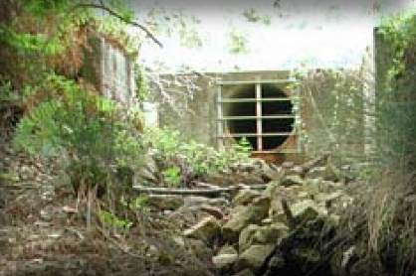
References

Caltrans, Storm Water Quality Handbooks. 2003. (http://www.dot.ca.gov/hq/construc/stormwater/ manuals.htm)

Connecticut Department of Environmental Protection. Connecticut Stormwater Quality Manual. 2004. (http:// dep.state.ct.us/wtr/stormwater/strmwtrman.htm)

Idaho Department of Environmental Quality. Catalog of Stormwater SCMs for Cities and Counties. March 2003. (http://www.google.com/u/ DEQ?q=stormwater&domains=www.deq.idaho. gov&sitesearch=www.deq.idaho.gov)

Maine Department of Environmental Protection. Maine Stormwater Best Management Practices Manual. January 2006. (http://www.maine.gov/dep/blwq/ docstand/stormwater/stormwaterSCMs/index.htm)

Maryland Department of the Environment. Maryland Stormwater Design Manual, Volumes I and II, October 2000. (http://www.mde.state.md.us/Programs/ WaterPrograms/SedimentandStormwater/stormwater_ design/index.asp)

New Jersey Department of Environmental Protection. New Jersey Stormwater Best Management Practices Manual. April 2004. http://www.state.nj.us/dep/ stormwater/SCM_manual2.htm

U.S. Department of Transportation. Federal Highway Administration.

Stormwater Best Management Practices

in an Ultra-Urban Setting: Selection and Monitoring.

(Undated).

(http://www.fhwa.dot.gov/environment/ultraurb/index.

htm)

U.S. Environmental Protection Agency. Office of Research and Development. The Use of Best Management Practices (SCMs) in Urban Watersheds. EPA/600/R-04/184. September 2004.

Vermont Agency of Natural Resources. The Vermont Stormwater Management Manual. April 2002. (http://www.vtwaterquality.org/stormwater.htm)

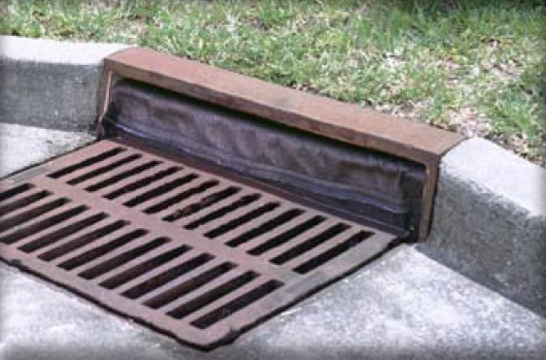
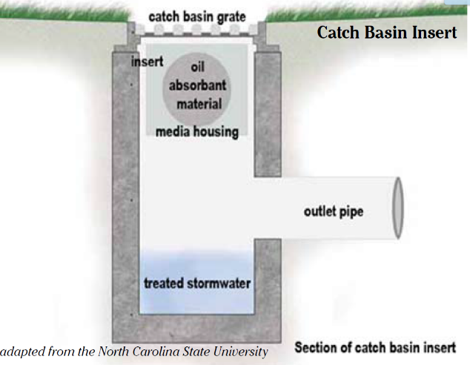
Catch Basin Inserts
Accessories
Description

Catch Basin Inserts are a SCM accessory that add filtering efficiency to traditional catch basins. These proprietary SCMs are capable of removing a range of pollutants, from trash and debris to fine sediments and oil/grease and metals depending upon the filtering medium used. They typically have three components:

- an insert that fits in into the catch basin

- absorbent material (can be a single unit or a series of filters)

- a housing to hold the absorbent material

- applications.
Additionally, larger sized sediment can clog and significantly reduce the effectiveness of some Catch Basin Insert filtering media. Therefore, it is important to ensure that flow rates, sediment removal, and the frequency of inspection and maintenance are evaluated.

Note: Silt sacks used to provide construction period sediment control are not a post-construction Catch Basin Insert.
Design and Construction

- Since Catch Basin Inserts are usually proprietary devices, the manufacturer should be asked to ensure that the device will work in the type of catch basin in which it is installed.
- Catch Basin Inserts are typically designed and used to filter smaller volume flows. Flow characteristics and sediment loading should be evaluated and any resulting modifications to the catch basin made before installation of the insert.

- When a Catch Basin Insert is proposed, to determine if additional pollutant removal credit for TSS and/or TP is warranted, follow the process specified in Section 5.3 of the Stormwater Handbook.
Maintenance
Inspect Catch Basin Inserts per the manufacturer’s schedule, and especially after large rainfall events. Whoever is responsible for maintenance should explicitly agree to conduct the maintenance per the manufacturer’s recommendation and to lawfully dispose of the cleanings or used filtration media.

Applicability and Planning Considerations

Catch basin inserts can be useful for specialized

applications, such as targeting specific pollutants

other than TSS, at Land Uses with Higher Potential Pollution Loads, for oil control at small sites, for

retrofits of existing catch basins
with no or undersized sumps, to

- add TSS treatment to areas with higher sediment loading, or to improve

conditions at size-constrained sites (e.g., catch basins near beaches).

- If using a proprietary Catch Basin Insert, the manufacturer’s specifications must be followed, which may include modifications to the catch basin. Such modifications may include a high flow bypass or other feature to handle clogging or larger storm events.

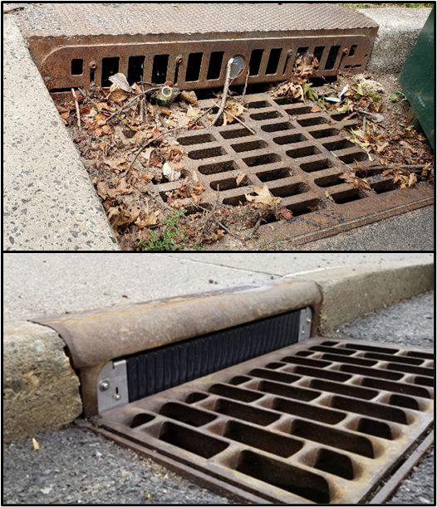
Vertical Curb Inlet Grates
Accessories
Description

Vertical curb inlet grates are a SCM accessory developed to add filtering efficiency to traditional FHWA "open curb inlets”, “curb opening inlets”, or “combination inlets”. Both generic and proprietary versions are available. These SCMs prevent trash, and leaf litter from entering the catch basin sump through the open curb. They come in two configurations:
- Fixed (top photo). A fixed grate spans across the open curb and allows water to flow through grate openings.
- Retractable (bottom photo). A movable grate inset spans across the open curb opening that opens when water pusses against it.
Applicability and Planning Considerations

All deep sump catch basins that contain a curb inlet must be installed with a vertical curb inlet grate to receive TSS pretreatment credit (see “Deep Sump Catch Basin” section of this Appendix for more information).

Vertical curb inlet grates can be useful for specialized
applications, such as targeting specific pollutants
other than TSS, in areas with commercial and industrial land uses, for trash or litter control at small sites, and for retrofits of existing catch basins to add enhanced prevention of TSS, leaf litter, and trash accumulation, or to improve existing conditions at size-constrained sites (e.g., catch basins near bathing beaches)..
Design and Construction

Since vertical curb inlet grates are usually proprietary devices, the manufacturer should be consulted to ensure that the device will work in the type of catch basin in which it is installed. All manufacturer specifications must be followed to ensure combability and proper installation. Flow characteristics and sediment loading should be evaluated and any resulting modifications to the catch basin made before installation of the insert.
Accessories

For Vertical curb inlet grates in combination inlets, the clear space in the curb opening, or each individual clear space if the curb opening has two or more clear spaces, shall have an area of no more than seven (7.0) square inches or be no greater than two (2.0) inches across the smallest dimension. Fixed curb guards shall me made of cast iron, coated or uncoated stainless steel. The moveable portion of retractable curb guards can be made of stainless steel or hard plastic.
Maintenance

Inspect vertical curb inlet grates per the manufacturer’s schedule, and especially after large rainfall events. Whoever is responsible for maintenance should explicitly agree to conduct the maintenance per the manufacturer’s recommendation and to lawfully dispose of cleanings and replace the grate should it become damaged.

Due to the increased litter accumulation on the street, an enhanced street sweeping program is recommended to ensure the litter is not swept off the street.

Since small particles and debris may still enter the catch basin sump, it should be cleaned on a regular schedule, at minimum as frequently as catch basins without a vertical curb inlet.

References
Evaluation of Street Sweeping and Curb Inlet Screens as Measures to Control Trash in Stormwater. 2016. State Water Resources Control Board Grant Agreement No. 12-420-550. EOA Inc. Oakland CA.
Massachusetts
Stormwater Management
Handbook
Operating and Source Controls

- Auto Salvage Yards
- Auto Fueling Facilities (Gas Stations)
- Building, Repair, and Maintenance of Boats and Ships
- Commercial Animal Handling Areas
- Commercial Composting
- Commercial Printing Operations
- Loading and Unloading Areas for Liquid or Solid Material
- Painting/Finishing/Coating of Vehicles/Boats/ Buildings/Equipment
- Railroad Yards
- SCMs for Retail and Wholesale Service Industries
- Vehicle Washing
- Road Salt Storage and Snow Disposal

Operating and Source Controls
This section of Appendix A identifies specific pollution prevention measures for use at certain industrial and commercial facilities, snow disposal measures, and deicer storage. The pollution prevention measures listed apply to industrial and commercial land uses. The snow disposal measures apply to all land uses. The deicer storage requirements apply to those who store deicers.
Implementation of these measures described herein for industrial and commercial land uses can help the operators of these facilities prevent the pollutants generated by their operations from entering Surface Waters or groundwater. These measures are required to be included in the Long Term Pollution Prevention Plan (LTPPP) required by Stormwater Standards No. 4 - 6 to be submitted with the Wetlands NOI or 401 Application, when new development or Redevelopment is proposed within a Wetland Resource Area or Buffer Zone (310 CMR 10.05(6)(k)4, 5, and 6. They must be implemented thereafter.
The measures described herein that are applicable to industrial land uses dovetail with the requirements for those industrial land uses subject to the NPDES Multi-Sector General Permit, and must be addressed in the required industrial Stormwater Pollution Prevention Plan (SWPPP). In addition to inclusion in the LTPPP, they also need to be incorporated directly or by reference in the Post Construction Operation and Maintenance Plan required by Stormwater Standard No. 9.
The measures required by the snow disposal and deicer storage guidance published by MassDEP must be consulted to determine if the measures need to be incorporated in the LTPPP and Operation/Maintenance Plans. In general, industrial and commercial land uses that require authorization for proposed activities in Wetland Resource Areas must address the snow disposal requirements as part of the LTPPP, including identifying a location on site at least 50 feet away from bank, BVW, IVW, or salt marsh, where snow will be disposed during the winter months. When Vernal Pools or other critical areas are located on sites, the Snow Disposal Guidance should be consulted directly as part of establishing a snow disposal location and in formulating the LTPPP.

Pollution prevention measures are identified for the following land uses:
Operating and Source Controls
- Auto Salvage Yards (Auto recycling facilities)
- Auto Fueling Facilities (Gas stations)
- Building, Repair, and Maintenance of Boats and Ships
- Commercial Animal Handling Areas
- Commercial and Municipal Composting Operations
- Commercial Printing Operations
- Loading and Unloading Areas for Liquid or Solid Material
- Painting/Finishing/ Coating of Vehicles/Boats/ Buildings/ Equipment
- Railroad Yards
- Commercial (Retail and Wholesale)
- Service Industries
- Road Salt Storage and Snow Disposal

Auto Salvage Yards
The auto salvage business offers great opportunities for recycle / reuse. The dismantling of vehicles for reusable parts and fluids and the sale of remaining materials as scrap has gone a long way toward lessening the burden on our landfills. Unfortunately, the methods used in dismantling and storage can, and often have, resulted in serious negative impacts on the environment.
Fluids Handling
Properly remove and handle automobile fluids. Fluids associated with auto salvage include:
- Drained motor oil
- Antifreeze
- Hydraulic oil/fluid
- Transmission fluid
- Brake fluid
- Window cleaner
- Oil recovered from steam cleaning
- Water recovered from steam cleaning
- Storm water runoff from storage area
Drained Motor Oil
Store used oil inside under cover or in covered containers on an impervious pad with adequate containment. An accepted practice is to allow oil to remain in the engine when auto is sold. The oil and the filters are sold with the engine. However, this is not true of all salvage yards. Used motor oil can be stored and sold to a processor or re-refiner or used as a fuel or energy source.
Antifreeze
Most salvaged vehicles have antifreeze in their systems. Spent antifreeze typically contains ethylene-glycol, an environmentally regulated chemical, and an accumulation of heavy metals. As a result, spent antifreeze is managed as hazardous waste in MA. Antifreeze can be reclaimed and reused. Store used antifreeze inside under cover or in covered containers on an impervious pad with adequate containment. For details on antifreeze recycling see Massachusetts Office of Technical Assistance and Technology (OTA) at https://www.mass.gov/files/antifreeze_recycling.pdf

Operating and Source Controls
Other Vehicle Fluids
Brake fluid, transmission fluid, and hydraulic oils are not considered financially feasible for recovery. Store these fluids under cover or in covered containers on an impervious pad with adequate containment. Dispose of these fluids as a hazardous waste.
Wastewater and Stormwater Runoff
Steam-cleaning auto engines and parts results in oil-contaminated wastewater. Segregate this water from domestic-type wastewater. Steam clean engines and parts inside and under cover to prevent exposure to rain, snow, snowmelt and runoff.
This wastewater should be given time to allow for solids settlement. If possible, separate the used oil for recycling and collection by a permitted used-oil transporter. Dispose of the remaining sludge as a hazardous waste.
Other Recyclable Materials
Other salvage yard materials that can be recycled include:
- Lead Acid Batteries (State law prohibits disposal in a landfill)
- Radiators, Engines, Air Conditioning Coils, Catalytic Converters
- Scrap Metals and Plastic
- Rubber-Related Materials
All the materials listed above are recyclable and should be recycled instead of being disposed of in landfills.

Auto Fueling Facilities (gas stations)
Description of Pollutant Sources
A fueling station is a facility dedicated to the transfer of fuels from a stationary pumping station to mobile vehicles or equipment. It includes above- or under-ground fuel storage facilities. In addition to general service gas stations, fueling may also occur at 24-hour convenience stores, construction sites, warehouses, car washes, manufacturing establishments, port facilities, and businesses with fleet vehicles. Typically, stormwater contamination at fueling stations is caused by leaks/spills of fuels, lube oils, radiator coolants, and vehicle washwater.
Pollutant Control Approach
Construct new or substantially remodeled fueling stations on an impervious concrete pad under a roof to keep out rainfall and stormwater run-on. Use a treatment SCM such as an oil grit separator, sand filter or equivalent for contaminated stormwater and wastewaters in the fueling containment area.
Applicable Operational BMPs
- Prepare an emergency spill response and cleanup plan and have designated trained person(s) available either on-site or on call at all times to promptly implement that plan and immediately cleanup all spills. Keep suitable cleanup materials, such as dry adsorbent materials, on-site to allow prompt cleanup of a spill.
- Train employees on the proper use of fuel dispensers. Post “No Topping Off” signs (topping off gas tanks causes spillage and vents gas fumes to the air). Make sure that the automatic shutoff on the fuel nozzle is functioning properly.
- The person conducting the fuel transfer must be present at the fueling pump during fuel transfer, particularly at unattended or self-serve stations.
- Keep drained oil filters in a suitable container or drum. Drums should be closed on an impervious pad with adequate containment.
For more information about when you need to report a spill to MassDEP and how quickly you need to report it (in many instances a spill must be reported within 2 hours), go to this MassDEP web page: https://www.mass.gov/how-to/report-a-spill-or-environmental-emergency

Operating and Source Controls

Applicable Source Control BMPs
- Design the fueling island to control spills (e.g., use dead-end sumps or spill-control separators) and to treat collected stormwater and/or wastewater to required levels. Slope the concrete containment pad around the fueling island toward drains; either trench drains, catch basins and/or a dead-end sump. Drains to treatment should have a shutoff valve, which must be closed in the event of a spill.
- Alternatively, design the fueling island as a spill-containment pad with a sill or berm raised to a minimum of four inches to prevent the runoff of spilled liquids and to prevent run-on of stormwater from the surrounding area.
- The fueling pad should be paved with Portland cement concrete, or equivalent.
- The fueling island should have a roof or canopy to prevent direct entry of precipitation onto the spill containment pad. The roof or canopy should, at a minimum, cover the spill containment pad (within the grade break or fuel dispensing area) and preferably extend several additional feet to reduce the introduction of windblown rain. Convey all roof drains to storm drains outside the fueling containment area.
- Convey stormwater collected on the fuel island containment pad to a sanitary sewer system, if approved by the sanitary authority; or to an approved treatment system such as an oil/grit separator, sand filter or equivalent. Alternatively, a lined vegetated filter strip can convey stormwater from the fuel island to a bioretention area with an under-drain. Discharges from treatment systems to storm drains or Surface Waters or to the ground must not display ongoing or recurring visible sheen and must meet the requirements of the permit under which they are discharged.
- Stormwater collected on the fuel island containment pad may be collected and held for proper off-site disposal.
- Transfer the fuel from the delivery tank trucks to the fuel storage tank in impervious contained areas and ensure that appropriate overflow protection is used. Alternatively, cover nearby storm drains during the filling process and use drip pans under all hose connections.
Additional BMPs for Vehicles 10 feet high or greater
A roof or canopy may not be practicable at fueling stations that regularly fuel vehicles that are 10 feet high or taller. At those types of fueling facilities, consider using the following additional BMPs:
Operating and Source Controls
- If a roof or canopy is impractical, equip the concrete fueling pad with emergency spill controls, including a shutoff valve for the drainage from the fueling area. The valve must be closed in the event of a spill. An electronically actuated valve is preferred to minimize the time lapse between spill and containment. Spills must be cleaned up and contaminated materials disposed off-site in accordance with MassDEP policies and regulations: https://www.mass.gov/topics/cleanup-of-sites-spills
- The valve may be opened to convey contaminated stormwater to a sanitary sewer, if approved by the sewer authority, or to oil removal treatment such as an API oil/grit separator, sand filter or equivalent treatment, and then to a basic treatment BMP. Discharges from treatment systems to storm drains or Surface Water or to the ground must not display ongoing or recurring visible sheen and must not contain a significant amount of oil and grease.
- An explosive or flammable mixture is defined under state and federal regulations, based on a flash point determination of the mixture. See Appendix B IV for sources of information for flammability and other chemical risks: http://www.osha.gov/dsg/hazcom/ghd053107.html If contaminated stormwater is determined not to be explosive or flammable, then it could be conveyed to a sanitary sewer system.

Building, Repair, and Maintenance of Boats and Ships
Description of Pollutant Sources
Sources of pollutants at boat and shipbuilding, repair, and maintenance at boatyards, shipyards, ports, and marinas include pressure washing, surface preparation, paint removal, sanding, painting, engine maintenance and repairs, and material handling and storage, if conducted outdoors. If feasible, these activities should be done inside under cover. If done outside, use an impervious surface with adequate containment. Potential pollutants include spent abrasive grits, solvents, oils, ethylene glycol, wash water, paint over-spray, cleaners/ detergents, anti-corrosive compounds, paint chips, scrap metal, welding rods, resins, glass fibers, dust, and miscellaneous trash. Pollutant constituents include TSS, oil and grease, organics, copper, lead, tin, and zinc.
Pollutant Control Approach
Apply good housekeeping, preventive maintenance and cover and containment BMPs in and around work areas. See: https://www.mass.gov/files/documents/2016/08/wl/cmg-4-1_0.pdf
Applicable Operational BMPs
Applicable operational BMPs are:
- Regularly clean all accessible work, service and storage areas to remove debris, spent sandblasting material, and any other potential stormwater pollutants.
- Sweep rather than hose debris on the dock. If hosing is unavoidable, collect and convey the hose water to a wastewater treatment system or facility.
- Collect spent abrasives regularly and store under cover to await proper disposal.
- Dispose of greasy rags, oil filters, air filters, batteries, spent coolant, and degreasers properly.
- Drain oil filters before disposal or recycling.
- Immediately repair or replace leaking connections, valves, pipes, hoses and equipment that causes the contamination of stormwater.
- Use drip pans, drop cloths, tarpaulins or other protective devices in all paint mixing and solvent operations unless carried out in impervious contained and covered areas.

Operating and Source Controls

- Convey sanitary sewage to pump-out stations, portable on-site pump-outs, or commercial mobile pump-out facilities or other appropriate onshore facilities.
- Maintain automatic bilge pumps in a manner that will prevent waste material from being pumped automatically into Surface Water.
- Prohibit uncontained spray painting, blasting or sanding activities over open water or in any area where these activities may be exposed to rain, snow, snow melt or runoff.
- Do not dump or pour waste materials down floor drains, sinks, or outdoor storm drain inlets that discharge to Surface Water or groundwater. Plug floor drains that are connected to storm drains or to Surface Water. If necessary, install a sump that is pumped regularly.
- Prohibit outside spray painting, blasting or sanding activities during windy conditions that render containment ineffective.
- Do not paint and/or use spray guns on topsides or above decks.
- Immediately clean up any spillage on dock, boat or ship deck areas and dispose of the wastes properly.
Applicable Structural Source Control BMPs
- Use fixed platforms with appropriate plastic or tarpaulin barriers as work surfaces and for containment when performing work on a vessel in the water to prevent blast material or paint overspray from contacting stormwater or the receiving water. Use of such platforms will be kept to a minimum and at no time be used for extensive repair or construction (anything in excess of 25 percent of the surface area of the vessel above the waterline).
- Use plastic or tarpaulin barriers beneath the hull and between the hull and dry dock walls to contain and collect waste and spent materials. Clean and sweep regularly to remove debris.
- Enclose, cover, or contain blasting and sanding activities to the maximum extent practicable to prevent abrasives, dust, and paint chips from reaching storm sewers or receiving waters. Use plywood and/or plastic sheeting to cover open areas between decks when sandblasting scuppers, railings, freeing ports, ladders, and doorways.
- Direct deck drainage to a collection system sump for settling and/or additional treatment.
- Store cracked batteries in a covered secondary container.
- Apply source control BMPs provided in this Appendix for other activities conducted at the marina, boat yard, shipyard, or port facility (BMPs for Fueling at Dedicated Stations, BMPs for Washing and Steam Cleaning Vehicle/Equipment/Building Structures, and BMPs for Spills of Oil and Hazardous Substances).
Recommended Additional Operational BMPs
- Consider recycling paint, paint thinner, solvents, used oils, oil filters, pressure wash wastewater and any other recyclable materials.
- Perform activities like paint mixing, solvent mixing, fuel mixing on shore inside or under cover or on an impervious area with adequate containment.

Commercial Animal Handling Areas
Operating and Source Controls
Description of Pollutant Sources
Animals at racetracks, kennels, fenced pens, veterinarians, and businesses that provide boarding services for horses, dogs, cats, and other animals, can generate pollutants from the following activities: manure deposits, animal washing, grazing and any other animal handling activity that could contaminate stormwater. Pollutants can include coliform bacteria, nutrients, and total suspended solids.
Pollutant Control Approach
To prevent, to the maximum extent practicable, the discharge of contaminated stormwater from animal handling and keeping areas.
Applicable Operational BMPs
- Regularly sweep and clean animal keeping areas to collect and properly dispose of droppings, uneaten food, and other potential stormwater contaminants
- Do not hose down to storm drains or to receiving water those areas that contain potential stormwater contaminants
- Do not allow any wash waters to be discharged to storm drains. Wash water is wastewater that must not be discharged to the stormwater management system.
- If animals are kept in unpaved and uncovered areas, the ground should either have vegetative cover or some other type of ground cover such as mulch
- If animals are not leashed or in cages, surround the area where animals are kept with a fence or other means that prevents animals from moving away from the controlled area where BMPs are used.

Commercial and Municipal Composting
Description of Pollutant Sources
Commercial compost facilities, operating outside without cover, require large areas to decompose wastes and other feedstocks. Design these facilities so as to separate stormwater from leachate (i.e., industrial wastewater) to the greatest extent practicable. When stormwater is allowed to contact any active composting areas, including waste receiving and processing areas, it becomes leachate.
Pollutants in leachate include nutrients, biochemical oxygen demand (BOD), organics, coliform bacteria, acidic pH, color, and suspended solids. Stormwater at a compost facility consists of runoff from areas at the facility that are not associated with active processing and curing, such as product storage areas, vehicle maintenance areas, and access roads.
Applicable Operational BMPs
- Ensure that the compost feedstocks do not contain dangerous or hazardous wastes, or solid wastes that are not beneficial to the composting process. Train employees to screen these materials in incoming wastes.
- Store finished compost properly, such as in a covered area, to prevent contamination of stormwater.
Applicable Structural Source Control BMPs
- Provide curbing for all compost pads to prevent stormwater run-on and leachate run-off.
- Slope all compost pads sufficiently to direct leachate to collection devices.
- Provide one or more sumps or catch basins capable of collecting leachate and conveying it to the leachate holding structure for all compost pads.
Applicable Treatment BMPs
- Convey all leachate from composting operations to a sanitary sewer, holding tank, or on-site treatment systems designed to treat the leachate and TSS.
- Line the ponds used to collect, store, or treat leachate and other contaminated waters associated with the composting process to prevent groundwater contamination.
Operating and Source Controls

Recommended Additional BMPs
- Regularly clean up debris from yard areas.
- Locate stored residues in areas designed to collect leachate.
- Limit storage times of residues to prevent degradation and generation of leachate.
- Consider using leachate as make-up water in early stages of the composting process. Because leachate can contain pathogenic bacteria, take care to avoid contaminating finished product or nearly finished product with leachate.
- In areas of the state with dry climates, consider using evaporation as a means of reducing the quantity of leachate.

Commercial Printing Operations
Operating and Source Controls
Description of Pollutant Sources
Materials used in the printing process include inorganic and organic acids, resins, solvents, polyester film, developers, alcohol, vinyl lacquer, dyes, acetates, and polymers. Waste products may include waste inks and ink sludge, resins, photographic chemicals, solvents, acid and alkaline solutions, chlorides, chromium, zinc, lead, silver, spent formaldehyde, plasticizers, and used lubricating oils. As the printing operations are conducted indoors, the only likely points of potential contact with stormwater are the outside temporary storage of waste materials and offloading of chemicals at external unloading bays. Pollutants can include TSS, pH, heavy metals, oil and grease, and COD.
Pollutant Control Approach
Ensure appropriate disposal of process wastes. Cover and contain stored raw and waste materials.
Applicable Operational BMPs
- Discharge process wastewaters to a sanitary sewer, if approved by the local sewer authority, or to an approved process wastewater treatment system.
- Do not discharge process wastes or wastewaters into storm drains, groundwater or Surface Water.
- Determine whether any of these wastes are regulated as dangerous wastes and dispose of them accordingly.
Applicable Structural Source Control BMP
Store raw materials or waste materials that could contaminate stormwater in covered and contained areas.
Recommended Additional BMPs
- Train all employees in pollution prevention, spill response, and environmentally acceptable materials-handling procedures.
- Store materials in proper, appropriately labeled containers. Identify and label all chemical substances.
- Regularly inspect all stormwater management devices and maintain them as necessary.
- Try to use press washes without listed solvents, and with the lowest VOC content possible. Don't evaporate ink cleanup trays to the outside atmosphere.
- Place cleanup sludges in containers with a tight lid and dispose of as hazardous waste. Do not dispose of cleanup sludges in the garbage or in containers of soiled towels.

Loading and Unloading Areas for Liquid or Solid Material
Description of Pollutant Sources
Loading/unloading of liquid and solid materials at industrial and commercial facilities are typically conducted at shipping and receiving, outside storage, and fueling areas. Materials transferred can include products, raw materials, intermediate products, waste materials, fuels, scrap metals, etc. Leaks and spills of fuels, oils, powders, organics, heavy metals, salts, acids, and alkalis during transfer are potential causes of stormwater contamination. Spills from hydraulic line breaks are a common problem at loading docks.
Pollutant Control Approach
Cover and contain the loading/ unloading area where necessary to prevent run-on of stormwater and runoff of contaminated stormwater.
Applicable Operational BMPs
At All Loading/ Unloading Areas:
- A significant amount of debris can accumulate outside uncovered loading/unloading areas. Sweep these surfaces frequently to remove material that could otherwise be washed off by stormwater. Sweep outside areas that are covered for a period of time by containers, logs, or other material after the areas are cleared.
- Place drip pans, or other appropriate temporary containment device, at locations where leaks or spills may occur, such as hose connections, hose reels and filler nozzles. Always use drip pans when making and breaking connections. Check loading and unloading equipment such as valves, pumps, flanges, and connections regularly for leaks and repair as needed.
At Tanker Truck and Rail Transfer Areas to Above/Below-ground Storage Tanks:
- To minimize the risk of accidental spillage, prepare an "Operations
- Plan" that describes procedures for loading/unloading. Train employees, especially forklift operators, in its execution and post it or otherwise have it readily available to employees.
- Prepare and implement an Emergency Spill Cleanup Plan for the facility that includes the following BMPs:

Operating and Source Controls

- Ensure the cleanup of liquid/solid spills in the loading/ unloading area immediately, if a significant spill occurs, and, upon completion of the loading/unloading activity, or at the end of the working day.
- Retain and maintain an appropriate oil spill cleanup kit on-site for rapid cleanup of material spills
- Ensure that an employee trained in spill containment and cleanup is present during loading/unloading.
- Notify MassDEP as required: https://www.mass.gov/topics/cleanup-of-sites-spills
At Rail Transfer Areas to Above/below-ground Storage Tanks:
- Install a drip pan system within the rails to collect spills/leaks from tank cars and hose connections, hose reels, and filler nozzles.
Applicable Structural Source Control BMPs
At All Loading/ Unloading Areas:
- To the extent practicable, conduct unloading or loading of solids and liquids in a manufacturing building, under a roof, or lean-to, or other appropriate cover.
- Berm, dike, and/or slope the loading/unloading area to prevent run-on of stormwater and to prevent the runoff or loss of any spilled material from the area.
- Large loading areas frequently are not curbed along the shoreline. As a result, stormwater passes directly off the paved surface into Surface Water. Place curbs along the edge, or slope the edge such that the stormwater can flow to an internal storm drain system that leads to a treatment BMP.
- Pave and slope loading/unloading areas to prevent the pooling of water. The use of catch basins and drain lines within the interior of the paved area must be minimized as they will frequently be covered by material, or they should be placed in designated “alleyways” that are not covered by material, containers or equipment.

Recommended Structural Source Control BMPs
For the transfer of pollutant liquids in areas that cannot contain a catastrophic spill, install an automatic shutoff system in case of unanticipated off-loading interruption (e.g., coupling break, hose rupture, overfill, etc.).
At Loading and Unloading Docks:
- Install/maintain overhangs, or door skirts that enclose the trailer end, to prevent contact with rainwater.
- Design the loading/unloading area with berms and grading to prevent the run-on of stormwater.
- Retain on-site the necessary materials for rapid cleanup of spills.
At Tanker Truck Transfer Areas to Above/Below-Ground Storage Tanks:
- Pave the area on which the transfer takes place. If any transferred liquid, such as gasoline, is reactive with asphalt, pave the area with Portland cement concrete.
- Slope, berm, or dike the transfer area to a dead-end sump, spill containment sump, an oil/grit separator, or other spill control device.

Painting, Finishing, and Coating of Vehicles, Boats, Buildings and Equipment
Description of Pollutant Sources
Surface preparation and the application of paints, finishes and/or coatings to vehicles, boats, buildings, and/or equipment outdoors can be sources of pollutants. Potential pollutants include organic compounds, oils and greases, heavy metals, and suspended solids.
Pollutant Control Approach
Cover and contain painting and sanding operations and apply good housekeeping and preventive maintenance practices to prevent the contamination of stormwater with painting oversprays and grit from sanding. https://dtsc.ca.gov/dtsc-website-archive/auto-body-and-paint-abp/
Applicable Operational BMPs
- Train employees in the careful application of paints, finishes, and coatings to reduce misuse and over spray. Use ground- or drop-cloths underneath outdoor painting, scraping, sandblasting work, and properly clean and temporarily store collected debris daily.
- Do not conduct spraying, blasting, or sanding activities over open water or where wind may blow paint into water.
- Wipe up spills with rags and other absorbent materials immediately. Do not hose down the area to a storm drain or receiving water or conveyance ditch to receiving water.
- On marine dock areas, sweep rather than hose down debris. Collect any hose water generated and convey to appropriate treatment and disposal.
- Use a storm drain cover, filter fabric, or similarly effective runoff control device if dust, grit, washwater, or other pollutants may escape the work area and enter a catch basin. The containment device(s) must be in place at the beginning of the workday. Collect contaminated runoff and solids and properly dispose of such wastes before removing the containment device(s) at the end of the workday.
- Use a ground cloth, pail, drum, drip pan, tarpaulin, or other protective device for activities such as paint mixing and tool cleaning outside or where spills can contaminate stormwater.

Operating and Source Controls

- Properly dispose of all wastes and prevent all uncontrolled releases to the air, ground or water.
- Clean brushes and tools covered with non-water-based paints, finishes, or other materials in a manner that allows collection of used solvents (e.g., paint thinner or turpentine) for recycling or proper disposal.
- Store toxic materials under cover during precipitation events and when not in use to prevent contact with stormwater.
Applicable Structural Source Control BMPs
Enclose and/or contain all work while using a spray gun or conducting sand blasting. Do not conduct outside spraying, grit blasting, or sanding activities during windy conditions that render containment ineffective.
Recommended Additional Operational BMPs
- Clean paintbrushes and tools covered with water-based paints in sinks connected to sanitary sewers or in portable containers that can be dumped into a sanitary sewer drain.
- Recycle paint, paint thinner, solvents, pressure washwater, and any other recyclable materials.
- Use efficient spray equipment such as electrostatic, air-atomized, high-volume/low-pressure, or gravity feed spray equipment.
- Purchase recycled paints, paint thinner, solvents, and other products if feasible.

Railroad Yards
Operating and Source Controls
Note: MassDEP requires an oil grit separator, sand filter or equivalent to manage stormwater runoff from this land use.
Description of Pollutant Sources
Pollutant sources can include drips/leaks of vehicle fluids onto the railroad bed, human waste disposal, litter, locomotive/railcar/equipment cleaning areas, fueling areas, outside material storage areas, the erosion and loss of soil particles from the railroad bed, maintenance and repair activities at railroad terminals, switching yards, and maintenance yards, and herbicides used for vegetation management. Waste materials can include waste oil, solvents, degreasers, antifreeze solutions, radiator flush, acids, brake fluids, soiled rags, oil filters, sulfuric acid and battery sludges, and machine chips with residual machining oil and toxic fluids/solids lost during transit. Potential pollutants include oil and grease, TSS, BOD, organics, pesticides, and metals.
Pollutant Control Approach
Apply good housekeeping and preventive maintenance practices to control leaks and spills of liquids in railroad yard areas.
Applicable Operational and Structural Source Control BMPs
- Do not allow discharge to outside areas from toilets while a train is in transit. Pump out facilities should be used to service these units.
- Use drip pans at hose/pipe connections during liquid transfer and other leak-prone areas.
- During maintenance, do not discard debris or waste liquids along the tracks or in railroad yards.
Applicable Treatment BMPs
In areas subjected to leaks/spills of oils or other chemicals, convey the contaminated stormwater to appropriate treatment such as a sanitary sewer, if approved by the appropriate sewer authority, or to an oil/grit separator for floating oils, or other treatment, as approved by the local jurisdiction.

Retail and Wholesale
Restaurants/Fast Food (SIC: 5800)
Description
Businesses that provide food service to the general public, including drive-through facilities.
Potential Pollutant Generating Sources
Potential pollutant sources include high-use customer parking lots and garbage dumpsters. The cleaning of roofs and other outside areas of restaurant and cooking vent filters in the parking lot can cause cooking grease to be discharged to the storm drains. MassDEP prohibits discharging wash water or grease to storm drains or Surface Water.
Retail/General Merchandise (SIC: 5300, 5600, 5700, 5900, and 5990)
Description
This group includes general merchandising stores such as department stores, shopping malls, variety stores, 24-hour convenience stores, and general retail stores that focus on a few product types such as clothing and shoes. It also includes furniture and appliance stores.
Potential Pollutant Generating Sources
Of particular concern are the high-use parking lots of shopping malls and 24-hour convenience stores. Furniture and appliance stores may provide repair services in which dangerous wastes may be produced.
Retail/Wholesale Vehicle and Equipment Dealers (SIC: 5010, 5080, and 5500, 7510 excluding fueling stations)
Description
This group includes all retail and wholesale businesses that sell, rent, or lease cars, trucks, boats, trailers, mobile homes, motorcycles and recreational vehicles. It includes both new and used vehicle dealers. It also includes sellers of heavy equipment for construction, farming, and industry. With the exception of motorcycle dealers, these businesses have large parking lots. Most retail dealers that sell new vehicles and large equipment also provide repair and maintenance services.

Operating and Source Controls

Potential Pollutant Generating Sources
Oil and other materials that have dripped from parked vehicles can contaminate stormwater at high-use parking areas. Vehicles are washed regularly, generating vehicle grime and detergent pollutants. The storm- or washwater runoff will contain oils and various organics, metals, and phosphorus. Repair and maintenance services generate a variety of waste liquids and solids including used oils and engine fluids, solvents, waste paint, soiled rags, and dirty used engine parts. Many of these materials are hazardous wastes.
Retail/Wholesale Nurseries and Building Materials (SIC: 5030, 5198, 5210, 5230, and 5260)
Description
These businesses are placed in a separate group because they are likely to store much of their merchandise outside of the main building. They include nurseries, and businesses that sell building and construction materials and equipment, paint, and hardware.
Potential Pollutant Generating Sources
Some businesses may have small fueling capabilities for forklifts and may also maintain and repair their vehicles and equipment. Some businesses may have unpaved areas, with the potential to contaminate stormwater by leaching of nutrients, pesticides, and herbicides. Storm runoff from exposed storage areas can contain suspended solids, and oil and grease from vehicles and forklifts and high-use customer parking lots, and other pollutants. Runoff from nurseries may contain nutrients, pesticides and/or herbicides.
Retail/Wholesale Chemicals and Petroleum (SIC: 5160, 5170)
Description
These businesses sell plastic materials, chemicals and related products. This group also includes the bulk storage and selling of petroleum products such as diesel oil and automotive fuels.

Potential Pollutant Generating Sources
The general areas of concern are the spillage of chemicals or petroleum during loading and unloading, and the washing and maintenance of tanker trucks and other vehicles. Also, the fire code requires that vegetation be controlled within a tank farm to avoid a fire hazard. Herbicides are typically used. The concentration of oil in untreated stormwater is known to exceed the water quality effluent guideline for oil and grease. Runoff is also likely to contain significant concentrations of benzene, phenol, chloroform, lead, and zinc.
Retail/Wholesale Foods and Beverages (SIC 5140, 5180, 542, 54)
Description
Included are businesses that provide retail food stores, including general groceries, fish and seafood, meats and meat products, dairy products, poultry, soft drinks, and alcoholic beverages.
Potential Pollutant Generating Sources
Vehicles may be fueled, washed and maintained at the business. Spillage of food and beverages may occur. Waste food and broken contaminated glass may be temporarily stored in containers located outside. High-use customer parking lots may be sources of oil and other contaminants.
Other Retail/Wholesale Businesses (SIC: 5010 (not 5012), 5040, 5060,5070, 5090)
Description
Businesses in this group include sellers of vehicle parts, tires, furniture and home furnishings, photographic and office equipment, electrical goods, sporting goods and toys, paper products, drugs, and apparel.
Potential Pollutant Generating Sources
Pollutant sources include high-use parking lots, and delivery vehicles that may be fueled, washed, and maintained on premises.

Service Industries
Animal Care Services (SIC: 0740, 0750)
Description
This group includes racetracks, kennels, fenced pens, veterinarians and businesses that provide boarding services for animals including horses, dogs, and cats.
Potential Pollutant Generating Sources
The primary sources of pollution include animal manure, wash waters, waste products from animal treatment, runoff from pastures where larger livestock are allowed to roam, and vehicle maintenance and repair shops. Pastures may border streams and direct access to the stream may occur. Both Surface Water and groundwater may be contaminated. Potential stormwater contaminants include fecal coliform, oil and grease, suspended solids, BOD, and nutrients.
Commercial Car and Truck Washes (SIC: 7542)
Description
Facilities include automatic systems found at individual businesses or at gas stations and 24-hour convenience stores, as well as self-service car washes. There are three main types: tunnels, rollovers and hand-held wands. The tunnel wash, the largest, is housed in a long building through which the vehicle is pulled. At a rollover wash, the vehicle remains stationary while the equipment passes over. Wands are used at self-serve car washes. Some car washing businesses also sell gasoline.
Potential Pollutant Generating Sources
Wash wastewater may contain detergents and waxes. Wastewater should be discharged to sanitary sewers. In self-service operations a drain is located inside each car bay. Although these businesses discharge the wastewater to the sanitary sewer, some wash water can find its way to the storm drain, particularly with the rollover and wand systems. Rollover systems often do not have air-drying.
Consequently, as it leaves the enclosure the car sheds water to the pavement. With the self-service system, wash water with detergents can spray outside the building and drain to storm sewer. Users of self-serve operations may also clean engines and change oil, dumping the used oil into the storm drain. Potential pollutants include oil and grease, detergents, soaps, BOD, and TSS.

Operating and Source Controls
Equipment Repair (SIC: 7353, 7600)
Description
This group includes several businesses that specialize in repairing different equipment including communications equipment, radio, TV, household appliances, and refrigeration systems. Also included are businesses that rent or lease heavy construction equipment, as miscellaneous repair and maintenance may occur on-site.
Potential Pollutant Generating Sources
Potential pollutant sources include storage and handling of fuels, waste oils and solvents, and loading/unloading areas. Potential pollutants include oil and grease, low/high pH, and suspended solids.
Laundries and Other Cleaning Services
(SIC: 7211 through 7217)
Description
This category includes all types of cleaning services such as laundries, linen suppliers, diaper services, coin-operated laundries and dry cleaners, and carpet and upholstery services. Wet washing may involve the use of acids, bleaches and/or multiple organic solvents. Dry cleaners use an organic-based solvent, and sometimes small amounts of water and detergent. Solvents may be recovered and filtered for further use. Carpets and upholstery may be cleaned with dry materials, hot water extraction processes, or in-plant processes using solvents followed by a detergent wash.
Potential Pollutant Generating Sources
Wash liquids are discharged to sanitary sewers. Stormwater pollutant sources include: loading and unloading of liquid materials, particularly at large commercial operations, disposal of spent solvents and solvent cans, high-use customer parking lots, and outside storage and handling of solvents and waste materials. Potential stormwater contaminants include oil and grease, chlorinated and other solvents, soaps and detergents, low/high pH, and suspended solids.

Marinas and Boat Clubs (SIC: 7999)
Description
Marinas and yacht clubs provide moorage for recreational boats. Marinas may also provide fueling and maintenance services. Other activities include cleaning and painting of boat surfaces, minor boat repair, and pumping of bilges and sanitary holding tanks. Not all marinas have a system to receive pumped bilge water.
Potential Pollutant Generating Sources
Both solid and liquid wastes are produced as well as stormwater runoff from high-use customer parking lots. Waste materials include sewage and bilge water. Maintenance by the tenants will produce used oils, oil filters, solvents, waste paints and varnishes, used batteries, and empty contaminated containers and soiled rags. Potential stormwater contaminants include oil and grease, suspended solids, heavy metals, and low/high pH. Boat wash water is industrial waste water and must not be directed to stormwater inlets, Resource Areas, or groundwaters. It must be captured, pretreated, and then directed to a publicly owned treatment works (POTW). Permission from the POTW is required to dispose of the boat wash wastewater. The POTW may have specific pretreatment requirements. For assistance, contact the Massachusetts Office of Coastal Zone Management (MCZM).
Golf and Country Clubs (SIC: 7992, 7997)
Description
Public and private golf courses and parks are included.
Potential Pollutant Generating Sources
Maintenance of grassed areas and landscaped vegetation has historically required the use of fertilizers and pesticides. Golf courses contain small lakes that are sometimes treated with algaecides and/or mosquito larvicides. The fertilizer and pesticide application process can lead to inadvertent contamination of nearby Surface Waters by overuse, misapplication, or the occurrence of storms shortly after application. Heavy watering of surface greens in golf courses may cause pesticides or fertilizers to migrate to surface and shallow groundwater resources. The use of pesticides and fertilizers generates waste containers. Equipment must be cleaned and maintained.
Miscellaneous Services (SIC: 4959, 7260, 7312, 7332, 7333, 7340, 7395, 7641, 7990, 8411)
Description
This group includes photographic studios, commercial photography, funeral services, amusement parks, furniture and upholstery repair and pest control services, and other professional offices. Pollutants from these activities can include pesticides, waste solvents, heavy metals, pH, and suspended solids, soaps and detergents, and oil and grease.
Potential Pollutant Generating Sources
Leaks and spills of materials from the following businesses can be sources of stormwater pollutants:
- Building maintenance produces wash and rinse solutions, oils, and solvents.
- Pest control produces rinse water with residual pesticides from washing application equipment and empty containers.
- Outdoor advertising produces photographic chemicals, inks, waste paints, and organic paint sludges containing metals.
- Funeral services produce formalin, formaldehyde, and ammonia.
- Upholstery and furniture repair businesses produce oil, stripping compounds, wood preservatives and solvents.
Professional Services (SIC: 6000, 7000 and 8000, 806, 807)
Description
The remaining service businesses include theaters, hotels/motels, finance, banking, hospitals, medical/dental laboratories, medical services, nursing homes, schools/universities, and legal, financial and engineering services. Stormwater from parking lots will contain undesirable concentrations of oil and grease, suspended particulates, and metals such as lead, cadmium and zinc. Dangerous wastes might be generated at hospitals, nursing homes and other medical services.
Potential Pollutant Generating Sources
The primary concern is runoff from high-use parking areas, maintenance shops, and storage and handling of dangerous wastes.
Vehicle Maintenance and Repair (SIC: 4000, 7530, 7600)
Description
This category includes businesses that paint, repair and maintain automobiles, motorcycles, trucks, and buses and battery, radiator, muffler, lube, tune-up and tire shops, excluding those businesses listed elsewhere in this manual.

Potential Pollutant Generating Sources
Pollutant sources include storage and handling of vehicles, solvents, cleaning chemicals, waste materials, vehicle liquids, batteries, and washing and steam-cleaning of vehicles, parts, and equipment. Potential pollutants include waste oil, solvents, degreasers, antifreeze, radiator flush, acid solutions with chromium, zinc, copper, lead and cadmium, brake fluid, soiled rags, oil filters, sulfuric acid and battery sludge, and machine chips in residual machining oil. Floor drains are prohibited. Dry shop techniques for maintenance should be utilized to reduce generation of liquids.
Construction Businesses (SIC: 1500, 1600, and 1700)
Description
This category includes builders of homes, commercial and industrial buildings, and heavy equipment as well as plumbing, painting and paper hanging, carpentry, electrical, roofing and sheet metal, wrecking and demolition, stonework, drywall, and masonry contractors. It does not include construction sites.
Potential Pollutant Generating Sources
Potential pollutant sources include leaks/spills of used oils, solvents, paints, batteries, acids, strong acid/alkaline wastes, paint/varnish removers, tars, soaps, coatings, asbestos, lubricants, anti-freeze compounds, litter, and fuels at the headquarters, operation, staging, and maintenance/repair locations of the businesses. Demolition contractors may store reclaimed material before resale.
Roofing contractors generate residual tars and sealing compounds, spent solvents, kerosene, and soap cleaners, as well as non-hazardous-waste roofing materials. Sheet metal contractors produce small quantities of acids and solvent cleaners such as kerosene, metal shavings, adhesive residues and enamel coatings, and asbestos residues that have been removed from buildings. Asphalt paving contractors are likely to store application equipment such as dump trucks, pavers, tack coat tankers and pavement rollers at their businesses. Stormwater passing through this equipment may be contaminated by the petroleum residuals. Potential pollutants include oil and grease, suspended solids, BOD, heavy metals, pH, COD, and organic compounds. A Construction Period Erosion Sedimentation Pollution Prevention Plan (CPPP) must be prepared and implemented as part of any alteration proposed to a wetland Resource Area. The CPPP must be submitted as part of the wetlands Notice of Intent or Water Quality Certification application. Additionally, if the proposed land disturbance is ≥1-acre, a Construction Period Stormwater Pollution Prevention Plan (SWPPP) must be prepared and implemented pursuant to the EPA Construction General Permit (CGP). The CGP requires construction contractors to submit a Notice of Intent to EPA to apply for coverage under the CGP.
The purpose of the CPPP and SWPPP is utilize source controls to prevent construction period runoff from being discharged to Resource Areas and Waters of the United States.

Vehicle Washing
Description
This management measure involves educating the general public, businesses, and municipal ﬂeets (public works, school buses, ﬁre, police, and parks) on the water quality impacts of the outdoor washing of automobiles and how to avoid allowing polluted runoﬀ to enter the storm drain system.
Outdoor car (aka vehicle) washing has the potential to result in high loads of nutrients, metals, and hydrocarbons during dry weather conditions in many water- sheds, as the detergent-rich water used to wash the grime oﬀ our cars ﬂows down the street and into the storm drain. Commercial car wash facilities often recycle their water or are required to treat their wash water discharge prior to release to the sanitary sewer system. As a result, most storm water impacts from car washing are from residents, businesses, and charity car wash fundraisers that discharge polluted wash water to the storm drain system.
According to the surveys, 55 to 70 percent of households wash their own cars, with the remainder going to a commercial car wash. Sixty percent of residents could be classiﬁed as "chronic car-washers" who wash their cars at least once a month (Smith, 1996, and Hardwick, 1997). Between 70 to 90 percent of residents reported that their car wash water drained directly to the street and, presumably, to the nearest stream.
Applicability
Car washing is a common routine for residents and a popular way for organizations such as scout troops, schools, and sports teams to raise funds. This activity is not limited by geographic region, but its impact on water quality is greatest in more urbanized areas with higher concentrations of automobiles.
Currently, only a few pollution prevention programs incorporate proper car washing practices as part of an overall message to residents on ways to reduce nonpoint source pollution. Other programs have extended this message to include charity car washes and provide these charity groups with equipment and training to alleviate the problems associated with polluted wash water entering the storm drain system.

Implementation
Operating and Source Controls
The development of a prevention program to reduce the impact of car wash runoﬀ includes outreach on management practices to reduce discharges to storm drains. Some of these management practices include the following:
- Using a commercial car wash.
- Washing cars on gravel, grass, or other permeable surfaces.
- Blocking oﬀ the storm drain during charity carwash events or using an insert to catch wash water.
- Pumping soapy water from car washes into a sanitary sewer drain.
- If pumping into a drain is not feasible, pumping car wash water onto grass or landscaping to provide ﬁltration.
- Using hoses with nozzles that automatically turn oﬀ when left unattended.
- Using only biodegradable soaps.
- Minimize the amounts of soap and water used. Wash cars less frequently.
- For businesses, good housekeeping practices can minimize the risk of contamination from wash water discharges. The following are general best management practices that businesses with their own vehicle washing facilities can incorporate to control water quality impacts from wash water discharges:
- All vehicle washing should be done in areas designed to collect and hold the wash and rinse water or eﬄuent generated. Wash water eﬄuent should be recycled, collected, or treated prior to discharge to the sanitary sewer system.
- Pressure cleaning and steam cleaning should be done oﬀ-site to avoid generating runoﬀ with high pollutant concentrations. If done on-site, no pressure cleaning and steam cleaning should be done in areas designated as wellhead protection areas for Public Water Supply.
- On-site storm drain locations should be mapped to avoid discharges to the storm drain system or to wetland Resource Areas.
- Spills should be immediately contained and treated.
Effectiveness
The effectiveness of car washing management practices at reducing nonpoint source pollutant loads has yet to be measured accurately. Due to the diﬀuse nature of nonpoint source pollution, it is often diﬃcult to determine the exact impact of a particular pollution prevention measure at reducing pollutant loading. While not much is known about the water quality of car wash water, it is clear that car washing is a common behavior.
Residents are typically not aware of the water quality consequences of car washing and do not understand the chemical content of the soaps and detergents they use. Car washing is a very diﬃcult watershed behavior to change since it is often hard to deﬁne a better alternative. However, as with all pollution prevention measures, the reduction of pollutant loads from outdoor car washing activities are bound to have a positive eﬀect on storm water quality.
References
Center for Watershed Protection. 1999. On Watershed Behavior. Watershed Protection Techniques 3(3): 671-679.
Natural Resources Defense Council. 1999. Stormwater Strategies: Community Responses to Runoﬀ Pollution. Natural Resources Defense Council, Inc, New York, NY
USEPA Pollution Prevention/Good Housekeeping for Municipal Operations USEPA. Vehicle Washing Fact Sheet.
Smith, J. 1996.

Public Survey Used to Estimate Pollutant Loads in Maryland. Technical note 73. Watershed Protection Techniques. 2(2): 361-363.
Hardwick, N. 1997. Lake Sammamish Watershed Water Quality Survey. King County Water and Land Resources Division. Seattle, WA. 122p.

Road Salt Storage and Snow Disposal
This section addresses snow disposal and road salt storage. Snow dumps in or near Wetland Resource Areas or Buffer Zones, or plowing of snow directly into Wetland Resource Areas can alter wetlands. The application and storage of deicing materials, most commonly salts such as sodium chloride, can lead to water quality problems for surrounding areas. Salts, gravel, sand, and other materials are applied to highways and roads to reduce the amount of ice during winter storm events. Salts lower the melting point of ice, allowing roadways to stay free of ice buildup during cold winters. Sand and gravel increase traction on the road, making travel safer.
Snow Disposal
MassDEP has developed a guidance document for communities regarding snow disposal, available on the web at: https://www.mass.gov/guides/snow-disposal-guidance. The guidance applies to all federal agencies, state agencies, state authorities, municipal agencies and private businesses disposing of snow in the Commonwealth of Massachusetts.
Finding a place to dispose of collected snow poses a challenge to municipalities and businesses as they clear roads, parking lots, bridges, and sidewalks. While MassDEP is aware of the threats to public safety caused by snow, collected snow that is contaminated with road salt, sand, litter, and automotive pollutants such as oil also threatens public health and the environment.
As snow melts, road salt, sand, litter, and other pollutants are transported into Surface Water or through the soil where they may eventually reach the groundwater. Road salt and other pollutants can contaminate water supplies and are toxic to aquatic life at certain levels. Sand washed into waterbodies can create sand bars or fill in wetlands and ponds, impacting aquatic life, causing flooding, and affecting our use of these resources.
There are several steps that communities can take to minimize the impacts of snow disposal on public health and the environment. These steps will help communities avoid the costs of a contaminated water supply, degraded waterbodies, and flooding. Everything that occurs on the land has the potential to impact the Commonwealth’s water resources.
The snow disposal guidelines address: (1) site selection; (2) site preparation and maintenance; and (3) emergency snow disposal.

Site Selection
Operating and Source Controls
The key to selecting effective snow disposal sites is to locate them adjacent to or on pervious surfaces in upland areas or upland locations on impervious surfaces away from water resources and drinking water wells. At these locations, the snow meltwater can filter into the soil, leaving behind sand and debris which can be removed in the spring. The following conditions should be followed:
- Within water supply Zone A and Zone II, avoid storage or disposal of snow and ice containing deicing chemicals that has been collected from streets located outside these zones. Municipalities may have a water supply protection land use control that prohibits the disposal of snow and ice containing deicing chemicals from outside the Zone A and Zone II, subject to the Massachusetts Drinking Water Regulations at 310 CMR 22.20C and 310 CMR 22.21(2).
- Avoid storage or disposal of snow or ice in Interim Wellhead Protection Areas (IWPA) of Public Water Supply wells, and within 75 feet of a private well, where road salt may contaminate water supplies.
- Avoid dumping snow into any waterbody, including rivers, the ocean, reservoirs, ponds, or wetlands. In addition to water quality impacts and flooding, snow disposed of in open water can cause navigational hazards when it freezes into ice blocks.
- Avoid dumping snow on MassDEP-designated high and medium-yield aquifers where it may contaminate groundwater.
- Avoid dumping snow in sanitary landfills and gravel pits. Snow meltwater will create more contaminated leachate in landfills posing a greater risk to groundwater, and in gravel pits, there is little opportunity for pollutants to be filtered out of meltwater because groundwater is close to the land surface.
- Avoid disposing snow on top of storm drain catch basins or in stormwater drainage systems including detention basins, swales or ditches. Snow combined with sand and debris may block a stormwater drainage system, causing localized flooding. A high volume of sand, sediment, and litter released from melting snow also may be quickly transported through the system into Surface Water.
Recommended Site Selection Procedures
It is important that the municipal Department of Public Works or Highway Department, Conservation Commission, and Board of Health work together to select appropriate snow disposal sites. The following steps should be taken:
- Estimate how much snow disposal capacity may be needed for the season so that an adequate number of disposal sites can be selected and prepared.
- Identify sites that could potentially be used for snow disposal, such as municipal open space (e.g., parking lots or parks).
- Select sites located in upland locations that are not likely to impact sensitive environmental resources first.
- If more storage space is still needed, prioritize the sites with the least environmental impact (using the site selection criteria, and local or MassGIS maps as a guide).
Snow Disposal Mapping Assistance
MassDEP has an online mapping tool to assist in identifying possible locations to potentially dispose of snow. MassDEP encourages municipalities to use this tool to identify possible snow disposal options. The tool identifies wetland Resource Areas, public drinking water supplies and other sensitive locations where snow should not be disposed. The tool may be accessed through the Internet at the following web address: https://maps.env.state.ma.us/dep/arcgis/js/templates/PSF/.
Site Preparation and Maintenance
In addition to carefully selecting disposal sites before the winter begins, it is important to prepare and maintain these sites to maximize their effectiveness. The following maintenance measures should be undertaken for all snow disposal sites:
- A silt fence or equivalent barrier should be placed securely on the downgradient side of the snow disposal site.
- Wherever possible maintain a 50-foot vegetated buffer between the disposal site and adjacent waterbodies to filter pollutants from the meltwater.
- Clear debris from the site prior to using the site for snow disposal.
- Clear debris from the site and properly dispose of it at the end of the snow season, and no later than May 15.
Snow Disposal Approvals
Proper snow disposal may be undertaken through one of the following approval procedures:
- Routine snow disposal: Minimal, if any, administrative review is required in these cases when upland and pervious snow disposal locations or upland locations on impervious surfaces that have functioning and maintained stormwater management systems have been identified, mapped, and used for snow disposal following ordinary snowfalls. Use of upland and pervious snow disposal sites avoids wetland Resource Areas and allows snow meltwater to recharge groundwater and will help filter pollutants, sand, and other debris. This process will address the majority of snow removal efforts until an entity exhausts all available upland snow disposal sites. The location and mapping of snow disposal sites will help facilitate each entity’s routine snow management efforts.
- Emergency Certifications: If an entity demonstrates that there is no remaining capacity at upland snow disposal locations, local Conservation Commissions may issue an Emergency Certification under the Massachusetts Wetlands Protection regulations to authorize snow disposal in Buffer Zones to wetlands, certain open water areas, and certain wetland Resource Areas (i.e., within flood plains). Emergency Certifications can only be issued at the request of a public agency or by order of a public agency for the protection of the health or safety of citizens, and are limited to those activities necessary to abate the emergency. See 310 CMR 10.06(1)-(4). Use the following guidelines in these emergency situations:
    - Dispose of snow in open water with adequate flow and mixing to prevent ice dams from forming.
    - Do not dispose of snow in salt marshes, vegetated wetlands, certified vernal pools, shellfish beds, mudflats, drinking water reservoirs and their tributaries, Zone IIs or IWPAs of Public Water Supply wells, Outstanding Resource Waters, or Areas of Critical Environmental Concern.
    - Do not dispose of snow where trucks may cause shoreline damage or erosion.
    - Consult with the municipal Conservation Commission to ensure that snow disposal in open water complies with local ordinances and bylaws.

- Severe Weather Emergency Declarations – In the event of a large-scale severe weather event, MassDEP may issue a broader Emergency Declaration under the Wetlands Protection Act which allows federal agencies, state agencies, state authorities, municipalities, and businesses greater flexibility in snow disposal practices. Emergency Declarations typically authorize greater snow disposal options while protecting especially sensitive resources such as public drinking water supplies, vernal pools, land containing shellfish, FEMA designated floodways, coastal dunes, and salt marsh. In the event of severe winter storm emergencies, the snow disposal site maps created by municipalities will enable MassDEP and the Massachusetts Emergency Management Agency (MEMA) in helping communities identify appropriate snow disposal locations.
If upland disposal sites have been exhausted, the Emergency Declaration issued by MassDEP allows for snow disposal near water bodies. In these situations, a buffer of at least 50 feet, preferably vegetated, should still be maintained between the site and the waterbody. Furthermore, it is essential that the other guidelines for preparing and maintaining snow disposal sites be followed to minimize the threat to adjacent waterbodies.
Under extraordinary conditions, when all land-based snow disposal options are exhausted, the Emergency Declaration issued by MassDEP may allow disposal of snow in certain waterbodies under certain conditions. A federal agency, state agency, state authority, municipality or business seeking to dispose of snow in a waterbody should take the following steps:
    - Call the emergency phone number [(888) 304-1133)] and notify the MEMA of the municipality’s intent.
    - MEMA will ask for information about where the disposal will take place.
    - MEMA will confirm that disposal is consistent with MassDEP’s Severe Weather Emergency Declaration and these guidelines and is therefore approved.
Deicer/Road Salt Storage
MassDEP has developed a guidance document for communities regarding storage of road salt or chemical deicing agents, available on the web at: https://www.mass.gov/guides/guidelines-on-road-salt-storage. The guidance applies to all parties storing road salt or other chemical deicing agents. This practice is applicable to areas that receive snowfall in winter months and require deicing materials. Municipalities in these areas must ensure proper storage and application for equipment and materials and identify appropriate areas for snow disposal.
Deicing Materials
To prevent increased pollutant concentrations in stormwater discharges, the amount of road salt applied should be reduced. Calibration devices for spreaders in trucks aid maintenance workers in the proper application of road salts. Many drinking water supply watersheds in Massachusetts use lower amounts of road salt to protect the resource. Reduced salt areas should be designated next to roads and wetlands. The amount of salt applied should be varied to reflect site-specific characteristics, such as road width and design, traffic concentration, and proximity to Surface Waters. Alternative materials, such as sand or gravel, calcium chloride, and calcium magnesium acetate may be used in especially sensitive areas. Information about road deicing materials can also be found at the American Association of State Highway and Transportation Officials web site at: http://www.transportation.org/.
Proper Storage of Deicing Materials
Proper snow management includes proper storage of deicing materials. Although covering stored road salts may be costly, the benefits are greater than the perceived costs. Correct road salt storage prevents salt from lumping together, which makes it easier to load and apply. Covering salt storage piles reduces salt loss from stormwater runoff and potential contamination to streams, aquifers, and estuarine areas. Salt storage piles should be located outside the 100-year floodplain for further protection against Surface Water contamination.
The Massachusetts General Laws, Chapter 85, Section 7A, forbid outside storage of salt in areas that would threaten groundwater and Surface Water sources for public water supplies or within 200 feet of an established river or estuary. Outside Zone IIs, Zone As and 200 feet of established rivers or estuaries, road salt and other deicing compounds must be stored on sheltered (protected from precipitation and wind), impervious pads. Internal flow within the shelter must be directed to a collection system and external flow directed around the shelter.
The Drinking Water Regulations require municipalities proposing new water sources to enact land use controls that prohibit the uncovered, uncontained storage of road deicing materials within:
- Wellhead Protection Areas (Zone I and Zone II) for Public Water Supply wells and
- Zone A for new public supply reservoirs
References
American Association of State Highway and Transportation Officials. 2000. AASHTO: Transportation Center of Excellence. http://www.transportation.org/
Massachusetts Executive Office of Environmental Affairs. Adopt a Stream Program. Road Salt: Some Alternatives and Strategies. http://www.mass.gov/dfwele/river/programs/adoptastream/index.htm
Massachusetts General Law Chapter 85, section 7A, http://www.mass.gov/legis/laws/mgl/85-7a.htm
MassDEP, 2020, Snow Disposal Guidance, https://www.mass.gov/guides/snow-disposal-guidance.
MassDEP, 1997, Guidelines on Deicing Chemical (Road Salt) Storage, https://www.mass.gov/guides/guidelines-on-road-salt-storage
USEPA. 1995. Planning Considerations for Roads, Highways and Bridges. U.S. Environmental Protection Agency, Office of Water, Washington, DC. https://www.epa.gov/nps/roads-highways-and-bridges-additional-resources
Koppelman, L.E., E. Tanenbaum, and C. Swick. 1984. Nonpoint Source Management Handbook. Long Island Regional Planning Board, Hauppauge, NY.

MassDEP has endeavored to make sure that requirements in the regulations and other sections of the Massachusetts Stormwater Handbook are consistent. If there is a discrepancy between the information listed in this Appendix and elsewhere in this document, the most restrictive must be applied.
EPA BMP-BATT (version 2.1): https://www.epa.gov/npdes-permits/stormwater-tools-new-england#swbmp.

