**Massachusetts Tobacco Availability and Pricing Survey**

*Fiscal Year 2023*

Report Prepared by: JSI Research & Training Institute, Inc. & The Massachusetts Tobacco Cessation and Prevention Program

# 

# Executive Summary

Since 2010, the Massachusetts Tobacco Cessation & Prevention Program (MTCP) at the Department of Public Health has been working with JSI Research & Training Institute, Inc. (JSI) to collect information on tobacco availability and pricing (“pricing survey”) at tobacco retailers across the state. This report presents pricing survey data collected by funded Boards of Health (BOH) and JSI in fiscal year 2023, from July 1, 2022 – June 30, 2023 (“FY23”). FY23 data collection was attempted in 100% of retailers (n=6,892) in Massachusetts and was completed in 73% of retailers (n=5,041).

Data have been collected with the intention to track trends in pricing and availability of tobacco projects and assess the impact of tobacco control regulations on availability and price of tobacco products including the state’s comprehensive flavored tobacco restriction.

Based on data from the FY2023 pricing survey all categories of tobacco products recorded showed an increase in availability in FY2023 in MA as compared to the previous year. The largest increase in availability was for nicotine pouches (available at 39% of retailers in FY2022, compared to 50% in FY2023), followed by vape products, from 46% to 51% (respectively). Prices of most tobacco products have increased from previous years.

Data continue to show the effectiveness of flavored policies and community-level cigar packaging regulations.

**FY23 Data Highlights**

|  |  |
| --- | --- |
| Topic Area | Key Findings |
| Cigarettes | Cigarettes were available in 98% of tobacco retailers. The most commonly observed brand of cigarettes was *Marlboro Red* (97% of retailers). Between FY2022 and FY2023, the price of *Marlboro Red* increased $0.74 from $11.32 to $12.06. |
| Single cigars | Single cigars were available in 68% of tobacco retailers. The most commonly observed brand of single cigars was *Black and Mild* (48% of retailers). |
| Multi-pack cigars | Multi-pack cigars were available in 76% of tobacco retailers. The most commonly observed brand of multi-pack cigars was *Game* (41% of retailers). |
| Chewing tobacco | Chewing tobacco products were available in 43% of tobacco retailers. The most commonly observed brand of chewing tobacco was *Grizzly* (51% of retailers). |
| Nicotine Pouches | Nicotine pouches were available in 50% of tobacco retailers. This is an 11% increase from FY22, the largest for any product. The most commonly observed brand of nicotine pouches was *Zyn* (51% of retailers). |
| Vape Products | Vape products were available in 50% of tobacco retailers. The most commonly observed brand of vape products was JUUL (39% of retailers) |
| Product availability in mint, menthol, wintergreen and other flavors | As a result of the flavored tobacco restriction enacted in June 2020, the availability of tobacco products in mint, menthol and wintergreen flavors in FY23 was near 0%, down from 87% in FY20. Availability of products in other flavors was 4.9%, down from 30% in FY20 |
| Advertisements for mint, menthol or wintergreen tobacco products | Advertising for mint, menthol, and wintergreen products (located anywhere in the store) was observed at 20 retailers, in 18 cities, or 0.4% overall. |

# Introduction

The Massachusetts Tobacco Cessation & Prevention’s (MTCP) mission is to reduce the health and economic burden of tobacco use by: preventing young people from starting to use tobacco and nicotine products; helping current tobacco and nicotine users to quit; protecting children and adults from secondhand smoke; and identifying and eliminating tobacco-related inequities.

In order to help achieve this mission, JSI Research & Training Institute, Inc. (JSI) has been working with MTCP to collect information on tobacco availability and pricing at retail establishments across the state. Data have been collected since 2010, with the intention to track trends in pricing and availability of tobacco projects (Goal 1) and assess the impact of tobacco control regulations on availability and price of tobacco products (Goal 2). These goals are described in more detail below.

**GOAL 1:** **Track trends in pricing and availability of tobacco products.**

The tobacco industry uses a variety of tactics in their business, marketing, and pricing strategies to attract new users and prevent current users from quitting, such as:

* Increasing density of retailers
* Decreasing price of products
* Increasing exposure and access to products
* Creating appealing, flavored products

Tracking the availability and price of tobacco products can help evaluate retailer compliance with existing policies, build an evidence base for the efficacy of those policies, and monitor statewide trends over time.

**GOAL 2:** **Assess the impact of tobacco control regulations on availability and price of tobacco products.**

In order to reduce the impact of tobacco industry tactics on youth and adult tobacco use, many local communities in Massachusetts have passed policies to regulate the environment in which tobacco products are sold, such as:

* Capping the number of tobacco retailers
* Banning the sale of tobacco in pharmacies
* Restricting the price of cigars
* Restricting sales of flavored tobacco products

As of June 1, 2020, the sale of flavored combustible cigarettes and other tobacco products, including menthol cigarettes and flavored chewing tobacco, are restricted to licensed smoking bars where they may be sold only for on-site consumption.

# Pricing Laws in Massachusetts

Extensive research on the impact of tobacco pricing on consumer behavior suggests that significantly increasing the price of tobacco is an effective tool to reduce tobacco use.[1] Higher prices prevent the initiation of tobacco use among non-users and nudge current users to stop or reduce their intensity (or quantity) of tobacco intake.[2]

A study analyzing data from the Youth Risk Behavior Survey (YRBS) from 1999-2013 found that tax increases had the largest impact on reducing tobacco product use among younger adolescents; every $1.00 increase in cigarette tax was associated with a 2.2 and 1.6 percentage point reduction in smoking among youth ages 14 and 15, respectively.[3] In addition, the impact of cigarette prices on smoking behavior increases as prices increase. For every 10% increase in cigarette prices, there is a 3-5% decrease in adult smoking prevalence and a 6-7% decrease in youth smoking prevalence.[4]

Industry documents confirm that tobacco companies are aware that price increases are an effective way to prevent initiation and increase cessation.[5] One document from Philip Morris International Inc., the “Big Tobacco” company recognized for its best-selling product, *Marlboro*, reads:

“

*A high cigarette price, more than any other cigarette attribute, has the most dramatic impact on the share of the quitting population…price, not tar level, is the main driving force for quitting.5*

”

The industry is also aware that price increases affect youth more than adults, as acknowledged by an R.J. Reynolds Tobacco Company analyst:

“

*The disproportionately high rate of incidence decline among YAS [young adult smokers] is tied to heightened price sensitivity and social acceptability. Increasing prices, however, appear to be the most important factor as YAS appear to be more concerned about the price or value of cigarettes than the market in general. [6]*

”

## Taxes

As of January 1, 2024, the excise tax per pack of 20 cigarettes in Massachusetts is $3.51, the fifth highest cigarette tax rate in the country.**[7]**For other types of tobacco products, the excise tax rates are as follows: $3.51 per pack of 20 little cigars, 210% of the wholesale price of smokeless tobacco (excluding nicotine pouches), and 40% of the wholesale price for cigars and smoking tobacco. Note that all prices included in this report are pre-tax.

## Cigar Packaging/Pricing Regulation

A growing number of municipalities across the Commonwealth have implemented cigar packaging/pricing regulations (CPPR). In September 2014, 80 municipalities had a CPPR. In 2022 to 2023, 195 communities (covering about 75% of the state’s population) had CPPRs in place. These regulations raise the minimum price of single and multi-pack cigars to $2.50 and $5.00, respectively. In addition to increasing the price, research conducted in Massachusetts found that these CPPRs also decreased the availability of single cigars.[8]

# 

# Flavored Product Regulation

Over the years, a growing number of municipalities have implemented flavored tobacco product restrictions (FTPR). These regulations restricted the sale of all flavored tobacco products (excluding menthol but including e-cigarettes) to adult-only retailers, such as tobacconists and vape shops. Research conducted in Massachusetts has found that with rigorous enforcement, FTRPs successfully reduce the availability of flavored tobacco products on the market and have the potential to curb youth tobacco use, even shortly after implementation.[9],[10],[11]

Pricing survey data has helped illuminate inequities in the availability and price of tobacco products, which exist due to deliberate industry targeting of tobacco products, including menthol products, to people of color and other marginalized populations. An analysis examining the price of Newport (menthol) cigarettes in Boston found that neighborhoods of color had a lower average price of Newport cigarettes, and a higher percentage of retailers selling Newport cigarettes below minimum price, compared to primarily white neighborhoods (this association was not seen among non-menthol cigarette brands).[12]

To address inequities in menthol tobacco availability and use, Massachusetts passed a law in November 2019: *An Act Modernizing Tobacco Control[13]*. This statewide law restricts the sale of all flavored tobacco and vape products, including mint/menthol flavors, to smoking bars for on-site consumption only. Going forward, pricing survey data will be a key data source to evaluate the statewide law.

# In February 2020, the Public Health Council (PHC) voted to finalize the promulgation of 105 CMR 665. Regulations took effect in March 2020. Local boards of health have enforcement authority for provisions of the regulations. Starting on June 1, 2020, the sale of flavored combustible cigarettes and other tobacco products, including menthol cigarettes and flavored chewing tobacco, are restricted to licensed smoking bars where they may be sold only for on-site consumption. Also, effective as of this date was the addition of a 75 percent excise tax on the wholesale price of nicotine vaping products, in addition to the state’s 6.25 percent sales tax. Methods

## The Sample

The tobacco retail point-of-sale toolkit (POST) is an online data system managed by MTCP and Counter Tool that contains data from all tobacco retailers in Massachusetts. MTCP field staff and FDA inspectors use POST to collect real-time data and track enforcement and inspection visits among tobacco retailers throughout Massachusetts. MTCP also uses POST to maintain a list of all retailers with tobacco licenses in the state.

Using this database, JSI obtained a list of all retail establishments within each of the fifteen funded Board of Health (BOH) regions, a total of 4,430 tobacco retail establishments (herein referred to as the “funded sample”). Each quarter, JSI provided BOH regions with random samples of retailers in their regions to survey.

Additional staff managed by JSI provided support for data collection and worked in communities not covered through regional funding using the same pricing survey tool. These areas, referred to as the “unfunded sample” comprised of 2,462 retailers in FY2023. Establishments in the unfunded sample are clustered by county and further divided into city/town to create daily assignments for observers. Each daily assignment had groupings of approximately the same size that were geographically close to each other.

Pricing surveys were collected across the four quarters of the fiscal year:

|  |  |
| --- | --- |
| Quarter 1: July 2022 – September 2022 | Quarter 2: October 2022 – December 2022 |
| Quarter 3: January 2023 – March 2023 | Quarter 4: April 2023 – June 2023 |

The combined sample totaled 6,892 active retailers. Of these, 5,041 retail establishments were visited in FY2023, for a completion rate of 73%. Reasons when the visit to the store or the pricing survey itself could not be completed included: store closures or stores going out of business, retailers in the sample that no longer sold tobacco products, and data collectors unable to secure to cooperation of retail staff to participate in the survey (rare).

**Figure 1. BOH and Unfunded Regions in Massachusetts (FY2023)**

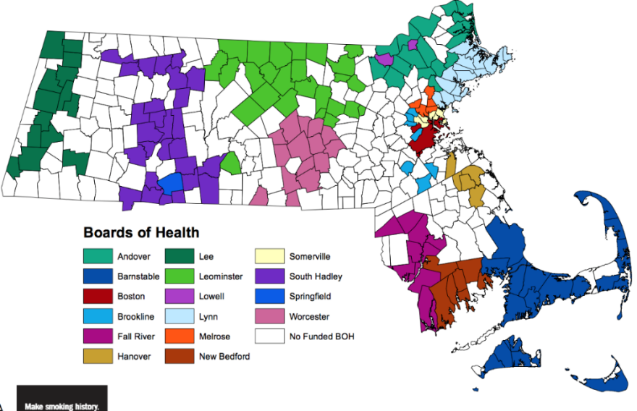

## Data Collection

Data collectors administered the pricing survey using Alchemer, an online data collection tool. Survey administrators entered retailer responses directly into Alchemer using Apple iPads and Android tablets connected to the internet. The FY2023 survey form included:

1. Tobacco product availability (overall; mint, menthol, wintergreen flavors; other flavors)
2. Cigarette availability and price (*Marlboro, Newport* and cheapest cigarette brand)
3. Cheapest single and multi-pack cigar or cigarillo availability and price (including mint/menthol flavors and flavored cigars/cigarillos)
4. Cheapest e-cigarette availability, flavor type, and price (including vape pod/pack and cheapest disposable vape device)
5. Cheapest smokeless tobacco product availability, flavor type, and price
6. Cheapest nicotine pouches availability, flavor type, and price
7. Advertising for mint, menthol, or wintergreen tobacco products

# Results

## Overall availability

All categories of tobacco products recorded in the pricing survey showed an increase in availability in FY2023 as compared to the previous year. The largest increase in availability between FY2022 and FY2023 was for nicotine pouches (available at 38% of retailers in FY2022, compared to 50% in FY2023), followed by vape products, from 45% to 50% (respectively). Cigarettes remain the most commonly available product at 98% of tobacco retailers.

**Figure 2. Annual Availability of Tobacco Products, FY2020-FY2023**

*Data for Nicotine Pouches and Flavor Enhancers was not collected in FY2020

## Availability in Mint, Menthol, Wintergreen and Other Flavors

As in FY2021 and FY2022, the availability of tobacco products in mint, menthol, and wintergreen flavors remained near 0% in FY2023. In contrast, tobacco products in other flavors were observed to be available in 4.9% of sampled retailers. Although this overall availability is low compared to non-flavored tobacco products, general availability of products in other flavors showed a slight increase between FY2021 and FY2023.

**Figure 3a. Annual Availability of Tobacco Products in Mint, Menthol, and Wintergreen flavors, FY2020-FY2023**

*Data for Nicotine Pouches and Flavor Enhancers was not collected in FY2020

**Figure 3b. Annual Availability of Tobacco Products in Other Flavors, FY2020-FY2023**

*Data for Nicotine Pouches and Flavor Enhancers was not collected in FY2020

## *Marlboro Red* Cigarette Availability and Pricing

In FY2023, the availability of *Marlboro Red* cigarettes remained unchanged from the previous year, at 97% of retailers. Concurrently, the average price of *Marlboro Red* cigarettes increased $0.74, from $11.32 in FY2022 to $12.06 in FY2023. This was the largest annual change in price for this product since 2014.

**Figure 4. Annual Availability and Price per Pack of *Marlboro Red* Cigarette Products, FY2012-FY2023**

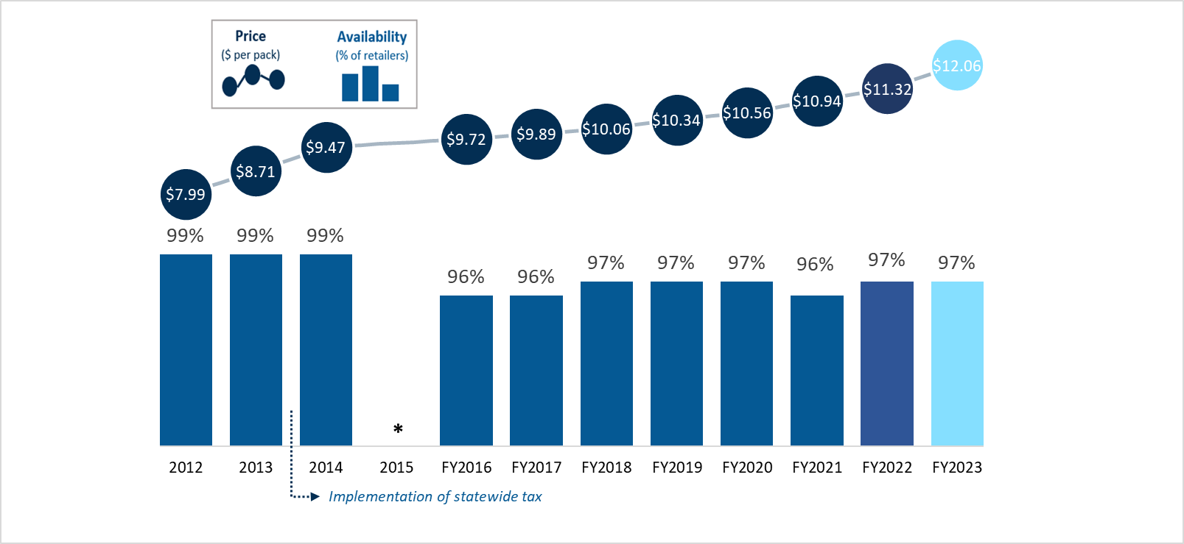

## *In 2015, data collection period was switched from calendar year to a fiscal year cycle

## *Marlboro Red* Cigarette Minimum Pricing

**Figure 5. *Marlboro Red* Cigarette Prices Compared to FY2023 State Mandated Minimum Price**

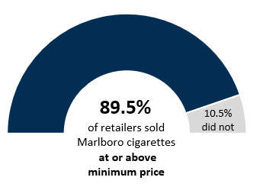The Department of Revenue (DOR)-mandated minimum price of *Marlboro Red* cigarettes between July 2022 and June 2023 ranged from $10.90 to $11.28 at chain stores, and $11.07 to $11.45 at independent retailers. The observed price of *Marlboro Red* cigarettes ranged from $9.25 to over $22. In FY2023, the majority of sampled retailers (89.5%) were observed to be selling *Marlboro Red* cigarettes at or above the state mandated minimum price, a slight increase from FY2022 (86.9%), indicating that most retailers are aware of and complying with pricing regulations.

## Cheapest Cigarette Availability and Pricing

The most commonly observed brand of the least expensive cigarettes was *Crowns*, available at 54% of retailers. Three other cheapest cigarettes observed included *Montego*, *Maverick* and *Lucky Strike*, though these were much less widely available (<10% of retailers). The average price for the cheapest observed brands of cigarettes increased from $8.29 in FY2022 to $8.36 in FY2023 (pre-tax).

**Figure 6. Availability of Least Expensive Cigarette Brands, FY2023**

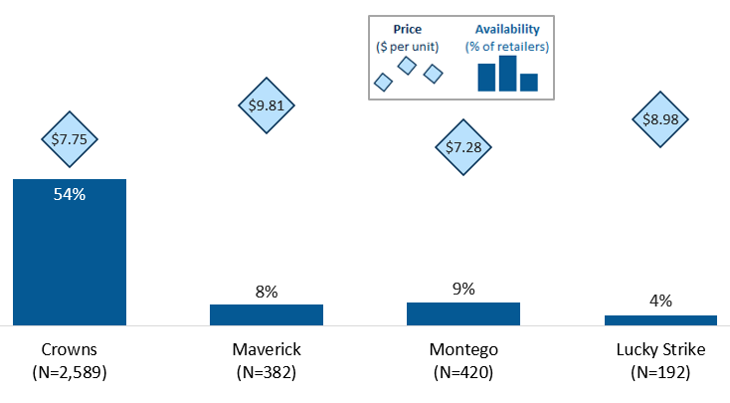

## Single and 5-Pack cigar Availability and Pricing

Comparing the overall availability of single and multi-pack cigars, multi-packs are more widely available among the sampled retailers, with almost three quarters (**73%**) of tobacco retailers carrying multi-pack cigars. Cigars in multi-packs usually contain 2, 4 or 5 cigars per pack, though 3, 10 and 20 pack cigars are less widely available.

In FY2023, availability and price of both single and 5-pack cigars increased slightly from FY2022. Figure 7 shows availability and price trends of single cigars between FY2016 and FY2023. The availability of **single cigars** increased from 65% in FY22 to **68%** in FY23. At the same time, the average price of single cigars increased by $0.14 (from 2.65 to **$2.79**).

**Figure 7: Overall Availability and Price per Cigar of Single Cigars (all flavors), FY2016-FY2023**

Availability and pricing of multi-pack cigars is shown in Figure 8. Multi-pack cigars are more widely available than single cigars in every year when data was collected, except for 2018. Availability of multi-packs showed small changes year-to-year moving slightly higher from 73% in FY2022 to **76%** in FY2023. The average price of a single cigar in multi-pack packaging was $1.10 in FY2023, slightly lower than the in previous year at $1.17. Compared to cigars sold in single packs, the unit cost of a cigar is less than half, when sold in multi-packs.

**Figure 8. Overall Availability and Unit Price of Multi-Pack Cigars (all flavors), FY2016-FY2023**

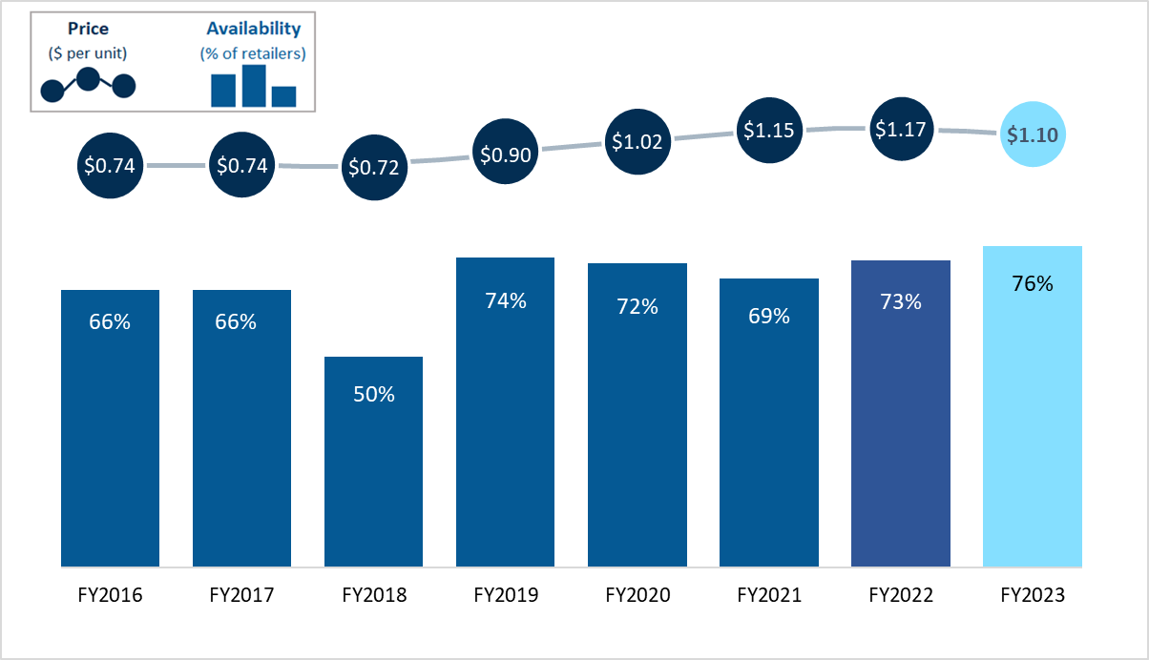

Availability and pricing of 5-pack cigars is shown in Figure 9. Although multipack cigars overall are widely available, cigars in specific packaging such as 5-packs, are found less frequently. Availability of **5-pack cigars** declined slightly from 15% in FY2022 to **14%** in FY2023, while the average price of these cigars increased from the previous year by $0.19 (from $5.82 to **$6.01**)**.**

**Figure 9. Overall Availability and Price per Pack of 5-Pack Cigars (all flavors), FY2016-FY2023**

The most commonly observed brand of single cigars was *Black and Mild* (available at 48% of sampled retailers), followed by *Backwoods* (24% of retailers). However, retailers sell a wide variety of single cigars of different sizes, type, flavor, and quality, each designed to appeal to a specific segment of tobacco users. The variation in price between these products is one of the indications of the different target segments.

**Figure 10. Brand Specific Availability and Price of Least Expensive Single Cigars, FY2023**

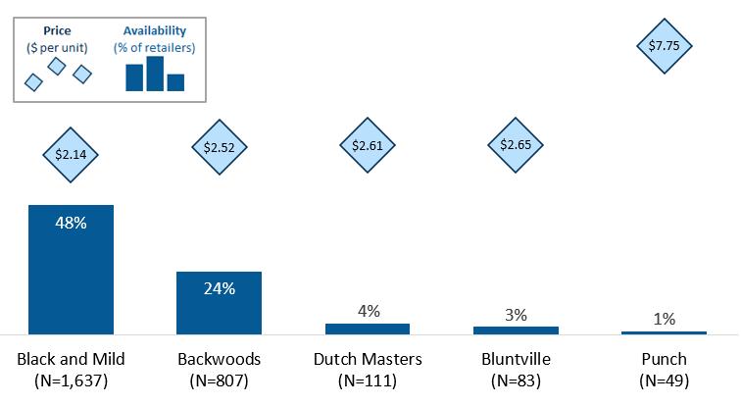

The most commonly observed brand of multi-pack cigars was Game, observed at 41% of all sampled retailers in FY2023. Several other brands were also observed, but their availability was much lower, ranging from 6% to 8% of retailers. The availability of *Game* cigars remained the same as compared to last year, while the availability of *Dutch Masters*, *Black and Mild,* and *Backwoods* decreased slightly. These four brands ranged in price from $1.24 to $1.56 (per cigar). The least expensive brand of multi-pack cigars (*Double Diamond*, at $0.26) increased in availability, from 4% of retailers in FY2022 to 8% in FY2023.

**Figure 11. Brand Specific Availability and Price of Least Expensive Multi-Pack Cigars, FY2023**

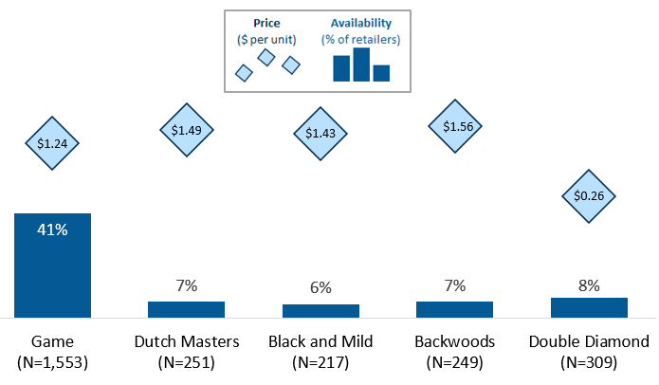

## Smokeless Tobacco Availability and Pricing

Tobacco use in smokeless forms is well documented and has a long history.[14] This section focuses on the availability, pricing, and brands of the cheapest chewing tobacco products observed in the pricing survey. Other types of smokeless products (i.e., snus, snuff, dissolvables) were not captured in FY2023.

In FY2023, the availability of chewing tobacco in retailers increased slightly from 42% in FY22 to 43%. while the price per unit increased $0.58 from FY2022.

**Figure 12. Overall Availability and Price per Unit of Smokeless Chewing Tobacco, FY2018-FY2023**

**\*Price data not collected in FY2021**

The most commonly observed brand of chewing tobacco was *Grizzly*, available in 51% of retailers at $12.54 per unit. The second most available brand was *Longhorn*, available at 22% of retailers, for $6.10 per unit. Other less widely available products included *Skoal*, *Copenhagen*, *Stokers*, and *Klondike*, available at between 1% and 5% of retailers, with a wide price range of $4.85 to $13.79.

**Figure 13. Brand Specific Availability of Least Expensive Chewing Tobacco, FY2023**

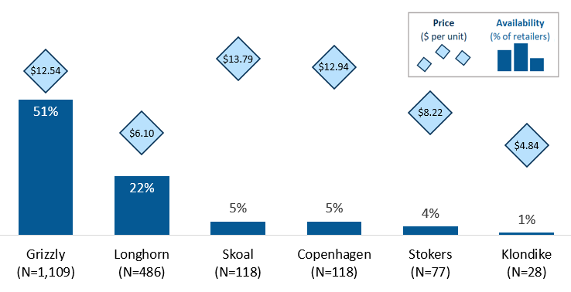

## Availability and Average Price of Nicotine Pouches

Nicotine pouches are a relatively new form of non-combustible nicotine products that are being rapidly developed and marketed, with little regulatory oversight.[15] These products are less expensive than chewing tobacco, contain nicotine, and the long-term health impact of their use is largely unknown. In Massachusetts, the availability of nicotine pouches among sampled retailers increased 22% in the last three years, from 29% availability in FY2021 to 38% and 50% in FY2022 and FY2023, respectively. The average price observed for nicotine pouches increased from $5.09 in FY2022 to $5.25 in FY23.

**Figure 14. Overall Availability of Least Expensive Nicotine Pouches, FY2021- FY2023**

*Note: Price data not collected in 2021

The most commonly observed brands of nicotine pouches in FY2023 were *Zyn* and *On*, available at 51% and 45% of retailers, respectively. All of the commonly observed brands showed a proportional increase in price from the previous year, with FY2023 prices ranging from $3.48 (*Longhorn*) to $6.04 (*Zyn*).

**Figure 15. Brand Specific Availability of Least Expensive Nicotine Pouches, FY2023**

## Vape Product Availability and Pricing

Vape devices, or e-cigarettes, use battery power to create vapor from a liquid that typically contains nicotine. These devices were first introduced in the US in 2007 and advertised by manufacturers as a tool to assist people in quitting cigarette smoking.[16] Despite that potential benefit, the use of vape devices is highly addictive. Some products, particularly JUUL e-cigarettes, have been found to attract new users, with high rates of young people increasingly initiating tobacco use through vape products over cigarettes.[17]

Figure 16 shows vape product availability from FY2016 to FY2023. In FY2020, Massachusetts banned the sale of vape products for 4 months starting on September 24th 2019. Thus, no data were collected for tobacco and unflavored vape products in that fiscal year. Prior to the ban, vape products were available in over half of all retailers (between 50% and 57% in FY2016-FY2019). In FY2021, the availability dropped noticeably to 42% of retailers, and has been steadily increasing in the last three years to 50% in FY2023, almost back to the level it was prior to the ban.

**Figure 16. Annual Availability Vape Products (Any), FY2016-FY2023**

*Statewide sales ban on vape products from September 24, 2019 to December 11, 2019

State regulations restrict the sale of vape products with concentrations greater than 35mg/ml products to specialty tobacco and vape shops (not surveyed for this report). As shown in Figure 17, overall availability of vape products in concentration greater than 35mg/ml decreased from 6% in FY22 to **3%** in FY23. In FY2023, availability of these high-concentration products at approved retailers was **39**%. Excluding these approved retailers, the availability drops to **2%,** indicating that almost all retailers are compliant with the state regulation of restricted sale of high-concentration products.

**Figure 17. Availability Vape Products in Concentrations >35mg/ml, FY2020-FY2023**

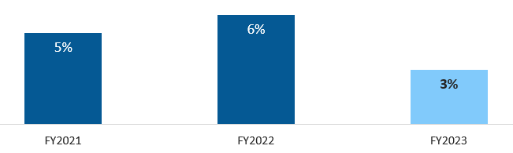

In FY2023, prices for vape pod devices varied, with the five least expensive product prices ranging from $13.10 (*Blu*) to $25.07 (*JUUL*) per unit. The most commonly available brand observed among the least expensive vape pod devices was *JUUL* (available at 39% of retailers), followed closely by *Vuse* (34% of retailers). *Blu* products were third most common, available at 11% of all observed retailers.

**Figure 18. Brand Specific Availability and Price of Least Expensive Pod Vape Devices, FY2023**

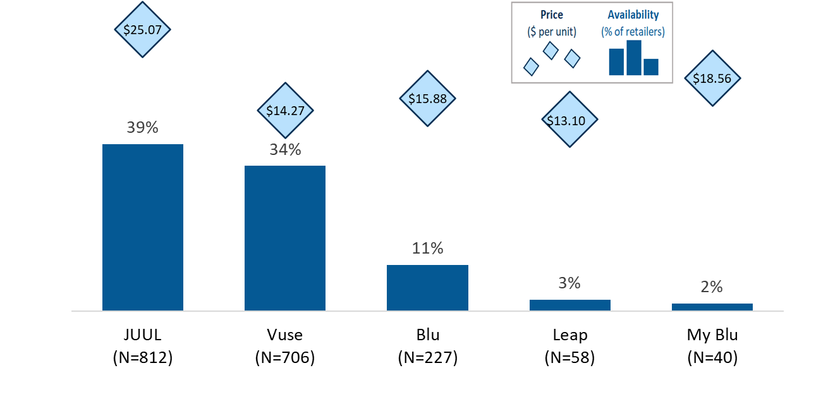

Vape pods/packs followed a similar trend, with *JUUL*, *Vuse*, and *Blu* being the three most commonly available product brands (available at 42%, 25%, and 17% of retailers in FY2023, respectively). Prices for the five least expensive vape pods/pack were slightly different to vape pod device prices, with *VUSE* brand ranking highest ($11.56 per unit) and the other brands all priced between $7.03 and $8.40 per unit.

**Figure 19. Brand Specific Availability of Least Expensive Vape Pod/Packs, FY2023**

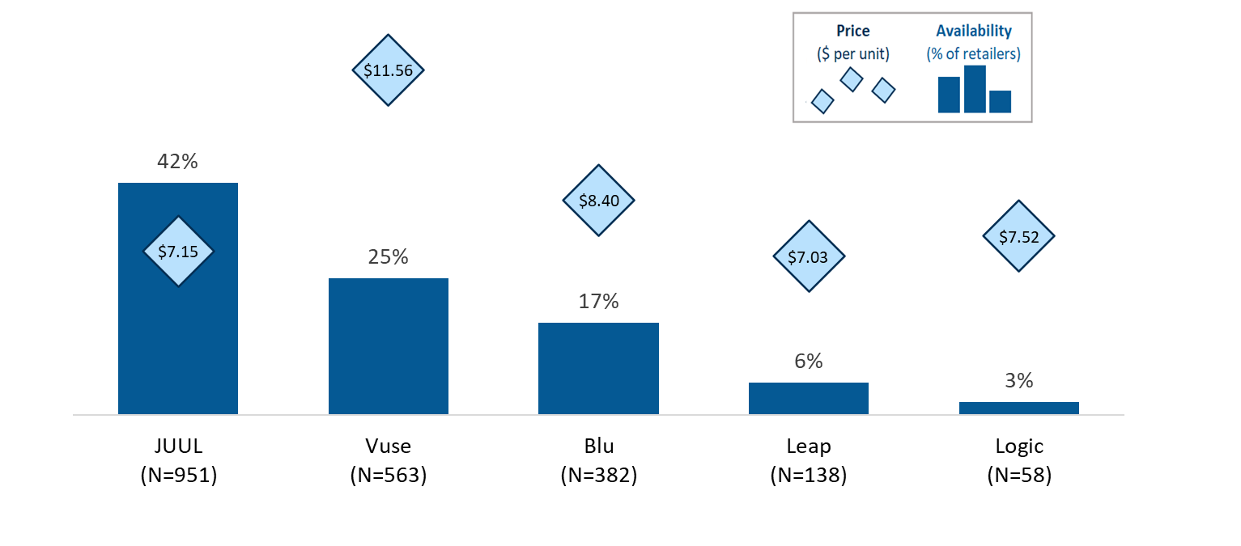

Disposable vape devices are also widely available throughout the state of Massachusetts. Among the five least expensive disposable vape devices observed in FY2023, *Vuse* products were the least expensive option ($14.78 per unit), but only available at about 1% of retailers. The most widely available disposable vape device products were *Blu* brand (available at 43% of retailers), followed by *Crave* (25%) and *Luto* (19%), with prices ranging from $17.39 (*Blu*) to $18.83 (*Crave*).

**Figure 20. Brand Specific Availability of Least Expensive Disposable Vape Devices, FY2023**

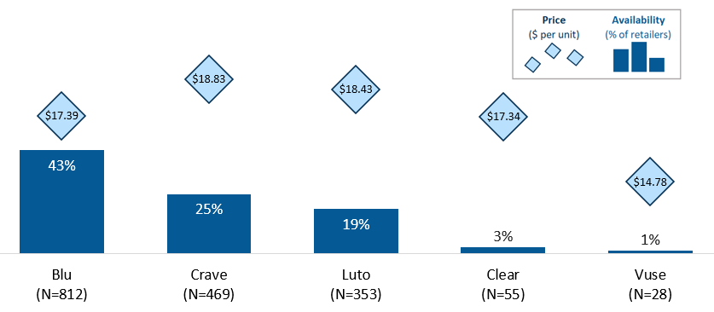

Looking across all vape product types (pod vape devices, vape pod packs, and disposable vape devices), pod vape devices are most commonly available and have not changed noticeably over time (65% availability in FY2022 vs. 66% in FY2023). Availability of vape pod packs and disposable vape devices have increased more noticeably in the last year, with availability of vape pod packs increasing 4% (41% to 45%) and disposable vape devices increasing 8% (30% to 38%) between FY2022 and FY2023. Similar to other tobacco products, all three types of vape devices increased in price between FY2022 and FY2023, with the largest price difference seen in disposable vape devices ($13.85 per unit in FY2022 to $17.78 in FY2023, an increase of $3.93 per unit).

**Figure 21. Overall Availability and Price per Unit of Vape Products, FY2023**

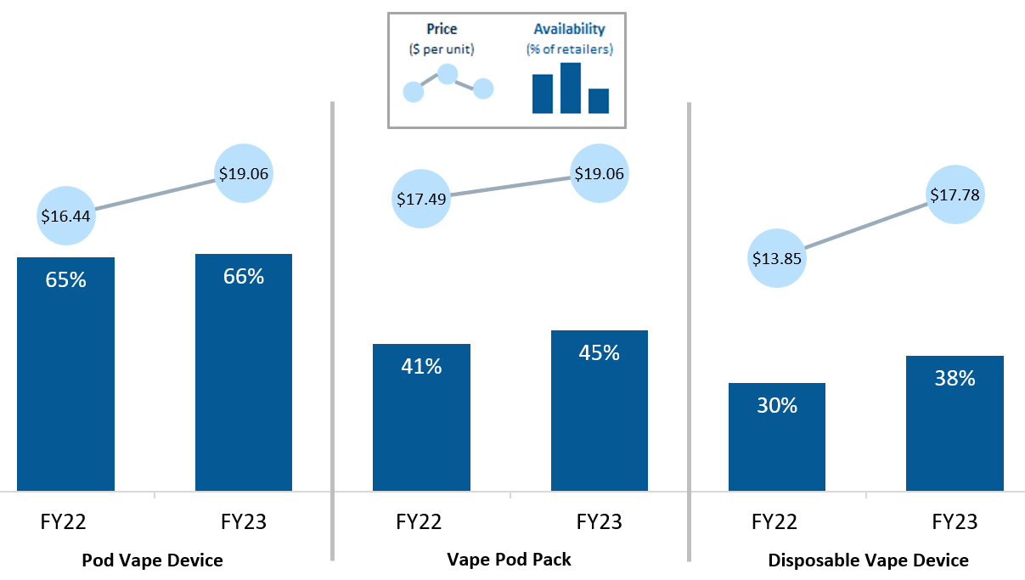

# Policy Impact

## Impact of cigar pricing/packaging restrictions

In addition to statewide policies, some cities and towns enact their own policies to impose further tobacco-related controls at the local level. These may include restrictions on the sale of single cigars by retailers or setting the minimum price by type and packing of specific tobacco products. Figure 21 shows a map of Massachusetts highlighting the regions of the state where local regulations were in effect as of June 30, 2022.

**Figure 22. Geographic Distribution of Communities with Cigar Pricing/Packaging Restrictions as of June 30, 2022.**

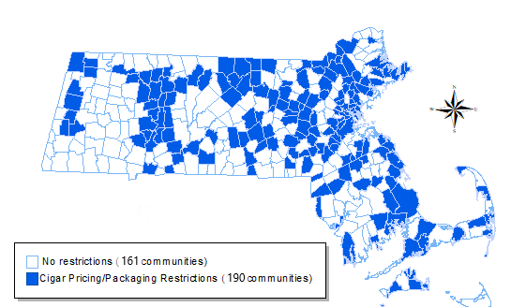

As in previous years, communities with packaging regulations were observed to have lower availability and higher sales prices of both single or 5-pack cigars. **Single cigars** were available at **79%** of retailers in cities and towns without regulations, and at **67%** of retailers in regulated cities and towns. This difference in availability was lower for **5-Pack cigars,** which were available at **15%** of retailers in areas without regulations, and at **14%** of retailers in areas with regulations. The difference in price for single cigars was observed to be **$1.85** in cities and towns without regulations and **$3.17** for cities and towns with regulations. For 5-pack cigars the difference was **$4.31** vs **$6.64**, more than $2 higher for communities with local restrictions.

**Figure 23. Overall Annual Availability and Pricing of Cigars, by Communities with and without Cigar Packaging Regulations, FY2021-FY2022**

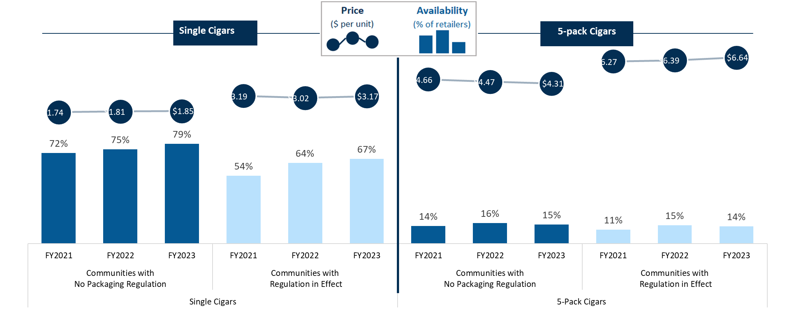

## Impact of the statewide flavored tobacco restriction

On June 1, 2020, Massachusetts imposed restrictions on the sale of flavored tobacco products. Under this law, the sale of flavored cigarettes, cigars, chewing tobacco, and vaping products is prohibited in the state.[18] The restriction was introduced as an addition to existing regulations aimed to reduce smoking rates in youth and young adults, who often initiate tobacco use with flavored products. Following the introduction of this restriction, all tobacco products monitored in the pricing survey experienced a sharp decrease in availability. As observed in FY2021 and FY2022, the availability of mint, menthol, and wintergreen flavors was near 0% in FY2023 for all types of tobacco products, indicating that virtually all of the sampled retailers were compliant with the statewide flavored tobacco restriction.

The availability of other flavors (excluding mint, menthol, and wintergreen) experienced a similar sharp decrease with the introduction of the restriction, however availability has not dropped to near 0%. In FY2023, cigars in other flavors were available in about 4% of sampled retailers (4.3% availability for multi-pack cigars; 3.8% for single cigars), and vape products and nicotine pouches were available at about 2% of sampled retailers. Compared to FY2022, slight increases were observed among all tobacco products except chewing tobacco, when looking at flavored products excluding mint, menthol, and wintergreen.

Figures 24 and 25 show availability trends of different tobacco products by mint, menthol, wintergreen and other flavors.

**Figure 24. Overall Annual Availability of Menthol Tobacco Products, FY2020-FY2023**

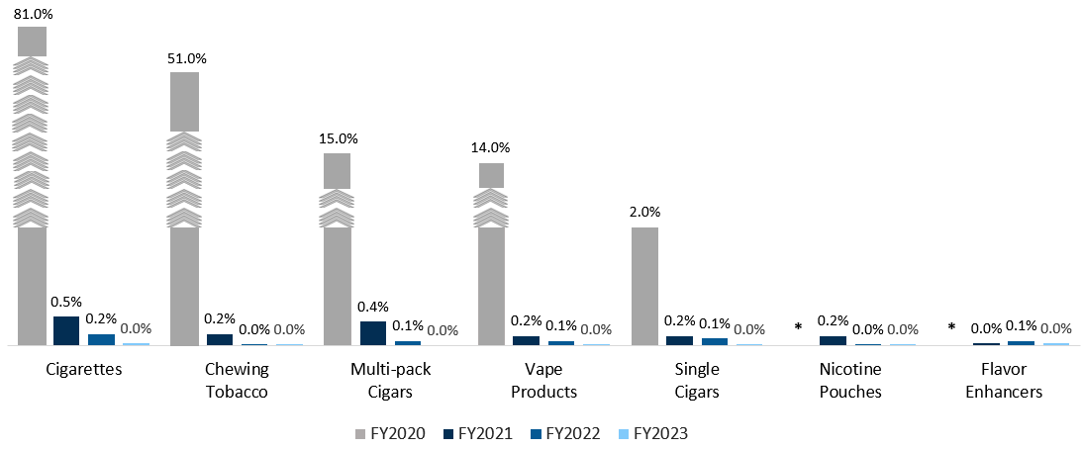

**Figure 25. Overall Annual Availability of Other Flavored Tobacco Products (excluding mint, menthol, and wintergreen), FY2020-FY2023**

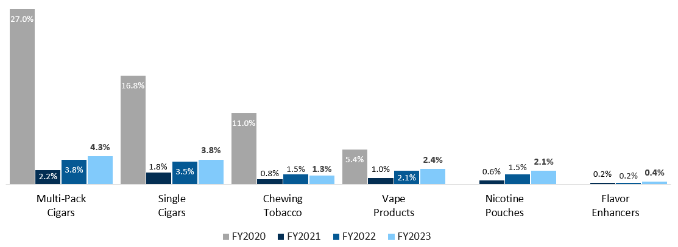

In Massachusetts, advertising for tobacco products is restricted in public places and in the proximity of schools and playgrounds. These regulations aim to reduce visibility and exposure to tobacco products generally and provide specific protections for younger age groups. Restrictions include advertising of flavored tobacco products and advertising to young age groups at retail store locations.

Survey administrators collected information of advertising for mint, menthol, and wintergreen products within the retail location at the time of administering the survey. In FY2022, advertising for mint, menthol, and wintergreen products located anywhere in the store was observed at 59 retailers in 31 cities and towns (about 1.2% of sampled retailers). In FY2023, advertising for these products was slightly lower, observed at about 20 retailers in 18 cities and towns (about 0.4% of sampled retailers; data not shown).

# Takeaways

Based on data from the FY2023 pricing survey all categories of tobacco products recorded showed an increase in availability in FY2023 in MA as compared to the previous year. The largest increase in availability was for nicotine pouches (available at 39% of retailers in FY2022, compared to 51% in FY2023), followed by vape products, from 46% to 51% (respectively). Prices of most tobacco products have increased from previous years.

Data continue to show the effectiveness of flavored policies. As observed in FY2021 and FY2022, the availability of mint, menthol, and wintergreen flavors was near 0% in FY2023 for all types of tobacco products, indicating that virtually all the sampled retailers were compliant with the statewide flavored tobacco restriction. The availability of other flavors (excluding mint, menthol, and wintergreen) experienced a similar sharp decrease with the introduction of the restriction; however availability has not stayed near 0%. In FY2023, cigars in other flavors were available in about 4% of sampled retailers.

As in previous years, communities with cigar packaging regulations were observed to have lower availability and higher sales prices. Single cigars were available at 79% of retailers in cities and towns without regulations, and at 67% of retailers in regulated cities and towns. The difference in price for single cigars was observed to be $1.85 in cities and towns without regulations and $3.17 for cities and towns with regulations. A similar trend was seen for 5-pack cigars.

For free cessation counseling and nicotine replacement therapy (NRT) call 1-800-QUIT-NOW, the Massachusetts Quitline for tobacco and nicotine or enroll online at https://ma.quitlogix.org/en-US/.

To anonymously report a flavored tobacco violation in a retailer call (800) 992-1895.

# Appendix A. FY2023 Pricing Survey Availability data by Town

|  | Retailers Observed | Cigarettes Availability | Retailers  Sell  Cigarettes | Single  Cigar  Availability | Retailers  Sell Single Cigars | Multi-Pack  Cigar  Availability | Retailers  Sell Multi-Pack Cigars | Vape  Product  Availability | Retailers  Sell Vape Products | Chewing Tobacco Availability | Retailers  Sell Chewing Tobacco | Nicotine Pouch Availability | Retailers  Sell Nicotine Pouches |
| --- | --- | --- | --- | --- | --- | --- | --- | --- | --- | --- | --- | --- | --- |
| OVERALL | 5041 | 98% | 4917 | 68% | 3407 | 76% | 3848 | 50% | 2528 | 43% | 2184 | 50% | 2525 |
| ABINGTON | 22 | 100% | 22 | 73% | 16 | 82% | 18 | 73% | 16 | 64% | 14 | 68% | 15 |
| ACTON | 5 | 100% | 5 | 80% | 4 | 100% | 5 | 80% | 4 | 40% | 2 | 60% | 3 |
| ACUSHNET | 7 | 100% | 7 | 57% | 4 | 100% | 7 | 43% | 3 | 43% | 3 | 57% | 4 |
| ADAMS | 9 | 100% | 9 | 67% | 6 | 78% | 7 | 67% | 6 | 78% | 7 | 56% | 5 |
| AGAWAM | 16 | 100% | 16 | 31% | 5 | 63% | 10 | 50% | 8 | 50% | 8 | 50% | 8 |
| AMESBURY | 13 | 100% | 13 | 85% | 11 | 77% | 10 | 38% | 5 | 46% | 6 | 62% | 8 |
| AMHERST | 11 | 100% | 11 | 64% | 7 | 82% | 9 | 45% | 5 | 55% | 6 | 64% | 7 |
| ANDOVER | 11 | 100% | 11 | 55% | 6 | 64% | 7 | 45% | 5 | 36% | 4 | 45% | 5 |
| ARLINGTON | 18 | 100% | 18 | 67% | 12 | 78% | 14 | 72% | 13 | 61% | 11 | 72% | 13 |
| ASHBURNHAM | 5 | 100% | 5 | 20% | 1 | 80% | 4 | 40% | 2 | 40% | 2 | 40% | 2 |
| ASHBY | 5 | 100% | 5 | 40% | 2 | 60% | 3 | 20% | 1 | . | . | . | . |
| ASHFIELD | 1 | 100% | 1 | 100% | 1 | 100% | 1 | . | . | 100% | 1 | . | . |
| ATHOL | 14 | 100% | 14 | 64% | 9 | 86% | 12 | 57% | 8 | 50% | 7 | 57% | 8 |
| ATTLEBORO | 46 | 96% | 44 | 37% | 17 | 74% | 34 | 54% | 25 | 35% | 16 | 54% | 25 |
| AUBURN | 21 | 100% | 21 | 81% | 17 | 86% | 18 | 71% | 15 | 71% | 15 | 62% | 13 |
| AVON | 4 | 100% | 4 | 50% | 2 | 75% | 3 | 50% | 2 | 50% | 2 | 50% | 2 |
| AYER | 11 | 100% | 11 | 73% | 8 | 64% | 7 | 36% | 4 | 45% | 5 | 45% | 5 |
| BARNSTABLE | 39 | 100% | 39 | 92% | 36 | 82% | 32 | 74% | 29 | 62% | 24 | 69% | 27 |
| BARRE | 6 | 100% | 6 | 83% | 5 | 83% | 5 | 50% | 3 | 50% | 3 | 67% | 4 |
| BELLINGHAM | 25 | 96% | 24 | 68% | 17 | 76% | 19 | 52% | 13 | 48% | 12 | 60% | 15 |
| BELMONT | 14 | 93% | 13 | 57% | 8 | 64% | 9 | 57% | 8 | 57% | 8 | 57% | 8 |
| BERKLEY | 4 | 100% | 4 | 100% | 4 | 75% | 3 | 50% | 2 | 75% | 3 | 50% | 2 |
| BERLIN | 7 | 100% | 7 | 57% | 4 | 57% | 4 | 57% | 4 | 57% | 4 | 57% | 4 |
| BERNARDSTON | 1 | 100% | 1 | . | . | . | . | . | . | . | . | . | . |
| BEVERLY | 8 | 100% | 8 | 63% | 5 | 75% | 6 | 63% | 5 | 63% | 5 | 63% | 5 |
| BILLERICA | 33 | 100% | 33 | 36% | 12 | 61% | 20 | 30% | 10 | 39% | 13 | 48% | 16 |
| BLACKSTONE | 10 | 100% | 10 | 100% | 10 | 100% | 10 | . | . | 30% | 3 | 40% | 4 |
| BOLTON | 2 | 100% | 2 | 50% | 1 | 50% | 1 | . | . | 50% | 1 | 50% | 1 |
| BOSTON | 588 | 99% | 580 | 77% | 451 | 83% | 487 | 49% | 287 | 32% | 186 | 44% | 256 |
| BOURNE | 23 | 100% | 23 | 70% | 16 | 83% | 19 | 74% | 17 | 70% | 16 | 70% | 16 |
| BRAINTREE | 28 | 96% | 27 | 64% | 18 | 75% | 21 | 64% | 18 | 57% | 16 | 64% | 18 |
| BREWSTER | 4 | 100% | 4 | 75% | 3 | 50% | 2 | 50% | 2 | 50% | 2 | 50% | 2 |
| BRIDGEWATER | 17 | 100% | 17 | 65% | 11 | 82% | 14 | 59% | 10 | 65% | 11 | 65% | 11 |
| BROCKTON | 99 | 99% | 98 | 78% | 77 | 88% | 87 | 46% | 46 | 32% | 32 | 40% | 40 |
| BROOKFIELD | 1 | 100% | 1 | 100% | 1 | 100% | 1 | 100% | 1 | 100% | 1 | 100% | 1 |
| BROOKLINE | 17 | 100% | 17 | 65% | 11 | 71% | 12 | 59% | 10 | 41% | 7 | 59% | 10 |
| BUCKLAND | 1 | 100% | 1 | 100% | 1 | 100% | 1 | 100% | 1 | 100% | 1 | 100% | 1 |
| BURLINGTON | 16 | 100% | 16 | 56% | 9 | 6% | 1 | 19% | 3 | 31% | 5 | . | . |
| CAMBRIDGE | 68 | 100% | 68 | 54% | 37 | 69% | 47 | 59% | 40 | 35% | 24 | 49% | 33 |
| CANTON | 18 | 89% | 16 | 94% | 17 | 83% | 15 | 6% | 1 | 61% | 11 | 72% | 13 |
| CARVER | 16 | 94% | 15 | 31% | 5 | 56% | 9 | 44% | 7 | 50% | 8 | 44% | 7 |
| CHARLEMONT | 2 | 100% | 2 | 100% | 2 | 100% | 2 | 50% | 1 | 50% | 1 | 50% | 1 |
| CHATHAM | 8 | 100% | 8 | 75% | 6 | 63% | 5 | 50% | 4 | 75% | 6 | 75% | 6 |
| CHELMSFORD | 21 | 100% | 21 | 48% | 10 | 52% | 11 | 38% | 8 | 52% | 11 | 52% | 11 |
| CHELSEA | 42 | 100% | 42 | 69% | 29 | 90% | 38 | 55% | 23 | 26% | 11 | 45% | 19 |
| CHESHIRE | 4 | 100% | 4 | 75% | 3 | 75% | 3 | 75% | 3 | 75% | 3 | 75% | 3 |
| CHICOPEE | 5 | 100% | 3 | 100% | 3 | 100% | 3 | . | . | . | . | 33% | 1 |
| CHILMARK | 2 | 100% | 2 | . | . | . | . | . | . | . | . | . | . |
| CLINTON | 16 | 100% | 16 | 50% | 8 | 75% | 12 | 44% | 7 | 38% | 6 | 50% | 8 |
| COHASSET | 6 | 100% | 6 | 67% | 4 | 67% | 4 | 50% | 3 | 50% | 3 | 50% | 3 |
| COLRAIN | 1 | 100% | 1 | 100% | 1 | 100% | 1 | . | . | 100% | 1 | . | . |
| CONCORD | 1 | 100% | 1 | 100% | 1 | 100% | 1 | 100% | 1 | 100% | 1 | 100% | 1 |
| CONWAY | 1 | 100% | 1 | 100% | 1 | . | . | . | . | . | . | . | . |
| DALTON | 5 | 100% | 5 | 100% | 5 | 100% | 5 | 60% | 3 | 60% | 3 | 60% | 3 |
| DANVERS | 25 | 88% | 22 | 68% | 17 | 60% | 15 | 52% | 13 | 48% | 12 | 64% | 16 |
| DARTMOUTH | 1 | . | . | 100% | 1 | . | . | . | . | . | . | . | . |
| DEDHAM | 19 | 100% | 19 | 58% | 11 | 74% | 14 | 5% | 1 | 47% | 9 | 53% | 10 |
| DEERFIELD | 6 | 100% | 6 | 67% | 4 | 67% | 4 | 67% | 4 | 67% | 4 | 83% | 5 |
| DENNIS | 17 | 94% | 16 | 82% | 14 | 59% | 10 | 47% | 8 | 41% | 7 | 53% | 9 |
| DIGHTON | 7 | 100% | 7 | 86% | 6 | 100% | 7 | 86% | 6 | 57% | 4 | 100% | 7 |
| DOVER | 2 | 100% | 2 | 100% | 2 | 100% | 2 | 50% | 1 | 50% | 1 | 50% | 1 |
| DRACUT | 24 | 96% | 23 | 67% | 16 | 92% | 22 | 58% | 14 | 25% | 6 | 67% | 16 |
| DUDLEY | 10 | 100% | 10 | 60% | 6 | 60% | 6 | 40% | 4 | 20% | 2 | 20% | 2 |
| DUNSTABLE | 1 | 100% | 1 | 100% | 1 | 100% | 1 | . | . | 100% | 1 | 100% | 1 |
| DUXBURY | 7 | 100% | 7 | 86% | 6 | 86% | 6 | 43% | 3 | 57% | 4 | 71% | 5 |
| EAST BRIDGEWATER | 13 | 100% | 13 | 77% | 10 | 92% | 12 | 54% | 7 | 69% | 9 | 69% | 9 |
| EAST LONGMEADOW | 14 | 86% | 12 | 71% | 10 | 71% | 10 | 43% | 6 | 50% | 7 | 50% | 7 |
| EASTHAM | 5 | 100% | 5 | 100% | 5 | 80% | 4 | 80% | 4 | 60% | 3 | 60% | 3 |
| EASTHAMPTON | 13 | 100% | 13 | 38% | 5 | 77% | 10 | 54% | 7 | 69% | 9 | 62% | 8 |
| EASTON | 18 | 100% | 18 | 44% | 8 | 61% | 11 | 61% | 11 | 56% | 10 | 56% | 10 |
| EDGARTOWN | 9 | 89% | 8 | 44% | 4 | 56% | 5 | 33% | 3 | 56% | 5 | 56% | 5 |
| EGREMONT | 2 | 100% | 2 | . | . | . | . | . | . | . | . | . | . |
| ERVING | 1 | 100% | 1 | 100% | 1 | 100% | 1 | . | . | 100% | 1 | . | . |
| ESSEX | 3 | 100% | 3 | 33% | 1 | 100% | 3 | 100% | 3 | 100% | 3 | 100% | 3 |
| EVERETT | 55 | 96% | 53 | 67% | 37 | 78% | 43 | 53% | 29 | 31% | 17 | 44% | 24 |
| FAIRHAVEN | 16 | 100% | 16 | 38% | 6 | 75% | 12 | 69% | 11 | 50% | 8 | 63% | 10 |
| FALL RIVER | 118 | 97% | 114 | 78% | 92 | 81% | 95 | 59% | 70 | 25% | 29 | 36% | 43 |
| FALMOUTH | 31 | 100% | 31 | 68% | 21 | 87% | 27 | 74% | 23 | 68% | 21 | 81% | 25 |
| FITCHBURG | 43 | 100% | 43 | 65% | 28 | 81% | 35 | 49% | 21 | 40% | 17 | 58% | 25 |
| FOXBOROUGH | 12 | 100% | 12 | 83% | 10 | 75% | 9 | 58% | 7 | 58% | 7 | 58% | 7 |
| FRAMINGHAM | 5 | 100% | 5 | 80% | 4 | 100% | 5 | 100% | 5 | 60% | 3 | 40% | 2 |
| FRANKLIN | 21 | 100% | 21 | 62% | 13 | 81% | 17 | 71% | 15 | 62% | 13 | 76% | 16 |
| FREETOWN | 8 | 100% | 8 | 88% | 7 | 100% | 8 | 75% | 6 | 63% | 5 | 88% | 7 |
| GARDNER | 18 | 100% | 18 | 94% | 17 | 100% | 18 | 78% | 14 | 83% | 15 | 78% | 14 |
| GEORGETOWN | 5 | 100% | 5 | 100% | 5 | 20% | 1 | . | . | 40% | 2 | . | . |
| GILL | 2 | 100% | 2 | . | . | 50% | 1 | . | . | 50% | 1 | 50% | 1 |
| GLOUCESTER | 28 | 100% | 28 | 46% | 13 | 75% | 21 | 54% | 15 | 50% | 14 | 54% | 15 |
| GRANBY | 4 | 100% | 4 | 75% | 3 | 100% | 4 | 75% | 3 | 75% | 3 | 50% | 2 |
| GREAT BARRINGTON | 10 | 100% | 10 | 90% | 9 | 90% | 9 | 60% | 6 | 60% | 6 | 60% | 6 |
| GREENFIELD | 21 | 100% | 21 | 48% | 10 | 71% | 15 | 62% | 13 | 52% | 11 | 52% | 11 |
| GROTON | 7 | 100% | 7 | 57% | 4 | 86% | 6 | 57% | 4 | 71% | 5 | 71% | 5 |
| GROVELAND | 3 | 100% | 3 | 100% | 3 | 33% | 1 | . | . | . | . | . | . |
| HADLEY | 7 | 100% | 7 | 86% | 6 | 86% | 6 | 29% | 2 | 57% | 4 | 71% | 5 |
| HALIFAX | 6 | 100% | 6 | 100% | 6 | 100% | 6 | 83% | 5 | 83% | 5 | 100% | 6 |
| HAMILTON | 5 | 100% | 5 | 60% | 3 | 80% | 4 | 60% | 3 | 60% | 3 | 80% | 4 |
| HANOVER | 20 | 100% | 20 | 70% | 14 | 75% | 15 | 55% | 11 | 55% | 11 | 60% | 12 |
| HANSON | 6 | 100% | 6 | 83% | 5 | 100% | 6 | 83% | 5 | 50% | 3 | 100% | 6 |
| HARVARD | 1 | . | . | . | . | . | . | . | . | . | . | . | . |
| HARWICH | 11 | 100% | 11 | 27% | 3 | 64% | 7 | 64% | 7 | 64% | 7 | 55% | 6 |
| HATFIELD | 2 | 100% | 2 | 50% | 1 | 100% | 2 | . | . | 100% | 2 | 100% | 2 |
| HAVERHILL | 52 | 98% | 51 | 63% | 33 | 87% | 45 | 44% | 23 | 42% | 22 | 50% | 26 |
| HINGHAM | 14 | 100% | 14 | 57% | 8 | 71% | 10 | 50% | 7 | 50% | 7 | 64% | 9 |
| HINSDALE | 1 | 100% | 1 | 100% | 1 | 100% | 1 | 100% | 1 | 100% | 1 | 100% | 1 |
| HOLBROOK | 14 | 100% | 14 | 43% | 6 | 57% | 8 | 57% | 8 | 36% | 5 | 29% | 4 |
| HOLDEN | 1 | 100% | 1 | 100% | 1 | 100% | 1 | 100% | 1 | 100% | 1 | 100% | 1 |
| HOLLISTON | 10 | 90% | 9 | 40% | 4 | 70% | 7 | 20% | 2 | 30% | 3 | 40% | 4 |
| HOLYOKE | 8 | 88% | 7 | 75% | 6 | 100% | 8 | 63% | 5 | 75% | 6 | 50% | 4 |
| HOPEDALE | 3 | 67% | 2 | 100% | 3 | 100% | 3 | 100% | 3 | 67% | 2 | 67% | 2 |
| HOPKINTON | 7 | 100% | 7 | 29% | 2 | 57% | 4 | 43% | 3 | 43% | 3 | 43% | 3 |
| HUBBARDSTON | 2 | 100% | 2 | 50% | 1 | 100% | 2 | 50% | 1 | 100% | 2 | 50% | 1 |
| HUDSON | 16 | 100% | 16 | 56% | 9 | 6% | 1 | 6% | 1 | 19% | 3 | 6% | 1 |
| HULL | 9 | 100% | 9 | 89% | 8 | 89% | 8 | 22% | 2 | 56% | 5 | 78% | 7 |
| IPSWICH | 8 | 100% | 8 | 38% | 3 | 50% | 4 | 50% | 4 | 50% | 4 | 38% | 3 |
| KINGSTON | 16 | 100% | 16 | 81% | 13 | 94% | 15 | 69% | 11 | 75% | 12 | 81% | 13 |
| LAKEVILLE | 6 | 100% | 6 | 100% | 6 | 100% | 6 | 67% | 4 | 67% | 4 | 83% | 5 |
| LANCASTER | 4 | 100% | 4 | 75% | 3 | 100% | 4 | 100% | 4 | 100% | 4 | 75% | 3 |
| LANESBOROUGH | 5 | 80% | 4 | 60% | 3 | 60% | 3 | 80% | 4 | 60% | 3 | 40% | 2 |
| LAWRENCE | 96 | 94% | 90 | 81% | 78 | 90% | 86 | 15% | 14 | 15% | 14 | 14% | 13 |
| LEE | 11 | 100% | 11 | 82% | 9 | 82% | 9 | 64% | 7 | 73% | 8 | 82% | 9 |
| LENOX | 5 | 80% | 4 | 80% | 4 | 40% | 2 | 40% | 2 | 60% | 3 | 40% | 2 |
| LEOMINSTER | 35 | 97% | 34 | 63% | 22 | 89% | 31 | 54% | 19 | 49% | 17 | 63% | 22 |
| LEXINGTON | 12 | 100% | 12 | 75% | 9 | 17% | 2 | 33% | 4 | 33% | 4 | 8% | 1 |
| LINCOLN | 1 | 100% | 1 | . | . | . | . | . | . | . | . | . | . |
| LITTLETON | 10 | 100% | 10 | 50% | 5 | 60% | 6 | 40% | 4 | 60% | 6 | 50% | 5 |
| LONGMEADOW | 7 | 86% | 6 | 43% | 3 | 43% | 3 | . | . | 29% | 2 | 43% | 3 |
| LOWELL | 105 | 98% | 103 | 53% | 56 | 70% | 73 | 33% | 35 | 29% | 30 | 35% | 37 |
| LUDLOW | 15 | 100% | 15 | 60% | 9 | 93% | 14 | 47% | 7 | 80% | 12 | 73% | 11 |
| LUNENBURG | 10 | 100% | 9 | 78% | 7 | 100% | 9 | 56% | 5 | 56% | 5 | 89% | 8 |
| LYNN | 117 | 98% | 115 | 76% | 89 | 91% | 106 | 48% | 56 | 26% | 30 | 42% | 49 |
| LYNNFIELD | 5 | 100% | 5 | 80% | 4 | 100% | 5 | 100% | 5 | 60% | 3 | 80% | 4 |
| MALDEN | 47 | 98% | 46 | 66% | 31 | 79% | 37 | 11% | 5 | 19% | 9 | 32% | 15 |
| MANCHESTER | 2 | 100% | 2 | 50% | 1 | 50% | 1 | 50% | 1 | 50% | 1 | 50% | 1 |
| MANSFIELD | 21 | 100% | 21 | 81% | 17 | 86% | 18 | 71% | 15 | 67% | 14 | 67% | 14 |
| MARBLEHEAD | 6 | 100% | 6 | 50% | 3 | 50% | 3 | 50% | 3 | 50% | 3 | 50% | 3 |
| MARION | 5 | 100% | 5 | 20% | 1 | 20% | 1 | 20% | 1 | 20% | 1 | 20% | 1 |
| MARLBOROUGH | 25 | 100% | 25 | 64% | 16 | 4% | 1 | 28% | 7 | 24% | 6 | . | . |
| MARSHFIELD | 15 | 100% | 15 | 93% | 14 | 87% | 13 | 73% | 11 | 73% | 11 | 80% | 12 |
| MASHPEE | 12 | 92% | 11 | 50% | 6 | 75% | 9 | 83% | 10 | 75% | 9 | 75% | 9 |
| MATTAPOISETT | 6 | 100% | 6 | 83% | 5 | 83% | 5 | 50% | 3 | 83% | 5 | 67% | 4 |
| MAYNARD | 8 | 100% | 8 | 63% | 5 | 75% | 6 | 50% | 4 | 50% | 4 | 50% | 4 |
| MEDFIELD | 6 | 100% | 6 | 33% | 2 | 50% | 3 | 50% | 3 | 50% | 3 | 50% | 3 |
| MEDFORD | 45 | 96% | 43 | 60% | 27 | 69% | 31 | 53% | 24 | 38% | 17 | 56% | 25 |
| MEDWAY | 10 | 100% | 10 | 70% | 7 | 80% | 8 | 60% | 6 | 40% | 4 | 60% | 6 |
| MELROSE | 10 | 100% | 10 | 90% | 9 | 90% | 9 | 70% | 7 | 80% | 8 | 90% | 9 |
| MENDON | 6 | 100% | 6 | 67% | 4 | 100% | 6 | 33% | 2 | 83% | 5 | 83% | 5 |
| MERRIMAC | 3 | 100% | 3 | 67% | 2 | . | . | . | . | 33% | 1 | . | . |
| METHUEN | 37 | 97% | 36 | 49% | 18 | 59% | 22 | 38% | 14 | 35% | 13 | 30% | 11 |
| MIDDLEBOROUGH | 23 | 96% | 22 | 65% | 15 | 74% | 17 | 74% | 17 | 61% | 14 | 70% | 16 |
| MIDDLETON | 12 | 83% | 10 | 50% | 6 | 83% | 10 | 67% | 8 | 42% | 5 | 75% | 9 |
| MILFORD | 29 | 97% | 28 | 24% | 7 | 76% | 22 | 55% | 16 | 45% | 13 | 55% | 16 |
| MILLBURY | 1 | 100% | 1 | 100% | 1 | 100% | 1 | . | . | . | . | . | . |
| MILLIS | 8 | 100% | 8 | 25% | 2 | 75% | 6 | 75% | 6 | 38% | 3 | 75% | 6 |
| MILTON | 9 | 100% | 9 | 78% | 7 | 78% | 7 | 44% | 4 | 78% | 7 | 78% | 7 |
| MONSON | 4 | 100% | 4 | 50% | 2 | 100% | 4 | 75% | 3 | 75% | 3 | 75% | 3 |
| NAHANT | 2 | 100% | 2 | 100% | 2 | 100% | 2 | 100% | 2 | 100% | 2 | 50% | 1 |
| NANTUCKET | 17 | 100% | 17 | 35% | 6 | 47% | 8 | 35% | 6 | 35% | 6 | 41% | 7 |
| NATICK | 14 | 100% | 14 | 79% | 11 | 7% | 1 | . | . | 36% | 5 | . | . |
| NEEDHAM | 1 | 100% | 1 | 100% | 1 | 100% | 1 | . | . | 100% | 1 | 100% | 1 |
| NEW BEDFORD | 124 | 98% | 121 | 85% | 105 | 87% | 108 | 64% | 79 | 22% | 27 | 39% | 48 |
| NEW SALEM | 1 | 100% | 1 | 100% | 1 | 100% | 1 | . | . | . | . | . | . |
| NEWBURY | 5 | 100% | 5 | 80% | 4 | 40% | 2 | 20% | 1 | 40% | 2 | 20% | 1 |
| NEWBURYPORT | 12 | 100% | 12 | 33% | 4 | 67% | 8 | 58% | 7 | 50% | 6 | 58% | 7 |
| NEWTON | 12 | 100% | 12 | 42% | 5 | 8% | 1 | 25% | 3 | 33% | 4 | 17% | 2 |
| NORFOLK | 5 | 100% | 5 | 80% | 4 | 80% | 4 | 40% | 2 | 60% | 3 | 60% | 3 |
| NORTH ADAMS | 10 | 100% | 10 | 80% | 8 | 90% | 9 | 60% | 6 | 60% | 6 | 50% | 5 |
| NORTH ANDOVER | 12 | 100% | 12 | 33% | 4 | 58% | 7 | 17% | 2 | 50% | 6 | 42% | 5 |
| NORTH ATTLEBORO | 15 | 100% | 15 | 60% | 9 | 67% | 10 | 53% | 8 | 60% | 9 | 60% | 9 |
| NORTH READING | 13 | 92% | 12 | 77% | 10 | 62% | 8 | 46% | 6 | 46% | 6 | 46% | 6 |
| NORTHAMPTON | 22 | 86% | 19 | 68% | 15 | 82% | 18 | 73% | 16 | 73% | 16 | 59% | 13 |
| NORTHBOROUGH | 1 | 100% | 1 | 100% | 1 | 100% | 1 | 100% | 1 | 100% | 1 | 100% | 1 |
| NORTHBRIDGE | 11 | 100% | 10 | 70% | 7 | 80% | 8 | 80% | 8 | 70% | 7 | 70% | 7 |
| NORTHFIELD | 2 | 100% | 2 | 50% | 1 | 50% | 1 | . | . | . | . | . | . |
| NORTON | 13 | 77% | 10 | 38% | 5 | 69% | 9 | 54% | 7 | 46% | 6 | 54% | 7 |
| NORWELL | 7 | 100% | 7 | 86% | 6 | 86% | 6 | 86% | 6 | 71% | 5 | 71% | 5 |
| NORWOOD | 31 | 100% | 31 | 58% | 18 | 77% | 24 | 10% | 3 | 52% | 16 | 61% | 19 |
| OAK BLUFFS | 6 | 100% | 6 | 33% | 2 | 67% | 4 | . | . | 50% | 3 | 50% | 3 |
| ORANGE | 8 | 88% | 7 | 100% | 8 | 100% | 8 | 75% | 6 | 88% | 7 | 100% | 8 |
| ORLEANS | 5 | 100% | 5 | 40% | 2 | 60% | 3 | 60% | 3 | 60% | 3 | 60% | 3 |
| OTIS | 2 | 100% | 2 | . | . | . | . | . | . | . | . | . | . |
| PALMER | 13 | 100% | 13 | 54% | 7 | 77% | 10 | 62% | 8 | 69% | 9 | 69% | 9 |
| PEABODY | 28 | 100% | 28 | 75% | 21 | 86% | 24 | 54% | 15 | 50% | 14 | 61% | 17 |
| PEMBROKE | 18 | 100% | 18 | 94% | 17 | 89% | 16 | 61% | 11 | 67% | 12 | 78% | 14 |
| PEPPERELL | 5 | 100% | 5 | 60% | 3 | 60% | 3 | 40% | 2 | 40% | 2 | 40% | 2 |
| PETERSHAM | 1 | 100% | 1 | . | . | 100% | 1 | . | . | 100% | 1 | . | . |
| PHILLIPSTON | 2 | 100% | 2 | 50% | 1 | 50% | 1 | 50% | 1 | 50% | 1 | 50% | 1 |
| PITTSFIELD | 40 | 100% | 40 | 83% | 33 | 93% | 37 | 55% | 22 | 63% | 25 | 53% | 21 |
| PLAINVILLE | 12 | 100% | 12 | 50% | 6 | 75% | 9 | 50% | 6 | 75% | 9 | 75% | 9 |
| PLYMOUTH | 34 | 100% | 34 | 59% | 20 | 74% | 25 | 56% | 19 | 47% | 16 | 59% | 20 |
| PLYMPTON | 2 | 100% | 2 | 100% | 2 | 100% | 2 | 100% | 2 | 100% | 2 | 100% | 2 |
| PRINCETON | 1 | 100% | 1 | 100% | 1 | 100% | 1 | 100% | 1 | 100% | 1 | 100% | 1 |
| PROVINCETOWN | 10 | 100% | 10 | 20% | 2 | 70% | 7 | 30% | 3 | 30% | 3 | 30% | 3 |
| QUINCY | 72 | 99% | 71 | 69% | 50 | 78% | 56 | 61% | 44 | 53% | 38 | 65% | 47 |
| RANDOLPH | 38 | 97% | 37 | 74% | 28 | 79% | 30 | 61% | 23 | 42% | 16 | 58% | 22 |
| RAYNHAM | 19 | 100% | 19 | 79% | 15 | 84% | 16 | 63% | 12 | 58% | 11 | 63% | 12 |
| READING | 12 | 100% | 12 | 75% | 9 | 17% | 2 | 25% | 3 | 50% | 6 | 17% | 2 |
| REHOBOTH | 8 | 75% | 6 | 88% | 7 | 63% | 5 | 50% | 4 | 38% | 3 | 50% | 4 |
| REVERE | 41 | 100% | 41 | 76% | 31 | 85% | 35 | 68% | 28 | 41% | 17 | 46% | 19 |
| ROCHESTER | 1 | 100% | 1 | 100% | 1 | 100% | 1 | 100% | 1 | . | . | 100% | 1 |
| ROCKLAND | 19 | 100% | 19 | 74% | 14 | 95% | 18 | 68% | 13 | 63% | 12 | 74% | 14 |
| ROCKPORT | 2 | 100% | 2 | 50% | 1 | 100% | 2 | 50% | 1 | 100% | 2 | 100% | 2 |
| ROWLEY | 7 | 86% | 6 | 71% | 5 | 71% | 5 | 29% | 2 | 43% | 3 | 43% | 3 |
| SALEM | 50 | 98% | 49 | 64% | 32 | 90% | 45 | 64% | 32 | 46% | 23 | 66% | 33 |
| SALISBURY | 9 | 100% | 9 | 33% | 3 | 56% | 5 | 22% | 2 | 33% | 3 | 56% | 5 |
| SANDWICH | 14 | 100% | 14 | 71% | 10 | 79% | 11 | 79% | 11 | 79% | 11 | 64% | 9 |
| SAUGUS | 26 | 96% | 25 | 65% | 17 | 85% | 22 | 73% | 19 | 62% | 16 | 65% | 17 |
| SCITUATE | 11 | 100% | 11 | 64% | 7 | 64% | 7 | 45% | 5 | 45% | 5 | 55% | 6 |
| SEEKONK | 21 | 95% | 20 | 81% | 17 | 86% | 18 | 81% | 17 | 57% | 12 | 71% | 15 |
| SHARON | 5 | 100% | 5 | 80% | 4 | 60% | 3 | 40% | 2 | 40% | 2 | 40% | 2 |
| SHEFFIELD | 2 | 100% | 2 | 100% | 2 | 100% | 2 | . | . | 50% | 1 | . | . |
| SHELBURNE | 4 | 100% | 4 | . | . | 25% | 1 | . | . | 75% | 3 | 25% | 1 |
| SHIRLEY | 4 | 100% | 4 | 75% | 3 | 100% | 4 | 50% | 2 | 75% | 3 | 75% | 3 |
| SHREWSBURY | 3 | 67% | 2 | 67% | 2 | 67% | 2 | 100% | 3 | 67% | 2 | 67% | 2 |
| SOMERSET | 24 | 100% | 24 | 63% | 15 | 75% | 18 | 58% | 14 | 46% | 11 | 50% | 12 |
| SOMERVILLE | 67 | 100% | 67 | 52% | 35 | 70% | 47 | 10% | 7 | 36% | 24 | 45% | 30 |
| SOUTH HADLEY | 10 | 100% | 10 | 40% | 4 | 90% | 9 | 10% | 1 | 60% | 6 | 70% | 7 |
| SOUTHAMPTON | 5 | 100% | 5 | 40% | 2 | 80% | 4 | 40% | 2 | 80% | 4 | 40% | 2 |
| SOUTHBOROUGH | 7 | 100% | 7 | 71% | 5 | . | . | 14% | 1 | 43% | 3 | 29% | 2 |
| SOUTHBRIDGE | 2 | 100% | 2 | 100% | 2 | 100% | 2 | 100% | 2 | 100% | 2 | 50% | 1 |
| SOUTHWICK | 10 | 100% | 10 | 70% | 7 | 90% | 9 | 40% | 4 | 40% | 4 | 50% | 5 |
| SPENCER | 1 | 100% | 1 | . | . | . | . | . | . | . | . | . | . |
| SPRINGFIELD | 188 | 97% | 179 | 90% | 165 | 91% | 167 | 38% | 69 | 29% | 54 | 32% | 58 |
| STERLING | 1 | 100% | 1 | . | . | 100% | 1 | 100% | 1 | 100% | 1 | 100% | 1 |
| STOCKBRIDGE | 2 | 100% | 2 | 100% | 2 | 50% | 1 | 50% | 1 | 50% | 1 | 50% | 1 |
| STONEHAM | 1 | 100% | 1 | . | . | 100% | 1 | 100% | 1 | 100% | 1 | 100% | 1 |
| STOUGHTON | 32 | 100% | 32 | 66% | 21 | 78% | 25 | 72% | 23 | 59% | 19 | 69% | 22 |
| STOW | 3 | 100% | 3 | 100% | 3 | 67% | 2 | 67% | 2 | 67% | 2 | 67% | 2 |
| STURBRIDGE | 10 | 100% | 10 | 70% | 7 | 60% | 6 | 50% | 5 | 60% | 6 | 50% | 5 |
| SUDBURY | 5 | 100% | 5 | 80% | 4 | . | . | 20% | 1 | 60% | 3 | . | . |
| SUNDERLAND | 4 | 100% | 4 | 100% | 4 | 100% | 4 | 50% | 2 | 75% | 3 | 100% | 4 |
| SUTTON | 6 | 83% | 5 | 83% | 5 | 83% | 5 | 83% | 5 | 50% | 3 | 83% | 5 |
| SWAMPSCOTT | 8 | 100% | 8 | 63% | 5 | 50% | 4 | 50% | 4 | 50% | 4 | 50% | 4 |
| SWANSEA | 19 | 95% | 18 | 68% | 13 | 68% | 13 | 53% | 10 | 42% | 8 | 53% | 10 |
| TAUNTON | 55 | 95% | 52 | 78% | 43 | 82% | 45 | 69% | 38 | 35% | 19 | 60% | 33 |
| TEMPLETON | 5 | 100% | 5 | 80% | 4 | 100% | 5 | 40% | 2 | 40% | 2 | 40% | 2 |
| TEWKSBURY | 23 | 91% | 21 | 57% | 13 | 70% | 16 | 70% | 16 | 52% | 12 | 57% | 13 |
| TISBURY | 4 | 100% | 4 | 50% | 2 | 50% | 2 | 50% | 2 | 50% | 2 | 50% | 2 |
| TOPSFIELD | 4 | 100% | 4 | 50% | 2 | 50% | 2 | 25% | 1 | 25% | 1 | 25% | 1 |
| TOWNSEND | 6 | 100% | 6 | 50% | 3 | 67% | 4 | 33% | 2 | 50% | 3 | 50% | 3 |
| TRURO | 4 | 100% | 4 | 50% | 2 | 50% | 2 | . | . | . | . | . | . |
| TYNGSBOROUGH | 7 | 100% | 7 | 71% | 5 | . | . | 14% | 1 | 29% | 2 | . | . |
| UPTON | 5 | 100% | 5 | 60% | 3 | 60% | 3 | 20% | 1 | 40% | 2 | 40% | 2 |
| UXBRIDGE | 12 | 100% | 12 | 75% | 9 | 100% | 12 | 100% | 12 | 75% | 9 | 92% | 11 |
| WAKEFIELD | 23 | 96% | 22 | 74% | 17 | 87% | 20 | 65% | 15 | 65% | 15 | 74% | 17 |
| WALPOLE | 19 | 94% | 17 | 61% | 11 | 78% | 14 | 44% | 8 | 44% | 8 | 61% | 11 |
| WALTHAM | 15 | 100% | 15 | 53% | 8 | 13% | 2 | 20% | 3 | 27% | 4 | 13% | 2 |
| WAREHAM | 30 | 100% | 30 | 63% | 19 | 87% | 26 | 77% | 23 | 70% | 21 | 67% | 20 |
| WARREN | 4 | 100% | 4 | 75% | 3 | 75% | 3 | 50% | 2 | 75% | 3 | 75% | 3 |
| WATERTOWN | 29 | 93% | 27 | 41% | 12 | 79% | 23 | 55% | 16 | 48% | 14 | 55% | 16 |
| WAYLAND | 8 | 100% | 8 | 63% | 5 | . | . | 13% | 1 | 25% | 2 | . | . |
| WEBSTER | 17 | 100% | 16 | 88% | 14 | 94% | 15 | 69% | 11 | 44% | 7 | 38% | 6 |
| WELLFLEET | 6 | 100% | 6 | 50% | 3 | 50% | 3 | 33% | 2 | 17% | 1 | 17% | 1 |
| WENDELL | 1 | 100% | 1 | . | . | . | . | . | . | . | . | . | . |
| WENHAM | 1 | 100% | 1 | 100% | 1 | 100% | 1 | 100% | 1 | 100% | 1 | 100% | 1 |
| WEST BOYLSTON | 9 | 100% | 9 | 56% | 5 | 67% | 6 | 56% | 5 | 33% | 3 | 56% | 5 |
| WEST BRIDGEWATER | 15 | 100% | 15 | 73% | 11 | 87% | 13 | 60% | 9 | 47% | 7 | 60% | 9 |
| WEST BROOKFIELD | 4 | 100% | 4 | 100% | 4 | 100% | 4 | 75% | 3 | 75% | 3 | 75% | 3 |
| WEST SPRINGFIELD | 28 | 96% | 27 | 79% | 22 | 86% | 24 | 68% | 19 | 71% | 20 | 75% | 21 |
| WEST STOCKBRIDGE | 2 | 100% | 2 | 50% | 1 | 50% | 1 | . | . | . | . | . | . |
| WESTBOROUGH | 16 | 94% | 15 | 88% | 14 | 88% | 14 | 69% | 11 | 50% | 8 | 69% | 11 |
| WESTFIELD | 4 | 100% | 4 | 100% | 4 | 100% | 4 | 75% | 3 | 75% | 3 | 100% | 4 |
| WESTFORD | 16 | 100% | 16 | 56% | 9 | 13% | 2 | 25% | 4 | 31% | 5 | 6% | 1 |
| WESTMINSTER | 6 | 100% | 6 | 50% | 3 | 50% | 3 | 33% | 2 | 50% | 3 | 33% | 2 |
| WESTPORT | 18 | 94% | 17 | 28% | 5 | 72% | 13 | 44% | 8 | 39% | 7 | 50% | 9 |
| WESTWOOD | 2 | 100% | 2 | 100% | 2 | 100% | 2 | 100% | 2 | 100% | 2 | 100% | 2 |
| WEYMOUTH | 57 | 98% | 56 | 53% | 30 | 79% | 45 | 61% | 35 | 51% | 29 | 70% | 40 |
| WHATELY | 3 | 100% | 3 | . | . | 100% | 3 | 67% | 2 | 67% | 2 | 67% | 2 |
| WHITMAN | 13 | 100% | 13 | 77% | 10 | 100% | 13 | 77% | 10 | 77% | 10 | 85% | 11 |
| WILBRAHAM | 7 | 100% | 7 | 43% | 3 | 86% | 6 | 71% | 5 | 71% | 5 | 71% | 5 |
| WILLIAMSTOWN | 6 | 100% | 6 | 67% | 4 | 50% | 3 | 33% | 2 | 50% | 3 | 17% | 1 |
| WILMINGTON | 12 | 100% | 12 | 67% | 8 | . | . | 17% | 2 | 33% | 4 | . | . |
| WINCHENDON | 8 | 100% | 8 | 75% | 6 | 88% | 7 | 38% | 3 | 50% | 4 | 63% | 5 |
| WINCHESTER | 5 | 100% | 5 | 20% | 1 | 80% | 4 | 60% | 3 | 80% | 4 | 80% | 4 |
| WINDSOR | 2 | 100% | 2 | 50% | 1 | 100% | 2 | . | . | 50% | 1 | . | . |
| WINTHROP | 10 | 100% | 10 | 40% | 4 | 50% | 5 | 40% | 4 | 40% | 4 | 40% | 4 |
| WOBURN | 33 | 97% | 32 | 39% | 13 | . | . | 18% | 6 | 18% | 6 | 6% | 2 |
| WORCESTER | 175 | 97% | 162 | 74% | 123 | 88% | 147 | 60% | 101 | 46% | 76 | 59% | 98 |
| WRENTHAM | 8 | 100% | 8 | 75% | 6 | 75% | 6 | 63% | 5 | 63% | 5 | 63% | 5 |
| YARMOUTH | 19 | 100% | 19 | 47% | 9 | 84% | 16 | 63% | 12 | 63% | 12 | 53% | 10 |

# Appendix B. Average Price of Tobacco Products, Pricing Survey FY2023

| CITY/TOWN | Retailer Count | *Marlboro* (average price) | *Newport* (average price) | Cheapest Cigarette Brand (average price) | Single Cigar (average price) | Unit Price Multi-Pack Cigars (average price) | Unit Price Cheapest Vape Pod Pack (average price) |
| --- | --- | --- | --- | --- | --- | --- | --- |
| **Overall** | **5041** | **$12.06** | **$11.15** | **$8.36** | **$2.79** | **$1.10** | **$8.57** |
| ABINGTON | 22 | $11.88 | $10.85 | $7.85 | $3.07 | $1.09 | $9.17 |
| ACTON | 5 | $11.84 | $11.37 | $8.57 | $4.06 | $0.90 | $7.51 |
| ACUSHNET | 7 | $11.39 | $10.57 | $7.51 | $1.49 | $0.74 | $8.54 |
| ADAMS | 9 | $11.91 | $11.07 | $7.96 | $2.43 | $1.17 | $8.46 |
| AGAWAM | 16 | $11.69 | $10.80 | $8.15 | $3.35 | $1.18 | $8.31 |
| AMESBURY | 13 | $12.36 | $11.28 | $9.03 | $1.94 | $0.91 | $9.68 |
| AMHERST | 11 | $12.34 | $10.99 | $8.44 | $3.72 | $1.34 | $10.16 |
| ANDOVER | 11 | $12.67 | $11.49 | $9.59 | $2.26 | $1.35 | $8.64 |
| ARLINGTON | 18 | $12.01 | $11.00 | $8.77 | $2.71 | $1.07 | $9.22 |
| ASHBURNHAM | 5 | $13.10 | $11.83 | $9.35 | $2.50 | $1.16 | $8.77 |
| ASHBY | 5 | $11.84 | $11.27 | $8.51 | $2.50 | $0.92 | . |
| ASHFIELD | 1 | $12.30 | $11.22 | $11.22 | $1.79 | $0.50 | . |
| ATHOL | 14 | $12.61 | $11.52 | $7.90 | $3.04 | $0.89 | $7.50 |
| ATTLEBORO | 46 | $11.67 | $10.86 | $7.94 | $2.44 | $1.49 | $7.80 |
| AUBURN | 21 | $12.28 | $11.05 | $8.00 | $2.14 | $0.93 | $7.42 |
| AVON | 4 | $11.38 | $10.28 | $7.50 | $2.50 | $1.13 | $9.00 |
| AYER | 11 | $11.93 | $11.18 | $7.79 | $2.84 | $1.04 | $8.76 |
| BARNSTABLE | 39 | $12.16 | $11.16 | $8.14 | $2.57 | $0.67 | $10.63 |
| BARRE | 6 | $12.34 | $11.40 | $7.83 | $1.59 | $0.41 | $8.33 |
| BELLINGHAM | 25 | $11.87 | $10.97 | $7.98 | $2.98 | $1.24 | $8.74 |
| BELMONT | 14 | $11.88 | $10.95 | $9.30 | $2.75 | $1.52 | $9.08 |
| BERKLEY | 4 | $12.63 | $11.72 | $8.68 | $1.82 | $0.73 | $8.87 |
| BERLIN | 7 | $12.20 | $10.96 | $8.54 | $1.59 | $0.91 | $9.16 |
| BERNARDSTON | 1 | $12.47 | $12.90 | $7.44 | . | . | . |
| BEVERLY | 8 | $12.04 | $11.08 | $7.96 | $2.25 | $0.96 | $7.50 |
| BILLERICA | 33 | $12.29 | $11.65 | $9.08 | $3.31 | $1.20 | $8.69 |
| BLACKSTONE | 10 | $12.27 | $11.05 | $7.57 | $1.75 | $0.59 | . |
| BOLTON | 2 | $12.48 | $11.19 | $8.78 | $2.99 | $1.25 | . |
| BOSTON | 588 | $12.01 | $11.00 | $8.43 | $3.10 | $1.11 | $6.79 |
| BOURNE | 23 | $12.49 | $11.39 | $7.64 | $1.86 | $0.76 | $14.03 |
| BRAINTREE | 28 | $12.43 | $11.41 | $8.56 | $3.03 | $1.62 | $9.50 |
| BREWSTER | 4 | $11.87 | $10.85 | $8.64 | $4.12 | $2.05 | $9.87 |
| BRIDGEWATER | 17 | $12.02 | $11.12 | $8.12 | $26.90 | $1.40 | $7.38 |
| BROCKTON | 99 | $11.36 | $10.50 | $7.49 | $2.80 | $1.36 | $8.89 |
| BROOKFIELD | 1 | $12.42 | $11.33 | $7.20 | $1.58 | $0.59 | $8.55 |
| BROOKLINE | 17 | $12.16 | $11.32 | $9.15 | $3.90 | $1.16 | $8.97 |
| BUCKLAND | 1 | $12.71 | $11.71 | $7.30 | $2.50 | $1.37 | $11.99 |
| BURLINGTON | 16 | $12.75 | $13.07 | $11.93 | $3.06 | $4.65 | . |
| CAMBRIDGE | 68 | $12.11 | $11.15 | $9.23 | $2.80 | $0.95 | $8.66 |
| CANTON | 18 | $12.11 | $11.12 | $8.15 | $2.42 | $1.12 | $9.50 |
| CARVER | 16 | $11.43 | $10.73 | $7.82 | $4.00 | $1.35 | $8.74 |
| CHARLEMONT | 2 | $12.35 | $11.58 | $8.88 | $3.25 | $0.78 | $5.00 |
| CHATHAM | 8 | $12.29 | $11.10 | $8.37 | $5.64 | $1.80 | $13.12 |
| CHELMSFORD | 21 | $12.39 | $11.36 | $8.87 | $2.67 | $1.66 | $9.20 |
| CHELSEA | 42 | $12.13 | $11.32 | $7.88 | $2.99 | $0.56 | $9.61 |
| CHESHIRE | 4 | $12.02 | $11.28 | $7.91 | $1.76 | $1.11 | $6.16 |
| CHICOPEE | 5 | $11.98 | $10.69 | $8.39 | $1.70 | $0.75 | . |
| CHILMARK | 2 | $13.18 | . | $11.79 | . | . | . |
| CLINTON | 16 | $12.19 | $11.14 | $8.01 | $3.03 | $1.54 | $9.20 |
| COHASSET | 6 | $12.21 | $11.03 | $9.24 | $2.88 | $1.10 | $11.64 |
| COLRAIN | 1 | $12.73 | $11.39 | $7.45 | $1.89 | $1.05 | . |
| CONCORD | 1 | $10.59 | $10.44 | $7.99 | $1.19 | $0.60 | $6.95 |
| CONWAY | 1 | $13.40 | . | $13.40 | $2.99 | . | . |
| DALTON | 5 | $12.17 | $10.99 | $8.07 | $1.84 | $1.46 | $7.00 |
| DANVERS | 25 | $12.59 | $11.43 | $9.20 | $3.53 | $1.61 | $9.10 |
| DARTMOUTH | 1 | . | . | . | $9.95 | . | . |
| DEDHAM | 19 | $11.81 | $11.00 | $8.33 | $3.07 | $1.31 | $8.15 |
| DEERFIELD | 6 | $12.53 | $11.51 | $8.01 | $2.38 | $0.94 | $8.39 |
| DENNIS | 17 | $12.35 | $11.20 | $8.72 | $3.50 | $1.01 | $11.34 |
| DIGHTON | 7 | $12.21 | $11.40 | $7.32 | $1.86 | $0.82 | $7.06 |
| DOVER | 2 | $12.57 | $12.17 | $9.77 | $5.19 | $1.60 | $9.00 |
| DRACUT | 24 | $12.10 | $11.32 | $7.92 | $2.76 | $1.27 | $9.52 |
| DUDLEY | 10 | $12.10 | $11.55 | $8.39 | $1.83 | $0.86 | $8.53 |
| DUNSTABLE | 1 | $12.55 | $11.45 | $10.99 | $1.19 | $0.90 | . |
| DUXBURY | 7 | $11.81 | $11.03 | $8.86 | $4.93 | $1.28 | $7.25 |
| EAST BRIDGEWATER | 13 | $11.75 | $10.49 | $7.19 | $1.83 | $0.77 | $9.26 |
| EAST LONGMEADOW | 14 | $11.69 | $10.91 | $8.15 | $2.80 | $1.60 | $8.66 |
| EASTHAM | 5 | $11.96 | $10.79 | $8.64 | $3.02 | $0.81 | $9.00 |
| EASTHAMPTON | 13 | $12.44 | $11.25 | $8.43 | $4.02 | $1.22 | $8.69 |
| EASTON | 18 | $11.94 | $11.11 | $9.15 | $3.82 | $1.27 | $7.63 |
| EDGARTOWN | 9 | $12.91 | $11.38 | $10.52 | $2.20 | $1.40 | $10.00 |
| EGREMONT | 2 | $13.32 | $13.44 | $12.65 | . | . | . |
| ERVING | 1 | $11.95 | $10.78 | $9.14 | $1.88 | $0.89 | . |
| ESSEX | 3 | $12.45 | $11.28 | $7.70 | $2.59 | $1.68 | $6.65 |
| EVERETT | 55 | $12.49 | $11.45 | $8.38 | $2.67 | $0.66 | $8.88 |
| FAIRHAVEN | 16 | $11.73 | $10.78 | $7.68 | $3.47 | $1.07 | $8.29 |
| FALL RIVER | 118 | $11.04 | $10.32 | $7.31 | $1.36 | $0.53 | $6.85 |
| FALMOUTH | 31 | $12.20 | $11.25 | $7.96 | $4.53 | $1.46 | $10.67 |
| FITCHBURG | 43 | $11.89 | $10.92 | $7.72 | $2.73 | $1.19 | $10.13 |
| FOXBOROUGH | 12 | $12.31 | $11.38 | $8.06 | $2.17 | $0.83 | $9.89 |
| FRAMINGHAM | 5 | $11.87 | $10.97 | $7.28 | $1.94 | $1.16 | $8.40 |
| FRANKLIN | 21 | $12.16 | $11.34 | $8.27 | $4.77 | $1.08 | $10.59 |
| FREETOWN | 8 | $11.71 | $10.40 | $7.74 | $1.22 | $0.72 | $10.16 |
| GARDNER | 18 | $12.35 | $11.28 | $7.86 | $2.90 | $1.23 | $8.48 |
| GEORGETOWN | 5 | $12.40 | $12.64 | $11.97 | $1.64 | $0.90 | . |
| GILL | 2 | $13.14 | $11.81 | $10.63 | . | $1.00 | . |
| GLOUCESTER | 28 | $12.10 | $11.26 | $8.11 | $2.38 | $1.23 | $7.39 |
| GRANBY | 4 | $12.17 | $11.12 | $7.37 | $3.48 | $1.24 | $7.65 |
| GREAT BARRINGTON | 10 | $12.23 | $11.27 | $8.69 | $2.95 | $1.24 | $9.04 |
| GREENFIELD | 21 | $12.55 | $11.20 | $8.14 | $3.00 | $1.38 | $10.80 |
| GROTON | 7 | $12.08 | $10.81 | $8.56 | $3.43 | $1.14 | $8.90 |
| GROVELAND | 3 | $12.22 | $12.42 | $11.95 | $1.35 | $0.75 | . |
| HADLEY | 7 | $12.28 | $11.19 | $8.03 | $3.23 | $1.49 | $8.00 |
| HALIFAX | 6 | $11.70 | $10.58 | $7.16 | $3.41 | $1.39 | $8.84 |
| HAMILTON | 5 | $11.74 | $10.53 | $8.92 | $2.44 | $1.64 | $10.58 |
| HANOVER | 20 | $11.60 | $10.55 | $8.55 | $2.49 | $0.58 | $6.78 |
| HANSON | 6 | $11.49 | $11.33 | $7.65 | $1.69 | $1.08 | $6.94 |
| HARVARD | 1 | . | . | . | . | . | . |
| HARWICH | 11 | $12.08 | $10.80 | $7.44 | $5.04 | $1.50 | $8.55 |
| HATFIELD | 2 | $12.32 | $11.29 | $7.47 | $2.50 | $1.75 | . |
| HAVERHILL | 52 | $11.99 | $11.12 | $8.35 | $2.59 | $1.27 | $8.16 |
| HINGHAM | 14 | $12.09 | $11.24 | $9.27 | $2.91 | $1.08 | $11.31 |
| HINSDALE | 1 | $12.42 | $11.48 | $7.76 | $1.19 | . | $8.23 |
| HOLBROOK | 14 | $11.63 | $10.70 | $7.58 | $2.64 | $1.33 | $6.92 |
| HOLDEN | 1 | $12.48 | $11.39 | $7.34 | $2.90 | $2.90 | $8.25 |
| HOLLISTON | 10 | $11.88 | $10.69 | $8.29 | $1.65 | $0.72 | $5.95 |
| HOLYOKE | 8 | $11.68 | $10.73 | $8.54 | $2.17 | $1.18 | $7.98 |
| HOPEDALE | 3 | $11.68 | $10.70 | $7.59 | $6.30 | $1.28 | $8.66 |
| HOPKINTON | 7 | $12.22 | $11.08 | $9.34 | $10.58 | $1.53 | $7.36 |
| HUBBARDSTON | 2 | $11.75 | $11.73 | $7.49 | $3.29 | $0.75 | $8.75 |
| HUDSON | 16 | $12.03 | $12.21 | $10.88 | $1.98 | $0.50 | $9.50 |
| HULL | 9 | $12.41 | $11.40 | $7.86 | $2.09 | $1.25 | $6.75 |
| IPSWICH | 8 | $11.91 | $10.77 | $8.93 | $2.50 | $1.19 | $9.06 |
| KINGSTON | 16 | $12.16 | $11.21 | $8.12 | $3.75 | $1.27 | $9.73 |
| LAKEVILLE | 6 | $11.40 | $10.53 | $7.56 | $2.18 | $0.75 | $7.18 |
| LANCASTER | 4 | $11.90 | $10.63 | $8.52 | $2.34 | $0.90 | $7.86 |
| LANESBOROUGH | 5 | $12.28 | $11.25 | $8.06 | $2.50 | $1.79 | $10.75 |
| LAWRENCE | 96 | $11.76 | $11.24 | $8.78 | $2.68 | $1.30 | $7.49 |
| LEE | 11 | $13.01 | $11.84 | $8.39 | $3.09 | $1.23 | $7.62 |
| LENOX | 5 | $13.04 | $11.66 | $8.62 | $4.50 | $2.04 | $8.11 |
| LEOMINSTER | 35 | $12.04 | $11.09 | $7.64 | $2.73 | $1.25 | $9.50 |
| LEXINGTON | 12 | $12.76 | $12.83 | $10.88 | $2.26 | $1.75 | $7.55 |
| LINCOLN | 1 | $12.78 | $12.90 | $11.70 | . | . | . |
| LITTLETON | 10 | $12.69 | $11.72 | $8.88 | $3.03 | $1.22 | $9.24 |
| LONGMEADOW | 7 | $11.55 | $11.09 | $8.95 | $1.53 | $1.00 | . |
| LOWELL | 105 | $12.22 | $11.23 | $7.89 | $2.63 | $1.38 | $8.51 |
| LUDLOW | 15 | $11.98 | $10.91 | $7.77 | $2.45 | $1.23 | $6.47 |
| LUNENBURG | 10 | $12.25 | $10.96 | $7.53 | $1.69 | $0.82 | $7.44 |
| LYNN | 117 | $11.88 | $11.11 | $7.97 | $2.58 | $0.94 | $8.60 |
| LYNNFIELD | 5 | $12.15 | $11.16 | $9.19 | $4.12 | $1.26 | $7.37 |
| MALDEN | 47 | $11.80 | $10.91 | $8.31 | $3.19 | $1.22 | $6.43 |
| MANCHESTER | 2 | $12.23 | $12.44 | $9.59 | $2.69 | $1.15 | $9.00 |
| MANSFIELD | 21 | $12.12 | $11.23 | $8.10 | $3.68 | $1.37 | $9.13 |
| MARBLEHEAD | 6 | $11.98 | $10.80 | $8.65 | $2.19 | $1.19 | $10.99 |
| MARION | 5 | $11.90 | $10.95 | $7.23 | $2.51 | $1.00 | $8.00 |
| MARLBOROUGH | 25 | $12.67 | $13.04 | $11.16 | $2.21 | $1.27 | $7.17 |
| MARSHFIELD | 15 | $12.08 | $11.09 | $8.16 | $3.93 | $0.67 | $7.34 |
| MASHPEE | 12 | $12.48 | $11.39 | $7.75 | $3.00 | $1.49 | $9.76 |
| MATTAPOISETT | 6 | $12.38 | $11.27 | $9.11 | $1.70 | $0.96 | $10.83 |
| MAYNARD | 8 | $12.30 | $11.05 | $8.70 | $2.32 | $1.63 | $7.66 |
| MEDFIELD | 6 | $12.03 | $11.00 | $8.67 | $3.74 | $1.21 | $9.54 |
| MEDFORD | 45 | $11.86 | $11.05 | $8.40 | $2.74 | $1.43 | $8.05 |
| MEDWAY | 10 | $12.15 | $11.05 | $8.15 | $3.22 | $1.31 | $11.24 |
| MELROSE | 10 | $12.23 | $11.06 | $8.48 | $3.22 | $1.37 | $7.19 |
| MENDON | 6 | $11.92 | $10.90 | $7.96 | $5.72 | $1.67 | $8.25 |
| MERRIMAC | 3 | $12.93 | $13.09 | $12.20 | $3.37 | . | . |
| METHUEN | 37 | $12.08 | $11.35 | $9.09 | $2.12 | $1.36 | $10.89 |
| MIDDLEBOROUGH | 23 | $11.33 | $10.33 | $7.29 | $3.20 | $1.30 | $9.13 |
| MIDDLETON | 12 | $11.86 | $10.83 | $8.46 | $4.27 | $1.31 | $9.12 |
| MILFORD | 29 | $11.94 | $10.76 | $8.08 | $3.81 | $1.12 | $9.15 |
| MILLBURY | 1 | $11.92 | $10.80 | $6.99 | $14.99 | $1.25 | . |
| MILLIS | 8 | $11.88 | $10.94 | $8.28 | $7.24 | $1.24 | $10.11 |
| MILTON | 9 | $12.24 | $11.60 | $9.60 | $3.84 | $1.41 | $13.12 |
| MONSON | 4 | $11.88 | $11.00 | $7.92 | $1.65 | $0.92 | $6.52 |
| NAHANT | 2 | $12.74 | $11.34 | $8.54 | $2.30 | $1.84 | $7.25 |
| NANTUCKET | 17 | $13.80 | $12.53 | $12.09 | $2.19 | $1.62 | $10.93 |
| NATICK | 14 | $12.12 | $12.40 | $9.80 | $1.27 | $0.70 | . |
| NEEDHAM | 1 | $11.25 | $10.46 | $9.00 | $2.50 | $1.25 | . |
| NEW BEDFORD | 124 | $11.45 | $10.56 | $7.33 | $1.37 | $0.59 | $8.21 |
| NEW SALEM | 1 | $12.50 | $11.40 | $11.10 | $1.99 | $0.75 | . |
| NEWBURY | 5 | $12.48 | $12.27 | $10.85 | $5.32 | $1.56 | $9.50 |
| NEWBURYPORT | 12 | $12.26 | $11.21 | $9.18 | $4.37 | $1.36 | $7.91 |
| NEWTON | 12 | $12.38 | $12.61 | $10.53 | $1.97 | $1.23 | $8.55 |
| NORFOLK | 5 | $12.53 | $11.40 | $8.18 | $4.49 | $1.86 | $11.27 |
| NORTH ADAMS | 10 | $12.00 | $11.04 | $7.52 | $3.39 | $1.37 | $6.04 |
| NORTH ANDOVER | 12 | $11.97 | $11.31 | $9.34 | $2.17 | $1.30 | $6.50 |
| NORTH ATTLEBORO | 15 | $12.26 | $11.15 | $8.43 | $4.11 | $1.21 | $10.04 |
| NORTH READING | 13 | $12.25 | $11.14 | $9.23 | $4.66 | $1.45 | $11.48 |
| NORTHAMPTON | 22 | $12.25 | $11.09 | $7.83 | $3.27 | $1.81 | $9.21 |
| NORTHBOROUGH | 1 | $11.76 | $10.82 | $7.53 | $1.50 | $0.50 | $8.00 |
| NORTHBRIDGE | 11 | $12.30 | $11.18 | $7.74 | $2.77 | $0.69 | $7.81 |
| NORTHFIELD | 2 | $12.09 | $12.22 | $10.14 | $0.99 | $0.50 | . |
| NORTON | 13 | $11.90 | $11.07 | $7.96 | $5.90 | $1.36 | $8.69 |
| NORWELL | 7 | $11.88 | $11.13 | $8.44 | $3.73 | $1.35 | $7.50 |
| NORWOOD | 31 | $12.32 | $11.21 | $8.50 | $3.42 | $1.41 | $9.66 |
| OAK BLUFFS | 6 | $12.89 | $12.08 | $10.72 | $2.50 | $1.46 | . |
| ORANGE | 8 | $12.12 | $10.73 | $7.65 | $2.40 | $0.93 | $9.22 |
| ORLEANS | 5 | $12.43 | $11.13 | $8.42 | $7.49 | $2.08 | $8.50 |
| OTIS | 2 | $13.17 | . | $12.91 | . | . | . |
| PALMER | 13 | $11.93 | $10.92 | $7.75 | $2.42 | $1.23 | $7.26 |
| PEABODY | 28 | $12.19 | $11.39 | $8.09 | $3.03 | $1.52 | $10.30 |
| PEMBROKE | 18 | $12.19 | $11.21 | $8.55 | $2.29 | $0.47 | $6.79 |
| PEPPERELL | 5 | $12.80 | $11.34 | $9.79 | $1.39 | $1.41 | $8.02 |
| PETERSHAM | 1 | $12.48 | $11.39 | $11.10 | . | $1.60 | . |
| PHILLIPSTON | 2 | $12.64 | $11.02 | $8.84 | $1.87 | $0.60 | $8.43 |
| PITTSFIELD | 40 | $12.13 | $11.17 | $7.61 | $3.00 | $1.45 | $10.31 |
| PLAINVILLE | 12 | $11.79 | $10.87 | $7.80 | $3.42 | $1.19 | $8.63 |
| PLYMOUTH | 34 | $12.32 | $11.37 | $8.55 | $3.27 | $1.39 | $9.69 |
| PLYMPTON | 2 | $12.26 | $11.33 | $7.53 | $1.89 | $0.87 | $8.00 |
| PRINCETON | 1 | $12.48 | $11.38 | $7.46 | $2.50 | $0.80 | $6.25 |
| PROVINCETOWN | 10 | $12.32 | $11.58 | $8.91 | $2.51 | $1.58 | $8.73 |
| QUINCY | 72 | $12.27 | $11.31 | $8.38 | $1.80 | $0.96 | $8.76 |
| RANDOLPH | 38 | $12.12 | $11.18 | $8.18 | $1.49 | $0.88 | $9.32 |
| RAYNHAM | 19 | $12.04 | $11.12 | $8.17 | $2.12 | $0.71 | $10.49 |
| READING | 12 | $12.99 | $13.17 | $11.76 | $2.67 | $1.27 | $8.55 |
| REHOBOTH | 8 | $11.76 | $11.02 | $7.71 | $4.47 | $1.01 | $8.18 |
| REVERE | 41 | $12.04 | $11.05 | $8.02 | $3.33 | $0.72 | $10.44 |
| ROCHESTER | 1 | $11.39 | $10.19 | $7.19 | $1.49 | $1.00 | $5.50 |
| ROCKLAND | 19 | $11.99 | $11.21 | $7.80 | $1.58 | $0.43 | $6.64 |
| ROCKPORT | 2 | $12.06 | $11.16 | $7.40 | $2.50 | $0.75 | $5.25 |
| ROWLEY | 7 | $12.26 | $11.16 | $8.54 | $4.00 | $1.00 | $8.43 |
| SALEM | 50 | $12.43 | $11.32 | $8.09 | $3.36 | $1.18 | $9.00 |
| SALISBURY | 9 | $11.96 | $10.88 | $9.71 | $1.89 | $1.05 | $6.43 |
| SANDWICH | 14 | $12.34 | $11.19 | $8.02 | $5.90 | $1.20 | $9.14 |
| SAUGUS | 26 | $12.25 | $11.19 | $8.22 | $3.41 | $1.06 | $7.75 |
| SCITUATE | 11 | $12.26 | $11.49 | $9.07 | $5.21 | $1.38 | $10.24 |
| SEEKONK | 21 | $11.52 | $10.46 | $8.04 | $3.70 | $0.88 | $8.49 |
| SHARON | 5 | $12.43 | $11.49 | $8.49 | $3.97 | $2.08 | $9.62 |
| SHEFFIELD | 2 | $12.80 | $11.51 | $8.66 | $1.69 | $0.50 | . |
| SHELBURNE | 4 | $12.54 | $11.15 | $9.16 | . | $1.50 | . |
| SHIRLEY | 4 | $12.67 | $11.71 | $7.44 | $2.12 | $1.03 | $5.62 |
| SHREWSBURY | 3 | $12.01 | $10.94 | $8.88 | $1.67 | $0.99 | $13.97 |
| SOMERSET | 24 | $11.70 | $10.89 | $8.22 | $2.14 | $0.92 | $8.66 |
| SOMERVILLE | 67 | $12.14 | $11.28 | $8.88 | $3.09 | $0.80 | $8.23 |
| SOUTH HADLEY | 10 | $12.33 | $11.36 | $7.83 | $3.20 | $1.10 | $5.00 |
| SOUTHAMPTON | 5 | $12.47 | $11.45 | $8.62 | $2.25 | $1.51 | $6.95 |
| SOUTHBOROUGH | 7 | $12.47 | $12.77 | $11.80 | $1.20 | . | . |
| SOUTHBRIDGE | 2 | $11.89 | $10.62 | $6.91 | $1.24 | $1.10 | $8.02 |
| SOUTHWICK | 10 | $11.80 | $10.79 | $7.67 | $1.50 | $0.59 | $8.06 |
| SPENCER | 1 | $11.72 | $10.78 | $10.08 | . | . | . |
| SPRINGFIELD | 188 | $11.73 | $10.71 | $7.93 | $1.47 | $0.52 | $9.02 |
| STERLING | 1 | $12.50 | $12.25 | $7.00 | . | $0.88 | $8.25 |
| STOCKBRIDGE | 2 | $12.60 | $11.55 | $10.21 | $3.25 | $1.80 | $9.55 |
| STONEHAM | 1 | $11.79 | $10.65 | $7.25 | . | $1.25 | $10.50 |
| STOUGHTON | 32 | $11.98 | $11.05 | $7.91 | $2.38 | $1.03 | $7.72 |
| STOW | 3 | $12.17 | $11.41 | $9.76 | $4.25 | $1.35 | $8.65 |
| STURBRIDGE | 10 | $12.62 | $11.76 | $9.16 | $1.73 | $0.76 | $8.58 |
| SUDBURY | 5 | $13.19 | $13.54 | $12.53 | $4.04 | . | . |
| SUNDERLAND | 4 | $12.83 | $11.61 | $8.23 | $2.50 | $1.38 | $9.00 |
| SUTTON | 6 | $11.88 | $11.37 | $8.01 | $1.44 | $0.80 | $6.44 |
| SWAMPSCOTT | 8 | $12.23 | $11.39 | $9.21 | $2.79 | $1.26 | $8.92 |
| SWANSEA | 19 | $11.93 | $11.03 | $8.15 | $1.36 | $0.70 | $7.61 |
| TAUNTON | 55 | $12.06 | $10.96 | $7.69 | $1.54 | $0.94 | $8.34 |
| TEMPLETON | 5 | $12.57 | $11.51 | $8.12 | $2.65 | $1.00 | $7.57 |
| TEWKSBURY | 23 | $12.60 | $11.53 | $8.55 | $3.20 | $1.26 | $15.91 |
| TISBURY | 4 | $13.24 | $11.84 | $9.55 | $2.55 | $1.27 | $8.15 |
| TOPSFIELD | 4 | $12.13 | $11.73 | $9.84 | $2.67 | $1.32 | $10.00 |
| TOWNSEND | 6 | $11.86 | $11.29 | $8.15 | $6.92 | $1.66 | $15.24 |
| TRURO | 4 | $14.61 | $12.29 | $10.18 | $1.84 | $1.78 | . |
| TYNGSBOROUGH | 7 | $12.82 | $13.08 | $12.18 | $2.82 | . | . |
| UPTON | 5 | $12.46 | $11.35 | $9.34 | $1.88 | $1.16 | $7.75 |
| UXBRIDGE | 12 | $12.11 | $11.28 | $7.79 | $2.34 | $1.15 | $7.87 |
| WAKEFIELD | 23 | $12.55 | $11.36 | $8.11 | $3.31 | $1.48 | $8.35 |
| WALPOLE | 19 | $12.52 | $11.67 | $9.11 | $3.90 | $1.37 | $10.35 |
| WALTHAM | 15 | $12.42 | $12.48 | $10.93 | $2.25 | $1.00 | $5.75 |
| WAREHAM | 30 | $12.33 | $11.32 | $7.95 | $2.54 | $1.74 | $12.28 |
| WARREN | 4 | $15.13 | $11.38 | $7.87 | $1.31 | $1.41 | $8.56 |
| WATERTOWN | 29 | $12.20 | $11.15 | $9.02 | $3.41 | $0.88 | $9.12 |
| WAYLAND | 8 | $13.16 | $13.45 | $12.10 | $4.23 | . | . |
| WEBSTER | 17 | $12.31 | $11.11 | $8.07 | $2.51 | $0.90 | $7.53 |
| WELLFLEET | 6 | $12.26 | $11.66 | $8.70 | $4.26 | $1.40 | $6.95 |
| WENDELL | 1 | $12.86 | $11.38 | $9.18 | . | . | . |
| WENHAM | 1 | $12.23 | $12.59 | $7.49 | $1.99 | $1.24 | $12.99 |
| WEST BOYLSTON | 9 | $12.22 | $11.33 | $7.87 | $3.47 | $1.66 | $7.38 |
| WEST BRIDGEWATER | 15 | $11.87 | $10.93 | $7.81 | $1.45 | $0.91 | $8.94 |
| WEST BROOKFIELD | 4 | $12.28 | $10.98 | $7.25 | $3.19 | $0.59 | $6.56 |
| WEST SPRINGFIELD | 28 | $11.94 | $10.79 | $7.81 | $2.69 | $1.71 | $9.17 |
| WEST STOCKBRIDGE | 2 | $12.29 | $11.15 | $9.96 | $4.99 | $1.60 | . |
| WESTBOROUGH | 16 | $12.62 | $11.63 | $8.97 | $2.20 | $0.97 | $7.35 |
| WESTFIELD | 4 | $12.03 | $11.11 | $7.53 | $1.77 | $0.68 | $6.98 |
| WESTFORD | 16 | $12.56 | $12.72 | $11.11 | $3.04 | $0.58 | $4.69 |
| WESTMINSTER | 6 | $12.58 | $11.94 | $9.15 | $1.99 | $0.59 | $15.54 |
| WESTPORT | 18 | $11.54 | $10.76 | $7.83 | $2.57 | $1.40 | $7.03 |
| WESTWOOD | 2 | $12.68 | $11.72 | $8.87 | $2.78 | $1.56 | $10.99 |
| WEYMOUTH | 57 | $12.14 | $11.20 | $8.19 | $3.04 | $0.74 | $6.97 |
| WHATELY | 3 | $12.16 | $11.06 | $8.75 | . | $1.04 | $7.75 |
| WHITMAN | 13 | $11.74 | $10.73 | $7.20 | $1.29 | $0.82 | $7.92 |
| WILBRAHAM | 7 | $11.85 | $11.19 | $7.94 | $2.50 | $1.24 | $6.25 |
| WILLIAMSTOWN | 6 | $12.16 | $10.62 | $7.63 | $4.25 | $1.40 | $6.10 |
| WILMINGTON | 12 | $12.50 | $12.95 | $11.78 | $1.98 | . | . |
| WINCHENDON | 8 | $12.41 | $11.37 | $7.67 | $2.85 | $1.10 | $12.49 |
| WINCHESTER | 5 | $11.90 | $11.85 | $8.29 | $2.80 | $1.52 | $8.75 |
| WINDSOR | 2 | $12.52 | $11.15 | $7.98 | $1.50 | $1.59 | . |
| WINTHROP | 10 | $12.57 | $11.37 | $8.08 | $3.25 | $1.43 | $10.43 |
| WOBURN | 33 | $12.05 | $12.32 | $10.33 | $2.78 | . | . |
| WORCESTER | 175 | $12.08 | $11.14 | $7.89 | $2.84 | $1.43 | $7.86 |
| WRENTHAM | 8 | $12.40 | $11.33 | $7.86 | $5.70 | $1.28 | $10.48 |
| YARMOUTH | 19 | $12.16 | $10.93 | $8.04 | $2.82 | $1.13 | $10.73 |

# References

1. U.S. National Cancer Institute and World Health Organization. The Economics of Tobacco and Tobacco Control. National Cancer Institute Tobacco Control Monograph 21. NIH Publication No. 16-CA-8029A. Bethesda, MD: U.S. Department of Health and Human Services, National Institutes of Health, National Cancer Institute; and Geneva, CH: World Health Organization; 2016.
2. Chaloupka FJ, Yurekli A, Fong GT. Tobacco taxes as a tobacco control strategy. Tobacco Control. 2012; 21: 172-180.
3. Haawkins SS, Bach N, Baum CF. Impact of Tobacco Control Polcies on Adolescent Smoking. Journal of Adolescent Health. 2016; 58(6): 679-685.
4. Center for Public Health Systems Science. Pricing Policy: A Tobacco Control Guide. St. Louis: Center for Public Health Systems Science, George Warren Brown School of Social Work at Washington University in St. Louis and the Tobacco Control Legal Consortium; 2014.
5. Campaign for Tobacco-Free Kids. Raising Cigarette Taxes Reduces Smoking, Especially Among Kids. 2019. Accessed from: https://www.tobaccofreekids.org/assets/factsheets/0146.pdf.
6. Chaloupka FJ, Cummings KM, Morley CP, et al. Tax, price and cigarette smoking: evidence from the tobacco documents and implications for tobacco company marketing strategies. Tobacco Control. 2002; **11:**i62-i72.
7. Campaign for Tobacco-Free Kids, State Cigarette Excise Tax Rates & Rankings, 2017. Retrieved from: https://www.tobaccofreekids.org/assets/factsheets/0097.pdf
8. Kephart L, Song G, Henley P, et al. Single Cigar Price and Availability in Communities With and Without a Cigar Packaging and Pricing Regulation. Preventing Chronic Disease. 2019: 16: 180624.
9. Kingsley M, Song G, Robertson J, P Henley, WWS Ursprung. Impact of flavoured tobacco restriction policies on flavoured product availability in Massachusetts. *Tob Control*. Online February 18, 2019.
10. Kephart L, Setodji C, Pane J*, et al*. Evaluating tobacco retailer experience and compliance with a flavoured tobacco product restriction in Boston, Massachusetts: impact on product availability, advertisement and consumer demand. *Tobacco Control*Published Online First: 14 October 2019.
11. Kingsley M, Setodji CM, Pane JD, et al. Short-Term Impact of a Flavored Tobacco Restriction: Changes in Youth Tobacco Use in a Massachusetts Community. American Journal of Preventive Medicine. 2019; 57(6): 741-748.
12. Kephart L, Song G, Henley P, et al. The Association Between Neighborhood Racial Composition and Menthol Cigarette Pricing in Boston, MA. Health & Place. 2019; 58: 102144.
13. 2019 Tobacco Control Law. Mass.gov. Available at: https://www.mass.gov/guides/2019-tobacco-control-law
14. IARC Working Group on the Evaluation of Carcinogenic Risks to Humans. Smokeless Tobacco and Some Tobacco-specific N-Nitrosamines. Lyon (FR): International Agency for Research on Cancer; 2007. (IARC Monographs on the Evaluation of Carcinogenic Risks to Humans, No. 89.) Available from: https://www.ncbi.nlm.nih.gov/books/NBK326497/
15. Patwardhan S, Fagerström K. The New Nicotine Pouch Category: A Tobacco Harm Reduction Tool? Nicotine Tob Res. 2022 Mar 1;24(4):623-625. doi: 10.1093/ntr/ntab198. PMID: 34606613; PMCID: PMC8887571.
16. Ramamurthi D, Gall PA, Ayoub N, Jackler RK. Leading-Brand Advertisement of Quitting Smoking Benefits for E-Cigarettes. Am J Public Health. 2016 Nov;106(11):2057-2063. doi: 10.2105/AJPH.2016.303437. Epub 2016 Sep 15. PMID: 27631743; PMCID: PMC5055793.
17. Vallone DM, Cuccia AF, Briggs J, Xiao H, Schillo BA, Hair EC. Electronic Cigarette and JUUL Use Among Adolescents and Young Adults. JAMA Pediatr. 2020 Mar 1;174(3):277-286. doi: 10.1001/jamapediatrics.2019.5436. Erratum in: JAMA Pediatr. 2020 Mar 1;174(3):305. PMID: 31961395; PMCID: PMC6990671.
18. Mass.gov Guide: vaping public health emergency. https://www.mass.gov/guides/vaping-public-health-emergency. Accessed October 22, 2019