**Massachusetts ‘Top-20’ SSURGO Soils Data Layer**

**Created by NRCS in September, 2020**

The Web Soil Survey (<http://websoilsurvey.nrcs.usda.gov>) provides soil data and information produced by the NCSS. It is operated by the USDA Natural Resources Conservation Service (NRCS) and provides access to the largest natural resource information system in the world: The Soil Survey Geographic Database or ‘SSURGO’. Currently, more than 95 percent of the nation’s soil maps and data are available online, including all the land area of Massachusetts. The Web Soil Survey (WSS) website is updated and maintained online as the single authoritative source of SSURGO data. Any soil survey or subset area within it can be downloaded from that site. Larger downloads or DVD orders for multiple surveys, along with many other spatial datasets, can be accessed at the Geospatial Data Gateway (<http://datagateway.nrcs.usda.gov>).

***Soil Survey Data Structure***

Soil survey data consists of the spatial layer, or map unit delineations, showing the soil types as map unit polygons, typically overlayed on an aerial photo (Figure 1). These polygons are often labeled with a map unit symbol. In Massachusetts all map unit symbols are numeric and range from 1 to 999. Each symbol corresponds to a map unit with a name, such as “Paxton fine sandy loam, 0 to 3 percent slopes”. In addition to this spatial information, the soil survey database contains an immense amount of chemical and physical soil data that describes the typical soils found within each of these map units.

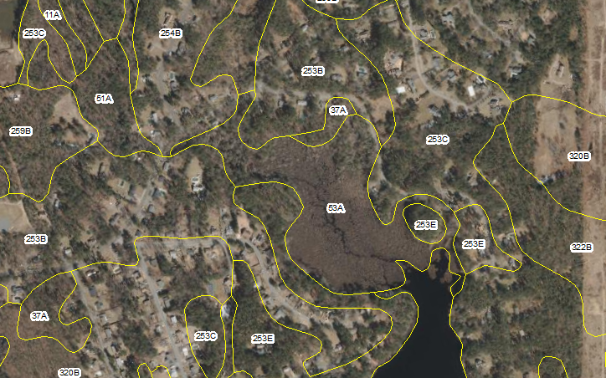

Figure 1: A soil survey map showing map unit polygons labeled with the map unit symbol.

It is important to note that all soil surveys were mapped at a certain scale and the minimum map unit size shown on a map is often between 1 and 5 acres. There may be areas of soils with significantly different characteristics within these soil map unit polygons that are too small to show on the maps. These areas are described in the soil data structure as inclusions within the larger soil map unit. In using soil survey information, the distinction between the map unit as a whole and the individual components that make up the map unit is an important concept. Typically, a soil map unit has one or more major (named) components and one or more minor, unmapped components (inclusions). Major components make up most of the map unit and are present in every delineation of a map unit. Each minor component typically makes up only a small percentage of the map unit and may only occur on a specific landform or micro-feature.

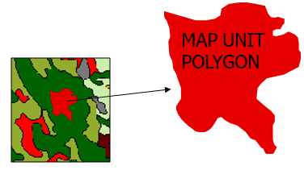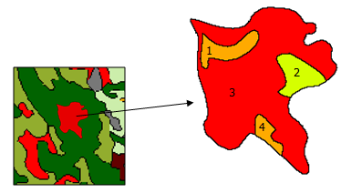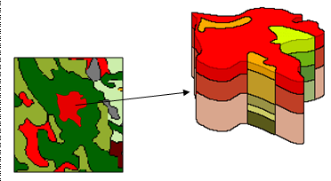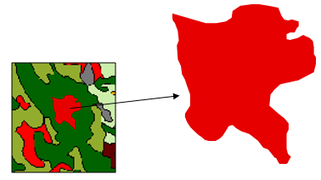

A map unit polygon as distributed by SSURGO

Un-mapped soil components in the polygon (inclusions)

Un-mapped 3-dimensional soil horizon

To display one value, aggregation is necessary

*Figure 2: Map unit polygon structure and components.*

Because of this one-to-many data structure, there are many layers of data associated with each polygon in the SSURGO dataset, including component data and horizon data for each component. In order to create a spatial output for SSURGO information queries some ‘aggregation’ of the data must occur. In Web Soil Survey, the user has some control over the method of aggregation. For the Massachusetts ‘Top20’ SSURGO shapefile, the aggregation has been done in order to create a simplified shapefile with the most commonly requested data attributes.

The results of aggregation do not reflect the presence or absence of limitations of the components which are not listed in the database. Minor components may be very different from the major components. Such differences could significantly affect use and management of areas within the map unit. An on-site investigation is necessarily required to identify the location of individual map unit components.

***Soil Survey Interpretations***

****Using this aggregation technique, soil ratings and interpretive maps can be created that represent the suitability, limitations, and ratings of each soil map unit. These are collectively referred to as soil interpretations and can include ratings such as farmland classification, hydrologic soil group, and suitability for buildings with basements, among many others. Data on physical and chemical properties can also be queried and reported. In 2020, over 10,000 mapping requests and over 200,000 data requests were made of Massachusetts soils data through Web Soil Survey. The most requested maps and data can be seen in the charts below.



***Massachusetts Top 20 Soils Data Layer***

To provide a simple, statewide soils data layer, the Massachusetts Top 20 soils data layer is a statewide shapefile of the soil survey data that contains a single set of attributes for each soil survey map unit. The attributes provided are those soil properties or ratings that are most requested by soil survey users through the Web Soil Survey platform.

To create the shapefile, statewide gSSURGO data was downloaded from USDA’s Geospatial Data Gateway. A Soil Data Access query was used to extract certain data elements for these most-commonly requested soil properties and interpretations and exported into an excel file. This excel file was joined with the spatial data using the mukey and the resulting shapefile was exported. Descriptions for each attribute included in the shapefile is listed below.

For more information contact your local NRCS office or visit <https://www.nrcs.usda.gov/wps/portal/nrcs/main/ma/soils/>

MassGIS distributes the data from <https://www.mass.gov/info-details/massgis-data-soils-ssurgo-certified-nrcs>.

***Attribute definitions and parameters in the Massachusetts Top 20 Soils Data Layer:***

|  |  |  |
| --- | --- | --- |
| Attribute | Attribute Name | Attribute description |
| Area Symbol | AREASYMBOL | Soil Survey Area Symbol |
| Map Unit Symbol | MUSYM | The symbol used to uniquely identify the soil mapunit in the soil survey. |
| Map Unit Key | MUKEY | The symbol used to uniquely identify the soil mapunit in the national soils information system database. |
| Area Name | AREANAME | Soil Survey Area name |
| Map Unit Name | MUNAME | Soil map unit name |
| Component Name | COMPNAME | Name of the dominant component of the soil map unit |
| Map Unit Kind | MUKIND | The kind of mapunit |
| Farmland Classification | FRMLNDCLS | Identification of map units as prime farmland, farmland of statewide importance, or farmland of unique importance. |
| Hydric Rating by Map Unit | HYDRCRATNG | Hydric soils are defined by the National Technical Committee for Hydric Soils (NTCHS) as soils that formed under conditions of saturation, flooding, or ponding long enough during the growing season to develop anaerobic conditions in the upper part (Federal Register, 1994). Under natural conditions, these soils are either saturated or inundated long enough during the growing season to support the growth and reproduction of hydrophytic vegetation. Reported for the dominant component of the map unit. |
| Drainage Class | DRAINCLASS | The natural drainage condition of the soil refers to the frequency and duration of wet periods. This column displays the dominant drainage class for the map unit, based on composition percentage of each map unit component. |
| Mineral Surface texture | MINSURFTEXT | The soil texture description of the first mineral soil horizon. Reported for the dominant component of the map unit. |
| T Factor | TFACTOR | Soil loss tolerance factor. The maximum amount of erosion at which the quality of a soil as a medium for plant growth can be maintained. Reported for the dominant component of the map unit. |
| Available Water Storage 0-100 cm | AWS100 | Available water storage (AWS). The volume of water that the soil, to a depth of 100 centimeters, can store that is available to plants. It is reported as the weighted average of all components in the map unit and is expressed as centimeters of water. AWS is calculated from AWC (available water capacity) which is commonly estimated as the difference between the water contents at 1/10 or 1/3 bar (field capacity) and 15 bars (permanent wilting point) tension and adjusted for salinity and fragments. |
| Available Water Storage 0-25 cm | AWS25 | Available water storage (AWS). The volume of water that the soil, to a depth of 25 centimeters, can store that is available to plants. It is reported as the weighted average of all components in the map unit and is expressed as centimeters of water. AWS is calculated from AWC (available water capacity) which is commonly estimated as the difference between the water contents at 1/10 or 1/3 bar (field capacity) and 15 bars (permanent wilting point) tension and adjusted for salinity and fragments. |
| Depth to Water Table | DEP2WATTBL | The shallowest depth to a wet soil layer (water table) at any time during the year expressed as centimeters from the soil surface, for components whose composition in the map unit is equal to or exceeds 15%. *These values are derived from the national database. They are intended for general planning purposes only and are not, in any way, intended to replace or supersede an on-site investigation. On-site investigations by certified soil evaluators are required by MA Environmental Code Title V for siting septic systems. |
| Dwellings with Basements | DWELLWB | The rating of the map unit as a site for dwellings with basements, expressed as the dominant rating class for the map unit, based on composition percentage of each map unit component. |
| Hydrologic Soil Group | HYDROLGRP | Hydrologic Group is a grouping of soils that have similar runoff potential under similar storm and cover conditions. This column displays the dominant hydrologic group for the map unit, based on composition percentage of each map unit component. |
| Nonirrigated Land Capability Class | NIRRLCC | This column displays the dominant capability class and subclass, under non-irrigated conditions, for the map unit based on composition percentage of all components in the map unit. |
| Local Roads and Streets | ROADS | The rating of the map unit as a site for local roads and streets, expressed as the dominant rating class for the map unit, based on composition percentage of each map unit component. |
| Septic Tank Absorption Fields | SEPTANKAF | The rating of the map unit as a site for septic tank absorption fields, expressed as the dominant rating class for the map unit, based on composition percentage of each map unit component. *These values are derived from the national database. They are intended for general planning purposes only and are not, in any way, intended to replace or supersede an on-site investigation. On-site investigations by certified soil evaluators are required by MA Environmental Code Title V for siting septic systems. |
| Representative Slope | SLOPE | The difference in elevation between two points, expressed as a percentage of the distance between those points. This column displays the slope gradient of the dominant component of the map unit based on composition percentage. |
| Flooding Frequency Class | FLOODING | The annual probability of a flood event expressed as a class. This column displays the dominant flood frequency class for the map unit, based on composition percentage of map unit components whose composition in the map unit is equal to or exceeds 15%. |
| Ponding Frequency Class | PONDING | The annual probability of a ponding event expressed as a class. This column displays the dominant ponding frequency class for the map unit, based on composition percentage of map unit components whose composition in the map unit is equal to or exceeds 15%. |
| Corrosion of Concrete | CORCONCRET | "Risk of corrosion" pertains to potential soil-induced electrochemical or chemical action that corrodes or weakens concrete. The rate of corrosion of concrete is based mainly on the sulfate and sodium content, texture, moisture content, and acidity of the soil. Special site examination and design may be needed if the combination of factors results in a severe hazard of corrosion. The concrete in installations that intersect soil boundaries or soil layers is more susceptible to corrosion than the concrete in installations that are entirely within one kind of soil or within one soil layer. The risk of corrosion is expressed as "low," "moderate," or "high." Reported for the dominant component of the map unit. |
| Soil Taxonomy Classification | TAXCLNAME | A concatenation of the Soil Taxonomy subgroup and family for a soil (long name). Reported for the dominant component of the map unit. |
| Depth to Any Soil Restrictive Layer | CM2RESLYR | The distance in centimeters from the soil surface to the upper boundary of any restrictive layer. Reported for the dominant component of the map unit. |
| Restriction Kind | RESKIND | Type of nearly continuous layer that has one or more physical, chemical, or thermal properties that significantly reduce the movement of water and air through the soil or that otherwise provides an unfavorable root environment. Reported for the dominant component of the map unit. |
| Parent Material Name | PARMATNM | Reports the name for each of the parent materials that may occur in a vertical cross section of a soil. Reported for the dominant component of the map unit. |
| Unified Soil Classification (Surface) | UNIFSOILCL | Reports the Unified soil classification group symbol for the first mineral horizon of the dominant component of the map unit. |
| AASHTO Group Classification (Surface) | AASHTO | Reports the American Association of State Highway and Transportation Officials (AASHTO) class rating for the first mineral horizon of the dominant component of the map unit. |
| K Factor, Rock Free | KFACTRF | An erodibility factor which quantifies the susceptibility of soil particles to detachment by water. Reported for the first mineral horizon of the dominant component of the map unit. |
| K Factor, Whole Soil | KFACTWS | An erodibility factor which quantifies the susceptibility of soil particles to detachment and movement by water. This factor is adjusted for the effect of rock fragments. Reported for the first mineral horizon of the dominant component of the map unit. |
| pH (1 to 1Water) | PHWATER | The average relative acidity or alkalinity of a soil the first mineral horizon of the dominant component of the map unit. *Note that the soil pH can be highly influenced by soil management. |
| Percent Clay | CLAY | The percent clay in the first mineral horizon of the dominant component of the map unit. Calculated as mineral particles less than 0.002mm in diameter as a weight percentage of the less than 2.0mm fraction. |
| Saturated Hydraulic Conductivity (Ksat) | KSAT | The amount of water that would move vertically through a unit area of saturated soil in unit time under unit hydraulic gradient (in/hr). Reported for the first mineral horizon of the dominant component of the map unit. |
| Organic Matter | OM | The amount by weight of decomposed plant and animal residue expressed as a weight percentage of the less than 2 mm soil material. Reported for the first mineral horizon of the dominant component of the map unit. |
| Percent Sand | SAND | The percent sand in the first mineral horizon of the dominant component of the map unit. Calculated as mineral particles 0.05mm to 2.0mm in equivalent diameter as a weight percentage of the less than 2 mm fraction. |
| Nitrate-Nitrogen Leaching Potential (MA) | NLEACHING | An indicator of the potential for nitrates dissolved in water to percolate to the groundwater. In Massachusetts, the rating is based on a soil interpretation that uses soil and climate properties in the National Soil Information System (NASIS) database and results in a ranking of low, moderate, or high potential for nitrate-nitrogen leaching. Reported for the dominant component of the map unit. |