March 26, 2025

William Anderson
Office of the General Counsel
Department of Public Health
250 Washington Street
Boston, MA 02108

RE: 105 CMR 125.000: Licensing of Radiologic Technologists

Dear Mr. Anderson:

In addition to our testimony submitted to your office on March 7, 2025, please accept the following supplemental information in response to comments made during today’s public hearing.

Question: Does the Introduction of a limited X-ray licensure pathway lead to decreased interest in rad tech programs (less rad techs)?

Answer: No, the data does not support that claim. NH and NV are two of the most recent states to start utilizing the ARRT Limited Scope of Practice in Radiography Exam to evaluate competency for limited X-ray licensure, NH in 2018 and NV in 2020. The numbers below show the number of first-time applicants for the full radiography exam (radiologic technologists) in each state dating back to 2014 (note, the 2024 data is not complete as this data was pulled in early 2024). As we can see, the number of individuals sitting for the ARRT Radiography Exam to gain certification as radiologic technologists did not drop post introduction of limited licensure pathways in these states. Rather, in Nevada’s case, the number had a significant increase in the first two years following the introduction of limited scope. This chart is provided on the next page.
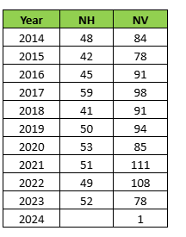
Question: Has any state ever revoked their pathway to limited X-ray licensure due to patient safety or quality concerns?

Answer: No. In fact, limited X-ray licensure has been around since 1972 when it was first introduced in the state of Mississippi. Since then, 34 other states have adopted some sort of pathway towards limited X-ray licensure and none have reversed course. See timeline below:

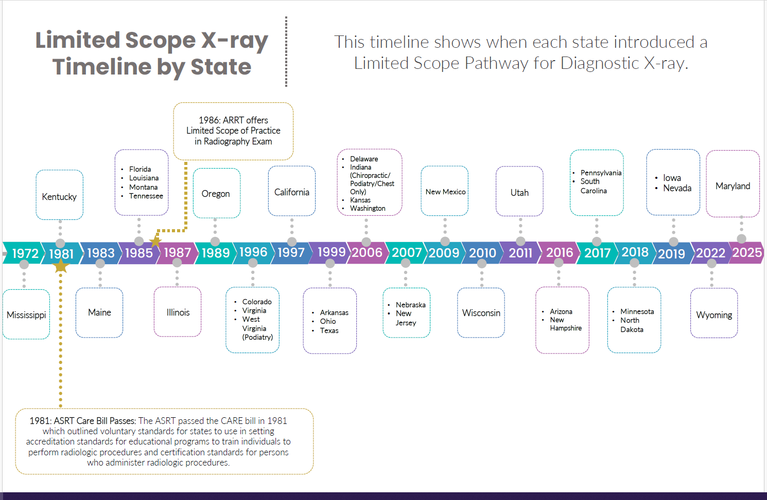

Question: If Massachusetts institutes limited X-ray will the license be utilized?

Answer: In answering this question, if we evaluate data from other states, the assumption would be yes. See data below showing the active number of limited licensees in some states with an achievable pathway (data accurate as of 4/2024). Note, states like New Jersey and Wisconsin have exacerbated requirements for limited X-ray licensure that make it essentially unobtainable in those states.

Question: Will the shortage of radiologic technologists sustain, or should we evaluate the market based on its historic cyclical nature?

Answer: In answering this question, it is important to highlight some significant data recently outlined by the American Society of Radiologic Technologists (ASRT) in the “White Paper From the 2024 Consensus Committee on the Future of Medical Imaging and Radiation Therapy.” The ASRT conducted surveys in 2022 and 2023 to evaluate vacancy rates among all imaging and therapeutic disciplines. Vacancy rates are at their highest levels since the ASRT began evaluating staffing metrics in 2003. Specifically, as it applies to radiographers (X-ray techs), the estimated vacancy rate in 2023 was 18.1%, almost three times what it was in 2021. The point being this is an issue that will continue to plague our industry for years to come.

Sincerely,

James Brennan

Jim Brennan
Massachusetts Urgent Care Association



Gareth Dickens
ConvenientMD Urgent Care

