June 23, 2021

Board of Registration in Nursing
239 Causeway St., Suite 500, 5th Floor
Boston, MA 02114

Dear Board of Registration Chair Kelly,

I am writing this letter on behalf of Massasoit Community College to urgently request your support in removing the proposed regulation revision for 244 CMR 6.04 2 (b)4. c. (iii) (a)-Waiver and Faculty. The most recently proposed change (May 2021) would limit the option to utilize BSN prepared, part-time faculty, many of whom practice in our hospitals and other clinical settings supervising student nurses. The proposed regulatory change would eliminate the option to hire new part-time faculty who are experienced to teach in the clinical or laboratory setting who hold a BSN but not an MSN degree. The proposed regulation would be particularly challenging to meet in specialized areas such as pediatrics, maternity, and mental health nursing. Although hiring graduate level faculty is always the preferred option, there is a significant nursing faculty shortage in the Commonwealth of Massachusetts and the South Shore area. The shortage is due to several well-known factors. Graduate programs in nursing are not producing a large enough pool of potential nurse educators to meet the demand. Higher compensation for clinical practice dissuades potential nurse educators from teaching, further reducing the availability of qualified graduate level faculty.

It is increasingly difficult to fill faculty positions with MSN prepared faculty. Having the ability to hire BSN prepared part-time faculty allows Massasoit to build on their clinical expertise and mentor them in the educator role. Many of these part-time faculty live and work in the local community. It is not unusual for these faculty to discover a passion for teaching and seek to continue their education.

Over 50% of the current RN workforce in Massachusetts is over age 50. Massasoit Community College is committed and prepared to meet the future nursing needs of our Commonwealth. Our diverse nursing program serves an important role in meeting the workforce needs of the Greater Boston area, and especially Brockton and the South Shore. This proposed change is a hardship and will create barriers to educate professional nurses and meet the needs of our community now and in the future. As the president of a college located in a diverse and underserved urban community, I am deeply concerned about the impact of this proposed regulation on our program, our college and our community.

If this proposed regulatory language is not removed, the unintended consequences will result in an increased faculty shortage, and will severely impact many Massachusetts nursing programs, including Massasoit Community College, to be unable to maintain our current enrollment of students. As a result, we will no longer be able to graduate the number of new nurses to meet the current and future workforce needs of the Greater Boston area, Brockton and South Shore areas.

I appreciate your consideration and dedication to quality, affordable education for the next generation of nurses.

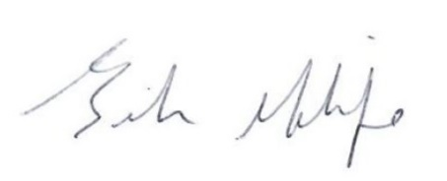
Sincerely,

Brenda Molife, Ph.D.
Interim President

