INDOOR AIR QUALITY
POST-OCCUPANCY ASSESSMENT

Massasoit Community College
at Middleborough Center
49 Union Street
Middleborough, Massachusetts



Prepared by:
Massachusetts Department of Public Health
Bureau of Environmental Health
Indoor Air Quality Program
November 2010

Background/Introduction
In response to a request from Ms. Lisa Verrochi, Project Manager, Division of Capital Asset Management (DCAM), the Massachusetts Department of Public Health (MDPH), Bureau of Environmental Health (BEH), conducted post-occupancy air testing at Massasoit Community College (MCC) at Middleborough Center located at 49 Union Street, Middleborough, Massachusetts. This air sampling was done to assess indoor air quality of newly occupied space leased by Massachusetts state education facilities. On September 14, 2010, a visit to conduct indoor air quality testing was made by Cory Holmes, Environmental Analyst/Regional Inspector in BEH’s IAQ Program. Mr. Holmes was accompanied by Ms. Verrochi during the assessment.
MCC leases space on the top floor of a two-story building that formerly served as the Lincoln D. Lynch Elementary School. The building is constructed of yellow brick that was built in the 1930s. The space leased by MCC was completely renovated including wall to wall carpeting, painting and the installation of air-conditioning (AC) systems. MCC currently occupies space on the upper floor consisting of four classrooms, student/faculty lounges, restrooms and office space. Windows are openable throughout the building.

Methods
Air tests for carbon dioxide, carbon monoxide, temperature and relative humidity were taken with the TSI, Q-Trak, IAQ Monitor 7565. Air tests for airborne particle matter with a diameter less than 2.5 micrometers were taken with the TSI, DUSTTRAK™ Aerosol Monitor Model 8520. Screening for total volatile organic compounds was conducted using a Thermo Environmental Instruments Inc., Model 580 Series Photo Ionization Detector (PID). BEH staff also performed visual inspection of building materials for water damage and/or microbial growth.

Results
The tests were taken during normal operations. Test results appear in Table 1 and are listed by room number/function.

Discussion

Ventilation
It can be seen from Table 1 that carbon dioxide levels were below 800 parts per million (ppm) in all areas indicating optimal air exchange at the time of testing (Table 1). It is important to note, however that several classrooms were empty at the time of testing, which can greatly reduce carbon dioxide levels. Carbon dioxide levels would be expected to increase with full occupancy.
Fresh air and AC is provided by air handling units (AHU) located above the ceiling tile system in each classroom (Picture 1). Fresh air is drawn into the AHU through an air intake vent located on the roof (Picture 2), heated or cooled and delivered to occupied areas via ducted air diffusers (Picture 3). Return air is drawn into ceiling-mounted vents and ducted back to AHUs.
Digital wall-mounted thermostats control the AC/ventilation system and have fan settings of “on” and “automatic”. Thermostats were found set to the “automatic” setting at the time of assessment (Picture 4). The automatic setting on the thermostat activates the system at a preset temperature. Once the preset temperature is reached, the system is deactivated. Therefore, no mechanical ventilation is provided until the thermostat re-activates the system. Without a continuous source of fresh outside air and removal via the exhaust/return system, indoor environmental pollutants can build-up and lead to indoor air quality/comfort complaints.
Fresh air and heat is provided during fall/winter months by unit ventilator (univent) systems (Picture 5). A univent draws outdoor air through an air intake located on the exterior wall of the building (Picture 6) and return air from the room through an air intake located at the base of the unit (Figure 1). Fresh and return air are mixed, filtered, heated, and then delivered to the room through an air diffuser located in the top of the unit.
To maximize air exchange, the MDPH recommends that both supply and exhaust ventilation operate continuously during periods of occupancy. In order to have proper ventilation with a mechanical supply and exhaust system, the systems must be balanced to provide an adequate amount of fresh air to the interior of a room while removing stale air from the room. It is recommended that HVAC systems be re-balanced every five years to ensure adequate air systems function (SMACNA, 1994).
The Massachusetts Building Code requires a minimum ventilation rate of 20 cubic feet per minute (cfm) per occupant of fresh outside air or have openable windows in each room (SBBRS, 1997; BOCA, 1993). The ventilation must be on at all times that the room is occupied. Providing adequate fresh air ventilation with open windows and maintaining the temperature in the comfort range during the cold weather season is impractical. Mechanical ventilation is usually required to provide adequate fresh air ventilation.
Carbon dioxide is not a problem in and of itself. It is used as an indicator of the adequacy of the fresh air ventilation. As carbon dioxide levels rise, it indicates that the ventilating system is malfunctioning or the design occupancy of the room is being exceeded. When this happens, a buildup of common indoor air pollutants can occur, leading to discomfort or health complaints. The Occupational Safety and Health Administration (OSHA) standard for carbon dioxide is 5,000 parts per million parts of air (ppm). Workers may be exposed to this level for 40 hours/week, based on a time-weighted average (OSHA, 1997).
The MDPH uses a guideline of 800 ppm for publicly occupied buildings. A guideline of 600 ppm or less is preferred in schools due to the fact that the majority of occupants are young and considered to be a more sensitive population in the evaluation of environmental health status. Inadequate ventilation and/or elevated temperatures are major causes of complaints such as respiratory, eye, nose and throat irritation, lethargy and headaches. For more information concerning carbon dioxide, please see Appendix A.
Indoor temperature measurements ranged from 68°F to 75°F (Table 1), which were within the MDPH recommended comfort range in all but one area surveyed. The MDPH recommends that indoor air temperatures be maintained in a range of 70 º F to 78 º F in order to provide for the comfort of building occupants. In many cases concerning indoor air quality, fluctuations of temperature in occupied spaces are typically experienced, even in a building with an adequate fresh air supply. The lounge areas do not have AHUs but utilize window-mounted ACs for cooling.
Relative humidity measurements ranged from 45 to 55 percent, which were within the MDPH recommended comfort range the day of the assessment (Table 1). The MDPH recommends a comfort range of 40 to 60 percent for indoor air relative humidity. Relative humidity levels in the building would be expected to drop during the winter months due to heating. The sensation of dryness and irritation is common in a low relative humidity environment. Low relative humidity is a very common problem during the heating season in the northeast part of the United States.

Microbial/Moisture Concerns
No water-damaged building materials or visible mold growth were observed in MCC space during the assessment. BEH staff examined the building to identify breaches in the building envelope that could provide a source of water penetration. BEH identified the following conditions:
- Branches overhanging the roof (Picture 7);
- A roof drain was obstructed by leaves/debris (Picture 8); and
- Trees against the building (Picture 9), which can hold moisture against exterior brick leading to accelerated degradation.

Other Indoor Air Evaluations
Indoor air quality can be negatively influenced by the presence of respiratory irritants, such as products of combustion. The process of combustion produces a number of pollutants. Common combustion emissions include carbon monoxide, carbon dioxide, water vapor, and smoke (fine airborne particle material). Of these materials, exposure to carbon monoxide and particulate matter with a diameter of 2.5 micrometers (μm) or less (PM2.5) can produce immediate, acute health effects upon exposure. To determine whether combustion products were present in the indoor environment, BEH staff obtained measurements for carbon monoxide and PM2.5.

Carbon Monoxide
Carbon monoxide is a by-product of incomplete combustion of organic matter (e.g.,
gasoline, wood and tobacco). Exposure to carbon monoxide can produce immediate and acute health affects. Several air quality standards have been established to address carbon monoxide and prevent symptoms from exposure to these substances. The MDPH established a corrective action level concerning carbon monoxide in ice skating rinks that use fossil-fueled ice resurfacing equipment. If an operator of an indoor ice rink measures a carbon monoxide level over 30 ppm, taken 20 minutes after resurfacing within a rink, that operator must take actions to reduce carbon monoxide levels (MDPH, 1997).
The American Society of Heating Refrigeration and Air-Conditioning Engineers (ASHRAE) has adopted the National Ambient Air Quality Standards (NAAQS) as one set of criteria for assessing indoor air quality and monitoring of fresh air introduced by HVAC systems (ASHRAE, 1989). The NAAQS are standards established by the US EPA to protect the public health from six criteria pollutants, including carbon monoxide and particulate matter (US EPA, 2006). As recommended by ASHRAE, pollutant levels of fresh air introduced to a building should not exceed the NAAQS levels (ASHRAE, 1989). The NAAQS were adopted by reference in the Building Officials & Code Administrators (BOCA) National Mechanical Code of 1993 (BOCA, 1993), which is now an HVAC standard included in the Massachusetts State Building Code (SBBRS, 1997). According to the NAAQS, carbon monoxide levels in outdoor air should not exceed 9 ppm in an eight-hour average (US EPA, 2006).
Carbon monoxide should not be present in a typical, indoor environment. If it is present, indoor carbon monoxide levels should be less than or equal to outdoor levels. On the day of the assessment, outdoor carbon monoxide concentrations were non-detect (ND) (Table 1). No measureable levels of carbon monoxide were detected inside the building during the assessment (Table 1).

Particulate Matter
The US EPA has established NAAQS limits for exposure to particulate matter. Particulate matter is airborne solids that can be irritating to the eyes, nose and throat. The NAAQS originally established exposure limits to particulate matter with a diameter of 10 μm or less (PM10). According to the NAAQS, PM10 levels should not exceed 150 micrograms per cubic meter (μg/m³) in a 24-hour average (US EPA, 2006). These standards were adopted by both ASHRAE and BOCA. Since the issuance of the ASHRAE standard and BOCA Code, US EPA established a more protective standard for fine airborne particles. This more stringent PM2.5 standard requires outdoor air particle levels be maintained below 35 μg/m³ over a 24-hour average (US EPA, 2006). Although both the ASHRAE standard and BOCA Code adopted the PM10 standard for evaluating air quality, MDPH uses the more protective PM2.5 standard for evaluating airborne particulate matter concentrations in the indoor environment.
Outdoor PM2.5 was measured at 12 μg/m³ (Table 1). PM2.5 levels measured indoors ranged from 6 to 12 μg/m³ (Table 1), which were below the NAAQS PM2.5 level of 35 μg/m³. Frequently, indoor air levels of particulates (including PM2.5) can be at higher levels than those measured outdoors. A number of mechanical devices and/or activities that occur in buildings can generate particulate during normal operations. Sources of indoor airborne particulates may include but are not limited to particles generated during the operation of fan belts in the HVAC system, use of stoves and/or microwave ovens in kitchen areas; use of photocopiers, fax machines and computer printing devices; operation of an ordinary vacuum cleaner and heavy foot traffic indoors.

Volatile Organic Compounds
Indoor air concentrations can be greatly impacted by the use of products containing volatile organic compounds (VOCs) within the building. VOCs are carbon-containing substances that have the ability to evaporate at room temperature. Frequently, exposure to low levels of total volatile organic compounds (TVOCs) may produce eye, nose, throat and/or respiratory irritation in some sensitive individuals. For example, chemicals evaporating from a paint can stored at room temperature would most likely contain VOCs. In an effort to determine whether VOCs were present in the building, air monitoring for TVOCs was conducted. Outdoor air samples were taken for comparison. A slight TVOC measurement of 0.5 ppm was measured outdoors (Table 1), which was attributed to fresh asphalt that was poured 10 days prior to the assessment (Picture 10). No measurable levels of TVOCs were detected in the building during the assessment (Table 1).

Other Conditions
Other conditions that can affect indoor air quality were observed during the assessment. Restrooms are equipped with mechanical exhaust vents that are ducted to rooftop exhaust motors. Exhaust ventilation is necessary in restrooms to remove excess moisture and to prevent odors from penetrating into adjacent areas. The vents were not drawing air at the time of the assessment. BEH staff examined restroom exhaust vents on the roof; the exhaust vent for the men’s room appeared to be a modern vent that was reportedly deactivated (Picture 11). The exhaust vent for the women’s restroom was antiquated, in disrepair and appeared not to have operated for some time (Pictures 12 and 13).
Finally, the type of filters installed in univents provide minimal filtration of respirable dusts (Picture 14). In order to decrease aerosolized particulates, disposable filters with an increased dust spot efficiency can be installed. The dust spot efficiency is the ability of a filter to remove particulates of a certain diameter from air passing through the filter. Filters that have been determined by ASHRAE to meet its standard for a dust spot efficiency of a minimum of 40 percent would be sufficient to reduce many airborne particulates (Thornburg, D., 2000; MEHRC, 1997; ASHRAE, 1992). Note that increasing filtration can reduce airflow (called pressure drop), which can subsequently reduce the efficiency of the unit due to increased resistance. Prior to any increase of filtration, each univent should be evaluated by a ventilation engineer to ascertain whether it can maintain function with more efficient filters. Filters for the AHUs could not be examined due to access (e.g., above ceiling tiles). Pleated filters with a Minimum Efficiency Reporting Value dust-spot efficiency of 9 or higher, should be installed in AHUs.

Conclusions/Recommendations
In view of the findings at the time of the visit, the following recommendations are made:
- Set the thermostat to the fan “on” position to operate the ventilation system continuously during full occupancy.
- Change filters for air handling equipment as per the manufacturers’ instructions or more frequently if needed.
- Examine AHUs for filtration, upgrade to pleated MERV 9 (or higher) dust-spot efficiency if not currently installed.
- Consider increasing the dust-spot efficiency of univent filters. Prior to any increase of filtration, univents should be evaluated by a ventilation engineer as to whether it can maintain function with more efficient filters.
- Consider adopting a balancing schedule of every 5 years for all mechanical ventilation systems, as recommended by ventilation industrial standards (SMACNA, 1994).
- Restore restroom exhaust ventilation. Inspect motors and belts for proper function, and perform repairs and adjustments as necessary.
- Trim tree branches from overhanging roof and exterior brick.
- Clear roof drains and inspect periodically for proper drainage.
- Refer to resource manual and other related indoor air quality documents located on the MDPH’s website for further building-wide evaluations and advice on maintaining public buildings. These documents are available at: http://mass.gov/dph/indoor_air.

References
ASHRAE. 1989. Ventilation for Acceptable Indoor Air Quality. American Society of Heating, Refrigeration and Air Conditioning Engineers. ANSI/ASHRAE 62-1989.
ASHRAE. 1992. Gravimetric and Dust-Spot Procedures for Testing Air-Cleaning Devices Used in General Ventilation for Removing Particulate Matter. American Society of Heating, Refrigeration and Air Conditioning Engineers. ANSI/ASHRAE 52.1-1992.
BOCA. 1993. The BOCA National Mechanical Code/1993. 8th ed. Building Officials and Code Administrators International, Inc., Country Club Hill, IL.
MDPH. 1997. Requirements to Maintain Air Quality in Indoor Skating Rinks (State Sanitary Code, Chapter XI). 105 CMR 675.000. Massachusetts Department of Public Health, Boston, MA.
MEHRC. 1997. Indoor Air Quality for HVAC Operators & Contractors Workbook. MidAtlantic Environmental Hygiene Resource Center, Philadelphia, PA.
OSHA. 1997. Limits for Air Contaminants. Occupational Safety and Health Administration. Code of Federal Regulations. 29 C.F.R 1910.1000 Table Z-1-A.
SBBRS. 1997. Mechanical Ventilation. State Board of Building Regulations and Standards. Code of Massachusetts Regulations. 780 CMR 1209.0.
SMACNA. 1994. HVAC Systems Commissioning Manual. 1st ed. Sheet Metal and Air Conditioning Contractors’ National Association, Inc., Chantilly, VA.
Thornburg, D. 2000. Filter Selection: a Standard Solution. Engineering Systems 17:6 pp. 74-80.
US EPA. 2006. National Ambient Air Quality Standards (NAAQS). US Environmental Protection Agency, Office of Air Quality Planning and Standards, Washington, DC. http://www.epa.gov/air/criteria.html.
Picture 1

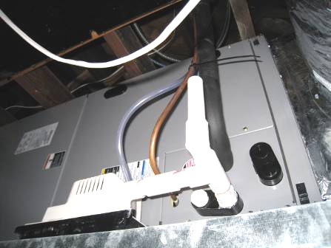

Air Handling Unit above Ceiling Tile System in Classroom

Picture 2

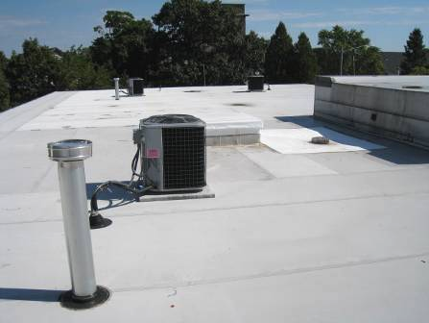

Fresh Air Intakes for Air Handling Units

Picture 3

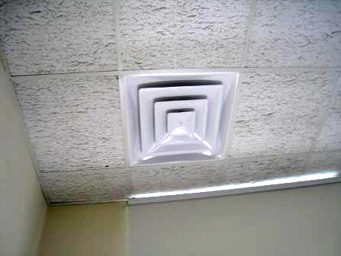

Ceiling-Mounted Supply Diffuser

Picture 4

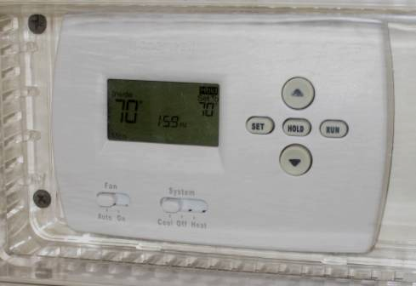

Digital Thermostat in Classroom for AHU, Note Fan in “Auto” Position

Picture 5

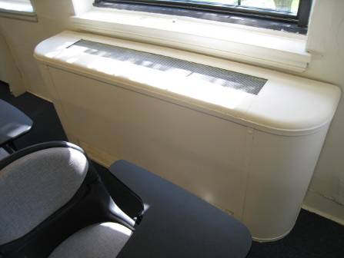

Classroom Univent 1930’s Vintage

Picture 6



Univent Fresh Air Intake

Picture 7

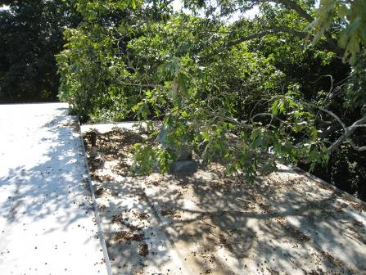

Tree Branches Overhanging Roof

Picture 8

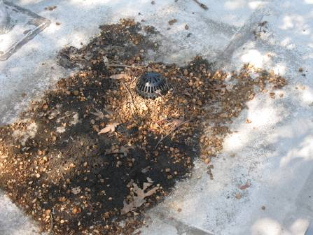

Roof Drain Clogged with Leaves and Debris

Picture 9

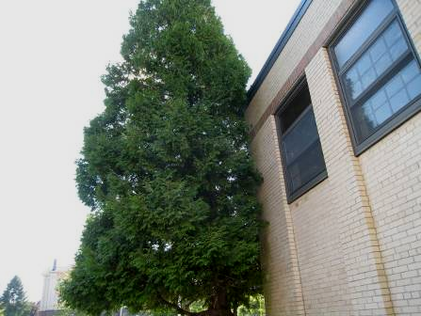

Trees Growing against Exterior Brick

Picture 10

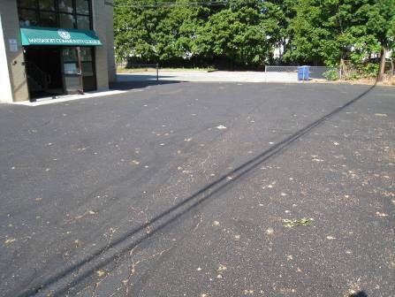

Recently Paved Asphalt in MCC Parking Lot

Picture 11

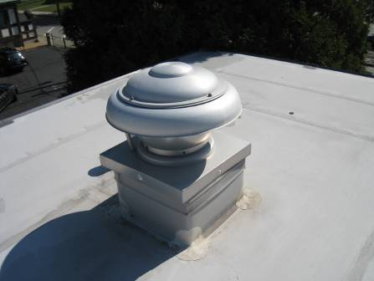

Modern Exhaust Vent for Men’s Restroom

Picture 12

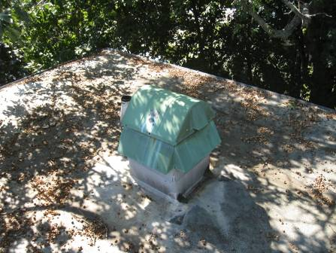

Vintage Exhaust Vent for Women’s Restroom

Picture 13

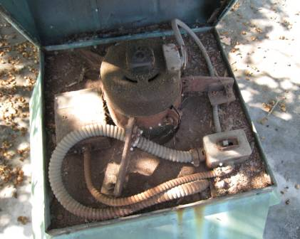

Interior of Women’s Restroom Exhaust Vent/Motor, Note Accumulated Rust and Debris

Picture 14

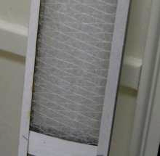

Fibrous Mesh Filters Installed in Univents
Location | Occupants  in Room |  | Temp  (°F) |  | Relative  Humidity  (%) |  | Carbon  Dioxide  (ppm) |  | Carbon Monoxide  (ppm) |  | PM2.5 |  | TVOCs  (ppm) |  | Windows  Openable |  | Ventilation |  |  |  | Remarks
 |  |  |  |  |  |  |  |  |  |  | (µg/m3) |  |  |  |  |  | Supply |  | Exhaust |  | Remarks
Outside/  Background |  | 75 |  | 56 |  | 328 |  | ND |  | 12 |  | 0.5 |  |  |  |  |  |  |  | Slight asphalt odors - poured 10 days prior to assessment
102 | 0 | 73 |  | 53 |  | 386 |  | ND |  | 7 |  | ND |  | Y |  | Y |  | Y |  | Thermostat fan “auto”
103 | 12 | 75 |  | 53 |  | 484 |  | ND |  | 9 |  | ND |  | Y |  | Y |  | Y |  | Thermostat fan “auto”
106 | 0 | 71 |  | 54 |  | 402 |  | ND |  | 8 |  | ND |  | Y |  | Y |  | Y |  | Thermostat fan “auto”
107 | 0 | 71 |  | 45 |  | 399 |  | ND |  | 6 |  | ND |  | Y |  | Y |  | Y |  | Window AC unit
109 | 0 | 72 |  | 55 |  | 410 |  | ND |  | 12 |  | ND |  | Y |  | Y |  | Y
111 | 0 | 71 |  | 50 |  | 411 |  | ND |  | 10 |  | ND |  | Y |  | Y |  | Y |  | Window AC unit
113 | 0 | 68 |  | 47 |  | 395 |  | ND |  | 7 |  | ND |  | Y |  | Y |  | Y |  | Window AC unit
Women’s Restroom |  |  |  |  |  |  |  |  |  |  |  |  |  | Y |  | Y  Passive door vent |  | Y |  | Exhaust – not functioning
Men’s Restroom |  |  |  |  |  |  |  |  |  |  |  |  |  | Y |  | Y  Passive door vent |  | Y |  | Exhaust – not functioning

Building envelope means the roof, exterior walls, exterior windows, exterior doors and foundation of a building.

