To: | Peter Sutton | Date: |  | August 21, 2024
To: | MassDOT  10 Park Plaza  Boston, MA 02116 |  |  | August 21, 2024
To: | MassDOT  10 Park Plaza  Boston, MA 02116 | Project #: |  | 15893.02
From: | Rick Plenge, PE, PTOE  Kenia French | Re: | Next Gen Vision Map and Project Prioritization Methodology and Update Procedures – Executive Summary

Executive Summary
As established within the prior Massachusetts Bicycle and Pedestrian Transportation Planning efforts and current MassDOT Statewide Long Range Transportation Plan, Beyond Mobility project, there is an overarching goal in expanding a high comfort network for pedestrians and bicyclists to all applicable state roadways that are within the range of a short walking or biking trip. In order to be realized, this goal requires the planning, prioritization, design and construction of high comfort pedestrian and bicycle infrastructure. This study involved several main components:
- Establishing the ‘Recommended Infrastructure’ for pedestrians and bicycle on the study area road network
- Identifying gaps in existing bicycle and pedestrian infrastructure
- Creating a ‘Vision Map’ where 100% of residents living or working along applicable roadway segments have access to high comfort pedestrian and bicycle facilities for short walking and biking trips
- Prioritizing gap segments in terms of which have the highest need for infrastructure improvements and group them into mid and long-term projects

Compilation of Available Data Sets
To identify facility gaps and establish recommended infrastructure, a variety of open-source datasets were utilized, primarily from MassDOT and MassGIS. MassDOT’s Road Inventory 2022 layer served as the base data for a variety of the project variables, most importantly the road corridors. Additionally, Annual Average Daily Traffic (AADT) data, available speed data, and sidewalk width data was derived from this layer as well. For the primary speed data source, INRIX probe data was utilized to provide real time information as to the speed of traffic on select roadways throughout the state. MassDOT’s Bike Inventory layer was used as the source for existing bicycle inventory.
In order to develop the project Vision Map, MassGIS Parcel and Assessing data were used for land use information. The Department of Revenue’s Land Use Classification Codes were also used to translate land use information into useable categories.
For the prioritization phase of the project, MassDOT’s Beyond Mobility Project recommendations were used as a guideline for how to prioritize project corridors. Data sources for that analysis included the 2015-2019 American Community Survey, North American Industry Classification System and MassGIS.
It should be noted that the Next Gen Methodology and Process Update Memo supplements this executive summary and provides a detailed overview of the data and methodology used to complete this analysis. The methodology memo contains a complete, step by step guide on how this analysis was completed, as well as how to update it in the future.

Establishing the ‘Recommended Infrastructure’ for bicycles and pedestrians on the study road network
For the purposes of this study, the study area roadway network was limited to MassDOT jurisdictional roads. These selected roads were further limited by excluding Interstates and limited access roadways, including those where bicycle and pedestrian access is restricted. This analysis originally included a more expansive query that included MassDOT jurisdictional roads, roads eligible for federal funding and roads part of the National Highway System that were not necessarily under MassDOT jurisdiction. This query was changed to only include roads under MassDOT jurisdiction to ensure that prioritized projects would fall within MassDOT’s purview where they have more control on the ultimate funding and implementation of the projects.
To determine the recommended infrastructure for bicycles, the Federal Highway Administration (FHWA) Bikeway Selection Guide was used as a framework. This guide builds upon a traditional level of traffic stress framework and recommends increased bicycle facility width or separation from vehicular traffic lanes as the speed and volume of vehicular traffic increases. As is illustrated within Figures 1 and 2 below, a recommended bicycle infrastructure type was assigned for each roadway based on existing speed data and annual average daily traffic (AADT) data, along with corresponding land use. In urban locations, facility treatments range from traditional bike lanes to separated bikeways/shared use paths. In rural locations, the width of the shoulder facility increases with the corresponding increase in travel speeds and volumes.
Figure 1. FHWA Bikeway Selection Criteria for Urban Roads
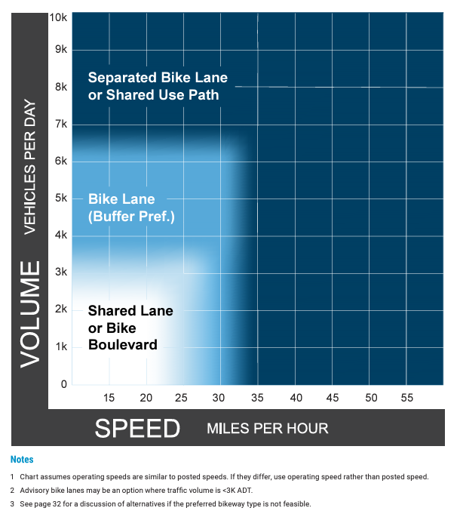

Figure 2. FHWA Bikeway Selection Criteria for Rural Roads
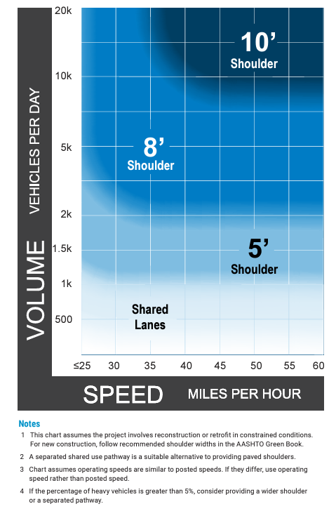
To determine the recommended infrastructure for pedestrians, a ‘high comfort sidewalk facility’ was established to be at least 5 feet wide. It should be noted that based on limitations with the available pedestrian facility/infrastructure GIS inventory, no assessment of a sidewalk’s accessibility or overall condition was performed. Ongoing data collection and analysis of sidewalk condition as part of a separate study will be available later this year and should be able to supplement the existing roadway inventory data layer and provide further insights into the overall condition and accessibility of sidewalks.

Identifying gaps in existing bicycle and pedestrian infrastructure
To identify gaps in existing bicycle infrastructure, recommended infrastructure based on the FHWA methodology noted above were compared to existing bicycle infrastructure for both urban and rural land uses. First, the study area roadway network was broken out by urban and rural land use contexts using the 2020 Census Data. Next existing bicycle infrastructure for each road segment was determined based on a combination of GIS analysis methods and targeted review of aerial imagery within the state. Then, the existing infrastructure was compared to the recommended infrastructure to establish whether there was an infrastructure gap. Bicycle infrastructure gaps were put into four categories:
- Physical Gaps, which were segments that did not have any bicycle infrastructure.
- Quality Gaps, which were segments where the existing infrastructure did not meet the recommended quality of the facility based on the roadway condition context. For example, a road that has a standard bike lane where the speed and AADT values indicate it should be a separated bike lane.
- Sufficient Infrastructure, where the existing bicycle infrastructure matched with the recommended infrastructure.
- Insufficient Data, which were segments where sufficient data was lacking to establish what the recommended infrastructure should be. For example, speed limit or volume data was lacking in the vicinity of the roadway segment to draw conclusions as to the recommended facility type.
To identify gaps in pedestrian infrastructure, sidewalk width data from MassDOT’s road inventory layer was used. The current sidewalk width was evaluated as to whether it was less than or equal to the 5-foot threshold, based on MassDOT Engineering Directive E-20-001. Pedestrian infrastructure gaps were put into three categories:
- Physical Gaps, which were segments with no sidewalk.
- Quality Gaps, which were segments where the sidewalk was less than 5 feet wide.
- Sufficient Infrastructure, which where segments where the sidewalk was greater than or equal to 5 feet wide.

Creating a ‘Vision Map’ to Achieve 100% Bikeability and Walkability
The Vision Map roadways are considered to be roads that people would potentially bike and/or walk on in order to reach destinations in the surrounding area. The ultimate goal of the Vision Map is to represent a road network that covers any potential short trips that local populations may want to take. These trips could vary from connecting homes to other homes to connecting homes to grocery stores to connecting schools to recreational facilities. To identify as many of these potential trips as possible, an analysis was conducted considering two key components:
- The potential land uses that people may be interested in accessing or traveling between via a high comfort bicycle and pedestrian network
- The road corridors that fell within the bike- and walk-shed thresholds for these land uses.

Land use was analyzed at the parcel level. Massachusetts assessing data was used in combination with the Department of Revenue’s land use classification codes to establish whether a particular parcel was a destination of interest. Some land uses that were considered destinations of interest include residences, schools, community centers, open space/recreational parcels and places of business. Some land uses that were not considered destinations of interest were agricultural lands and conservation lands (without recreational uses). A table summary of the land use codes utilized within this analysis are summarized within the Next Gen Methodology and Process Update Memo.
Once the parcels of interest were determined, bike- and walk-shed thresholds were applied to the parcel boundaries to determine which road corridors could potentially be used to access these destinations. The bike- and walk-shed thresholds were developed based on the average likely trip length for each mode of transportation, as was defined within the prior Massachusetts Bicycle and Pedestrian Transportation Plans. For bikes, a 3-mile bike-shed threshold was applied while a 0.5-mile threshold was applied for pedestrians.
Based on the larger bike-shed buffer applied to each applicable land use, the Bicycle Vision Map includes 2,285 miles of MassDOT jurisdictional road segments total. The Pedestrian Vision Map includes 2,285 miles of MassDOT jurisdictional road segments total as well. Note that these numbers were reduced by updating the road query to include MassDOT jurisdictional roads only. Previously, 4,400 miles of bike corridors and 4,380 miles of pedestrian corridors were included in the original Vision Map analysis.

Prioritizing Gap Segments in Terms of Highest Need for Potential Projects
Once the Vision Map road segments were determined, the road segments were scored and ranked in terms of their highest priority. Based on MassDOT’s Beyond Mobility Priority Areas, eleven factors in total were used to score and rank the potential road segments. These factors were then ranked in order of ‘most important’ to ‘least important’. This ranking was then applied as a weighting to the road segments, so that the most important factors had a larger impact on the overall score.
Prioritization Factors
- Environmental Justice
- Pedestrian/Bicycle Crashes
- HSIP Clusters
- Transit Stop Presence
- Access to food
- Population Density
- Access to Recreational Facilities/Open Space
- Employment Density
- Proximity to Public Services
- Percentage Transit Commuters
- Designated Truck Routes

Some of the most important factors considered were overall road segment safety, destination connectivity, and equity. All three of these factors come from Beyond Mobility project goals and recommendations. Safety was measured based on whether pedestrian/bicycle crashes occurred on a road segment, and whether the road segment fell within a bicycle or pedestrian crash cluster. Destination connectivity was measured by transit stop presence, access to food, access to recreational facilities, proximity to public services, and percentage of transit commuters. Equity was measured based on whether a road segment fell within an Environmental Justice block group. For the purposes of this study, Environmental Justice block groups were defined in accordance with how the Beyond Mobility project defined environmental justice. These block groups were based on the statewide block groups, yet with expanded variables considered which included senior status, disability status, zero vehicle households, minority status, language isolation and low income status. Additionally, these block groups were identified by comparing block group averages to regional averages, giving an overall more holistic view of environmental justice in Massachusetts.
To ensure regional equity, urban and rural segments were scored based on slightly different criteria. For instance, the population density factor was weighted higher for rural area segments as compared to urban area segments because population density varies more in rural areas and is therefore a more meaningful variable While urban areas tend to all have high population density, in rural areas, higher population density can indicate a community center or other important residence that may have higher multimodal transportation connectivity needs. Additionally, for rural roads, a segment was considered close to a transit facility if it was within 1 mile for walking and 3 miles for biking. For urban roads, a segment was considered close to a transit facility if it was within 0.5 miles for walking and 1.5 miles for biking.
To continue to ensure regional equity, segments were ranked by Metropolitan Planning Organization (MPO) and urban/rural designation, rather than for the entire state, as is consistent with Beyond Mobility guidelines. The reason for this breakout is because the Boston Region often skews statewide results, driving up numbers for important indicators like Median Household Income by nature of being a large metropolitan area. By ranking segments at the regional level, we can ensure that each MPO has high priority segments identified based on the factors that are most relevant to that specific region. As a result, future funding can be more equitably distributed. For example, all urban segments in the Central Massachusetts MPO were ranked compared to each other, and all rural segments in the Central Massachusetts MPO were ranked compared to each other. These segments were ranked using the ‘percentile ranking’ method, so that they could be combined and compared to each other, while maintaining regional integrity. The highest priority segments were broken into “Mid-Term” or “Long-Term” categories based on overall mileage. Mileage estimates were based on approximately how many miles of project improvements road mileage could reasonably be constructed in a typical annual MassDOT capital budget cycle. “Mid-Term” is considered the next 3-9 years, while Long-Term is the next 10-20 years.
For pedestrian projects, the top 5% of projects (> 95th percentile) were considered Mid-Term, which added up to 180 miles total. The top 10% of projects ( > 90th percentile, <= 95th percentile) were considered Long-Term, which added up to 287 miles. For bicycle projects, the top 2.5% of projects (> 97.5th percentile) were considered Mid-Term, which added up to 171 miles total. The top 5% ( > 95th percentile, <= 97.5th percentile) were considered Long-Term, which added up to 244 miles total.
It should be noted that the top 5% and 10% of pedestrian projects are defined consecutively. The top 10% of projects does not include the top 5% as part of its overall mileage count, its simply showing the next 5% of projects to be completed according to our analysis. This is because Long-Term projects are defined assuming that all Mid-Term projects will be completed by the time any of these projects are started. The names reflect what % of overall projects will be completed at those particular time marks – ideally, at the end of the Mid-Term phase, the top 5% of projects defined by our study will be completed, and by the Long-Term phase, the top 10% of projects defined by our study will be completed. This same logic applies to bicycle projects where the top 2.5% and 5% of projects were defined consecutively.

Conclusion/Next Steps
The results of this analysis will provide MassDOT with a roadmap of recommended pedestrian and bicycle infrastructure projects for the foreseeable future. This project and its outcomes will directly support MassDOT in prioritizing their capital investments and achieving their transportation vision as established within the recently completed Beyond Mobility 2050 Transportation Plan. The core values of the Beyond Mobility plan were integrated within this Next Gen planning effort and included a focus on equity, safety, connectivity and a distinction of rural versus urban land use context.
As an output of this analysis, reviewers can reference MPO-specific summary of projects, as well as MPO-specific maps to understand where the highest priorities lie in terms of pedestrian and bicycle infrastructure needs. Overall, there is a large portion of MassDOT owned roads that require upgrades to existing pedestrian and bicycle infrastructure or the construction of new facilities. With the refinement of the analysis to only include MassDOT jurisdictional roadways, there was an obvious reduction in number of roadway miles being identified for improvements, but also a reduction in the length of individual projects segments. The Boston Region MPO has the largest number of lane miles under MassDOT jurisdiction followed by the Central Massachusetts, Pioneer Valley, Southern Massachusetts MPOs. The majority of MPOs do not currently have sufficient bicycle infrastructure, with only four MPOs having greater than 10% sufficient infrastructure including the Franklin, Berkshire, Pioneer Valley and Montachusett MPOs. As expected, the percentage of MPOs with sufficient pedestrian infrastructure is much greater, with 10 of the 13 MPOs having greater than 14% sufficient infrastructure, and many of those having at least 25% sufficient infrastructure. In reviewing the correlation of sufficient pedestrian and bicycle infrastructure within environmental justice communities, 22% of pedestrian and only 4% of bicycle infrastructure is currently sufficient within REJ+ communities. The review of sufficient pedestrian infrastructure within urban and rural areas indicates that 4% of infrastructure within rural areas and 29% within urban areas is currently sufficient. Similarly the review of bicycle infrastructure within urban and rural areas indicates that a 21% of bicycle facilities in rural areas and 2% within urban areas is currently acceptable. The prioritized list of Mid-Term and Long-Term priority segments and these key performance indicators discussed above will support MassDOT in identifying distinct projects that could be further evaluated within the project development process.
This project was developed to serve as a living process that will grow with MassDOT as projects are completed or new data sets are identified and integrated within the Next Gen platform. The supporting Next Gen Methodology and Process Update Memo developed within this project provides MassDOT with the tools to update this analysis as datasets improve or are developed. This includes the integration of the on-going statewide LIDAR assessment of pedestrian sidewalks that will greatly improve the quality of sidewalk infrastructure data currently provided within the roadway inventory data layer. This dataset will also establish new capabilities to assess the true quality and accessibility of a sidewalk similar to what was performed for bikes within this current project. Further functionality and tracking of progress could also be achieved by establishing an interactive dashboard that users could view progress and provide a more dynamic and real time assessment of the state of the pedestrian and bicycle network. With the combination of these results and tools, MassDOT should be able to effectively prioritize pedestrian and bicycle projects using data-driven analysis that is in line with Beyond Mobility plan goals for the foreseeable future.

