NOTE: Tips on formatting this document for accessibility by visually impaired readers are provided in blue highlighted text. Please delete these notes prior to finalizing the document.

ROAD SAFETY AUDIT
Audit Location
Municipality of XX
Date

Prepared For:
MassDOT

On Behalf Of:
Client

Prepared By:
Company
Address

NOTE: PLEASE DO NOT DELETE THE PAGE BREAK THAT FOLLOWS THIS PARAGRAPH. IT INTRODUCES A NEW SECTION AND FORMAT.

Table of Contents
Contents
Background 1
Project Data 1
Project Location and Description 1
Audit Observations and Potential Safety Enhancements 3
Summary of Road Safety Audit 3

List of Appendices
Appendix A. RSA Meeting Agenda
Appendix B. RSA Audit Team Contact List
Appendix C. Detailed Crash Data
Appendix D. Additional Information

List of Figures
Figure 1: Locus Map 2

List of Tables
Table 1: Participating Audit Team Members 1
Table 2: Estimated Time Frame and Costs Breakdown 3
Table 3: Potential Safety Enhancement Summary 4

NOTE: PLEASE DO NOT DELETE THE PAGE BREAK THAT FOLLOWS THIS PARAGRAPH. IT INTRODUCES A NEW SECTION AND FORMAT.

Background
[Use RSA Report Normal style.]
Briefly describe why the audit was conducted.

Project Data
[Use RSA Report Normal style.]
Provide the date and location of the audit, as well as the names and affiliations of the audit team members. Briefly describe the RSA process and what background materials were reviewed.
Table 1: Participating Audit Team Members
Audit Team Member | Agency/Affiliation
Tables: tables must be formatted correctly to be made accessible. Do not split or merge table cells. The Tables in this template have been formatted correctly for you.

If you are inserting a new table you must use the Insert Table tool, do not use the Draw Table Tool. Give your Table a title by using the Caption Tool. Identify the header by selecting the top row of you table, right click and choose “Table Properties,” then select “Row” tab and check the box labeled “Repeat as header row at the top of each page”. Then you must restrict the table cells to a single page by selecting the entire table, then right click and choose “Table Properties,” then select “Row” tab and uncheck the box labeled “Allow rows to break across pages.”

Project Location and Description
[Use RSA Report Normal style.]
Briefly describe the audit site.
For a roadway corridor, include the length of audit roadway corridor, its end points, the jurisdictions and functional classifications of all roadways, and any regulatory speed limits on the roadways.
For intersections, include the intersecting roadways, the jurisdictions and functional classifications of each roadway, and the regulatory speed limits on each roadway.
Provide a locus map in the project description section.
Include any historical information or other pertinent information (if conceptual or design plans have been developed, discuss the circumstances and, if possible, provide a plan in the Appendix) that may be relevant to safety enhancements or final recommendations.
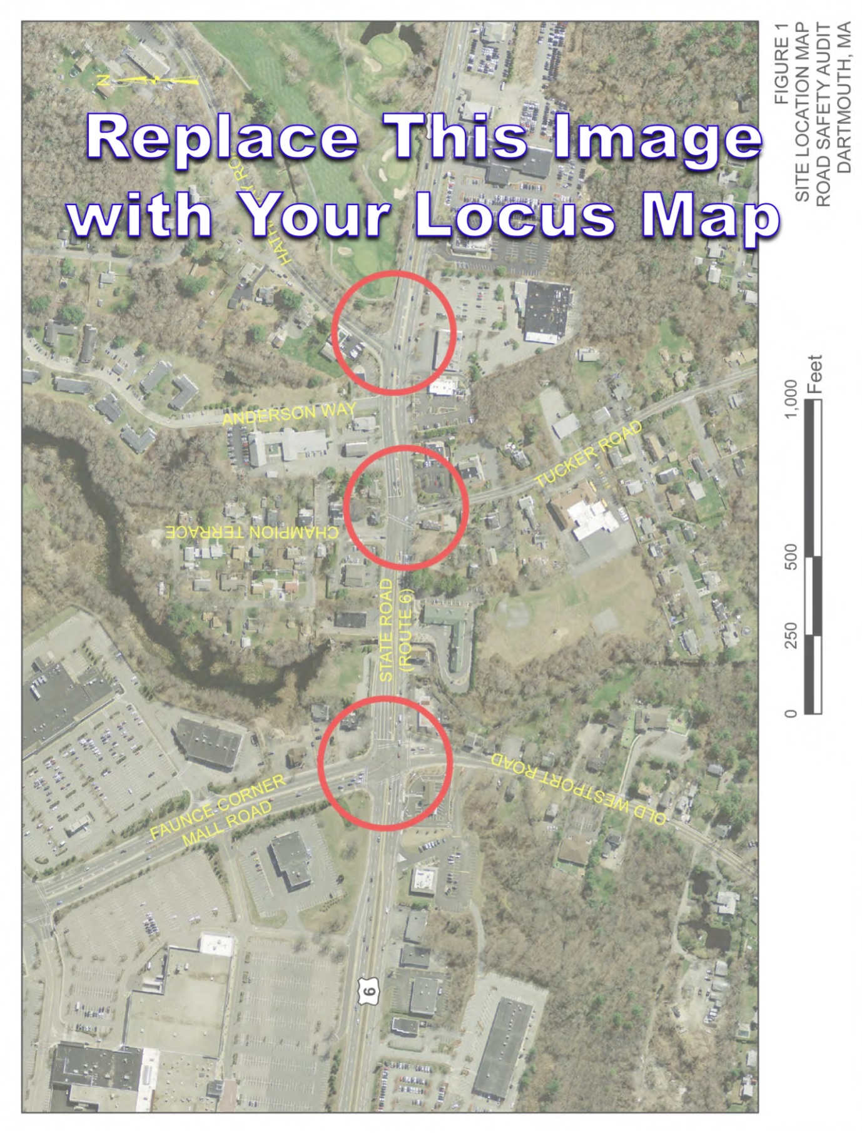Figure 1: Locus Map
[Use “Change Picture” option to replace image placeholders with your own. Depending on your version of Word, “Right click>Change Picture” or choose “Change Picture” from “Picture Tools” menu.]

When replacing a whole page with a pdf from another source, tagging and accessibility will need to be done with your PDF Accessibility Checker.

Audit Observations and Potential Safety Enhancements
[Use “Change Picture” option to replace image placeholders with your own. Depending on your version of Word, “Right click>Change Picture” or choose “Change Picture” from “Picture Tools” menu.]
[Use RSA Report Normal style.]
Identify the different safety issues and possible potential safety enhancements discussed during the audit. For each safety issue, state what the issue is, identify the location of the issue, and provide a complete description of the issue. Provide pictures and/or figures to illustrate each issue. List in detail the possible safety enhancements for each issue as discussed.
Image 1: Write your caption here.

Summary of Road Safety Audit
[Use RSA Report Normal style.]
List each safety issue and potential safety enhancement discussed during the audit. For each safety issue, describe the potential safety enhancement, its potential safety payoff, the estimated time frame for completion, the estimated construction cost, and the roadway jurisdiction. If there are conceptual or design plans in progress for this location, identify the potential safety enhancements that have been incorporated into the design. If there are issues with the plans, as designed, this should be noted as well.
Safety payoff estimates are subjective and may be based on the relative percent of crashes that may be reduced by the enhancement based on known and documented crash reduction factors, if available, or estimated crash reduction based on a stated source.
[You can copy/paste these image placeholders throughout document to then replace with your images afterwards. Insert captions via the “References” tab and use the “Image” label. Use “Caption 2” style for formatting.]
Image 2: Write your caption here.

Table 2: Estimated Time Frame and Costs Breakdown
Time Frame |  |  | Costs
Short-Term | <1 Year |  | Low | <$10,000
Mid-Term | 1-3 Years |  | Medium | $10,001-$50,000
Long-Term | >3 Years |  | High | >$50,000

NOTE: PLEASE DO NOT DELETE THE PAGE BREAK THAT FOLLOWS THIS PARAGRAPH. IT INTRODUCES A NEW SECTION AND FORMAT.

Table 3: Potential Safety Enhancement Summary
Safety Issue | Potential Safety Enhancement | Safety Payoff | Time Frame | Cost | Jurisdiction

Additional PDF Accessibility Notes:
- Please be sure to structure your document by applying the Heading Styles that have been set up in this template for you. Use “Heading 1” for headings and “Caption 1”for captions (tables/figures).
- Table summaries need to be fixed in your PDF Accessibility Checker (such as Adobe Acrobat Pro) during accessibility check. (In Adobe Acrobat Pro, for example, open the Touch Up Reading Order tool > right click on the table > select “Edit Table Summary”, write a brief summary and hit OK.)
- Reading order will need to be adjusted in your PDF Accessibility Checker during accessibility check. (In Adobe Acrobat Pro, for example, open the Touch Up Reading Order tool > choose “Show Order Panel” towards the bottom. This will bring up numbered boxes on the page and the reading order panel on the right. Drag the items in the reading order panel on the right into the order in which you want them to be read.)
- If you want page numbers to be read, they will need to be tagged as text your PDF Accessibility Checker during accessibility check.
NOTE: PLEASE DO NOT DELETE THE PAGE BREAK THAT FOLLOWS THIS PARAGRAPH.
IT INTRODUCES A NEW SECTION AND FORMAT.

- RSA Meeting Agenda
[The style above is the RSA Report Appendix Cover Page style. It automatically numbers the appendices and links to the RSA Report Normal style.]

- RSA Audit Team Contact List

Participating Audit Team Members
Date: | January 1, 2014 |  | Location: | Anytown, MA
Audit Team Members |  | Agency/Affiliation |  |  | Email Address | Phone Number
Name |  | Agency |  |  | Email | xxx-xxx-xxxx

- Detailed Crash Data
This appendix should include detailed crash analysis such as collision diagrams and crash data [state specific crash source and other details so that an evaluation of the effectiveness of the improvements may be performed.]

- Additional Information
Additional appendices should be provided for any additional information about the site that is not provided in the report.

- Road Safety Audit References

Road Safety Audit References

FHWA Office of Safety - Proven Safety Countermeasures, U.S. Department of Transportation, Federal Highway Administration https://safety.fhwa.dot.gov/provencountermeasures/.
Road Safety Audits, A Synthesis of Highway Practice. NCHRP Synthesis 336. Transportation Research Board, National Cooperative Highway Research Program, 2004.
Road Safety Audits. U.S. Department of Transportation, Federal Highway Administration, https://safety.fhwa.dot.gov/rsa/
FHWA Road Safety Audit Guidelines. U.S. Department of Transportation, Federal Highway Administration, 2006.
Road Safety Audit, 2nd edition. Austroads, 2000.
Road Safety Audits. ITE Technical Council Committee 4S-7. Institute of Transportation Engineers, February 1995.

